Do you wish you could contribute more to Zion? Zion’s Scrip Program is a way for everyone to give more to Zion. Recently, $8000 was given to the church from the Scrip Program to help cover some of the shortfall from our 2017-2018 church budget. Ideally, by increasing our Scrip usage, the Scrip Program could annually give the church thousands of dollars without costing our members any extra money.

Scrip is a yearlong fundraising effort where you simply purchase Scrip gift cards to pay for the things you normally would. We’re not asking you to buy anything you wouldn’t ordinarily buy. What we are asking you to do is to pay for the things you buy with Scrip instead of cash, check, or credit card.

Scrip gift cards are sold in the office and the Book Nook on Sundays. We have gift cards on hand from many local retailers, and you can order gift cards through the office for hundreds more retailers.

Currently, there are only 14 families doing the majority of Scrip purchases. These 14 families make up 75% of our Scrip profits. These families on average purchase $500 worth of Scrip gift cards per month and raise an extra $200 to give to Zion each year. If we could get more people to regularly participate in the Scrip Program, the results could make a big impact on Zion’s budget.

Please see the Sower for more information about Scrip and do not hesitate to contact the office with questions.

Words don’t begin to express my appreciation to everyone who helped make my 100th birthday such a happy occasion. May God bless you all. Vi Fox

Stewardship Note
2 Corinthians 8:3 – “For they gave according to their means, as I can testify, and beyond their means, of their own free will.” St. Paul lifts up an example of faithful Christian generosity in the Epistle lesson today. Read those words again this week and ponder them. How is the Lord calling you
to increase your generosity toward His work?

Announcements – July 1, 2018
Please silence your cell phone during worship.
Our sanctuary has a HEARING LOOP. Please switch hearing aids to T-coil mode. We have 2 headsets and receivers for use by those without hearing aids. Ask an usher for help.

Forgot your offering? Don’t have your checkbook or cash? Today or any day you can visit our website at zionkearney.com and click on the “giving” tab. Or, text “zionkearney” (one word) to 77977. You’ll receive a text back with instructions to start giving.

For Your Safety and Security … all exterior doors are locked 15 minutes after the church service begins. If you are running late please go to the west door for access to the sanctuary.

The Family of Lewis and Carolyn Westman invites you to a 50th Wedding Anniversary Open House from 1:00 pm – 4:00 pm today, July 1st. The celebration will be held at the George Spencer Tasting Room located at 7155 Pawnee Rd, Gibbon, NE. No gifts, please.

Summer Office Hours… Monday-Friday 9:00-1:00. The office will be closed on July 4.

Mission Sunday -July 8
Next Sunday we will collect gifts for Rev. John Clausing and his family who serve the Lord in Eastern Africa. There are mission envelopes which can be used in the narthex. Please place any gifts in the offering plate. In addition to this the VBS offering has been designated to go to this family and Rev. Clausing and his family will be joing us July 24 to tell us about their work in Africa.

The July Sower… is avilable to pick up in the narthex and outside Pators office. If anyone is not receiving the Sower by email and would like to, please notify the office staff.

A fundraiser is being planned to support Bryceton Herrera and family. The date is set for Sunday, September 30th. The event will include a meal and silent auction in Zion’s gym. More details will be provided the closer we get to September. At this time we are asking people to save the date so you are able to attend and consider donating baskets for the silent auction. It is recommended that a family or families go together to assemble a basket to donate to the silent auction. A list of ideas is available if you need help deciding on a basket.

Please contact Michelle Millsap at 308-233-7398, Lisa Splittgerber at 308-627-4566 or tolisplit@hotmail.com, or speak with Amy Woodman if you have any questions. Also, please contact Michelle if you plan to donate a basket so that we do not have duplicate baskets. Completed baskets will not be due until September. Anyone interested in helping with the fundraiser is welcome to contact Michelle as well. Thank you!

School News

- Thank You… to everyone who continures to collect and bring in Family Fresh Reciepts for our school. We have collected and subitted $150,000 in reciepts, and will receive a check for $1,000 for our school.
Thank you also to the Helping Hands ladies who meet the first Thursday of each month to prepare all of the reciepts and labes for submission. They would welcome you to join them.

- There are several openings in our morning Tuesday/Thursday preschool class as well as the afternoon prekindergarten class.
Vacation Bible School is only two weeks away. VBS will run July 15th-19th from 6-8. If you haven't registered your child, please do that as soon as possible. Registration forms are available on the bulletin board and in the narthex. Please feel free to invite your friends and family and encourage them to turn in their registration forms too. Those involved with VBS are encouraged to bring a plain t-shirt the first night so that an iron-on Splash Canyon logo can be put on the shirt to wear on Thursday and to have as a keepsake. Families are encouraged to attend on Thursday at 6 for a shortened evening including a program and fun activities.

We are asking for monetary donations to cover the various expenses required to carry out VBS. A donation box is in the narthex for those who are able to contribute. We will also be posting a list of items that can be donated for crafts and snacks. Please remove the note off the bulletin board of the item that you can donate. Craft items can be turned into the office right away and snack items should be turned in by Friday the 13th.

We are considering a fun culminating activity for Splash Canyon and invite the congregation to join. On Saturday, July 21st, we will be taking a group to kayak Turkey Creek. A kayak would cost $25 for a one and a half hour kayak ride. The fee includes life jackets and transportation to the drop-off point at Yanney. A younger child can sit in an adult’s kayak for free. A parent must accompany their children younger than high school age.

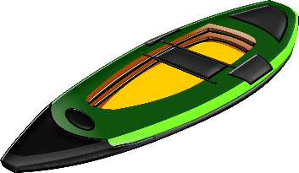
If you are interested in joining us for kayaking, please contact the office to give them a list of the people who will be attending by the Friday the 13th. Payment will need to be made by Friday the 20th. Checks can be made out to Zion. An exact time will be determined once we know how many people will be attending.
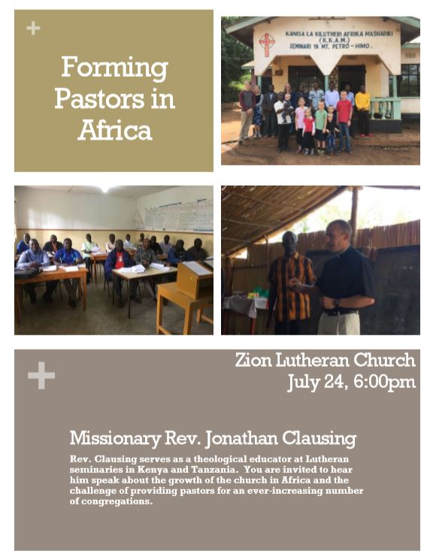

Please make plans to attend

Please make plans to attend

