Do you wish you could contribute more to Zion? Zion’s Scrip Program is a way for everyone to give more to Zion. Recently, $8000 was given to the church from the Scrip Program to help cover some of the shortfall from our 2017-2018 church budget. Ideally, by increasing our Scrip usage, the Scrip Program could annually give the church thousands of dollars without costing our members any extra money.

Scrip is a yearlong fundraising effort where you simply purchase Scrip gift cards to pay for the things you normally would. We’re not asking you to buy anything you wouldn’t ordinarily buy. What we are asking you to do is to pay for the things you buy with Scrip instead of cash, check, or credit card.

Scrip gift cards are sold in the office during the week and the Book Nook on Sundays. We have gift cards on hand from many local retailers, and you can order gift cards through the office for hundreds more retailers.

Currently, there are only 14 families doing the majority of Scrip purchases. These 14 families make up 75% of our Scrip profits. These families on average purchase $500 worth of Scrip gift cards per month and raise an extra $200 to give to Zion each year. If we could get more people to regularly participate in the Scrip Program, the results could make a big impact on Zion’s budget.

Please see the Sower for more information about Scrip and do not hesitate to contact the office with questions.

Summer Office Hours… Monday-Friday 9:00-1:00.

Stewardship Note
2 Corinthians 12:10 – “For the sake of Christ, then, I am content with weaknesses, insults, hardships, persecutions, and calamities.” Paul found contentment in Christ. To be content means to accept what the Lord gives us at any given time as somehow being from the hand of the Father who wants to bless us. Sometimes it’s hard to see how things like hardships, calamities, and insults will turn out for a blessing: but that is why Paul found this contentment in Christ and not in his own wisdom.
Announcements – July 8, 2018
Please silence your cell phone during worship.
Our sanctuary has a HEARING LOOP. Please switch hearing aids to T-coil mode. We have 2 headsets and receivers for use by those without hearing aids. Ask an usher for help.

Forgot your offering? Don’t have your checkbook or cash? Today or any day you can visit our website at zionkearney.com and click on the “giving” tab. Or, text “zionkearney” (one word) to 77977. You’ll receive a text back with instructions to start giving.

For Your Safety and Security … all exterior doors are locked 15 minutes after the church service begins. If you are running late please go to the west door for access to the sanctuary.

Today is Mission Sunday! We will collect gifts for Rev. John Clausing and his family who serve the Lord in Eastern Africa. In the narthex there are mission envelopes you can use to place your gift in the offering plate. In addition to this the VBS offering has been designated to go to this family. Rev. Clausing and his family will be joing us July 24 to tell us about their work in Africa.

Pr. DeLoach will be on vacation the next two weeks, so please contact Pr. Gaunt (308-455-0552) for any emergencies requiring pastoral care.

All VBS Volunteers, (youth and adult) will meet Wednesday, July 11, at 7:00 p.m. to finalize plans, and Saturday, July 14th at 9:00 a.m. to set up and decorate.

Voters Meeting…please note that there will be a special voters meeting next Sunday, July 15 to consider extending a call to Debra Erickson as our new first grade teacher.
Our regularly scheduled July Voters Meeting will be Sunday, July 22 at 10:30 in the Fellowship Hall.

Mens Bible Study…will not meet July 19 because of VBS.

Mary Martha… will meet tomorrow, July 9 at 7:00. We will be doing several small service projects for the Church and School.

A fundraiser is being planned to support Bryceton Herrera and family. The date is set for Sunday, September 30th. The event will include a meal and silent auction in Zion’s gym. More details will be provided the closer we get to September. At this time we are asking people to save the date so you are able to attend and consider donating baskets for the silent auction. It is recommended that a family or families go together to assemble a basket to donate to the silent auction. A list of ideas is available if you need help deciding on a basket.

Please contact Michelle Millsap at 308-233-7398, Lisa Splittgerber at 308-627-4566 or tolisplit@hotmail.com, or speak with Amy Woodman if you have any questions. Also, please contact Michelle if you plan to donate a basket so that we do not have duplicate baskets. Completed baskets will not be due until September. Anyone interested in helping with the fundraiser is welcome to contact Michelle as well. Thank you!

School News

- Thank You… to everyone who continues to collect and bring in Family Fresh Receipts for our school. We have collected and submitted $150,000 in receipts, and will receive a check for $1,000 for our school. Thank you also to the Helping Hands ladies who meet the first Thursday of each month to prepare all of the receipts and labels for submission. They would welcome you to join them.
- There are several openings in our morning Tuesday/Thursday preschool class as well as the afternoon prekindergarten class.

VBS… On the bulletin board wall there is a display of items needed for VBS. If you wish to help, please take the slip of paper for the item(s) you wish to donate, then bring donations to Zion by next Sunday.

Vacation Bible School is only one week away! VBS will run July 15th-19th from 6-8. If you haven't registered your child, please do that as soon as possible. Registration forms are available on the bulletin board and in the narthex. Please feel free to invite your friends and family and encourage them to turn in their registration forms too. Those involved with VBS are encouraged to bring a plain t-shirt the first night so that an iron-on Splash Canyon logo can be put on the shirt to wear on Thursday and to have as a keepsake. Families are encouraged to attend on Thursday at 6 for a shortened evening including a program and fun activities.

We are asking for monetary donations to cover the various expenses required to carry out VBS. A donation box is in the narthex for those who are able to contribute. We will also be posting a list of items that can be donated for crafts and snacks. Please remove the note off the bulletin board of the item that you can donate. Craft items can be turned into the office right away and snack items should be turned in by Friday the 13th.
.

We are considering a fun culminating activity for Splash Canyon and invite the congregation to join us. On Saturday, July 21st, we will be taking a group to kayak Turkey Creek. A kayak would cost $25 for a one and a half hour kayak ride. The fee includes life jackets and transportation to the drop-off point at Yanney. A younger child can sit in an adult’s kayak for free. A parent must accompany their children younger than high school age. We would meet at 4:30 p.m. for an approximate start time of 5:00 p.m.

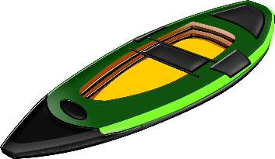
If you are interested in joining us for kayaking, please contact the office to give them a list of the people who will be attending by the Friday the 13th. Payment will need to be made by Friday the 20th. Checks can be made out to Zion. An exact time will be determined once we know how many people will be attending.
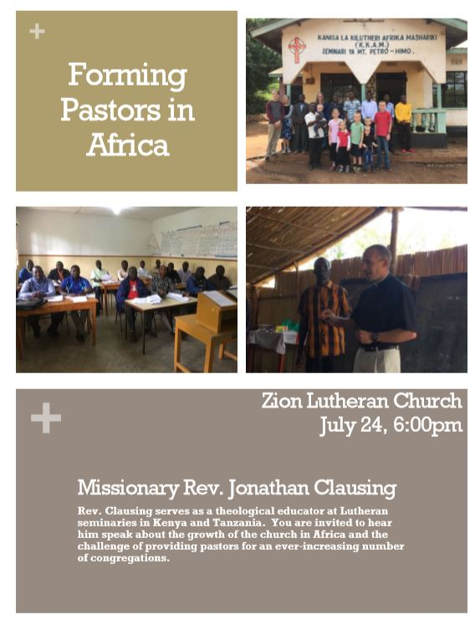

Please make plans to attend

Please make plans to attend

