Do you wish you could contribute more to Zion? Zion’s Scrip Program is a way for everyone to give more to Zion. Recently, $8000 was given to the church from the Scrip Program to help cover some of the shortfall from our 2017-2018 church budget. Ideally, by increasing our Scrip usage, the Scrip Program could annually give the church thousands of dollars without costing our members any extra money.

Scrip is a yearlong fundraising effort where you simply purchase Scrip gift cards to pay for the things you normally would. We’re not asking you to buy anything you wouldn’t ordinarily buy. What we are asking you to do is to pay for the things you buy with Scrip instead of cash, check, or credit card.

Scrip gift cards are sold in the office during the week and the Book Nook on Sundays. We have gift cards on hand from many local retailers, and you can order gift cards through the office for hundreds more retailers.

Currently, there are only 14 families doing the majority of Scrip purchases. These 14 families make up 75% of our Scrip profits. These families on average purchase $500 worth of Scrip gift cards per month and raise an extra $200 to give to Zion each year. If we could get more people to regularly participate in the Scrip Program, the results could make a big impact on Zion’s budget.

Please see the Sower for more information about Scrip and do not hesitate to contact the office with questions.

Summer Office Hours… Monday-Friday 9:00-1:00.

Stewardship Note
Amos 7:8 – “And the LORD said to me, "Amos, what do you see?" And I said, "A plumb line." Then the Lord said, "Behold, I am setting a plumb line in the midst of my people Israel; I will never again pass by them.” One of the sins for which the Lord condemned the people through Amos was a disregard for the call of kindness, charity, and generosity toward the weak and lowly. We can see here how seriously the Lord sees this! And that’s no surprise when we consider how God’s activity toward us is built on kindness, charity, and generosity. To act otherwise is to act against the Lord’s own nature.
Announcements – July 15, 2018
Please silence your cell phone during worship.
Our sanctuary has a HEARING LOOP. Please switch hearing aids to T-coil mode. We have 2 headsets and receivers for use by those without hearing aids. Ask an usher for help.

Forgot your offering? Don’t have your checkbook or cash? Today or any day you can visit our website at zionkearney.com and click on the “giving” tab. Or, text “zionkearney” (one word) to 77977. You’ll receive a text back with instructions to start giving.

For Your Safety and Security … all exterior doors are locked 15 minutes after the church service begins. If you are running late please go to the west door for access to the sanctuary.

Voters Meeting…please note that there will be a special voters meeting today, July 15 to consider extending a call to Debra Erickson as our new first grade teacher.

Our regularly scheduled July Voters Meeting will be next Sunday, July 22 at 10:30 in the Fellowship Hall.

Senior Citizens… will meet tomorrow July 16 for their monthly potluck dinner at 12 noon. All are welcome to join them.

Mens Bible Study…will not meet July 19 because of VBS. The next men’s bible study will be Aug.16 at 6:00pm. Before the bible study, the men will be grilling steaks. Please watch for more details.

Missionary… Rev. Klausing will be at Zion on Tuesday, July 24 at 6:00 pm to tell about the mission work, including the training of Pastors,that is being done in Africa. After the presentation, Mary Martha will serve Root Beer Floats.

Pr. DeLoach will be on vacation for one more week,and then attend
Higher Things with our youth the following week, so please contact Pr. Gaunt (308-455-0552) for any emergencies requiring pastoral care.

Vacation Bible School begins today! VBS will run July 15th-19th from 6-8. If you haven't registered your child, please do that as soon as possible. Registration forms are available on the bulletin board and in the narthex. Please feel free to invite your friends and family and encourage them to turn in their registration forms too. Those involved with VBS are encouraged to bring a plain t-shirt the first night so that an iron-on Splash Canyon logo can be put on the shirt to wear on Thursday and to have as a keepsake. Families are encouraged to attend on Thursday at 6 for a shortened evening including a program and fun activities.

We are asking for monetary donations to cover the various expenses required to carry out VBS. A donation box is in the narthex for those who are able to contribute. Thank you to all who donated food and supplies for our VBS.

We are considering a fun culminating activity for Splash Canyon and invite the congregation to join us. On Saturday, July 21st, we will be taking a group to kayak Turkey Creek. A kayak would cost $25 for a one and a half hour kayak ride. The fee includes life jackets and transportation to the drop-off point at Yanney. A younger child can sit in an adult’s kayak for free. A parent must accompany their children younger than high school age. We would meet at 4:30 p.m. for an approximate start time of 5:00 p.m.

If you are interested in joining us for kayaking, please contact the office to give them a list of the people who will be attending by the Friday the 13th. Payment will need to be made by Friday the 20th. Checks can be made out to Zion. An exact time will be determined once we know how many people will be attending.

An Altar Guild Meeting… is scheduled for Sunday, July 29 at 11:15 in the sancuary. All guild members are asked to attend if possible. We will be reviewing Altar Guild procedures.

Lewie & Carolyn Westman… would like to thank those who sent the pretty cards for their 50th anniversary. Thank you also to those who attended the party at the winery. It was a very special day for us and we will have many happy memories. God has Truly blessed us.
A fundraiser is being planned to support Bryceton Herrera and family. The date is set for Sunday, September 30th. The event will include a meal and silent auction in Zion’s gym. More details will be provided the closer we get to September. At this time we are asking people to save the date so you are able to attend and consider donating baskets for the silent auction. It is recommended that a family or families go together to assemble a basket to donate to the silent auction. A list of ideas is available if you need help deciding on a basket.

Please contact Michelle Millsap at 308-233-7398, Lisa Splittgerber at 308-627-4566 or tolisplit@hotmail.com, or speak with Amy Woodman if you have any questions. Also, please contact Michelle if you plan to donate a basket so that we do not have duplicate baskets. Completed baskets will not be due until September. Anyone interested in helping with the fundraiser is welcome to contact Michelle as well. Thank you!

Bethlehem Lutheran Church… is hosting a 3-player golf tournament in celebration of her 100th anniversary. The tournament will begin at 9 am on July 21st at the Ravenna Golf Club (1117 Alba Ave, Ravenna, NE 68869). The cost is $50 per golfer. Lunch will be provided as well as cash and flag prizes. All proceeds will go to the Ravenna Ministerial Alliance Financial Assistance Fund. Register by calling (308) 452 3150 (golf course) or (308) 452 3685 (Bethlehem.

Bethlehem is also inviting Zion to their worship service and noon meal celebrating their 100th anniversary on August 26. They are requesting an RSVP for all who can attend by August 1. For mor edetails please check the flyer on the bulletin board wall.

School News

- There are several openings in our morning Tuesday/Thursday preschool class as well as the afternoon prekindergarten class.
- School families please be watching for a mailing with details about final registration day and activities leading up to the start of school.

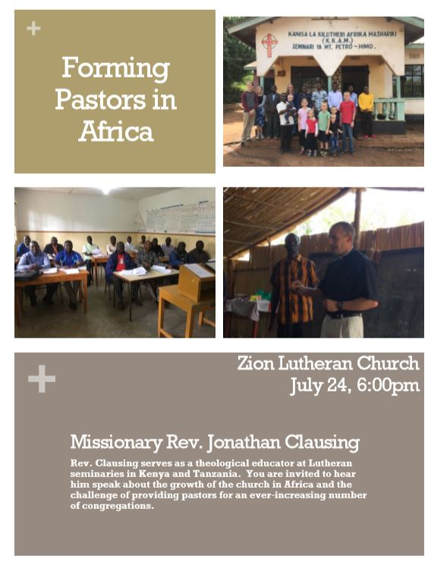

Please make plans to attend

Please make plans to attend

