We had a great week of VBS. The children learned that God’s Promises are Yes in Jesus! We were happy to have around 50 children each night. The week concluded with a closing program followed by a hot dog meal and outdoor games. The offering was designated to go to Missionary Rev. Clausing and his family.

A big thank you to all who helped with, or donated items to VBS.

VBS Director: Pastor Gaunt (opening & closing each day)
Story Leader: Nathan Gaunt
Decorations: Rachel Strong
Registration: Anthony Splittgerber, Beth Rosenthal
Adult Leaders: Brooke Fisher, Lisa Splittgerber, Jessica Shiers Blattner, Shirley Oertwig
Adult Helpers: Liz Gaunt, Rachael Burger, Carol Gaunt
Youth Helpers: Ansley Noyes, Addison Helmbrecht, Addison Splittgerber, Jayden Young, Isaiah Gaunt, Jase Blattner, Emma Schmidt
Game Leaders: Darcy Willers, Phil Vogel, Matt Hodgson, Ann Hinners
Snacks: Ellen Koopman and Mary Martha ladies, Isobel Zayas & Abigail Lange
Crafts: Lacy Ahrens, Janine Podany, Des Fiddelke, Paige Ahrens, Alexandra Splittgerber, Jessica Zehendner
Video: Jesse & Ashli Florang
Photography: Kay Banner

Summer Office Hours… Monday-Friday 9:00-1:00.

Stewardship Note
Ephesians 2:13 – “But now in Christ Jesus you who once were far off have been brought near by the blood of Christ.” What all of mankind’s efforts, works, and scheming could not do, the blood of Christ did: we have peace with God, we are brought near to the Father. This life-giving sacrifice of Christ sets the pattern for the sacrifices we are called to make for others within our vocations in home, church, and society.

Announcements – July 22, 2018
Please silence your cell phone during worship.
Our sanctuary has a HEARING LOOP. Please switch hearing aids to T-coil mode. We have 2 headsets and receivers for use by those without hearing aids. Ask an usher for help.

Forgot your offering? Don’t have your checkbook or cash? Today or any day you can visit our website at zionkearney.com and click on the “giving” tab. Or, text “zionkearney” (one word) to 77977. You’ll receive a text back with instructions to start giving.

For Your Safety and Security … all exterior doors are locked 15 minutes after the church service begins. If you are running late please go to the west door for access to the sanctuary.

Voters Meeting… Our July Voters Meeting will be today, July 22 at 10:30 in the Fellowship Hall.

Debra Erickson…has accepted the call that was extended to her by the Zion voters to serve as our first grade teacher. Thanks be to God.

Missionary… Rev. Klausing and his family will be at Zion on Tuesday, July 24 at 6:00 pm to tell about the mission work, including the training of Pastors, that is being done in Africa. After the presentation, Mary Martha will serve Root Beer Floats.

An Altar Guild Meeting… is scheduled for Sunday, July 29 at 11:15 in the sancuary. All guild members are asked to attend if possible. We will be reviewing Altar Guild procedures.

Pr. DeLoach will be back from vacation tomorrow…he will then be taking our youth to the Higher Things Conference in Kansas through Friday of this week, so please contact Pr. Gaunt (308-455-0552) for any emergencies requiring pastoral care.

Peach Sales… The first shipment will be here for August 11 sales, we plan to have more the following two weekends. Please tell your friends. They are so delicous!!!

I want to express… my great appreciation and thanks to Pastor DeLoach and Pastor Gaunt for all their visits, and the prayers, cards and food by my Zion friends at the time of my surgery and cancer treatment. Thank you also for the cards and caring thoughts for the loss of my sister.
God’s Blessings, Marilyn Fuqua

Lewie & Carolyn Westman… would like to thank those who sent the pretty cards for their 50th anniversary. Thank you also to those who attended the party at the winery. It was a very special day for us and we will have many happy memories. God has Truly blessed us.

The family of Lavonne Peterson has requested a card shower in honor of her 80th birthday on July 23. Cards can be mailed to:
568 V. Rd. Kearney, NE 68845

A fundraiser is being planned to support Bryceton Herrera and family. The date is set for Sunday, September 30th. The event will include a meal and silent auction in Zion’s gym. More details will be provided the closer we get to September. At this time we are asking people to save the date so you are able to attend and consider donating baskets for the silent auction. It is recommended that a family or families go together to assemble a basket to donate to the silent auction. A list of ideas is available if you need help deciding on a basket.

Please contact Michelle Millsap at 308-233-7398, Lisa Splittgerber at 308-627-4566 or tolisplit@hotmail.com, or speak with Amy Woodman if you have any questions. Also, please contact Michelle if you plan to donate a basket so that we do not have duplicate baskets. Completed baskets will not be due until September. Anyone interested in helping with the fundraiser is welcome to contact Michelle as well. Thank you!

Bethlehem Lutheran Church… is inviting Zion members to their worship service and noon meal celebrating their 100th anniversary on August 26. They are requesting an RSVP for all who can attend by August 1. For more details please check the flyer on the bulletin board wall.

School News

- There are several openings in our morning Tuesday/Thursday preschool class as well as the afternoon prekindergarten class.

- Final Registration days are August 1 for early childhood classes and August 2 for Kindergarten-8th grade, 11:00 am -6:00 pm each day.

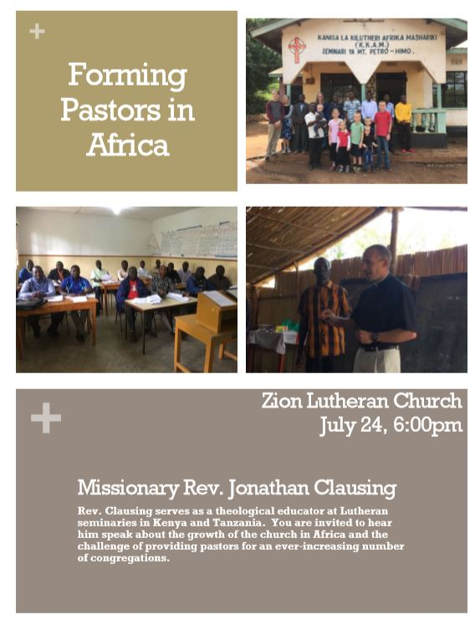

Please make plans to attend

