**Help Needed**

The Trustees will be recoating the school roof on Saturday, Sept 15 at 1:00 pm.  They need and would appreciate, help from the congregation.  Please call the church office if you can help.

234-3410

**Sleeping Mats**

The Sleeping Mat group has been meeting for 3 years this past August. We have sent 158 sleeping mats through the Grand Island Orphan Gran Train mainly for international aid. (Recycling about 95,000 bags) Special thanks to Kay & Dave Banner, Pat & Jim Catterson, Linda & Craig Nuttelman, Nancy & Mark Dissmeyer, Carolyn & Lewis Westman and Blance Horst (from Ravenna) for all their hard work of flattening, cutting and knotting. Also huge thanks to Pat & Kay for crocheting most of those 158.

Margaret & Norbert Smith

**Wise Women…**

Join us at Bethlehem Lutheran Church on September 8th from 9am-4pm for a day of exploring safety for yourself and others. Topics include bystander intervention, dynamics of relationship violence, situational awareness, and the role faith has in relationships. An officer from the Nebraska State Patrol and domestic violence survivor Bethany will give a moving presentation entitled “He Never Hit Me.”  This event is for women only. We ask you to bring an item from The S.A.F.E. Center's wish list as admission. ([www.safecenter.org/donations/](https://legacy-exchange.charter-business.net/owa/redir.aspx?REF=IbVcGNc7aMMujd2WebjNIW0wehEPk42jj6kDAOsBj4Iv9k63ygLWCAFodHRwOi8vd3d3LnNhZmVjZW50ZXIub3JnL2RvbmF0aW9ucy8.)) Please RSVP by calling Bethlehem Lutheran Church at 308-452-3685 by August 31. Lunch is provided.

**Stewardship Note**

**Deuteronomy 4:6 – “Keep them and do them, for that will be your wisdom and your understanding in the sight of the peoples, who, when they hear all these statutes, will say, ‘Surely this great nation is a wise and understanding people.’ ”** There is no wiser, more fulfilling life than a life lived according to the Word of God. We should be encouraged by this when the world tempts us to think that the Word of God is harmful to us. Our Father loves us; so all His Word is meant to bless us.



**Announcements – September 2, 2018**

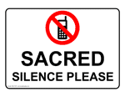**Please silence your cell phone during worship**.

Our sanctuary has a **HEARING LOOP.** Pleaseswitch hearing aids to T-coil mode. We have 2 headsets and receivers for use by those without hearing aids. Ask an usher for help.

**Forgot your offering**? Don’t have your checkbook or cash? Today or any day you can visit our website at zionkearney.com and click on the “giving” tab. Or, text “zionkearney” (one word) to 77977. You’ll receive a text back with instructions to start giving**.**

**For Your Safety and Security …** all exterior doors are locked 15 minutes after the church service begins. If you are running late please go to the west door for access to the sanctuary.



**Sunday School Promotion Today**

Today is Sunday School Promotion Sunday when the children will move into their new class. Children will gather in the gym to meet their new teacher before going to their new classroom. Also at today’s service we will be instaling Sunday School teachers**:**

**Pre-School,** Vacant

**Pre-K & Kindergarten-** Kim & Lindsay Wilkens

**1st & 2nd grade**- Brooke Fisher

**3rd & 4th grade** –Steve Junge

**5th & 6th** grade- Susan Tonniges

**7th & 8th grade** – Jessica Hinners

**9th – 12th grade**- Pastor Gaunt.

Our thanks to these teachers and those who have served in the past. Special thanks to Bev Nuttelman, Craig Nuttelman and Lavonne Peterson for their many years of service.

**Midweek Class**

Midweek classes will begin Wednesday, September 6. Classes will go from 5:45 to 7:00 pm. This class is for all Zion public school youth, who are in the 4th grade or older. Students need to bring a 3 ring binder (one inch or more), their bible, and their catechism. First year students will receive a catechism.

A class schedule and assignment sheet will be distributed at the first class. Call Pr. DeLoach (308-627-5860) with any questions.

**Adult Instruction Class**

A new adult instruction class will start this week.  If you are interested in becoming a member at Zion, or are interested in learning more about the Christian faith, please plan to attend.  You will receive a free "Luther's Small Catechism" as a lifelong tool for learning. **"Here We Stand...Together"** is the theme Pastor Gaunt will follow for this class.  It will be offered in the Fellowship Hall, at 7:00 pm beginning Wednesday, September 5, 2018.

If you are interested in attending this class but Wednesday’s will not work for you, please contact the Church office.

308-234-3410

**Golf Scramble Next Sunday**

Zion Lutheran is hosting its Annual 2 Person Golf Scramble. The golf tournament will take place at the Elks Country Golf. Cost is $60 per team (two divisions: 2 adults or 1 adult/1child) which includes 18 holes of golf and dinner. If interested in participating or sponsoring a hole for $50, Registration forms are available in the office area. Good golf skills not required.

**Mission Sunday- Next Week**

Our next Mission Sunday is September 9. This month we will support our college and seminary students who are studing for full time church work.

Mission gifts will be given to support Matthias Wollberg who is in his fourth year of study at Concordia Seminary, Ft. Wayne and Abigail DeLoach who is in her first year of study at Concordia, Seward,to become a Lutheran school teacher. There are special Mission Envelopes in the Narthex that may be used. All gifts should be clearly marked and placed in the offering plate.

**Special Music…**

ADULT CHOIR AND HANDBELLS will both begin Wednesday, September 12.  Handbells meets at 6:00 pm in the balcony, with adult choir following at 7:00 p.m.

ZYG

**Fall Youth Activities**

September

**Sept.9: Youth in 7th -12th grade and their parents meet after Church at 10:15 in the sanctuary to plan fall activities**



Sept.23: Fall Kick Off - outdoor activities at the Wilkens Farm

October

Oct.7: Game Night, make your own pizza

Oct.28: Pumpkin Patch, Pumpkin Carving Competition

November

Nov.11: Rake and Run, Followed by Something Warm



December

Bible Hour Gift Exchange?

Dec. 22: Caroling, Ice Skating

Looking Ahead:

Higher Things at Concordia Seward

June 24-27, 2019

Register by November 1 before it fills!

**Bryceton Herrera Silent Auction and Luncheon Benefit**

Sunday, September 30th from 11:30 to 3:00 at Zion Lutheran Church

**Raffle Tickets:**Thanks to donations from Builder’s Warehouse and Kearney Moving, we will have 3 raffle items.  First Prize: Weber 2 Burner Grill (purchased at a discounted price at True Value). Second Prize: Yeti Hopper Flip 18 Cooler. Third Prize: $100 Hy-Vee Gift Card.  Tickets are 1 ticket for $5 or 5 tickets for $20. Winners will not need to be present to win. Tickets can be purchased at the Zion office or through Michelle Millsap, Lisa Splittgerber, Amy Woodman, or Darcy Willers.

**Window Decals:**Another way to support Bryceton is

to purchase window decals.  Decals are $5 per decal and are available at the Zion office or through Amy Woodman today after church.

Auction items are currently being gathered.  We are asking that items be turned in no later than September 15th.  Volunteers are also needed. People are needed to help before, during, and after the benefit.  Zion members are asked to bring cookies and bars for the dessert. Please contact Michelle Millsap at 308-233-7398 to sign up to donate items, volunteer to work, and/or to bring desserts or with any questions.

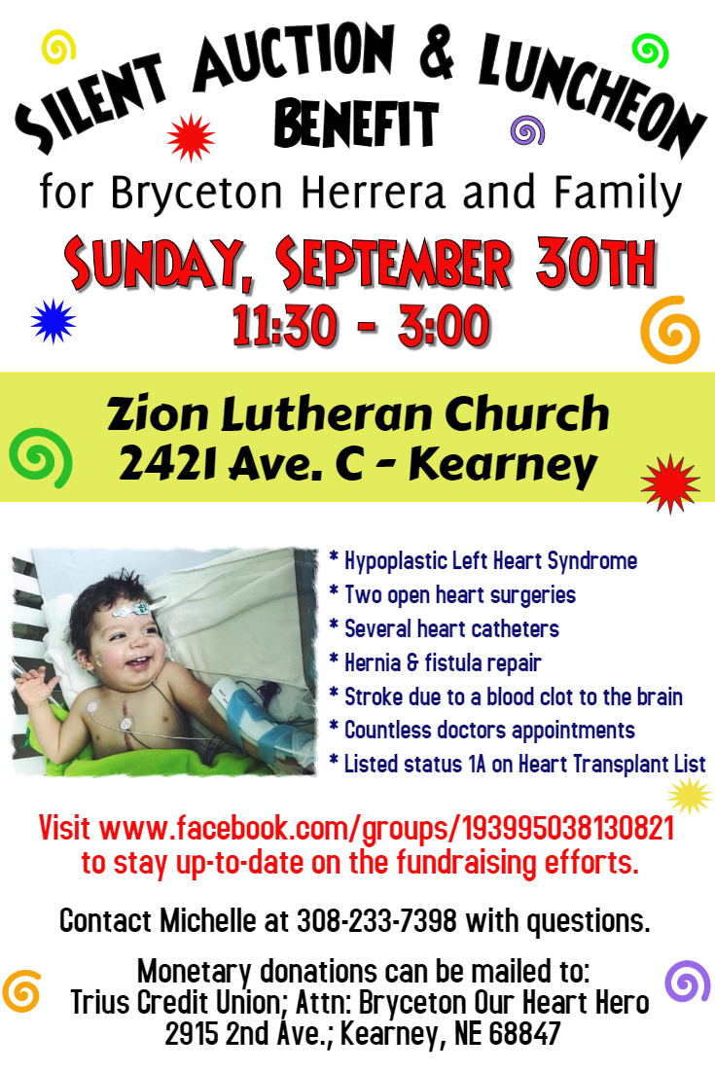

**Bryceton Herrera Silent Auction and Luncheon Benefit**

Sunday, September 30th from 11:30 to 3:00 at Zion Lutheran Church

**Raffle Tickets:**Thanks to donations from Builder’s Warehouse and Kearney Moving, we will have 3 raffle items.  First Prize: Weber 2 Burner Grill (purchased at a discounted price at True Value). Second Prize: Yeti Hopper Flip 18 Cooler. Third Prize: $100 Hy-Vee Gift Card.  Tickets are 1 ticket for $5 or 5 tickets for $20. Winners will not need to be present to win. Tickets can be purchased at the Zion office or through Michelle Millsap, Lisa Splittgerber, Amy Woodman, or Darcy Willers.

**Window Decals:**Another way to support Bryceton is to purchase window decals.  Decals are $5 per decal and are available at the Zion office or through Amy Woodman today after church.

Auction items are currently being gathered.  We are asking that items be turned in no later than September 15th.  Volunteers are also needed. People are needed to help before, during, and after the benefit.  Zion members are asked to bring cookies and bars for the dessert. Please contact Michelle Millsap at 308-233-7398 to sign up to donate items, volunteer to work, and/or to bring desserts or with any questions.

