Congregational Financial Report
The budget we adopted together in June 2018 requires weekly contributions of $7,183. The offering receipts for the first 17 weeks of this fiscal year have fallen short of this target amount by an average of $1,150 per week or $19,550 total during that period. Drawing the congregation's attention to this now will hopefully enable us to correct our situation prior to the end of the fiscal year in June 2019. During the upcoming Thanksgiving and Christmas season, let us be mindful of God’s blessings to us individually as well as Zion Lutheran Church and School. The Lord has blessed our members with what we need to meet Zion's needs. May God enable all of us to show thankfulness and trust toward Him by regularly giving the first percentage of our income to support our work together. Dana Daniels, Chairman

Poinsettia
We will be using poinsettias decorate our Church this Christmas season. If you wish to provide a poinsettia, the cost will be $12. To avoid confusion, please place your money in an envelope and turn in to the church office. Checks should be made out to Mary Martha.
Food Collection
Zion will collect food items during the month of November to help supply Kearney agencies who assist the needy. There are grocery carts in the narthex and school area to gather these items. Non-perishable items only please.

Thank You
With heartfelt appreciation we would like to thank Pastor DeLoach and Pastor Gaunt for spiritual guidance, prayers and visits during Wayne’s illness and passing. In addition to pastors we would like to thank everyone who prepared and served a delicious lunch.
Wayne Loved Zion Lutheran Church and school!
God’s Richest Blessings, Dorothy Sikes and family

Stewardship Note –
Mark 12:44 – “For they all contributed out of their abundance, but she out of her poverty has put in everything she had, all she had to live on.” From Old Testament times right through to today the Lord has urged us to give to His work in the Church in proportion to how He has blessed us. He has also called us to sacrificial giving, that is, giving that actually costs us something. That’s the shape of true Christian generosity.

Announcements – November 11, 2018
Please remember...to silence your cell phone upon entering the sanctuary.

Zion’s sanctuary is equipped with a HEARING LOOP. Please switch hearing aids to T-coil mode. We have 2 headsets and receivers that persons without hearing aids can use. Ask an usher for assistance.
Forgot your offering? Don’t have your checkbook or cash? Today or any day you can give in a new way! Visit our website at zionkearney.com and click on the “giving” tab. Or, text “zionkearney” (one word) to 77977. You’ll receive a text back with instructions to start giving.

Zion Family Thanksgiving Dinner – Today
The Mary Martha Guild invites all to join them as we give thanks to God for all that He has done. Please join us for the Zion Family Thanksgiving Dinner today, at 11:30 a.m. in the gym. A free-will offering will be taken with the proceeds going to support Zion students studying for full time church work, Matthias Wollberg, Abigail DeLoach and Taylor Zehendner.
Please note that Mary Martha will provide all of the food.

VETERANS DAY PROGRAM - Tomorrow
On Monday, November 12th at 2:00 p.m., the Kindergarten-8th graders of Zion Lutheran School will be hosting a Veterans Day Program. The congregation is invited to attend. The program will include special music, presentations by each class and a guest speaker.
Men’s Bible Study
Our men’s bible Study group will meet this Thursday, November 15 at 7:00 pm.

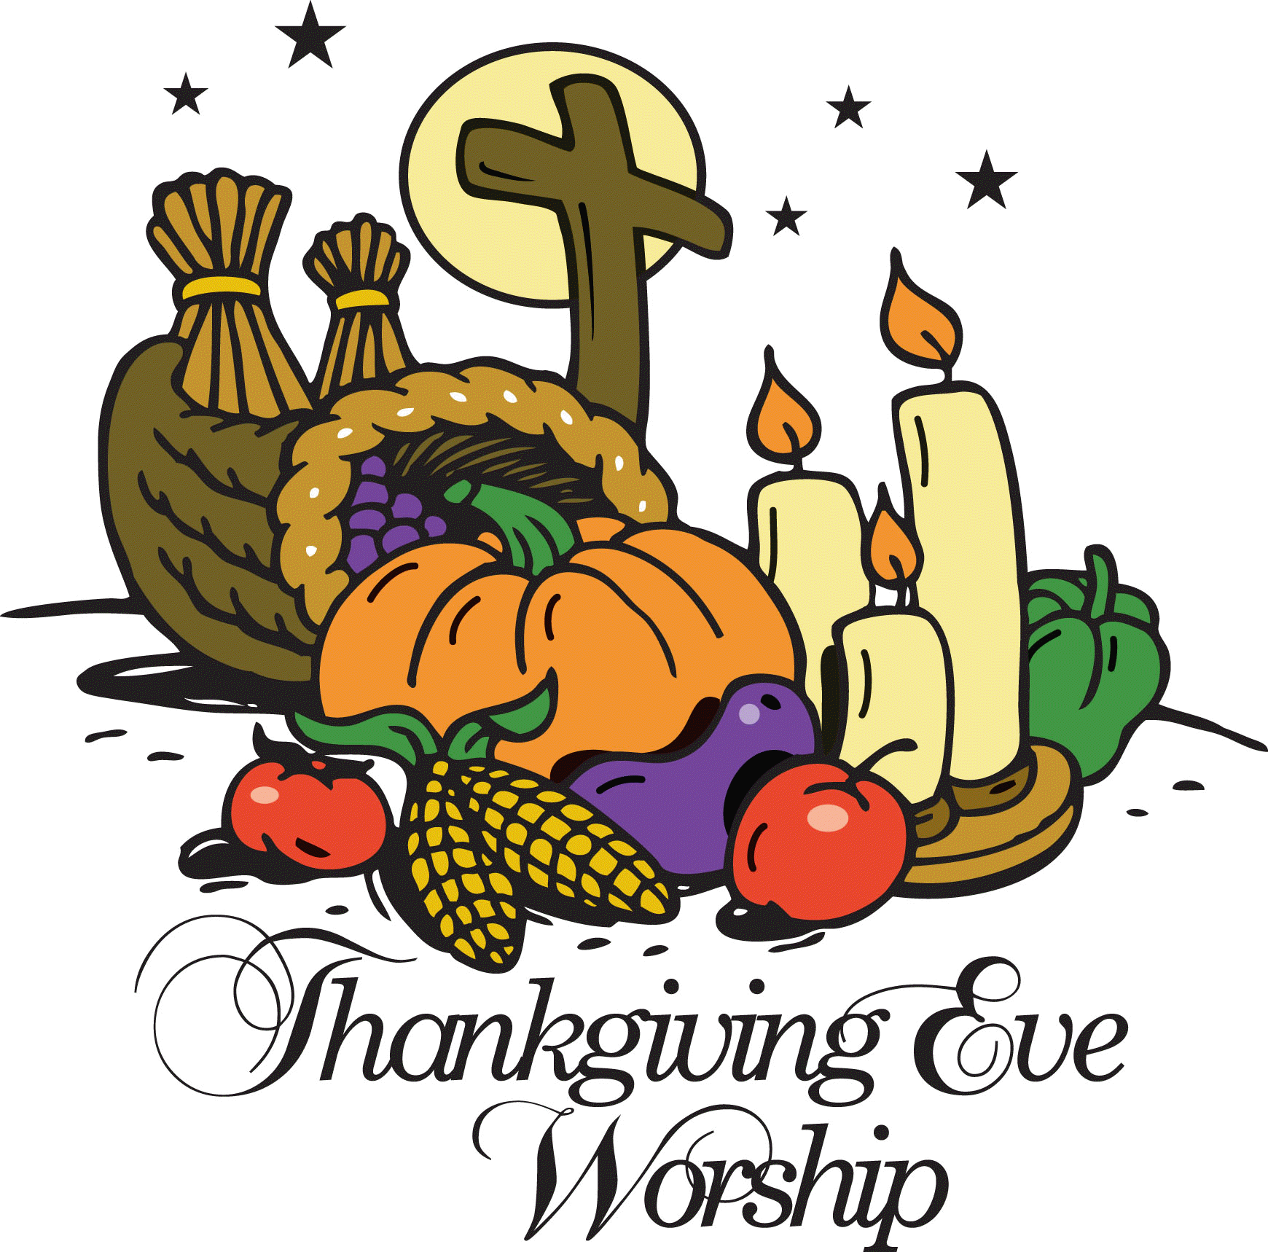
Thanksgiving Eve Worship
We extend a very special invitation to you and your family to come and worship with us on Wednesday, November 21, at 7:00 p.m. For those who have guests visiting, we also invite them to come and worship with us.

You Are Invited!
Following the Thanksgiving Service on Wed. Nov. 21, please stop by our home at 3510 14th Ave. in Kearney! We would like to thank you for your many prayers, gifts, and words of encouragement. We will be serving snacks and beverages. Please bring nothing but yourself. Feel free to come and go as your schedule allows any time until 10:00 pm!
Pastor, Carol, Abigail, & Zach

Quarterly Voters Meeting
Our Quarterly Voters Meeting will be held Sunday, November 25 at 10:15 in the Fellowship Hall. Business will include election of officers and board members for 2019.

Mary Martha Circles… will meet Monday, November 12 at 7:00 pm.
Peace Circle (Margaret’s) will meet at Margaret Smith’s home, 4306 Linden Dr.
Love Circle (Bev’s) will meet at Brooke Fisher’s home,
20510 Dunbar Rd., Amherst.

PLASTIC BAGS
The Zion sleeping mat group is always in need of plastic shopping bags. Don’t throw them away bring them to the Zion office. The bags are made into sleeping mats and donated to the orphan grain train.

BookNook
Please stop by the BookNook and see what they have to offer. It was recently restocked with a variety of greeting cards (sympathy, birthday, Christmas, thank you, Thanksgiving etc.) They also have special occasion dinner napkins.
We have available copies of Pastor Allwardt’s 3 devotion books (Messages from the Coast, Rattlesnakes and Rainbows, and More Rainbows than Rattlesnakes) available for $12 each. They are nice for personal devotions or gifts.
A more complete list of items available is posted on the window of the BookNook.

TEACHING POSITION
Zion Lutheran School will be looking for a new first grade teacher for the 2019-2020 year. Miss Erickson signed on for the current year as she also is completing her Masters’ degree in Library Sciences. At the conclusion of this school year she will be looking for a position in the world of libraries. As it can be difficult to fill this grade level, we will beginning our search early. If you or someone you know has had a successful experience teaching in the lower elementary grades, please contact Mr. Splittgerber. Please continue to pray for our school as we look to fill this position for the 2019-2020 year. Thank you, Mr. Splittgerber

School News
2019-2020 ENROLLMENT
Zion will begin enrollment for returning families and Zion members only on December 1, 2018. Enrollment will open to the public on January 3, 2019.

GIVE WHERE YOU LIVE
This year Zion Lutheran School will be participating in the Give Where You Live Campaign. It will be December 6 (giving day), but donations will be accepted beginning November 1st. To participate/contribute online go to: www.givewhereyoulive.net/zionlutheranschool

if you would rather donate in person feel free to stop by the office.

CHRISTMAS PROGRAM
Mark your calendars. The Zion School Christmas program will be Sunday, December 9th at 4:30 p.m. This is for students in Kindergarten-8th grade.

BASKETBALL
Basketball practices for boys and girls will begin soon for 5th-8th grade.
Since this is a club team, all Zion members in grades 5-8 who attend public school are welcome to be on the team. Please contact Mr. Splittgerber for more information.

