Adult Handbells – The adult handbell schedule has changed. There will be NO handbells this Wednesday, November 13th. The dates for handbells will be November 20, December 4, and December 18.

School News

- Zion will be holding a Veterans’ Day program on Monday, November 11th at 2:00 pm. Everyone is welcome to attend.

- Save your Apple Market receipts dated September 1, 2019 – March 2, 2020 and turn them into the office for the school to earn FREE rewards.
- Pies will be available on Wednesday, November 20th from 3:30-6:00 pm.

- Give Where You Live will be held December 5, 2019. Zion will participate again this year. Online giving day will be December 5th from midnight to midnight. If you wish to donate other than online you may drop your donation off during regular office hours at the church/school office.

- Mark your calendars. The Zion School Christmas program will be Sunday, December 15th at 4:00 p.m. This is for students in Kindergarten-8th grade.

- Basketball practices for boys and girls will begin soon for 5th-8th grade. Since this is a club team, all Zion members in grades 5-8 who attend public school are welcome to be on the team. Please contact Mr. Splittgerber for more information.

- 2020-2021 Enrollment will begin soon for returning families and for Zion members only. Enrollment will be open to the public on January 6, 2020

Announcements – November 10, 2019
Thou shalt silence your cell phone during worship.
Our sanctuary has a HEARING LOOP. Please switch hearing aids to T-coil mode. We have 2 headsets and receivers for use by those without hearing aids.
Ask an usher for assistance.

Forgot your offering? Don’t have your checkbook or cash? Today or any day you can visit our website at zionkearney.com and click on the “giving” tab. Or, text “zionkearney” (one word) to 77977. You’ll receive a text back with instructions to start giving.

Thank you – to the adult bell choir for providing the beautiful music during offering this morning!

Zion Youth – TODAY, November 10th the Zion youth will host Bible Trivia and hymn sing with the residents at Mother Hull home at 2:00 pm. Plan to attend and bring a friend!

Installation – TODAY, Sunday, November 10th at 4:00pm Holy Cross will host a Service of Installation for Timothy Barone as Associate Pastor. Guest preacher is Rev. Dr. Bruce Hartung. Installing pastor is Rev. Richard Snow. A meal will be served following the Installation worship service.
Veterans’ Day Program - Tomorrow – On Monday, November 11th at 2:00 p.m., Zion Lutheran School will be hosting a Veterans Day Program. The congregation is invited to attend. The program will include special music and a guest speaker.
Mary Martha – The Mary Martha groups will meet in their circles on Monday, November 11th at 7:00 pm.
PEACE Circle: At the home of Susan Tonniges, 1206 16th Ave

LOVE Circle: At the home of Shirley Oertwig,
12470 Riverdale Rd, Riverdale

Dorothy Sikes – The family of Dorothy Sikes would like to invite the congregation to an open house 90th birthday celebration in the fellowship hall Saturday, November 16th from 2:00-4:00 pm.
Zion Family Thanksgiving Dinner - The Mary Martha Guild invites all members of Zion to join them as we give thanks to God for all that He has done. Make plans to join us for the Family Thanksgiving Dinner to be held, Sunday, November 17th at 11:30am in the gym. Mary Martha will provide the turkey, dressing, potatoes, gravy, green bean casserole, dinner rolls, salads, desserts, drinks, and table service. Come join us as we give thanks. A free will offering will be taken with the proceeds going to support Abigail DeLoach and Taylor Zehendner who are studying for full time church work.

Senior Citizens – will meet for their monthly potluck and fellowship on Monday, November 18th at 12:00 pm. Everyone is invited!

Men’s Bible Study - Our Men’s Bible Study group will meet Thursday, November 21 at 7:00 pm.

Voters’ Meeting – The quarterly voters’ meeting will be held on Sunday, November 24th at 10:30am in the fellowship hall.

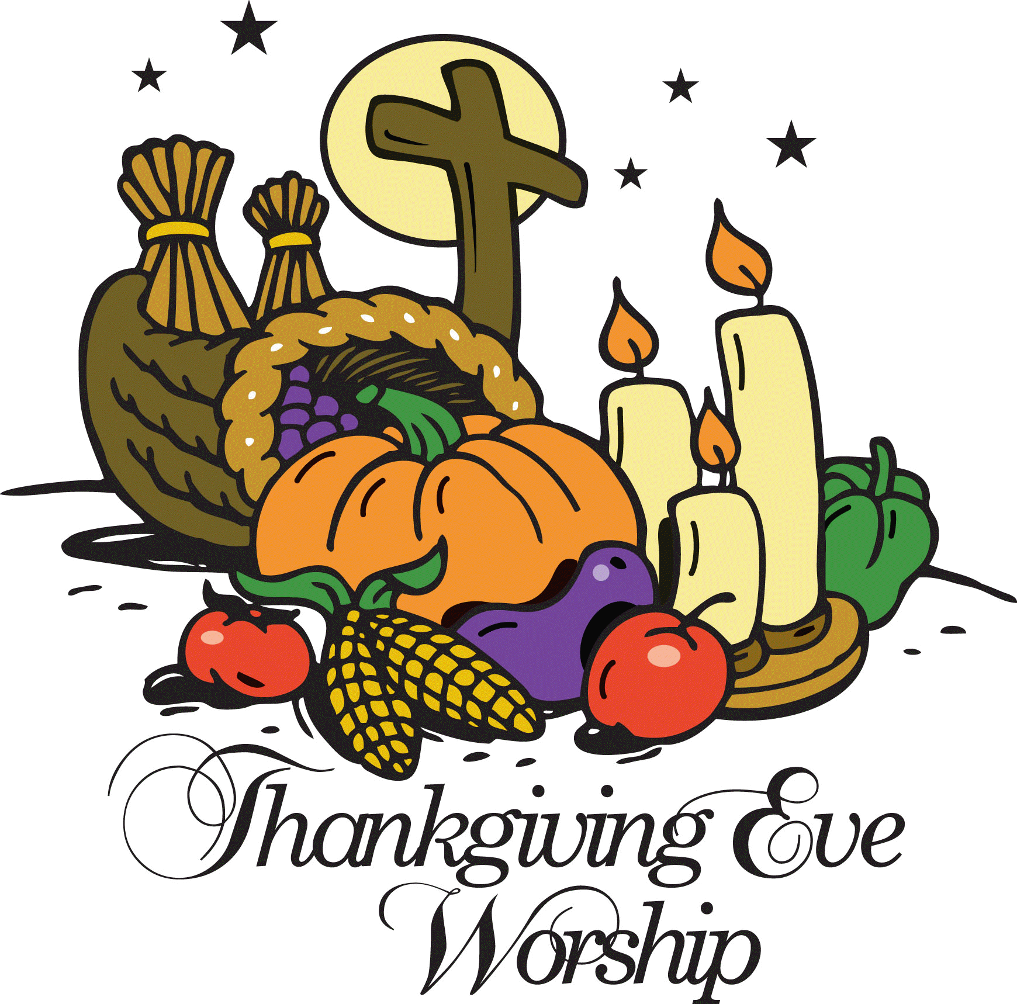
Thanksgiving Eve Worship
We extend a very special invitation to you and your family to come and worship with us on Wednesday, November 27, at 7:00 p.m. For those who have guests visiting, we also invite them to come and worship with us.

Radio Broadcast and Flowers – Zion is in need of radio broadcast sponsors. Please consider sponsoring a radio broadcast, several families can sponsor together, or providing altar flowers to beautify the sanctuary. The sign up sheet is on the board across from the mailboxes. There are several open dates. Sign up today! The 2020 sheets are up, so sign up early to get your date!

Poinsettia - We will be using poinsettias decorate our Church this Christmas season. If you wish to provide a poinsettia, the cost will be $13. Orders are due into the office by Monday, December 2. To avoid confusion, please place your money in an envelope and turn in to the church office. Checks should be made out to Mary Martha.

Thank You –The family of Jeff and Rachel Strong would like to thank everyone for their prayers and support during this time of Jeff’s illness. Please continue to pray for Jeff and his family during his recovery and healing after the transplant.
Thank You – Members and friends of Zion Lutheran Church, we would like to say THANK YOU again for all the love, support, and prayers we have received during our entire adoption journey. We are excited to announce that on Friday, November 15 we will finalize our adoption of Jeremiah at 9:00 am at the Buffalo County Courthouse. Anyone who is interested is welcome to attend.
In Christ
Marc, Lyn, and Jeremiah Hoffman

Food Collection - Zion will collect food items during the month of November to help supply Kearney agencies who assist the needy. There are grocery carts in the narthex and school area to gather these items. Non-perishable items only please.

Zion’s Mission Projects - The 4th Quarter missions are being collected for church work student support. Current church work students are Abigail DeLoach and Taylor Zehendner both at CUNE. Please use a special mission envelope located in the narthax and clearly mark your envelope number and place in the offering plate. Thank you for your supporting this project.

HLHS Blood Drive – On Tuesday, November 19th from 8:30a-2:30p the Heartland Lutheran National Honor Society Students will be hosting a blood drive for the Red Cross. The students have set a goal of 30 units to be donated. Please consider donating!

“Christmas Blessings Tour” – The Merryman Performing Arts Center will be presenting Sandi Patty’s “Christmas Blessings Tour” on Friday, December 6th at 7:00pm. Ticket prices are $35/$39/$44. Tickets on sale now at pickmytickets.com or at the Merryman box office at 308-698-8297. A group of 10 or more will receive a 10% discount.

Luke 20:38 – “Now he is not God of the dead, but of the living, for all live to him.” We are people of the Resurrection. We know our future. And this knowledge colors all our actions in this world. Since we know we are destined to live in God’s kingdom forever, what kind of lives ought we to live? Where should our priorities be?

