School News
- Save your Apple Market receipts dated September 1, 2019 –
March 2, 2020 and turn them into the office for the school to earn FREE rewards.

- The school is saving Family Fresh receipts. If you shop at Family Fresh save your receipts and turn them into the office.

- The Zion school students in grades 3rd-8th will sing TODAY at Zion on during service.

- There are extra pies available for sale if you need some for your holiday gatherings or if you just want to enjoy a delicious pie. Please see Lisa Splittgerber or contact the office.

- Give Where You Live will be held December 5, 2019. Zion will participate again this year. Online giving day will be December 5th from midnight to midnight. If you wish to donate other than online you may drop your donation off during regular office hours at the church/school office.

- Mark your calendars. The Zion School Christmas program will be Sunday, December 15th at 4:00 p.m. This is for students in Kindergarten-8th grade.

- Basketball practices for boys and girls will begin soon for 5th-8th grade. Since this is a club team, all Zion members in grades 5-8 who attend public school are welcome to be on the team. Please contact Mr. Splittgerber for more information.

- 2020-2021 Enrollment will begin soon for returning families and for Zion members only. Enrollment will be open to the public on January 6, 2020.

- The office will be closed Wednesday-Friday, November 27-29. If you will need into the office during those times please make arrangements before.

- Do you like science? Zion Lutheran School is adopting a new science text and program to replace the current text which is about 18 years old. The purchase of the classroom kits is costly, nearly $2,000 per class. If you would like to help the school with a donation to offset this cost, please make out a check to Zion Lutheran and note SCIENCE on the memo line. If you would like more information, please see Mr. Splittgerber. Thank you!

Announcements – November 24, 2019
Thou shalt silence your cell phone during worship.
Our sanctuary has a HEARING LOOP. Please switch hearing aids to T-coil mode. We have 2 headsets and receivers for use by those without hearing aids. Ask an usher for assistance.

Forgot your offering? Don’t have your checkbook or cash? Today or any day you can visit our website at zionkearney.com and click on the “giving” tab. Or, text “zionkearney” (one word) to 77977. You’ll receive a text back with instructions to start giving.

Thank you – Zion Lutheran School 3rd – 8th Choir for providing the special music for our service today.

Voters’ Meeting – The quarterly voters’ meeting will be held following the service, at 10:30am in the fellowship hall.
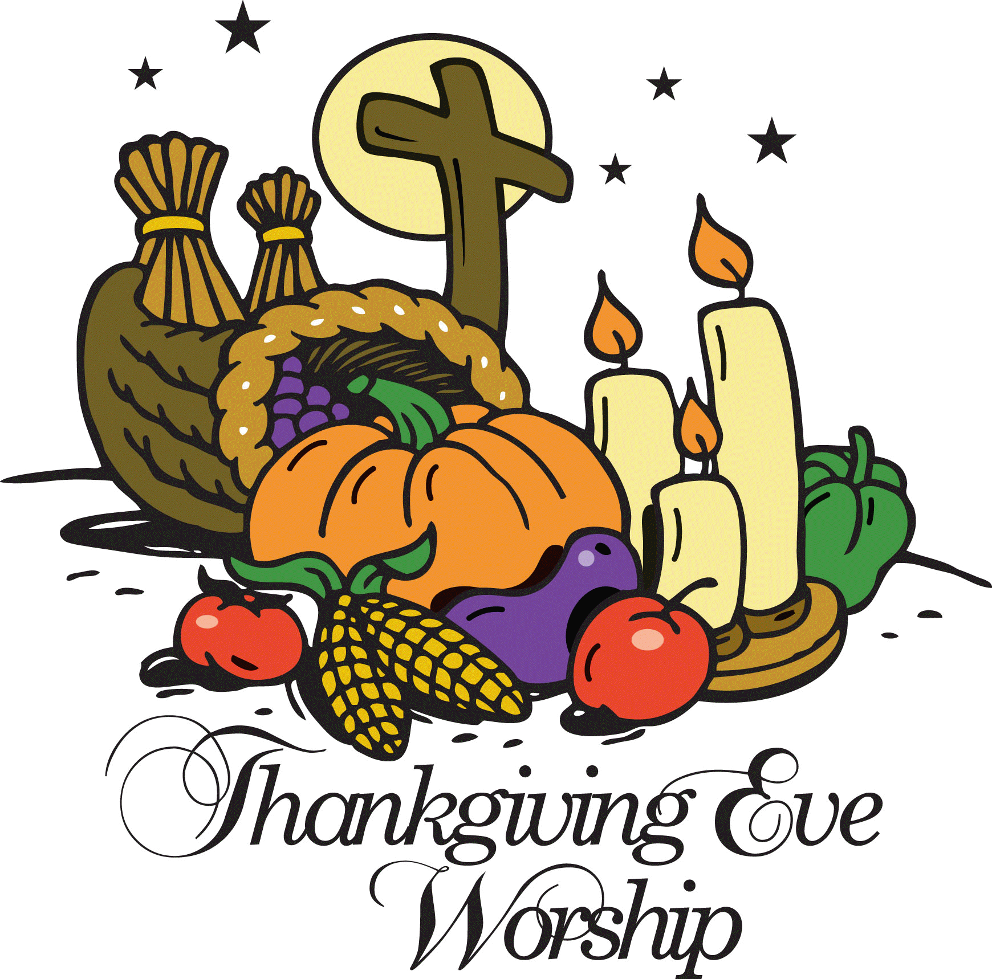
Thanksgiving Eve Worship - We extend a very special invitation to you and your family to come and worship with us on Wednesday, November 27, at 7:00 p.m. For those who have guests visiting, we also invite them to come and worship with us.

Office Closed – the office will be closed Wednesday-Friday, November 27-29. If you will need into the office during those times please make arrangements before.

Church Christmas Decorating – Mark your calendar to help ring in the Christmas spirit and decorate the Church for Christmas. The date for decorating will be Saturday, November 30th at 10:00 am. Stay as long as you like. We would really appreciate some men to help with the heavy items.

Zion Youth All youth and their families are invited to join Zion as they travel to Christmas City to view the "Light of the World Pageant" on Sunday, December 1. Meet at the Zion parking lot at 5:30 pm to travel to Minden. Bring: lawn chairs, blankets, spending money for snacks. This event is OUTSIDE. The ice skating will be rescheduled for a later time, the pageant only comes around once a year! Please call Carol @ 308.233.1345 if you would like to come OR if you are able to drive.

Sunday School Teachers – Zion is in need of Sunday School teachers and substitute Sunday School teachers. If you are interested or would like more information please contact the church office.

Radio Broadcast and Flowers – Zion is in need of radio broadcast sponsors. Please consider sponsoring a radio broadcast, several families can sponsor together, or providing altar flowers to beautify the sanctuary. The sign up sheet is on the board across from the mailboxes. There are several open dates. Sign up today! The 2020 sheets are up, so sign up early to get your date!

Poinsettia - We will be using poinsettias to decorate our Church this Christmas season. If you wish to provide a poinsettia, the cost will be $13. Orders are due into the office by Monday, December 2. To avoid confusion, please place your money in an envelope and turn in to the church office. Checks should be made out to Mary Martha.

Book Nook – The book nook has Zion Lutheran Church Christmas cards for sale. They are priced at $2.00 for a package of 12 cards and envelopes. The book nook also offers an assortment of all occasion greeting cards. A box is $4.50 and individual cards are $0.50. Stop by today for all of your card needs. Scrip is also available for purchase in the book nook on Sunday mornings or at the office during office hours. Scrip cards work great for gifts or for yourself. Support Zion and purchase a scrip gift card today!

A CHRISTMAS GIFT TO LAST ALL YEAR - -The Book Nook has copies of the daily devotional books written by Pastor Allward: Rainbows and Rattlesnakes" and "More Rainbows Than Rattlesnakes", for sale @ $12 each. These sales also support local missions as well as the Ysleta Hispanic Mission in El Paso, TX. His third book, Messages from the Coast", has a longer meditation for each week of the year - also costs $12. Discounts are available for purchasing a number of copies at the same time (see Pastor Allwardt for details).

Food Collection - Zion will collect food items during the month of November to help supply Kearney agencies who assist the needy. There are grocery carts in the narthex and school area to gather these items. Non-perishable items only please.

Adult Handbells – The adult handbell practice schedule has changed. The dates for handbell practice will be December 4, and December 18.

Zion’s Mission Projects - The 4th Quarter missions are being collected for church work student support. Current church work students are Abigail DeLoach and Taylor Zehendner both at CUNE. Please use a special mission envelope located in the narthax and clearly mark your envelope number and place in the offering plate. Thank you for your supporting this project.

Christmas Caroling - Please join us in singing Christmas carols to the shut-ins Sunday, December 8th at 2:00 p.m. They really appreciate and enjoy the beautiful music. No special music knowledge is needed, just the enjoyment of singing traditional Christmas carols. The time commitment is about 1 ½ - 2 hours max. Please meet at the church.

The 6th, 7th, and 8th grade class and the Sunday School classes will be caroling on different days to other care homes.

Children Christmas Rehearsal - The rehearsal dates for the Children’s Christmas Eve Service will be 12/7, 12/14, and 12/21. The rehearsals will begin 9:00 am. After the rehearsal on Dec. 21 the children will go Christmas Caroling, return to Zion for pizza and then go ice skating. Bring a friend for caroling, pizza, and skating the cost is $10. Please note that our Sunday School children who are not participating in the Christmas Eve service are welcome to join us. Please meet us at the church at 10:30 am.

“Christmas Blessings Tour” – The Merryman Performing Arts Center will be presenting Sandi Patty’s “Christmas Blessings Tour” on Friday, December 6th at 7:00pm. Ticket prices are $35/$39/$44. Tickets on sale now at pickmytickets.com or at the Merryman box office at 308-698-8297. A group of 10 or more will receive a 10% discount.

Colossians 1:18 – “And he is the head of the body, the church.” We are part of the Body of Christ; He is our Head. Where He goes, we follow. His thoughts direct our actions. This is how the people of God learn how to give and why they give: Because Jesus gives, indeed He gives all He has.

