Divine Service

The Nineteenth Sunday
after Pentecost
October 11, 2020
Zion Lutheran Church
Kearney, Nebraska

Welcome to Zion!
All worshippers please fill out an attendance card in the pew rack and let us know how we might be of service to you.

Holy Communion at Zion

The Lord’s Supper is celebrated at this congregation as Jesus has given it. As he says, our Lord gives into our mouths not only bread and wine but his very body and blood to eat and to drink for the forgiveness of sins and to strengthen our union with him and with one another. Our Lord invites to his table those who trust his words, repent of all sin, and set aside any refusal to forgive and love as he forgives and loves us, that they may show forth his death until he comes. All communicants need to register in the narthex prior to the service.

Because those who eat and drink our Lord’s body and blood unworthily do great harm and because Holy Communion is a confession of the faith which is confessed at this altar, any who are not yet instructed, in doubt, or who hold a confession differing from that of this congregation and The Lutheran Church—Missouri Synod, are asked not to commune until they are able to speak with our pastor first. He is happy to visit with you about the Christian faith and how to receive the Lord’s Supper for your good and for the good of others. Those not communing are invited to come to the altar, cross your arms in front of you, and bow your head to receive a pastoral blessing.

Christ Sets Life Before Us so that We Can Walk in His Ways

The God who reveals Himself in His incarnate Son promises life and blessing to all who obey His commandments “by loving the Lord your God, by walking in his ways, and by keeping his commandments and his statutes and his rules” (Deut. 30:16). However, we are “people of the flesh” and “infants in Christ” (1 Cor. 3:1), among whom “there is jealousy and strife” (1 Cor. 3:3). Jesus must instruct us against the human ways of anger, adultery, divorce and false witness (Matt. 5:21–37), because all who live in these ways “shall surely perish” (Deut. 30:18). On the cross, He died to forgive our sins and free us from the ways of curse and death. Since Jesus Christ is our “life and length of days” (Deut. 30:20), we can be reconciled to our brother, live in chastity and marital faithfulness, and speak with honesty. He who serves from His cross also offers His gift of reconciliation at His altar, and we can be at peace with our brothers and sisters in Christ who are “God’s field, God’s building” (1 Cor. 3:9).
Confession and Absolution

902 Lord Jesus Christ, Be Present Now
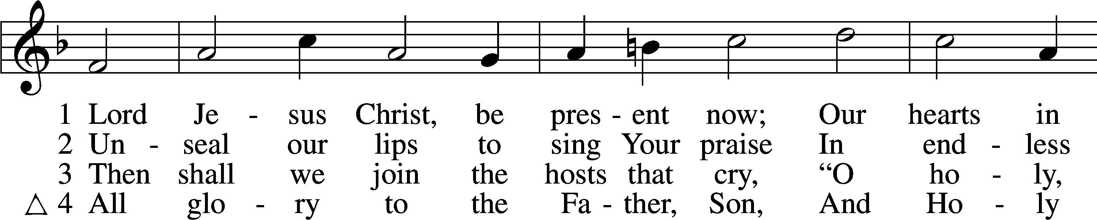
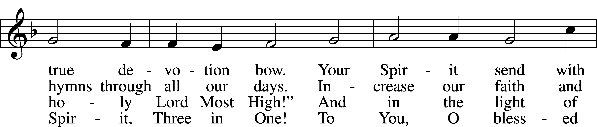
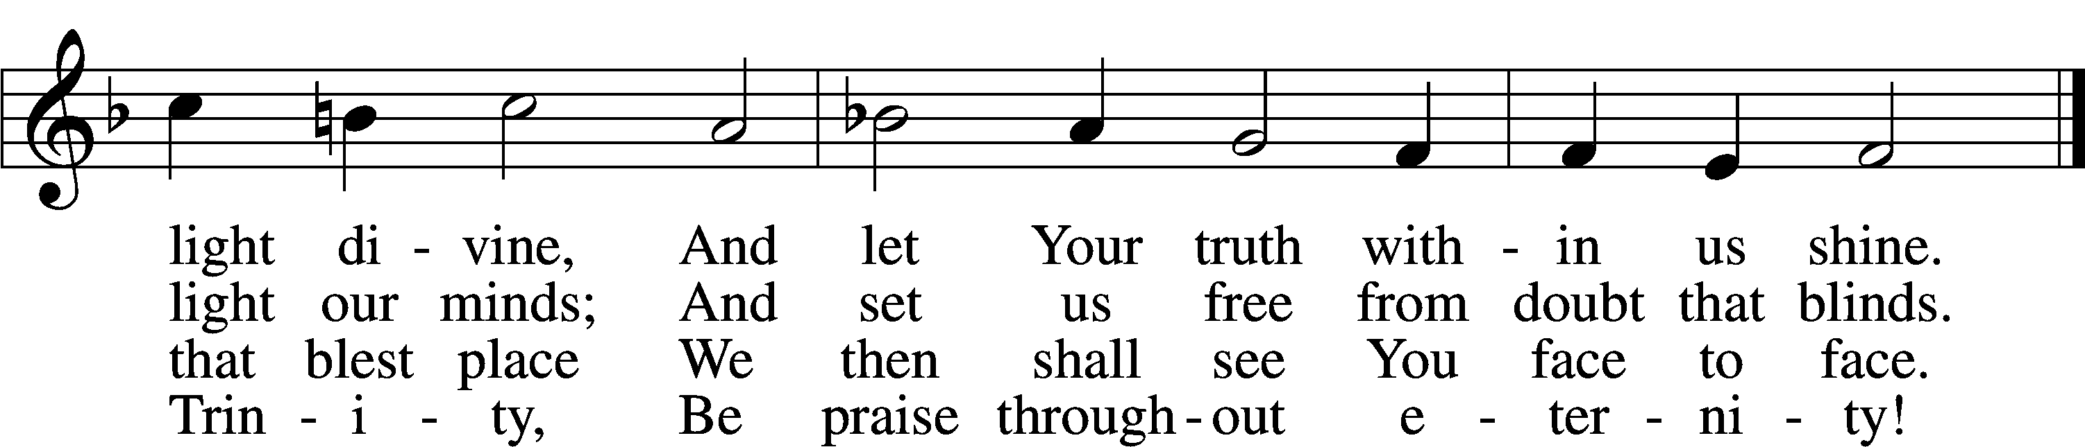
Tune and text: Public domain

Stand

The sign of the cross may be made by all in remembrance of their Baptism.

Invocation
P In the name of the Father and of the T Son and of the Holy Spirit.
C Amen.

Exhortation LSB 151
P If we say we have no sin, we deceive ourselves, and the truth is not in us.
C But if we confess our sins, God, who is faithful and just, will forgive our sins and cleanse us from all unrighteousness.

Silence for reflection on God’s Word and for self-examination.

Confession of Sins LSB 151
P Let us then confess our sins to God our Father.
C Most merciful God, we confess that we are by nature sinful and unclean. We have sinned against You in thought, word, and deed, by what we have done and by what we have left undone. We have not loved You with our whole heart; we have not loved our neighbors as ourselves. We justly deserve Your present and eternal punishment. For the sake of Your Son, Jesus Christ, have mercy on us. Forgive us, renew us, and lead us, so that we may delight in Your will and walk in Your ways to the glory of Your holy name. Amen.

Absolution LSB 151
P Almighty God in His mercy has given His Son to die for you and for His sake forgives you all your sins. As a called and ordained servant of Christ, and by His authority, I therefore forgive you all your sins in the name of the Father and of the T Son and of the Holy Spirit.
C Amen.

Service of the Word

Introit Isaiah 61:10; antiphon: Psalm 146:2
I will praise the Lord as long | as I live;*
I will sing praises to my God while I have my | being.
I will greatly rejoice | in the Lord;*
my soul shall exult | in my God,
for he has clothed me with the garments of sal- | vation;*
he has covered me with the robe of | righteousness,
as a bridegroom decks himself like a priest with a beautiful | headdress,*
and as a bride adorns herself | with her jewels.
Glory be to the Father and | to the Son*
and to the Holy | Spirit;
as it was in the be- | ginning,*
is now, and will be forever. | Amen.
I will praise the Lord as long | as I live;*
I will sing praises to my God while I have my | being.

Kyrie LSB 152
A In peace let us pray to the Lord.


A For the peace from above and for our salvation let us pray to the Lord.


A For the peace of the whole world, for the well-being of the Church of God, and for the unity of all let us pray to the Lord.


A For this holy house and for all who offer here their worship and praise let us pray to the Lord.


A Help, save, comfort, and defend us, gracious Lord.


Gloria in Excelsis LSB 154
A Glory to God in the highest, and peace to His people on earth.
C Lord God, heavenly king, almighty God and Father:
We worship You, we give You thanks, we praise You for Your glory.
Lord Jesus Christ, only Son of the Father, Lord God, Lamb of God:
You take away the sin of the world; have mercy on us.
You are seated at the right hand of the Father; receive our prayer.
For You alone are the Holy One, You alone are the Lord,
You alone are the Most High, Jesus Christ, with the Holy Spirit,
in the glory of God the Father. Amen.

Salutation and Collect of the Day
P The Lord be with you.
C And also with you.

P Let us pray.
Almighty God, You invite us to trust in You for our salvation. Deal with us not in the severity of Your judgment but by the greatness of Your mercy; through Jesus Christ, Your Son, our Lord, who lives and reigns with You and the Holy Spirit, one God, now and forever.

C Amen.

Sit

Old Testament Reading Isaiah 25:6–9
6On this mountain the Lord of hosts will make for all peoples
a feast of rich food, a feast of well-aged wine,
of rich food full of marrow, of aged wine well refined.
7And he will swallow up on this mountain
the covering that is cast over all peoples,
the veil that is spread over all nations.
8He will swallow up death forever;
and the Lord God will wipe away tears from all faces,
and the reproach of his people he will take away from all the earth,
for the Lord has spoken.
9It will be said on that day,
“Behold, this is our God; we have waited for him, that he might save us.
This is the Lord; we have waited for him;
let us be glad and rejoice in his salvation.”

A This is the Word of the Lord.
C Thanks be to God.

Gradual Psalm 91:11; 103:1
He will command his angels con- | cerning you*
to guard you in | all your ways.
Bless the Lord, | O my soul,*
and all that is within me, bless his | holy name!

Epistle Philippians 4:4–13
4Rejoice in the Lord always; again I will say, Rejoice. 5Let your reasonableness be known to everyone. The Lord is at hand; 6do not be anxious about anything, but in everything by prayer and supplication with thanksgiving let your requests be made known to God. 7And the peace of God, which surpasses all understanding, will guard your hearts and your minds in Christ Jesus.
8Finally, brothers, whatever is true, whatever is honorable, whatever is just, whatever is pure, whatever is lovely, whatever is commendable, if there is any excellence, if there is anything worthy of praise, think about these things. 9What you have learned and received and heard and seen in me—practice these things, and the God of peace will be with you.
10I rejoiced in the Lord greatly that now at length you have revived your concern for me. You were indeed concerned for me, but you had no opportunity. 11Not that I am speaking of being in need, for I have learned in whatever situation I am to be content. 12I know how to be brought low, and I know how to abound. In any and every circumstance, I have learned the secret of facing plenty and hunger, abundance and need. 13I can do all things through him who strengthens me.

A This is the Word of the Lord.
C Thanks be to God.

Stand

Alleluia and Verse LSB 156
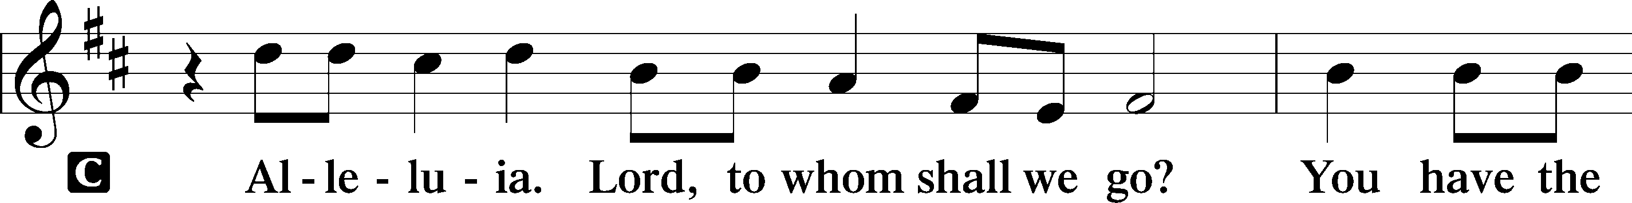
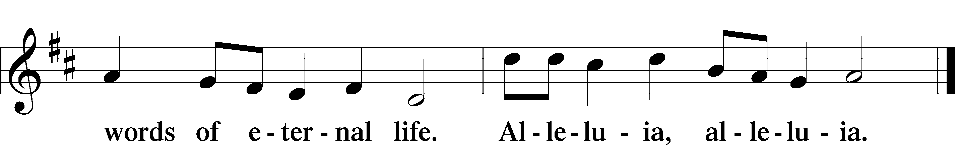

Holy Gospel Matthew 22:1–14
P The Holy Gospel according to St. Matthew, the twenty-second chapter.

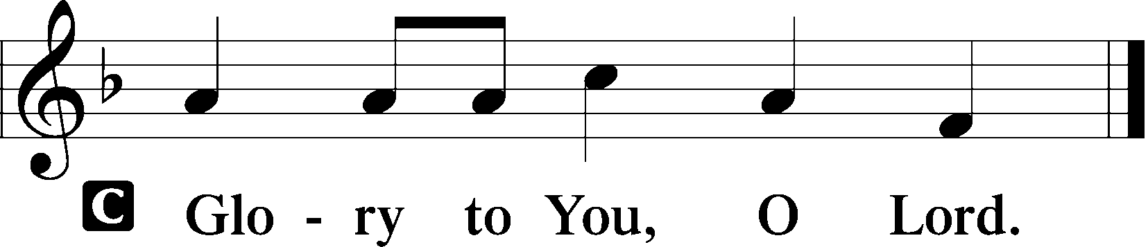

1Again Jesus spoke to them in parables, saying, 2“The kingdom of heaven may be compared to a king who gave a wedding feast for his son, 3and sent his servants to call those who were invited to the wedding feast, but they would not come. 4Again he sent other servants, saying, ‘Tell those who are invited, See, I have prepared my dinner, my oxen and my fat calves have been slaughtered, and everything is ready. Come to the wedding feast.’ 5But they paid no attention and went off, one to his farm, another to his business, 6while the rest seized his servants, treated them shamefully, and killed them. 7The king was angry, and he sent his troops and destroyed those murderers and burned their city. 8Then he said to his servants, ‘The wedding feast is ready, but those invited were not worthy. 9Go therefore to the main roads and invite to the wedding feast as many as you find.’ 10And those servants went out into the roads and gathered all whom they found, both bad and good. So the wedding hall was filled with guests.
11“But when the king came in to look at the guests, he saw there a man who had no wedding garment. 12And he said to him, ‘Friend, how did you get in here without a wedding garment?’ And he was speechless. 13Then the king said to the attendants, ‘Bind him hand and foot and cast him into the outer darkness. In that place there will be weeping and gnashing of teeth.’ 14For many are called, but few are chosen.”

P This is the Gospel of the Lord.

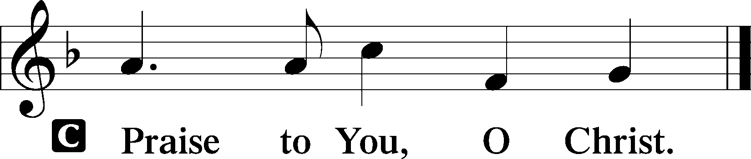

Sit

514 The Bridegroom Soon Will Call Us
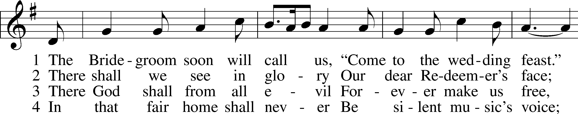
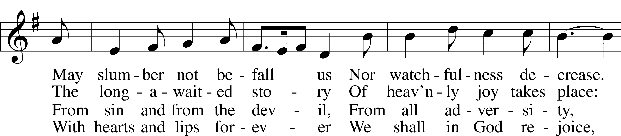
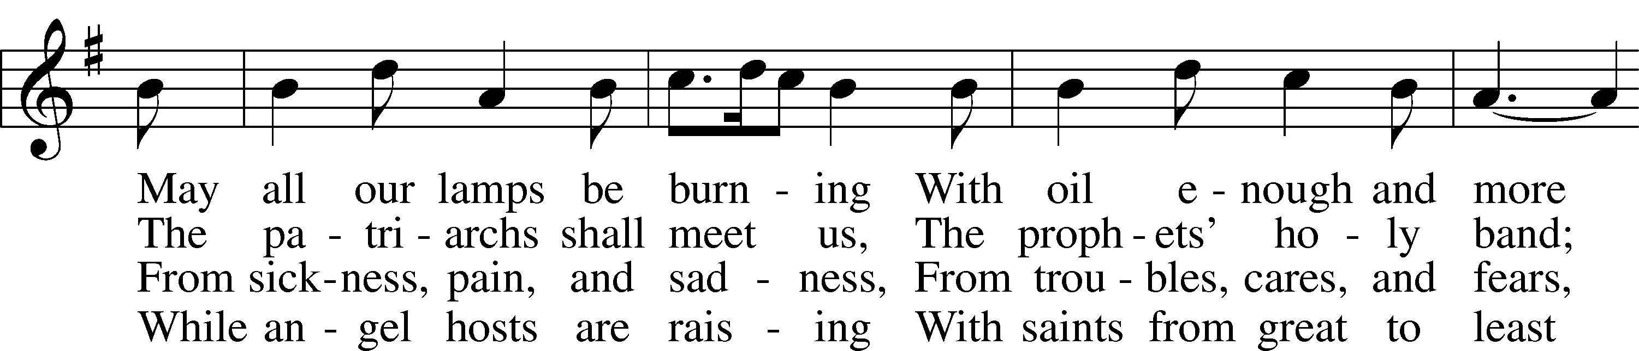
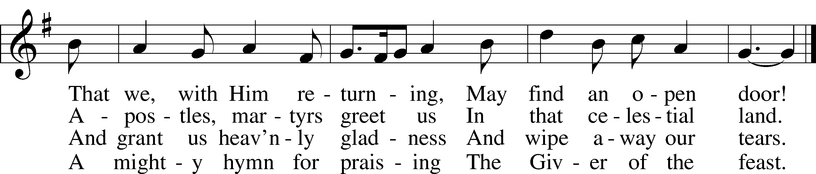
Tune and text: Public domain
Text (st. 1): © 1982 Concordia Publishing House. Used by permission: LSB Hymn License no. 110003744

Sermon: The Wedding Feast

Stand

Apostles’ Creed
C I believe in God, the Father Almighty,
maker of heaven and earth.

And in Jesus Christ, His only Son, our Lord,
who was conceived by the Holy Spirit,
born of the virgin Mary,
suffered under Pontius Pilate,
was crucified, died and was buried.
He descended into hell.
The third day He rose again from the dead.
He ascended into heaven
and sits at the right hand of God the Father Almighty.
From thence He will come to judge the living and the dead.

I believe in the Holy Spirit,
the holy Christian Church,
the communion of saints,
the forgiveness of sins,
the resurrection of the body,
and the life T everlasting. Amen.

Prayer of the Church

Offertory LSB 159
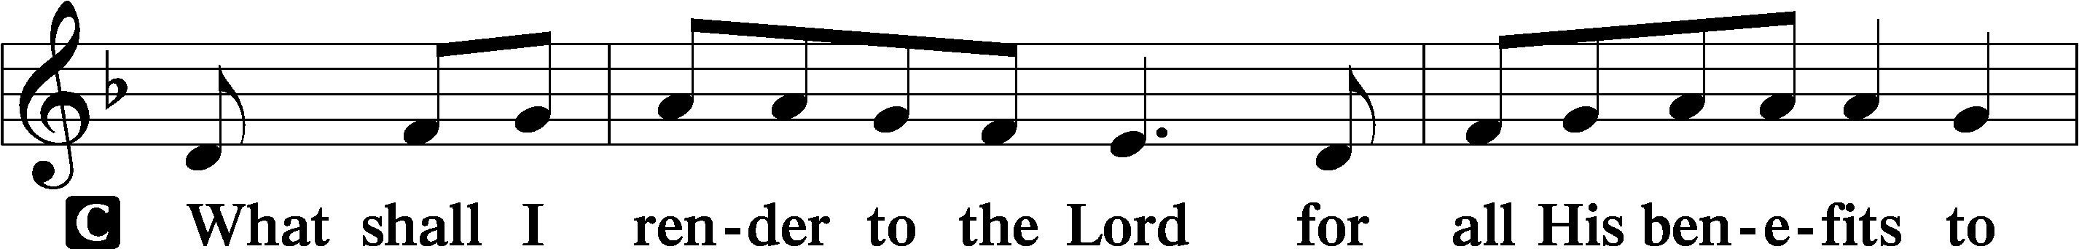
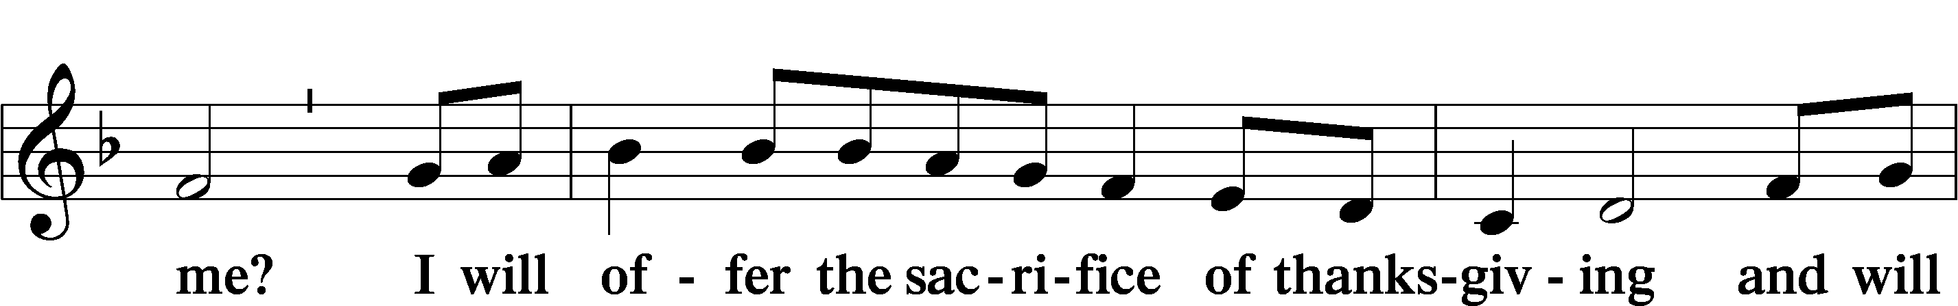
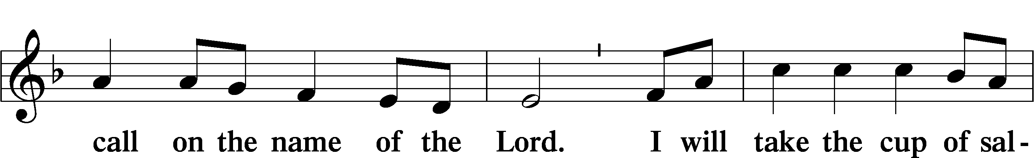
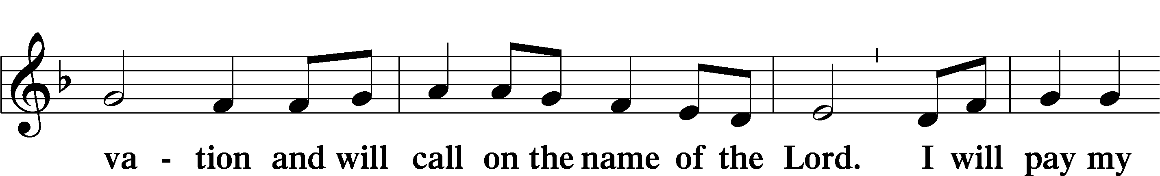
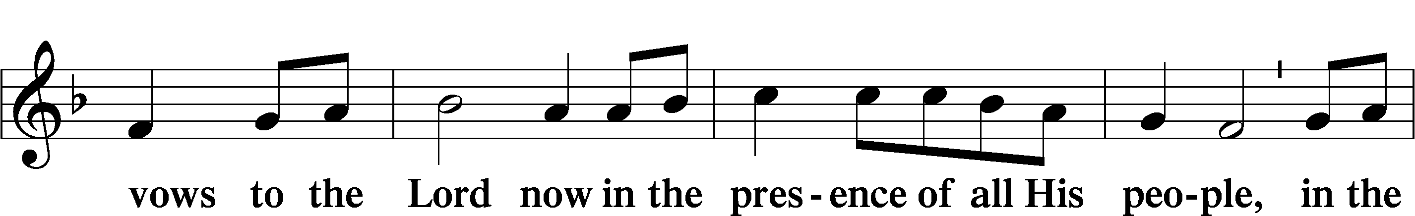
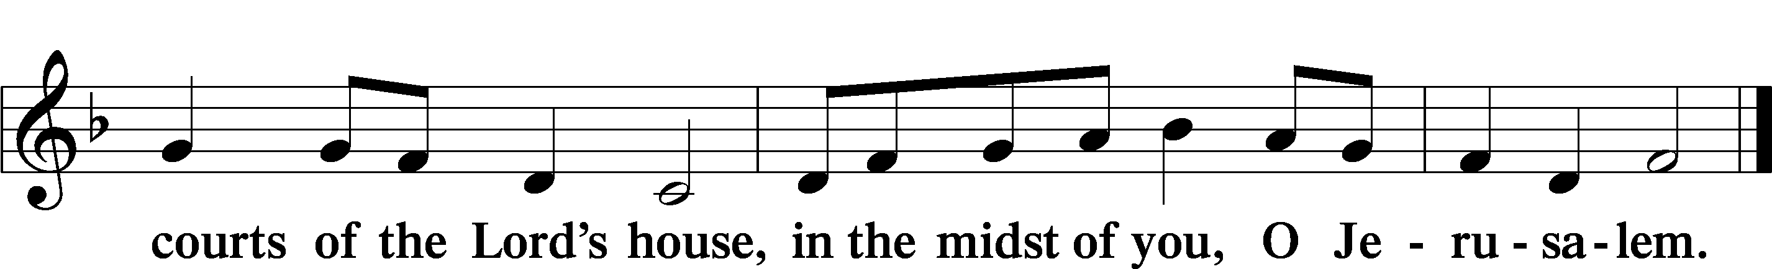

Service of the Sacrament

Preface LSB 160





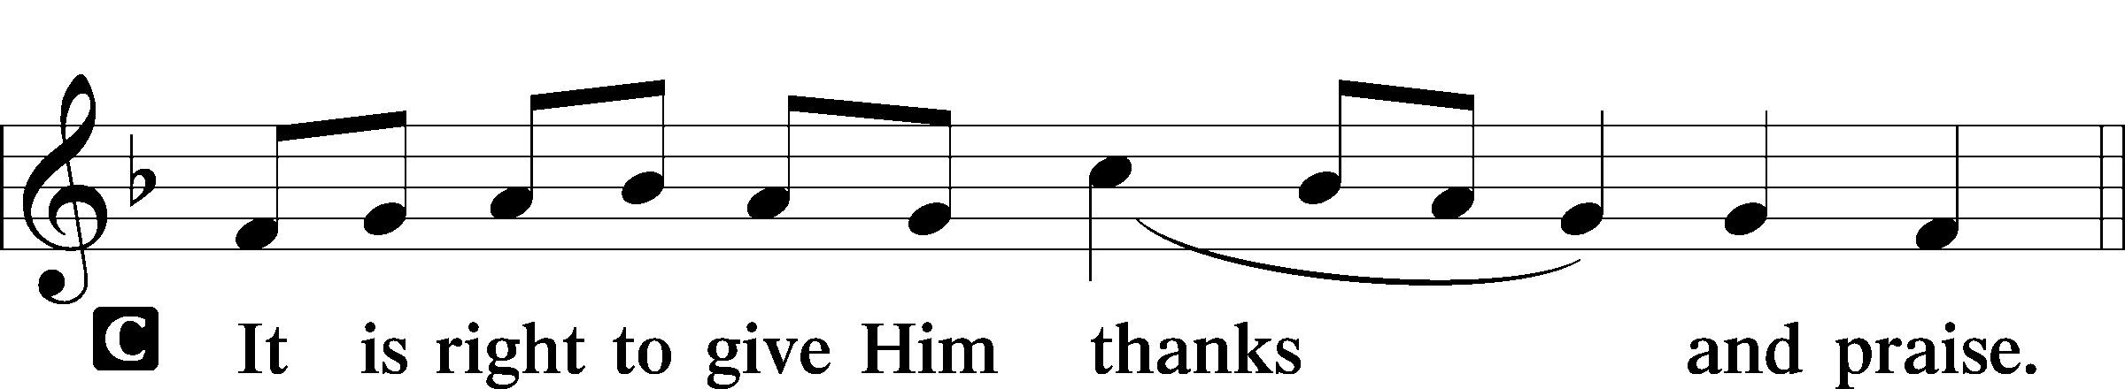

Proper Preface
P It is truly good, right, and salutary that we should at all times and in all places give thanks to You, holy Lord, almighty Father, everlasting God, through Jesus Christ, our Lord, who on this day overcame death and the grave and by His glorious resurrection opened to us the way of everlasting life. Therefore with angels and archangels and with all the company of heaven we laud and magnify Your glorious name, evermore praising You and saying:

Sanctus LSB 161
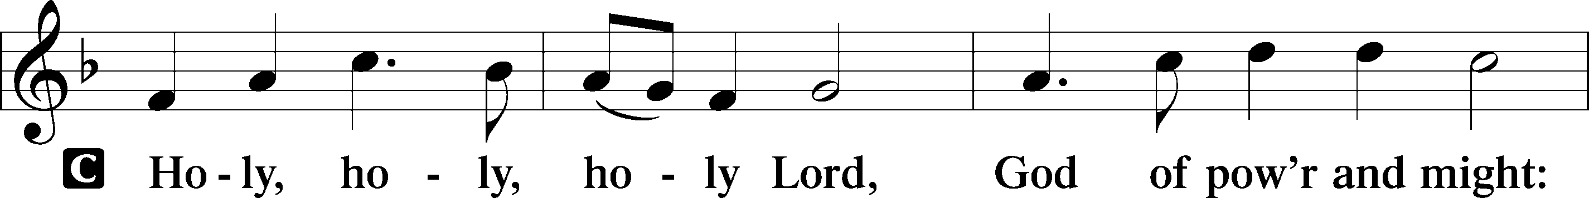
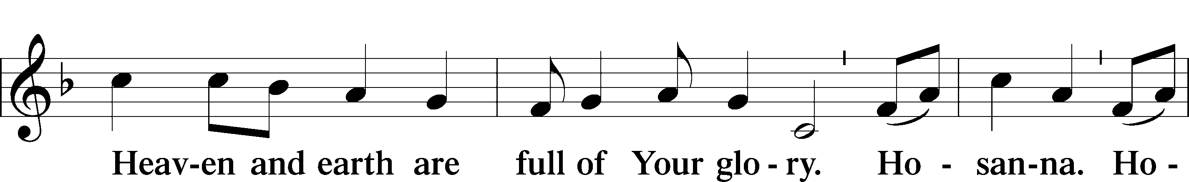
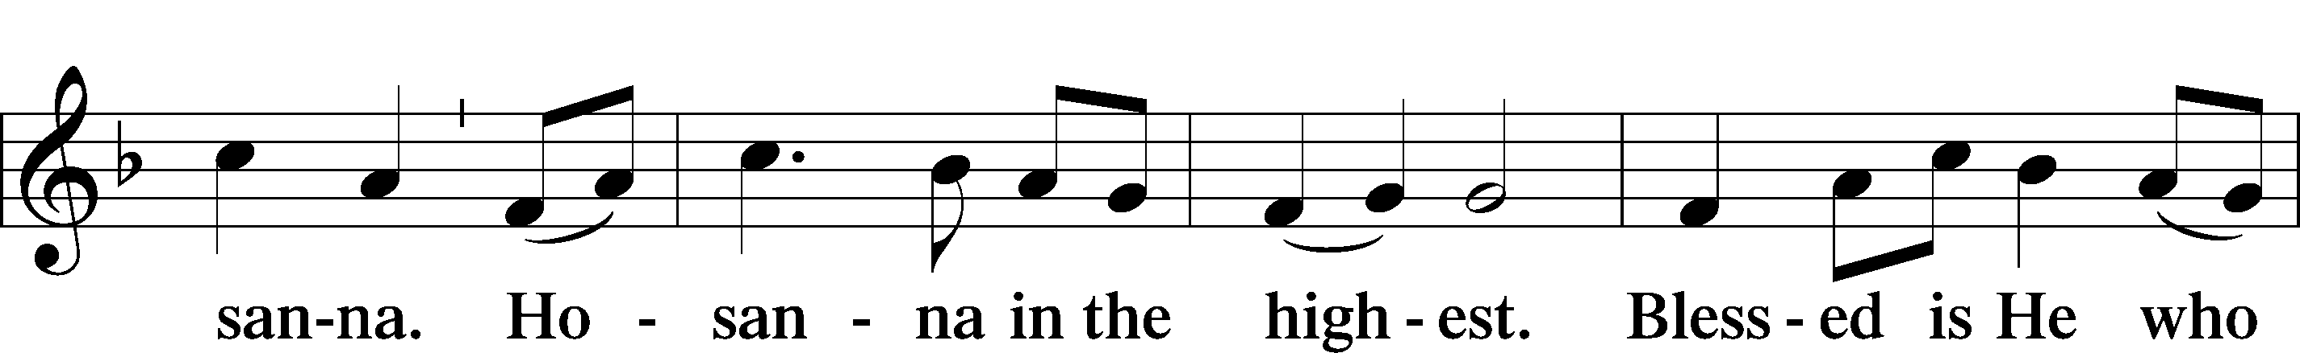
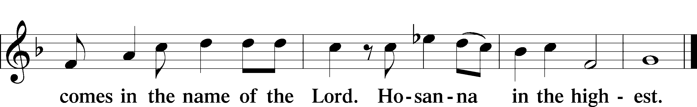

Lord’s Prayer
C Our Father who art in heaven,
hallowed be Thy name,
Thy kingdom come,
Thy will be done on earth
as it is in heaven;
give us this day our daily bread;
and forgive us our trespasses
as we forgive those
who trespass against us;
and lead us not into temptation,
but deliver us from evil.
For Thine is the kingdom
and the power and the glory
forever and ever. Amen.

The Words of Our Lord
P Our Lord Jesus Christ, on the night when He was betrayed, took bread, and when He had given thanks, He broke it and gave it to the disciples and said: “Take, eat; this is My T body, which is given for you. This do in remembrance of Me.”

In the same way also He took the cup after supper, and when He had given thanks, He gave it to them, saying: “Drink of it, all of you; this cup is the new testament in My T blood, which is shed for you for the forgiveness of sins. This do, as often as you drink it, in remembrance of Me.”
Pax Domini LSB 163
P The peace of the Lord be with you always.
C Amen.

Agnus Dei LSB 163
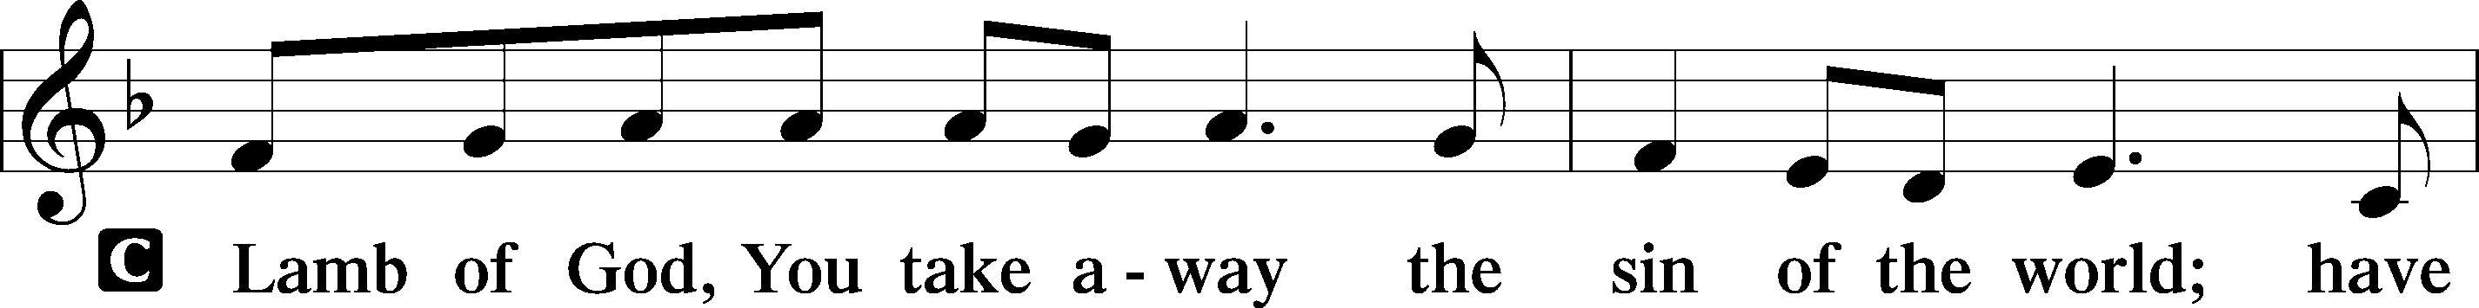
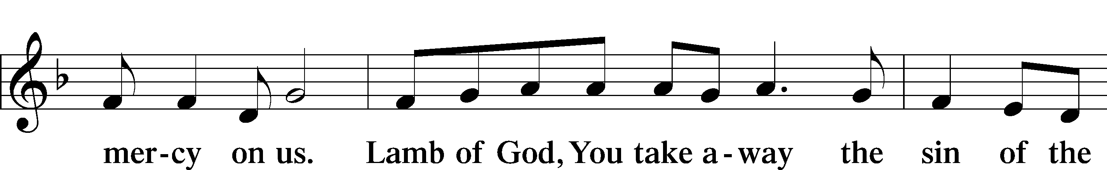
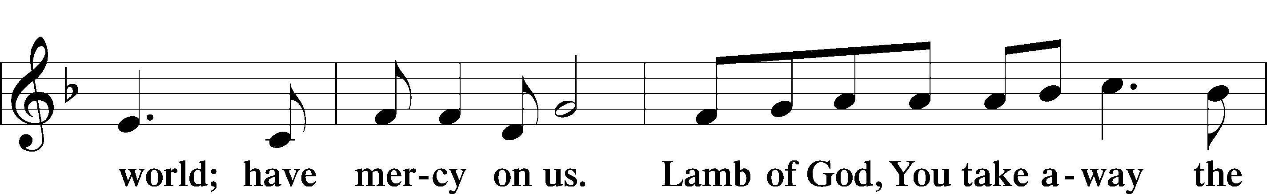
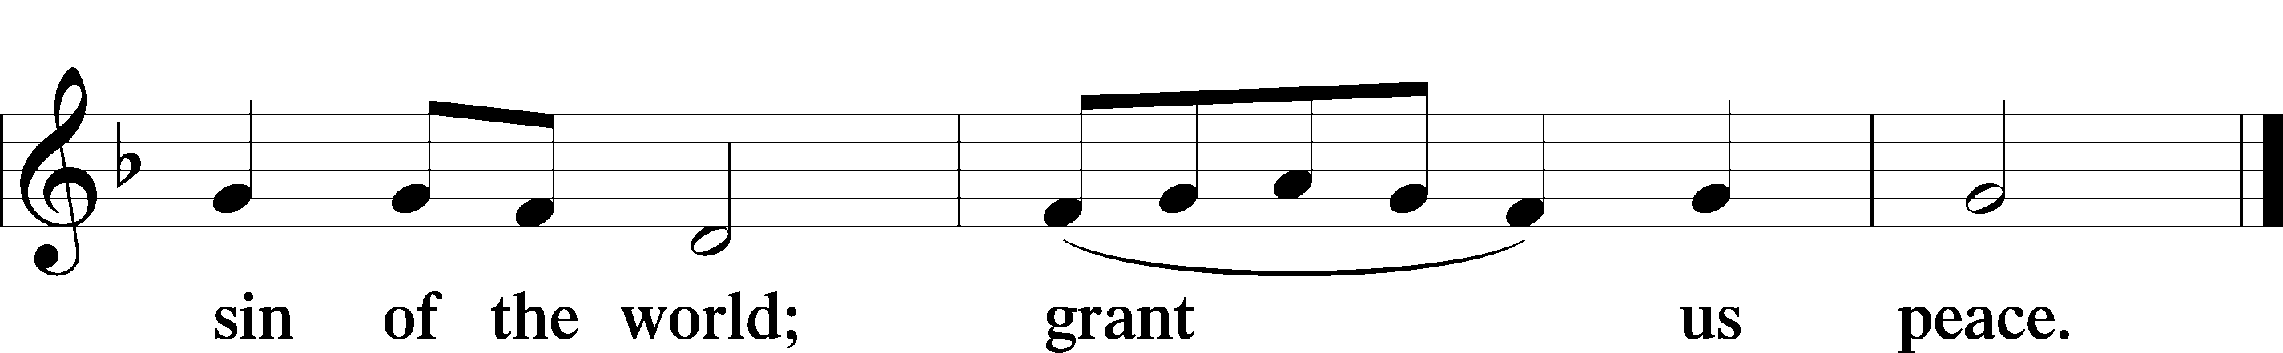

Sit

Distribution

626 Come, Let Us Eat
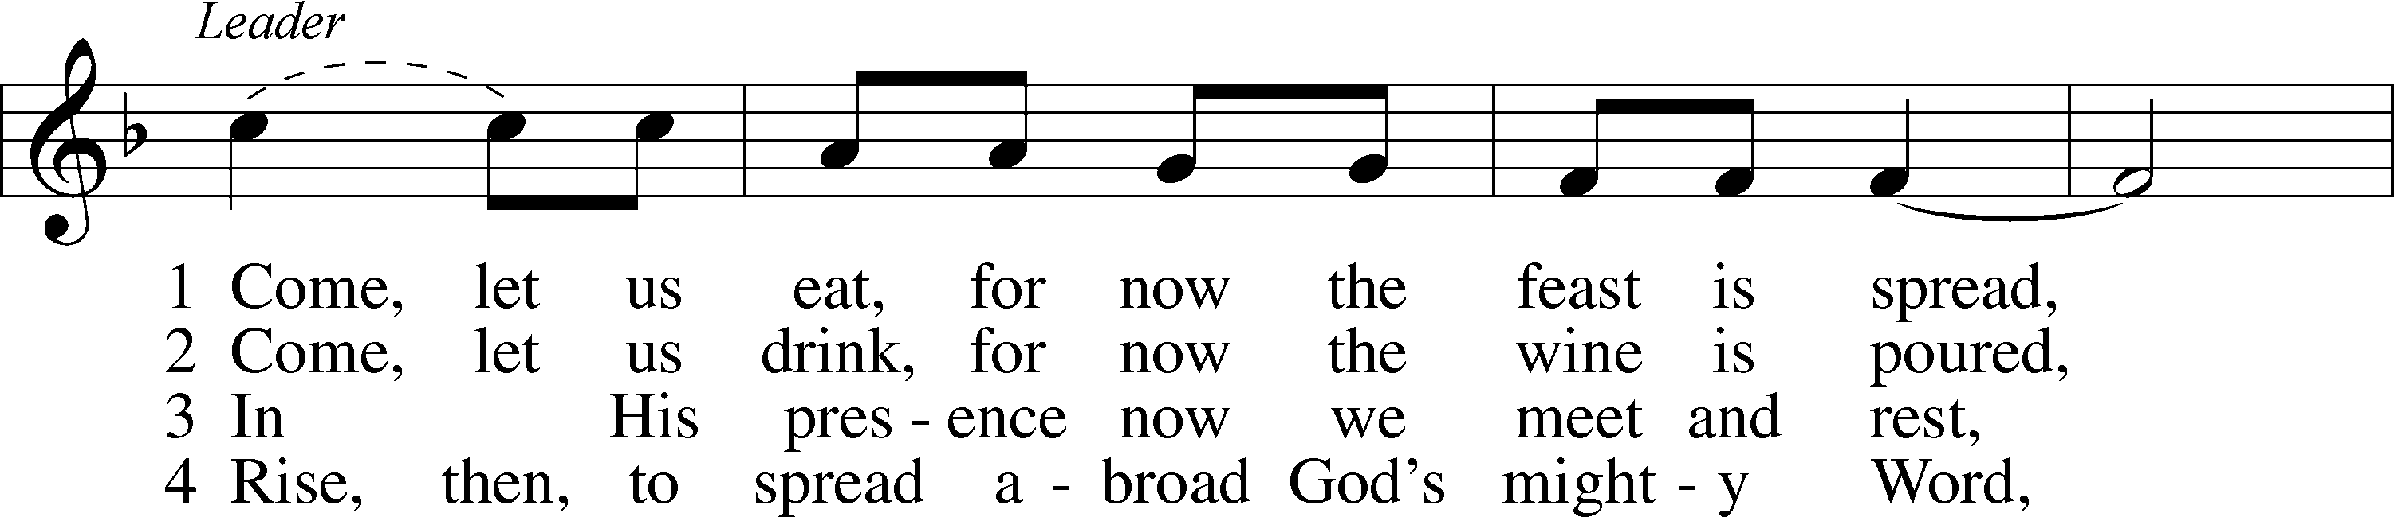
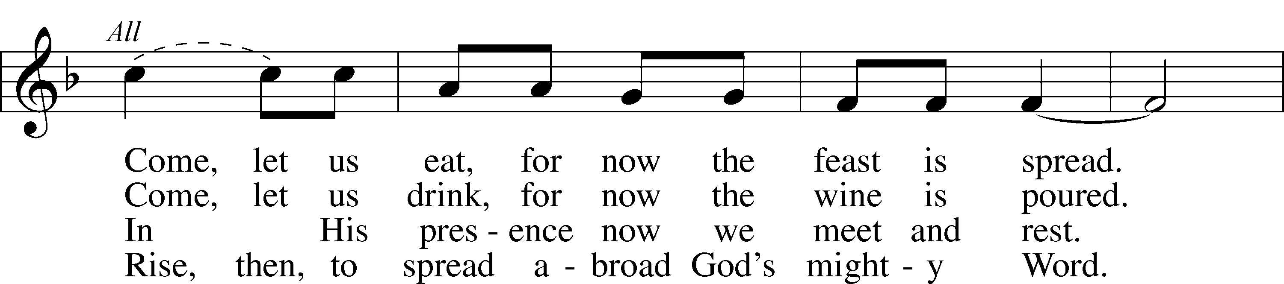
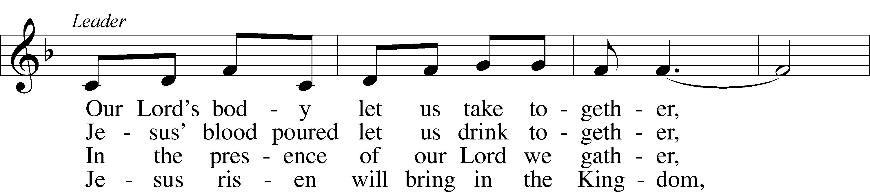
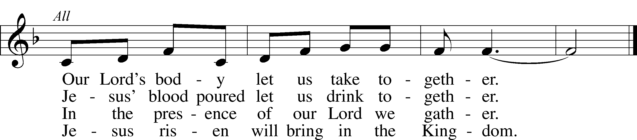
Tune and text: © Lutheran World Federation. Used by permission: LSB Hymn License no. 110003744
Text (st. 4): © 1972 Augsburg Fortress. Used by permission: LSB Hymn License no. 110003744

754 Entrust Your Days and Burdens sts. 1–4, 6
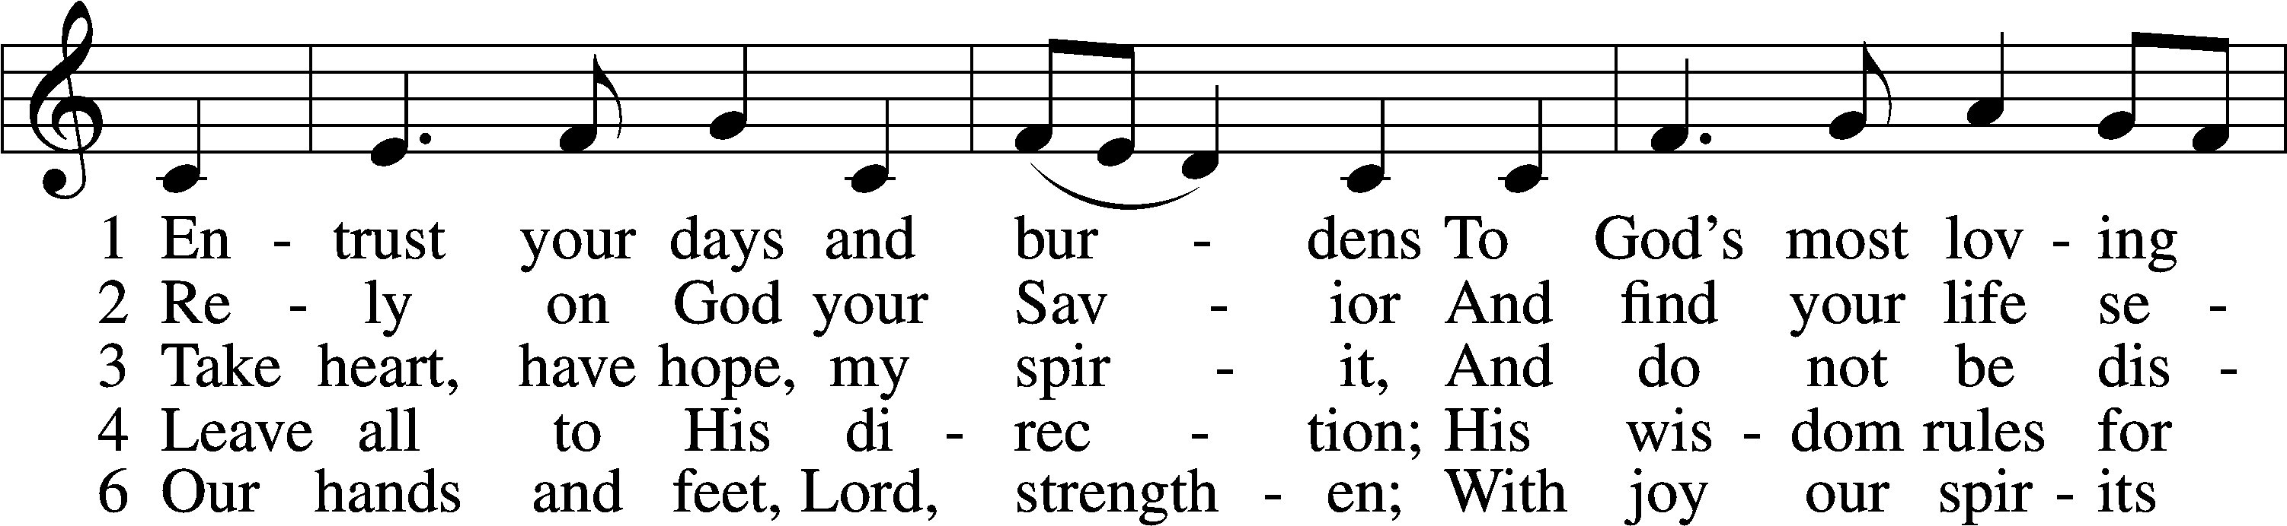
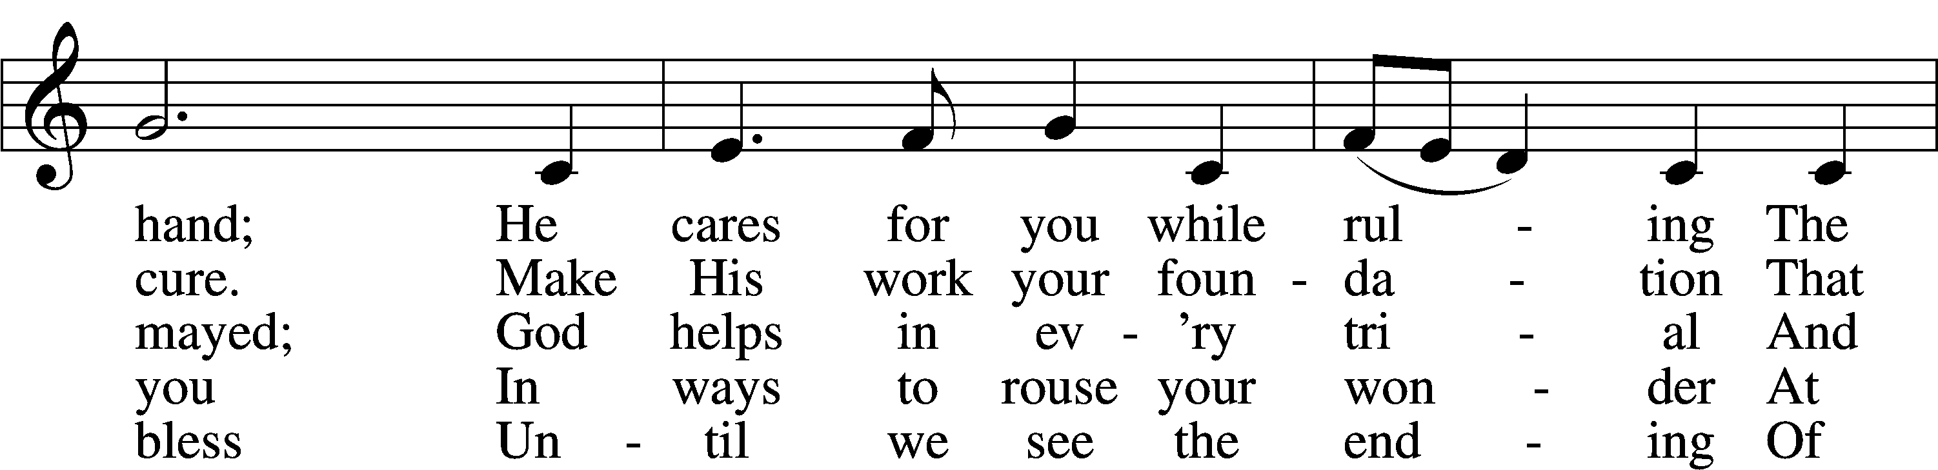
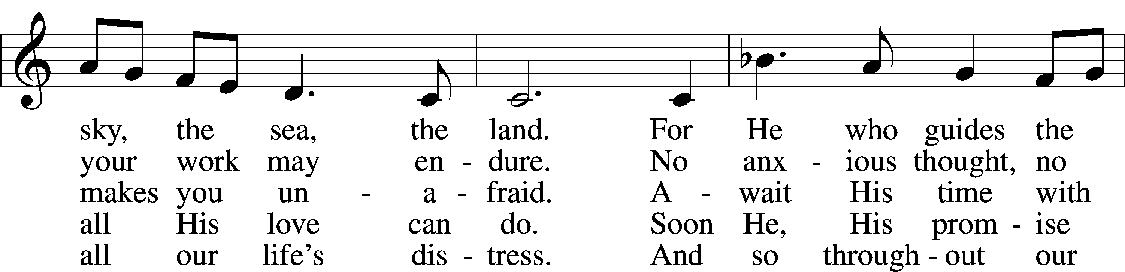
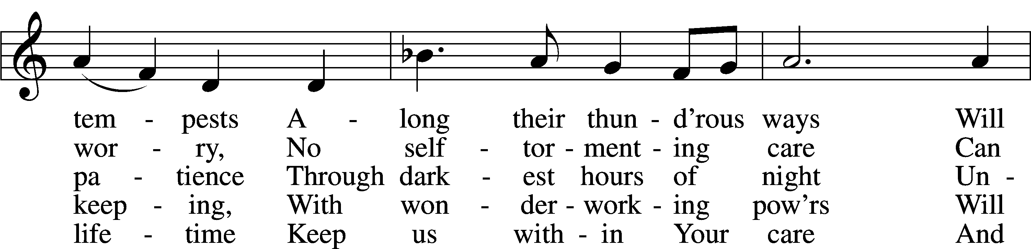
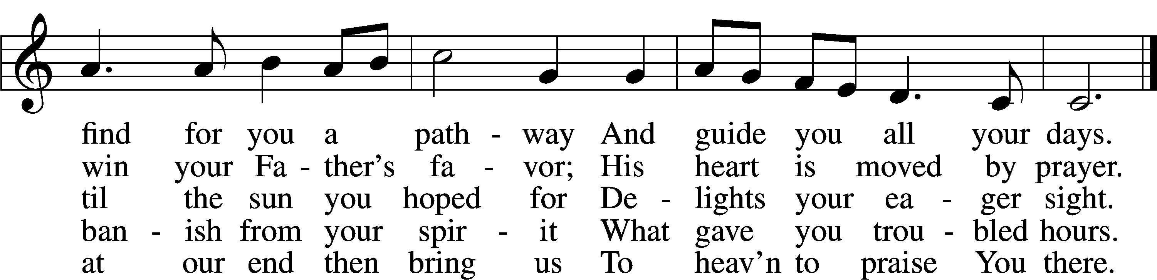
Tune: © 2002 Stephen R. Johnson. Used by permission: LSB Hymn License no. 110003744
Text (sts. 1–4): © 1982 Concordia Publishing House; (st. 6): © 2006 Concordia Publishing House. Used by permission: LSB Hymn License no. 110003744

680 Thine the Amen, Thine the Praise
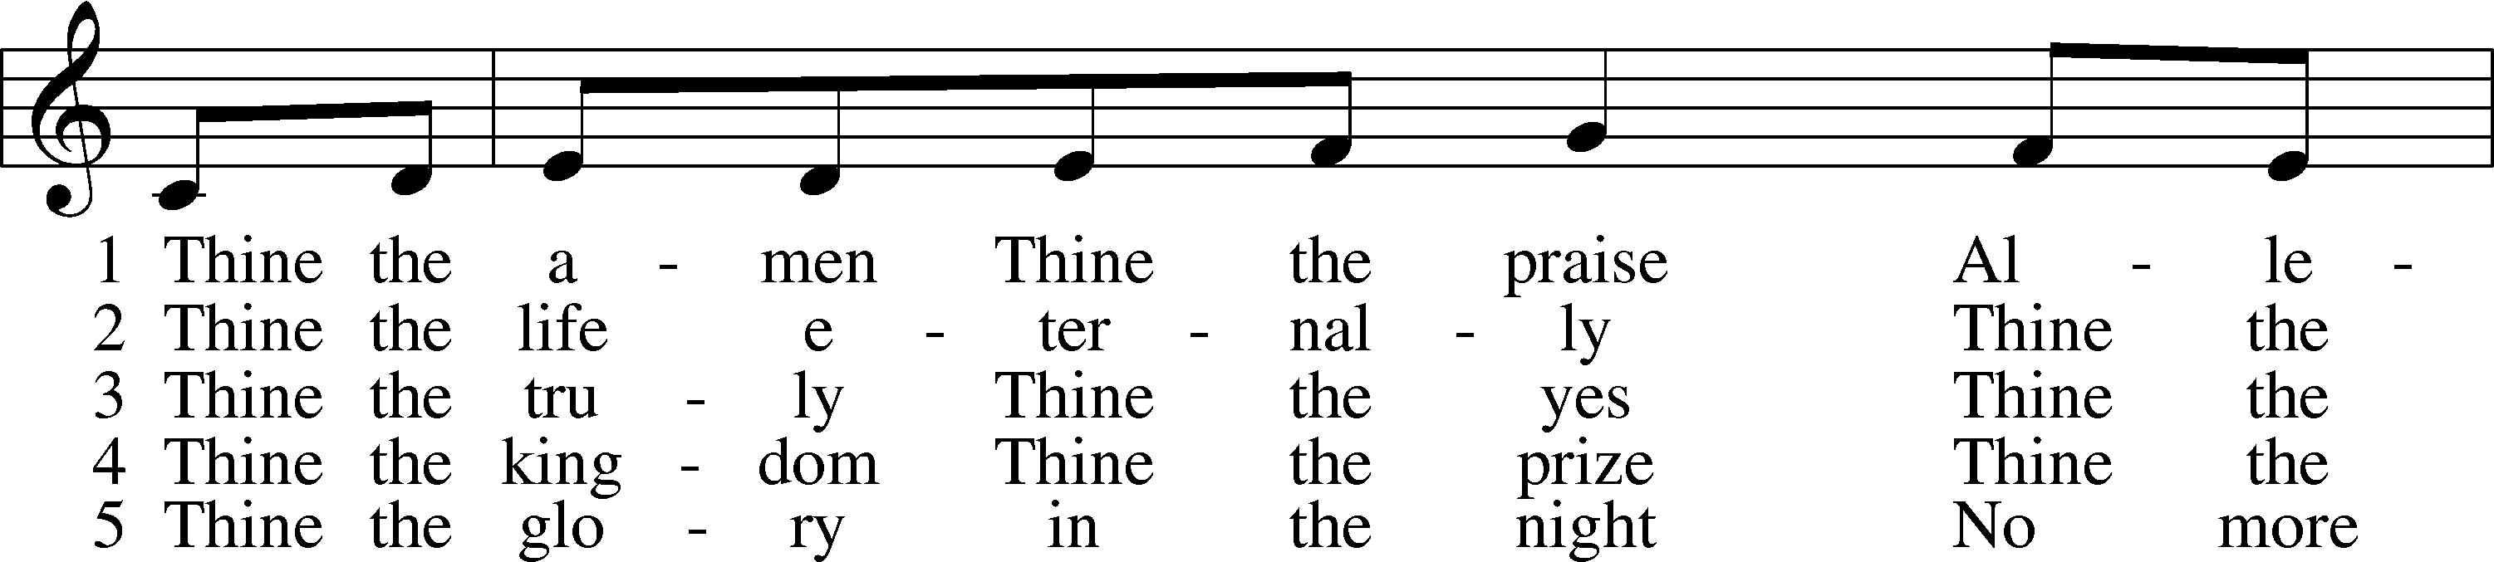
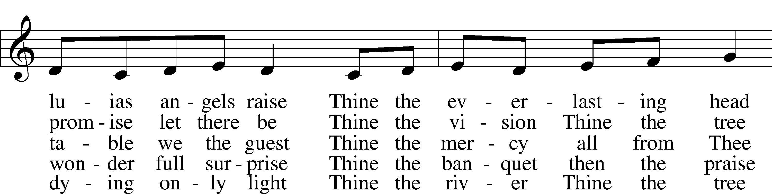
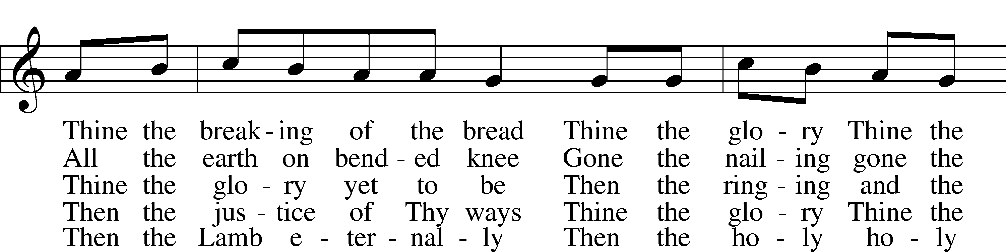
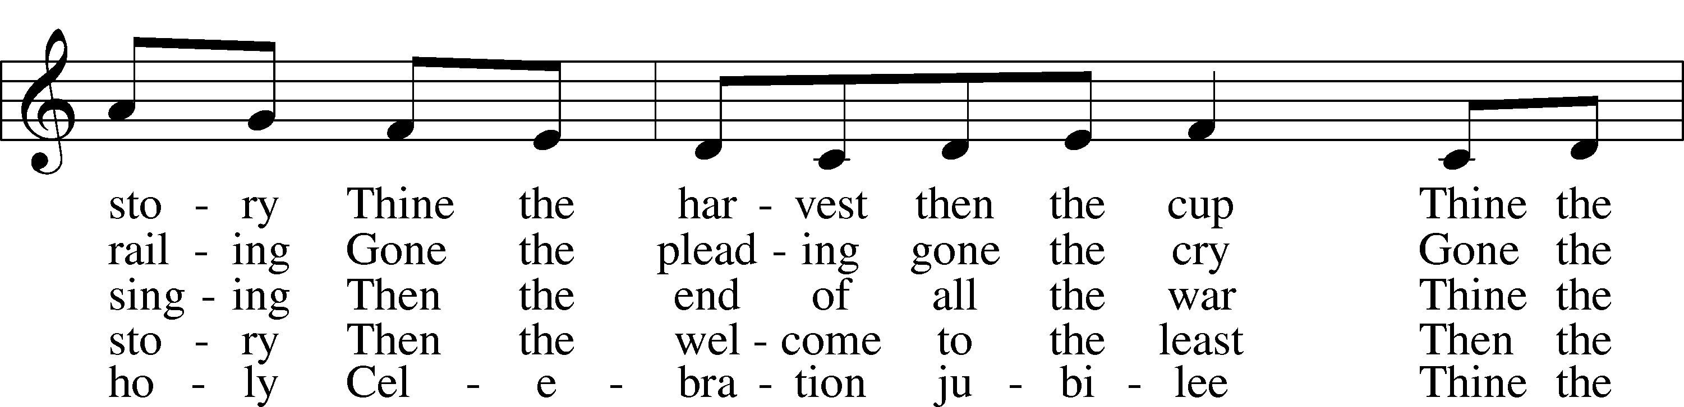
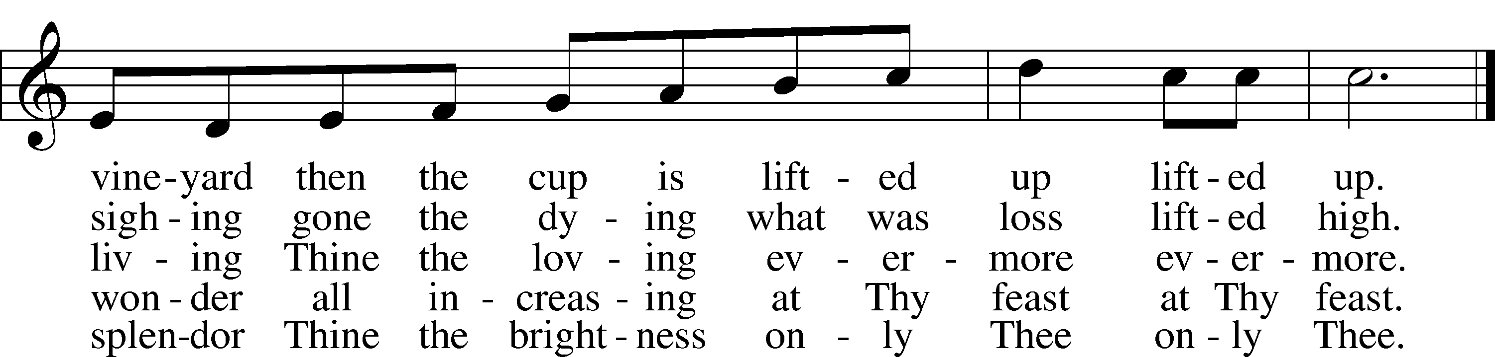
Text and tune: © 1983 Augsburg Publishing House. Used by permission: LSB Hymn License no. 110003744

Stand

The Dismissal
P The body and blood of our Lord Jesus Christ strengthen and preserve you in body and soul to life everlasting. Depart T in peace.
C Amen.

Thank the Lord LSB 164
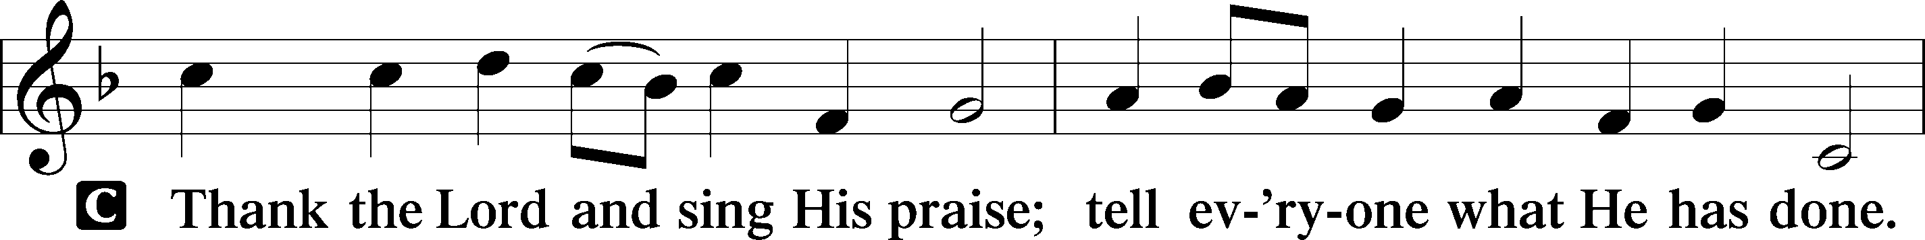
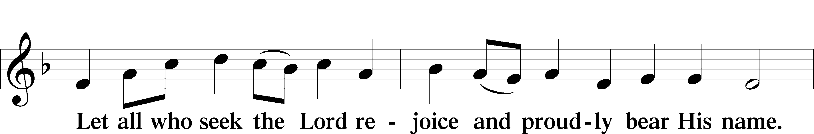
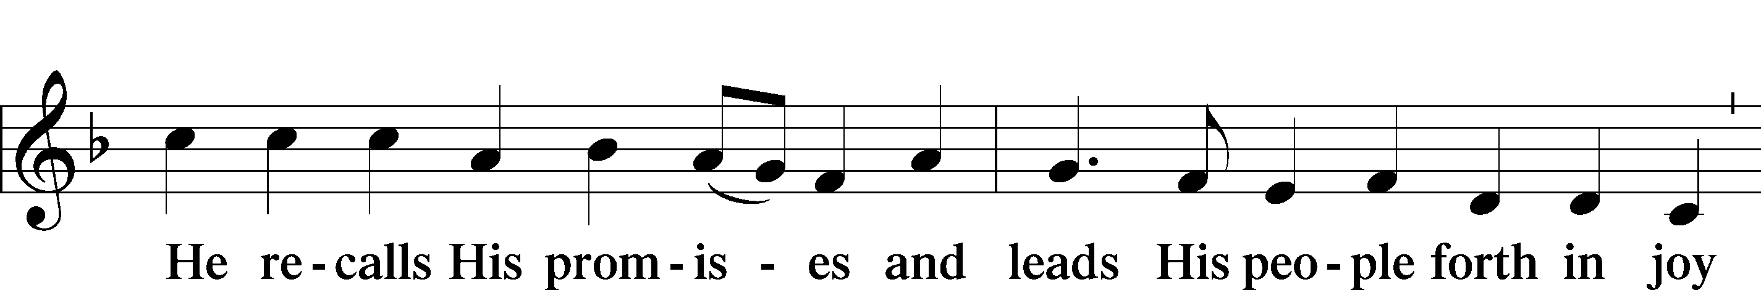
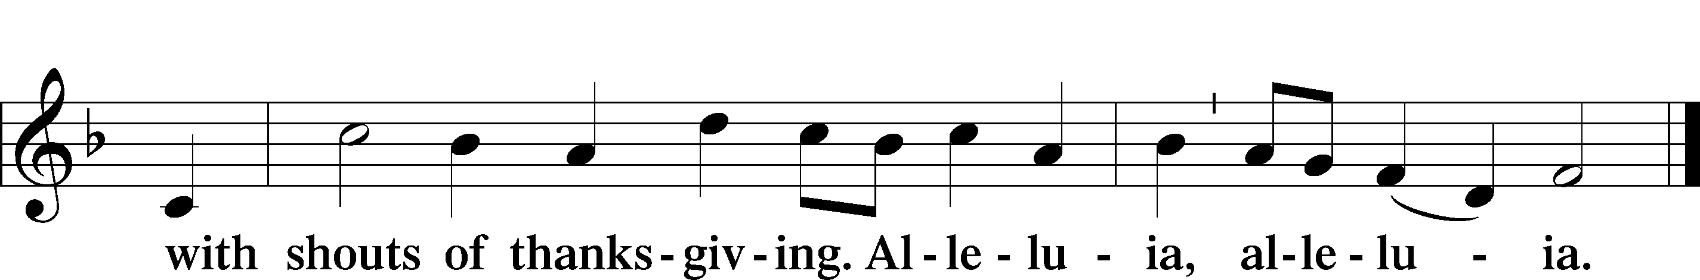

Post-Communion Collect
A Let us pray.
We give thanks to You, almighty God, that You have refreshed us through this salutary gift, and we implore You that of Your mercy You would strengthen us through the same in faith toward You and in fervent love toward one another; through Jesus Christ, Your Son, our Lord, who lives and reigns with You and the Holy Spirit, one God, now and forever.
C Amen.

Benediction LSB 166
P The Lord bless you and keep you.
The Lord make His face shine on you and be gracious to you.
The Lord look upon you with favor and T give you peace.
C Amen.

917 Savior, Again to Thy Dear Name We Raise
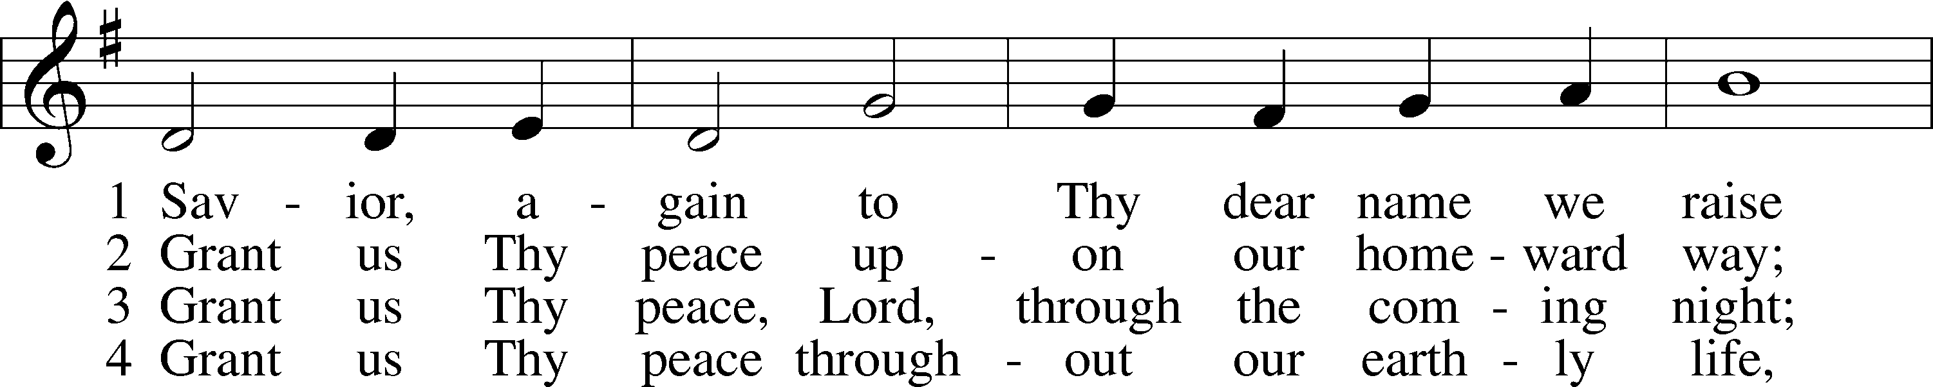
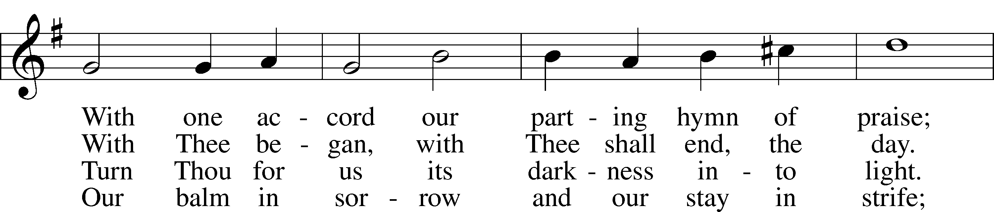
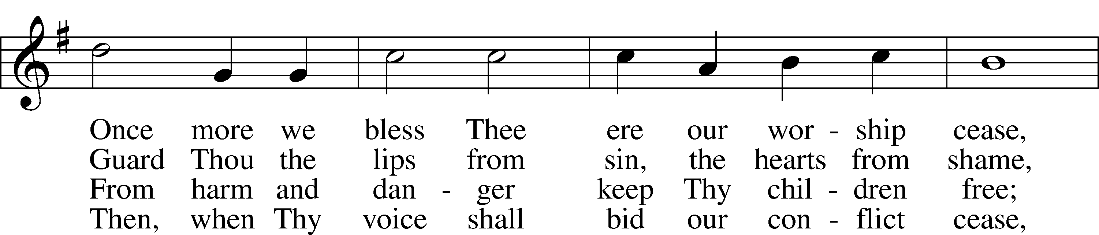
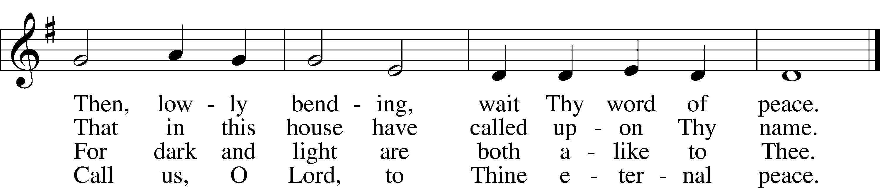
Text and tune: Public domain

Prayers for Our Members
Robin Baker, Bailey Hockemeier, Leah Vogel | Expectant Mothers
Norman Abels (Brookestone Meadows – Elkhorn) | Healing
Judy Ahrens (St. Luke’s) | Healing
Vaughn Albrecht (Northridge) | Healing
Tom & DyAnn Altwine | Healing
David Banner | Healing
Lyle Colsden (Mother Hull) | Healing
Pat Flodine (Cambridge Court) | Healing
Vi Fox (Prairie View) | Healing
Verleen Gentry | Healing
Ruby Hatfield | Healing
Sandy Heiden | Healing
Chelsea Herrera | Healing
Carol Kreutzer | Healing
Betty Mustard | Healing
Roger Riekenberg | Healing
Marion Richmond | Healing
Geraldine Roeder | Healing
Bev Nuttelman | Cancer
Kim Vos | Cancer

Prayers for Our Members’ Family & Friends
Brandon & Shannon Howell (Quentin & Janel Lange’s friends) | Family
Will Brennemann (Jami Helmbrecht’s father) | Healing
Reg Duke (Westman’s brother-in-law) | Healing
James Gentry (Verleen Gentry’s son) | Healing
Roger Hoffman (Marc’s father) | Healing
Sharon Kreutzer (former member) | Healing
Lyra Mais (Zion student) | Healing
Randy Solomon (Beth Rosenthal’s father) | Healing
Mary Ann Mertz (Pam’s Uhlir’s friend) | Healing
Roy Reynolds (Verleen Gentry’s son-in-law) | Healing
Janet Stalder (Carol Florang’s sister) | Healing
Ron Halvorsen (Jeff’s dad) | Cancer
Carol Haubold (Don Helmbrecht’s sister) | Cancer
Tyler Holland (Quentin & Janel Lange’s brother-in-law) | Cancer
Randy Jochum (Ken Hockemeier’s brother-in-law) | Cancer
Fred Koch (Pam Uhlir’s cousin) | Cancer
Lynda Kreutzer (Rich & Carol’s sister-in-law) | Cancer
Sharon Mulhair (Pam Uhlir’s cousin) | Cancer
Becky Rathkie (former Zion teacher) | Cancer
Jeannie Schmidt (Lisa Splittgerber’s sister-in-law) | Cancer
Tyrone Uhlir (Pam’s nephew) | Cancer

Today’s Radio Broadcast is given to the Glory of the Lord in memory of Lillian Johnson

Serving in Worship

Sunday, October 11~ 9:00am  Elder: Nathan Gaunt  Usher: Marc Hoffman &  Steve Junge  Engineer: Zach DeLoach  Announcer: Brooke Fisher  Altar Guild: Jami Helmbrecht &  Shirley Helmbrecht | Sunday, October 18~ 9:00am  Elder: Rich Kreutzer  Usher: Roger Riekenberg &  Robert Glanzer  Engineer: Jared Nuttelman  Announcer: Jesse Florang  Altar Guild: Jami Helmbrecht &  Shirley Helmbrecht

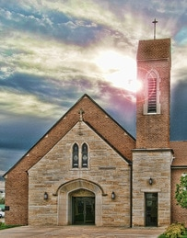

ZION LUTHERAN CHURCH AND SCHOOL

Pr. James DeLoach, Pastor + (308) 627-5260
james.deloach@zionkearney.org
Pr. Doug Gaunt, Pastor + (308) 455-0552
doug.gaunt@zionkearney.org
Tony Splittgerber, Principal + (308) 293-0168
anthony.splittgerber@zionkearney.org

Church Office
Administrative Assistant: Jessica Shiers
Email: school@zionkearney.org
Phone: (308)-234-3410 Fax: (308) 236-8100
Office Hours: Monday-Friday 8:00am-4:00pm
Radio Broadcast: Sunday @ 10:30 a.m. on 1460 AM
Website: www.zionkearney.com

Our Response to the Gospel

Date: 10/04/2020

Offering: $7,951.10
Weekly Need: $7,542.37



Where our Triune God strengthens us through His mercy in faith toward Him and in fervent love toward one another.

This Week at Zion

Sun  10/11 | 9:00a  10:30a | Divine Service  Radio Broadcast 1460am
Mon  10/12 | 7:00p  Birthdays  Anniversaries | Mary Martha-Fellowship Hall  Eli Randolph  Adam & Jami Helmbrecht
Tues  10/13 | 1:30p  7:00p  7:00p  Birthdays  Anniversaries | Sleeping Mats  Bd of Elder  Bd of Trustees  Ryan Fisher  Ashli Florang  Nancy McKillip  ---
Wed  10/14 | 8:25a  9:00a  5:45p  7:00p  Birthdays  Anniversaries | K-8th Chapel  ECE Chapel  Midweek Class  Adult Choir  Gerald Dulitz  Leviticus Gaunt  ---
Thurs  10/15 | 7:00p  Birthdays  Anniversaries | No School-Office Closed  Men’s Bible Study  Cody Willers  ---
Fri  10/16 | Birthdays  Anniversaries | No School-Office Closed  Lacey Ahrens  Robert Glanzer  Elizabeth Lange  ---
Sat  10/17 | 5:00p  Birthdays  Anniversaries | Divine Service  ---  ---
Sun  10/18 | 9:00a  10:30a  Birthdays  Anniversaries | Divine Service  Radio Broadcast 1460am  ---  ---
ANNOUNCEMENTS

Pastor Appreciation – October is Pastor Appreciation month. Our pastors at Zion work very hard, are very kind, and always ready to help. We want to thank them for ALL that they do for all of God’s children and the church. Zion is very blessed to have the pastors that we do and appreciate all that they do! You are welcome and encouraged to show your appreciation to our pastors in your very own special way.

Pie Sales - The school children are taking orders for delicious Holiday Pies. Any of our school children would be happy to take your order or stop by the office. New this year is the option to order online. Visit www.zionkearney.org to place your order online. Pass this information along to anyone who would appreciate a delicious pie while supporting a great school! Orders need to be placed by October 30. Thank you for your support!

Mary Martha – Mary Martha will meet on Monday in the fellowship hall at 7:00p.m.

Men’s Bible Study – The Men’s Bible Study will meet on Thursday all men are welcome to join the fellowship.

No School/Office Closed – There will be no school on Thursday & Friday for fall break. The office will be closed. If you need anything please make arrangements.

Sound Engineer – Zion is in search of volunteers to help with the audio and video of our worship service. Training will be provided. Please contact the office or Pr. DeLoach if interested or with questions.

A Bible Study – is prerecorded and available each Sunday, along with a study guide you can use to follow along. We are studying the three lessons for the day—the Old Testament, the Epistle, and the Gospel. Go to Zion’s website www.zionkearney.com to access the video and study guide.

Offering during this time. If you are not able to attend live Church Services, you may: drop your offering in the mail slot by the south doors, mail it to the church, or use online giving option at zionkearney.com. If you have any questions or need assistance please contact the office at 308-234-3410 or school@zionkearney.org. Thank you for supporting of your church!

The Lord’s Prayer Booklet – There is a Lord’s Prayer Booklet, to assist with your devotions, on the counter in the narthex. Feel free to take one. These are compliments of Pastor & Carol Gaunt.

Radio Broadcast & Altar Flowers - Please help Zion spread the Gospel! There are several open dates. This is a great need during this time, many people are listening to our broadcast during this time. There are also many openings for altar flowers. Please help beautify the sanctuary.

Mission Offerings - The fourth quarter missions, October through December, will be for Student Support (current are Abigail DeLoach, Taylor Zehendner, and Peter Kreutzer, all three are at CUNE). If you would like to donate to this mission please use the mission envelopes located in the narthex. Thank you for your support.

Apple Market Receipts – Apple Market receipts will be accepted from register dates September 1, 2020 – March 1, 2021. Please turn in your receipts to the office to earn free things for the school!

Family Fresh Receipts –Don’t forget that Zion collects Family Fresh receipts any date. Please turn them into the office.

Boxtops –Boxtops has discontinued the labels on the packages. They now have an app for your smartphone to redeem qualifying products. If you do not have a smartphone or don’t want to install the app turn your grocery receipts with qualifying boxtop products into the office and they will get scanned to continue to earn money for Zion.

2021 Radio & Flower Charts – The 2021 radio and flower charts are posted in the hallway by the mailboxes. If there is a special day make sure you sign up early. You are welcome to call the office to sign up for your spot.

