819 Sing Praise to God, the Highest Good
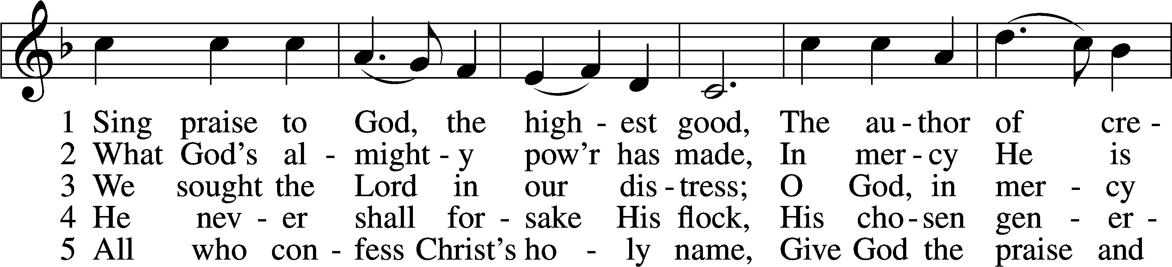
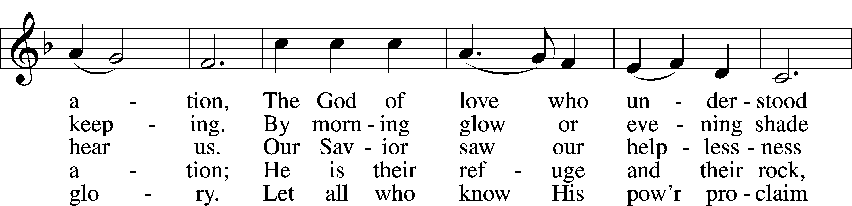
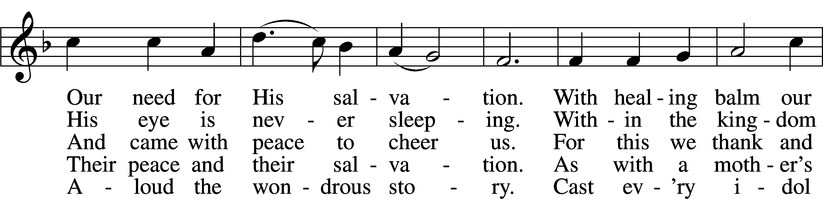
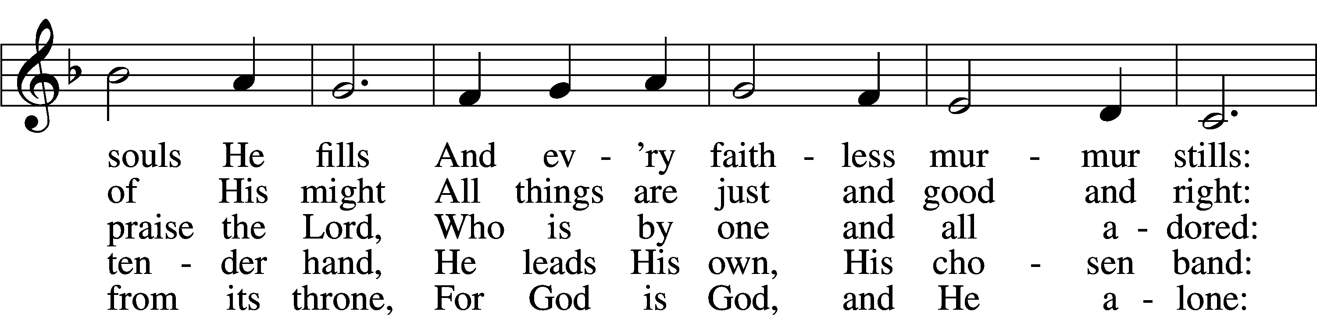
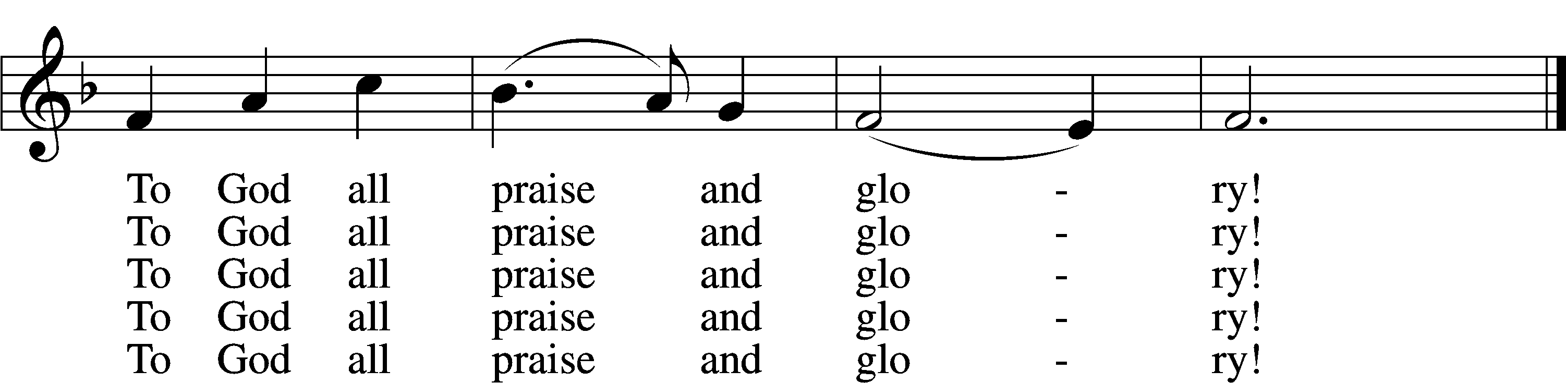
Text and tune: Public domain

The Baptism of Ellis Matthew Junge Saturday 5pm

Confession and Absolution

Stand

The sign of the cross may be made by all in remembrance of their Baptism.

Invocation
P In the name of the Father and of the T Son and of the Holy Spirit.
C Amen.

Exhortation LSB 151
P If we say we have no sin, we deceive ourselves, and the truth is not in us.
C But if we confess our sins, God, who is faithful and just, will forgive our sins and cleanse us from all unrighteousness.

Silence for reflection on God’s Word and for self-examination.

Confession of Sins LSB 151
P Let us then confess our sins to God our Father.
C Most merciful God, we confess that we are by nature sinful and unclean. We have sinned against You in thought, word, and deed, by what we have done and by what we have left undone. We have not loved You with our whole heart; we have not loved our neighbors as ourselves. We justly deserve Your present and eternal punishment. For the sake of Your Son, Jesus Christ, have mercy on us. Forgive us, renew us, and lead us, so that we may delight in Your will and walk in Your ways to the glory of Your holy name. Amen.

Absolution LSB 151
P Almighty God in His mercy has given His Son to die for you and for His sake forgives you all your sins. As a called and ordained servant of Christ, and by His authority, I therefore forgive you all your sins in the name of the Father and of the T Son and of the Holy Spirit.
C Amen.

Service of the Word

Introit Psalm 121:1–4, 7–8; antiphon: v. 5
The Lord is your | keeper;*
the Lord is your shade on your | right hand.
I lift up my eyes | to the hills.*
From where does my | help come?
My help comes | from the Lord,*
who made | heaven and earth.
He will not let your | foot be moved;*
he who keeps you will not | slumber.
Behold, he who keeps | Israel*
will neither slum- | ber nor sleep.
The Lord will keep you from all | evil;*
he will | keep your life.
The Lord will keep your going out and your | coming in*
from this time forth and for- | evermore.
Glory be to the Father and | to the Son*
and to the Holy | Spirit;
as it was in the be- | ginning,*
is now, and will be forever. | Amen.
The Lord is your | keeper;*
the Lord is your shade on your | right hand.

Kyrie LSB 186
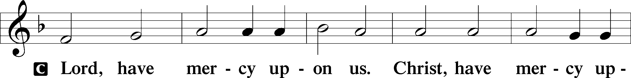
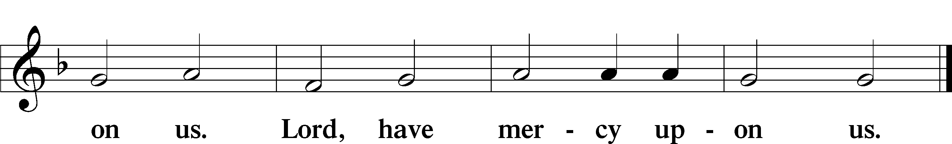

Gloria in Excelsis LSB 154
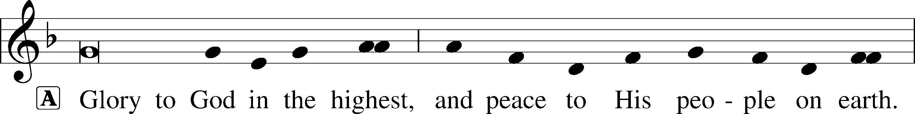
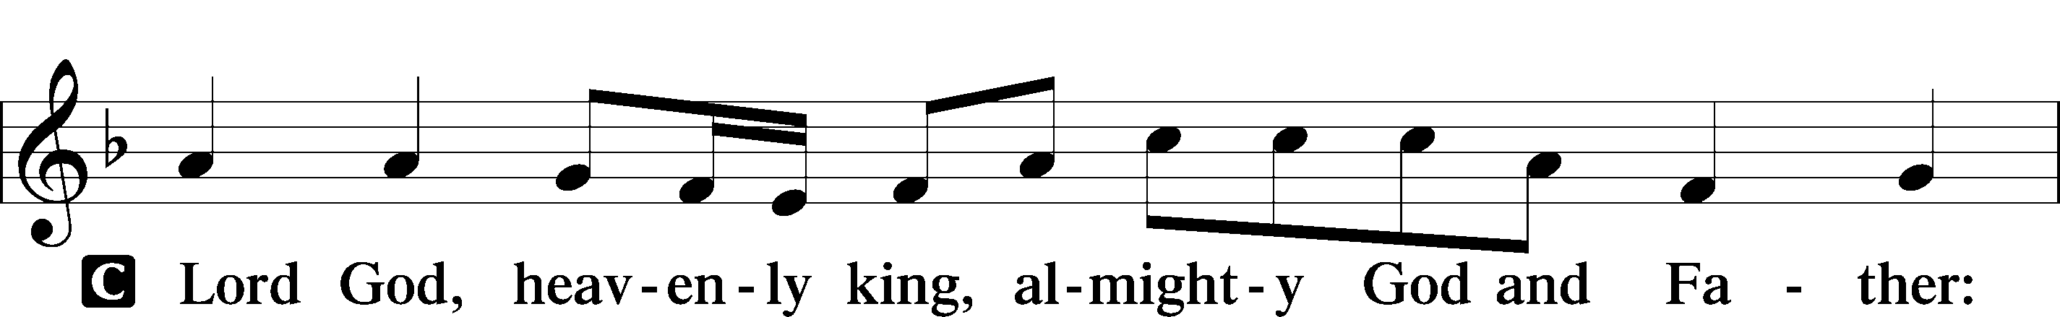
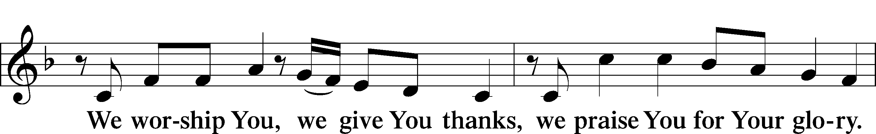
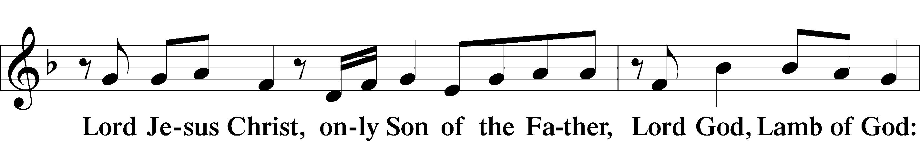
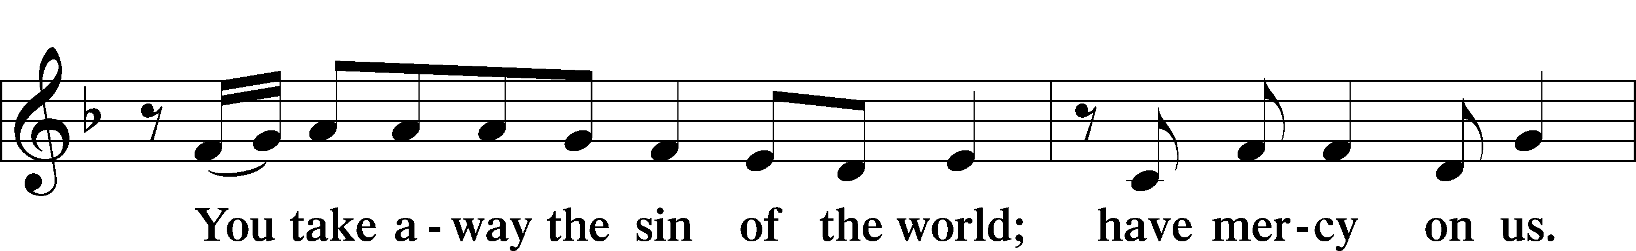
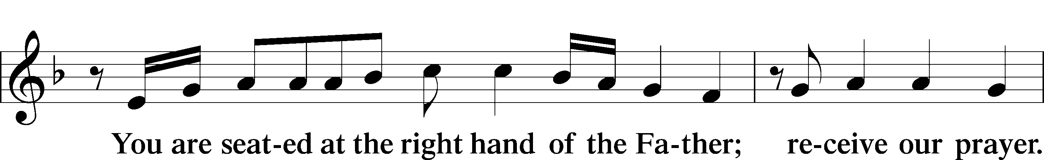
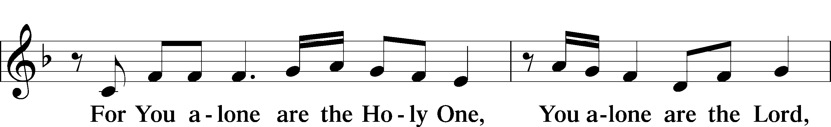
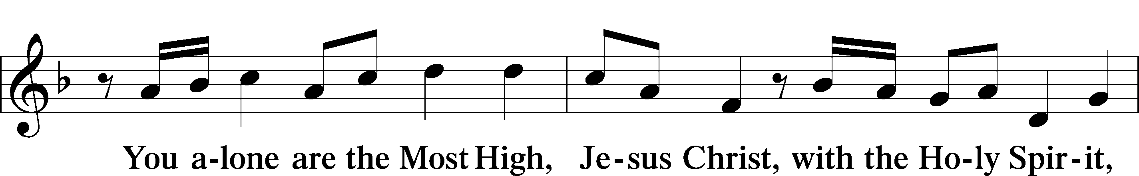
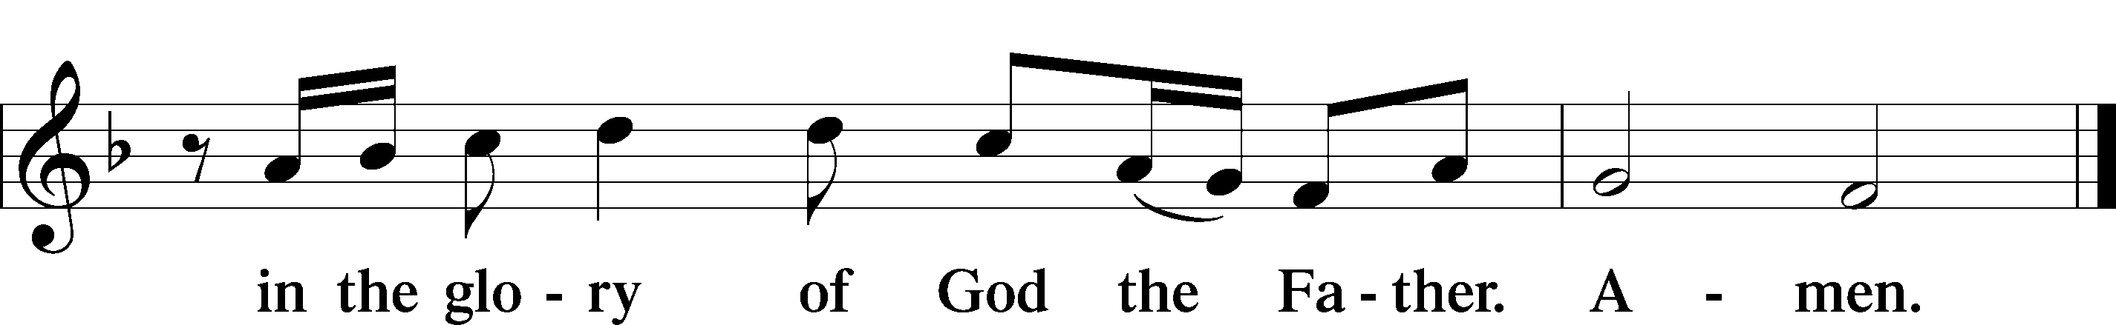

Salutation and Collect of the Day
P The Lord be with you.
C And also with you.

P Let us pray.
O God, the protector of all who trust in You, have mercy on us that with You as our ruler and guide we may so pass through things temporal that we lose not the things eternal; through Jesus Christ, Your Son, our Lord, who lives and reigns with You and the Holy Spirit, one God, now and forever.

C Amen.

Sit

Old Testament Reading Isaiah 45:1–7
¹Thus says the Lord to his anointed, to Cyrus,
whose right hand I have grasped,
to subdue nations before him
and to loose the belts of kings,
to open doors before him
that gates may not be closed:
²“I will go before you
and level the exalted places,
I will break in pieces the doors of bronze
and cut through the bars of iron,
³I will give you the treasures of darkness
and the hoards in secret places,
that you may know that it is I, the Lord,
the God of Israel, who call you by your name.
⁴For the sake of my servant Jacob,
and Israel my chosen,
I call you by your name,
I name you, though you do not know me.
⁵I am the Lord, and there is no other,
besides me there is no God;
I equip you, though you do not know me,
⁶that people may know, from the rising of the sun
and from the west, that there is none besides me;
I am the Lord, and there is no other.
⁷I form light and create darkness,
I make well-being and create calamity,
I am the Lord, who does all these things.”

A This is the Word of the Lord.
C Thanks be to God.

Gradual Psalm 91:11; 103:1
He will command his angels con- | cerning you*
to guard you in | all your ways.
Bless the Lord, | O my soul,*
and all that is within me, bless his | holy name!

Epistle 1 Thessalonians 1:1–10
¹Paul, Silvanus, and Timothy,
To the church of the Thessalonians in God the Father and the Lord Jesus Christ:
Grace to you and peace.
²We give thanks to God always for all of you, constantly mentioning you in our prayers, ³remembering before our God and Father your work of faith and labor of love and steadfastness of hope in our Lord Jesus Christ. ⁴For we know, brothers loved by God, that he has chosen you, ⁵because our gospel came to you not only in word, but also in power and in the Holy Spirit and with full conviction. You know what kind of men we proved to be among you for your sake. ⁶And you became imitators of us and of the Lord, for you received the word in much affliction, with the joy of the Holy Spirit, ⁷so that you became an example to all the believers in Macedonia and in Achaia. ⁸For not only has the word of the Lord sounded forth from you in Macedonia and Achaia, but your faith in God has gone forth everywhere, so that we need not say anything. ⁹For they themselves report concerning us the kind of reception we had among you, and how you turned to God from idols to serve the living and true God, ¹⁰and to wait for his Son from heaven, whom he raised from the dead, Jesus who delivers us from the wrath to come.

A This is the Word of the Lord.
C Thanks be to God.

Stand

Alleluia and Verse LSB 156
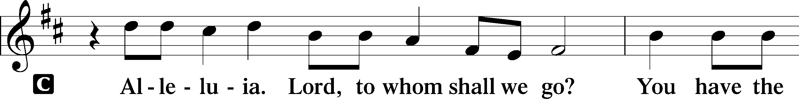
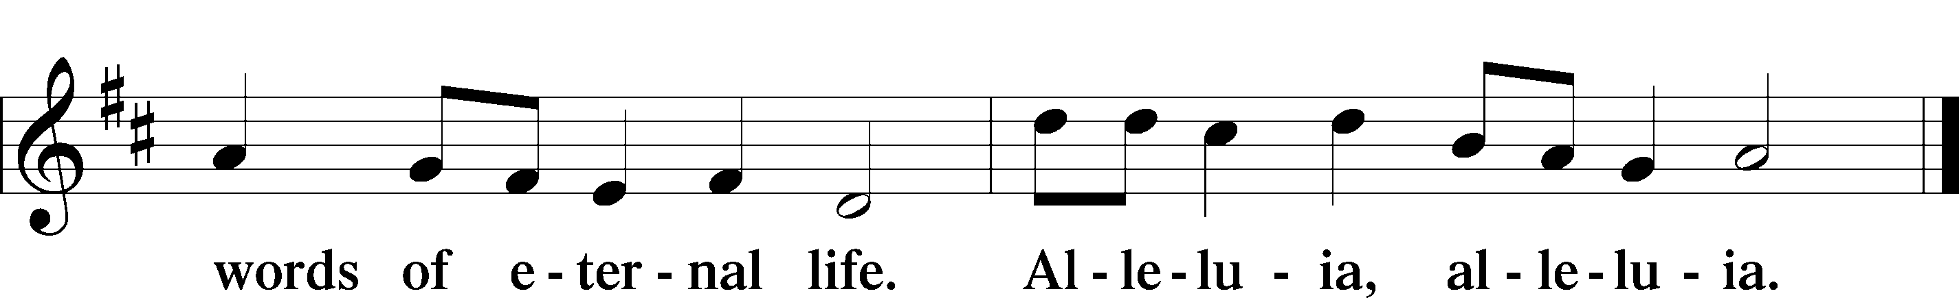

Holy Gospel Matthew 22:15–22
P The Holy Gospel according to St. Matthew, the twenty-second chapter.
C Glory to You, O Lord.

¹⁵Then the Pharisees went and plotted how to entangle [Jesus] in his talk. ¹⁶And they sent their disciples to him, along with the Herodians, saying, “Teacher, we know that you are true and teach the way of God truthfully, and you do not care about anyone’s opinion, for you are not swayed by appearances. ¹⁷Tell us, then, what you think. Is it lawful to pay taxes to Caesar, or not?” ¹⁸But Jesus, aware of their malice, said, “Why put me to the test, you hypocrites? ¹⁹Show me the coin for the tax.” And they brought him a denarius. ²⁰And Jesus said to them, “Whose likeness and inscription is this?” ²¹They said, “Caesar’s.” Then he said to them, “Therefore render to Caesar the things that are Caesar’s, and to God the things that are God’s.” ²²When they heard it, they marveled. And they left him and went away.

P This is the Gospel of the Lord.
C Praise to You, O Christ.

Sit

940 Holy God, We Praise Thy Name sts. 1–5
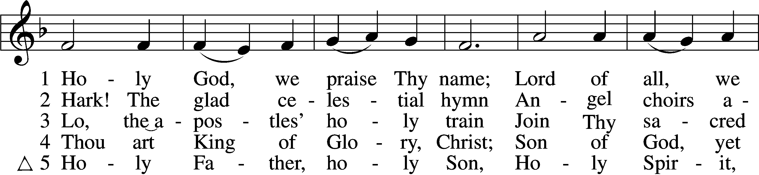
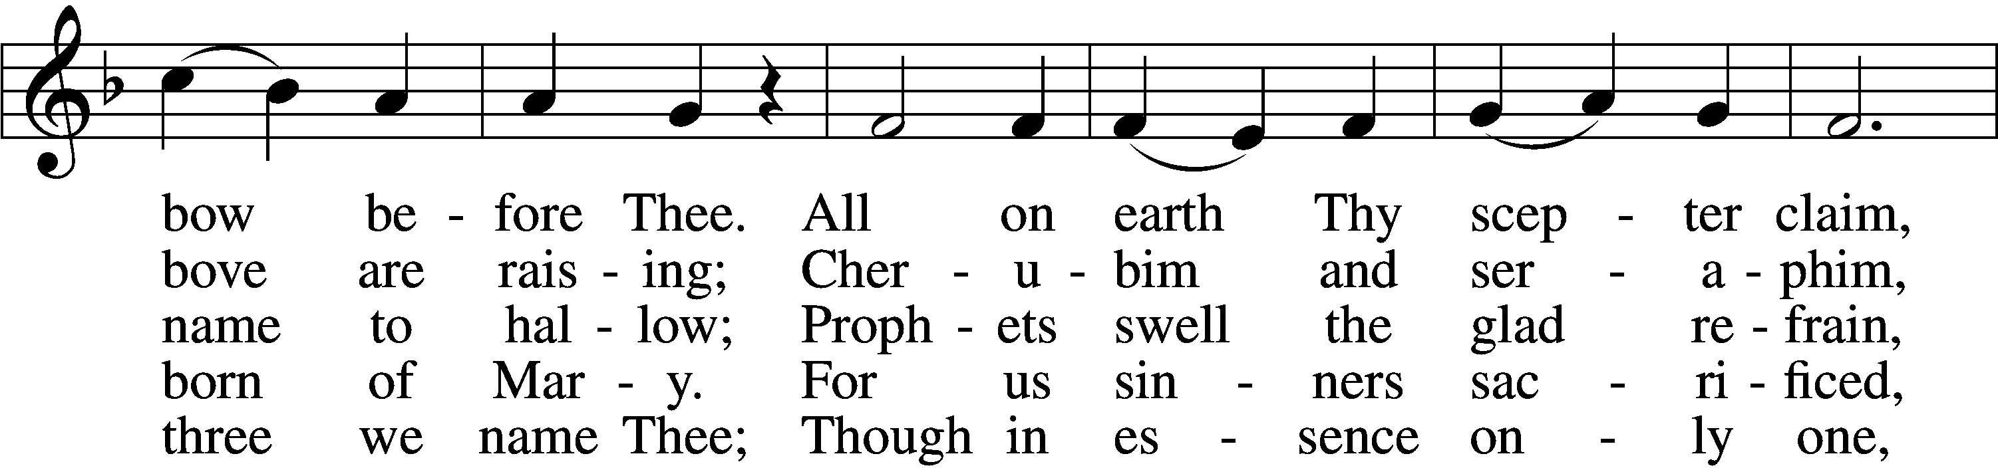
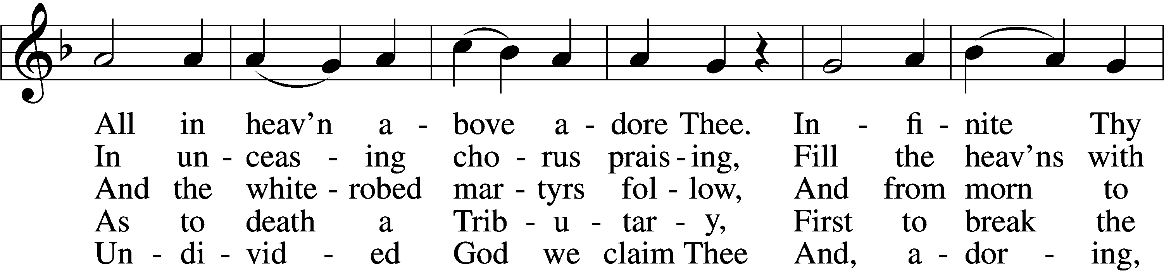
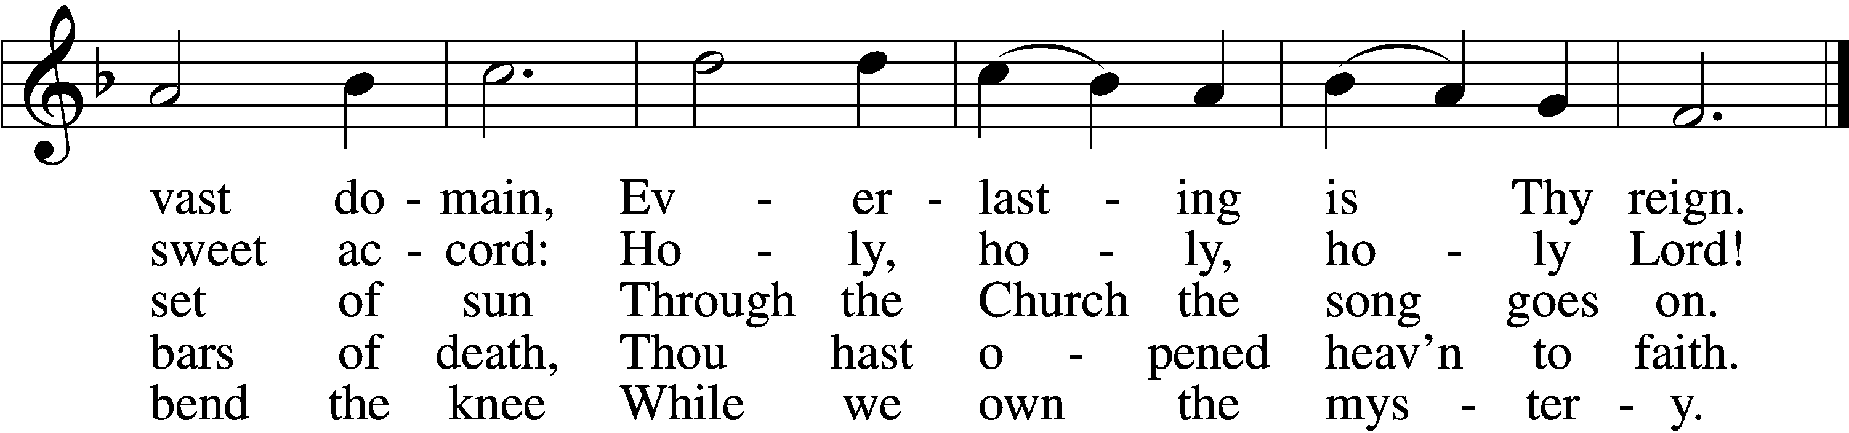
Text and tune: Public domain

Sermon: Religion and Politics

Stand

Nicene Creed
C I believe in one God,
the Father Almighty,
maker of heaven and earth
and of all things visible and invisible.

And in one Lord Jesus Christ,
the only-begotten Son of God,
begotten of His Father before all worlds,
God of God, Light of Light,
very God of very God,
begotten, not made,
being of one substance with the Father,
by whom all things were made;
who for us men and for our salvation came down from heaven
and was incarnate by the Holy Spirit of the virgin Mary
and was made man;
and was crucified also for us under Pontius Pilate.
He suffered and was buried.
And the third day He rose again according to the Scriptures
and ascended into heaven
and sits at the right hand of the Father.
And He will come again with glory to judge both the living and the dead,
whose kingdom will have no end.

And I believe in the Holy Spirit,
the Lord and giver of life,
who proceeds from the Father and the Son,
who with the Father and the Son together is worshiped and glorified,
who spoke by the prophets.
And I believe in one holy Christian and apostolic Church,
I acknowledge one Baptism for the remission of sins,
and I look for the resurrection of the dead
and the life T of the world to come. Amen.

Prayer of the Church

Offertory LSB 159
C What shall I render to the Lord for all His benefits to me?
I will offer the sacrifice of thanksgiving and will call on the name of the Lord.
I will take the cup of salvation and will call on the name of the Lord.
I will pay my vows to the Lord now in the presence of all His people,
in the courts of the Lord’s house, in the midst of you, O Jerusalem.

Service of the Sacrament

Preface LSB 160
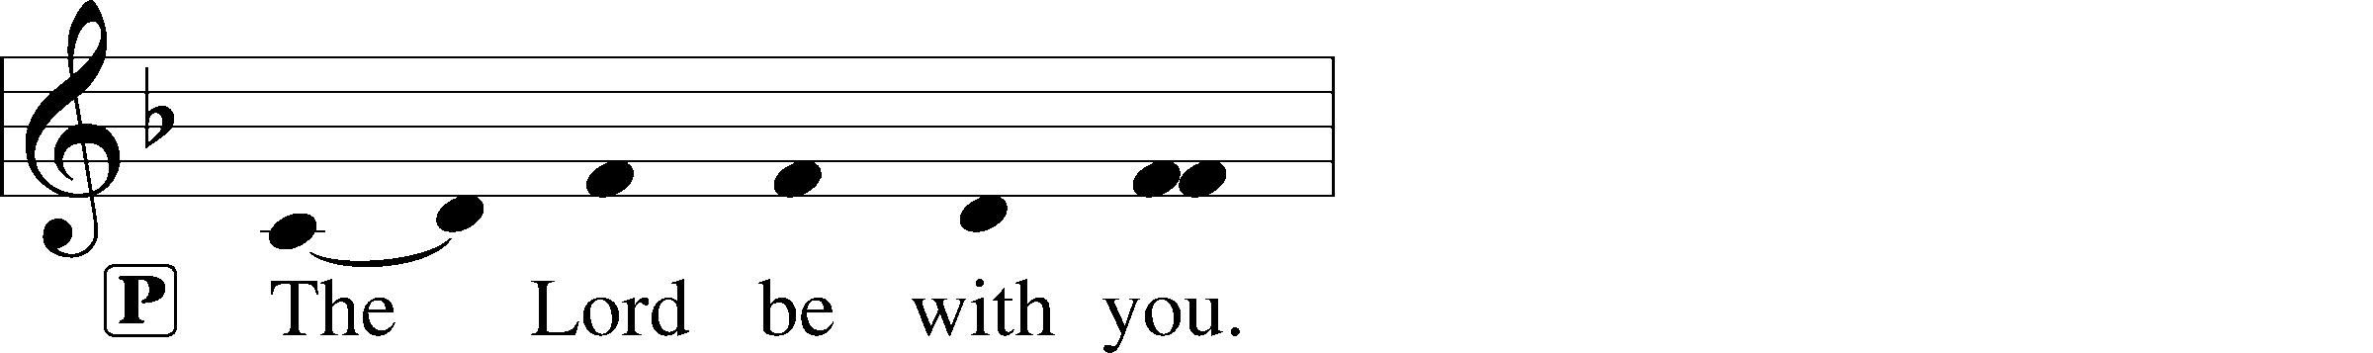
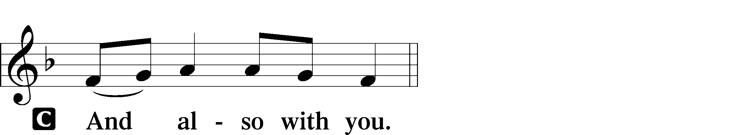
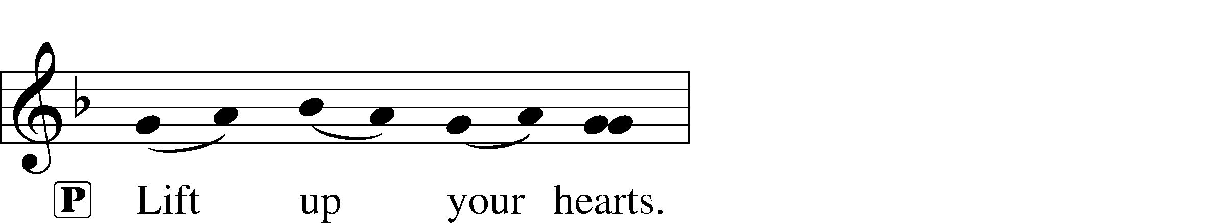
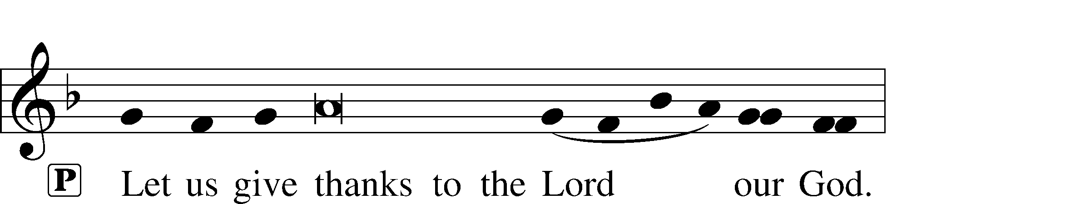
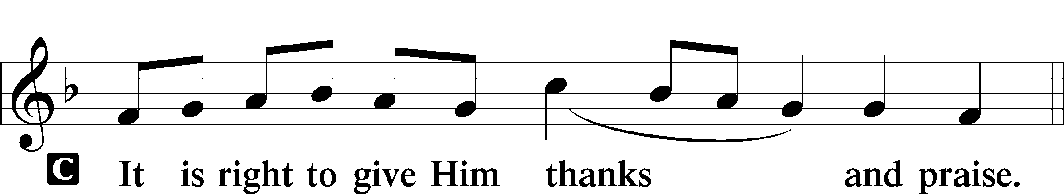

Proper Preface
P It is truly good, right, and salutary that we should at all times and in all places give thanks to You, holy Lord, almighty Father, everlasting God, through Jesus Christ, our Lord. Therefore with angels and archangels and with all the company of heaven we laud and magnify Your glorious name, evermore praising You and saying:

Sanctus LSB 161
C Holy, holy, holy Lord God of pow’r and might:
Heaven and earth are full of Your glory.
Hosanna. Hosanna.
Hosanna in the highest.
Blessed is He who comes in the name of the Lord.
Hosanna in the highest.

Lord’s Prayer
C Our Father who art in heaven,
hallowed be Thy name,
Thy kingdom come,
Thy will be done on earth
as it is in heaven;
give us this day our daily bread;
and forgive us our trespasses
as we forgive those
who trespass against us;
and lead us not into temptation,
but deliver us from evil.
For Thine is the kingdom
and the power and the glory
forever and ever. Amen.

The Words of Our Lord
P Our Lord Jesus Christ, on the night when He was betrayed, took bread, and when He had given thanks, He broke it and gave it to the disciples and said: “Take, eat; this is My T body, which is given for you. This do in remembrance of Me.”

In the same way also He took the cup after supper, and when He had given thanks, He gave it to them, saying: “Drink of it, all of you; this cup is the new testament in My T blood, which is shed for you for the forgiveness of sins. This do, as often as you drink it, in remembrance of Me.”

Pax Domini LSB 163
P The peace of the Lord be with you always.
C Amen.

Agnus Dei LSB 163
C Lamb of God, You take away the sin of the world; have mercy on us.
Lamb of God, You take away the sin of the world; have mercy on us.
Lamb of God, You take away the sin of the world; grant us peace.

Sit

Distribution

781 We Give Thee But Thine Own
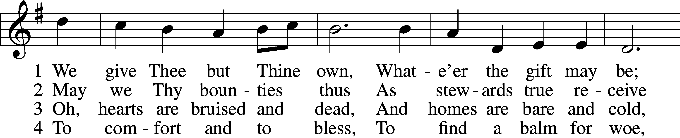
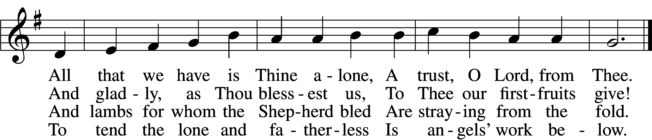

5 The captive to release,
To God the lost to bring,
To teach the way of life and peace,
It is a Christ-like thing.

6 And we believe Thy Word,
Though dim our faith may be:
Whate’er for Thine we do, O Lord,
We do it unto Thee.
Tune and text: Public domain

627 Jesus Christ, Our Blessed Savior sts. 1–2, 4–5, 7–10
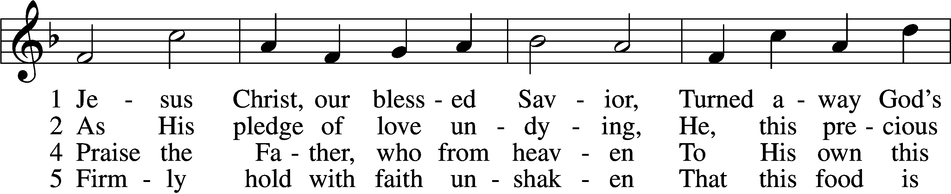
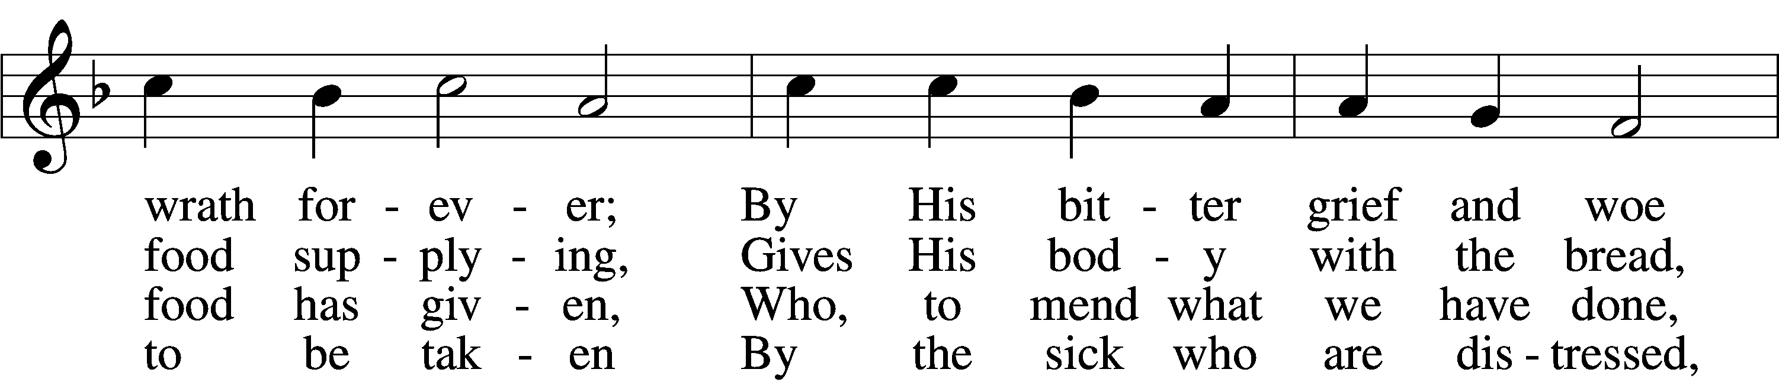
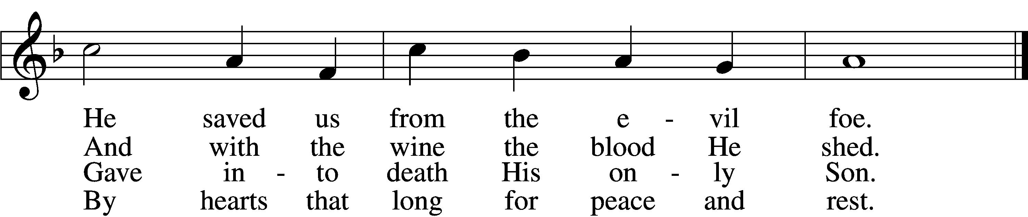

7 Christ says: “Come, all you that labor,
And receive My grace and favor:
Those who feel no pain or ill
Need no physician’s help or skill.

8 “For what purpose was My dying
If not for your justifying?
And what use this precious food
If you yourself were pure and good?”

9 If your heart this truth professes
And your mouth your sin confesses,
You will be your Savior’s guest,
Be at His banquet truly blest.

10 Let this food your faith so nourish
That its fruit of love may flourish
And your neighbor learn from you
How much God’s wondrous love can do.
Text (sts. 1–2, 4–5, 7, 9) and tune: Public domain
Text (sts. 8, 10): © 1980 and 2006 Concordia Publishing House. Used by permission: LSB Hymn License no. 110003744

784 Take My Life and Let It Be
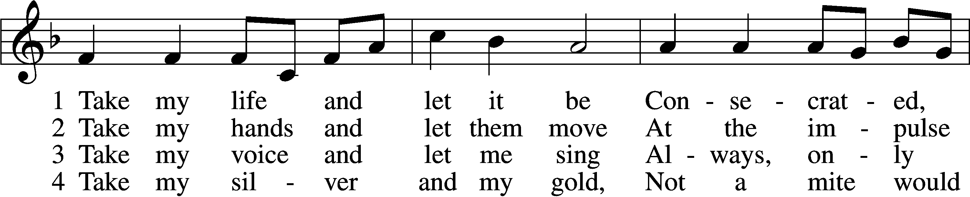
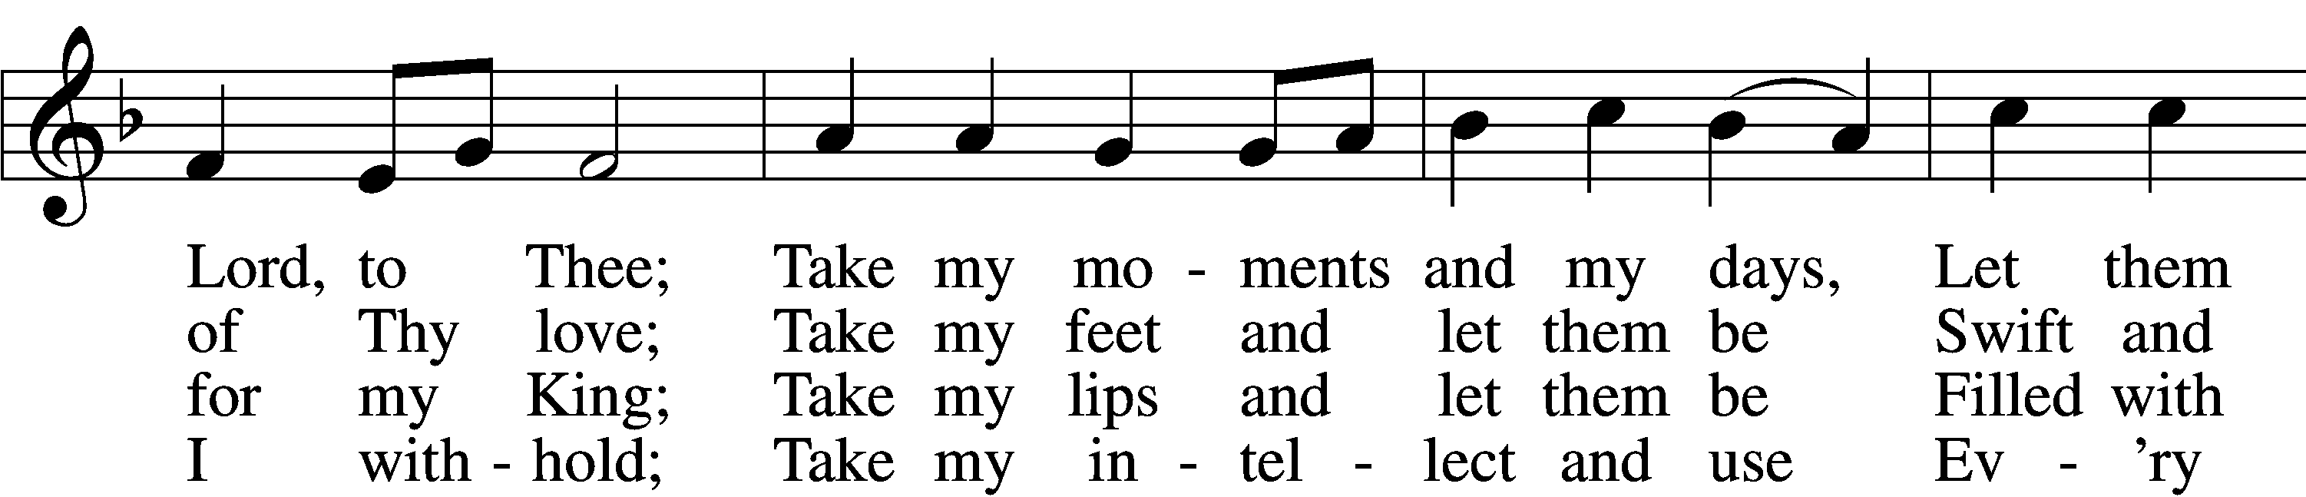
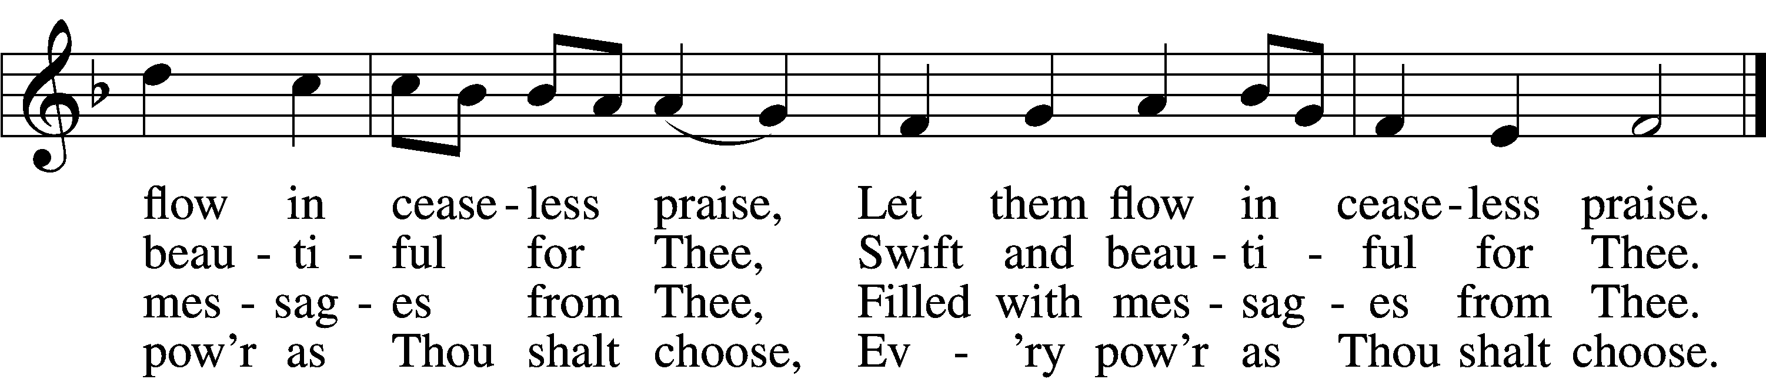

5 Take my will and make it Thine,
It shall be no longer mine;
Take my heart, it is Thine own,
It shall be Thy royal throne,
It shall be Thy royal throne.

6 Take my love, my Lord, I pour
At Thy feet its treasure store;
Take myself, and I will be
Ever, only, all for Thee,
Ever, only, all for Thee.
Tune and text: Public domain

Stand

The Dismissal
P The body and blood of our Lord Jesus Christ strengthen and preserve you in body and soul to life everlasting. Depart T in peace.
C Amen.

Thank the Lord LSB 164
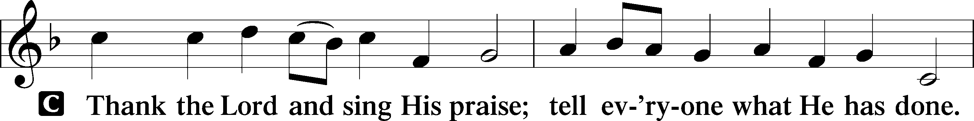
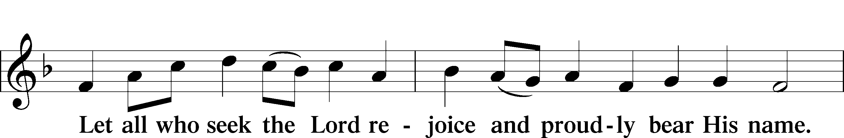
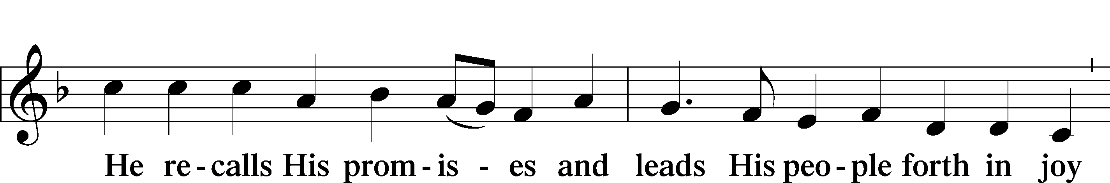
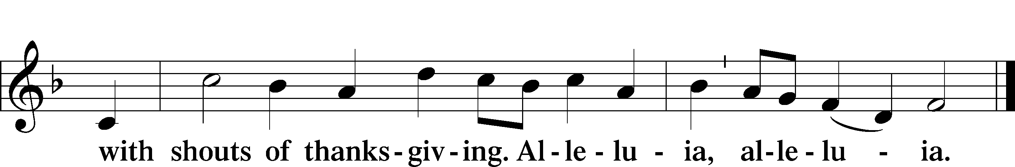

Post-Communion Collect
A Let us pray.
O God the Father, the fountain and source of all goodness, who in loving-kindness sent Your only-begotten Son into the flesh, we thank You that for His sake You have given us pardon and peace in this Sacrament, and we ask You not to forsake Your children but always to rule our hearts and minds by Your Holy Spirit that we may be enabled constantly to serve You; through Jesus Christ, Your Son, our Lord, who lives and reigns with You and the Holy Spirit, one God, now and forever.
C Amen.

Benediction LSB 166
P The Lord bless you and keep you.
The Lord make His face shine on you and be gracious to you.
The Lord look upon you with favor and T give you peace.
C Amen.

824 May God Bestow on Us His Grace
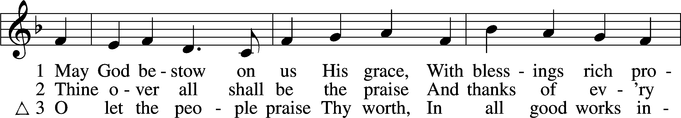
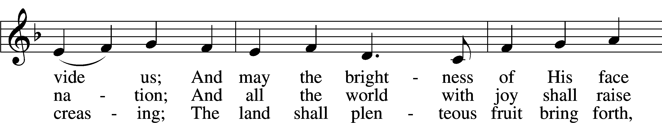
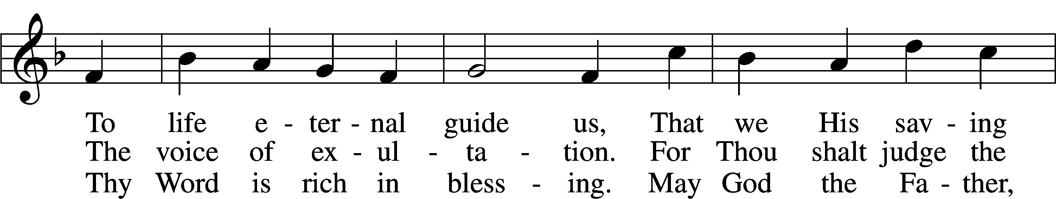
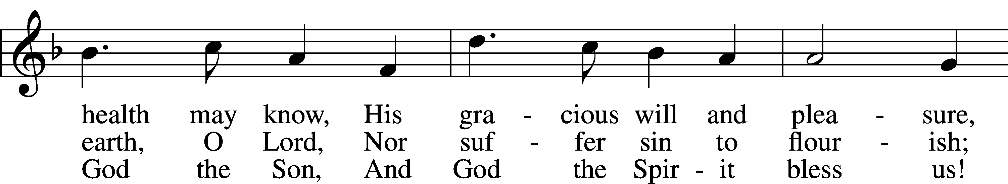
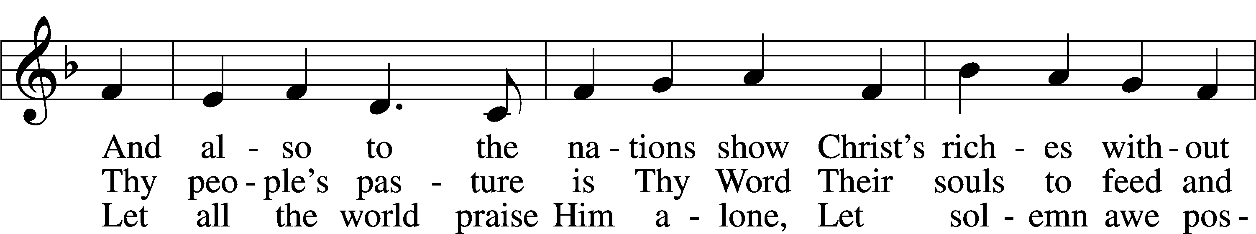
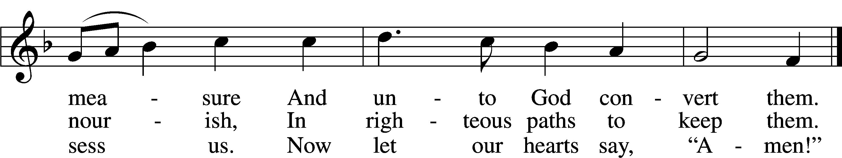
Tune: © 2004 David Lee. Used by permission: LSB Hymn License no. 110003744
Text: Public domain

Acknowledgments
Unless otherwise indicated, Scripture quotations are from the ESV® Bible (The Holy Bible, English Standard Version®), copyright © 2001 by Crossway, a publishing ministry of Good News Publishers. Used by permission. All rights reserved.
Created by Lutheran Service Builder © 2018 Concordia Publishing House.

