Divine Service
Twenty-third Sunday after Pentecost
November 8, 2020
Zion Lutheran Church
Kearney, Nebraska

Welcome to Zion!
All worshippers please fill out an attendance card in the pew rack and let us know how we might be of service to you.

Holy Communion at Zion

The Lord’s Supper is celebrated at this congregation as Jesus has given it. As he says, our Lord gives into our mouths not only bread and wine but his very body and blood to eat and to drink for the forgiveness of sins and to strengthen our union with him and with one another. Our Lord invites to his table those who trust his words, repent of all sin, and set aside any refusal to forgive and love as he forgives and loves us, that they may show forth his death until he comes. All communicants need to register in the narthex prior to the service.

Because those who eat and drink our Lord’s body and blood unworthily do great harm and because Holy Communion is a confession of the faith which is confessed at this altar, any who are not yet instructed, in doubt, or who hold a confession differing from that of this congregation and The Lutheran Church—Missouri Synod, are asked not to commune until they are able to speak with our pastor first. He is happy to visit with you about the Christian faith and how to receive the Lord’s Supper for your good and for the good of others. Those not communing are invited to come to the altar, cross your arms in front of you, and bow your head to receive a pastoral blessing.

The Gospel Prepares Us for Our Heavenly Bridegroom’s Coming

The Day of the Lord is “darkness, and not light” (Amos 5:18, 20) for all who trust in their own righteousness and piety. The Lord will not accept their “burnt offerings and grain offerings,” nor will He look upon their “peace offerings” (Amos 5:22). Instead, He desires a heart of faith that trusts in Him, which lets “justice roll down like waters, and righteousness like an ever-flowing stream” (Amos 5:24) in love for the neighbor. In order for the “lamps” of our lives to burn brightly with such love, we must be filled with the “oil” of forgiveness through faith in our Bridegroom, Jesus Christ (Matt. 25:1–4). Therefore, as we await His coming, wisdom directs us “to the dealers” (Matt. 25:9), that is, to the ministers of His Gospel. Thus, we wait upon the Lord, and we “encourage one another with these words” (1 Thess. 4:18). Waking or sleeping, we are prepared to meet Him when He comes “with a cry of command, with the voice of an archangel, and with the sound of the trumpet of God,” and “we will always be with the Lord” (1 Thess. 4:16, 17).
Confession and Absolution

663 Rise, My Soul, to Watch and Pray
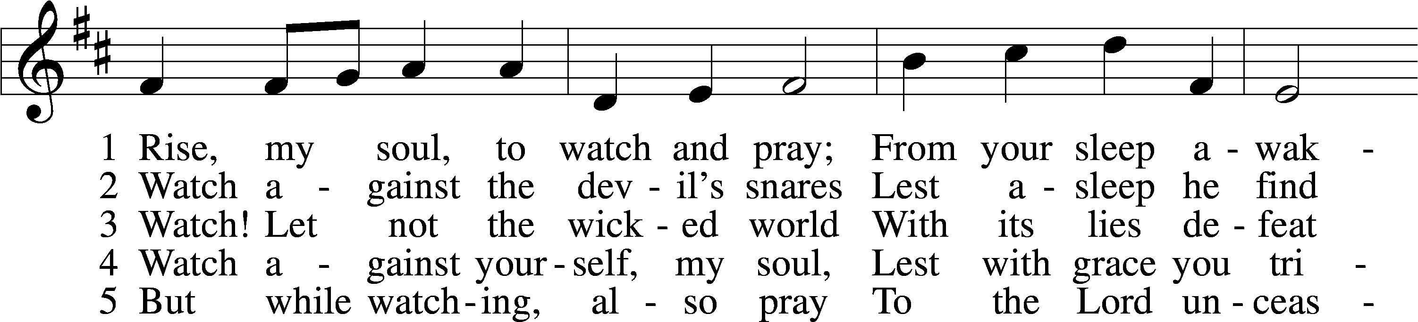
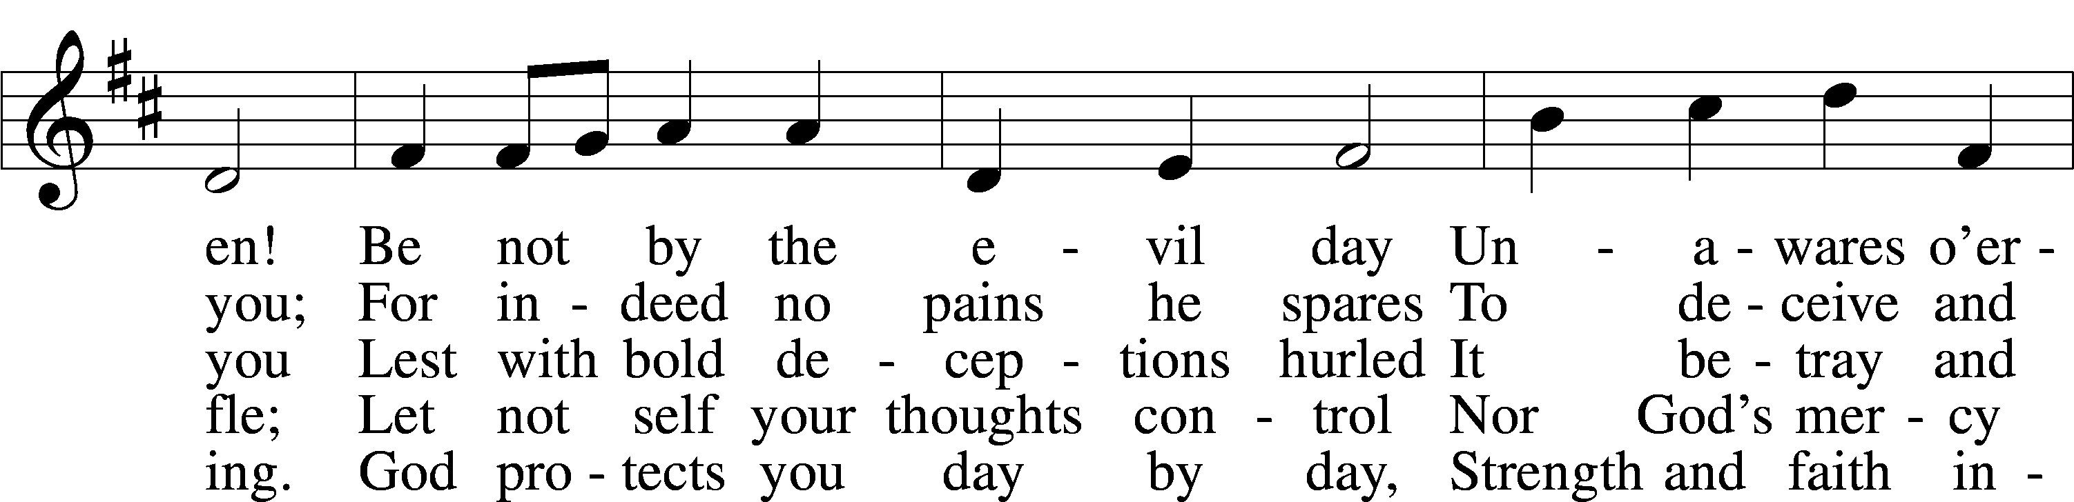
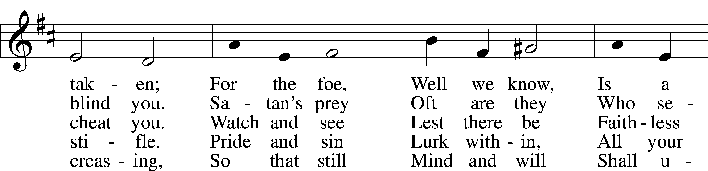
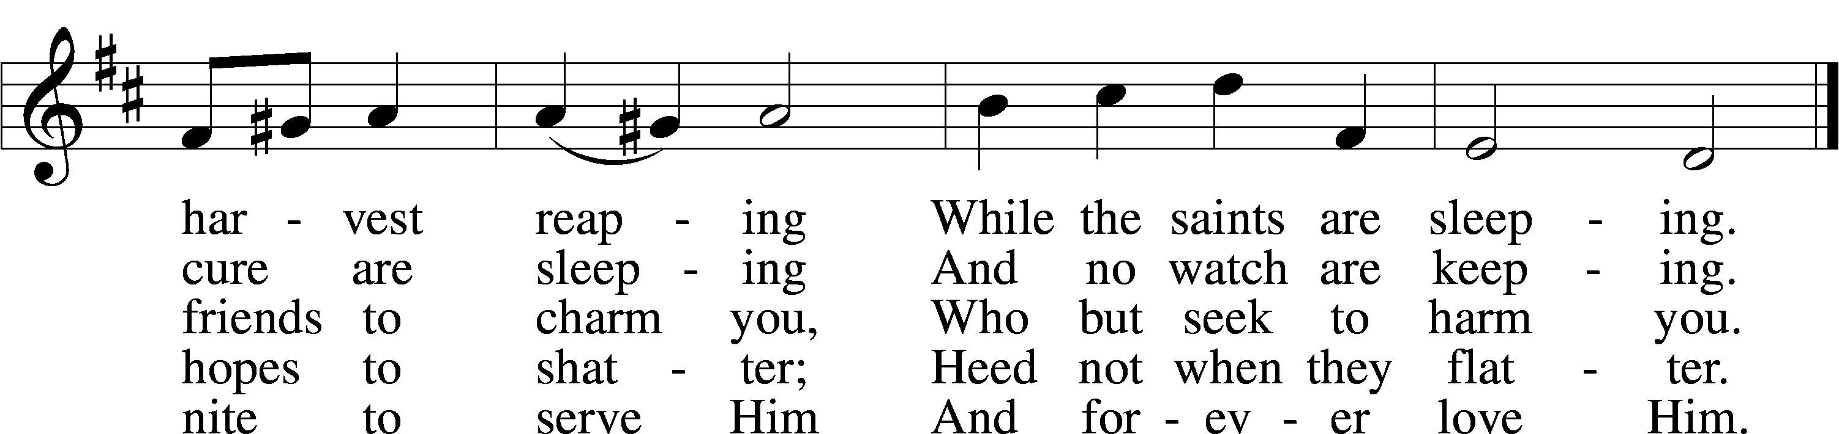
Tune and text: Public domain

Stand

The sign of the cross may be made by all in remembrance of their Baptism.

Invocation
P In the name of the Father and of the T Son and of the Holy Spirit.
C Amen.

Exhortation LSB 151
P If we say we have no sin, we deceive ourselves, and the truth is not in us.
C But if we confess our sins, God, who is faithful and just, will forgive our sins and cleanse us from all unrighteousness.

Silence for reflection on God’s Word and for self-examination.

Confession of Sins LSB 151
P Let us then confess our sins to God our Father.
C Most merciful God, we confess that we are by nature sinful and unclean. We have sinned against You in thought, word, and deed, by what we have done and by what we have left undone. We have not loved You with our whole heart; we have not loved our neighbors as ourselves. We justly deserve Your present and eternal punishment. For the sake of Your Son, Jesus Christ, have mercy on us. Forgive us, renew us, and lead us, so that we may delight in Your will and walk in Your ways to the glory of Your holy name. Amen.

Absolution LSB 151
P Almighty God in His mercy has given His Son to die for you and for His sake forgives you all your sins. As a called and ordained servant of Christ, and by His authority, I therefore forgive you all your sins in the name of the Father and of the T Son and of the Holy Spirit.
C Amen.

Service of the Word

Introit Psalm 84:1, 9–12; antiphon: v. 3
Even the sparrow finds a home, and the swallow a nest for herself, where she may | lay her young,*
at your altars, O Lord of hosts, my King | and my God.
How lovely is your | dwelling place,*
O |Lord of hosts!
Behold our shield, | O God;*
look on the face of your a- | nointed!
For a day in your courts is better than a thousand | elsewhere.*
I would rather be a doorkeeper in the house of my God than dwell in the tents of | wickedness.
For the Lord God is a sun and shield; the Lord bestows favor and | honor.*
No good thing does he withhold from those who walk up- | rightly.
O |Lord of hosts,*
blessèd is the one who | trusts in you!
Glory be to the Father and | to the Son*
and to the Holy | Spirit;
as it was in the be- | ginning,*
is now, and will be forever. | Amen.
Even the sparrow finds a home, and the swallow a nest for herself, where she may | lay her young,*
at your altars, O Lord of hosts, my King | and my God.

Kyrie LSB 152
A In peace let us pray to the Lord.
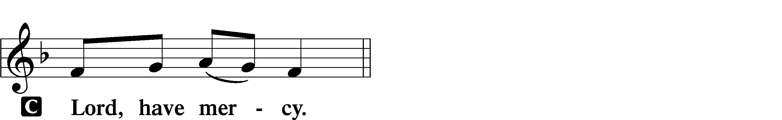

A For the peace from above and for our salvation let us pray to the Lord.
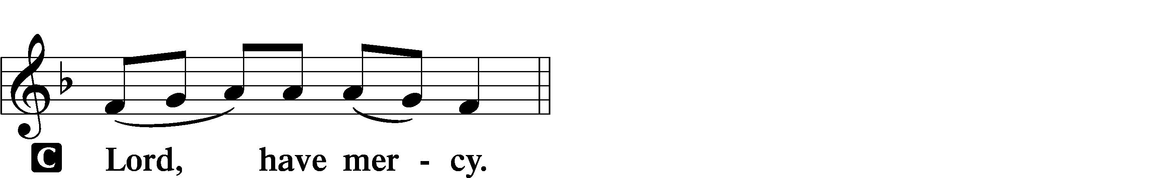

A For the peace of the whole world, for the well-being of the Church of God, and for the unity of all let us pray to the Lord.
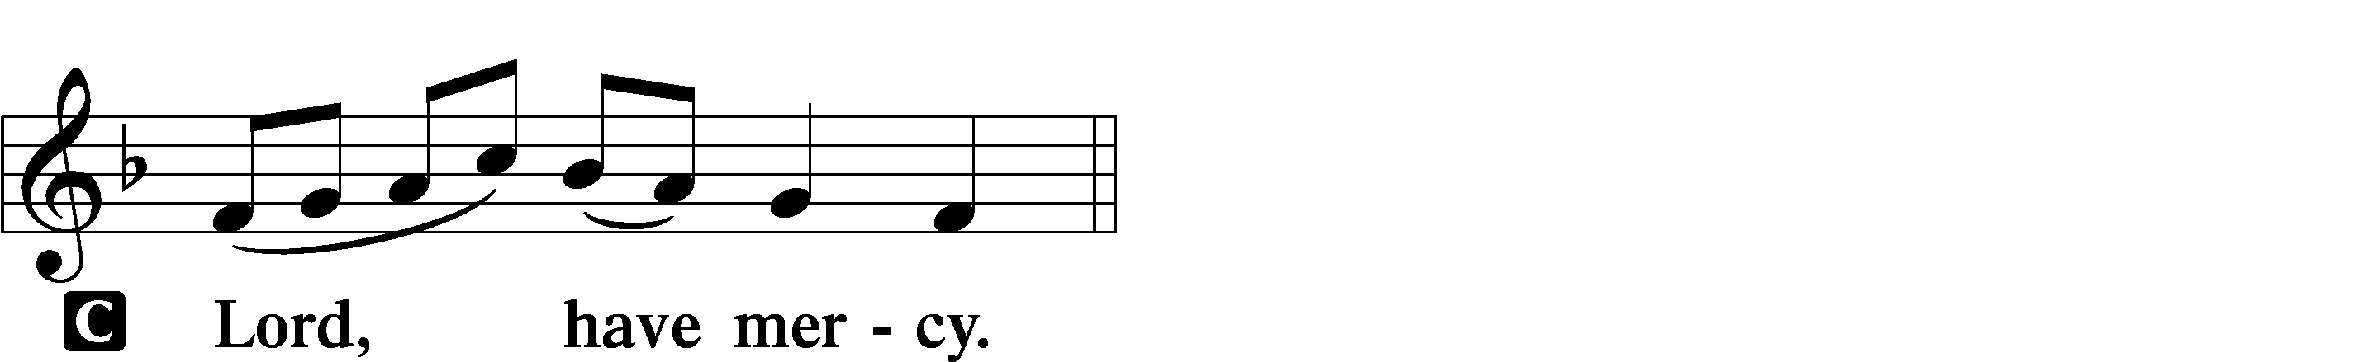

A For this holy house and for all who offer here their worship and praise let us pray to the Lord.
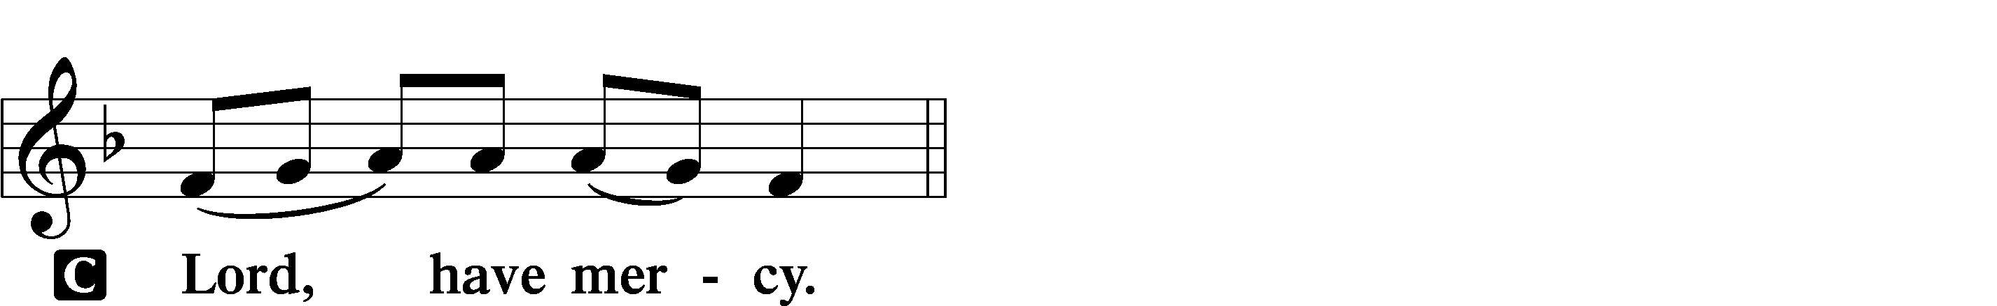

A Help, save, comfort, and defend us, gracious Lord.

Gloria in Excelsis LSB 154
A Glory to God in the highest, and peace to His people on earth.
C Lord God, heavenly king, almighty God and Father:
We worship You, we give You thanks, we praise You for Your glory.
Lord Jesus Christ, only Son of the Father, Lord God, Lamb of God:
You take away the sin of the world; have mercy on us.
You are seated at the right hand of the Father; receive our prayer.
For You alone are the Holy One, You alone are the Lord,
You alone are the Most High, Jesus Christ, with the Holy Spirit,
in the glory of God the Father. Amen.

Salutation and Collect of the Day
P The Lord be with you.
C And also with you.

P Let us pray.
Lord God, heavenly Father, send forth Your Son to lead home His bride, the Church, that with all the company of the redeemed we may finally enter into His eternal wedding feast; through the same Jesus Christ, our Lord, who lives and reigns with You and the Holy Spirit, one God, now and forever.

C Amen.

Sit

Old Testament Reading Amos 5:18–24
¹⁸Woe to you who desire the day of the Lord!
Why would you have the day of the Lord?
It is darkness, and not light,
¹⁹as if a man fled from a lion,
and a bear met him,
or went into the house and leaned his hand against the wall,
and a serpent bit him.
²⁰Is not the day of the Lord darkness, and not light,
and gloom with no brightness in it?
²¹“I hate, I despise your feasts,
and I take no delight in your solemn assemblies.
²²Even though you offer me your burnt offerings and grain offerings,
I will not accept them;
and the peace offerings of your fattened animals,
I will not look upon them.
²³Take away from me the noise of your songs;
to the melody of your harps I will not listen.
²⁴But let justice roll down like waters,
and righteousness like an ever-flowing stream.”

A This is the Word of the Lord.
C Thanks be to God.

Gradual Revelation 7:14b; Psalm 84:5
These are the ones coming out of the great tribu- | lation.*
They have washed their robes and made them white in the blood | of the Lamb.
Blessèd are those whose strength is | in you,*
in whose heart are the highways to | Zion.

Epistle 1 Thessalonians 4:13–18
¹³But we do not want you to be uninformed, brothers, about those who are asleep, that you may not grieve as others do who have no hope. ¹⁴For since we believe that Jesus died and rose again, even so, through Jesus, God will bring with him those who have fallen asleep. ¹⁵For this we declare to you by a word from the Lord, that we who are alive, who are left until the coming of the Lord, will not precede those who have fallen asleep. ¹⁶For the Lord himself will descend from heaven with a cry of command, with the voice of an archangel, and with the sound of the trumpet of God. And the dead in Christ will rise first. ¹⁷Then we who are alive, who are left, will be caught up together with them in the clouds to meet the Lord in the air, and so we will always be with the Lord. ¹⁸Therefore encourage one another with these words.

A This is the Word of the Lord.
C Thanks be to God.

Stand

Alleluia and Verse LSB 156
C Alleluia.
Lord, to whom shall we go?
You have the words of eternal life.
Alleluia, alleluia.

Holy Gospel Matthew 25:1–13
P The Holy Gospel according to St. Matthew, the twenty-fifth chapter.
C Glory to You, O Lord.

¹[Jesus said:] “The kingdom of heaven will be like ten virgins who took their lamps and went to meet the bridegroom. ²Five of them were foolish, and five were wise. ³For when the foolish took their lamps, they took no oil with them, ⁴but the wise took flasks of oil with their lamps. ⁵As the bridegroom was delayed, they all became drowsy and slept. ⁶But at midnight there was a cry, ‘Here is the bridegroom! Come out to meet him.’ ⁷Then all those virgins rose and trimmed their lamps. ⁸And the foolish said to the wise, ‘Give us some of your oil, for our lamps are going out.’ ⁹But the wise answered, saying, ‘Since there will not be enough for us and for you, go rather to the dealers and buy for yourselves.’ ¹⁰And while they were going to buy, the bridegroom came, and those who were ready went in with him to the marriage feast, and the door was shut. ¹¹Afterward the other virgins came also, saying, ‘Lord, lord, open to us.’ ¹²But he answered, ‘Truly, I say to you, I do not know you.’ ¹³Watch therefore, for you know neither the day nor the hour.”

P This is the Gospel of the Lord.
C Praise to You, O Christ.

Sit

516 Wake, Awake, for Night Is Flying
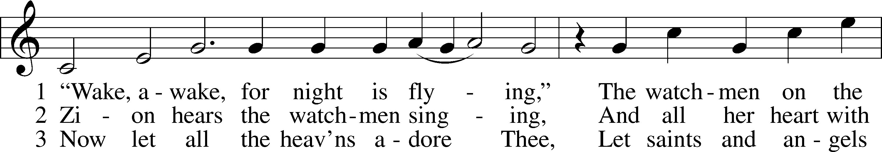
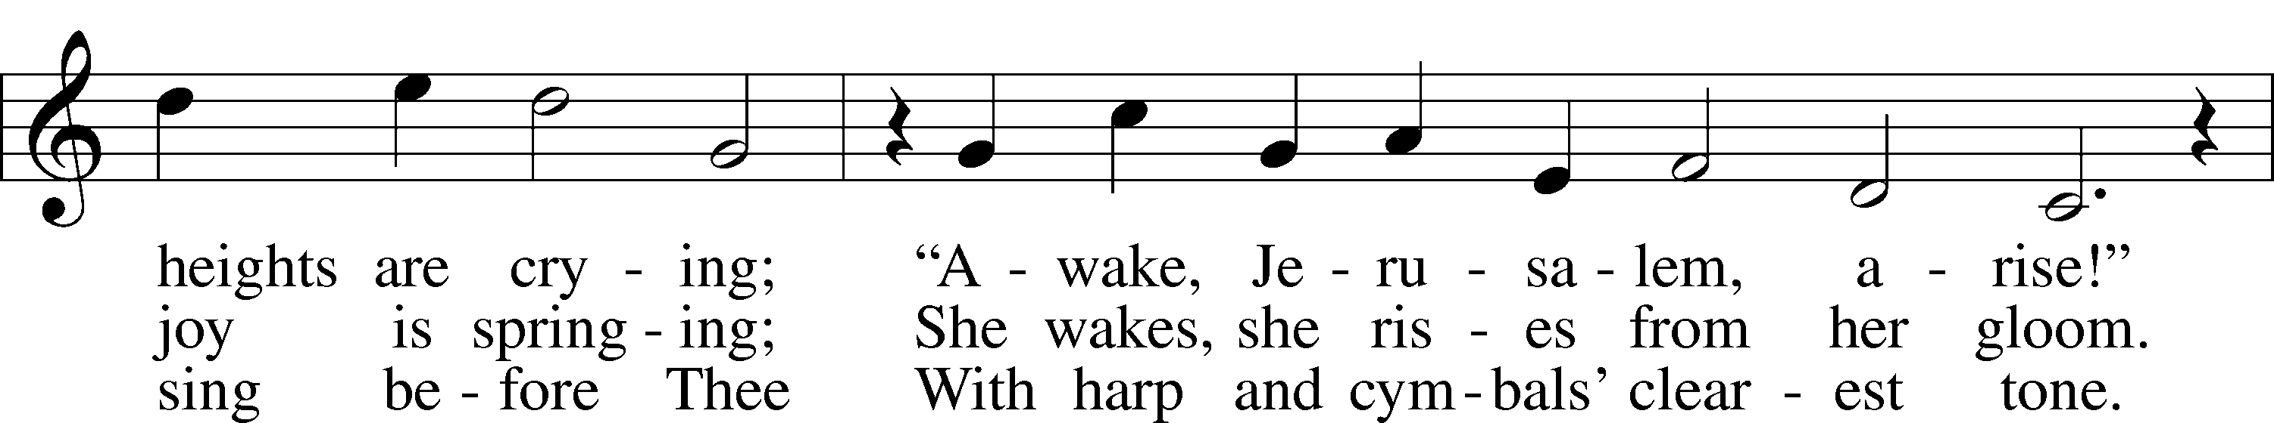
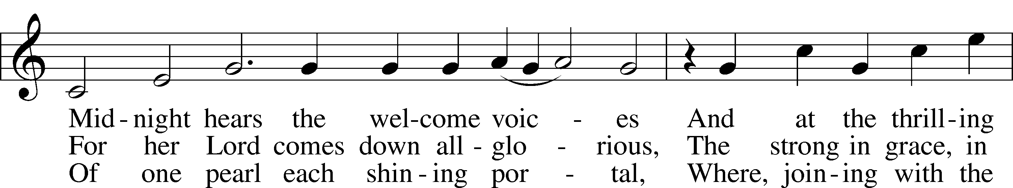
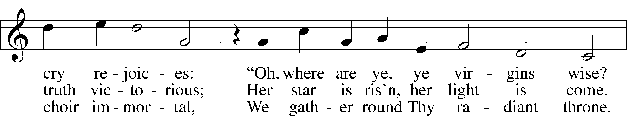
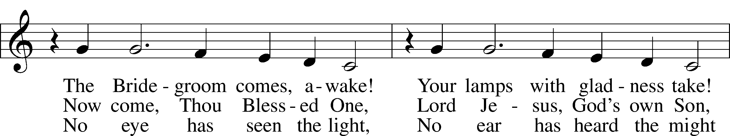
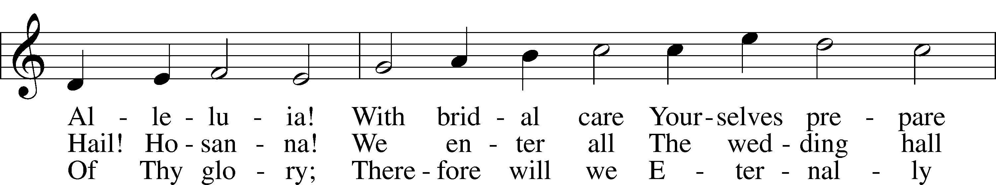
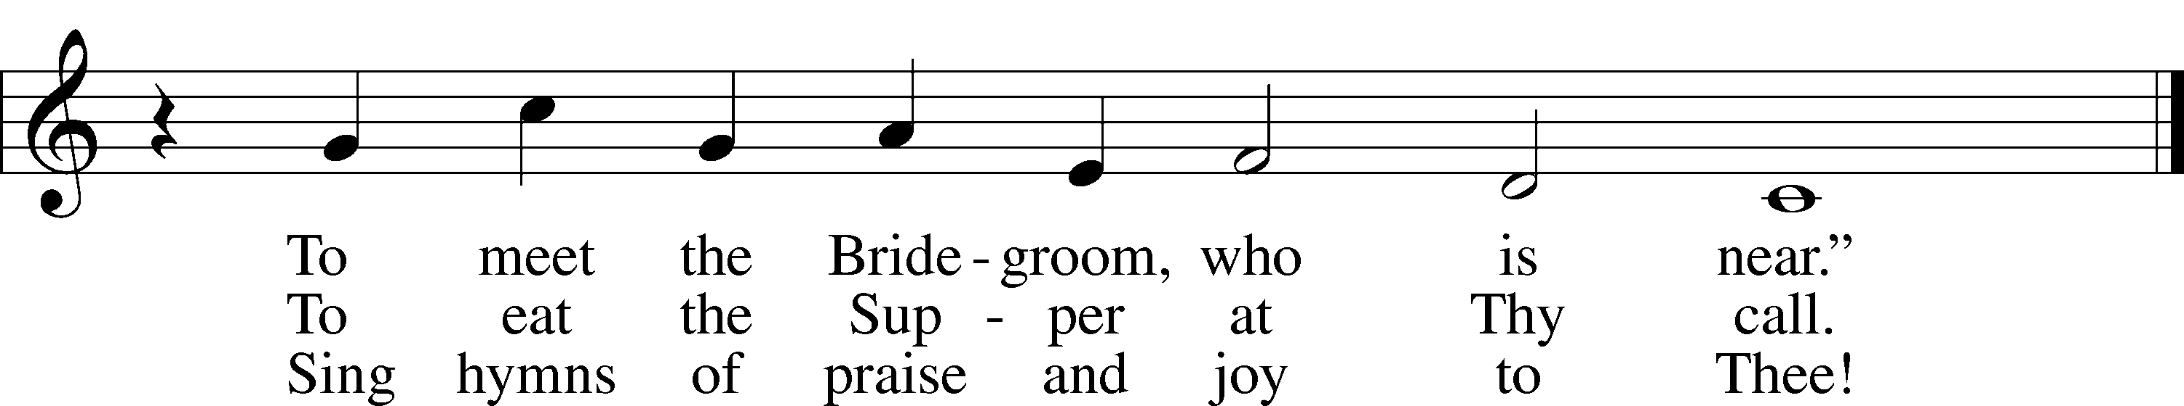
Text and tune: Public domain

Sermon

Stand

Apostles’ Creed
C I believe in God, the Father Almighty,
maker of heaven and earth.

And in Jesus Christ, His only Son, our Lord,
who was conceived by the Holy Spirit,
born of the virgin Mary,
suffered under Pontius Pilate,
was crucified, died and was buried.
He descended into hell.
The third day He rose again from the dead.
He ascended into heaven
and sits at the right hand of God the Father Almighty.
From thence He will come to judge the living and the dead.

I believe in the Holy Spirit,
the holy Christian Church,
the communion of saints,
the forgiveness of sins,
the resurrection of the body,
and the life T everlasting. Amen.

Prayer of the Church

Offertory LSB 159
C What shall I render to the Lord for all His benefits to me?
I will offer the sacrifice of thanksgiving and will call on the name of the Lord.
I will take the cup of salvation and will call on the name of the Lord.
I will pay my vows to the Lord now in the presence of all His people,
in the courts of the Lord’s house, in the midst of you, O Jerusalem.

Service of the Sacrament

Preface LSB 160
P The Lord be with you.

P Lift up your hearts.

P Let us give thanks to the Lord our God.
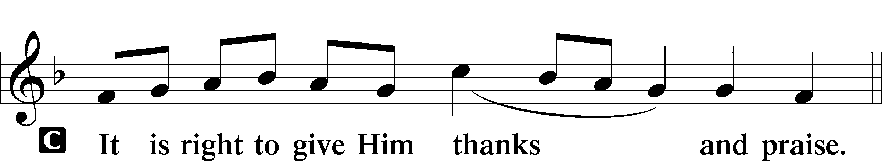

Proper Preface
P It is truly good, right, and salutary that we should at all times and in all places give thanks to You, holy Lord, almighty Father, everlasting God, through Jesus Christ, our Lord, who on this day overcame death and the grave and by His glorious resurrection opened to us the way of everlasting life. Therefore with angels and archangels and with all the company of heaven we laud and magnify Your glorious name, evermore praising You and saying:

Sanctus LSB 161
C Holy, holy, holy Lord God of pow’r and might:
Heaven and earth are full of Your glory.
Hosanna. Hosanna.
Hosanna in the highest.
Blessed is He who comes in the name of the Lord.
Hosanna in the highest.

Lord’s Prayer
C Our Father who art in heaven,
hallowed be Thy name,
Thy kingdom come,
Thy will be done on earth
as it is in heaven;
give us this day our daily bread;
and forgive us our trespasses
as we forgive those
who trespass against us;
and lead us not into temptation,
but deliver us from evil.
For Thine is the kingdom
and the power and the glory
forever and ever. Amen.

The Words of Our Lord
P Our Lord Jesus Christ, on the night when He was betrayed, took bread, and when He had given thanks, He broke it and gave it to the disciples and said: “Take, eat; this is My T body, which is given for you. This do in remembrance of Me.”

In the same way also He took the cup after supper, and when He had given thanks, He gave it to them, saying: “Drink of it, all of you; this cup is the new testament in My T blood, which is shed for you for the forgiveness of sins. This do, as often as you drink it, in remembrance of Me.”

Pax Domini LSB 163
P The peace of the Lord be with you always.
C Amen.

Agnus Dei LSB 163
C Lamb of God, You take away the sin of the world; have mercy on us.
Lamb of God, You take away the sin of the world; have mercy on us.
Lamb of God, You take away the sin of the world; grant us peace.

Sit

Distribution

621 Let All Mortal Flesh Keep Silence
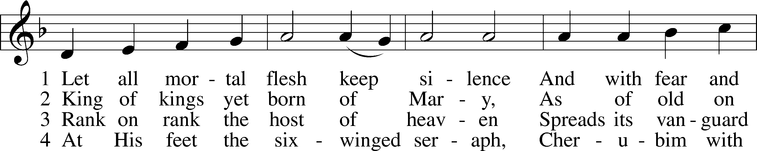
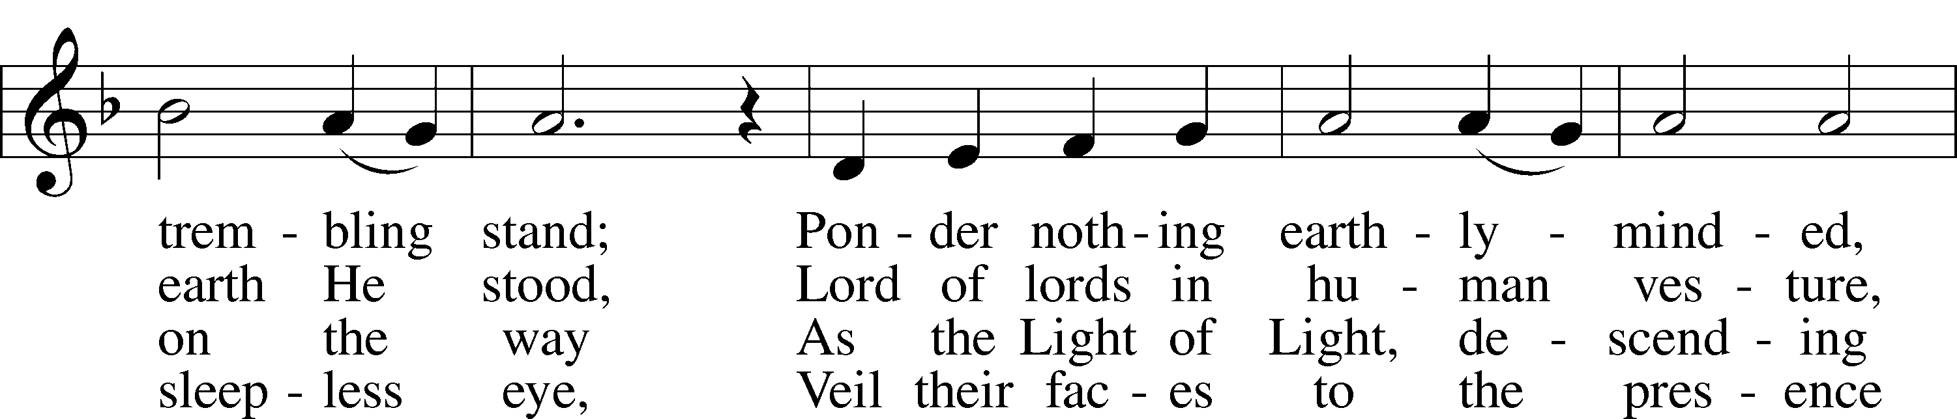
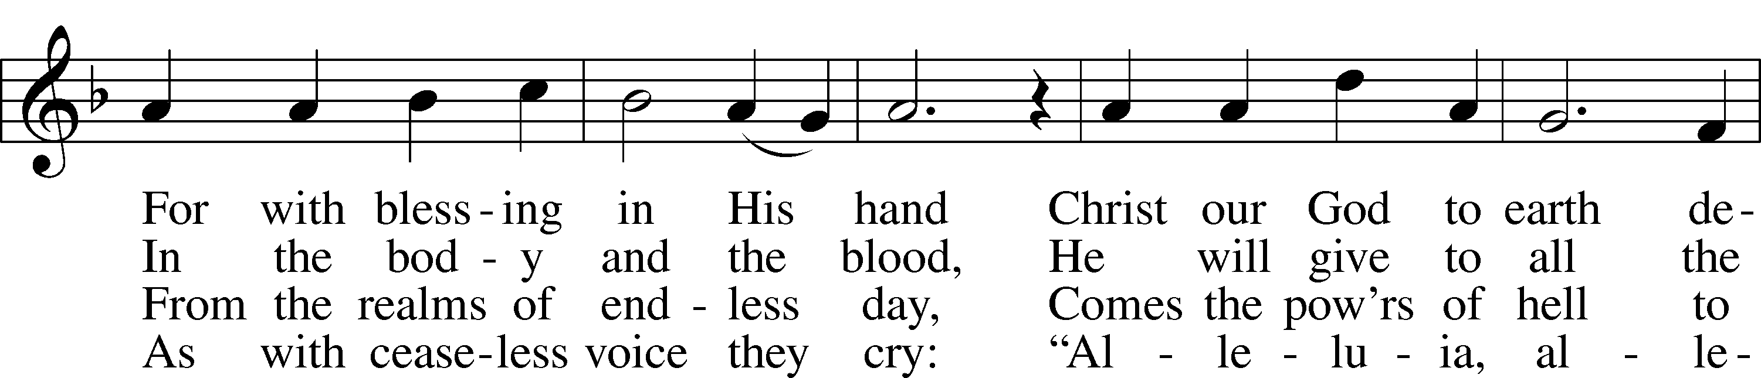
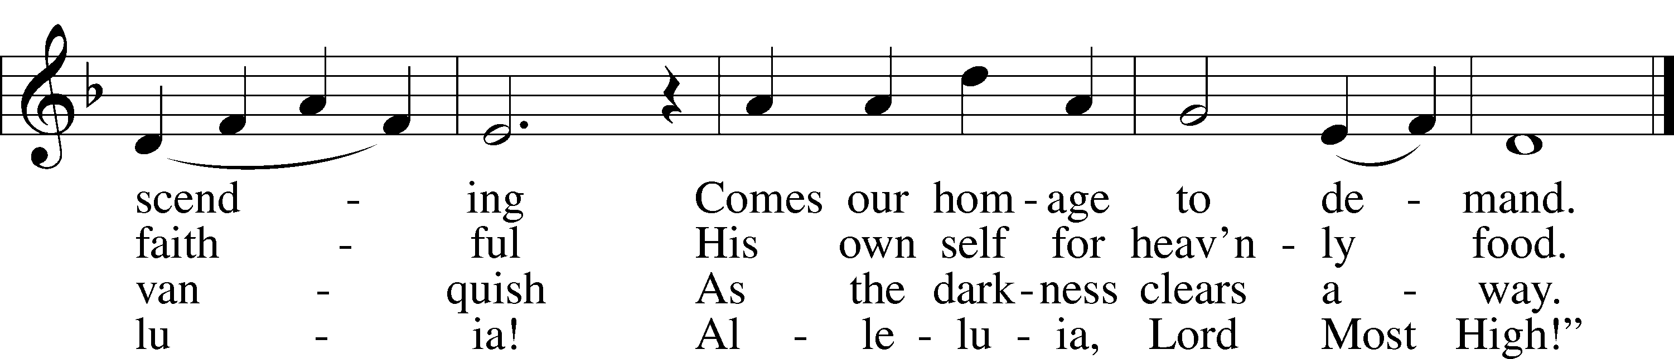
Text and tune: Public domain

636 Soul, Adorn Yourself with Gladness sts. 1–2, 4–5, 7
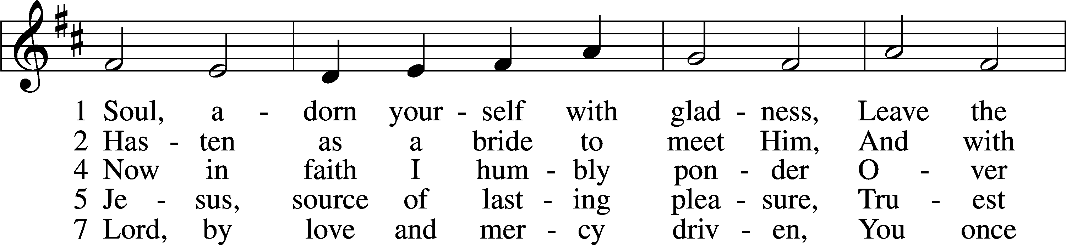
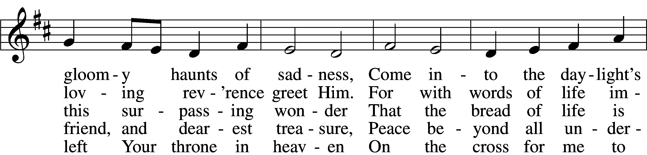
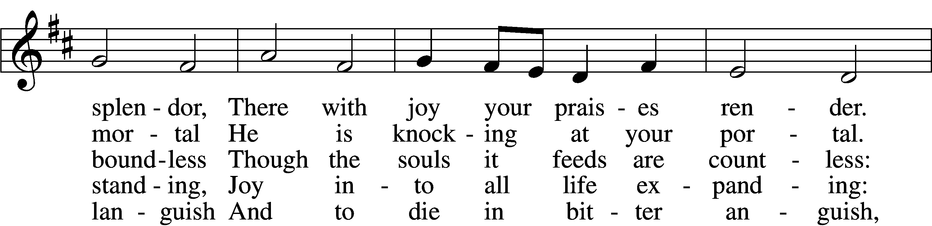
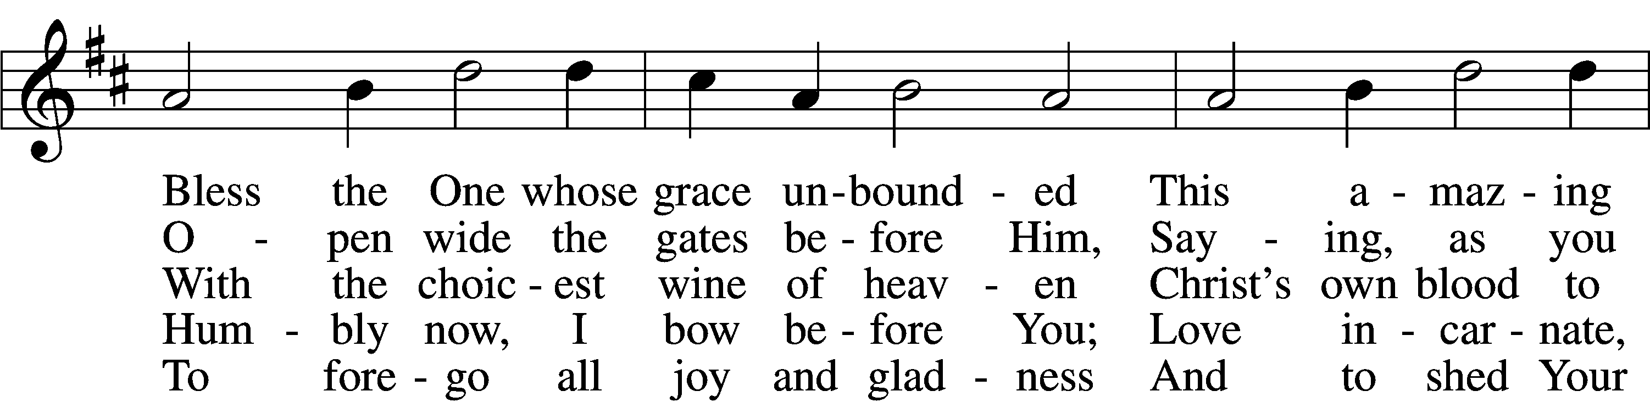
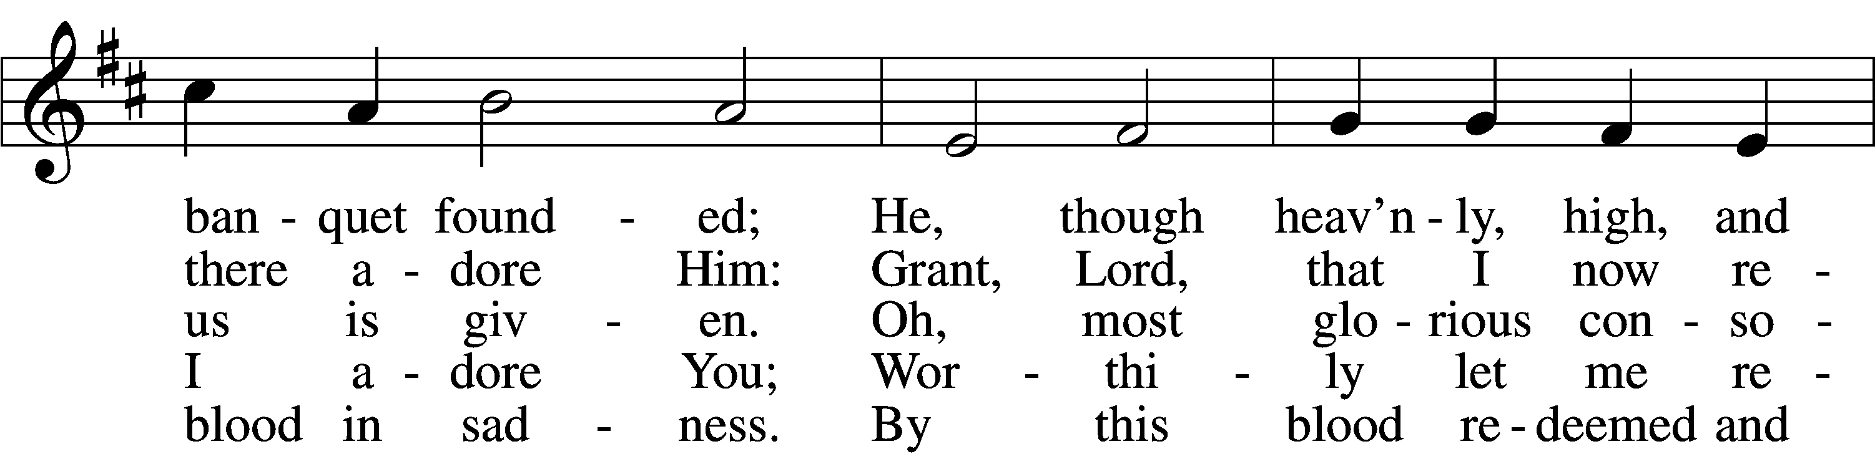
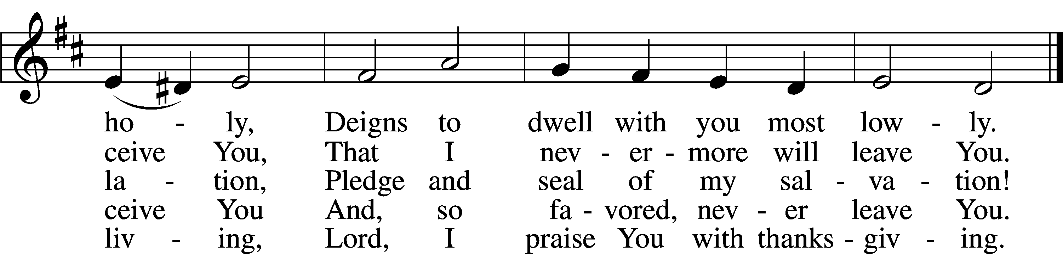
Tune and text: Public domain
Text (sts. 1, 4–5): © 1978 Lutheran Book of Worship. Used by permission: LSB Hymn License no. 110003744

720 We Walk by Faith and Not by Sight
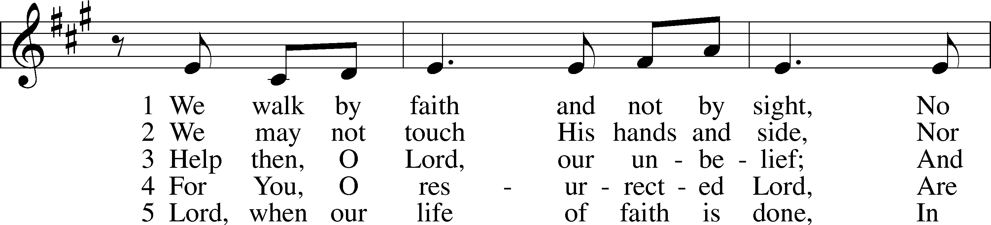
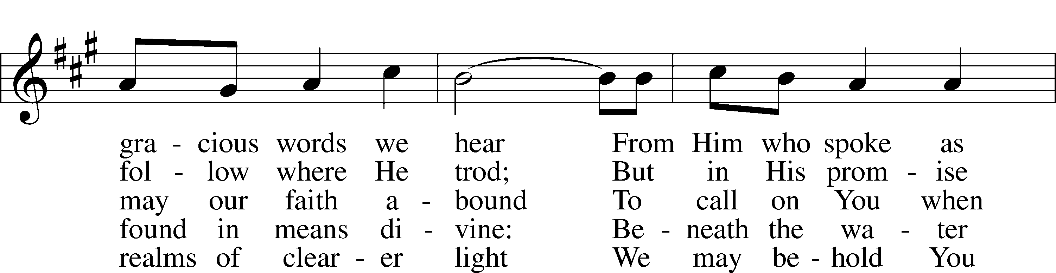
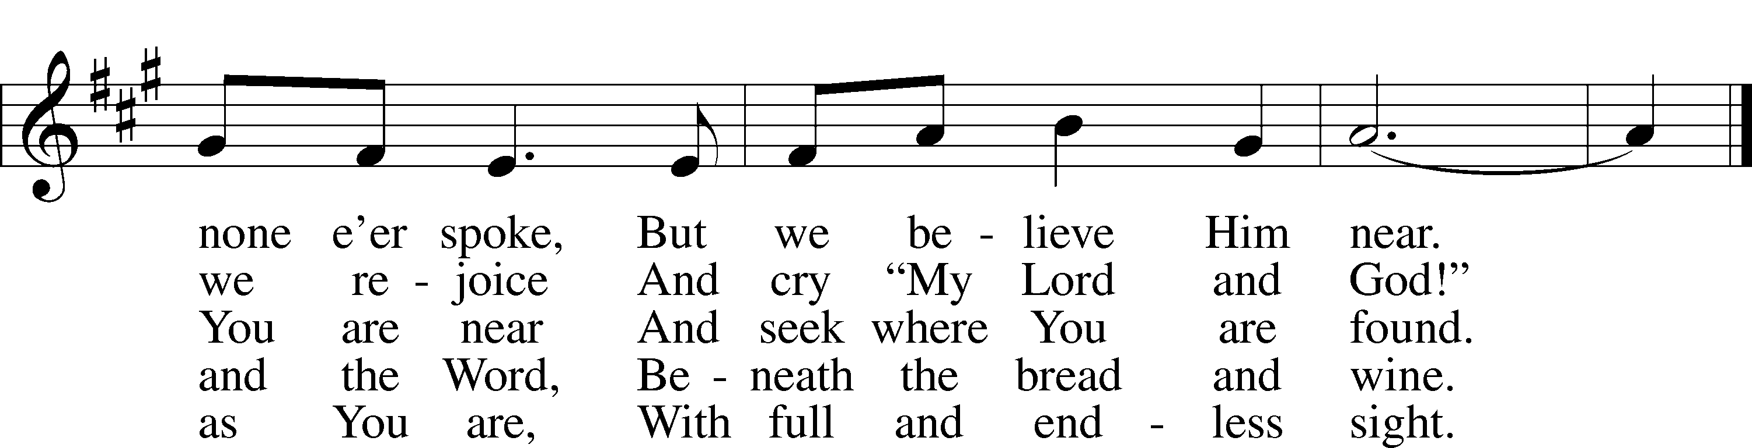
Tune: © 1984 GIA Publications, Inc. Used by permission: LSB Hymn License no. 110003744
Text: Public domain

Stand

The Dismissal
P The body and blood of our Lord Jesus Christ strengthen and preserve you in body and soul to life everlasting. Depart T in peace.
C Amen.

Thank the Lord LSB 164
C Thank the Lord and sing His praise; tell ev’ryone what He has done.
Let all who seek the Lord rejoice and proudly bear His name.
He recalls His promises and leads His people forth in joy
with shouts of thanksgiving. Alleluia, alleluia.

Post-Communion Collect
A Let us pray.
Gracious God, our heavenly Father, You have given us a foretaste of the feast to come in the Holy Supper of Your Son’s body and blood. Keep us firm in the true faith throughout our days of pilgrimage that, on the day of His coming, we may, together with all Your saints, celebrate the marriage feast of the Lamb in His kingdom which has no end; through Jesus Christ, Your Son, our Lord, who lives and reigns with You and the Holy Spirit, one God, now and forever.
C Amen.

Benediction LSB 166
P The Lord bless you and keep you.
The Lord make His face shine on you and be gracious to you.
The Lord look upon you with favor and T give you peace.
C Amen.

514 The Bridegroom Soon Will Call Us
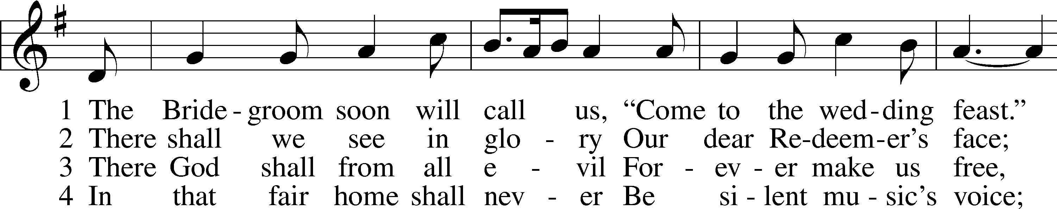
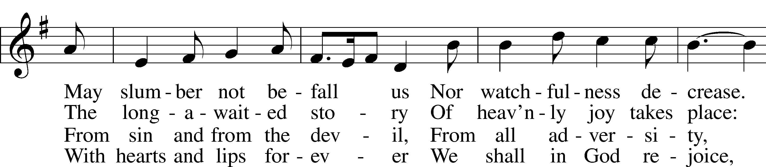
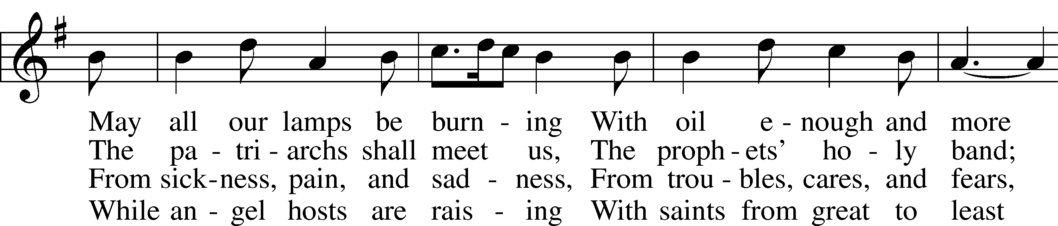
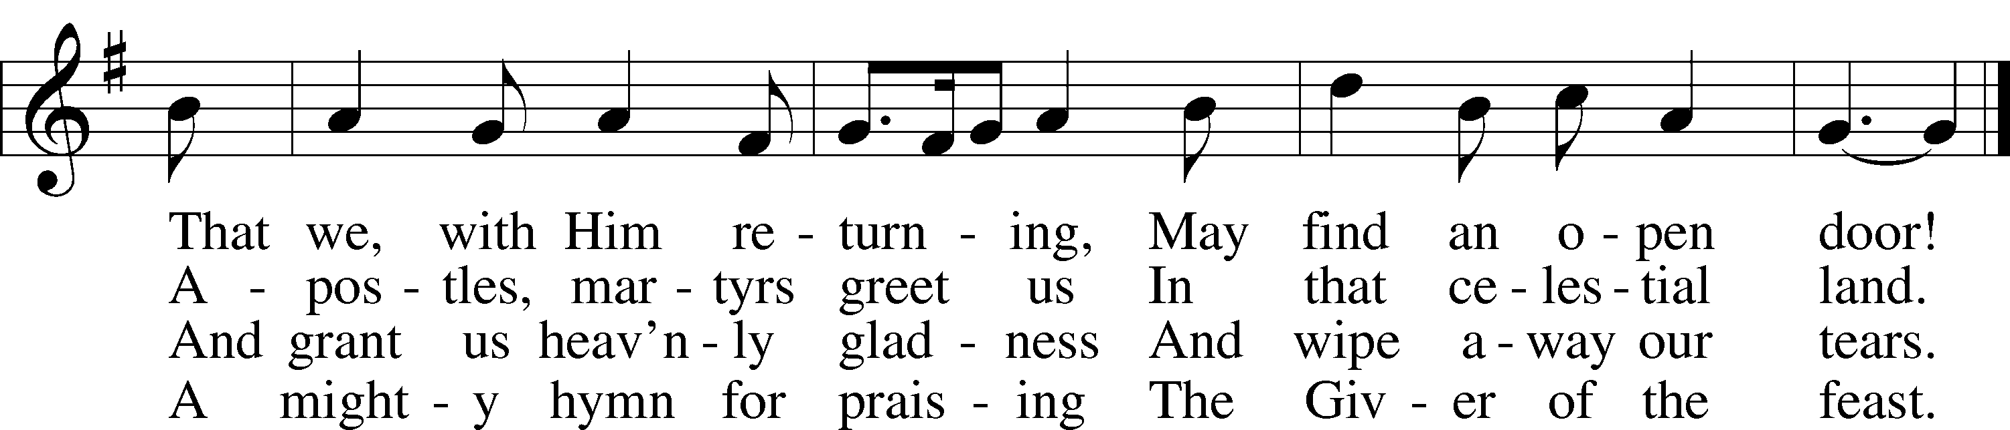
Tune and text: Public domain
Text (st. 1): © 1982 Concordia Publishing House. Used by permission: LSB Hymn License no. 110003744

Acknowledgments
Unless otherwise indicated, Scripture quotations are from the ESV® Bible (The Holy Bible, English Standard Version®), copyright © 2001 by Crossway, a publishing ministry of Good News Publishers. Used by permission. All rights reserved.
Created by Lutheran Service Builder © 2020 Concordia Publishing House.

Prayers for Our Members
Robin Baker, Bailey Hockemeier, Leah Vogel | Expectant Mothers
Norman Abels (Brookestone Meadows – Elkhorn) | Healing
Judy Ahrens (St. Luke’s) | Healing
Vaughn Albrecht (Northridge) | Healing
Tom & DyAnn Altwine | Healing
David Banner | Healing
Lyle Colsden (Mother Hull) | Healing
Pat Flodine (Cambridge Court) | Healing
Vi Fox (Prairie View) | Healing
Verleen Gentry | Healing
Ruby Hatfield | Healing
Michelle Millsap | Healing
Roger Riekenberg | Healing
Marion Richmond | Healing
Geraldine Roeder | Healing
Lavern Stuehm | Healing
Fran Junge | Cancer
Bev Nuttelman | Cancer
Kim Vos | Cancer

Prayers for Our Members’ Family & Friends
Brandon & Shannon Howell (Quentin & Janel Lange’s friends) | Family
Will Brennemann (Jami Helmbrecht’s father) | Healing
Reg Duke (Westman’s brother-in-law) | Healing
James Gentry (Verleen Gentry’s son) | Healing
Roger Hoffman (Marc’s father) | Healing
Sharon Kreutzer (former member) | Healing
Lyra Mais (Zion student) | Healing
Randy Solomon (Beth Rosenthal’s father) | Healing
Mary Ann Mertz (Pam’s Uhlir’s friend) | Healing
Roy Reynolds (Verleen Gentry’s son-in-law) | Healing
Janet Stalder (Carol Florang’s sister) | Healing
D.D. Dugger (Sue Kaiser’s brother) | Cancer
Ron Halvorsen (Jeff’s dad) | Cancer
Carol Haubold (Don Helmbrecht’s sister) | Cancer
Tyler Holland (Quentin & Janel Lange’s brother-in-law) | Cancer
Randy Jochum (Ken Hockemeier’s brother-in-law) | Cancer
Fred Koch (Pam Uhlir’s cousin) | Cancer
Lynda Kreutzer (Rich & Carol’s sister-in-law) | Cancer
Sharon Mulhair (Pam Uhlir’s cousin) | Cancer
Becky Rathkie (former Zion teacher) | Cancer
Jeannie Schmidt (Lisa Splittgerber’s sister-in-law) | Cancer
Tyrone Uhlir (Pam’s nephew) | Cancer

Today’s Radio Broadcast is given to the Glory of the Lord by Cheryl Scarborough for her birthday

Today’s altar flowers is given to the Glory of the Lord by
Cheryl Scarborough for her birthday

Serving in Worship

Sunday, November 8~ 9:00am  Elder: Dan Oertwig  Usher: Marc Hoffman &  Steve Junge  Engineer: Zach DeLoach  Announcer: Brooke Fisher  Altar Guild: Brooke Fisher &  Tracy Schake | Sunday, November 15~ 9:00am  Elder: Nathan Gaunt  Usher: Robert Glanzer  Engineer: Jared Nuttelman  Announcer: Jesse Florang  Altar Guild: Brooke Fisher &  Tracy Schake

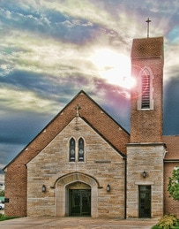

Our Response to the Gospel

Date: 11/01/2020

Offering: $6,794.65
Weekly Need: $7,542.37

ZION LUTHERAN CHURCH AND SCHOOL

Pr. James DeLoach, Pastor + (308) 627-5260
james.deloach@zionkearney.org
Pr. Doug Gaunt, Pastor + (308) 455-0552
doug.gaunt@zionkearney.org
Tony Splittgerber, Principal + (308) 293-0168
anthony.splittgerber@zionkearney.org

Church Office
Administrative Assistant: Jessica Shiers
Email: school@zionkearney.org
Phone: (308)-234-3410 Fax: (308) 236-8100
Office Hours: Monday-Friday 8:00am-4:00pm
Radio Broadcast: Sunday @ 10:30 a.m. on 1460 AM
Website: www.zionkearney.com

Where our Triune God strengthens us through His mercy in faith toward Him and in fervent love toward one another.

This Week at Zion

Sun  11/08 | 9:00a  10:30a | Divine Service  Radio Broadcast 1460am
Mon  11/09 | 7:00p  Birthdays  Anniversaries | Mary Martha - FH  ---  ---
Tues  11/10 | 1:30p  7:00p  7:00p  Birthdays  Anniversaries | Sleeping Mats  Bd of Elders  Bd of Trustees  LaRae Crow  ---
Wed  11/11 | 8:25a  9:00a  5:45p  7:00p  Birthdays  Anniversaries | K-8th Chapel  ECE Chapel  Midweek Class  Adult Choir  Bailey Helmbrecht  Doreen Lemburg  Phyllis Willuweit  ---
Thurs  11/12 | Birthdays  Anniversaries | Pamela Uhlir  ---
Fri  11/13 | Birthdays  Anniversaries | ---  ---
Sat  11/14 | 5:00p  Birthdays  Anniversaries | Divine Service  Cheryl Scarborough  ---
Sun  11/15 | 9:00a  10:30a  Birthdays  Anniversaries | Divine Service  Radio Broadcast 1460am  ---  ---
ANNOUNCEMENTS

Mary Martha – Mary Martha will meet in the fellowship hall on November 9th at 7:00p.m. Both circles will meet together.

Thanksgiving Meal Cancelled – The Mary Martha Guild has made the decision to NOT have our Thanksgiving meal this year because of Covid-19 concerns. We plan to make every effort to bring it back next year.

Food Collection – Zion will collect food items during the month of November to help supply Kearney agencies who assists the needy. There will be grocery carts in the narthex and school are to gather these items. Non-perishable items only please.

Poinsettias – Zion will be taking poinsettia orders to adorn the Church Sanctuary during Christmas time. They will be $14.00 per plant. To order there is an envelope in the narthex, place your money in the envelope with your name, place the envelope in the offering plate or the mail slot on the south side of the building or drop it off during office hours. Please make checks out to Mary Martha.

Volunteering Opportunities – Zion needs volunteers to help with the audio, video, and ushers for our worship service. Training will be provided. Please contact the office or Pr. DeLoach if interested or with questions.

A Bible Study – is prerecorded and available each Sunday, along with a study guide you can use to follow along. We are studying the three lessons for the day—the Old Testament, the Epistle, and the Gospel. Go to Zion’s website www.zionkearney.com to access the video and study guide.

Offering during this time. If you are not able to attend live Church Services, you may: drop your offering in the mail slot by the south doors, mail it to the church, or use online giving option at zionkearney.com. If you have any questions or need assistance please contact the office at 308-234-3410 or school@zionkearney.org. Thank you for supporting of your church!

Radio Broadcast & Altar Flowers - Please help Zion spread the Gospel! There are several open dates. This is a great need during this time, many people are listening to our broadcast during this time. There are also many openings for altar flowers. Please help beautify the sanctuary.

Mission Offerings - The fourth quarter missions, October through December, will support those preparing for fulltime church work (Peter Kreutzer and Taylor Zehendner, both at CUNE). If you would like to donate to this mission please use the mission envelopes located in the narthex. Thank you for your support.

Apple Market Receipts – Apple Market receipts will be accepted from register dates September 1, 2020 – March 1, 2021. Please turn in your receipts to the office to earn free things for the school!

Family Fresh Receipts –Don’t forget that Zion collects Family Fresh receipts any date. Please turn them into the office.

Boxtops –Boxtops has discontinued the labels on the packages. They now have an app for your smartphone to redeem qualifying products. If you do not have a smartphone or don’t want to install the app turn your grocery receipts with qualifying boxtop products into the office and they will get scanned to continue to earn money for Zion.

2021 Radio & Flower Charts – The 2021 radio and flower charts are posted in the hallway by the mailboxes. If there is a special day make sure you sign up early. You are welcome to call the office to sign up for your spot.

The Lord’s Prayer Booklet – There is a Lord’s Prayer Booklet, to assist with your devotions, on the counter in the narthex. Feel free to take one. These are compliments of Pastor & Carol Gaunt.

Give Where You Live - This year Zion will be participating in Give Where You Live Campaign. It will be December 3rd (giving day), but donations will be accepted beginning November 5th. To contribute online go to: https://www.givewhereyoulive.net//zionlutheranschool. If you would rather give in person feel free to stop by the office. Please share this with family and friends.

Heartland Lutheran Blood Drive – On Friday, November 13 from 8:30am-2:30pm Heartland Lutheran will be holding a blood drive. Please call Mrs. Zehendner at 308-385-3900 to schedule an appointment time.

Organ Available – I am moving and must part with my 2-manual, full-pedal Rodgers organ. I am a former organ teacher and church organist, so parting with the organ isn't easy. I'm hoping a congregation, school, or individual can provide it continued use. I may be reached at Enidhansen11@gmail.com or by calling 308.440.8087. Thank you,

Employment Opportunities at Zion

2020 has been a real year of change and through it all Zion has been blessed with a remarkably steady and stable staff. Recently however, personal events have led to some upcoming staff changes and we praying that the Lord will bless these individuals as they move on and also that the Lord will continue to provide Zion with stellar replacements. If you or someone you know may be interested in the following positions, please pass this information along to them and let Mr. Splittgerber know. Thank you!

1) Part-time Cook: We are looking for someone who has some experience/interest in food service. Task include meal prep, serving, and cleaning. Candidate strengths should include time management, kitchen experience, and a positive disposition. This position is for 3 days a week.
2) Elementary School Teacher: Mr. Vogel and family will be moving at the conclusion of this school year so the search for another high quality Lutheran teacher has begun. Full time teachers in our school must be members of the LCMS (or willing to become so). The grade level will most probably be for the 3rd/4th grade.

