Advent Vespers
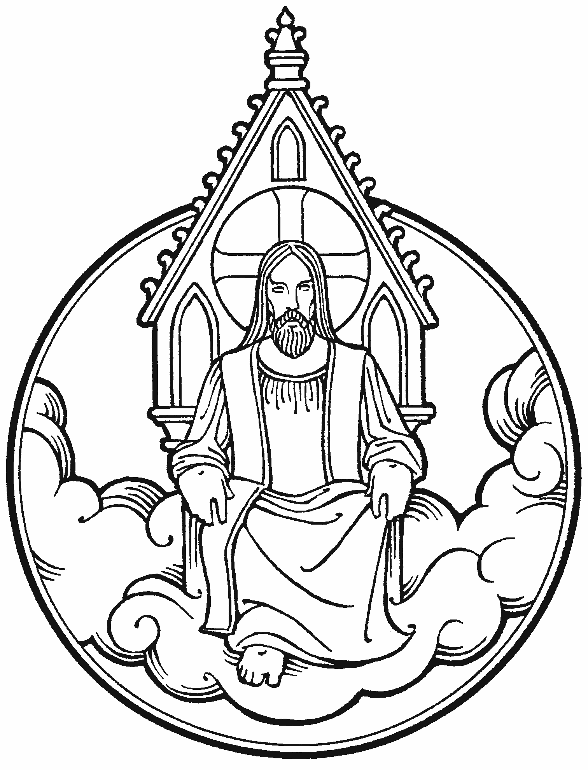

December 9, 2020
7:00p.m.
Zion Lutheran Church
Kearney, Nebraska

Masks – According to Kearney City Ordinance No. 8457 masks are required “at a location that is open to the general public and where they cannot maintain six foot of distance.”

Vespers LSB 229

936 Sing Praise to the God of Israel
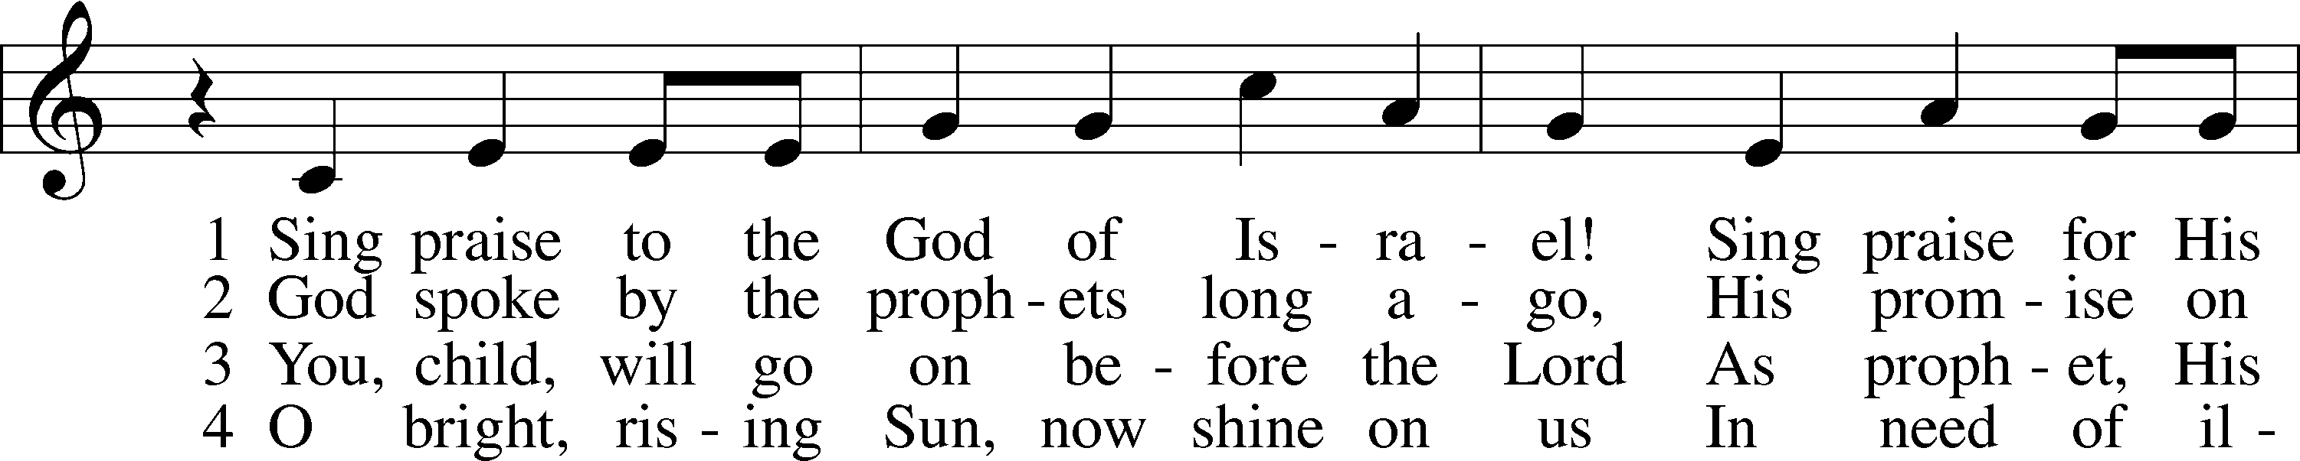
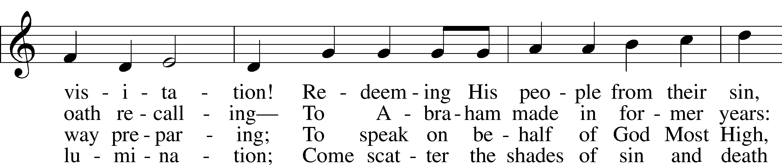
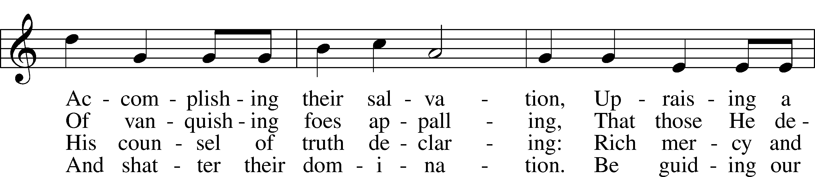
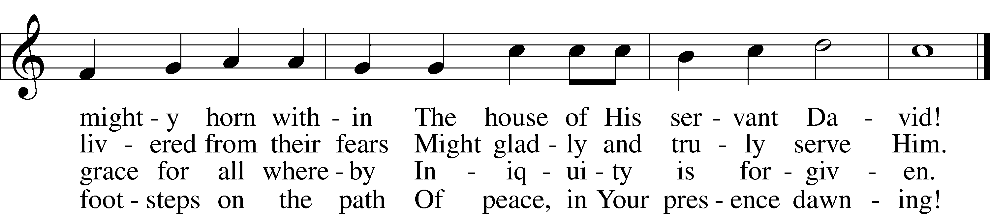
Text: © 1992 Stephen P. Starke, admin. Concordia Publishing House. Used by permission: LSB Hymn License no. 110003744
Tune: Public domain

Stand

L O Lord, open my lips,
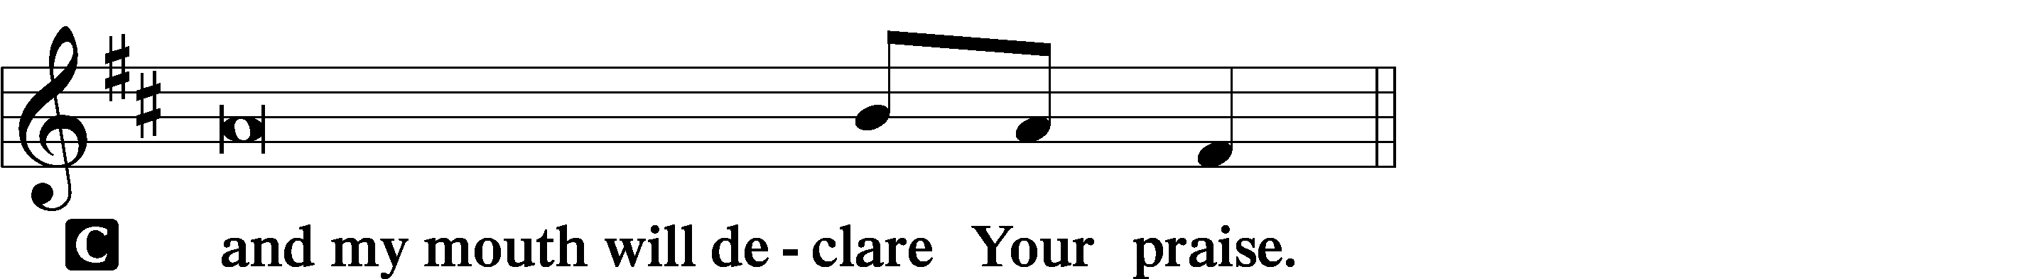

L Make haste, O God, to deliver me;
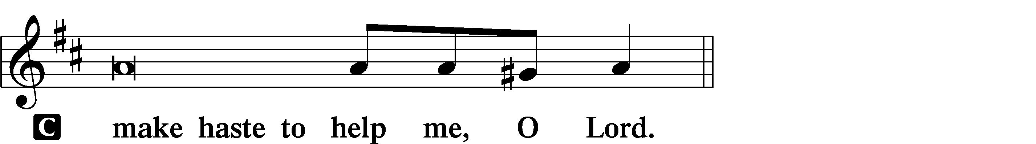

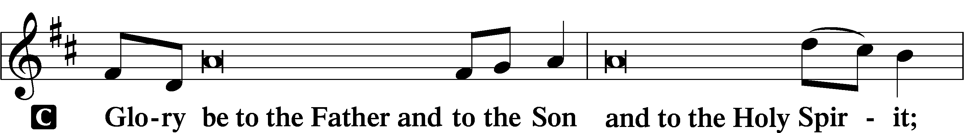
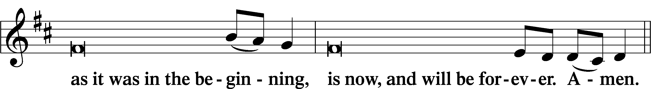
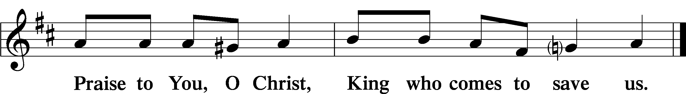

Sit

Readings

Reading Genesis 15:1–6
God’s Covenant with Abram
¹After these things the word of the Lord came to Abram in a vision: “Fear not, Abram, I am your shield; your reward shall be very great.” ²But Abram said, “O Lord God, what will you give me, for I continue childless, and the heir of my house is Eliezer of Damascus?” ³And Abram said, “Behold, you have given me no offspring, and a member of my household will be my heir.” ⁴And behold, the word of the Lord came to him: “This man shall not be your heir; your very own son shall be your heir.” ⁵And he brought him outside and said, “Look toward heaven, and number the stars, if you are able to number them.” Then he said to him, “So shall your offspring be.” ⁶And he believed the Lord, and he counted it to him as righteousness.

Responsory (Advent) LSB 230
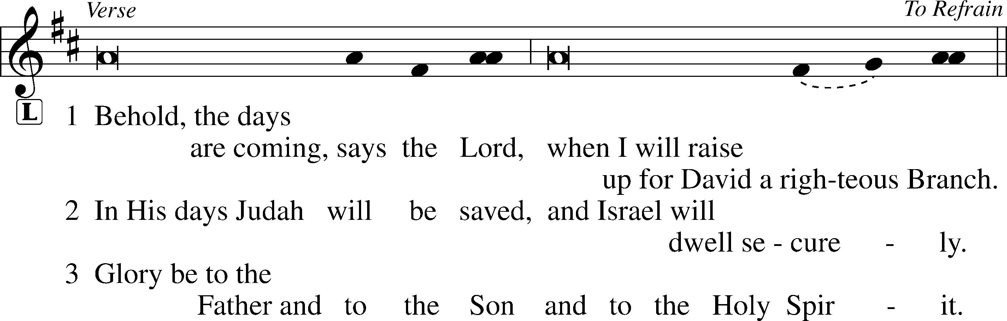
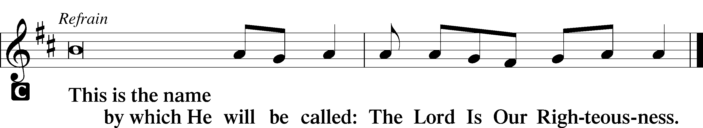

352 Let the Earth Now Praise the Lord
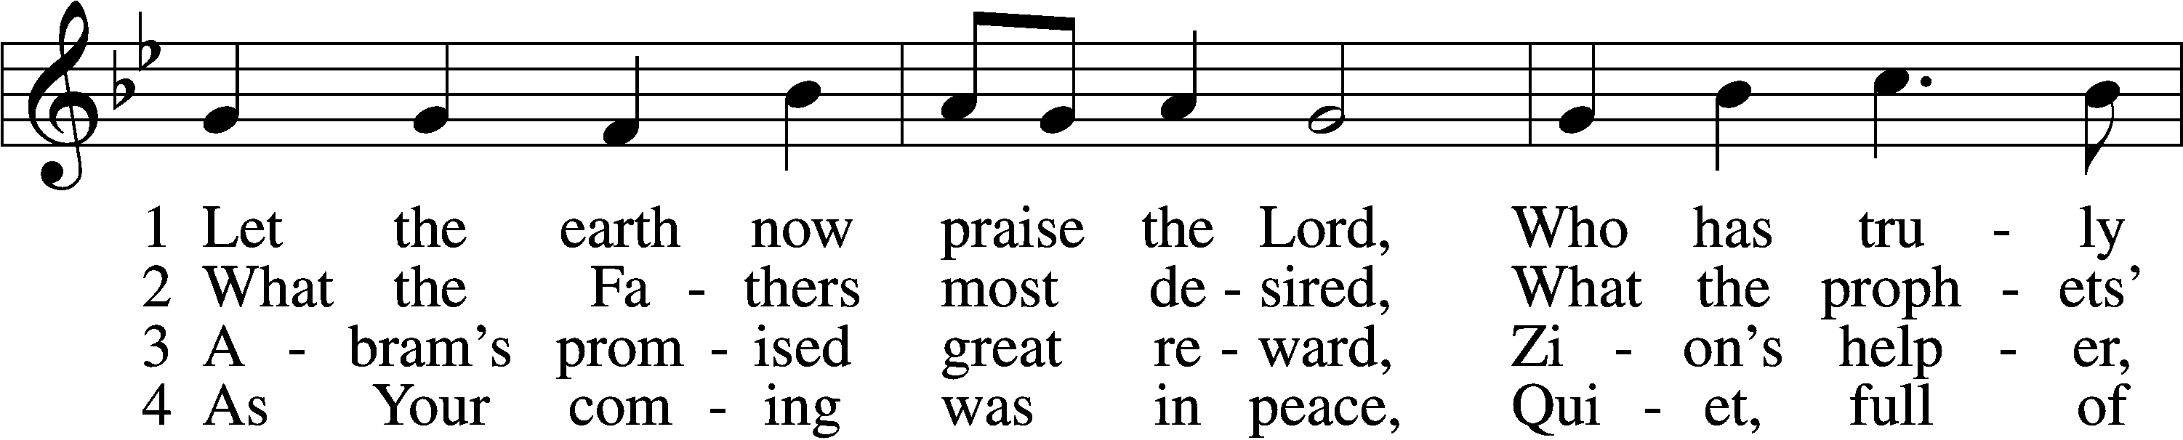
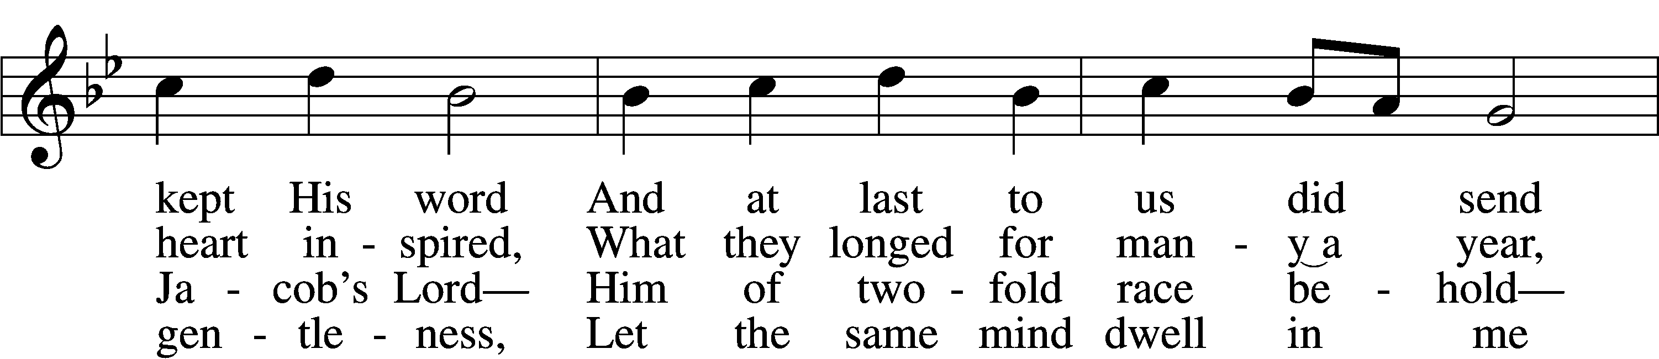
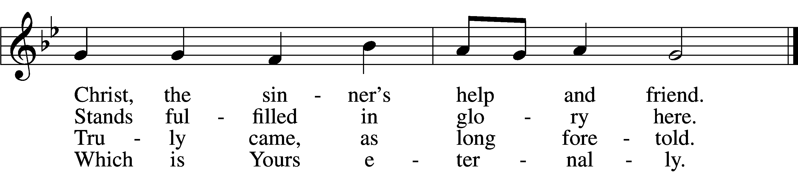

5 Bruise for me the serpent’s head
That, set free from doubt and dread,
I may cling to You in faith,
Safely kept through life and death.

6 Then when You will come again
As the glorious king to reign,
I with joy will see Your face,
Freely ransomed by Your grace. Tune and text: Public domain
Sermon ~ God's Promise to Abraham

Canticle
Stand

933 My Soul Rejoices
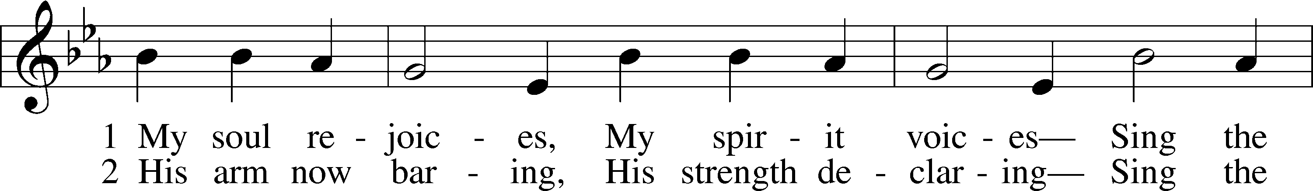
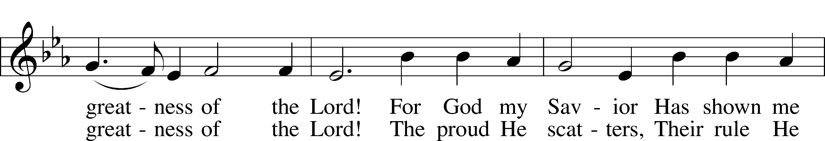
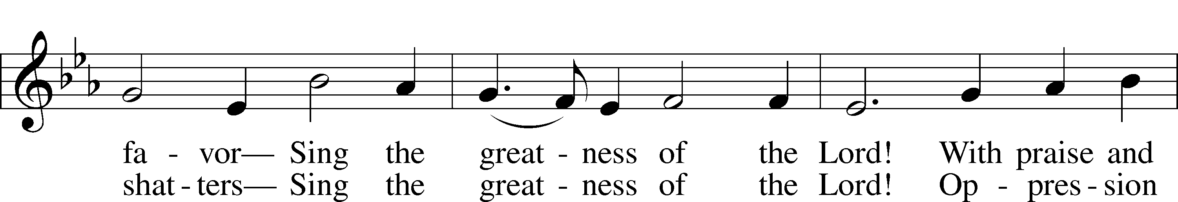
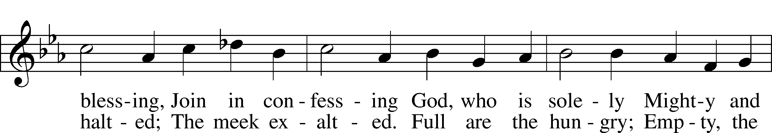
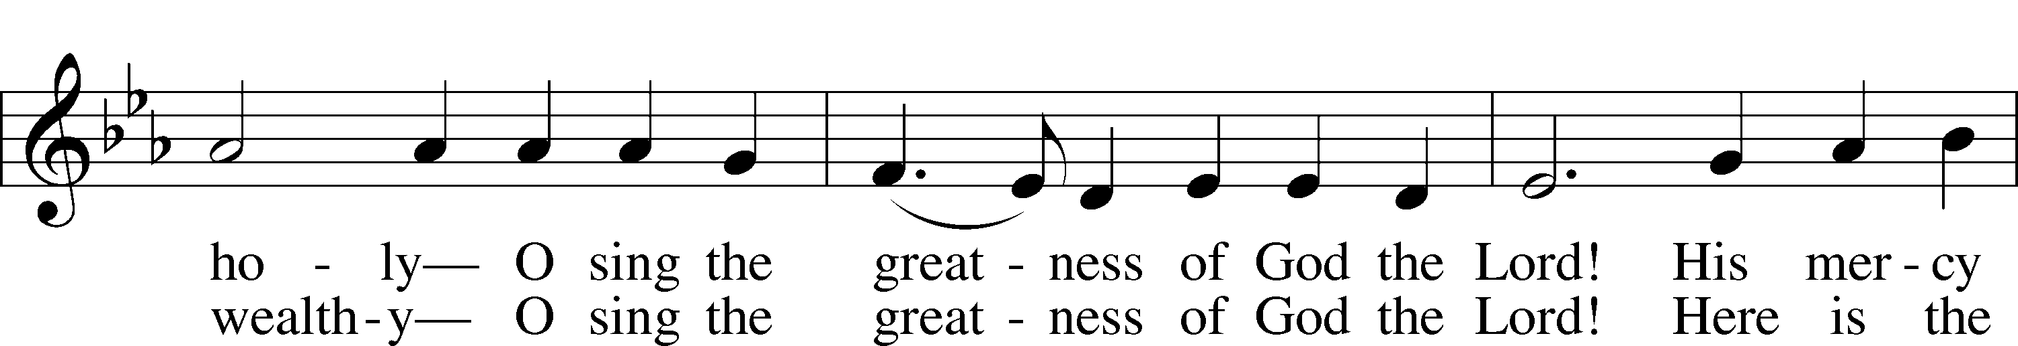
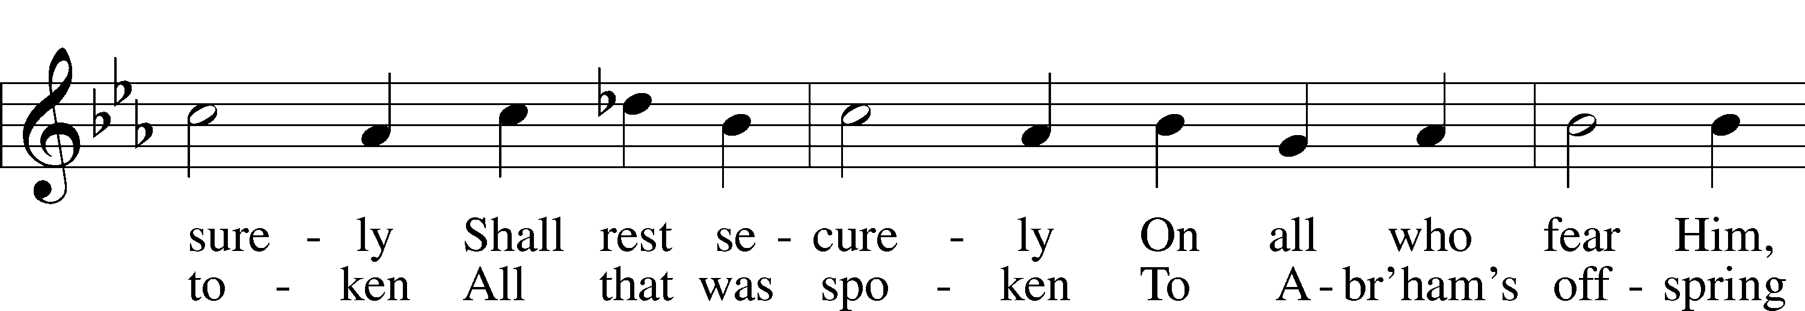
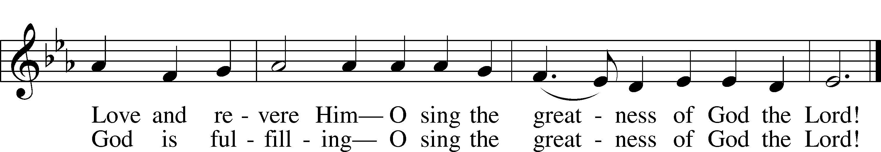
Tune: Public domain
Text: © 1991 Stephen P. Starke, admin. Concordia Publishing House. Used by permission: LSB Hymn License no. 110003744

Prayer

Kneel/Stand

Kyrie LSB 233
C Lord, have mercy;
Christ, have mercy;
Lord, have mercy.

Lord’s Prayer
C Our Father who art in heaven,
hallowed be Thy name,
Thy kingdom come,
Thy will be done on earth
as it is in heaven;
give us this day our daily bread;
and forgive us our trespasses
as we forgive those
who trespass against us;
and lead us not into temptation,
but deliver us from evil.
For Thine is the kingdom
and the power and the glory
forever and ever. Amen.

Collects

P The Lord be with you.
C And with your spirit.

Collect of the Day
P Stir up our hearts, O Lord, to make ready the way of Your only-begotten Son, that by His coming we may be enabled to serve You with pure minds; through the same Jesus Christ, our Lord, who lives and reigns with You and the Holy Spirit, one God, now and forever.

Collect
Heavenly Father, ruler of all things, Your Son, our Savior Jesus Christ, healed all manner of infirmities and cured all manner of diseases. Mercifully help Your servant [name] in body and soul and, if it be Your will, free [him/her] from [his/her] sickness that, restored to health, [he/she] may with a thankful heart bless Your holy name; through Jesus Christ, our Lord.

Collect for Peace
L O God, from whom come all holy desires, all good counsels, and all just works, give to us, Your servants, that peace which the world cannot give, that our hearts may be set to obey Your commandments and also that we, being defended from the fear of our enemies, may live in peace and quietness; through Jesus Christ, Your Son, our Lord, who lives and reigns with You and the Holy Spirit, one God, now and forever.
C Amen.

Benedicamus LSB 234
L Let us bless the Lord.
C Thanks be to God.

Benediction LSB 234
P The grace of our Lord T Jesus Christ and the love of God and the communion of the Holy Spirit be with you all.
C Amen.

Sit

881 Christ, Mighty Savior
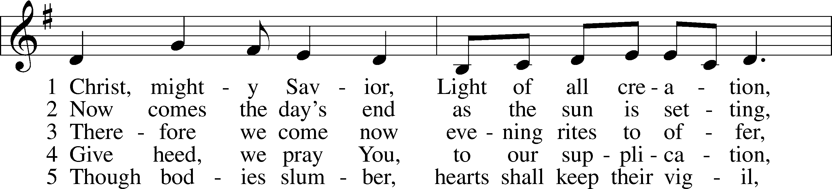
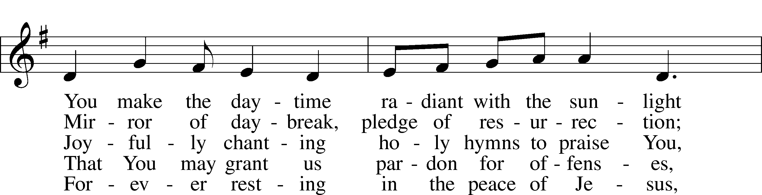
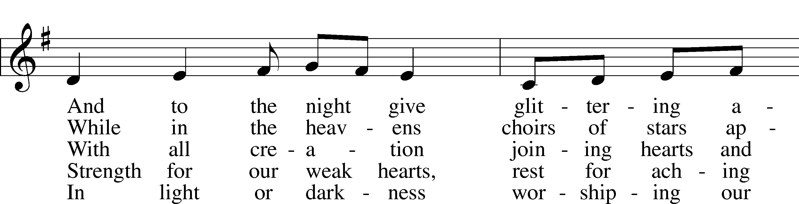
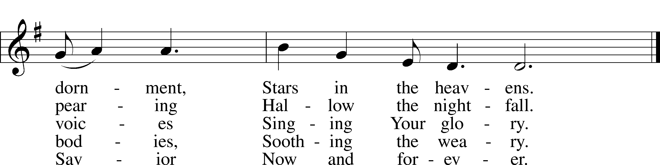
Tune: © 1984 Washington National Cathedral. Used by permission: LSB Hymn License no. 110003744
Text: © 1982 The United Methodist Publishing House, admin. Music Services (ASCAP). Used by permission: LSB Hymn License no. 110003744

Acknowledgments
Vespers from Lutheran Service Book
Unless otherwise indicated, Scripture quotations are from the ESV® Bible (The Holy Bible, English Standard Version®), copyright © 2001 by Crossway, a publishing ministry of Good News Publishers. Used by permission. All rights reserved.
Created by Lutheran Service Builder © 2020 Concordia Publishing House.
OPPORTUNITIES FOR WORSHIP DURING ADVENT
Dec 9 | 7:00 pm | Advent Service
Dec 12/13 | 5:00p/9:00a | Sunday Worship
Dec 16 | 7:00 pm | Advent Service
Dec 19/20 | 5:00p/9:00a | Sunday Worship
Dec 24 | 7:00 pm | Christmas Eve Candlelight Service
Dec 25 | 10:00 am | Christmas Day Worship

