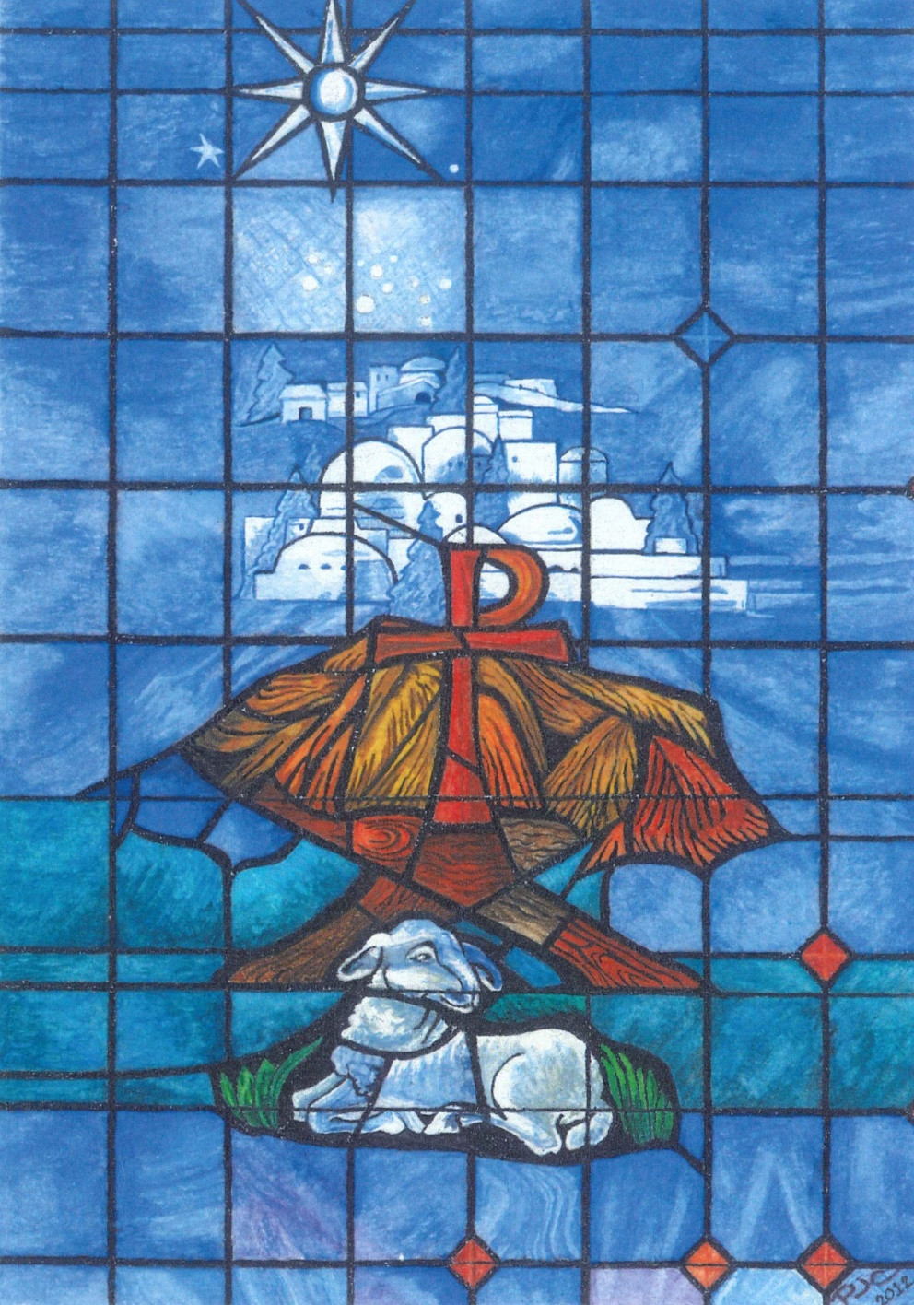
Christmas 24 December 2020
Eve 5 & 7 p.m.

Zion Lutheran Church & School
Missouri Synod
ssouri Synod
2124 C Avenue
308.234.3410
www.zionkearney.com

Bulletin cover - The Advent of Christ (His Incarnation and Birth) is an original watercolor painting by Peggy J. Colson. The son of God came into the world to bear our sins and be our Savior (represented by the sacrificial lamb at the foot of the manger). Taking to Himself our human nature, the Son of God entered Creation at Bethlehem (the city in white). In nature both God and man, Jesus is the “Christ” (the “Chi” & “Rho” in the manger are the first two Greek letters of the word “Christ”). He came to fulfill the ancient Messianic promises made by God to the Jewish people. “He shall save His people from their sins,” the angel said to Mary. The Messiah still comes to us today, through his Word. His manger is a humble and lowly heart.

Evening Prayer

Welcome to our members, friends, and new visitors!
As we gather on this holy night, we do so in faith and trust
in our Heavenly Father who kept His promise to send our Redeemer . . . a baby born of woman (as all of us were),
yet sinless and divine. We receive and give thanks for the birth of our Savior Jesus Christ, God’s Son. For He brings with Him life, immortality . . . and light.

Preservice Music
Stand for the Procession of Light – The Paschal Candle
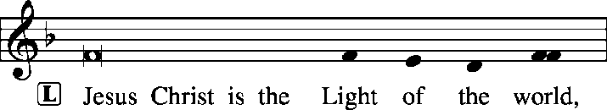 John 8:12
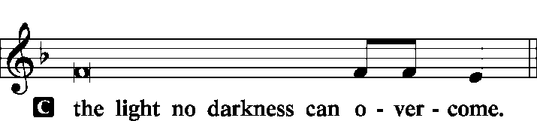 John 1:5
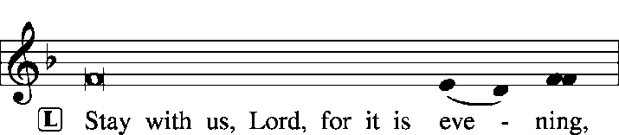
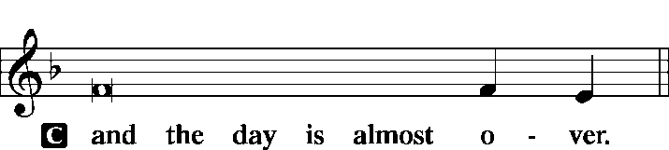 Luke 24:29
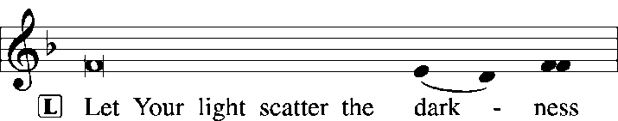 1 Cor. 4:5
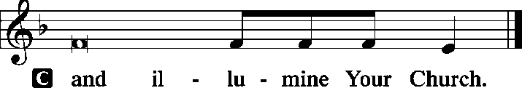 2 Cor. 4:6

Phos Hilaron (Hymn of Light)
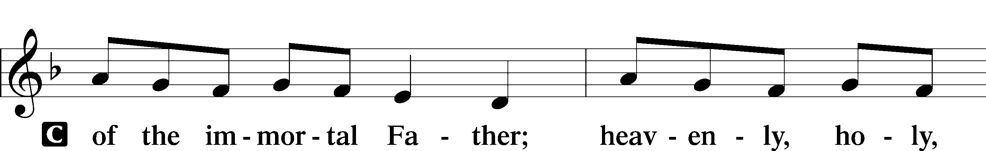
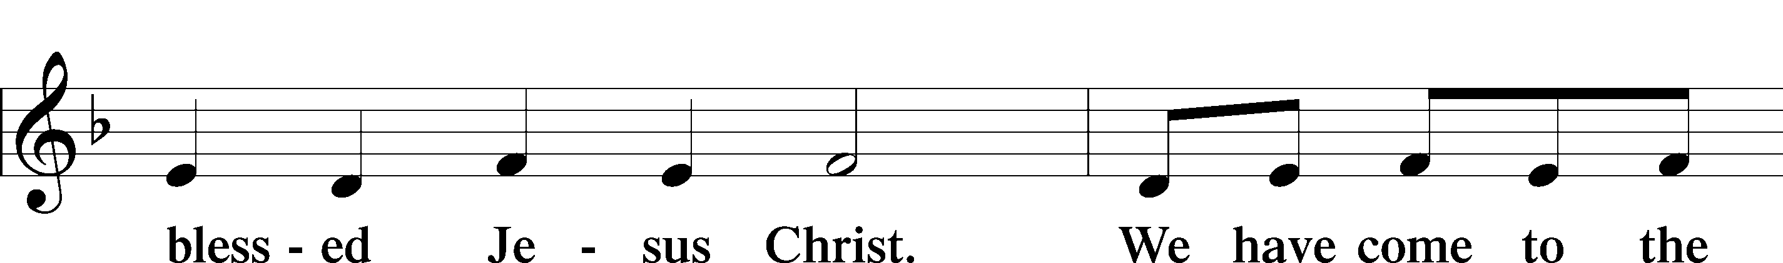
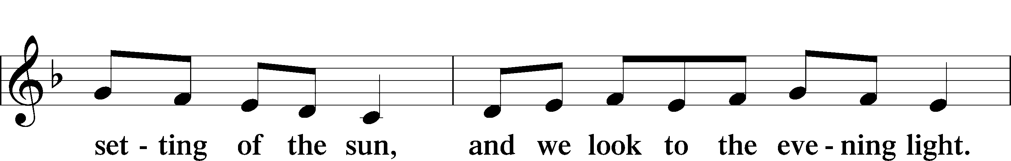
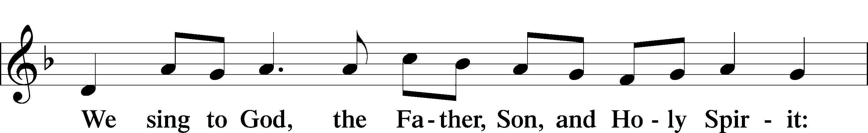
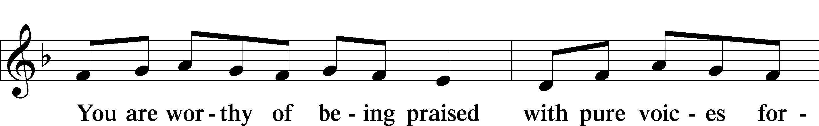
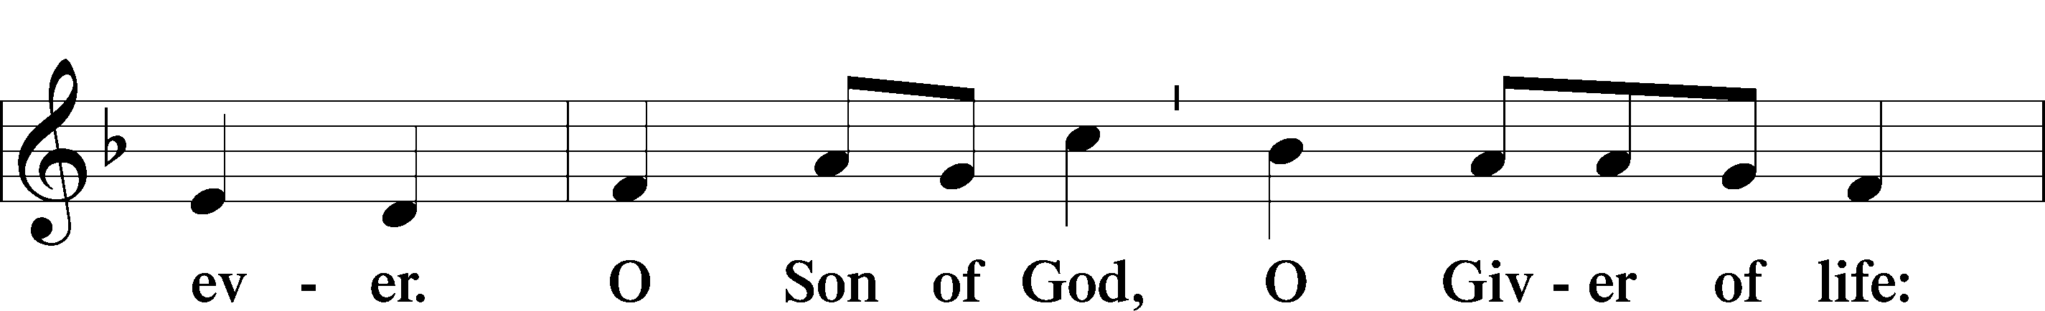
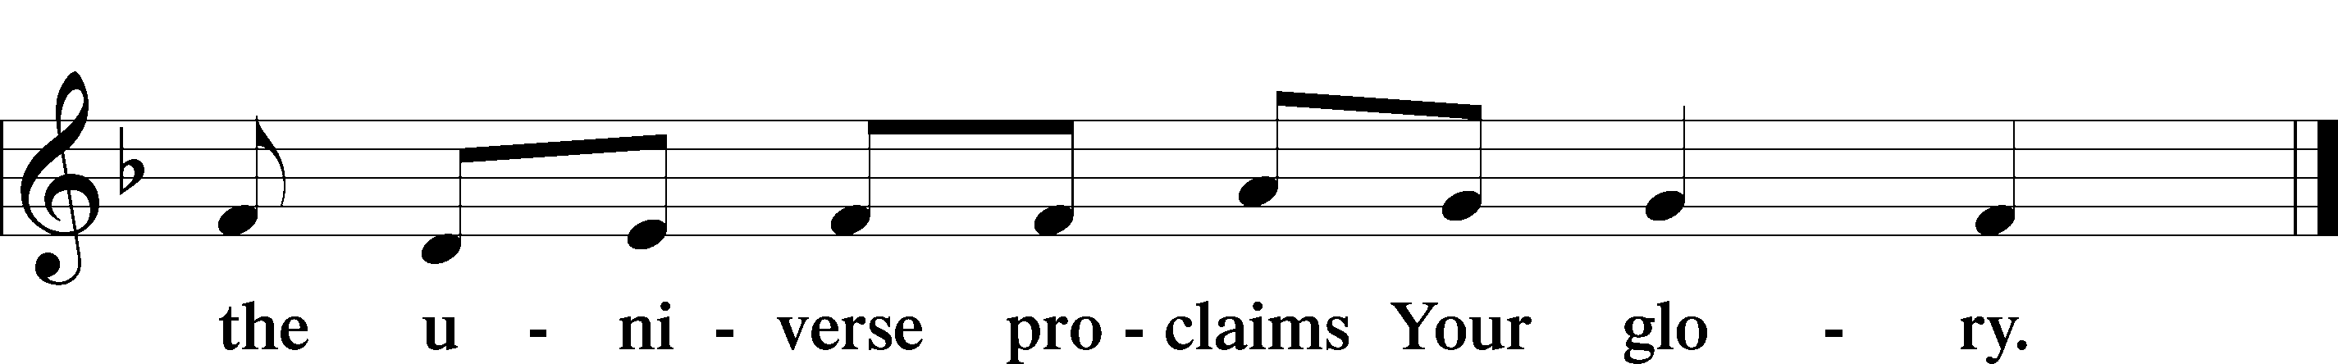

Thanksgiving for Light
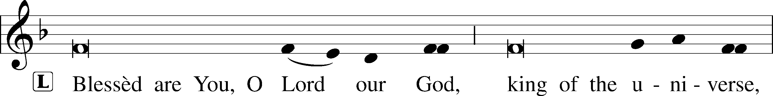
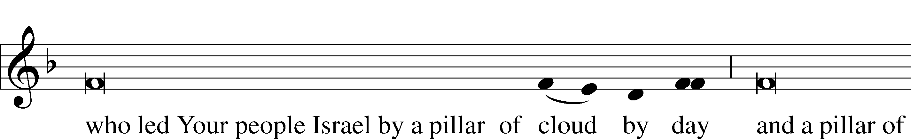
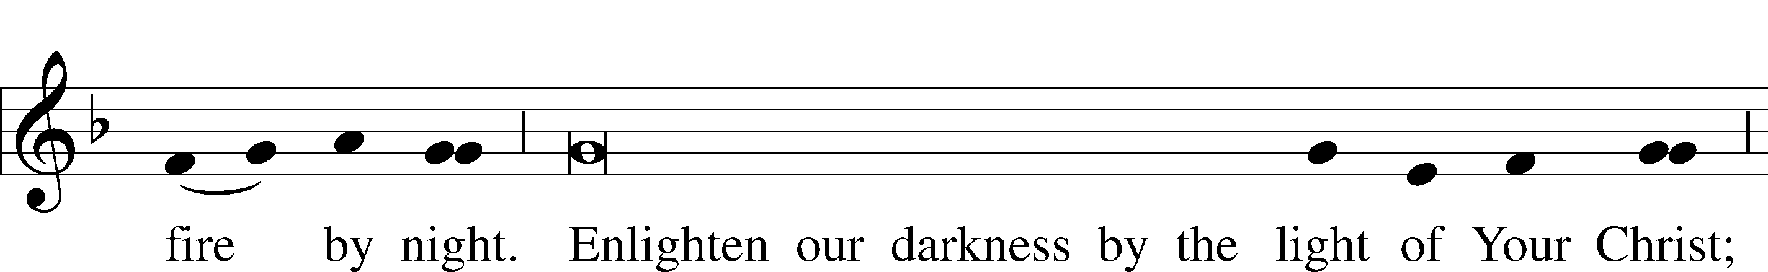
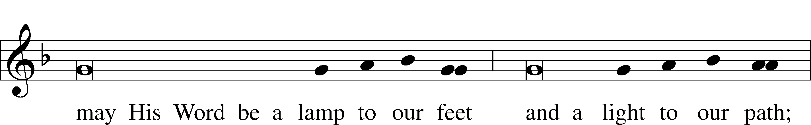
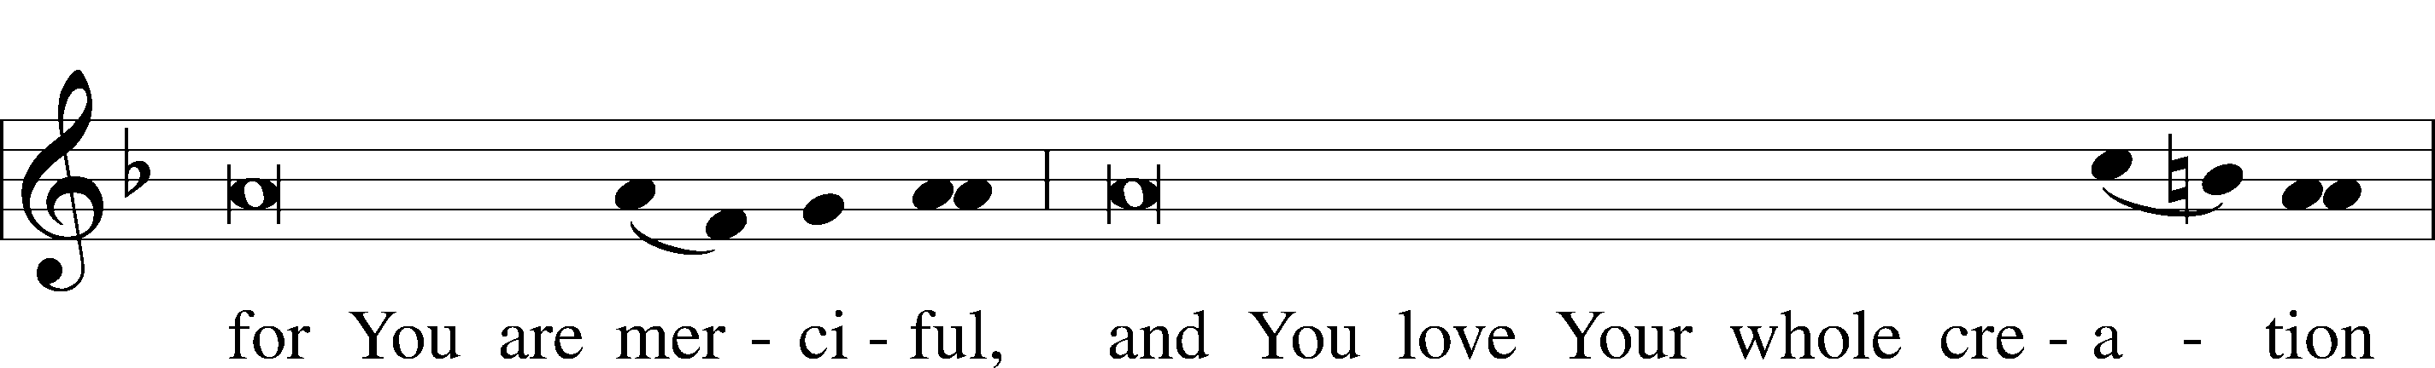
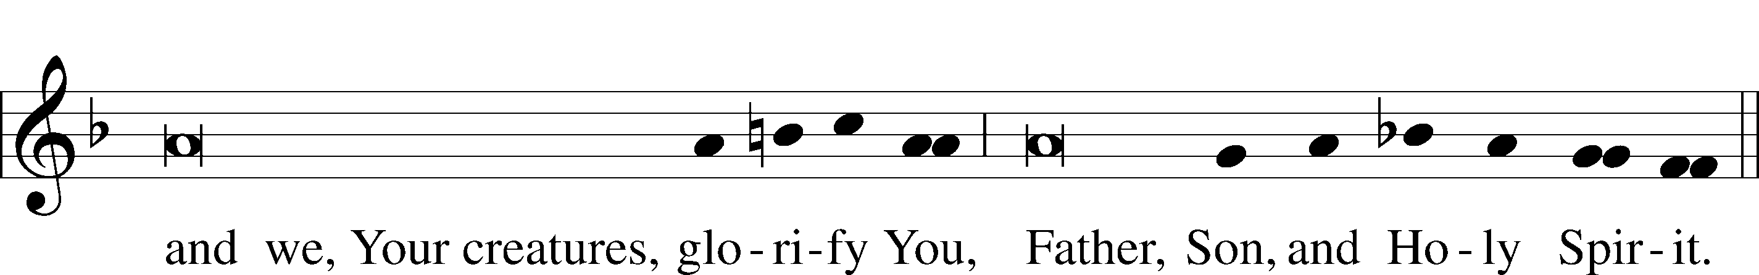

Sit

Hymn 377 ~ On Christmas Night All Christians Sing
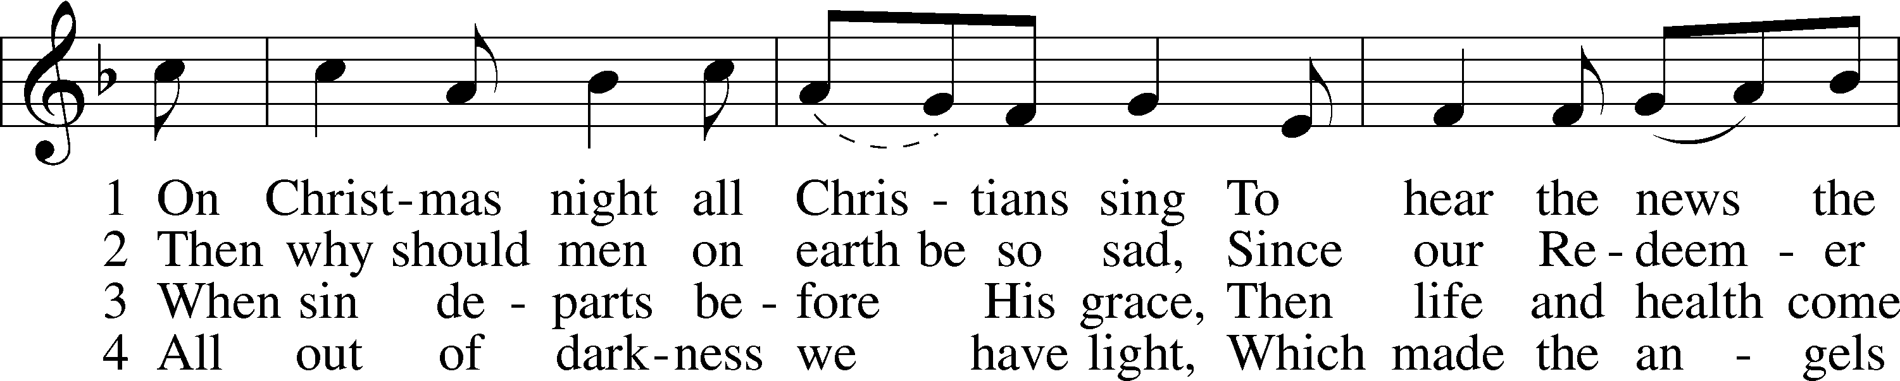
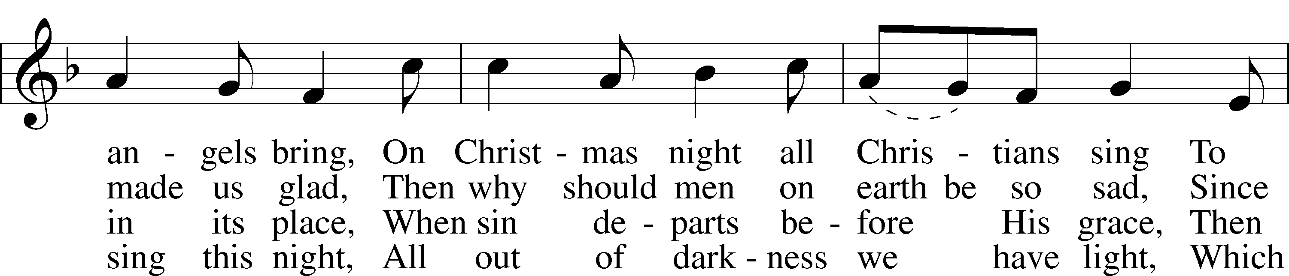
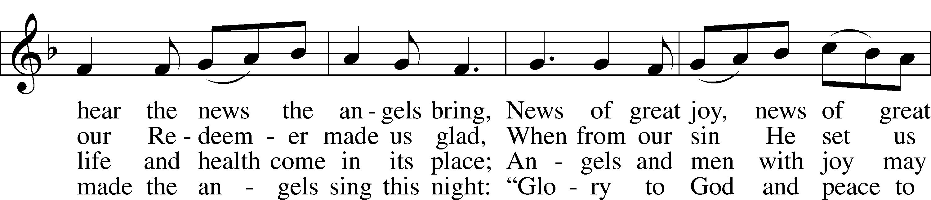
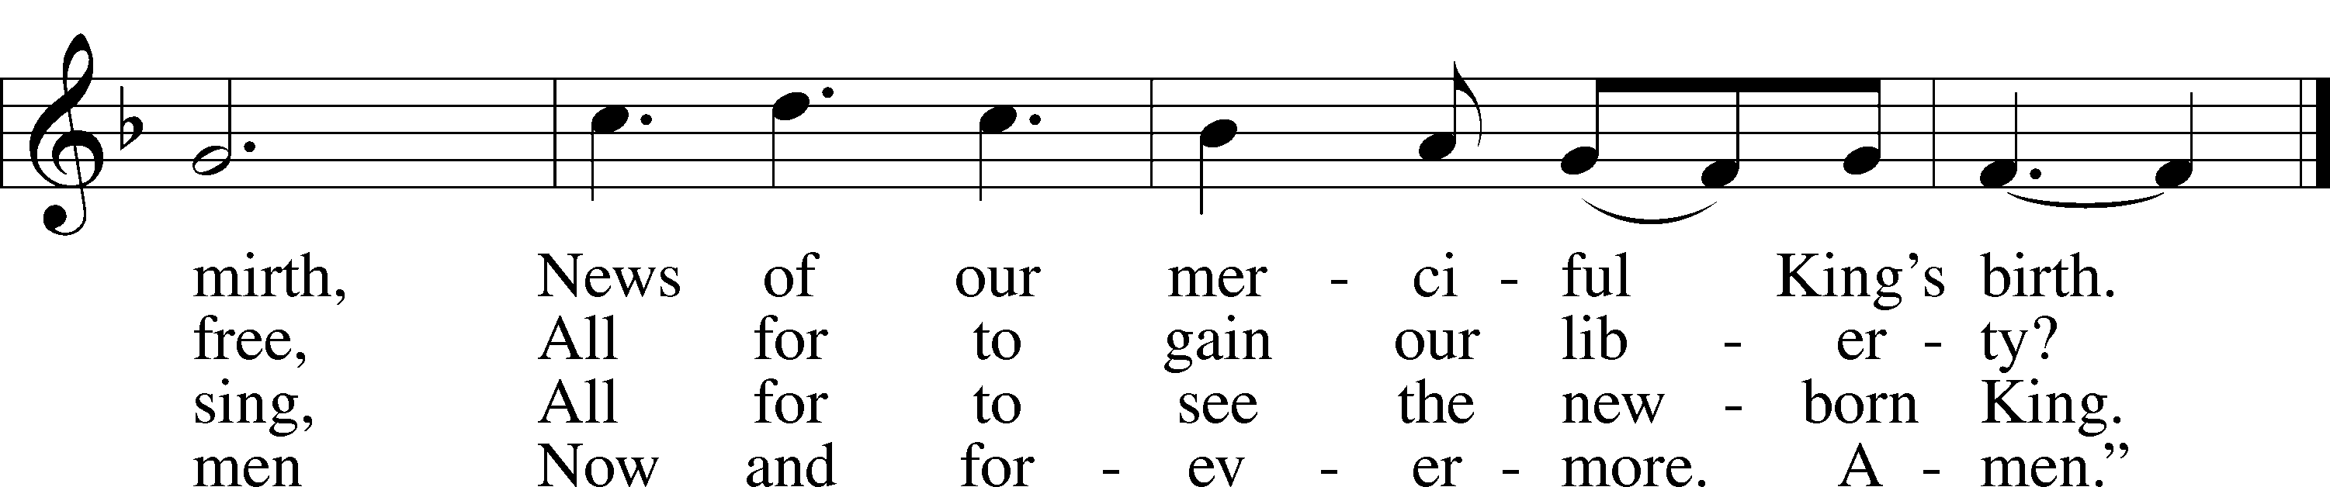
Tune and text: Public domain
Readings
Reading Isaiah 9:2–7
² The people who walked in darkness
have seen a great light;
those who dwelt in a land of deep darkness,
on them has light shined.
³You have multiplied the nation;
you have increased its joy;
they rejoice before you
as with joy at the harvest,
as they are glad when they divide the spoil.
⁴For the yoke of his burden,
and the staff for his shoulder,
the rod of his oppressor,
you have broken as on the day of Midian.
⁵For every boot of the tramping warrior in battle tumult
and every garment rolled in blood
will be burned as fuel for the fire.
⁶For to us a child is born,
to us a son is given;
and the government shall be upon his shoulder,
and his name shall be called
Wonderful Counselor, Mighty God,
Everlasting Father, Prince of Peace.
⁷Of the increase of his government and of peace
there will be no end,
on the throne of David and over his kingdom,
to establish it and to uphold it
with justice and with righteousness
from this time forth and forevermore.
The zeal of the Lord of hosts will do this.

Reading Response
A This is the Word of the Lord.
C Thanks be to God.

Hymn 359 ~ Lo, How a Rose E’er Blooming Soloist, vs. 1
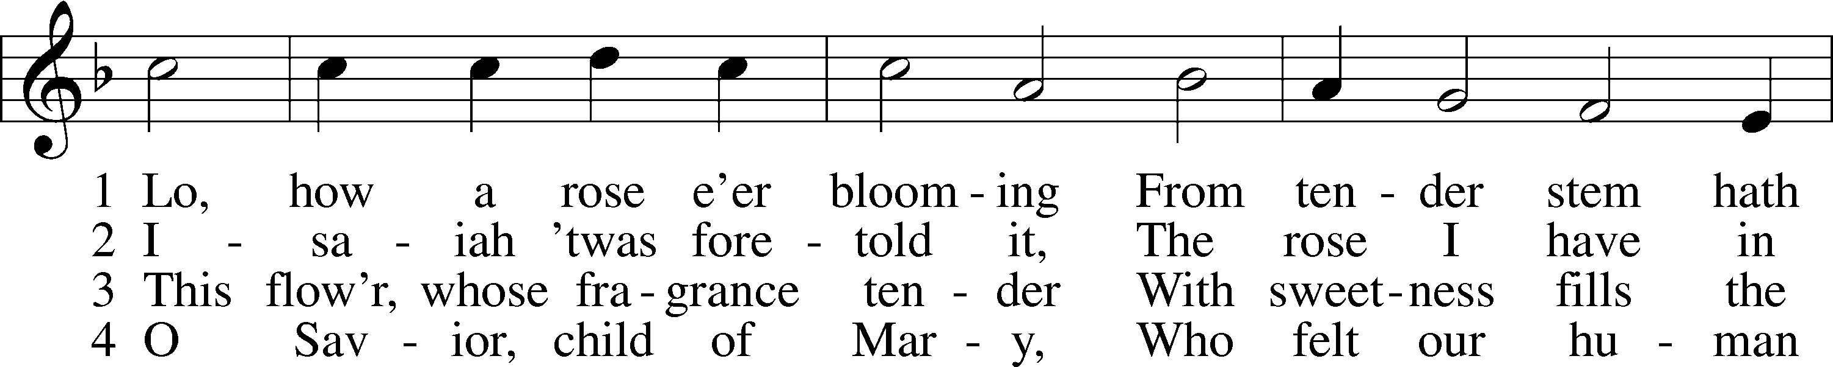
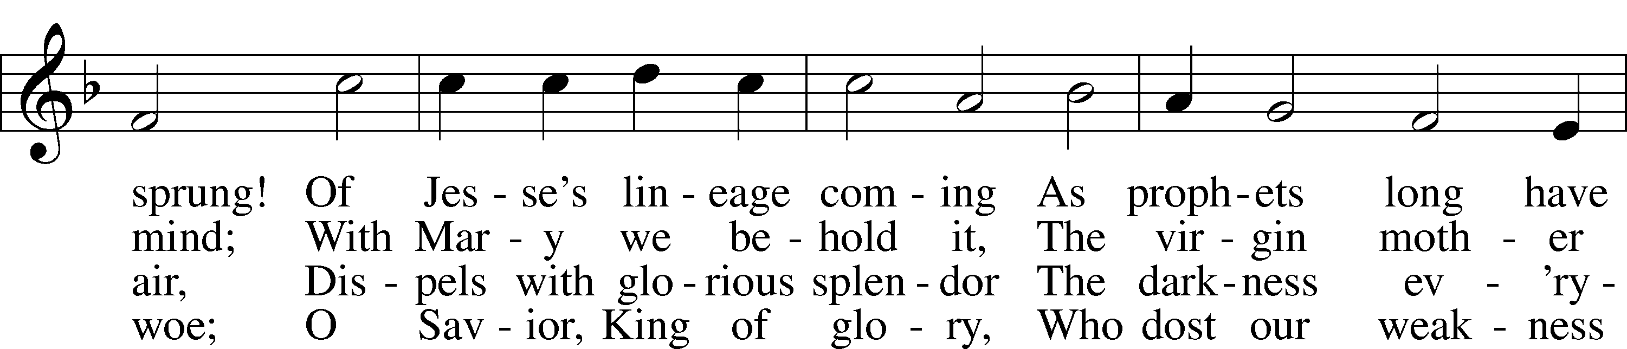
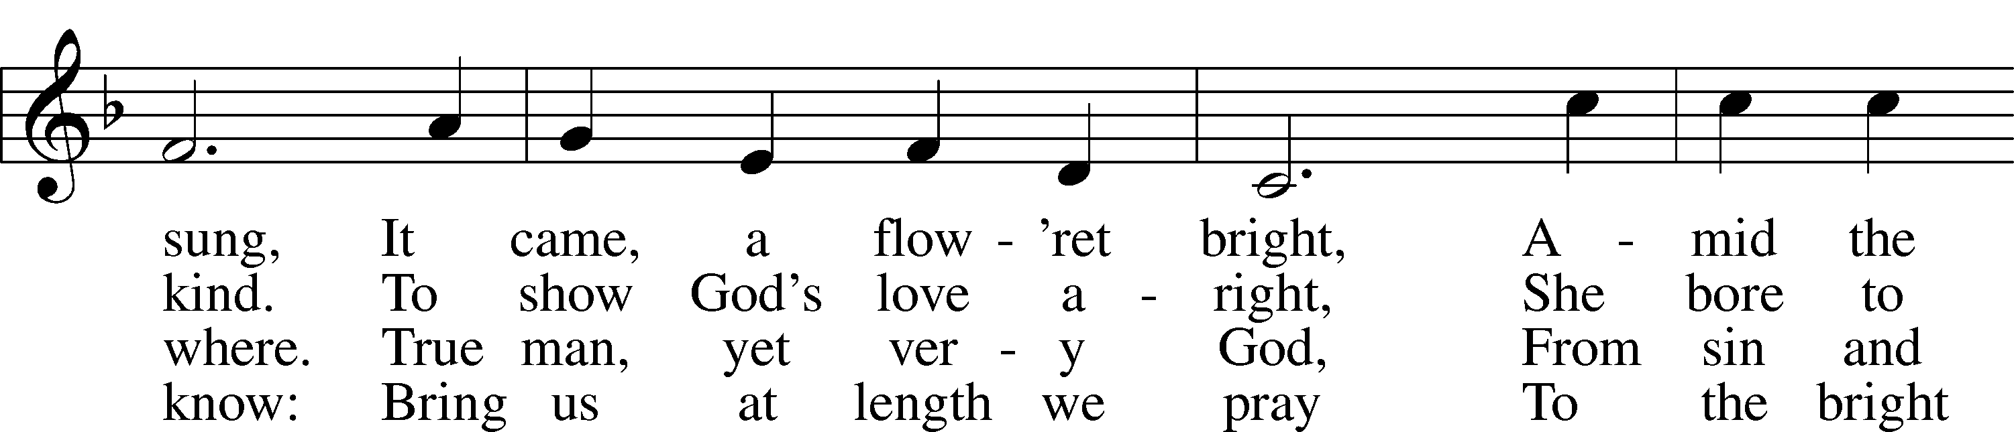
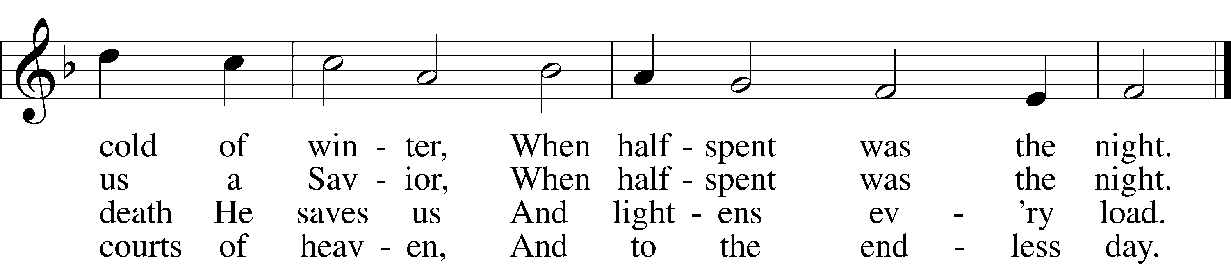
Text and tune: Public domain

Reading Titus 2:11–14
¹¹For the grace of God has appeared, bringing salvation for all people, ¹²training us to renounce ungodliness and worldly passions, and to live self-controlled, upright, and godly lives in the present age, ¹³waiting for our blessed hope, the appearing of the glory of our great God and Savior Jesus Christ, ¹⁴who gave himself for us to redeem us from all lawlessness and to purify for himself a people for his own possession who are zealous for good works.

Reading Response
A This is the Word of the Lord.
C Thanks be to God.

Reading Luke 2:1–20
¹In those days a decree went out from Caesar Augustus that all the world should be registered. ²This was the first registration when Quirinius was governor of Syria. ³And all went to be registered, each to his own town. ⁴And Joseph also went up from Galilee, from the town of Nazareth, to Judea, to the city of David, which is called Bethlehem, because he was of the house and lineage of David, ⁵to be registered with Mary, his betrothed, who was with child. ⁶And while they were there, the time came for her to give birth. ⁷And she gave birth to her firstborn son and wrapped him in swaddling cloths and laid him in a manger, because there was no place for them in the inn.
⁸And in the same region there were shepherds out in the field, keeping watch over their flock by night. ⁹And an angel of the Lord appeared to them, and the glory of the Lord shone around them, and they were filled with fear. ¹⁰And the angel said to them, “Fear not, for behold, I bring you good news of a great joy that will be for all the people. ¹¹For unto you is born this day in the city of David a Savior, who is Christ the Lord. ¹²And this will be a sign for you: you will find a baby wrapped in swaddling cloths and lying in a manger.” ¹³And suddenly there was with the angel a multitude of the heavenly host praising God and saying,
¹⁴“Glory to God in the highest,
and on earth peace among those with whom he is pleased!”
¹⁵When the angels went away from them into heaven, the shepherds said to one another, “Let us go over to Bethlehem and see this thing that has happened, which the Lord has made known to us.” ¹⁶And they went with haste and found Mary and Joseph, and the baby lying in a manger. ¹⁷And when they saw it, they made known the saying that had been told them concerning this child. ¹⁸And all who heard it wondered at what the shepherds told them. ¹⁹But Mary treasured up all these things, pondering them in her heart. ²⁰And the shepherds returned, glorifying and praising God for all they had heard and seen, as it had been told them.
Reading Response
A This is the Word of the Lord.
C Thanks be to God.

Final Reading Response
L In many and various ways, God spoke to His people of old by the prophets.
C But now in these last days, He has spoken to us by His Son.

Hymn 384 Congregation - vs. 1, 4-5, Women - v.2, Men - vs.3
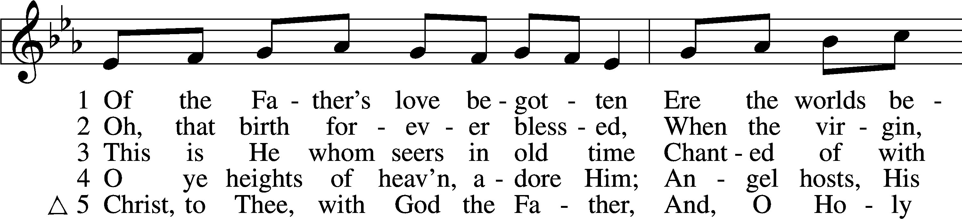
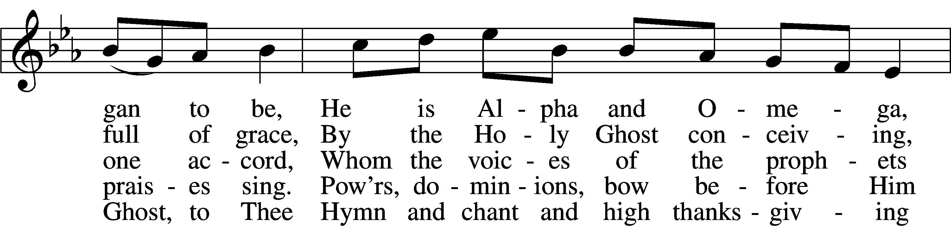
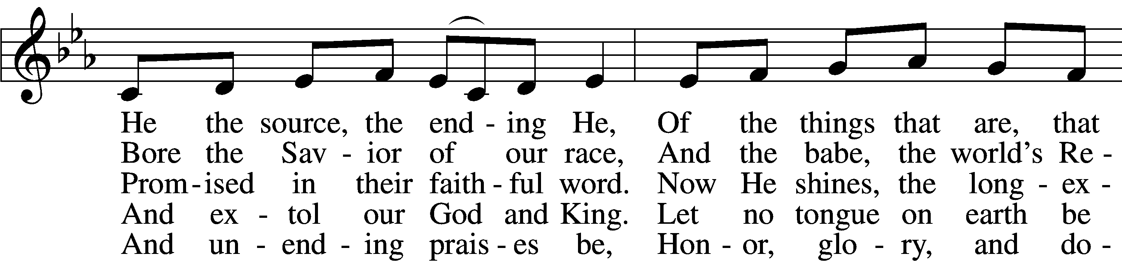
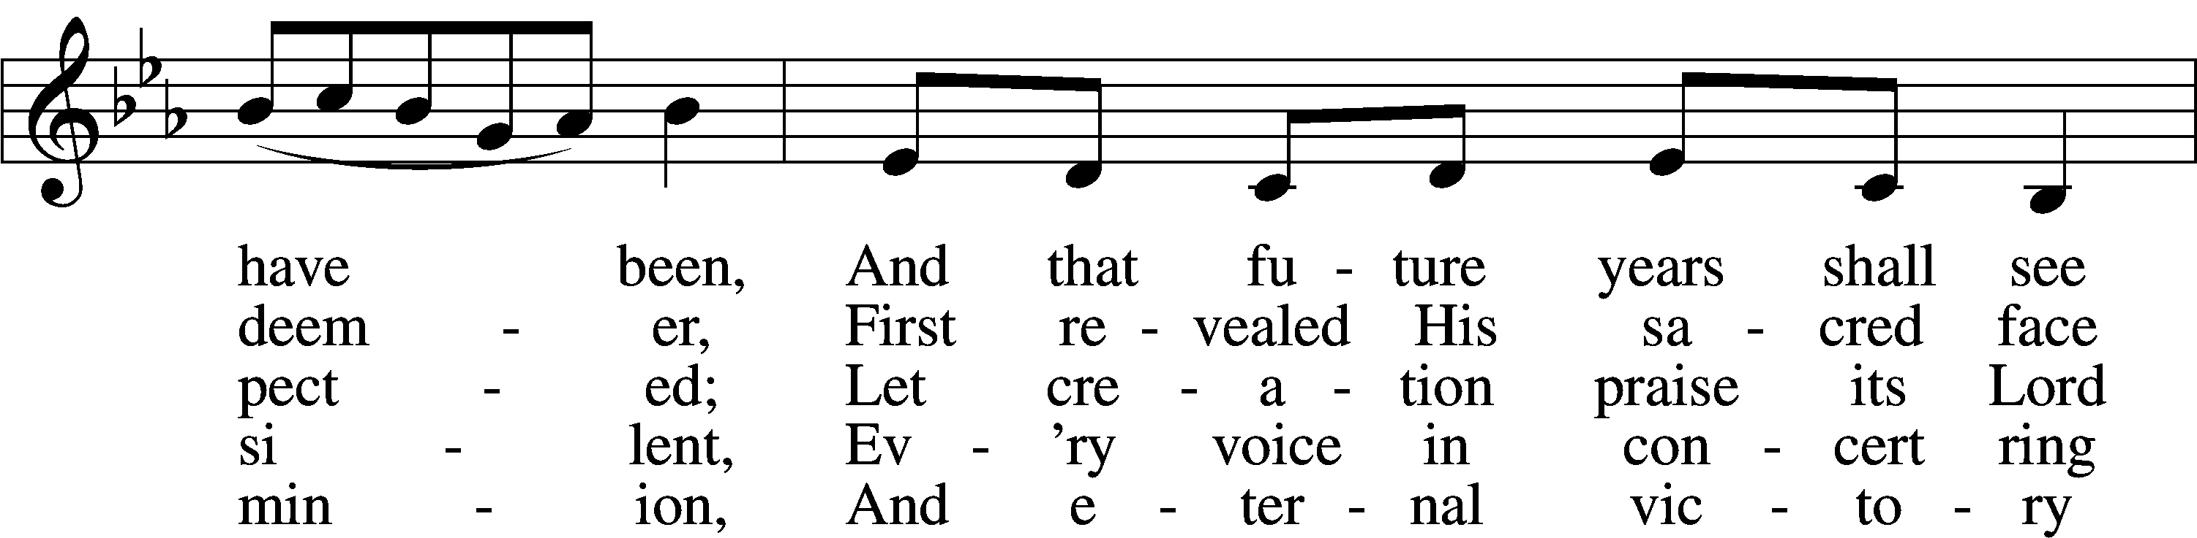
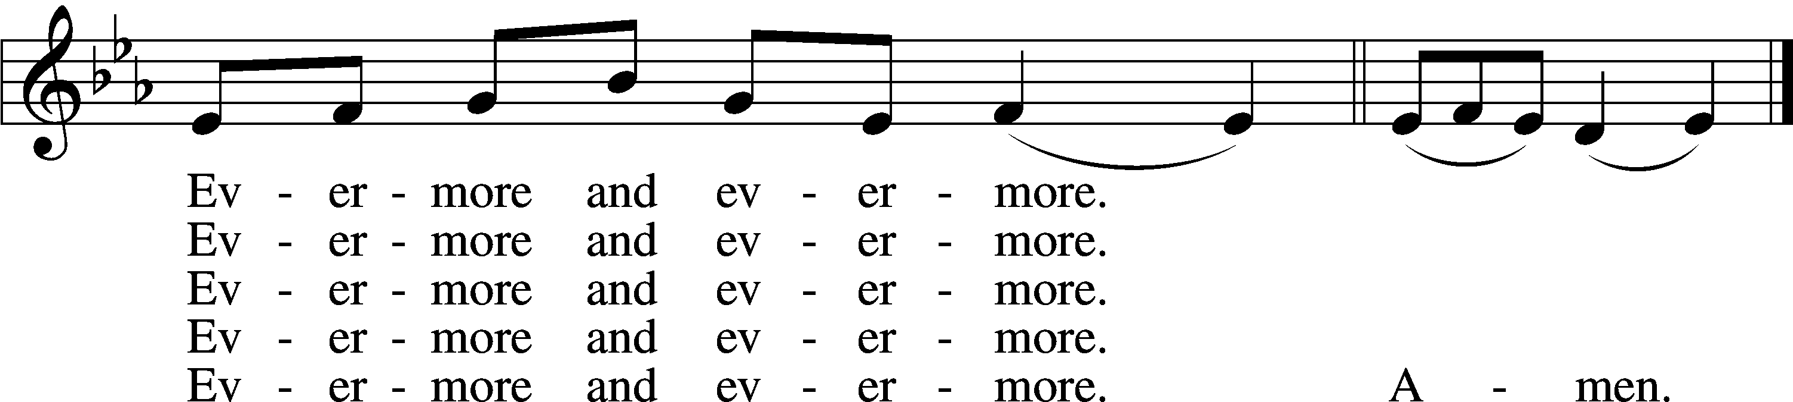
Text and tune: Public domain

Sermon

Hymn 393 ~ Infant Holy, Infant Lowly
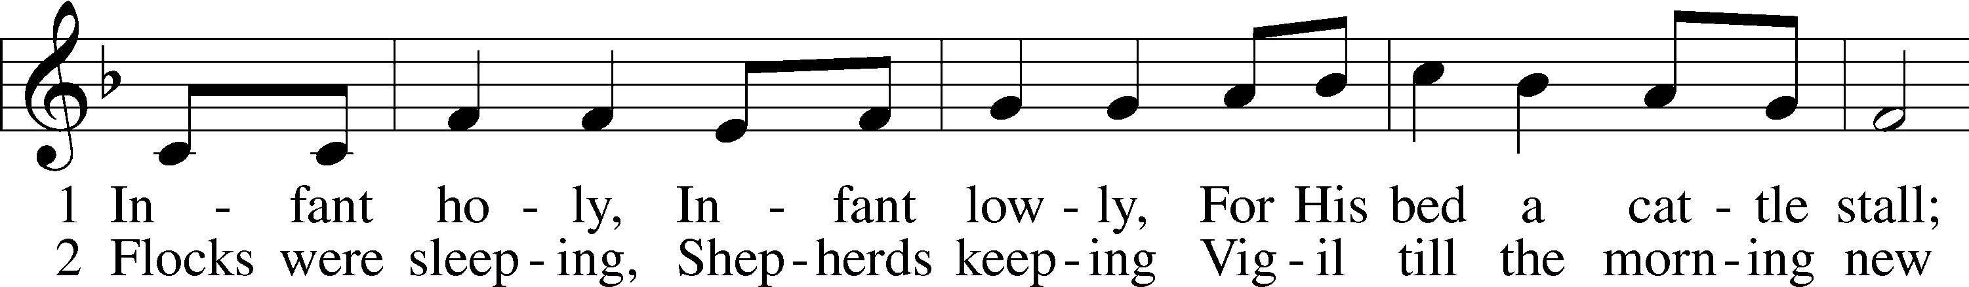
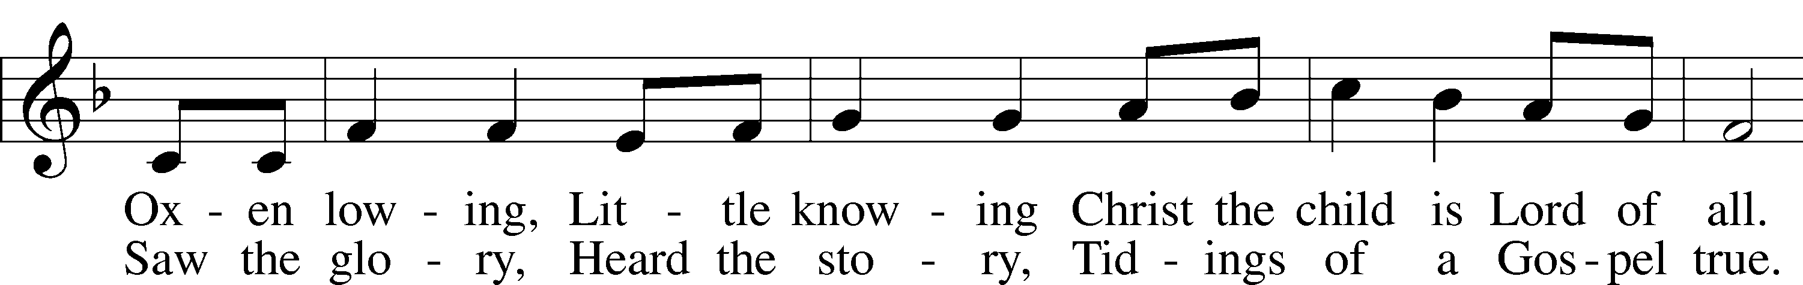
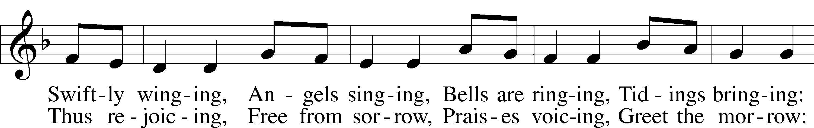
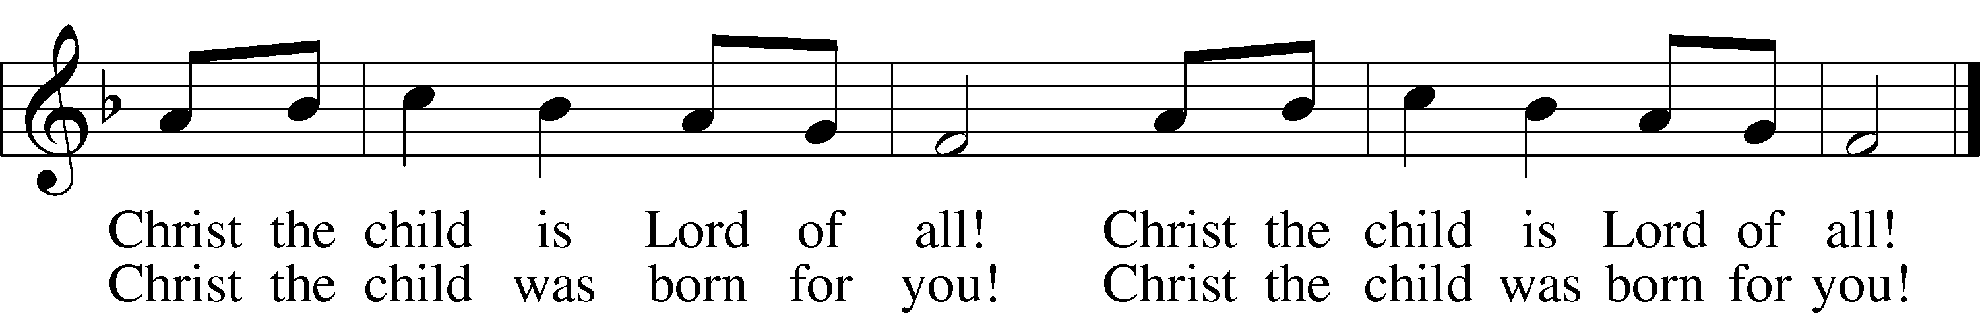
Tune and text: Public domain
Prayer
Stand

Litany
L In peace let us pray to the Lord:
C Lord, have mercy.
L For the peace from above and for our salvation, let us pray to the Lord:
C Lord, have mercy.
L For the peace of the whole world, for the well-being of the Church of God, and for the unity of all, let us pray to the Lord:
C Lord, have mercy.
L For this holy house and for all who offer here their worship and praise, let us pray to the Lord:
C Lord, have mercy.
L For [names of synodical and district presidents], for all pastors in Christ, for all servants of the Church, and for all the people, let us pray to the Lord:
C Lord, have mercy.
L For [name of president or monarch], for all public servants, for the government and those who protect us, that they may be upheld and strengthened in every good deed, let us pray to the Lord:
C Lord, have mercy.
L For those who work to bring peace, justice, health, and protection in this and every place, let us pray to the Lord:
C Lord, have mercy.
L For those who bring offerings, those who do good works in this congregation, those who toil, those who sing, and all the people here present who await from the Lord great and abundant mercy, let us pray to the Lord:
C Lord, have mercy.
L For favorable weather, for an abundance of the fruits of the earth, and for peaceful times, let us pray to the Lord:
C Lord, have mercy.
L For our deliverance from all affliction, wrath, danger, and need, let us pray to the Lord:
C Lord, have mercy.
L For . . . [additional bids for prayer may be inserted here] . . . let us pray to the Lord:
C Lord, have mercy.
L For the faithful who have gone before us and are with Christ, let us give thanks to the Lord:
C Alleluia.
L Help, save, comfort, and defend us, gracious Lord.

Silence for individual prayer may follow.

L Rejoicing in the fellowship of all the saints, let us commend ourselves, one another, and our whole life to Christ, our Lord:
C To You, O Lord.

Please be seated

The Candlelight Service
Pastor will light his candle from the Paschal Candle. Then the ushers will move down the center aisle and light those in the pews. Please tip your unlit candle, drawing the flame from your neighbor’s lit candle. Parents, please assist the children and be careful with the hot wax!

Collect for Christmas Eve
P: O God, because you once caused this holy night to shine with the brightness of the true Light, grant that we who have known the mystery of that Light here on earth may come to the full measure of its joys in heaven; through Jesus Christ, our Lord, who lives and reigns with you and the Holy Spirit, one God, now and forever.
C: Amen.

Collect for Peace
L O God, from whom come all holy desires, all good counsels, and all just works, give to us, Your servants, that peace which the world cannot give, that our hearts may be set to obey Your commandments and also that we, being defended from the fear of our enemies, may live in peace and quietness; through Jesus Christ, Your Son, our Lord, who lives and reigns with You and the Holy Spirit, one God, now and forever.
C Amen.

Lord’s Prayer
L Taught by our Lord and trusting His promises, we are bold to pray:
C Our Father who art in heaven
hallowed be Thy name,
Thy kingdom come,
Thy will be done on earth
as it is in heaven;
give us this day our daily bread;
and forgive us our trespasses
as we forgive those
who trespass against us;
and lead us not into temptation,
but deliver us from evil.
For Thine is the kingdom…

Hymn 364 ~ Away in a Manger
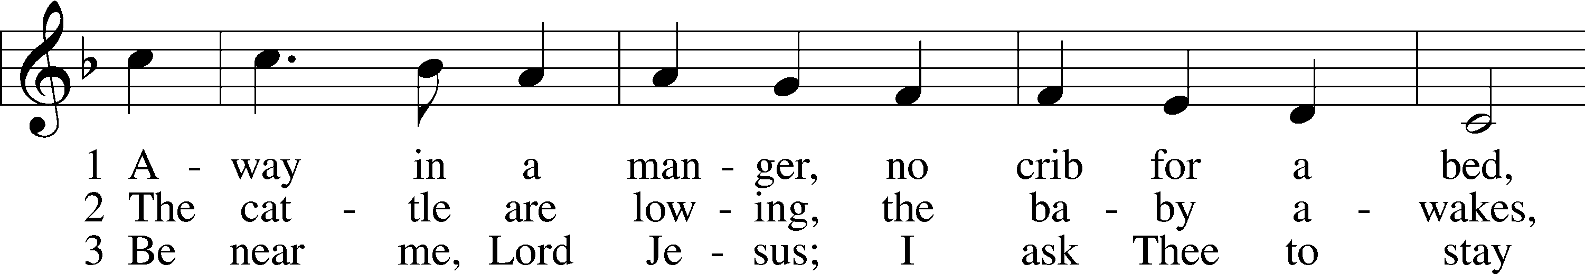
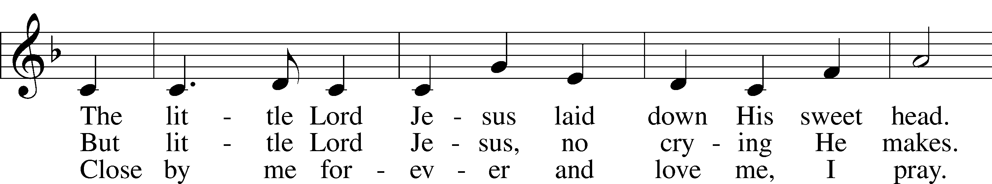
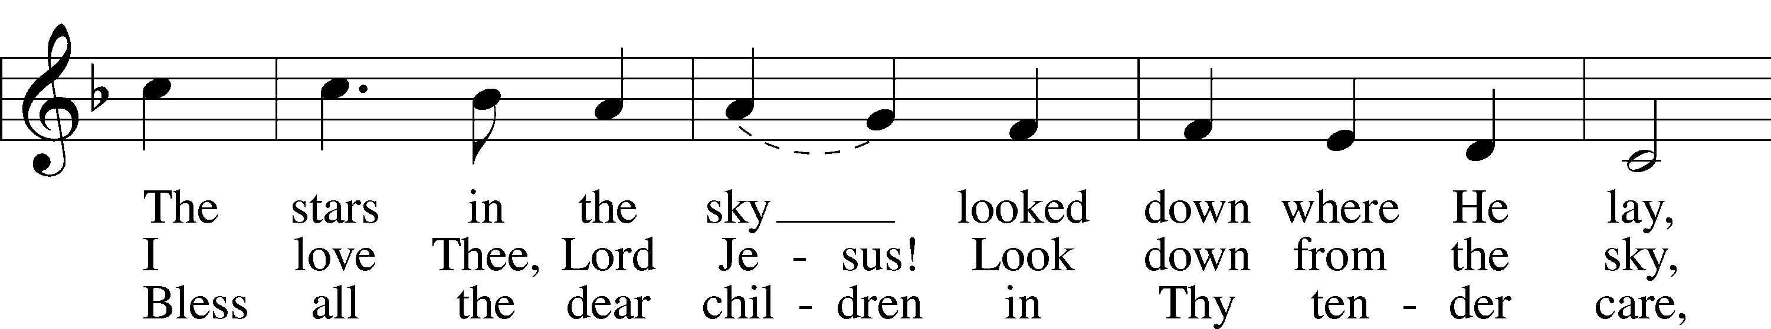
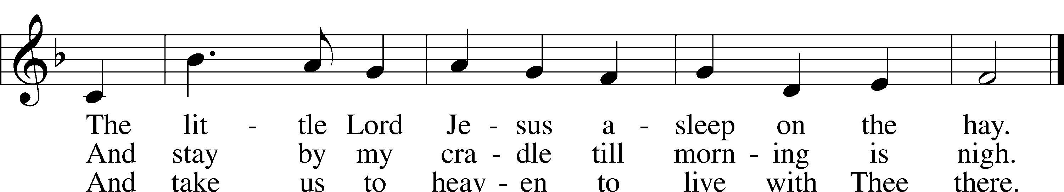
Tune and text: Public domain
Hymn 363 ~ Silent Night, Holy Night
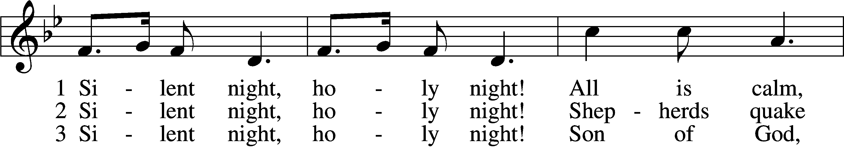
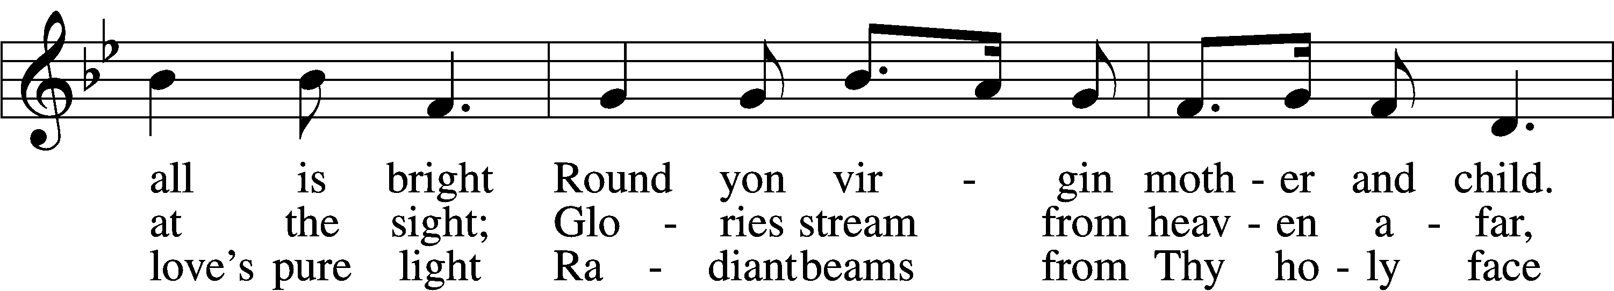
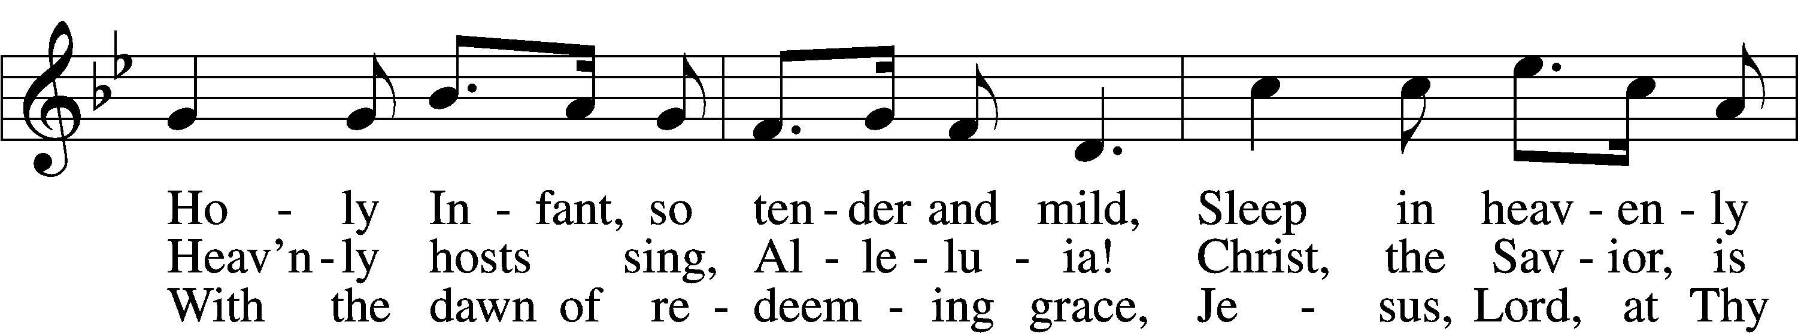
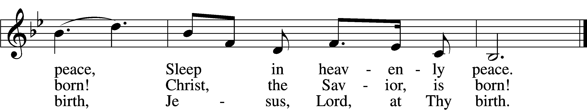
Tune and text: Public domain

Stand

Benedicamus
L Let us bless the Lord.
C Thanks be to God.

Benediction
P The almighty and merciful Lord, the Father, the T Son, and the Holy Spirit, bless and preserve you.
C Amen.

After the benediction, the lights will come back up. Please carefully extinguish the candles, being careful with the hot wax!
Hymn 368 ~ Angels We Have Heard on High
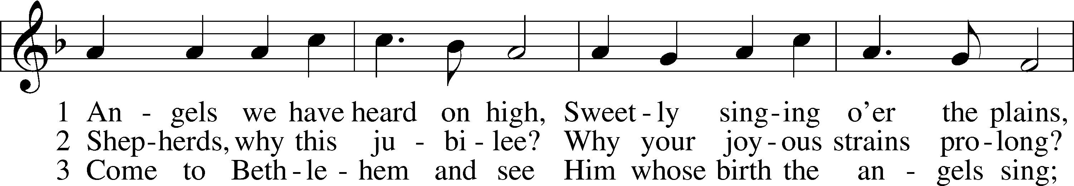
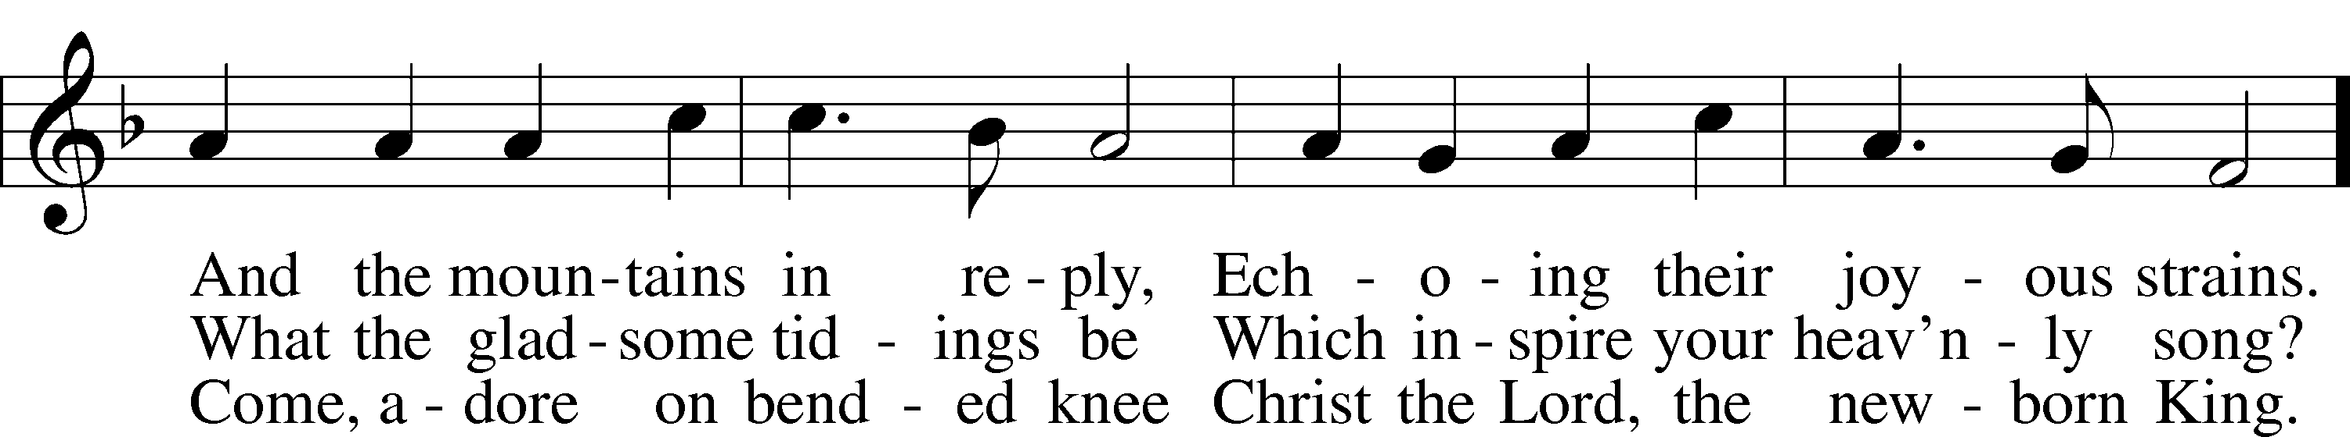
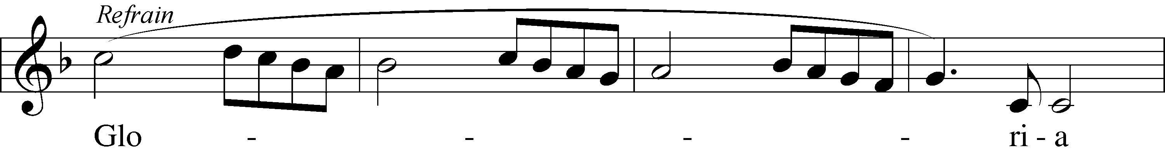
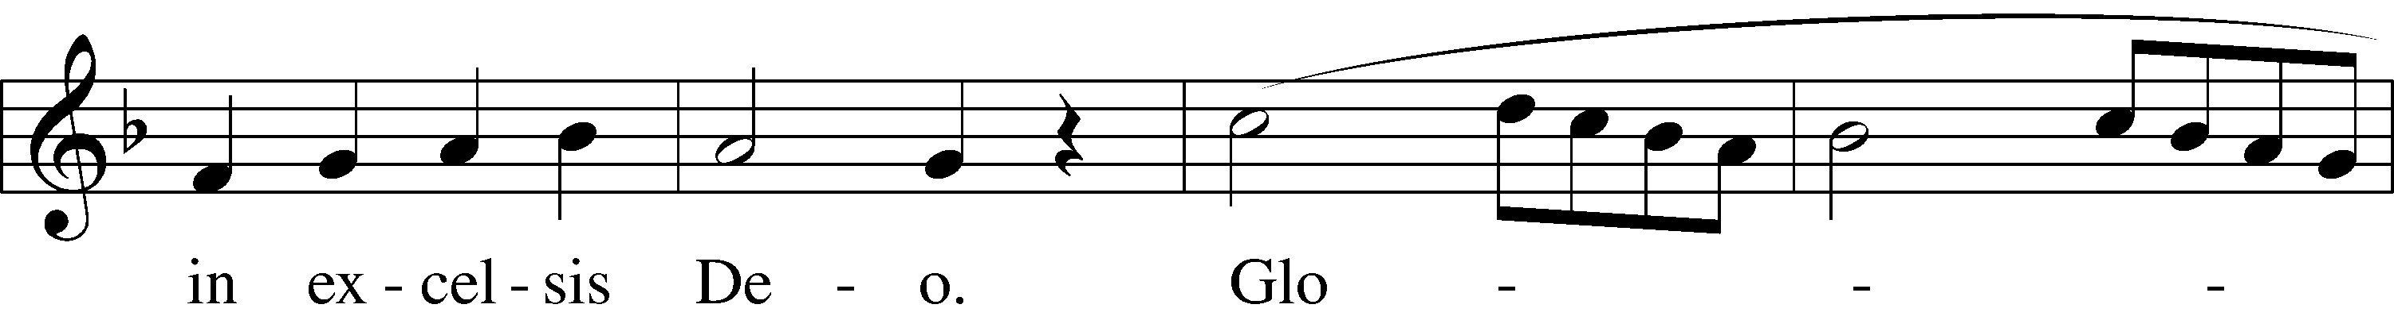
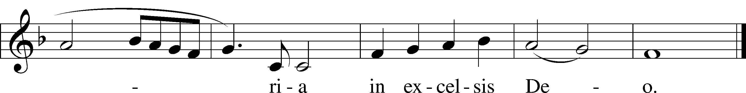
Text and tune: Public domain

Acknowledgments
Unless otherwise indicated, Scripture quotations are from the ESV® Bible (The Holy Bible, English Standard Version®), copyright © 2001 by Crossway, a publishing ministry of Good News Publishers. Used by permission. All rights reserved.
Created by Lutheran Service Builder © 2020 Concordia Publishing House.

A Christmas Day Invitation
Please join us for our Christmas Day Festival Service tomorrow at 10:00 a.m. as we celebrate the birth of our Savior, who descends to be with us in His Holy Word and Supper. Jesus gives us the greatest gift of all---forgiveness of sins, life, and salvation.

In His Service this Evening
Pastor | James DeLoach | Assistant | Zach DeLoach
Organist | Teresa Leising | Elder | Nathan Gaunt
Ushers |  | Altar Guild

