Palm Sunday
05 April 2020 + 9:00 a.m.

Zion Lutheran Church & School

Kearney, NE + (308) 234-3410
zionkearney.com

Rev. James DeLoach, Pastor + (308) 627-5260

Rev. Doug Gaunt, Pastor + (308) 455-0552
Tony Splittgerber, Principal + (308) 293-0168
Confession and Absolution

442 All Glory, Laud, and Honor
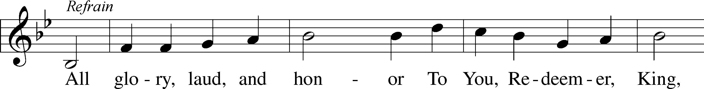
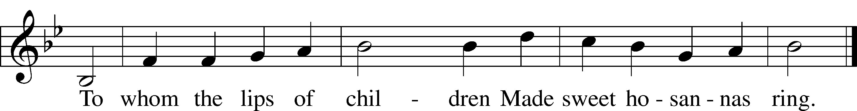
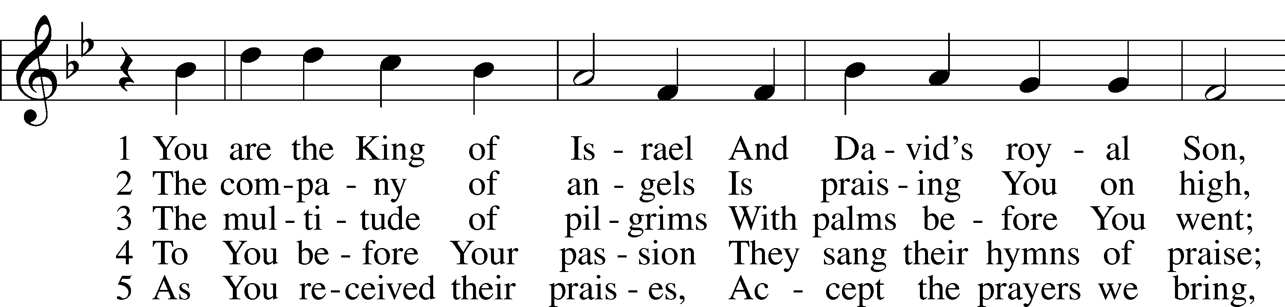
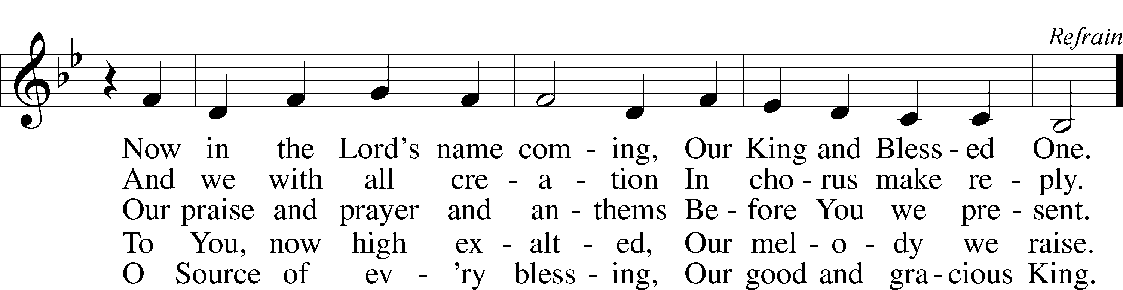
Tune and text: Public domain

The sign of the cross may be made by all in remembrance of their Baptism.

P In the name of the Father and of the T Son and of the Holy Spirit.
C Amen.

P Beloved in the Lord! Let us draw near with a true heart and confess our sins unto God our Father, beseeching Him in the name of our Lord Jesus Christ to grant us forgiveness.

P Our help is in the name of the Lord,
C who made heaven and earth.
P I said, I will confess my transgressions unto the Lord,
C and You forgave the iniquity of my sin.

Silence for reflection on God’s Word and for self-examination.

P O almighty God, merciful Father,
C I, a poor, miserable sinner, confess unto You all my sins and iniquities with which I have ever offended You and justly deserved Your temporal and eternal punishment. But I am heartily sorry for them and sincerely repent of them, and I pray You of Your boundless mercy and for the sake of the holy, innocent, bitter sufferings and death of Your beloved Son, Jesus Christ, to be gracious and merciful to me, a poor, sinful being.

P Upon this your confession, I, by virtue of my office, as a called and ordained servant of the Word, announce the grace of God unto all of you, and in the stead and by the command of my Lord Jesus Christ I forgive you all your sins in the name of the Father and of the T Son and of the Holy Spirit.
C Amen.

Service of the Word

Introit Psalm 24:7–10; antiphon: Psalm 118:26
Blessèd is he who comes in the name | of the Lord!*
We bless you from the house | of the Lord.
Lift up your heads, O gates! And be lifted up, O | ancient doors,*
that the King of glory | may come in.
Who is this King of | glory?*
The Lord, strong and mighty, the Lord, mighty in | battle!
Lift up your heads, O gates! And lift them up, O | ancient doors,*
that the King of glory | may come in.
Who is this King of | glory?*
The Lord of hosts, he is the King of | glory!
Blessèd is he who comes in the name | of the Lord!*
We bless you from the house | of the Lord.

C Glory be to the Father and to the Son and to the Holy Ghost;
as it was in the beginning, is now, and ever shall be, world without end. Amen.

Kyrie LSB 186
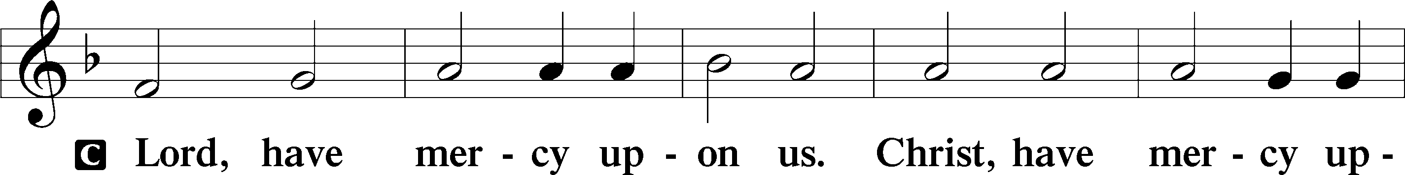
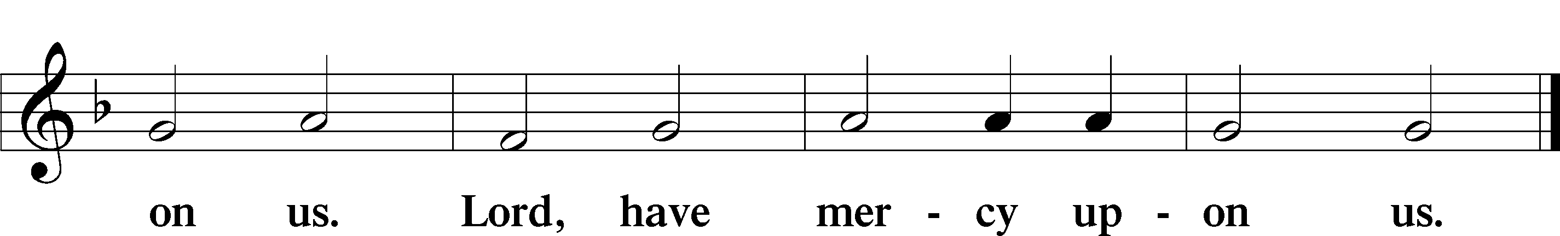

Salutation and Collect of the Day
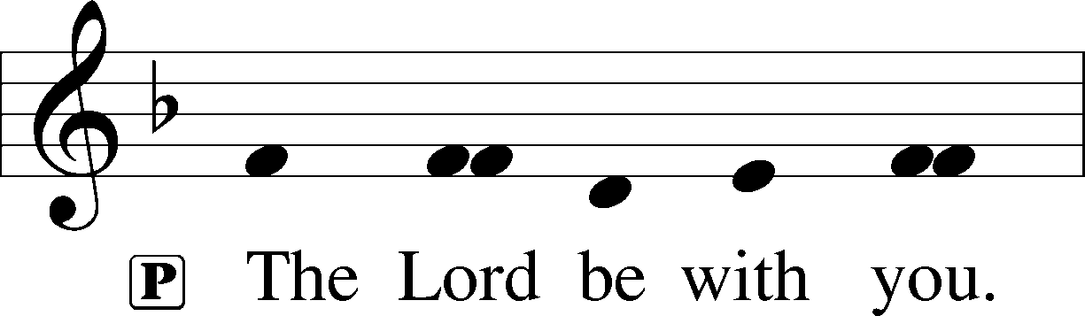
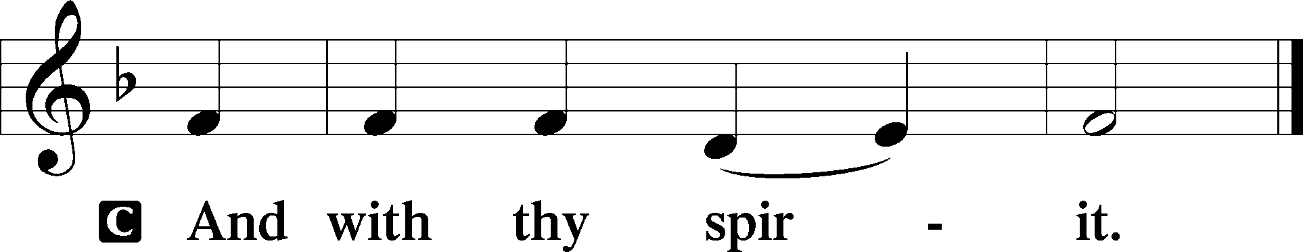

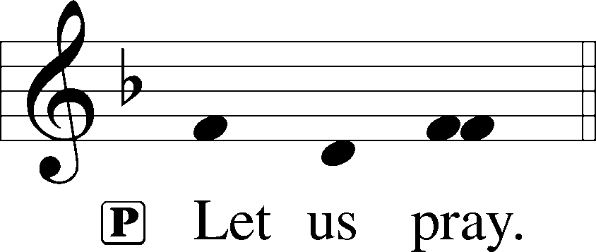

P Most merciful God, as the people of Jerusalem, with palms in their hands, gathered to greet Your dearly beloved Son when He came into His Holy City, grant that we may ever hail Him as our King and, when He comes again, may go forth to meet Him with trusting and steadfast hearts and follow Him in the way that leads to eternal life; through the same Jesus Christ, our Lord, who lives and reigns with You and the Holy Spirit, one God, now and forever.

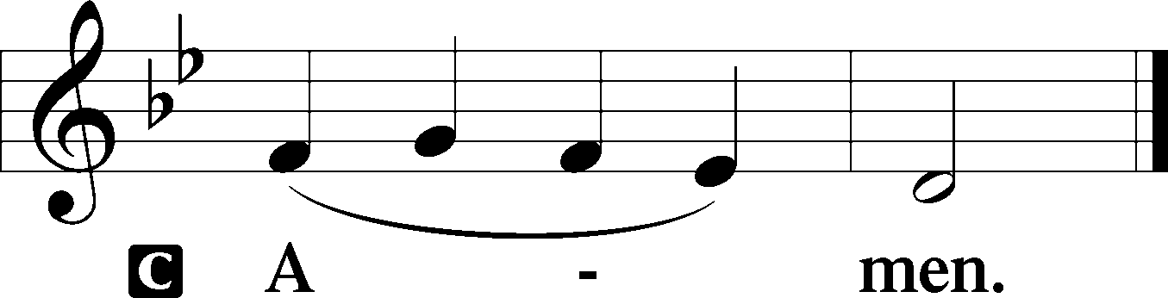

Old Testament Reading Zechariah 9:9-12

⁹ Rejoice greatly, O daughter of Zion!
Shout aloud, O daughter of Jerusalem!
Behold, your king is coming to you;
righteous and having salvation is he,
humble and mounted on a donkey,
on a colt, the foal of a donkey.
¹⁰ I will cut off the chariot from Ephraim
and the war horse from Jerusalem;
and the battle bow shall be cut off,
and he shall speak peace to the nations;
his rule shall be from sea to sea,
and from the River to the ends of the earth.
¹¹ As for you also, because of the blood of my covenant with you,
I will set your prisoners free from the waterless pit.
¹² Return to your stronghold, O prisoners of hope;
today I declare that I will restore to you double.

A This is the Word of the Lord.
C Thanks be to God.

Epistle Philippians 2:5–11

5Have this mind among yourselves, which is yours in Christ Jesus, 6who, though he was in the form of God, did not count equality with God a thing to be grasped, 7but made himself nothing, taking the form of a servant, being born in the likeness of men. 8And being found in human form, he humbled himself by becoming obedient to the point of death, even death on a cross. 9Therefore God has highly exalted him and bestowed on him the name that is above every name, 10so that at the name of Jesus every knee should bow, in heaven and on earth and under the earth, 11and every tongue confess that Jesus Christ is Lord, to the glory of God the Father.

A This is the Word of the Lord.
C Thanks be to God.

Verse
Return to the Lord, your God, for he is gracious and merciful, slow to anger, and abounding in steadfast love.

Holy Gospel John 12:12-19
P The Holy Gospel according to St. John, the twelfth chapter.
C Glory be to Thee, O Lord.

The next day the large crowd that had come to the feast heard that Jesus was coming to Jerusalem. So they took branches of palm trees and went out to meet him, crying out, "Hosanna! Blessed is he who comes in the name of the Lord, even the King of Israel!" And Jesus found a young donkey and sat on it, just as it is written, “Fear not, daughter of Zion; behold, your king is coming, sitting on a donkey's colt!” His disciples did not understand these things at first, but when Jesus was glorified, then they remembered that these things had been written about him and had been done to him. The crowd that had been with him when he called Lazarus out of the tomb and raised him from the dead continued to bear witness. The reason why the crowd went to meet him was that they heard he had done this sign. So the Pharisees said to one another, "You see that you are gaining nothing. Look, the world has gone after him."

P This is the Gospel of the Lord.
C Praise be to Thee, O Christ.

Apostles’ Creed
C I believe in God, the Father Almighty,
maker of heaven and earth.

And in Jesus Christ, His only Son, our Lord,
who was conceived by the Holy Spirit,
born of the virgin Mary,
suffered under Pontius Pilate,
was crucified, died and was buried.
He descended into hell.
The third day He rose again from the dead.
He ascended into heaven
and sits at the right hand of God the Father Almighty.
From thence He will come to judge the living and the dead.

I believe in the Holy Spirit,
the holy Christian Church,
the communion of saints,
the forgiveness of sins,
the resurrection of the body,
and the life T everlasting. Amen.

443 Hosanna, Loud Hosanna
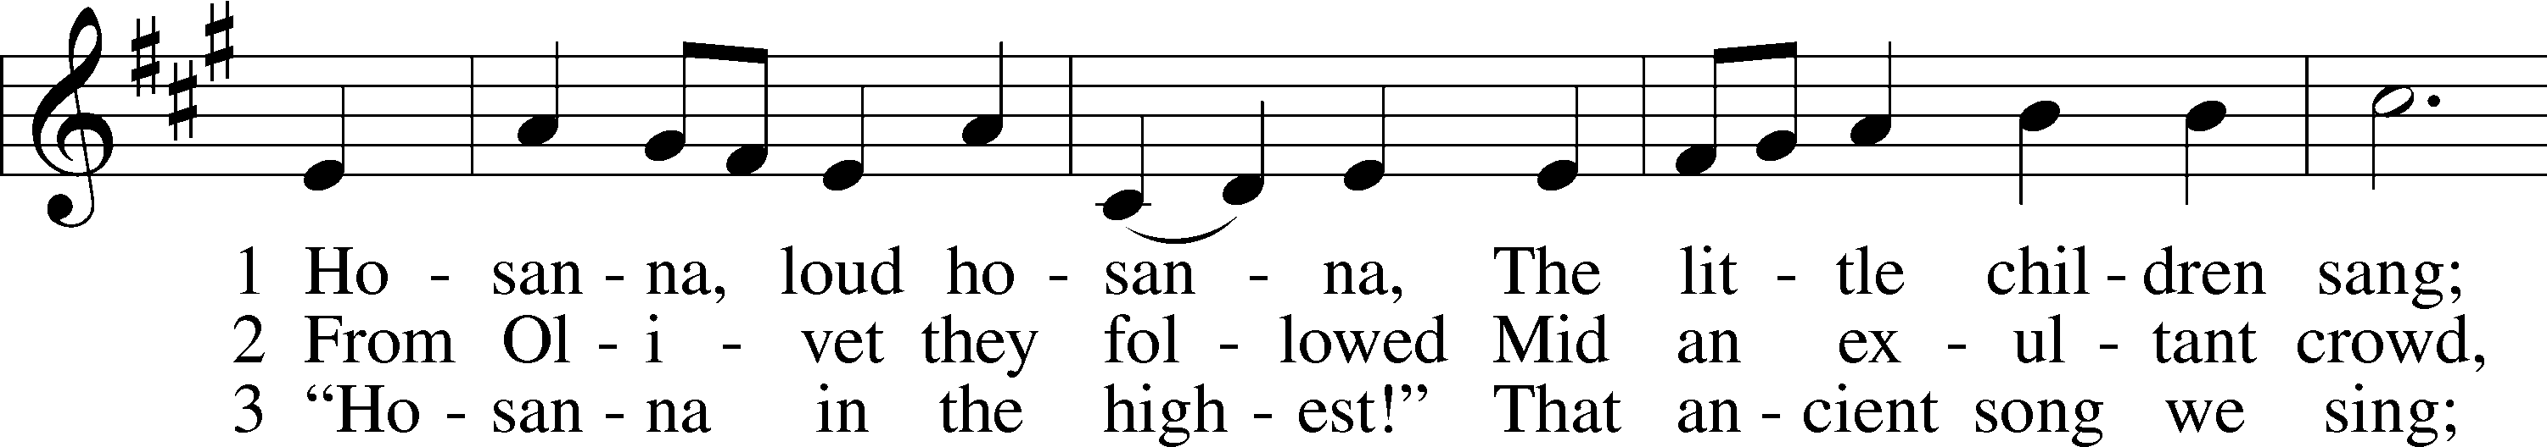
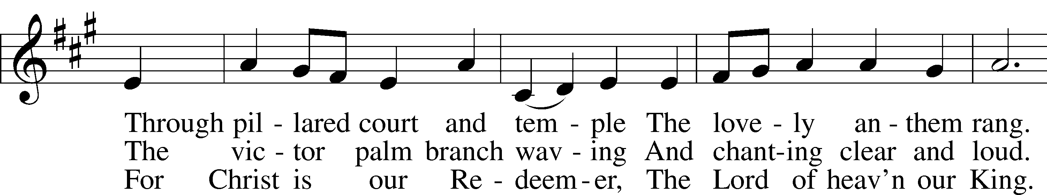
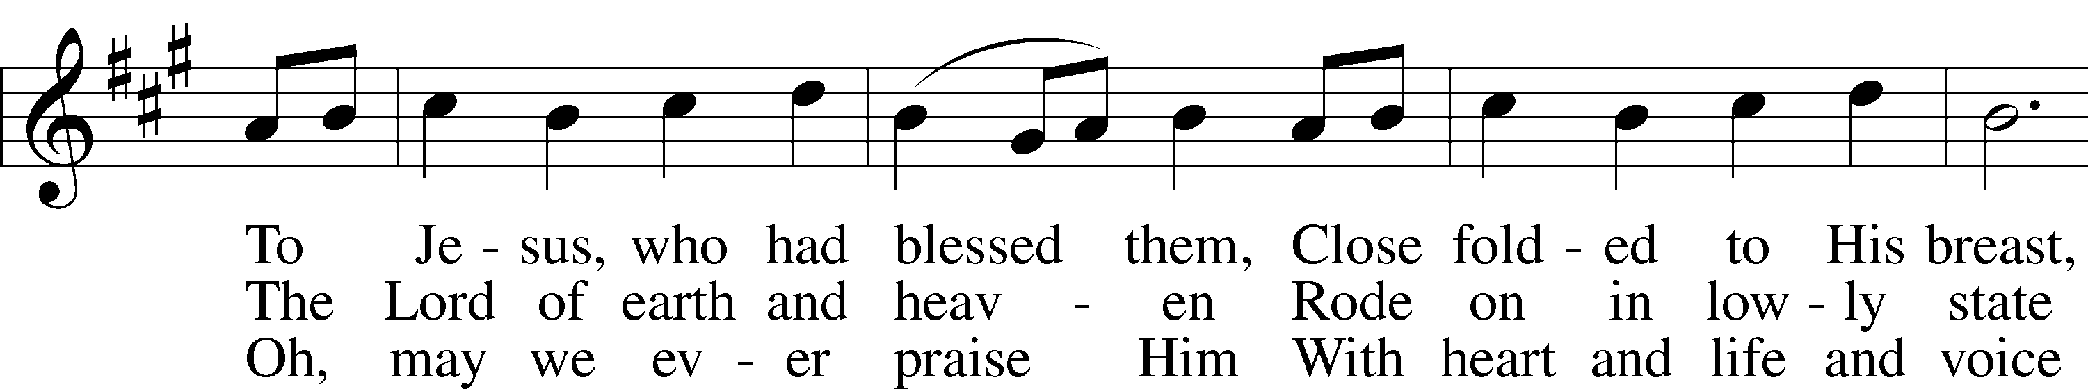
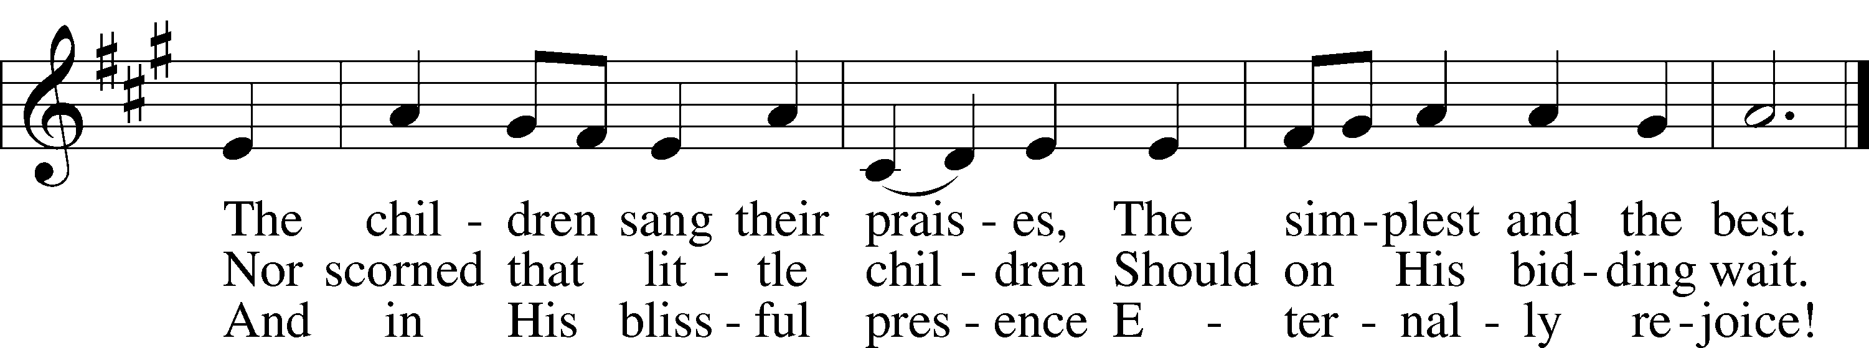
Tune and text: Public domain

Sermon

P The peace of God, which passes all understanding, keep your hearts and minds in Christ Jesus.
C Amen.

Offertory LSB 192
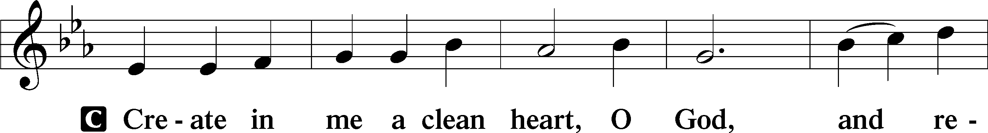
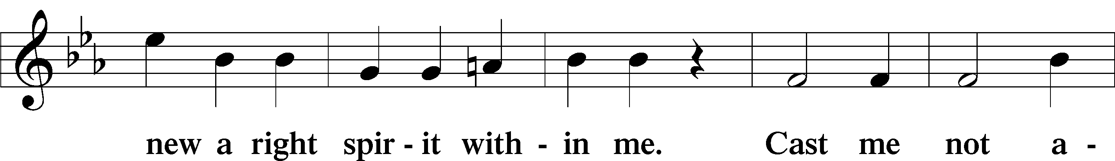
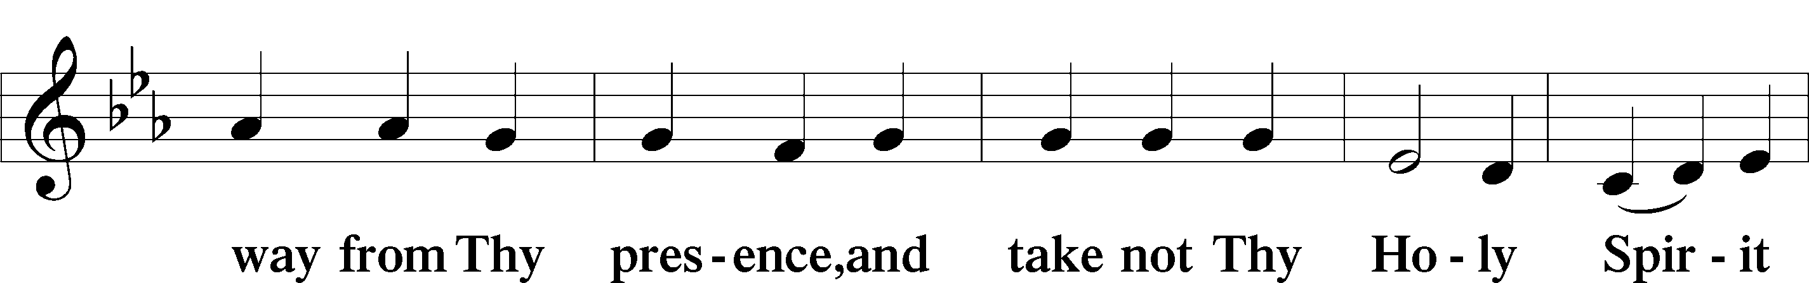
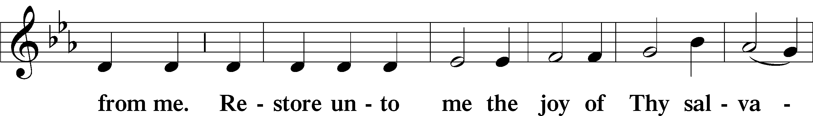
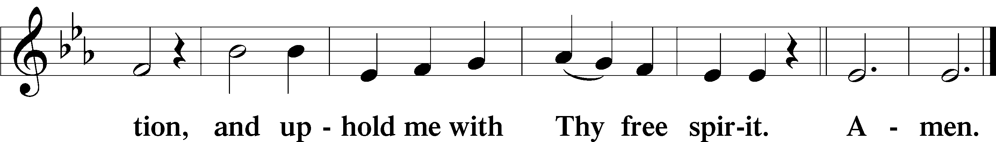

Offering
To worship the Lord with your offering: 1) Go to zionkearney.com and click on the Pushpay icon;
2) Mail your gift to Zion Lutheran Church, 2421 C Ave, Kearney, NE 68847

Prayer of the Church

Lord’s Prayer LSB 196
C Our Father who art in heaven,
hallowed be Thy name,
Thy kingdom come,
Thy will be done on earth as it is in heaven;
give us this day our daily bread;
and forgive us our trespasses as we forgive those who trespass against us;
and lead us not into temptation,
but deliver us from evil.
For Thine is the kingdom and the power and the glory forever and ever. Amen.

Benedicamus LSB 202
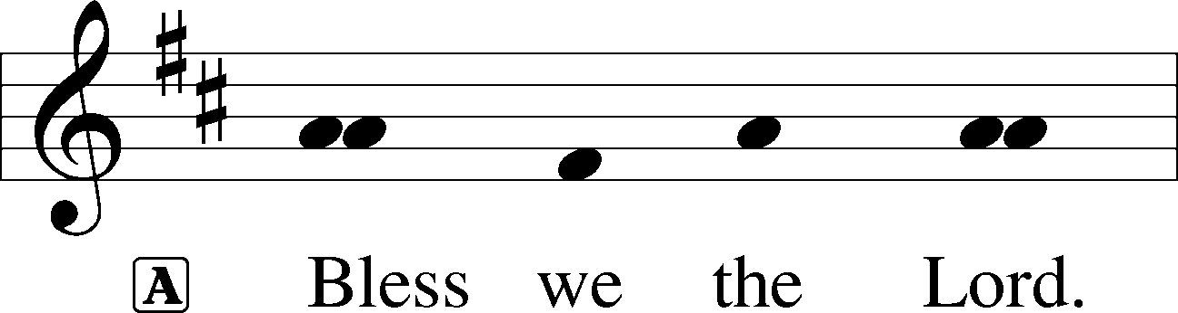

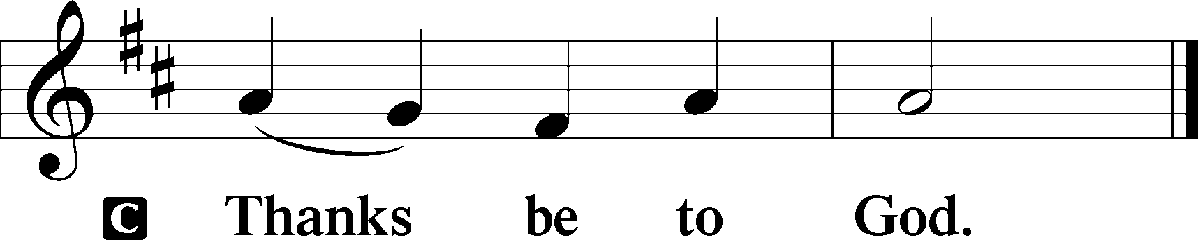

Benediction LSB 202
P The Lord bless you and keep you.
The Lord make His face shine upon you and be gracious unto you.
The Lord lift up His countenance upon you and T give you peace.
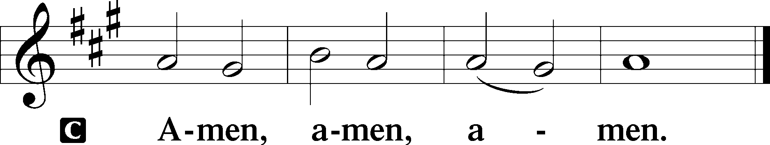

441 Ride On, Ride On in Majesty
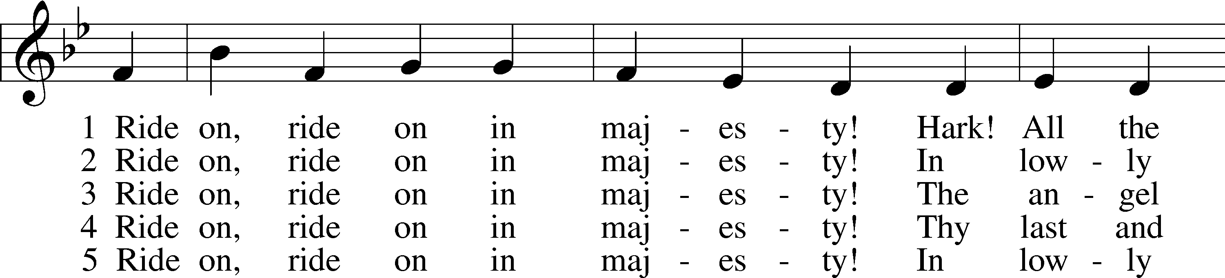
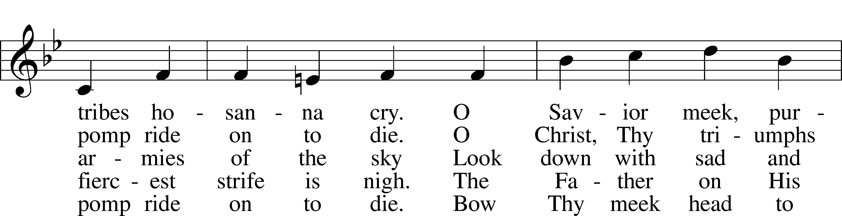
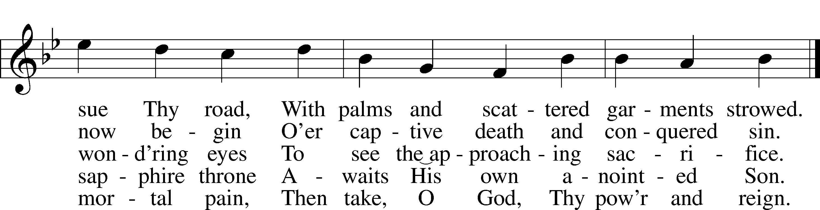
Tune and text: Public domain

Acknowledgments
Divine Service, Setting Three from Lutheran Service Book
Unless otherwise indicated, Scripture quotations are from the ESV® Bible (The Holy Bible, English Standard Version®), copyright © 2001 by Crossway, a publishing ministry of Good News Publishers. Used by permission. All rights reserved.
Created by Lutheran Service Builder © 2018 Concordia Publishing House.

The Radio Broadcast today is given to the Glory of the Lord by Carolyn Wilkens

Opportunities to Worship during Holy Week
Thurs. April 9 | Maundy Thursday Service | 7:00pm
Friday, April 10 | Tenebrae Service | 7:00pm
Saturday, April 11 | Easter Vigil Service | 7:00pm
Sunday, April 12 | Easter Festival Service | 9:00am

Prayers for Our Members
Chelsea Junge, Christina Long, Tenaya Nuttelman | Expectant Mothers
Norman Abels (Brookestone Meadows – Elkhorn) | Healing
Judy Ahrens | Healing
Vaughn Albrecht (Northridge) | Healing
Tom & DyAnn Altwine | Healing
Lyle Colsden (Mother Hull) | Healing
Brenda Fletcher | Healing
Pat Flodine (Cambridge Court) | Healing
Vi Fox (Prairie View) | Healing
Verleen Gentry | Healing
Robert Glanzer | Healing
Tiffany Hartman | Healing
Ruby Hatfield | Healing
Carol Herron | Healing
Carol Kreutzer | Healing
Marion Richmond | Healing
Geraldine Roeder | Healing
Dorothy Sikes | Healing
Carolyn Westman | Healing
Bev Nuttelman | Cancer
Kim Vos | Cancer
Prayers for Our Members’ Family & Friends
Brittany Helmbrecht & baby girl Lennon (Don & Shirley’s daughter-in-law) | Mother & Baby
Becci Koopman (Todd & Ellen Koopman daughter-in-law) | Expectant Mother
Shaylee Kreutzer (Rich & Carol Kreutzer’s daughter-in-law) | Expectant Mother
Lana Latsabidze (Bruce & Ann Fattig daughter-in-law) | Expectant Mother
Amy Nuttelman (Keith & Bev Nuttelman’s daughter-in-law) | Expectant Mother
Family and Friends Larry Willers (Todd Willers’ father) | Grief
Ava Jean Winnie (Nic Kitzing’s cousin) | Healing
Will Brennemann (Jami Helmbrecht’s father) | Healing
Don Berg (Evelyn Heiden’s brother) | Healing
Reg Duke (Westman’s brother-in-law) | Healing
James Gentry (Verleen Gentry’s son) | Healing
Mark Glover (Shirley Helmbrecht’s brother) | Healing
Brooke Guthrie (Bailey Hockemeier’s sister) | Healing
Lois Hanson (Pastor Hanson’s wife) | Healing
Norman Hockemeier (Ken’s father) | Healing
Roger Hoffman (Marc’s father) | Healing
Miles Margritz (Wanda Glanzer’s nephew) | Healing
Randy Solomon (Beth Rosenthal’s father) | Healing
Mary Ann Mertz (Pam’s Uhlir’s friend) | Healing
Roy Reynolds (Verleen Gentry’s son-in-law) | Healing
Tyler Christensen (Bruce & Joni Brooks nephew) | Cancer
Patty Ellis (Fran Junge’s sister) | Cancer
Ron Halvorsen (Jeff’s dad) | Cancer
Carol Haubold (Don Helmbrecht’s sister) | Cancer
Tyler Holland (Quentin & Janel Lange brother-in-law) | Cancer
Fred Koch (Pam Uhlir’s cousin) | Cancer
Lynda Kreutzer (Rich & Carol’s sister-in-law) | Cancer
Sharon Mulhair (Pam Uhlir’s cousin) | Cancer
Tyrone Uhlir (Pam’s nephew) | Cancer
Members of Zion Lutheran North Shelton | Loss & Restoration
Pr.James, Pr. Clausing, Our sister congregations in Haiti | Missionaries
John Christensen, John Harbols | Military

Sun  04/05 | 9:00a | Divine Service
Mon  04/06 | Birthdays  Anniversaries | ---  Ryan & Brooke Fisher
Tues  04/07 | Birthdays  Anniversaries | Ellen Hockemeier  Frances Junge  Taylor Zehendner  ---
Wed  04/08 | 5:45p  Birthdays  Anniversaries | Midweek - ONLINE  ---  ---
Thurs  04/09 | 7:00p  Birthdays  Anniversaries | Adult Instruction  Brynne Fisher  Dallas Jorgensen  ---
Fri  04/10 | Birthdays  Anniversaries | Chelsea Junge  ---
Sat  04/11 | Birthdays  Anniversaries | ---  ---
Sun  04/12 | 9:00a  Birthdays  Anniversaries | Divine Service  David Hartman  ---

Our Response to the Gospel

Date: 03/29/2020

Attendance: cancelled

Offering: $7,731.23
Weekly Need: $7,542.37

Serving in Worship

Palm Sunday Service Sunday, April 5 9:00am
Acolyte: Allison Wilkens
Elder: Ken Hockemeier
Usher: Fred Flessner & Lennis Hodgson
Engineer: Peter Kreutzer
Announcer: Jesse Florang
Altar Guild: Ellen Hockemeier & Rachael Burger

Maundy Thursday Service Thursday, April 9 7:00pm
Acolyte: Kassidy Halvorsen
Elder: Ken Hockemeier
Usher: Fred Flessner & Lennis Hodgson
Engineer: Peter Kreutzer
Altar Guild: Shirley Helmbrecht

Tenebrae Service Friday, April 10 7:00pm
Acolyte: Alexandra Splittgerber
Elder: Ken Hockemeier
Usher: Mike Wilkens & Jeff Strong
Engineer: Rich Kreutzer
Altar Guild: Shirley Helmbrecht

Easter Vigil Service Saturday, April 11 7:00pm
Acolyte: Lindsay Wilkens
Elder: Nathan Gaunt
Usher: Marc Hoffman & Steve Junge
Engineer: Rich Kreutzer
Altar Guild: Ellen Hockemeier & Rachael Burger

Easter Festival Service Sunday, April 12 9:00am
Acolyte: Reily Fisher
Elder: Nathan Gaunt
Usher: Roger Riekenberg & Robert Glanzer
Engineer: Jared Nuttelman
Announcer: Lonna Gronewaller
Altar Guild: Ellen Hockemeier & Rachael Burger

ZION LUTHERAN CHURCH AND SCHOOL

Pr. James DeLoach, Pastor + (308) 627-5260
james.deloach@zionkearney.org

Pr. Doug Gaunt, Pastor + (308) 455-0552
doug.gaunt@zionkearney.org

Tony Splittgerber, Principal + (308) 293-0168
anthony.splittgerber@zionkearney.org

Church Office
Administrative Assistant: Jessica Shiers
Email: school@zionkearney.org
Phone: (308)-234-3410 Fax: (308) 236-8100
Office Hours: Monday-Friday 8:00am-4:00pm
Radio Broadcast: Sunday @ 10:30 a.m. on 1460 AM
Website: www.zionkearney.com

