The Resurrection of our Lord
Zion Lutheran Church – Kearney, NE
12 April 2020

457 Jesus Christ Is Risen Today
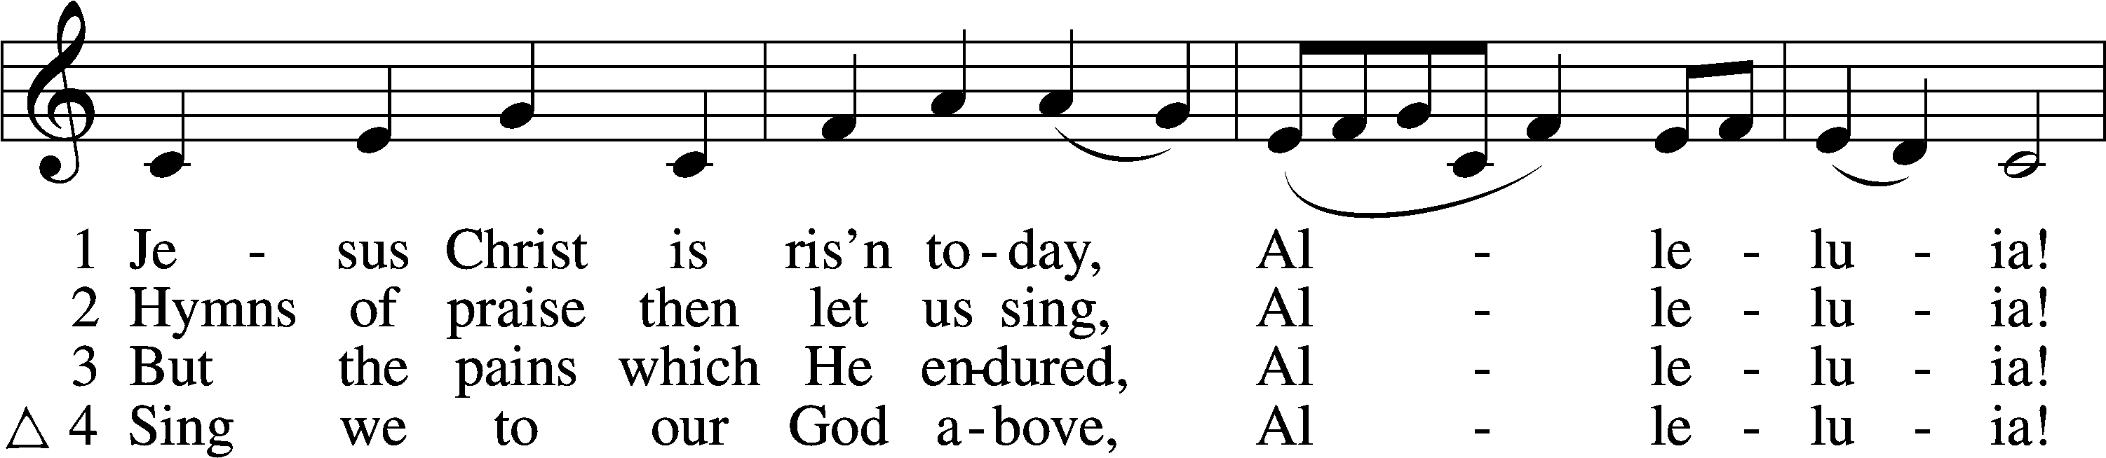
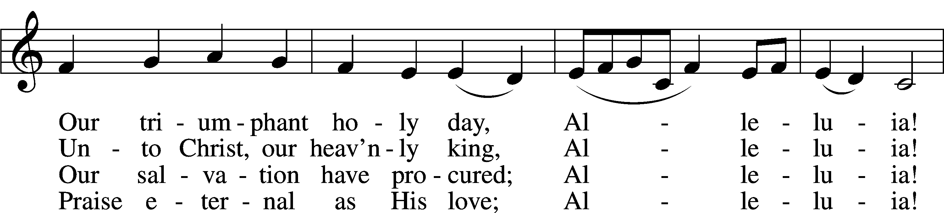
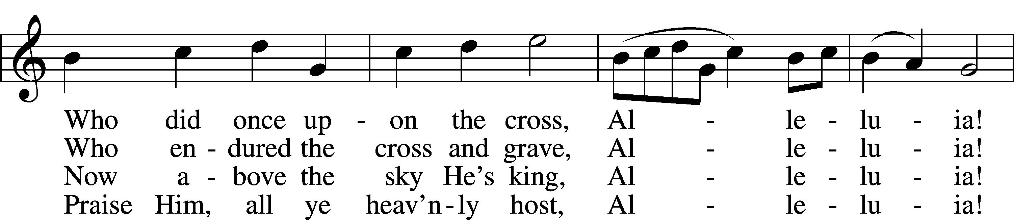
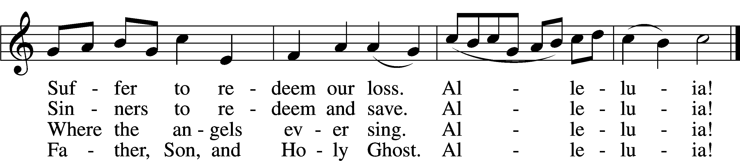
Text and tune: Public domain

Confession and Absolution
The sign of the cross may be made by all in remembrance of their Baptism.

P In the name of the Father and of the + Son and of the Holy Spirit.
C Amen.

P If we say we have no sin, we deceive ourselves, and the truth is not in us.
C But if we confess our sins, God, who is faithful and just, will forgive our sins and cleanse us from all unrighteousness.

Silence for reflection on God’s Word and for self-examination.

P Let us then confess our sins to God our Father.
C Most merciful God, we confess that we are by nature sinful and unclean. We have sinned against You in thought, word, and deed, by what we have done and by what we have left undone. We have not loved You with our whole heart; we have not loved our neighbors as ourselves. We justly deserve Your present and eternal punishment. For the sake of Your Son, Jesus Christ, have mercy on us. Forgive us, renew us, and lead us, so that we may delight in Your will and walk in Your ways to the glory of Your holy name. Amen.

P Almighty God in His mercy has given His Son to die for you and for His sake forgives you all your sins. As a called and ordained servant of Christ, and by His authority, I therefore forgive you all your sins in the name of the Father and of the + Son and of the Holy Spirit.
C Amen.
Service of the Word

Introit Exodus 15:2a, 6, 13, 17–18; antiphon: v. 1b
I will sing to the Lord, for he has triumphed | gloriously;*
the horse and his rider he has thrown in- | to the sea.
The Lord is my strength | and my song,*
and he has become my sal- | vation.
Your right hand, O Lord, glorious | in power,*
your right hand, O Lord, shatters the | enemy.
You have led in your steadfast love the people whom you | have redeemed;*
you have guided them by your strength to your ho- | ly abode.
You will bring them in and plant them on your own | mountain,*
the place, O Lord, which you have made for | your abode,
the sanctuary, O Lord, which your hands have es- | tablished.*
The Lord will reign forever and | ever.
Glory be to the Father and | to the Son*
and to the Holy | Spirit;
as it was in the be- | ginning,*
is now, and will be forever. | Amen.
I will sing to the Lord, for he has triumphed | gloriously;*
the horse and his rider he has thrown in- | to the sea.

Kyrie LSB 152

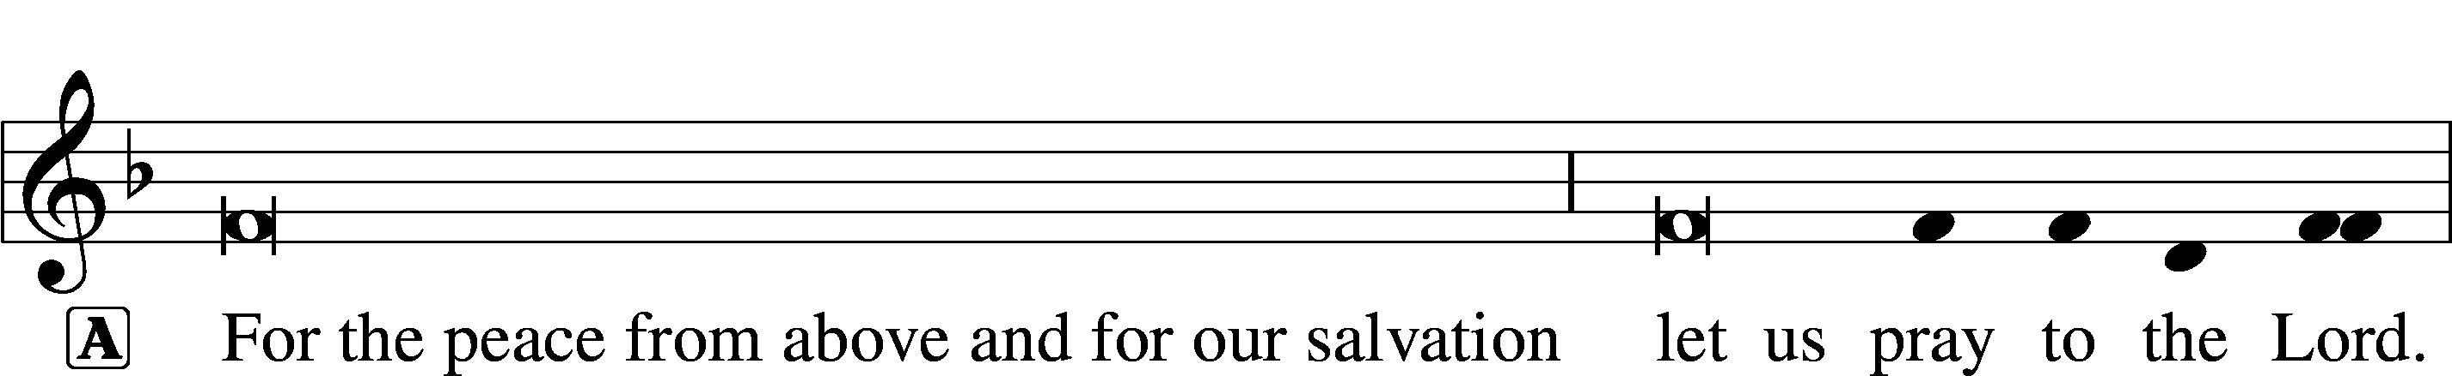

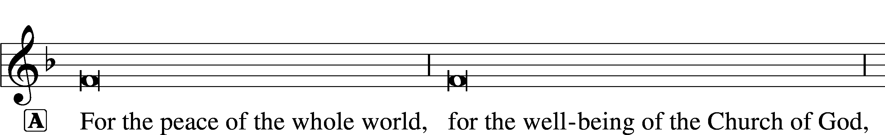

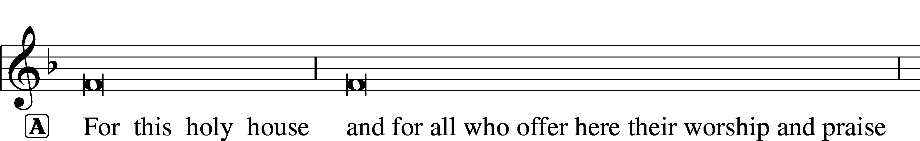

This Is the Feast LSB 155
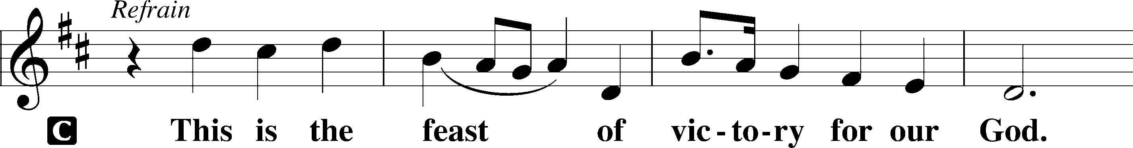
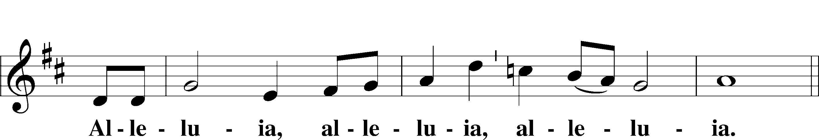
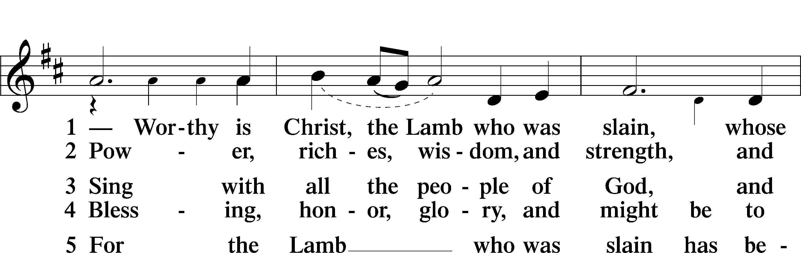
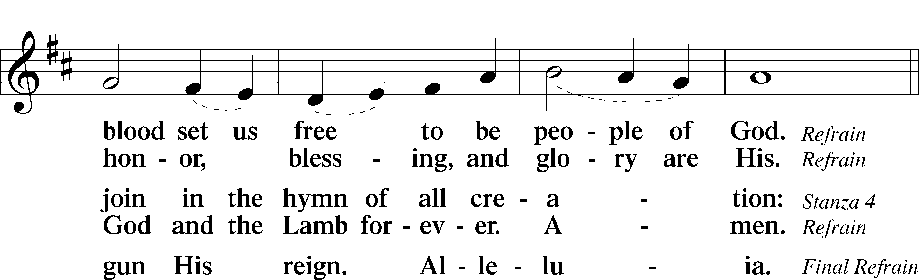
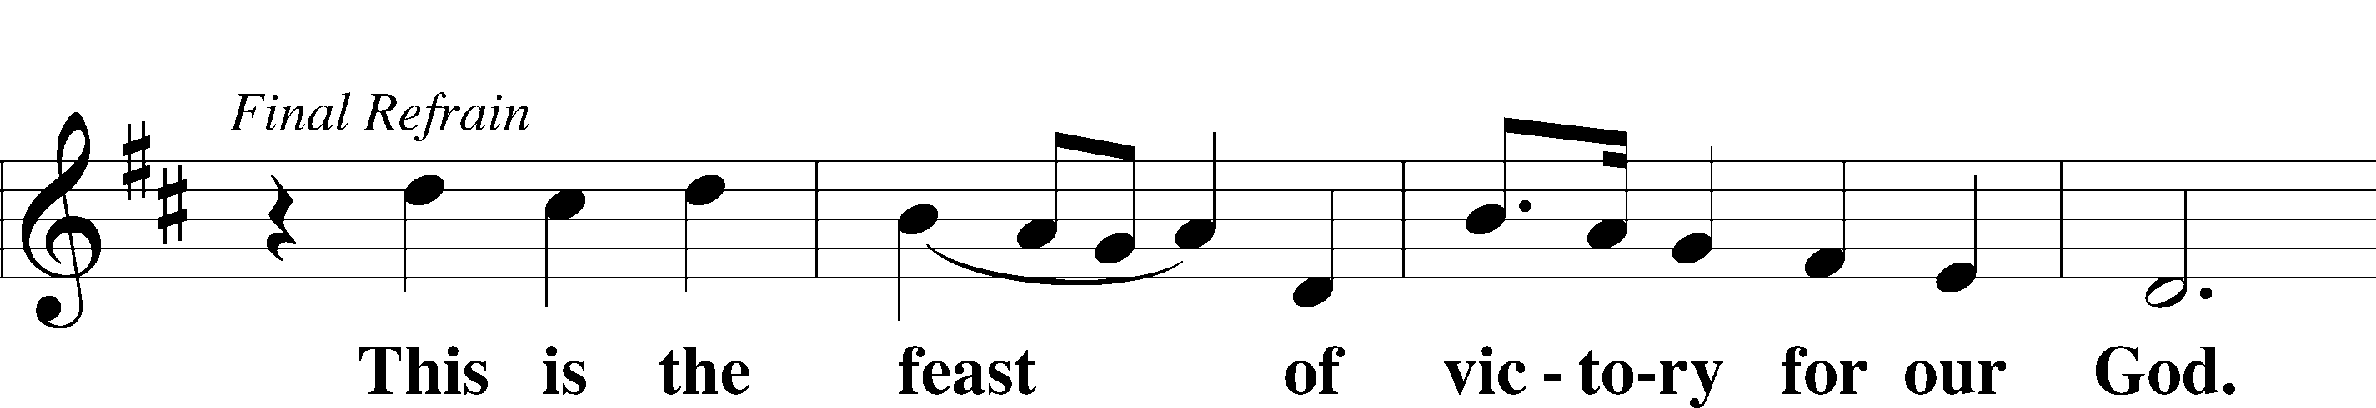
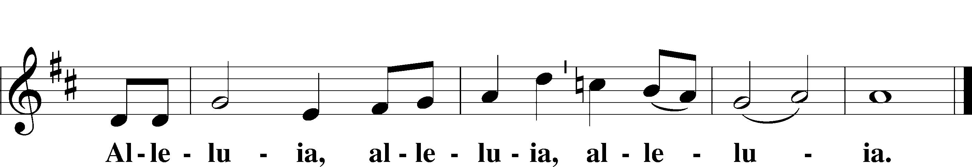

Salutation and Collect of the Day
P The Lord be with you.
C And also with you.

P Let us pray.
Almighty God the Father, through Your only-begotten Son, Jesus Christ, You have overcome death and opened the gate of everlasting life to us. Grant that we, who celebrate with joy the day of our Lord’s resurrection, may be raised from the death of sin by Your life-giving Spirit; through Jesus Christ, our Lord, who lives and reigns with You and the Holy Spirit, one God, now and forever.
C Amen.

First Reading Acts 10:34-43
34Peter opened his mouth and said: “Truly I understand that God shows no partiality, 35but in every nation anyone who fears him and does what is right is acceptable to him. 36As for the word that he sent to Israel, preaching good news of peace through Jesus Christ (he is Lord of all), 37you yourselves know what happened throughout all Judea, beginning from Galilee after the baptism that John proclaimed: 38how God anointed Jesus of Nazareth with the Holy Spirit and with power. He went about doing good and healing all who were oppressed by the devil, for God was with him. 39And we are witnesses of all that he did both in the country of the Jews and in Jerusalem. They put him to death by hanging him on a tree, 40but God raised him on the third day and made him to appear, 41not to all the people but to us who had been chosen by God as witnesses, who ate and drank with him after he rose from the dead. 42And he commanded us to preach to the people and to testify that he is the one appointed by God to be judge of the living and the dead. 43To him all the prophets bear witness that everyone who believes in him receives forgiveness of sins through his name.”

A This is the Word of the Lord.
C Thanks be to God.

Gradual adapt. from Matthew 28:7; Hebrews 2:7; Psalm 8:6
Christ has risen | from the dead.*
[God the Father] has crowned him with glory and | honor.
He has given him dominion over the works | of his hands;*
he has put all things un- | der his feet.

Epistle Colossians 3:1–4
1If then you have been raised with Christ, seek the things that are above, where Christ is, seated at the right hand of God. 2Set your minds on things that are above, not on things that are on earth. 3For you have died, and your life is hidden with Christ in God. 4When Christ who is your life appears, then you also will appear with him in glory.

A This is the Word of the Lord.
C Thanks be to God.

Verse of the Day 2 Timothy 1:10b
Alleluia. [Christ Jesus] abolished death and brought life and immortality to light through the gospel. Alleluia.

Holy Gospel Matthew 28:1–10
P The Holy Gospel according to St. Matthew, the twenty-eighth chapter.
C Glory to You, O Lord.
1Now after the Sabbath, toward the dawn of the first day of the week, Mary Magdalene and the other Mary went to see the tomb. 2And behold, there was a great earthquake, for an angel of the Lord descended from heaven and came and rolled back the stone and sat on it. 3His appearance was like lightning, and his clothing white as snow. 4And for fear of him the guards trembled and became like dead men. 5But the angel said to the women, “Do not be afraid, for I know that you seek Jesus who was crucified. 6He is not here, for he has risen, as he said. Come, see the place where he lay. 7Then go quickly and tell his disciples that he has risen from the dead, and behold, he is going before you to Galilee; there you will see him. See, I have told you.” 8So they departed quickly from the tomb with fear and great joy, and ran to tell his disciples. 9And behold, Jesus met them and said, “Greetings!” And they came up and took hold of his feet and worshiped him. 10Then Jesus said to them, “Do not be afraid; go and tell my brothers to go to Galilee, and there they will see me.”

P This is the Gospel of the Lord.
C Praise to You, O Christ.

480 He’s Risen, He’s Risen
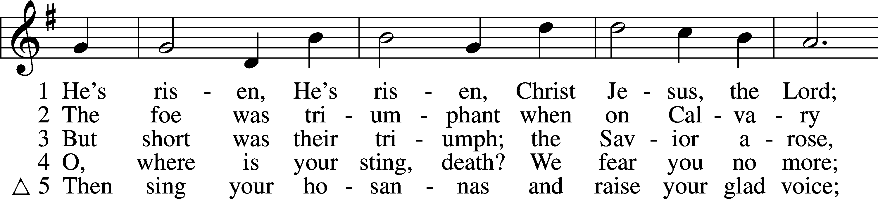
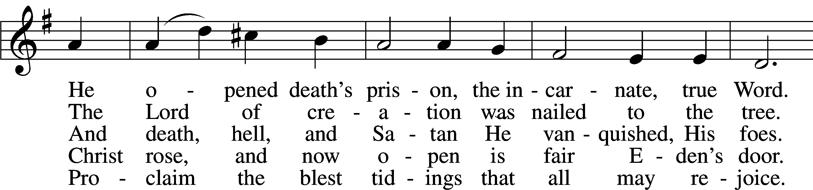
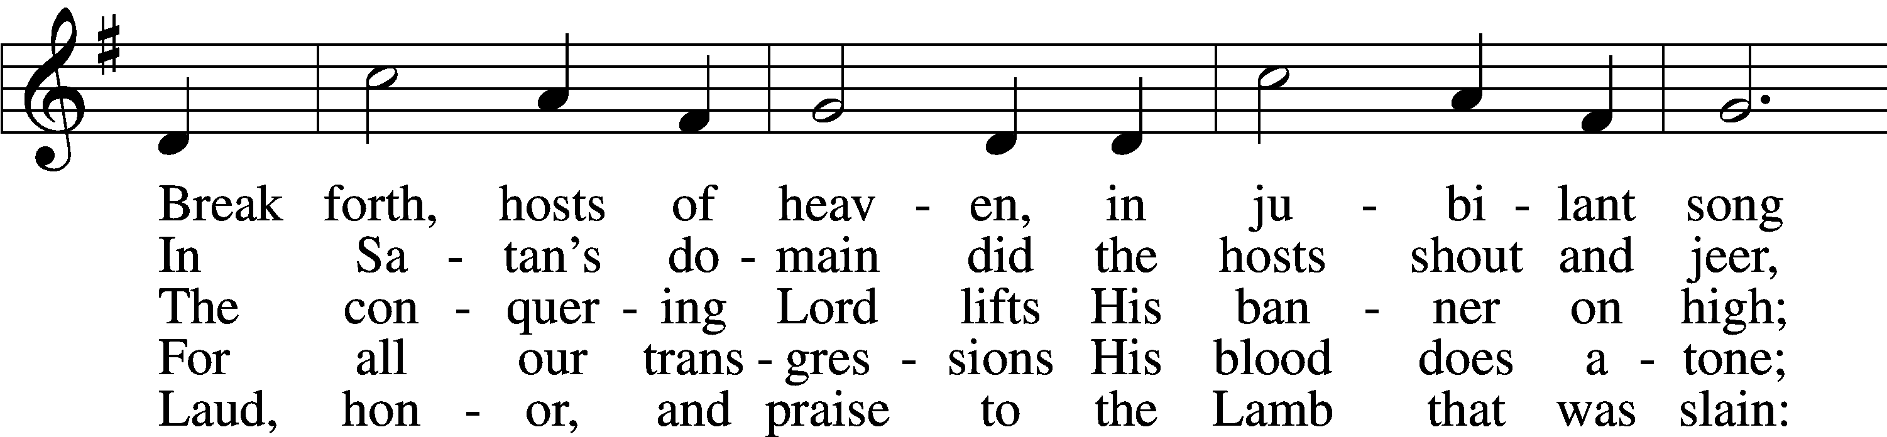
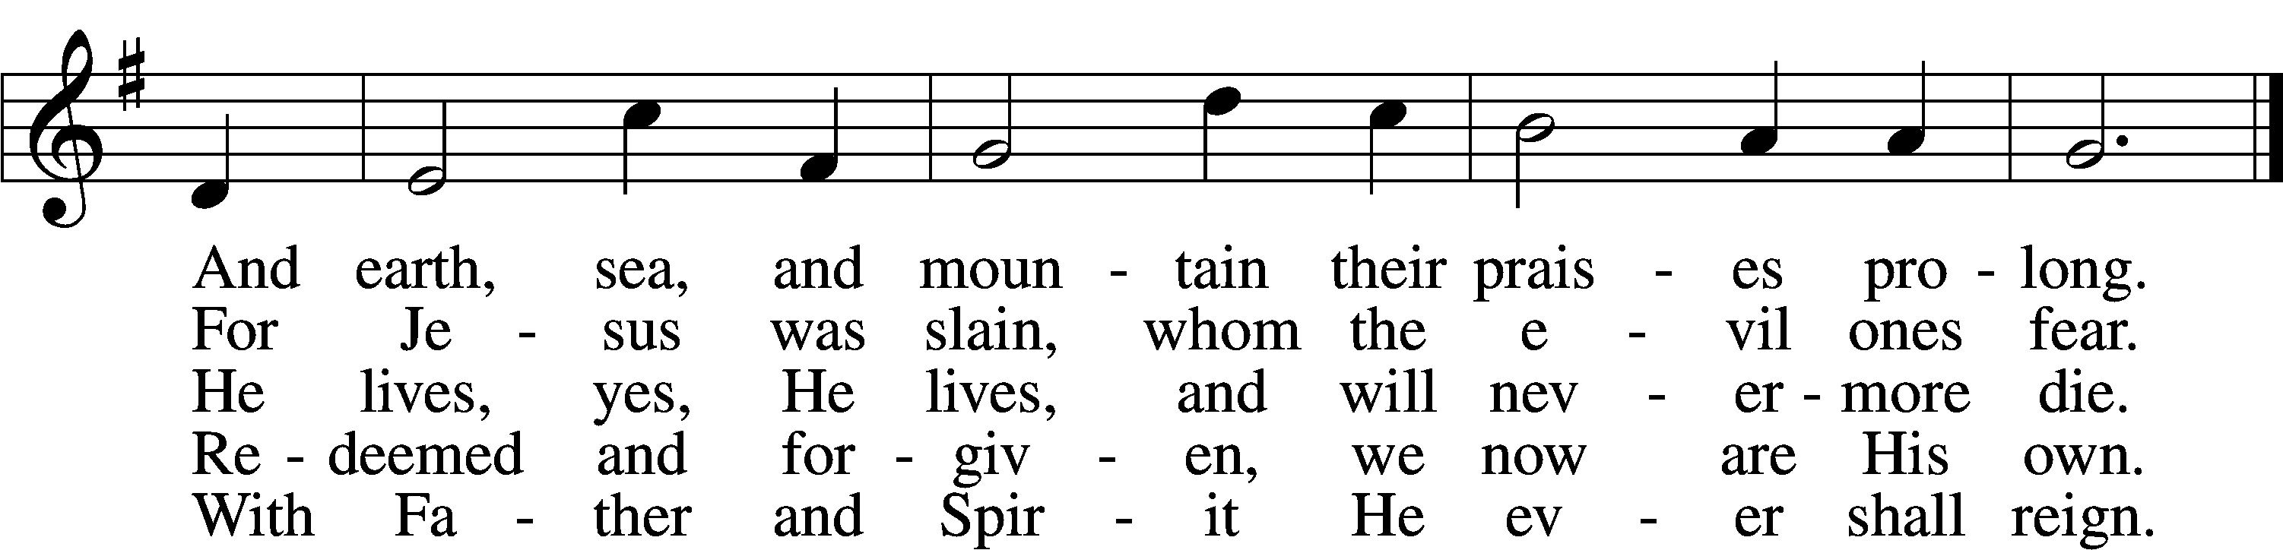
Tune: Public domain
Text: © 1941 Concordia Publishing House. Used by permission: CPH Limited Promotional License no. 119000000

Sermon

Nicene Creed
C I believe in one God,
the Father Almighty,
maker of heaven and earth
and of all things visible and invisible.

And in one Lord Jesus Christ,
the only-begotten Son of God,
begotten of His Father before all worlds,
God of God, Light of Light,
very God of very God,
begotten, not made,
being of one substance with the Father,
by whom all things were made;
who for us men and for our salvation came down from heaven
and was incarnate by the Holy Spirit of the virgin Mary
and was made man;
and was crucified also for us under Pontius Pilate.
He suffered and was buried.
And the third day He rose again according to the Scriptures
and ascended into heaven
and sits at the right hand of the Father.
And He will come again with glory to judge both the living and the dead,
whose kingdom will have no end.

And I believe in the Holy Spirit,
the Lord and giver of life,
who proceeds from the Father and the Son,
who with the Father and the Son together is worshiped and glorified,
who spoke by the prophets.
And I believe in one holy Christian and apostolic Church,
I acknowledge one Baptism for the remission of sins,
and I look for the resurrection of the dead
and the life + of the world to come. Amen.
Offering
To worship the Lord with your offering: 1) Go to zionkearney.com and click on the Pushpay icon;
2) Or, mail your gift to Zion Lutheran Church, 2421 C Ave, Kearney, NE 68847

Litany of the Resurrection
A O Lord,
C have mercy.
A O Christ,
C have mercy.
A O Lord,
C have mercy.
A Lord Jesus Christ, Son of God,
C hear us.
A Paschal Lamb, who was offered for us and has taken away the sin of the world,
C have mercy on us.
A Who was crucified for our transgressions and raised for our justification,
C have mercy on us.
A Who foretold Your passion saying, “The Son of Man must be crucified and on the third day rise again,”
C have mercy on us.
A Who destroyed death by dying, and by rising to life again brought life and immortality to light,
C have mercy on us.
A Whose resurrection was first announced by an angel to the women,
C have mercy on us.
A Who appeared to Mary Magdalene and was worshiped by her,
C have mercy on us.
A Who revealed Yourself to the two disciples on the Emmaus road and made Yourself known to them in the Scriptures and in the breaking of the bread,
C have mercy on us.
A Who appeared to the disciples, bestowing on them Your peace and Your Spirit,
C have mercy on us.
A Who showed Your wounded hands and side to the apostle Thomas that he too might believe,
C have mercy on us.
A Who appeared to seven disciples on the Sea of Tiberias, bringing a miraculous catch of fish,
C have mercy on us.
A Who appeared to Peter and to the Twelve, to over 500 disciples, to James and to all the apostles, and to Paul on the Damascus road,
C have mercy on us.
A Who commissioned Your Church to make disciples of all nations by baptizing and teaching them,
C have mercy on us.
A By Your glorious resurrection from the dead,
C good Lord, deliver us.
A By Your victory over sin and death,
C good Lord, deliver us.
A By the majesty of Your risen body,
C good Lord, deliver us.
A We poor sinners implore You
C to hear us, Lord Jesus.
A That we may daily die and rise with You in our Baptism and walk in the freedom of Your forgiveness,
C grant us, good Lord.
A That we may set our minds on things above and not on earthly things, serving others as we have been served by You,
C grant us, good Lord.
A That we may dwell with You forever in the new creation as citizens of the heavenly Jerusalem, together with all the saints,
C grant us, good Lord.
A Christ, the Lamb of God, who takes away the sin of the world,
C have mercy on us.
A Christ, the Lamb of God, who takes away the sin of the world,
C have mercy on us.
A Christ, the Lamb of God, who takes away the sin of the world,
C grant us Your peace.
A O Lord,
C have mercy.
A O Christ,
C have mercy.
A O Lord,
C have mercy. Amen.

Prayer of the Church
Lord’s Prayer
C Our Father who art in heaven,
hallowed be Thy name,
Thy kingdom come,
Thy will be done on earth
as it is in heaven;
give us this day our daily bread;
and forgive us our trespasses
as we forgive those
who trespass against us;
and lead us not into temptation,
but deliver us from evil.
For Thine is the kingdom
and the power and the glory
forever and ever. Amen.

Collect for the Word
A Let us pray.
Lord Jesus Christ, giver and perfecter of our faith, we thank and praise You for continuing among us the preaching of Your Gospel for our instruction and edification. Send Your blessing upon the Word, which has been spoken to us, and by Your Holy Spirit increase our saving knowledge of You, that day by day we may be strengthened in the divine truth and remain steadfast in Your grace. Give us strength to fight the good fight and by faith to overcome all the temptations of Satan, the flesh, and the world so that we may finally receive the salvation of our souls; for You live and reign with the Father and the Holy Spirit, one God, now and forever.
C Amen.

Benediction LSB 166
P The Lord bless you and keep you.
The Lord make His face shine on you and be gracious to you.
The Lord look upon you with favor and + give you peace.
C Amen.

461 I Know That My Redeemer Lives
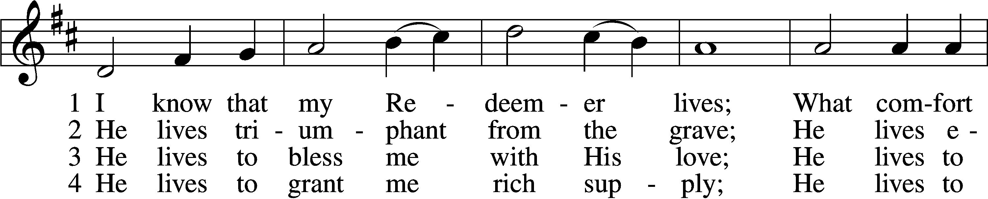
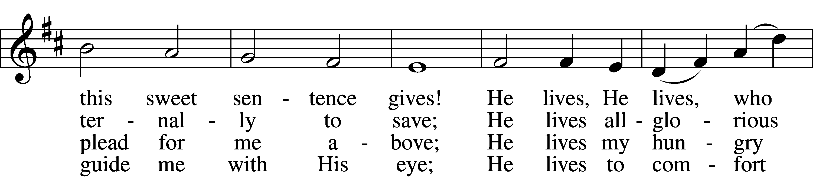
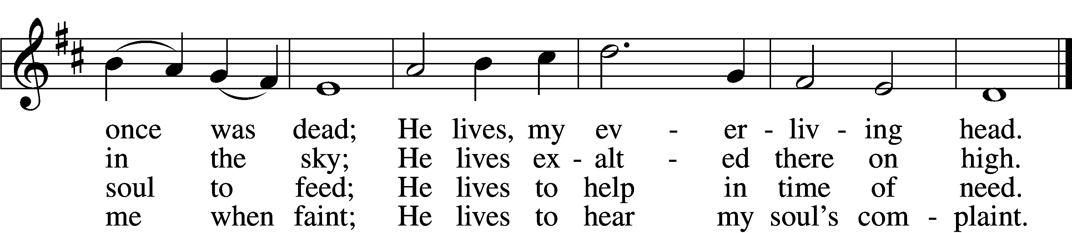

5 He lives to silence all my fears;
He lives to wipe away my tears;
He lives to calm my troubled heart;
He lives all blessings to impart.

6 He lives, my kind, wise, heav’nly friend;
He lives and loves me to the end;
He lives, and while He lives, I’ll sing;
He lives, my Prophet, Priest, and King.

7 He lives and grants me daily breath;
He lives, and I shall conquer death;
He lives my mansion to prepare;
He lives to bring me safely there.

8 He lives, all glory to His name!
He lives, my Jesus, still the same;
Oh, the sweet joy this sentence gives:
I know that my Redeemer lives!
Tune and text: Public domain

Acknowledgments
Divine Service, Setting One from Lutheran Service Book
Unless otherwise indicated, Scripture quotations are from the ESV® Bible (The Holy Bible, English Standard Version®), copyright © 2001 by Crossway, a publishing ministry of Good News Publishers. Used by permission. All rights reserved.
Created by Lutheran Service Builder © 2018 Concordia Publishing House.

The Radio Broadcast today is given to the Glory of the Lord by Ted’s Missions

Prayers for Our Members
Chelsea Junge, Christina Long, Tenaya Nuttelman | Expectant Mothers
Norman Abels (Brookestone Meadows – Elkhorn) | Healing
Judy Ahrens | Healing
Vaughn Albrecht (Northridge) | Healing
Tom & DyAnn Altwine | Healing
Lyle Colsden (Mother Hull) | Healing
Brenda Fletcher | Healing
Pat Flodine (Cambridge Court) | Healing
Vi Fox (Prairie View) | Healing
Verleen Gentry | Healing
Tiffany Hartman | Healing
Ruby Hatfield | Healing
Carol Herron | Healing
Carol Kreutzer | Healing
Marion Richmond | Healing
Geraldine Roeder | Healing
Dorothy Sikes | Healing
Carolyn Westman | Healing
Bev Nuttelman | Cancer
Kim Vos | Cancer
Prayers for Our Members’ Family & Friends
Becci Koopman (Todd & Ellen Koopman daughter-in-law) | Expectant Mother
Shaylee Kreutzer (Rich & Carol Kreutzer’s daughter-in-law) | Expectant Mother
Lana Latsabidze (Bruce & Ann Fattig daughter-in-law) | Expectant Mother
Amy Nuttelman (Keith & Bev Nuttelman’s daughter-in-law) | Expectant Mother
Ava Jean Winnie (Nic Kitzing’s cousin) | Healing
Will Brennemann (Jami Helmbrecht’s father) | Healing
Don Berg (Evelyn Heiden’s brother) | Healing
Reg Duke (Westman’s brother-in-law) | Healing
James Gentry (Verleen Gentry’s son) | Healing
Mark Glover (Shirley Helmbrecht’s brother) | Healing
Brooke Guthrie (Bailey Hockemeier’s sister) | Healing
Lois Hanson (Pastor Hanson’s wife) | Healing
Norman Hockemeier (Ken’s father) | Healing
Roger Hoffman (Marc’s father) | Healing
Miles Margritz (Wanda Glanzer’s nephew) | Healing
Randy Solomon (Beth Rosenthal’s father) | Healing
Mary Ann Mertz (Pam’s Uhlir’s friend) | Healing
Roy Reynolds (Verleen Gentry’s son-in-law) | Healing
Patty Ellis (Fran Junge’s sister) | Cancer
Ron Halvorsen (Jeff’s dad) | Cancer
Carol Haubold (Don Helmbrecht’s sister) | Cancer
Tyler Holland (Quentin & Janel Lange brother-in-law) | Cancer
Fred Koch (Pam Uhlir’s cousin) | Cancer
Lynda Kreutzer (Rich & Carol’s sister-in-law) | Cancer
Sharon Mulhair (Pam Uhlir’s cousin) | Cancer
Tyrone Uhlir (Pam’s nephew) | Cancer
Members of Zion Lutheran North Shelton | Loss & Restoration
Pr.James, Pr. Clausing, Our sister congregations in Haiti | Missionaries
John Christensen, John Harbols | Military

Our Response to the Gospel

Date: 04/05/2020

Attendance: cancelled

Offering: $6,312.00
Weekly Need: $7,542.37

Sun  04/12 | 9:00a | Divine Service
Mon  04/13 | Birthdays  Anniversaries | Jami Helmbrecht  Lorelie Hanneman  Sarah Burger  ---
Tues  04/14 | Birthdays  Anniversaries | Linda Johnson  Lisa Splittgerber  ---
Wed  04/15 | 5:45p  Birthdays  Anniversaries | Midweek - ONLINE  ---  ---
Thurs  04/16 | 7:00p  Birthdays  Anniversaries | Adult Instruction  ---  ---
Fri  04/17 | Birthdays  Anniversaries | ---  ---
Sat  04/18 | Birthdays  Anniversaries | ---  ---
Sun  04/19 | 9:00a  Birthdays  Anniversaries | Divine Service  Jessica Shiers  ---

ANNOUNCEMENTS

Offering during this time. There are several options to get your weekly offering into church. Please continue to give weekly offering because we are committed to continue to pay employees, utilities, and the monthly expense. Ways to continue your offering are: drop the offering in the mail slot by the south doors, mail it to the church, and utilize online giving pushpay.com. If you have any questions or need assistance please contact the office at 308-234-3410 or school@zionkearney.org. Thank you for your support of our church!

Higher Things Conference 2020 - We are planning to attend Higher Things in Fort Collins from June 29 to July 2. If you are interested please let Pastor DeLoach or Pastor Gaunt know as soon as possible.

Radio Broadcast - Please help Zion spread the Gospel! This is a great need during this time, so many people are utilizing this resource during this time.

