Confession and Absolution

467 Awake, My Heart, with Gladness sts. 1–4, 6
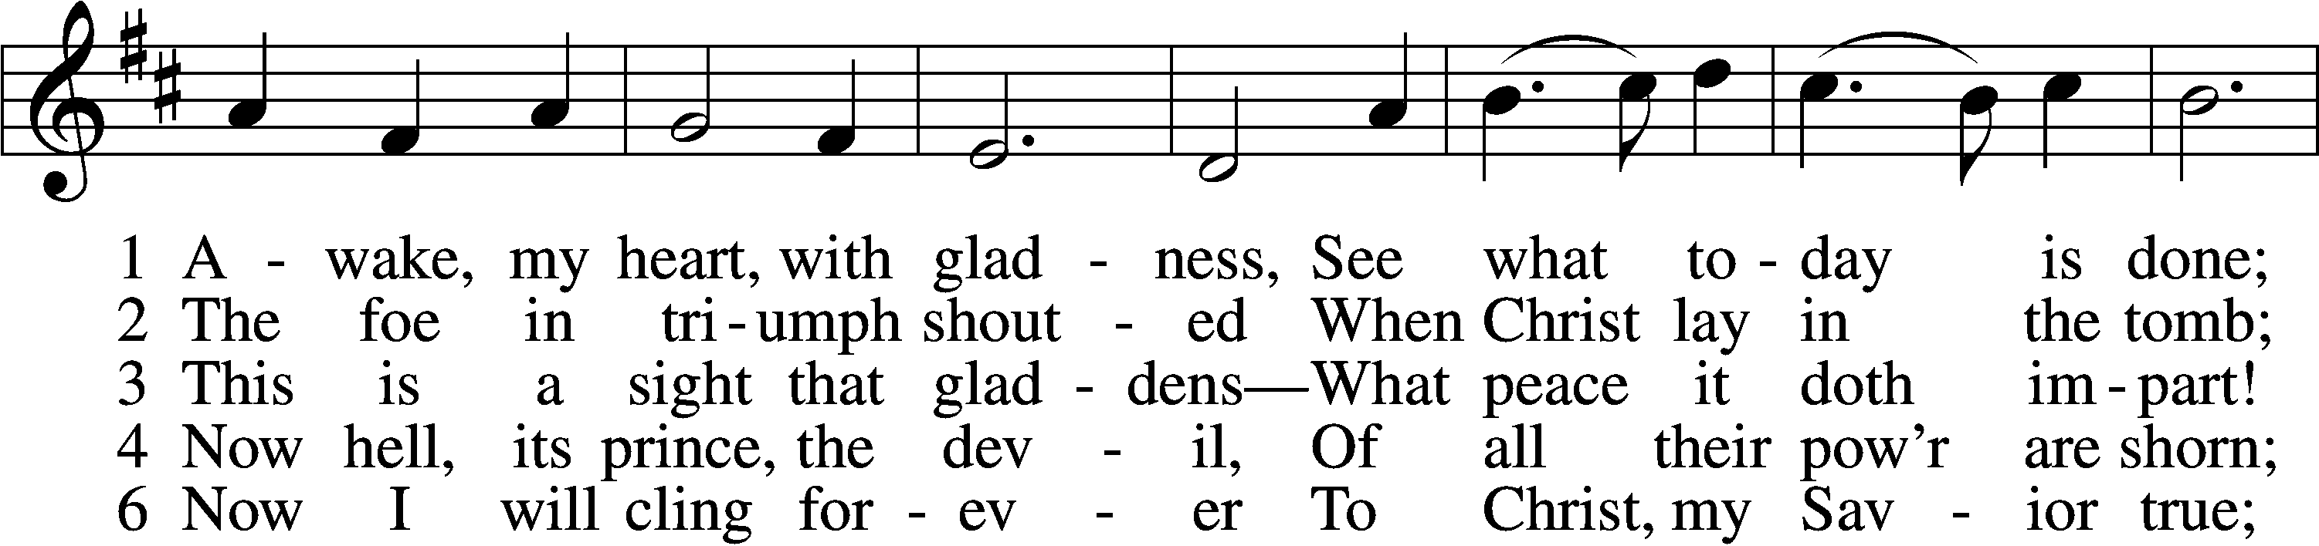
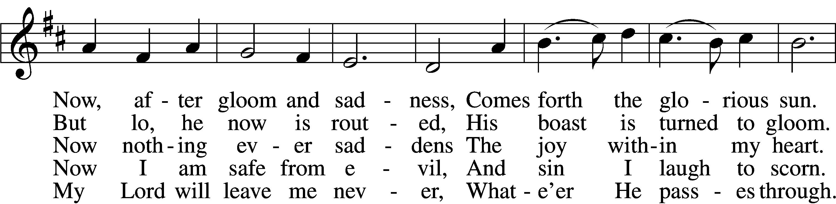
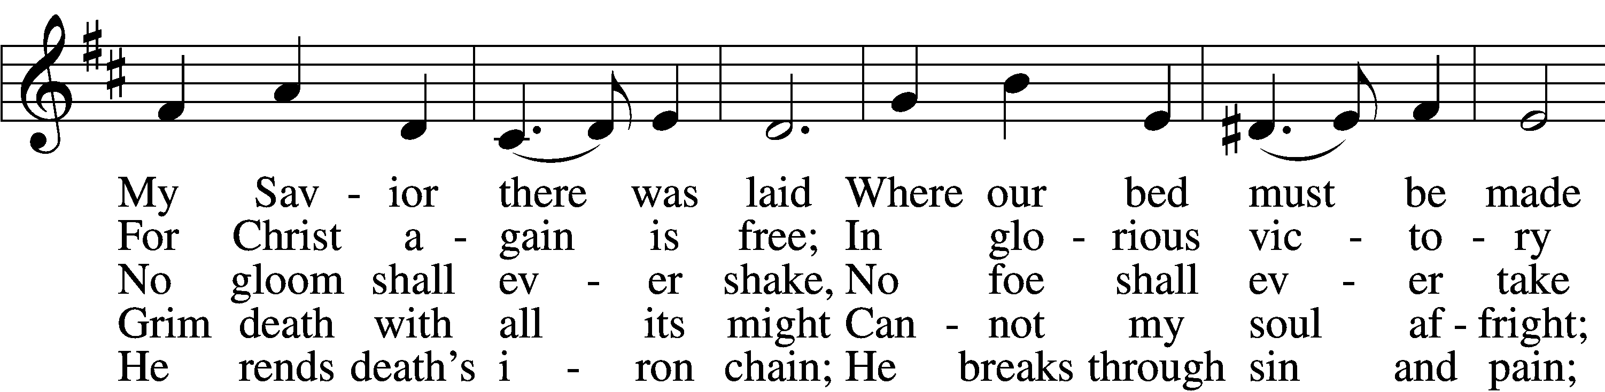
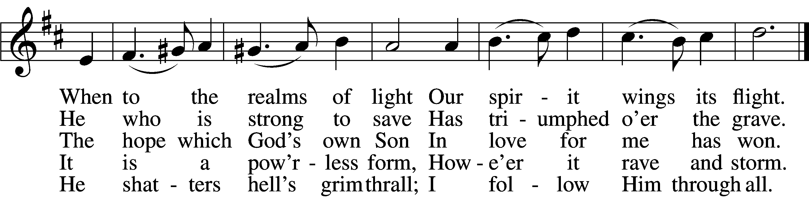
Text and tune: Public domain

The sign of the cross may be made by all in remembrance of their Baptism.

P In the name of the Father and of the T Son and of the Holy Spirit.
C Amen.

P If we say we have no sin, we deceive ourselves, and the truth is not in us.
C But if we confess our sins, God, who is faithful and just, will forgive our sins and cleanse us from all unrighteousness.

Silence for reflection on God’s Word and for self-examination.

P Let us then confess our sins to God our Father.
C Most merciful God, we confess that we are by nature sinful and unclean. We have sinned against You in thought, word, and deed, by what we have done and by what we have left undone. We have not loved You with our whole heart; we have not loved our neighbors as ourselves. We justly deserve Your present and eternal punishment. For the sake of Your Son, Jesus Christ, have mercy on us. Forgive us, renew us, and lead us, so that we may delight in Your will and walk in Your ways to the glory of Your holy name. Amen.

P Almighty God in His mercy has given His Son to die for you and for His sake forgives you all your sins. As a called and ordained servant of Christ, and by His authority, I therefore forgive you all your sins in the name of the Father and of the T Son and of the Holy Spirit.
C Amen.

Service of the Word

Introit Psalm 105:1–5, 8; antiphon: 1 Peter 2:2–3
Like newborn infants, long for the pure spiritual milk, that by it you may grow up to sal- | vation—*
if indeed you have tasted that the | Lord is good.
Oh give thanks to the Lord; call up- | on his name;*
make known his deeds among the | peoples!
Sing to him, sing prais- | es to him;*
tell of all his | wondrous works!
Glory in his | holy name;*
let the hearts of those who seek the | Lord rejoice!
Seek the Lord | and his strength;*
seek his presence con- | tinually!
Remember the wondrous works that | he has done,*
his miracles, and the judgments he | uttered.
He remembers his covenant for- | ever,*
the word that he commanded, for a thousand gener- | ations.
Glory be to the Father and | to the Son*
and to the Holy | Spirit;
as it was in the be- | ginning,*
is now, and will be forever. | Amen.
Like newborn infants, long for the pure spiritual milk, that by it you may grow up to sal- | vation—*
if indeed you have tasted that the | Lord is good.

Kyrie LSB 152
A In peace let us pray to the Lord.
C Lord, have mercy.
A For the peace from above and for our salvation let us pray to the Lord.
C Lord, have mercy.
A For the peace of the whole world, for the well-being of the Church of God, and for the unity of all let us pray to the Lord.
C Lord, have mercy.
A For this holy house and for all who offer here their worship and praise let us pray to the Lord.
C Lord, have mercy.
A Help, save, comfort, and defend us, gracious Lord.
C Amen.

This Is the Feast LSB 155
C This is the feast of victory for our God.
Alleluia, alleluia, alleluia.

Worthy is Christ, the Lamb who was slain, whose blood set us free to be people of God.

This is the feast of victory for our God.
Alleluia, alleluia, alleluia.

Power, riches, wisdom, and strength, and honor, blessing, and glory are His.

This is the feast of victory for our God.
Alleluia, alleluia, alleluia.

Sing with all the people of God, and join in the hymn of all creation:
Blessing, honor, glory, and might be to God and the Lamb forever. Amen.

This is the feast of victory for our God.
Alleluia, alleluia, alleluia.

For the Lamb who was slain has begun His reign. Alleluia.

This is the feast of victory for our God.
Alleluia, alleluia, alleluia.

Salutation and Collect of the Day
P The Lord be with you.
C And also with you.

P Let us pray.
Almighty God, grant that we who have celebrated the Lord’s resurrection may by Your grace confess in our life and conversation that Jesus is Lord and God; through the same Jesus Christ, Your Son, who lives and reigns with You and the Holy Spirit, one God, now and forever.

C Amen.

First Reading Acts 5:29–42
29But Peter and the apostles answered, “We must obey God rather than men. 30The God of our fathers raised Jesus, whom you killed by hanging him on a tree. 31God exalted him at his right hand as Leader and Savior, to give repentance to Israel and forgiveness of sins. 32And we are witnesses to these things, and so is the Holy Spirit, whom God has given to those who obey him.”
33When they heard this, they were enraged and wanted to kill them. 34But a Pharisee in the council named Gamaliel, a teacher of the law held in honor by all the people, stood up and gave orders to put the men outside for a little while. 35And he said to them, “Men of Israel, take care what you are about to do with these men. 36For before these days Theudas rose up, claiming to be somebody, and a number of men, about four hundred, joined him. He was killed, and all who followed him were dispersed and came to nothing. 37After him Judas the Galilean rose up in the days of the census and drew away some of the people after him. He too perished, and all who followed him were scattered. 38So in the present case I tell you, keep away from these men and let them alone, for if this plan or this undertaking is of man, it will fail; 39but if it is of God, you will not be able to overthrow them. You might even be found opposing God!” So they took his advice, 40and when they had called in the apostles, they beat them and charged them not to speak in the name of Jesus, and let them go. 41Then they left the presence of the council, rejoicing that they were counted worthy to suffer dishonor for the name. 42And every day, in the temple and from house to house, they did not cease teaching and preaching Jesus as the Christ.

A This is the Word of the Lord.
C Thanks be to God.

Gradual adapt. from Matthew 28:7; Hebrews 2:7; Psalm 8:6
Christ has risen | from the dead.*
[God the Father] has crowned him with glory and | honor.
He has given him dominion over the works | of his hands;*
he has put all things un- | der his feet.

Epistle 1 Peter 1:3–9
3Blessed be the God and Father of our Lord Jesus Christ! According to his great mercy, he has caused us to be born again to a living hope through the resurrection of Jesus Christ from the dead, 4to an inheritance that is imperishable, undefiled, and unfading, kept in heaven for you, 5who by God’s power are being guarded through faith for a salvation ready to be revealed in the last time. 6In this you rejoice, though now for a little while, if necessary, you have been grieved by various trials, 7so that the tested genuineness of your faith—more precious than gold that perishes though it is tested by fire—may be found to result in praise and glory and honor at the revelation of Jesus Christ. 8Though you have not seen him, you love him. Though you do not now see him, you believe in him and rejoice with joy that is inexpressible and filled with glory, 9obtaining the outcome of your faith, the salvation of your souls.

A This is the Word of the Lord.
C Thanks be to God.

Stand

Alleluia and Verse LSB 156
C Alleluia.
Lord, to whom shall we go?
You have the words of eternal life.
Alleluia, alleluia.

Holy Gospel John 20:19–31
P The Holy Gospel according to St. John, the twentieth chapter.
C Glory to You, O Lord.

19On the evening of that day, the first day of the week, the doors being locked where the disciples were for fear of the Jews, Jesus came and stood among them and said to them, “Peace be with you.” 20When he had said this, he showed them his hands and his side. Then the disciples were glad when they saw the Lord. 21Jesus said to them again, “Peace be with you. As the Father has sent me, even so I am sending you.” 22And when he had said this, he breathed on them and said to them, “Receive the Holy Spirit. 23If you forgive the sins of anyone, they are forgiven; if you withhold forgiveness from anyone, it is withheld.”
24Now Thomas, one of the Twelve, called the Twin, was not with them when Jesus came. 25So the other disciples told him, “We have seen the Lord.” But he said to them, “Unless I see in his hands the mark of the nails, and place my finger into the mark of the nails, and place my hand into his side, I will never believe.”
26Eight days later, his disciples were inside again, and Thomas was with them. Although the doors were locked, Jesus came and stood among them and said, “Peace be with you.” 27Then he said to Thomas, “Put your finger here, and see my hands; and put out your hand, and place it in my side. Do not disbelieve, but believe.” 28Thomas answered him, “My Lord and my God!” 29Jesus said to him, “Have you believed because you have seen me? Blessed are those who have not seen and yet have believed.”
30Now Jesus did many other signs in the presence of the disciples, which are not written in this book; 31but these are written so that you may believe that Jesus is the Christ, the Son of God, and that by believing you may have life in his name.

P This is the Gospel of the Lord.
C Praise to You, O Christ.

470 O Sons and Daughters of the King sts. 1–4
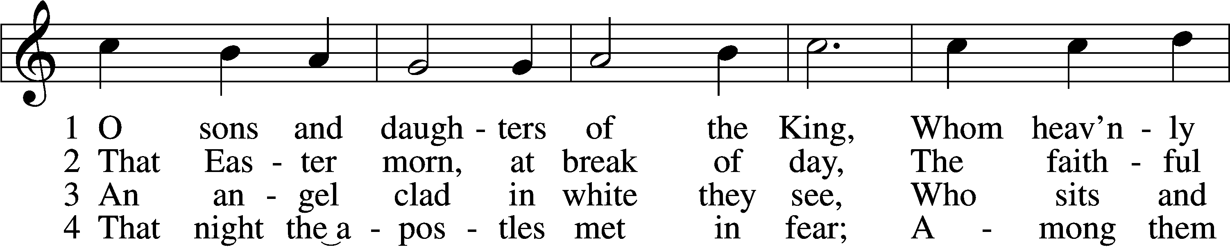
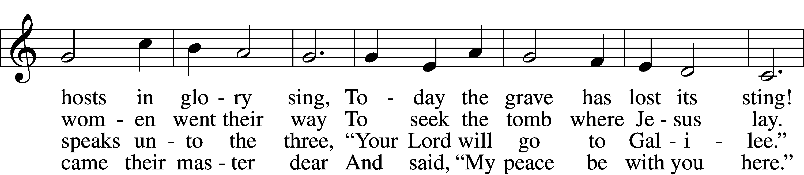
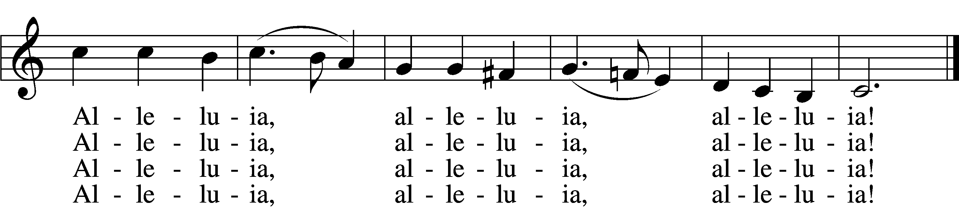
Tune and text: Public domain

Sermon

470 O Sons and Daughters of the King sts. 5–8
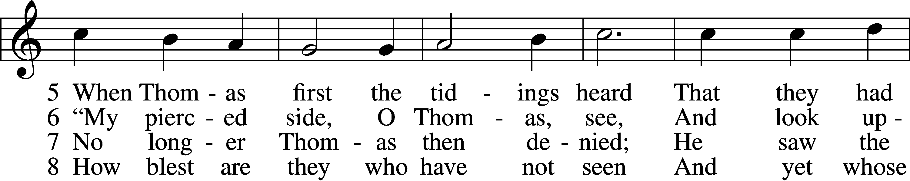
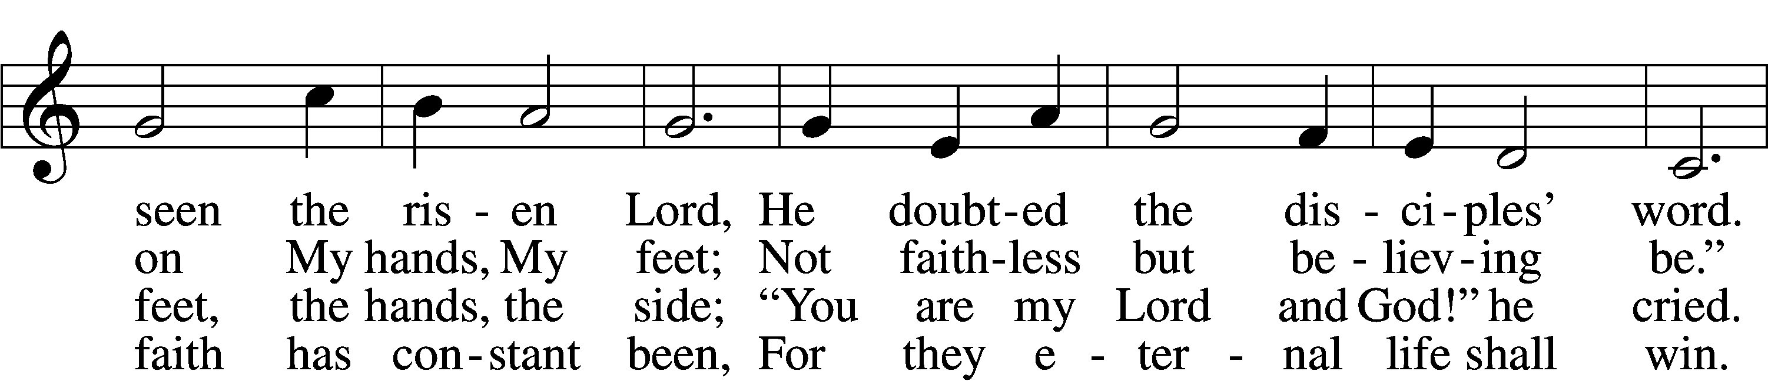
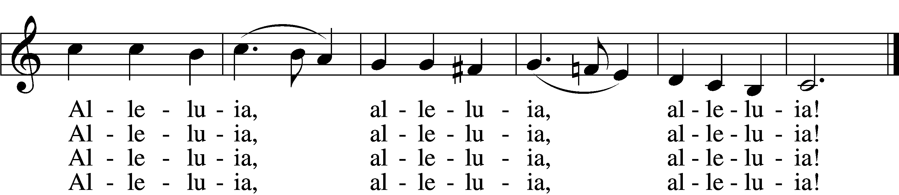
Tune and text: Public domain

Nicene Creed
C I believe in one God,
the Father Almighty,
maker of heaven and earth
and of all things visible and invisible.

And in one Lord Jesus Christ,
the only-begotten Son of God,
begotten of His Father before all worlds,
God of God, Light of Light,
very God of very God,
begotten, not made,
being of one substance with the Father,
by whom all things were made;
who for us men and for our salvation came down from heaven
and was incarnate by the Holy Spirit of the virgin Mary
and was made man;
and was crucified also for us under Pontius Pilate.
He suffered and was buried.
And the third day He rose again according to the Scriptures
and ascended into heaven
and sits at the right hand of the Father.
And He will come again with glory to judge both the living and the dead,
whose kingdom will have no end.

And I believe in the Holy Spirit,
the Lord and giver of life,
who proceeds from the Father and the Son,
who with the Father and the Son together is worshiped and glorified,
who spoke by the prophets.
And I believe in one holy Christian and apostolic Church,
I acknowledge one Baptism for the remission of sins,
and I look for the resurrection of the dead
and the life T of the world to come. Amen.

Offering

Prayer of the Church

Lord’s Prayer
C Our Father who art in heaven,
hallowed be Thy name,
Thy kingdom come,
Thy will be done on earth
as it is in heaven;
give us this day our daily bread;
and forgive us our trespasses
as we forgive those
who trespass against us;
and lead us not into temptation,
but deliver us from evil.
For Thine is the kingdom
and the power and the glory
forever and ever. Amen.

Closing Collect
P Almighty and merciful God, we have again worshiped in Your presence and received both forgiveness for our many sins and the assurance of Your love in Jesus Christ. We thank You for this undeserved grace and ask You to keep us in faith until we inherit eternal salvation; through Jesus Christ, our Lord.
C Amen.

Benediction LSB 166
P The Lord bless you and keep you.
The Lord make His face shine on you and be gracious to you.
The Lord look upon you with favor and T give you peace.
C Amen.

472 These Things Did Thomas Count as Real
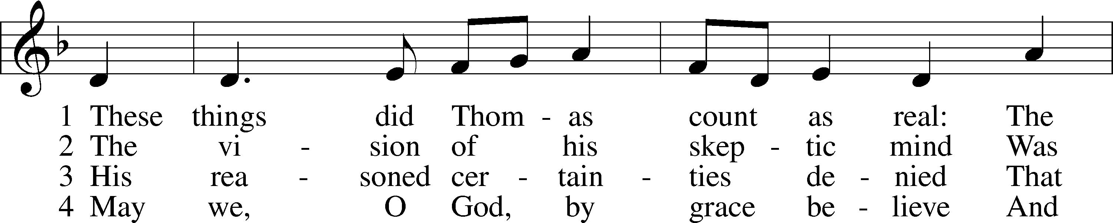
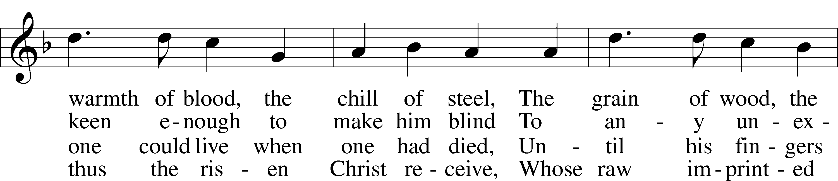
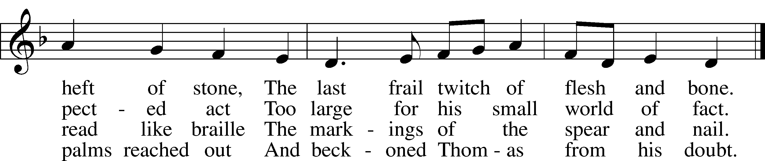
Tune: © 2003 Stephen R. Johnson. Used by permission: CPH Limited Promotional License no. 119000000
Text: © 1984 Oxford University Press. Used by permission: CPH Limited Promotional License no. 119000000

Acknowledgments
Divine Service, Setting One from Lutheran Service Book
Unless otherwise indicated, Scripture quotations are from the ESV® Bible (The Holy Bible, English Standard Version®), copyright © 2001 by Crossway, a publishing ministry of Good News Publishers. Used by permission. All rights reserved.
Created by Lutheran Service Builder © 2018 Concordia Publishing House.

The Radio Broadcast today is given to the Glory of the Lord by Ted’s Missions

Prayers for Our Members
Chelsea Junge, Christina Long, Tenaya Nuttelman | Expectant Mothers
Norman Abels (Brookestone Meadows – Elkhorn) | Healing
Judy Ahrens | Healing
Vaughn Albrecht (Northridge) | Healing
Tom & DyAnn Altwine | Healing
Lyle Colsden (Mother Hull) | Healing
Brenda Fletcher | Healing
Pat Flodine (Cambridge Court) | Healing
Vi Fox (Prairie View) | Healing
Verleen Gentry | Healing
Tiffany Hartman | Healing
Ruby Hatfield | Healing
Carol Herron | Healing
Carol Kreutzer | Healing
Teresa Leising | Healing
Marion Richmond | Healing
Geraldine Roeder | Healing
Dorothy Sikes | Healing
Carolyn Westman | Healing
Bev Nuttelman | Cancer
Kim Vos | Cancer
Prayers for Our Members’ Family & Friends
Becci Koopman (Todd & Ellen Koopman daughter-in-law) | Expectant Mother
Shaylee Kreutzer (Rich & Carol Kreutzer’s daughter-in-law) | Expectant Mother
Lana Latsabidze (Bruce & Ann Fattig daughter-in-law) | Expectant Mother
Amy Nuttelman (Keith & Bev Nuttelman’s daughter-in-law) | Expectant Mother
Ava Jean Winnie (Nic Kitzing’s cousin) | Healing
Will Brennemann (Jami Helmbrecht’s father) | Healing
Don Berg (Evelyn Heiden’s brother) | Healing
Reg Duke (Westman’s brother-in-law) | Healing
James Gentry (Verleen Gentry’s son) | Healing
Lee Gilbert | Healing
Mark Glover (Shirley Helmbrecht’s brother) | Healing
Brooke Guthrie (Bailey Hockemeier’s sister) | Healing
Lois Hanson (Pastor Hanson’s wife) | Healing
Norman Hockemeier (Ken’s father) | Healing
Roger Hoffman (Marc’s father) | Healing
Vernon Knight Jr. (Brenda Fletcher’s brother) | Healing
Miles Margritz (Wanda Glanzer’s nephew) | Healing
Randy Solomon (Beth Rosenthal’s father) | Healing
Mary Ann Mertz (Pam’s Uhlir’s friend) | Healing
Roy Reynolds (Verleen Gentry’s son-in-law) | Healing
Patty Ellis (Fran Junge’s sister) | Cancer
Ron Halvorsen (Jeff’s dad) | Cancer
Carol Haubold (Don Helmbrecht’s sister) | Cancer
Tyler Holland (Quentin & Janel Lange brother-in-law) | Cancer
Fred Koch (Pam Uhlir’s cousin) | Cancer
Lynda Kreutzer (Rich & Carol’s sister-in-law) | Cancer
Sharon Mulhair (Pam Uhlir’s cousin) | Cancer
Tyrone Uhlir (Pam’s nephew) | Cancer
Members of Zion Lutheran North Shelton | Loss & Restoration
Pr.James, Pr. Clausing, Our sister congregations in Haiti | Missionaries
John Christensen, John Harbols | Military

Sun  04/19 | 9:00a | Divine Service
Mon  04/20 | Birthdays  Anniversaries | Michelle Clark  Rebecca Thornton  Marc & Lyn Hoffman
Tues  04/21 | Birthdays  Anniversaries | Patricia Flodine  ---
Wed  04/22 | 5:45p  Birthdays  Anniversaries | Midweek - ONLINE  Matthew Herron  ---
Thurs  04/23 | Birthdays  Anniversaries | Amie Nabity  ---
Fri  04/24 | Birthdays  Anniversaries | Theodore Florang  ---
Sat  04/25 | Birthdays  Anniversaries | April Fletcher  Nicole Hoehner  ---
Sun  04/26 | 9:00a  Birthdays  Anniversaries | Divine Service  Margaret Smith  ---

Our Response to the Gospel

Date: 04/12/2020

Attendance: cancelled

Offering: $9,186.23
Weekly Need: $7,542.37

ANNOUNCEMENTS

Offering during this time. There are several options to get your weekly offering into church. Please continue to give weekly offering because we are committed to continue to pay employees, utilities, and the monthly expense. Ways to continue your offering are: drop the offering in the mail slot by the south doors, mail it to the church, and utilize online giving pushpay.com. If you have any questions or need assistance please contact the office at 308-234-3410 or school@zionkearney.org. Thank you for your support of our church!

Higher Things Conference 2020 - We are planning to attend Higher Things in Fort Collins from June 29 to July 2. If you are interested please let Pastor DeLoach or Pastor Gaunt know as soon as possible.

Radio Broadcast - Please help Zion spread the Gospel! This is a great need during this time, so many people are utilizing this resource during this time.

