Confession and Absolution

476 Who Are You Who Walk in Sorrow
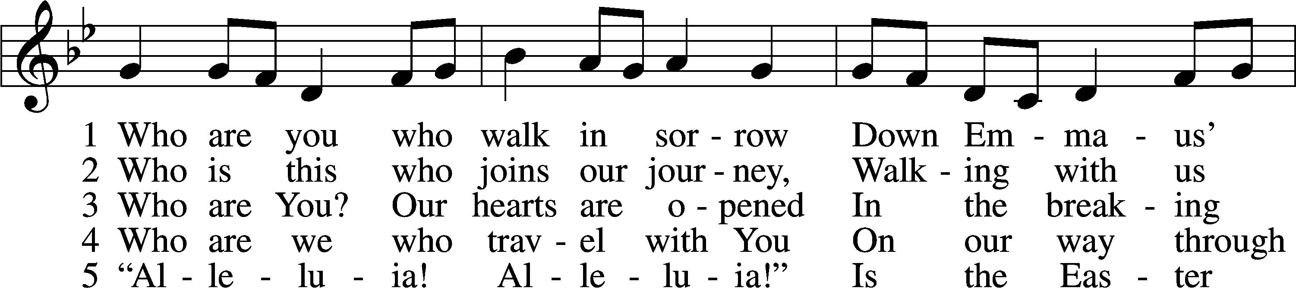
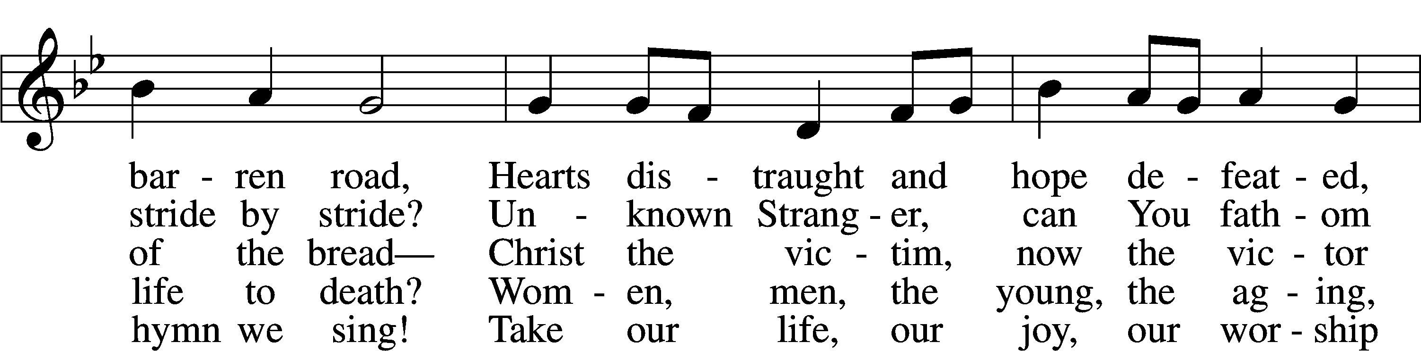
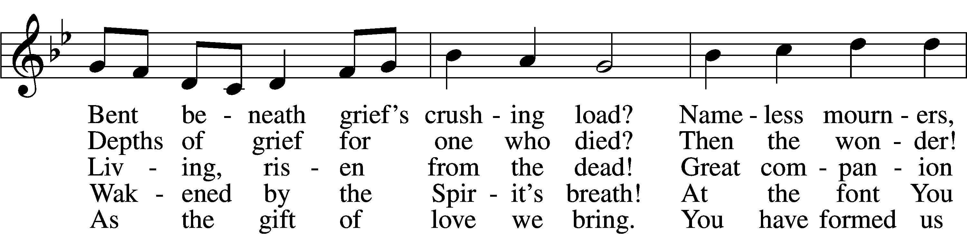
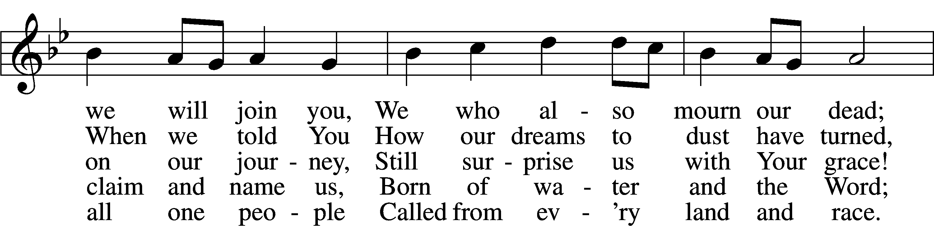
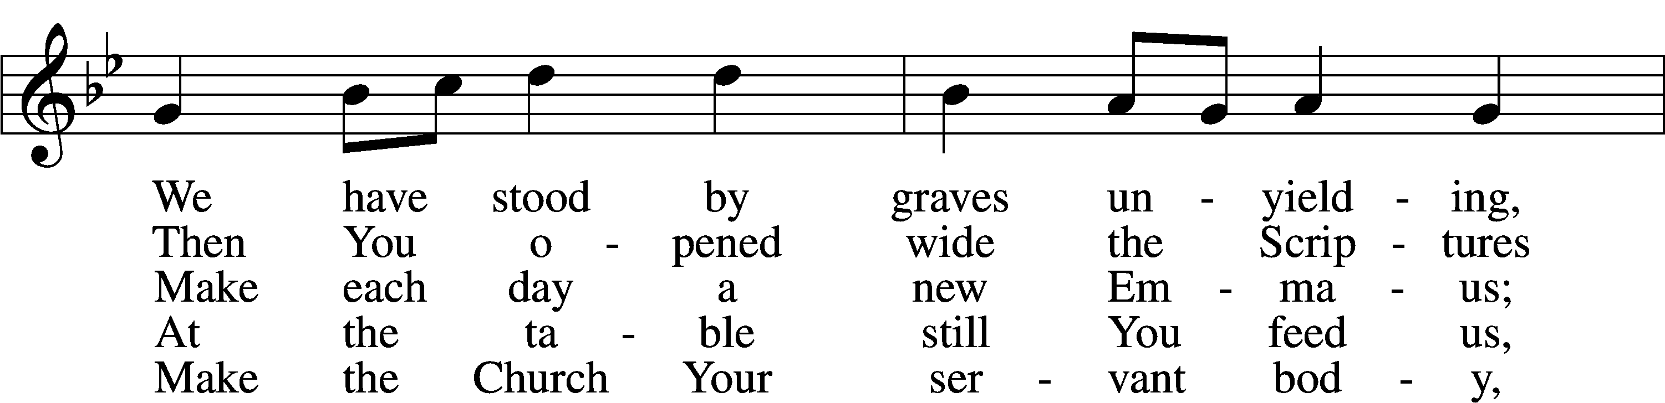
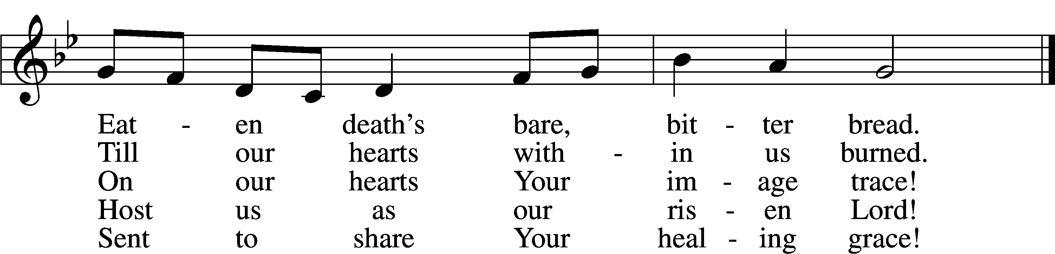
Tune: Public domain
Text: © 2000 National Association of Pastoral Musicians. Used by permission: CPH Limited Promotional License no. 119000000

The sign of the cross may be made by all in remembrance of their Baptism.

P In the name of the Father and of the T Son and of the Holy Spirit.
C Amen.

P If we say we have no sin, we deceive ourselves, and the truth is not in us.
C But if we confess our sins, God, who is faithful and just, will forgive our sins and cleanse us from all unrighteousness.

Silence for reflection on God’s Word and for self-examination.

P Let us then confess our sins to God our Father.
C Most merciful God, we confess that we are by nature sinful and unclean. We have sinned against You in thought, word, and deed, by what we have done and by what we have left undone. We have not loved You with our whole heart; we have not loved our neighbors as ourselves. We justly deserve Your present and eternal punishment. For the sake of Your Son, Jesus Christ, have mercy on us. Forgive us, renew us, and lead us, so that we may delight in Your will and walk in Your ways to the glory of Your holy name. Amen.

P Almighty God in His mercy has given His Son to die for you and for His sake forgives you all your sins. As a called and ordained servant of Christ, and by His authority, I therefore forgive you all your sins in the name of the Father and of the T Son and of the Holy Spirit.
C Amen.

Service of the Word

Introit Psalm 133; antiphon: v. 1
Behold, how good and pleas- | ant it is*
when brothers dwell in | unity!
It is like the precious oil on the head, running down on the beard, on the beard of | Aaron,*
running down on the collar | of his robes!
It is like the dew of Hermon, which falls on the mountains of | Zion!*
For there the Lord has commanded the blessing, life for- | evermore.
Glory be to the Father and | to the Son*
and to the Holy | Spirit;
as it was in the be- | ginning,*
is now, and will be forever. | Amen.
Behold, how good and pleas- | ant it is*
when brothers dwell in | unity!

Kyrie LSB 152

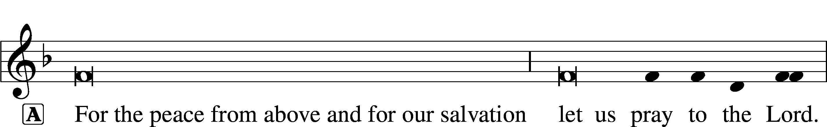

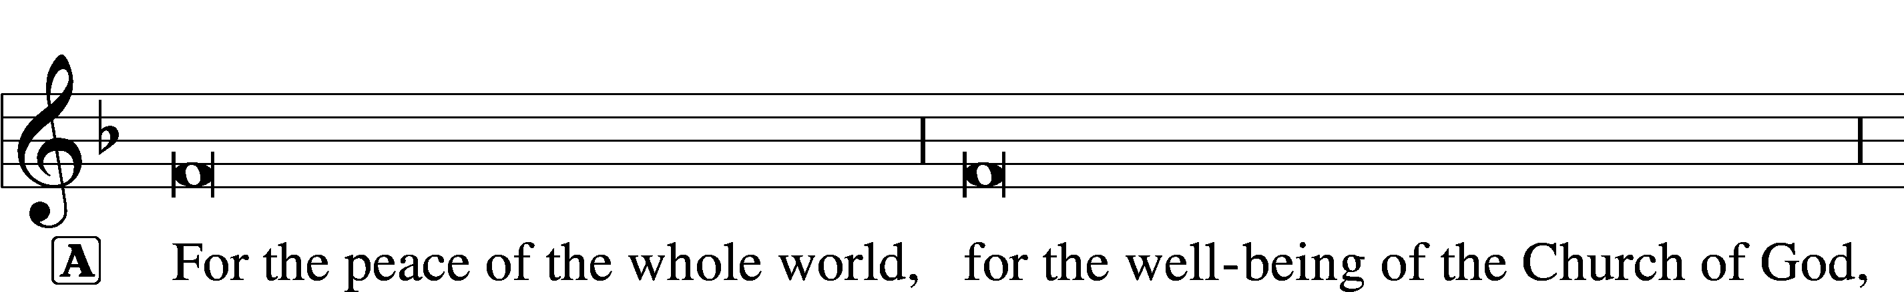

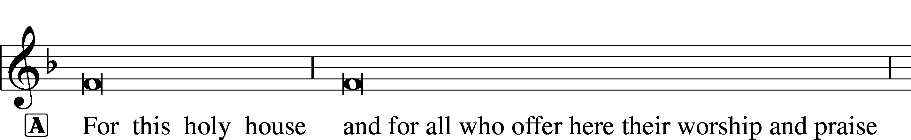

This Is the Feast LSB 155
C This is the feast of victory for our God.
Alleluia, alleluia, alleluia.

Worthy is Christ, the Lamb who was slain, whose blood set us free to be people of God.

This is the feast of victory for our God.
Alleluia, alleluia, alleluia.

Power, riches, wisdom, and strength, and honor, blessing, and glory are His.

This is the feast of victory for our God.
Alleluia, alleluia, alleluia.

Sing with all the people of God, and join in the hymn of all creation:
Blessing, honor, glory, and might be to God and the Lamb forever. Amen.

This is the feast of victory for our God.
Alleluia, alleluia, alleluia.

For the Lamb who was slain has begun His reign. Alleluia.

This is the feast of victory for our God.
Alleluia, alleluia, alleluia.

Salutation and Collect of the Day
P The Lord be with you.
C And also with you.

P Let us pray.
O God, through the humiliation of Your Son You raised up the fallen world. Grant to Your faithful people, rescued from the peril of everlasting death, perpetual gladness and eternal joys; through Jesus Christ, our Lord, who lives and reigns with You and the Holy Spirit, one God, now and forever.

C Amen.

Sit

First Reading Acts 2:14a, 36–41
14Peter, standing with the eleven, lifted up his voice and addressed them, . . .
36Let all the house of Israel therefore know for certain that God has made him both Lord and Christ, this Jesus whom you crucified.”
37Now when they heard this they were cut to the heart, and said to Peter and the rest of the apostles, “Brothers, what shall we do?” 38And Peter said to them, “Repent and be baptized every one of you in the name of Jesus Christ for the forgiveness of your sins, and you will receive the gift of the Holy Spirit. 39For the promise is for you and for your children and for all who are far off, everyone whom the Lord our God calls to himself.” 40And with many other words he bore witness and continued to exhort them, saying, “Save yourselves from this crooked generation.” 41So those who received his word were baptized, and there were added that day about three thousand souls.

A This is the Word of the Lord.
C Thanks be to God.

Epistle 1 Peter 1:17–25
17If you call on him as Father who judges impartially according to each one’s deeds, conduct yourselves with fear throughout the time of your exile, 18knowing that you were ransomed from the futile ways inherited from your forefathers, not with perishable things such as silver or gold, 19but with the precious blood of Christ, like that of a lamb without blemish or spot. 20He was foreknown before the foundation of the world but was made manifest in the last times for your sake, 21who through him are believers in God, who raised him from the dead and gave him glory, so that your faith and hope are in God.
22Having purified your souls by your obedience to the truth for a sincere brotherly love, love one another earnestly from a pure heart, 23since you have been born again, not of perishable seed but of imperishable, through the living and abiding word of God; 24for
“All flesh is like grass
and all its glory like the flower of grass.
The grass withers,
and the flower falls,
25but the word of the Lord remains forever.”
And this word is the good news that was preached to you.

A This is the Word of the Lord.
C Thanks be to God.

Stand

Alleluia and Verse LSB 156
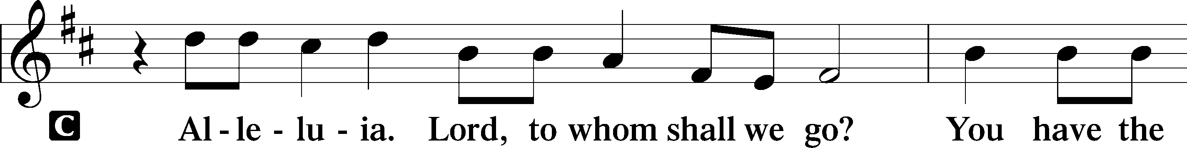
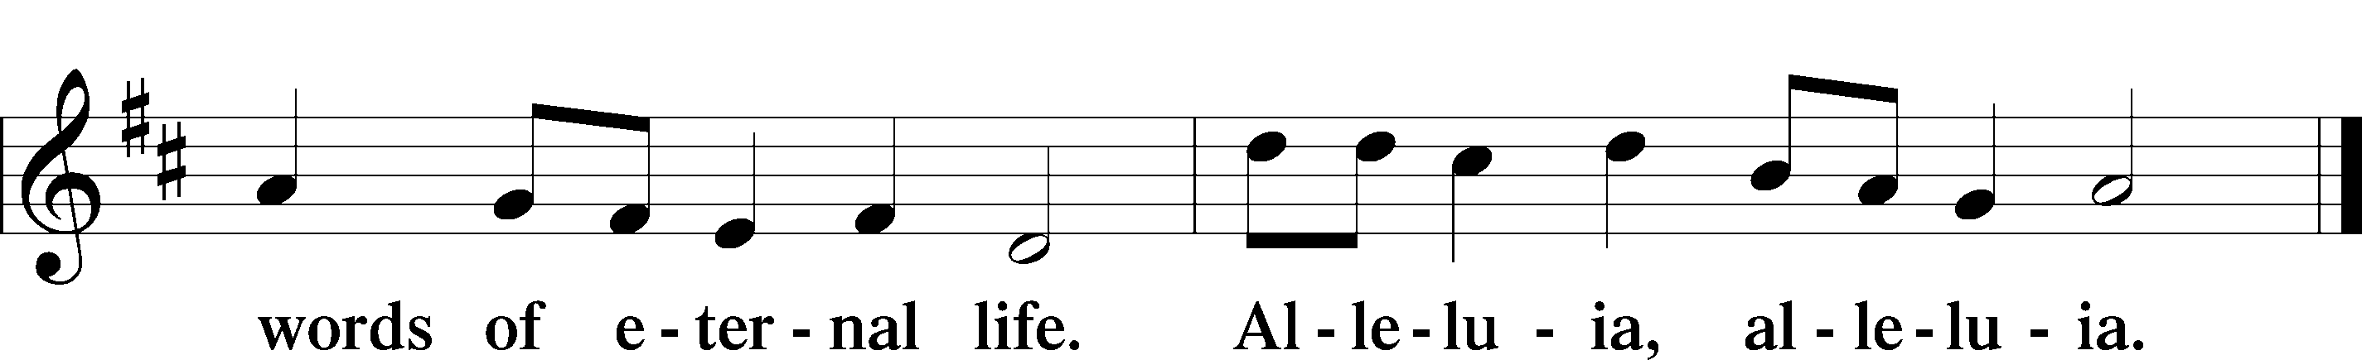

Holy Gospel Luke 24:13–35
P The Holy Gospel according to St. Luke, the twenty-fourth chapter.
C Glory to You, O Lord.

13That very day two of them were going to a village named Emmaus, about seven miles from Jerusalem, 14and they were talking with each other about all these things that had happened. 15While they were talking and discussing together, Jesus himself drew near and went with them. 16But their eyes were kept from recognizing him. 17And he said to them, “What is this conversation that you are holding with each other as you walk?” And they stood still, looking sad. 18Then one of them, named Cleopas, answered him, “Are you the only visitor to Jerusalem who does not know the things that have happened there in these days?” 19And he said to them, “What things?” And they said to him, “Concerning Jesus of Nazareth, a man who was a prophet mighty in deed and word before God and all the people, 20and how our chief priests and rulers delivered him up to be condemned to death, and crucified him. 21But we had hoped that he was the one to redeem Israel. Yes, and besides all this, it is now the third day since these things happened. 22Moreover, some women of our company amazed us. They were at the tomb early in the morning, 23and when they did not find his body, they came back saying that they had even seen a vision of angels, who said that he was alive. 24Some of those who were with us went to the tomb and found it just as the women had said, but him they did not see.” 25And he said to them, “O foolish ones, and slow of heart to believe all that the prophets have spoken! 26Was it not necessary that the Christ should suffer these things and enter into his glory?” 27And beginning with Moses and all the Prophets, he interpreted to them in all the Scriptures the things concerning himself.
28So they drew near to the village to which they were going. He acted as if he were going farther, 29but they urged him strongly, saying, “Stay with us, for it is toward evening and the day is now far spent.” So he went in to stay with them. 30When he was at table with them, he took the bread and blessed and broke it and gave it to them. 31And their eyes were opened, and they recognized him. And he vanished from their sight. 32They said to each other, “Did not our hearts burn within us while he talked to us on the road, while he opened to us the Scriptures?” 33And they rose that same hour and returned to Jerusalem. And they found the eleven and those who were with them gathered together, 34saying, “The Lord has risen indeed, and has appeared to Simon!” 35Then they told what had happened on the road, and how he was known to them in the breaking of the bread.

P This is the Gospel of the Lord.
C Praise to You, O Christ.

483 With High Delight Let Us Unite
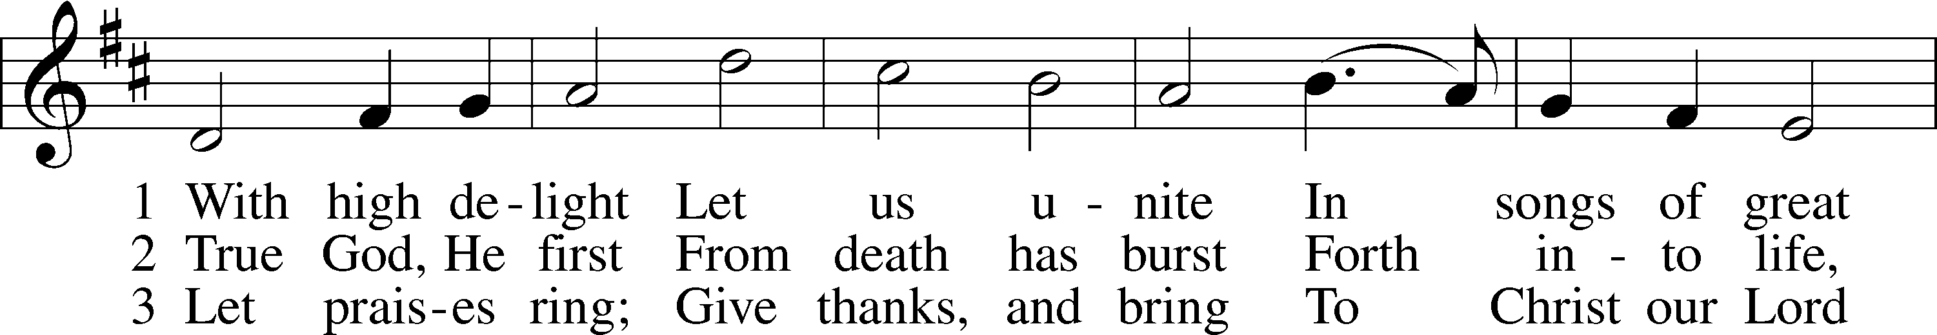
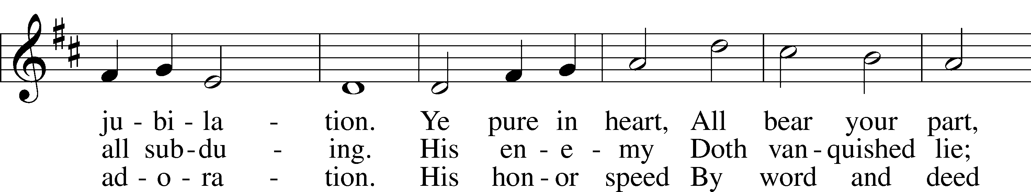
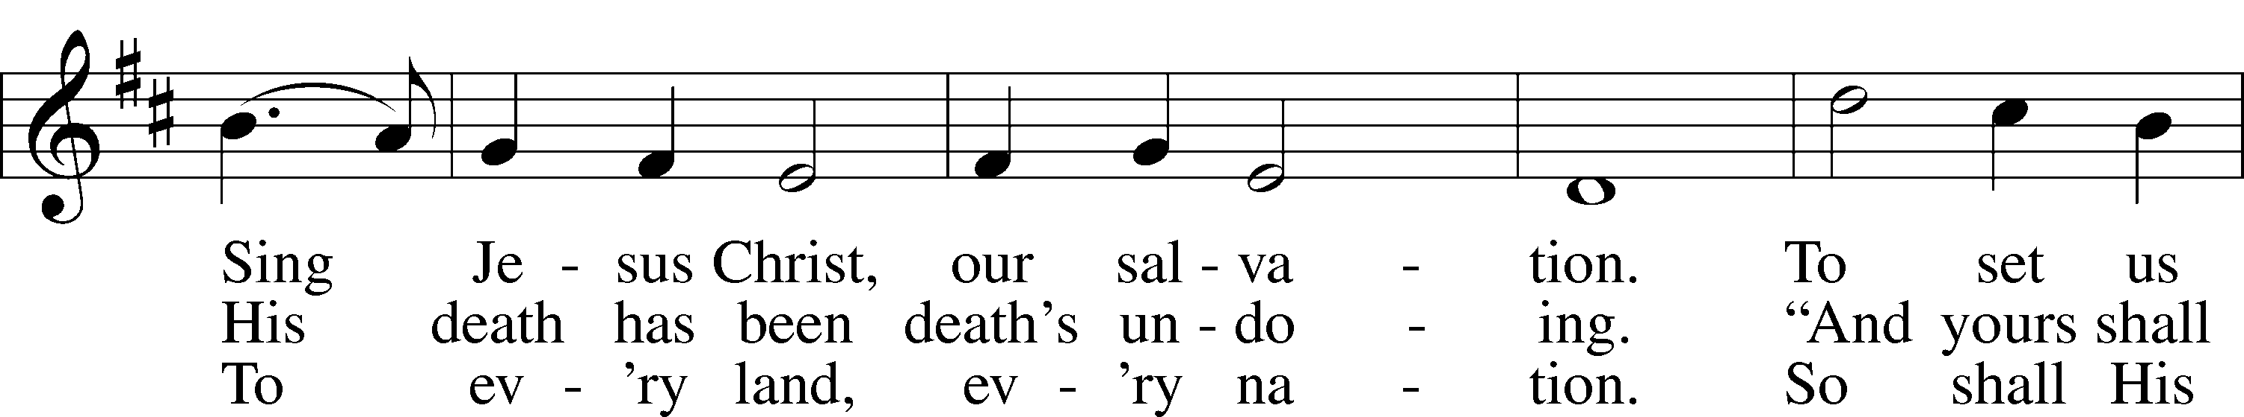
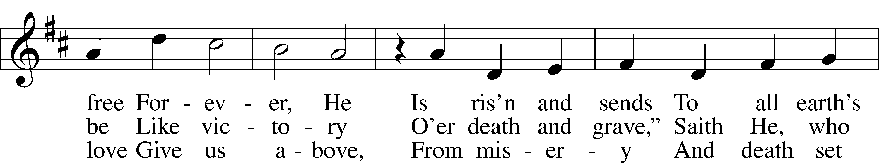
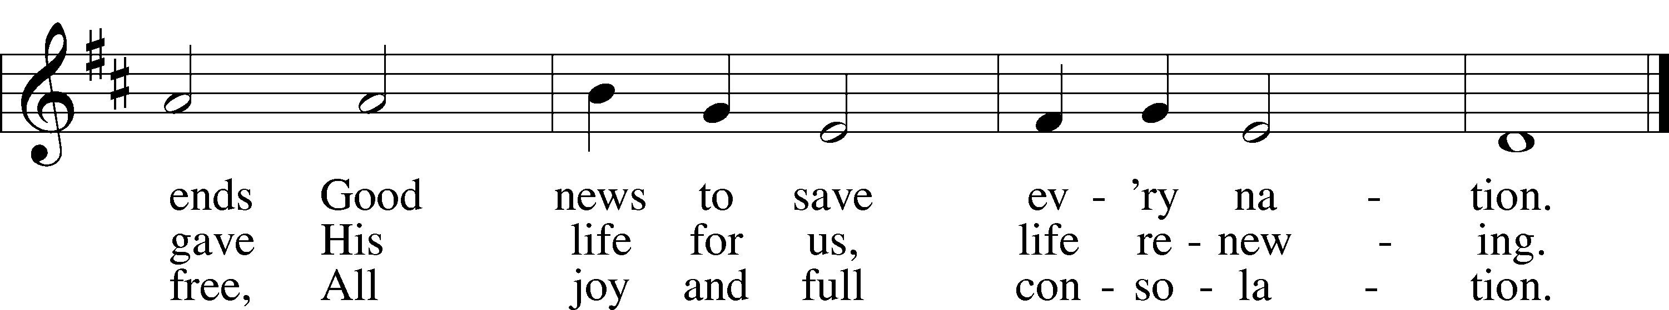
Text: © 1969 Concordia Publishing House. Used by permission: CPH Limited Promotional License no. 119000000
Tune: Public domain

Sermon

Nicene Creed
C I believe in one God,
the Father Almighty,
maker of heaven and earth
and of all things visible and invisible.

And in one Lord Jesus Christ,
the only-begotten Son of God,
begotten of His Father before all worlds,
God of God, Light of Light,
very God of very God,
begotten, not made,
being of one substance with the Father,
by whom all things were made;
who for us men and for our salvation came down from heaven
and was incarnate by the Holy Spirit of the virgin Mary
and was made man;
and was crucified also for us under Pontius Pilate.
He suffered and was buried.
And the third day He rose again according to the Scriptures
and ascended into heaven
and sits at the right hand of the Father.
And He will come again with glory to judge both the living and the dead,
whose kingdom will have no end.

And I believe in the Holy Spirit,
the Lord and giver of life,
who proceeds from the Father and the Son,
who with the Father and the Son together is worshiped and glorified,
who spoke by the prophets.
And I believe in one holy Christian and apostolic Church,
I acknowledge one Baptism for the remission of sins,
and I look for the resurrection of the dead
and the life T of the world to come. Amen.

Prayer of the Church

Offering

Offertory LSB 159
C What shall I render to the Lord for all His benefits to me?
I will offer the sacrifice of thanksgiving and will call on the name of the Lord.
I will take the cup of salvation and will call on the name of the Lord.
I will pay my vows to the Lord now in the presence of all His people,
in the courts of the Lord’s house, in the midst of you, O Jerusalem.

Service of the Sacrament

Preface LSB 160
P The Lord be with you.
C And also with you.

P Lift up your hearts.
C We lift them to the Lord.

P Let us give thanks to the Lord our God.
C It is right to give Him thanks and praise.

P It is truly good, right, and salutary that we should at all times and in all places give thanks to You, holy Lord, almighty Father, everlasting God. And most especially are we bound to praise You on this day for the glorious resurrection of Your Son, Jesus Christ, the very Paschal Lamb, who was sacrificed for us and bore the sins of the world. By His dying He has destroyed death, and by His rising again He has restored to us everlasting life. Therefore with Mary Magdalene, Peter and John, and with all the witnesses of the resurrection, with angels and archangels, and with all the company of heaven we laud and magnify Your glorious name, evermore praising You and saying:

Sanctus LSB 161
C Holy, holy, holy Lord God of pow’r and might:
Heaven and earth are full of Your glory.
Hosanna. Hosanna.
Hosanna in the highest.
Blessed is He who comes in the name of the Lord.
Hosanna in the highest.

Lord’s Prayer LSB 162
P Lord, remember us in Your kingdom and teach us to pray:
C Our Father who art in heaven,
hallowed be Thy name,
Thy kingdom come,
Thy will be done on earth
as it is in heaven;
give us this day our daily bread;
and forgive us our trespasses
as we forgive those
who trespass against us;
and lead us not into temptation,
but deliver us from evil.
For Thine is the kingdom
and the power and the glory
forever and ever. Amen.

The Words of Our Lord
P Our Lord Jesus Christ, on the night when He was betrayed, took bread, and when He had given thanks, He broke it and gave it to the disciples and said: “Take, eat; this is My T body, which is given for you. This do in remembrance of Me.”

In the same way also He took the cup after supper, and when He had given thanks, He gave it to them, saying: “Drink of it, all of you; this cup is the new testament in My T blood, which is shed for you for the forgiveness of sins. This do, as often as you drink it, in remembrance of Me.”

Pax Domini LSB 163
P The peace of the Lord be with you always.
C Amen.

Agnus Dei LSB 163
C Lamb of God, You take away the sin of the world; have mercy on us.
Lamb of God, You take away the sin of the world; have mercy on us.
Lamb of God, You take away the sin of the world; grant us peace.

Distribution

Thank the Lord LSB 164
C Thank the Lord and sing His praise; tell ev’ryone what He has done.
Let all who seek the Lord rejoice and proudly bear His name.
He recalls His promises and leads His people forth in joy
with shouts of thanksgiving. Alleluia, alleluia.

Post-Communion Collect
A Let us pray.
We give thanks to You, almighty God, that You have refreshed us through this salutary gift, and we implore You that of Your mercy You would strengthen us through the same in faith toward You and in fervent love toward one another; through Jesus Christ, Your Son, our Lord, who lives and reigns with You and the Holy Spirit, one God, now and forever.
C Amen.

Benediction LSB 166
P The Lord bless you and keep you.
The Lord make His face shine on you and be gracious to you.
The Lord look upon you with favor and T give you peace.
C Amen.

919 Abide, O Dearest Jesus
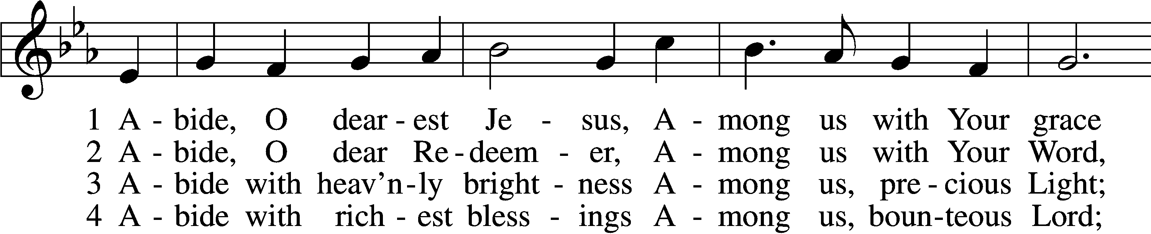
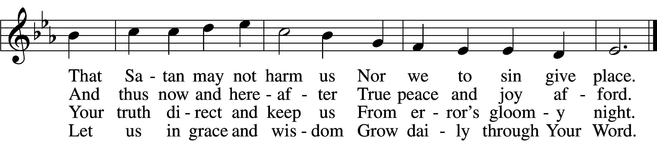

5 Abide with Your protection
Among us, Lord, our strength,
Lest world and Satan fell us
And overcome at length.

6 Abide, O faithful Savior,
Among us with Your love;
Grant steadfastness and help us
To reach our home above.
Tune and text: Public domain

Acknowledgments
Divine Service, Setting One from Lutheran Service Book
Unless otherwise indicated, Scripture quotations are from the ESV® Bible (The Holy Bible, English Standard Version®), copyright © 2001 by Crossway, a publishing ministry of Good News Publishers. Used by permission. All rights reserved.
Created by Lutheran Service Builder © 2018 Concordia Publishing House.

The Radio Broadcast today is given to the Glory of the Lord by Craig & Linda Nuttelman

Prayers for Our Members
Chelsea Junge, Christina Long, Tenaya Nuttelman | Expectant Mothers
Amy Hodgson | Baptized & Confirmed
Norman Abels (Brookestone Meadows – Elkhorn) | Healing
Judy Ahrens | Healing
Vaughn Albrecht (Northridge) | Healing
Tom & DyAnn Altwine | Healing
Lyle Colsden (Mother Hull) | Healing
Brenda Fletcher | Healing
Pat Flodine (Cambridge Court) | Healing
Vi Fox (Prairie View) | Healing
Verleen Gentry | Healing
Tiffany Hartman | Healing
Ruby Hatfield | Healing
Carol Herron | Healing
Carol Kreutzer | Healing
Teresa Leising | Healing
Marion Richmond | Healing
Geraldine Roeder | Healing
Dorothy Sikes | Healing
Carolyn Westman | Healing
Linda Nuttelman | Recovery
Bev Nuttelman | Cancer
Kim Vos | Cancer
Prayers for Our Members’ Family & Friends
Becci Koopman (Todd & Ellen Koopman daughter-in-law) | Expectant Mother
Shaylee Kreutzer (Rich & Carol Kreutzer’s daughter-in-law) | Expectant Mother
Lana Latsabidze (Bruce & Ann Fattig daughter-in-law) | Expectant Mother
Amy Nuttelman (Keith & Bev Nuttelman’s daughter-in-law) | Expectant Mother
Ava Jean Winnie (Nic Kitzing’s cousin) | Healing
Will Brennemann (Jami Helmbrecht’s father) | Healing
Don Berg (Evelyn Heiden’s brother) | Healing
Reg Duke (Westman’s brother-in-law) | Healing
James Gentry (Verleen Gentry’s son) | Healing
Lee Gilbert | Healing
Mark Glover (Shirley Helmbrecht’s brother) | Healing
Brooke Guthrie (Bailey Hockemeier’s sister) | Healing
Lois Hanson (Pastor Hanson’s wife) | Healing
Norman Hockemeier (Ken’s father) | Healing
Roger Hoffman (Marc’s father) | Healing
Vernon Knight Jr. (Brenda Fletcher’s brother) | Healing
Miles Margritz (Wanda Glanzer’s nephew) | Healing
Randy Solomon (Beth Rosenthal’s father) | Healing
Mary Ann Mertz (Pam’s Uhlir’s friend) | Healing
Roy Reynolds (Verleen Gentry’s son-in-law) | Healing
Patty Ellis (Fran Junge’s sister) | Cancer
Ron Halvorsen (Jeff’s dad) | Cancer
Carol Haubold (Don Helmbrecht’s sister) | Cancer
Tyler Holland (Quentin & Janel Lange brother-in-law) | Cancer
Fred Koch (Pam Uhlir’s cousin) | Cancer
Lynda Kreutzer (Rich & Carol’s sister-in-law) | Cancer
Sharon Mulhair (Pam Uhlir’s cousin) | Cancer
Tyrone Uhlir (Pam’s nephew) | Cancer
Members of Zion Lutheran North Shelton | Loss & Restoration
Pr.James, Pr. Clausing, Our sister congregations in Haiti | Missionaries
John Christensen, John Harbols | Military

Sun  04/26 | 9:00a | Divine Service
Mon  04/27 | Birthdays  Anniversaries | ---  ---
Tues  04/28 | Birthdays  Anniversaries | Waunita DeLaet  ---
Wed  04/29 | 5:45p  Birthdays  Anniversaries | Midweek - ONLINE  ---  Craig & Linda Nuttelman
Thurs  04/30 | Birthdays  Anniversaries | Alexis Wollberg  Udeane Fischer  ---
Fri  05/01 | Birthdays  Anniversaries | ---  ---
Sat  05/02 | Birthdays  Anniversaries | ---  ---
Sun  05/03 | 9:00a  Birthdays  Anniversaries | Divine Service  Carol H  ---

Our Response to the Gospel

Date: 04/19/2020

Attendance: cancelled

Offering: $8,090.00
Weekly Need: $7,542.37

ANNOUNCEMENTS

Offering during this time. There are several options to get your weekly offering into church. Please continue to give weekly offering because we are committed to continue to pay employees, utilities, and the monthly expense. Ways to continue your offering are: drop the offering in the mail slot by the south doors, mail it to the church, and utilize online giving pushpay.com. If you have any questions or need assistance please contact the office at 308-234-3410 or school@zionkearney.org. Thank you for your support of our church!

Higher Things Conference 2020 - We are planning to attend Higher Things in Fort Collins from June 29 to July 2. If you are interested please let Pastor DeLoach or Pastor Gaunt know as soon as possible.

Radio Broadcast - Please help Zion spread the Gospel! This is a great need during this time, so many people are utilizing this resource during this time.

Thank You
Dear Zion
Thank you so much for all the prayers, thoughts, cards and meals.
Thank you to Pastor DeLoach and Pastor Gaunt for your visits, we are truly blest to have such caring Pastors. We see Christ’s love for us through all of you.

Keith and Beverly Nuttelman

