Confession and Absolution

602 The Gifts Christ Freely Gives
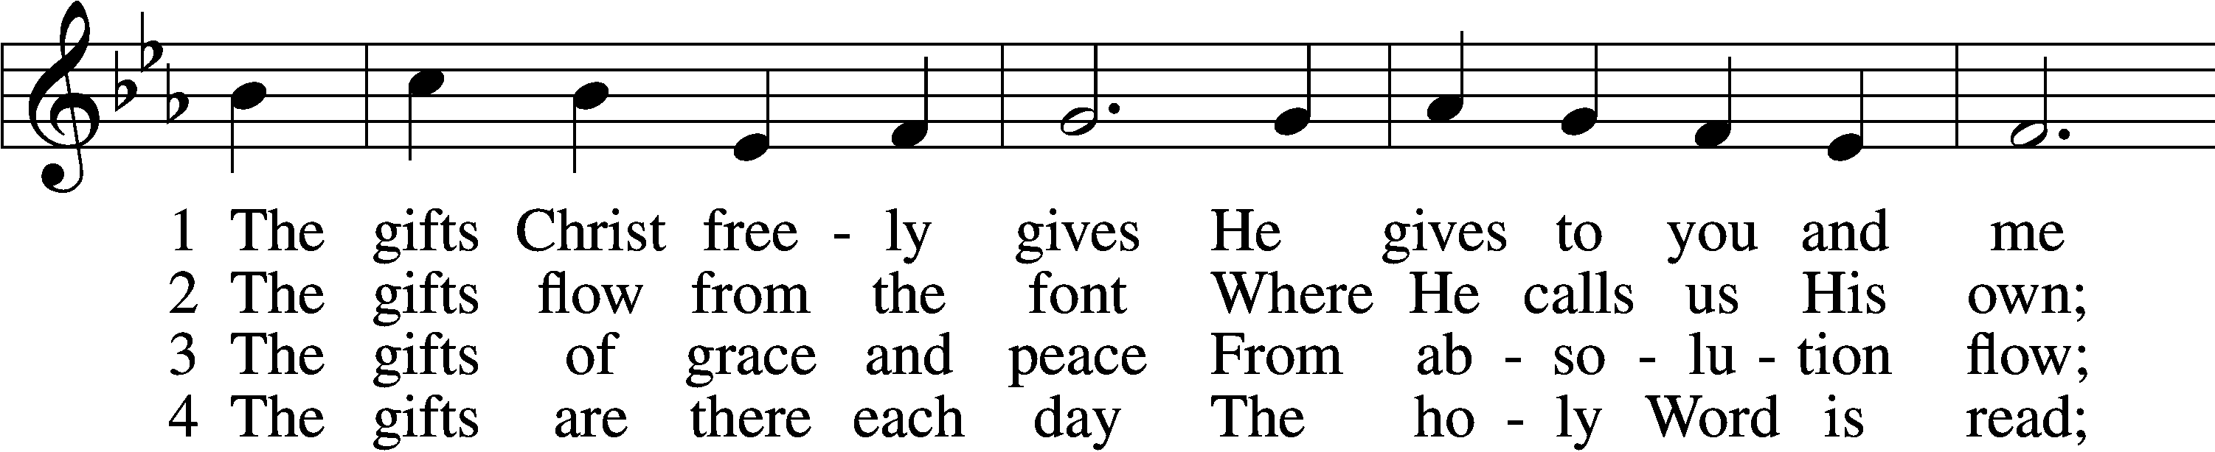
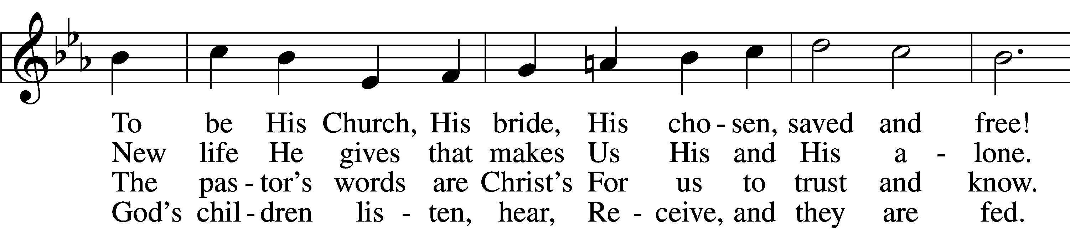
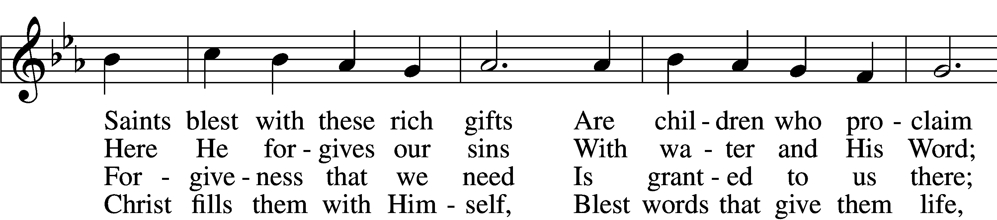
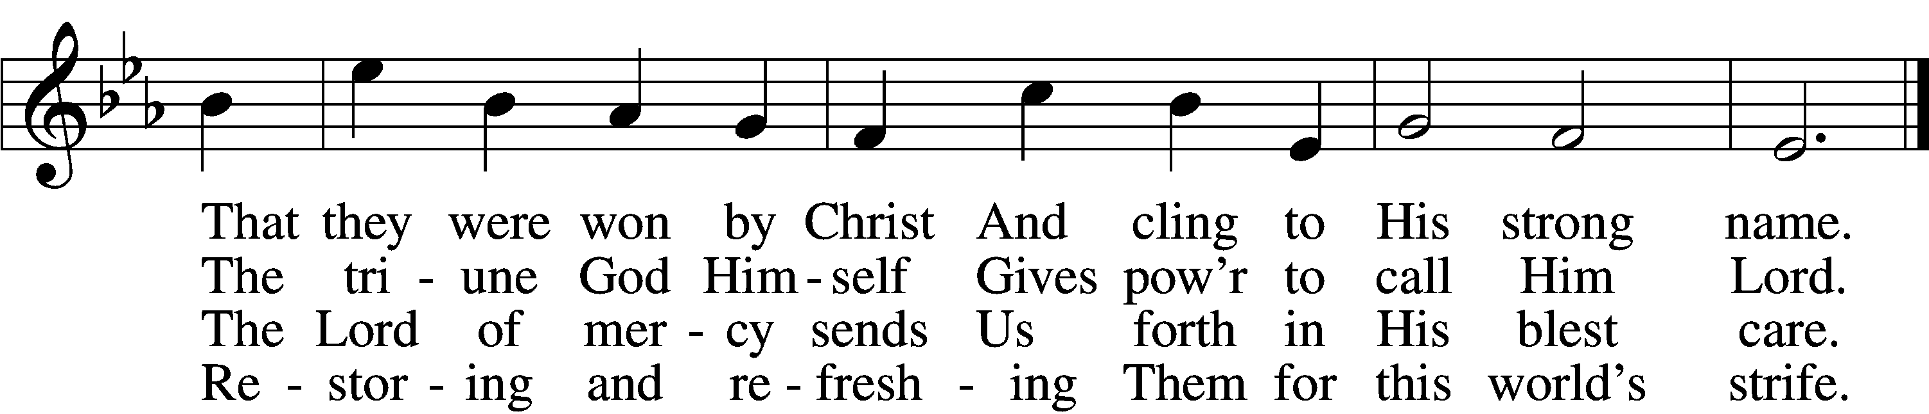

5 The gifts are in the feast,
Gifts far more than we see;
Beneath the bread and wine
Is food from Calvary.
The body and the blood
Remove our ev’ry sin;
We leave His presence in
His peace, renewed again.

6 All glory to the One
Who lavishes such love;
The triune God in love
Assures our life above.
His means of grace for us
Are gifts He loves to give;
All thanks and praise for His
Great love by which we live!
Tune: Public domain
Text: © 2001 Richard C. Resch. Used by permission: CPH Limited Promotional License no. 119000000

Stand

The sign of the cross may be made by all in remembrance of their Baptism.

P In the name of the Father and of the Son and of the Holy Spirit.
C Amen.

P If we say we have no sin, we deceive ourselves, and the truth is not in us.
C But if we confess our sins, God, who is faithful and just, will forgive our sins and cleanse us from all unrighteousness.

Silence for reflection on God’s Word and for self-examination.

P Let us then confess our sins to God our Father.
C Most merciful God, we confess that we are by nature sinful and unclean. We have sinned against You in thought, word, and deed, by what we have done and by what we have left undone. We have not loved You with our whole heart; we have not loved our neighbors as ourselves. We justly deserve Your present and eternal punishment. For the sake of Your Son, Jesus Christ, have mercy on us. Forgive us, renew us, and lead us, so that we may delight in Your will and walk in Your ways to the glory of Your holy name. Amen.

P Almighty God in His mercy has given His Son to die for you and for His sake forgives you all your sins. As a called and ordained servant of Christ, and by His authority, I therefore forgive you all your sins in the name of the Father and of the Son and of the Holy Spirit.
C Amen.

Service of the Word

Introit Psalm 119:89–93; antiphon: v. 105
Your word is a lamp | to my feet*
and a light | to my path.
Forever, O | Lord, your word*
is firmly fixed | in the heavens.
Your faithfulness endures to all gener- | ations;*
you have established the earth, and it | stands fast.
By your appointment they | stand this day,*
for all things are your | servants.
If your law had not been | my delight,*
I would have perished in my af- | fliction.
I will never forget your | precepts,*
for by them you have giv- | en me life.
Glory be to the Father and | to the Son*
and to the Holy | Spirit;
as it was in the be- | ginning,*
is now, and will be forever. | Amen.
Your word is a lamp | to my feet*
and a light | to my path.

Kyrie LSB 152
A In peace let us pray to the Lord.
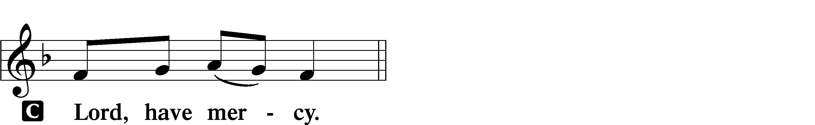

A For the peace from above and for our salvation let us pray to the Lord.
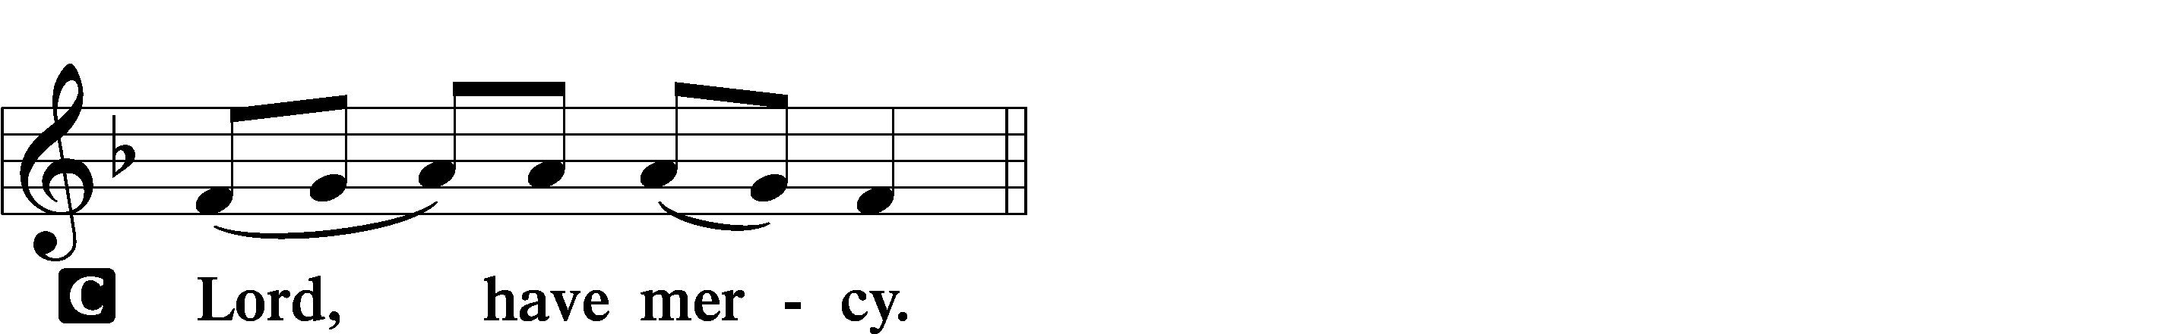

A For the peace of the whole world, for the well-being of the Church of God, and for the unity of all let us pray to the Lord.
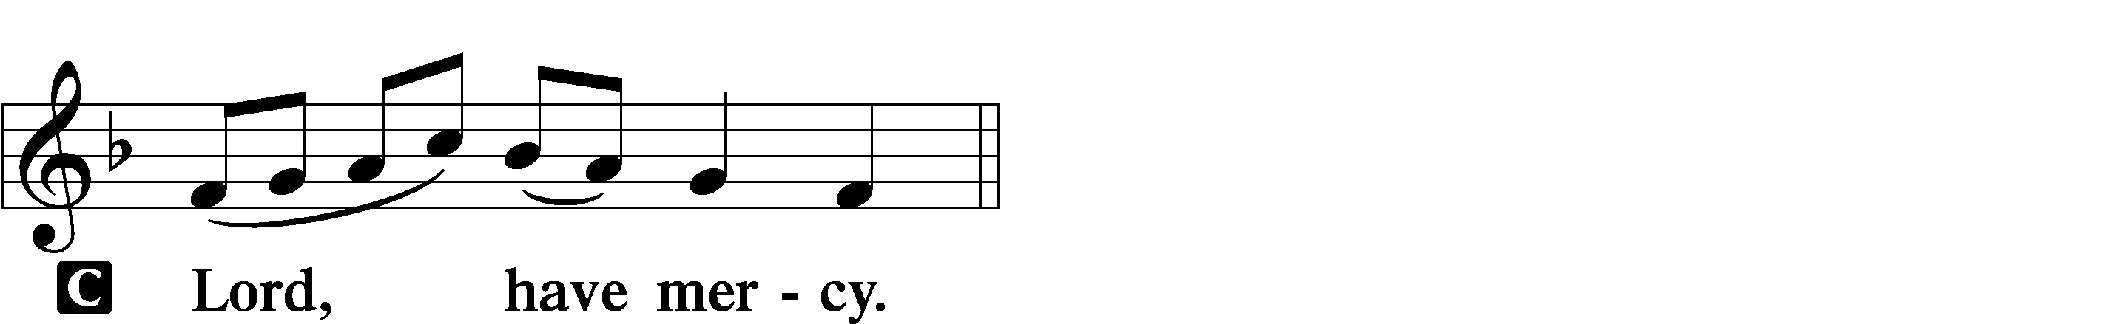

A For this holy house and for all who offer here their worship and praise let us pray to the Lord.
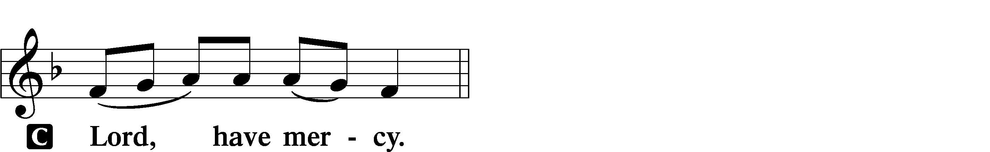

A Help, save, comfort, and defend us, gracious Lord.

This Is the Feast LSB 155
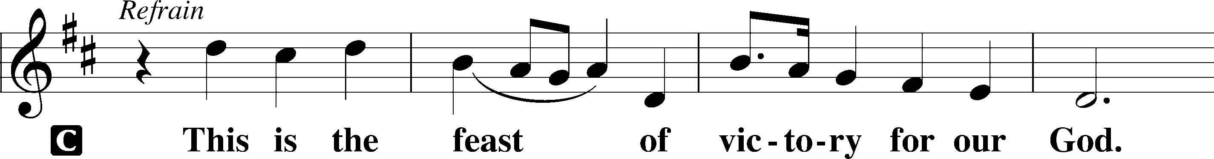
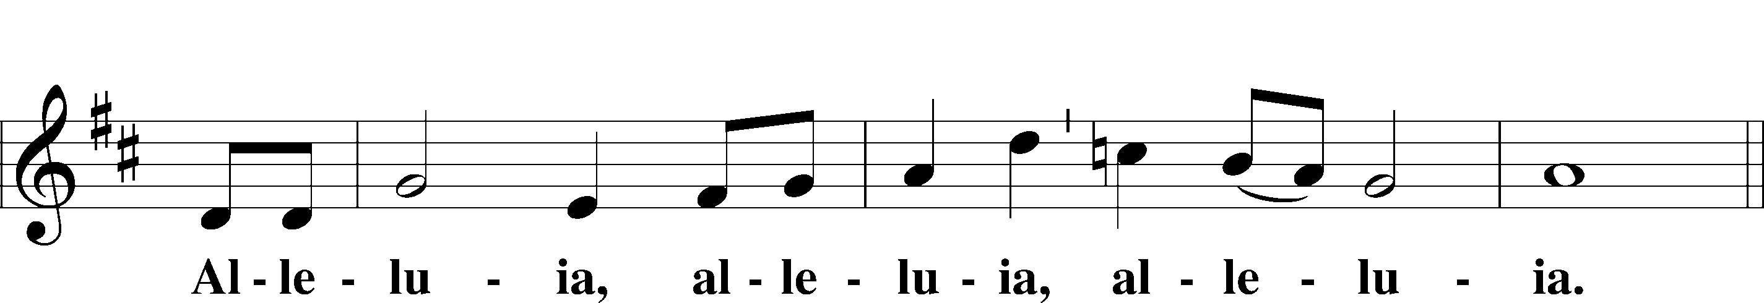
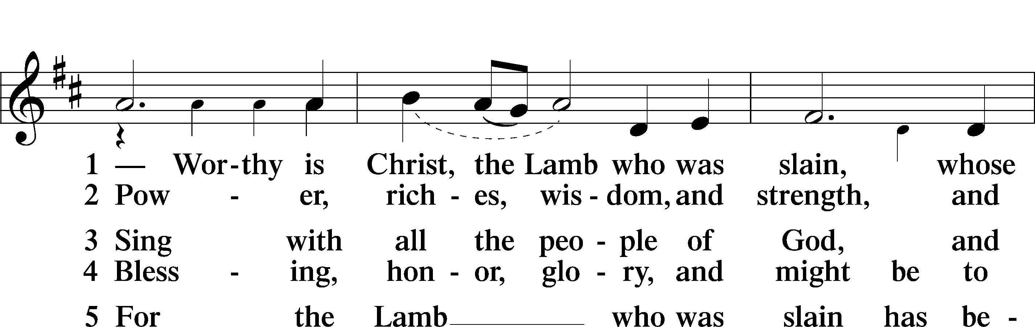
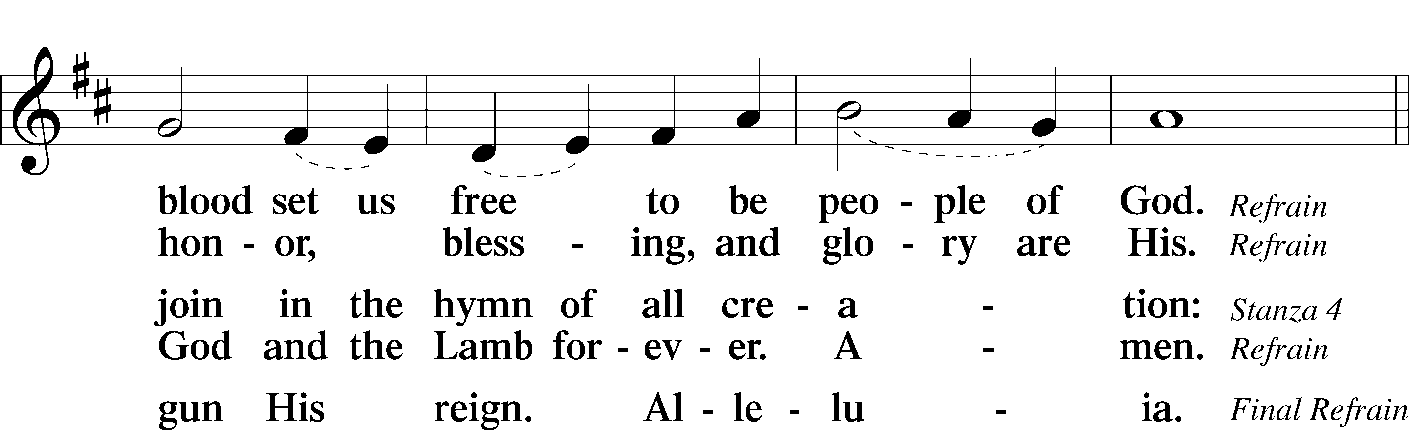
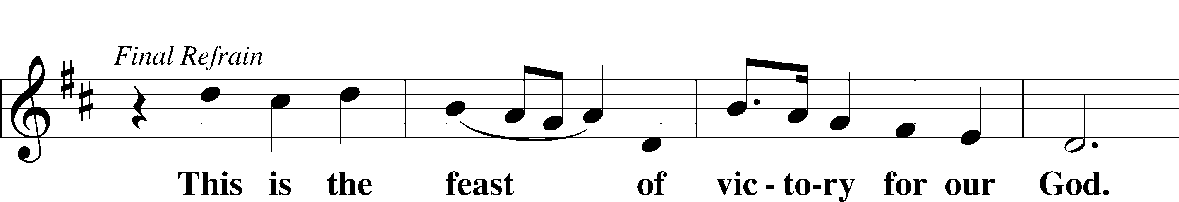
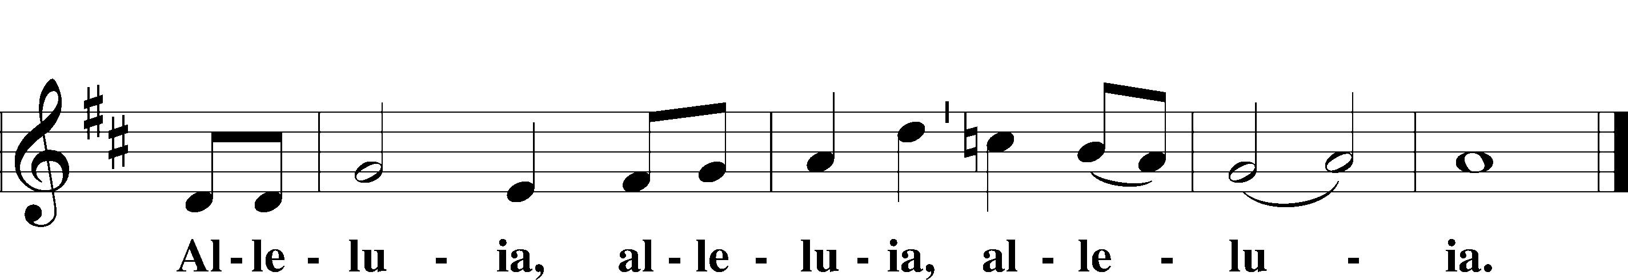

Salutation and Collect of the Day
P The Lord be with you.
C And also with you.

P Let us pray.
O God, the giver of all that is good, by Your holy inspiration grant that we may think those things that are right and by Your merciful guiding accomplish them; through Jesus Christ, Your Son, our Lord, who lives and reigns with You and the Holy Spirit, one God, now and forever.

C Amen.

Sit

First Reading Acts 17:16–31
16While Paul was waiting for them at Athens, his spirit was provoked within him as he saw that the city was full of idols. 17So he reasoned in the synagogue with the Jews and the devout persons, and in the marketplace every day with those who happened to be there. 18Some of the Epicurean and Stoic philosophers also conversed with him. And some said, “What does this babbler wish to say?” Others said, “He seems to be a preacher of foreign divinities”—because he was preaching Jesus and the resurrection. 19And they took hold of him and brought him to the Areopagus, saying, “May we know what this new teaching is that you are presenting? 20For you bring some strange things to our ears. We wish to know therefore what these things mean.” 21Now all the Athenians and the foreigners who lived there would spend their time in nothing except telling or hearing something new.
22So Paul, standing in the midst of the Areopagus, said: “Men of Athens, I perceive that in every way you are very religious. 23For as I passed along and observed the objects of your worship, I found also an altar with this inscription, ‘To the unknown god.’ What therefore you worship as unknown, this I proclaim to you. 24The God who made the world and everything in it, being Lord of heaven and earth, does not live in temples made by man, 25nor is he served by human hands, as though he needed anything, since he himself gives to all mankind life and breath and everything. 26And he made from one man every nation of mankind to live on all the face of the earth, having determined allotted periods and the boundaries of their dwelling place, 27that they should seek God, in the hope that they might feel their way toward him and find him. Yet he is actually not far from each one of us, 28for
“‘In him we live and move and have our being’;
as even some of your own poets have said,
“‘For we are indeed his offspring.’
29Being then God’s offspring, we ought not to think that the divine being is like gold or silver or stone, an image formed by the art and imagination of man. 30The times of ignorance God overlooked, but now he commands all people everywhere to repent, 31because he has fixed a day on which he will judge the world in righteousness by a man whom he has appointed; and of this he has given assurance to all by raising him from the dead.”

A This is the Word of the Lord.
C Thanks be to God.

Gradual adapt. from Matthew 28:7; Hebrews 2:7; Psalm 8:6
Christ has risen | from the dead.*
[God the Father] has crowned him with glory and | honor.
He has given him dominion over the works | of his hands;*
he has put all things un- | der his feet.

Epistle 1 Peter 3:13–22
13Now who is there to harm you if you are zealous for what is good? 14But even if you should suffer for righteousness’ sake, you will be blessed. Have no fear of them, nor be troubled, 15but in your hearts regard Christ the Lord as holy, always being prepared to make a defense to anyone who asks you for a reason for the hope that is in you; 16yet do it with gentleness and respect, having a good conscience, so that, when you are slandered, those who revile your good behavior in Christ may be put to shame. 17For it is better to suffer for doing good, if that should be God’s will, than for doing evil.
18For Christ also suffered once for sins, the righteous for the unrighteous, that he might bring us to God, being put to death in the flesh but made alive in the spirit, 19in which he went and proclaimed to the spirits in prison, 20because they formerly did not obey, when God’s patience waited in the days of Noah, while the ark was being prepared, in which a few, that is, eight persons, were brought safely through water. 21Baptism, which corresponds to this, now saves you, not as a removal of dirt from the body but as an appeal to God for a good conscience, through the resurrection of Jesus Christ, 22who has gone into heaven and is at the right hand of God, with angels, authorities, and powers having been subjected to him.

A This is the Word of the Lord.
C Thanks be to God.

Stand

Alleluia and Verse LSB 156
C Alleluia.
Lord, to whom shall we go?
You have the words of eternal life.
Alleluia, alleluia.

Holy Gospel John 14:15–21
P The Holy Gospel according to St. John, the fourteenth chapter.
C Glory to You, O Lord.

15[Jesus said:] “If you love me, you will keep my commandments. 16And I will ask the Father, and he will give you another Helper, to be with you forever, 17even the Spirit of truth, whom the world cannot receive, because it neither sees him nor knows him. You know him, for he dwells with you and will be in you.
18“I will not leave you as orphans; I will come to you. 19Yet a little while and the world will see me no more, but you will see me. Because I live, you also will live. 20In that day you will know that I am in my Father, and you in me, and I in you. 21Whoever has my commandments and keeps them, he it is who loves me. And he who loves me will be loved by my Father, and I will love him and manifest myself to him.”

P This is the Gospel of the Lord.
C Praise to You, O Christ.

Sit

500 Creator Spirit, by Whose Aid
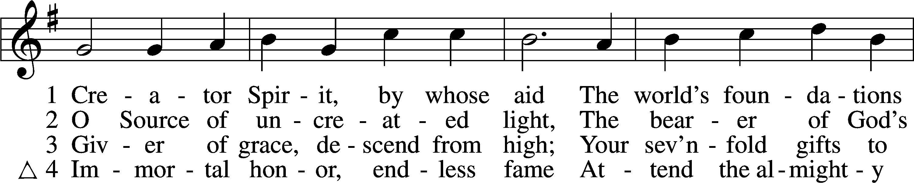
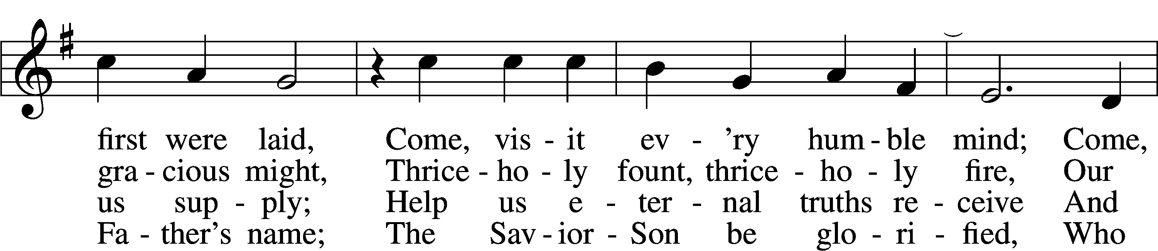
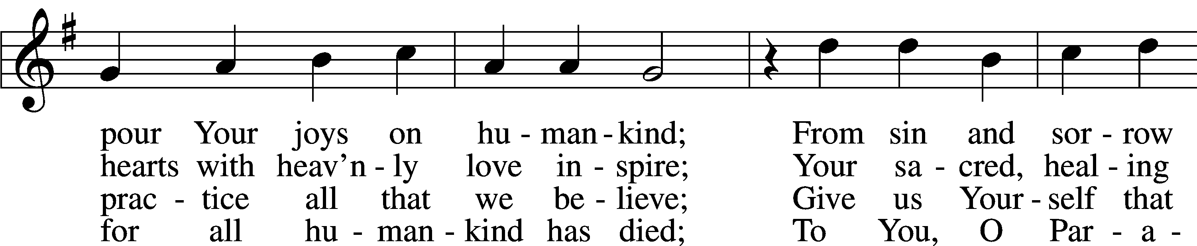
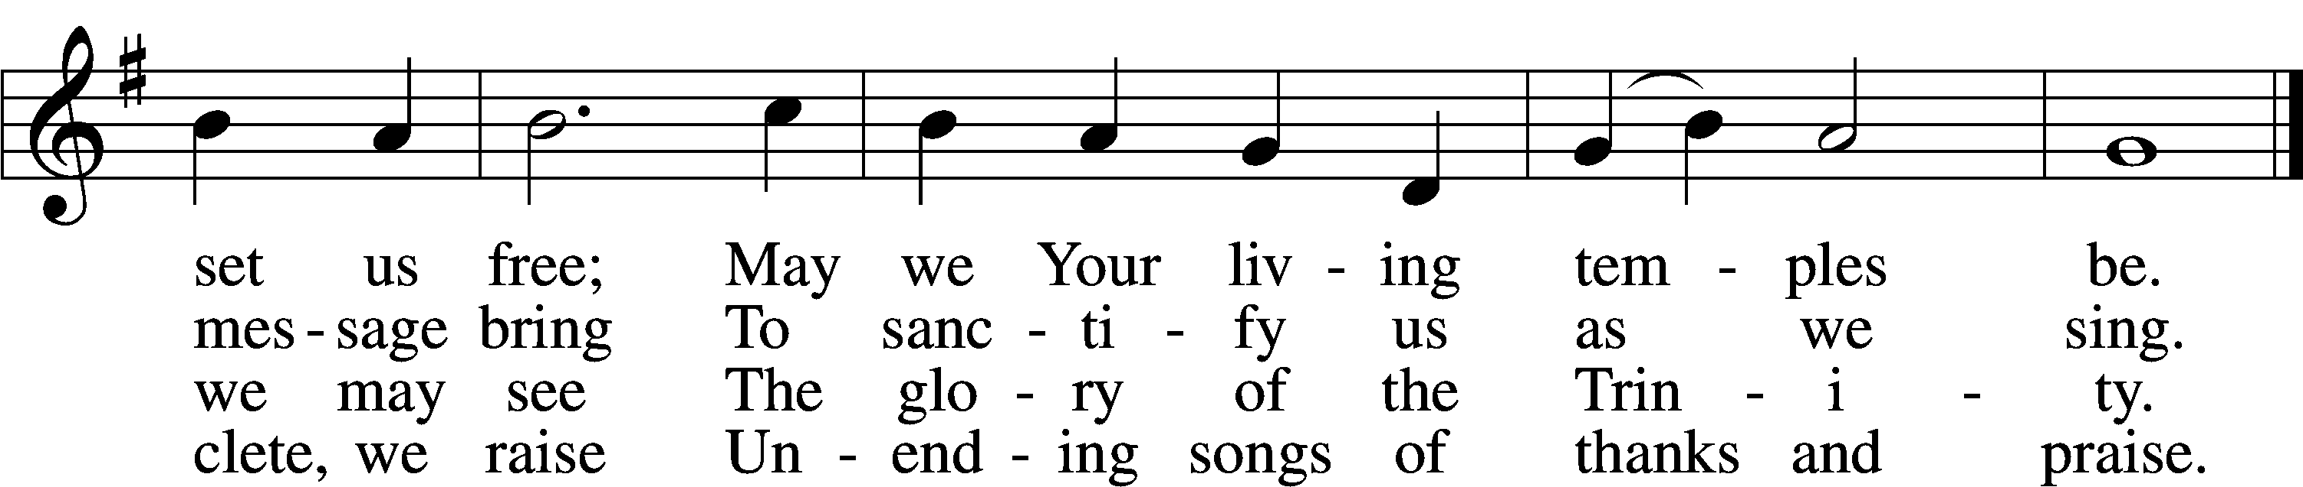
Text and tune: Public domain

Sermon

Stand

Apostles’ Creed
C I believe in God, the Father Almighty,
maker of heaven and earth.

And in Jesus Christ, His only Son, our Lord,
who was conceived by the Holy Spirit,
born of the virgin Mary,
suffered under Pontius Pilate,
was crucified, died and was buried.
He descended into hell.
The third day He rose again from the dead.
He ascended into heaven
and sits at the right hand of God the Father Almighty.
From thence He will come to judge the living and the dead.

I believe in the Holy Spirit,
the holy Christian Church,
the communion of saints,
the forgiveness of sins,
the resurrection of the body,
and the life everlasting. Amen.

Prayer of the Church

Sit

Offering

Offertory LSB 159
C What shall I render to the Lord for all His benefits to me?
I will offer the sacrifice of thanksgiving and will call on the name of the Lord.
I will take the cup of salvation and will call on the name of the Lord.
I will pay my vows to the Lord now in the presence of all His people,
in the courts of the Lord’s house, in the midst of you, O Jerusalem.

Service of the Sacrament

Preface LSB 160
P The Lord be with you.
C And also with you.

P Lift up your hearts.
C We lift them to the Lord.

P Let us give thanks to the Lord our God.
C It is right to give Him thanks and praise.

P It is truly good, right, and salutary that we should at all times and in all places give thanks to You, holy Lord, almighty Father, everlasting God. And most especially are we bound to praise You on this day for the glorious resurrection of Your Son, Jesus Christ, the very Paschal Lamb, who was sacrificed for us and bore the sins of the world. By His dying He has destroyed death, and by His rising again He has restored to us everlasting life. Therefore with Mary Magdalene, Peter and John, and with all the witnesses of the resurrection, with angels and archangels, and with all the company of heaven we laud and magnify Your glorious name, evermore praising You and saying:

Sanctus LSB 161
C Holy, holy, holy Lord God of pow’r and might:
Heaven and earth are full of Your glory.
Hosanna. Hosanna.
Hosanna in the highest.
Blessed is He who comes in the name of the Lord.
Hosanna in the highest.

Lord’s Prayer LSB 162
P Lord, remember us in Your kingdom and teach us to pray:
C Our Father who art in heaven,
hallowed be Thy name,
Thy kingdom come,
Thy will be done on earth
as it is in heaven;
give us this day our daily bread;
and forgive us our trespasses
as we forgive those
who trespass against us;
and lead us not into temptation,
but deliver us from evil.
For Thine is the kingdom
and the power and the glory
forever and ever. Amen.

The Words of Our Lord
P Our Lord Jesus Christ, on the night when He was betrayed, took bread, and when He had given thanks, He broke it and gave it to the disciples and said: “Take, eat; this is My body, which is given for you. This do in remembrance of Me.”

In the same way also He took the cup after supper, and when He had given thanks, He gave it to them, saying: “Drink of it, all of you; this cup is the new testament in My blood, which is shed for you for the forgiveness of sins. This do, as often as you drink it, in remembrance of Me.”

Pax Domini LSB 163
P The peace of the Lord be with you always.
C Amen.

Agnus Dei LSB 163
C Lamb of God, You take away the sin of the world; have mercy on us.
Lamb of God, You take away the sin of the world; have mercy on us.
Lamb of God, You take away the sin of the world; grant us peace.

Sit

Distribution

The pastor and those who assist him receive the body and blood of Christ first and then distribute them to those who come to receive, saying:

642 O Living Bread from Heaven
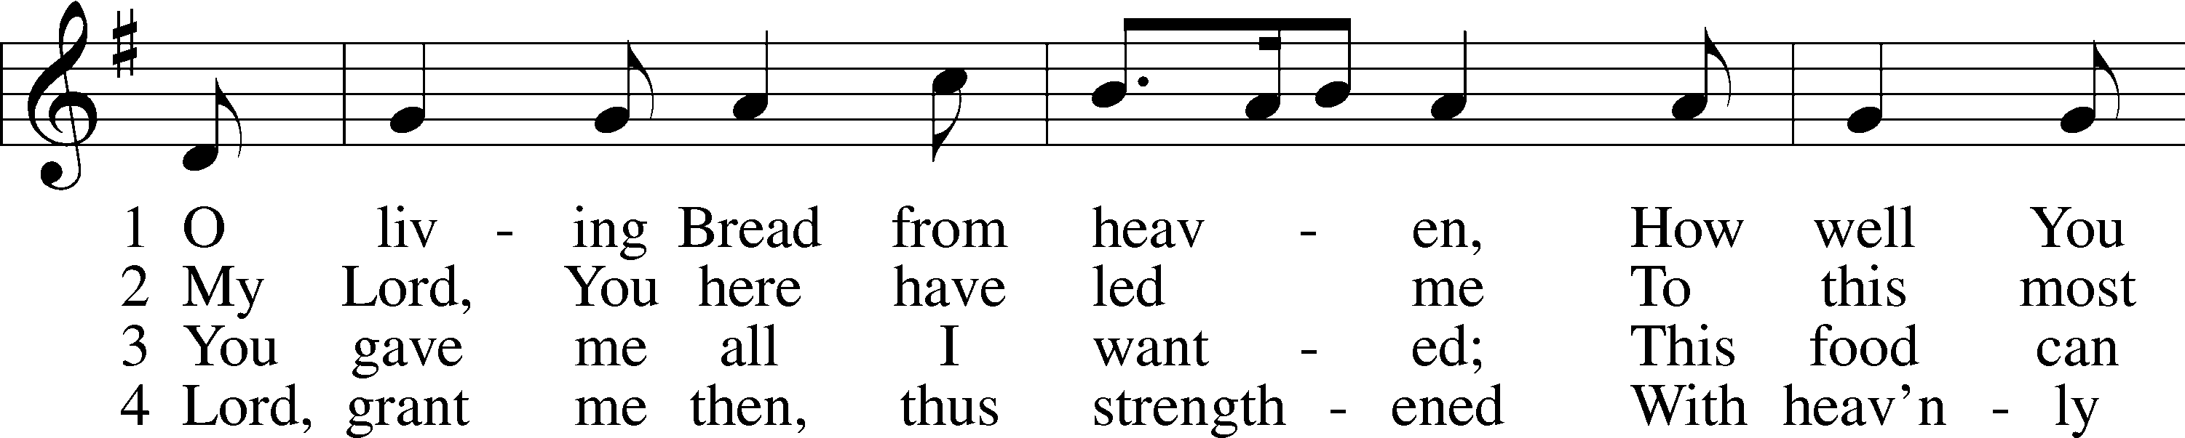
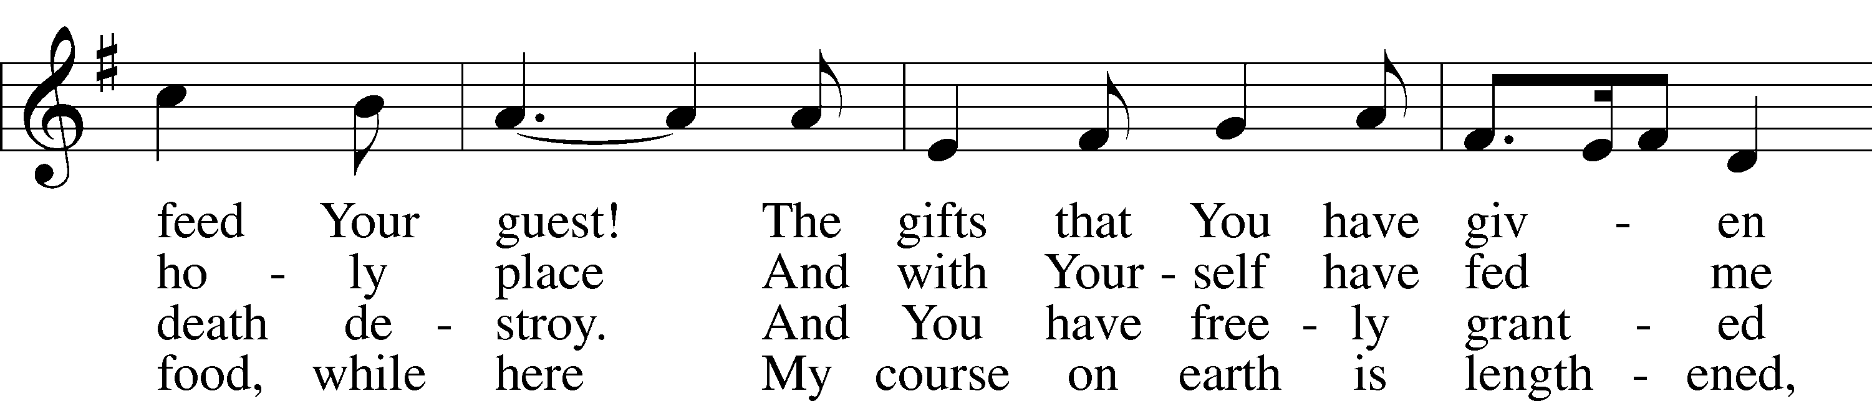
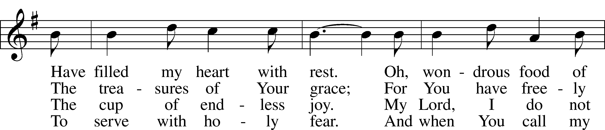
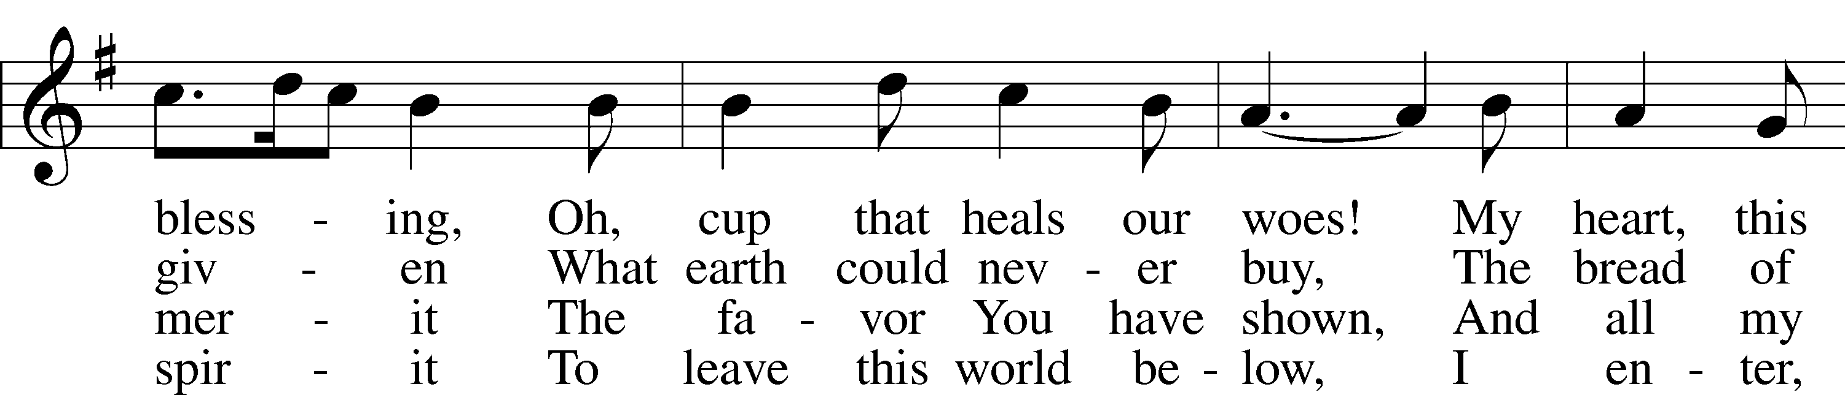
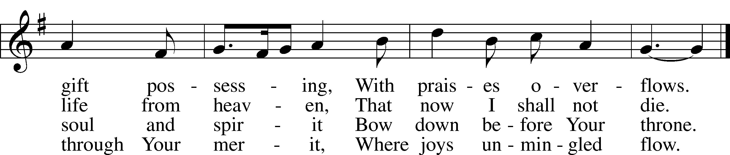
Tune and text: Public domain

725 Children of the Heavenly Father
1 Children of the heav’nly Father
Safely in His bosom gather;
Nestling bird nor star in heaven
Such a refuge e’er was given.

2 God His own doth tend and nourish;
In His holy courts they flourish.
From all evil things He spares them;
In His mighty arms He bears them.

3 Neither life nor death shall ever
From the Lord His children sever;
Unto them His grace He showeth,
And their sorrows all He knoweth.

4 Though He giveth or He taketh,
God His children ne’er forsaketh;
His the loving purpose solely
To preserve them pure and holy.
Text: © Augsburg Publishing House. Used by permission: CPH Limited Promotional License no. 119000000

Stand

In dismissing the communicants, the following is said:

P The body and blood of our Lord Jesus Christ strengthen and preserve you in body and soul to life everlasting. Depart in peace.
C Amen.

Thank the Lord LSB 164
C Thank the Lord and sing His praise; tell ev’ryone what He has done.
Let all who seek the Lord rejoice and proudly bear His name.
He recalls His promises and leads His people forth in joy
with shouts of thanksgiving. Alleluia, alleluia.

Post-Communion Collect
A Let us pray.
We give thanks to You, almighty God, that You have refreshed us through this salutary gift, and we implore You that of Your mercy You would strengthen us through the same in faith toward You and in fervent love toward one another; through Jesus Christ, Your Son, our Lord, who lives and reigns with You and the Holy Spirit, one God, now and forever.
C Amen.

Benediction LSB 166
P The Lord bless you and keep you.
The Lord make His face shine on you and be gracious to you.
The Lord look upon you with favor and give you peace.
C Amen.

556 Dear Christians, One and All, Rejoice sts. 1–2, 5, 8
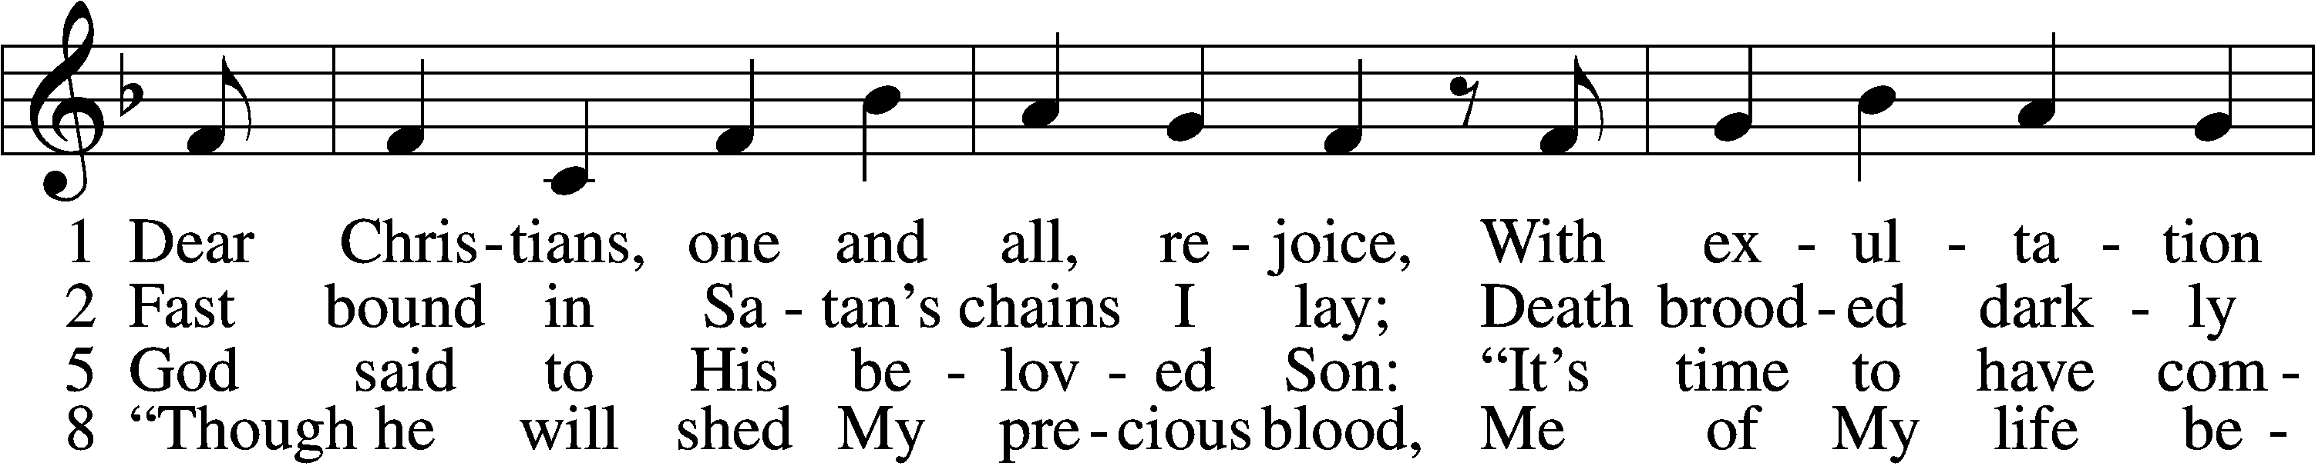
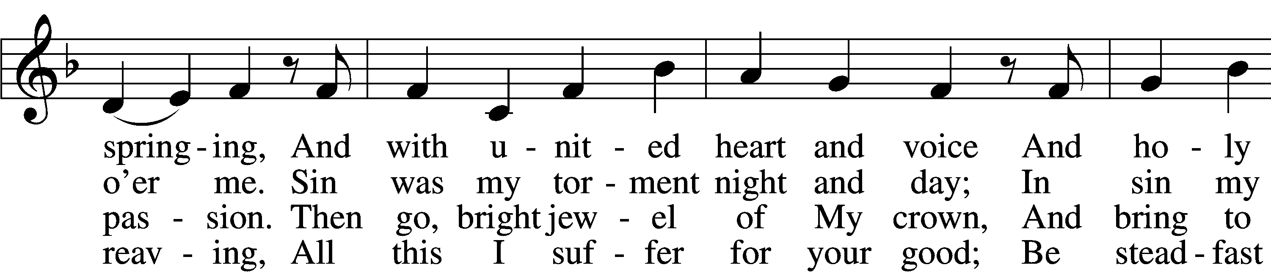
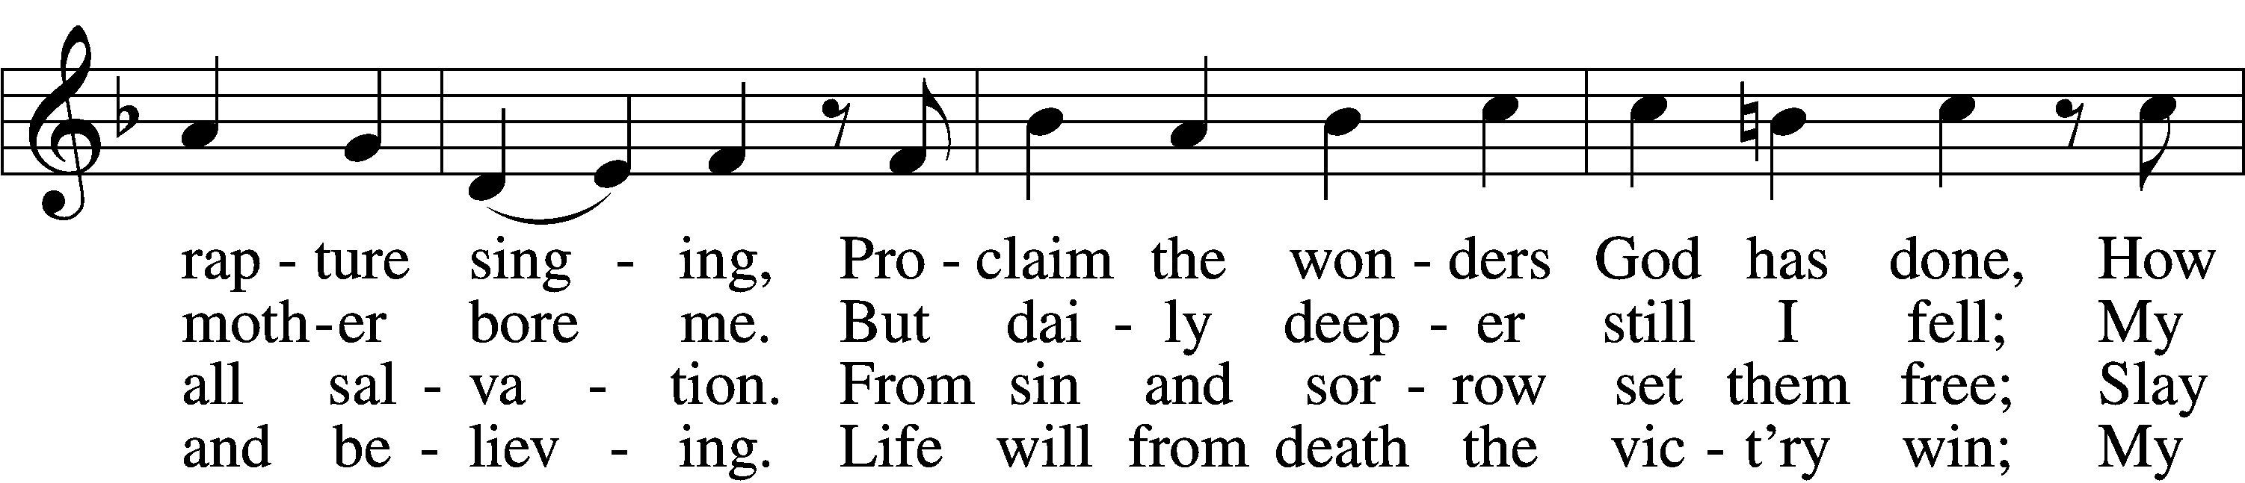
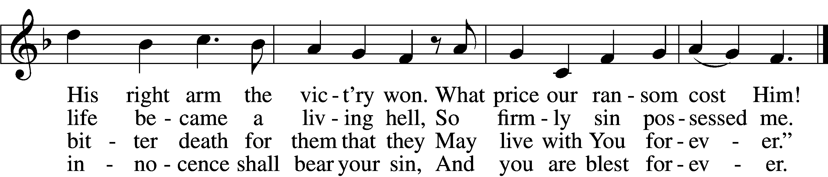
Text and tune: Public domain

Acknowledgments
Divine Service, Setting One from Lutheran Service Book
Unless otherwise indicated, Scripture quotations are from the ESV® Bible (The Holy Bible, English Standard Version®), copyright © 2001 by Crossway, a publishing ministry of Good News Publishers. Used by permission. All rights reserved.
Created by Lutheran Service Builder © 2018 Concordia Publishing House.
The Radio Broadcast today is given to the Glory of the Lord by
Lavern & Elaine Stuehm in memory of loved ones.

Prayers for Our Members
Chelsea Junge, Christina Long, Tenaya Nuttelman | Expectant Mothers
Family and Friends of Craig Nuttelman | Grief
Norman Abels (Brookestone Meadows – Elkhorn) | Healing
Judy Ahrens | Healing
Vaughn Albrecht (Northridge) | Healing
Tom & DyAnn Altwine | Healing
Lyle Colsden (Mother Hull) | Healing
Brenda Fletcher | Healing
Pat Flodine (Cambridge Court) | Healing
Vi Fox (Prairie View) | Healing
Verleen Gentry | Healing
Tiffany Hartman | Healing
Ruby Hatfield | Healing
Carol Herron | Healing
Carol Kreutzer | Healing
Teresa Leising | Healing
Marion Richmond | Healing
Geraldine Roeder | Healing
Dorothy Sikes | Healing
Bev Nuttelman | Cancer
Kim Vos | Cancer
Ramona Gaunt | Palliative Care
Linda Nuttelman | Recovery
Prayers for Our Members’ Family & Friends
Shaylee Kreutzer (Rich & Carol Kreutzer’s daughter-in-law) | Expectant Mother
Lana Latsabidze (Bruce & Ann Fattig daughter-in-law) | Expectant Mother
Amy Nuttelman (Keith & Bev Nuttelman’s daughter-in-law) | Expectant Mother
Becci Koopman & baby Everett Gene  (Todd & Ellen Koopman daughter-in-law & grandson) | Birth
Ava Jean Winnie (Nic Kitzing’s cousin) | Healing
Will Brennemann (Jami Helmbrecht’s father) | Healing
Don Berg (Evelyn Heiden’s brother) | Healing
Reg Duke (Westman’s brother-in-law) | Healing
James Gentry (Verleen Gentry’s son) | Healing
Lee Gilbert | Healing
Mark Glover (Shirley Helmbrecht’s brother) | Healing
Brooke Guthrie (Bailey Hockemeier’s sister) | Healing
Lois Hanson (Pastor Hanson’s wife) | Healing
Norman Hockemeier (Ken’s father) | Healing
Roger Hoffman (Marc’s father) | Healing
Vernon Knight Jr. (Brenda Fletcher’s brother) | Healing
Miles Margritz (Wanda Glanzer’s nephew) | Healing
Randy Solomon (Beth Rosenthal’s father) | Healing
Mary Ann Mertz (Pam’s Uhlir’s friend) | Healing
Roy Reynolds (Verleen Gentry’s son-in-law) | Healing
Janet Stalder (Carol Florang’s sister) | Healing
Patty Ellis (Fran Junge’s sister) | Cancer
Ron Halvorsen (Jeff’s dad) | Cancer
Carol Haubold (Don Helmbrecht’s sister) | Cancer
Tyler Holland (Quentin & Janel Lange brother-in-law) | Cancer
Fred Koch (Pam Uhlir’s cousin) | Cancer
Lynda Kreutzer (Rich & Carol’s sister-in-law) | Cancer
Sharon Mulhair (Pam Uhlir’s cousin) | Cancer
Tyrone Uhlir (Pam’s nephew) | Cancer
Members of Zion Lutheran North Shelton | Loss & Restoration
Pr.James, Pr. Clausing, Our sister congregations in Haiti | Missionaries
John Christensen, John Harbols | Military

Sun  05/17 | 9:00a  11:00a | Divine Service  Divine Service
Mon  05/18 | Birthdays  Anniversaries | ---  ---
Tues  05/19 | Birthdays  Anniversaries | Alton Schmitt  Lavern Stuehm  ---
Wed  05/20 | Birthdays  Anniversaries | ---  ---
Thurs  05/21 | 7:00p  Birthdays  Anniversaries | Men’s Bible study  James Hatfield  Alfred Westman  ---
Fri  05/22 | Birthdays  Anniversaries | ---  ---
Sat  05/23 | 5:00p  Birthdays  Anniversaries | Divine Service  Addison Splittgerber  ---
Sun  05/24 | 9:00a  11:00a  Birthdays  Anniversaries | Divine Service  Divine Service  Brenda Fletcher  Henry Hodgson  Phyllis Wells  ---

Our Response to the Gospel

Date: 05/10/2020

Attendance:

Offering: $10,070.01
Weekly Need: $7,542.37

Serving in Worship

Sunday, May 17 9:00am
Acolyte: Shelby Clark
Elder: Ken Hockemeier
Usher: Roger Riekenberg & Robert Glanzer
Engineer: Jared Nuttelman
Announcer: Carol Kreutzer
Altar Guild: Carolyn Westman & Linda Nuttelman

Sunday, May 24 9:00am
Acolyte: Gabe Bates
Elder: Nathan Gaunt
Usher: Mike Wilkens & Jeff Strong
Engineer: Shawn Starkey
Announcer: Brooke Fisher
Altar Guild: Carolyn Westman & Linda Nuttelman

ANNOUNCEMENTS

Offering during this time. There are several options to get your weekly offering into church. Please continue to give weekly offering because we are committed to continue to pay employees, utilities, and the monthly expenses. Ways to continue your offering are: drop the offering in the mail slot by the south doors, mail it to the church, utilize online giving at zionkearney.com, if you attend church service place in the offering plate. If you have any questions or need assistance please contact the office at 308-234-3410 or school@zionkearney.org. Thank you for your support of our church!

Radio Broadcast - Please help Zion spread the Gospel! This is a great need during this time, many people are utilizing this resource during this time.

Men’s Bible Study – The Men’s Bible Study will tentatively meet on Thursday, May 21st. Watch for confirmation and details.

Church Reopen - Please go to Zion's church website at www.zionkearney.com and read about our plan to reopen for worship and how to register to attend.

Office Closed – The office will be closed on Monday, May 25th in observance of Memorial Day.

2421 Avenue C
Kearney, NE 68847
308-234-3410
school@zionkearney.org

ZION LUTHERAN CHURCH AND SCHOOL

Pr. James DeLoach, Pastor + (308) 627-5260
james.deloach@zionkearney.org
Pr. Doug Gaunt, Pastor + (308) 455-0552
doug.gaunt@zionkearney.org
Tony Splittgerber, Principal + (308) 293-0168
anthony.splittgerber@zionkearney.org

Church Office
Administrative Assistant: Jessica Shiers
Email: school@zionkearney.org
Phone: (308)-234-3410 Fax: (308) 236-8100
Office Hours: Monday-Friday 8:00am-4:00pm
Radio Broadcast: Sunday @ 10:30 a.m. on 1460 AM
Website: www.zionkearney.com

