Confession and Absolution

861 Christ Be My Leader
1 Christ be my Leader by night as by day;
Safe through the darkness, for He is the way.
Gladly I follow, my future His care,
Darkness is daylight when Jesus is there.

2 Christ be my Teacher in age as in youth,
Drifting or doubting, for He is the truth.
Grant me to trust Him; though shifting as sand,
Doubt cannot daunt me; in Jesus I stand.

3 Christ be my Savior in calm as in strife;
Death cannot hold me, for He is the life.
Nor darkness nor doubting nor sin and its stain
Can touch my salvation: with Jesus I reign.
Text: © 1964, renewed 1992 Hope Publishing Co. Used by permission: CPH Limited Promotional License no. 119000000

Stand

The sign of the cross may be made by all in remembrance of their Baptism.

P In the name of the Father and of the T Son and of the Holy Spirit.
C Amen.

P If we say we have no sin, we deceive ourselves, and the truth is not in us.
C But if we confess our sins, God, who is faithful and just, will forgive our sins and cleanse us from all unrighteousness.

Kneel/Stand

Silence for reflection on God’s Word and for self-examination.

P Let us then confess our sins to God our Father.
C Most merciful God, we confess that we are by nature sinful and unclean. We have sinned against You in thought, word, and deed, by what we have done and by what we have left undone. We have not loved You with our whole heart; we have not loved our neighbors as ourselves. We justly deserve Your present and eternal punishment. For the sake of Your Son, Jesus Christ, have mercy on us. Forgive us, renew us, and lead us, so that we may delight in Your will and walk in Your ways to the glory of Your holy name. Amen.

P Almighty God in His mercy has given His Son to die for you and for His sake forgives you all your sins. As a called and ordained servant of Christ, and by His authority, I therefore forgive you all your sins in the name of the Father and of the T Son and of the Holy Spirit.
C Amen.

Stand

Service of the Word

Introit Psalm 30:1–5; antiphon: Psalm 149:1
Praise the Lord! Sing to the Lord a | new song,*
his praise in the assembly of the | godly!
I will extol you, O Lord, for you have | drawn me up*
and have not let my foes rejoice | over me.
O Lord my God, I cried to | you for help,*
and you have | healed me.
O Lord, you have brought up my soul | from Sheol;*
you restored me to life from among those who go down | to the pit.
Sing praises to the Lord, O | you his saints,*
and give thanks to his | holy name.
For his anger is but for a moment, and his favor is for a | lifetime.*
Weeping may tarry for the night, but joy comes with the | morning.
Glory be to the Father and | to the Son*
and to the Holy | Spirit;
as it was in the be- | ginning,*
is now, and will be forever. | Amen.
Praise the Lord! Sing to the Lord a | new song,*
his praise in the assembly of the | godly!

Kyrie LSB 152
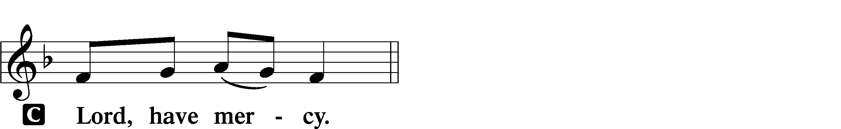

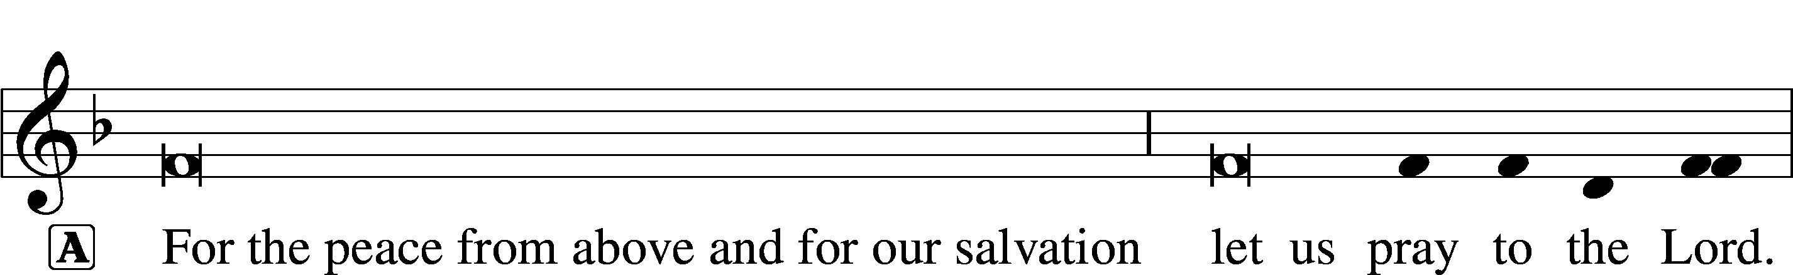
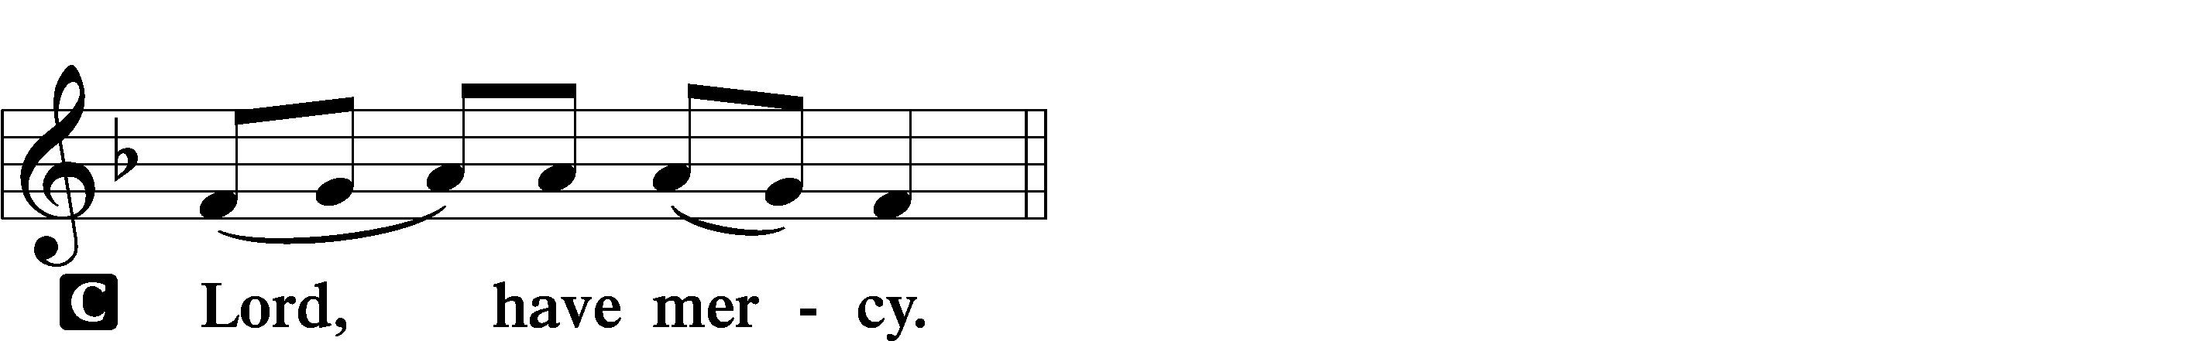

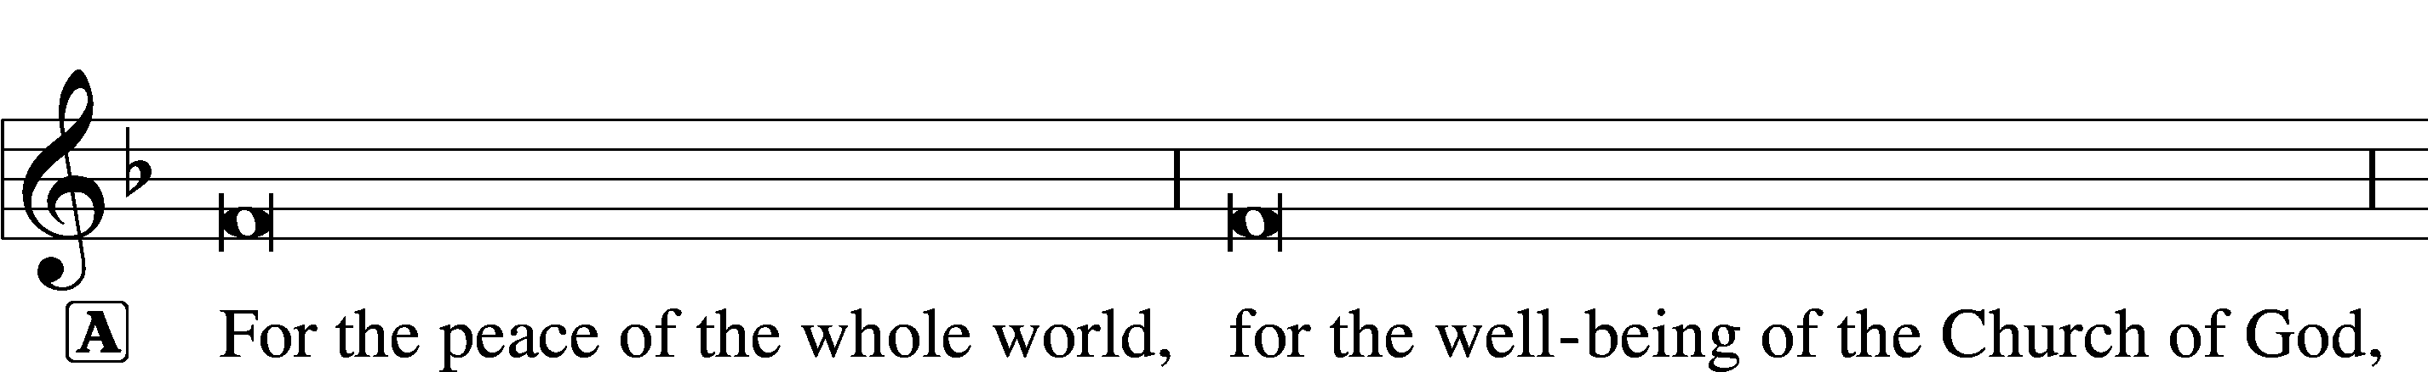
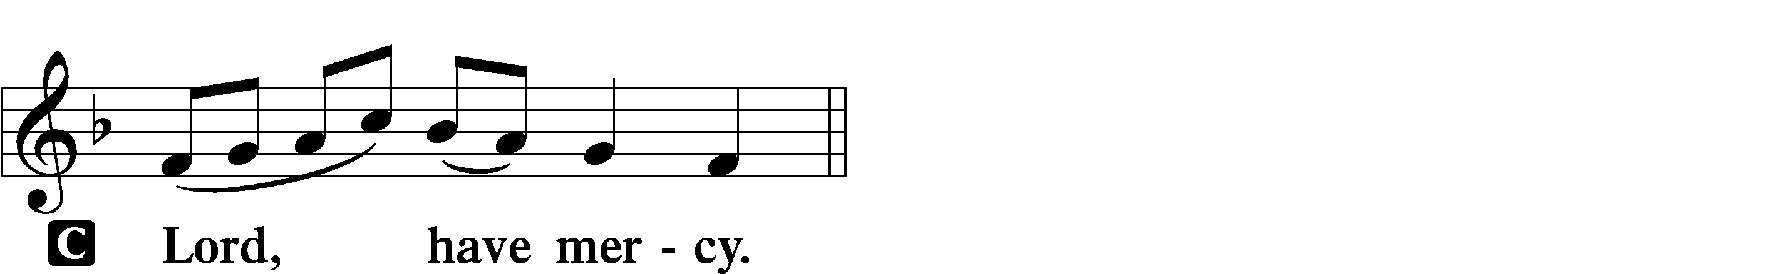

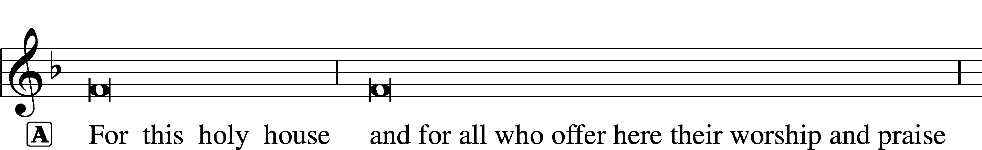
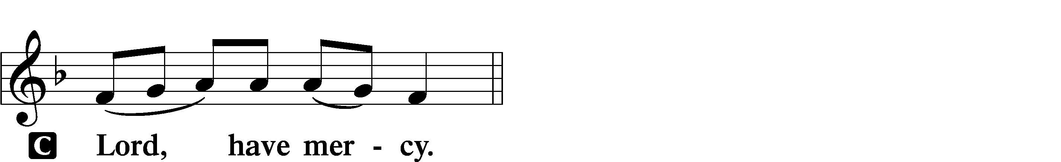

This Is the Feast LSB 155
C This is the feast of victory for our God.
Alleluia, alleluia, alleluia.

Worthy is Christ, the Lamb who was slain, whose blood set us free to be people of God.

This is the feast of victory for our God.
Alleluia, alleluia, alleluia.

Power, riches, wisdom, and strength, and honor, blessing, and glory are His.

This is the feast of victory for our God.
Alleluia, alleluia, alleluia.

Sing with all the people of God, and join in the hymn of all creation:
Blessing, honor, glory, and might be to God and the Lamb forever. Amen.

This is the feast of victory for our God.
Alleluia, alleluia, alleluia.

For the Lamb who was slain has begun His reign. Alleluia.

This is the feast of victory for our God.
Alleluia, alleluia, alleluia.

Salutation and Collect of the Day
P The Lord be with you.
C And also with you.

P Let us pray.
O God, You make the minds of Your faithful to be of one will. Grant that we may love what You have commanded and desire what You promise, that among the many changes of this world our hearts may be fixed where true joys are found; through Jesus Christ, Your Son, our Lord, who lives and reigns with You and the Holy Spirit, one God, now and forever.

C Amen.

Sit

First Reading Acts 6:1–9; 7:2a, 51–60
1Now in these days when the disciples were increasing in number, a complaint by the Hellenists arose against the Hebrews because their widows were being neglected in the daily distribution. 2And the twelve summoned the full number of the disciples and said, “It is not right that we should give up preaching the word of God to serve tables. 3Therefore, brothers, pick out from among you seven men of good repute, full of the Spirit and of wisdom, whom we will appoint to this duty. 4But we will devote ourselves to prayer and to the ministry of the word.” 5And what they said pleased the whole gathering, and they chose Stephen, a man full of faith and of the Holy Spirit, and Philip, and Prochorus, and Nicanor, and Timon, and Parmenas, and Nicolaus, a proselyte of Antioch. 6These they set before the apostles, and they prayed and laid their hands on them.
7And the word of God continued to increase, and the number of the disciples multiplied greatly in Jerusalem, and a great many of the priests became obedient to the faith.
8And Stephen, full of grace and power, was doing great wonders and signs among the people. 9Then some of those who belonged to the synagogue of the Freedmen (as it was called), and of the Cyrenians, and of the Alexandrians, and of those from Cilicia and Asia, rose up and disputed with Stephen. . . .
2And Stephen said:
“Brothers and fathers, hear me. . . .
51You stiff-necked people, uncircumcised in heart and ears, you always resist the Holy Spirit. As your fathers did, so do you. 52Which of the prophets did not your fathers persecute? And they killed those who announced beforehand the coming of the Righteous One, whom you have now betrayed and murdered, 53you who received the law as delivered by angels and did not keep it.”
54Now when they heard these things they were enraged, and they ground their teeth at him. 55But he, full of the Holy Spirit, gazed into heaven and saw the glory of God, and Jesus standing at the right hand of God. 56And he said, “Behold, I see the heavens opened, and the Son of Man standing at the right hand of God.” 57But they cried out with a loud voice and stopped their ears and rushed together at him. 58Then they cast him out of the city and stoned him. And the witnesses laid down their garments at the feet of a young man named Saul. 59And as they were stoning Stephen, he called out, “Lord Jesus, receive my spirit.” 60And falling to his knees he cried out with a loud voice, “Lord, do not hold this sin against them.” And when he had said this, he fell asleep.

A This is the Word of the Lord.
C Thanks be to God.

Gradual adapt. from Matthew 28:7; Hebrews 2:7; Psalm 8:6
Christ has risen | from the dead.*
[God the Father] has crowned him with glory and | honor.
He has given him dominion over the works | of his hands;*
he has put all things un- | der his feet.

Epistle 1 Peter 2:2–10
2Like newborn infants, long for the pure spiritual milk, that by it you may grow up to salvation— 3if indeed you have tasted that the Lord is good.
4As you come to him, a living stone rejected by men but in the sight of God chosen and precious, 5you yourselves like living stones are being built up as a spiritual house, to be a holy priesthood, to offer spiritual sacrifices acceptable to God through Jesus Christ. 6For it stands in Scripture:
“Behold, I am laying in Zion a stone,
a cornerstone chosen and precious,
and whoever believes in him will not be put to shame.”
7So the honor is for you who believe, but for those who do not believe,
“The stone that the builders rejected
has become the cornerstone,”
8and
“A stone of stumbling,
and a rock of offense.”
They stumble because they disobey the word, as they were destined to do.
9But you are a chosen race, a royal priesthood, a holy nation, a people for his own possession, that you may proclaim the excellencies of him who called you out of darkness into his marvelous light. 10Once you were not a people, but now you are God’s people; once you had not received mercy, but now you have received mercy.

A This is the Word of the Lord.
C Thanks be to God.

Stand

Alleluia and Verse LSB 156
C Alleluia.
Lord, to whom shall we go?
You have the words of eternal life.
Alleluia, alleluia.

Holy Gospel John 14:1–14
P The Holy Gospel according to St. John, the fourteenth chapter.
C Glory to You, O Lord.

1[Jesus said:] “Let not your hearts be troubled. Believe in God; believe also in me. 2In my Father’s house are many rooms. If it were not so, would I have told you that I go to prepare a place for you? 3And if I go and prepare a place for you, I will come again and will take you to myself, that where I am you may be also. 4And you know the way to where I am going.” 5Thomas said to him, “Lord, we do not know where you are going. How can we know the way?” 6Jesus said to him, “I am the way, and the truth, and the life. No one comes to the Father except through me. 7If you had known me, you would have known my Father also. From now on you do know him and have seen him.”
8Philip said to him, “Lord, show us the Father, and it is enough for us.” 9Jesus said to him, “Have I been with you so long, and you still do not know me, Philip? Whoever has seen me has seen the Father. How can you say, ‘Show us the Father’? 10Do you not believe that I am in the Father and the Father is in me? The words that I say to you I do not speak on my own authority, but the Father who dwells in me does his works. 11Believe me that I am in the Father and the Father is in me, or else believe on account of the works themselves.
12“Truly, truly, I say to you, whoever believes in me will also do the works that I do; and greater works than these will he do, because I am going to the Father. 13Whatever you ask in my name, this I will do, that the Father may be glorified in the Son. 14If you ask me anything in my name, I will do it.”

P This is the Gospel of the Lord.
C Praise to You, O Christ.

Sit

633 At the Lamb’s High Feast We Sing sts. 1–2, 5–7
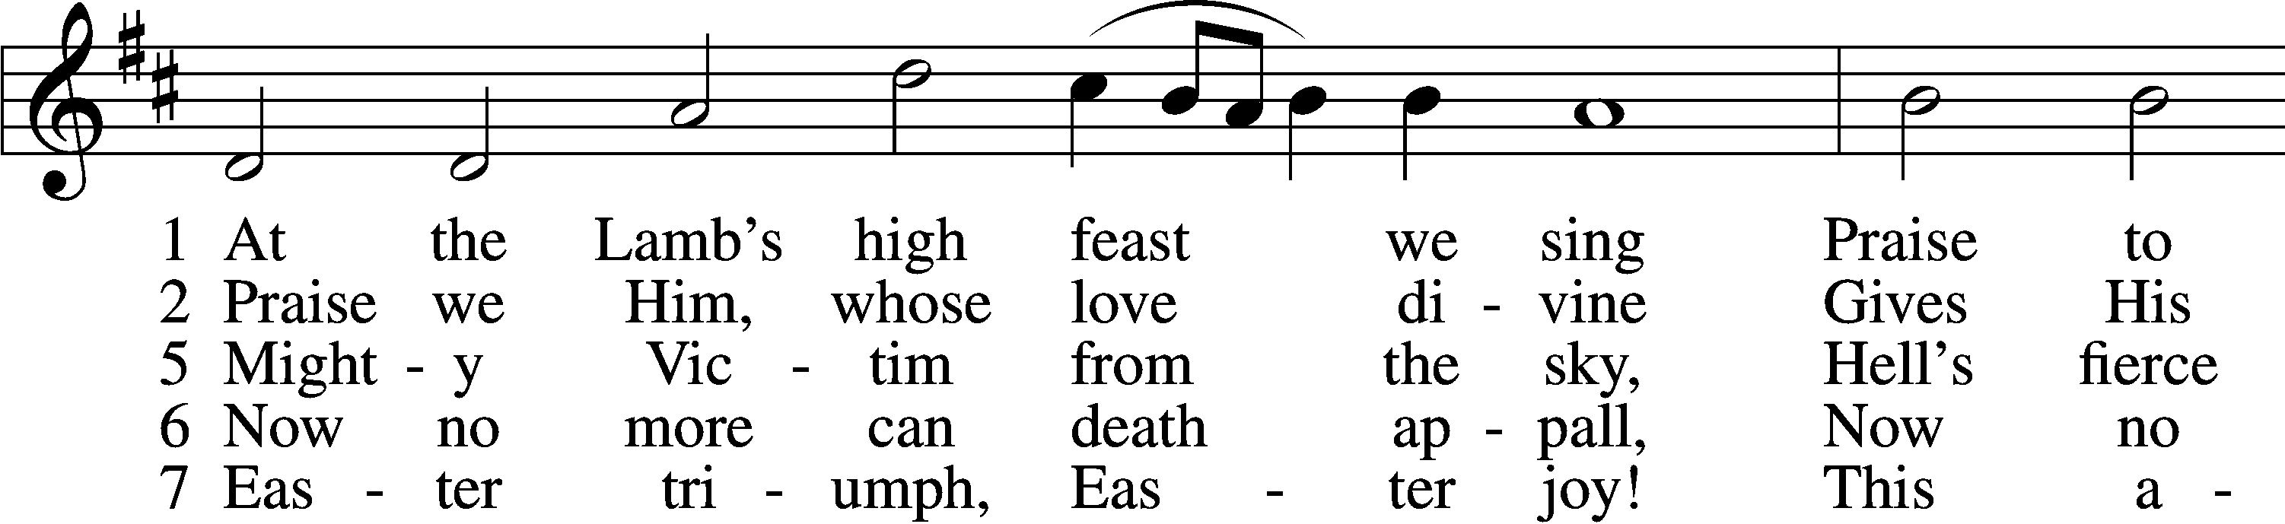
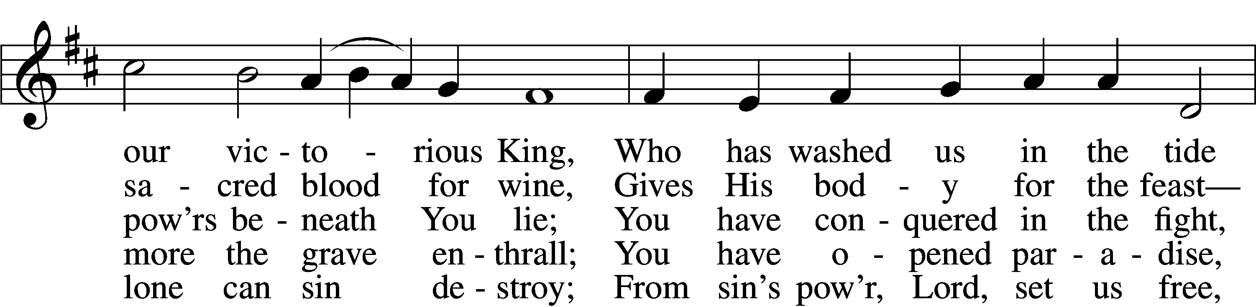
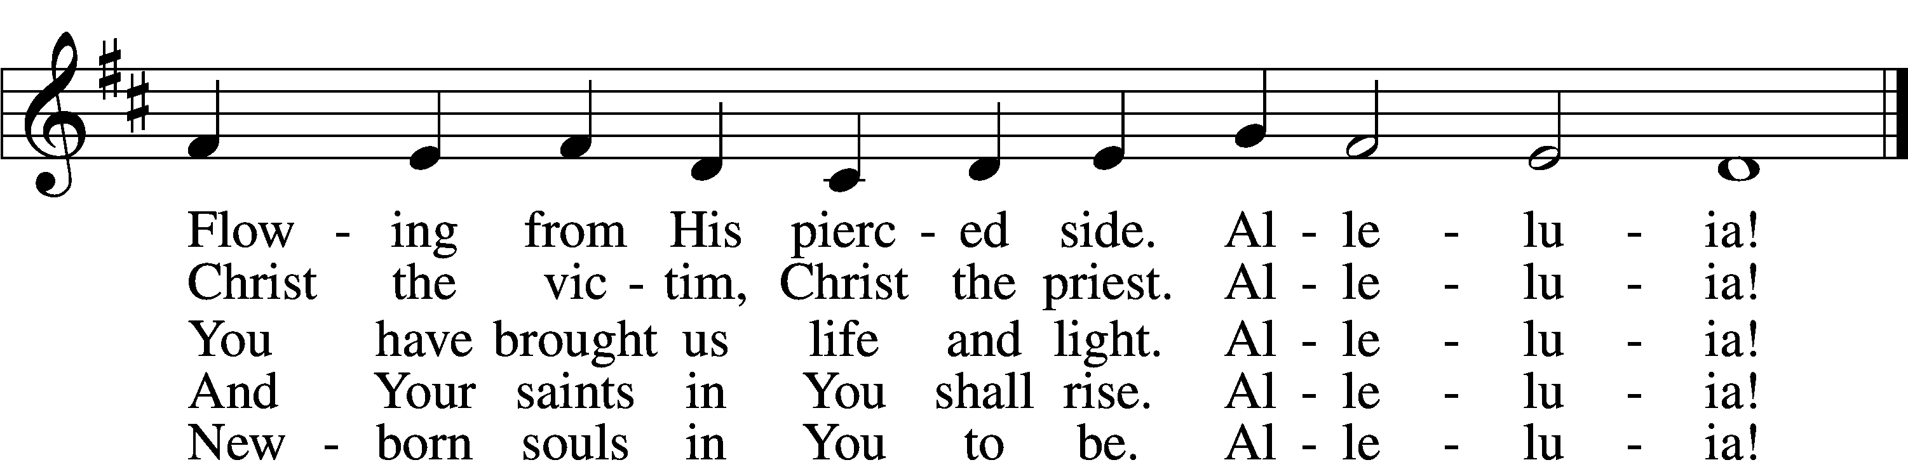
Text and tune: Public domain

Sermon

Stand

Nicene Creed
C I believe in one God,
the Father Almighty,
maker of heaven and earth
and of all things visible and invisible.

And in one Lord Jesus Christ,
the only-begotten Son of God,
begotten of His Father before all worlds,
God of God, Light of Light,
very God of very God,
begotten, not made,
being of one substance with the Father,
by whom all things were made;
who for us men and for our salvation came down from heaven
and was incarnate by the Holy Spirit of the virgin Mary
and was made man;
and was crucified also for us under Pontius Pilate.
He suffered and was buried.
And the third day He rose again according to the Scriptures
and ascended into heaven
and sits at the right hand of the Father.
And He will come again with glory to judge both the living and the dead,
whose kingdom will have no end.

And I believe in the Holy Spirit,
the Lord and giver of life,
who proceeds from the Father and the Son,
who with the Father and the Son together is worshiped and glorified,
who spoke by the prophets.
And I believe in one holy Christian and apostolic Church,
I acknowledge one Baptism for the remission of sins,
and I look for the resurrection of the dead
and the life T of the world to come. Amen.

Prayer of the Church

Offering Please place your offering in an offering plate in the narthex.

Offertory LSB 159
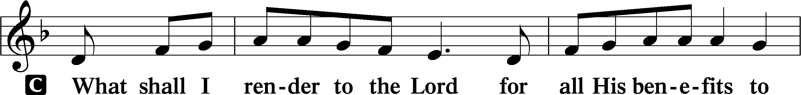
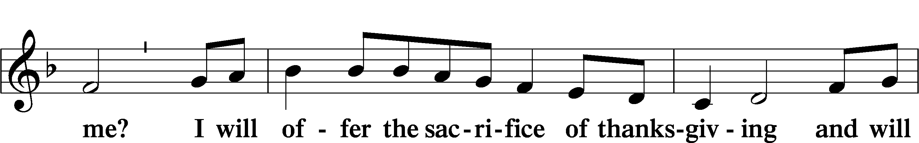
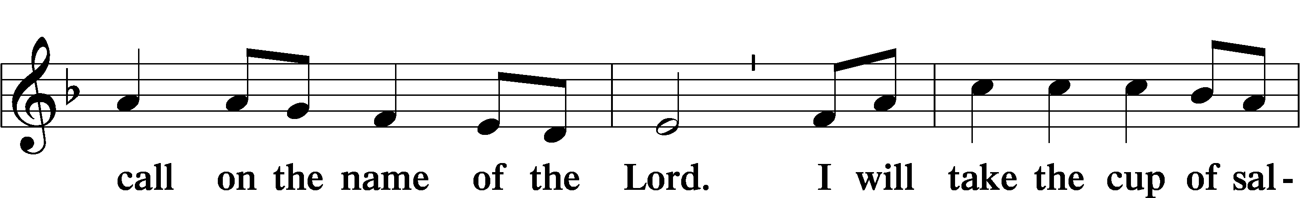
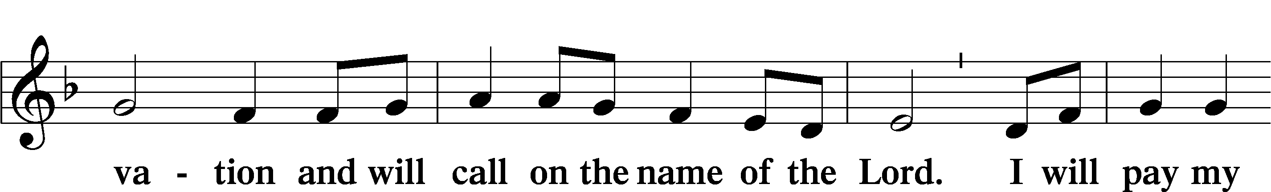
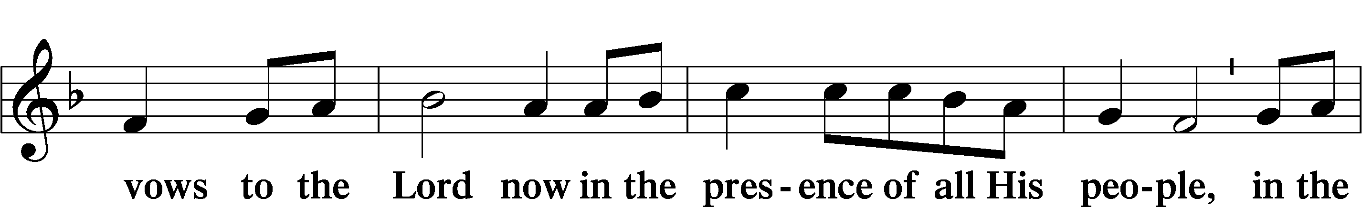
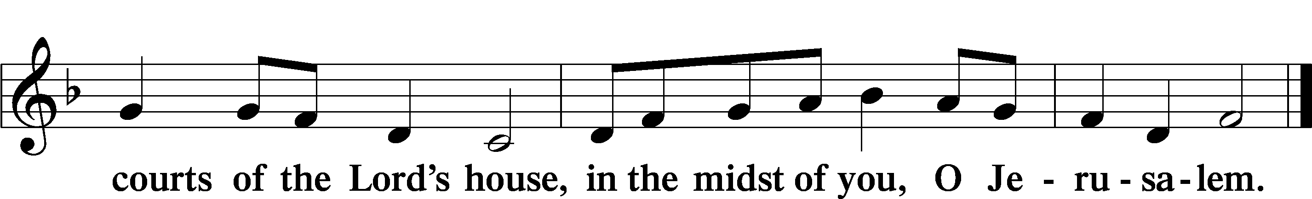

Service of the Sacrament

Preface LSB 160
P The Lord be with you.
C And also with you.

P Lift up your hearts.
C We lift them to the Lord.

P Let us give thanks to the Lord our God.
C It is right to give Him thanks and praise.

P It is truly good, right, and salutary that we should at all times and in all places give thanks to You, holy Lord, almighty Father, everlasting God. And most especially are we bound to praise You on this day for the glorious resurrection of Your Son, Jesus Christ, the very Paschal Lamb, who was sacrificed for us and bore the sins of the world. By His dying He has destroyed death, and by His rising again He has restored to us everlasting life. Therefore with Mary Magdalene, Peter and John, and with all the witnesses of the resurrection, with angels and archangels, and with all the company of heaven we laud and magnify Your glorious name, evermore praising You and saying:

Sanctus LSB 161
C Holy, holy, holy Lord God of pow’r and might:
Heaven and earth are full of Your glory.
Hosanna. Hosanna.
Hosanna in the highest.
Blessed is He who comes in the name of the Lord.
Hosanna in the highest.

Lord’s Prayer LSB 162
P Lord, remember us in Your kingdom and teach us to pray:
C Our Father who art in heaven,
hallowed be Thy name,
Thy kingdom come,
Thy will be done on earth
as it is in heaven;
give us this day our daily bread;
and forgive us our trespasses
as we forgive those
who trespass against us;
and lead us not into temptation,
but deliver us from evil.
For Thine is the kingdom
and the power and the glory
forever and ever. Amen.

The Words of Our Lord
P Our Lord Jesus Christ, on the night when He was betrayed, took bread, and when He had given thanks, He broke it and gave it to the disciples and said: “Take, eat; this is My T body, which is given for you. This do in remembrance of Me.”

In the same way also He took the cup after supper, and when He had given thanks, He gave it to them, saying: “Drink of it, all of you; this cup is the new testament in My T blood, which is shed for you for the forgiveness of sins. This do, as often as you drink it, in remembrance of Me.”

Pax Domini LSB 163
P The peace of the Lord be with you always.
C Amen.

Agnus Dei LSB 163
C Lamb of God, You take away the sin of the world; have mercy on us.
Lamb of God, You take away the sin of the world; have mercy on us.
Lamb of God, You take away the sin of the world; grant us peace.

Sit

Distribution

The pastor and those who assist him receive the body and blood of Christ first and then distribute them to those who commune. The pastor and assistant will stand in the front on the south side of the sanctuary. Those seated on the south side will be ushered up the center aisle one row at a time for a blessing or to commune. They will use the hand sanitizer before communing. The pastor will place Christ's body in your flat hand to be eaten. The assistant will place an individual cup containing the blood of Christ on a stand. You will take the cup from the stand, drink the precious blood of Jesus, drop the empty cup into the basket provided, and return to your seat via the side aisle. Then we will repeat the same steps on the north side of the sanctuary.

637 Draw Near and Take the Body of the Lord
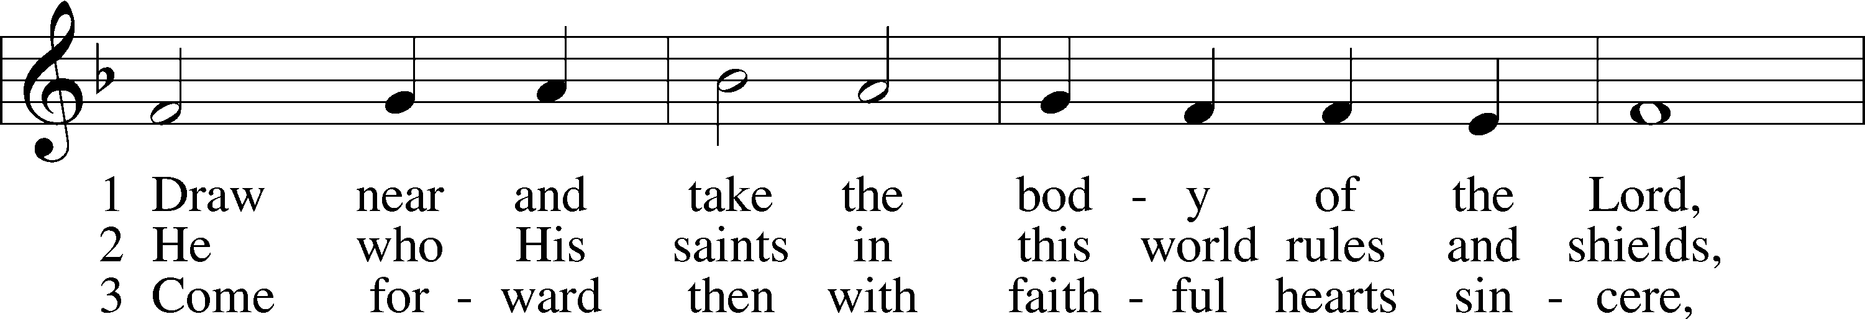
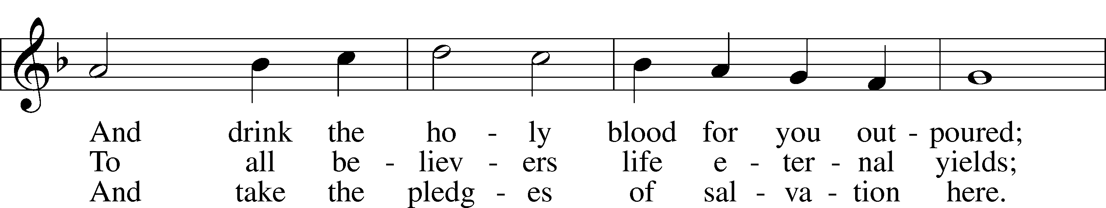
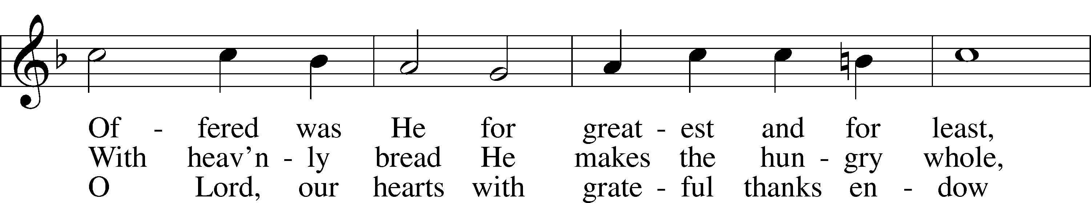
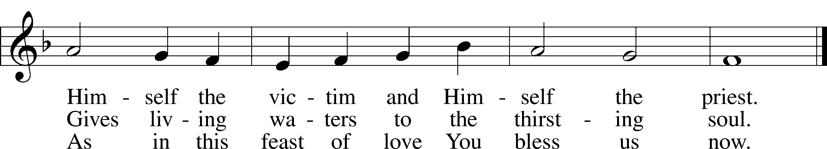
Text and tune: Public domain

646 Church of God, Elect and Glorious
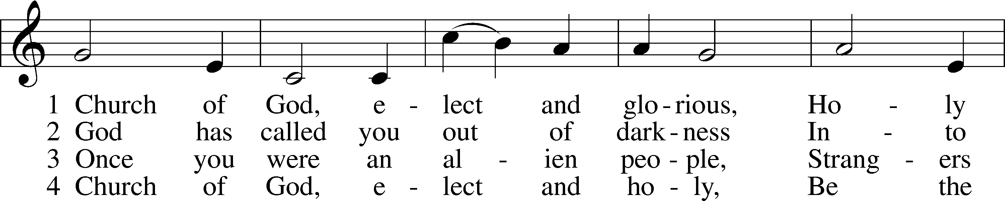
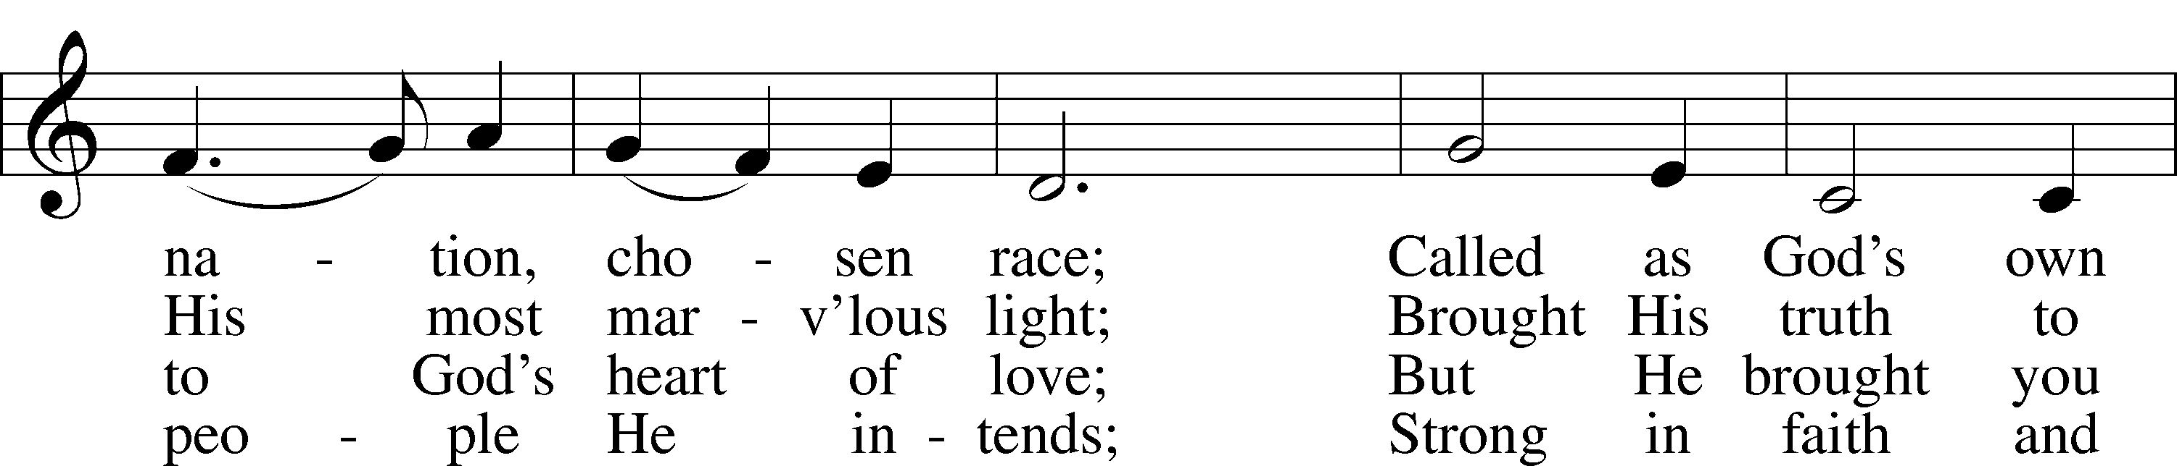
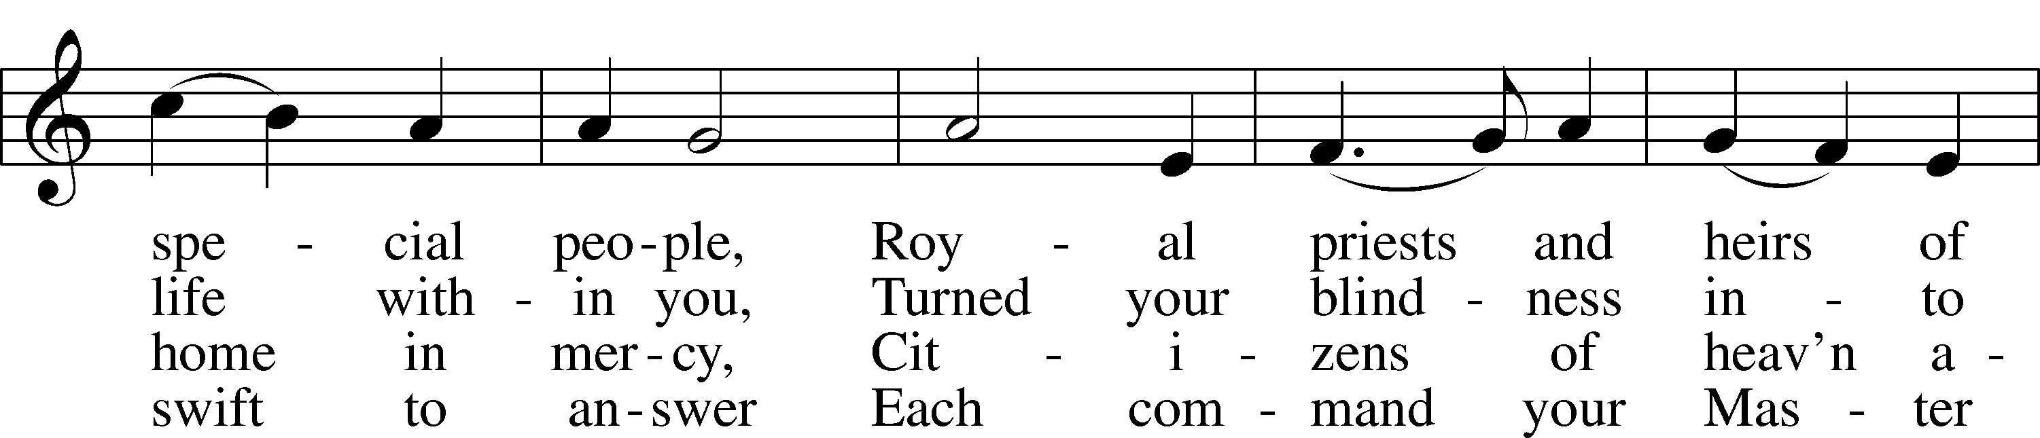
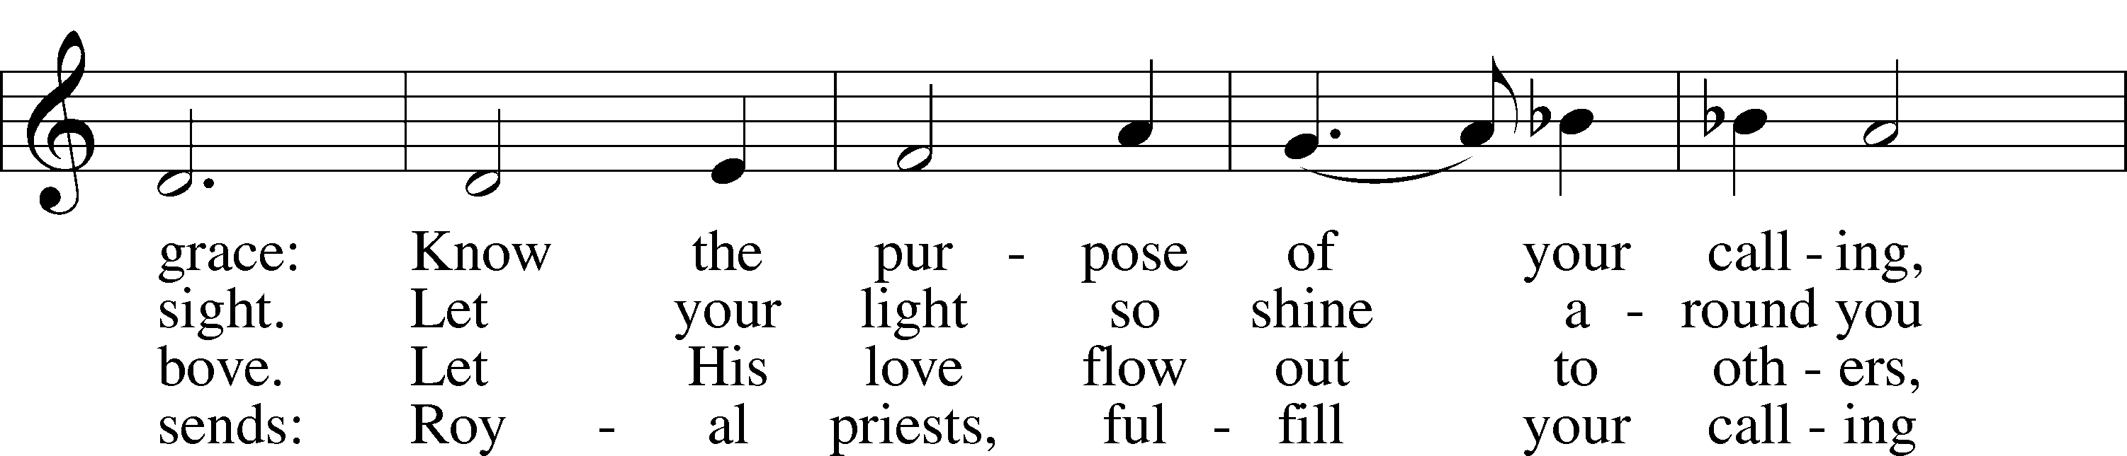
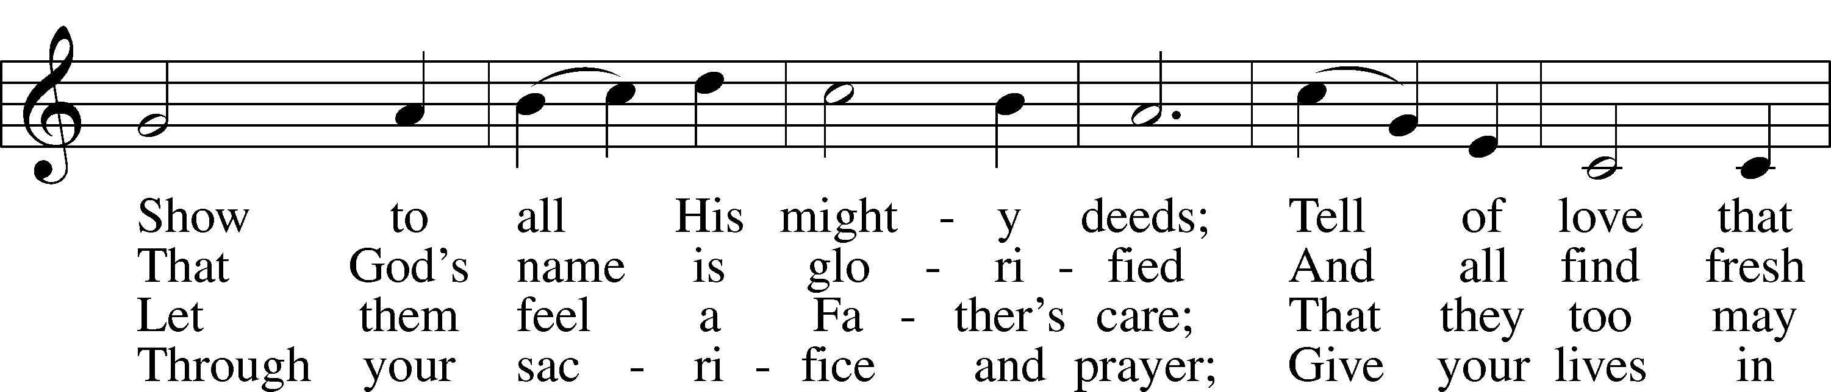
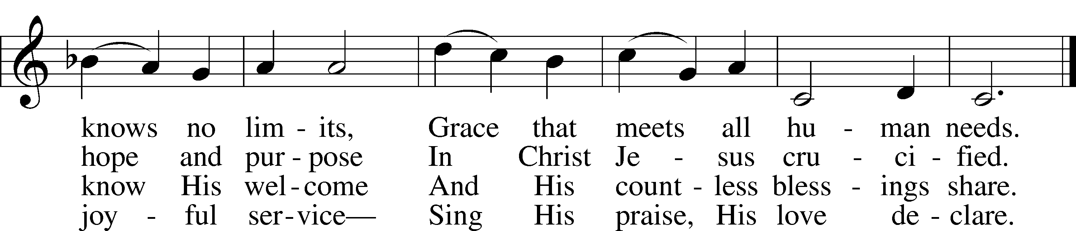
Text: © 1982 The Jubilate Group, admin. Hope Publishing Co. Used by permission: CPH Limited Promotional License no. 119000000
Tune: © 1942, renewed 1970 Hope Publishing Co. Used by permission: CPH Limited Promotional License no. 119000000

Stand

After the distribution is complete, the following is said:

P The body and blood of our Lord Jesus Christ strengthen and preserve you in body and soul to life everlasting. Depart T in peace.
C Amen.

Thank the Lord LSB 164
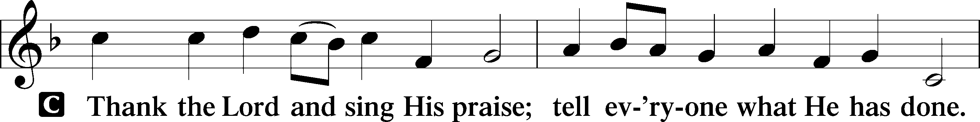
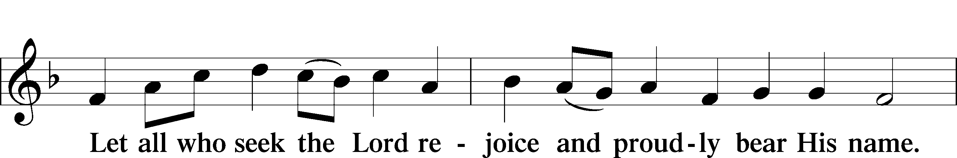
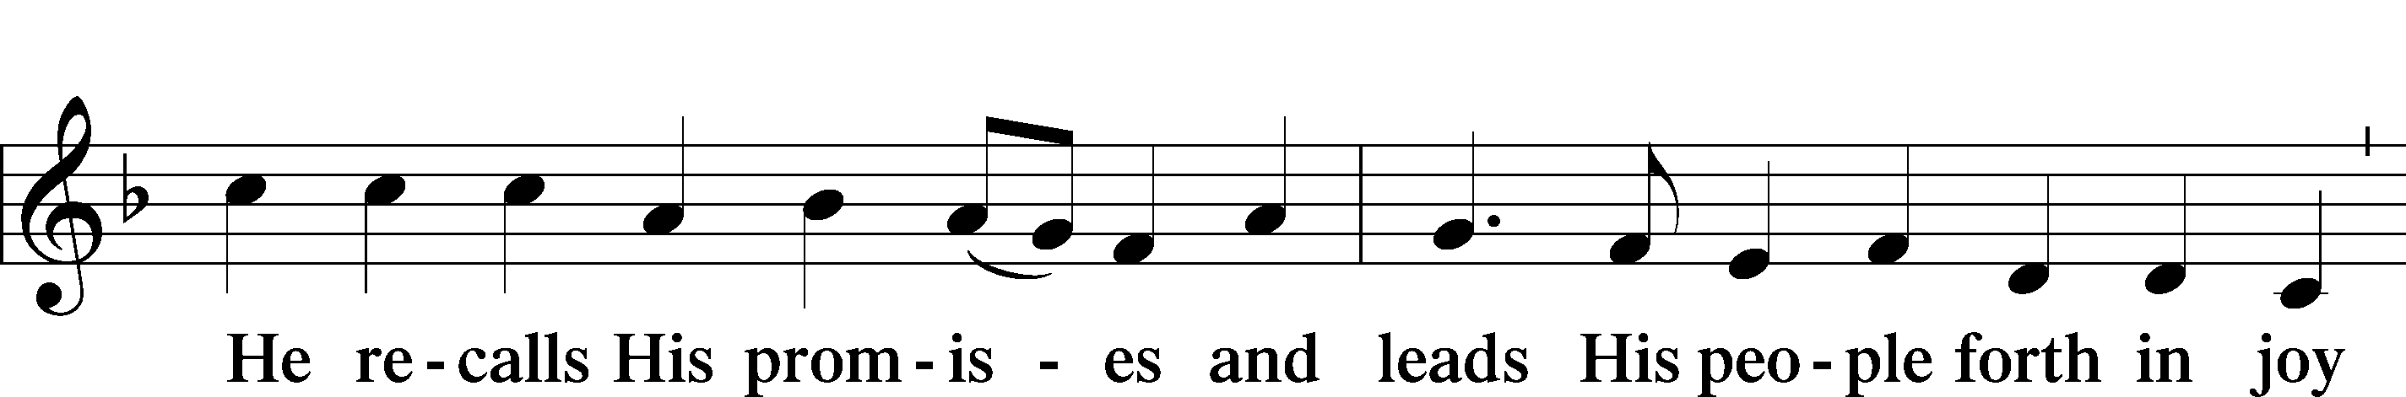
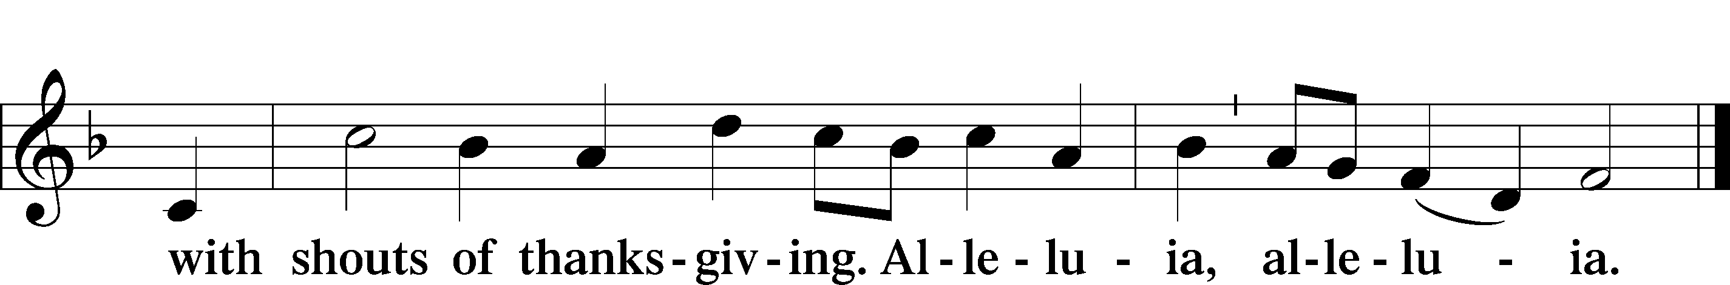

Post-Communion Collect
A Let us pray.
We give thanks to You, almighty God, that You have refreshed us through this salutary gift, and we implore You that of Your mercy You would strengthen us through the same in faith toward You and in fervent love toward one another; through Jesus Christ, Your Son, our Lord, who lives and reigns with You and the Holy Spirit, one God, now and forever.
C Amen.

Benediction LSB 166
P The Lord bless you and keep you.
The Lord make His face shine on you and be gracious to you.
The Lord look upon you with favor and T give you peace.
C Amen.

526 You Are the Way; through You Alone
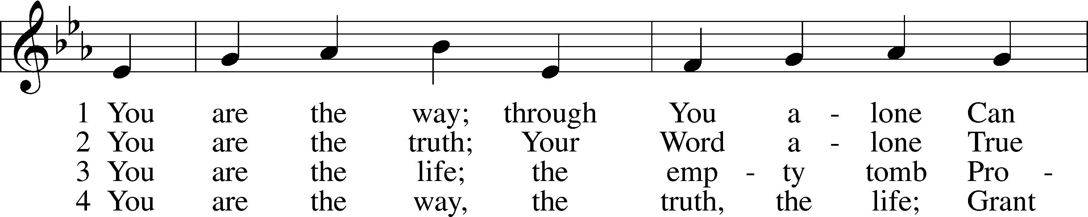
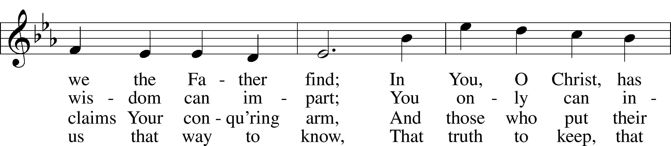
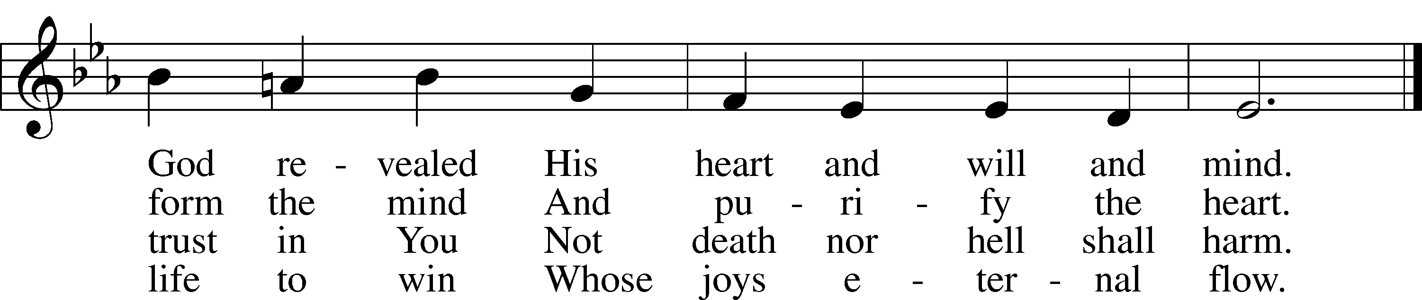
Tune and text: Public domain

After the closing hymn, please wait to be ushered out of the sanctuary and exit immediately through the west doors. Thank you.

Acknowledgments
Divine Service, Setting One from Lutheran Service Book
Unless otherwise indicated, Scripture quotations are from the ESV® Bible (The Holy Bible, English Standard Version®), copyright © 2001 by Crossway, a publishing ministry of Good News Publishers. Used by permission. All rights reserved.
Created by Lutheran Service Builder © 2018 Concordia Publishing House.

The Radio Broadcast today is given to the Glory of the Lord by
Ed and Connie DeLaet

Prayers for Our Members
Chelsea Junge, Christina Long, Tenaya Nuttelman | Expectant Mothers
Norman Abels (Brookestone Meadows – Elkhorn) | Healing
Judy Ahrens | Healing
Vaughn Albrecht (Northridge) | Healing
Tom & DyAnn Altwine | Healing
Lyle Colsden (Mother Hull) | Healing
Brenda Fletcher | Healing
Pat Flodine (Cambridge Court) | Healing
Vi Fox (Prairie View) | Healing
Verleen Gentry | Healing
Tiffany Hartman | Healing
Ruby Hatfield | Healing
Carol Herron | Healing
Carol Kreutzer | Healing
Teresa Leising | Healing
Marion Richmond | Healing
Geraldine Roeder | Healing
Dorothy Sikes | Healing
Bev Nuttelman | Cancer
Kim Vos | Cancer
Ramona Gaunt | Palliative Care
Linda Nuttelman | Recovery
Prayers for Our Members’ Family & Friends
Becci Koopman (Todd & Ellen Koopman daughter-in-law) | Expectant Mother
Shaylee Kreutzer (Rich & Carol Kreutzer’s daughter-in-law) | Expectant Mother
Lana Latsabidze (Bruce & Ann Fattig daughter-in-law) | Expectant Mother
Amy Nuttelman (Keith & Bev Nuttelman’s daughter-in-law) | Expectant Mother
Ava Jean Winnie (Nic Kitzing’s cousin) | Healing
Will Brennemann (Jami Helmbrecht’s father) | Healing
Don Berg (Evelyn Heiden’s brother) | Healing
Reg Duke (Westman’s brother-in-law) | Healing
James Gentry (Verleen Gentry’s son) | Healing
Lee Gilbert | Healing
Mark Glover (Shirley Helmbrecht’s brother) | Healing
Brooke Guthrie (Bailey Hockemeier’s sister) | Healing
Lois Hanson (Pastor Hanson’s wife) | Healing
Norman Hockemeier (Ken’s father) | Healing
Roger Hoffman (Marc’s father) | Healing
Vernon Knight Jr. (Brenda Fletcher’s brother) | Healing
Miles Margritz (Wanda Glanzer’s nephew) | Healing
Randy Solomon (Beth Rosenthal’s father) | Healing
Mary Ann Mertz (Pam’s Uhlir’s friend) | Healing
Roy Reynolds (Verleen Gentry’s son-in-law) | Healing
Janet Stalder (Carol Florang’s sister) | Healing
Patty Ellis (Fran Junge’s sister) | Cancer
Ron Halvorsen (Jeff’s dad) | Cancer
Carol Haubold (Don Helmbrecht’s sister) | Cancer
Tyler Holland (Quentin & Janel Lange brother-in-law) | Cancer
Fred Koch (Pam Uhlir’s cousin) | Cancer
Lynda Kreutzer (Rich & Carol’s sister-in-law) | Cancer
Sharon Mulhair (Pam Uhlir’s cousin) | Cancer
Tyrone Uhlir (Pam’s nephew) | Cancer
Members of Zion Lutheran North Shelton | Loss & Restoration
Pr.James, Pr. Clausing, Our sister congregations in Haiti | Missionaries
John Christensen, John Harbols | Military

Sun  05/10 | 9:00a  11:00a | Divine Service  Divine Service  Mother’s Day
Mon  05/11 | Birthdays  Anniversaries | Sophia Strong  ---
Tues  05/12 | Birthdays  Anniversaries | ---  ---
Wed  05/13 | Birthdays  Anniversaries | Roger Riekenberg  Ed & Connie DeLaet
Thurs  05/14 | Birthdays  Anniversaries | Paige Ahrens  ---
Fri  05/15 | Birthdays  Anniversaries | Anthony Wilbur  ---
Sat  05/16 | 5:00p  Birthdays  Anniversaries | Divine Service  ---  ---
Sun  05/17 | 9:00a  11:00a  Birthdays  Anniversaries | Divine Service  Divine Service  Marian Allwardt  Michelle Millsap  ---

Our Response to the Gospel

Date: 05/03/2020

Attendance: cancelled

Offering: $7,329.00
Weekly Need: $7,542.37

ANNOUNCEMENTS

Offering during this time. There are several options to get your weekly offering into church. Please continue to give weekly offering because we are committed to continue to pay employees, utilities, and the monthly expenses. Ways to continue your offering are: drop the offering in the mail slot by the south doors, mail it to the church, or utilize online giving at zionkearney.com. If you have any questions or need assistance please contact the office at 308-234-3410 or school@zionkearney.org. Thank you for your support of our church!

Radio Broadcast - Please help Zion spread the Gospel! This is a great need during this time, many people are utilizing this resource during this time.

Men’s Bible Study – The Men’s Bible Study will tentatively meet on Thursday, May 21st. Watch for confirmation and details.

Best of Kearney – Congratulations to Zion’s preschool for being voted Best of Kearney by the readers of the Kearney Hub for a seventh year!

Church Reopen - Please go to Zion's church website at www.zionkearney.com and read about our plan to reopen for worship and how to register to attend.

