Divine
Service

The Second Sunday of Pentecost
June 14, 2020
Zion Lutheran Church
Kearney, Nebraska

571 God Loved the World So That He Gave
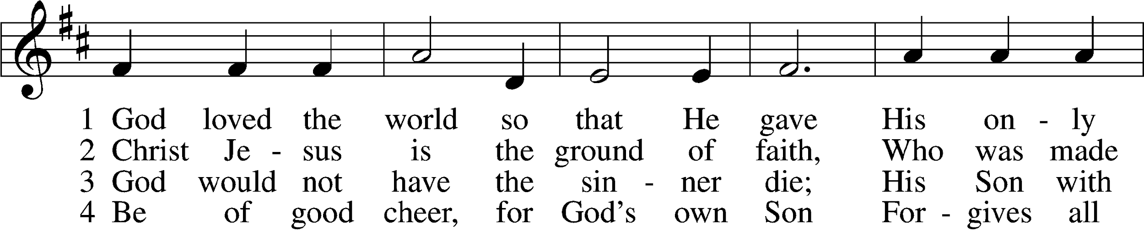
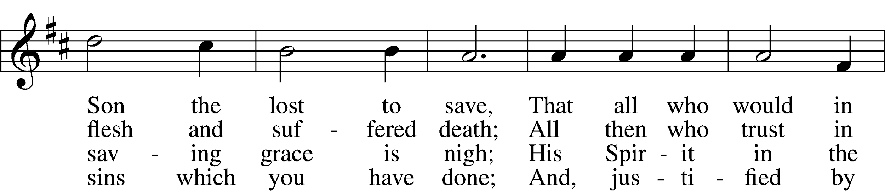
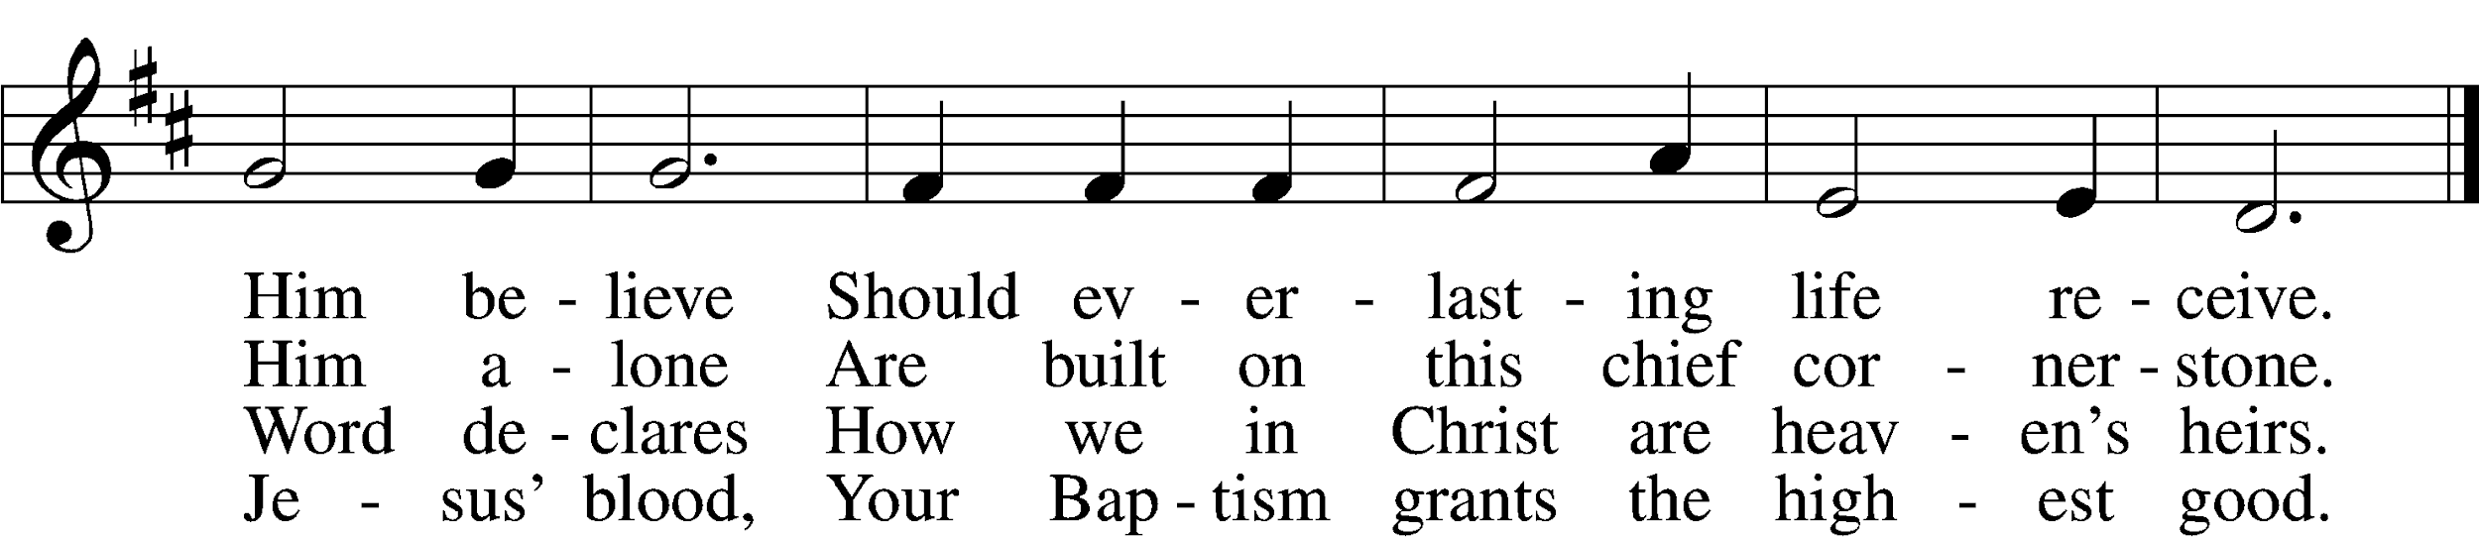

5 If you are sick, if death is near,
This truth your troubled heart can cheer:
Christ Jesus saves your soul from death;
That is the firmest ground of faith.

D 6 Glory to God the Father, Son,
And Holy Spirit, Three in One!
To You, O blessèd Trinity,
Be praise now and eternally!
Text and tune: Public domain

Confession and Absolution
Stand

The sign of the cross may be made by all in remembrance of their Baptism.

P In the name of the Father and of the T Son and of the Holy Spirit.
C Amen.

P. Beloved in the Lord! Let us draw near with a true heart and confess our sins unto God our Father, beseeching Him in the name of our Lord Jesus Christ to grant us forgiveness.

P Our help is in the name of the Lord,
C who made heaven and earth.
P I said, I will confess my transgressions unto the Lord,
C and You forgave the iniquity of my sin.

Silence for reflection on God’s Word and for self-examination.

P O almighty God, merciful Father,
C I, a poor, miserable sinner, confess unto You all my sins and iniquities with which I have ever offended You and justly deserved Your temporal and eternal punishment. But I am heartily sorry for them and sincerely repent of them, and I pray You of Your boundless mercy and for the sake of the holy, innocent, bitter sufferings and death of Your beloved Son, Jesus Christ, to be gracious and merciful to me, a poor, sinful being.

P Upon this your confession, I, by virtue of my office, as a called and ordained servant of the Word, announce the grace of God unto all of you, and in the stead and by the command of my Lord Jesus Christ I forgive you all your sins in the name of the Father and of the T Son and of the Holy Spirit.
C Amen.

Stand

Service of the Word

Introit Psalm 67:4–7; antiphon: v. 3
Let the peoples praise you, | O God;*
let all the peoples | praise you!
Let the nations be glad and | sing for joy,*
for you judge the peoples with equity and guide the nations up- | on earth.
Let the peoples praise you, | O God;*
let all the peoples | praise you!
The earth has yielded its | increase;*
God, our God, shall | bless us.
God shall | bless us;*
let all the ends of the earth | fear him!
Glory be to the Father and | to the Son*
and to the Holy | Spirit;
as it was in the be- | ginning,*
is now, and will be forever. | Amen.
Let the peoples praise you, | O God;*
let all the peoples | praise you!
C Glory be to the Father and to the Son and to the Holy Ghost;
as it was in the beginning, is now, and ever shall be, world without end. Amen.

Kyrie LSB 186
C Lord, have mercy upon us.
Christ, have mercy upon us.
Lord, have mercy upon us.

Gloria in Excelsis LSB 187
P Glory be to God on high:
C and on earth peace, goodwill toward men.
We praise Thee, we bless Thee, we worship Thee,
we glorify Thee, we give thanks to Thee, for Thy great glory.
O Lord God, heav’nly King, God the Father Almighty.
O Lord, the only-begotten Son, Jesus Christ;
O Lord God, Lamb of God, Son of the Father,
that takest away the sin of the world, have mercy upon us.
Thou that takest away the sin of the world, receive our prayer.
Thou that sittest at the right hand of God the Father, have mercy upon us.
For Thou only art holy; Thou only art the Lord.
Thou only, O Christ, with the Holy Ghost,
art most high in the glory of God the Father. Amen.

Salutation and Collect of the Day
P The Lord be with you.
C And with thy spirit.

P Let us pray.
Almighty, eternal God, in the Word of Your apostles and prophets You have proclaimed to us Your saving will. Grant us faith to believe Your promises that we may receive eternal salvation; through Jesus Christ, our Lord, who lives and reigns with You and the Holy Spirit, one God, now and forever.

C Amen.

Sit

Old Testament Reading Exodus 19:2–8
²[The people of Israel] set out from Rephidim and came into the wilderness of Sinai, and they encamped in the wilderness. There Israel encamped before the mountain, ³while Moses went up to God. The Lord called to him out of the mountain, saying, “Thus you shall say to the house of Jacob, and tell the people of Israel: ⁴You yourselves have seen what I did to the Egyptians, and how I bore you on eagles’ wings and brought you to myself. ⁵Now therefore, if you will indeed obey my voice and keep my covenant, you shall be my treasured possession among all peoples, for all the earth is mine; ⁶and you shall be to me a kingdom of priests and a holy nation. These are the words that you shall speak to the people of Israel.”
⁷So Moses came and called the elders of the people and set before them all these words that the Lord had commanded him. ⁸All the people answered together and said, “All that the Lord has spoken we will do.” And Moses reported the words of the people to the Lord.

A This is the Word of the Lord.
C Thanks be to God.

Gradual Psalm 145:3, 5b, 6b
Great is the Lord, and greatly | to be praised,*
and his greatness is un- | searchable.
On your wondrous works, I will | meditate,*
and I will declare your | greatness.

Epistle Romans 5:6–15
⁶For while we were still weak, at the right time Christ died for the ungodly. ⁷For one will scarcely die for a righteous person—though perhaps for a good person one would dare even to die— ⁸but God shows his love for us in that while we were still sinners, Christ died for us. ⁹Since, therefore, we have now been justified by his blood, much more shall we be saved by him from the wrath of God. ¹⁰For if while we were enemies we were reconciled to God by the death of his Son, much more, now that we are reconciled, shall we be saved by his life. ¹¹More than that, we also rejoice in God through our Lord Jesus Christ, through whom we have now received reconciliation.
¹²Therefore, just as sin came into the world through one man, and death through sin, and so death spread to all men because all sinned— ¹³for sin indeed was in the world before the law was given, but sin is not counted where there is no law. ¹⁴Yet death reigned from Adam to Moses, even over those whose sinning was not like the transgression of Adam, who was a type of the one who was to come.
¹⁵But the free gift is not like the trespass. For if many died through one man’s trespass, much more have the grace of God and the free gift by the grace of that one man Jesus Christ abounded for many.

P This is the Word of the Lord.
C Thanks be to God.

Stand

Alleluia LSB 190
C Alleluia. Alleluia. Alleluia.

Holy Gospel Matthew 9:35—10:8
P The Holy Gospel according to St. Matthew, the ninth chapter.
C Glory be to Thee, O Lord.

³⁵Jesus went throughout all the cities and villages, teaching in their synagogues and proclaiming the gospel of the kingdom and healing every disease and every affliction. ³⁶When he saw the crowds, he had compassion for them, because they were harassed and helpless, like sheep without a shepherd. ³⁷Then he said to his disciples, “The harvest is plentiful, but the laborers are few; ³⁸therefore pray earnestly to the Lord of the harvest to send out laborers into his harvest.”
¹And he called to him his twelve disciples and gave them authority over unclean spirits, to cast them out, and to heal every disease and every affliction. ²The names of the twelve apostles are these: first, Simon, who is called Peter, and Andrew his brother; James the son of Zebedee, and John his brother; ³Philip and Bartholomew; Thomas and Matthew the tax collector; James the son of Alphaeus, and Thaddaeus; ⁴Simon the Cananaean, and Judas Iscariot, who betrayed him.
⁵These twelve Jesus sent out, instructing them, “Go nowhere among the Gentiles and enter no town of the Samaritans, ⁶but go rather to the lost sheep of the house of Israel. ⁷And proclaim as you go, saying, ‘The kingdom of heaven is at hand.’ ⁸Heal the sick, raise the dead, cleanse lepers, cast out demons. You received without paying; give without pay.”

P This is the Gospel of the Lord.
C Praise be to Thee, O Christ.

Apostles’ Creed
C I believe in God, the Father Almighty,
maker of heaven and earth.

And in Jesus Christ, His only Son, our Lord,
who was conceived by the Holy Spirit,
born of the virgin Mary,
suffered under Pontius Pilate,
was crucified, died and was buried.
He descended into hell.
The third day He rose again from the dead.
He ascended into heaven
and sits at the right hand of God the Father Almighty.
From thence He will come to judge the living and the dead.

I believe in the Holy Spirit,
the holy Christian Church,
the communion of saints,
the forgiveness of sins,
the resurrection of the body,
and the life T everlasting. Amen.

Sit

834 O God, O Lord of Heaven and Earth
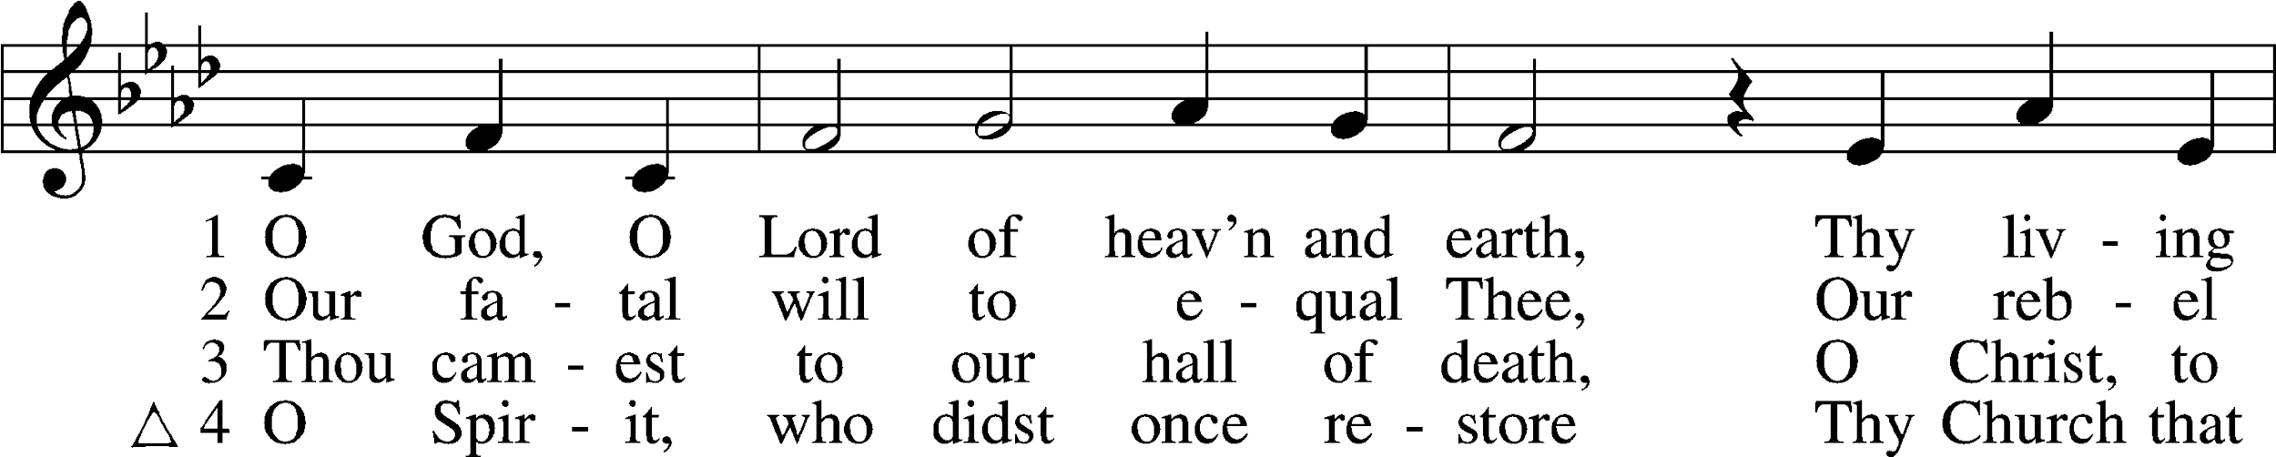
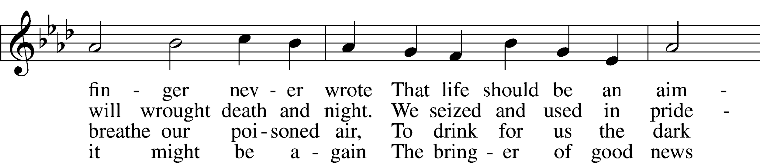
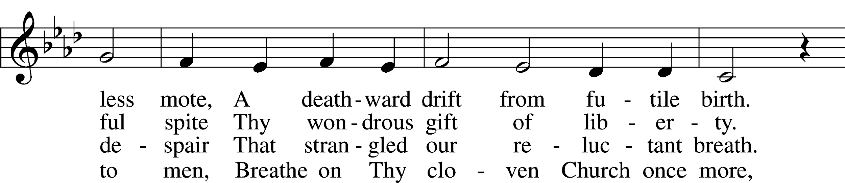
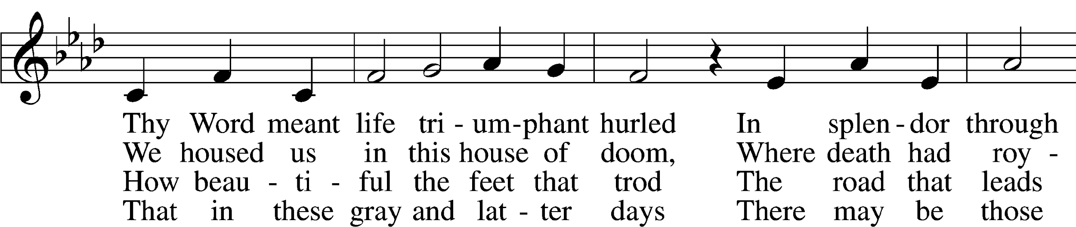
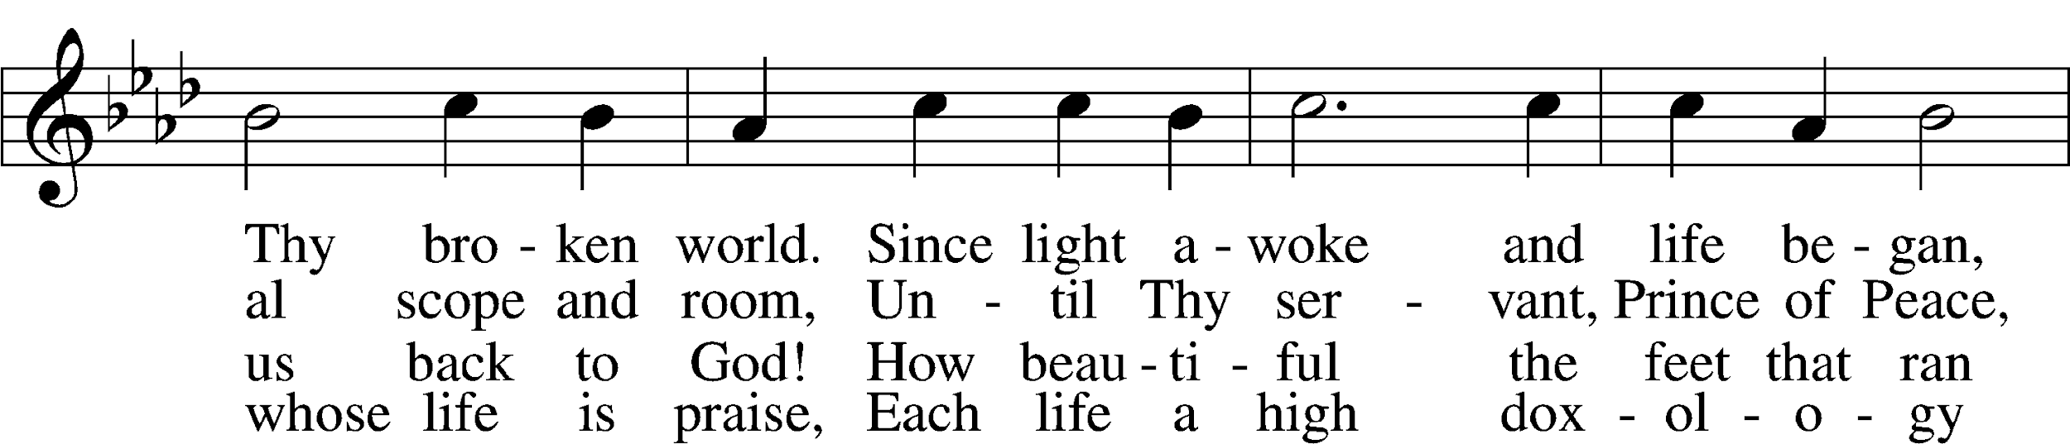
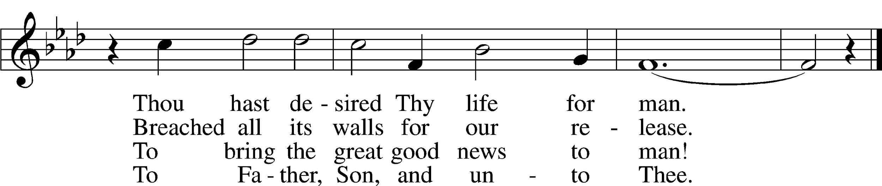
Tune and text: © 1967 Augsburg Fortress. Used by permission: CPH Limited Promotional License no. 119000000

Sermon

Stand

Offertory LSB 192
C Create in me a clean heart, O God, and renew a right spirit within me.
Cast me not away from Thy presence, and take not Thy Holy Spirit from me.
Restore unto me the joy of Thy salvation, and uphold me with Thy free spirit. Amen.

Sit

Offering

Stand

Prayer of the Church

Service of the Sacrament

Preface LSB 194
P The Lord be with you.
C And with thy spirit.

P Lift up your hearts.
C We lift them up unto the Lord.

P Let us give thanks unto the Lord, our God.
C It is meet and right so to do.

P It is truly meet, right, and salutary that we should at all times and in all places give thanks to You, holy Lord, almighty Father, everlasting God, through Jesus Christ, our Lord, who on this day overcame death and the grave and by His glorious resurrection opened to us the way of everlasting life. Therefore with angels and archangels and with all the company of heaven we laud and magnify Your glorious name, evermore praising You and saying:

Sanctus LSB 195
C Holy, holy, holy Lord God of Sabaoth;
heav’n and earth are full of Thy glory.
Hosanna, hosanna, hosanna in the highest.
Blessed is He, blessed is He, blessed is He that cometh in the name of the Lord.
Hosanna, hosanna, hosanna in the highest.

Lord’s Prayer LSB 196
C Our Father who art in heaven,
hallowed be Thy name,
Thy kingdom come,
Thy will be done on earth as it is in heaven;
give us this day our daily bread;
and forgive us our trespasses as we forgive those who trespass against us;
and lead us not into temptation,
but deliver us from evil.
For Thine is the kingdom and the power and the glory forever and ever. Amen.

The Words of Our Lord LSB 197
P Our Lord Jesus Christ, on the night when He was betrayed, took bread, and when He had given thanks, He broke it and gave it to the disciples and said: “Take, eat; this is My T body, which is given for you. This do in remembrance of Me.”

In the same way also He took the cup after supper, and when He had given thanks, He gave it to them, saying: “Drink of it, all of you; this cup is the new testament in My T blood, which is shed for you for the forgiveness of sins. This do, as often as you drink it, in remembrance of Me.”

Pax Domini LSB 197
P The peace of the Lord be with you always.
C Amen.

Agnus Dei LSB 198
C O Christ, Thou Lamb of God, that takest away the sin of the world, have mercy upon us.
O Christ, Thou Lamb of God, that takest away the sin of the world, have mercy upon us.
O Christ, Thou Lamb of God, that takest away the sin of the world, grant us Thy peace. Amen.

Sit

Distribution

641 You Satisfy the Hungry Heart
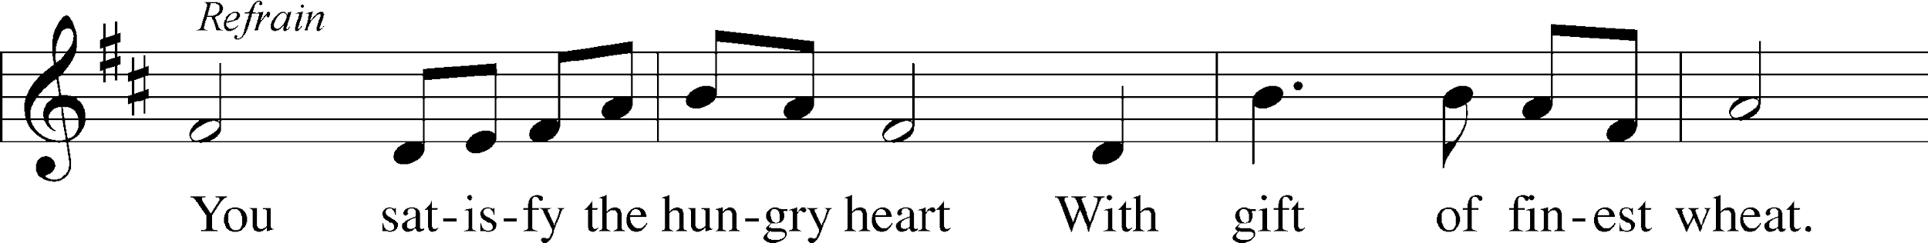
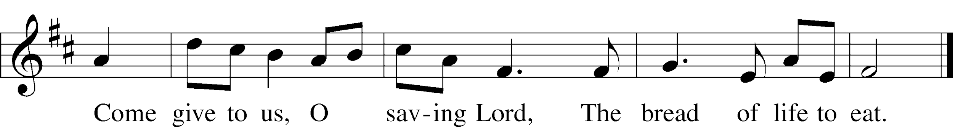
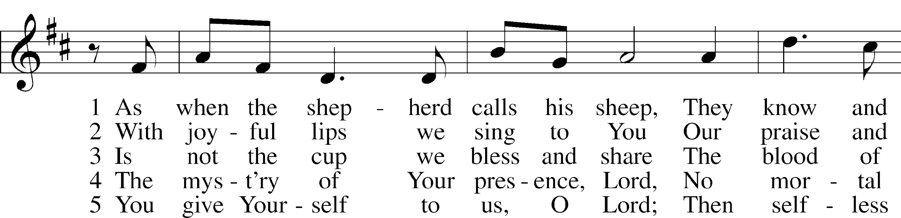
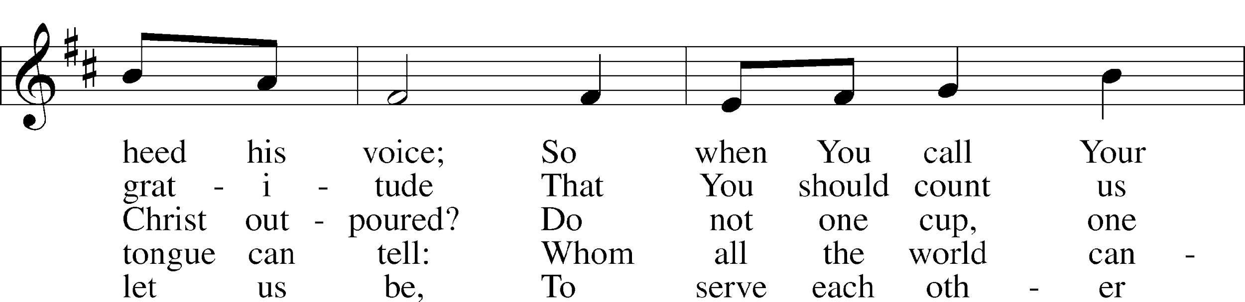
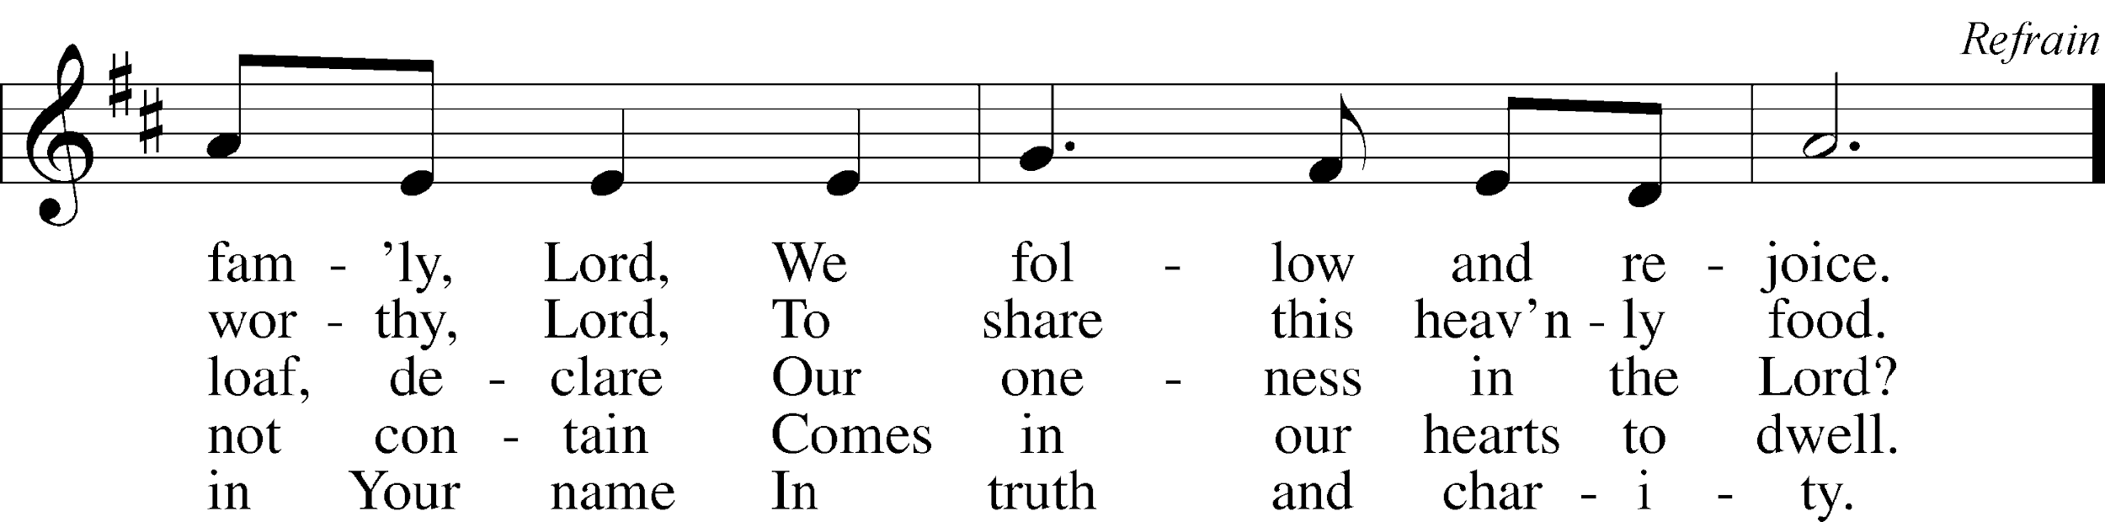
Text and tune: © 1977 Archdiocese of Philadelphia, admin. International Liturgy Publications. Used by permission: CPH Limited Promotional License no. 119000000

856 O Christ, Who Called the Twelve
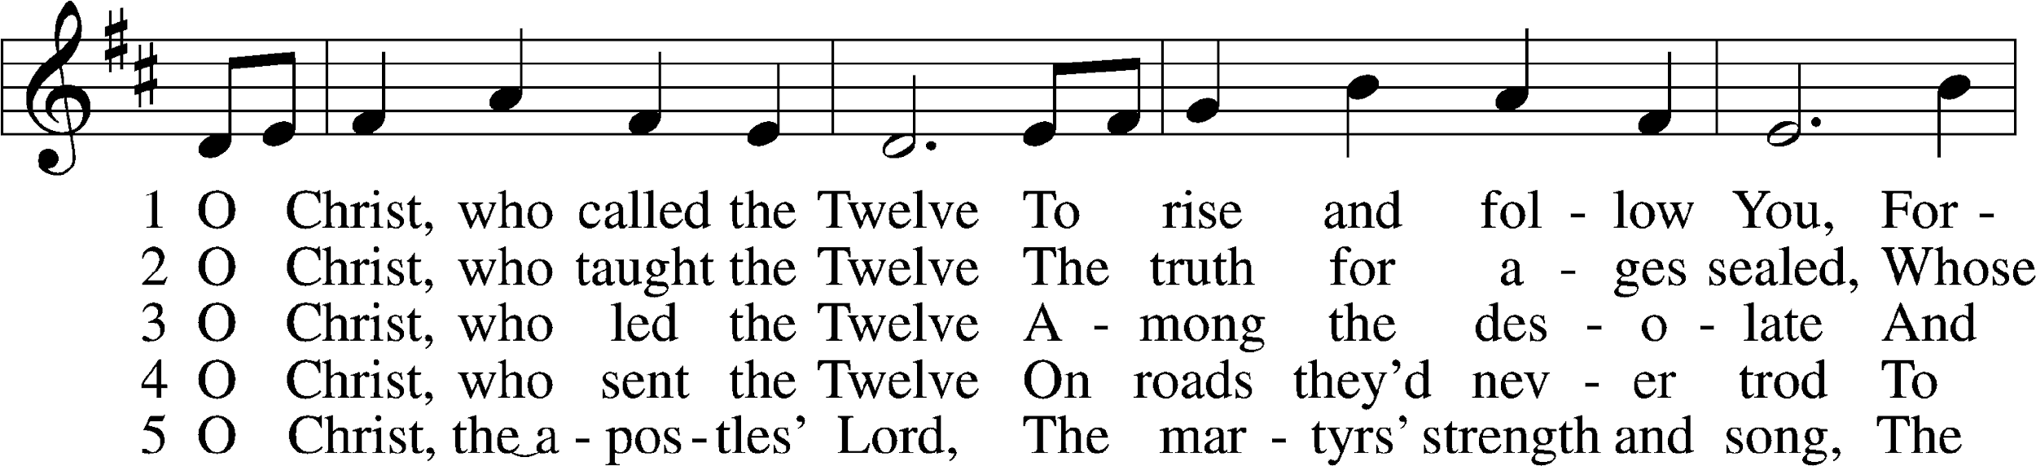
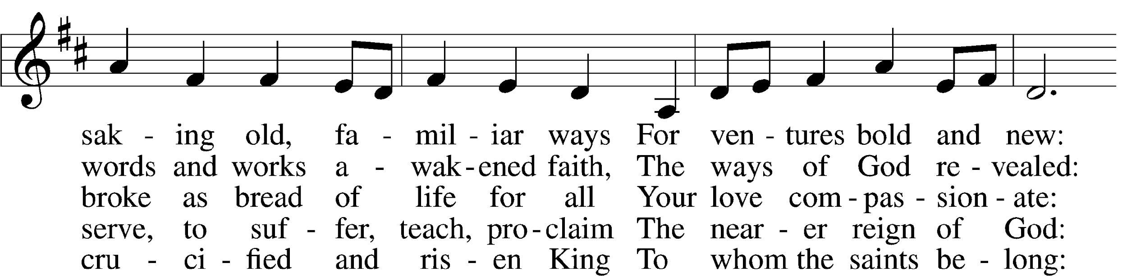
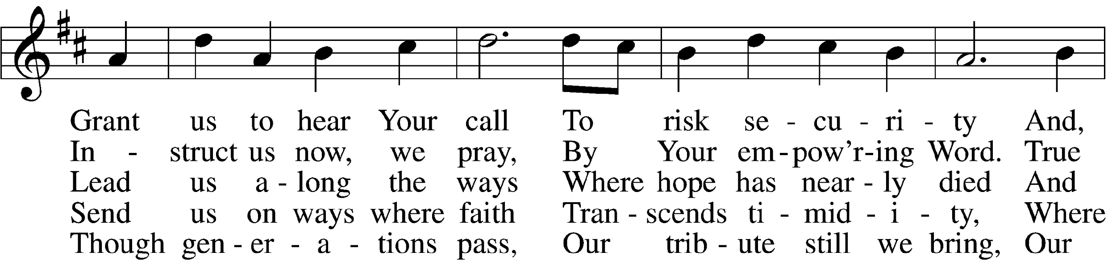
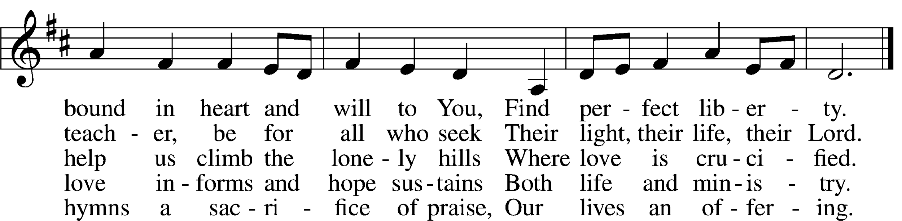
Tune: Public domain
Text: © 1993 GIA Publications, Inc. Used by permission: CPH Limited Promotional License no. 119000000

In dismissing the communicants, the following is said:

P The body and blood of our Lord Jesus Christ strengthen and preserve you in body and soul to life everlasting. Depart in peace.
C Amen.

Stand

Nunc Dimittis LSB 199
C Lord, now lettest Thou Thy servant depart in peace according to Thy word,
for mine eyes have seen Thy salvation, which Thou hast prepared before the face of all people,
a light to lighten the Gentiles and the glory of Thy people Israel.
Glory be to the Father and to the Son and to the Holy Ghost;
as it was in the beginning, is now, and ever shall be, world without end. Amen.

Thanksgiving LSB 200
A O give thanks unto the Lord, for He is good,
C and His mercy endureth forever.

A Let us pray.
We give thanks to You, almighty God, that You have refreshed us through this salutary gift, and we implore You that of Your mercy You would strengthen us through the same in faith toward You and in fervent love toward one another; through Jesus Christ, Your Son, our Lord, who lives and reigns with You and the Holy Spirit, one God, now and forever.
C Amen.

P The Lord be with you.
C And with thy spirit.

Benedicamus LSB 202
A Bless we the Lord.
C Thanks be to God.

Benediction LSB 202
P The Lord bless you and keep you.
The Lord make His face shine upon you and be gracious unto you.
The Lord lift up His countenance upon you and T give you peace.
C Amen, amen, amen.

827 Hark, the Voice of Jesus Calling
1 Hark, the voice of Jesus calling,
“Who will go and work today?
Fields are white and harvests waiting—
Who will bear the sheaves away?”
Loud and long the Master calleth;
Rich reward He offers thee.
Who will answer, gladly saying,
“Here am I, send me, send me”?

2 Some take up His task in morning,
To their Lord responding soon;
Some are called in heat of midday,
Others late in afternoon;
Even as the sun is setting,
Some are sent into the fields,
There to gather in the bounty
That God’s Word so richly yields.

3 For as rain and snow from heaven
Water seeds in dusty soil,
Causing them to bud and flower,
Giving bread to those who toil;
So the Lord sends forth His promise,
Words of life and joy and peace—
Never void to Him returning,
Bearing fruit with great increase.

4 Hearken to the Lord whose coming
Marks the time when grace shall end,
When with His angelic reapers
He in glory shall descend.
Soon the night, the final harvest;
Soon the time for work shall cease.
Then the souls His grace has garnered
Shall enjoy His Sabbath peace.
Text (st. 1): Public domain
Text (sts. 2–4): © 2001 Stephen P. Starke, admin. Concordia Publishing House. Used by permission: CPH Limited Promotional License no. 119000000

Acknowledgments
Divine Service, Setting Three from Lutheran Service Book
Unless otherwise indicated, Scripture quotations are from the ESV® Bible (The Holy Bible, English Standard Version®), copyright © 2001 by Crossway, a publishing ministry of Good News Publishers. Used by permission. All rights reserved.
Created by Lutheran Service Builder © 2018 Concordia Publishing House.

Today’s Radio Broadcast is given to the Glory of the Lord by
Marian Allwardt in celebration and memory of their
wedding anniversary.

Prayers for Our Members
Chelsea Junge, Christina Long, Tenaya Nuttelman | Expectant Mothers
Norman Abels (Brookestone Meadows – Elkhorn) | Healing
Judy Ahrens | Healing
Vaughn Albrecht (Northridge) | Healing
Tom & DyAnn Altwine | Healing
Lyle Colsden (Mother Hull) | Healing
Brenda Fletcher | Healing
Pat Flodine (Cambridge Court) | Healing
Vi Fox (Prairie View) | Healing
Verleen Gentry | Healing
Tiffany Hartman | Healing
Ruby Hatfield | Healing
Carol Kreutzer | Healing
Teresa Leising | Healing
Marion Richmond | Healing
Geraldine Roeder | Healing
Dorothy Sikes | Healing
Bev Nuttelman | Cancer
Kim Vos | Cancer
Ramona Gaunt | Palliative Care

Prayers for Our Members’ Family & Friends
Shaylee Kreutzer (Rich & Carol Kreutzer’s daughter-in-law) | Expectant Mother
Lana Latsabidze (Bruce & Ann Fattig daughter-in-law) | Expectant Mother
Amy Nuttelman (Keith & Bev Nuttelman’s daughter-in-law) | Expectant Mother
Brandon & Shannon Howell (Quentin & Janel’s Lange’s friends) | Family
Ava Jean Winnie (Nic Kitzing’s cousin) | Healing
Will Brennemann (Jami Helmbrecht’s father) | Healing
Don Berg (Evelyn Heiden’s brother) | Healing
Reg Duke (Westman’s brother-in-law) | Healing
James Gentry (Verleen Gentry’s son) | Healing
Mark Glover (Shirley Helmbrecht’s brother) | Healing
Dixie Green (Judy Tadlock’s sister) | Healing
Lois Hanson (Pastor Hanson’s wife) | Healing
Norman Hockemeier (Ken’s father) | Healing
Roger Hoffman (Marc’s father) | Healing
Vernon Knight Jr. (Brenda Fletcher’s brother) | Healing
Miles Margritz (Wanda Glanzer’s nephew) | Healing
Randy Solomon (Beth Rosenthal’s father) | Healing
Mary Ann Mertz (Pam’s Uhlir’s friend) | Healing
Roy Reynolds (Verleen Gentry’s son-in-law) | Healing
Janet Stalder (Carol Florang’s sister) | Healing
Patty Ellis (Fran Junge’s sister) | Cancer
Ron Halvorsen (Jeff’s dad) | Cancer
Carol Haubold (Don Helmbrecht’s sister) | Cancer
Tyler Holland (Quentin & Janel Lange brother-in-law) | Cancer
Fred Koch (Pam Uhlir’s cousin) | Cancer
Lynda Kreutzer (Rich & Carol’s sister-in-law) | Cancer
Sharon Mulhair (Pam Uhlir’s cousin) | Cancer
Tyrone Uhlir (Pam’s nephew) | Cancer
Zona Fritz (Judy Tadlock’s sister) | Recovery

Serving in Worship
Sunday, June 14 ~ 9:00am  Acolyte: Isaiah Gaunt  Elder: Dan Oertwig  Usher: Mark Hoffman & Steve Junge  Engineer: Rich Kreutzer  Announcer: Carol Kreutzer  Altar Guild: Linda Johnson | Sunday, June 21 ~ 9:00am  Acolyte: Makenna Starkey  Elder: Ken Hockemeier  Usher: Roger Riekenberg & Robert Glanzer  Engineer: Jared Nuttelman  Announcer: Brooke Fisher  Altar Guild: Linda Johnson

Sun  06/14 | 9:00a | Divine Service
Mon  06/15 | Birthdays  Anniversaries | ---  ---
Tues  06/16 | Birthdays  Anniversaries | Lynden Hollander  Debra Mitchel  ---
Wed  06/17 | Birthdays  Anniversaries | Justin Koopman  ---
Thurs  06/18 | Birthdays  Anniversaries | --  ---
Fri  06/19 | Birthdays  Anniversaries | ---  Donald & Marion Richmond
Sat  06/20 | 5:00p  Birthdays  Anniversaries | Divine Service  Jessica McKillip  ---
Sun  06/21 | 9:00a  10:a  Birthdays  Anniversaries | Father’s Day  Divine Service  Voter’s Meeting  ---

ANNOUNCEMENTS

Offering during this time. If you are not yet comfortable attending live Church Services, you may: drop your offering in the mail slot by the south doors, mail it to the church, or use online giving option at zionkearney.com. If you have any questions or need assistance please contact the office at 308-234-3410 or school@zionkearney.org. Thank you for your support of our church!

Radio Broadcast & Altar Flowers - Please help Zion spread the Gospel! This is a great need during this time, many people are utilizing this resource during this time. There are also many openings for altar flowers. Please help beautify the sanctuary.

Church Reopen - Please go to Zion's church website at www.zionkearney.com and read about our plan to reopen for worship and how to register to attend.

Come Help Us Celebrate Zachariah DeLoach’s high school graduation at a “stop by” event on Friday, June 19, from 7:00-9:00 PM at the DeLoach’s. Simply pull over at the end of our driveway and Zach will greet you in your vehicle. We will be handing out bottled beverages. Thank you for supporting Zach these past twelve years! Pastor and Carol DeLoach, 3510 14th Ave, Kearney.

The words “Thank You” seem inadequate in appreciation for helping make my 102nd birthday a happy one. God bless you all. Vi Fox

Higher Things Conference – Postponed until August 6-7.

Proposed By-law Changes – please see the June sower for the proposed by-law changes that will be voted on in the June voter’s meeting on June 21st.

Missions – Missions for this quarter will be for Rev. Roger James. If you would like to donate to this mission please use the mission envelopes located in the narthex. Thank you for your support.

Puzzles for nursing homes – There is a collection box in the narthex for puzzle donations for nursing homes. This will give the residence in the facilities something to occupy their time while they are in isolation during the COVID-19 restrictions. Thank you for your support and helping the residents with activities.

The Lord’s Prayer Booklet – There is a Lord’s Prayer Booklet, to assist with your devotions, on the counter in the narthex. Feel free to take one. These are compliments of Pastor & Carol Gaunt.

Help needed – The school will be getting new carpet this summer and the trustees could use help in removing the old carpet. We will announce the date as we get closer. Please consider joining us to help update the school. We appreciate your help and support of our wonderful school!

Sanctuary Update Survey – Please complete the yellow sanctuary insert and return to the church office in the box in the narthex. They need to be returned by June 30th.

2421 Avenue C
Kearney, NE 68847
308-234-3410
school@zionkearney.or
g

ZION LUTHERAN CHURCH AND SCHOOL

Pr. James DeLoach, Pastor + (308) 627-5260
james.deloach@zionkearney.org
Pr. Doug Gaunt, Pastor + (308) 455-0552
doug.gaunt@zionkearney.org
Tony Splittgerber, Principal + (308) 293-0168
anthony.splittgerber@zionkearney.org

Church Office
Administrative Assistant: Jessica Shiers
Email: school@zionkearney.org
Phone: (308)-234-3410 Fax: (308) 236-8100
Office Hours: Monday-Friday 9:00am-1:00pm
Radio Broadcast: Sunday @ 10:30 a.m. on 1460 AM
Website: www.zionkearney.com

