Passion Sunday
With the Procession of Palms
27 March + 5 pm and 28 March + 9 am

Zion Lutheran Church & School

Kearney, NE + (308) 234-3410

Rev. James DeLoach, Pastor + (308) 627-5260

Rev. Doug Gaunt, Pastor + (308) 455-0552
Tony Splittgerber, Principal + (308) 293-0168
Welcome to Zion!
Guests please record your attendance on a pink pad in the pew rack and let us know how we can be of service to you.

Holy Communion at Zion

The Lord’s Supper is celebrated at this congregation as Jesus has given it. As he says, our Lord gives into our mouths not only bread and wine but his very body and blood to eat and to drink for the forgiveness of sins and to strengthen our union with him and with one another. Our Lord invites to his table those who trust his words, repent of all sin, and set aside any refusal to forgive and love as he forgives and loves us, that they may show forth his death until he comes. All communicants need to register in the narthex prior to the service.

Because those who eat and drink our Lord’s body and blood unworthily do so to their great harm and because Holy Communion is a confession of the faith which is confessed at this altar, any who are not yet instructed, in doubt, or who hold a confession differing from that of this congregation and The Lutheran Church—Missouri Synod, are asked not to commune until they are able to speak with our pastor first. He is happy to visit with you about the Christian faith and how to receive the Lord’s Supper for your good and for the good of others. Those not communing are invited to come to the altar, cross your arms in front of you, and bow your head to receive a pastoral blessing.

Service Note: Why do we use the Processional Cross?
Palm Sunday is a Festival Sunday. So, like many Lutheran congregations, we begin and end this service with a procession. To begin we turn to face the back of the church and follow the cross as the crucifer carries it to the chancel. At the end of the service as the cross is carried down the middle aisle, we turn to face it when it passes by until the crucifer exits the sanctuary. Then the congregation turns to face the front of the church once again.
When the cross passes by you are welcome to bow your head slightly (as we also do when we enter the altar area). We do not worship the cross itself, but the One Who died on the cross for us. We bow in humble adoration of Lord Jesus Christ, who gave His own life to save all mankind. We also bow to show reverence to Jesus because we believe that He has risen victorious over death and is truly present among us today. The High King of Heaven graciously visits us in His Holy Word and Sacraments to give us heavenly fruit from the tree of His cross—forgiveness of sins, eternal life, and rescue from death and the devil.

PROCESSION OF PALMS

The service of Passion Sunday, beginning with the procession with palms, reflects the contrasting attitudes toward Jesus that were on display during the days leading up to His crucifixion. “Palm Sunday” is named after the palms which were spread before Jesus as He entered Jerusalem. The acclamation of the people, “Hosanna to the Son of David, blessed is he who comes in the name of the Lord,” clearly reveal that they hailed Jesus as the messianic king. Yet only days later, our Lord would hear the cry “Crucify!” This contrast is reflected on this day as the joy of His triumphal entry into Jerusalem gives way to the somber remembrance of His passion. The extended reading from the Passion narrative sets before the people of God all that our Lord did on our behalf. We are thus prepared to enter Holy Week—the most important week of the church year.

The congregation stands and faces the processional cross at the entrance to the nave.

GREETING
P The grace of our Lord Jesus Christ, the love of God and the communion of the Holy Spirit be with you all.
C Amen.

P Blessed is He who comes in the name of the Lord.
C Hosanna to the Son of David.

COLLECT FOR PALM SUNDAY
P Let us pray.

Most merciful God, as the people of Jerusalem, with palms in their hands, gathered to greet Your dearly beloved Son when He came into His Holy City, grant that we may ever hail Him as our King, and when He comes again, may go forth to meet Him with trusting and steadfast hearts, and follow Him in the way that leads to eternal life; through the same Jesus Christ, our Lord, who lives and reigns with You and the Holy Spirit, one God, now and forever.
C Amen.

HOLY GOSPEL FOR PALM SUNDAY

P The Holy Gospel according to St. John, the Twelfth chapter.
C Glory to You, O Lord.

The next day the large crowd that had come to the feast heard that Jesus was coming to Jerusalem. So they took branches of palm trees and went out to meet him, crying out, "Hosanna! Blessed is he who comes in the name of the Lord, even the King of Israel!" And Jesus found a young donkey and sat on it, just as it is written, “Fear not, daughter of Zion; behold, your king is coming, sitting on a donkey's colt!” His disciples did not understand these things at first, but when Jesus was glorified, then they remembered that these things had been written about him and had been done to him. The crowd that had been with him when he called Lazarus out of the tomb and raised him from the dead continued to bear witness. The reason why the crowd went to meet him was that they heard he had done this sign. So the Pharisees said to one another, "You see that you are gaining nothing. Look, the world has gone after him."
(John 12:12–19)
P This is the Gospel of the Lord.
C Praise to You, O Christ.

P Let us go forth in peace
C In the name of the Lord.

PROCESSIONAL HYMN: “All Glory, Laud, and Honor” # 442

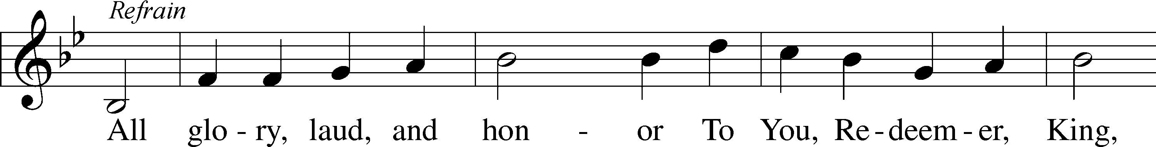
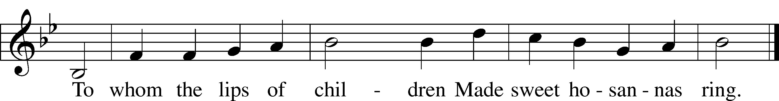

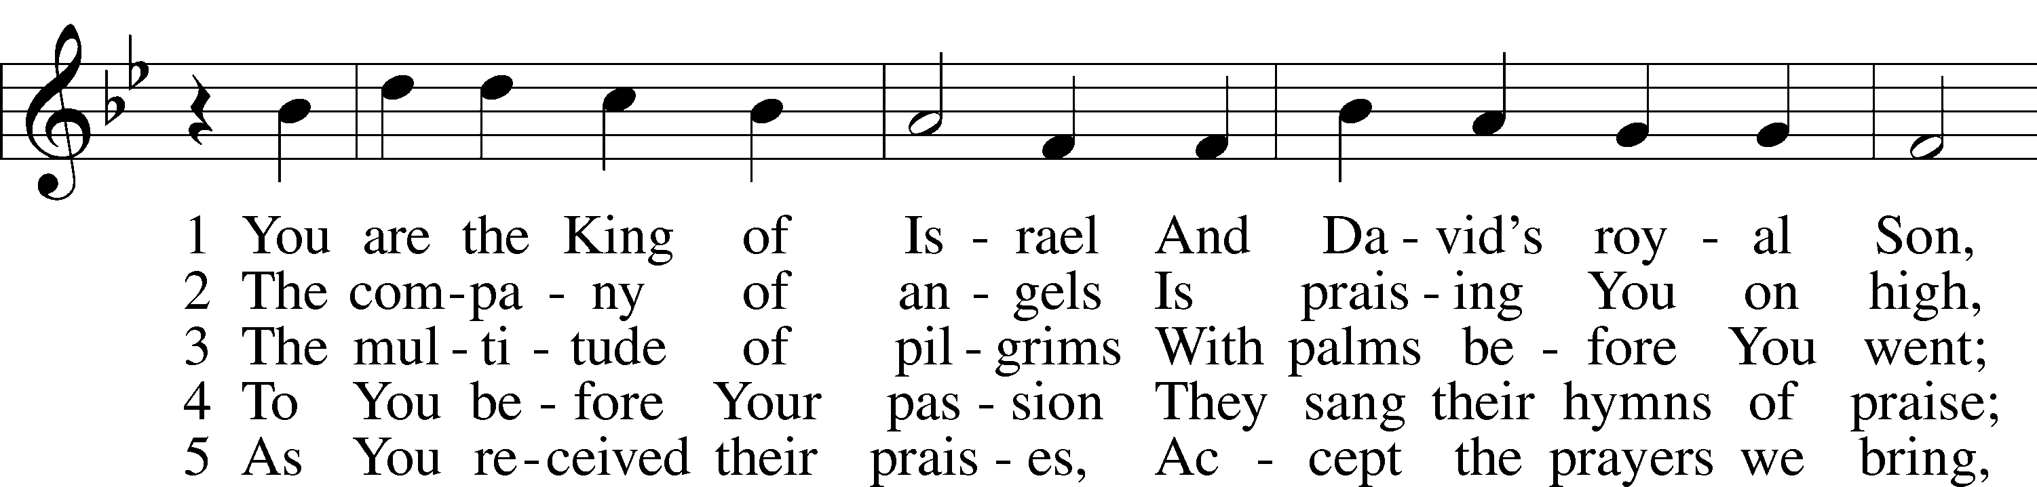
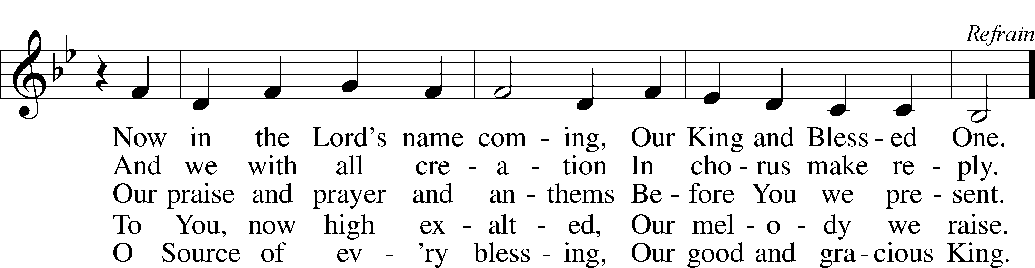

Tune and text: Public domain

Service of the Word

P Blessed is He who comes in the name of the Lord.
C Hosanna in the highest!

Please be seated for a time of silence, which highlights the contrast between Jesus’ triumphal entry and His Passion.

Introit Psalm 24:7–10; antiphon: Psalm 118:26
Blessèd is he who comes in the name | of the Lord!*
We bless you from the house | of the Lord.
Lift up your heads, O gates! And be lifted up, O | ancient doors,*
that the King of glory | may come in.
Who is this King of | glory?*
The Lord, strong and mighty, the Lord, mighty in | battle!
Lift up your heads, O gates! And lift them up, O | ancient doors,*
that the King of glory | may come in.
Who is this King of | glory?*
The Lord of hosts, he is the King of | glory!
Blessèd is he who comes in the name | of the Lord!*
We bless you from the house | of the Lord.

C Glory be to the Father and to the Son and to the Holy Ghost;
as it was in the beginning, is now, and ever shall be, world without end. Amen.

Kyrie LSB 186
C Lord, have mercy upon us.
Christ, have mercy upon us.
Lord, have mercy upon us.

Salutation and Collect of the Day
P The Lord be with you.
C And with thy spirit.

P Let us pray.
Almighty and everlasting God, You sent Your Son, our Savior Jesus Christ, to take upon Himself our flesh and to suffer death upon the cross. Mercifully grant that we may follow the example of His great humility and patience and be made partakers of His resurrection; through the same Jesus Christ, our Lord, who lives and reigns with You and the Holy Spirit, one God, now and forever.

C Amen.
OLD TESTAMENT – Zachariah 9:9-12
⁹Rejoice greatly, O daughter of Zion!
Shout aloud, O daughter of Jerusalem!
behold, your king is coming to you;
righteous and having salvation is he,
humble and mounted on a donkey,
on a colt, the foal of a donkey.
¹⁰I will cut off the chariot from Ephraim
and the war horse from Jerusalem;
and the battle bow shall be cut off,
and he shall speak peace to the nations;
his rule shall be from sea to sea,
and from the River to the ends of the earth.
¹¹As for you also, because of the blood of my covenant with you,
I will set your prisoners free from the waterless pit.
¹²Return to your stronghold, O prisoners of hope;
today I declare that I will restore to you double.

A This is the Word of the Lord.
C Thanks be to God.

Gradual Hebrews 9:12a, c, 15a; Psalm 111:9a
[Christ] entered once for all into the holy places, by means of | his own blood,*
thus securing an eternal re- | demption.
Therefore he is the mediator of a new | covenant,*
so that those who are called may receive the promised eternal in- | heritance.
He sent redemption to his | people;*
he has commanded his covenant for- | ever.
Epistle Philippians 2:5–11
⁵Have this mind among yourselves, which is yours in Christ Jesus, ⁶who, though he was in the form of God, did not count equality with God a thing to be grasped, ⁷but made himself nothing, taking the form of a servant, being born in the likeness of men. ⁸And being found in human form, he humbled himself by becoming obedient to the point of death, even death on a cross. ⁹Therefore God has highly exalted him and bestowed on him the name that is above every name, ¹⁰so that at the name of Jesus every knee should bow, in heaven and on earth and under the earth, ¹¹and every tongue confess that Jesus Christ is Lord, to the glory of God the Father.

A This is the Word of the Lord.
C Thanks be to God.

The Passion of Our Lord According to St. Mark
Mark 15:1-5 | Jesus Delivered to Pilate
¹And as soon as it was morning, the chief priests held a consultation with the elders and scribes and the whole Council. And they bound Jesus and led him away and delivered him over to Pilate. ²And Pilate asked him, “Are you the King of the Jews?” And he answered him, “You have said so.” ³And the chief priests accused him of many things. ⁴And Pilate again asked him, “Have you no answer to make? See how many charges they bring against you.” ⁵But Jesus made no further answer, so that Pilate was amazed.
At the end of each section the pastor says, “Thus far the Passion of Our Lord.”
438 A Lamb Goes Uncomplaining Forth st. 1
1 A Lamb goes uncomplaining forth,
The guilt of sinners bearing
And, laden with the sins of earth,
None else the burden sharing;
Goes patient on, grows weak and faint,
To slaughter led without complaint,
That spotless life to offer,
He bears the stripes, the wounds, the lies,
The mockery, and yet replies,
“All this I gladly suffer.”

Mark 15:6-15 |  | Jesus Delivered to be Crucified
⁶Now at the feast he used to release for them one prisoner for whom they asked. ⁷And among the rebels in prison, who had committed murder in the insurrection, there was a man called Barabbas. ⁸And the crowd came up and began to ask Pilate to do as he usually did for them. ⁹And he answered them, saying, “Do you want me to release for you the King of the Jews?” ¹⁰For he perceived that it was out of envy that the chief priests had delivered him up. ¹¹But the chief priests stirred up the crowd to have him release for them Barabbas instead. ¹²And Pilate again said to them, “Then what shall I do with the man you call the King of the Jews?” ¹³And they cried out again, “Crucify him.” ¹⁴And Pilate said to them, “Why, what evil has he done?” But they shouted all the more, “Crucify him.” ¹⁵So Pilate, wishing to satisfy the crowd, released for them Barabbas, and having scourged Jesus, he delivered him to be crucified.

438 A Lamb Goes Uncomplaining Forth st. 2
2 This Lamb is Christ, the soul’s great friend,
The Lamb of God, our Savior,
Whom God the Father chose to send
To gain for us His favor.
“Go forth, My Son,” the Father said,
“And free My children from their dread
Of guilt and condemnation.
The wrath and stripes are hard to bear,
But by Your passion they will share
The fruit of Your salvation.”
Mark 15:16-32 |  |  | Jesus Mocked and Crucified
¹⁶And the soldiers led him away inside the palace (that is, the governor’s headquarters), and they called together the whole battalion. ¹⁷And they clothed him in a purple cloak, and twisting together a crown of thorns, they put it on him. ¹⁸And they began to salute him, “Hail, King of the Jews!” ¹⁹And they were striking his head with a reed and spitting on him and kneeling down in homage to him. ²⁰And when they had mocked him, they stripped him of the purple cloak and put his own clothes on him. And they led him out to crucify him.

²¹And they compelled a passerby, Simon of Cyrene, who was coming in from the country, the father of Alexander and Rufus, to carry his cross. ²²And they brought him to the place called Golgotha (which means Place of a Skull). ²³And they offered him wine mixed with myrrh, but he did not take it. ²⁴And they crucified him and divided his garments among them, casting lots for them, to decide what each should take. ²⁵And it was the third hour when they crucified him. ²⁶And the inscription of the charge against him read, “The King of the Jews.” ²⁷And with him they crucified two robbers, one on his right and one on his left. ²⁹And those who passed by derided him, wagging their heads and saying, “Aha! You who would destroy the temple and rebuild it in three days, ³⁰save yourself, and come down from the cross!” ³¹So also the chief priests with the scribes mocked him to one another, saying, “He saved others; he cannot save himself. ³²Let the Christ, the King of Israel, come down now from the cross that we may see and believe.” Those who were crucified with him also reviled him.

438 A Lamb Goes Uncomplaining Forth st. 3
3 “Yes, Father, yes, most willingly
I’ll bear what You command Me.
My will conforms to Your decree,
I’ll do what You have asked Me.”
O wondrous Love, what have You done!
The Father offers up His Son,
Desiring our salvation.
O Love, how strong You are to save!
You lay the One into the grave
Who built the earth’s foundation.
Mark 15:33-41 |  |  | Jesus’ Suffering and Death
³³And when the sixth hour had come, there was darkness over the whole land until the ninth hour. ³⁴And at the ninth hour Jesus cried with a loud voice, “Eloi, Eloi, lema sabachthani?” which means, “My God, my God, why have you forsaken me?” ³⁵And some of the bystanders hearing it said, “Behold, he is calling Elijah.” ³⁶And someone ran and filled a sponge with sour wine, put it on a reed and gave it to him to drink, saying, “Wait, let us see whether Elijah will come to take him down.” ³⁷And Jesus uttered a loud cry and breathed his last. ³⁸And the curtain of the temple was torn in two, from top to bottom. ³⁹And when the centurion, who stood facing him, saw that in this way he breathed his last, he said, “Truly this man was the Son of God!”
⁴⁰There were also women looking on from a distance, among whom were Mary Magdalene, and Mary the mother of James the younger and of Joses, and Salome. ⁴¹When he was in Galilee, they followed him and ministered to him, and there were also many other women who came up with him to Jerusalem.

438 A Lamb Goes Uncomplaining Forth st. 4
4 Lord, when Your glory I shall see
And taste Your kingdom’s pleasure,
Your blood my royal robe shall be,
My joy beyond all measure!
When I appear before Your throne,
Your righteousness shall be my crown;
With these I need not hide me.
And there, in garments richly wrought,
As Your own bride shall we be brought
To stand in joy beside You.
Text: © 1941 Concordia Publishing House. Used by permission: LSB Hymn License no. 110003744

Mark 15:42-47 | Jesus is Buried
⁴²And when evening had come, since it was the day of Preparation, that is, the day before the Sabbath, ⁴³Joseph of Arimathea, a respected member of the Council, who was also himself looking for the kingdom of God, took courage and went to Pilate and asked for the body of Jesus. ⁴⁴Pilate was surprised to hear that he should have already died. And summoning the centurion, he asked him whether he was already dead. ⁴⁵And when he learned from the centurion that he was dead, he granted the corpse to Joseph. ⁴⁶And Joseph bought a linen shroud, and taking him down, wrapped him in the linen shroud and laid him in a tomb that had been cut out of the rock. And he rolled a stone against the entrance of the tomb. ⁴⁷Mary Magdalene and Mary the mother of Joses saw where he was laid.

Apostles’ Creed
C I believe in God, the Father Almighty,
maker of heaven and earth.

And in Jesus Christ, His only Son, our Lord,
who was conceived by the Holy Spirit,
born of the virgin Mary,
suffered under Pontius Pilate,
was crucified, died and was buried.
He descended into hell.
The third day He rose again from the dead.
He ascended into heaven
and sits at the right hand of God the Father Almighty.
From thence He will come to judge the living and the dead.

I believe in the Holy Spirit,
the holy Christian Church,
the communion of saints,
the forgiveness of sins,
the resurrection of the body,
and the life T everlasting. Amen.

443 Hosanna, Loud Hosanna
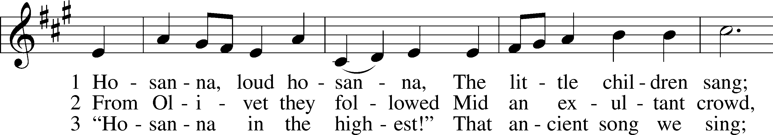
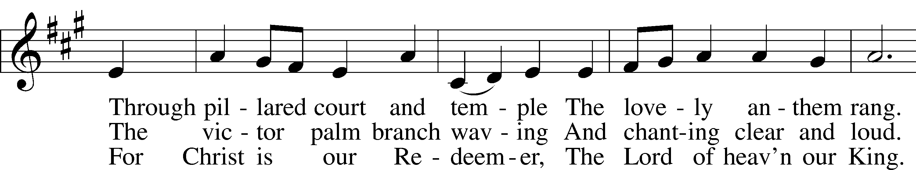
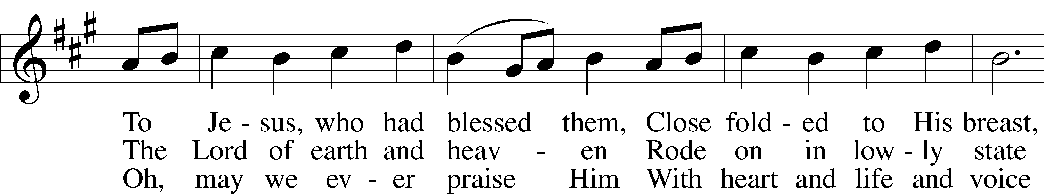
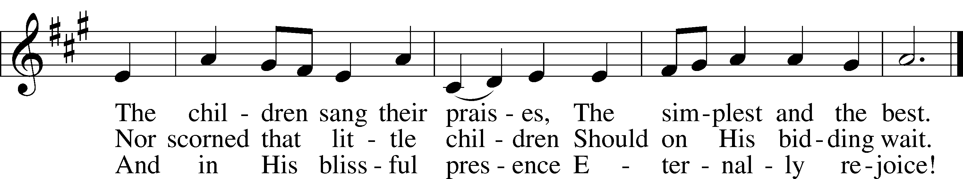
Tune and text: Public domain

SERMON
Stand

Offertory LSB 192
C Create in me a clean heart, O God, and renew a right spirit within me.
Cast me not away from Thy presence, and take not Thy Holy Spirit from me.
Restore unto me the joy of Thy salvation, and uphold me with Thy free spirit. Amen.

Prayer of the Church

Please be seated as the altar is prepared for Holy Communion.

Adult Choir: "Hallelujah! What a Savior!"

Stand

Service of the Sacrament
Preface LSB 194
P The Lord be with you.
C And with thy spirit.

P Lift up your hearts.
C We lift them up unto the Lord.

P Let us give thanks unto the Lord, our God.
C It is meet and right so to do.

P It is truly meet, right, and salutary that we should at all times and in all places give thanks to You, holy Lord, almighty Father, everlasting God, through Jesus Christ, our Lord, who accomplished the salvation of mankind by the tree of the cross that, where death arose, there life also might rise again and that the serpent who overcame by the tree of the garden might likewise by the tree of the cross be overcome. Therefore with angels and archangels and with all the company of heaven we laud and magnify Your glorious name, evermore praising You and saying:

Sanctus LSB 195
C Holy, holy, holy Lord God of Sabaoth;
heav’n and earth are full of Thy glory.
Hosanna, hosanna, hosanna in the highest.
Blessed is He, blessed is He, blessed is He that cometh in the name of the Lord.
Hosanna, hosanna, hosanna in the highest.

Lord’s Prayer LSB 196
P Our Father who art in heaven,
hallowed be Thy name,
Thy kingdom come,
Thy will be done on earth as it is in heaven;
give us this day our daily bread;
and forgive us our trespasses as we forgive those who trespass against us;
and lead us not into temptation,
but deliver us from evil.
C For Thine is the kingdom and the power and the glory forever and ever. Amen.
The Words of Our Lord LSB 197
P Our Lord Jesus Christ, on the night when He was betrayed, took bread, and when He had given thanks, He broke it and gave it to the disciples and said: “Take, eat; this is My T body, which is given for you. This do in remembrance of Me.”

In the same way also He took the cup after supper, and when He had given thanks, He gave it to them, saying: “Drink of it, all of you; this cup is the new testament in My T blood, which is shed for you for the forgiveness of sins. This do, as often as you drink it, in remembrance of Me.”

Pax Domini LSB 197
P The peace of the Lord be with you always.
C Amen.

Agnus Dei LSB 198
C O Christ, Thou Lamb of God, that takest away the sin of the world, have mercy upon us.
O Christ, Thou Lamb of God, that takest away the sin of the world, have mercy upon us.
O Christ, Thou Lamb of God, that takest away the sin of the world, grant us Thy peace. Amen.

Sit

Distribution

423 Jesus, Refuge of the Weary
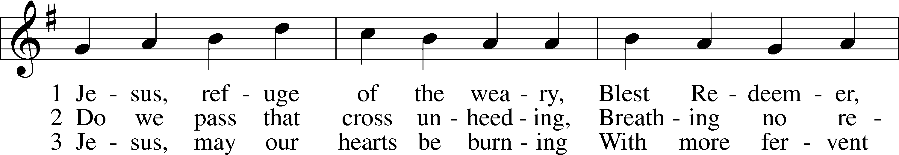
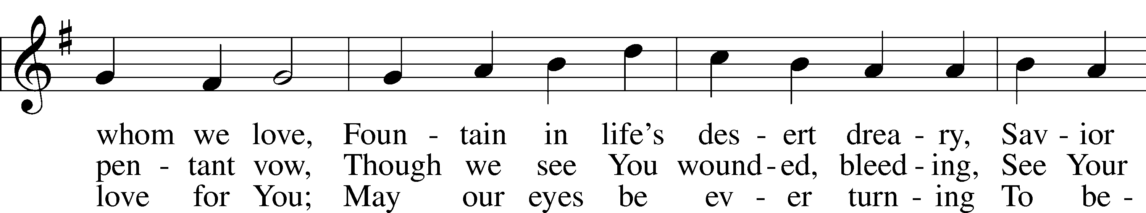
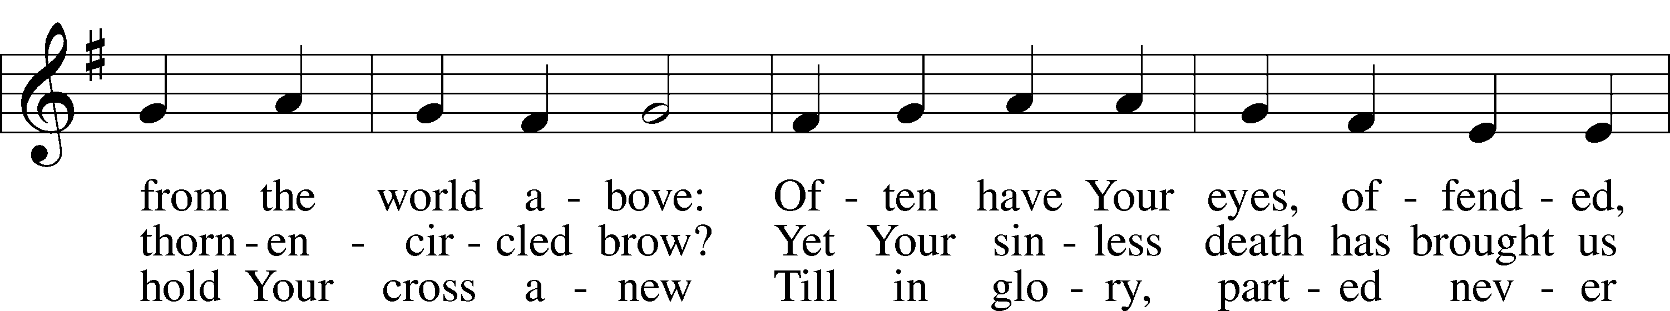
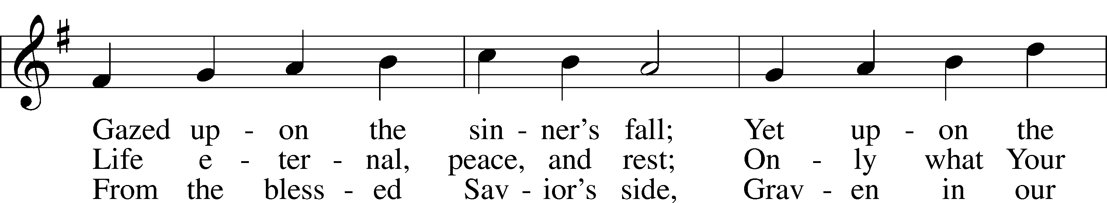
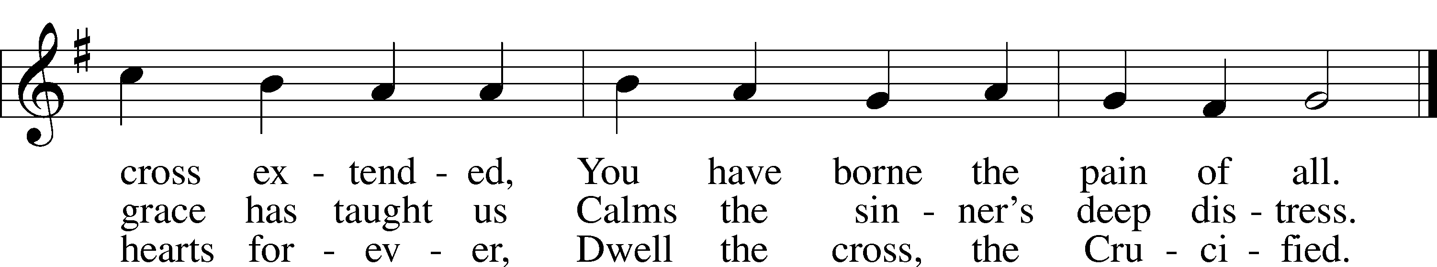
Tune and text: Public domain

437 Alas! And Did My Savior Bleed
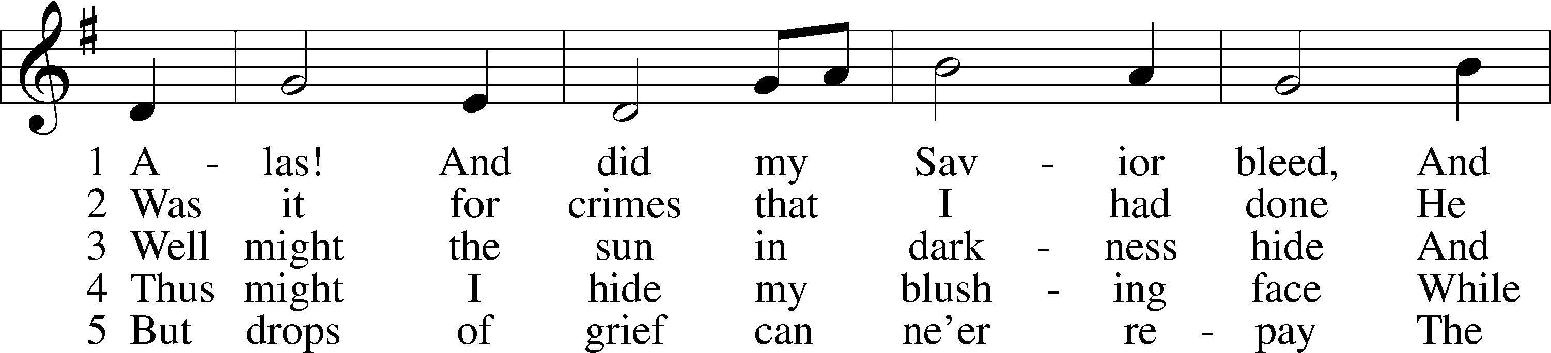
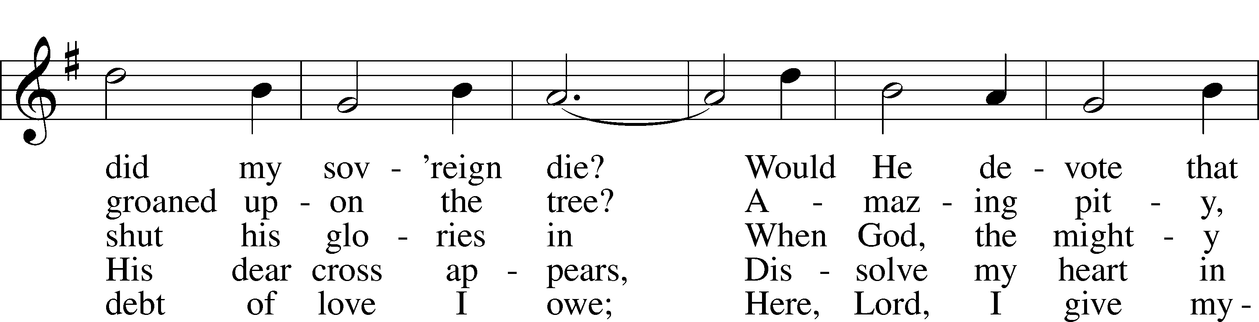
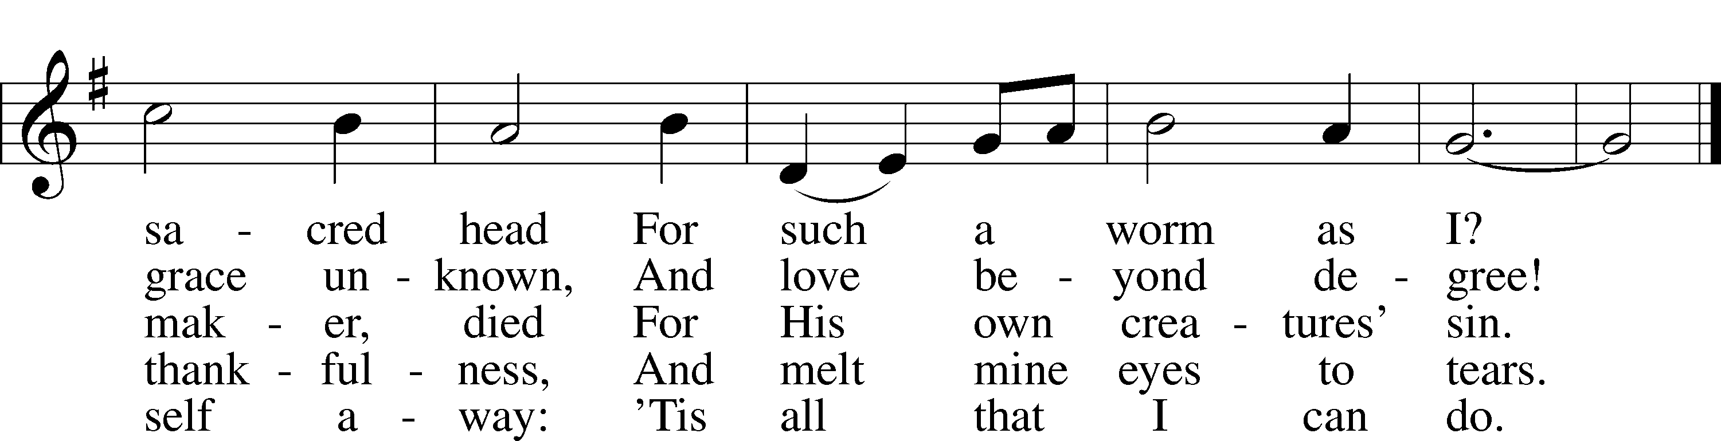
Text and tune: Public domain

634 The Death of Jesus Christ our Lord sts. 1–2, 4–5, 7
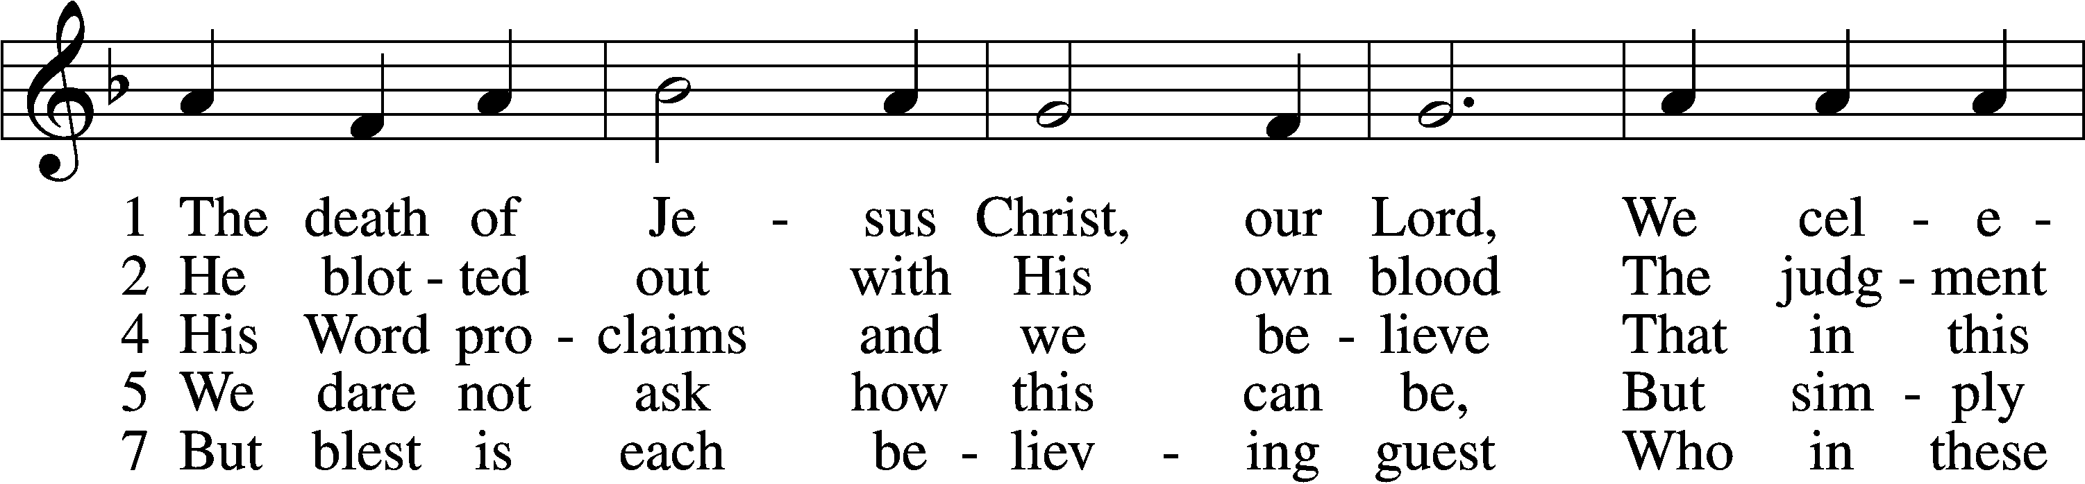
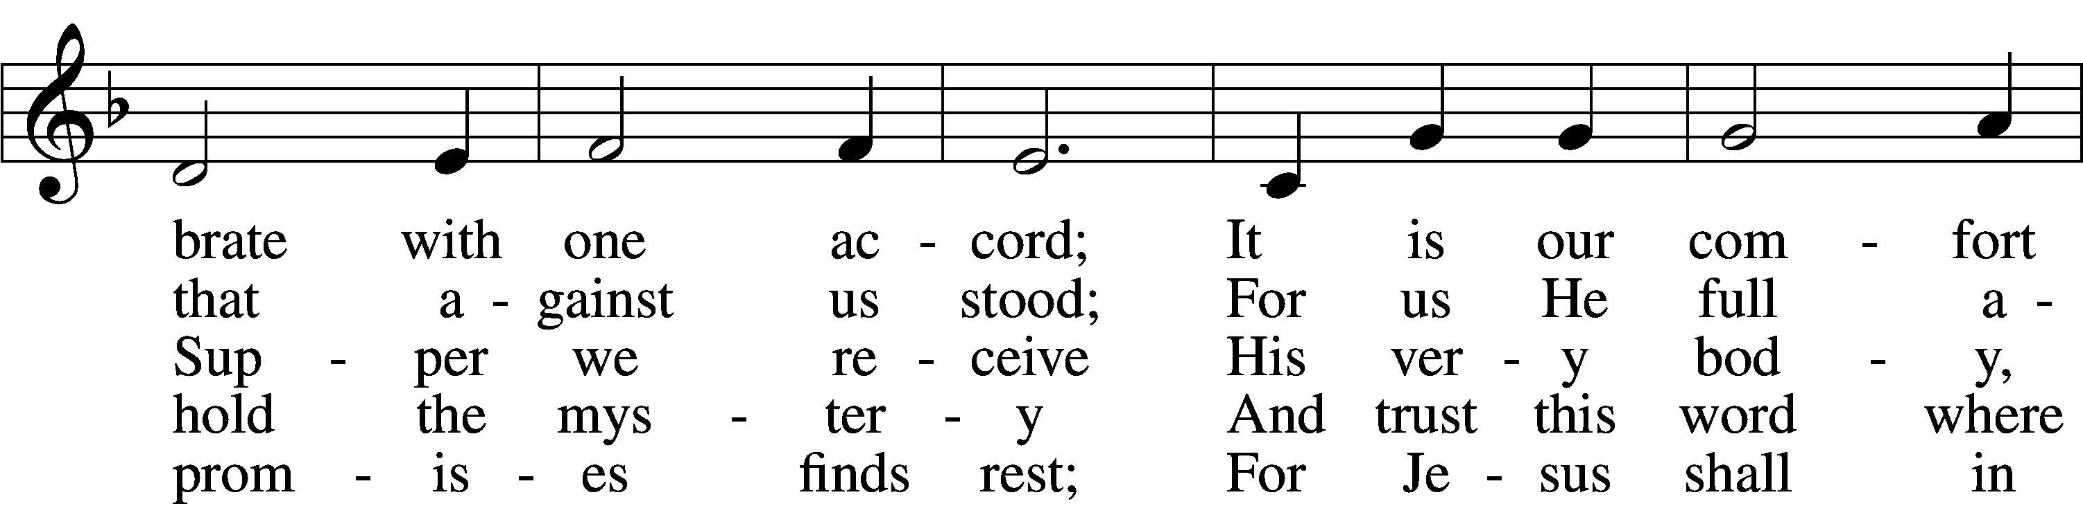
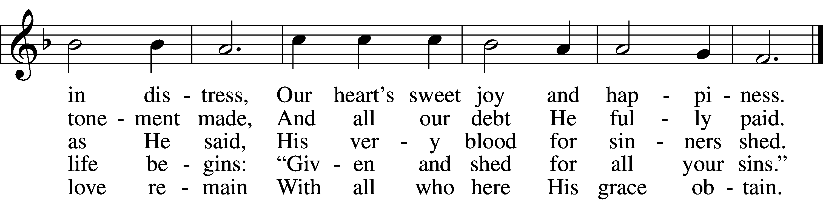
Tune and text: Public domain

In dismissing the communicants, the following is said:
P The body and blood of our Lord Jesus Christ strengthen and preserve you in body and soul to life everlasting. Depart T in peace.
C Amen.

Stand

Nunc Dimittis LSB 199
C Lord, now lettest Thou Thy servant depart in peace according to Thy word,
for mine eyes have seen Thy salvation, which Thou hast prepared before the face of all people,
a light to lighten the Gentiles and the glory of Thy people Israel.
Glory be to the Father and to the Son and to the Holy Ghost;
as it was in the beginning, is now, and ever shall be, world without end. Amen.

Thanksgiving LSB 200
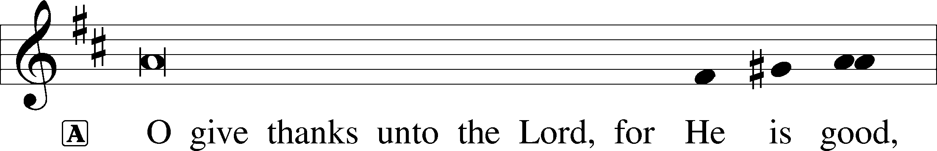

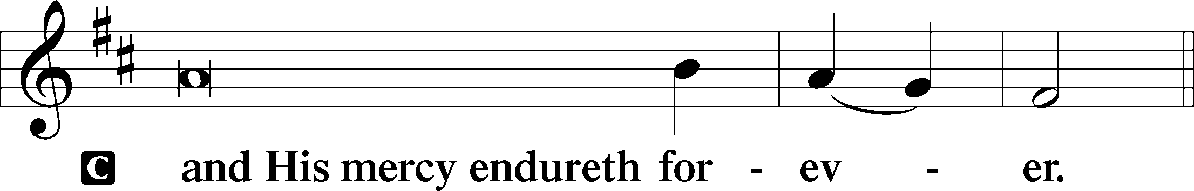

A Let us pray.
We give thanks to You, almighty God, that You have refreshed us through this salutary gift, and we implore You that of Your mercy You would strengthen us through the same in faith toward You and in fervent love toward one another; through Jesus Christ, Your Son, our Lord, who lives and reigns with You and the Holy Spirit, one God, now and forever.
C Amen.

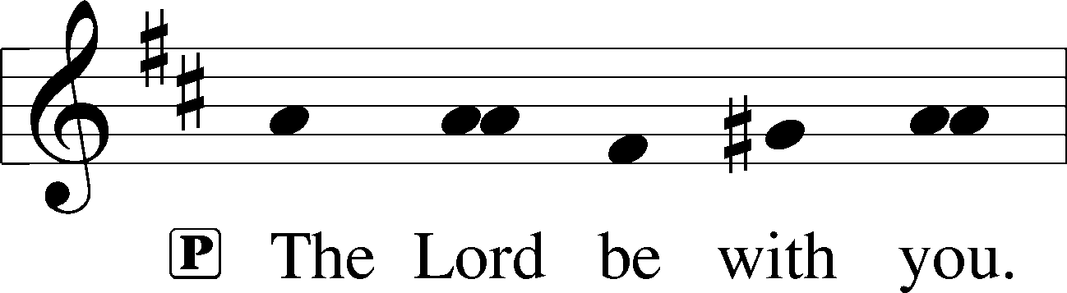

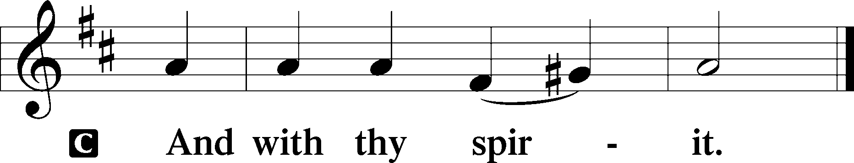

Benedicamus LSB 202
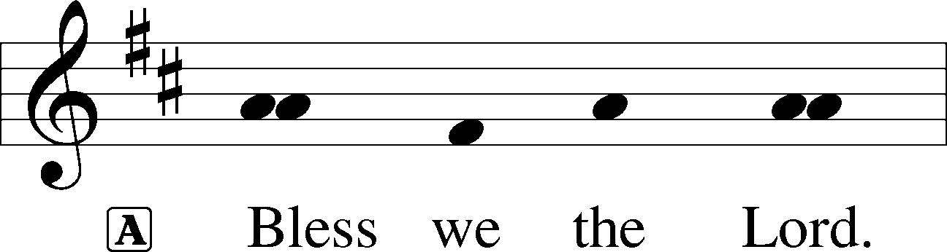

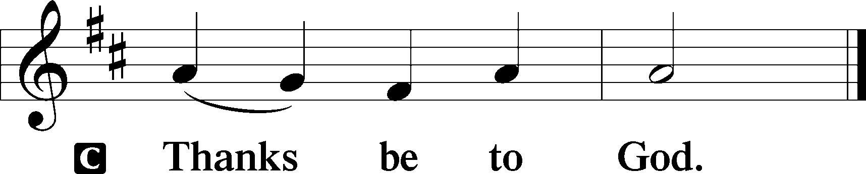

Benediction LSB 202
P The Lord bless you and keep you.
The Lord make His face shine upon you and be gracious unto you.
The Lord lift up His countenance upon you and T give you peace.
C Amen, amen, amen.

441 Ride On, Ride On in Majesty
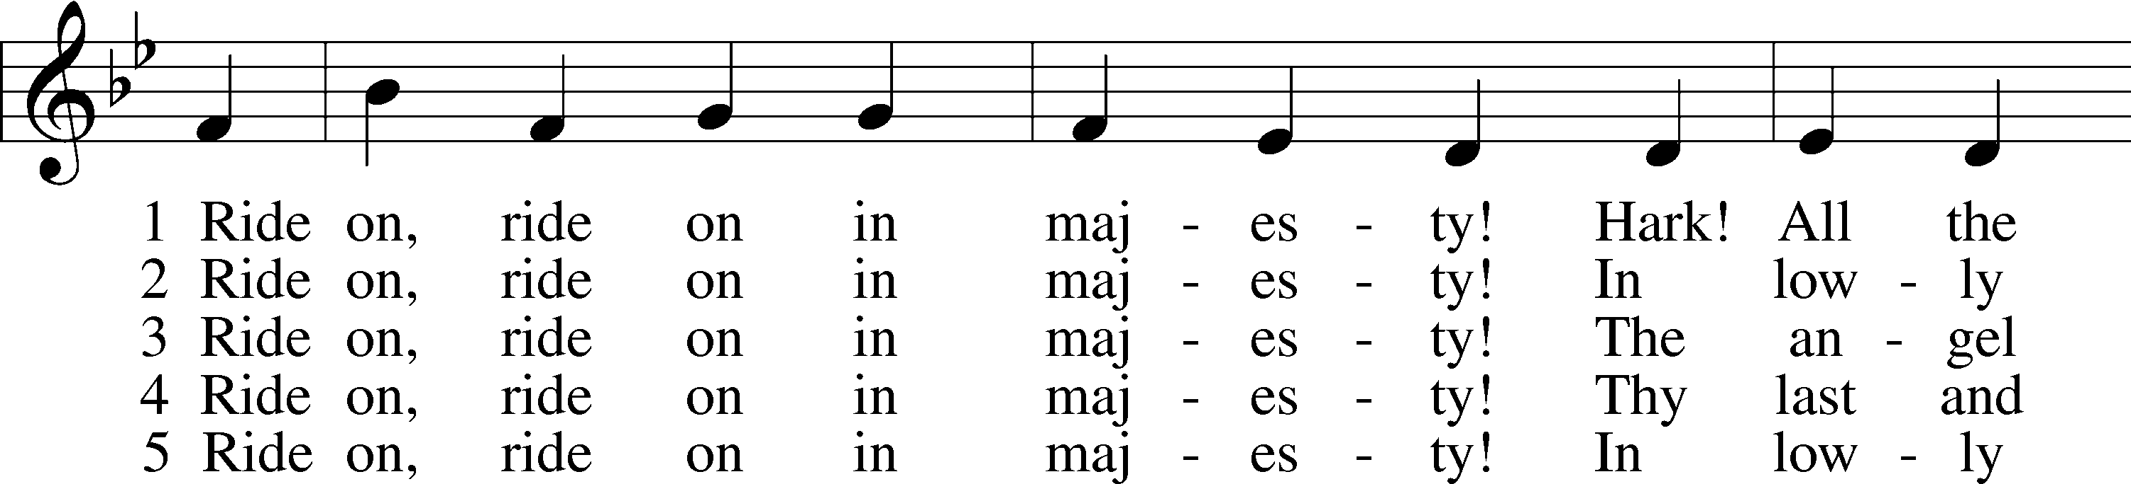
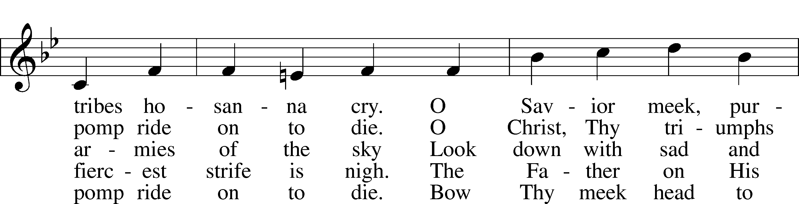
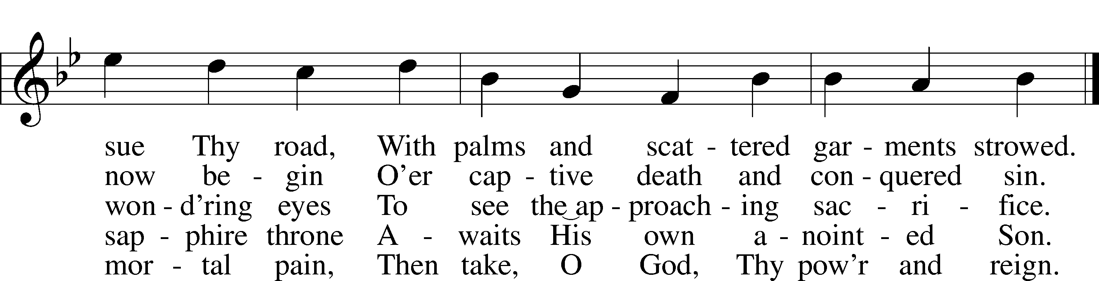
Tune and text: Public domain

Prayers for Our Members
Jade Florang, Nicole Teten, Naomi Wollberg | Expectant Mothers
Norman Abels (Brookestone Meadows – Elkhorn) | Healing
Judy Ahrens | Healing
Vaughn Albrecht (Mount Carmel) | Healing
Tom & DyAnn Altwine | Healing
Jim Catterson | Healing
Lyle Colsden (Mother Hull) | Healing
Pat Flodine (Cambridge Court) | Healing
Vi Fox (Prairie View) | Healing
Verleen Gentry | Healing
Ruby Hatfield | Healing
Boyd Millsap | Healing
Michelle Millsap | Healing
Roger Riekenberg | Healing
Don Richmond | Healing
Marion Richmond | Healing
Ivan Bombeck | Cancer
Fran Junge | Cancer
Bertha Marienau | Cancer
Bev Nuttelman | Cancer
Kim Vos | Cancer

ZION LUTHERAN CHURCH AND SCHOOL

Pr. James DeLoach, Pastor + (308) 627-5260
james.deloach@zionkearney.org
Pr. Doug Gaunt, Pastor + (308) 455-0552
doug.gaunt@zionkearney.org
Tony Splittgerber, Principal + (308) 293-0168
anthony.splittgerber@zionkearney.org

Church Office
Administrative Assistant: Jessica Shiers
Email: school@zionkearney.org
Phone: (308)-234-3410 Fax: (308) 236-8100
Office Hours: Monday-Friday 8:00am-4:00pm
Radio Broadcast: Sunday @ 10:30 a.m. on 1460 AM
Website: www.zionkearney.com

Prayers for Our Members’ Family & Friends
Dawn Gaunt (Pr. & Carol Gaunt’s daughter-in-law) | Expectant Mother
Brandon & Shannon Howell (Quentin & Janel Lange’s friends) | Expecting
Mariah (Quentin & Janel Lange friend) | Expecting
Will Brennemann (Jami Helmbrecht’s father) | Healing
Reg Duke (Westman’s brother-in-law) | Healing
James Gentry (Verleen Gentry’s son) | Healing
Roger Hoffman (Marc’s father) | Healing
Sharon Kreutzer (Richard’s mother) | Healing
Lyra Mais (Zion student) | Healing
Bailey Markowski (Steve & Fran Junge’s great niece) | Healing
Mary Ann Mertz (Pam’s Uhlir’s friend) | Healing
Tim Powers (Kim Wilken’s brother) | Healing
Roy Reynolds (Verleen Gentry’s son-in-law) | Healing
Lynne Saathoff (Verleen Gentry’s sister-in-law) | Healing
Randy Solomon (Beth Rosenthal’s father) | Healing
Janet Stalder (Carol Florang’s sister) | Healing
Angela Well (Charles Marineau’s granddaughter) | Healing
D.D. Dugger (Sue Kaiser’s brother) | Cancer
Stuart Gronewoller (Lonna’s brother-in-law) | Cancer
Ron Halvorsen (Jeff’s dad) | Cancer
Carol Haubold (Don Helmbrecht’s sister) | Cancer
Randy Jochum (Ken Hockemeier’s brother-in-law) | Cancer
Fred Koch (Pam Uhlir’s cousin) | Cancer
Lynda Kreutzer (Rich & Carol’s sister-in-law) | Cancer
John Moore (family of Susan Tonniges) | Cancer
Sharon Mulhair (Pam Uhlir’s cousin) | Cancer
Jeannie Schmidt (Lisa Splittgerber’s sister-in-law) | Cancer
Tyrone Uhlir (Pam’s nephew) | Cancer

Today’s Radio Broadcast is given to the Glory of the Lord by
Jim & Pat Catterson in honor of their anniversary.

Worship Assistants

Sunday, March 28 ~ 9:00am

Elder: Nathan Gaunt
Usher: Mike Wilkens & Jeff Strong
Engineer: Shawn Starkey
Announcer: Brooke Fisher
Altar Guild: Mary Fiddelke & Lyn Hoffman

Thursday, April 1 ~ 7:00pm

Elder: Nathan Gaunt
Usher: RogerRiekenberg & Robert Glanzer
Altar Guild: Shirley Helmbrecht

Friday, April 2 ~ 7:00pm

Elder: Nathan Gaunt
Usher: Mike Wilkens & Jeff Strong
Altar Guild: Shirley Helmbrecht

Saturday, April 3 ~ 7:00pm

Elder: Nathan Gaunt
Usher: Marc Hoffman & Steve Junge
Altar Guild: Shirley Helmbrecht

Sunday, April 4 ~ 7:00am & 9:00am

Elder: Nathan Gaunt
Usher: Fred Flessner & Lennis Hodgson
Engineer: Jamie Nikodym
Announcer: Jesse Florang
Altar Guild: Mary Fiddelke & Lyn Hoffman

Our Response to the Gospel

Date: 03/21/2021

Offering: $6,932.00
Weekly Need: $7,542.37

This Week at Zion

Where our Triune God strengthens us through His mercy in faith toward Him and in fervent love toward one another.

Sun  03/28 | 9:00a  10:30a | Divine Service  Radio Broadcast 1460am
Mon  03/29 | Birthdays  Anniversaries | ---  ---
Tues  03/30 | 1:30p  Birthdays  Anniversaries | Sleeping Mats  ---  --
Wed  03/31 | 8:30a  5:45p  Birthdays  Anniversaries | Chapel  Midweek  Carol Florang  ---
Thurs  04/01 | 7:00  Birthdays  Anniversaries | No School – Office Closed  Maunday Thursday Service  ---  James & Patricia Catterson
Fri  04/02 | 7:00p  Birthdays  Anniversaries | No School – Office Closed  Tenebrae Service  ---  Alton & Sylvia Schmitt
Sat  04/03 | 7:00p  Birthdays  Anniversaries | Easter Vigil  Quentin Lange  ---
Sun  04/04 | 7:00a  9:00a  10:30a  Birthdays  Anniversaries | Easter Sunrise Service  Easter Service  Radio Broadcast 1460am  ---  ---

ANNOUNCEMENTS

An Adult and Youth Bible Study – are prerecorded and available each Sunday, along with a study guide you can use to follow along. We are studying the three lessons for the day—the Old Testament, the Epistle, and the Gospel. Go to Zion’s website www.zionkearney.com to access the video and study guide.

Lenten Midweek Vespers – Thursday at 7 pm:
In the book of Joel, the prophet paints a vivid picture of the coming judgment of God, the day of the Lord. But right in the middle of this frightening portent of judgement, we find a tender invitation from the Lord: “Return to the Lord your God for he is gracious and merciful, slow to anger, and abounding in steadfast love; and he relents over disaster” (Joel 2:13b). During this season of Lent, we will consider this “call to return,” and how it played out for those who walked alongside Christ during His Passion, and for us today.
Jesus invites us to join Him once again at the Table. He repeats the invitation again and again because He feeds us in order to build us up and strengthen our faith. His invitation draws us into a place where we have fellowship with all believers. And yet, our fellowship is stained by sin: “Truly, I say to you, one of you will betray Me, one who is eating with Me” (Mark 14:18). We are not asked to root out the offender, not commanded to judge one another. That is God’s task, not ours. Instead, Jesus gives us His own body and blood, and with it a promise: “This is My blood of the covenant, which is poured out for many” (Mark 14:24). His invitation to return is accompanied by His promise to make all things new, when once again we will share the fruit of the vine with Christ Himself.

Zion Youth –March Madness TODAY- It’s tournament time! With the NCAA March Madness Tournament beginning, we decided to have our own Zion Lutheran Youth Group March Madness Tournament. TODAY from 11-2, youth group members are invited to participate in a 2-on-2 basketball tournament in the Zion Gym. Please contact Jamie Nikodym 402-746-0561or Kara Dauel 308-627-2113 to let them know you will participate. Lunch will be served!

Radio Broadcast - Please help Zion spread the Gospel! There are several open dates.

Mission Offerings - The first quarter missions will support Lutherans for Life, January through March. If you would like to donate to this mission, please use the mission envelopes located in the narthex. Thank you for your support.

Church Management System – Zion is in the process of changing to a web-based church management system called ChurchTrac. Please use the website link or the QR code below and set up your ChurchTrac account. This will link up to your profile and you will be given access to an amount of predetermined information about Zion and your fellow members. We always seek to keep your information secure. For security reasons, once you sign up, the office will approve you as a member, then you will have access to your profile. Also, you will be able to update your own directory information (address, phone number, etc.) and decide what information you want to share with fellow members.

If you currently give your offering online using Pushpay, then please switch to ChurchTrac. We would like to cancel our Pushpay subscription by the end of March. If you would like to start to give online, we believe ChurchTrac will be very user friendly. If you need any assistance please contact the church office (234-3410).

For a step by step guide there are copies in the narthex.

The website:

https://zionkearney.churchtrac.com/give

To use the QR code open your camera app on your smart phone and show it the image below. There will be a website that will pop up.
SCHOOL NEWS

Plant Sales – Plant sales have begun on Monday, March 1st. To order see a Zion student, contact the office, or order online at www.janetsjungle.com/kearney-zion-lutheran-school.html. Be sure to check out the online bonus buys throughout the sale. All orders must be turned into the office by April 5th. Plant pickup will be Thursday and Friday, April 22 & 23. Please go to tinyurl.com/5sueskak or call 308-234-3410 to set up a time to pick up your plants. Thank you for your support.

P.E.A.C.E Auction – COVID is preventing Zion from hosting the in person dinner and auction. However; we still are holding an online auction for the 12th annual fundraiser. Your participation is appreciated. The online auction will be from March 27th – April 10th at PEACE2021.ggo.bid. If you have any questions please contact the office. Thank you for supporting our school!

Registration Open - Registration is now open for the 2021-2022. New this year is an all-day prekindergarten option! If you have any questions, please feel free to contact the office. Please tell your family and friends about Zion. Enroll early to make sure you have a spot.

New Teacher Search - The search for another high quality Lutheran teacher has begun. Full time teachers in our school must be members of the LCMS (or willing to become so). The grade level will most probably be for the 3rd/4th grade. If you or someone you know might be interested in this position, please contact Mr. Splittgerber.
Scrip Cards - Scrip cards are still available during this time. Visit the office during normal hours to purchase your gift cards.

