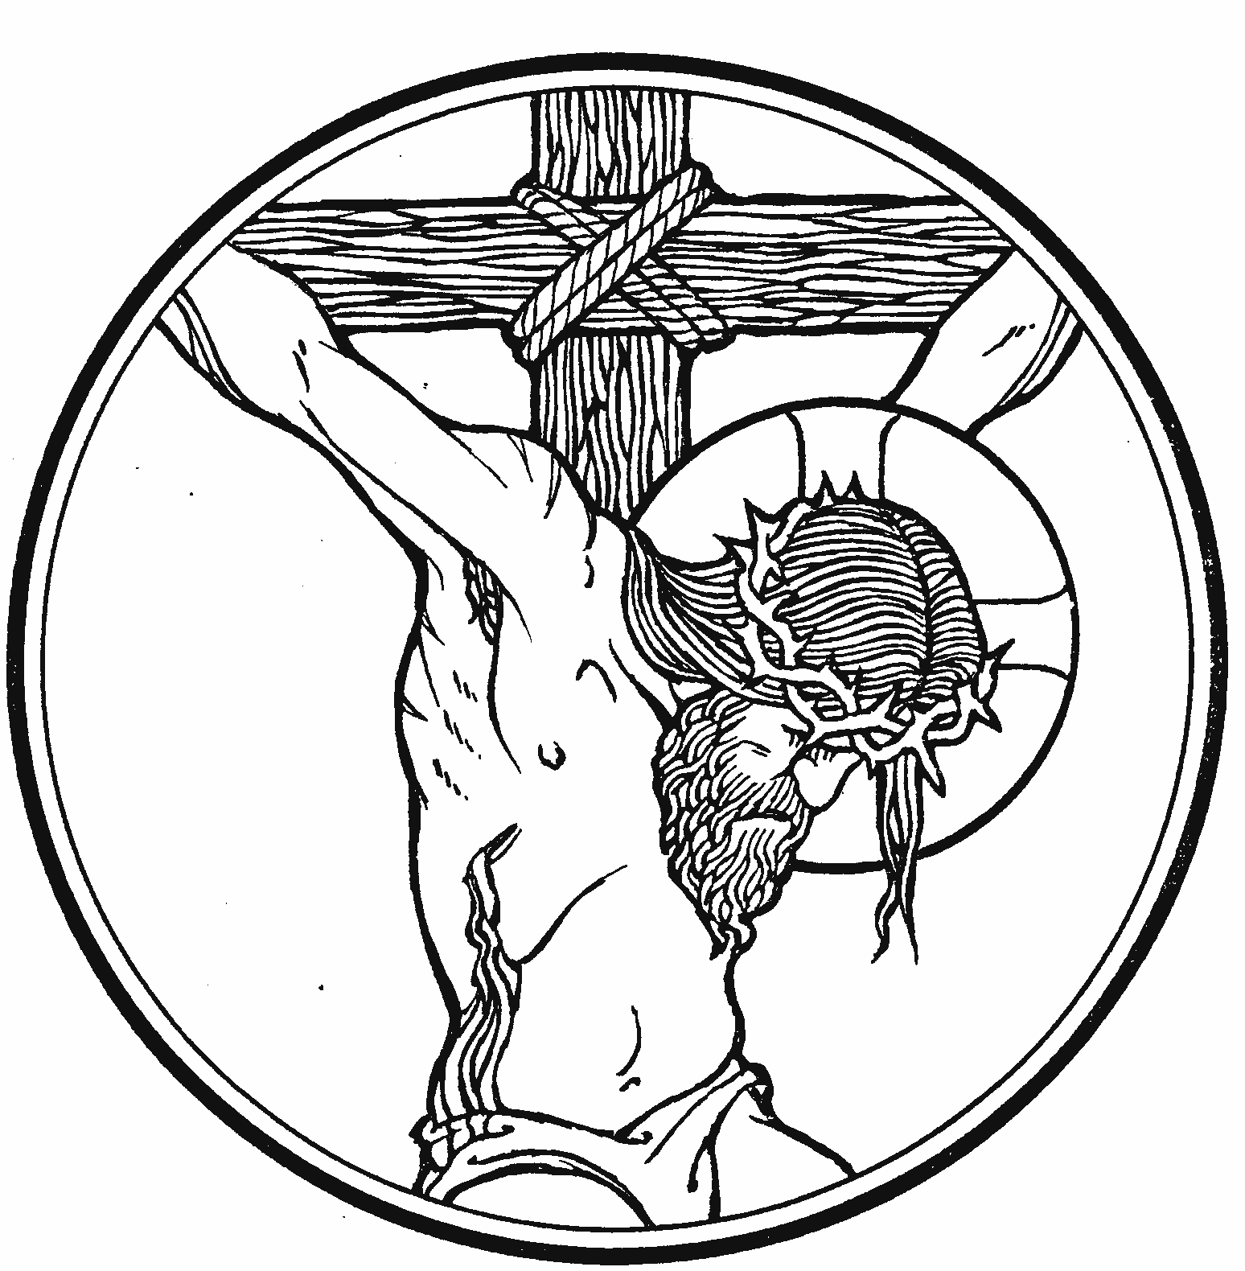

Good Friday ~ Tenebrae
14 April 2017 + 7:00 p.m.

Zion Lutheran Church & School
Kearney, NE + (308) 234-3410

Rev. James DeLoach, Pastor + (308) 627-5260
Rev. Doug Gaunt + (308) 455-0552
Tony Splittgerber, Principal + (308) 293-0168

Please gather in this evening in silence,
reflecting upon Jesus’ sacrificial death for you.

A warm welcome to all our guests!
Please sign our guest book in the narthex and let us know how we can serve you. We are glad you are here!

On this most holy day your Savior endured suffering and death by crucifixion. Why? He loves you and wants you to live forever with Him. You know this because He, Who deserved death the least, gave His own life to ransom you from your captors—sin, death, and the devil. There is nothing more amazing than this—that the sinless Son of God takes our mortal flesh and submits to temporal death so that we might forever live in bodies immortal and glorified as holy children of God! Therefore, we do not observe Good Friday as a funeral for Christ. It is finished, along with our salvation. Rather, we gather to repent of our sins and receive the forgiveness that Jesus won for us upon Calvary’s cross.
You are invited to make use of the following to guide your prayer and meditation before today’s service:

- Prayers for Worship on the hymnal’s inside cover,

- The Good Friday hymns (447-455),

- The penitential Psalms (6, 32, 36, 38, 43, 51),

- Or the Psalms (2, 22, 27) designated for Good Friday.
Tenebrae is Latin for "shadows." After the introductory versicles and prayers, the service consists of the reading of the Passion of Our Lord in sections followed by a hymn. After each reading a candle in the chancel is extinguished and the lights in the church are gradually dimmed. After the last candle is extinguished comes the strepitus—a sound that symbolizes the sealing of the tomb of Our Lord.

The congregation and pastor enter in silence.
Return to The Lord
Return to Truth
Peter addressed the people in Solomon’s Portico at the temple in Jerusalem after the time of Pentecost, and said directly, “Men of Israel . . . you denied the Holy and Righteous One and asked for a murderer to be granted to you, and you killed the Author of life” (Acts 3:12, 14–15). In the service of Good Friday, we reflect on that truth and remember the sacrifice that Jesus made for each of us. The hymnist describes the event with poignant beauty: “The Shepherd dies for sheep that loved to wander” (LSB 439:4). Good Friday is good for us and our salvation.

Please stand

Opening Versicles
P O Lord, open my lips,
C and my mouth will declare your praise.

P Make haste, O God, to deliver me;
C make haste to help me, O Lord.
Praise to you, O Christ, Lamb of our salvation.

Sentences of Devotion
P He was wounded for our transgressions, He was bruised for our iniquities, the chastisement for our peace was upon Him.
C WITH HIS STRIPES WE ARE HEALED.

P Almighty God, graciously behold this your family, for whom our Lord Jesus Christ was willing to be betrayed, to be given into the hands of sinners, and to suffer death on the cross, who lives and reigns with you and the Holy Spirit, one God, now and forever.
C AMEN.

P All we like sheep have gone astray,
C AND THE LORD HAS LAID UPON HIM THE INIQUITY OF US ALL.

P Almighty and most merciful God, give us grace so to contemplate the Passion of our Lord that we may find in it the forgiveness of our sins; through Jesus Christ, your Son, our Lord.
C. AMEN.
Please be seated

Hymn #436 (v. 1 - 4) ~ Go to Dark Gethsemane

The Passion of Our Lord
according to St. John

I. St. John 18:28-40

Hymn #439 (v. 1-2) ~ O Dearest Jesus, What Law Has Thou Broken

(The first candle is extinguished.)

II. St. John 19:1-16

Hymn #449 (v. 1-2) ~ O Sacred Head, Now Wounded

(The second candle is extinguished.)

III. St. John 19:17-24

Hymn #453 (v. 1, 4-5) ~ Upon the Cross Extended

(The third candle is extinguished.)

IV. St. John 19:25-30

HYMN: # 428 ~ Cross of Jesus, Cross of Sorrow

(The fourth candle is extinguished.)

V. St. John 19:31-37

After the reading:
P O Lord, have mercy on us.
C Thanks be to God.
Hymn # 435 (v. 1 - 3) ~ Come to Calvary’s Holy Mountain

(The fifth candle is extinguished.)
The Responsory
P We have an advocate with the Father;
Jesus is the propitiation for our sins.
C He was delivered up to death;
He was delivered for the sins of the people.
P Blessed is he whose transgression is forgiven
and whose sin is put away.
C He was delivered up to death;
He was delivered for the sins of the people.
P We have an advocate with the Father;
Jesus is the propitiation for our sins.
C He was delivered up to death;
He was delivered for the sins of the people.

(The sixth candle is extinguished.)
Hymn #454 Sing, My Tongue, the Glorious Battle
The Sermon Return to Truth

The Offering
To worship the Lord with your offering:
1) Place your offering in the basket as you leave,
2) Go to zionkearney.churchtrac.com/give,
3) Go to zionkearney.com and click the ChurchTrac icon,
4) Mail your gift to Zion Lutheran Church, 2421 C Ave, Kearney, NE 68847 or place it in the mail slot on the south side of the building.

Please stand

The Prayers

P Lord, have mercy.
C Lord, have mercy.
P Christ, have mercy.
C Christ, have mercy.
P Lord, have mercy.
C Lord, have mercy.
The Lord’s Prayer
Our Father who art in heaven,
hallowed be thy name,
thy kingdom come,
thy will be done on earth as it is in heaven.
Give us this day our daily bread;
and forgive us our trespasses
as we forgive those who trespass against us;
and lead us not into temptation,
but deliver us from evil.
For thine is the kingdom
and the power and the glory
forever and ever. Amen
P The Lord be with you.
C And also with you.
P Almighty God, graciously behold this Your family, for which our Lord Jesus Christ was willing to be betrayed and delivered into the hands of sinful men and to suffer death on the cross; through the same Lord Jesus Christ, Your Son, our Lord, who lives and reigns with You and the Holy Spirit, one God, now and forever.
C Amen.
P Almighty and everlasting God, who willed that Your Son should bear for us the pains of the cross and so remove from us the power of the adversary, help us so to remember and give thanks for our Lord’s Passion that we may receive remission of sin and redemption from everlasting death; through Jesus Christ, our Lord.
C Amen.

P O Lord Jesus Christ, Son of the Living God, who at the evening hour did rest in the tomb, and thereby sanctified the grave to be a bed of hope for your people: Make us abound in sorrow for our sins, which were the cause of your Passion, that when our bodies rest in the dust, our souls may live with you; who reigns with the Father and the Holy Spirit, one God, world without end.
C Amen.

P We adore you, O Christ and we bless you.
C BY YOUR HOLY CROSS YOU HAVE REDEEMED THE WORLD.
The Last Reading ~ St. John 19:38-42
The last candle is extinguished. Then comes the strepitus—a sound that symbolizes the sealing of the tomb of Our Lord
All is dark and silent for a time of meditation and prayer.
Hymn: # 429 ~ We Sing the Praise of Him Who Died
The congregation leaves in silence under minimal light.

Tonight’s service is part of one continuous liturgy known as the Triduum (Three Days). There is no Benediction or greeting because our worship continues with the Vigil of Easter on Saturday (7p.m.). On Sunday we will celebrate the Festival of the Resurrection of our Lord (7:00 & 9:00 a.m.).



Serving Zion This Evening
Minister: Rev. James DeLoach
Organist: Carol DeLoach
Elder: Nathan Gaunt
Usher Captain: Mike Wilkens & Jeff Strong
Altar Guild: Shirley Helmbrecht

Holy Week Schedule
+ Saturday - The Vigil of Easter ~ 7 p.m. +
+ Sunday Festival Divine Service ~ 7 & 9 a.m. +

