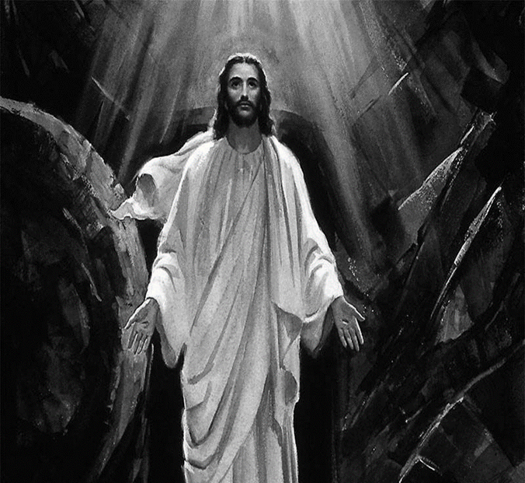

The Vigil of Easter
3 April 2021 + 7:00 p.m.

Zion Lutheran Church and School
Kearney, NE + (308) 234-3410

Rev. James DeLoach, Pastor + (308) 627-5260
Rev. Doug Gaunt, Pastor + (308) 455-0552
Mr. Tony Splittgerber, Principal + (308) 293-0168
The congregation is asked to be seated in silence. The service begins at the entry to the church.
RETURN TO THE LORD
RETURN TO THE CHURCH
The gathering of the followers of Jesus Christ has special meaning on every occasion. On the day between the commemoration of His death on the cross at Calvary and the celebration of His resurrection from the garden tomb, there is a singular opportunity for reflection and for worship. Through the death of Christ upon it, the cross has become a symbol for the end and the beginning of life. As we who are the Church keep an Easter vigil, we rejoice that our Lord has called us into an eternal relationship with Him and with one another. Honoring our Lord, we keep this feast with sincerity and truth.
The Vigil of Easter
Taken from Lutheran Service Book – Altar Book
The Vigil of Easter, which is celebrated at the end of Holy Saturday as the conclusion to the sacred Triduum, ushers in the celebration of the Resurrection of Our Lord on Easter Sunday. The Vigil of Easter connects the days of Holy Week, especially Holy Thursday and Good Friday, with the culminating celebration of the resurrection of Christ from the dead.
In some places throughout the early centuries of the Church’s life, the people of God would hold vigil, which means “keep watch,” through the night in expectation of Christ’s return. A vigil in expectation of Christ’s return at Easter became a common feature of the celebration of His crucifixion and resurrection. The vigil consisted of prayer, psalms and hymns, and readings, especially from the Old Testament, culminating in the celebration of the resurrection at dawn with the Lord’s Supper. As the Church gathered in vigil, she waited in hopeful expectation for the appearance of the resurrected Christ in those most recently born in Him, the newly baptized. During the vigil, those who had prepared throughout Lent to be joined to Christ were baptized. At the dawn of the new day at Easter sunrise, the newly baptized joined the entire Church in the chorus of alleluias at Christ’s resurrection from the dead.
While making a vigil through the night may not be common today, Christians nonetheless gather on Holy Saturday to wait in expectation for the news of Christ’s resurrection and for His second coming.

 The Service of Light 
P: In the name of the Father and of the  Son and of the Holy Spirit.
C: Amen.
P: Beloved in the Lord, on this most holy night, in which our Lord Jesus passed over from death to life, we are gathered here in vigil and prayer. This is the Passover of the Lord in which, by hearing His Word and celebrating his sacraments, we share in His victory over death.
Let us pray. O God, You are like a refiner’s fire, and Your Spirit enkindles the hearts of Your faithful people with the fire of Your love. Bless, we implore you, those who keep this joyful Easter festival that, burning with desire for life with You, we may be found rightly prepared to share in the Feast of Light which has no end; through Jesus Christ, Your Son, our Lord, who lives and reigns with you and the Holy Spirit, one God, now and forever.
C: Amen.
An assistant lights the Paschal Candle.
P: May the light of the gloriously risen Christ dispel the darkness of our hearts and minds.
Almighty and most merciful God, pour out on us Your abundant blessing that all who in true faith share this night in joyful celebration of the resurrection of our Lord Jesus Christ from the dead may be filled with your heavenly benediction. Once we were in darkness, but now we are in the Light, even Jesus Christ, our Lord.
C: Amen.
LUX CHRISTI -- The Light of Christ
Those on the inside end of the pew are asked to light their candle from the Paschal Candle as the Assistant walks down the aisle. Please do not tip a lit candle. Parents, please do not allow your child to hold a lit candle until you are certain that they can do so without spilling any wax.
At the entrance of the sanctuary, the bearer of the main candle stops as we sing:

A The light of Christ
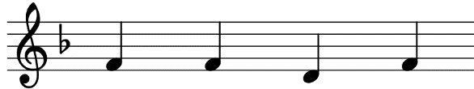
C Thanks be to God.

In the middle of the sanctuary, we stop again and sing:

A The light of Christ
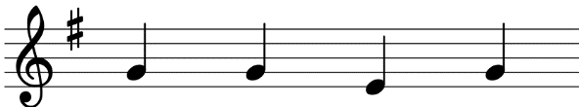
C Thanks be to God.
After the Candle Bearer reaches the stand, turns and faces the congregation, and as everyone has reached their pew, we sing:

A The light of Christ
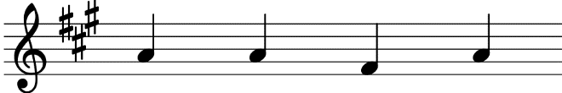
C Thanks be to God.

The Exsultet - Easter Proclamation
A: Rejoice now, all you heavenly choirs of angels; rejoice now, all creation; sound forth, trumpet of salvation, and proclaim the triumph of our King. Rejoice too, all the earth, in the radiance of the light now poured upon you and made brilliant by the brightness of the everlasting King; know that the ancient darkness has been forever banished. Rejoice, O Church of Christ, clothed in the brightness of this light; let all this house of God ring out with rejoicing, with the praises of all God’s faithful people.
P: The Lord be with you.
C: And with your spirit.

P: Lift up your hearts.
C: We lift them to the Lord.

P: Let us give thanks to the Lord, our God.
C: It is meet and right so to do.
P: It is truly good, right, and salutary that we should at all times and in all places, with all our heart and mind and voice, praise You, O Lord, Holy Father, almighty everlasting God, and Your only begotten Son, Jesus Christ. For He is the very Paschal Lamb who offered Himself for the sin of the world, who has cleansed us by the shedding of His precious blood. This is the night when You brought our fathers, the children of Israel, out of bondage in Egypt and led them through the Red Sea on dry ground. This is the night when all who believe in Christ are delivered from bondage to sin and are restored to life and immortality. This is the night when Christ, the Life, arose from the dead. The seal of the grave is broken, and the morning of the new creation breaks forth out of night. Oh, how wonderful and beyond all telling is Your mercy toward us, O God, that to redeem a slave You gave Your Son. How holy is this night when all wickedness is put to flight and sin is washed away? How holy is this night when innocence is restored to the fallen and joy is given to those downcast? How blessed is this night when man is reconciled to God in Christ? Holy Father accept now the evening sacrifices of our thanksgiving and praise. Let Christ, the true light and morning star, shine in our hearts, He who gave light to all creation, who lives and reigns with You and the Holy Spirit, one God, now and forever.
C: Amen.
 Service of Readings 
All may be seated and extinguish their candles at this time. The cove lights in the sanctuary are turned on. The ushers will collect the candles. Please do not spill any wax on the pew cushions.
P: In this most holy night our Savior, Christ the Lord, broke the power of death and by his resurrection brought life and salvation to all creation. Let us praise the Lord, for He truly keeps his word. The sun of righteousness has dawned upon us who have sat in darkness and in the shadow of death.
Each reading is followed by a brief silence.
The Creation
A: A reading from Genesis, the first and second chapters.
Genesis 1:1-2:3
A: This is the Word of the Lord. C: Thanks be to God.
P: Let us pray.
Almighty God, through Your Word and Spirit You most wonderfully created all things, and through the Word made flesh You brought new life to fallen humanity. Grant that in Your mercy we may be conformed to the image of Him who shares fully in our humanity, even Jesus Christ, our Lord.
C: Amen.
Hymn #597 – Water, Blood, and Spirit Crying
Israel’s Deliverance at the Red Sea
A: A reading from Exodus, chapters 14 and 15.
Exodus 14:10—15:1
A: This is the Word of the Lord. C: Thanks be to God.
P: Let us pray.
O God, You once delivered Your people Israel from bondage under Pharaoh and led them by a pillar of cloud and fire through the sea to safety. Grant that we may so follow Christ that through the waters of Baptism we may daily die and rise with Him and walk in safety through the wilderness of this life until we see Your salvation; through Jesus Christ, our Lord.
C: Amen.
Hymn #430 (1-3, 6) – My Song is Love Unknown
The Death of Jesus and Piercing of His Side
A: A reading from the Gospel according to St. John, the 19th Chapter.
St. John 19:28-37
A: This is the Gospel of the Lord. C: Thanks be to God.
P: Let us pray.
For this congregation, that having returned to our Lord throughout the season of Lent, we may go forward in the Easter season energized by the power of the Holy Spirit, so that our church, one in the Body of Christ, will be known in our community as a people filled with joy in the Lord who love and serve our neighbors; through Jesus Christ, our Lord.
C: Amen.
Hymn #487 (v. 1, 2, 5) -- Come, You Faithful, Raise the Strain
 Renewal of Baptismal Vows 
P: On this holiest of nights, the whole Church of our Lord Jesus Christ recalls His death and burial, rejoicing with great joy in the Gospel of His glorious and mighty resurrection from the dead. The apostle Paul says in Romans 6:3-11…
Flood Prayer
P: Let us pray. Almighty and eternal God, according to Your strict judgment You condemned the unbelieving world through the flood, Yet according to Your great mercy You preserved believing Noah and his family, eight souls in all. You drowned hard-hearted Pharaoh and all his host in the Red Sea, yet led Your people Israel through the water on dry ground, foreshadowing this washing of Your Holy Baptism. Through the Baptism in the Jordan of Your beloved Son, our Lord Jesus Christ, You sanctified and instituted all waters to be a blessed flood and a lavish washing away of sin. We pray that You would behold us according to Your boundless mercy and bless us with true faith by the Holy Spirit, that through this saving flood all sin in us, which have been inherited from Adam and which we ourselves have committed since, would be drowned and die. Grant that we be kept safe and secure in the holy Ark of the Christian Church, being separated from the multitude of unbelievers and serving Your name at all times with a fervent spirit and a joyful hope, so that, with all believers in Your promise, we would be declared worthy of eternal life through Jesus Christ, our Lord.
C: Amen.
Renunciation of the Devil and Confession of Faith
P: Do you renounce the devil?
C: Yes, I renounce him.
P: Do you renounce all his works?
C: Yes, I renounce them.
P: Do you renounce all his ways?
C: Yes, I renounce them.
P: Do you believe in God, the Father Almighty, maker of heaven and earth?
C: Yes, I believe in God, the Father Almighty, maker of heaven and earth.
P: Do you believe in Jesus Christ, His only Son?
C: Yes, I believe in Jesus Christ, His only Son our Lord, who was conceived by the Holy Spirit, born of the Virgin Mary, suffered under Pontius Pilate, was crucified, died, and was buried. He descended into hell. The third day, He rose again from the dead. He ascended into heaven and sits at the right hand of God the Father Almighty. From thence He will come to judge the living and the dead.
P: Do you believe in the Holy Spirit?
C: Yes, I believe in the Holy Spirit, the holy Christian church, the communion of saints, the forgiveness of sins, the resurrection of the body, and the life everlasting.
P: Almighty God, the Father of our Lord Jesus Christ, who has given you the new birth of water and the Spirit and has forgiven you all your sins, strengthen you with His grace to life  everlasting.
C: Amen.
P: Peace  be with you.
C: Amen.
 Service of Prayer 
⬆ Litany of the Resurrection
A: O Lord,
C: Have mercy.
A: O Christ,
C: Have mercy.
A: O Lord,
C: Have mercy.
A: Lord Jesus Christ, Son of God,
C: Hear us.
A: Paschal Lamb, who was offered for us and has taken away the sin of the world,
C: Have mercy on us.
A: Who was crucified for our transgressions and raised for our justification,
C: Have mercy on us.
A: Who foretold Your Passion saying, “The Son of Man must be crucified and on the third day rise again,”
C: Have mercy on us.
A: Who destroyed Death by dying, and by rising to life again has brought life and immortality to light,
C: Have mercy on us.
A: Whose resurrection was first announced by an angel to the women,
C: Have mercy on us.
A: Who appeared to Mary Magdalene and was worshiped by her:
C: Have mercy on us.
A: Who revealed Yourself to the two disciples on the Emmaus road and made Yourself known to them in the Scriptures and in the breaking of the bread,
C: Have mercy on us.
A: Who appeared to the disciples, bestowing on them Your peace and Your Spirit,
C: Have mercy on us.
A: Who showed Your wounded hands and side to the apostle Thomas that he too might believe,
C: Have mercy on us.
A: Who appeared to seven disciples on the Sea of Tiberias, bringing a miraculous catch of fish,
C: Have mercy on us.
A: Who appeared to Peter and to the Twelve, to over 500 disciples, to James and to all the apostles, and to Paul on the Damascus road,
C: Have mercy on us.
A: Who commissioned Your Church to make disciples of all nations by baptizing and teaching them,
C: Have mercy on us.
A: By Your glorious resurrection from the dead,
C: Good Lord, deliver us.
A: By Your victory over sin and death,
C: Good Lord, deliver us.
A: By the majesty of Your risen body,
C: Good Lord, deliver us.
A: We poor sinners implore You,
C: To hear us, Lord Jesus.
A: That we may daily die and rise with You in our Baptism and walk in the freedom of Your forgiveness,
C: Grant us, good Lord.
A: That we may set our minds on things above and not on earthly things, serving others as we have been served by You,
C: Grant us, good Lord.
A: That we may dwell with You forever in the new creation as citizens of the heavenly Jerusalem, together with all the saints,
C: Grant us, good Lord.
A: Christ, the Lamb of God, who takes away the sin of the world,
C: Have mercy on us.
A: Christ, the Lamb of God, who takes away the sin of the world,
C: Have mercy on us.
A: Christ, the Lamb of God, who takes away the sin of the world,
C: Grant us Your peace.
A: O Lord,
C: Have mercy.
A: O Christ,
C: Have mercy.
A: O Lord,
C: Have mercy. Amen.
 Service of the Word 
The lights in the church are brought to full brightness indicating that we are ready to celebrate the resurrection of Jesus with the Easter Acclamation and the singing of the Hymn of Praise!
P: Alleluia! Christ is risen!
C: The Lord is risen indeed! Alleluia!
During the Hymn of Praise the altar candles are lighted from the Christ Candle and the chancel is transformed with the colors and images of Our Lord’s resurrection, which anticipates our own!

⬆ Hymn of Praise -- This is the Feast p 155
P: The Lord be with you.
C: And also with you.
P: Let us pray.
O God, You made this most holy night to shine with the glory of the Lord’s resurrection. Preserve in us the spirit of adoption which You have given so that, made alive in body and soul, we may serve You purely; through Jesus Christ, our Lord, who lives and reigns with You and the Holy Spirit, one God, now and forever.
C: Amen.
Holy Gospel: St. Mark 16:1-8
P: The Holy Gospel according to St. Mark, the 16th Chapter.
C: Glory to You, O Lord!
When the Sabbath was past, Mary Magdalene and Mary the mother of James and Salome bought spices, so that they might go and anoint him. And very early on the first day of the week, when the sun had risen, they went to the tomb. And they were saying to one another, “Who will roll away the stone for us from the entrance of the tomb?” And looking up, they saw that the stone had been rolled back- it was very large. And entering the tomb, they saw a young man sitting on the right side, dressed in a white robe, and they were alarmed. And he said to them, “Do not be alarmed. You seek Jesus of Nazareth, who was crucified. He has risen; he is not here. See the place where they laid him. But go, tell his disciples and Peter that he is going before you to Galilee. There you will see him, just as he told you.” And they went out and fled from the tomb, for trembling and astonishment had seized them, and they said nothing to anyone, for they were afraid.
P: This is the Gospel of the Lord.
C: Praise to You, O Christ! Please be seated
Hymn #452 (vs. 1-5) – O Perfect Life of Love
Sermon – Return to the Church
Offering
To worship the Lord with your offering:
1) Place your offering in the basket as you leave
2) Go to zionkearney.churchtrac.com/give
3) Go to zionkearney.com and click on the ChurchTrac icon
4) Mail your gift to Zion Lutheran Church, 2421 C Ave, Kearney, NE 68847 or place it in the mail slot on the south side of the building.
Please be seated as the altar is prepared for the Lord’s Supper.
Offertory -- What shall I render to the Lord… p 159
 Service of the Sacrament 
⬆Preface + Sanctus p 160-161
Lord’s Prayer p 162
Words of Institution p 162
Pax Domini p 163
Agnus Dei p 163
Please be seated
The Distribution
Hymn #633 (v. 1-6) – At the Lamb’s High Feast We Sing
Hymn #482 -- This Joyful Eastertide
In dismissing the communicants, the following is said:
P: The body and blood of our Lord Jesus Christ strengthen and preserve you in body and soul to life everlasting. Depart + in peace.
C: Amen.
Post-Communion Prayer
P: Let us pray.
O God, for our redemption You gave Your only-begotten Son to the death of the cross and by His glorious resurrection delivered us from the power of our enemy. Grant that all our sin may be drowned through daily repentance and that day by day we may arise to live before You in righteousness and purity forever; through Jesus Christ, our Lord, who lives and reigns with You and the Holy Spirit, one God, now and forever.
C: Amen.
P: Let us bless the Lord.
C: Thanks be to God.
P: The almighty and merciful Lord, the Father, the  Son, and the Holy Spirit, bless and preserve you.
C: Amen.
Hymn # 473 -- Our Paschal Lamb, That Sets Us Free
Serving Zion This Evening
Preacher: Pr. James DeLoach Reader: Pr. Doug Gaunt
Organist: Carol DeLoach Assistant:
Candle Bearer: Graydn Fisher Elder: Nathan Gaunt
Usher Captain: Marc Hoffman & Engineer:
Steve Junge
Altar Guild: Shirley Helmbrecht

