The Resurrection of Our Lord
Easter Day
04 April 2021

Zion Lutheran Church & School

Kearney, NE + (308) 234-3410

Rev. James DeLoach, Pastor + (308) 627-5260

Rev. Doug Gaunt, Pastor + (308) 455-0552
Tony Splittgerber, Principal + (308) 293-0168
Welcome to Zion!
Guests please record your attendance on a pink pad in the pew rack and let us know how we can be of service to you.

Holy Communion at Zion

The Lord’s Supper is celebrated at this congregation as Jesus has given it. As he says, our Lord gives into our mouths not only bread and wine but his very body and blood to eat and to drink for the forgiveness of sins and to strengthen our union with him and with one another. Our Lord invites to his table those who trust his words, repent of all sin, and set aside any refusal to forgive and love as he forgives and loves us, that they may show forth his death until he comes. All communicants need to register in the narthex prior to the service.

Because those who eat and drink our Lord’s body and blood unworthily do so to their great harm and because Holy Communion is a confession of the faith which is confessed at this altar, any who are not yet instructed, in doubt, or who hold a confession differing from that of this congregation and The Lutheran Church—Missouri Synod, are asked not to commune until they are able to speak with our pastor first. He is happy to visit with you about the Christian faith and how to receive the Lord’s Supper for your good and for the good of others. Those not communing are invited to come to the altar, cross your arms in front of you, and bow your head to receive a pastoral blessing.

Easter Sunday
Alleluia! Christ is risen! He is risen indeed! Alleluia! Throughout this season of Lent, we have heard a drumbeat call from God to return to Him, and today we rejoice that this call was issued so that we might have life in abundance through the One who lived, died, and rose again to secure our salvation. Our journey has led us through some dark places, and we have grappled with the implications of our sin in many different forms, but today the call is especially personal; it is about what it all means for you. We are called to come and see the Christ; to see the salvation won for us; to see the life that He has secured; and to see the Word that we are to share with others. Our prayer is that others, too, would hear God’s call and respond in trust and faith.
© 2020 Concordia Publishing House. Scripture: ESV®.

Confession and Absolution

461 I Know That My Redeemer Lives sts. 1–3, 5, 7
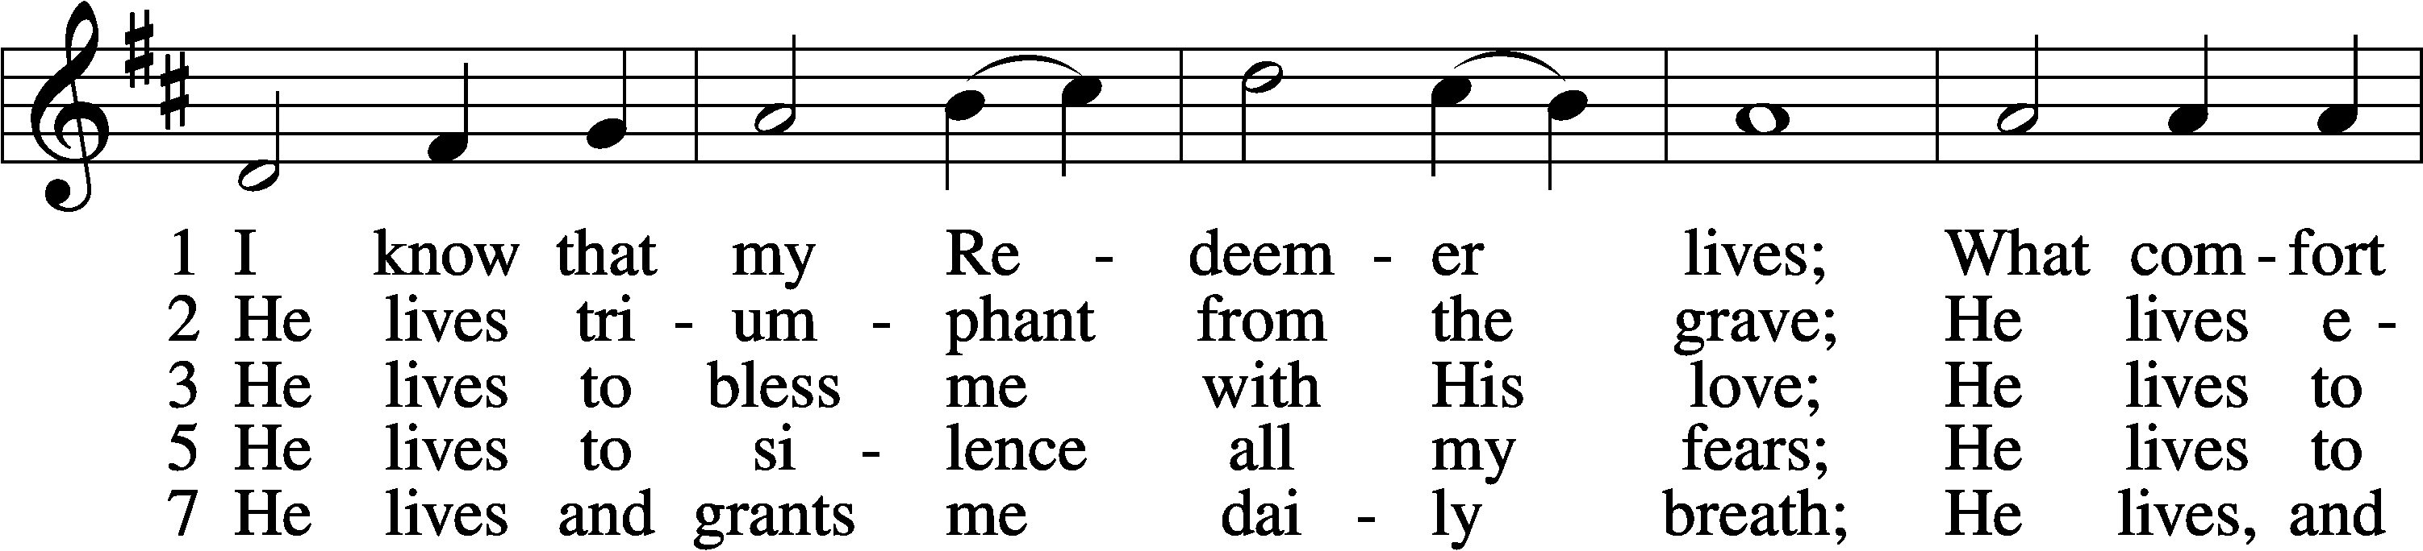
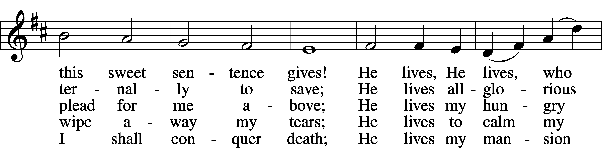
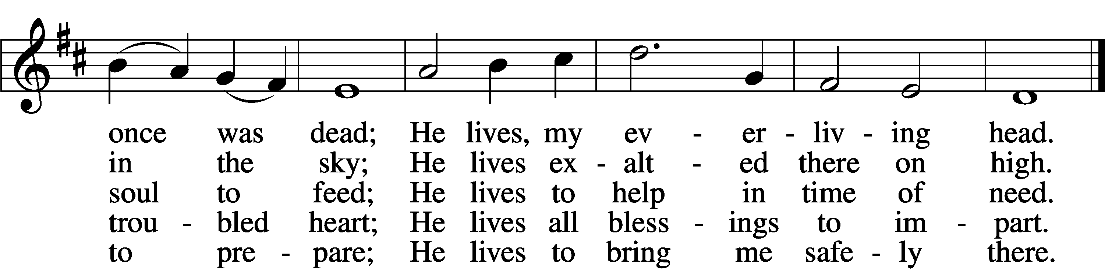
Tune and text: Public domain

Stand

The sign of the cross may be made by all in remembrance of their Baptism.

Invocation
P In the name of the Father and of the T Son and of the Holy Spirit.
C Amen.

Exhortation LSB 151
P If we say we have no sin, we deceive ourselves, and the truth is not in us.
C But if we confess our sins, God, who is faithful and just, will forgive our sins and cleanse us from all unrighteousness.

Silence for reflection on God’s Word and for self-examination.

Confession of Sins LSB 151
P Let us then confess our sins to God our Father.
C Most merciful God, we confess that we are by nature sinful and unclean. We have sinned against You in thought, word, and deed, by what we have done and by what we have left undone. We have not loved You with our whole heart; we have not loved our neighbors as ourselves. We justly deserve Your present and eternal punishment. For the sake of Your Son, Jesus Christ, have mercy on us. Forgive us, renew us, and lead us, so that we may delight in Your will and walk in Your ways to the glory of Your holy name. Amen.

Absolution LSB 151
P Almighty God in His mercy has given His Son to die for you and for His sake forgives you all your sins. As a called and ordained servant of Christ, and by His authority, I therefore forgive you all your sins in the name of the Father and of the T Son and of the Holy Spirit.
C Amen.

Service of the Word

Introit Exodus 15:2a, 6, 13, 17–18; antiphon: v. 1b
I will sing to the Lord, for he has triumphed | gloriously;*
the horse and his rider he has thrown in- | to the sea.
The Lord is my strength | and my song,*
and he has become my sal- | vation.
Your right hand, O Lord, glorious | in power,*
your right hand, O Lord, shatters the | enemy.
You have led in your steadfast love the people whom you | have redeemed;*
you have guided them by your strength to your ho- | ly abode.
You will bring them in and plant them on your own | mountain,*
the place, O Lord, which you have made for | your abode,
the sanctuary, O Lord, which your hands have es- | tablished.*
The Lord will reign forever and | ever.
Glory be to the Father and | to the Son*
and to the Holy | Spirit;
as it was in the be- | ginning,*
is now, and will be forever. | Amen.
I will sing to the Lord, for he has triumphed | gloriously;*
the horse and his rider he has thrown in- | to the sea.

Kyrie LSB 152

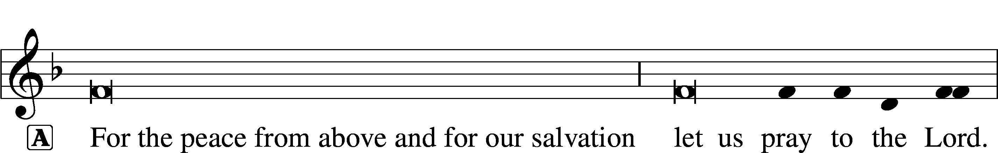

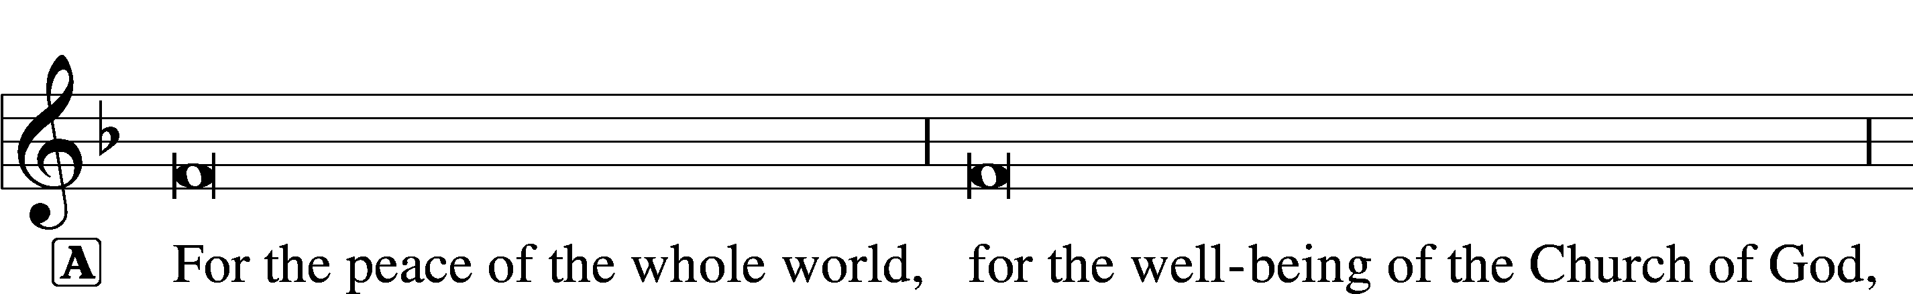

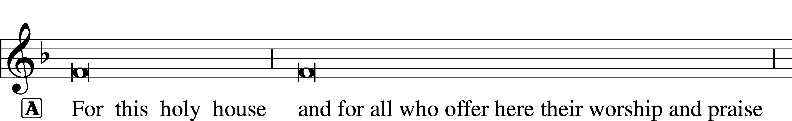

This Is the Feast LSB 155
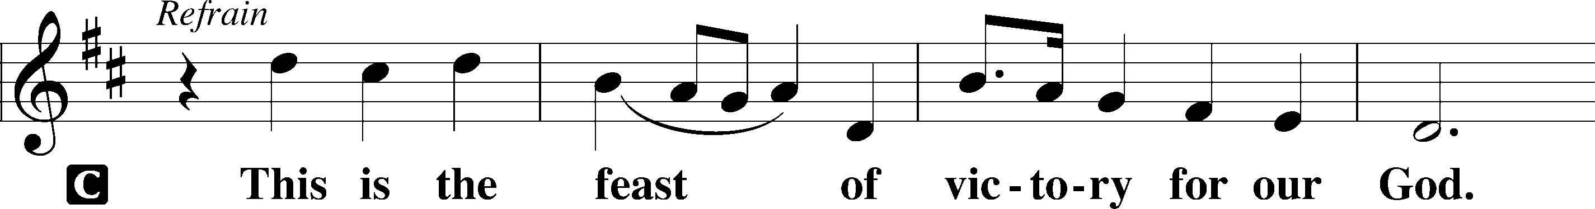
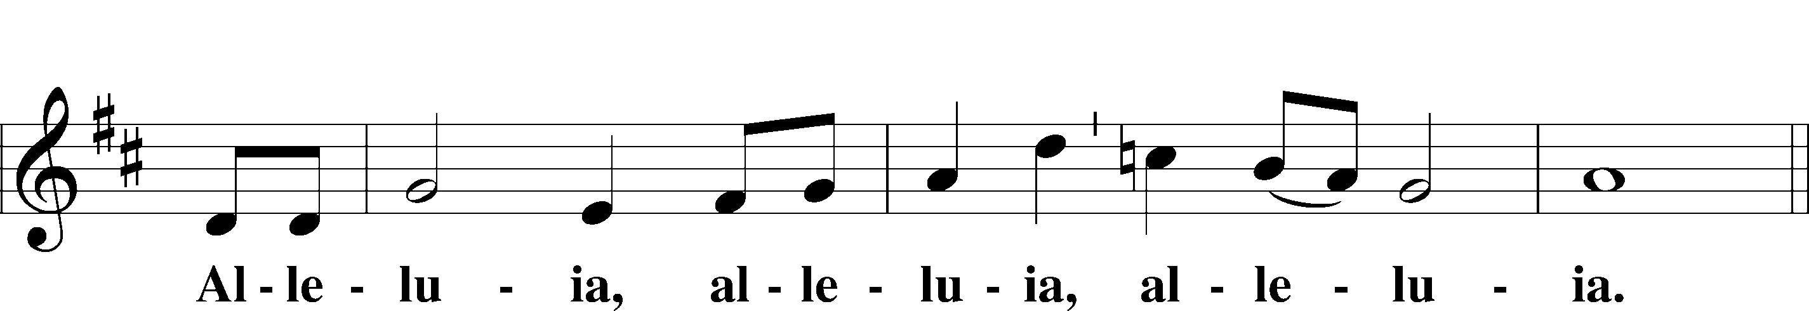
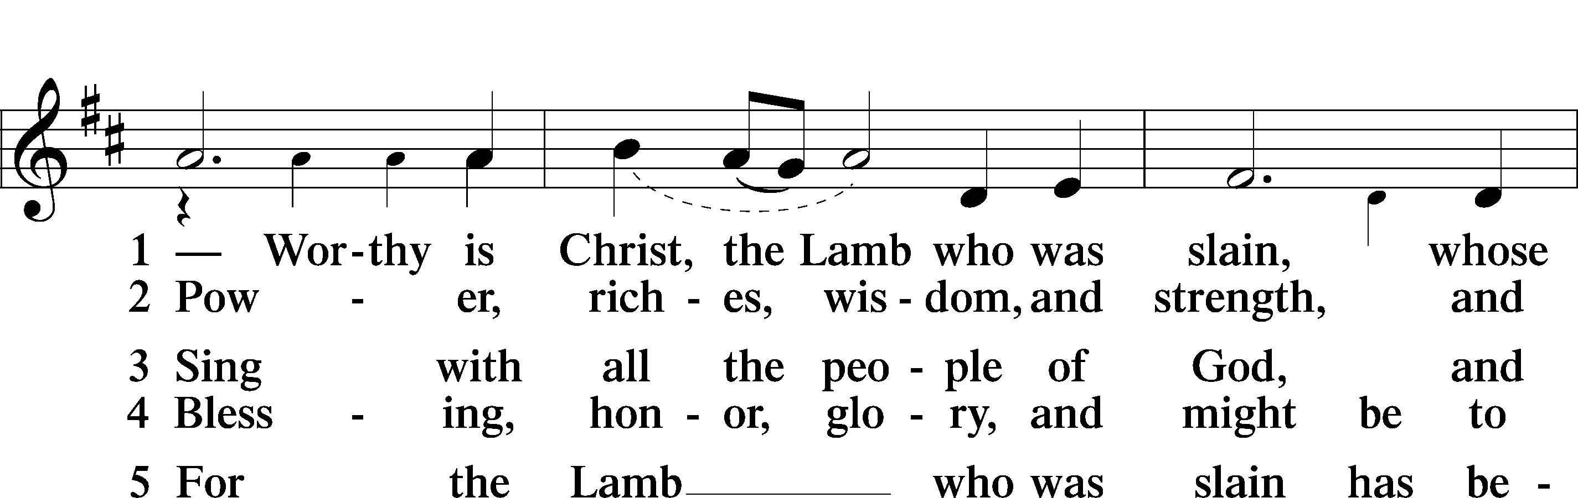
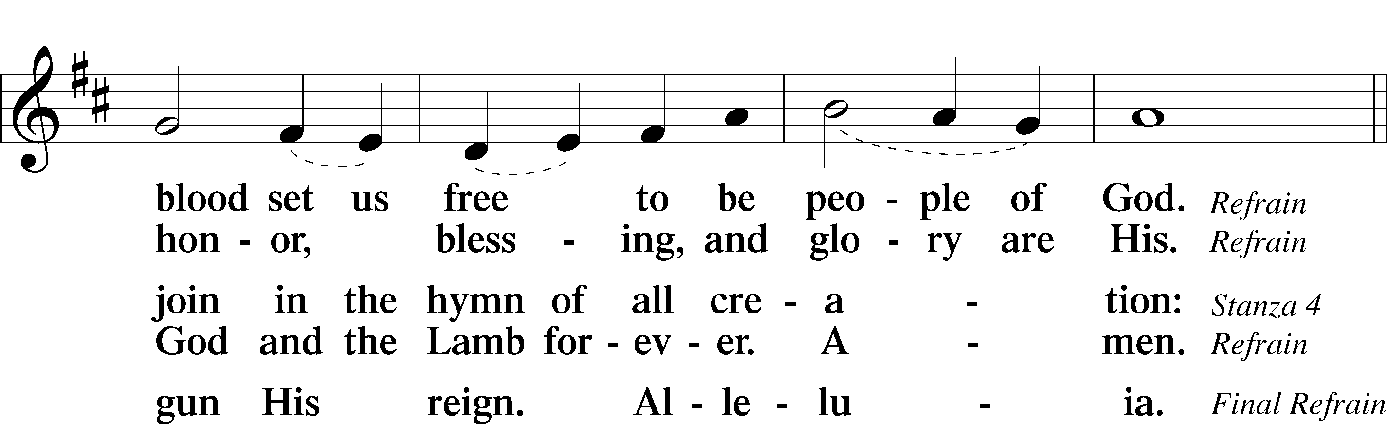
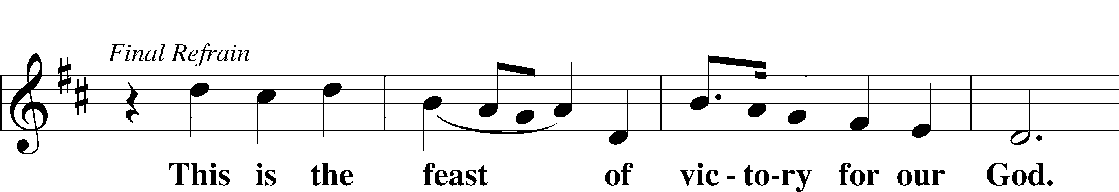
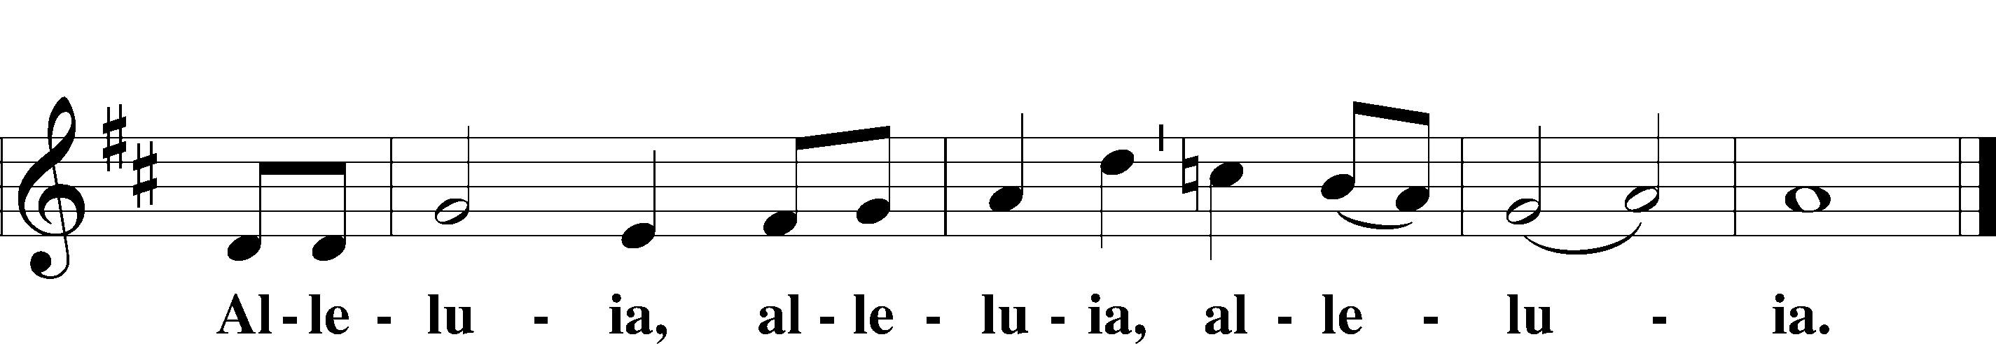

Salutation and Collect of the Day
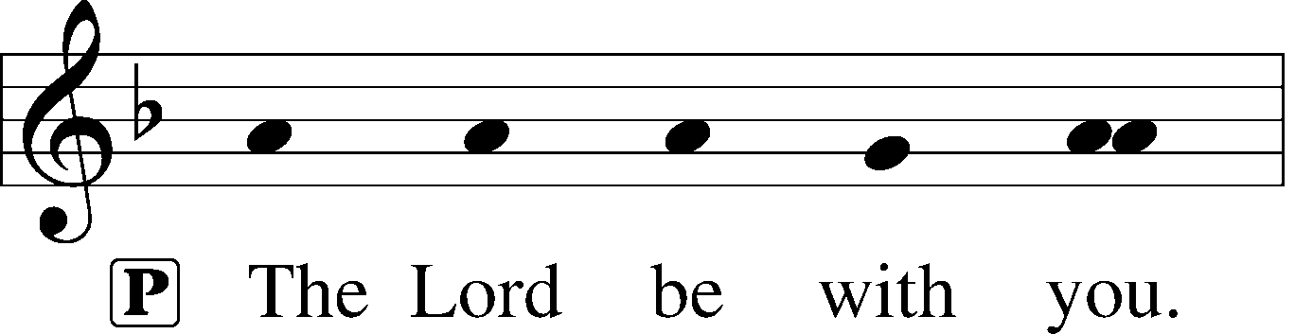
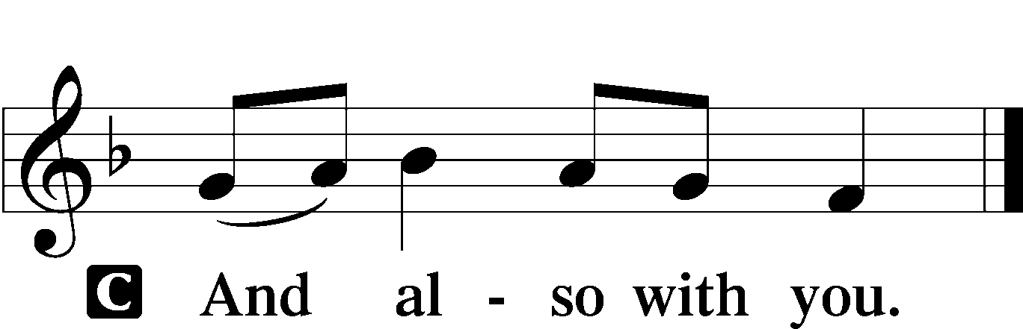

P Let us pray.
Almighty God the Father, through Your only-begotten Son, Jesus Christ, You have overcome death and opened the gate of everlasting life to us. Grant that we, who celebrate with joy the day of our Lord’s resurrection, may be raised from the death of sin by Your life-giving Spirit; through Jesus Christ, our Lord, who lives and reigns with You and the Holy Spirit, one God, now and forever.

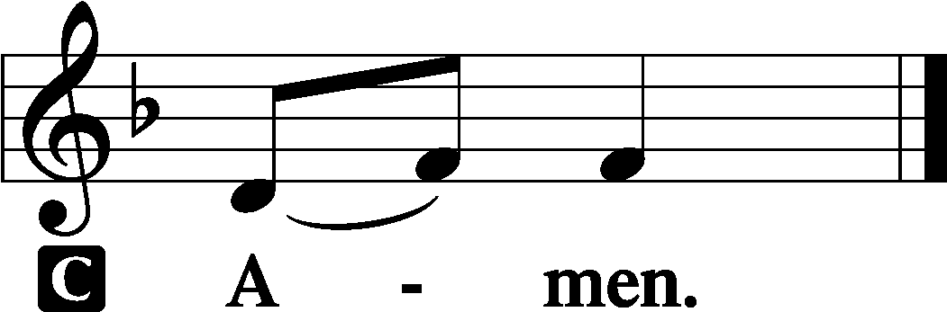

Sit

Old Testament Reading Isaiah 25:6–9
⁶On this mountain the Lord of hosts will make for all peoples
a feast of rich food, a feast of well-aged wine,
of rich food full of marrow, of aged wine well refined.
⁷And he will swallow up on this mountain
the covering that is cast over all peoples,
the veil that is spread over all nations.
⁸He will swallow up death forever;
and the Lord God will wipe away tears from all faces,
and the reproach of his people he will take away from all the earth,
for the Lord has spoken.
⁹It will be said on that day,
“Behold, this is our God; we have waited for him, that he might save us.
This is the Lord; we have waited for him;
let us be glad and rejoice in his salvation.”
A This is the Word of the Lord.
C Thanks be to God.

Gradual adapt. from Matthew 28:7; Hebrews 2:7; Psalm 8:6
Christ has risen | from the dead.*
[God the Father] has crowned him with glory and | honor.
He has given him dominion over the works | of his hands;*
he has put all things un- | der his feet.

Epistle 1 Corinthians 15:1–11
The Resurrection of Christ
¹Now I would remind you, brothers, of the gospel I preached to you, which you received, in which you stand, ²and by which you are being saved, if you hold fast to the word I preached to you—unless you believed in vain.
³For I delivered to you as of first importance what I also received: that Christ died for our sins in accordance with the Scriptures, ⁴that he was buried, that he was raised on the third day in accordance with the Scriptures, ⁵and that he appeared to Cephas, then to the twelve. ⁶Then he appeared to more than five hundred brothers at one time, most of whom are still alive, though some have fallen asleep. ⁷Then he appeared to James, then to all the apostles. ⁸Last of all, as to one untimely born, he appeared also to me. ⁹For I am the least of the apostles, unworthy to be called an apostle, because I persecuted the church of God. ¹⁰But by the grace of God I am what I am, and his grace toward me was not in vain. On the contrary, I worked harder than any of them, though it was not I, but the grace of God that is with me. ¹¹Whether then it was I or they, so we preach and so you believed.

A This is the Word of the Lord.
C Thanks be to God.

Stand

Verse of the Day 2 Timothy 1:10b
Alleluia. [Christ Jesus] abolished death and brought life and immortality to light through the gospel. Alleluia.

Holy Gospel Mark 16:1–8
P The Holy Gospel according to St. Mark, the sixteenth chapter.

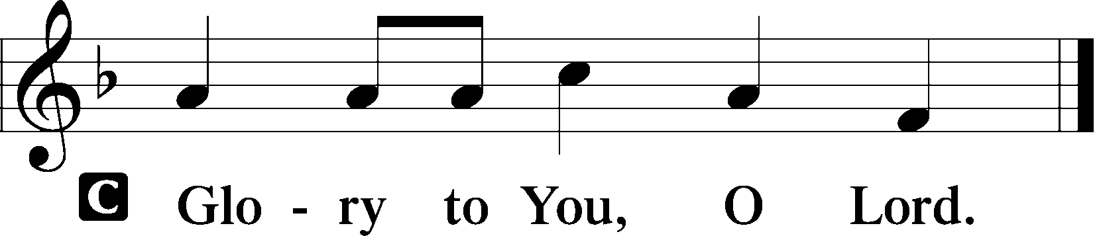

The Resurrection
¹When the Sabbath was past, Mary Magdalene and Mary the mother of James and Salome bought spices, so that they might go and anoint him. ²And very early on the first day of the week, when the sun had risen, they went to the tomb. ³And they were saying to one another, “Who will roll away the stone for us from the entrance of the tomb?” ⁴And looking up, they saw that the stone had been rolled back—it was very large. ⁵And entering the tomb, they saw a young man sitting on the right side, dressed in a white robe, and they were alarmed. ⁶And he said to them, “Do not be alarmed. You seek Jesus of Nazareth, who was crucified. He has risen; he is not here. See the place where they laid him. ⁷But go, tell his disciples and Peter that he is going before you to Galilee. There you will see him, just as he told you.” ⁸And they went out and fled from the tomb, for trembling and astonishment had seized them, and they said nothing to anyone, for they were afraid.

P This is the Gospel of the Lord.

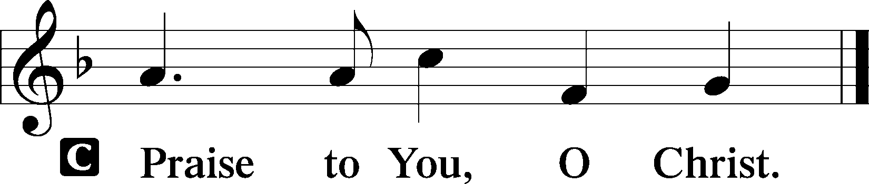

Sit

480 He’s Risen, He’s Risen
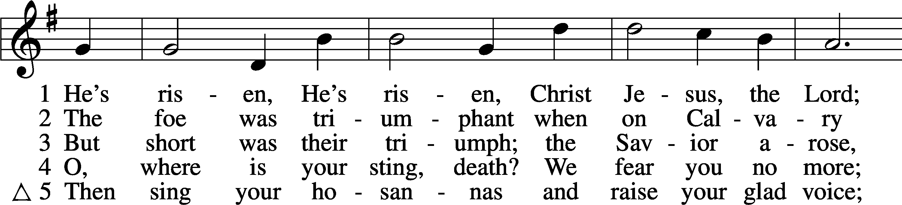
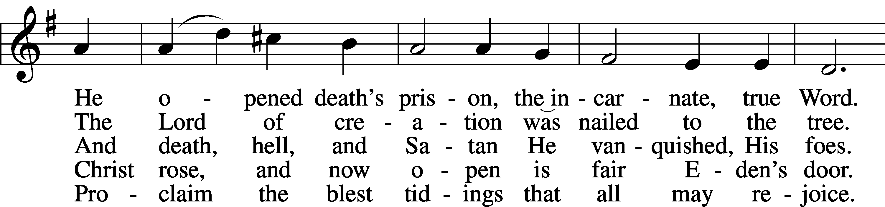
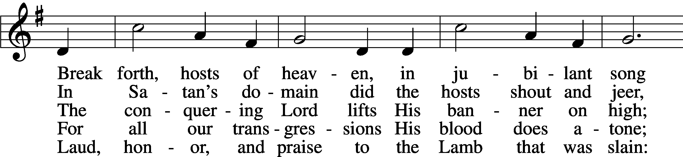
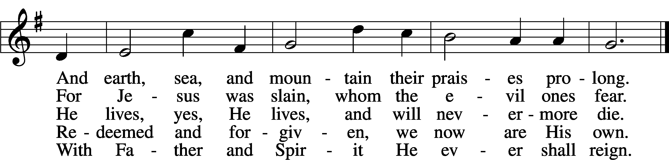
Tune: Public domain
Text: © 1941 Concordia Publishing House. Used by permission: LSB Hymn License no. 110003744

Sermon - Return and See!

Stand

Nicene Creed
C I believe in one God,
the Father Almighty,
maker of heaven and earth
and of all things visible and invisible.

And in one Lord Jesus Christ,
the only-begotten Son of God,
begotten of His Father before all worlds,
God of God, Light of Light,
very God of very God,
begotten, not made,
being of one substance with the Father,
by whom all things were made;
who for us men and for our salvation came down from heaven
and was incarnate by the Holy Spirit of the virgin Mary
and was made man;
and was crucified also for us under Pontius Pilate.
He suffered and was buried.
And the third day He rose again according to the Scriptures
and ascended into heaven
and sits at the right hand of the Father.
And He will come again with glory to judge both the living and the dead,
whose kingdom will have no end.

And I believe in the Holy Spirit,
the Lord and giver of life,
who proceeds from the Father and the Son,
who with the Father and the Son together is worshiped and glorified,
who spoke by the prophets.
And I believe in one holy Christian and apostolic Church,
I acknowledge one Baptism for the remission of sins,
and I look for the resurrection of the dead
and the life T of the world to come. Amen.

Prayer of the Church

Offering

Offertory LSB 159
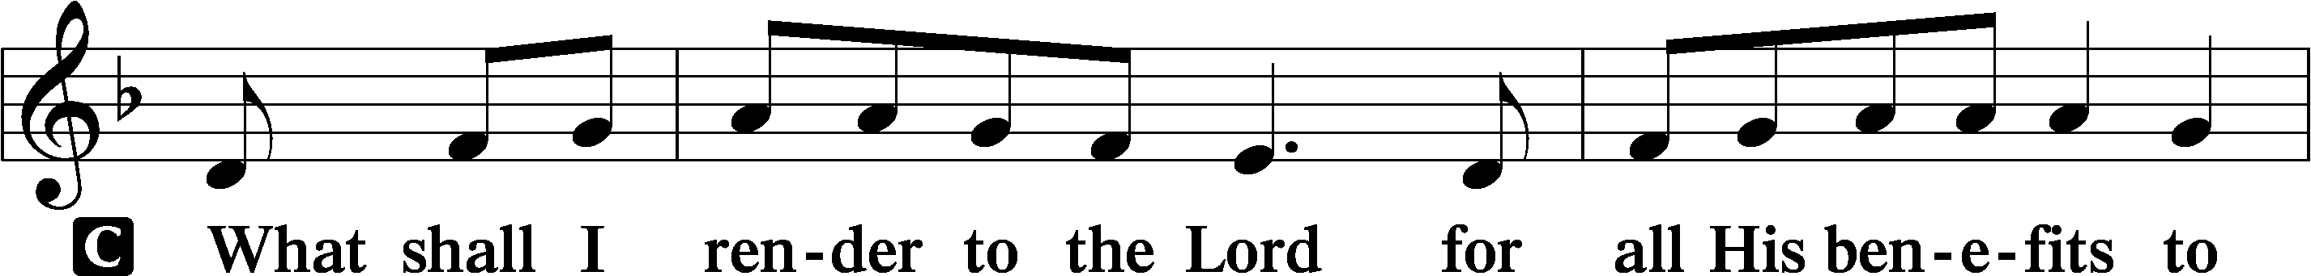
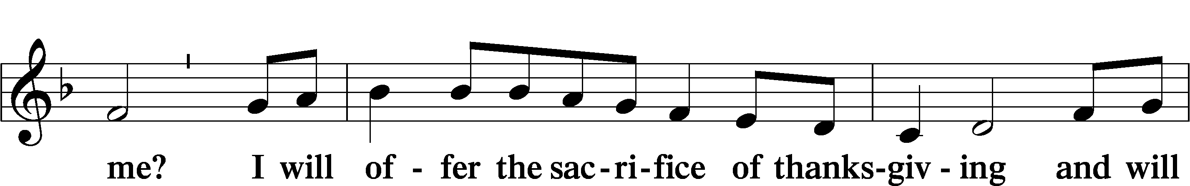
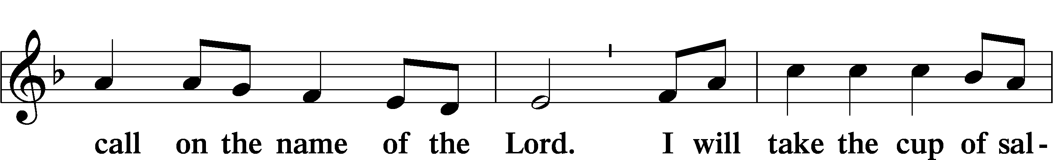
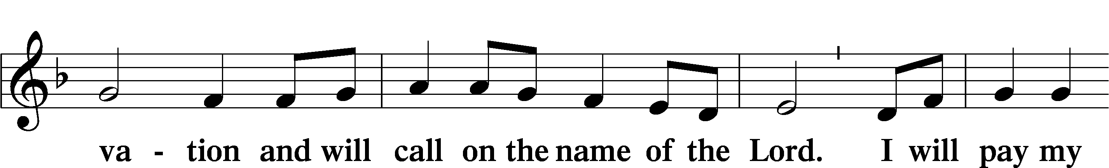
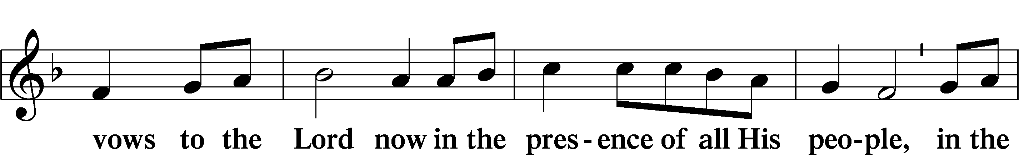
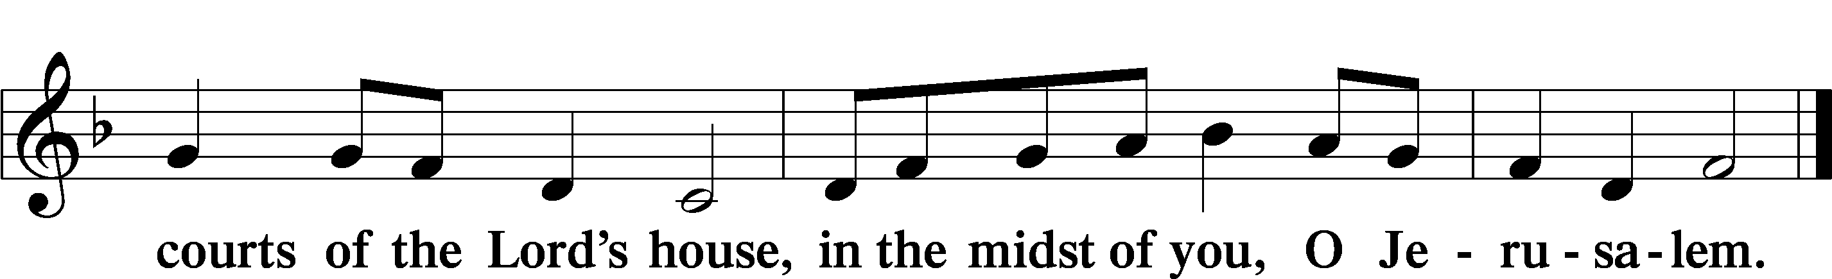

Service of the Sacrament

Preface LSB 160
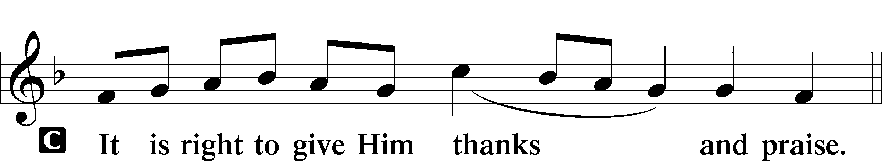

Proper Preface (Full)
P It is truly good, right, and salutary that we should at all times and in all places give thanks to You, holy Lord, almighty Father, everlasting God. And most especially are we bound to praise You on this day for the glorious resurrection of Your Son, Jesus Christ, the very Paschal Lamb, who was sacrificed for us and bore the sins of the world. By His dying He has destroyed death, and by His rising again He has restored to us everlasting life. Therefore with Mary Magdalene, Peter and John, and with all the witnesses of the resurrection, with angels and archangels, and with all the company of heaven we laud and magnify Your glorious name, evermore praising You and saying:

Sanctus LSB 161
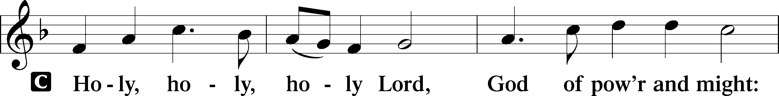
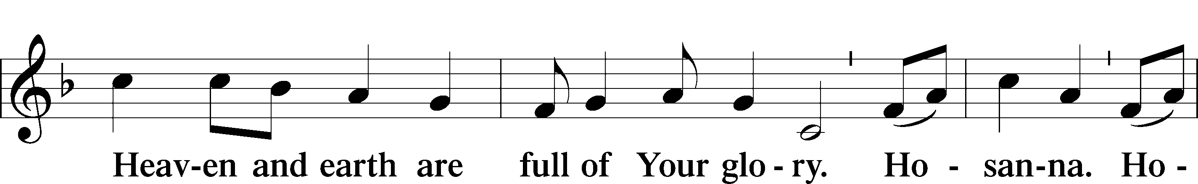
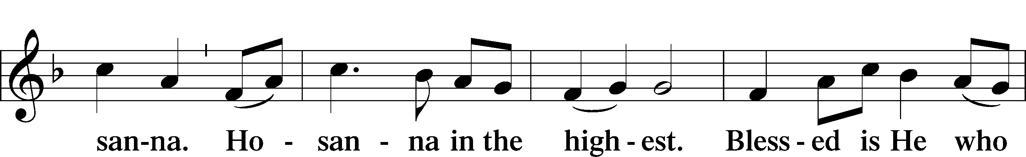
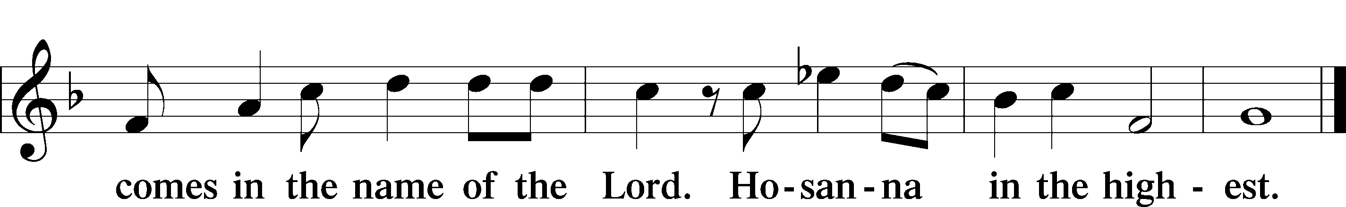

Lord’s Prayer LSB 162
P Lord, remember us in Your kingdom and teach us to pray:
C Our Father who art in heaven,
hallowed be Thy name,
Thy kingdom come,
Thy will be done on earth
as it is in heaven;
give us this day our daily bread;
and forgive us our trespasses
as we forgive those
who trespass against us;
and lead us not into temptation,
but deliver us from evil.
For Thine is the kingdom
and the power and the glory
forever and ever. Amen.

The Words of Our Lord
P Our Lord Jesus Christ, on the night when He was betrayed, took bread, and when He had given thanks, He broke it and gave it to the disciples and said: “Take, eat; this is My T body, which is given for you. This do in remembrance of Me.”

In the same way also He took the cup after supper, and when He had given thanks, He gave it to them, saying: “Drink of it, all of you; this cup is the new testament in My T blood, which is shed for you for the forgiveness of sins. This do, as often as you drink it, in remembrance of Me.”

Pax Domini LSB 163
P The peace of the Lord be with you always.
C Amen.

Agnus Dei LSB 163
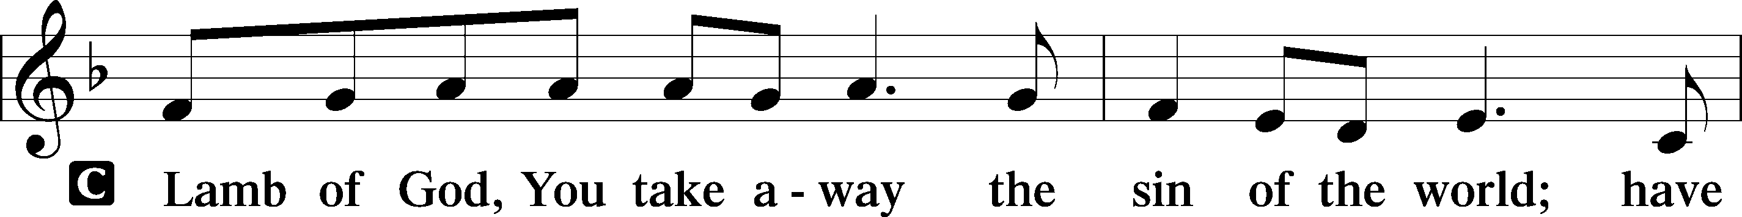
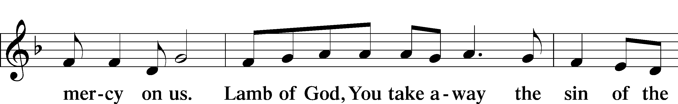
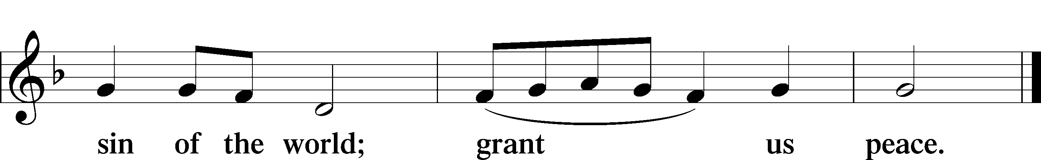

Sit

Distribution

469 Christ the Lord Is Risen Today
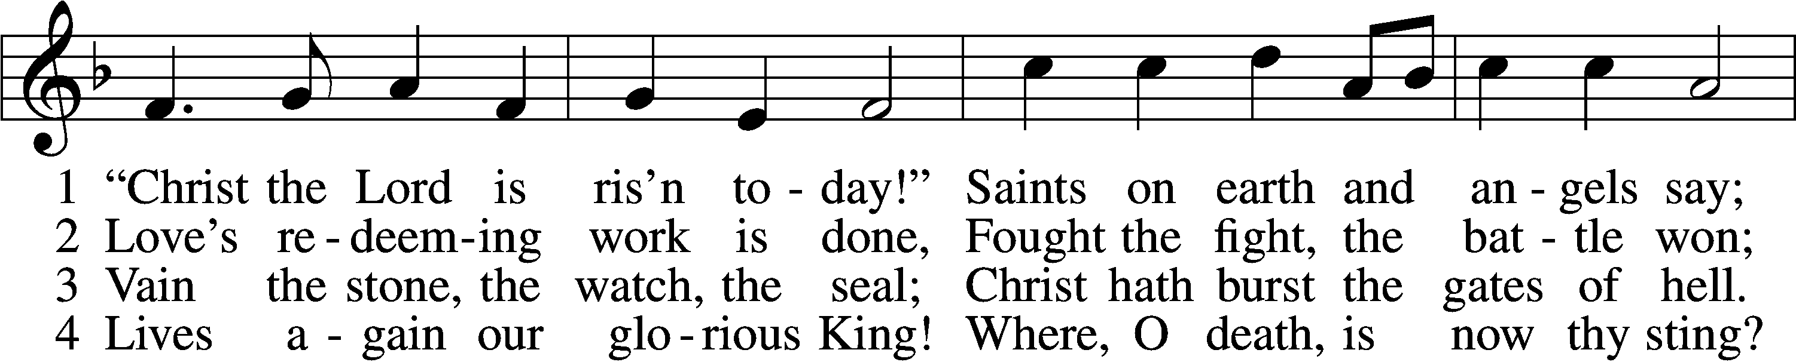
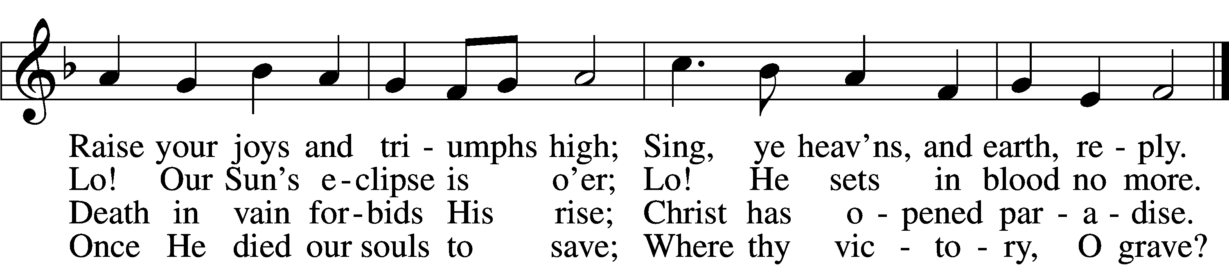

5 Soar we now where Christ has led;
Foll’wing our exalted Head.
Made like Him, like Him we rise;
Ours the cross, the grave, the skies.

6 Hail the Lord of earth and heav’n!
Praise to Thee by both be giv’n!
Thee we greet triumphant now:
Hail, the resurrection, Thou!
Text and tune: Public domain

633 At the Lamb’s High Feast We Sing
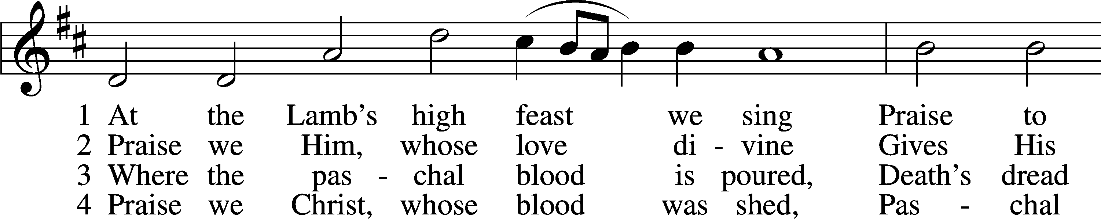
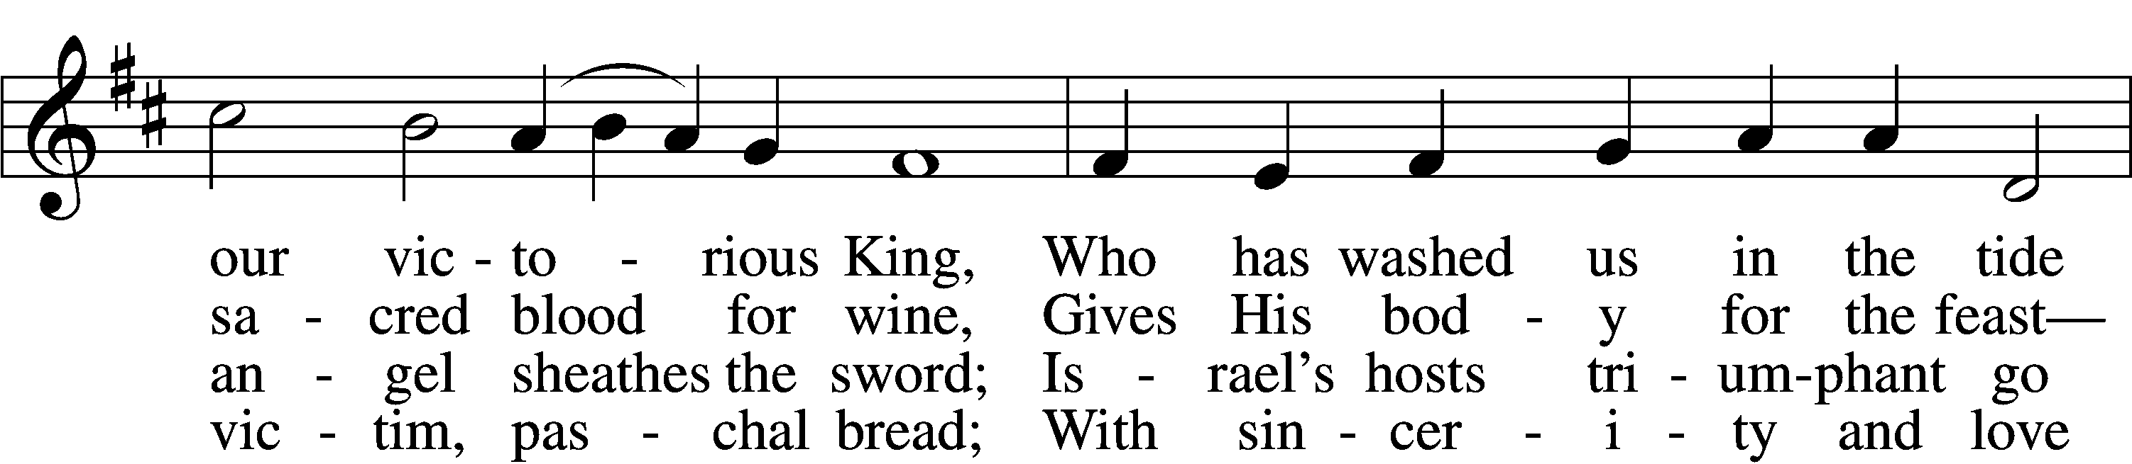
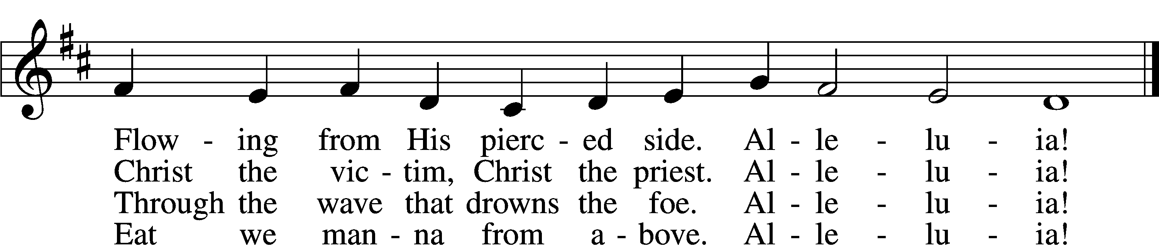

5 Mighty Victim from the sky,
Hell’s fierce pow’rs beneath You lie;
You have conquered in the fight,
You have brought us life and light.
Alleluia!

6 Now no more can death appall,
Now no more the grave enthrall;
You have opened paradise,
And Your saints in You shall rise.
Alleluia!

7 Easter triumph, Easter joy!
This alone can sin destroy;
From sin’s pow’r, Lord, set us free,
Newborn souls in You to be.
Alleluia!

D 8 Father, who the crown shall give,
Savior, by whose death we live,
Spirit, guide through all our days:
Three in One, Your name we praise.
Alleluia!
Tune and text: Public domain
464 The Strife Is O’er, the Battle Done
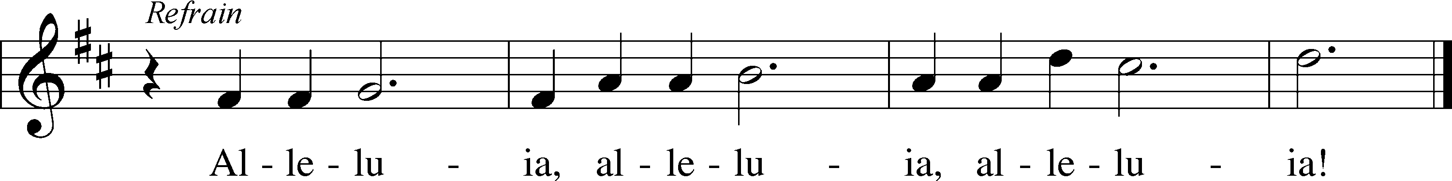
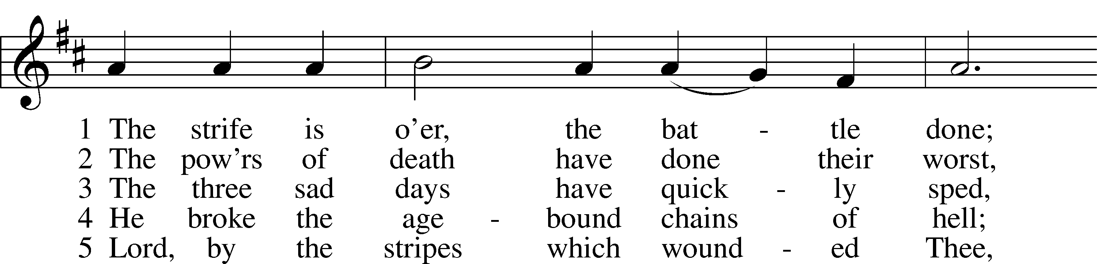
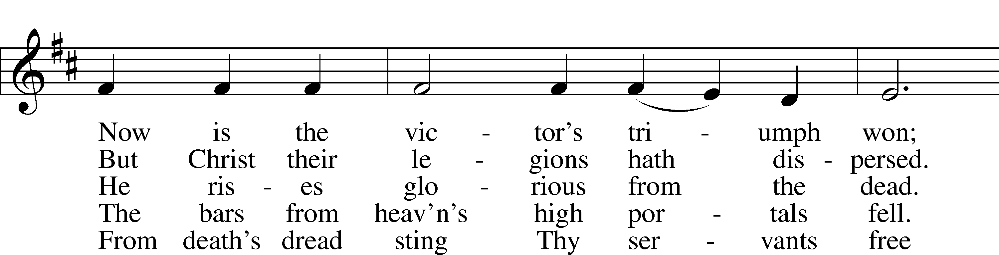
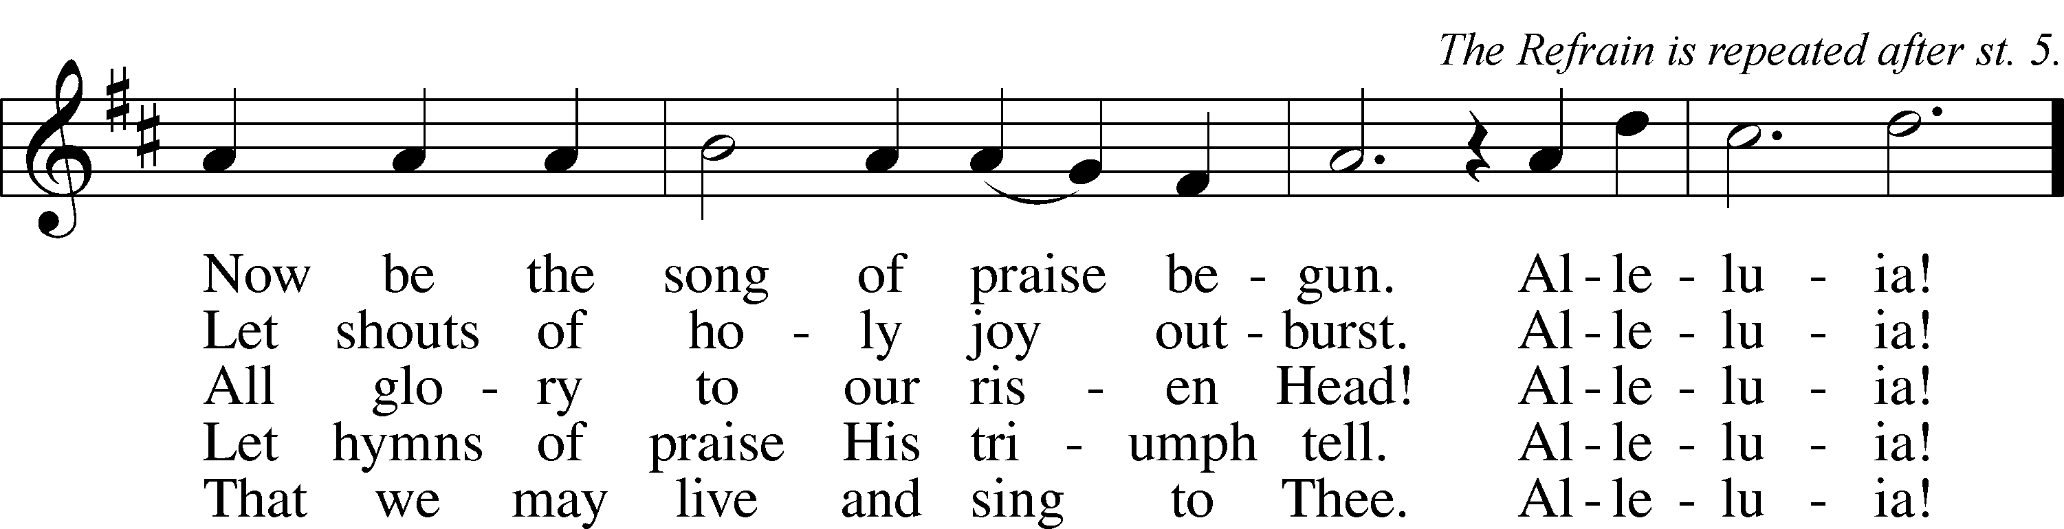
Text and tune: Public domain

Stand

The Dismissal
P The body and blood of our Lord Jesus Christ strengthen and preserve you in body and soul to life everlasting. Depart T in peace.
C Amen.

Thank the Lord LSB 164
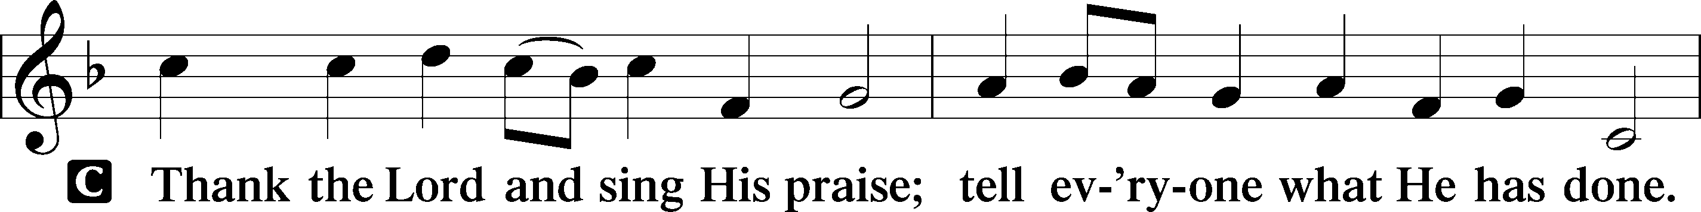
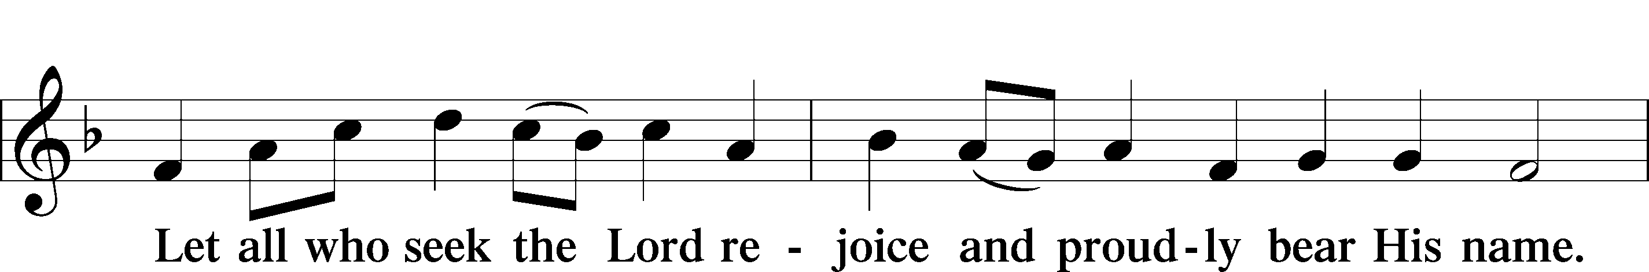
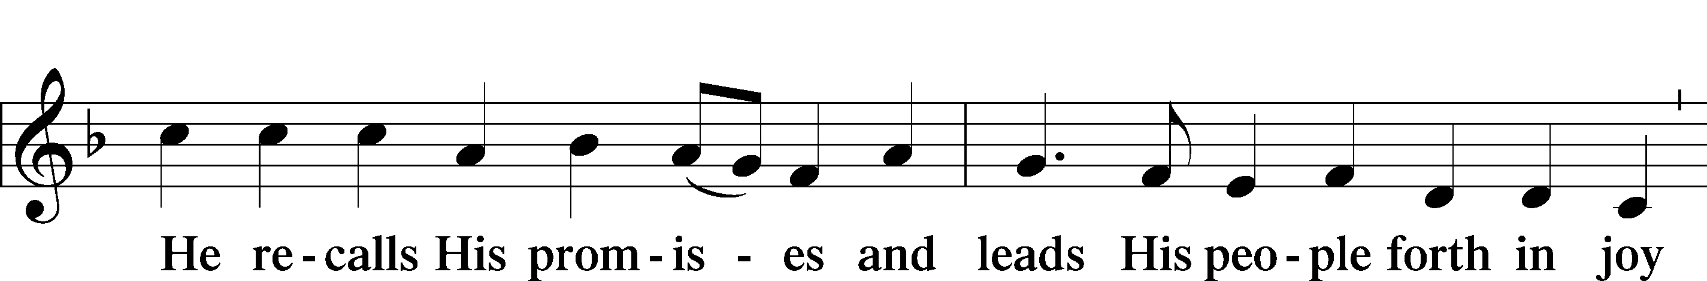
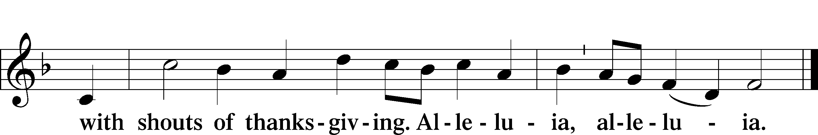

Post-Communion Collect
A Let us pray.
We give thanks to You, almighty God, that You have refreshed us through this salutary gift, and we implore You that of Your mercy You would strengthen us through the same in faith toward You and in fervent love toward one another; through Jesus Christ, Your Son, our Lord, who lives and reigns with You and the Holy Spirit, one God, now and forever.
C Amen.

Benediction LSB 166
P The Lord bless you and keep you.
The Lord make His face shine on you and be gracious to you.
The Lord look upon you with favor and T give you peace.
C Amen.

457 Jesus Christ Is Risen Today
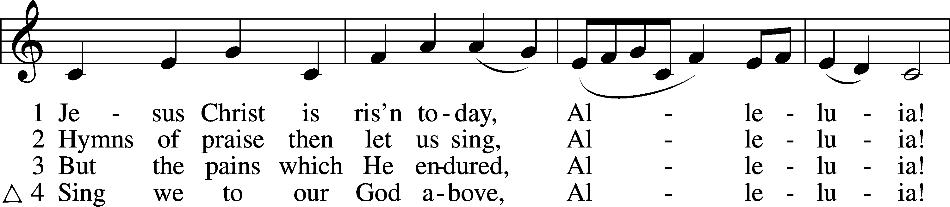
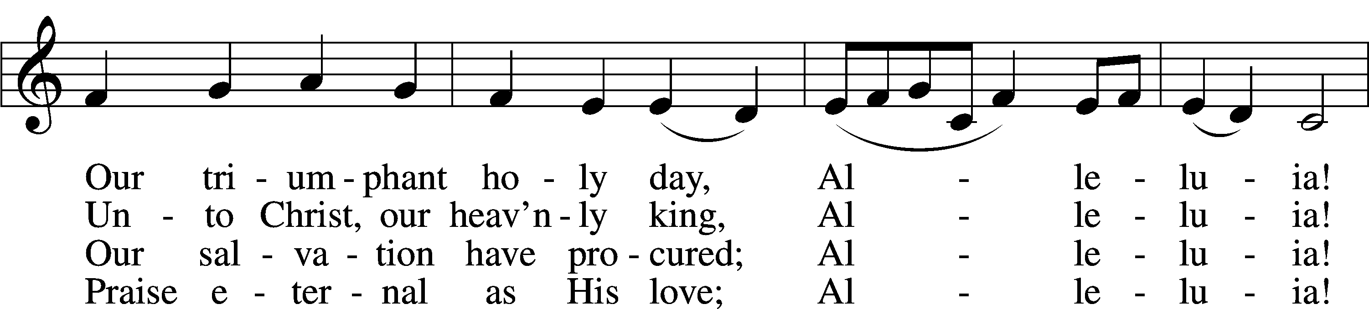
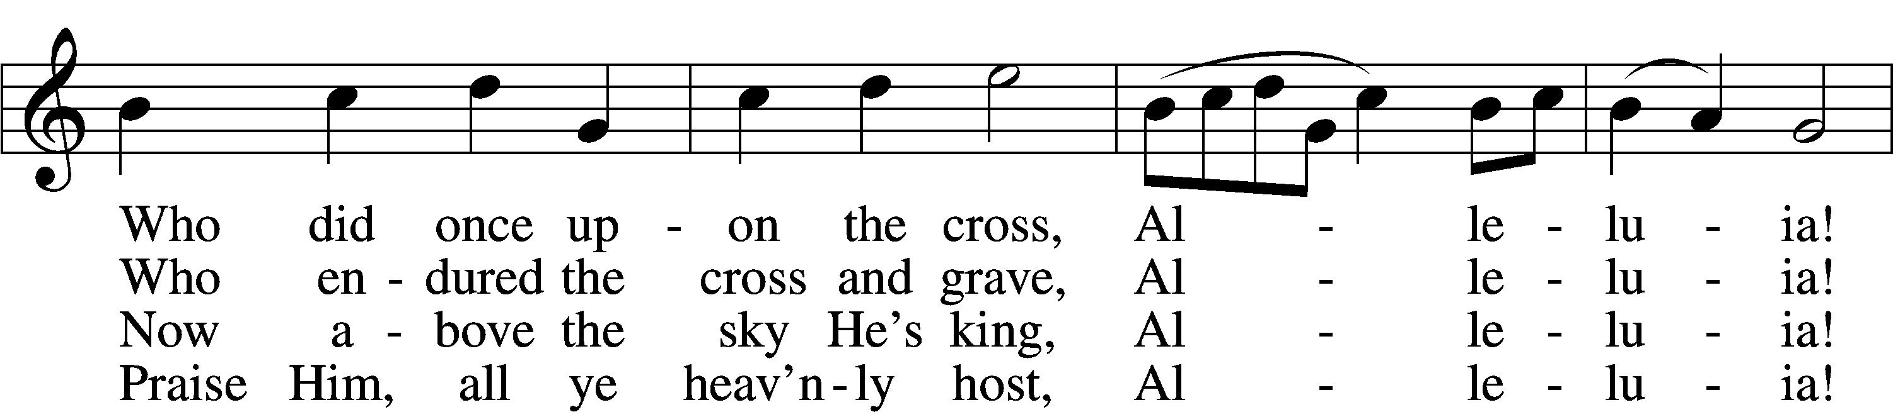
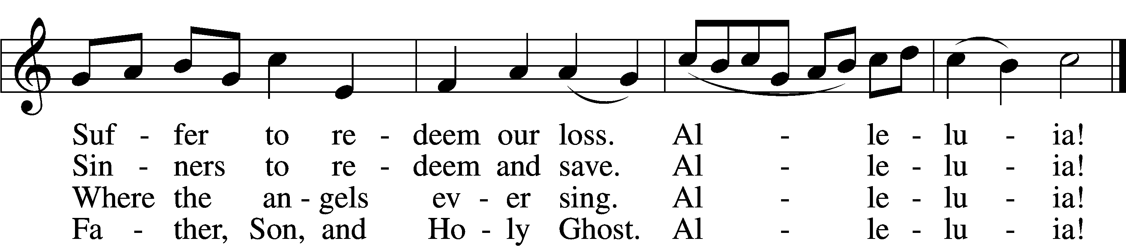
Text and tune: Public domain

Acknowledgments
Unless otherwise indicated, Scripture quotations are from the ESV® Bible (The Holy Bible, English Standard Version®), copyright © 2001 by Crossway, a publishing ministry of Good News Publishers. Used by permission. All rights reserved.
Created by Lutheran Service Builder © 2021 Concordia Publishing House.

Prayers for Our Members
Jade Florang, Nicole Teten, Naomi Wollberg | Expectant Mothers
Norman Abels (Brookestone Meadows – Elkhorn) | Healing
Judy Ahrens | Healing
Vaughn Albrecht (Mount Carmel) | Healing
Tom & DyAnn Altwine | Healing
Jim Catterson | Healing
Lyle Colsden (Mother Hull) | Healing
Pat Flodine (Cambridge Court) | Healing
Vi Fox (Prairie View) | Healing
Verleen Gentry | Healing
Ruby Hatfield | Healing
Boyd Millsap | Healing
Michelle Millsap | Healing
Roger Riekenberg | Healing
Don Richmond | Healing
Marion Richmond | Healing
Ivan Bombeck | Cancer
Fran Junge | Cancer
Bertha Marienau | Cancer
Bev Nuttelman | Cancer
Kim Vos | Cancer

ZION LUTHERAN CHURCH AND SCHOOL

Pr. James DeLoach, Pastor + (308) 627-5260
james.deloach@zionkearney.org
Pr. Doug Gaunt, Pastor + (308) 455-0552
doug.gaunt@zionkearney.org
Tony Splittgerber, Principal + (308) 293-0168
anthony.splittgerber@zionkearney.org

Church Office
Administrative Assistant: Jessica Shiers
Email: school@zionkearney.org
Phone: (308)-234-3410 Fax: (308) 236-8100
Office Hours: Monday-Friday 8:00am-4:00pm
Radio Broadcast: Sunday @ 10:30 a.m. on 1460 AM
Website: www.zionkearney.com

Prayers for Our Members’ Family & Friends
Dawn Gaunt (Pr. & Carol Gaunt’s daughter-in-law) | Expectant Mother
Brandon & Shannon Howell (Quentin & Janel Lange’s friends) | Expecting
Mariah (Quentin & Janel Lange friend) | Expecting
Will Brennemann (Jami Helmbrecht’s father) | Healing
Reg Duke (Westman’s brother-in-law) | Healing
James Gentry (Verleen Gentry’s son) | Healing
Roger Hoffman (Marc’s father) | Healing
Sharon Kreutzer (Richard’s mother) | Healing
Lyra Mais (Zion student) | Healing
Bailey Markowski (Steve & Fran Junge’s great niece) | Healing
Mary Ann Mertz (Pam’s Uhlir’s friend) | Healing
Tim Powers (Kim Wilken’s brother) | Healing
Roy Reynolds (Verleen Gentry’s son-in-law) | Healing
Lynne Saathoff (Verleen Gentry’s sister-in-law) | Healing
Randy Solomon (Beth Rosenthal’s father) | Healing
Janet Stalder (Carol Florang’s sister) | Healing
Angela Well (Charles Marineau’s granddaughter) | Healing
D.D. Dugger (Sue Kaiser’s brother) | Cancer
Stuart Gronewoller (Lonna’s brother-in-law) | Cancer
Ron Halvorsen (Jeff’s dad) | Cancer
Carol Haubold (Don Helmbrecht’s sister) | Cancer
Randy Jochum (Ken Hockemeier’s brother-in-law) | Cancer
Fred Koch (Pam Uhlir’s cousin) | Cancer
Lynda Kreutzer (Rich & Carol’s sister-in-law) | Cancer
John Moore (family of Susan Tonniges) | Cancer
Sharon Mulhair (Pam Uhlir’s cousin) | Cancer
Jeannie Schmidt (Lisa Splittgerber’s sister-in-law) | Cancer
Tyrone Uhlir (Pam’s nephew) | Cancer

Today’s Radio Broadcast is given to the Glory of the Lord by Carolyn Wilkens

Worship Assistants

Sunday, April 4~ 7:00 am & 9:00am

Elder: Nathan Gaunt
Usher: Fred Flessner & Lennis Hodgson
Engineer: Jamie Nikodym
Announcer: Jesse Florang
Altar Guild: Rachael Burger & Ellen Hockemeier

Sunday, April 11~ 7:00 am & 9:00am

Elder: Eric Rosenthal
Usher: March Hoffman & SteveJunge
Engineer: Zach DeLoach
Announcer: Lonna Gronewoller
Altar Guild: Rachael Burger & Ellen Hockemeier

Our Response to the Gospel

Date: 03/28/2021

Offering: $5,002.71
Weekly Need: $7,542.37

This Week at Zion

Sun  04/04 | 7:00a  9:00a  10:30a | Easter Sunrise Service  Divine Service  Radio Broadcast 1460am
Mon  04/05 | Birthdays  Anniversaries | No School/Office Closed  Addison Helmbrecht  Donald Richmond  ---
Tues  04/06 | 1:30p  7:00p  7:00p  Birthdays  Anniversaries | Sleeping Mats  Stewardship Board  Zion Foundation  ---  Ryan & Brooke Fisher
Wed  04/07 | 8:30a  5:45p  Birthdays  Anniversaries | Chapel  Midweek  Ellen Hockemeier  Frances Junge  Taylor Zehendner  ---
Thurs  04/08 | 7:00p  Birthdays  Anniversaries | ---  ---
Fri  04/09 | Birthdays  Anniversaries | Brynne Fisher  Dallas Jorgensen  ---
Sat  04/10 | 5:00p  Birthdays  Anniversaries | Divine Service  Chelsea Junge  ---
Sun  04/11 | 9:00a  10:30a  Birthdays  Anniversaries | Divine Service  Radio Broadcast 1460am  ---  ---

Where our Triune God strengthens us through His mercy in faith toward Him and in fervent love toward one another.

ANNOUNCEMENTS

Offering Options:
To worship the Lord with your offering:
1) Place your offering in the basket as you leave
2) Go to zionkearney.churchtrac.com/give
3) Go to zionkearney.com and click on the ChurchTrac icon
4) Mail your gift to Zion Lutheran Church, 2421 C Ave, Kearney, NE 68847 or place it in the mail slot on the south side of the building.

An Adult and Youth Bible Study – are prerecorded and available each Sunday, along with a study guide you can use to follow along. We are studying the three lessons for the day—the Old Testament, the Epistle, and the Gospel. Go to Zion’s website www.zionkearney.com to access the video and study guide.

Easter Lilies - Thank you to those that purchased Easter lilies to beautify the sanctuary during Easter. Those individuals are: David & Kay Banner, Pat & Patrice Brost, Paul & Rachael Burger, Waunita DeLaet, Pr. & Carol DeLoach, Mike & Melinda Dulitz, Jerry & Nancy Dulitz, Wes & Mary Fiddelke, Vi Fox, Pr. & Carol Gaunt, Lonna Gronewolller, Shirley & Don Helmbrecht, Doreen Lemburg, Dan & Shirley Oertwig, Marion & Don Richmond, Jane Schmid, Becky Thornton, Carlene Waldron in memory of Carl & Irene Jacobson & Lana Schroder

All who provided a lily are welcome to take it home after the 9:00 Sunday service.

Thank you – to the “Lutheran Luggers” who help move us into our new home on Sunday afternoon, March 21. We are so grateful for all the help and love shown us.
Don & Marion Richmond

Radio Broadcast - Please help Zion spread the Gospel! There are several open dates.

Church Management System – Zion is in the process of changing to a web-based church management system called ChurchTrac. Please use the website link or the QR code below and set up your ChurchTrac account. This will link up to your profile and you will be given access to an amount of predetermined information about Zion and your fellow members. We always seek to keep your information secure. For security reasons, once you sign up, the office will approve you as a member, then you will have access to your profile. Also, you will be able to update your own directory information (address, phone number, etc.) and decide what information you want to share with fellow members.

If you currently give your offering online using Pushpay, then please switch to ChurchTrac. We would like to cancel our Pushpay subscription by the end of March. If you would like to start to give online, we believe ChurchTrac will be very user friendly. If you need any assistance please contact the church office (234-3410).

For a step by step guide there are copies in the narthex.

The website:

https://zionkearney.churchtrac.com/give

To use the QR code open your camera app on your smart phone and show it the image below. There will be a website that will pop up.
SCHOOL NEWS

Plant Sales – It is the last few days to order plants To order see a Zion student, contact the office, or order online at www.janetsjungle.com/kearney-zion-lutheran-school.html. Be sure to check out the online bonus buys throughout the sale. Thank you for your support. Order must be in by Monday, April 5th. Thank you for your support.

P.E.A.C.E Auction – COVID is preventing Zion from hosting the in person dinner and auction. However; we still are holding an online auction for the 12th annual fundraiser. Your participation is appreciated. The online auction will be from March 27th – April 10th at PEACE2021.ggo.bid. If you have any questions please contact the office. Thank you for supporting our school!

Registration Open - Registration is now open for the 2021-2022. New this year is an all-day prekindergarten option! If you have any questions, please feel free to contact the office. Please tell your family and friends about Zion. Enroll early to make sure you have a spot.

New Teacher Search - The search for another high quality Lutheran teacher has begun. Full time teachers in our school must be members of the LCMS (or willing to become so). The grade level will most probably be for the 3rd/4th grade. If you or someone you know might be interested in this position, please contact Mr. Splittgerber.
Scrip Cards - Scrip cards are still available during this time. Visit the office during normal hours to purchase your gift cards.

Ways to Help – Turn in your Family Fresh shopping receipts to the office.

Scan your receipts for box top points. Download the box top app on your device and select Zion Lutheran of Kearney and scan your receipt. This is the only way box tops work, they no longer accept mailed submissions.

