Divine Service

7

Second Sunday of Easter
April 11, 2021

Zion Lutheran Church
Kearney, Nebraska

Welcome to Zion!
All worshippers please fill out an attendance card in the pew rack and let us know how we might be of service to you.

Holy Communion at Zion

The Lord’s Supper is celebrated at this congregation as Jesus has given it. As he says, our Lord gives into our mouths not only bread and wine but his very body and blood to eat and to drink for the forgiveness of sins and to strengthen our union with him and with one another. Our Lord invites to his table those who trust his words, repent of all sin, and set aside any refusal to forgive and love as he forgives and loves us, that they may show forth his death until he comes. All communicants need to register in the narthex prior to the service.

Because those who eat and drink our Lord’s body and blood unworthily do great harm and because Holy Communion is a confession of the faith which is confessed at this altar, any who are not yet instructed, in doubt, or who hold a confession differing from that of this congregation and The Lutheran Church—Missouri Synod, are asked not to commune until they are able to speak with our pastor first. He is happy to visit with you about the Christian faith and how to receive the Lord’s Supper for your good and for the good of others. Those not communing are invited to come to the altar, cross your arms in front of you, and bow your head to receive a pastoral blessing.

The Risen Christ Breathes His Peace in the Holy Absolution

The crucified and risen Lord Jesus appeared to His apostles on the first Easter Sunday. He “came and stood among them,” and with His Word and the wounds in “his hands and his side,” He granted them His peace (John 20:19–20). He sent them as ministers of the Gospel in His name to bestow the life-giving Holy Spirit for us and for His whole Church through the forgiveness of sins (John 20:21–23). Through this apostolic ministry, He calls us to believe that He “is the Christ, the Son of God,” so that by such faith we “may have life in his name” (John 20:31). The apostles “have seen and heard” this divine life manifested in the flesh of Christ, and those who succeed them in this apostolic ministry now proclaim that same Absolution to us, so that we “too may have fellowship” with the risen Christ, with the apostles and “with one another” (1 John 1:1–7). The one, holy, catholic and apostolic Church lives by “their testimony to the resurrection of the Lord Jesus,” and all who believe this Word are “of one heart and soul,” because in Him they truly have “everything in common” (Acts 4:32–33).
Confession and Absolution

466 Christ Has Arisen, Alleluia
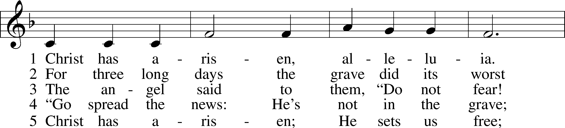
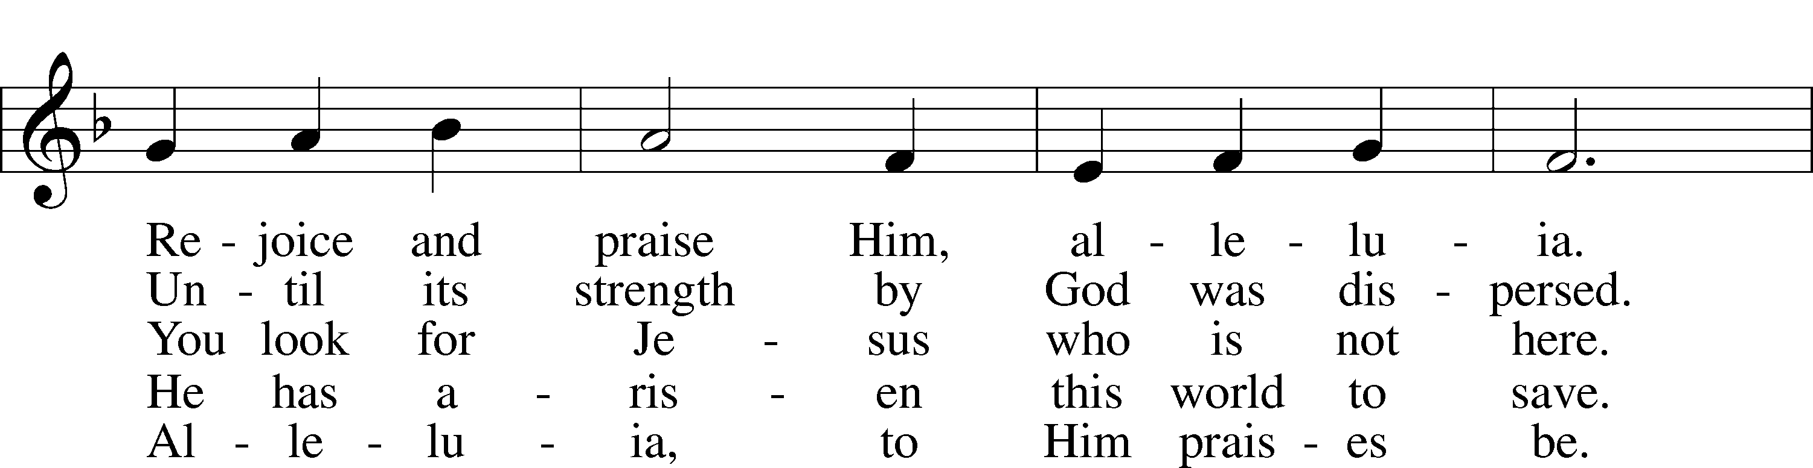
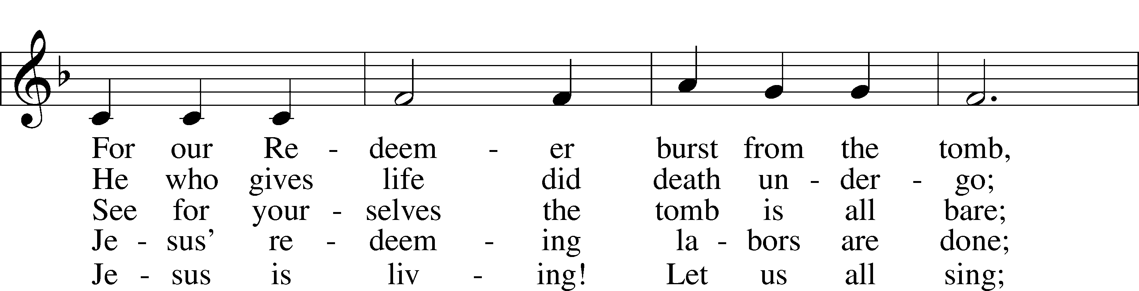
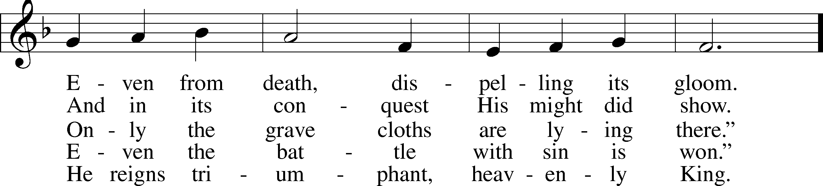
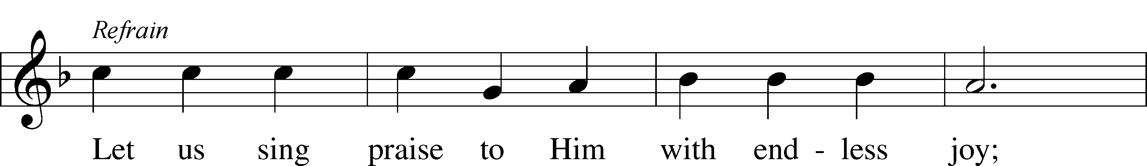
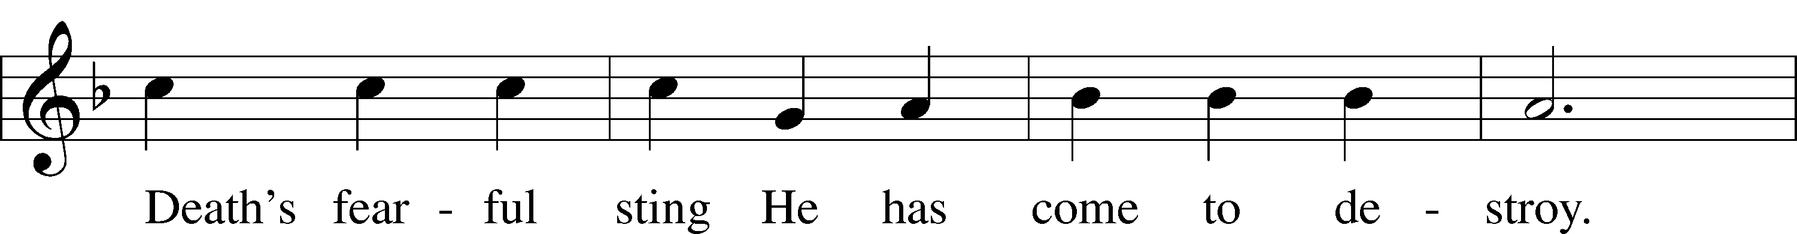
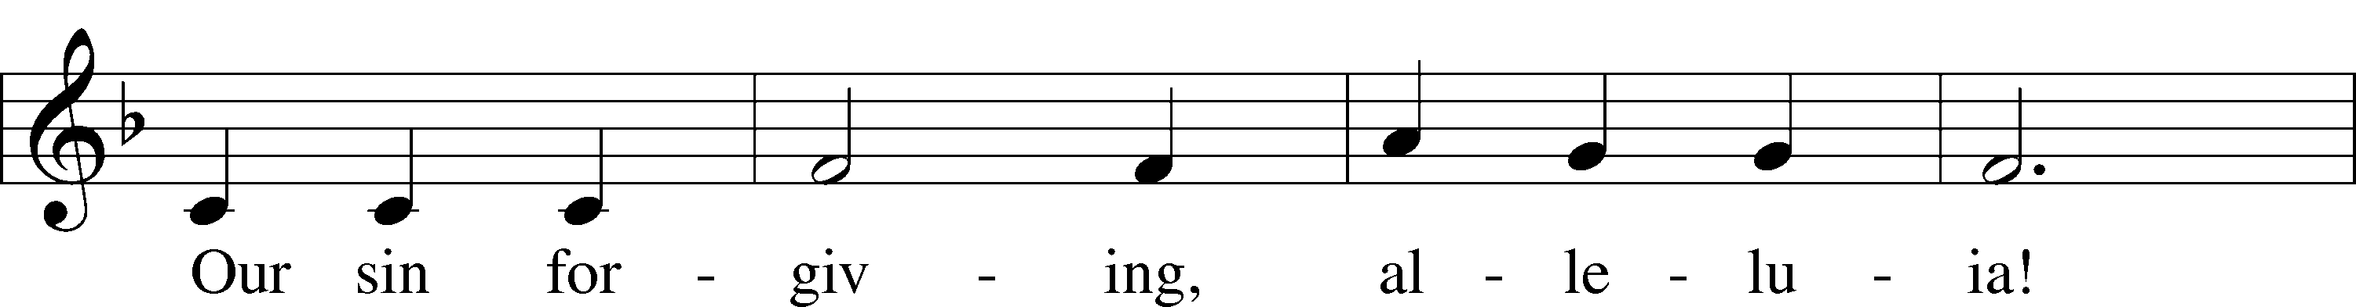
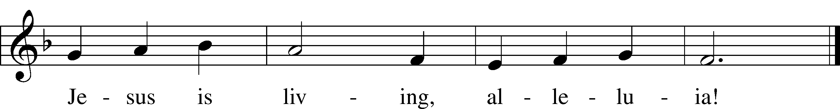
Text: © 1977 Howard S. Olson. Used by permission: LSB Hymn License no. 110003744
Tune: Public domain

Stand

The sign of the cross may be made by all in remembrance of their Baptism.

Invocation
P In the name of the Father and of the T Son and of the Holy Spirit.
C Amen.

Exhortation LSB 151
P If we say we have no sin, we deceive ourselves, and the truth is not in us.
C But if we confess our sins, God, who is faithful and just, will forgive our sins and cleanse us from all unrighteousness.

Silence for reflection on God’s Word and for self-examination.

Confession of Sins LSB 151
P Let us then confess our sins to God our Father.
C Most merciful God, we confess that we are by nature sinful and unclean. We have sinned against You in thought, word, and deed, by what we have done and by what we have left undone. We have not loved You with our whole heart; we have not loved our neighbors as ourselves. We justly deserve Your present and eternal punishment. For the sake of Your Son, Jesus Christ, have mercy on us. Forgive us, renew us, and lead us, so that we may delight in Your will and walk in Your ways to the glory of Your holy name. Amen.

Absolution LSB 151
P Almighty God in His mercy has given His Son to die for you and for His sake forgives you all your sins. As a called and ordained servant of Christ, and by His authority, I therefore forgive you all your sins in the name of the Father and of the T Son and of the Holy Spirit.
C Amen.

Service of the Word

Introit Psalm 105:1–5, 8; antiphon: 1 Peter 2:2–3
Like newborn infants, long for the pure spiritual milk, that by it you may grow up to sal- | vation—*
if indeed you have tasted that the | Lord is good.
Oh give thanks to the Lord; call up- | on his name;*
make known his deeds among the | peoples!
Sing to him, sing prais- | es to him;*
tell of all his | wondrous works!
Glory in his | holy name;*
let the hearts of those who seek the | Lord rejoice!
Seek the Lord | and his strength;*
seek his presence con- | tinually!
Remember the wondrous works that | he has done,*
his miracles, and the judgments he | uttered.
He remembers his covenant for- | ever,*
the word that he commanded, for a thousand gener- | ations.
Glory be to the Father and | to the Son*
and to the Holy | Spirit;
as it was in the be- | ginning,*
is now, and will be forever. | Amen.
Like newborn infants, long for the pure spiritual milk, that by it you may grow up to sal- | vation—*
if indeed you have tasted that the | Lord is good.

Kyrie LSB 152
A In peace let us pray to the Lord.
C Lord, have mercy.
A For the peace from above and for our salvation let us pray to the Lord.
C Lord, have mercy.
A For the peace of the whole world, for the well-being of the Church of God, and for the unity of all let us pray to the Lord.
C Lord, have mercy.
A For this holy house and for all who offer here their worship and praise let us pray to the Lord.
C Lord, have mercy.
A Help, save, comfort, and defend us, gracious Lord.
C Amen.

This Is the Feast LSB 155
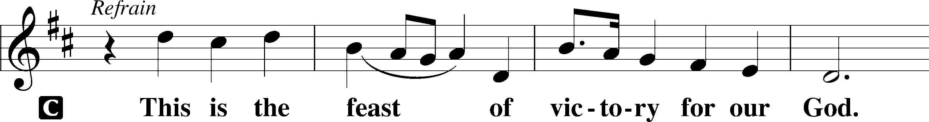
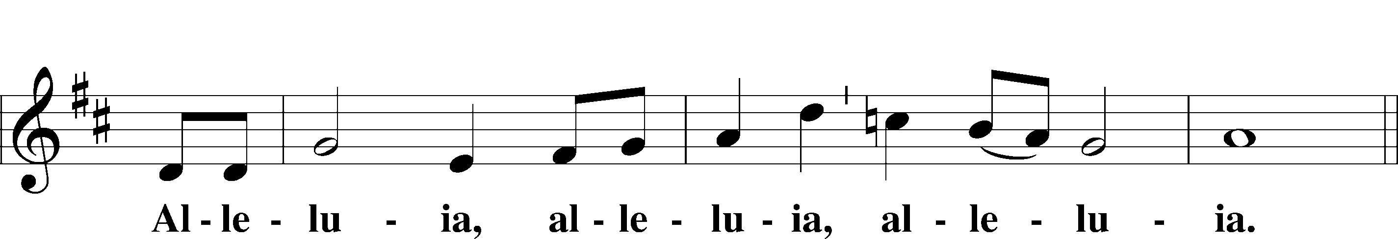
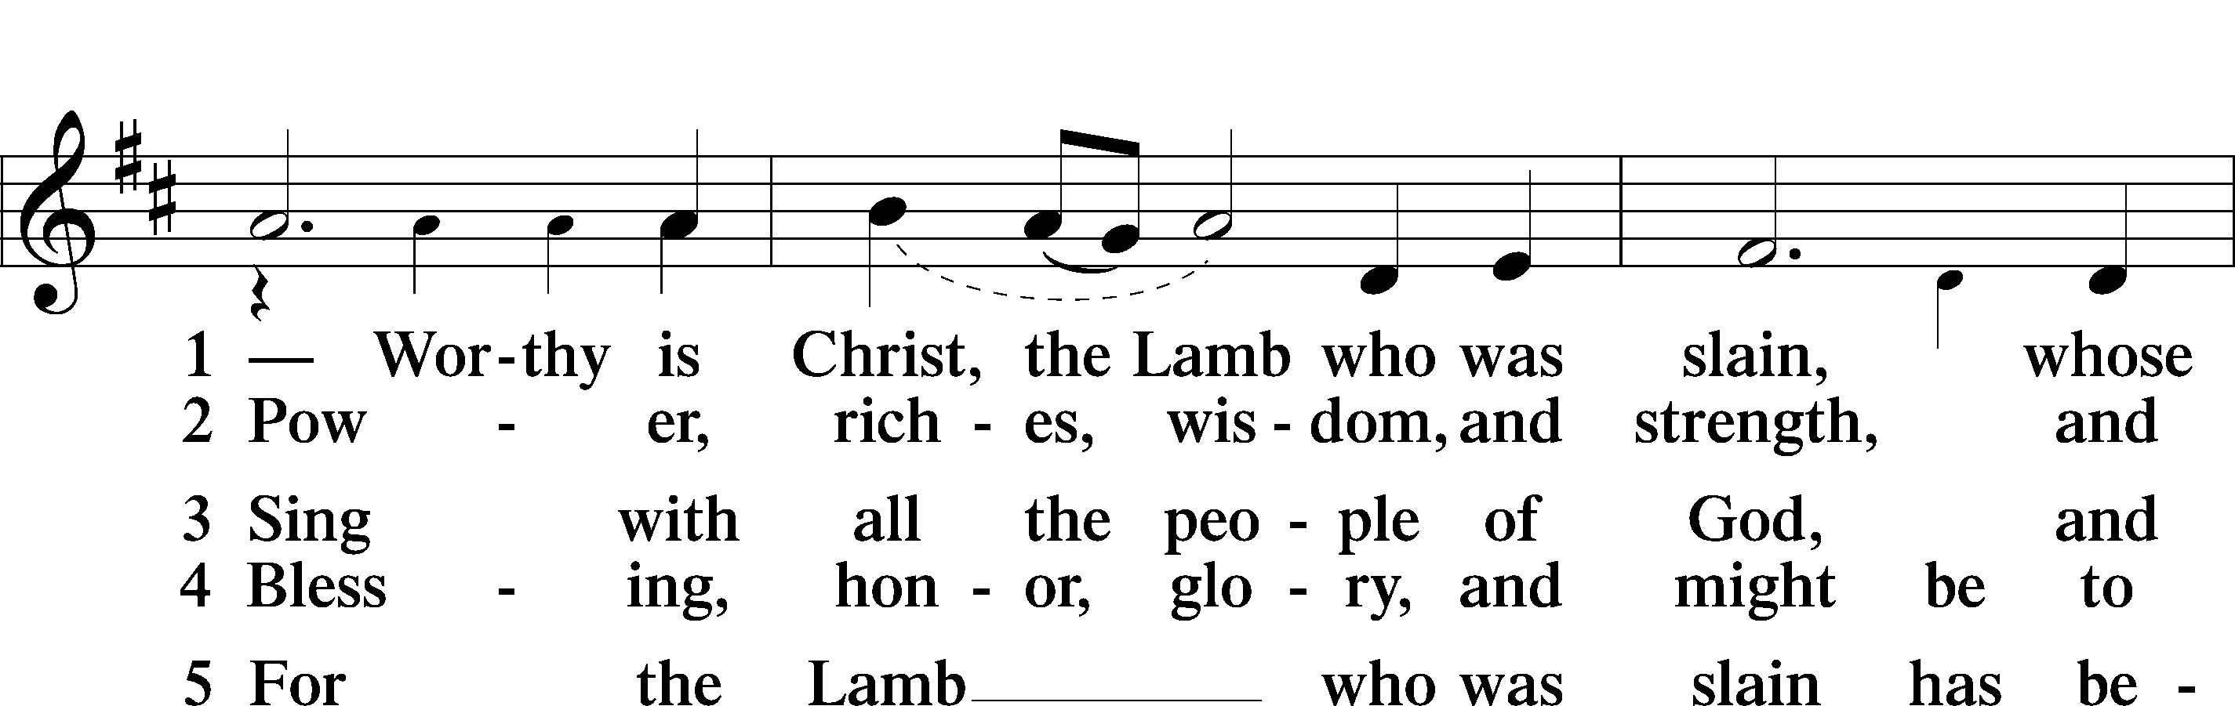
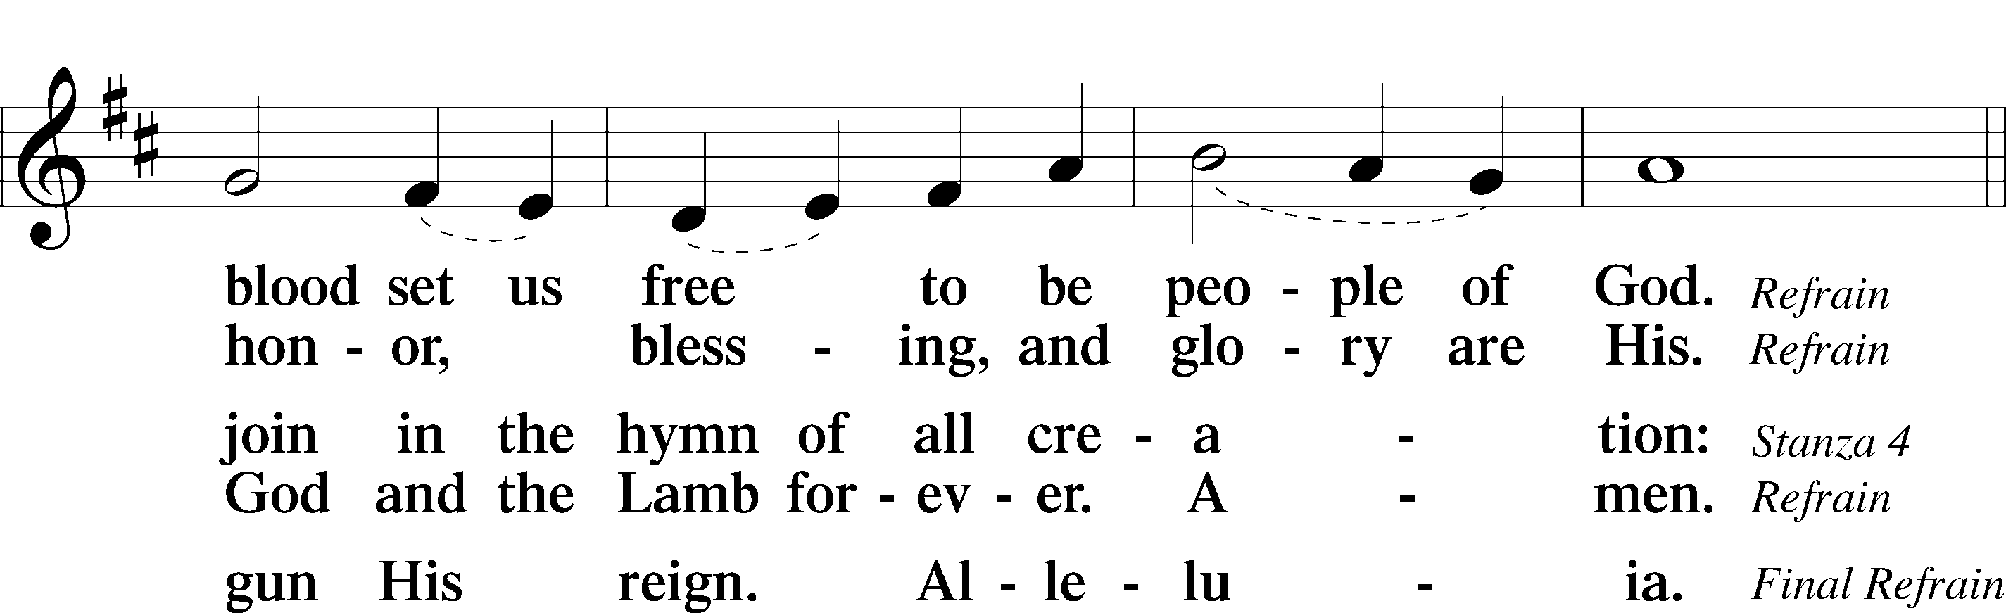
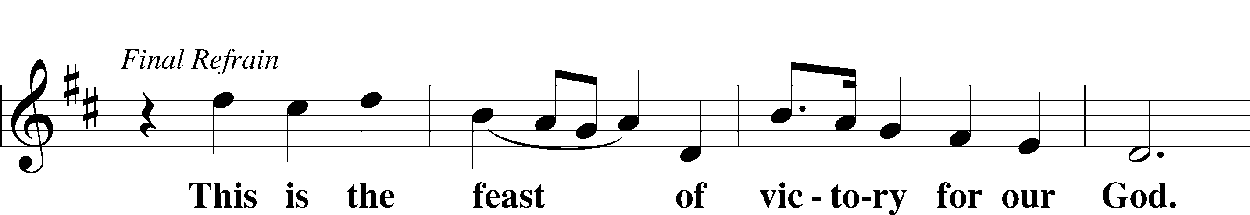
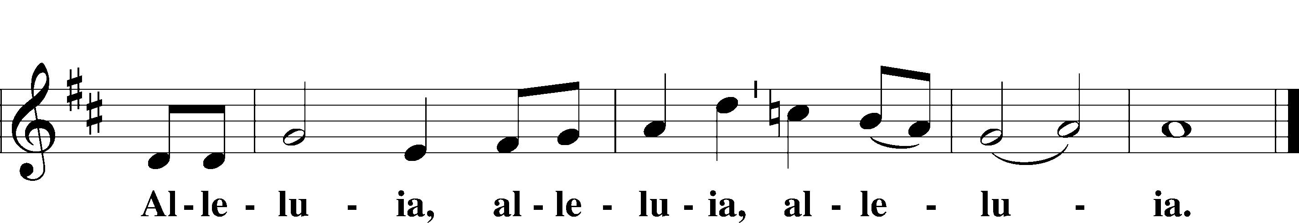

Salutation and Collect of the Day
P The Lord be with you.
C And also with you.

P Let us pray.
Almighty God, grant that we who have celebrated the Lord’s resurrection may by Your grace confess in our life and conversation that Jesus is Lord and God; through the same Jesus Christ, Your Son, who lives and reigns with You and the Holy Spirit, one God, now and forever.

C Amen.

Sit

First Reading Acts 4:32–35
They Had Everything in Common
32The full number of those who believed were of one heart and soul, and no one said that any of the things that belonged to him was his own, but they had everything in common. 33And with great power the apostles were giving their testimony to the resurrection of the Lord Jesus, and great grace was upon them all. 34There was not a needy person among them, for as many as were owners of lands or houses sold them and brought the proceeds of what was sold 35and laid it at the apostles’ feet, and it was distributed to each as any had need.

A This is the Word of the Lord.
C Thanks be to God.

Gradual adapt. from Matthew 28:7; Hebrews 2:7; Psalm 8:6
Christ has risen | from the dead.*
[God the Father] has crowned him with glory and | honor.
He has given him dominion over the works | of his hands;*
he has put all things un- | der his feet.

Epistle 1 John 1:1—2:2
The Word of Life
1That which was from the beginning, which we have heard, which we have seen with our eyes, which we looked upon and have touched with our hands, concerning the word of life— 2the life was made manifest, and we have seen it, and testify to it and proclaim to you the eternal life, which was with the Father and was made manifest to us— 3that which we have seen and heard we proclaim also to you, so that you too may have fellowship with us; and indeed our fellowship is with the Father and with his Son Jesus Christ. 4And we are writing these things so that our joy may be complete.
Walking in the Light
5This is the message we have heard from him and proclaim to you, that God is light, and in him is no darkness at all. 6If we say we have fellowship with him while we walk in darkness, we lie and do not practice the truth. 7But if we walk in the light, as he is in the light, we have fellowship with one another, and the blood of Jesus his Son cleanses us from all sin. 8If we say we have no sin, we deceive ourselves, and the truth is not in us. 9If we confess our sins, he is faithful and just to forgive us our sins and to cleanse us from all unrighteousness. 10If we say we have not sinned, we make him a liar, and his word is not in us.
Christ Our Advocate
1My little children, I am writing these things to you so that you may not sin. But if anyone does sin, we have an advocate with the Father, Jesus Christ the righteous. 2He is the propitiation for our sins, and not for ours only but also for the sins of the whole world.

A This is the Word of the Lord.
C Thanks be to God.

Stand

Alleluia and Verse LSB 156
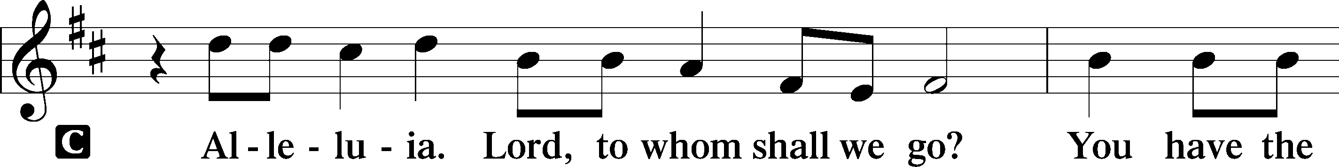
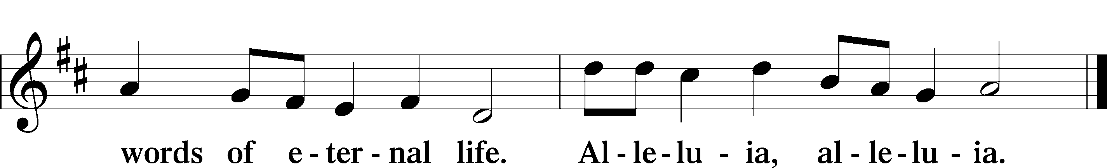

Holy Gospel John 20:19–31
P The Holy Gospel according to St. John, the twentieth chapter.

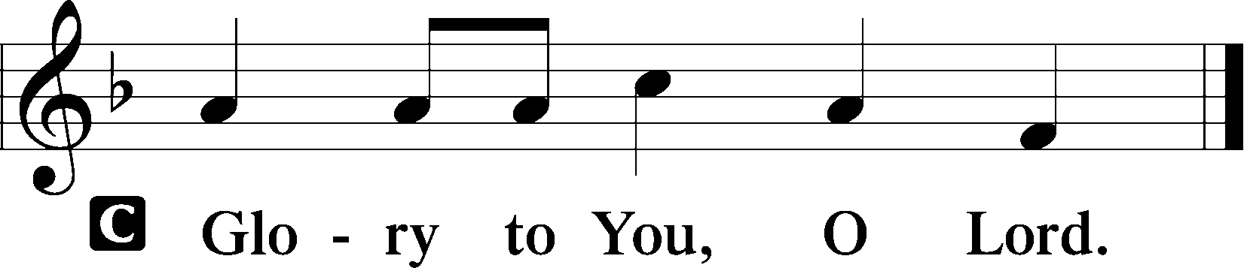

Jesus Appears to the Disciples
19On the evening of that day, the first day of the week, the doors being locked where the disciples were for fear of the Jews, Jesus came and stood among them and said to them, “Peace be with you.” 20When he had said this, he showed them his hands and his side. Then the disciples were glad when they saw the Lord. 21Jesus said to them again, “Peace be with you. As the Father has sent me, even so I am sending you.” 22And when he had said this, he breathed on them and said to them, “Receive the Holy Spirit. 23If you forgive the sins of anyone, they are forgiven; if you withhold forgiveness from anyone, it is withheld.”
Jesus and Thomas
24Now Thomas, one of the Twelve, called the Twin, was not with them when Jesus came. 25So the other disciples told him, “We have seen the Lord.” But he said to them, “Unless I see in his hands the mark of the nails, and place my finger into the mark of the nails, and place my hand into his side, I will never believe.”
26Eight days later, his disciples were inside again, and Thomas was with them. Although the doors were locked, Jesus came and stood among them and said, “Peace be with you.” 27Then he said to Thomas, “Put your finger here, and see my hands; and put out your hand, and place it in my side. Do not disbelieve, but believe.” 28Thomas answered him, “My Lord and my God!” 29Jesus said to him, “Have you believed because you have seen me? Blessed are those who have not seen and yet have believed.”
The Purpose of This Book
30Now Jesus did many other signs in the presence of the disciples, which are not written in this book; 31but these are written so that you may believe that Jesus is the Christ, the Son of God, and that by believing you may have life in his name.

P This is the Gospel of the Lord.

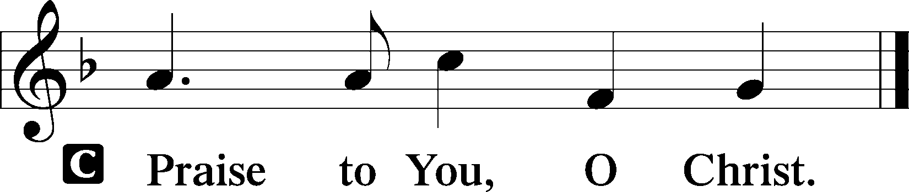

Sit

470 O Sons and Daughters of the King sts. 1, 4–8
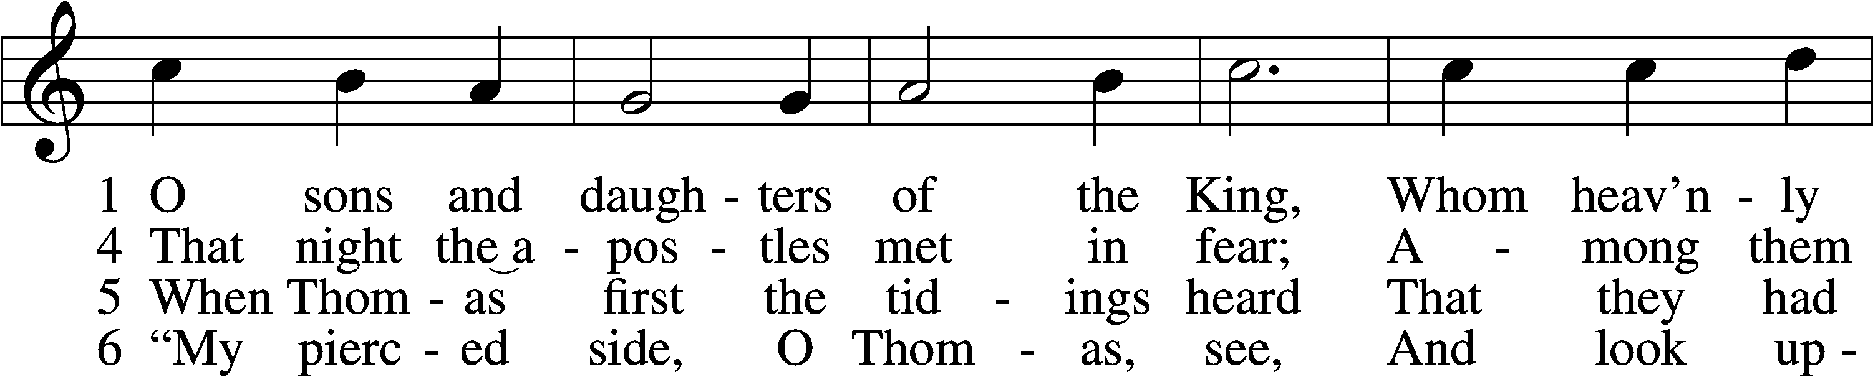
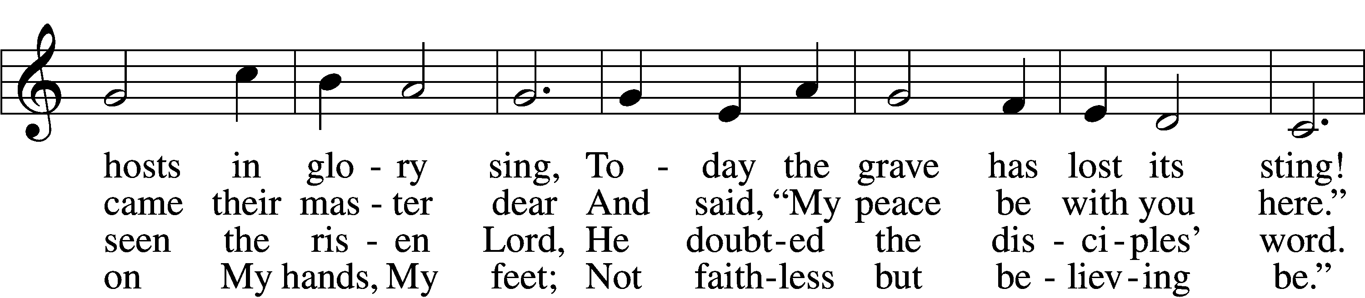
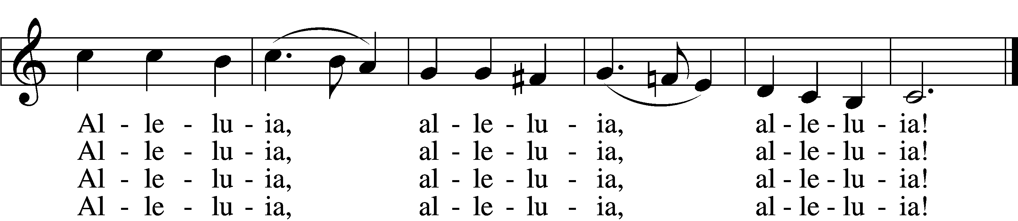

7 No longer Thomas then denied;
He saw the feet, the hands, the side;
“You are my Lord and God!” he cried.
Alleluia, alleluia, alleluia!

8 How blest are they who have not seen
And yet whose faith has constant been,
For they eternal life shall win.
Alleluia, alleluia, alleluia!
Tune and text: Public domain

Sermon

Stand

Apostles’ Creed
C I believe in God, the Father Almighty,
maker of heaven and earth.

And in Jesus Christ, His only Son, our Lord,
who was conceived by the Holy Spirit,
born of the virgin Mary,
suffered under Pontius Pilate,
was crucified, died and was buried.
He descended into hell.
The third day He rose again from the dead.
He ascended into heaven
and sits at the right hand of God the Father Almighty.
From thence He will come to judge the living and the dead.

I believe in the Holy Spirit,
the holy Christian Church,
the communion of saints,
the forgiveness of sins,
the resurrection of the body,
and the life T everlasting. Amen.

Prayer of the Church

Offertory LSB 159
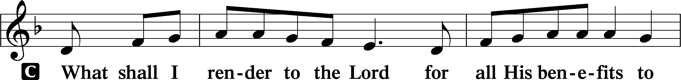
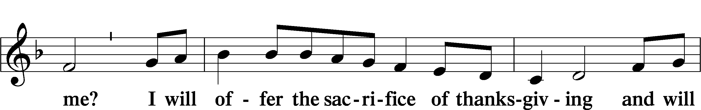
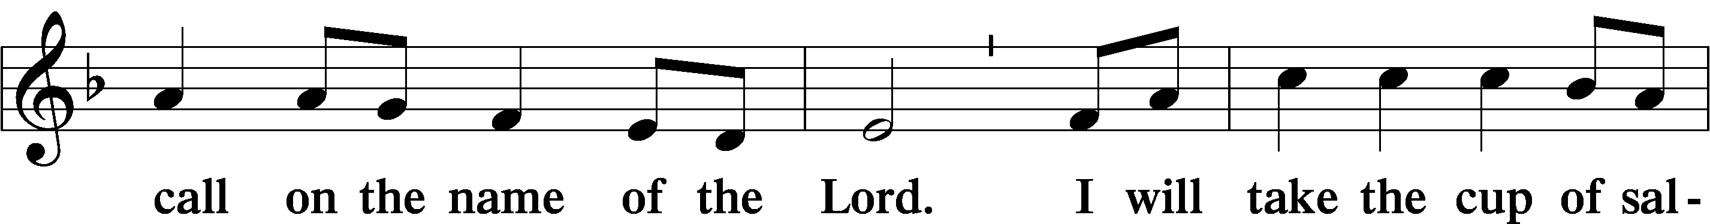
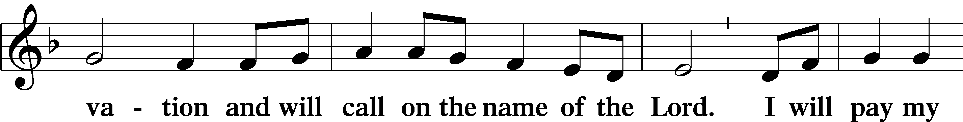
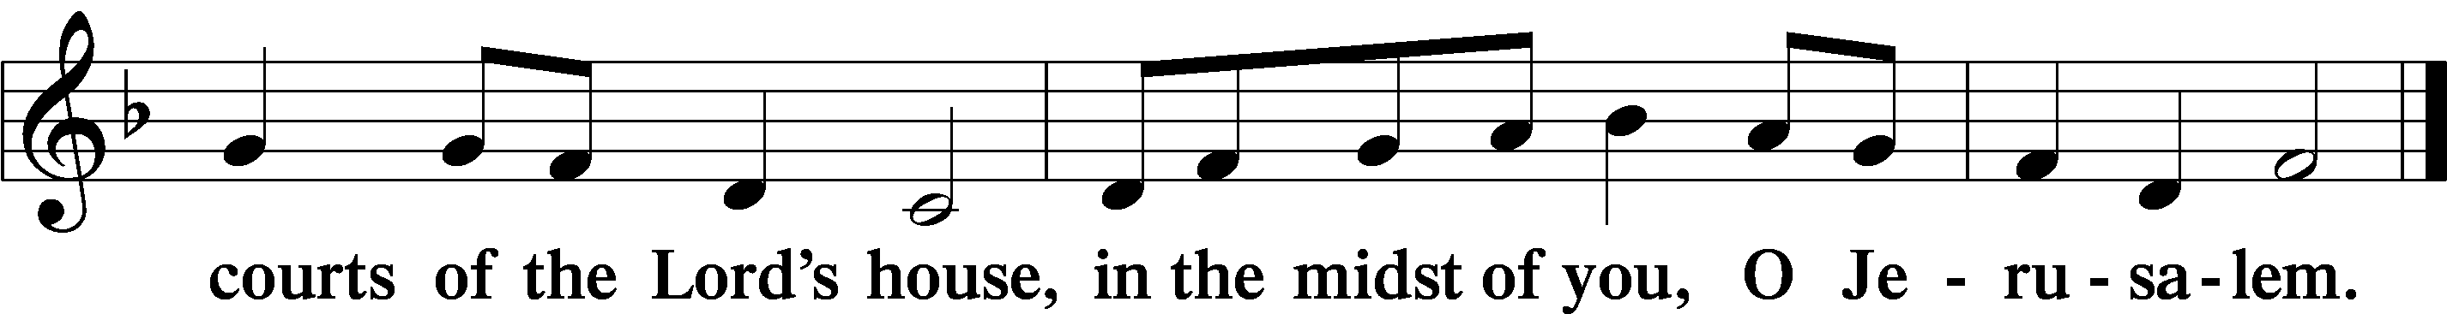
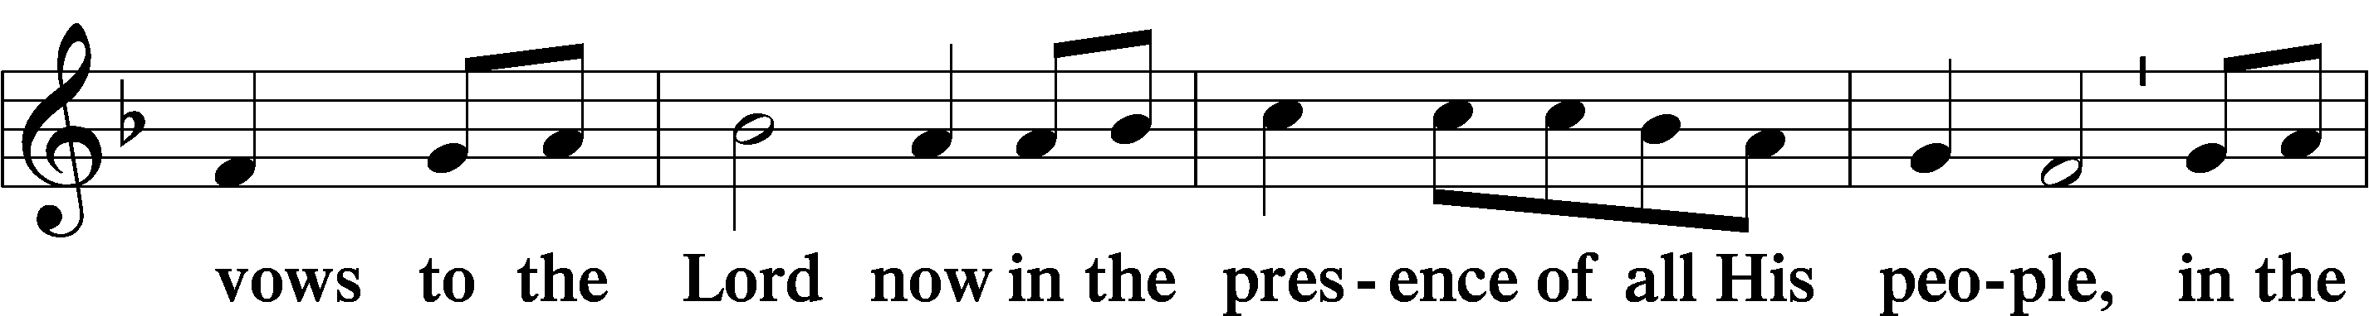

Service of the Sacrament

Preface LSB 160
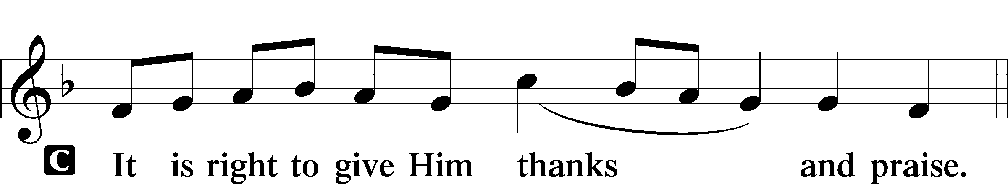

Proper Preface (Full)
P It is truly good, right, and salutary that we should at all times and in all places give thanks to You, holy Lord, almighty Father, everlasting God. And most especially are we bound to praise You on this day for the glorious resurrection of Your Son, Jesus Christ, the very Paschal Lamb, who was sacrificed for us and bore the sins of the world. By His dying He has destroyed death, and by His rising again He has restored to us everlasting life. Therefore with Mary Magdalene, Peter and John, and with all the witnesses of the resurrection, with angels and archangels, and with all the company of heaven we laud and magnify Your glorious name, evermore praising You and saying:

Sanctus LSB 161
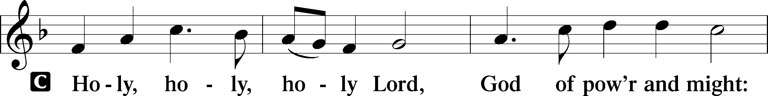
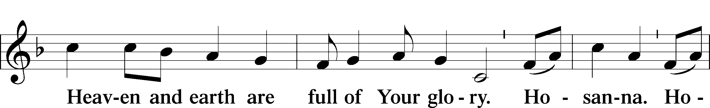
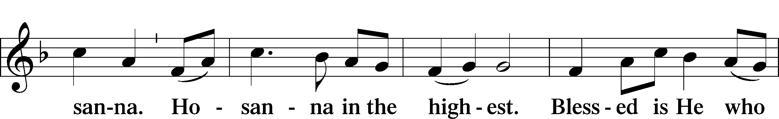
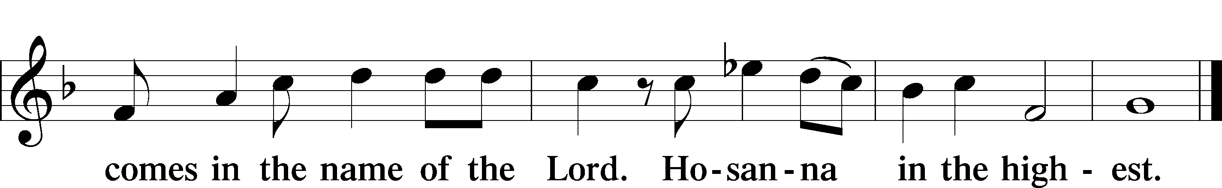

Lord’s Prayer
C Our Father who art in heaven,
hallowed be Thy name,
Thy kingdom come,
Thy will be done on earth
as it is in heaven;
give us this day our daily bread;
and forgive us our trespasses
as we forgive those
who trespass against us;
and lead us not into temptation,
but deliver us from evil.
For Thine is the kingdom
and the power and the glory
forever and ever. Amen.

The Words of Our Lord
P Our Lord Jesus Christ, on the night when He was betrayed, took bread, and when He had given thanks, He broke it and gave it to the disciples and said: “Take, eat; this is My T body, which is given for you. This do in remembrance of Me.”

In the same way also He took the cup after supper, and when He had given thanks, He gave it to them, saying: “Drink of it, all of you; this cup is the new testament in My T blood, which is shed for you for the forgiveness of sins. This do, as often as you drink it, in remembrance of Me.”
Pax Domini LSB 163
P The peace of the Lord be with you always.
C Amen.

Agnus Dei LSB 163
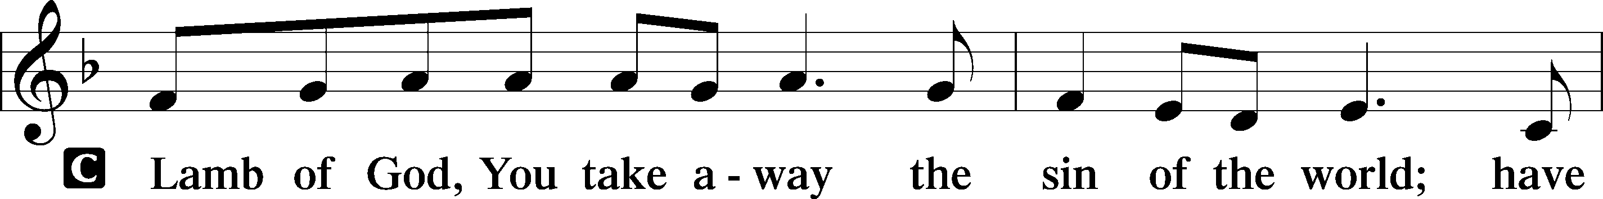
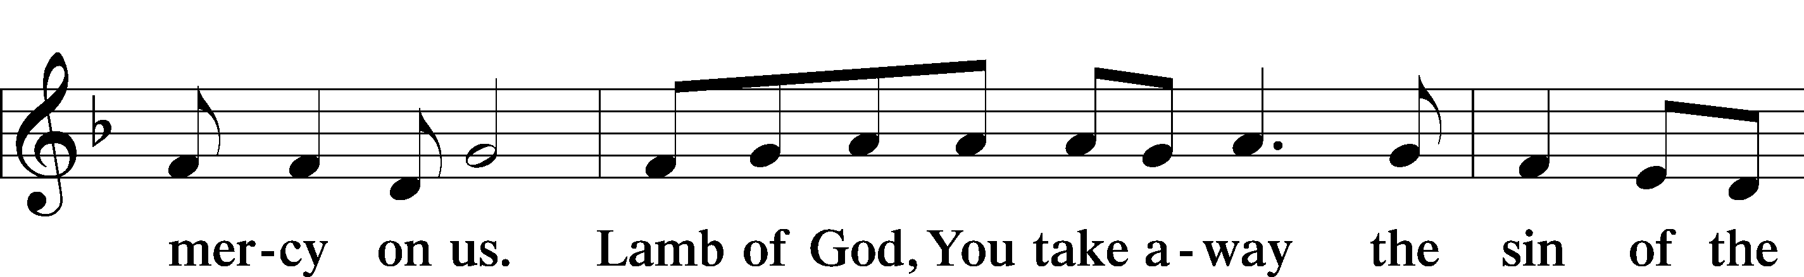
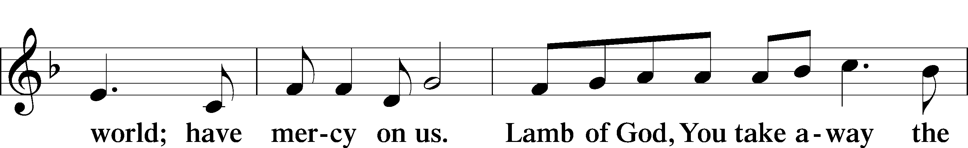
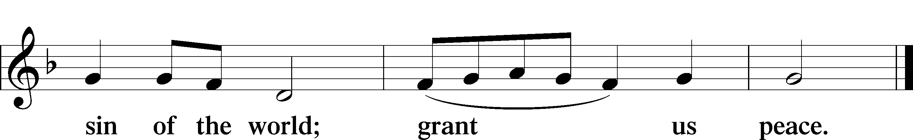

Sit

Distribution

636 Soul, Adorn Yourself with Gladness sts. 1–5, 7
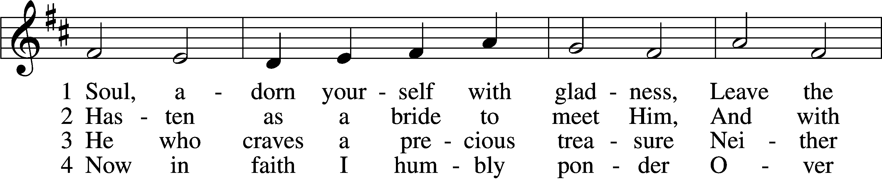
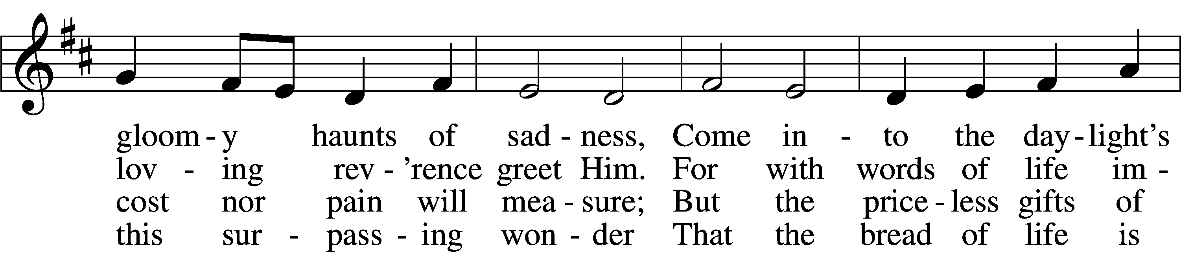
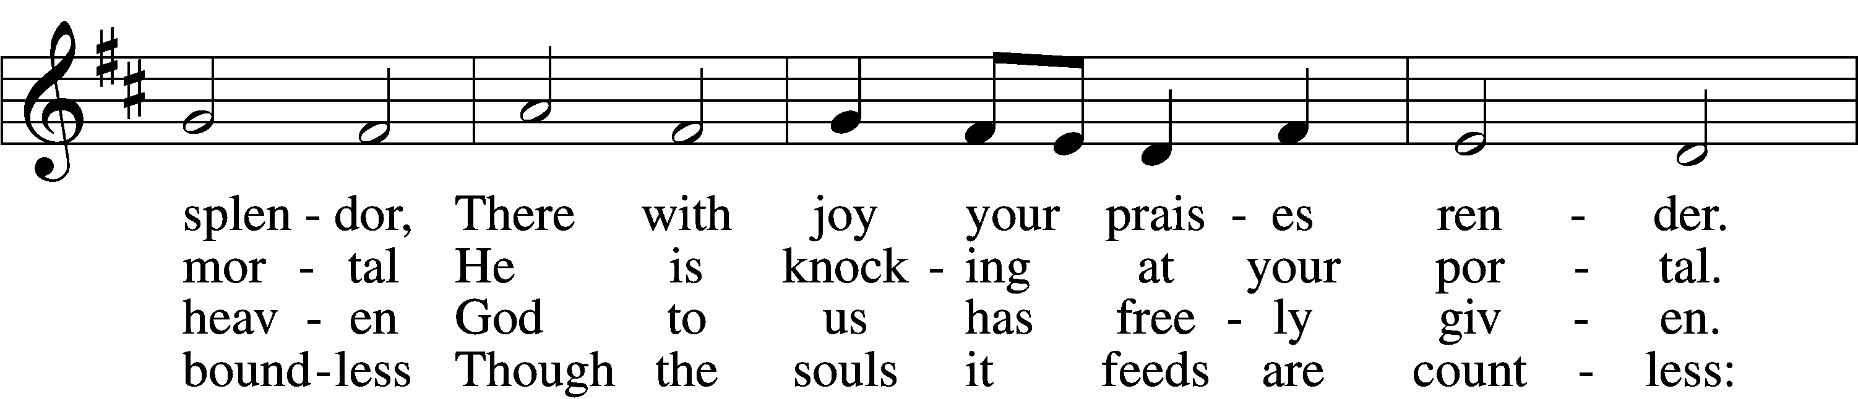
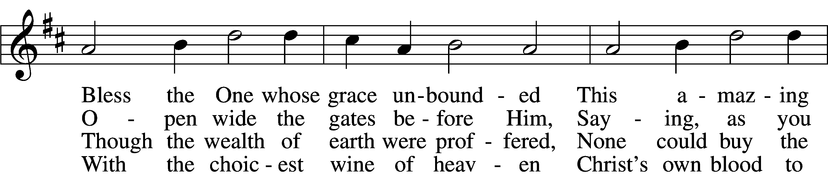
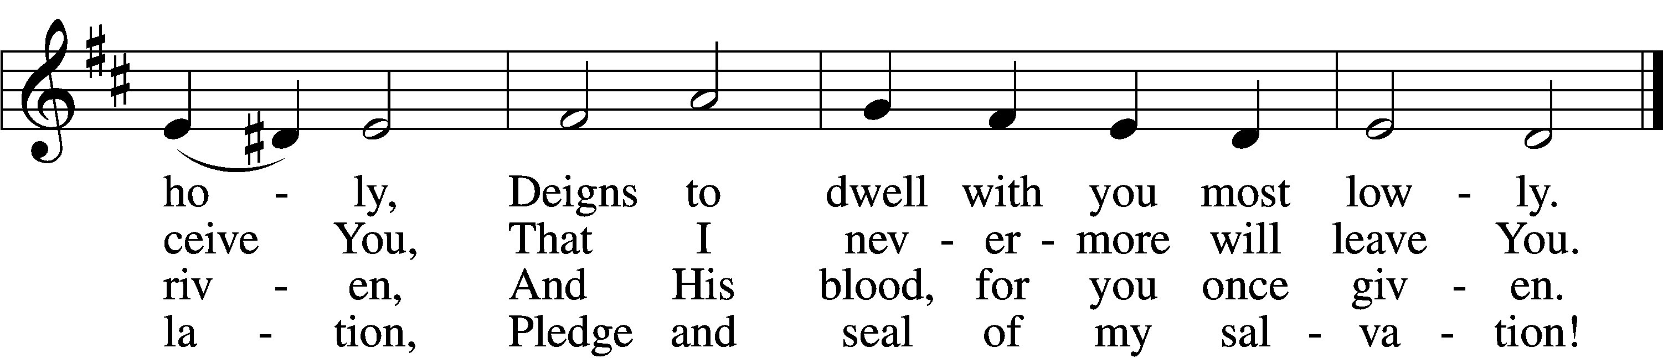
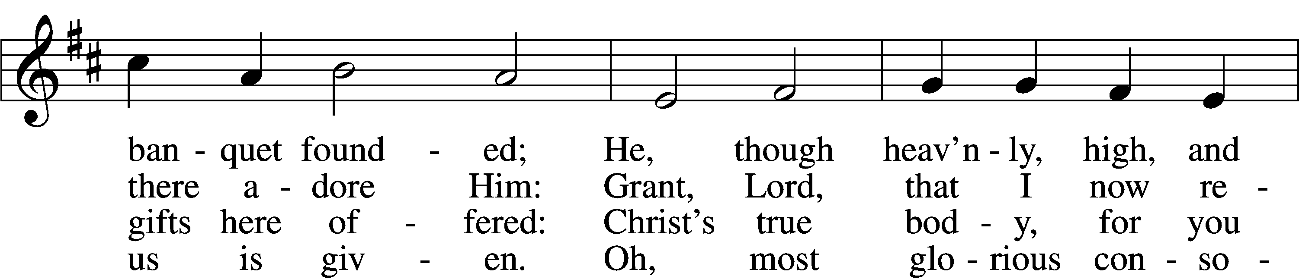
5 Jesus, source of lasting pleasure,
Truest friend, and dearest treasure,
Peace beyond all understanding,
Joy into all life expanding:
Humbly now, I bow before You;
Love incarnate, I adore You;
Worthily let me receive You
And, so favored, never leave You.

7 Lord, by love and mercy driven,
You once left Your throne in heaven
On the cross for me to languish
And to die in bitter anguish,
To forego all joy and gladness
And to shed Your blood in sadness.
By this blood redeemed and living,
Lord, I praise You with thanksgiving.
Tune and text: Public domain
Text (sts. 1, 4–5): © 1978 Lutheran Book of Worship. Used by permission: LSB Hymn License no. 110003744

637 Draw Near and Take the Body of the Lord
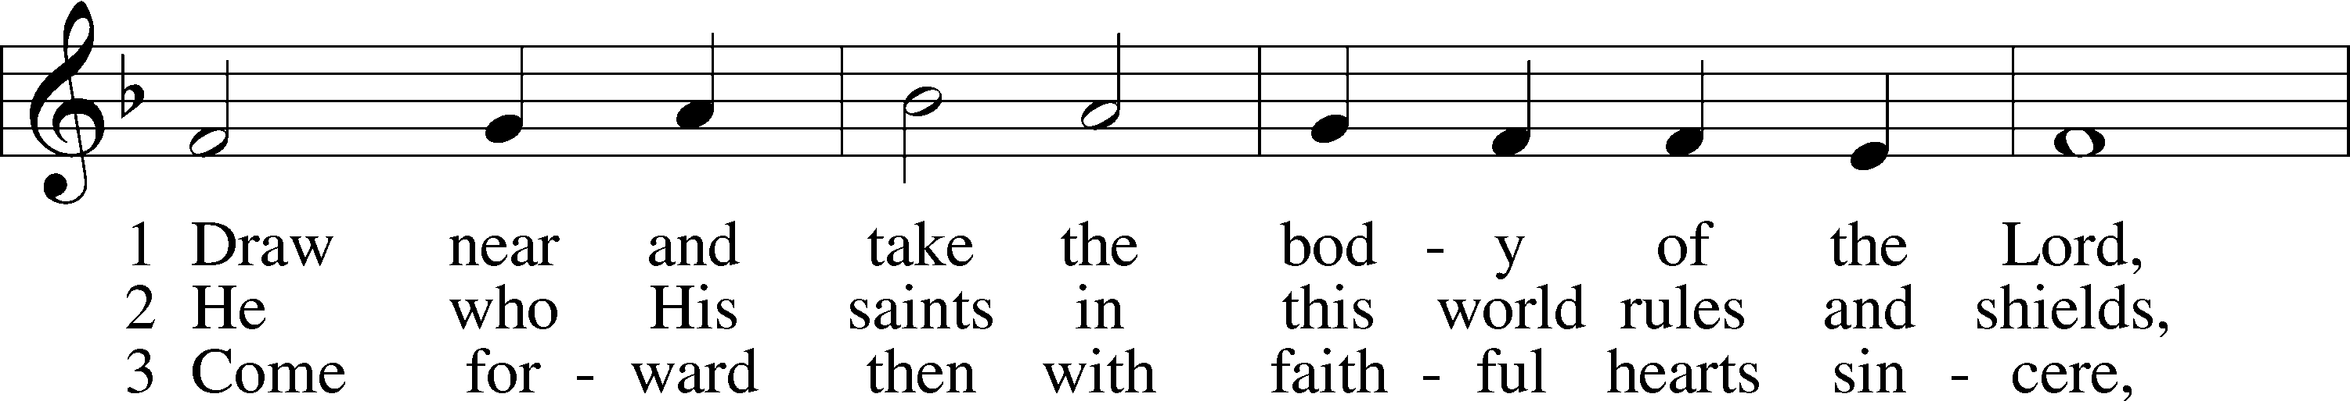
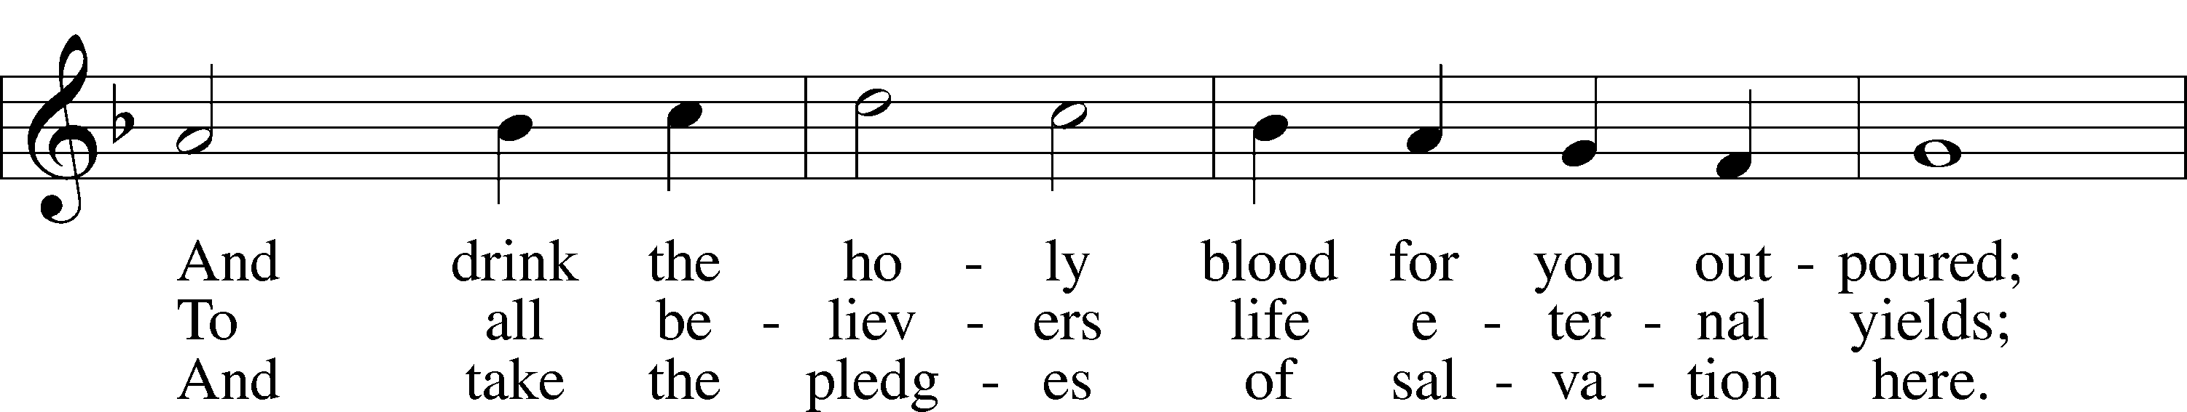
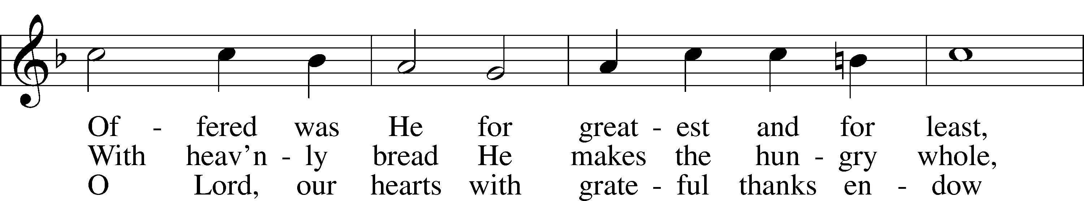
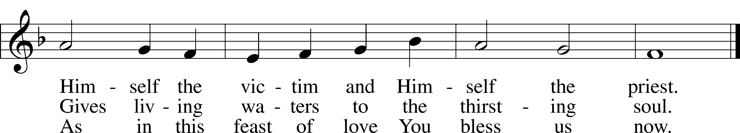
Text and tune: Public domain

483 With High Delight Let Us Unite
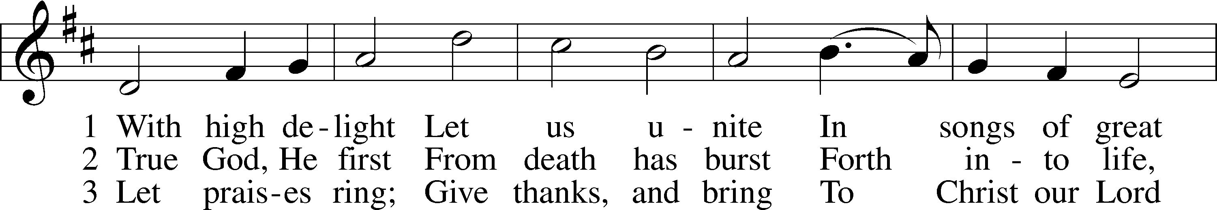
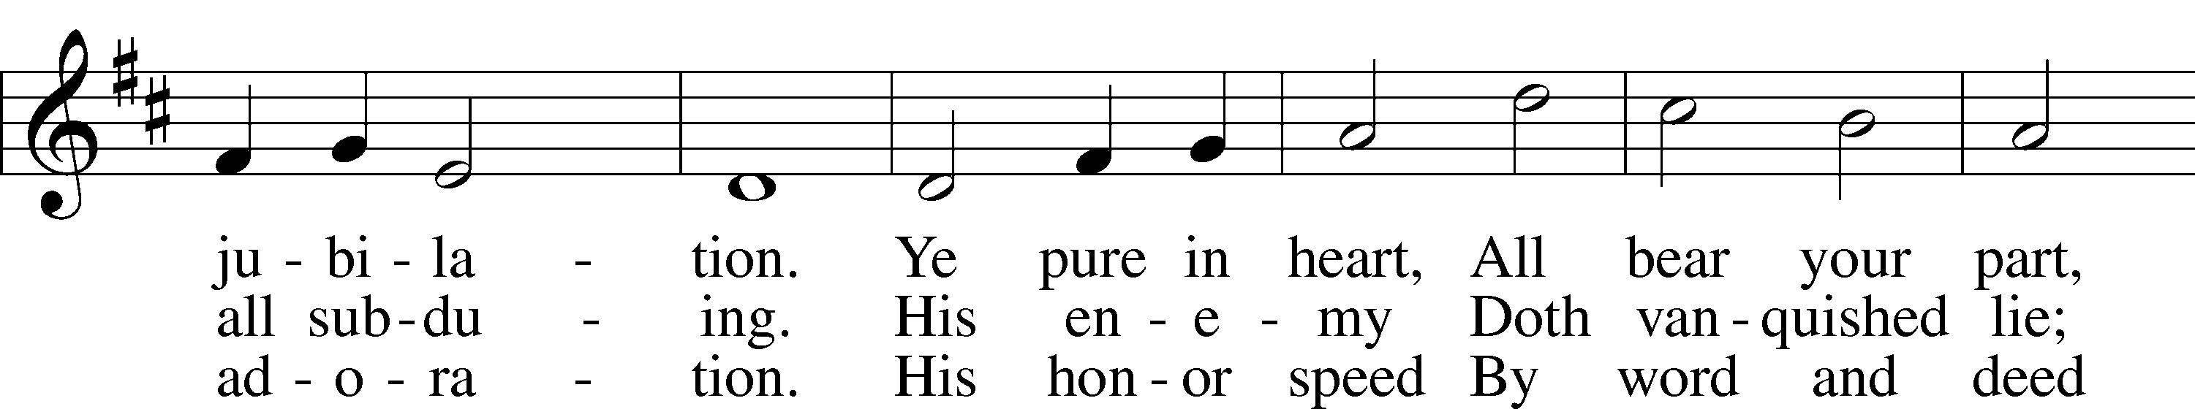
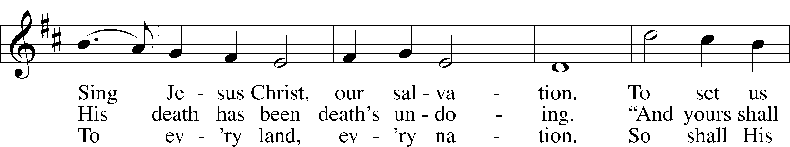
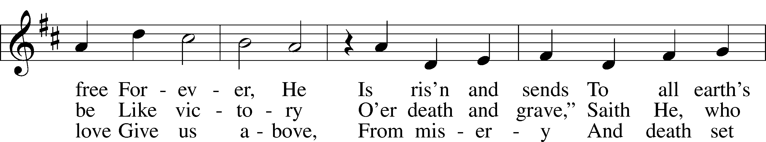
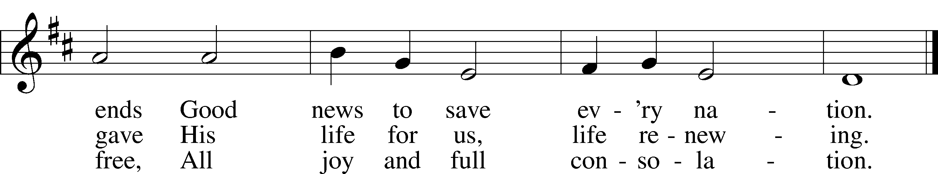
Text: © 1969 Concordia Publishing House. Used by permission: LSB Hymn License no. 110003744
Tune: Public domain

Stand

The Dismissal
P The body and blood of our Lord Jesus Christ strengthen and preserve you in body and soul to life everlasting. Depart T in peace.
C Amen.

Thank the Lord LSB 164
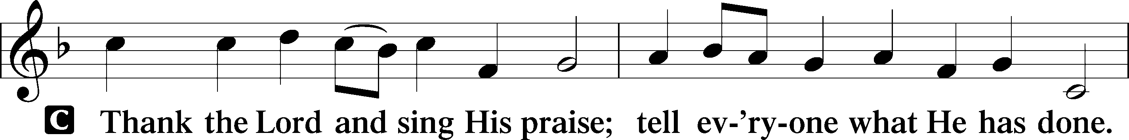
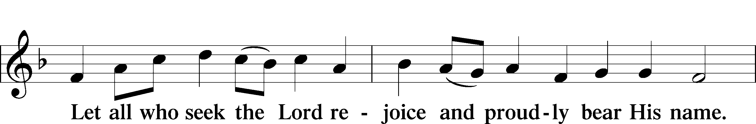
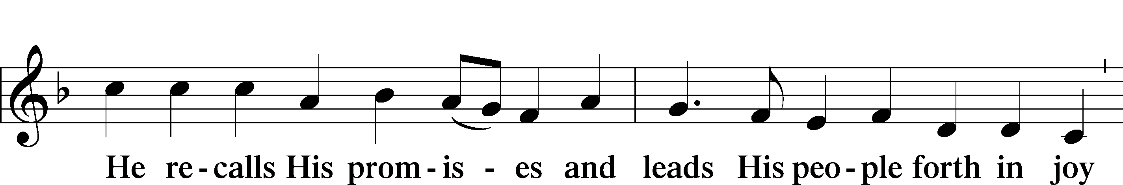
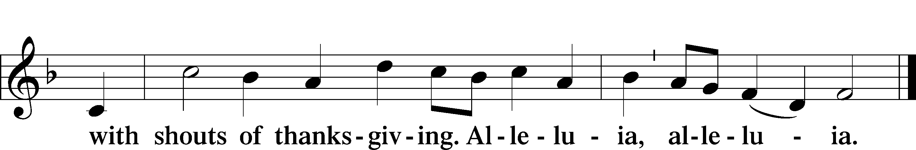

Post-Communion Collect
A Let us pray.
We give thanks to You, almighty God, that You have refreshed us through this salutary gift, and we implore You that of Your mercy You would strengthen us through the same in faith toward You and in fervent love toward one another; through Jesus Christ, Your Son, our Lord, who lives and reigns with You and the Holy Spirit, one God, now and forever.
C Amen.

Benediction LSB 166
P The Lord bless you and keep you.
The Lord make His face shine on you and be gracious to you.
The Lord look upon you with favor and T give you peace.
C Amen.

482 This Joyful Eastertide
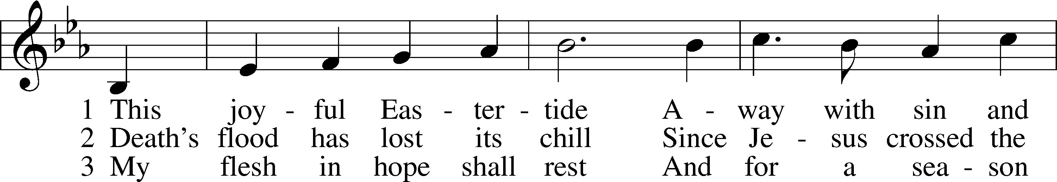
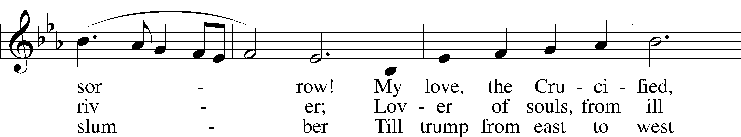
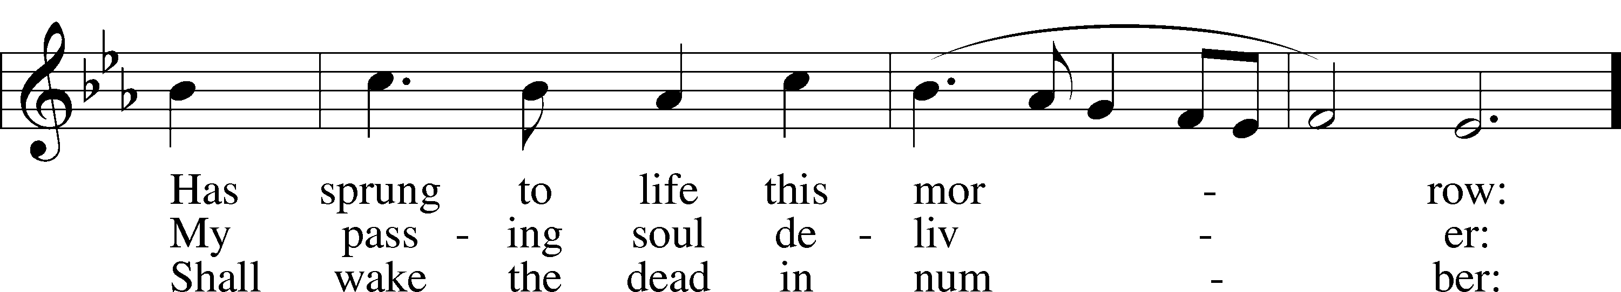
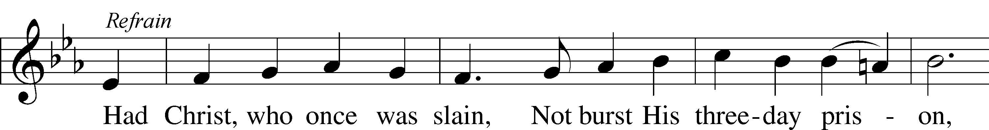
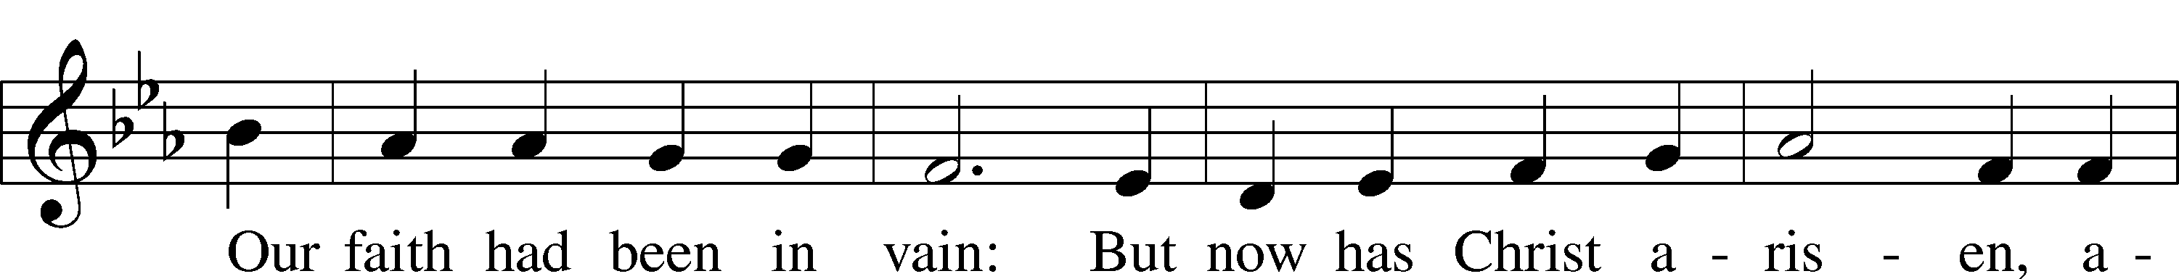
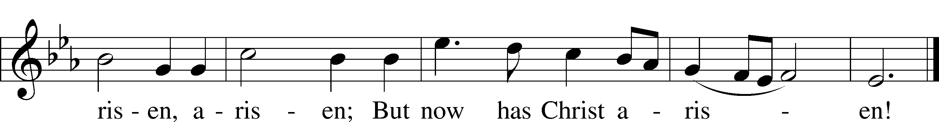
Text and tune: Public domain

Acknowledgments
Unless otherwise indicated, Scripture quotations are from the ESV® Bible (The Holy Bible, English Standard Version®), copyright © 2001 by Crossway, a publishing ministry of Good News Publishers. Used by permission. All rights reserved.
Created by Lutheran Service Builder © 2021 Concordia Publishing House.

Prayers for Our Members
Jade Florang, Monique Pohlman,  Nicole Teten, Naomi Wollberg | Expectant Mothers
Stella Vos | Baptism
Norman Abels (Brookestone Meadows – Elkhorn) | Healing
Judy Ahrens | Healing
Vaughn Albrecht (Mount Carmel) | Healing
Tom & DyAnn Altwine | Healing
Jim Catterson | Healing
Lyle Colsden (Mother Hull) | Healing
Pat Flodine (Cambridge Court) | Healing
Vi Fox (Prairie View) | Healing
Verleen Gentry | Healing
Ruby Hatfield | Healing
Boyd Millsap | Healing
Michelle Millsap | Healing
Roger Riekenberg | Healing
Don Richmond | Healing
Marion Richmond | Healing
Ivan Bombeck | Cancer
Fran Junge | Cancer
Bertha Marienau | Cancer
Bev Nuttelman | Cancer
Kim Vos | Cancer

ZION LUTHERAN CHURCH AND SCHOOL

Pr. James DeLoach, Pastor + (308) 627-5260
james.deloach@zionkearney.org
Pr. Doug Gaunt, Pastor + (308) 455-0552
doug.gaunt@zionkearney.org
Tony Splittgerber, Principal + (308) 293-0168
anthony.splittgerber@zionkearney.org

Church Office
Administrative Assistant: Jessica Shiers
Email: school@zionkearney.org
Phone: (308)-234-3410 Fax: (308) 236-8100
Office Hours: Monday-Friday 8:00am-4:00pm
Radio Broadcast: Sunday @ 10:30 a.m. on 1460 AM
Website: www.zionkearney.com

Prayers for Our Members’ Family & Friends
Dawn Gaunt (Pr. & Carol Gaunt’s daughter-in-law) | Expectant Mother
Brandon & Shannon Howell (Quentin & Janel Lange’s friends) | Expecting
Mariah (Quentin & Janel Lange friend) | Expecting
Will Brennemann (Jami Helmbrecht’s father) | Healing
Reg Duke (Westman’s brother-in-law) | Healing
James Gentry (Verleen Gentry’s son) | Healing
Roger Hoffman (Marc’s father) | Healing
Sharon Kreutzer (Richard’s mother) | Healing
Lyra Mais (Zion student) | Healing
Bailey Markowski (Steve & Fran Junge’s great niece) | Healing
Mary Ann Mertz (Pam’s Uhlir’s friend) | Healing
Tim Powers (Kim Wilken’s brother) | Healing
Roy Reynolds (Verleen Gentry’s son-in-law) | Healing
Lynne Saathoff (Verleen Gentry’s sister-in-law) | Healing
Randy Solomon (Beth Rosenthal’s father) | Healing
Janet Stalder (Carol Florang’s sister) | Healing
Angela Well (Charles Marineau’s granddaughter) | Healing
D.D. Dugger (Sue Kaiser’s brother) | Cancer
Stuart Gronewoller (Lonna’s brother-in-law) | Cancer
Ron Halvorsen (Jeff’s dad) | Cancer
Carol Haubold (Don Helmbrecht’s sister) | Cancer
Randy Jochum (Ken Hockemeier’s brother-in-law) | Cancer
Fred Koch (Pam Uhlir’s cousin) | Cancer
Lynda Kreutzer (Rich & Carol’s sister-in-law) | Cancer
John Moore (family of Susan Tonniges) | Cancer
Sharon Mulhair (Pam Uhlir’s cousin) | Cancer
Jeannie Schmidt (Lisa Splittgerber’s sister-in-law) | Cancer
Tyrone Uhlir (Pam’s nephew) | Cancer

Today’s Radio Broadcast is given to the Glory of the Lord by Lennis Hodgson in memory of parents

Worship Assistants

Sunday, April 11 ~ 9:00am

Elder: Dan Oertwig
Usher: Marc Hoffman & Steve Junge
Engineer: Zach DeLoach
Announcer: Lonna Gronewoller
Altar Guild: Ellen Hockemeier & Rachael Burger

Sunday, April 18 ~ 9:00am

Elder: Ken Hockemeier
Usher: Roger Riekenberg & Robert Glanzer
Engineer: Jared Nuttelman
Announcer: Carol Kreutzer
Altar Guild: Ellen Hockemeier & Rachael Burger

Our Response to the Gospel

Date: 04/04/2021

Offering: $9,899.01
Weekly Need: $7,542.37

This Week at Zion

Sun  04/11 | 9:00a  10:30a | Divine Service  Radio Broadcast 1460am
Mon  04/12 | 7:00p  Birthdays  Anniversaries | Mary Martha – FH in circles  David Hartman  ---
Tues  04/13 | 1:30p  7:00p  7:00p  Birthdays  Anniversaries | Sleeping Mats  Board of Elders  Board of Trustees  Jami Helmbrecht  Lorelie Hanneman  Sarah Burger  ---
Wed  04/14 | 8:30a  5:45p  Birthdays  Anniversaries | Chapel  Midweek  Linda Johnson  Lisa Splittgerber  ---
Thurs  04/15 | 7:00p  Birthdays  Anniversaries | Men’s Bible Study  ---  ---
Fri  04/16 | Birthdays  Anniversaries | ---  ---
Sat  04/17 | 5:00p  Birthdays  Anniversaries | Divine Service  ---  ---
Sun  04/18 | 9:00a  10:30a  Birthdays  Anniversaries | Divine Service  Radio Broadcast 1460am  ---  ---

Where our Triune God strengthens us through His mercy in faith toward Him and in fervent love toward one another.

ANNOUNCEMENTS

Offering Options:
To worship the Lord with your offering:
1) Place your offering in the basket as you leave
2) Go to zionkearney.churchtrac.com/give
3) Go to zionkearney.com and click on the ChurchTrac icon
4) Mail your gift to Zion Lutheran Church, 2421 C Ave, Kearney, NE 68847 or place it in the mail slot on the south side of the building.

An Adult and Youth Bible Study – are prerecorded and available each Sunday, along with a study guide you can use to follow along. We are studying the three lessons for the day—the Old Testament, the Epistle, and the Gospel. Go to Zion’s website www.zionkearney.com to access the video and study guide.

Baptism – We want to welcome Stella Vos to the Zion family. She was baptized on April 10th. She is the daughter of Brittney Vos and Aaron Gleason.

Mary Martha – Mary Martha will meet on Monday, April 12th at 7:00 in their circles in the fellowship hall at the church.

Men’s Bible Study – The Men’s Bible Study will meet this Thursday, April 15th in the fellowship hall.

Bible Reading Cards - A new set of Bible reading cards for the new year can be picked up in the church entryway. Each card is a tool to keep track of your Bible reading progress as you mark each chapter you have read in 2021. God works through His Word.

Mission Offerings - The second quarter missions will support higher things and Issues Etc. If you would like to donate to these missions, please use the mission envelopes located in the narthex. Thank you for your support. To learn more about these organizations please visit:

https://higherthings.org/about

https://issuesetc.org/support/

Radio Broadcast - Please help Zion spread the Gospel! There are several open dates.

Automatic Giving – If you currently are using PushPay for your autogiving. Please begin to use ChurchTrac, the new program. We are going to be discontinue using PushPay very soon. If you have any questions or need help please contact the office.

Church Management System – Zion is in the process of changing to a web-based church management system called ChurchTrac. Please use the website link or the QR code below and set up your ChurchTrac account. This will link up to your profile and you will be given access to an amount of predetermined information about Zion and your fellow members. We always seek to keep your information secure. For security reasons, once you sign up, the office will approve you as a member, then you will have access to your profile. Also, you will be able to update your own directory information (address, phone number, etc.) and decide what information you want to share with fellow members.

If you currently give your offering online using Pushpay, then please switch to ChurchTrac. We would like to cancel our Pushpay subscription by the end of March. If you would like to start to give online, we believe ChurchTrac will be very user friendly. If you need any assistance please contact the church office (234-3410).

For a step by step guide there are copies in the narthex.
The website:

https://zionkearney.churchtrac.com/give

To use the QR code open your camera app on your smart phone and show it the image below. There will be a website that will pop up.
SCHOOL NEWS

Plant Pickup – If you ordered plants and have not signed up for a time to pickup your plants if you ordered please go to: tinyurlcom/5sueskak to sign up for a time or call the office at 308-234-3410. Plant pickup this year is Thursday and Friday, April 22-23

P.E.A.C.E – The P.E.A.C.E online auction ended on Saturday, April 10th. Thank you to all of the supporters of Zion.

Registration Open - Registration is now open for the 2021-2022. New this year is an all-day prekindergarten option! If you have any questions, please feel free to contact the office. Please tell your family and friends about Zion. Enroll early to make sure you have a spot.

New Teacher Search - The search for another high quality Lutheran teacher has begun. Full time teachers in our school must be members of the LCMS (or willing to become so). The grade level will most probably be for the 3rd/4th grade. If you or someone you know might be interested in this position, please contact Mr. Splittgerber.
Scrip Cards - Scrip cards are still available during this time. Visit the office during normal hours to purchase your gift cards.

