Divine Service

Fourteenth Sunday
after Pentecost
August 29, 2021

Zion Lutheran Church
Kearney, Nebraska

Welcome to Zion!
All worshippers please fill out an attendance card in the pew rack and let us know how we might be of service to you.

Holy Communion at Zion

The Lord’s Supper is celebrated at this congregation as Jesus has given it. As he says, our Lord gives into our mouths not only bread and wine but his very body and blood to eat and to drink for the forgiveness of sins and to strengthen our union with him and with one another. Our Lord invites to his table those who trust his words, repent of all sin, and set aside any refusal to forgive and love as he forgives and loves us, that they may show forth his death until he comes. All communicants need to register in the narthex prior to the service.

Because those who eat and drink our Lord’s body and blood unworthily do great harm and because Holy Communion is a confession of the faith which is confessed at this altar, any who are not yet instructed, in doubt, or who hold a confession differing from that of this congregation and The Lutheran Church—Missouri Synod, are asked not to commune until they are able to speak with our pastor first. He is happy to visit with you about the Christian faith and how to receive the Lord’s Supper for your good and for the good of others. Those not communing are invited to come to the altar, cross your arms in front of you, and bow your head to receive a pastoral blessing.

We Are Cleansed and Sustained by the Word of God

Wickedness and evil come “from within, out of the heart,” and that is what defiles a person (Mark 7:21–23). Hence, we cannot save ourselves, because we are sinful and unclean from the inside out. But as the Lord Jesus “declared all foods clean” (Mark 7:19), so He cleanses us by His Word, the preaching of repentance and the forgiveness of sins. Therefore, “listen to the statutes and the rules” of the Lord, “and do them, that you may live” (Deut. 4:1). For His Word is righteous, and to live according to it is “your wisdom and your understanding in the sight of the peoples” (Deut. 4:6). Cling to His Word, and also teach it “to your children and your children’s children” (Deut. 4:9). Put on this “armor of God” by hearing and heeding what He speaks to you, that you may “stand firm” in the evil day (Eph. 6:11–13). Gird yourself with the righteousness of Christ, by faith in the “gospel of peace,” and take up “the sword of the Spirit, which is the word of God,” by confessing Christ Jesus and “praying at all times in the Spirit” (Eph. 6:14–18).

Confession and Absolution

660 Stand Up, Stand Up for Jesus
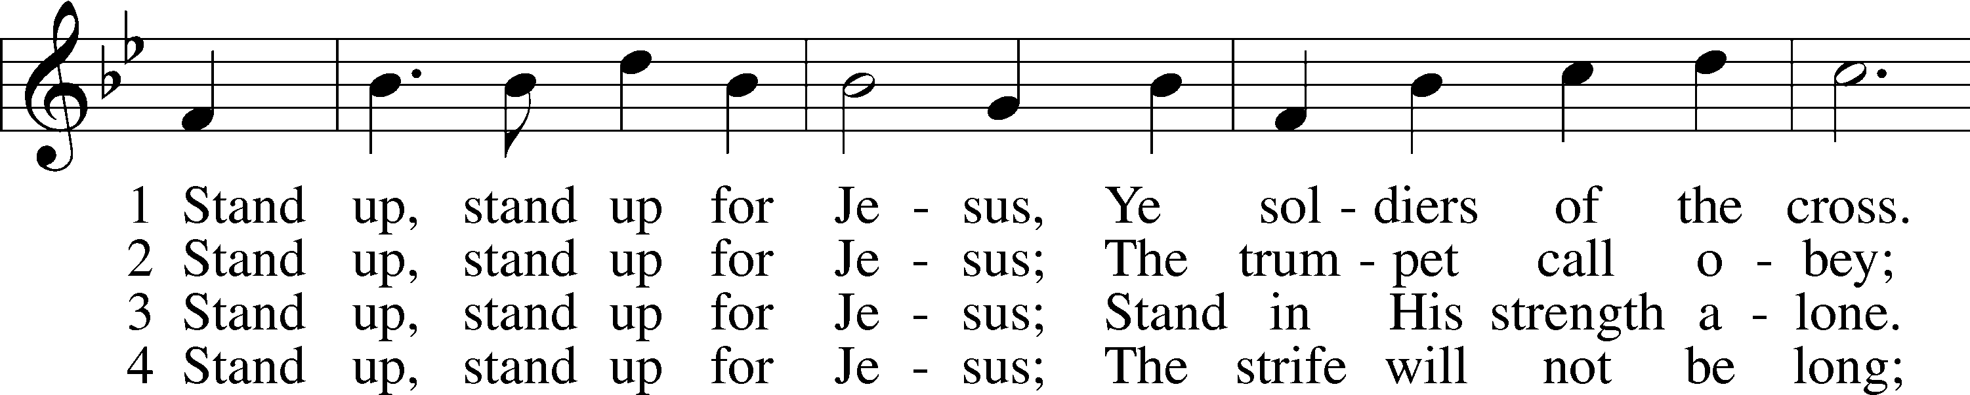
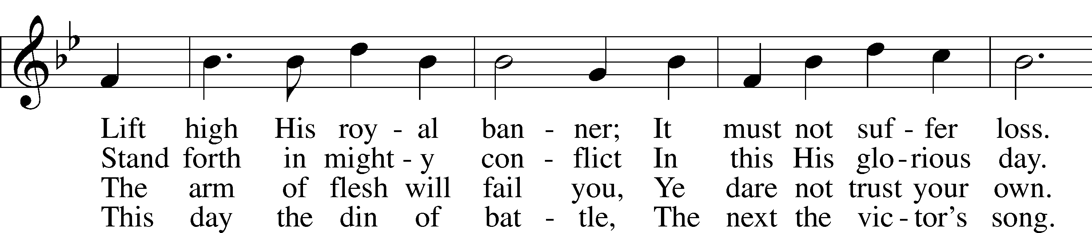
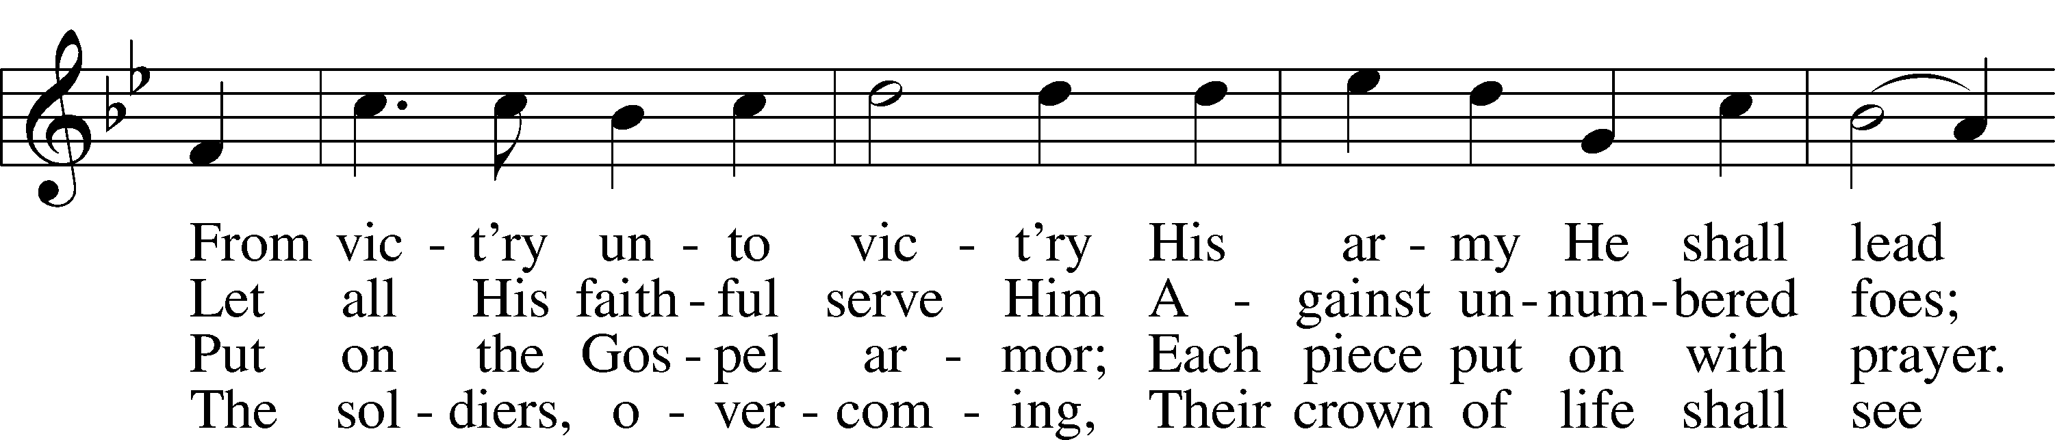
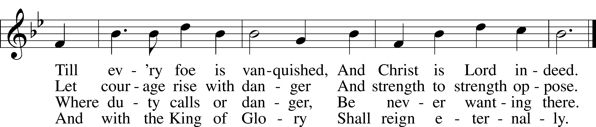
Tune and text: Public domain

Stand

The sign of the cross may be made by all in remembrance of their Baptism.

Invocation
P In the name of the Father and of the T Son and of the Holy Spirit.
C Amen.

Exhortation LSB 151
P If we say we have no sin, we deceive ourselves, and the truth is not in us.
C But if we confess our sins, God, who is faithful and just, will forgive our sins and cleanse us from all unrighteousness.

Silence for reflection on God’s Word and for self-examination.

Confession of Sins LSB 151
P Let us then confess our sins to God our Father.
C Most merciful God, we confess that we are by nature sinful and unclean. We have sinned against You in thought, word, and deed, by what we have done and by what we have left undone. We have not loved You with our whole heart; we have not loved our neighbors as ourselves. We justly deserve Your present and eternal punishment. For the sake of Your Son, Jesus Christ, have mercy on us. Forgive us, renew us, and lead us, so that we may delight in Your will and walk in Your ways to the glory of Your holy name. Amen.

Absolution LSB 151
P Almighty God in His mercy has given His Son to die for you and for His sake forgives you all your sins. As a called and ordained servant of Christ, and by His authority, I therefore forgive you all your sins in the name of the Father and of the T Son and of the Holy Spirit.
C Amen.

Service of the Word

Introit Psalm 51:7, 10–12; antiphon: v. 2
Wash me thoroughly from my in- | iquity,*
and cleanse me | from my sin!
Purge me with hyssop, and I | shall be clean;*
wash me, and I shall be whit- | er than snow.
Create in me a clean heart, | O God,*
and renew a right spirit with- | in me.
Cast me not away from your | presence,*
and take not your Holy Spirit | from me.
Restore to me the joy of your sal- | vation,*
and uphold me with a willing | spirit.
Glory be to the Father and | to the Son*
and to the Holy | Spirit;
as it was in the be- | ginning,*
is now, and will be forever. | Amen.
Wash me thoroughly from my in- | iquity,*
and cleanse me | from my sin!

Kyrie LSB 152
A In peace let us pray to the Lord.
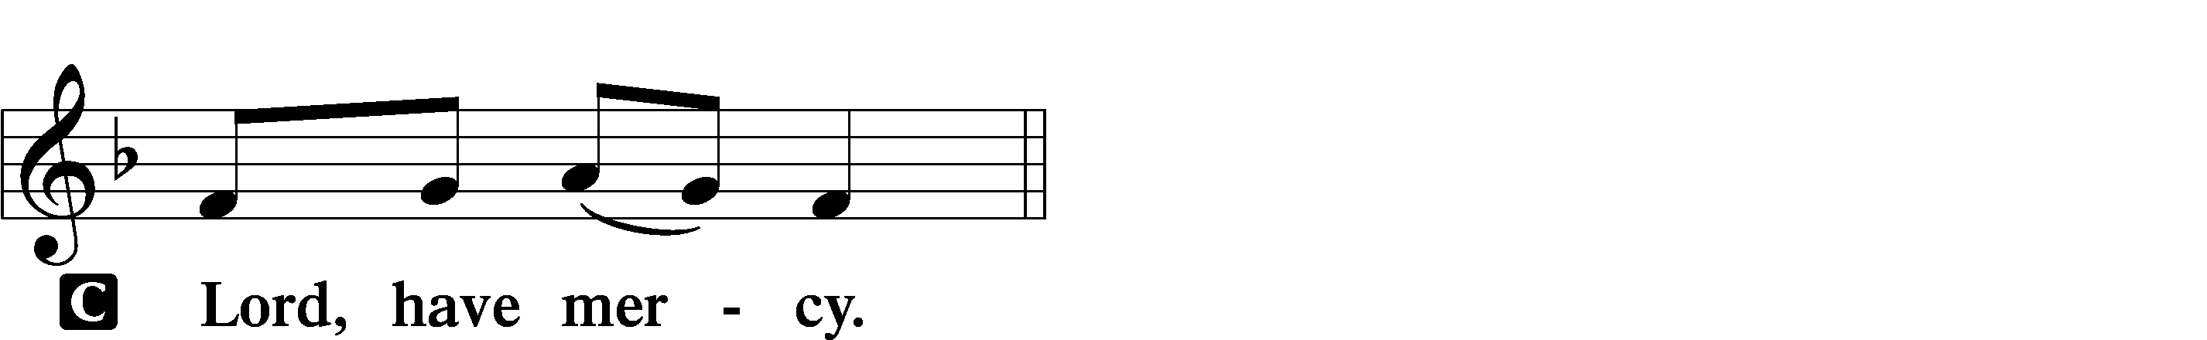
A For the peace from above and for our salvation let us pray to the Lord.
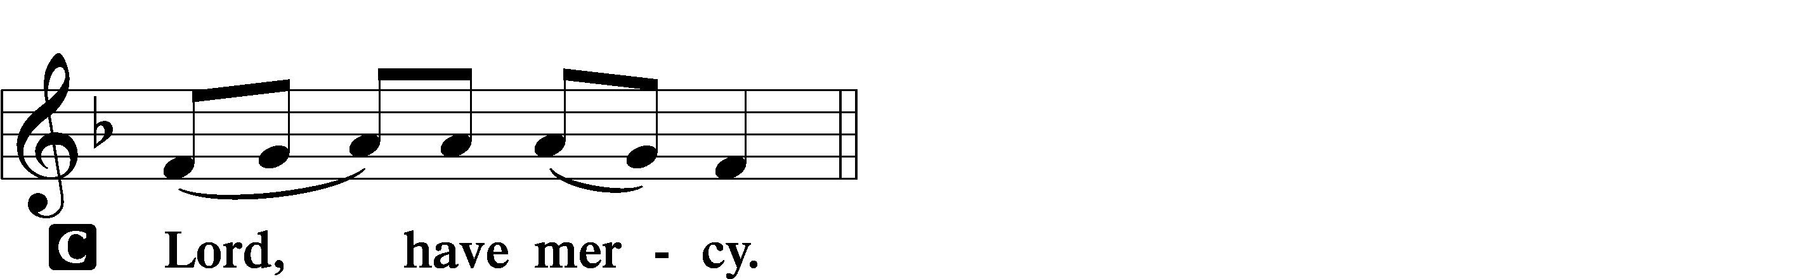

A For the peace of the whole world, for the well-being of the Church of God, and for the unity of all let us pray to the Lord.
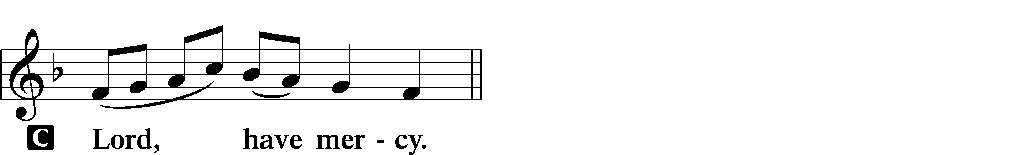

A For this holy house and for all who offer here their worship and praise let us pray to the Lord.
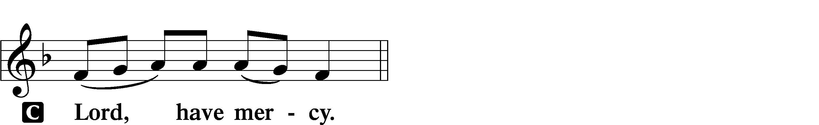

A Help, save, comfort, and defend us, gracious Lord.

Gloria in Excelsis LSB 154
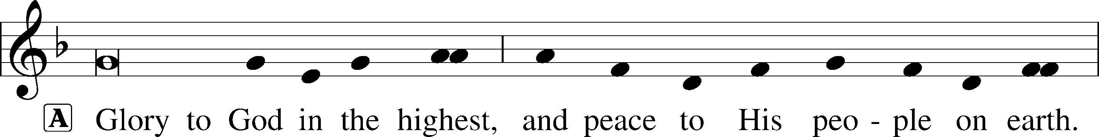
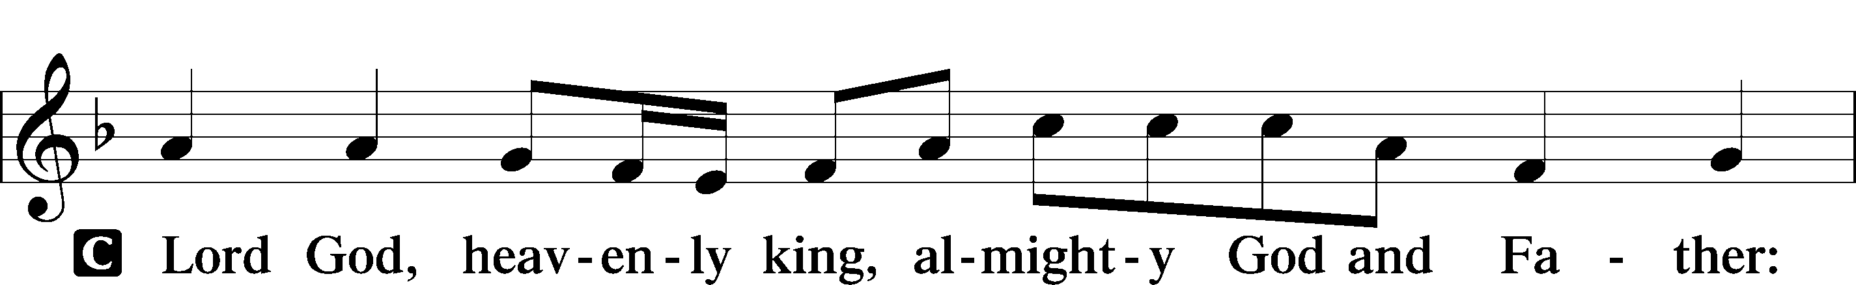
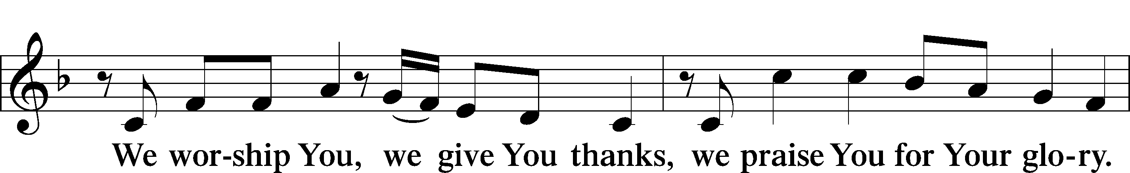
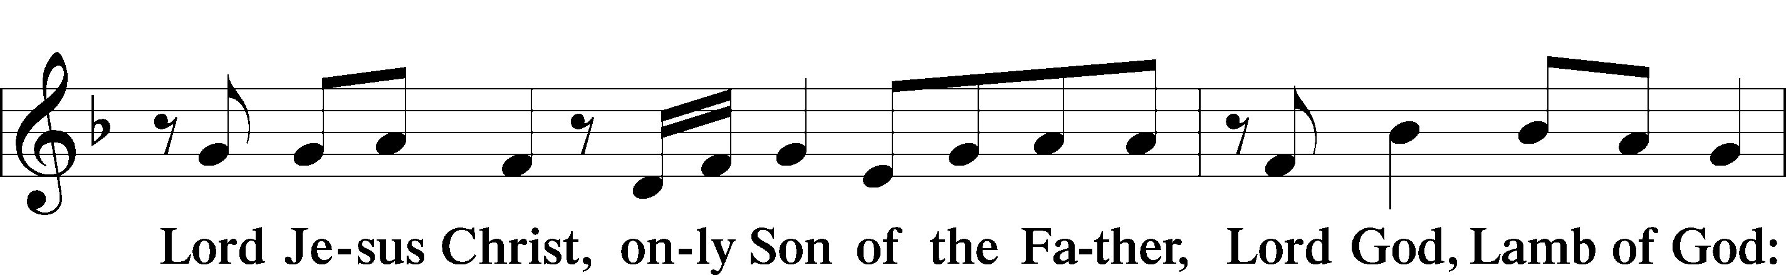
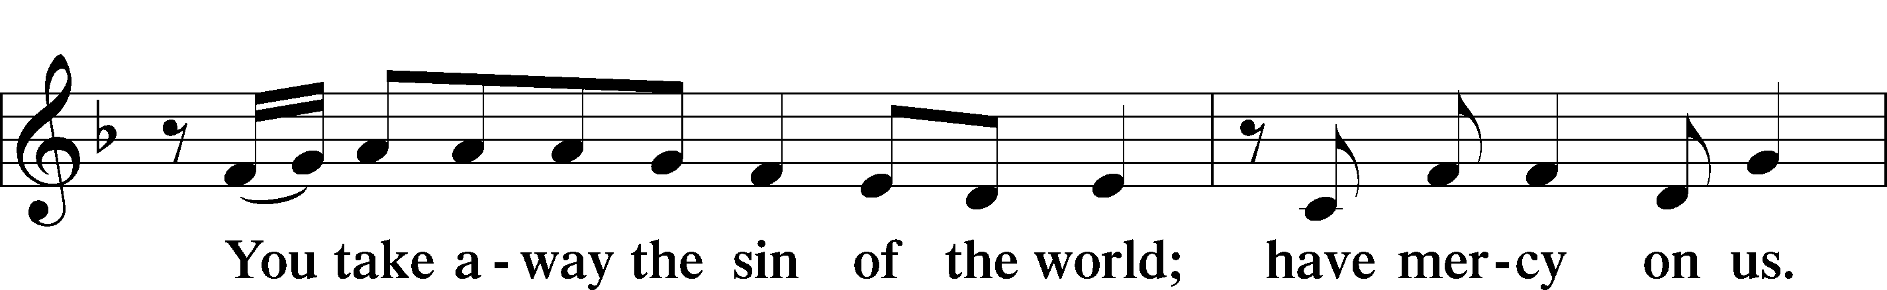
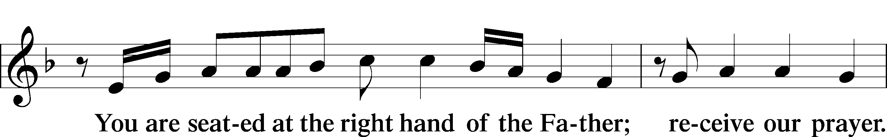
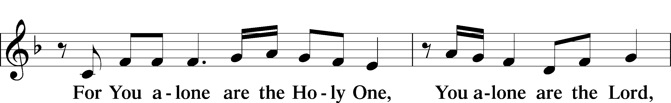
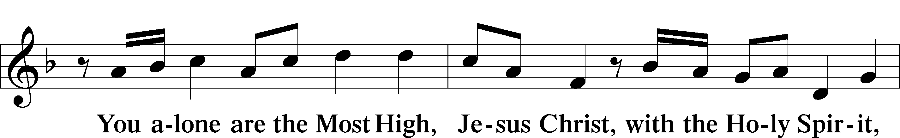
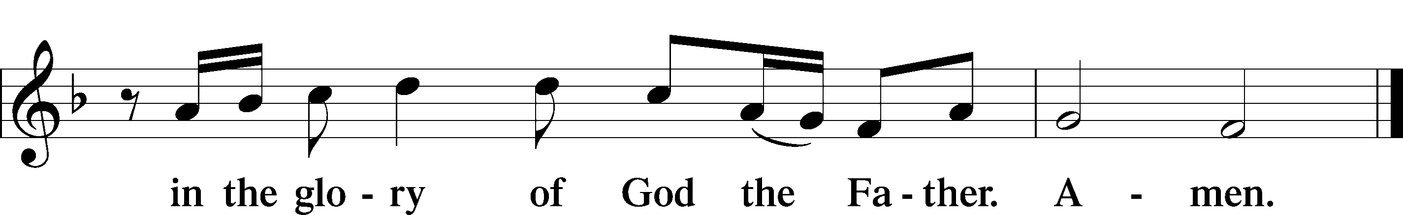

Salutation and Collect of the Day
P The Lord be with you.
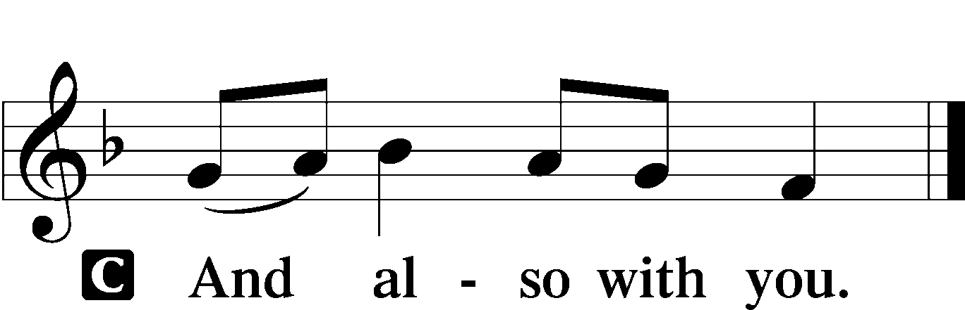

P Let us pray.
O God, the source of all that is just and good, nourish in us every virtue and bring to completion every good intent that we may grow in grace and bring forth the fruit of good works; through Jesus Christ, Your Son, our Lord, who lives and reigns with You and the Holy Spirit, one God, now and forever.

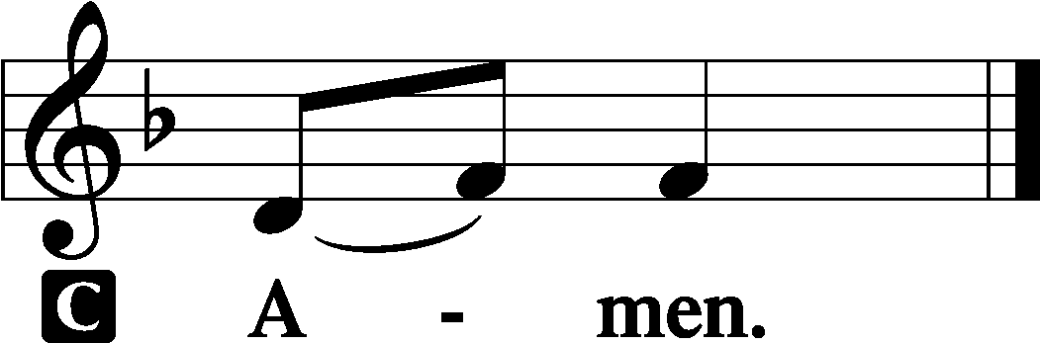

Sit

Old Testament Reading Deuteronomy 4:1–2, 6–9
Moses Commands Obedience
1“Now, O Israel, listen to the statutes and the just decrees that I am teaching you, and do them, that you may live, and go in and take possession of the land that the Lord, the God of your fathers, is giving you. 2You shall not add to the word that I command you, nor take from it, that you may keep the commandments of the Lord your God that I command you. . . .
6Keep them and do them, for that will be your wisdom and your understanding in the sight of the peoples, who, when they hear all these statutes, will say, ‘Surely this great nation is a wise and understanding people.’ 7For what great nation is there that has a god so near to it as the Lord our God is to us, whenever we call upon him? 8And what great nation is there, that has statutes and just decrees so righteous as all this law that I set before you today?
9“Only take care, and keep your soul diligently, lest you forget the things that your eyes have seen, and lest they depart from your heart all the days of your life. Make them known to your children and your children’s children.”

A This is the Word of the Lord.
C Thanks be to God.

Gradual Psalm 34:9, 19, alt.
Fear the Lord, | you his saints,*
for those who fear him lack | nothing!
Many are the afflictions of the | righteous,*
but the Lord delivers him out | of them all.

Epistle Ephesians 6:10–20
The Whole Armor of God
10Finally, be strong in the Lord and in the strength of his might. 11Put on the whole armor of God, that you may be able to stand against the schemes of the devil. 12For we do not wrestle against flesh and blood, but against the rulers, against the authorities, against the cosmic powers over this present darkness, against the spiritual forces of evil in the heavenly places. 13Therefore take up the whole armor of God, that you may be able to withstand in the evil day, and having done all, to stand firm. 14Stand therefore, having fastened on the belt of truth, and having put on the breastplate of righteousness, 15and, as shoes for your feet, having put on the readiness given by the gospel of peace. 16In all circumstances take up the shield of faith, with which you can extinguish all the flaming darts of the evil one; 17and take the helmet of salvation, and the sword of the Spirit, which is the word of God, 18praying at all times in the Spirit, with all prayer and supplication. To that end keep alert with all perseverance, making supplication for all the saints, 19and also for me, that words may be given to me in opening my mouth boldly to proclaim the mystery of the gospel, 20for which I am an ambassador in chains, that I may declare it boldly, as I ought to speak.
A This is the Word of the Lord.
C Thanks be to God.

Stand

Alleluia and Verse LSB 156
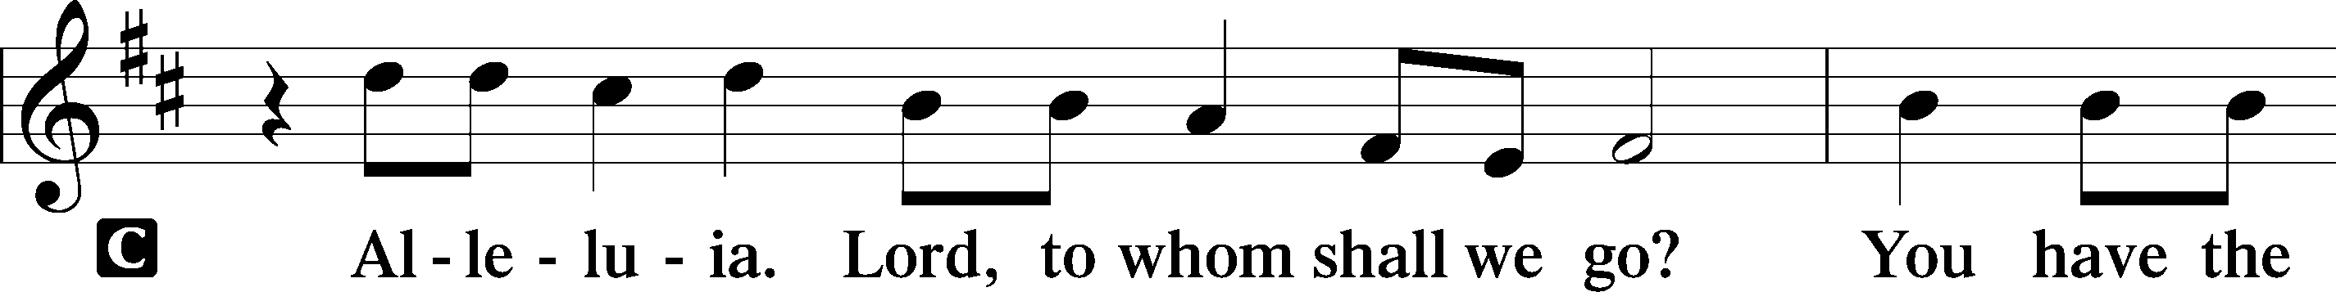
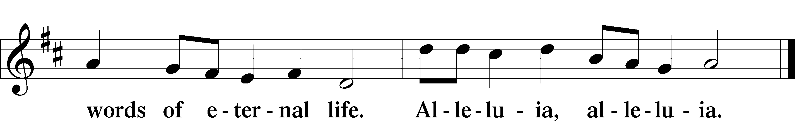

Holy Gospel Mark 7:14–23
P The Holy Gospel according to St. Mark, the seventh chapter.

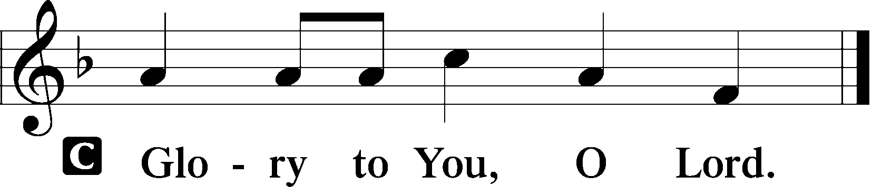

What Defiles a Person
14[Jesus] called the people to him again and said to them, “Hear me, all of you, and understand: 15There is nothing outside a person that by going into him can defile him, but the things that come out of a person are what defile him.” 17And when he had entered the house and left the people, his disciples asked him about the parable. 18And he said to them, “Then are you also without understanding? Do you not see that whatever goes into a person from outside cannot defile him, 19since it enters not his heart but his stomach, and is expelled?” (Thus he declared all foods clean.) 20And he said, “What comes out of a person is what defiles him. 21For from within, out of the heart of man, come evil thoughts, sexual immorality, theft, murder, adultery, 22coveting, wickedness, deceit, sensuality, envy, slander, pride, foolishness. 23All these evil things come from within, and they defile a person.”

P This is the Gospel of the Lord.

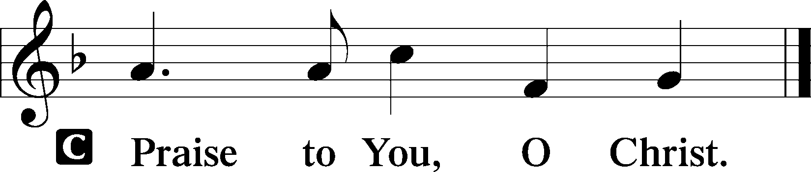

Sit

661 The Son of God Goes Forth to War
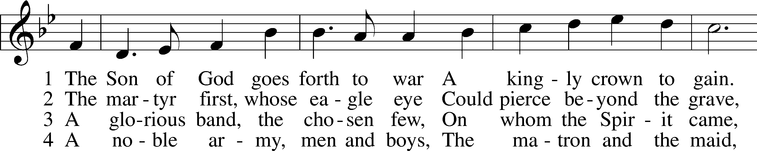
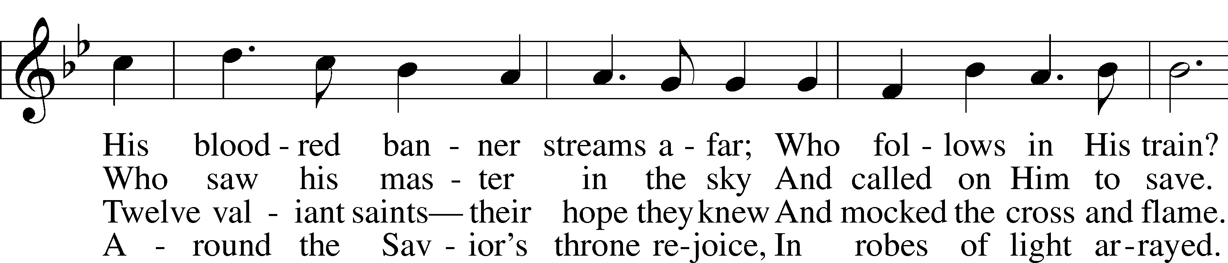
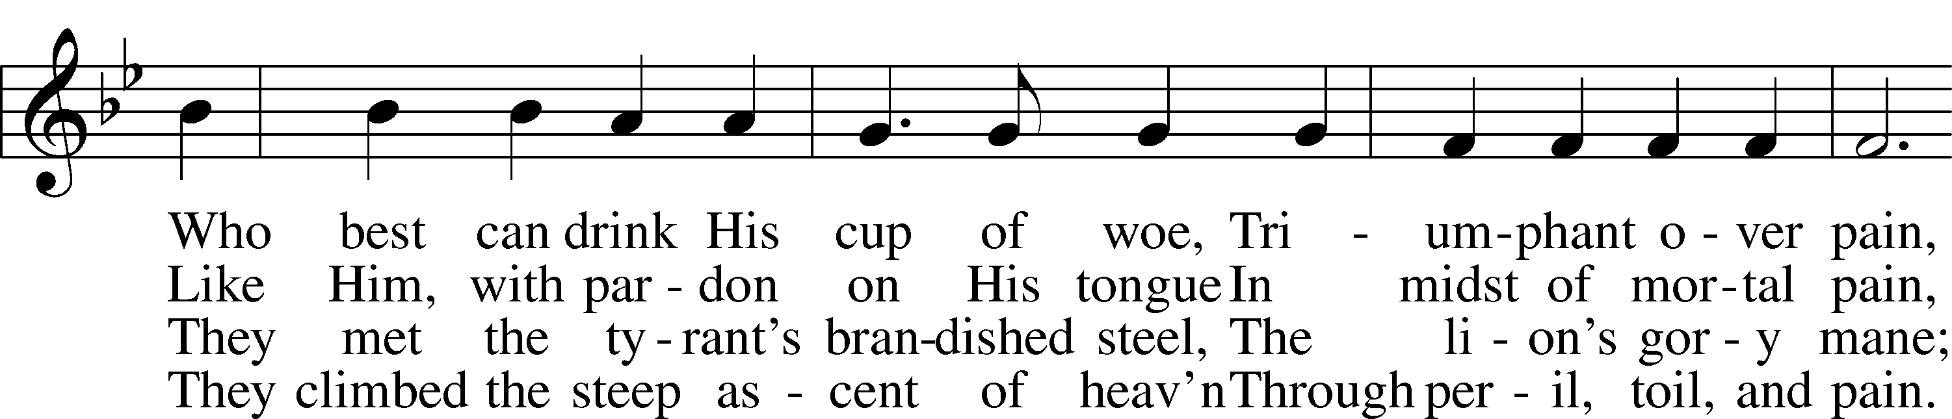
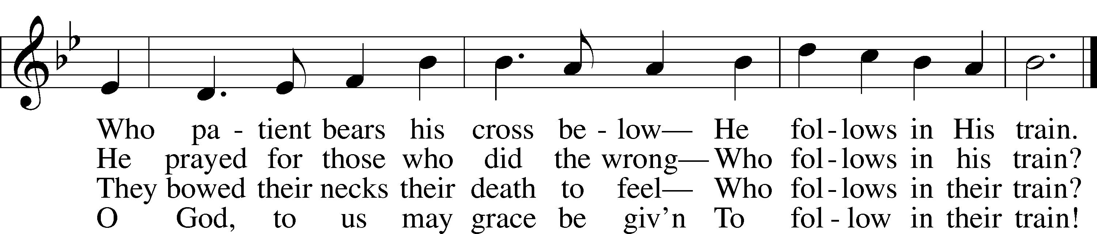
Tune and text: Public domain

Sermon ~ "Being Battle Ready" based on Ephesians 6:15

Stand

Apostles’ Creed
C I believe in God, the Father Almighty,
maker of heaven and earth.

And in Jesus Christ, His only Son, our Lord,
who was conceived by the Holy Spirit,
born of the virgin Mary,
suffered under Pontius Pilate,
was crucified, died and was buried.
He descended into hell.
The third day He rose again from the dead.
He ascended into heaven
and sits at the right hand of God the Father Almighty.
From thence He will come to judge the living and the dead.

I believe in the Holy Spirit,
the holy Christian Church,
the communion of saints,
the forgiveness of sins,
the resurrection of the body,
and the life T everlasting. Amen.

Prayer of the Church

Offering and Offertory LSB 159
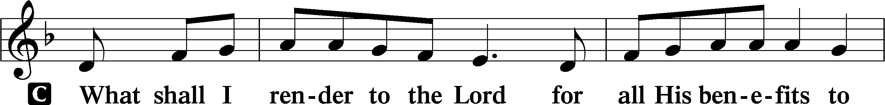
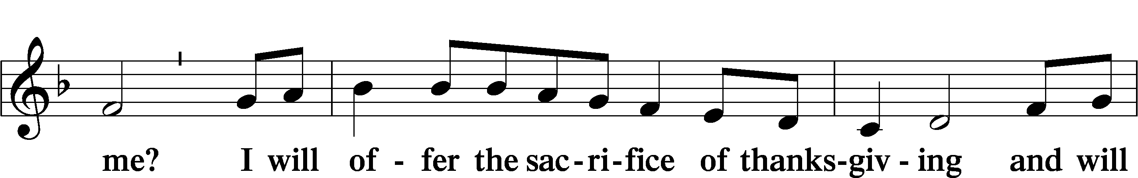
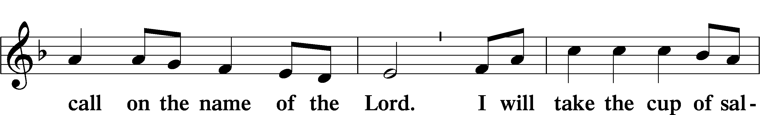
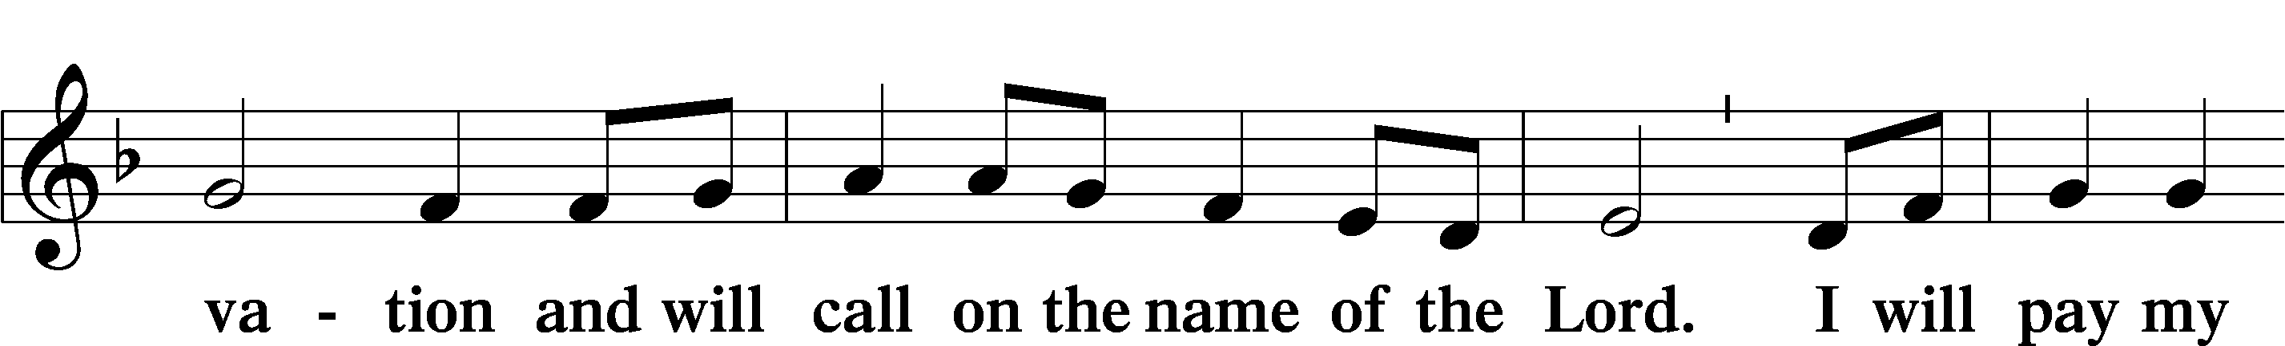
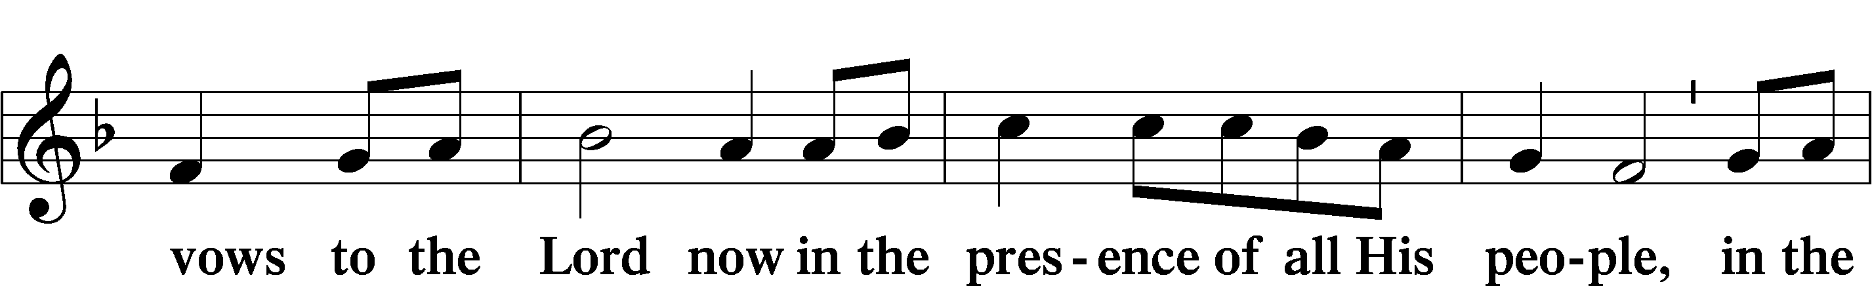
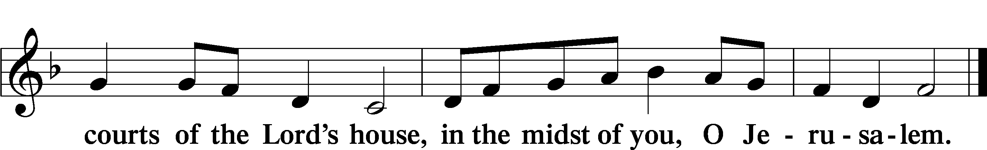

Service of the Sacrament

Preface LSB 160
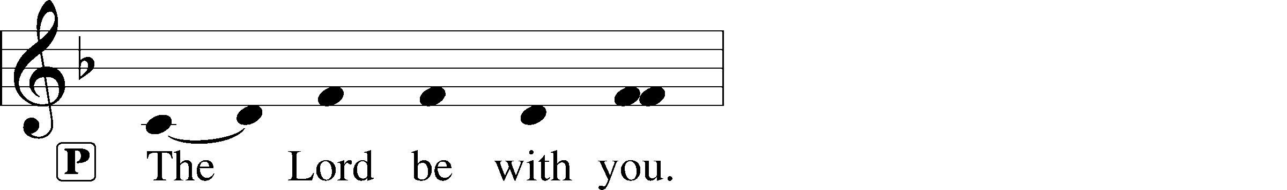
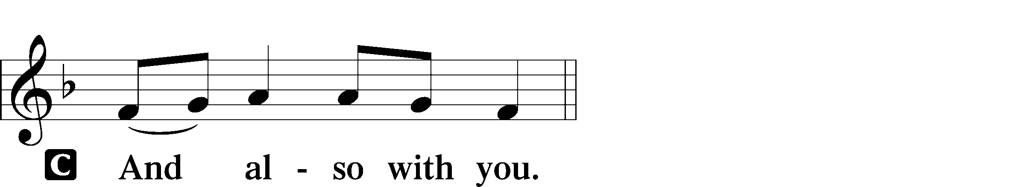
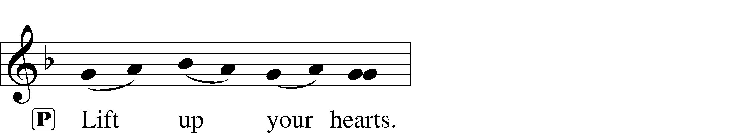
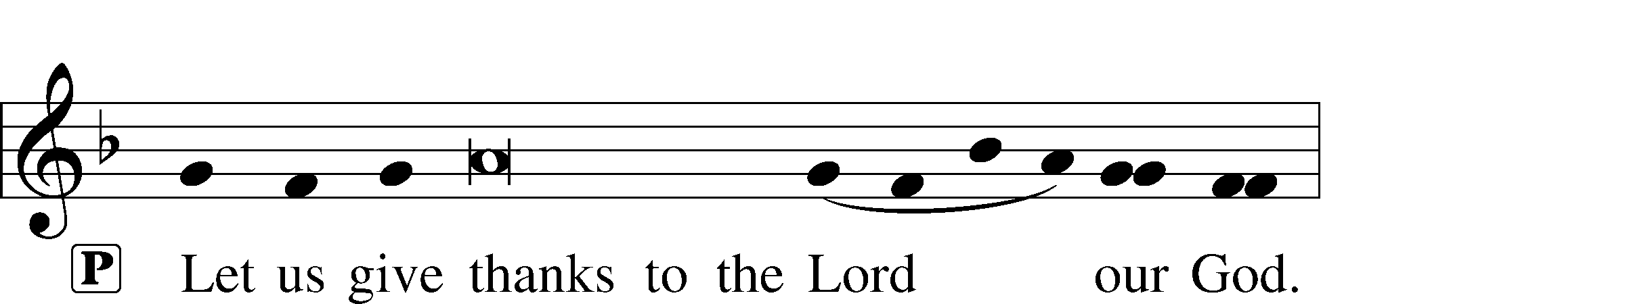
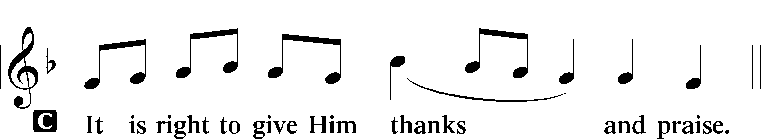

Proper Preface
P It is truly good, right, and salutary that we should at all times and in all places give thanks to You, holy Lord, almighty Father, everlasting God, through Jesus Christ, our Lord, who, having created all things, took on human flesh and was born of the virgin Mary. For our sake He died on the cross and rose from the dead to put an end to death, thus fulfilling Your will and gaining for You a holy people. Therefore with angels and archangels and with all the company of heaven we laud and magnify Your glorious name, evermore praising You and saying:

Sanctus LSB 161
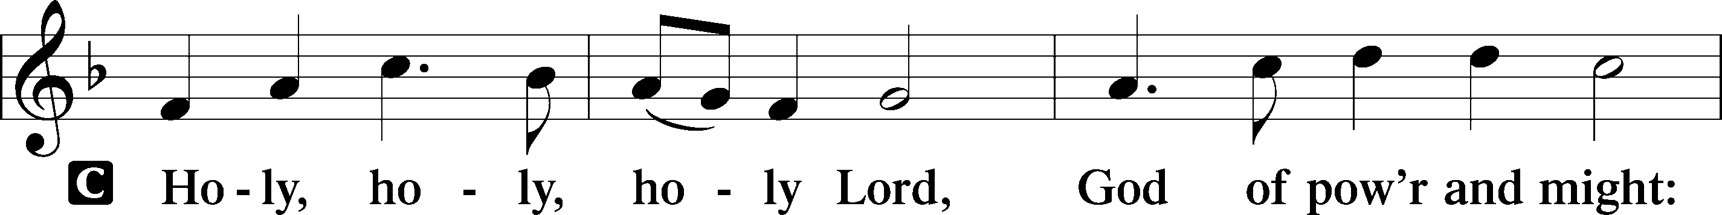
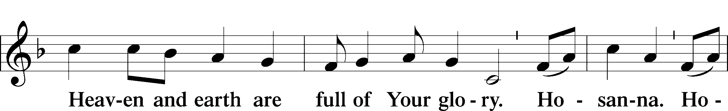
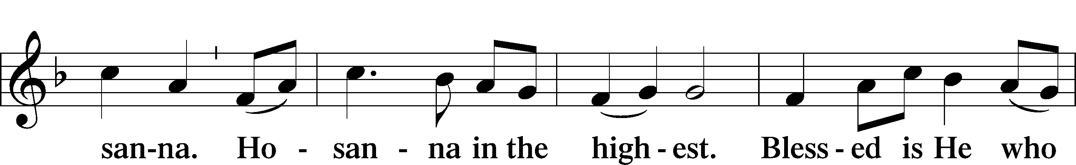
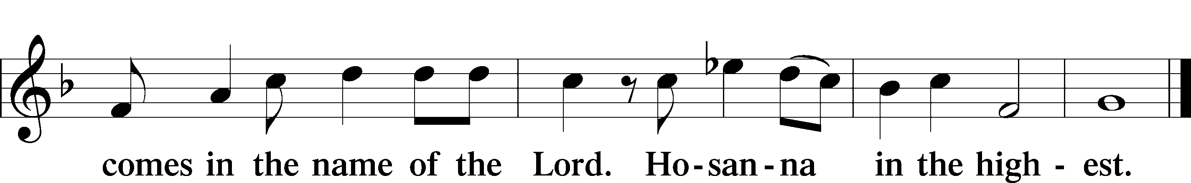

Lord’s Prayer

The Words of Our Lord
P Our Lord Jesus Christ, on the night when He was betrayed, took bread, and when He had given thanks, He broke it and gave it to the disciples and said: “Take, eat; this is My T body, which is given for you. This do in remembrance of Me.”

In the same way also He took the cup after supper, and when He had given thanks, He gave it to them, saying: “Drink of it, all of you; this cup is the new testament in My T blood, which is shed for you for the forgiveness of sins. This do, as often as you drink it, in remembrance of Me.”

Pax Domini LSB 163
P The peace of the Lord be with you always.
C Amen.

Agnus Dei LSB 163
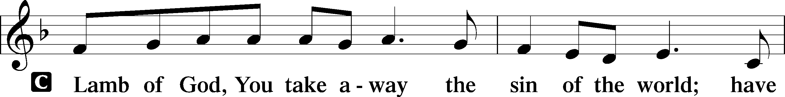
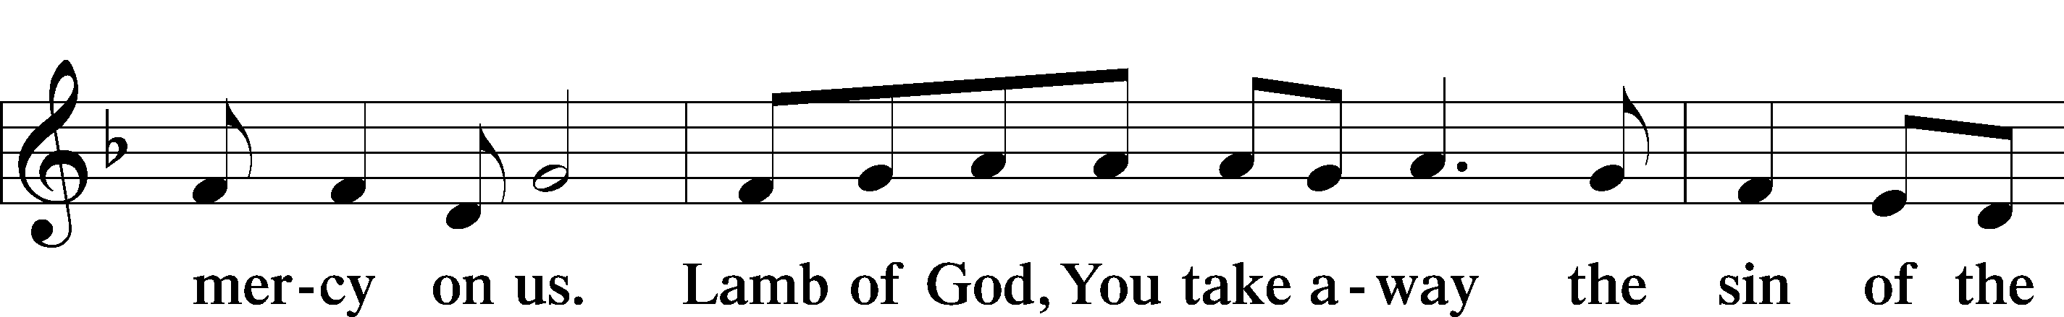
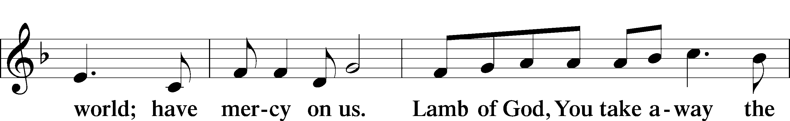
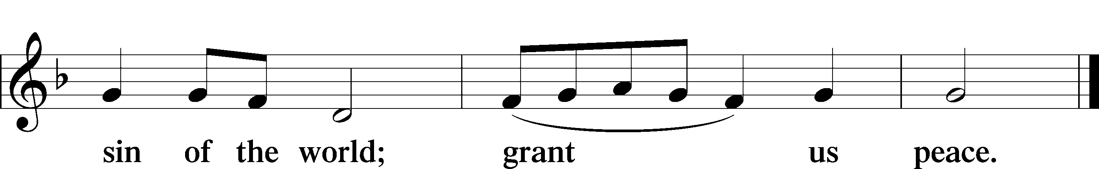

Sit

Distribution

566 By Grace I’m Saved
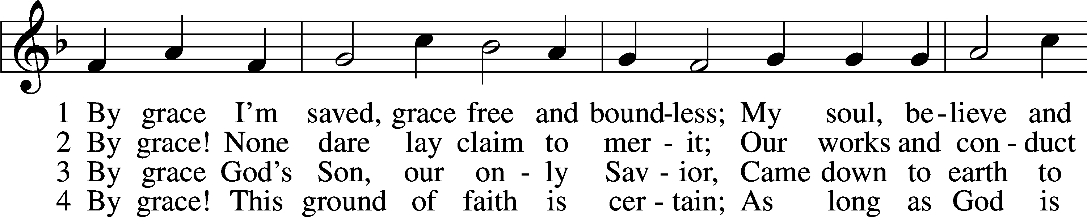
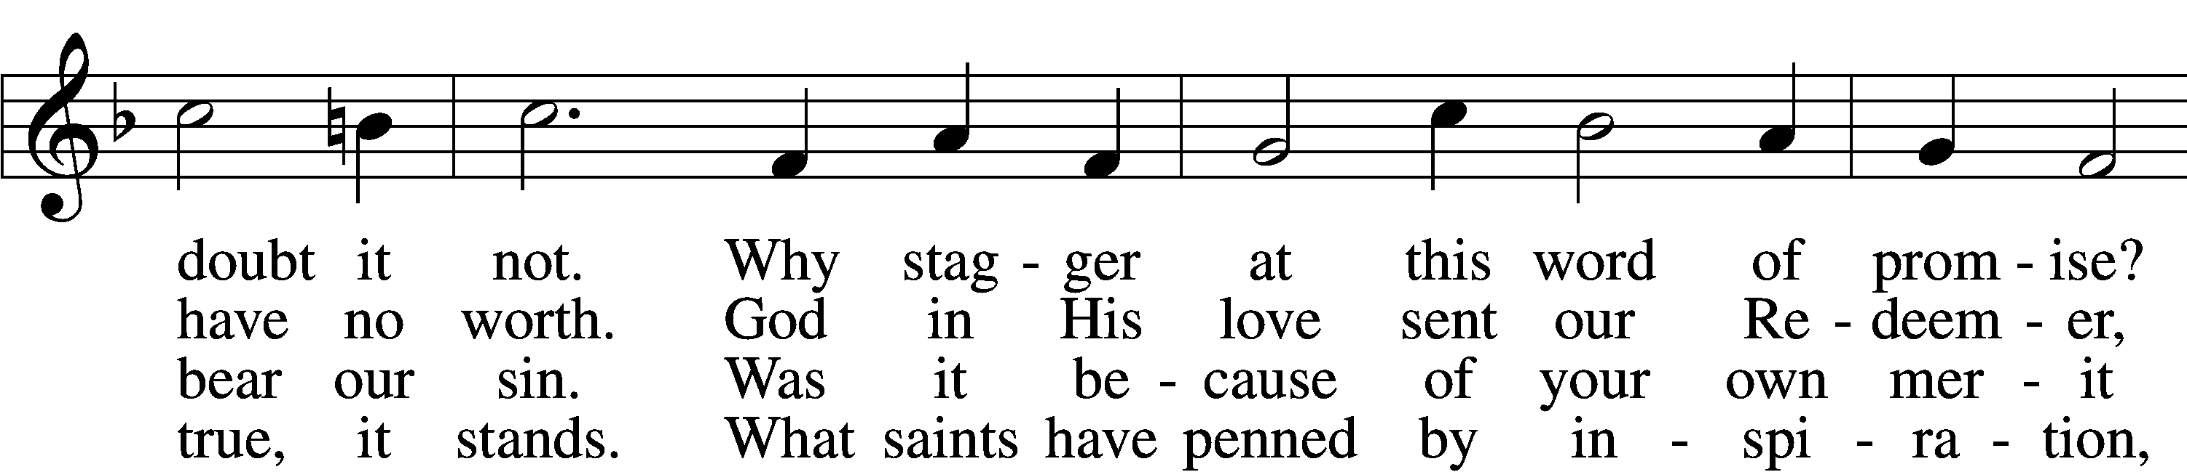
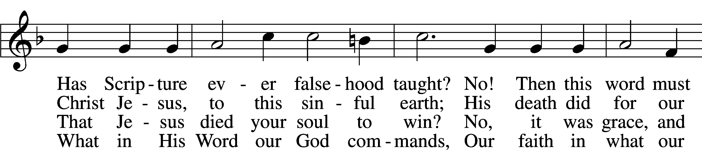
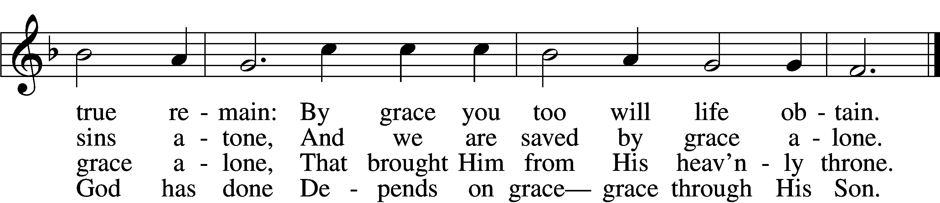

5 By grace to timid hearts that tremble,
In tribulation’s furnace tried,
By grace, in spite of fear and trouble,
The Father’s heart is open wide.
Where could I help and strength secure
If grace were not my anchor sure?

6 By grace! On this I’ll rest when dying;
In Jesus’ promise I rejoice;
For though I know my heart’s condition,
I also know my Savior’s voice.
My heart is glad, all grief has flown
Since I am saved by grace alone.
Tune and text: Public domain

656 A Mighty Fortress Is Our God
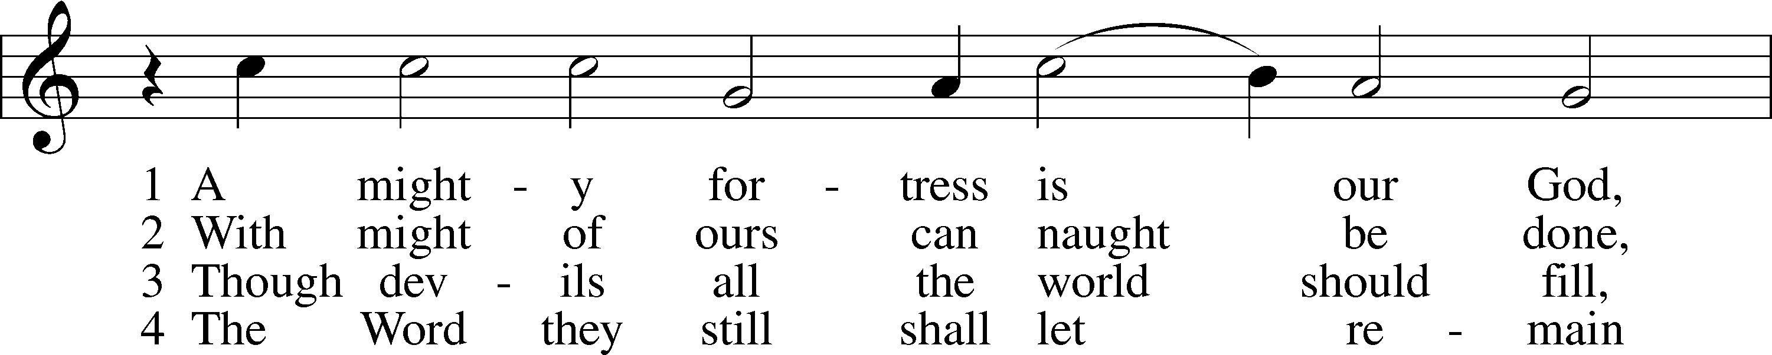
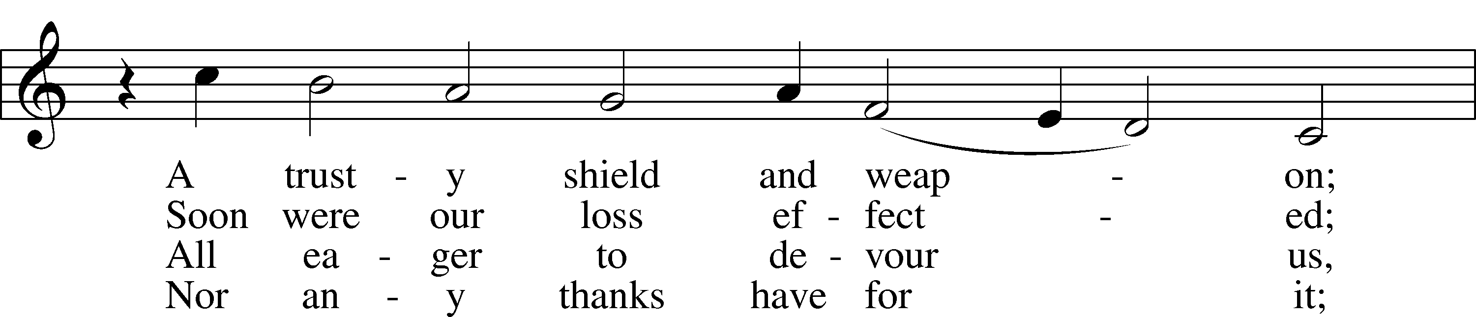
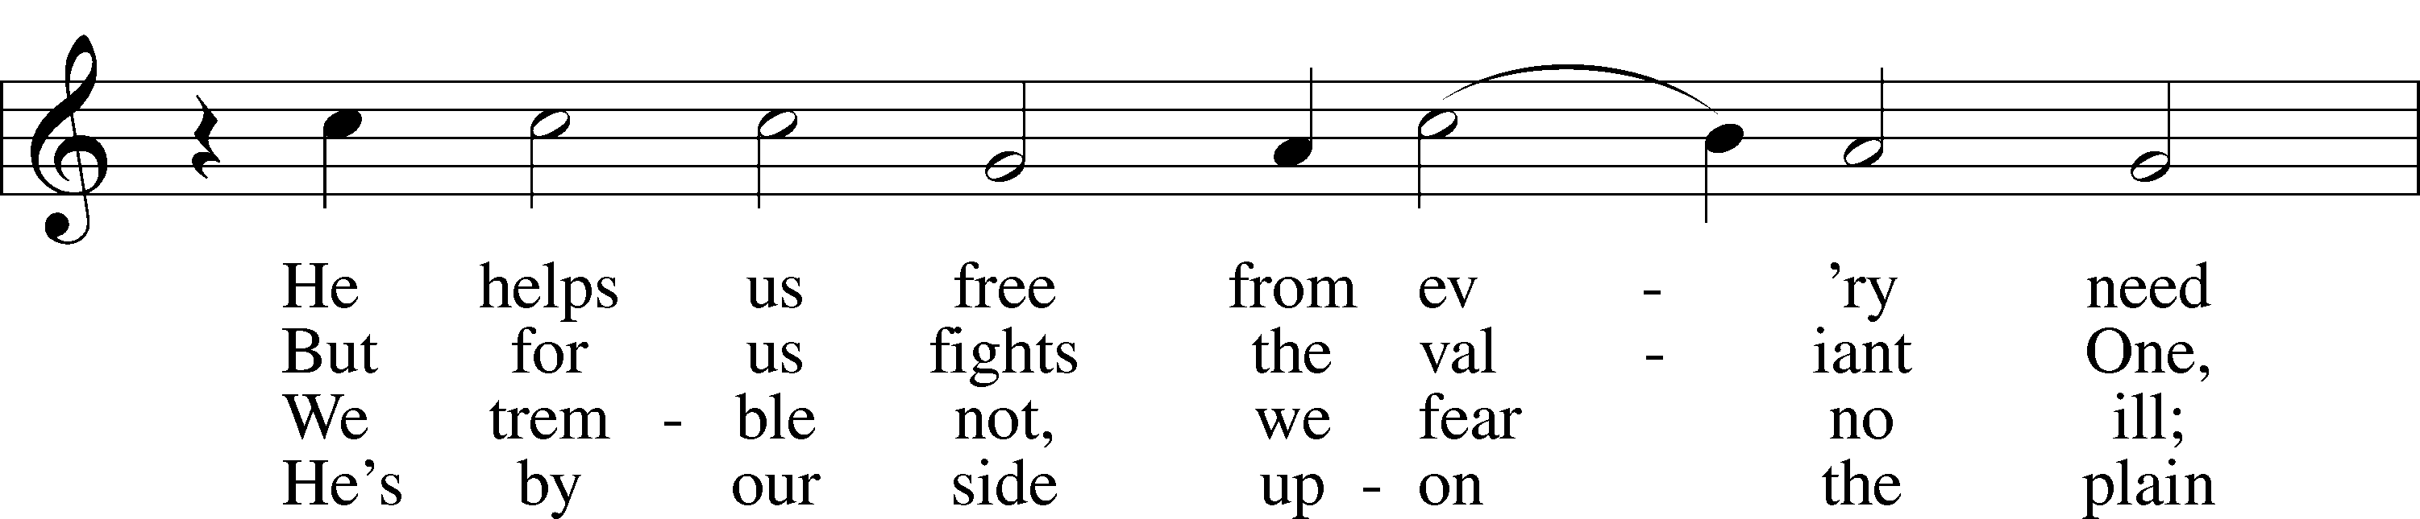
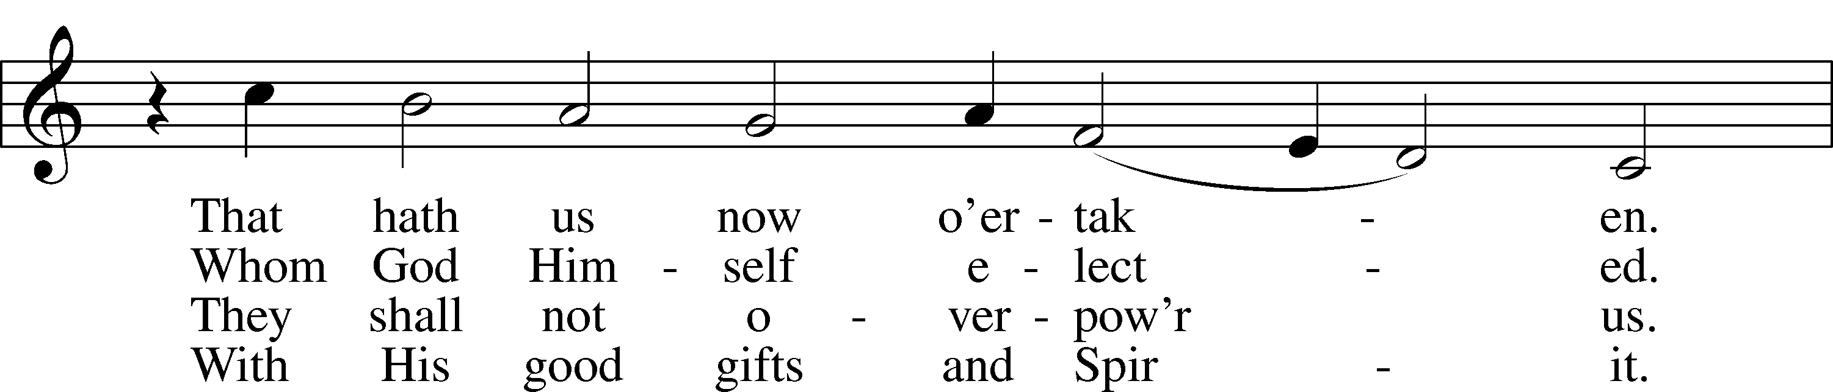
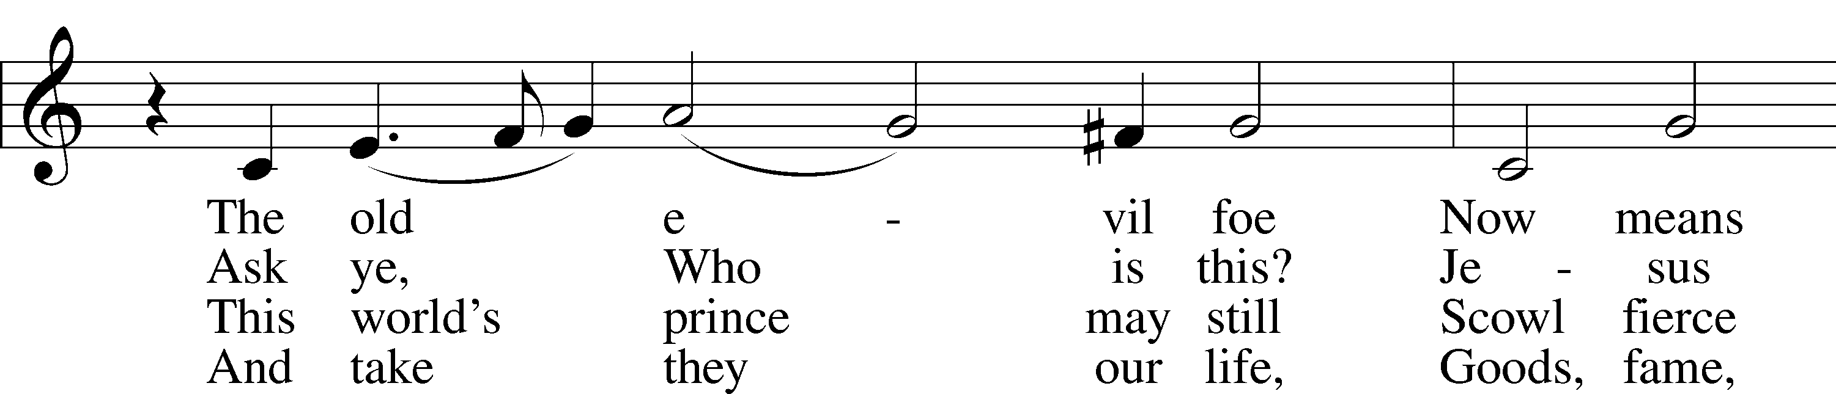
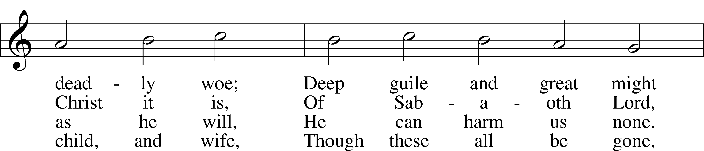
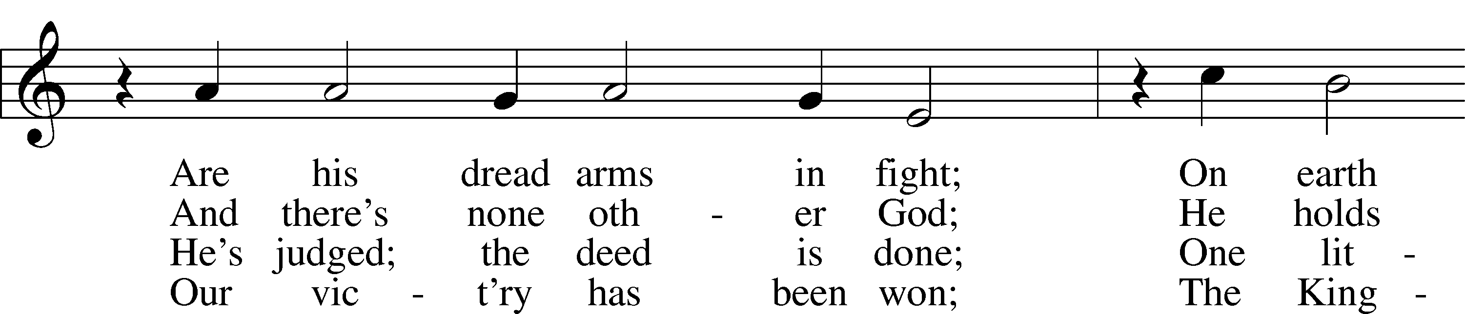
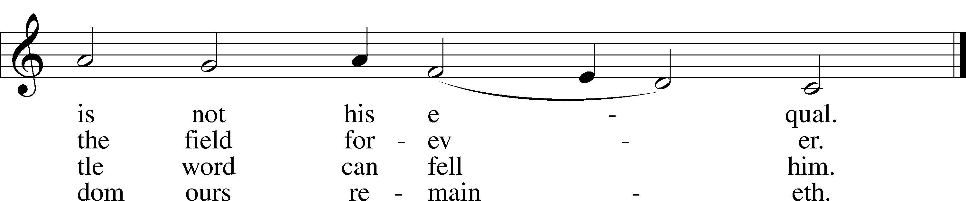
Tune and text: Public domain

666 O Little Flock, Fear Not the Foe
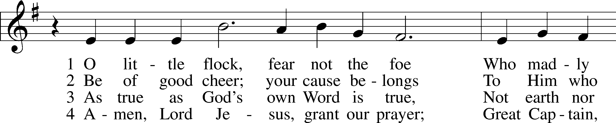
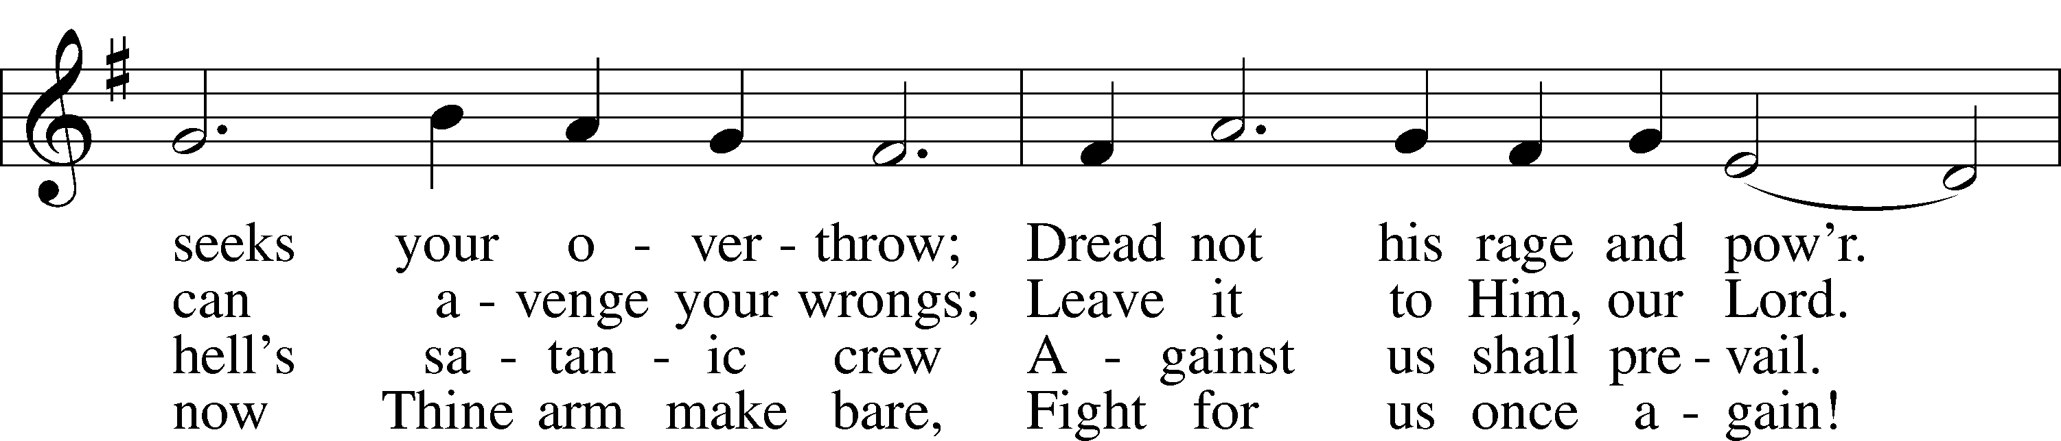
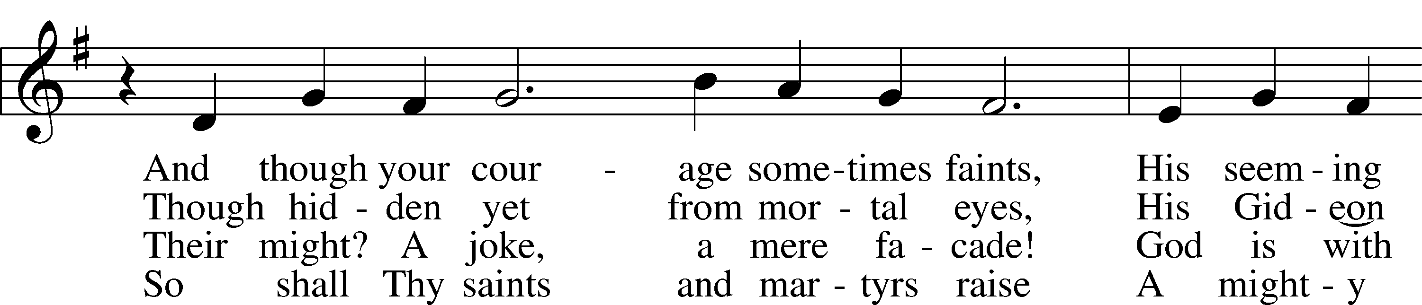
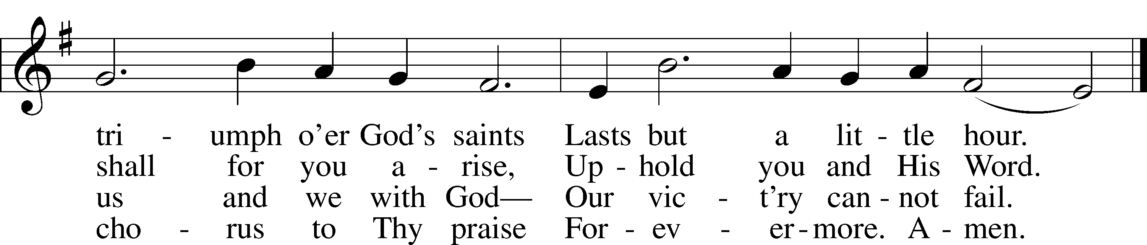
Tune and text: Public domain

Stand

The Dismissal
P The body and blood of our Lord Jesus Christ strengthen and preserve you in body and soul to life everlasting. Depart T in peace.
C Amen.

Thank the Lord LSB 164
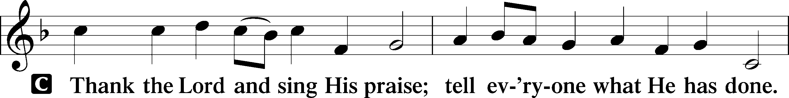
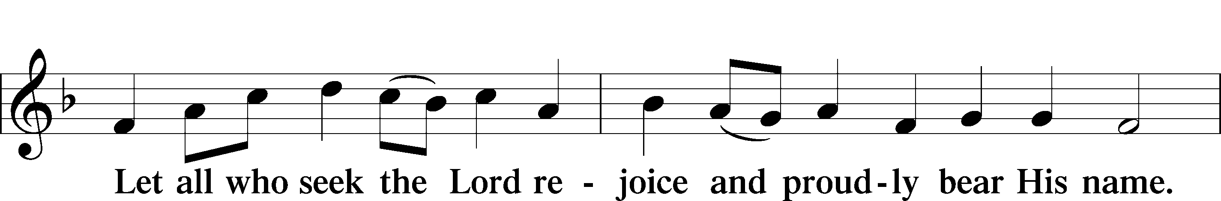
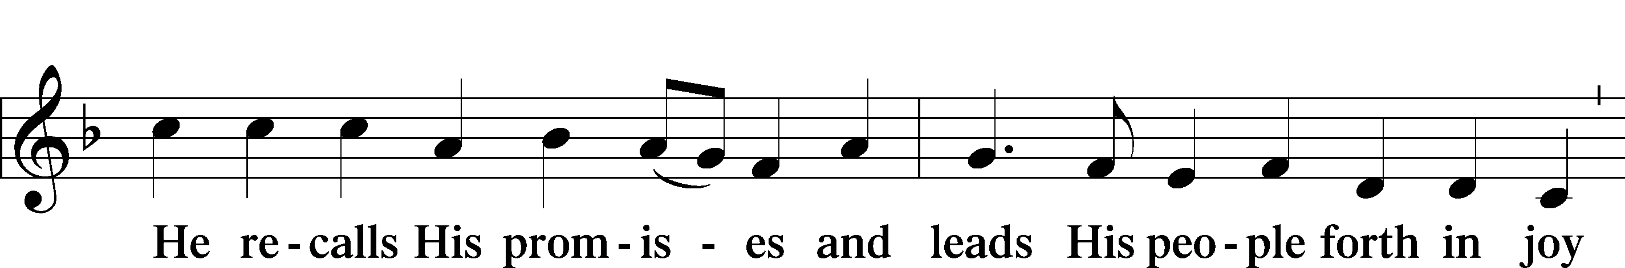
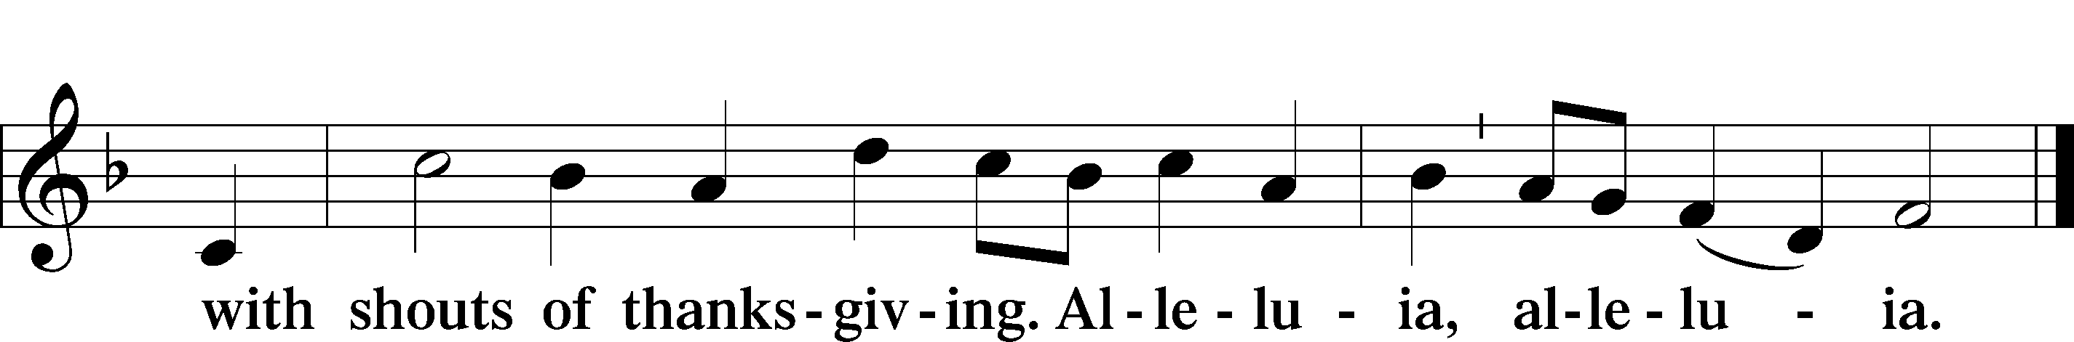

Post-Communion Collect
A Let us pray.
We give thanks to You, almighty God, that You have refreshed us through this salutary gift, and we implore You that of Your mercy You would strengthen us through the same in faith toward You and in fervent love toward one another; through Jesus Christ, Your Son, our Lord, who lives and reigns with You and the Holy Spirit, one God, now and forever.
C Amen.

Benediction LSB 166
P The Lord bless you and keep you.
The Lord make His face shine on you and be gracious to you.
The Lord look upon you with favor and T give you peace.
C Amen.

664 Fight the Good Fight
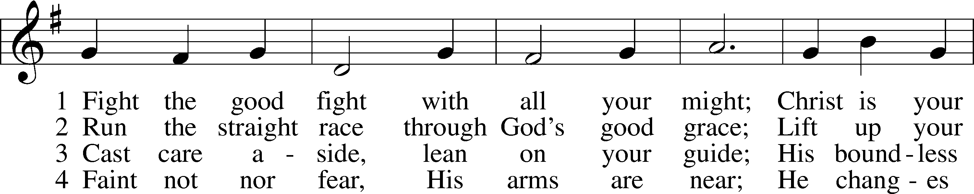
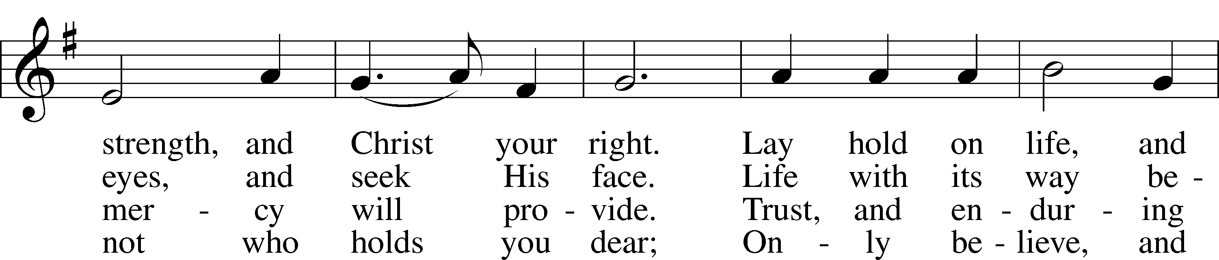
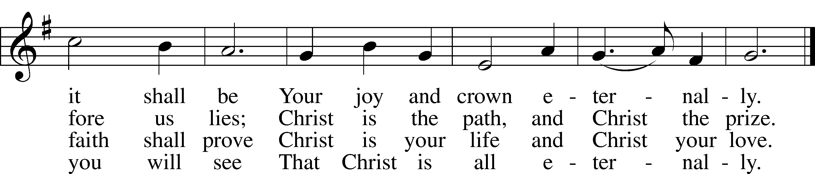
Text and tune: Public domain

Acknowledgments
Unless otherwise indicated, Scripture quotations are from the ESV® Bible (The Holy Bible, English Standard Version®), copyright © 2001 by Crossway, a publishing ministry of Good News Publishers. Used by permission. All rights reserved.
Created by Lutheran Service Builder © 2021 Concordia Publishing House.

Prayers for Our Members
Sharon Hockemeier | Expectant Mother
Garrett & Monique Pohlman at the birth of a daughter, Gemma Dae | Thanksgiving
Norman Abels (Brookestone Meadows – Elkhorn) | Healing
Judy Ahrens | Healing
Vaughn Albrecht (Mount Carmel) | Healing
Tom & DyAnn Altwine | Healing
Lyle Colsden (Mother Hull) | Healing
Pat Flodine (Cambridge Court) | Healing
Vi Fox (Prairie View) | Healing
Verleen Gentry | Healing
Ruby Hatfield | Healing
Lennis Hodgson | Healing
Boyd Millsap | Healing
Michelle Millsap | Healing
Roger Riekenberg | Healing
Don Richmond | Healing
Marion Richmond | Healing
Ivan Bombeck | Cancer
Fran Junge | Cancer
Bertha Marienau | Cancer
Kim Vos | Cancer

ZION LUTHERAN CHURCH AND SCHOOL

Pr. James DeLoach, Pastor + (308) 627-5260
james.deloach@zionkearney.org
Pr. Doug Gaunt, Pastor + (308) 455-0552
doug.gaunt@zionkearney.org
Tony Splittgerber, Principal + (308) 293-0168
anthony.splittgerber@zionkearney.org

Church Office
Secretary: Shirley Oertwig
Email: school@zionkearney.org
Phone: (308)-234-3410 Fax: (308) 236-8100
Office Hours: Monday-Friday 8:00am-4:00pm
Radio Broadcast: Sunday @ 10:30 a.m. on 1460 AM
Website: www.zionkearney.com
Prayers for Our Members’ Family & Friends
Naomi Wollberg (Andy & Jeanne Wollberg’s daughter-in-law) | Expecting
Reg Duke (Westman’s brother-in-law) | Healing
James Gentry (Verleen Gentry’s son) | Healing
Roger Hoffman (Marc’s father) | Healing
David Kreutzer | Healing
Sharon Kreutzer (Richard’s mother) | Healing
Lyra Mais (Zion student) | Healing
Dillon Malchow (Joy Barefoot’s nephew) | Healing
Mary Ann Mertz (Pam’s Uhlir’s friend) | Healing
Tim Powers (Kim Wilken’s brother) | Healing
Roy Reynolds (Verleen Gentry’s son-in-law) | Healing
Lynne Saathoff (Verleen Gentry’s sister-in-law) | Healing
Randy Solomon (Beth Rosenthal’s father) | Healing
Angela Well (Charles Marineau’s granddaughter) | Healing
Larry Bombeck (Ivan’s brother) | Healing
Katie Cunningham (Quentin & Janel Lange’s friend) | Burn
Jonah (Jase & Jarren Blattner’s friend) | Cancer
D.D. Dugger (Sue Kaiser’s brother) | Cancer
Stuart Gronewoller (Lonna’s brother-in-law) | Cancer
Ron Halvorsen (Jeff’s dad) | Cancer
Randy Jochum (Ken Hockemeier’s brother-in-law) | Cancer
Fred Koch (Pam Uhlir’s cousin) | Cancer
John Moore (family of Susan Tonniges) | Cancer
Sharon Mulhair (Pam Uhlir’s cousin) | Cancer
Kolby Shiers (Jessica’s cousin) | Cancer
Tyrone Uhlir (Pam’s nephew) | Cancer
Where our Triune God strengthens us through His mercy in faith toward Him and in fervent love toward one another.

Today’s Radio Broadcast is given to the Glory of the Lord by
a former Zion member.

The Altar flowers are given to the Glory of the Lord by Pastor Doug & Carol Gaunt in celebration of their wedding anniversary.

Worship Assistants

Sunday, August 29~ 9:00am

Elder: Bruce Brooks
Usher: Andy Wollberg
Engineer: Jared Nuttelman
Announcer: Lonna Gronewoller
Altar Guild: Waunita DeLaet & Connie DeLaet

Sunday, September 5 ~ 9:00am

Elder: Eric Rosenthal
Usher: Fred Flessner & Lennis Hodgson
Acolyte: Isaiah Gaunt
Engineer: Jamie Nikodym
Announcer: Carol Kreutzer
Altar Guild: Carol Gaunt & Liz Gaunt

Our Response to the Gospel

Date: 08/22/2021

Offering:
Weekly Need: $7,457.69

This Week at Zion

Sun  08/29 | 9:00a  10:30a  10:15a | Divine Service  Radio Broadcast 1460am & 92.1fm  Bible Study
Mon  08/30 | Birthdays  Anniversaries | ---  ---
Tues  08/31 | 1:30p  Birthdays  Anniversaries | Sleeping Mats  Kelie Bates, Matthew Kreutzer  ---
Wed  09/01 | 8:30a  5:45p  Birthdays  Anniversaries | Chapel  Midweek  ---  ---
Thurs  09/02 | Birthdays  Anniversaries | Carol Kreutzer  ---
Fri  09/03 | Birthdays  Anniversaries | Andy Wollberg  ---
Sat  09/04 | 5:00p  Birthdays  Anniversaries | Divine Service  Abigail Lange  ---
Sun  09/05 | 9:00a  10:30a  Birthdays  Anniversaries | Divine Service  Radio Broadcast 1460am & 92.1fm  ---  ---

Where our Triune God strengthens us through His mercy in faith toward Him and in fervent love toward one another.

“Blessed are those whose strengths is in You,
in whose heart are the highways to Zion.”
Psalm 84:5
ANNOUNCEMENTS

MIDWEEK CLASS BEGINS THIS WEEK
Midweek class for all Zion public school students (4th grade or older) begins this Wednesday, September 1st. Classes will meet in the fellowship hall and will go from 5:45 to 7:00 pm. Students need to bring a 3-ring binder (one inch or more), their bible, and their catechism. First-year students will receive a catechism. Pastor will distribute a class schedule and assignment sheet at the first class. Call Pr. DeLoach (308-627-5260) with any questions.

Adult choir - will begin Wednesday, September 8, at 7:00 p.m. We will meet in the balcony. If you cannot commit for an entire year, feel free to join us through Christmas. Choir takes a break in January and then resumes through Easter. No particular music skills are required other than a love of singing! New members are always welcome! If you have questions please call/text/email Carol DeLoach at carol.deloach@gmail.com, 627-2279.

Peaches –
Mary Martha will be selling peaches in the north parking lot today August 29, if they arrive in time. If any remain, they will be available at Zion on Monday morning. The cost will be $40 a lug.
The youth will have them available next weekend September 5th. (Youth please see the note about signing up to help!)

Zion Golf Tournament
Mark your calendar for the Zion Golf tournament scheduled for Sunday, September 12. Registration forms for golf tournament are available on the church and school website and at the church office.

Acolytes Beginning Sunday, September 5 we will return to having acolytes at our Sunday morning services. Those scheduled to serve in Sept. are: Sept. 5- Isaiah Gaunt, Sept. 12-Abigail Lange, Sept. 19 -Addison Helmbrecht, September 26. - Addison Splittgerber. Acolytes, if you are not able to serve on your assigned week, please call one of the other acolytes to arrange a trade.

Youth Peach Sale Sign-up Zion Youth will be selling peaches September 5th. We are looking for youth group helpers for that day to help sell. Please let Ms. Dauel or Ms. Nikodym know if you can help.

Sunday School Teachers The Board of Education is getting ready to restart Sunday School. However, we do not have enough teachers! We are looking to establish a teacher rotation so volunteers have schedule flexibility and won’t feel obligated to teach forever! If you would be willing to be part of a weekly or monthly teaching rotation, please tell the office, Pastor DeLoach, or Matt Hodgson. Our priority is for grades K-6, but we would love to do preschool/pre-k if we can get the volunteers.

Adult Bible Study -The adult bible study class is meeting once again on Sunday mornings. We have just begun a study entitled “Just Words.” It is a study of the doctrine of justification by grace through faith and the various biblical metaphors that convey the Gospel. Come grab a donut and cup of coffee as we learn together.

Offering Options:
1) Place your offering in the basket as you leave
2) Go to zionkearney.churchtrac.com/give
3) Go to zionkearney.com and click on the ChurchTrac icon
4) Mail your gift to Zion Lutheran Church, 2421 C Ave, Kearney, NE 68847 or place it in the mail slot on the south side of the building.
Radio Broadcast - Please help Zion spread the Gospel, signup to sponsor a radio broadcast! There are several open dates.

Church Management System – Zion has switched to a web-based church management system called ChurchTrac. Please pick-up a yellow sheet in the narthex to get setup today to view all of the benefits and features.

It is very important that you setup your account. This is the only way for the office to know of birthdays, anniversaries, etc. The old software program is no longer working, so old information is all what is being used, so more than likely we are missing a lot of babies, etc.

Mission Offerings - If you would like to donate to the missions Zion supports, please use the mission envelopes located in the narthex. The third quarter missions will be going to support Jonathan Clausing. Thank you for your support.

https://www.lcms.org/clausing

https://missioncentral.us/category/africa/jonathan-and-anita-clausing/
SCHOOL NEWS

The school year is off to a great start. We do still have a few openings in our 3 year old Pre-school classes. If you know of anyone needing preschool please have them contact our office.

The Theme for our school year is “Together by Christ’s Love” based on
1 John 4:7-8.

State Fair Our K-6th grade will attend the Nebraska State Fair this Wednesday, Sept. 1. This program is billed as Nebraska’s biggest classroom.

Zion Cross Country – The first meet for our cross country athletes is this Thursday, Sept. 2, hosted by Lexington.

Employment Opportunity

Secretary for the Church and the School:
If you enjoy working with people, have clerical/office experience, and like a fast-paced, ever-changing workday – this may be the position for you! Please contact Pastor DeLoach or Mr. Splittgerber if you are interested.

