Divine Service
Nineteenth Sunday
after Pentecost
October 3, 2021

Zion Lutheran Church
Kearney, Nebraska

Welcome to Zion!
All worshippers please fill out an attendance card in the pew rack and let us know how we might be of service to you.

Holy Communion at Zion

The Lord’s Supper is celebrated at this congregation as Jesus has given it. As he says, our Lord gives into our mouths not only bread and wine but his very body and blood to eat and to drink for the forgiveness of sins and to strengthen our union with him and with one another. Our Lord invites to his table those who trust his words, repent of all sin, and set aside any refusal to forgive and love as he forgives and loves us, that they may show forth his death until he comes. All communicants need to register in the narthex prior to the service.

Because those who eat and drink our Lord’s body and blood unworthily do great harm and because Holy Communion is a confession of the faith which is confessed at this altar, any who are not yet instructed, in doubt, or who hold a confession differing from that of this congregation and The Lutheran Church—Missouri Synod, are asked not to commune until they are able to speak with our pastor first. He is happy to visit with you about the Christian faith and how to receive the Lord’s Supper for your good and for the good of others. Those not communing are invited to come to the altar, cross your arms in front of you, and bow your head to receive a pastoral blessing.

Marriage Is a Sign that Manifests the Gospel of Christ and His Church

Humanity is created in the image and likeness of God. “It is not good that the man should be alone” (Gen. 2:18). For the Lord Himself is a perfect communion of three Persons — the Father, Son and Holy Spirit — in one God. Therefore, “the Lord God caused a deep sleep to fall upon the man, and while he slept took one of his ribs,” which “he made into a woman” and brought “to the man” (Gen. 2:21–22). It is for this reason that “a man shall leave his father and his mother and hold fast to his wife, and they shall become one flesh” (Gen. 2:24; Mark 10:7). This great mystery of holy marriage signifies Christ Jesus, the incarnate Son of God, and His Bride, the Church. Divorce and all manner of adultery contradict and undermine this sign, and in doing so, they confess a false Christ and a false gospel. “What therefore God has joined together, let not man separate” (Mark 10:9). In truth, Christ Jesus has atoned for all such sins, and He has perfected marriage in Himself “through suffering,” that He might bring “many sons to glory” in His resurrection (Heb. 2:8–10).
Confession and Absolution

869 With the Lord Begin Your Task
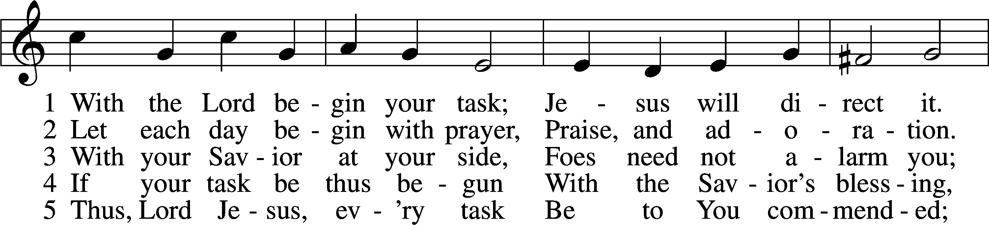
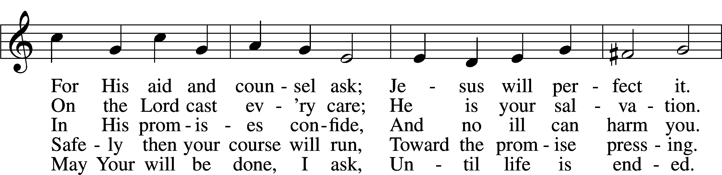
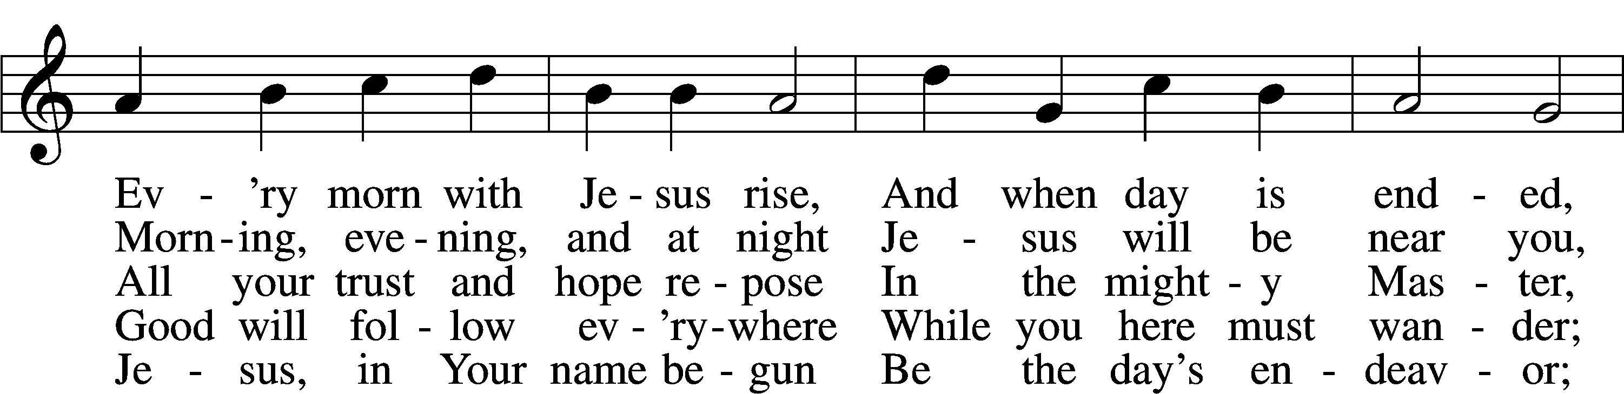
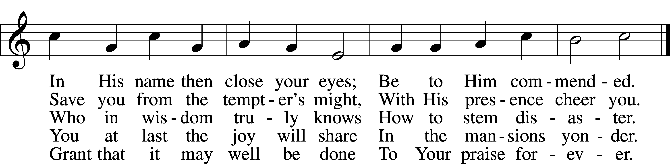
Tune: Public domain
Text: © 1941 Concordia Publishing House. Used by permission: LSB Hymn License no. 110003744

Stand

The sign of the cross may be made by all in remembrance of their Baptism.

Invocation
P In the name of the Father and of the T Son and of the Holy Spirit.
C Amen.

Exhortation LSB 151
P If we say we have no sin, we deceive ourselves, and the truth is not in us.
C But if we confess our sins, God, who is faithful and just, will forgive our sins and cleanse us from all unrighteousness.

Silence for reflection on God’s Word and for self-examination.

Confession of Sins LSB 151
P Let us then confess our sins to God our Father.
C Most merciful God, we confess that we are by nature sinful and unclean. We have sinned against You in thought, word, and deed, by what we have done and by what we have left undone. We have not loved You with our whole heart; we have not loved our neighbors as ourselves. We justly deserve Your present and eternal punishment. For the sake of Your Son, Jesus Christ, have mercy on us. Forgive us, renew us, and lead us, so that we may delight in Your will and walk in Your ways to the glory of Your holy name. Amen.

Absolution LSB 151
P Almighty God in His mercy has given His Son to die for you and for His sake forgives you all your sins. As a called and ordained servant of Christ, and by His authority, I therefore forgive you all your sins in the name of the Father and of the T Son and of the Holy Spirit.
C Amen.

Service of the Word

Introit Psalm 127:3–5; antiphon: v. 1a
Unless the Lord | builds the house,*
those who build it la- | bor in vain.
Behold, children are a heritage | from the Lord,*
the fruit of the womb | a reward.
Like arrows in the hand of a | warrior*
are the children | of one’s youth.
Blessèd is the man who fills his quiver | with them!*
He shall not be put to shame when he speaks with his enemies | in the gate.
Glory be to the Father and | to the Son*
and to the Holy | Spirit;
as it was in the be- | ginning,*
is now, and will be forever. | Amen.
Unless the Lord | builds the house,*
those who build it la- | bor in vain.

Kyrie LSB 152
A In peace let us pray to the Lord.
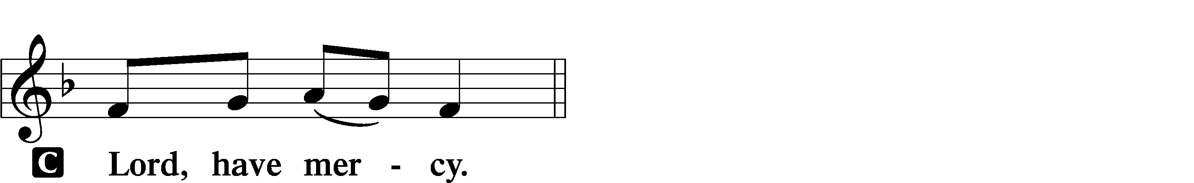

A For the peace from above and for our salvation let us pray to the Lord.
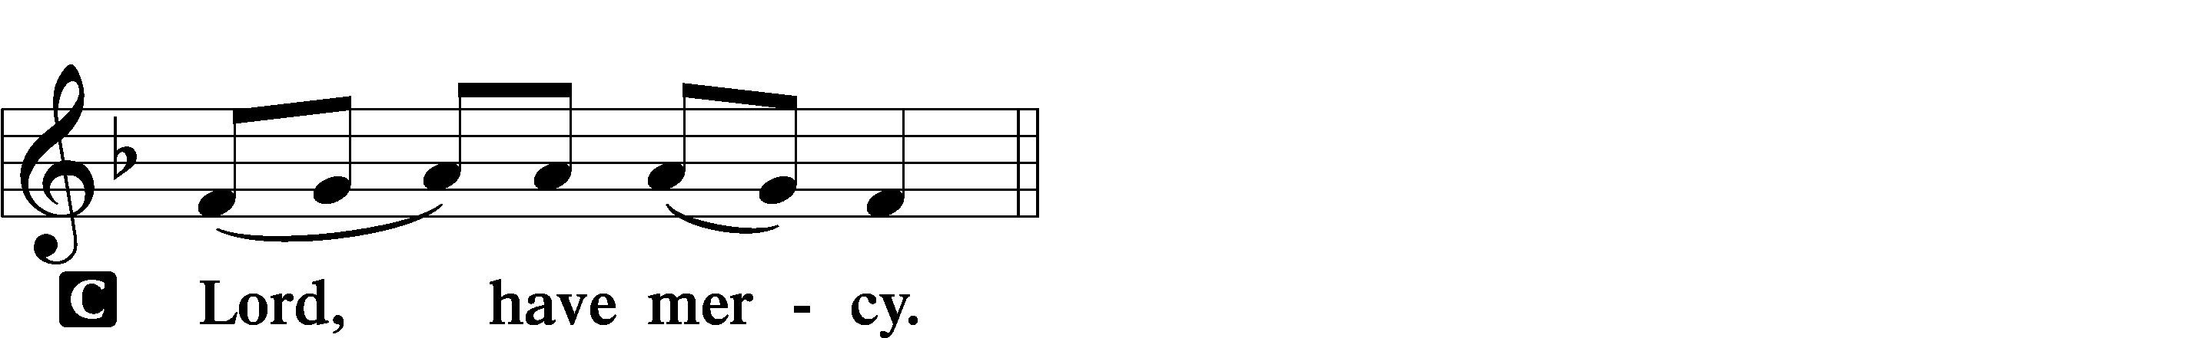

A For the peace of the whole world, for the well-being of the Church of God, and for the unity of all let us pray to the Lord.
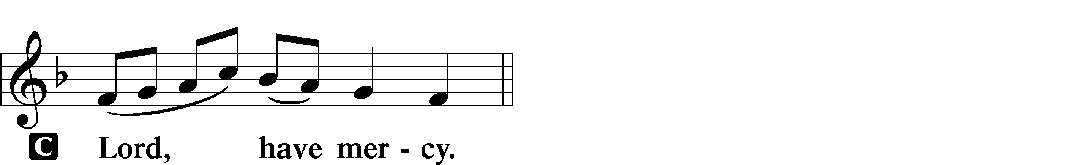

A For this holy house and for all who offer here their worship and praise let us pray to the Lord.
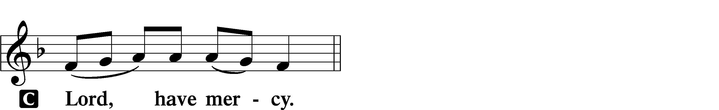

A Help, save, comfort, and defend us, gracious Lord.

Gloria in Excelsis LSB 154
A Glory to God in the highest, and peace to His people on earth.
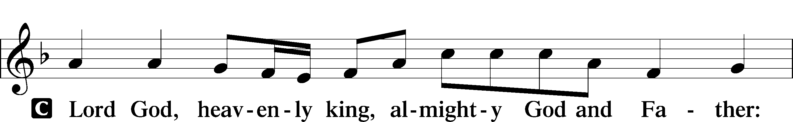
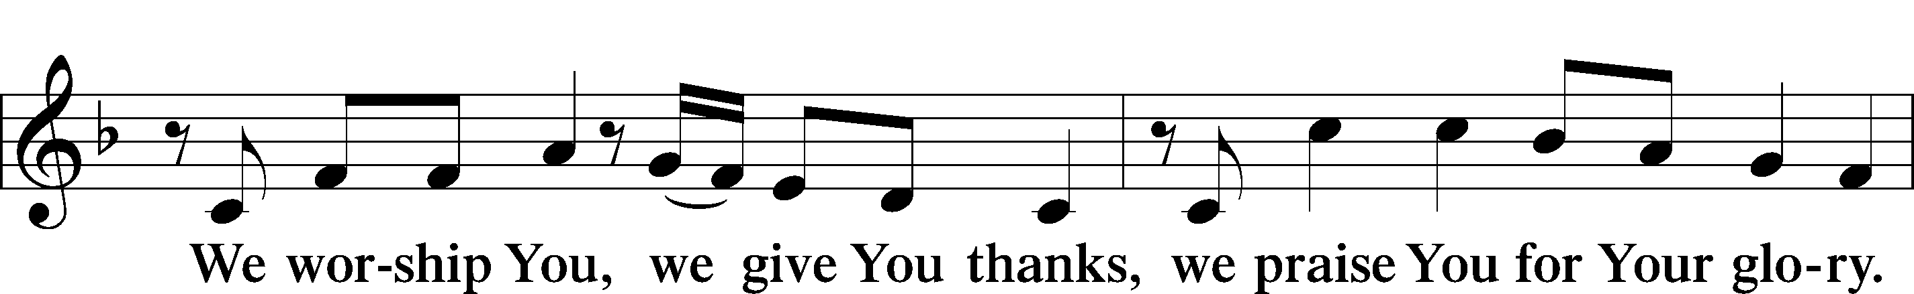
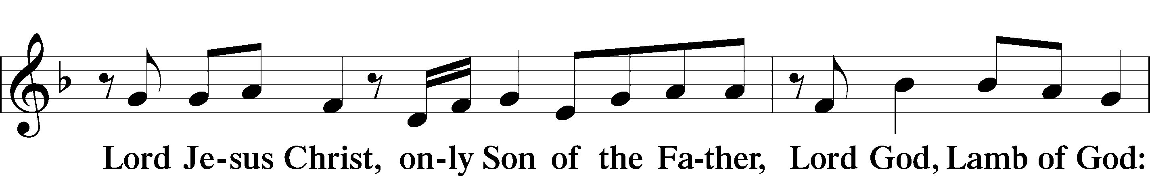
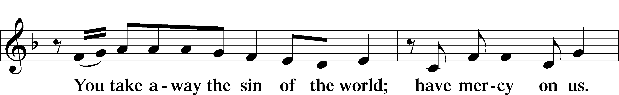
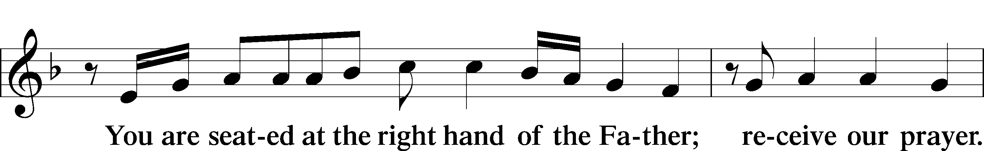
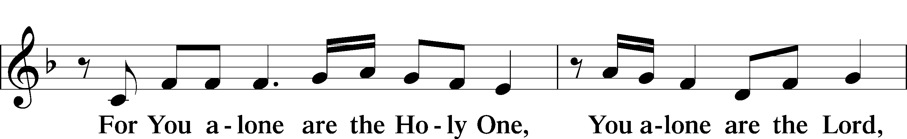
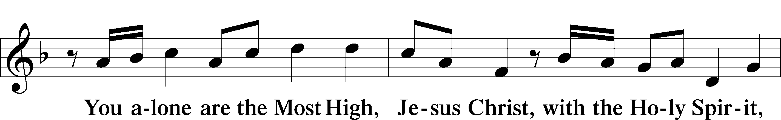
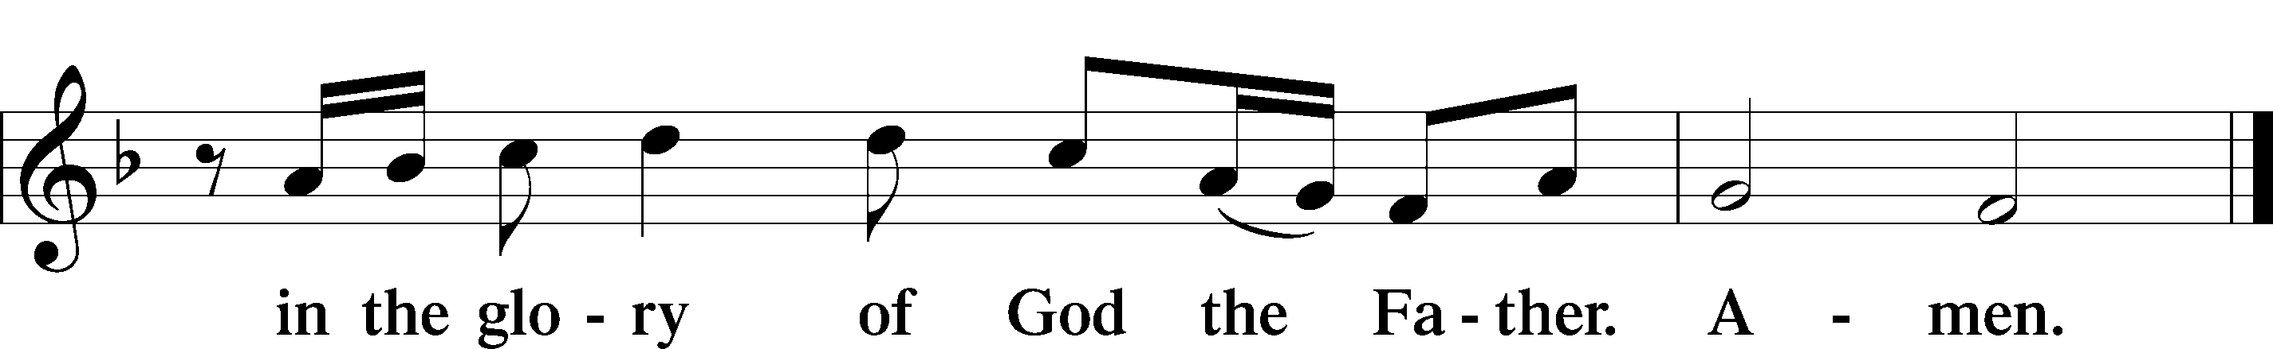

Salutation and Collect of the Day
P The Lord be with you.
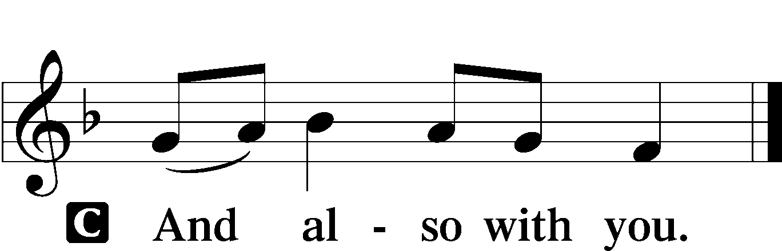

P Let us pray.
Merciful Father, Your patience and loving-kindness toward us have no end. Grant that by Your Holy Spirit we may always think and do those things that are pleasing in Your sight; through Jesus Christ, Your Son, our Lord, who lives and reigns with You and the Holy Spirit, one God, now and forever.

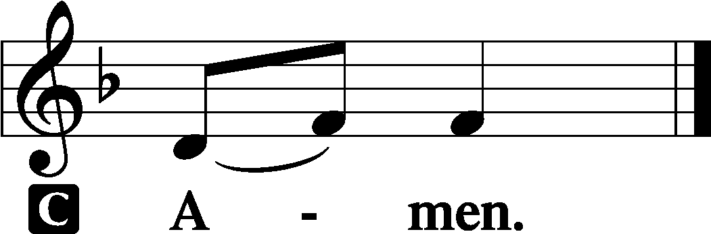

Sit
Old Testament Reading Genesis 2:18–25
18Then the Lord God said, “It is not good that the man should be alone; I will make him a helper fit for him.” 19So out of the ground the Lord God formed every beast of the field and every bird of the heavens and brought them to the man to see what he would call them. And whatever the man called every living creature, that was its name. 20The man gave names to all livestock and to the birds of the heavens and to every beast of the field. But for Adam there was not found a helper fit for him. 21So the Lord God caused a deep sleep to fall upon the man, and while he slept took one of his ribs and closed up its place with flesh. 22And the rib that the Lord God had taken from the man he made into a woman and brought her to the man. 23Then the man said,
“This at last is bone of my bones
and flesh of my flesh;
she shall be called Woman,
because she was taken out of Man.”
24Therefore a man shall leave his father and his mother and hold fast to his wife, and they shall become one flesh. 25And the man and his wife were both naked and were not ashamed.

A This is the Word of the Lord.
C Thanks be to God.

Gradual Psalm 91:11; 103:1
He will command his angels con- | cerning you*
to guard you in | all your ways.
Bless the Lord, | O my soul,*
and all that is within me, bless his | holy name!

Epistle Hebrews 2:1–13
Warning Against Neglecting Salvation
1Therefore we must pay much closer attention to what we have heard, lest we drift away from it. 2For since the message declared by angels proved to be reliable and every transgression or disobedience received a just retribution, 3how shall we escape if we neglect such a great salvation? It was declared at first by the Lord, and it was attested to us by those who heard, 4while God also bore witness by signs and wonders and various miracles and by gifts of the Holy Spirit distributed according to his will.
The Founder of Salvation
5Now it was not to angels that God subjected the world to come, of which we are speaking. 6It has been testified somewhere,
“What is man, that you are mindful of him,
or the son of man, that you care for him?
7You made him for a little while lower than the angels;
you have crowned him with glory and honor,
8putting everything in subjection under his feet.”
Now in putting everything in subjection to him, he left nothing outside his control. At present, we do not yet see everything in subjection to him. 9But we see him who for a little while was made lower than the angels, namely Jesus, crowned with glory and honor because of the suffering of death, so that by the grace of God he might taste death for everyone.
10For it was fitting that he, for whom and by whom all things exist, in bringing many sons to glory, should make the founder of their salvation perfect through suffering. 11For he who sanctifies and those who are sanctified all have one origin. That is why he is not ashamed to call them brothers, 12saying,
“I will tell of your name to my brothers;
in the midst of the congregation I will sing your praise.”
13And again,
“I will put my trust in him.”
And again,
“Behold, I and the children God has given me.”

A This is the Word of the Lord.
C Thanks be to God.

Stand

Alleluia and Verse LSB 156
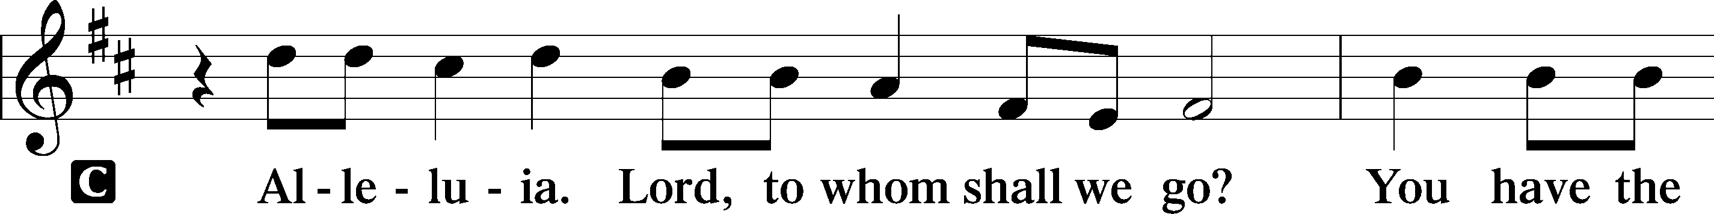
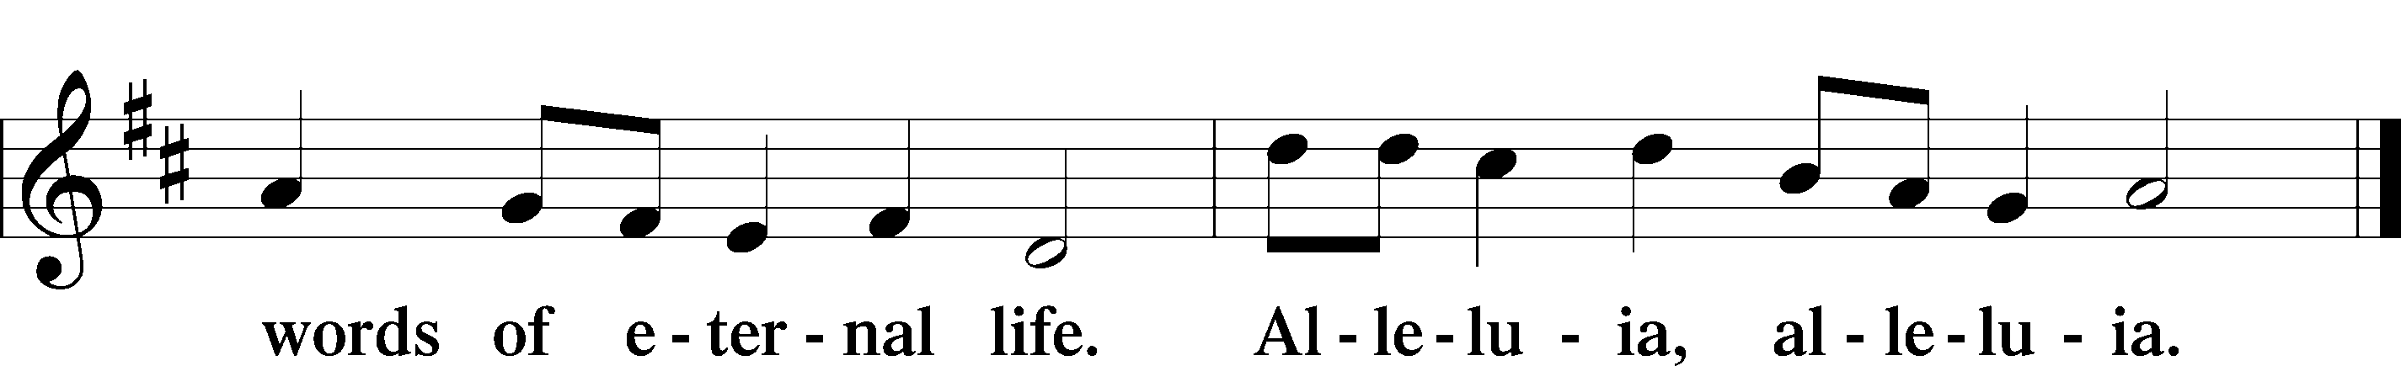

Holy Gospel Mark 10:2–16
P The Holy Gospel according to St. Mark, the tenth chapter.

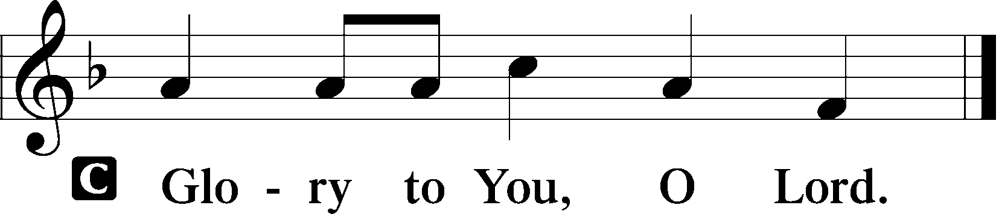

2Pharisees came up and in order to test [Jesus] asked, “Is it lawful for a man to divorce his wife?” 3He answered them, “What did Moses command you?” 4They said, “Moses allowed a man to write a certificate of divorce and to send her away.” 5And Jesus said to them, “Because of your hardness of heart he wrote you this commandment. 6But from the beginning of creation, ‘God made them male and female.’ 7‘Therefore a man shall leave his father and mother and hold fast to his wife, 8and they shall become one flesh.’ So they are no longer two but one flesh. 9What therefore God has joined together, let not man separate.”
10And in the house the disciples asked him again about this matter. 11And he said to them, “Whoever divorces his wife and marries another commits adultery against her, 12and if she divorces her husband and marries another, she commits adultery.”
Let the Children Come to Me
13And they were bringing children to him that he might touch them, and the disciples rebuked them. 14But when Jesus saw it, he was indignant and said to them, “Let the children come to me; do not hinder them, for to such belongs the kingdom of God. 15Truly, I say to you, whoever does not receive the kingdom of God like a child shall not enter it.” 16And he took them in his arms and blessed them, laying his hands on them.

P This is the Gospel of the Lord.

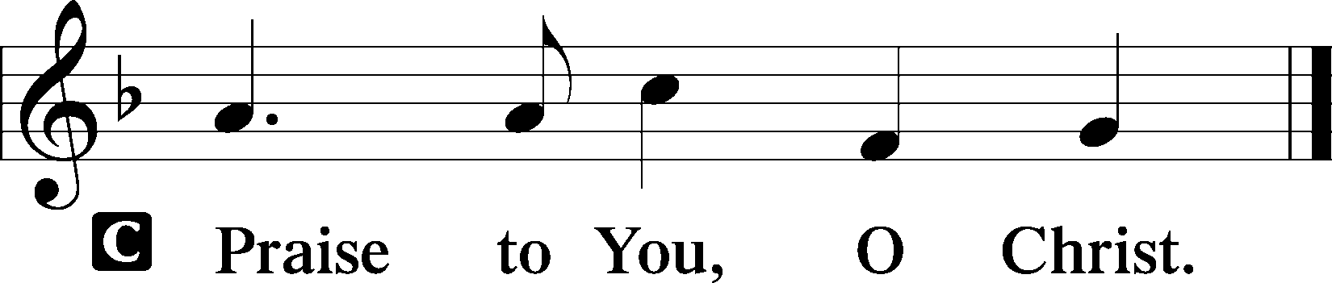

Sit

863 Our Father, by Whose Name
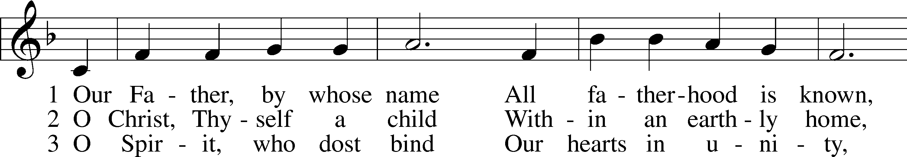
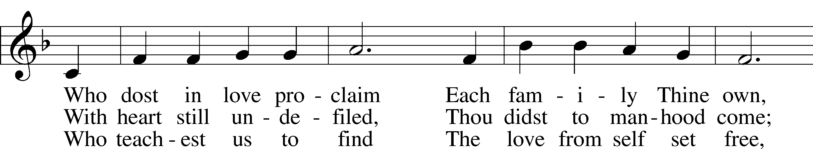
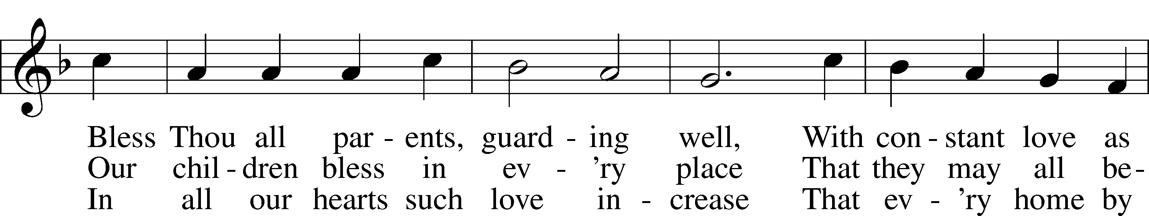
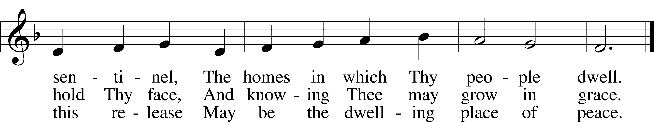
Text: © The Church Pension Fund. Used by permission: LSB Hymn License no. 110003744
Tune: Public domain

Sermon

Stand

Apostles’ Creed
C I believe in God, the Father Almighty,
maker of heaven and earth.

And in Jesus Christ, His only Son, our Lord,
who was conceived by the Holy Spirit,
born of the virgin Mary,
suffered under Pontius Pilate,
was crucified, died and was buried.
He descended into hell.
The third day He rose again from the dead.
He ascended into heaven
and sits at the right hand of God the Father Almighty.
From thence He will come to judge the living and the dead.

I believe in the Holy Spirit,
the holy Christian Church,
the communion of saints,
the forgiveness of sins,
the resurrection of the body,
and the life T everlasting. Amen.

Prayer of the Church

Offerings and Offertory LSB 159
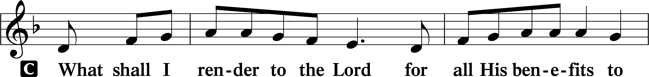
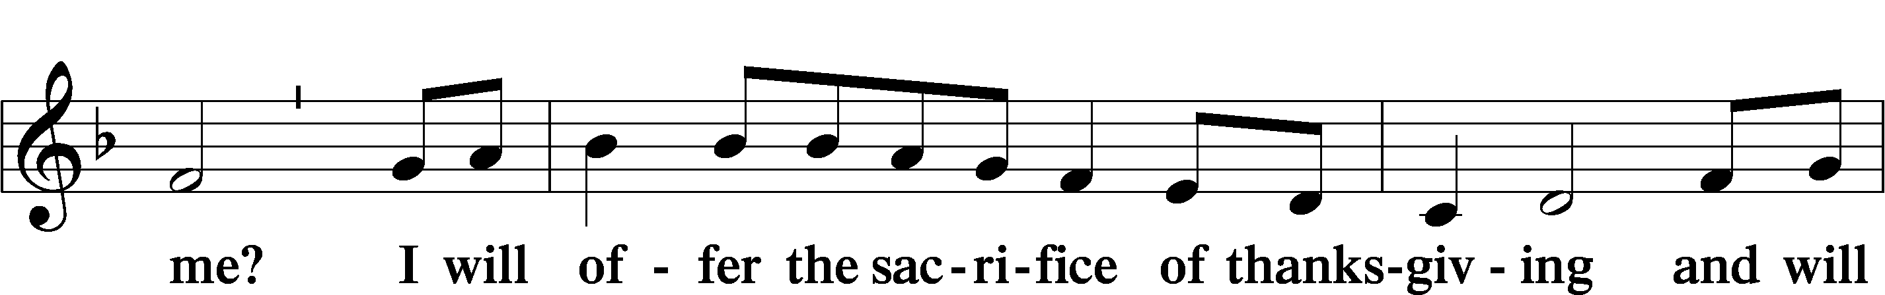
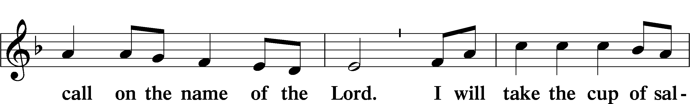
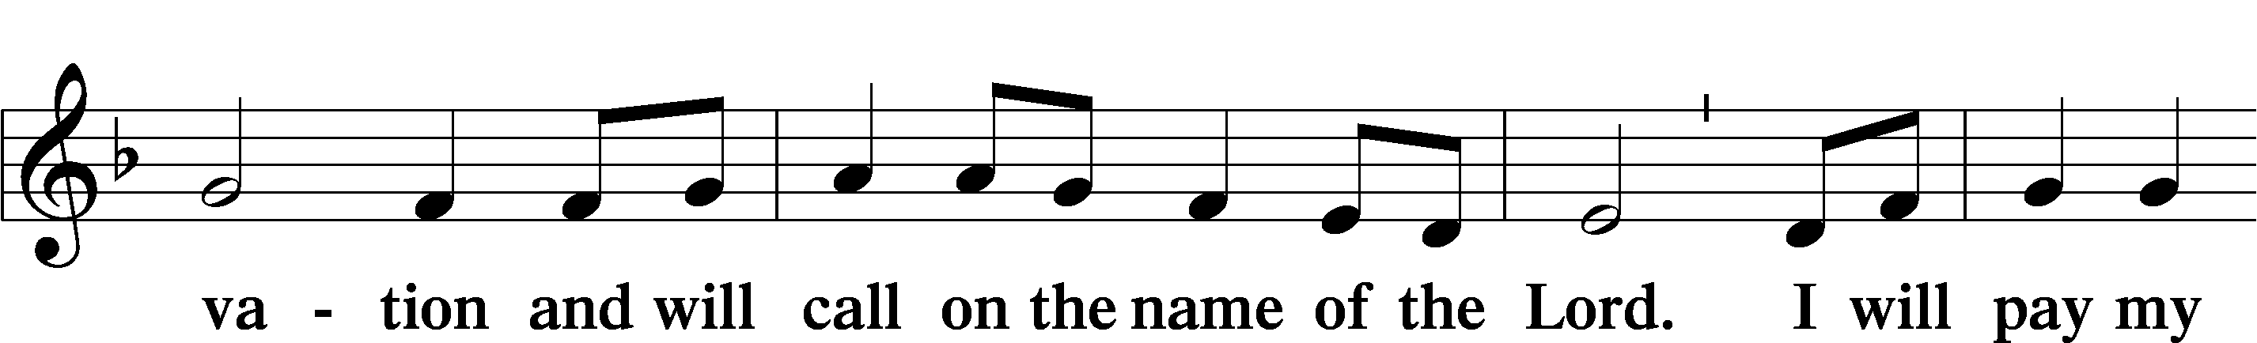
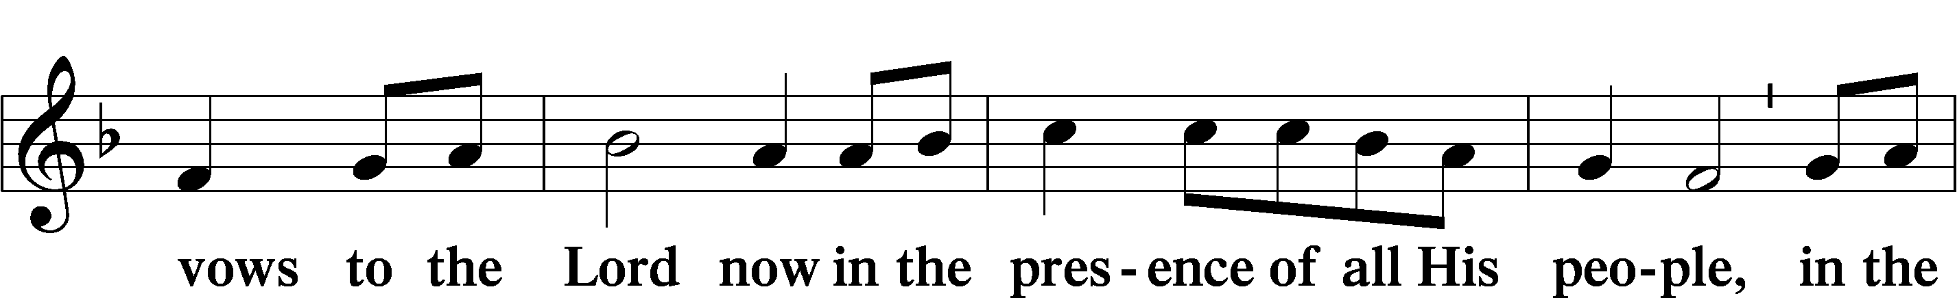
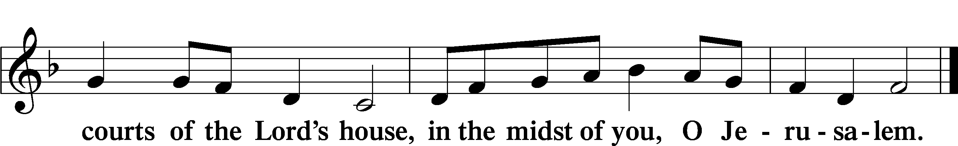

Service of the Sacrament

Preface LSB 160
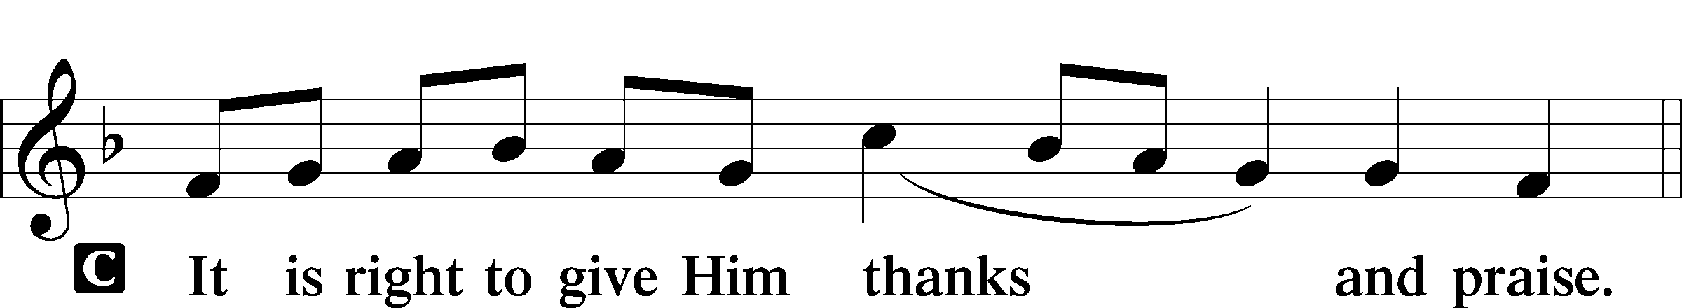

Proper Preface
P It is truly good, right, and salutary that we should at all times and in all places give thanks to You, holy Lord, almighty Father, everlasting God, through Jesus Christ, our Lord, who, having created all things, took on human flesh and was born of the virgin Mary. For our sake He died on the cross and rose from the dead to put an end to death, thus fulfilling Your will and gaining for You a holy people. Therefore with angels and archangels and with all the company of heaven we laud and magnify Your glorious name, evermore praising You and saying:

Sanctus LSB 161
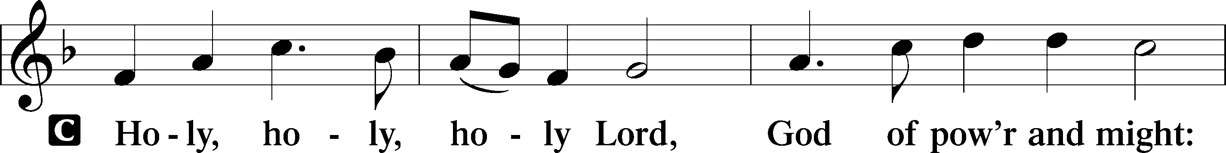
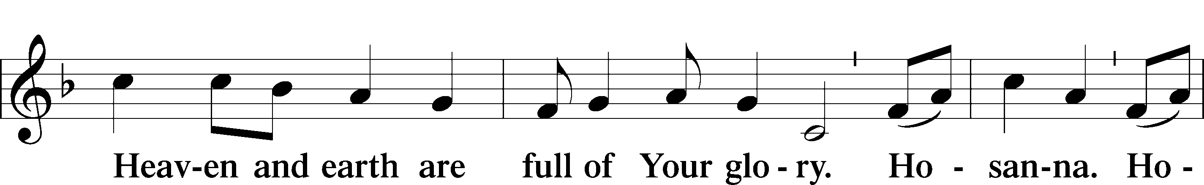
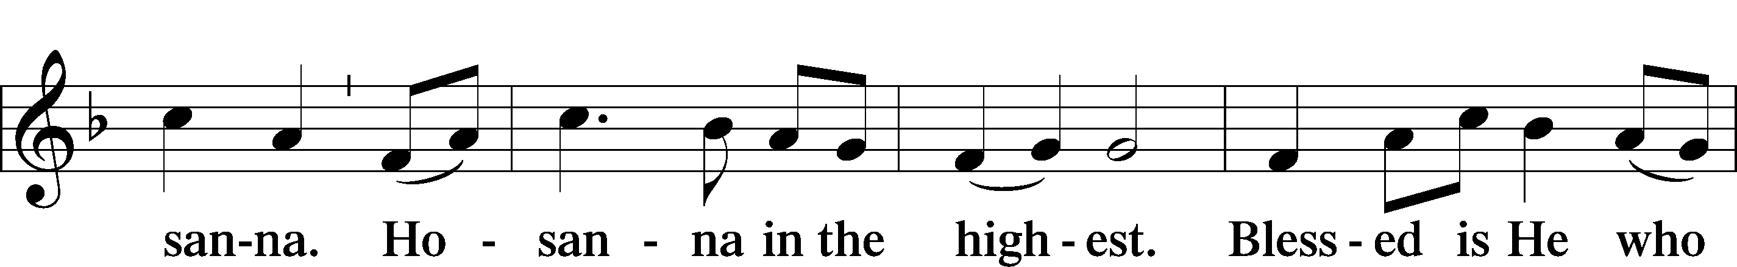
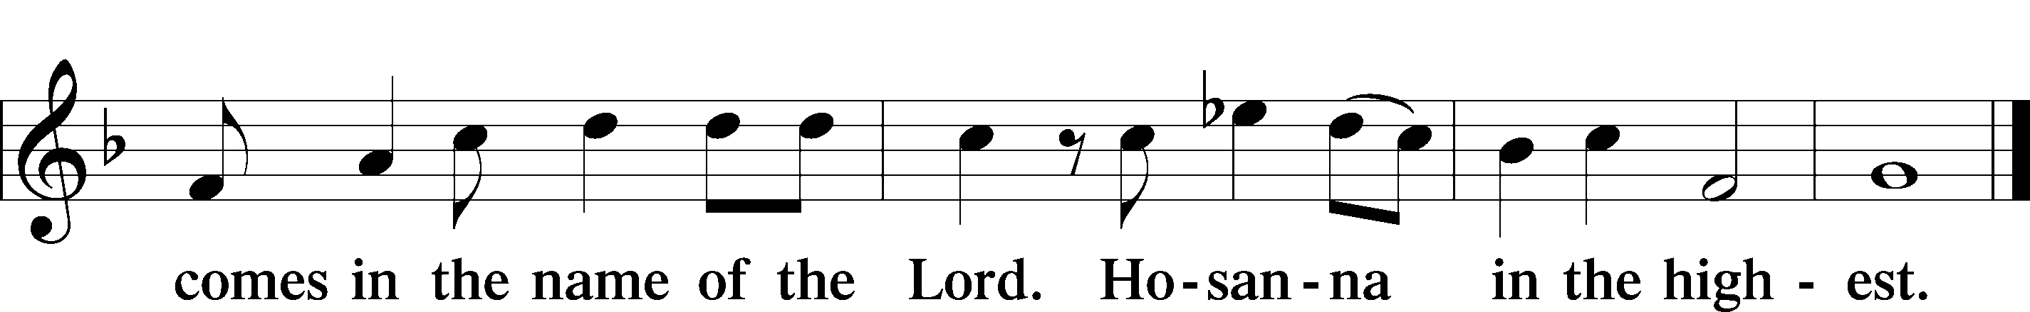
Lord’s Prayer
C Our Father who art in heaven,
hallowed be Thy name,
Thy kingdom come,
Thy will be done on earth
as it is in heaven;
give us this day our daily bread;
and forgive us our trespasses
as we forgive those
who trespass against us;
and lead us not into temptation,
but deliver us from evil.
For Thine is the kingdom
and the power and the glory
forever and ever. Amen.

The Words of Our Lord
P Our Lord Jesus Christ, on the night when He was betrayed, took bread, and when He had given thanks, He broke it and gave it to the disciples and said: “Take, eat; this is My T body, which is given for you. This do in remembrance of Me.”

In the same way also He took the cup after supper, and when He had given thanks, He gave it to them, saying: “Drink of it, all of you; this cup is the new testament in My T blood, which is shed for you for the forgiveness of sins. This do, as often as you drink it, in remembrance of Me.”

Pax Domini LSB 163
P The peace of the Lord be with you always.
C Amen.

Agnus Dei LSB 163
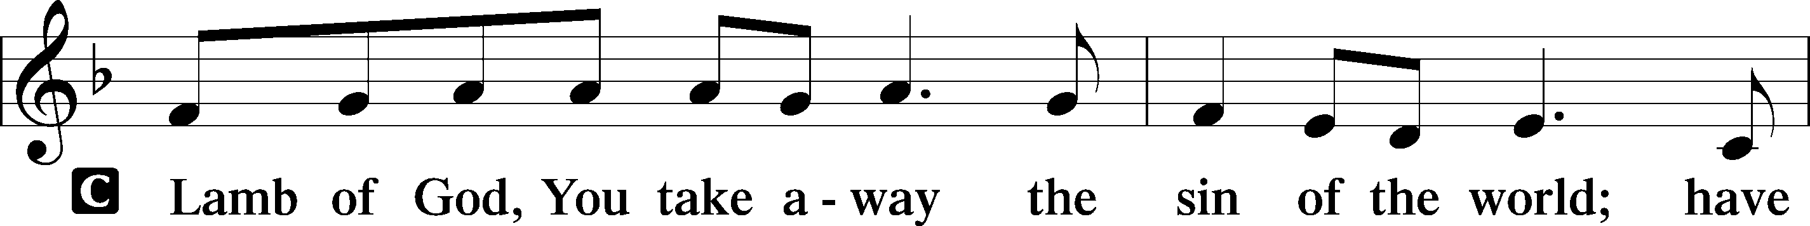
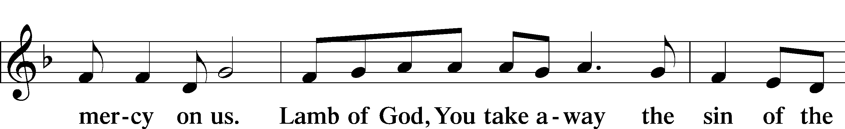
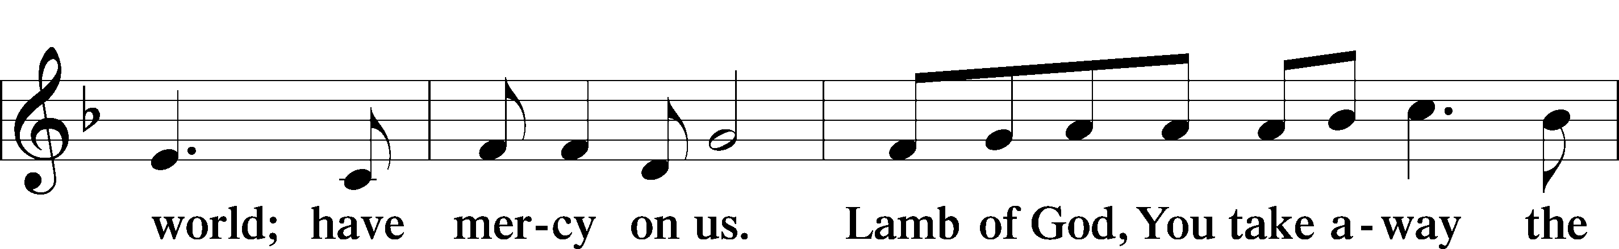
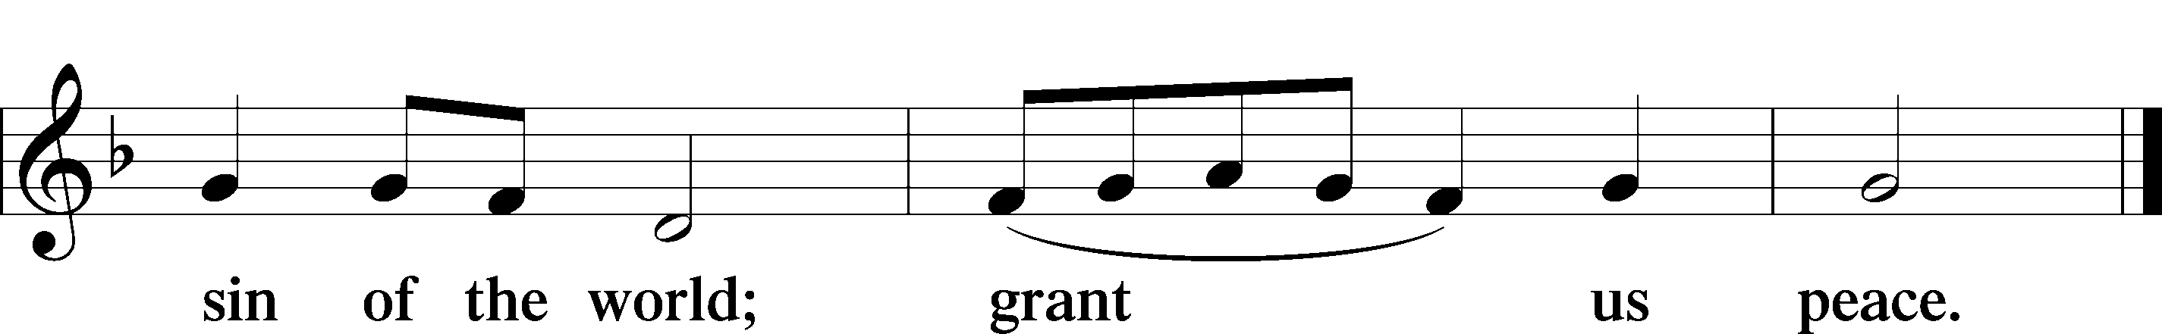
Sit

Distribution

637 Draw Near and Take the Body of the Lord
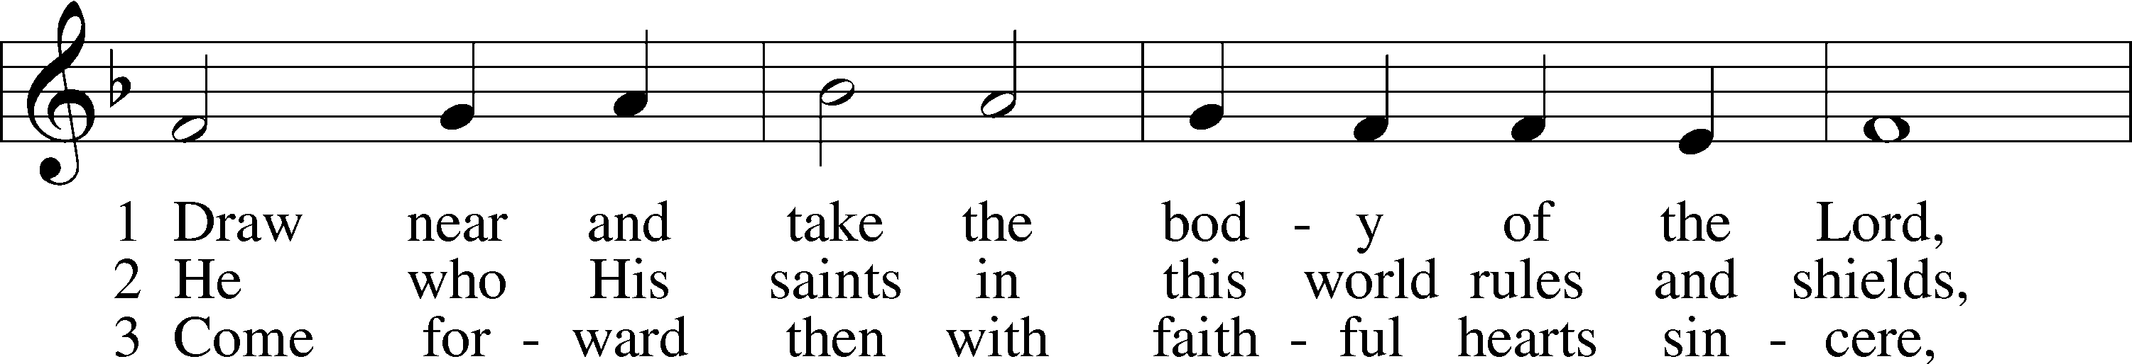
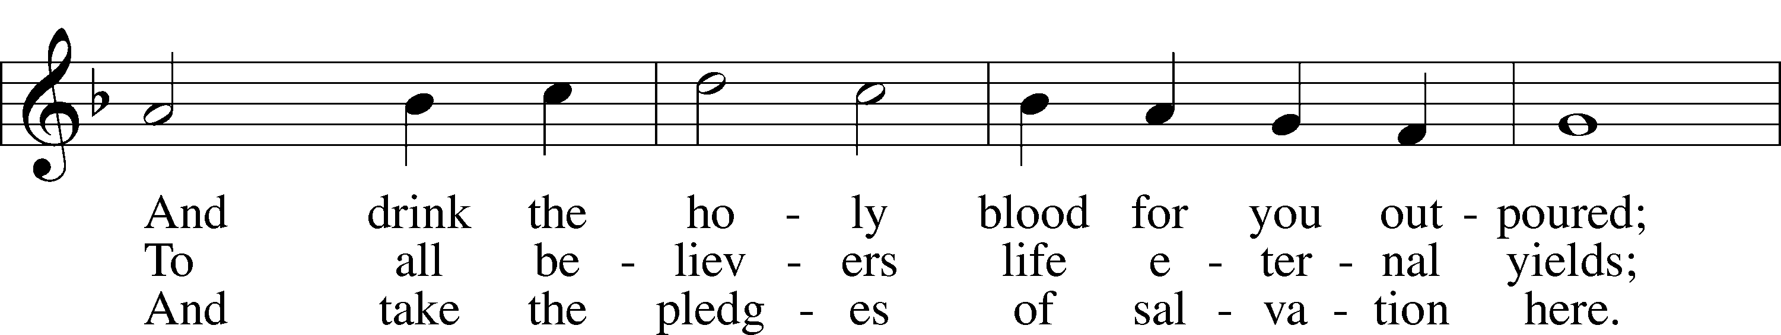
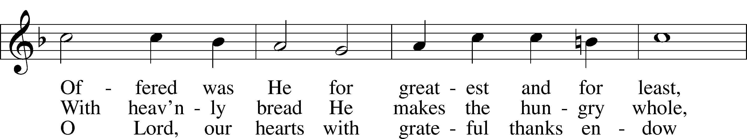
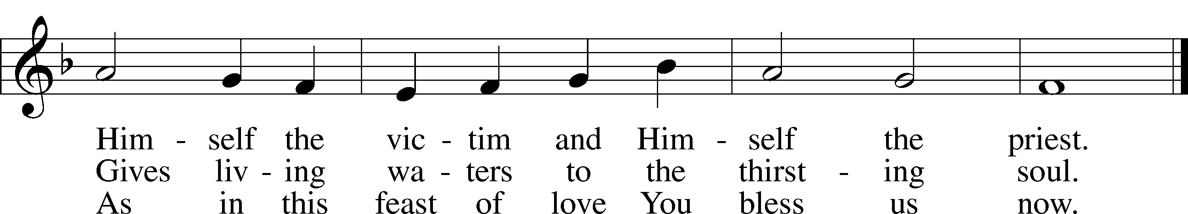
Text and tune: Public domain

561 The Tree of Life
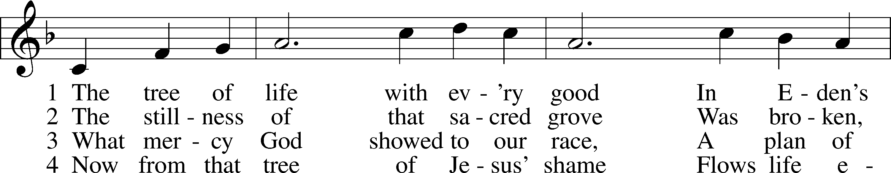
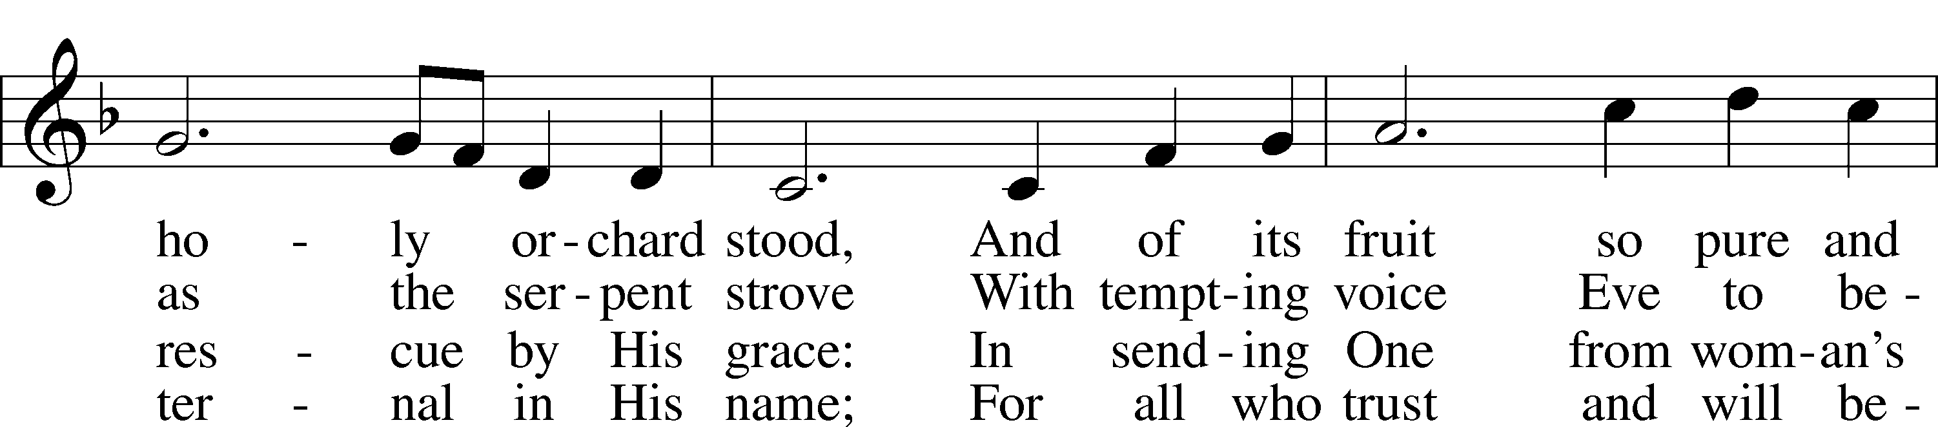
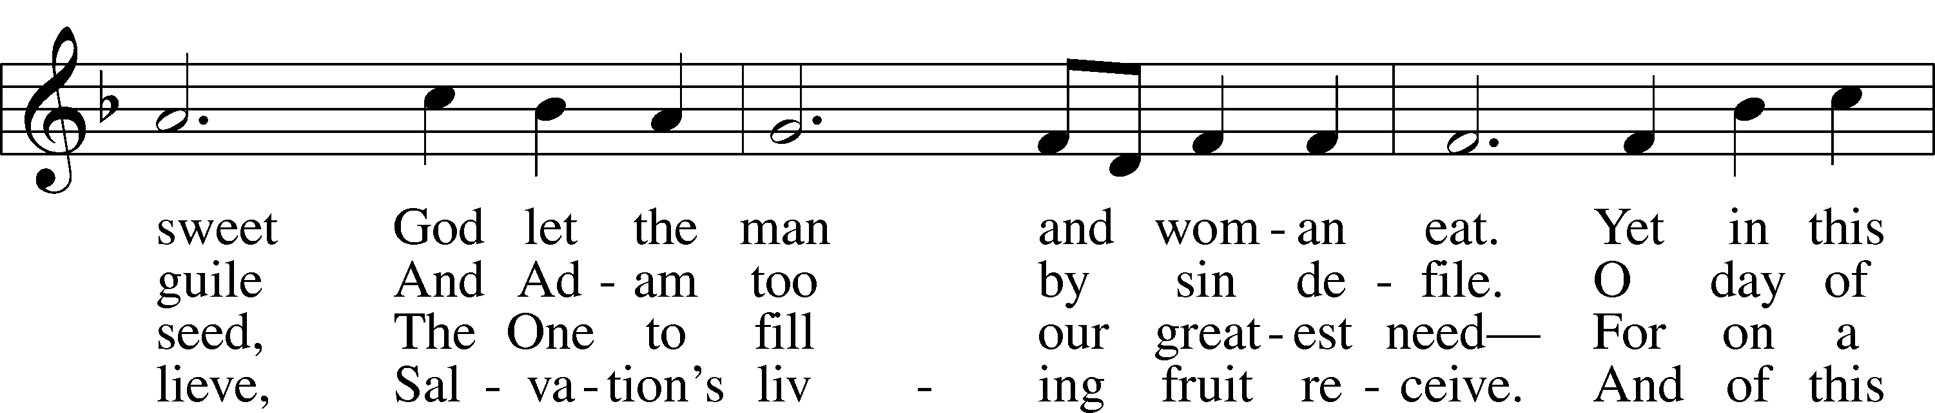
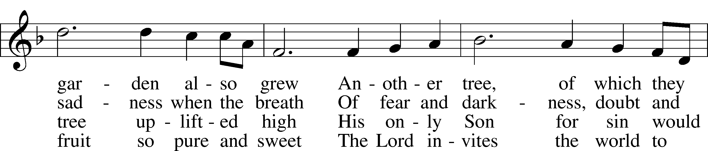
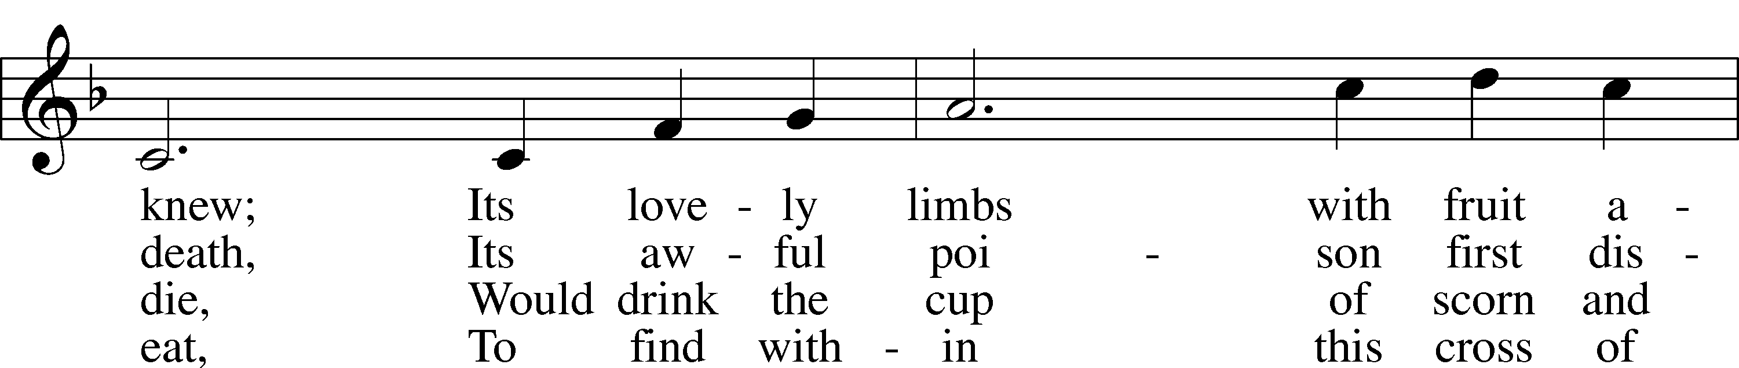
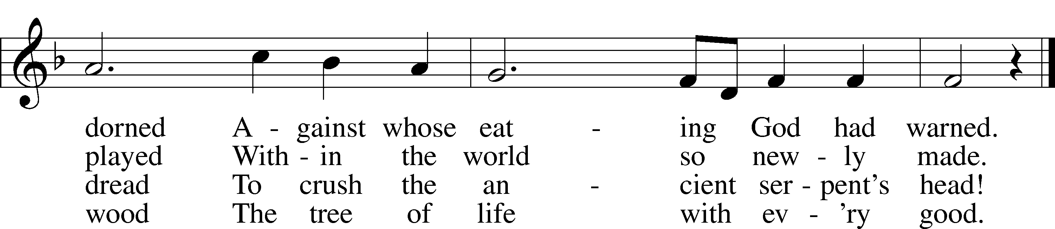
Tune: © 1995 Bruce W. Becker. Used by permission: LSB Hymn License no. 110003744
Text: © 1993 Stephen P. Starke, admin. Concordia Publishing House. Used by permission: LSB Hymn License no. 110003744

862 Oh, Blest the House
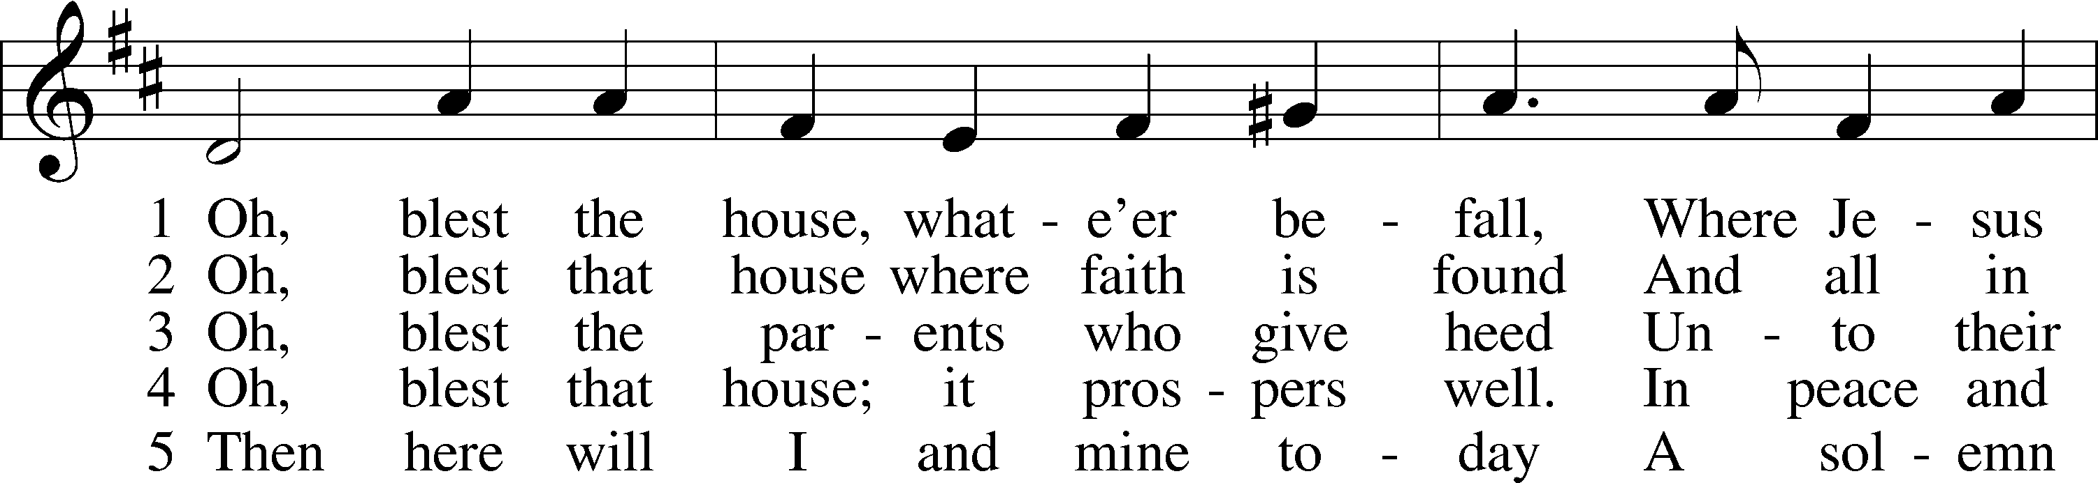
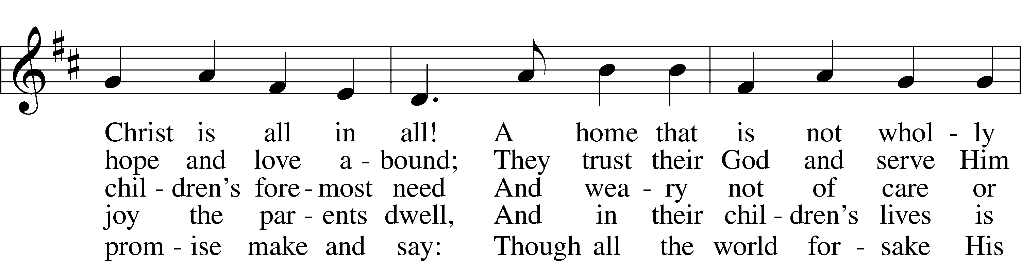
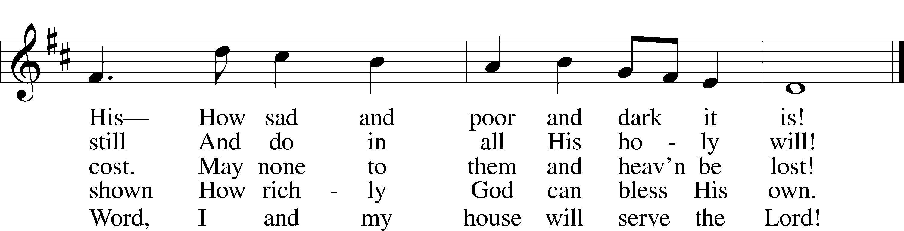
Tune and text: Public domain

Stand

The Dismissal
P The body and blood of our Lord Jesus Christ strengthen and preserve you in body and soul to life everlasting. Depart T in peace.
C Amen.

Thank the Lord LSB 164
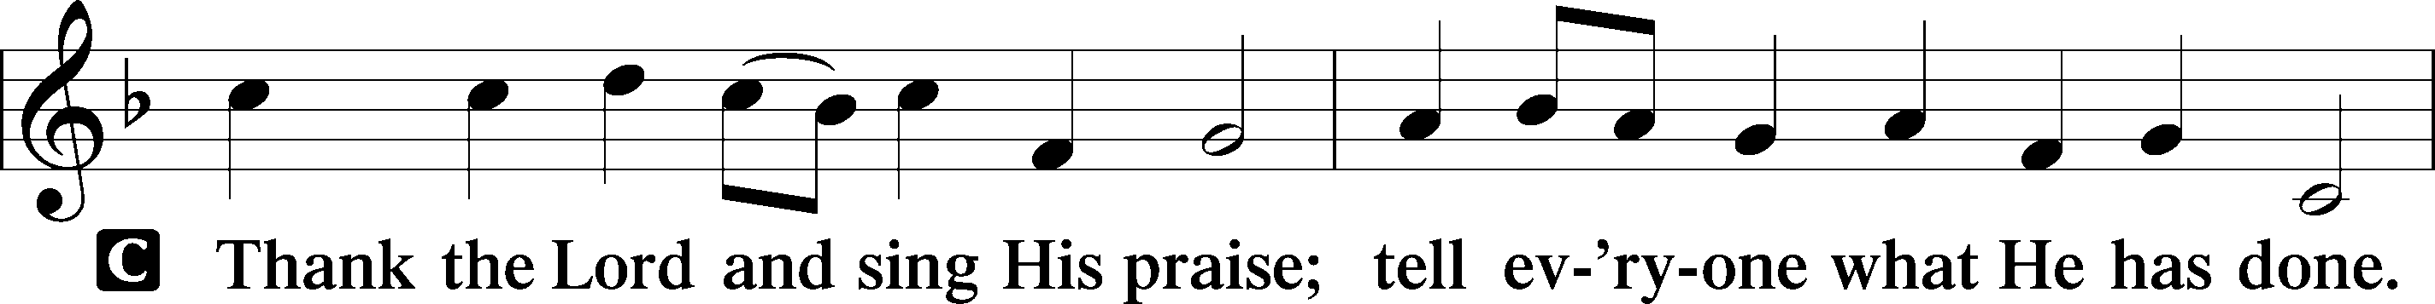
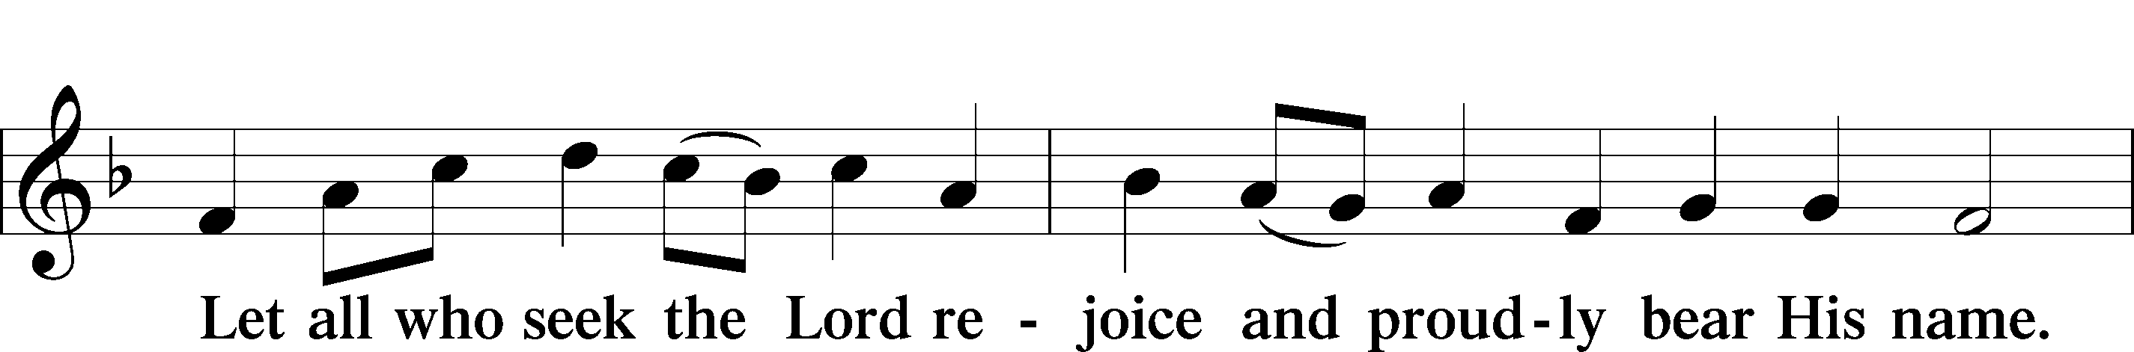
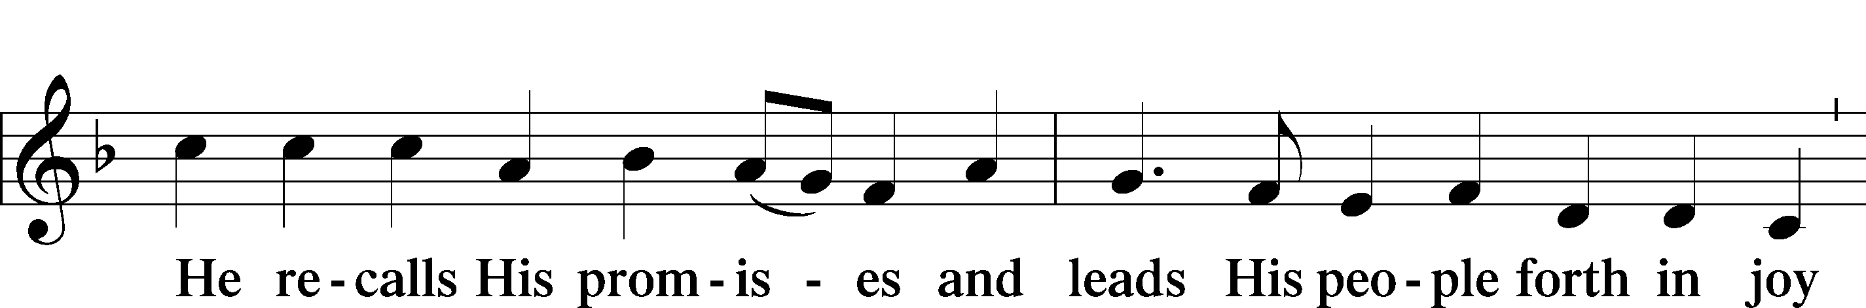
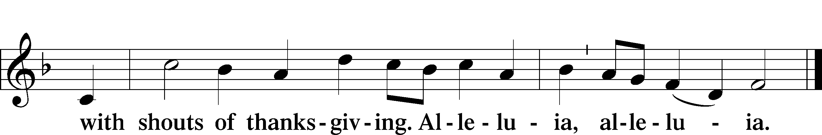

Post-Communion Collect
A Let us pray.
We give thanks to You, almighty God, that You have refreshed us through this salutary gift, and we implore You that of Your mercy You would strengthen us through the same in faith toward You and in fervent love toward one another; through Jesus Christ, Your Son, our Lord, who lives and reigns with You and the Holy Spirit, one God, now and forever.
C Amen.

Benediction LSB 166
P The Lord bless you and keep you.
The Lord make His face shine on you and be gracious to you.
The Lord look upon you with favor and T give you peace.
C Amen.

706 Love in Christ Is Strong and Living
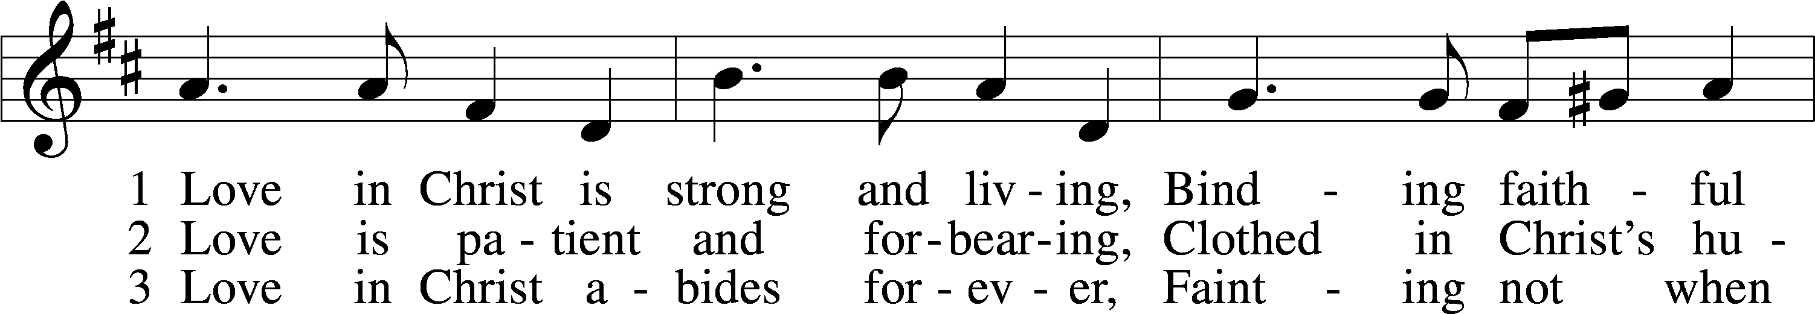
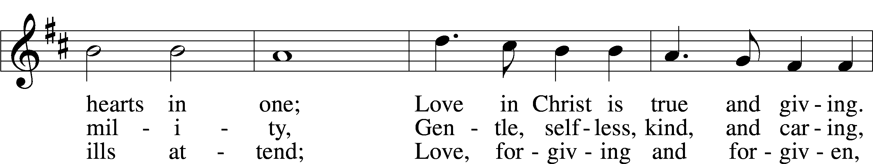
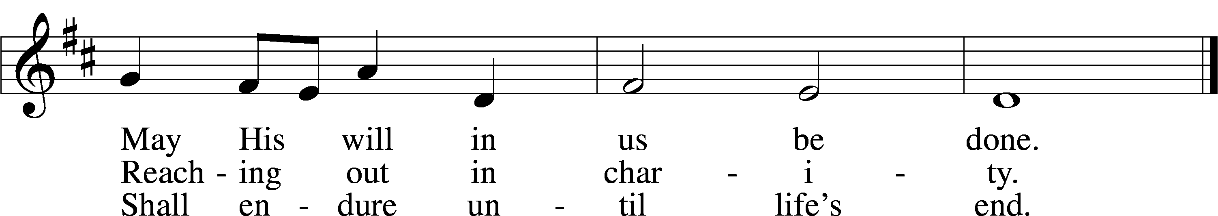

Text and tune: © 1979 Concordia Publishing House. Used by permission: LSB Hymn License no. 110003744

Acknowledgments
Unless otherwise indicated, Scripture quotations are from the ESV® Bible (The Holy Bible, English Standard Version®), copyright © 2001 by Crossway, a publishing ministry of Good News Publishers. Used by permission. All rights reserved.
Created by Lutheran Service Builder © 2021 Concordia Publishing House.

Prayers for Our Members
Sharon Hockemeier, Tenaya Nuttelman | Expectant Mothers
Norman Abels (Brookestone Meadows – Elkhorn) | Healing
Judy Ahrens | Healing
Vaughn Albrecht (Mount Carmel) | Healing
Tom & DyAnn Altwine | Healing
Lyle Colsden (Mother Hull) | Healing
Pat Flodine (Cambridge Court) | Healing
Vi Fox (Prairie View) | Healing
Mike Dulitz | Healing
Verleen Gentry | Healing
Wanda Glanzer | Healing
Ruby Hatfield | Healing
Evelyn Heiden | Healing
Lennis Hodgson | Healing
Don Richmond | Healing
Ivan Bombeck | Cancer
Fran Junge | Cancer
Bertha Marienau | Cancer
Kim Vos | Cancer

ZION LUTHERAN CHURCH AND SCHOOL

Pr. James DeLoach, Pastor + (308) 627-5260
james.deloach@zionkearney.org
Pr. Doug Gaunt, Pastor + (308) 455-0552
doug.gaunt@zionkearney.org
Tony Splittgerber, Principal + (308) 293-0168
anthony.splittgerber@zionkearney.org

Church Office
Secretary: Shirley Oertwig
Email: school@zionkearney.org
Phone: (308)-234-3410 Fax: (308) 236-8100
Office Hours: Monday-Friday 8:00am-4:00pm
Radio Broadcast: Sunday @ 10:30 a.m. on 1460 AM
Website: www.zionkearney.com
Prayers for Our Members’ Family & Friends
Naomi Wollberg (Andy & Jeanne Wollberg’s daughter-in-law) | Expecting
Reg Duke (Westman’s brother-in-law) | Healing
James Gentry (Verleen Gentry’s son) | Healing
Roger Hoffman (Marc’s father) | Healing
David Kreutzer (Richard’s brother) | Healing
Pastor Rob Kuefner | Healing
Dillon Malchow (Joy Barefoot’s nephew) | Healing
Mary Ann Mertz (Pam’s Uhlir’s friend) | Healing
Urijah Mitchell (Grandson of Sue & Dennis Bartels) | Healing
Tim Powers (Kim Wilken’s brother) | Healing
Roy Reynolds (Verleen Gentry’s son-in-law) | Healing
Lynne Saathoff (Verleen Gentry’s sister-in-law) | Healing
Randy Solomon (Beth Rosenthal’s father) | Healing
Tim Trampe (Don & Gretchen’s son) | Healing
Larry Bombeck (Ivan’s brother) | Healing
Katie Cunningham (Quentin & Janel Lange’s friend) | Burn
Jonah (Jase & Jarren Blattner’s friend) | Cancer
D.D. Dugger (Sue Kaiser’s brother) | Cancer
Stuart Gronewoller (Lonna’s brother-in-law) | Cancer
Ron Halvorsen (Jeff’s dad) | Cancer
Randy Jochum (Ken Hockemeier’s brother-in-law) | Cancer
Fred Koch (Pam Uhlir’s cousin) | Cancer
John Moore (family of Susan Tonniges) | Cancer
Sharon Mulhair (Pam Uhlir’s cousin) | Cancer
Kolby Shiers (Jessica’s cousin) | Cancer
Tyrone Uhlir (Pam’s nephew) | Cancer
John Weber (Zehendner’s friend) | Covid & Cancer
Tim Smallcomb (Wilkens’ friend) | Deployment

Today’s Radio Broadcast and Altar Flowers are given to the Glory of the Lord by the Zion Mary Martha LWML Guild and our former Concordia LWML ladies.

Worship Assistants

Sunday, October 3 ~ 9:00am

Elder: Bruce Brooks
Usher: Fred Flessner
Acolyte: Amy Tonniges
Engineer: Jamie Nikodym
Announcer: Carol Kreutzer
Altar Guild: Jamie & Shirley Helmbrecht
Special Music: Adult Choir

Sunday, October 10 ~ 9:00am

Elder: Eric Rosenthal
Usher: Steve Junge
Acolyte: Jarren Blattner
Engineer: Zach DeLoach
Announcer: Brooke Fisher
Altar Guild: Jamie & Shirley Helmbrecht

Our Response to the Gospel

Date: 09/26/2021
Offering:
Weekly Need: $7,457.69

This Week at Zion

Sun  10/03 | 9:00a  10:30a  10:15a | Divine Service  Radio Broadcast 1460am & 92.1fm  Bible Study
Mon  10/04 | Birthdays  Anniversary | Richard Kreutzer,  ---
Tues  10/05 | 1:30p  7:00p  Birthdays  Anniversaries | Sleeping Mats  Council  ---
Wed  10/06 | 8:30a  5:45p  7:00p  Birthdays  Anniversaries | Chapel  Midweek  Adult Choir  Shirley Oertwig  ---
Thurs  10/07 | Birthdays  Anniversaries | Fred Flessner, Dan Oertwig,  Jacob Wollberg  ---
Fri  10/08 | Birthdays  Anniversaries | ---  Tom & DyAnn Altwine
Sat  10/09 | 5:00p  Birthdays  Anniversaries | Divine Service  ---  --
Sun  10/10 | 9:00a  10:30a  Birthdays  Anniversaries | Divine Service  Radio Broadcast 1460am & 92.1fm  ---  ---

Where our Triune God strengthens us through His mercy in faith toward Him and in fervent love toward one another.

ANNOUNCEMENTS

Sunday School children are asked to meet after our service today in the front of the Sanctuary for opening. Kindergarten through 12th grade youth will meet with their teacher before moving to their respective classrooms.

LWML Sunday – TODAY– Mary Martha members encourage you to support LWML missions even if you are not a member of the organization. Mites, which are usually a collection of small change by LWML and church members, collectively contribute over 2 million dollars to missions in Nebraska districts and nationwide every two years. The tradition is based on the story of the Widow’s Mite, Luke 21: 1-4. See more information about the missions and work of LWML following the service at the display in the narthex. Mite boxes will also be available. On the last pages of today bulletin is a partial list of mission project the LWML hopes to fund in the next two years.

Mission Offerings – The fourth quarter missions, October through December, will be for Student Support. Zion’s current students studying for Church Work are:
Peter Kreutzer (Concordia) LTD
Jessica Zehendner (Concordia) LTD
Taylor Zehendner (Concordia) LTD

If you would like to donate to this mission please use the mission envelopes located in the narthex. Thank you for your support.

Welcome to Holly Reid, who has accepted the position of secretary for Zion Lutheran Church and School. Her first day will be October 11.

Adult Bible Study –The adult bible study class is meeting once again on Sunday mornings. We have begun a study entitled “Just Words.” It is a study of the doctrine of justification by grace through faith and the various biblical metaphors that convey the Gospel. Come grab a donut and cup of coffee as we learn together.
Sunday, Oct. 3, 2021-2:30-3:30 p.m.
Join the NATIONAL LIFE CHAIN!
Stand with thousands of pro-lifers throughout the USA!
Pick up signs at Medicap Pharmacy-2706 2nd Ave starting at 2:15
Offering Options:
1) Place your offering in the basket as you leave
2) Go to zionkearney.churchtrac.com/give
3) Go to zionkearney.com and click on the ChurchTrac icon
4) Mail your gift to Zion Lutheran Church, 2421 C Ave, Kearney, NE 68847 or place it in the mail slot on the south side of the building.
Radio Broadcast – Please help Zion spread the Gospel, signup to sponsor a radio broadcast! There are several open dates.

Church Management System – Zion has switched to a web-based church management system called ChurchTrac. Please pick-up a yellow sheet in the narthex to get setup today to view all of the benefits and features.

It is very important that you setup your account. This is the only way for the office to know of birthdays, anniversaries, etc. The old software program is no longer working, so old information is all what is being used, so more than likely we are missing a lot of babies, etc.

SCHOOL NEWS

The Theme for our school year is “Together by Christ’s Love” based on 1 John 4:7-8.

      - School Pictures are Oct. 5 & 6
- Cross Country Meet in Omaha Oct. 9
- UNK Homecoming Parade Oct. 9 (using our parking lot in the AM.)
- 5th-8th grade will sing the National Anthem at Strom Hockey October 9th

Early Childhood Openings!
We do still have openings in our 3 yr. old preschool classes. If you or someone you know is still looking for a high quality early childhood experience, please refer us to them!

2021–2023 Mission Grants - LWML

1. Deaconess Ministry Dakota Boys and Girls Ranch — Dakota Boys and Girls Ranch, $81,680
2. Healing the Invisible Wounds of War through Horses — Spirit Warrior, Central Maine, $95,000 — Featured October 2021
3. Thirst to Learn: Bible Books for Africa’s Children — Lutheran Heritage Foundation, $100,000
4. Making the Next Generation of Disciples for Life — LCMS Life Ministry, $92,000
5. Helping Hands for Lutheran Deaf Outreach — Lutheran Deaf Outreach, $50,000
6. Hope of Christ for Cancer Patients — Phil’s Friends, $70,000
7. Training Pastors to Serve the Church in Russia — Lutheran Theological Seminary, Novosibirsk, Siberia, $100,000
8. Light of Christ in Eastern Europe — Mission Central, $56,000
9. Propelling the Gospel — LAMP Ministry, Inc., $65,000
10. Educating Pastors in Africa — Mission Central, $100,000
11. Redeeming Life Maternity Home, Illinois Expansion — Redeeming Life Outreach Ministries, $100,000
12. Mercy Medical Care for Tanzania — Mwadui Lutheran School and Community, $68,182
13. Gospel Outreach to Women and Children in Mongolia — Lutheran Hour Ministries, $100,000
14. Caring for and Sharing Christ with Hurting People — Concordia Seminary, St. Louis, $100,000
15. The Littlest and Least of These, Dallas, Texas — St. Paul Lutheran Church and Christian Academy, $42,000
16. Bring the Inner-City Children to Camp — Lutheran Valley Retreat, Colorado, $25,000
17. Spiritual and Physical Food for Children of Peru — La Mision Luterana del Peru, $56,750
18. “Ends of Earth” Scholarships — Mission Opportunities Short Term (MOST) Ministries, $50,000
19. Sharing Jesus’ Love in India — Lutheran Braille Workers, $100,000
20. Mission & Outreach to the Least of These — Victory Lutheran Church, K. I. Sawyer Community, $51,356
21. Mercy House Belize Lutheran Campus — Belize Mission Society, $100,000
22. Ministry Vehicle Fund, Ethiopia and Sierra Leone — Lutheran Bible Translators, $70,000
23. Showing God’s Love in the International District, Albuquerque, New Mexico — God Cares About You Mission, $98,000

