Divine Service
Twenty Second Sunday
after Pentecost
October 24, 2021

Zion Lutheran Church
Kearney, Nebraska

Welcome to Zion!
All worshippers please fill out an attendance card in the pew rack and let us know how we might be of service to you.

Holy Communion at Zion

The Lord’s Supper is celebrated at this congregation as Jesus has given it. As he says, our Lord gives into our mouths not only bread and wine but his very body and blood to eat and to drink for the forgiveness of sins and to strengthen our union with him and with one another. Our Lord invites to his table those who trust his words, repent of all sin, and set aside any refusal to forgive and love as he forgives and loves us, that they may show forth his death until he comes. All communicants need to register in the narthex prior to the service.

Because those who eat and drink our Lord’s body and blood unworthily do great harm and because Holy Communion is a confession of the faith which is confessed at this altar, any who are not yet instructed, in doubt, or who hold a confession differing from that of this congregation and The Lutheran Church—Missouri Synod, are asked not to commune until they are able to speak with our pastor first. He is happy to visit with you about the Christian faith and how to receive the Lord’s Supper for your good and for the good of others. Those not communing are invited to come to the altar, cross your arms in front of you, and bow your head to receive a pastoral blessing.

The Lord Jesus Christ Opens Our Eyes to God
and Brings Us into His Presence

As He did for blind Bartimaeus, so does the Lord, Jesus Christ, have mercy upon you. With His Word of the Gospel, “he is calling you” to Himself, to “take heart,” to rise up and live by faith in His forgiveness. He opens your heart and mind to see and know God rightly in Him and to follow Him “on the way” of the cross and into life everlasting (Mark 10:49–52). “He is able to save to the uttermost those who draw near to God through him,” because He is the great High Priest, who offered Himself “once for all” as a sacrifice for sins. Since He is risen from the dead and “exalted above the heavens,” He “holds his priesthood permanently, because he continues forever,” and “he always lives to make intercession” for His people (Heb. 7:24–27). Along with that, He gathers the children of God to Himself by the proclamation of His Gospel, even “from the farthest parts of the earth.” In mercy He calls them, by the waters of Holy Baptism, “in a straight path in which they shall not stumble,” unto life everlasting (Jer. 31:8–9).

Confession and Absolution

504 Father Most Holy
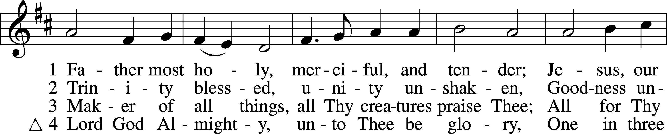
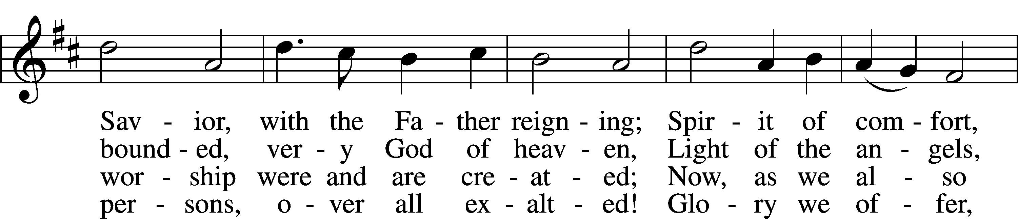
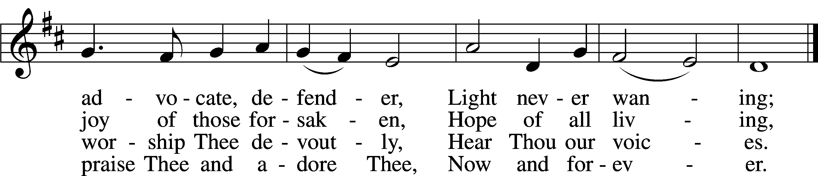
Tune and text: Public domain

Stand

The sign of the cross may be made by all in remembrance of their Baptism.

Invocation
P In the name of the Father and of the T Son and of the Holy Spirit.
C Amen.

Exhortation LSB 151
P If we say we have no sin, we deceive ourselves, and the truth is not in us.
C But if we confess our sins, God, who is faithful and just, will forgive our sins and cleanse us from all unrighteousness.

Silence for reflection on God’s Word and for self-examination.

Confession of Sins LSB 151
P Let us then confess our sins to God our Father.
C Most merciful God, we confess that we are by nature sinful and unclean. We have sinned against You in thought, word, and deed, by what we have done and by what we have left undone. We have not loved You with our whole heart; we have not loved our neighbors as ourselves. We justly deserve Your present and eternal punishment. For the sake of Your Son, Jesus Christ, have mercy on us. Forgive us, renew us, and lead us, so that we may delight in Your will and walk in Your ways to the glory of Your holy name. Amen.

Absolution LSB 151
P Almighty God in His mercy has given His Son to die for you and for His sake forgives you all your sins. As a called and ordained servant of Christ, and by His authority, I therefore forgive you all your sins in the name of the Father and of the T Son and of the Holy Spirit.
C Amen.

Service of the Word

Introit Psalm 131; antiphon: Psalm 130:1–2
Out of the depths I cry to you, | O Lord!*
O Lord, hear my voice! Let your ears be attentive to the voice of my pleas for | mercy!
O Lord, my heart is not lifted up; my eyes are not | raised too high;*
I do not occupy myself with things too great and too marvel- | ous for me.
But I have calmed and quieted my soul, like a weaned child with its | mother;*
like a weaned child is my soul with- | in me.
O Israel, hope | in the Lord*
from this time forth and for- | evermore.
Glory be to the Father and | to the Son*
and to the Holy | Spirit;
as it was in the be- | ginning,*
is now, and will be forever. | Amen.
Out of the depths I cry to you, | O Lord!*
O Lord, hear my voice! Let your ears be attentive to the voice of my pleas for | mercy!

Kyrie LSB 152
A In peace let us pray to the Lord.
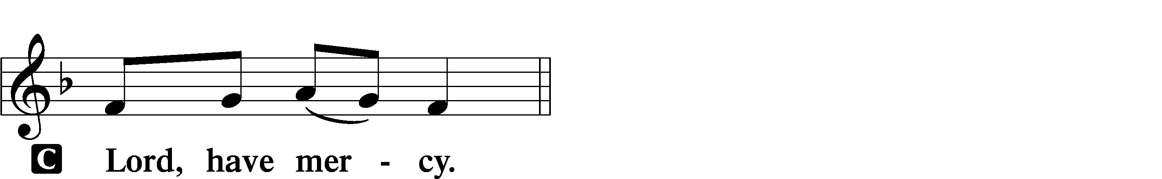

A For the peace from above and for our salvation let us pray to the Lord.
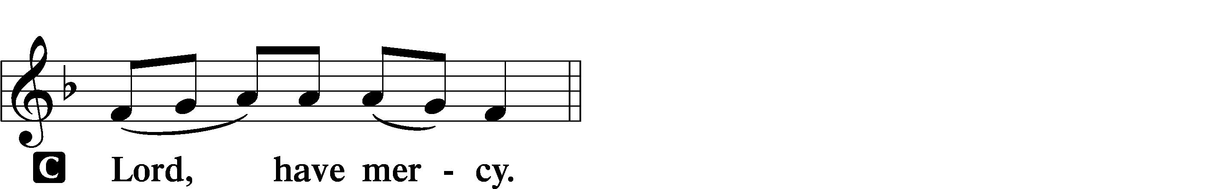

A For the peace of the whole world, for the well-being of the Church of God, and for the unity of all let us pray to the Lord.
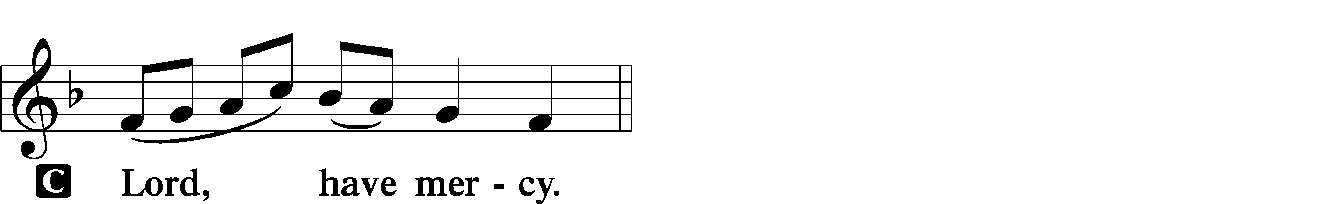

A For this holy house and for all who offer here their worship and praise let us pray to the Lord.
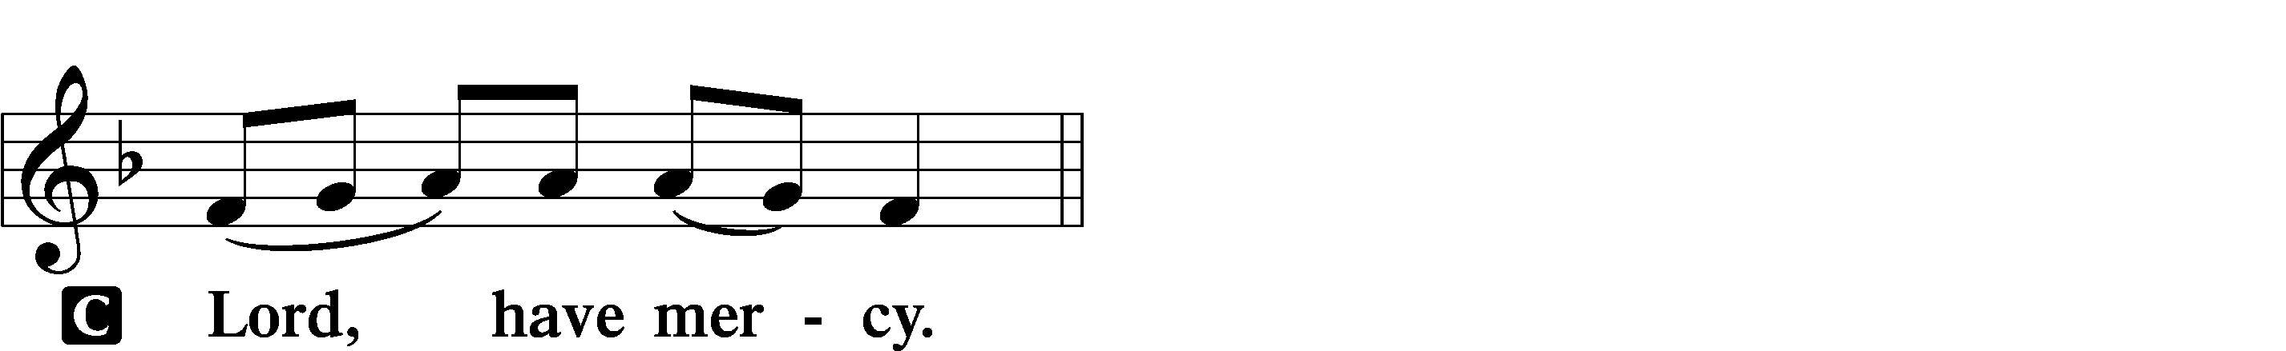

A Help, save, comfort, and defend us, gracious Lord.

Gloria in Excelsis LSB 154
A Glory to God in the highest, and peace to His people on earth.
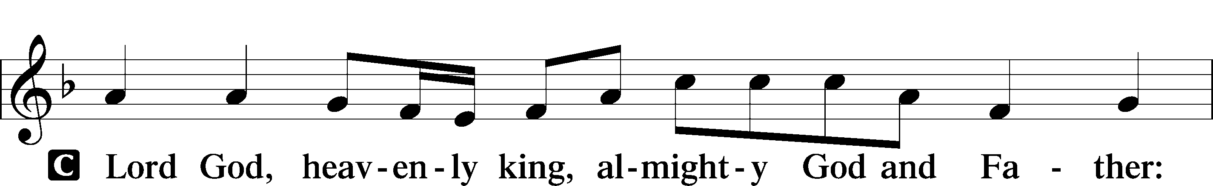
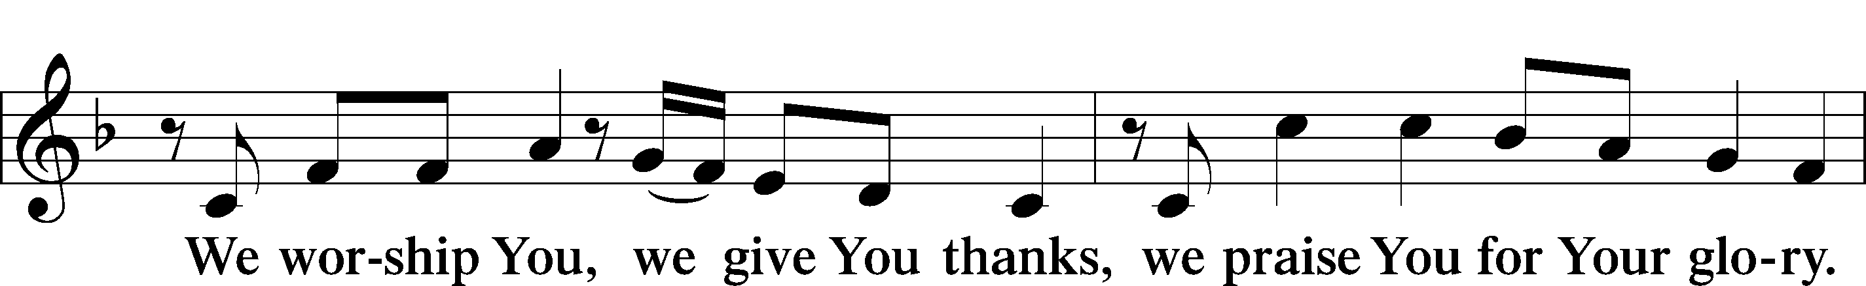
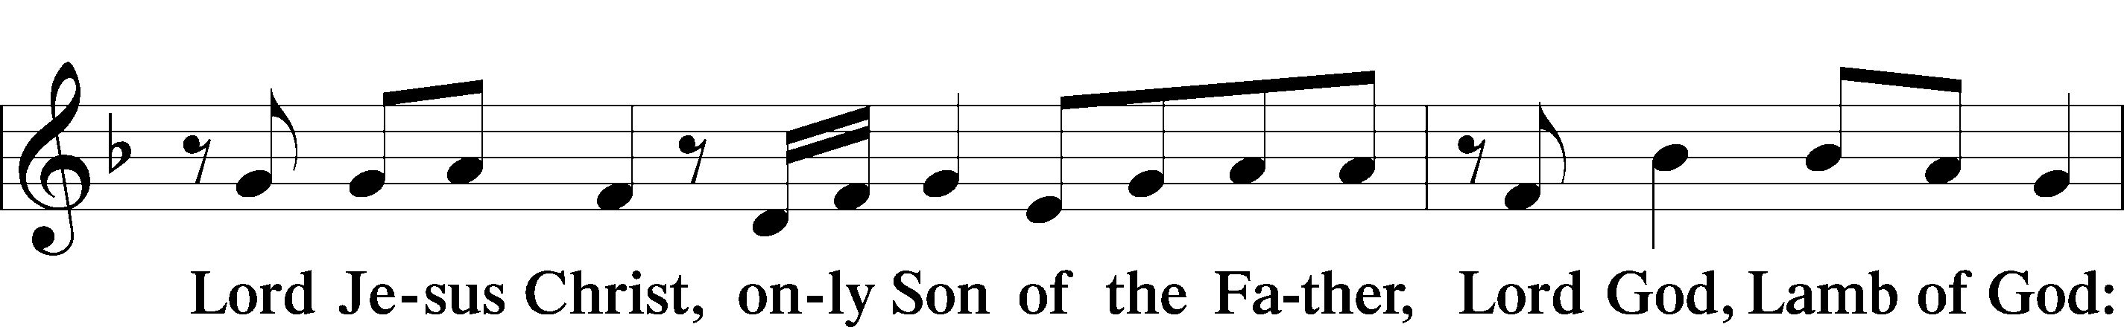
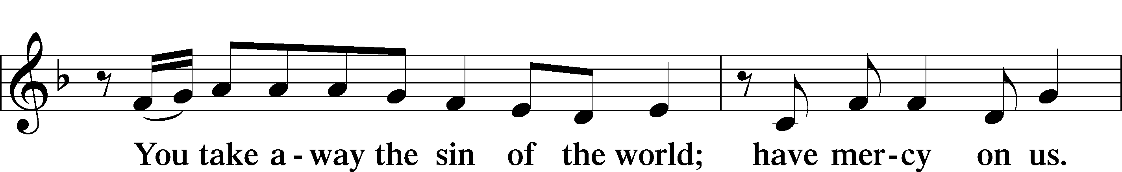
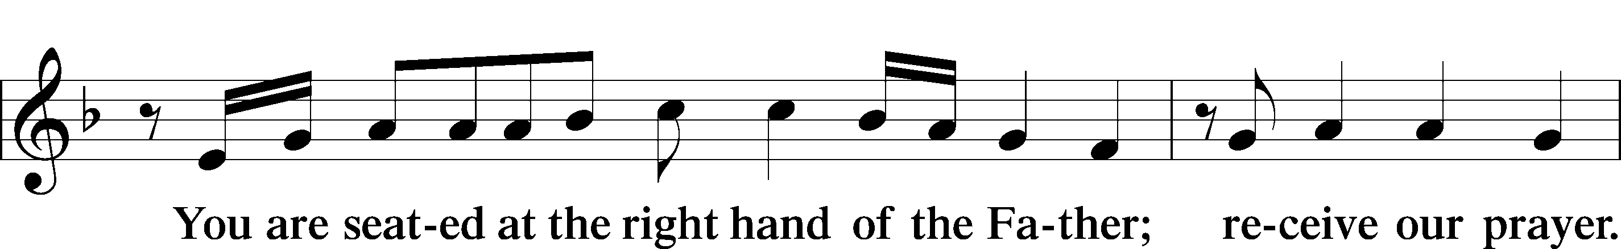
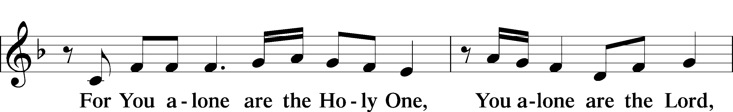
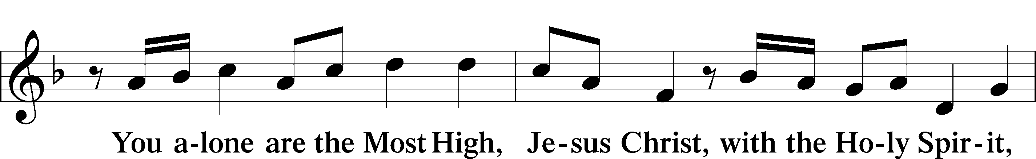
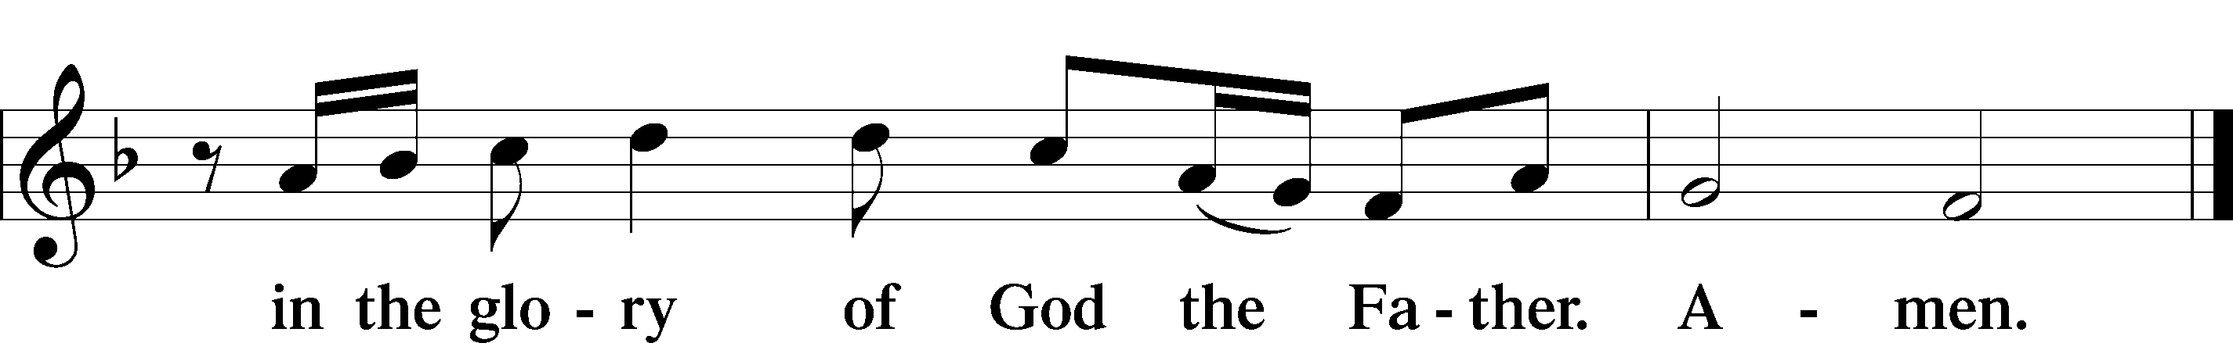

Salutation and Collect of the Day
P The Lord be with you.
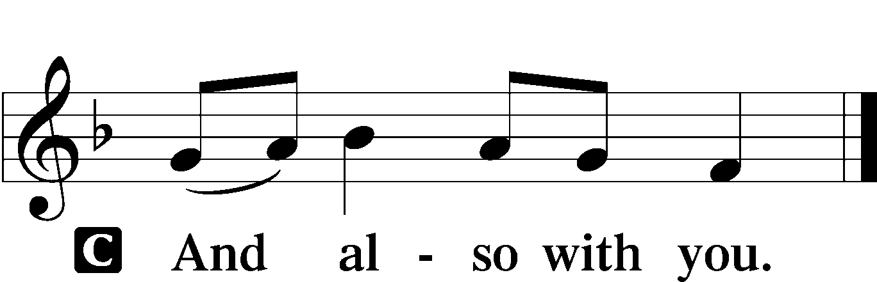

P Let us pray.
O God, the helper of all who call on You, have mercy on us and give us eyes of faith to see Your Son that we may follow Him on the way that leads to eternal life; through the same Jesus Christ, Your Son, our Lord, who lives and reigns with You and the Holy Spirit, one God, now and forever.

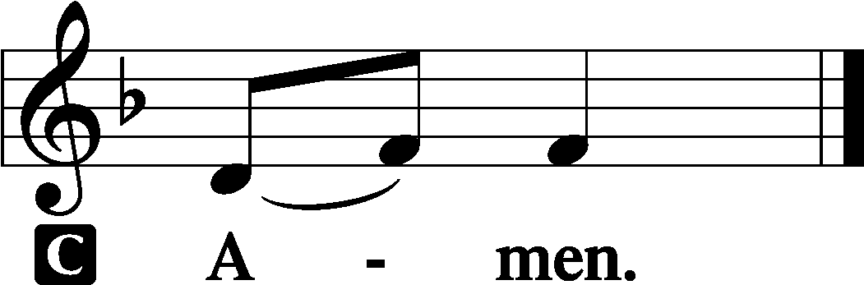

Sit
Old Testament Reading Jeremiah 31:7–9
⁷ Thus says the Lord:
“Sing aloud with gladness for Jacob,
and raise shouts for the chief of the nations;
proclaim, give praise, and say,
‘O Lord, save your people,
the remnant of Israel.’
⁸Behold, I will bring them from the north country
and gather them from the farthest parts of the earth,
among them the blind and the lame,
the pregnant woman and she who is in labor, together;
a great company, they shall return here.
⁹With weeping they shall come,
and with pleas for mercy I will lead them back,
I will make them walk by brooks of water,
in a straight path in which they shall not stumble,
for I am a father to Israel,
and Ephraim is my firstborn.”

A This is the Word of the Lord.
C Thanks be to God.

Gradual Psalm 91:11; 103:1
He will command his angels con- | cerning you*
to guard you in | all your ways.
Bless the Lord, | O my soul,*
and all that is within me, bless his | holy name!

Epistle Hebrews 7:23–28
²³The former priests were many in number, because they were prevented by death from continuing in office, ²⁴but he holds his priesthood permanently, because he continues forever. ²⁵Consequently, he is able to save to the uttermost those who draw near to God through him, since he always lives to make intercession for them.
²⁶For it was indeed fitting that we should have such a high priest, holy, innocent, unstained, separated from sinners, and exalted above the heavens. ²⁷He has no need, like those high priests, to offer sacrifices daily, first for his own sins and then for those of the people, since he did this once for all when he offered up himself. ²⁸For the law appoints men in their weakness as high priests, but the word of the oath, which came later than the law, appoints a Son who has been made perfect forever.

A This is the Word of the Lord.
C Thanks be to God.

Stand

Alleluia and Verse LSB 156
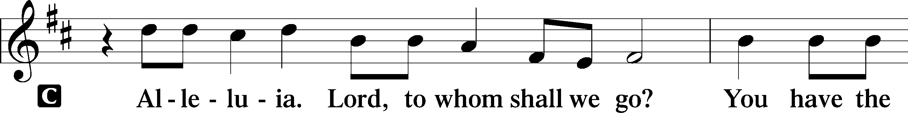
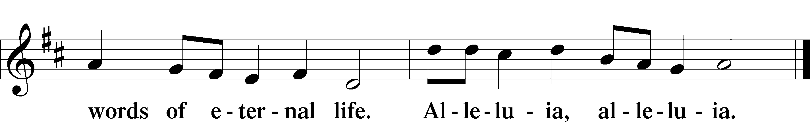

Holy Gospel Mark 10:46-52

P The Holy Gospel according to St. Mark, the tenth chapter.

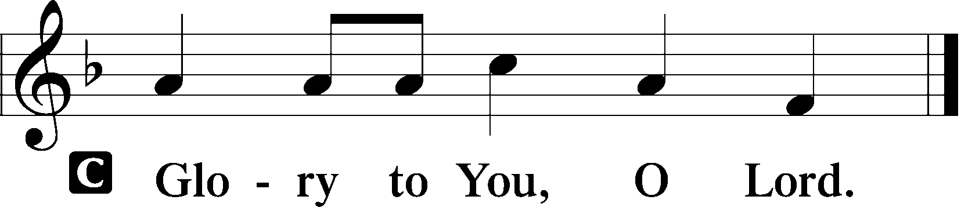

Jesus Heals Blind Bartimaeus
⁴⁶They came to Jericho. And as [Jesus] was leaving Jericho with his disciples and a great crowd, Bartimaeus, a blind beggar, the son of Timaeus, was sitting by the roadside. ⁴⁷And when he heard that it was Jesus of Nazareth, he began to cry out and say, “Jesus, Son of David, have mercy on me!” ⁴⁸And many rebuked him, telling him to be silent. But he cried out all the more, “Son of David, have mercy on me!” ⁴⁹And Jesus stopped and said, “Call him.” And they called the blind man, saying to him, “Take heart. Get up; he is calling you.” ⁵⁰And throwing off his cloak, he sprang up and came to Jesus. ⁵¹And Jesus said to him, “What do you want me to do for you?” And the blind man said to him, “Rabbi, let me recover my sight.” ⁵²And Jesus said to him, “Go your way; your faith has made you well.” And immediately he recovered his sight and followed him on the way.

P This is the Gospel of the Lord.

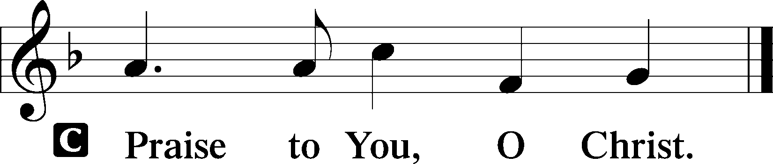

Sit

713 From God Can Nothing Move Me sts. 1–5, 7
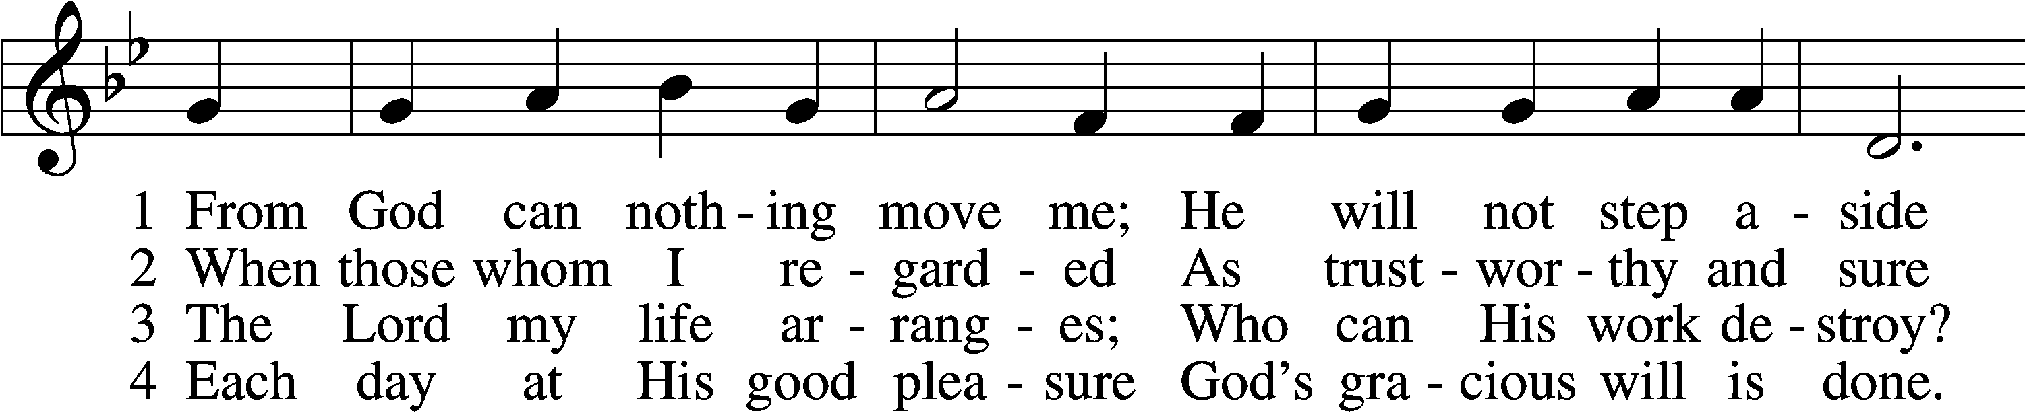
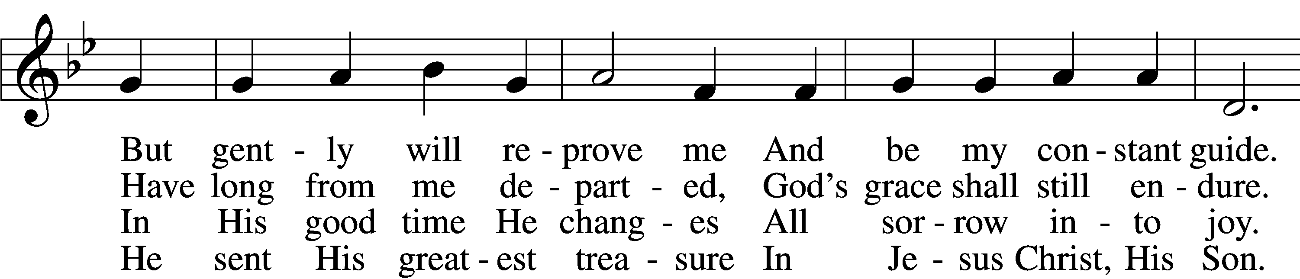
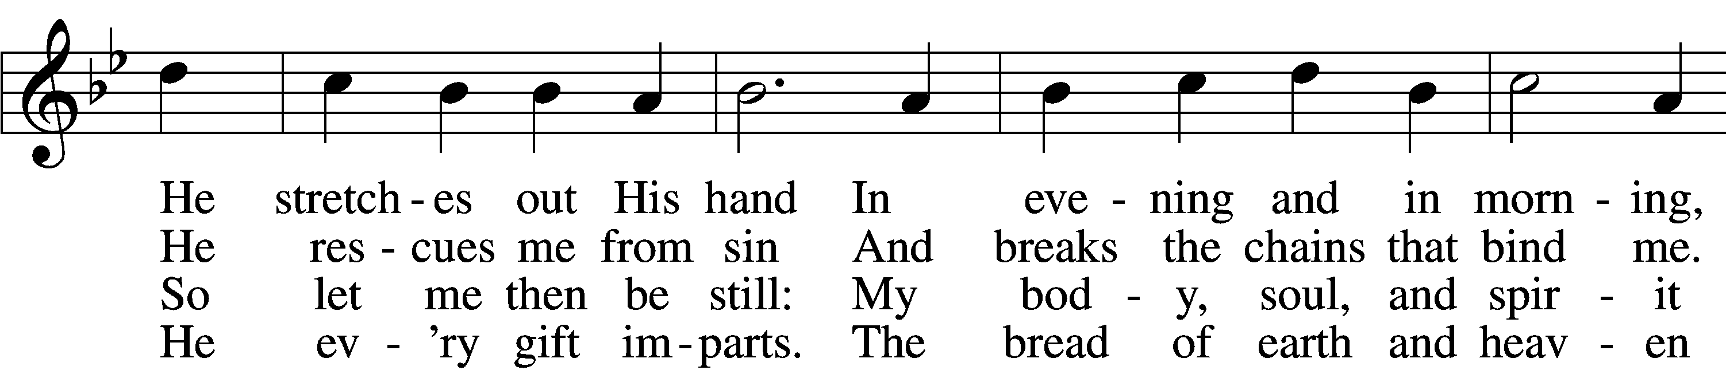
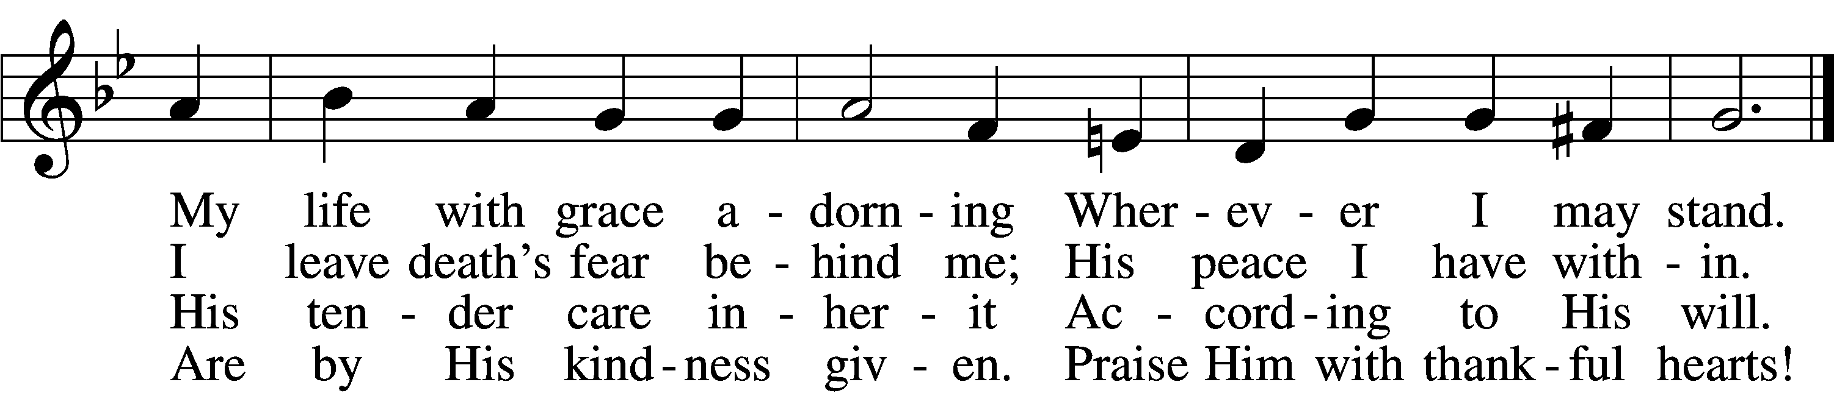

5 Praise God with acclamation
And in His gifts rejoice.
Each day finds its vocation
Responding to His voice.
Soon years on earth are past;
But time we spend expressing
The love of God brings blessing
That will forever last!

D 7 For thus the Father willed it,
Who fashioned us from clay;
And His own Son fulfilled it
And brought eternal day.
The Spirit now has come,
To us true faith has given;
He leads us home to heaven.
O praise the Three in One!
Tune: Public domain
Text (sts. 1–2): © 1978 Lutheran Book of Worship; (sts. 3–5, 7): © 2006 Concordia Publishing House. Used by permission: LSB Hymn License no. 110003744
Sermon

Please stand

Nicene Creed
C I believe in one God,
the Father Almighty,
maker of heaven and earth
and of all things visible and invisible.

And in one Lord Jesus Christ,
the only-begotten Son of God,
begotten of His Father before all worlds,
God of God, Light of Light,
very God of very God,
begotten, not made,
being of one substance with the Father,
by whom all things were made;
who for us men and for our salvation came down from heaven
and was incarnate by the Holy Spirit of the virgin Mary
and was made man;
and was crucified also for us under Pontius Pilate.
He suffered and was buried.
And the third day He rose again according to the Scriptures
and ascended into heaven
and sits at the right hand of the Father.
And He will come again with glory to judge both the living and the dead,
whose kingdom will have no end.

And I believe in the Holy Spirit,
the Lord and giver of life,
who proceeds from the Father and the Son,
who with the Father and the Son together is worshiped and glorified,
who spoke by the prophets.
And I believe in one holy Christian and apostolic Church,
I acknowledge one Baptism for the remission of sins,
and I look for the resurrection of the dead
and the life T of the world to come. Amen.

Prayer of the Church

Offerings and Offertory LSB 159
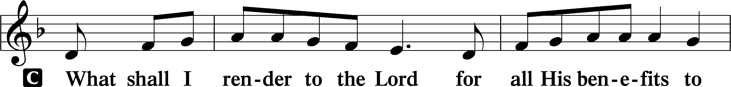
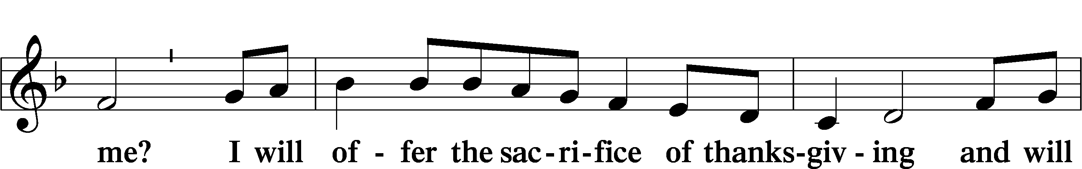
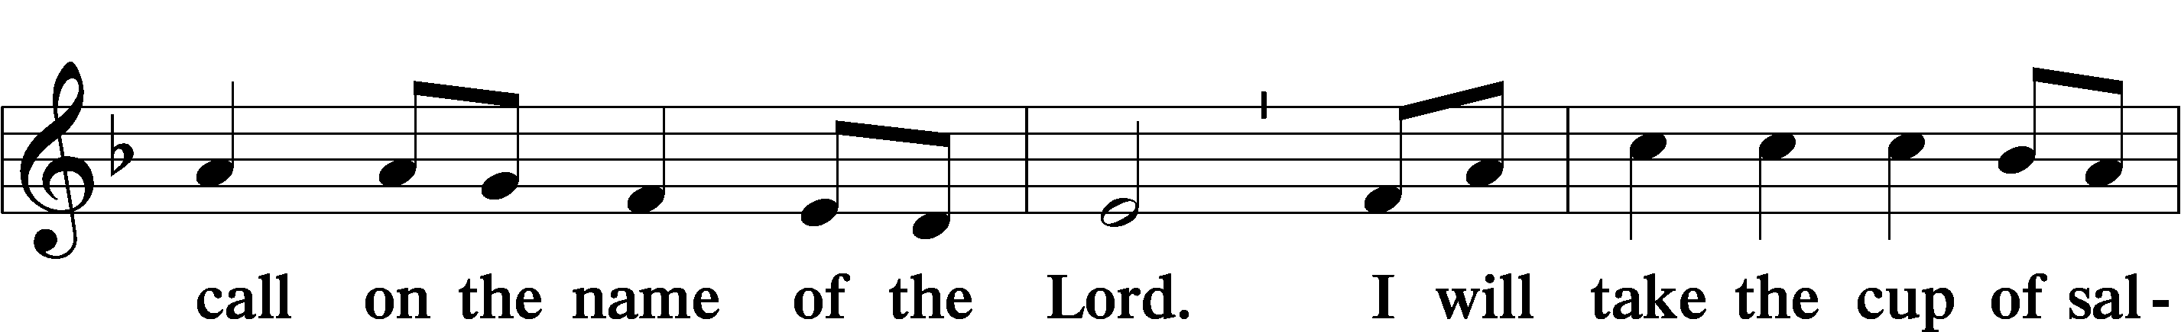
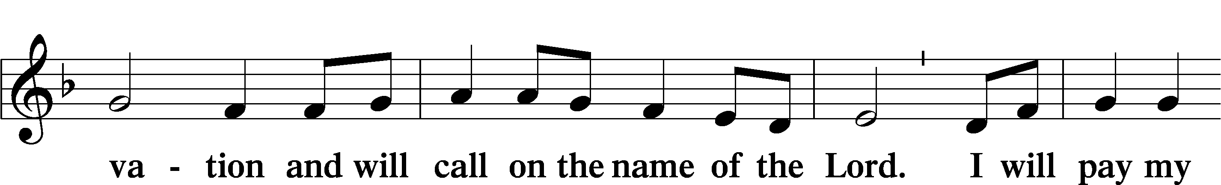
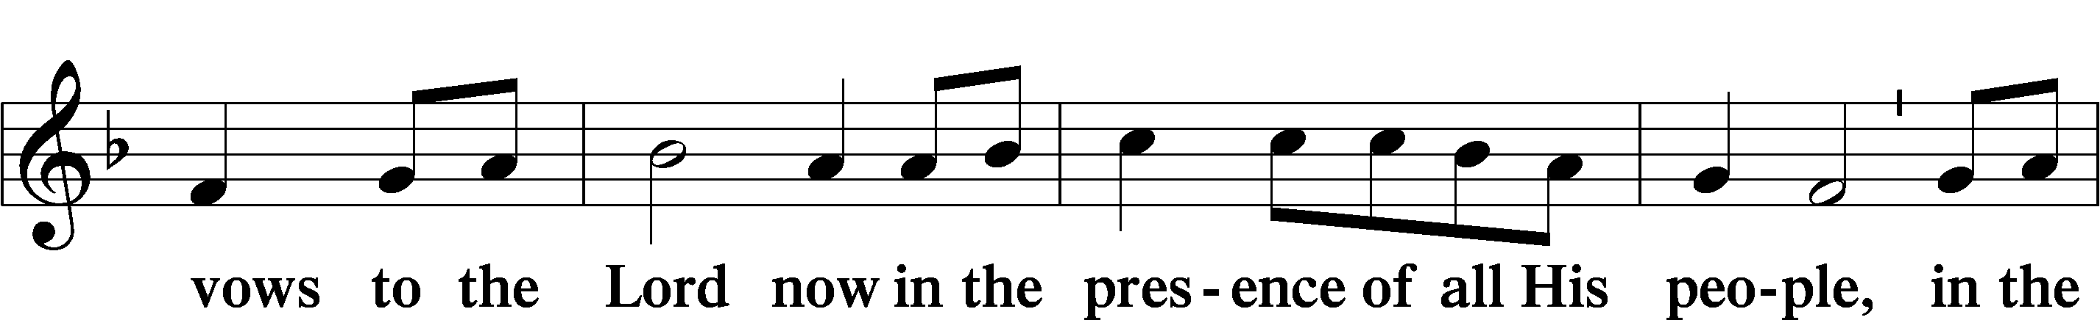
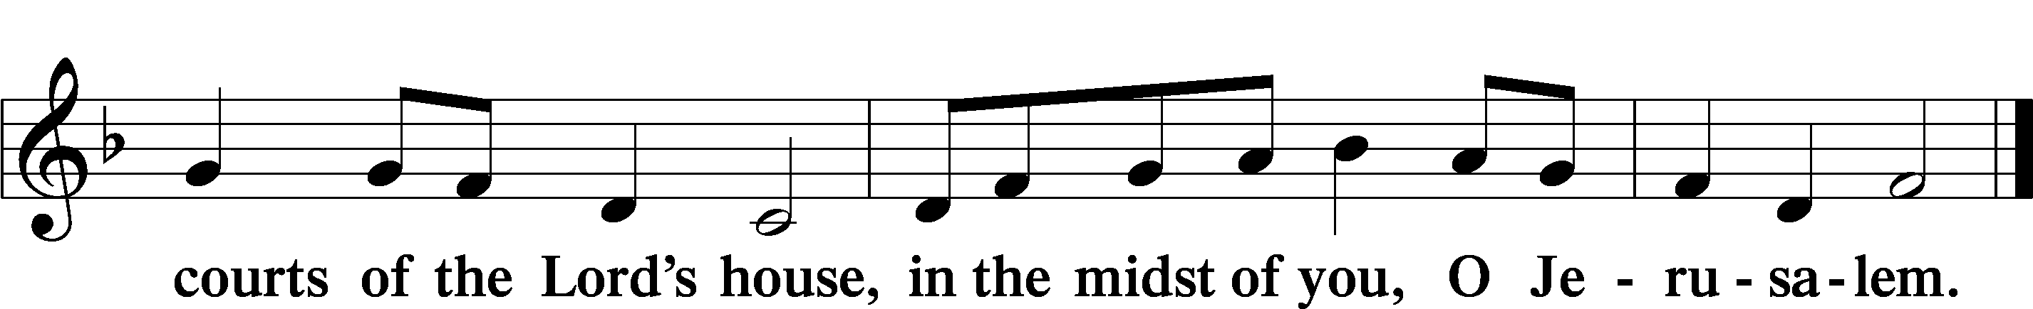

Service of the Sacrament

Preface LSB 160
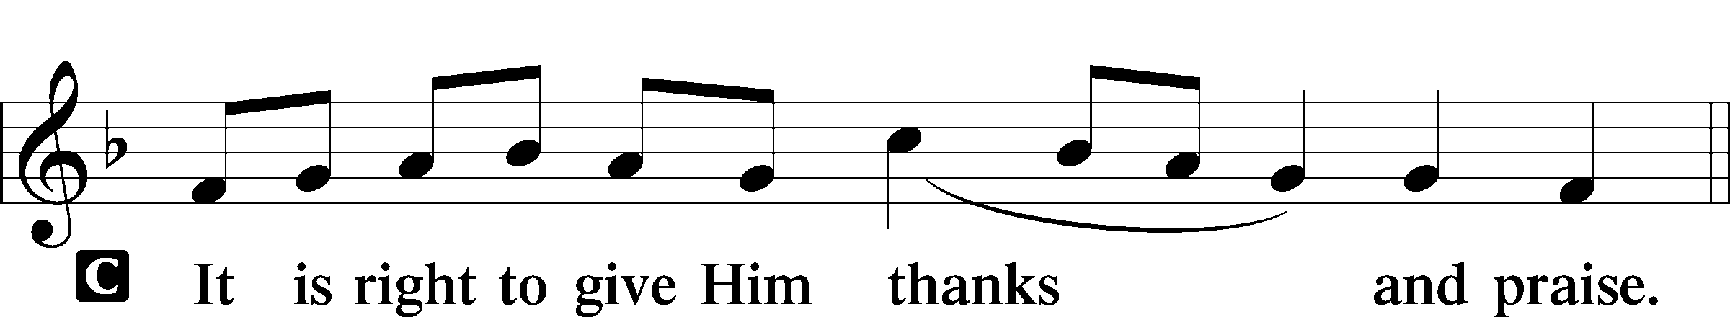

P It is truly good, right, and salutary that we should at all times and in all places give thanks to You, holy Lord, almighty Father, everlasting God, through Jesus Christ, our Lord. Therefore with angels and archangels and with all the company of heaven we laud and magnify Your glorious name, evermore praising You and saying:

Sanctus LSB 161
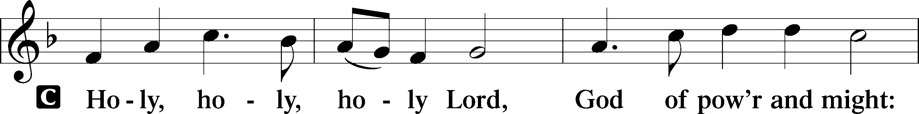
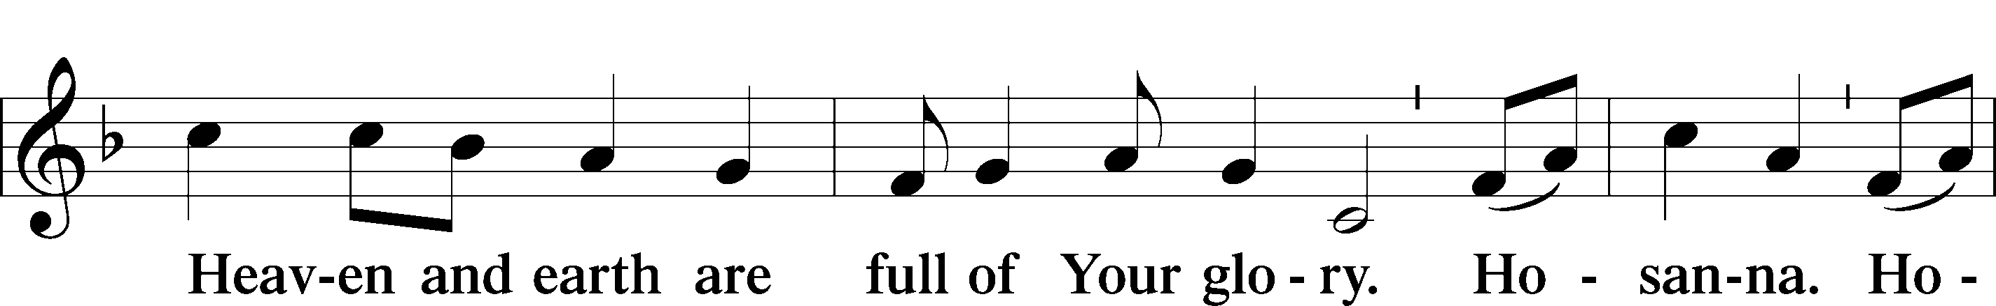
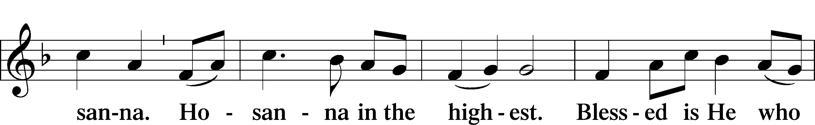
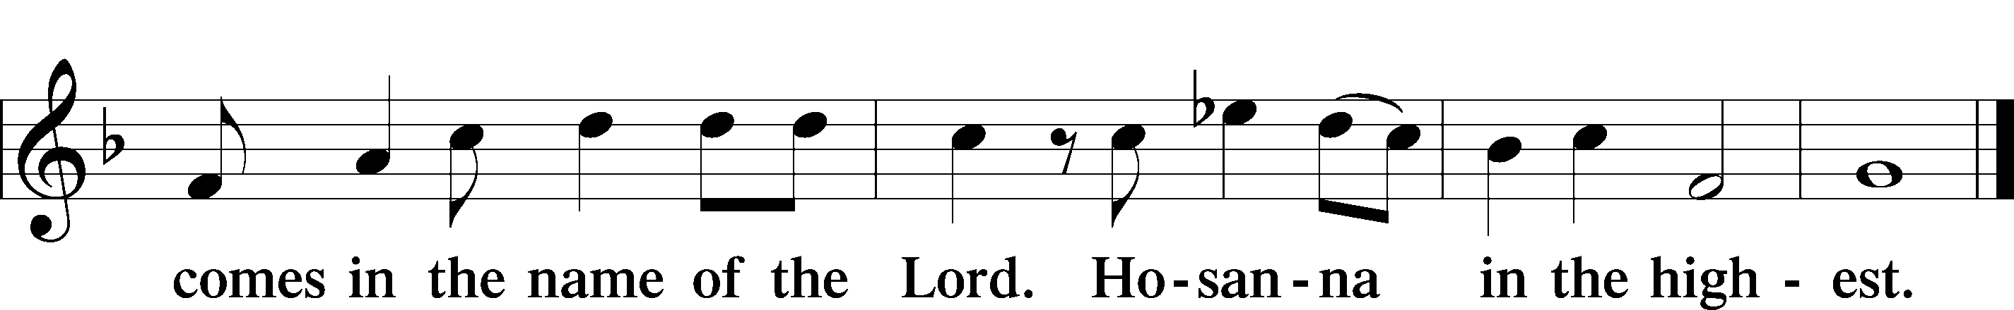

Lord’s Prayer

The Words of Our Lord
P Our Lord Jesus Christ, on the night when He was betrayed, took bread, and when He had given thanks, He broke it and gave it to the disciples and said: “Take, eat; this is My T body, which is given for you. This do in remembrance of Me.”

In the same way also He took the cup after supper, and when He had given thanks, He gave it to them, saying: “Drink of it, all of you; this cup is the new testament in My T blood, which is shed for you for the forgiveness of sins. This do, as often as you drink it, in remembrance of Me.”

Pax Domini LSB 163
P The peace of the Lord be with you always.
C Amen.

Agnus Dei LSB 163
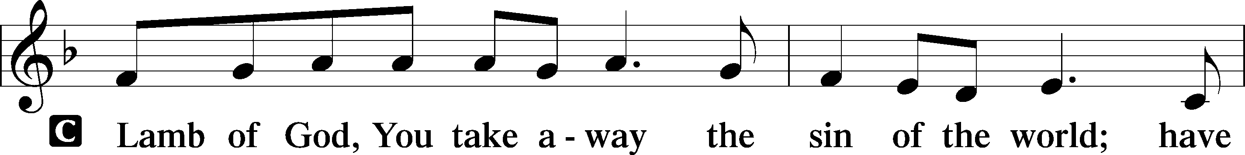
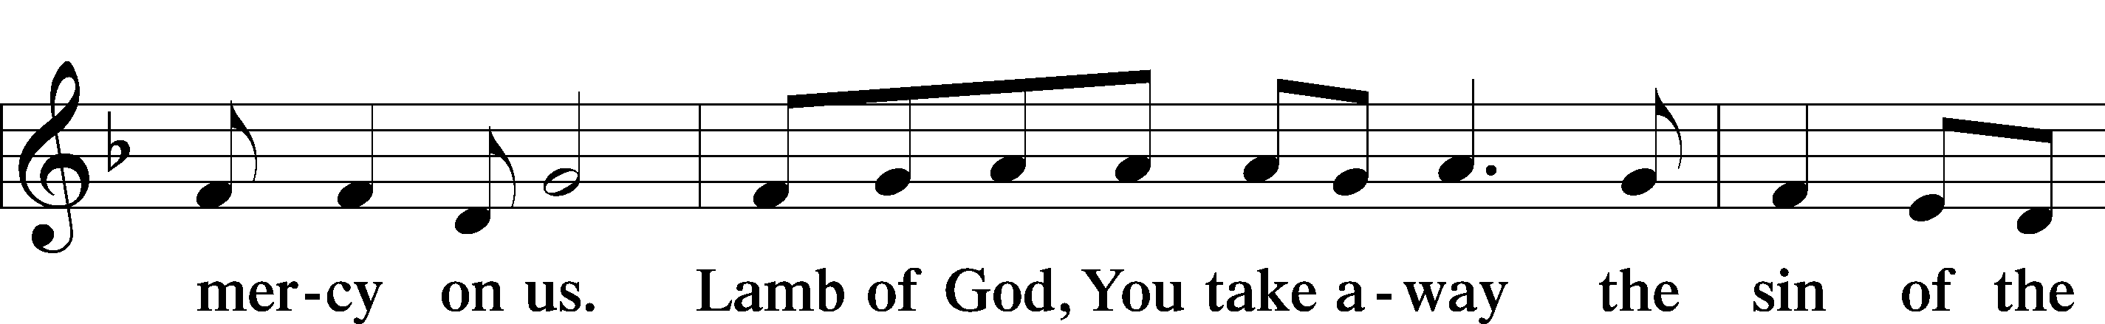
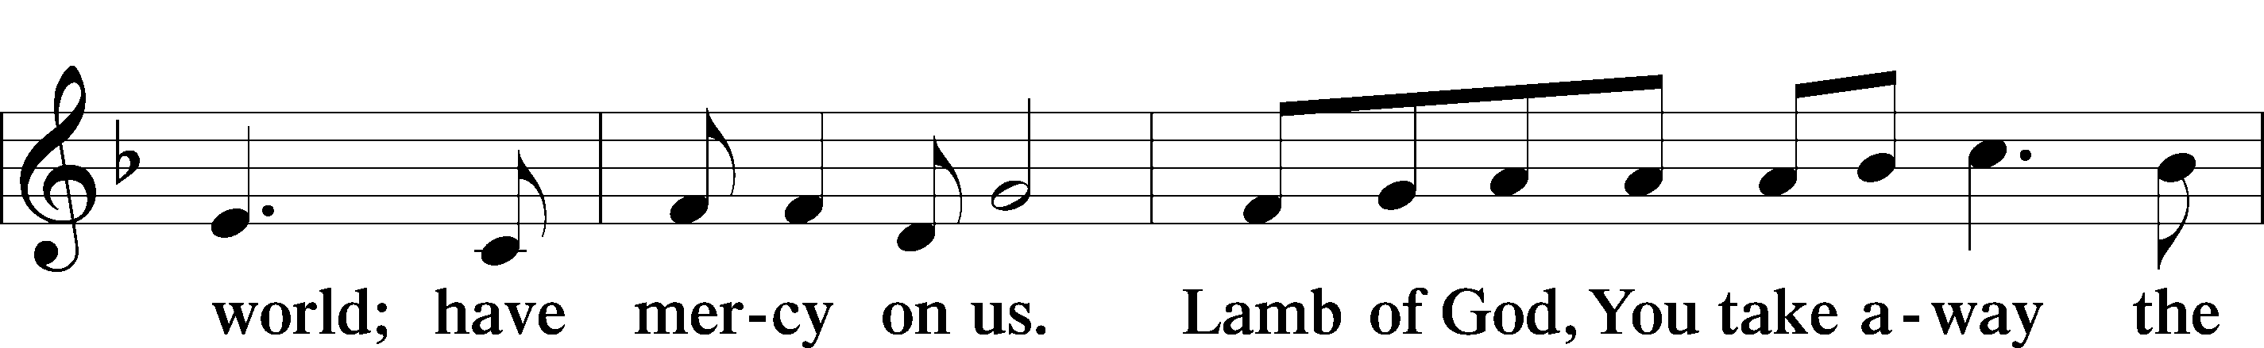
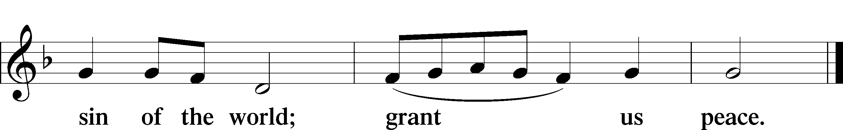
Sit

Distribution

620 Jesus Comes Today with Healing
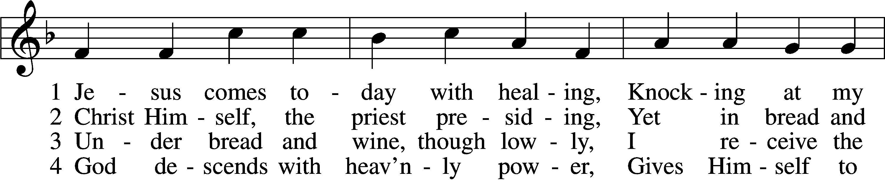
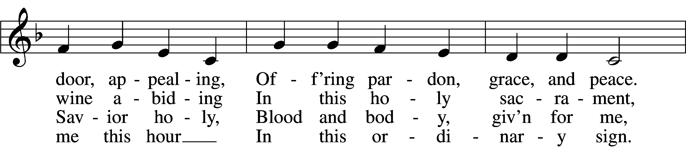
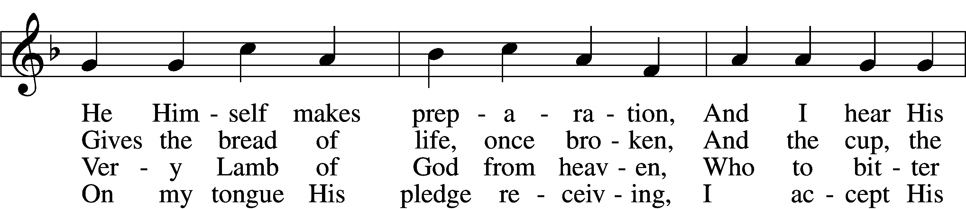
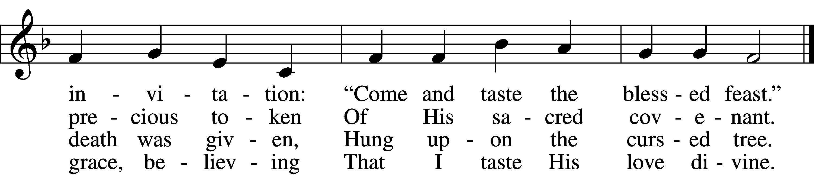

5 Let me praise God’s boundless favor,
Whose own feast of love I savor,
Bidden by His gracious call.
Wedding garments He provides me,
With a robe of white He hides me,
Fits me for the royal hall.

6 Now have I found consolation,
Comfort in my tribulation,
Balm to heal the troubled soul.
God, my shield from ev’ry terror,
Cleanses me from sin and error,
Makes my wounded spirit whole.
Text: © David W. Rogner. Used by permission: LSB Hymn License no. 110003744
Tune: Public domain

745 In God, My Faithful God
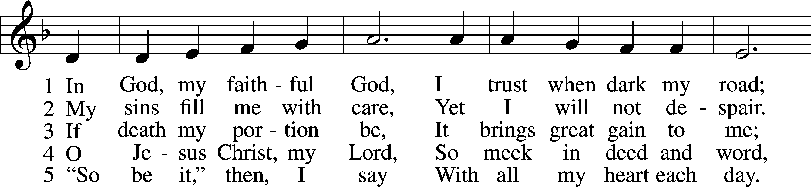
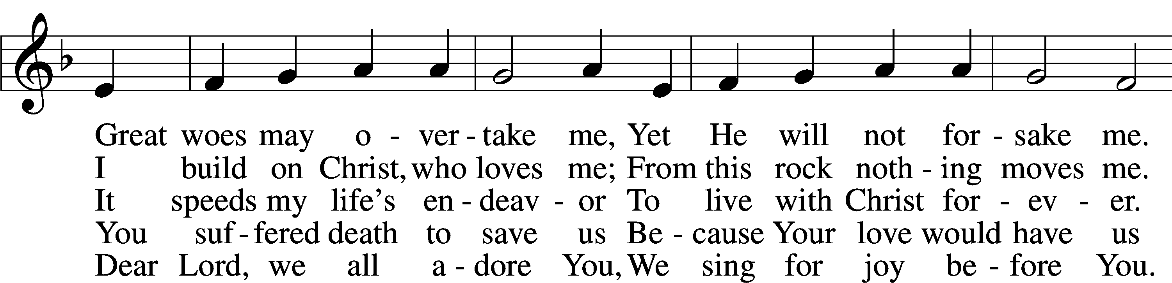
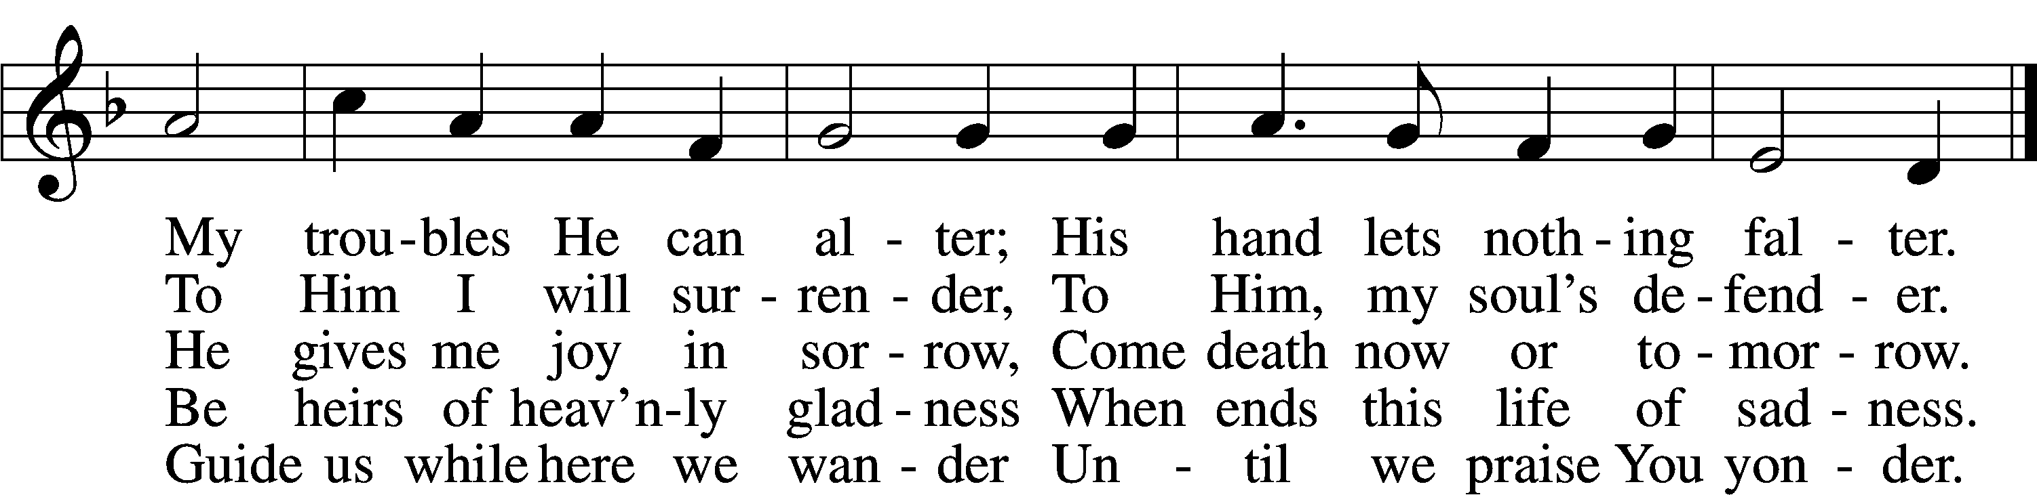
Tune and text: Public domain

529 Since Our Great High Priest, Christ Jesus
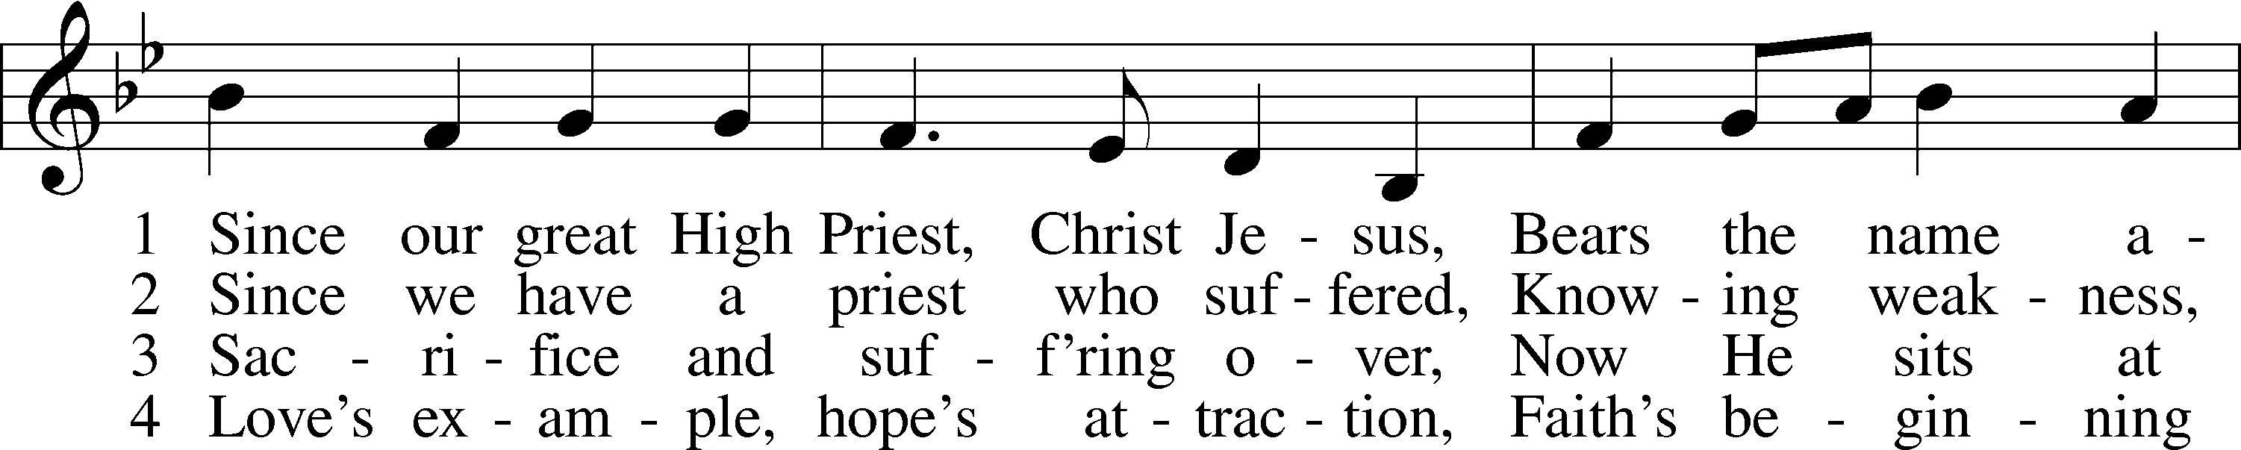
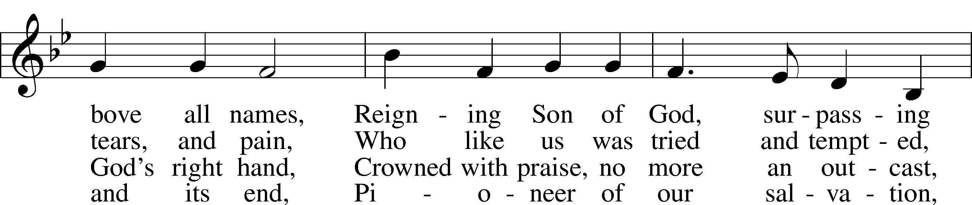
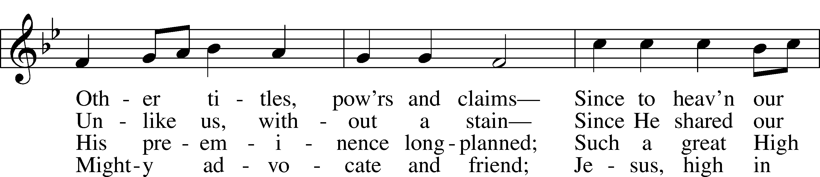
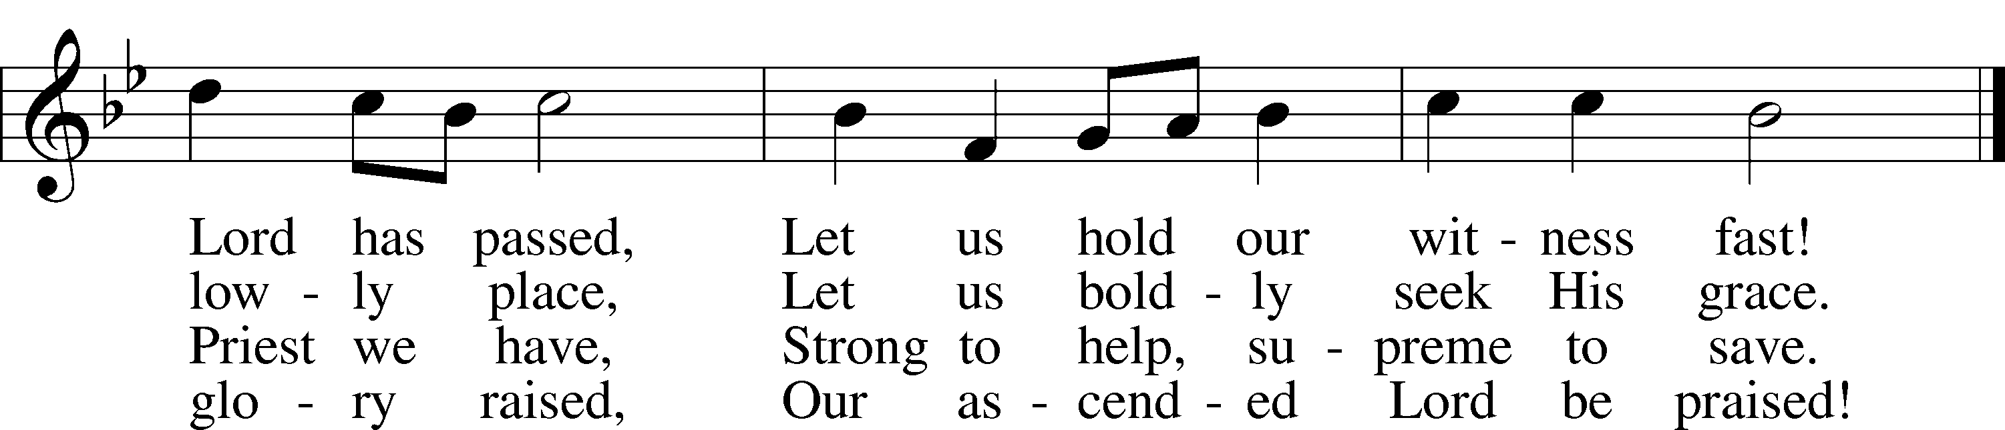
Tune: Public domain
Text: © 1973 The Jubilate Group, admin. Hope Publishing Co. Used by permission: LSB Hymn License no. 110003744

Stand

The Dismissal
P The body and blood of our Lord Jesus Christ strengthen and preserve you in body and soul to life everlasting. Depart T in peace.
C Amen.

Thank the Lord LSB 164
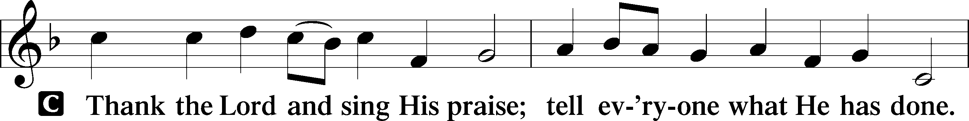
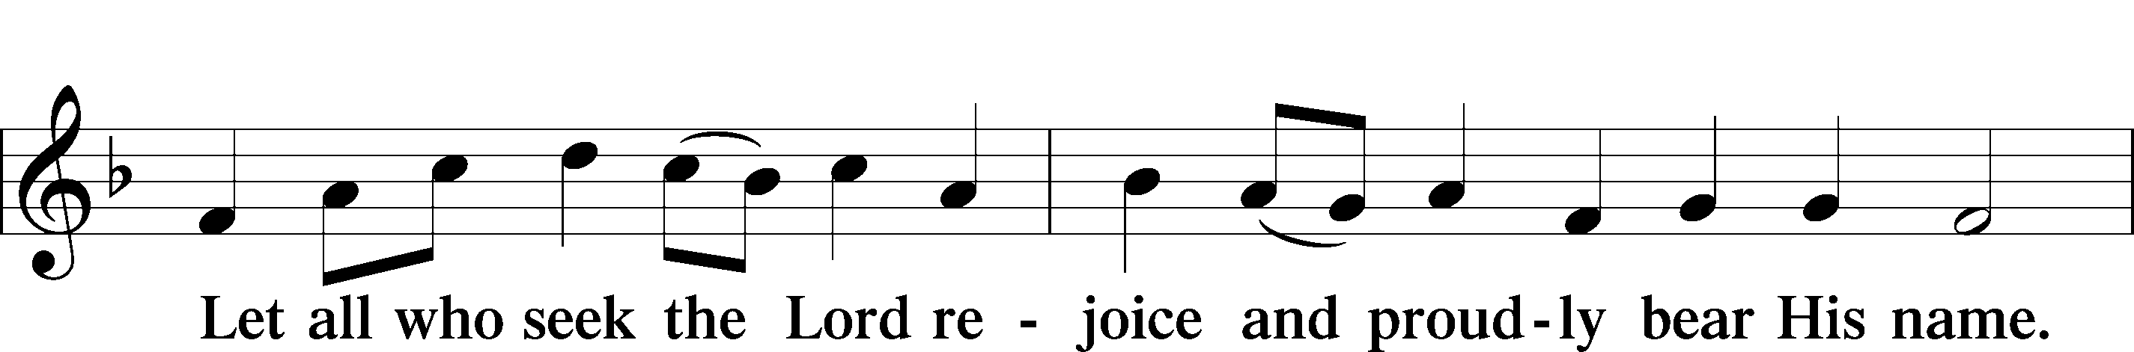
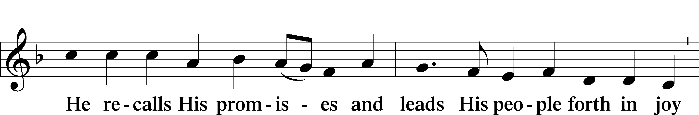
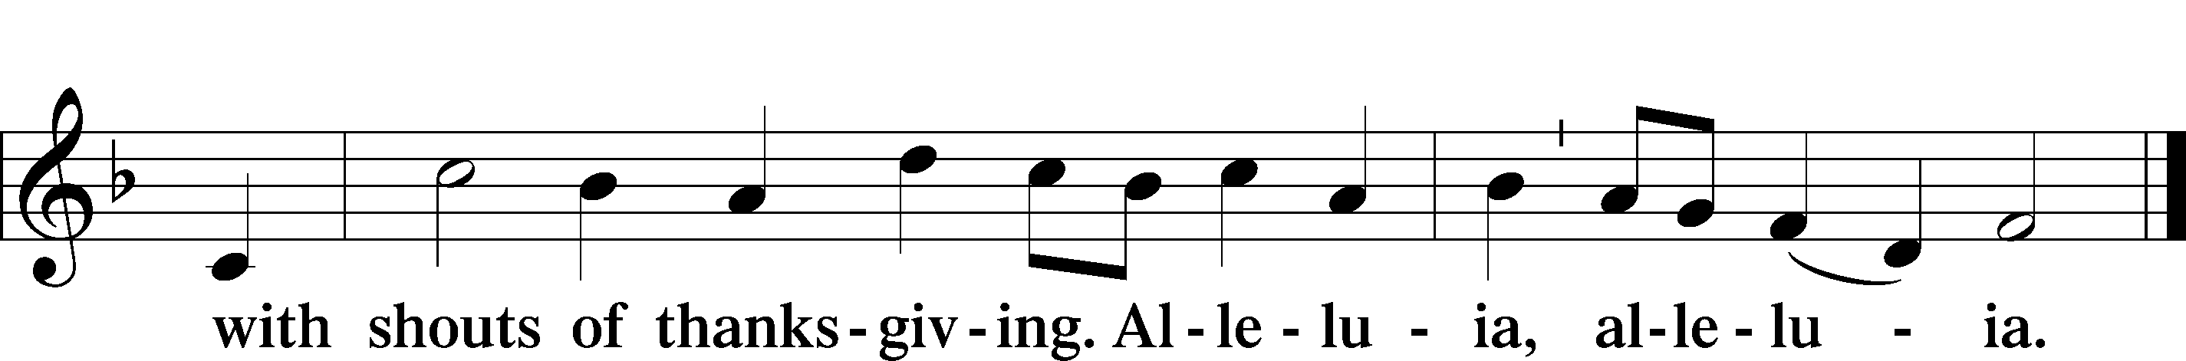

Post-Communion Collect
A Let us pray.
We give thanks to You, almighty God, that You have refreshed us through this salutary gift, and we implore You that of Your mercy You would strengthen us through the same in faith toward You and in fervent love toward one another; through Jesus Christ, Your Son, our Lord, who lives and reigns with You and the Holy Spirit, one God, now and forever.
C Amen.

Benediction LSB 166
P The Lord bless you and keep you.
The Lord make His face shine on you and be gracious to you.
The Lord look upon you with favor and T give you peace.
C Amen.

825 Rise, Shine, You People
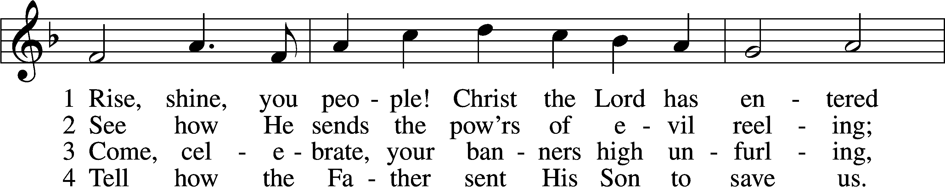
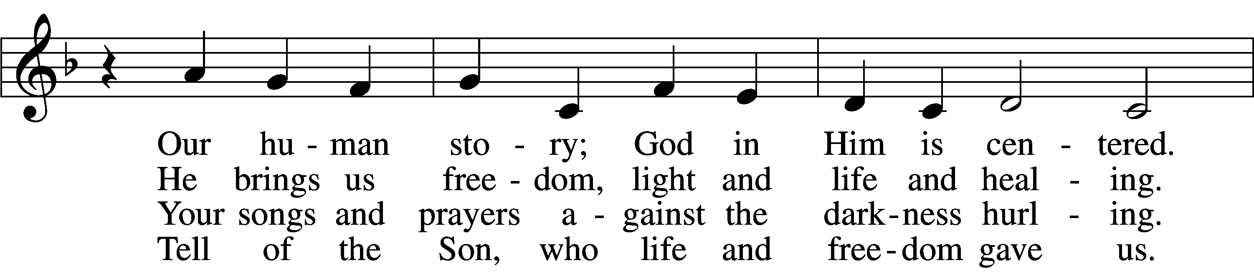
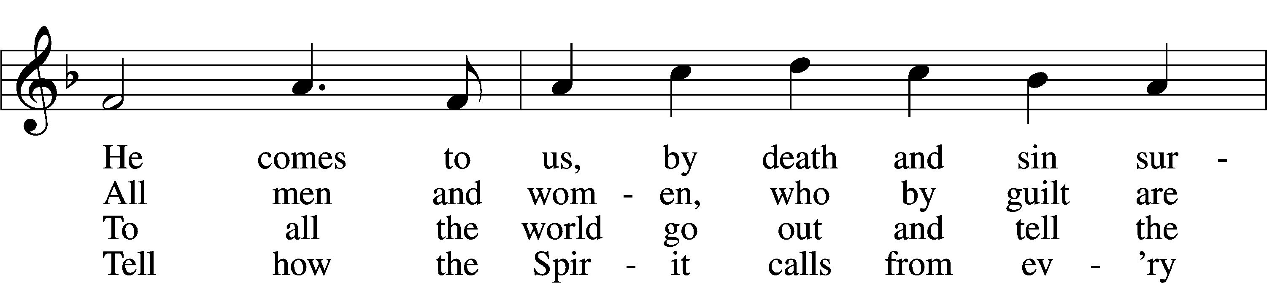
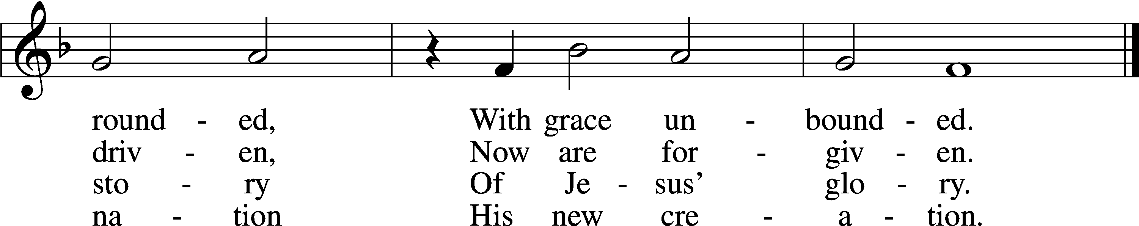
Tune and text: © 1974 Augsburg Publishing House, admin. Augsburg Fortress. Used by permission: LSB Hymn License no. 110003744

Acknowledgments
Unless otherwise indicated, Scripture quotations are from the ESV® Bible (The Holy Bible, English Standard Version®), copyright © 2001 by Crossway, a publishing ministry of Good News Publishers. Used by permission. All rights reserved.
Created by Lutheran Service Builder © 2021 Concordia Publishing House.

Prayers for Our Members
Sharon Hockemeier, Tenaya Nuttelman | Expectant Mothers
Norman Abels (Brookestone Meadows – Elkhorn) | Healing
Judy Ahrens | Healing
Vaughn Albrecht (Mount Carmel) | Healing
Tom & DyAnn Altwine | Healing
Lyle Colsden (Mother Hull) | Healing
Pat Flodine (Cambridge Court) | Healing
Vi Fox (Prairie View) | Hospitalized
Verleen Gentry | Healing
Wanda Glanzer | Healing
Ruby Hatfield | Healing
Evelyn Heiden (Mother Hull) | Healing
Lennis Hodgson | Healing
Don Richmond | Healing
Ivan Bombeck | Cancer
Fran Junge | Cancer
Bertha Marienau | Cancer
Kim Vos | Cancer

ZION LUTHERAN CHURCH AND SCHOOL

Pr. James DeLoach, Pastor + (308) 627-5260
james.deloach@zionkearney.org
Pr. Doug Gaunt, Pastor + (308) 455-0552
doug.gaunt@zionkearney.org
Tony Splittgerber, Principal + (308) 293-0168
anthony.splittgerber@zionkearney.org

Church Office
Secretary: Holly Reid
Email: school@zionkearney.org
Phone: (308)-234-3410 Fax: (308) 236-8100
Office Hours: Monday-Friday 8:00am-4:00pm
Radio Broadcast: Sunday @ 10:30 a.m. on 1460 AM and 92.1 FM
Website: www.zionkearney.com
Prayers for Our Members’ Family & Friends
Naomi Wollberg (Matthias’ wife) | Expecting
Elaine Arehardt (Zion’s Music Teacher) | Expecting
Larry Bombeck (Ivan’s brother) | Healing
Katie Cunningham (Quentin & Janel Lange’s friend) | Healing
Reg Duke (Westman’s brother-in-law) | Healing
James Gentry (Verleen’s son) | Healing
Roger Hoffman (Marc’s father) | Healing
David Kreutzer (Richard’s brother) | Healing
Pr. Rob Kuefner (Kearney Circuit Visitor) | Healing
Dillon Malchow (Joy Barefoot’s nephew) | Healing
Urijah Mitchell (Sue & Dennis Bartels’ Grandson) | Healing
Tim Powers (Kim Wilken’s brother) | Healing
Roy Reynolds (Verleen Gentry’s son-in-law) | Healing
Lynne Saathoff (Verleen Gentry’s sister-in-law) | Healing
Randy Solomon (Beth Rosenthal’s father) | Healing
Tim Trampe (Don & Gretchen’s son) | Healing
Jonah (Jase & Jarren Blattner’s friend) | Cancer
D.D. Dugger (Sue Kaiser’s brother) | Cancer
Stuart Gronewoller (Lonna’s brother-in-law) | Cancer
Linda Heapy (Janel Lange’s mother) | Cancer
Ron Halvorsen (Jeff’s dad) | Cancer
Bill Jedlicka (Pam Uhlir’s cousin) | Cancer
Randy Jochum (Ken Hockemeier’s brother-in-law) | Cancer
Sharon Mulhair (Pam Uhlir’s cousin) | Cancer
Kolby Shiers (Jessica’s cousin) | Cancer
Pr. Richard Snow (NE District President) | Cancer
Tyrone Uhlir (Pam’s nephew) | Cancer
John Weber (Zehendner’s friend) | Covid & Cancer
Tim Smallcomb (Wilkens’ friend) | Deployment
Family of Roger Kaiser (Susan Tonniges father) | Grief
Today’s Radio Broadcast is sponsored by Merna Oertwig – in memory of her husband, Fred.

Worship Assistants

Sunday, October 24~ 9:00am

Elder: Ken Hockemeier
Usher: Mike Wilkens
Acolyte: Makenna Starkey
Engineer: Shawn Starkey
Announcer: Lonna Gronewoller
Altar Guild: Jamie & Shirley Helmbrecht

Sunday, October 31~ 9:00am

Elder: Nathan Gaunt
Usher: Mike Wilkens
Acolyte: Noah Randolph
Engineer: Shawn Starkey
Announcer: Carol Kreutzer
Altar Guild: Jamie & Shirley Helmbrecht

Our Response to the Gospel

Date: 10/17/2021
Offering: $4,716
Weekly Need: $7,457.69

This Week at Zion

Sun  10/24 | 9:00a  10:20a  10:30a  5:00p | Divine Service  Bible Study/Sunday School  Radio Broadcast 1460am & 92.1fm  Divine Service
Mon
10/25
Tues  10/26 | 1:30p | Sleeping Mats
Wed  10/27 | 8:30a  5:45p  7:00p  Birthdays | Chapel  Midweek  Adult Choir  Eleanor Baker
Thurs  10/28 | Birthdays  Anniversaries | Angela Jorgensen  Ken & Ellen Hockemeier
Fri
10/29
Sat  10/30 | 1:00p-4:00p  Birthdays | School Carnival  Marla Hartmann
Sun  10/31 | 9:00a  10:20a  10:30a  4:30p | Divine Service  Bible Study/Sunday School  Radio Broadcast 1460am & 92.1fm  Reformation Service/Potluck

Where our Triune God strengthens us through His mercy in faith toward Him and in fervent love toward one another.

ANNOUNCEMENTS

The Kearney Circuit Reformation Service will be hosted by Zion this afternoon at 4:30 pm. All LCMS Congregations, in the Kearney Circuit and Nebraska, are invited. Dr. Gerhard Bode, a professor at Concordia Seminary, St. Louis will preach for this service. His areas of interest and expertise include the Reformation and the history of Lutheranism.

Following the service all are invited to stay for a meal of Brats & Hot Dogs, Potato Salad, Beans and Desserts. There will be a freewill offering that will go to the International Lutheran Council in support of other Lutherans throughout the world. All food will be provided by Zion Lutheran members and Thrivent. Dr. Bode will also be leading a study on the Reformation during Bible Class (Sun @ 10:30a). Please RSVP by October 25th so we can get a head count!

Sunday School is being offered for grades K-High School at 10:20am.

Adult Bible Study is studying the rich variety of words God uses to communicate the Gospel—that we are justified by grace through faith. Come grab a donut and cup of coffee as we fellowship and learn together.

Why has Zion’s 5pm service moved from Saturday to Sunday?

- Families who are out of town on Saturday at the lake, camping, or for travel sports will be back in time for a Sunday evening worship.
- Some of our older members attend Saturday evenings because of lighter street and parking lot traffic. Sunday evenings will allow them a similar opportunity.
- Due to leading the Saturday evening services our pastors often cannot attend their kids’ or grandkids’ Saturday games or events.
- A move to Sunday evening allows Pr. DeLoach and Carol to spend Saturday together, with family, or with friends without the responsibility of preaching or playing for a service that evening.
- If our pastors preside at a Saturday wedding, they are unable to attend the reception until much later, especially where travel is involved.
- Sunday evening is often a better option for our college and high school students.
- There are fewer social or sporting events on Sunday evenings.
Zion’s 4th Quarter (Oct – Dec) Mission Offerings will support Zion’s current students, who are studying for full-time church work. All our students are at Concordia (CUNE):
Peter Kreutzer - Lutheran Teacher’s Diploma (LTD)
Jessica Zehendner – LTD
Taylor Zehendner – LTD
Please use the mission envelopes located in the narthex for this offering. Or give via Church Trac by selecting “Missions.” Thank you for your support.

Offering Options:
1) Place your offering in the basket as you leave
2) Go to zionkearney.churchtrac.com/give
3) Go to zionkearney.com and click on the ChurchTrac icon
4) Mail your gift to Zion Lutheran Church, 2421 C Ave, Kearney, NE 68847. Or place it in the mail slot on the south side of the building.
Poinsettias – Zion will be taking poinsettia orders to adorn the Church Sanctuary during Christmas time. They will be $15.00 per plant. To order there is an envelope in the Fellowship Hall on Sunday’s and the Church Office during the week. Place your money in the envelope with your name, place the envelope in the offering plate or the mail slot on the south side of the building or drop it off during office hours. Please make checks out to Mary Martha.

Radio Broadcast – The sign-up sheets for the 2022 radio broadcast and altar flowers are up by the mailboxes! The remaining 2021 sheets are still up on the right side. The 14th, 21st, and 28th of November are still available for radio sponsors! Please help Zion spread the Gospel!

SCHOOL NEWS

The Theme for our school year is “Together by Christ’s Love” based on 1 John 4:7-8.

- Pie Sales are still going. Place an order with any Zion student or with the office by Friday, October 29th. The pie pick-up date is November 17th.
- The School Carnival is Saturday, October 30th from 1pm-4pm. Join us for games, food, and prizes. Tickets are $0.25 each. *Costumes are allowed but please help your children make appropriate choices on what to wear.
- Give Where You Live - Zion will be participating in the Give Where You Live Campaign again! It will be December 2nd (giving day), but donations will be accepted beginning November 4th. To contribute online go to: https://www.givewhereyoulive.net//zionlutheranschool. If you would rather give in person feel free to stop by the office. Please share this with family and friends.

