Divine Service
All Saints Sunday
November 7, 2021

Zion Lutheran Church
Kearney, Nebraska

Welcome to Zion!
All worshippers please fill out an attendance card in the pew rack and let us know how we might be of service to you.

Holy Communion at Zion

The Lord’s Supper is celebrated at this congregation as Jesus instituted it. As he says, so our Lord gives into our mouths not only bread and wine but his very body and blood to eat and to drink for the forgiveness of sins and to strengthen our union with him and with one another. Our Lord invites to his table those who repent of all sin, trust his words “given and shed for you for the forgiveness of sins,” and set aside any refusal to forgive and love as he forgives and loves us, that they may show forth his death until he comes. All communicants need to register in the narthex prior to the service.

The Lord’s Supper can harm those who receive it unworthily. Holy Communion is also a confession of the faith which is confessed at this altar. Therefore, any who are not yet instructed, in doubt, or who hold a confession differing from that of this congregation and The Lutheran Church—Missouri Synod, are asked not to commune until they are able to speak with our pastor first. He is most happy to visit with you about the Christian faith and how to receive the Lord’s Supper for your good and for the good of others. Those not communing are invited to come to the altar, cross your arms in front of you, and bow your head to receive a pastoral blessing.

Saints Are Blessed in the Eternal Presence of Christ

“A great multitude … from every nation, from all tribes and peoples and languages,” cry out, “Salvation belongs to our God who sits on the throne” (Rev. 7:9–17). Faith-filled saints from every place and time, with unified voices, eternally magnify the Lamb of God. As His beloved children, we, too, “shall see him as he is” (1 John 3:1–3). Joined with the throng of angels and myriad saints, we shall “serve him day and night in his temple” (Rev. 7:9–17). In our earthly tension vacillating between saint and sinner, faith and doubt, sacred and profane, we earnestly seek Jesus to calm our fears, comfort our spirits and forgive our sins. The Holy Spirit through faith in Christ propels us forward, fortifying us in Word and Sacrament, to our eternal home. In the midst of our constant struggle as believers, we need to be blessed. And so we are. The poor in spirit, the meek, the hungry, the thirsty, the merciful, the pure and the persecuted are all blessed, and we will most certainly inherit the kingdom of heaven (Matt. 5:1–12).

671 Sing with All the Saints in Glory
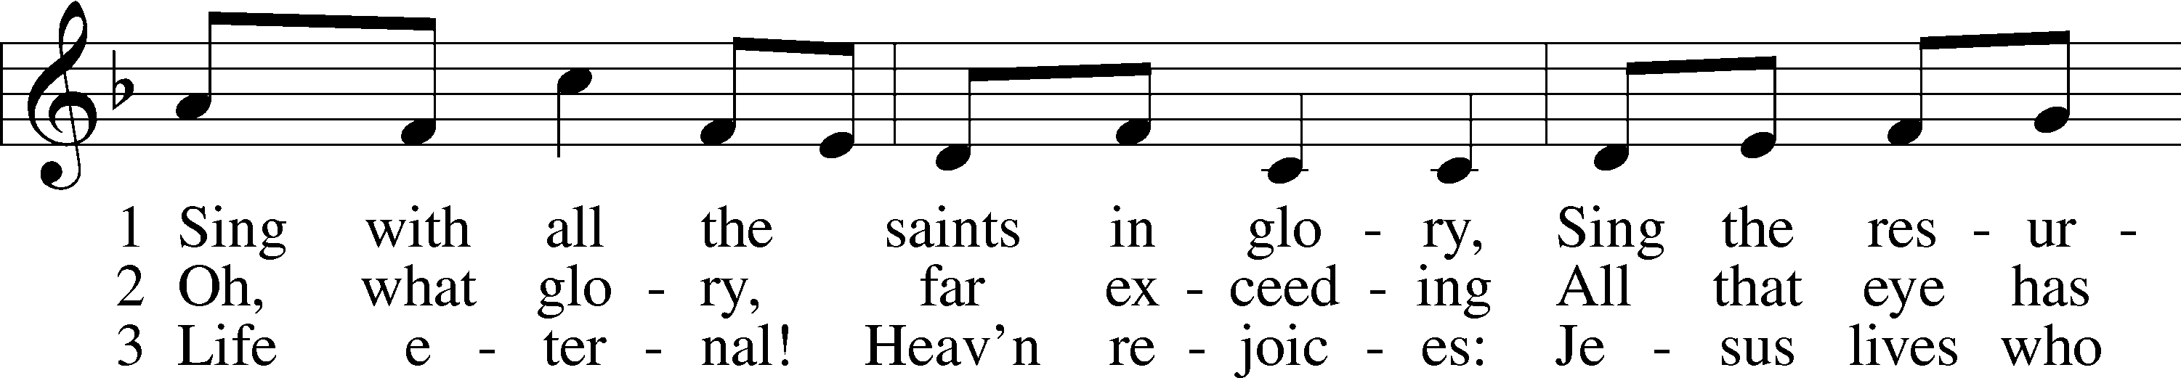
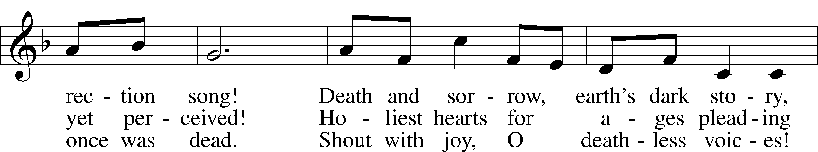
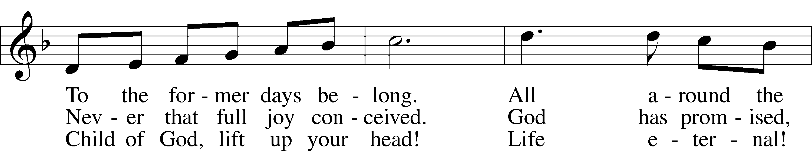
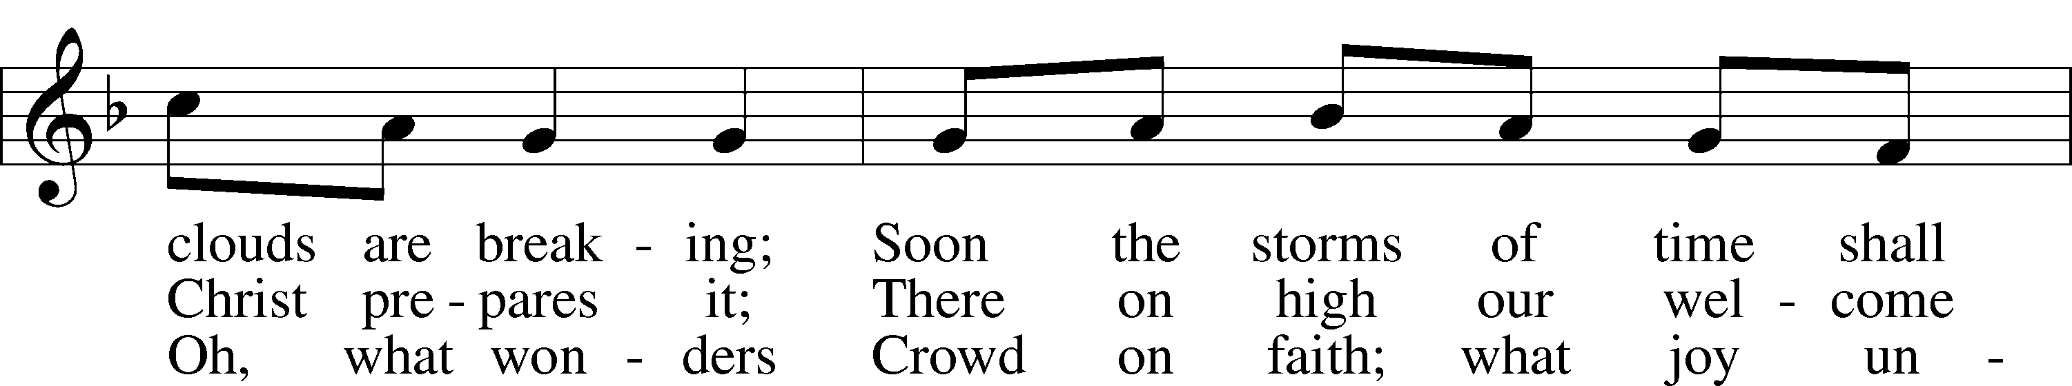
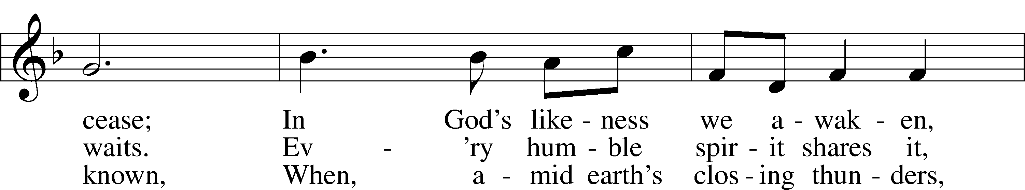
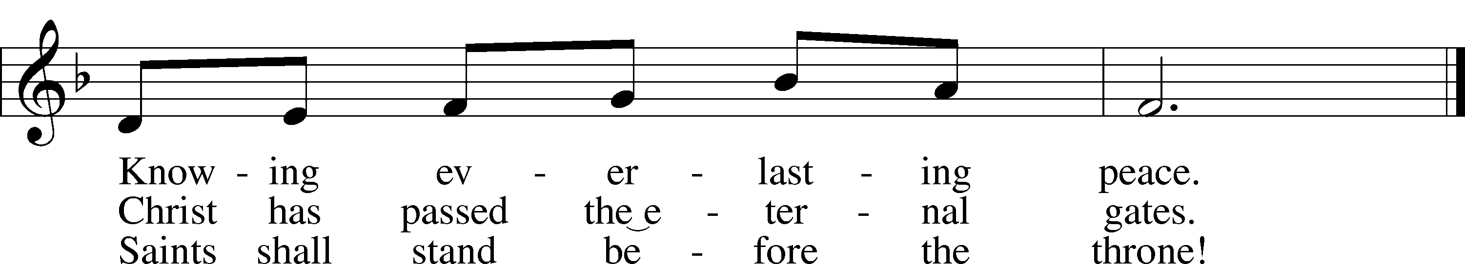
Text: Public domain
Tune: © 1995 Augsburg Fortress. Used by permission: LSB Hymn License no. 110003744

Confession and Absolution
Stand. The sign of the cross may be made by all in remembrance of their Baptism.

P In the name of the Father and of the T Son and of the Holy Spirit.
C Amen.

P Beloved in the Lord! Let us draw near with a true heart and confess our sins unto God our Father, beseeching Him in the name of our Lord Jesus Christ to grant us forgiveness.

P Our help is in the name of the Lord,
C who made heaven and earth.
P I said, I will confess my transgressions unto the Lord,
C and You forgave the iniquity of my sin.

Silence for reflection on God’s Word and for self-examination.

P O almighty God, merciful Father,
C I, a poor, miserable sinner, confess unto You all my sins and iniquities with which I have ever offended You and justly deserved Your temporal and eternal punishment. But I am heartily sorry for them and sincerely repent of them, and I pray You of Your boundless mercy and for the sake of the holy, innocent, bitter sufferings and death of Your beloved Son, Jesus Christ, to be gracious and merciful to me, a poor, sinful being.
P Upon this your confession, I, by virtue of my office, as a called and ordained servant of the Word, announce the grace of God unto all of you, and in the stead and by the command of my Lord Jesus Christ I forgive you all your sins in the name of the Father and of the T Son and of the Holy Spirit.
C Amen.

Service of the Word
Introit Psalm 31:1, 3, 5; antiphon: Revelation 7:14b

These are the ones coming out of the great tribu-| lation.*
They have washed their robes and made them white in the blood | of the Lamb.
In you, O Lord, do I take refuge; let me never be | put to shame;*
in your righteousness de-| liver me.
For you are my rock and my | fortress;*
and for your name’s sake you lead me and | guide me.
Into your hand I commit my | spirit;*
you have redeemed me, O Lord, | faithful God.

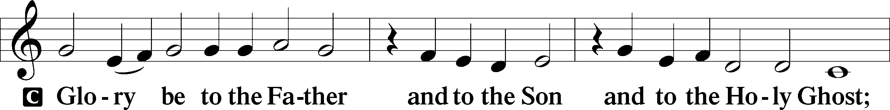
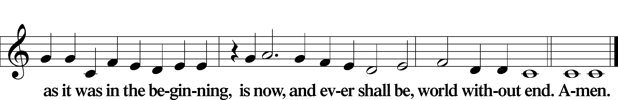
Kyrie LSB 186

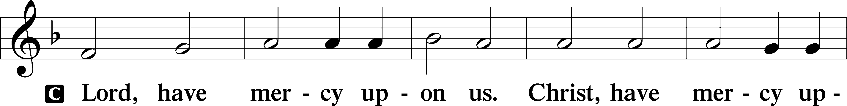
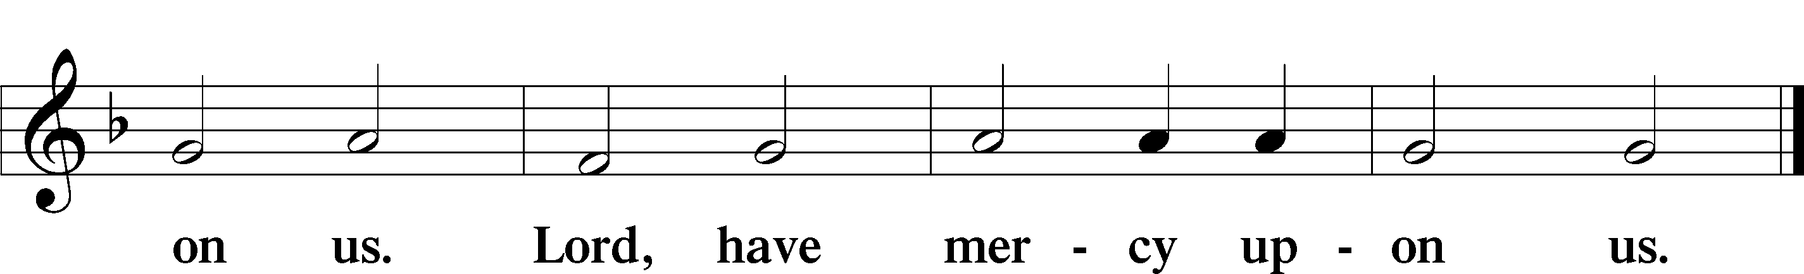

Gloria in Excelsis LSB 187
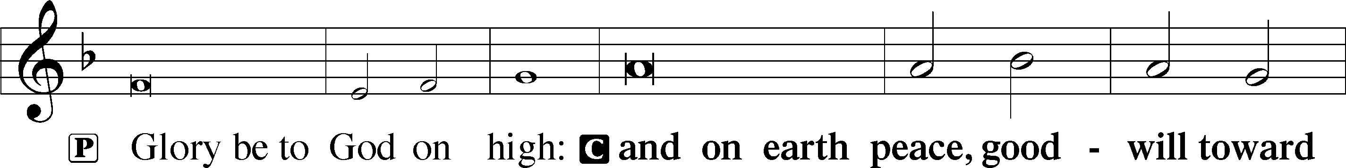
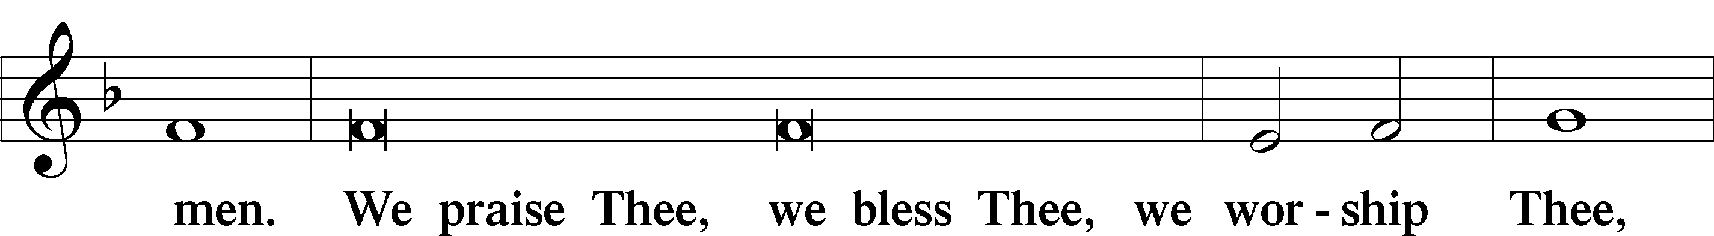
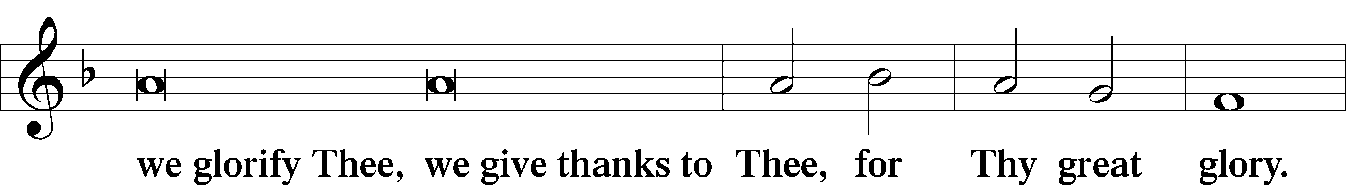
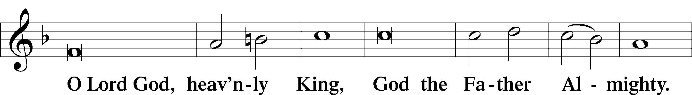
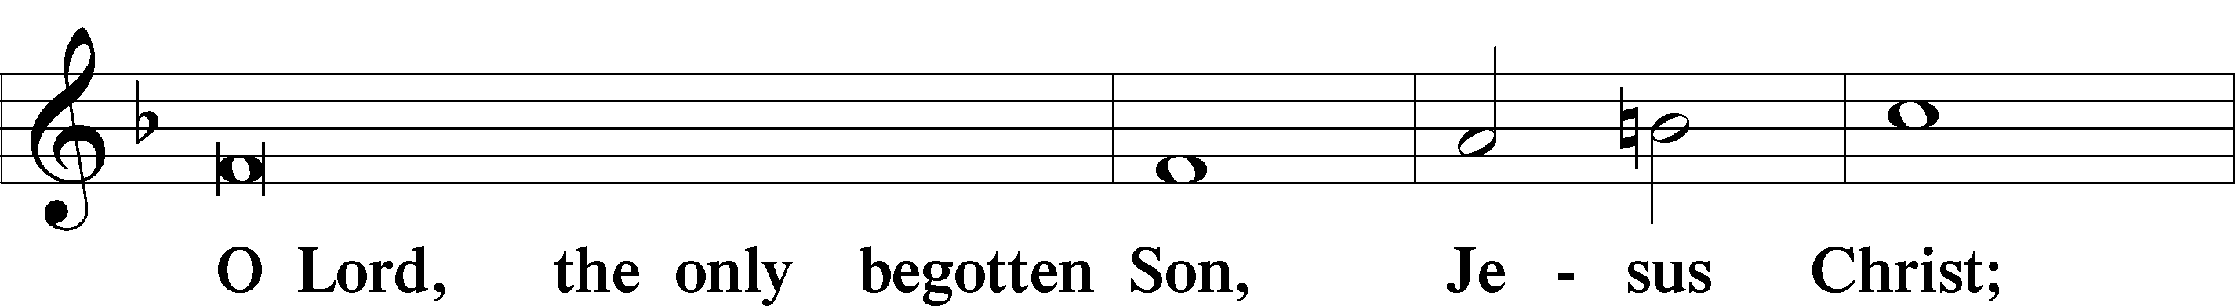
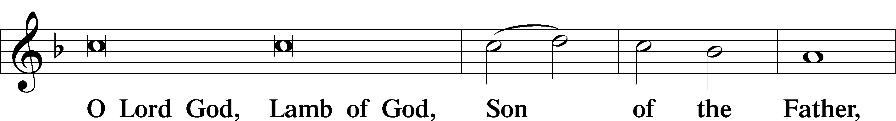
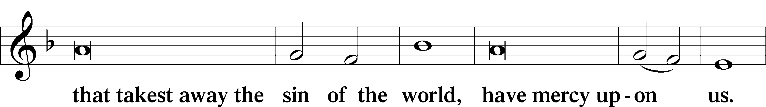
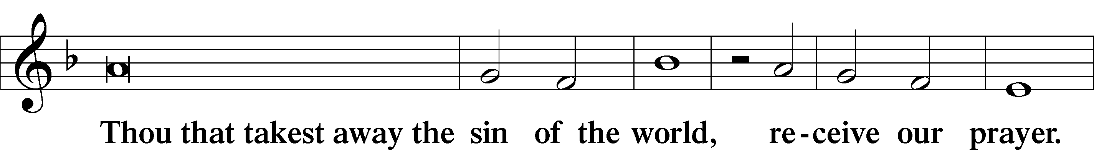
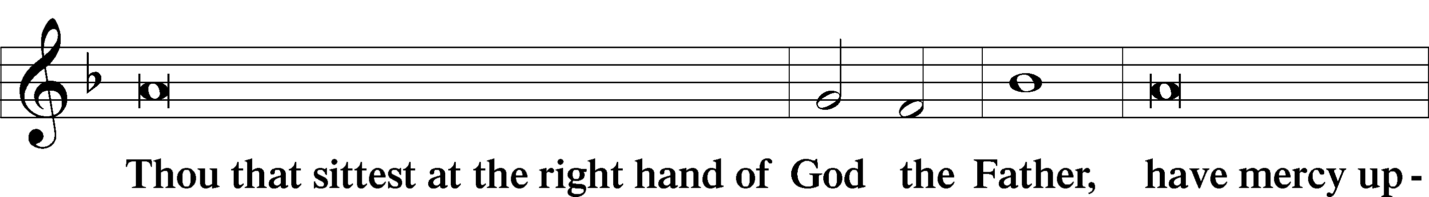
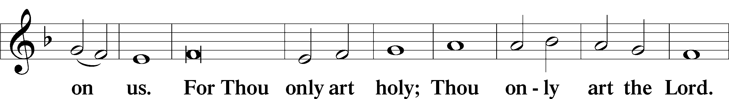
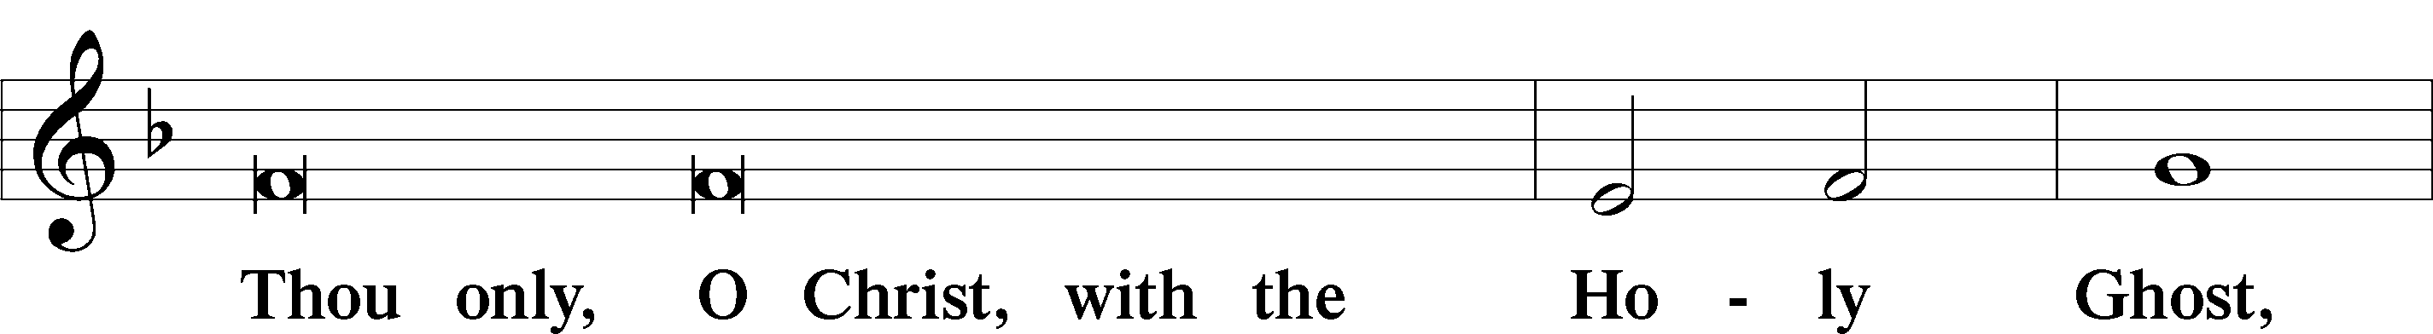
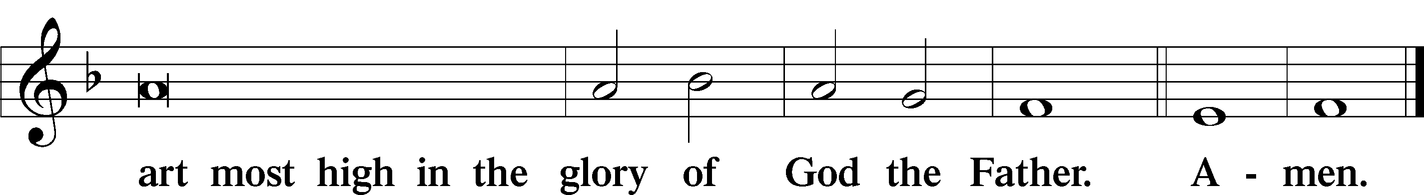

Salutation and Collect of the Day

P The Lord be with you.
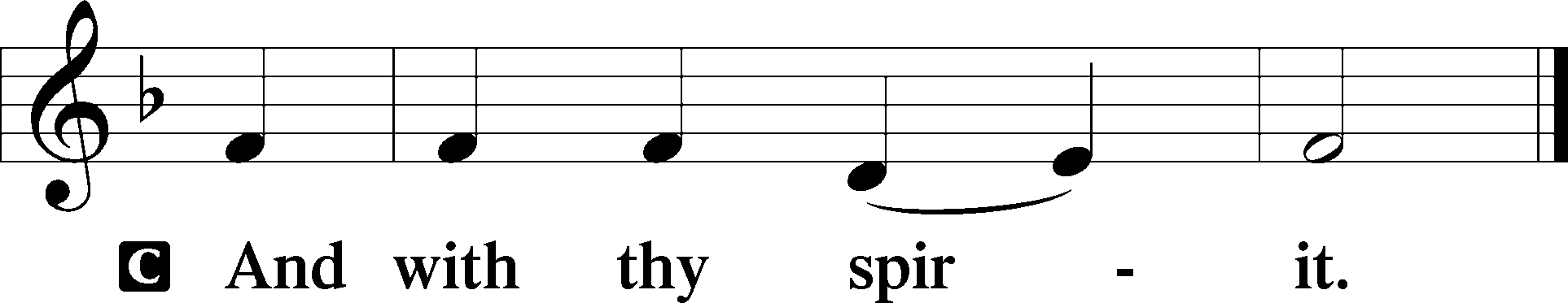

P Let us pray.

Almighty and everlasting God, You knit together Your faithful people of all times and places into one holy communion, the mystical body of Your Son, Jesus Christ. Grant us so to follow Your blessed saints in all virtuous and godly living that, together with them, we may come to the unspeakable joys You have prepared for those who love You; through Jesus Christ, our Lord, who lives and reigns with You and the Holy Spirit, one God, now and forever.

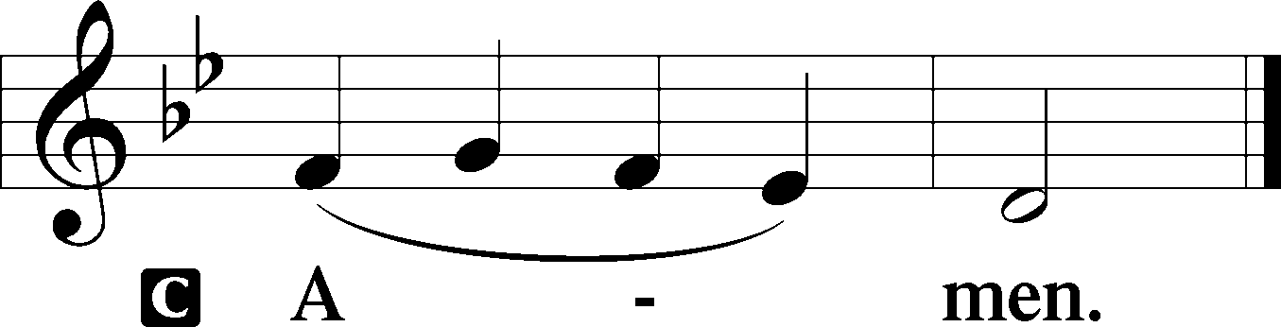

Sit

First Reading Revelation 7:9–17
⁹After this I looked, and behold, a great multitude that no one could number, from every nation, from all tribes and peoples and languages, standing before the throne and before the Lamb, clothed in white robes, with palm branches in their hands, ¹⁰and crying out with a loud voice, “Salvation belongs to our God who sits on the throne, and to the Lamb!” ¹¹And all the angels were standing around the throne and around the elders and the four living creatures, and they fell on their faces before the throne and worshiped God, ¹²saying, “Amen! Blessing and glory and wisdom and thanksgiving and honor and power and might be to our God forever and ever! Amen.”
¹³Then one of the elders addressed me, saying, “Who are these, clothed in white robes, and from where have they come?” ¹⁴I said to him, “Sir, you know.” And he said to me, “These are the ones coming out of the great tribulation. They have washed their robes and made them white in the blood of the Lamb.
¹⁵“Therefore they are before the throne of God,
and serve him day and night in his temple;
and he who sits on the throne will shelter them with his presence.
¹⁶They shall hunger no more, neither thirst anymore;
the sun shall not strike them,
nor any scorching heat.
¹⁷For the Lamb in the midst of the throne will be their shepherd,
and he will guide them to springs of living water,
and God will wipe away every tear from their eyes.”

P This is the Word of the Lord. C Thanks be to God.

Gradual Revelation 7:14b; Psalm 84:5
These are the ones coming out of the great tribu- | lation.*
They have washed their robes and made them white in the blood | of the Lamb.
Blessèd are those whose strength is | in you,*
in whose heart are the highways to | Zion.

Epistle 1 John 3:1–3
¹See what kind of love the Father has given to us, that we should be called children of God; and so we are. The reason why the world does not know us is that it did not know him. ²Beloved, we are God’s children now, and what we will be has not yet appeared; but we know that when he appears we shall be like him, because we shall see him as he is. ³And everyone who thus hopes in him purifies himself as he is pure.

P This is the Word of the Lord. C Thanks be to God.

Please stand for the Gospel processional and in reverence to Christ.

Verse of the Day (congregation echo alleluias) Hebrews 12:1a, 2a

Alleluia. Since we are surrounded by so great a cloud of |witnesses,*
let us [look] to Jesus, the founder and perfecter of our | faith. Alleluia.

Holy Gospel Matthew 5:1–12
P The Holy Gospel according to St. Matthew, the fifth chapter.

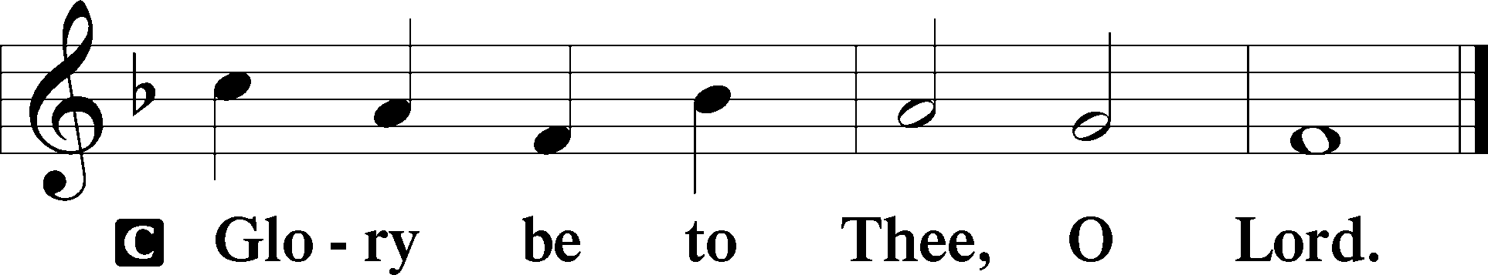

¹Seeing the crowds, [Jesus] went up on the mountain, and when he sat down, his disciples came to him.
²And he opened his mouth and taught them, saying:
³“Blessed are the poor in spirit, for theirs is the kingdom of heaven.
⁴“Blessed are those who mourn, for they shall be comforted.
⁵“Blessed are the meek, for they shall inherit the earth.
⁶“Blessed are those who hunger and thirst for righteousness, for they shall be satisfied.
⁷“Blessed are the merciful, for they shall receive mercy.
⁸“Blessed are the pure in heart, for they shall see God.
⁹“Blessed are the peacemakers, for they shall be called sons of God.
¹⁰“Blessed are those who are persecuted for righteousness’ sake, for theirs is the kingdom of heaven.
¹¹“Blessed are you when others revile you and persecute you and utter all kinds of evil against you falsely on my account. ¹²Rejoice and be glad, for your reward is great in heaven, for so they persecuted the prophets who were before you.”

P This is the Gospel of the Lord.

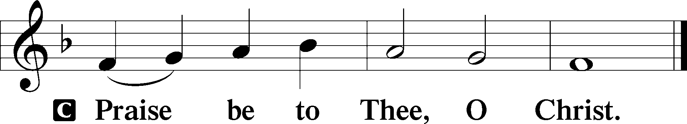

Nicene Creed

C I believe in one God,
the Father Almighty,
maker of heaven and earth
and of all things visible and invisible.

And in one Lord Jesus Christ,
the only-begotten Son of God,
begotten of His Father before all worlds,
God of God, Light of Light,
very God of very God,
begotten, not made,
being of one substance with the Father,
by whom all things were made;
who for us men and for our salvation came down from heaven
and was incarnate by the Holy Spirit of the virgin Mary
and was made man;
and was crucified also for us under Pontius Pilate.
He suffered and was buried.
And the third day He rose again according to the Scriptures
and ascended into heaven
and sits at the right hand of the Father.
And He will come again with glory to judge both the living and the dead,
whose kingdom will have no end.

And I believe in the Holy Spirit,
the Lord and giver of life,
who proceeds from the Father and the Son,
who with the Father and the Son together is worshiped and glorified,
who spoke by the prophets.
And I believe in one holy Christian and apostolic Church,
I acknowledge one Baptism for the remission of sins,
and I look for the resurrection of the dead
and the life T of the world to come. Amen.

When the crucifer returns the processional cross to its stand, please be seated.

677 For All the Saints (1-2=All, 3=M, 4=W, 5=M, 6=W, 7-8=All)
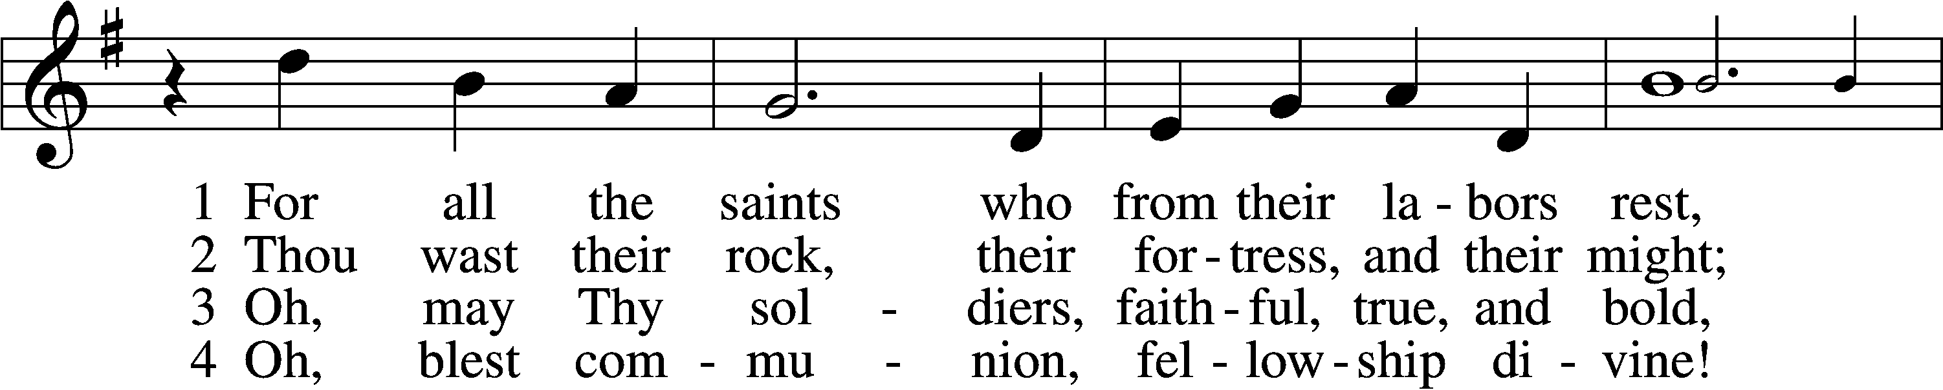
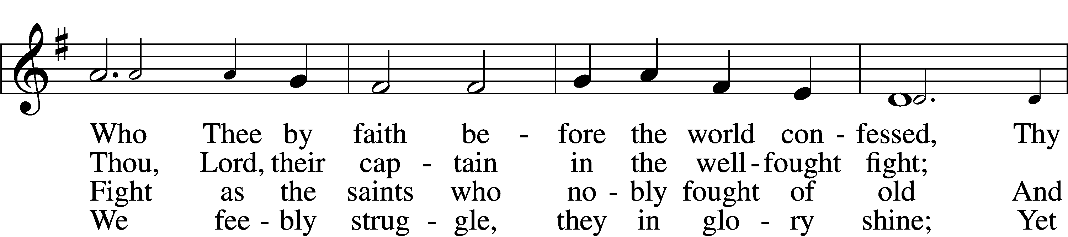
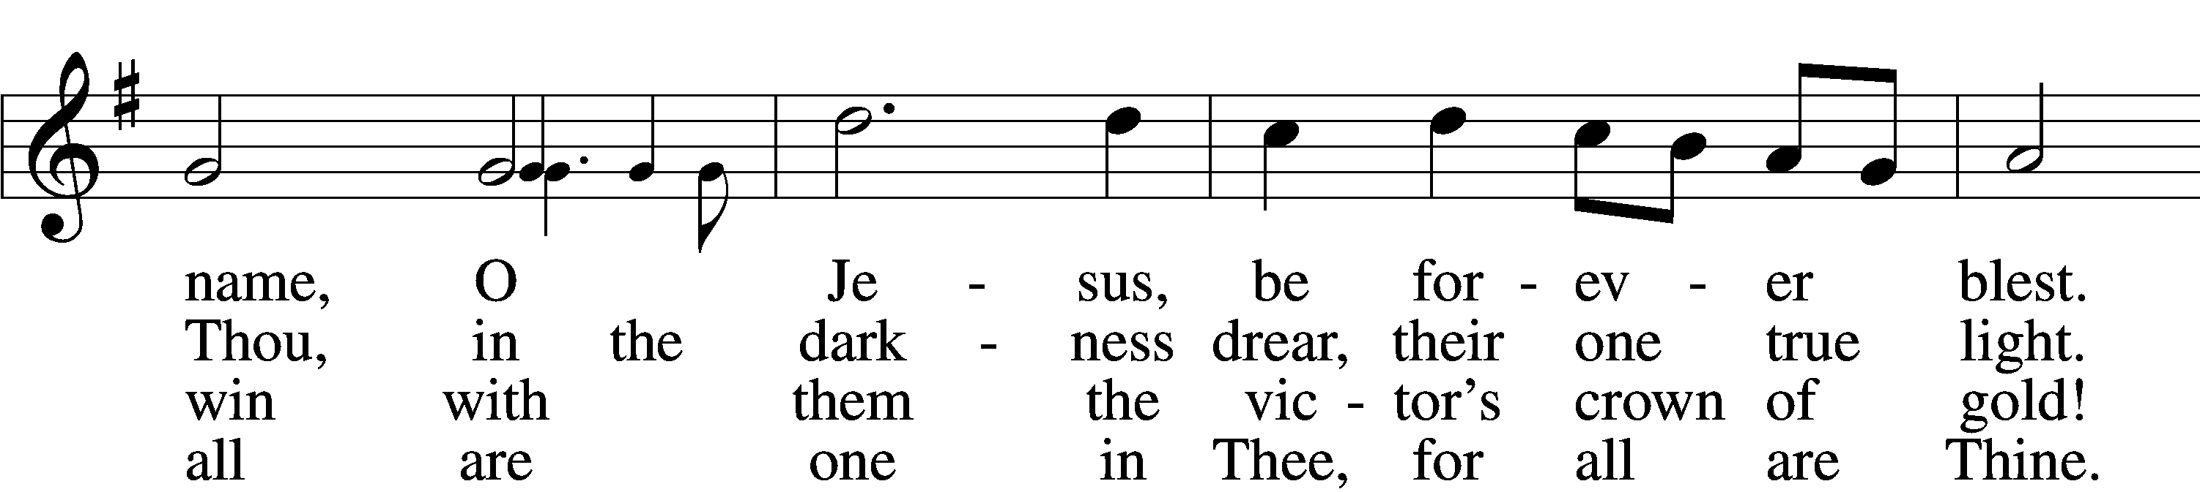
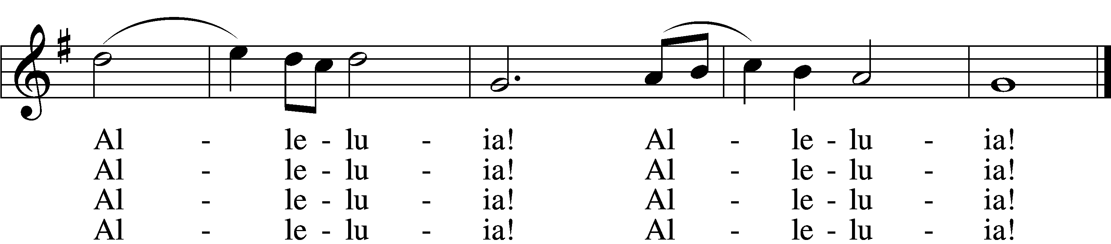

5 And when the fight is fierce, the warfare long,
Steals on the ear the distant triumph song,
And hearts are brave again, and arms are strong.
Alleluia! Alleluia!

6 The golden evening brightens in the west;
Soon, soon to faithful warriors cometh rest;
Sweet is the calm of paradise the blest.
Alleluia! Alleluia!

7 But, lo, there breaks a yet more glorious day:
The saints triumphant rise in bright array;
The King of Glory passes on His way.
Alleluia! Alleluia!

D 8 From earth’s wide bounds, from ocean’s farthest coast,
Through gates of pearl streams in the countless host,
Singing to Father, Son, and Holy Ghost:
Alleluia! Alleluia! Tune and text: Public domain
Sermon

Stand

Offertory LSB 192
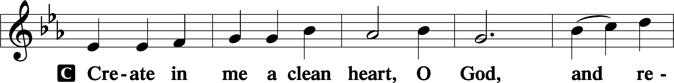
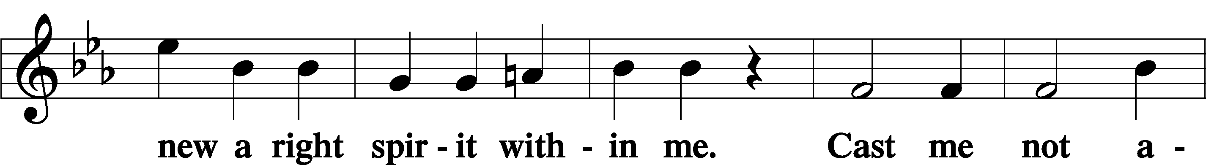
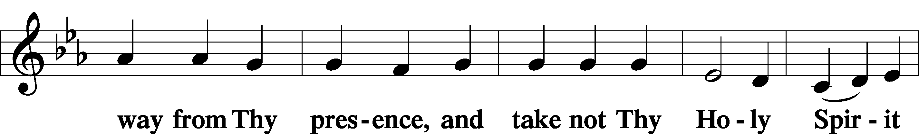
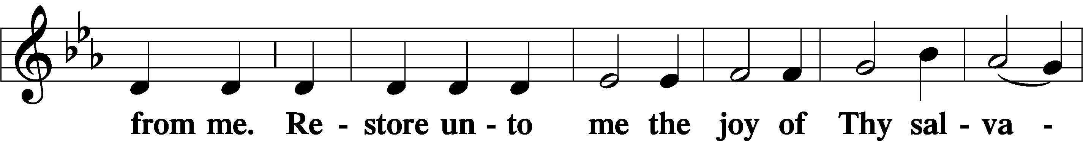
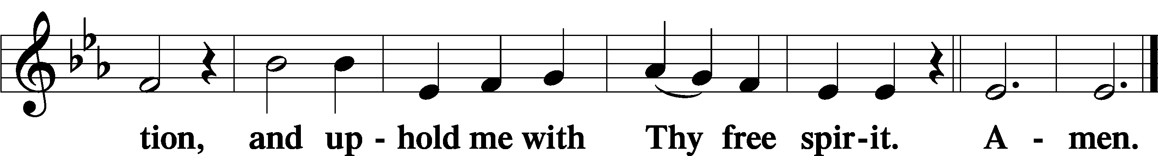

+ Remembrance of the Faithful Departed +

All Saints’ Day 2021

P: The Apostle John wrote: “I heard a voice from heaven saying, ‘Write this: Blessed are the dead who die in the Lord henceforth.’”
C: “Blessed indeed,” says the Spirit, “that they may rest from their labors.”
P: We remember with thanksgiving those who have gone before us in the faith, for they were created by God to offer Him praise and thanksgiving forever.
C: He gave them new life through His Son in Holy Baptism.
P: He fed them in the company of His saints at Holy Communion.
C: And in His mercy He has taken them to His side that they may joyfully serve Him forever.
P: In joyful expectation of the resurrection to life, we remember before You, O Lord, all our departed kin and friends who have preceded us in the faith,
+ Geraldine Roeder + November 10, 2020 | + Sherman Luhn + May 3, 2021
+ Lavern Stuehm + January 12, 2021 | +Beverly Nuttelman+ July 7, 2021

…and all who are in our hearts and minds this day.

C: We give thanks for the faith You gave them and we cling to Your promise of salvation.

P: O Lord, remember Your church throughout the world; help us grow in love for You and each other. As You have received our brothers and sisters who rest in You to the day of the resurrection, bring us at the last into the glory of your presence, that reunited with all Your saints we may praise you forever, through Your Son, Jesus Christ our Lord.
C: Amen.

The Prayer of the Church
All Saints’ Day

P: O Holy God, You have made us Your holy people, uniting us with the communion of saints in heaven and on earth. For Your holy church; for the congregations and pastors that faithfully teach your Word and administer your sacraments according to your command.
C: With the glorious company of apostles we praise You.
P: For all good and faithful gifts from your creation;
C: With the noble fellowship of prophets we praise You.
P: For those slandered and persecuted for confessing Your holy name; for those endangered and dying for speaking Your Word.
C: With the white-robed army of martyrs we praise You.
P: For the good works you do through us in Your name;
for the saints serving day and night before Your throne.
C: With the Church throughout the world we praise You.
P: As Your saints, we intercede for the whole world: all nations, all people, and all godly vocations.
C: Come, O Lord, and help Your people.
P: For our nation: give wisdom and godliness to those serving; for those in the military, especially ___.
C: Come, O Lord, and help Your people.
P: For our families, that you would enable us to reflect your abiding love by living holy lives for each other.
For all pregnant, especially ____, protect both mother and child.
C: Come, O Lord, and help Your people.
P: For all the sick, grant healing, especially to ____ and all whom we name in our hearts this day.
C: Come, O Lord, and help Your people.
P: With all Your saints, of heaven and earth, of today and ages past, we pray:
C: “Blessing and glory and wisdom and thanksgiving and honor and power and might be to our God forever and ever! Amen." [Rev. 7:12]

After the prayer please be seated while the table is prepared for the Lord’s Supper and the offering is brought forward. Please make use of the prayers in the front of the hymnal or meditate on a communion hymn.

Stand
Service of the Sacrament
Preface LSB 194

P The Lord be with you.

P Lift up your hearts.
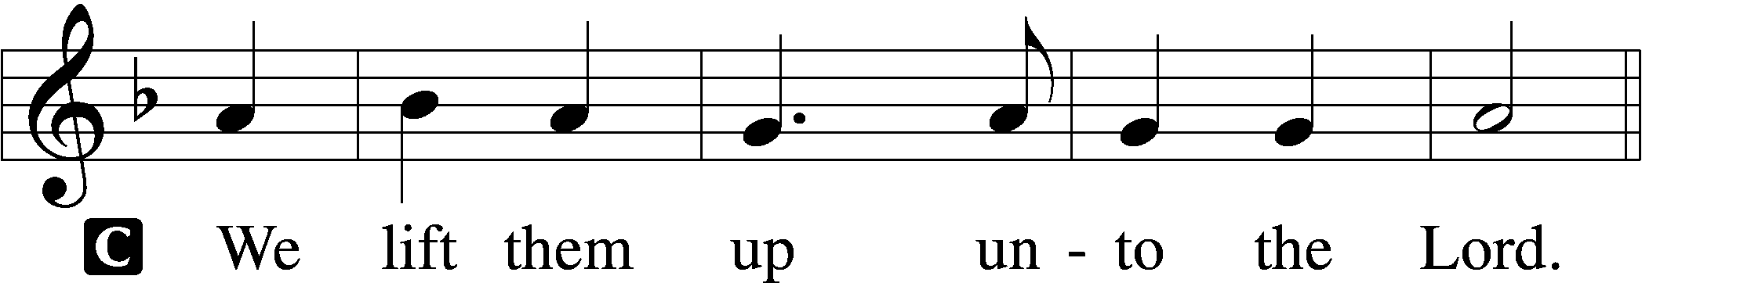

P Let us give thanks unto the Lord, our God.
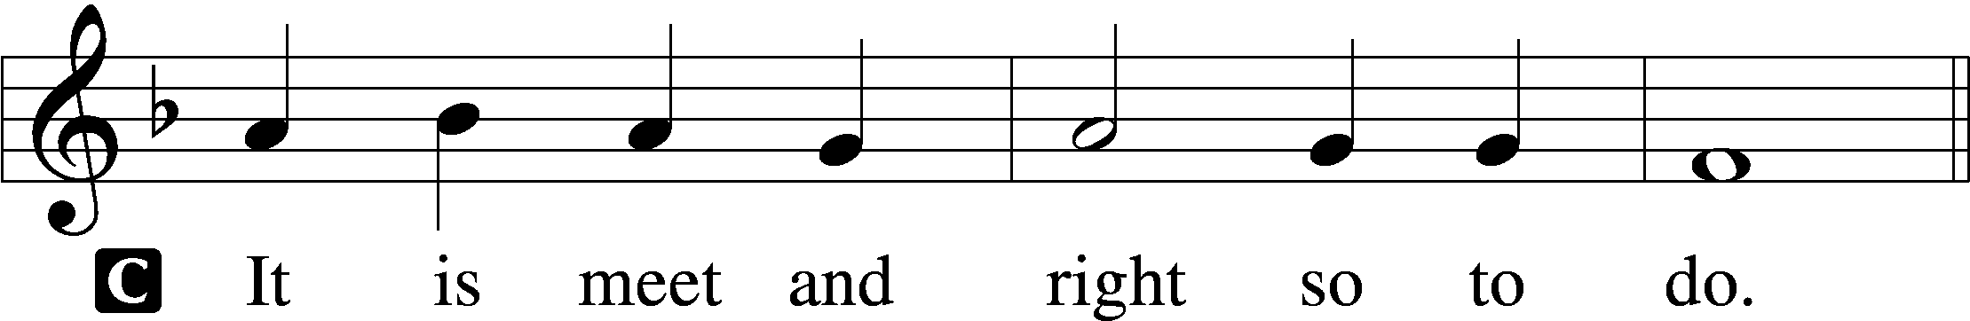

P It is truly good, right, and salutary that we should at all times and in all places give thanks to You, holy Lord, almighty Father, everlasting God. In the communion of all Your saints gathered into the one body of Your Son, You have surrounded us with so great a cloud of witnesses that we, encouraged by their faith and strengthened by their fellowship, may run with perseverance the race that is set before us and, together with them, receive the crown of glory that does not fade away. Therefore with angels and archangels and with all the company of heaven we laud and magnify Your glorious name, evermore praising You and saying:

Sanctus LSB 195
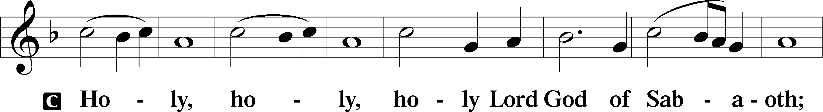
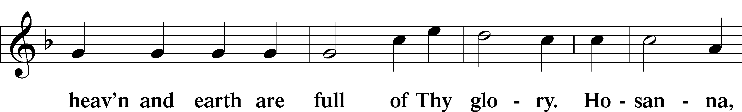
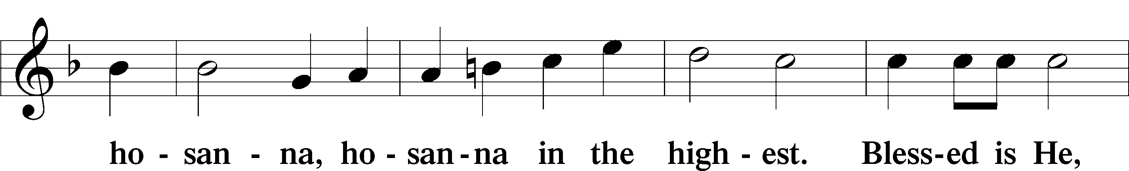
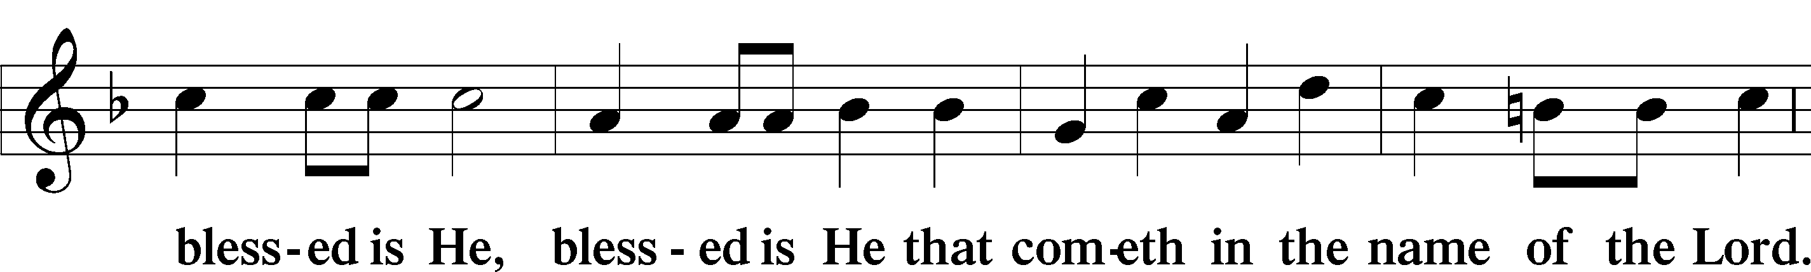
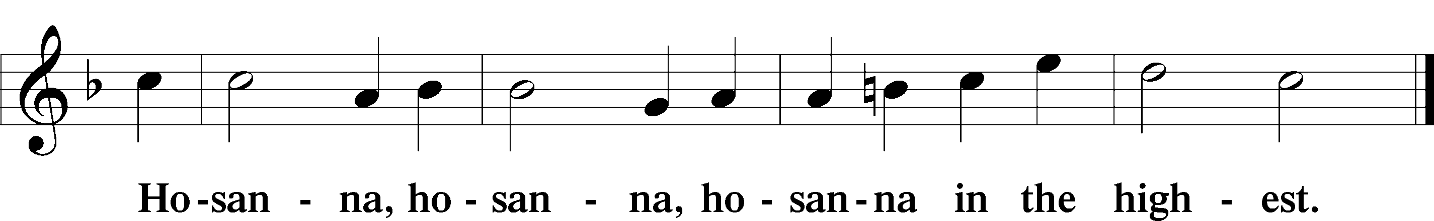

Lord’s Prayer 196
P Our Father who art in heaven,
hallowed be Thy name,
Thy kingdom come,
Thy will be done on earth as it is in heaven;
give us this day our daily bread;
and forgive us our trespasses as we forgive those who trespass against us;
and lead us not into temptation,
but deliver us from evil.
For Thine is the kingdom and the power and the glory forever and ever. Amen.

The Words of Our Lord LSB 197
P Our Lord Jesus Christ, on the night when He was betrayed, took bread, and when He had given thanks, He broke it and gave it to the disciples and said: “Take, eat; this is My T body, which is given for you. This do in remembrance of Me.”

In the same way also He took the cup after supper, and when He had given thanks, He gave it to them, saying: “Drink of it, all of you; this cup is the new testament in My T blood, which is shed for you for the forgiveness of sins. This do, as often as you drink it, in remembrance of Me.”

Agnus Dei LSB 198
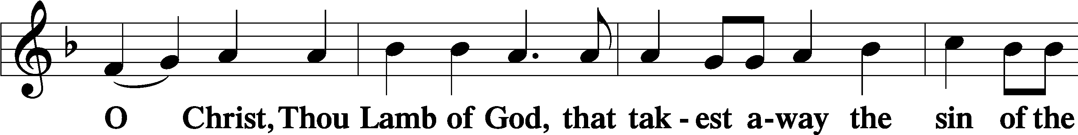
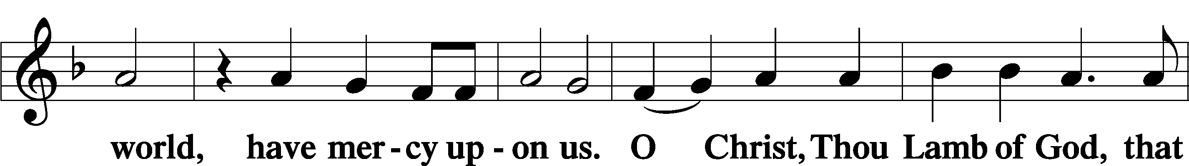
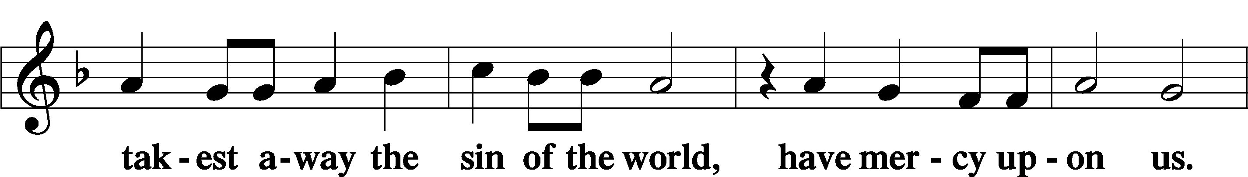
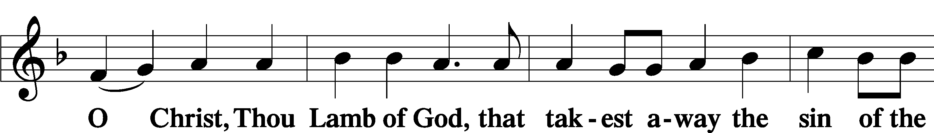

Sit

670 Ye Watchers and Ye Holy Ones
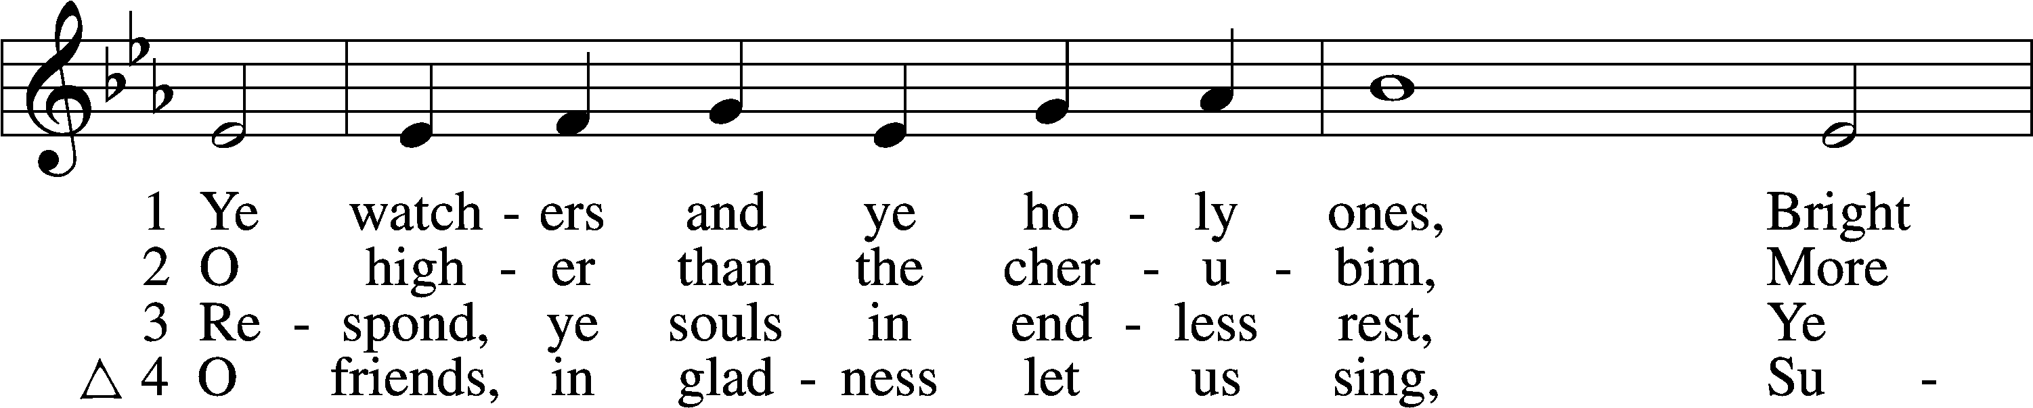
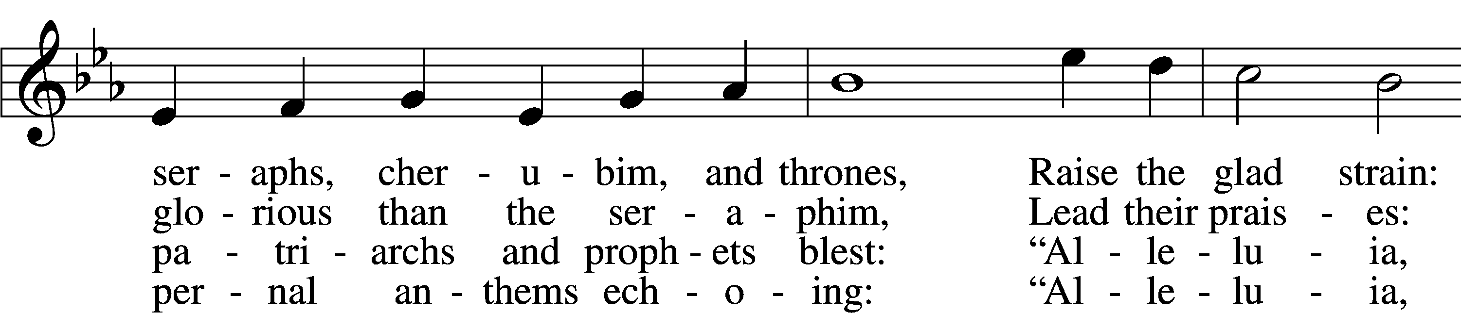
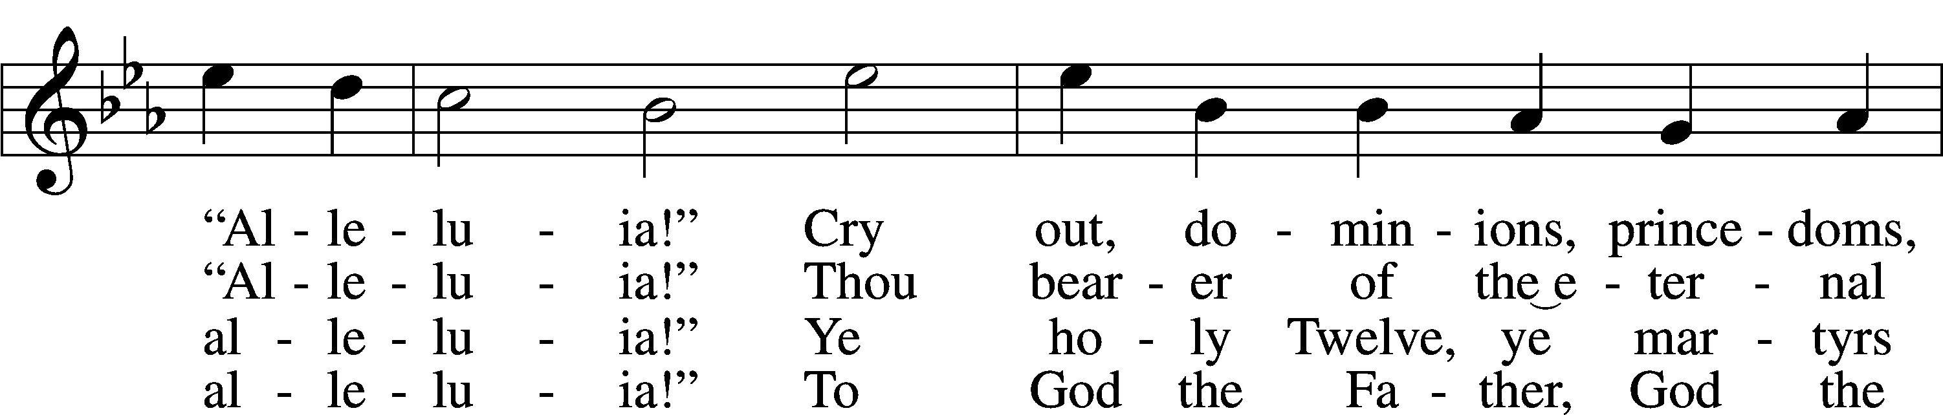
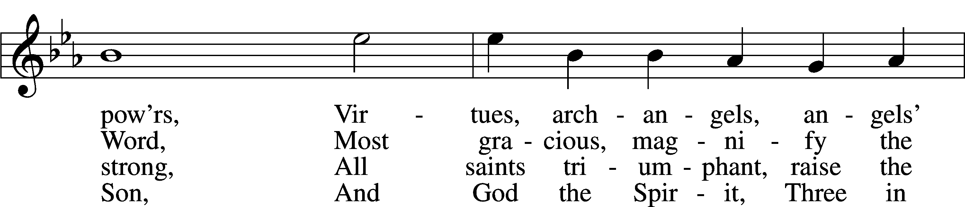
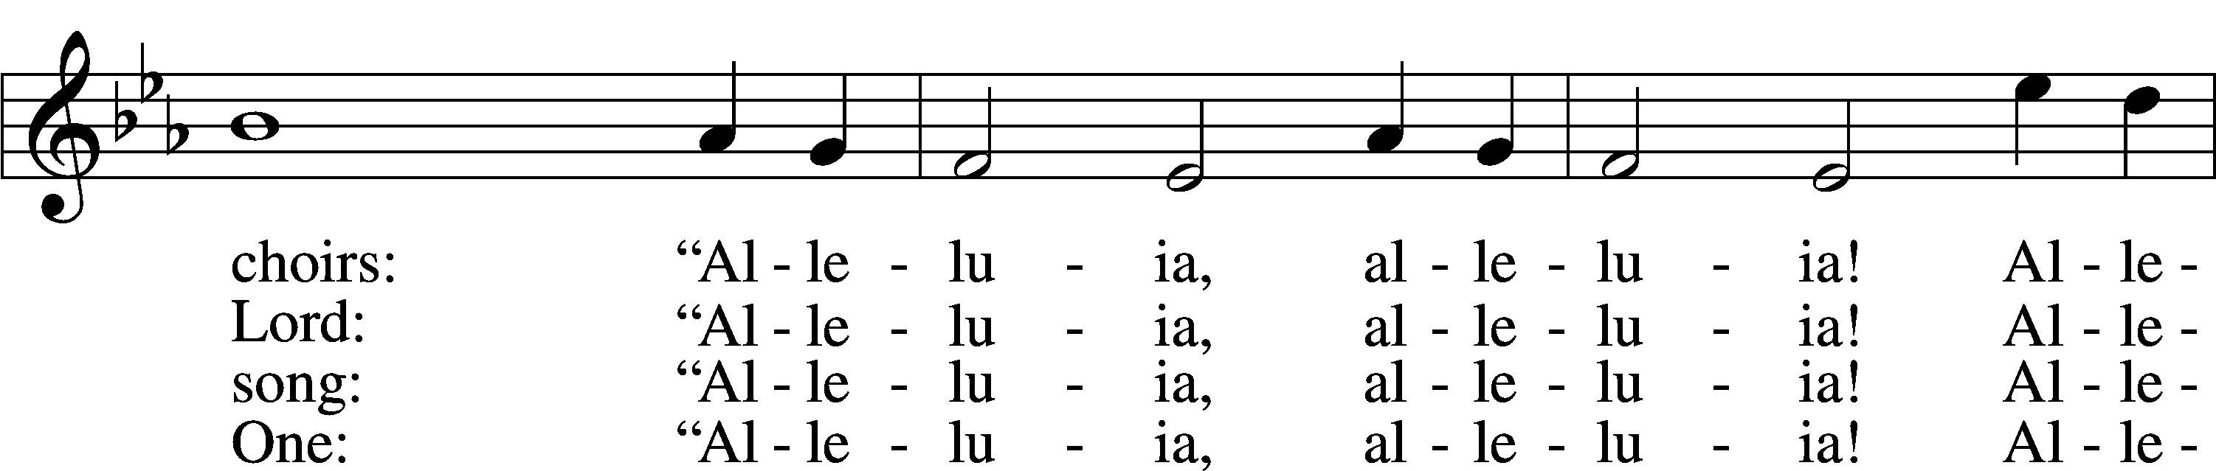
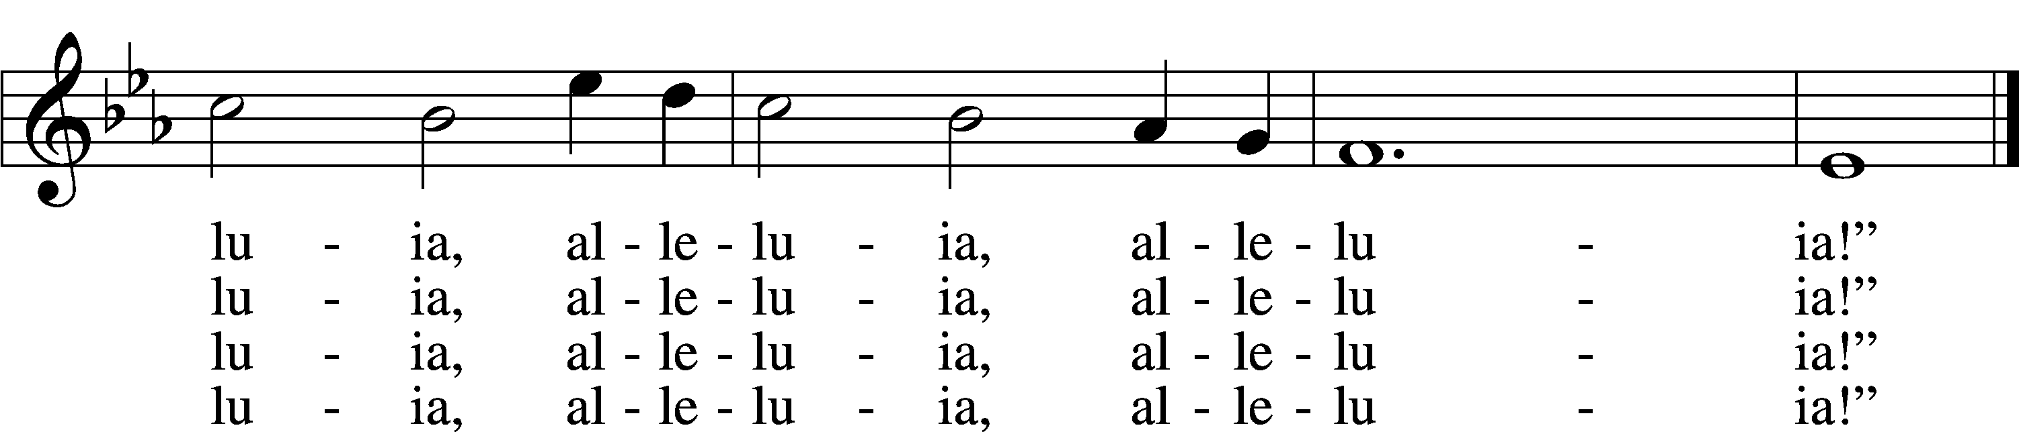
Tune and text: Public domain

676 Behold a Host, Arrayed in White
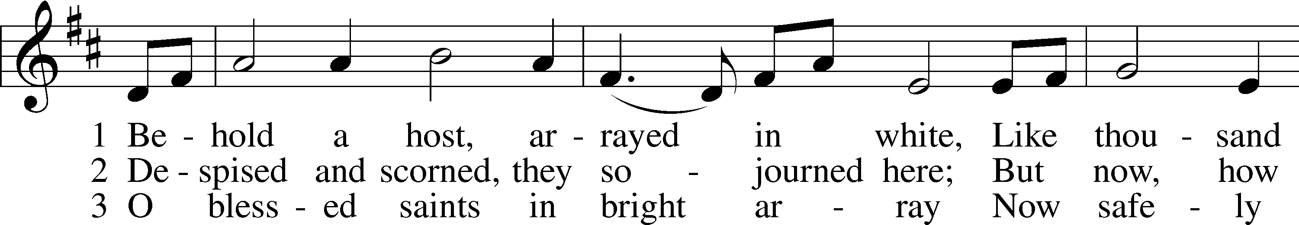
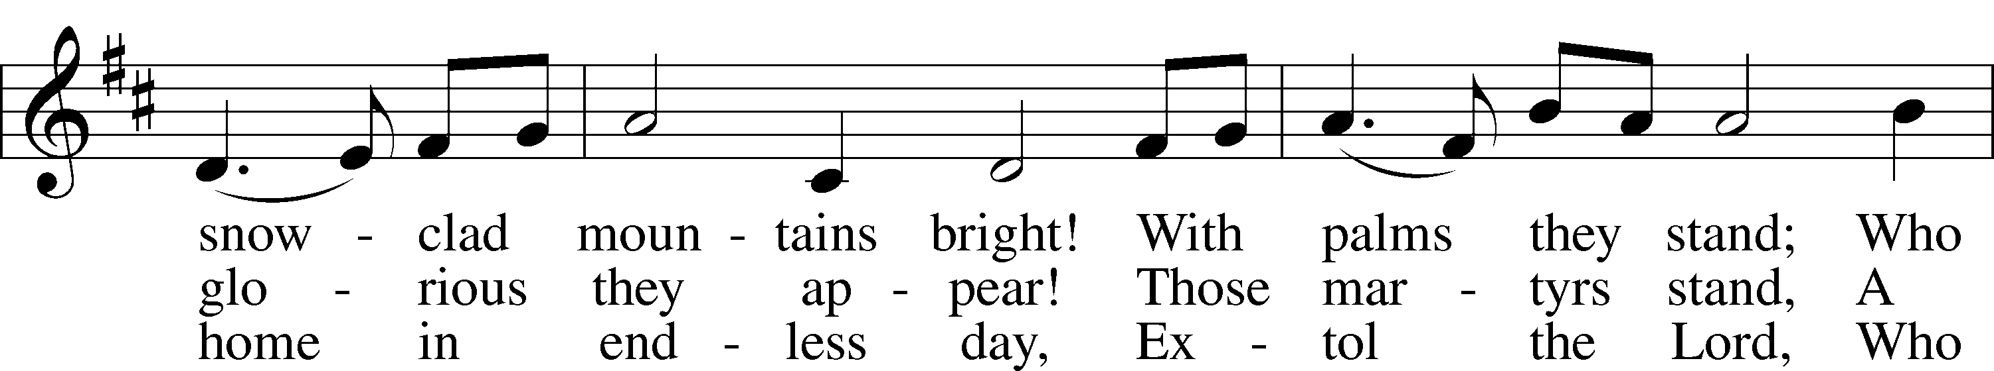
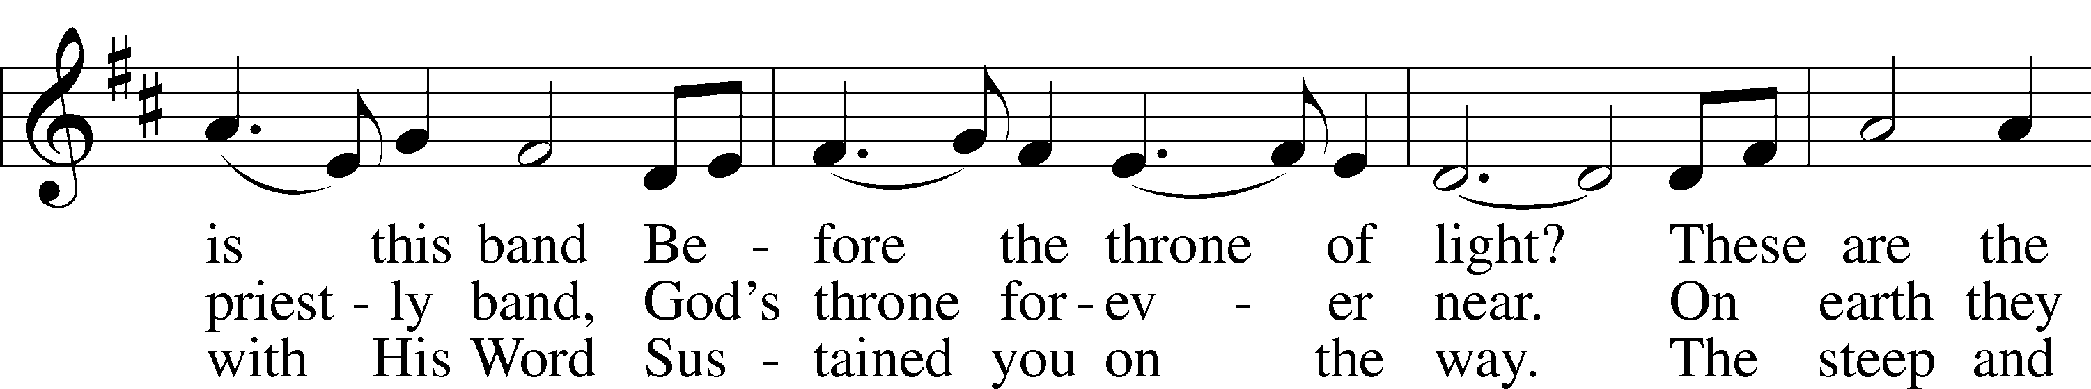
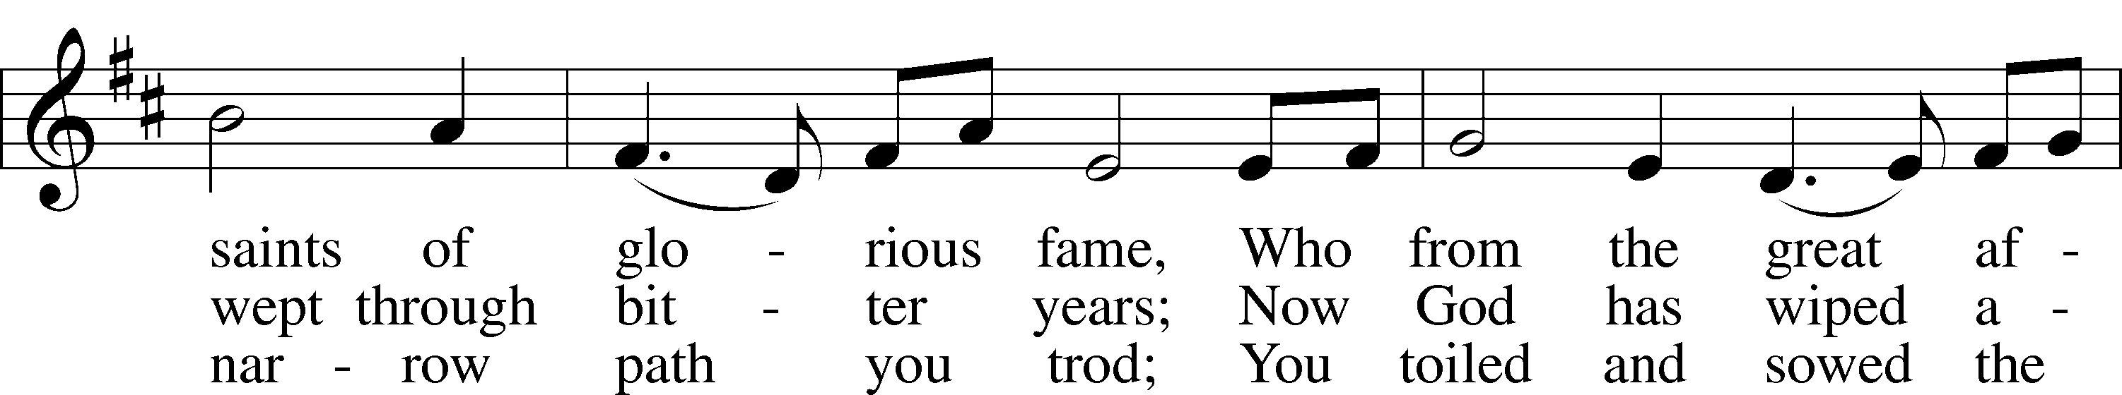
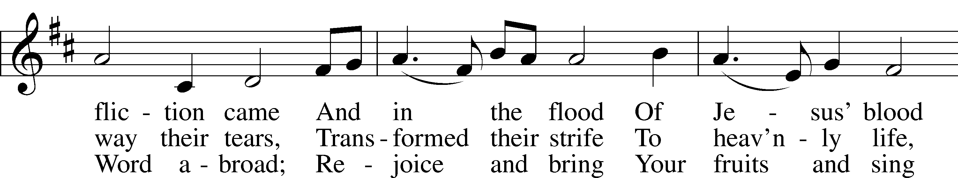
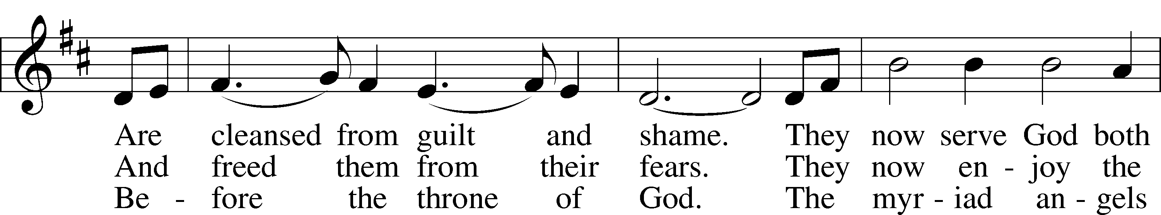
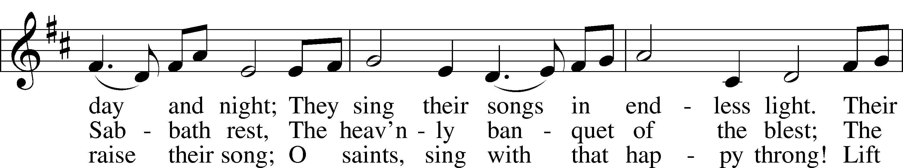
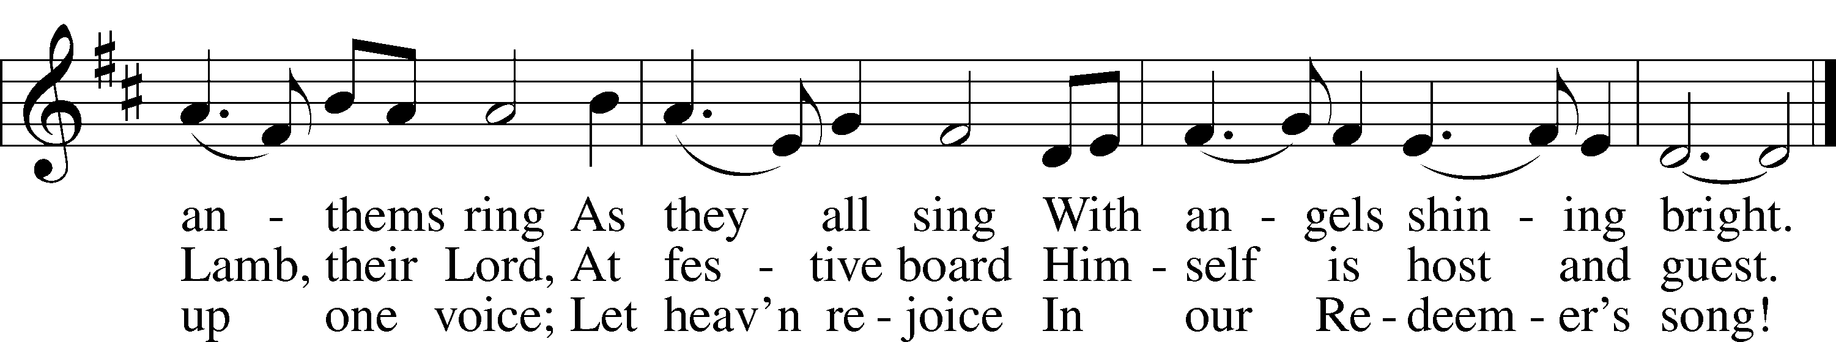

Tune and text: Public domain
813 Rejoice, O Pilgrim Throng
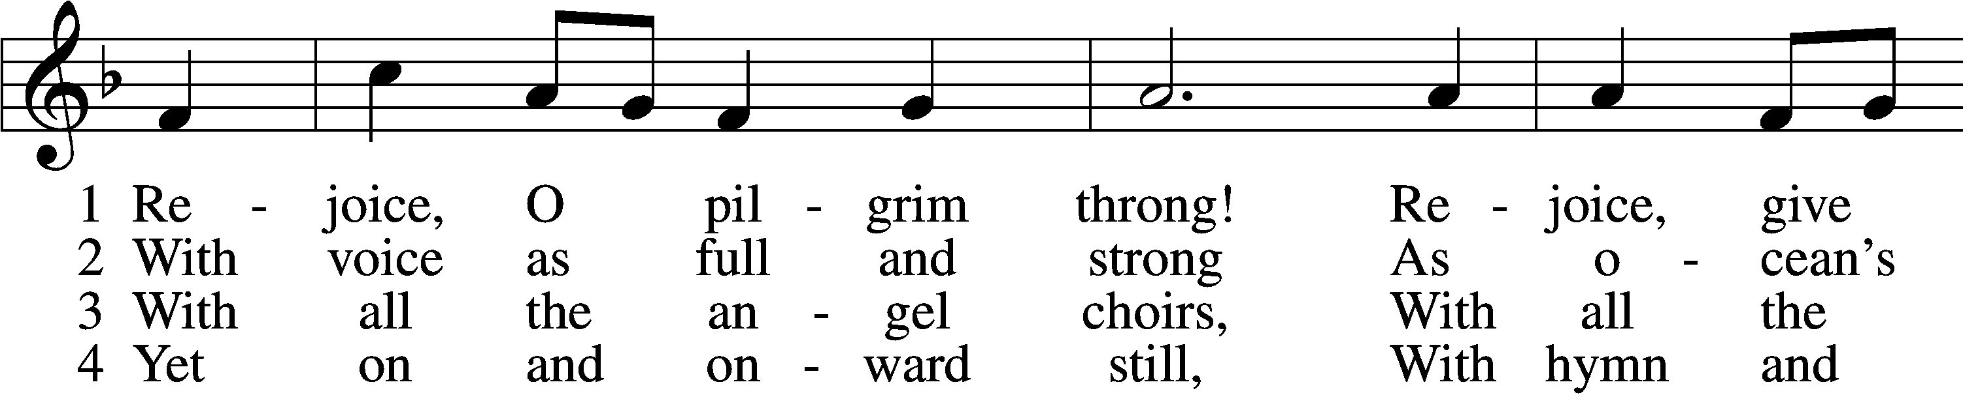
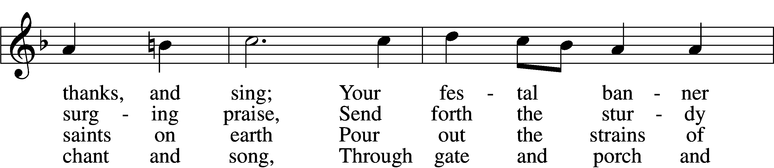
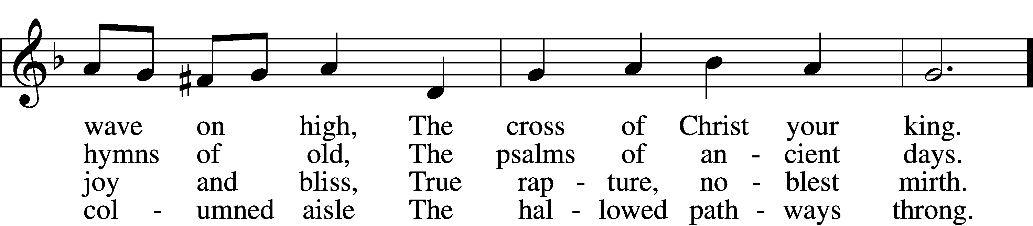
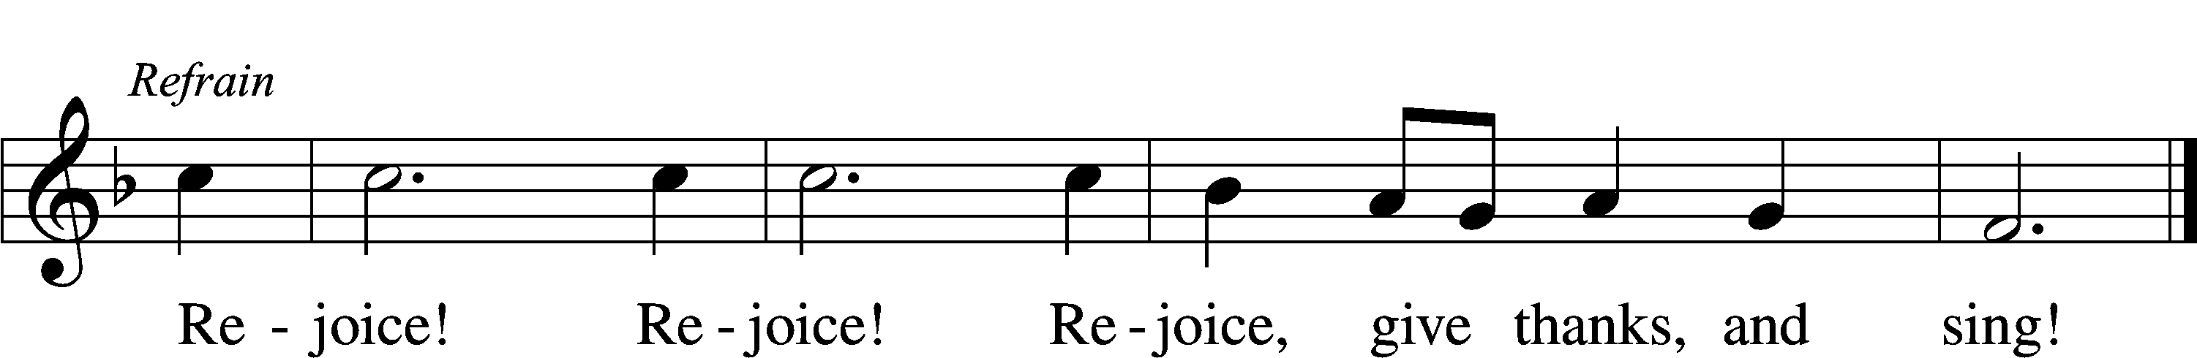

5 Still lift your standard high,
Still march in firm array,
As pilgrims through the darkness wend
Till dawns the golden day. Refrain

6 At last the march shall end;
The wearied ones shall rest;
The pilgrims find their home at last,
Jerusalem the blest. Refrain

D 7 Praise Him who reigns on high,
The Lord whom we adore:
The Father, Son, and Holy Ghost,
One God forevermore. Refrain

Text and tune: Public domain

Please stand

The Dismissal LSB 199
P The body and blood of our Lord Jesus Christ strengthen and preserve you in body and soul to life everlasting. Depart T in peace.
C Amen.

Nunc Dimittis LSB 199
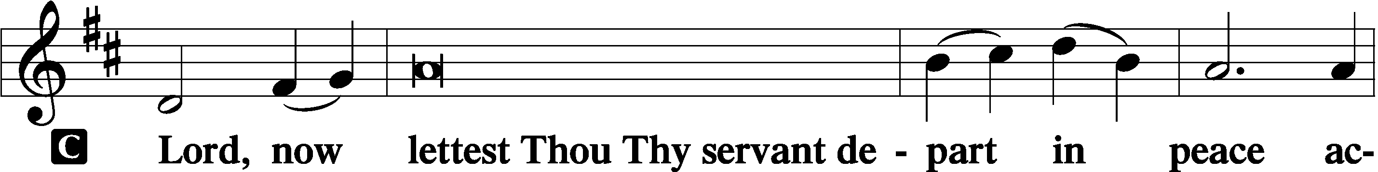
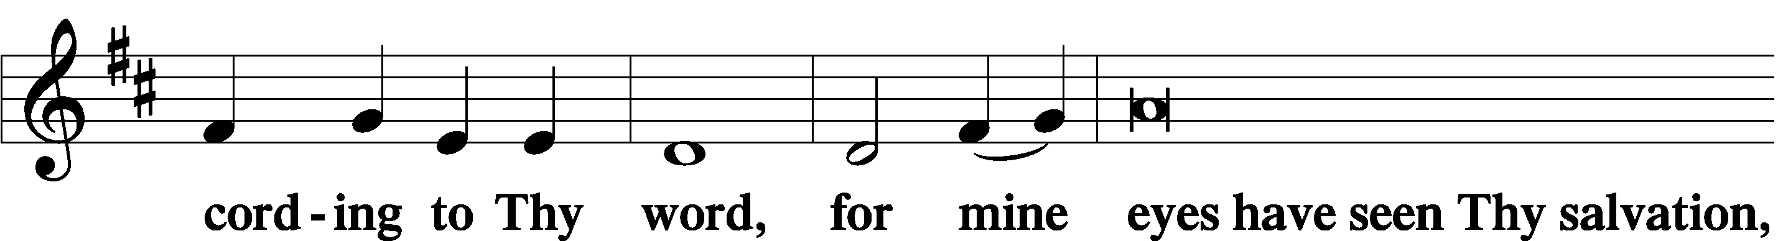
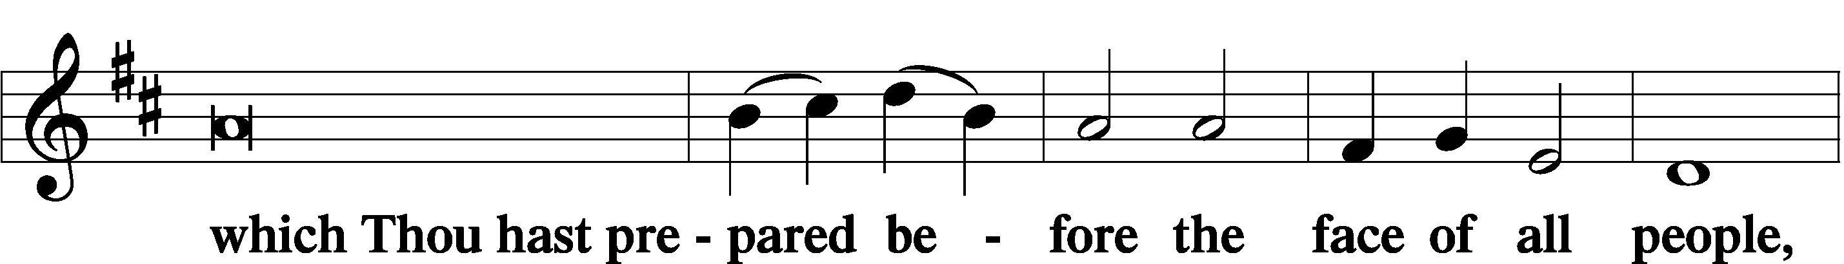
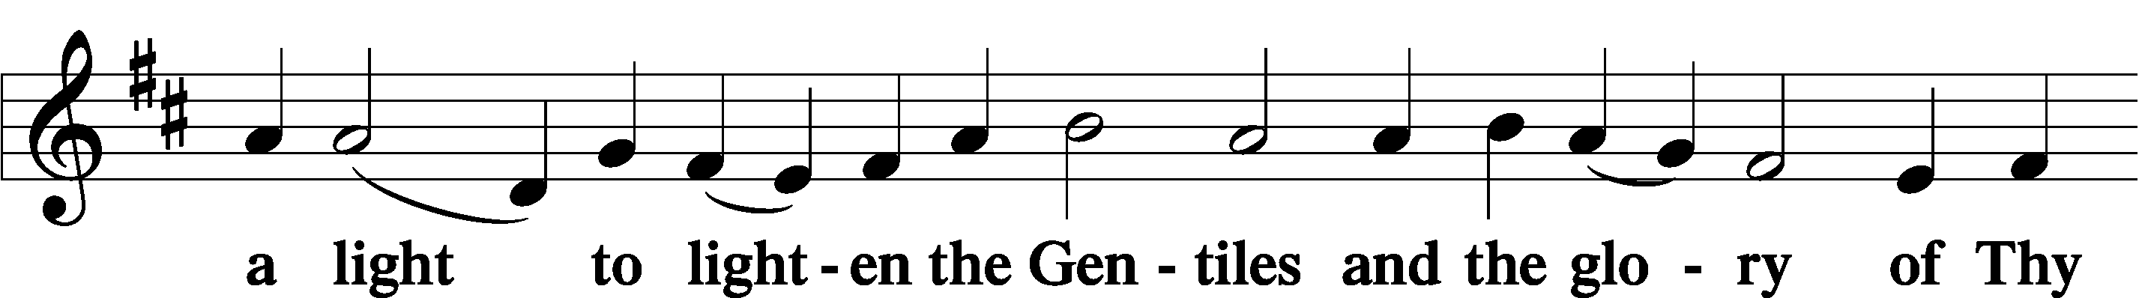
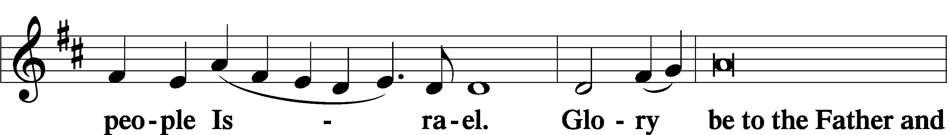
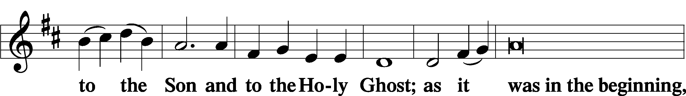
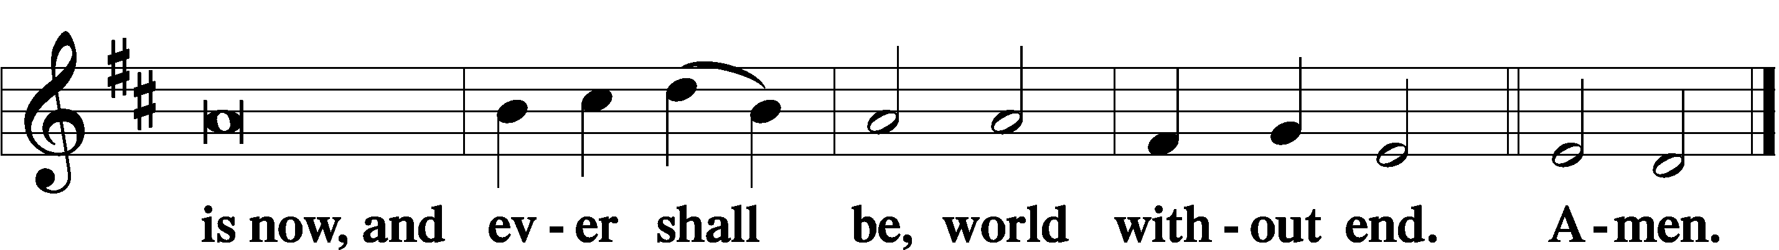

Thanksgiving LSB 200
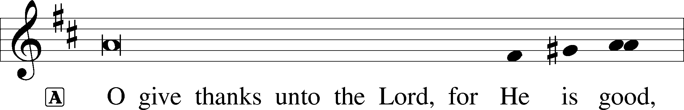
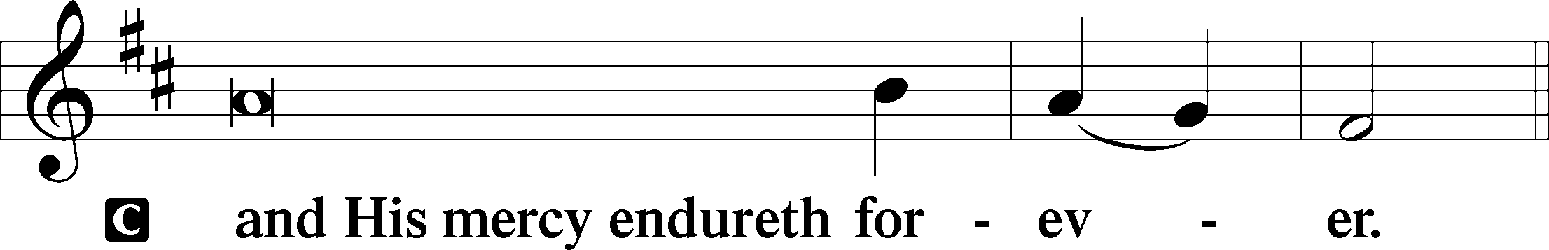

P Let us pray…
Gracious God, our heavenly Father, You have given us a foretaste of the feast to come in the Holy Supper of Your Son’s body and blood. Keep us firm in the true faith throughout our days of pilgrimage that, on the day of His coming, we may, together with all Your saints, celebrate the marriage feast of the Lamb in His kingdom which has no end; through Jesus Christ, Your Son, our Lord, who lives and reigns with You and the Holy Spirit, one God, now and forever.
C Amen.

Salutation LSB 201
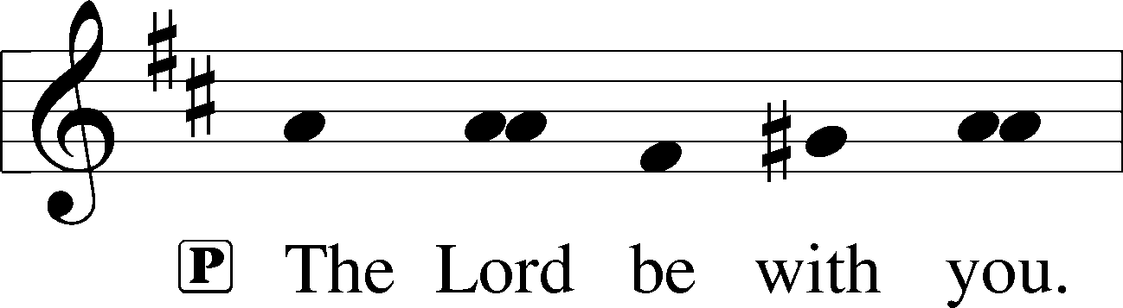

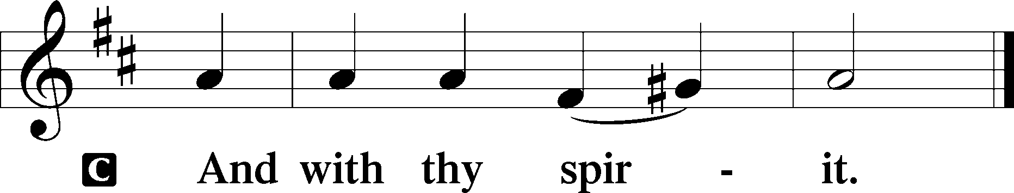

Benedicamus LSB 202
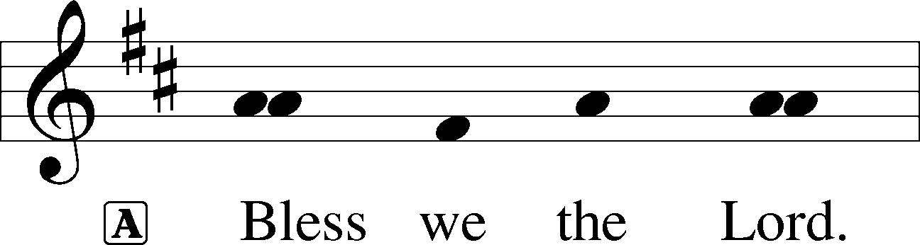

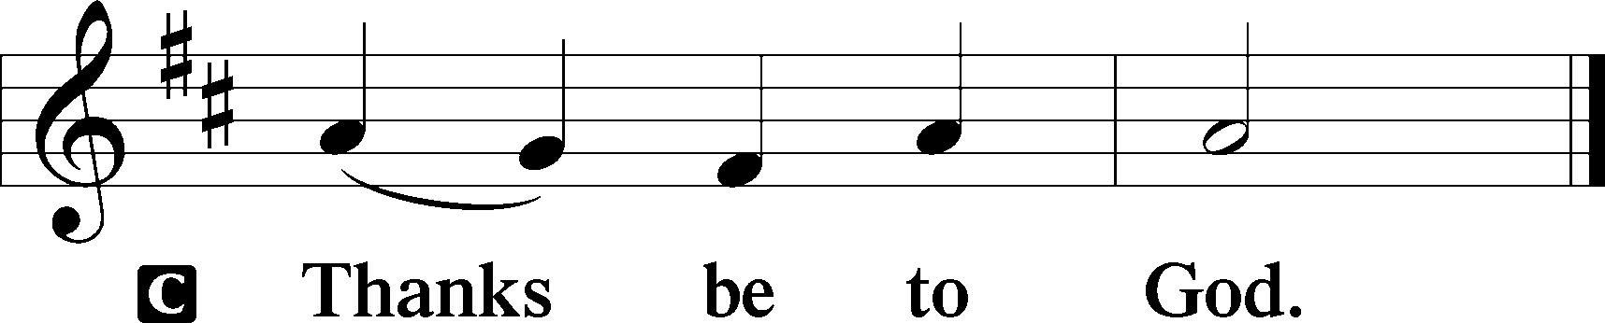

Benediction LSB 202
P The Lord bless you and keep you.
The Lord make His face shine upon you and be gracious unto you.
The Lord lift up His countenance upon you and T give you peace.

680 Thine the Amen, Thine the Praise
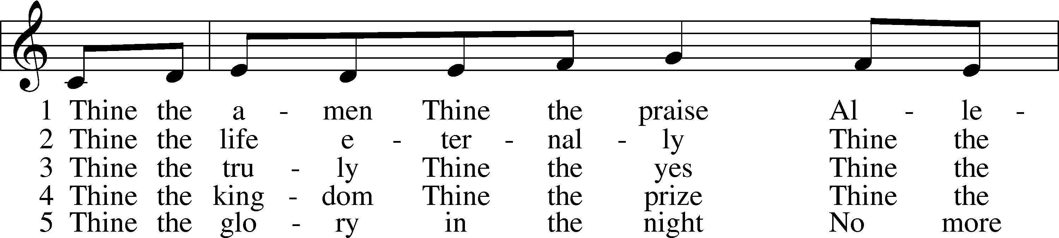
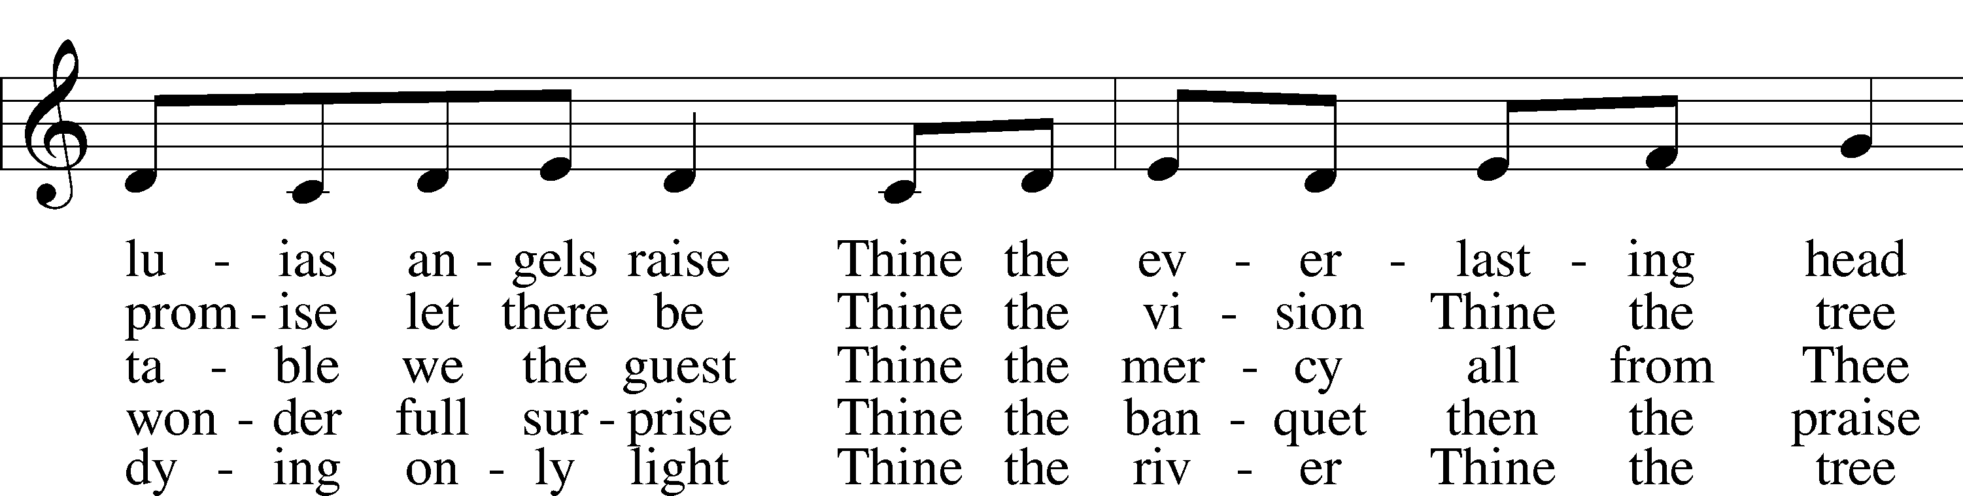
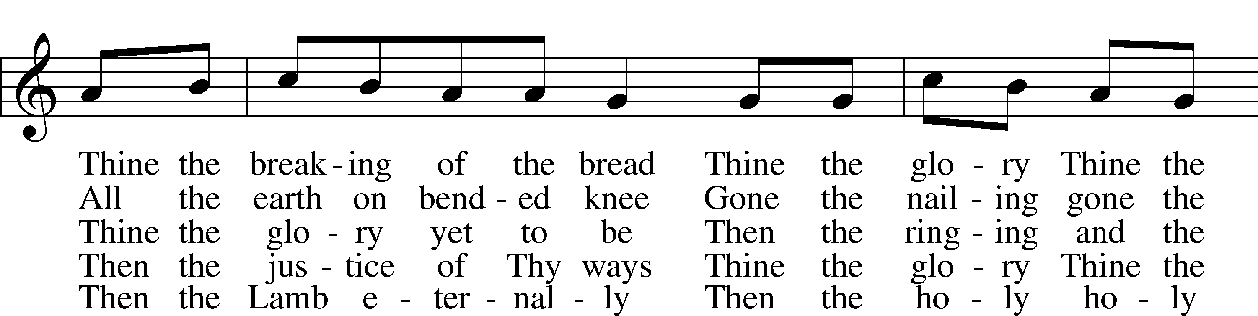
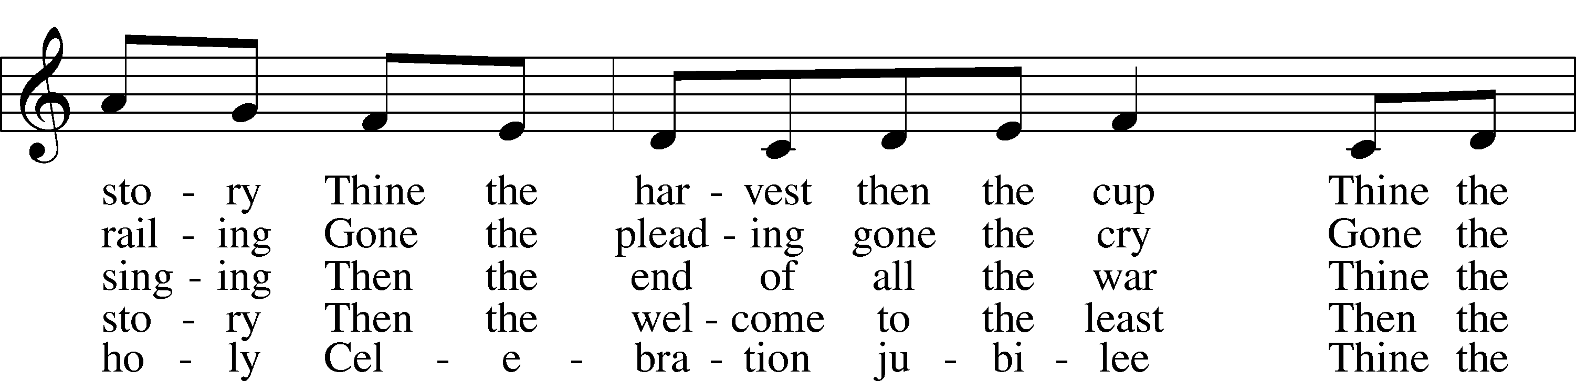
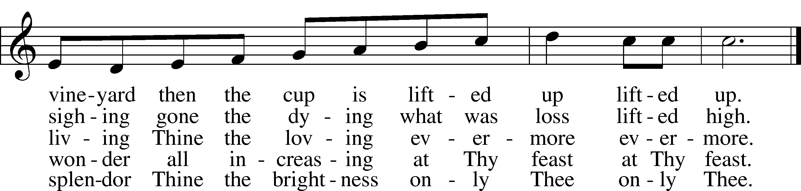
Text and tune: © 1983 Augsburg Publishing House. Used by permission: LSB Hymn License no. 110003744

Acknowledgments
Unless otherwise indicated, Scripture quotations are from the ESV® Bible (The Holy Bible, English Standard Version®), copyright © 2001 by Crossway, a publishing ministry of Good News Publishers. Used by permission. All rights reserved.
Created by Lutheran Service Builder © 2021 Concordia Publishing House.

Prayers for Our Members
Sharon Hockemeier, Tenaya Nuttelman | Expectant Mothers
Norman Abels (Brookestone Meadows – Elkhorn) | Healing
Judy Ahrens | Healing
Vaughn Albrecht (Mount Carmel) | Healing
Tom & DyAnn Altwine | Healing
Lyle Colsden (Mother Hull) | Healing
Mary Fiddelke | Back Surgery
Pat Flodine (Cambridge Court) | Healing
Vi Fox (Prairie View) | Hospitalized
Verleen Gentry | Healing
Wanda Glanzer | Healing
Ruby Hatfield | Healing
Evelyn Heiden (Mother Hull) | Healing
Lennis Hodgson | Healing
Don Richmond | Healing
Ivan Bombeck | Cancer
Fran Junge | Thanksgiving
Bertha Marienau | Cancer
Kim Vos | Cancer

ZION LUTHERAN CHURCH AND SCHOOL

Pr. James DeLoach, Pastor + (308) 627-5260
james.deloach@zionkearney.org
Pr. Doug Gaunt, Pastor + (308) 455-0552
doug.gaunt@zionkearney.org
Tony Splittgerber, Principal + (308) 293-0168
anthony.splittgerber@zionkearney.org

Church Office
Secretary: Holly Reid
Email: school@zionkearney.org
Phone: (308)-234-3410 Fax: (308) 236-8100
Office Hours: Monday-Friday 8:00am-4:00pm
Radio Broadcast: Sunday @ 10:30 a.m. on 1460 AM and 92.1 FM
Website: www.zionkearney.com
Prayers for Our Members’ Family & Friends
Naomi Wollberg (Matthias’ wife) | Expecting
Elaine Arehardt (Zion’s Music Teacher) | Expecting
Larry Bombeck (Ivan’s brother) | Healing
Katie Cunningham (Quentin & Janel Lange’s friend) | Healing
Reg Duke (Westman’s brother-in-law) | Healing
James Gentry (Verleen’s son) | Healing
Roger Hoffman (Marc’s father) | Healing
David Kreutzer (Richard’s brother) | Healing
Pr. Rob Kuefner (Kearney Circuit Visitor) | Healing
Dillon Malchow (Joy Barefoot’s nephew) | Healing
Urijah Mitchell (Sue & Dennis Bartels’ Grandson) | Healing
Tim Powers (Kim Wilken’s brother) | Healing
Roy Reynolds (Verleen Gentry’s son-in-law) | Healing
Lynne Saathoff (Verleen Gentry’s sister-in-law) | Healing
Randy Solomon (Beth Rosenthal’s father) | Healing
Tim Trampe (Don & Gretchen’s son) | Healing
Jonah (Jase & Jarren Blattner’s friend) | Cancer
D.D. Dugger (Sue Kaiser’s brother) | Cancer
Stuart Gronewoller (Lonna’s brother-in-law) | Cancer
Linda Heapy (Janel Lange’s mother) | Cancer
Ron Halvorsen (Jeff’s dad) | Cancer
Bill Jedlicka (Pam Uhlir’s cousin) | Cancer
Randy Jochum (Ken Hockemeier’s brother-in-law) | Cancer
Sharon Mulhair (Pam Uhlir’s cousin) | Cancer
Kolby Shiers (Jessica’s cousin) | Cancer
Pr. Richard Snow (NE District President) | Cancer
Tyrone Uhlir (Pam’s nephew) | Cancer
Family and Friends of John Weber (Zehendner’s friend) | Grief
Tim Smallcomb (Wilkens’ friend) | Deployment
Today’s Radio Broadcast is sponsored Wes & Mary Fiddelke - in memory of mothers Irene Fiddelke & Melvina Fletcher

Worship Assistants

Sunday, November 7th~ 9:00am

Elder: Bruce Brooks
Usher: Fred Flessner
Acolyte: Landen Eckhoff
Engineer: Jamie Nikodym
Announcer: Brooke Fisher
Altar Guild: Brooke Fisher & Tracy Schake

Sunday, November 14th~ 9:00am

Elder: Eric Rosenthal
Usher: Steve Junge
Acolyte: Jase Blattner
Engineer: Zach DeLoach
Announcer: Jesse Florang
Altar Guild: Brooke Fisher & Tracy Schake

Our Response to the Gospel

Date: 10/31/2021
Offering: $5,763
Weekly Need: $7,457.69

This Week at Zion

Sun  11/7 | 9:00a  10:20a  10:30a  5:00p | Divine Service  Bible Study/Sunday School  Radio Broadcast 1460am & 92.1fm  Divine Service
Mon  11/8 | 7:00p | Mary Martha
Tues  11/9 | 1:30p  7:00p  7:00p  7:00p | Sleeping Mats  Bd of Ed  Bd of Elders  Bd of Trustees
Wed  11/10 | 8:30a  5:45p  7:00p  Birthdays | Chapel  Midweek  Adult Choir  LaRae Crow
Thurs  11/11 | Birthdays | Bailey Helmbrecht  Doreen Lemburg  Phyllis Willuweit
Fri  11/12 | 2:00p  Birthdays | Veteran’s Day Program  Pamela Uhlir
Sat
11/13
Sun  11/14 | 9:00a  10:15a  10:30a  5:00p  Birthdays | Divine Service  Bible Study/Sunday School  Radio Broadcast 1460am & 92.1fm  Divine Service  Cheryl Scarborough

Where our Triune God strengthens us through His mercy in faith toward Him and in fervent love toward one another.

ANNOUNCEMENTS

The Zion Youth Group would like to give back this season by helping in our community. If you have any small jobs that you would like help with in the month of November, please contact Miss Nikodym (402) 746-0561 or Miss Dauel (308) 627-2113. Examples of jobs include raking leaves, cleaning up a garden, putting out or taking down decorations, etc.

Adult Bible Study is studying the rich variety of words God uses to communicate the Gospel—that we are justified by grace through faith. Come grab a donut and cup of coffee as we fellowship and learn together.

Zion’s 4th Quarter (Oct – Dec) Mission Offerings will support Zion’s current students, who are studying for full-time church work. All our students are at Concordia (CUNE):
Peter Kreutzer - Lutheran Teacher’s Diploma (LTD)
Jessica Zehendner – LTD
Taylor Zehendner – LTD
Please use the mission envelopes located in the narthex for this offering. Or give via Church Trac by selecting “Missions.” Thank you for your support.

Offering Options:
1) Place your offering in the basket as you leave
2) Go to zionkearney.churchtrac.com/give
3) Go to zionkearney.com and click on the ChurchTrac icon
4) Mail your gift to Zion Lutheran Church, 2421 C Ave, Kearney, NE 68847. Or place it in the mail slot on the south side of the building.
Poinsettias – Zion will be taking poinsettia orders to adorn the Church Sanctuary during Christmas time. They will be $15.00 per plant. To order there is an envelope in the Fellowship Hall on Sunday’s and the Church Office during the week. Place your money in the envelope with your name, place the envelope in the offering plate or the mail slot on the south side of the building or drop it off during office hours. Please make checks out to Mary Martha.

Radio Broadcast – The sign-up sheets for the 2022 radio broadcast and altar flowers are up by the mailboxes! The remaining 2021 sheets are still up on the right side. The 21st and 28th of November are still available for radio sponsors! Please help Zion spread the Gospel!

SCHOOL NEWS

The Theme for our school year is “Together by Christ’s Love” based on 1 John 4:7-8.

- Pie Pick-up The pie pick-up date is November 17th.

- Give Where You Live - Zion will be participating in the Give Where You Live Campaign again! It will be December 2nd (giving day), but donations will be accepted beginning November 4th. To contribute online go to: https://www.givewhereyoulive.net//zionlutheranschool. If you would rather give in person feel free to stop by the office. Please share this with family and friends.

