Divine Service
Last Sunday of the
Church Year
November 21, 2021
Zion Lutheran Church
Kearney, Nebraska
Welcome to Zion!
All worshippers please fill out an attendance card in the pew rack and let us know how we might be of service to you.

Holy Communion at Zion

The Lord’s Supper is celebrated at this congregation as Jesus instituted it. As he says, so our Lord gives into our mouths not only bread and wine but his very body and blood to eat and to drink for the forgiveness of sins and to strengthen our union with him and with one another. Our Lord invites to his table those who repent of all sin, trust his words “given and shed for you for the forgiveness of sins,” and set aside any refusal to forgive and love as he forgives and loves us, that they may show forth his death until he comes. All communicants need to register in the narthex prior to the service.

The Lord’s Supper can harm those who receive it unworthily. Holy Communion is also a confession of the faith which is confessed at this altar. Therefore, any who are not yet instructed, in doubt, or who hold a confession differing from that of this congregation and The Lutheran Church—Missouri Synod, are asked not to commune until they are able to speak with our pastor first. He is most happy to visit with you about the Christian faith and how to receive the Lord’s Supper for your good and for the good of others. Those not communing are invited to come to the altar, cross your arms in front of you, and bow your head to receive a pastoral blessing.

In Repentance We Are Alert to the Coming of Christ!

The signs of the end are all around us, constant reminders that “heaven and earth will pass away.” But all of these signs are centered in the cross of Christ, whereby He has conquered sin and death, that we might be raised with Him in righteousness through His Word of the Gospel, which “will not pass away” (Mark 13:31). He is “the firstborn of the dead,” who in His great love “has freed us from our sins by his blood” (Rev. 1:5). His salvation is certain because “his dominion is an everlasting dominion” and His kingdom “shall not be destroyed” (Dan. 7:14). For this purpose He came into the world, to reign in love through His voice of the Gospel, which is the truth (John 18:37). So is the righteousness of Christ “a light to the peoples,” which “will never be dismayed” because it is the justice of His cross and resurrection (Is. 51:4–6). As He “is able to keep you from stumbling and to present you blameless before the presence of his glory,” so wait upon “the mercy of our Lord Jesus Christ that leads to eternal life” (Jude 20–24).

Pre-Service Violin Music:
Joy Barefoot and Luke Barefoot

Confession and Absolution
336 Lo! He Comes with Clouds Descending
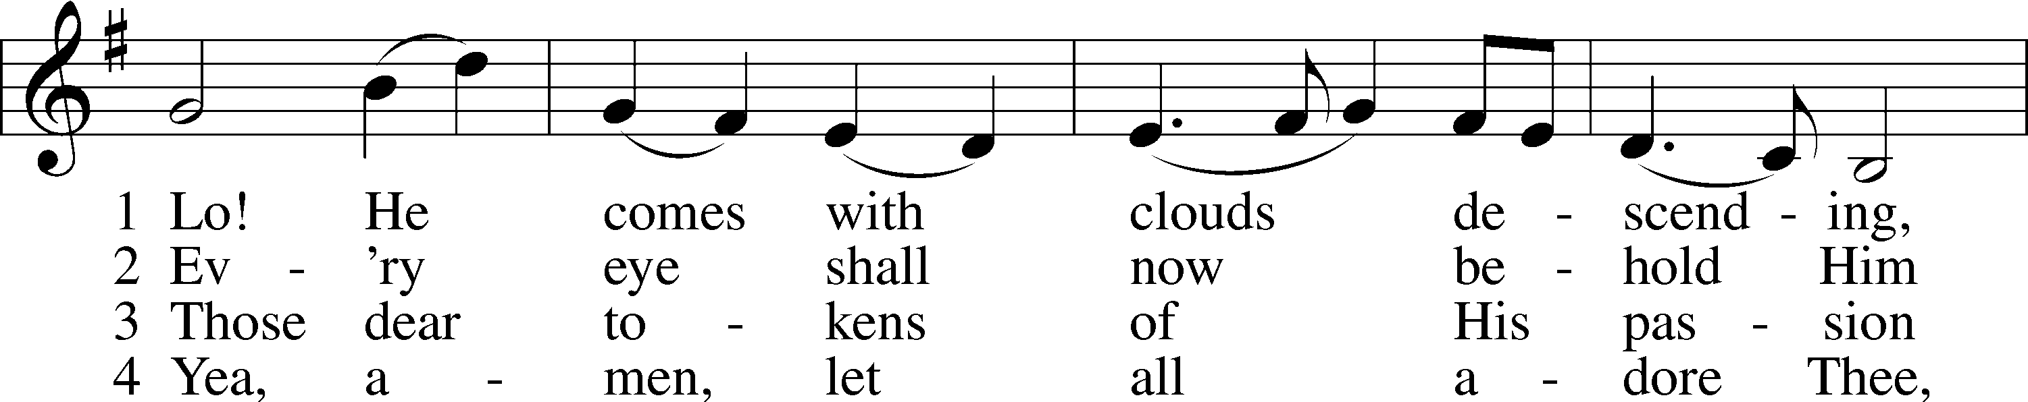
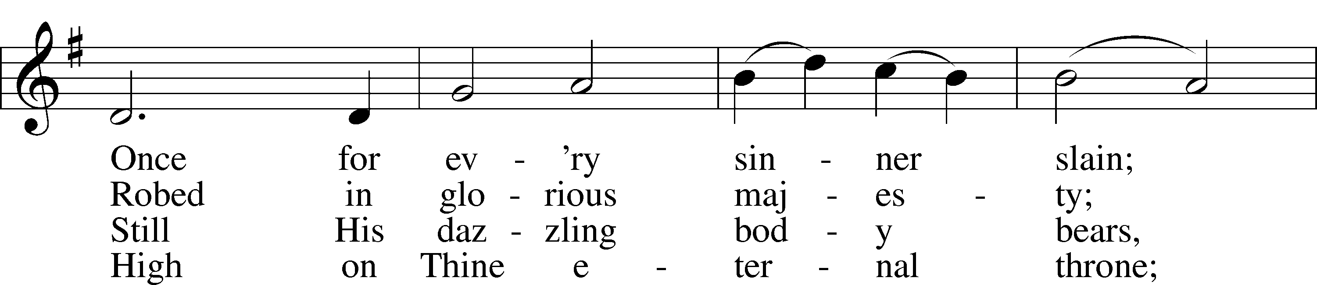
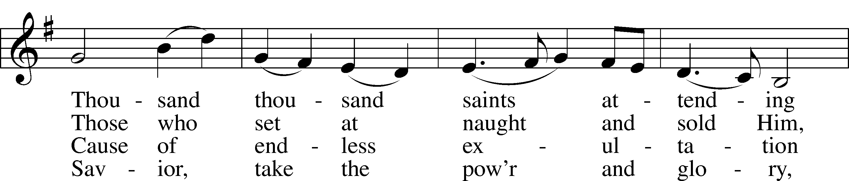
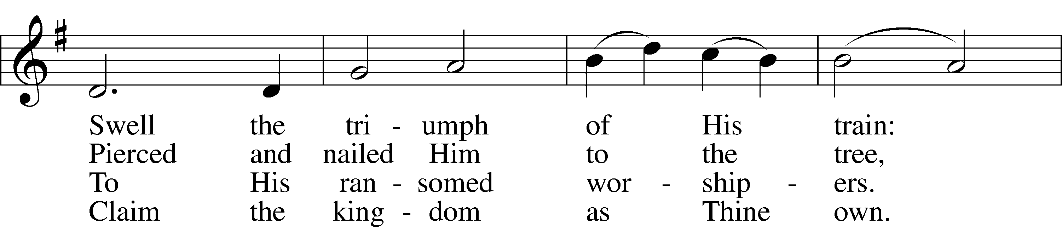
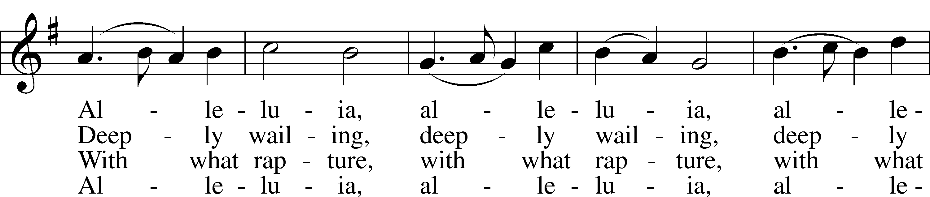
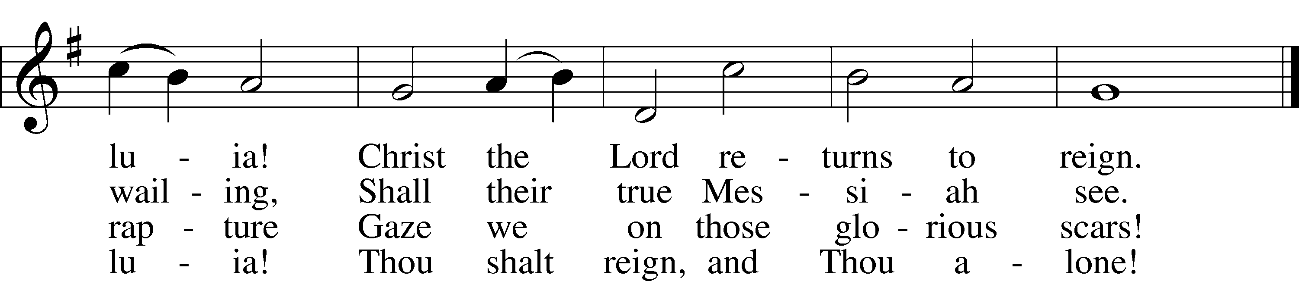
Text and tune: Public domain

Stand. The sign of the cross may be made by all in remembrance of their Baptism.

Invocation
P In the name of the Father and of the T Son and of the Holy Spirit.
C Amen.

Exhortation LSB 184
P Beloved in the Lord! Let us draw near with a true heart and confess our sins unto God our Father, beseeching Him in the name of our Lord Jesus Christ to grant us forgiveness.

P Our help is in the name of the Lord,
C who made heaven and earth.
P I said, I will confess my transgressions unto the Lord,
C and You forgave the iniquity of my sin.

Kneel/Stand

Silence for reflection on God’s Word and for self-examination.

Confession of Sins LSB 184
P O almighty God, merciful Father,
C I, a poor, miserable sinner, confess unto You all my sins and iniquities with which I have ever offended You and justly deserved Your temporal and eternal punishment. But I am heartily sorry for them and sincerely repent of them, and I pray You of Your boundless mercy and for the sake of the holy, innocent, bitter sufferings and death of Your beloved Son, Jesus Christ, to be gracious and merciful to me, a poor, sinful being.

Absolution
P Upon this your confession, I, by virtue of my office, as a called and ordained servant of the Word, announce the grace of God unto all of you, and in the stead and by the command of my Lord Jesus Christ I forgive you all your sins in the name of the Father and of the T Son and of the Holy Spirit.
C Amen.

Service of the Word
Introit Psalm 39:4-5a, 7-8, 12a; antiphon: 2 Peter 3:13b
We are looking forward to a new heaven and a | new earth,*
the home of | righteousness.
O Lord, make me know my end and what is the measure | of my days;*
let me know how fleeting | I am!
Behold, you have made my days a few | handbreadths,*
and my lifetime is as nothing be- | fore you.
And now, O Lord, for what | do I wait?*
My hope | is in you.
Deliver me from all my trans- | gressions.*
Do not make me the scorn | of the fool!
Hear my prayer, O Lord, and give ear | to my cry;*
hold not your peace | at my tears!
We are looking forward to a new heaven and a | new earth,*
the home of | righteousness.

Gloria Patri LSB 186
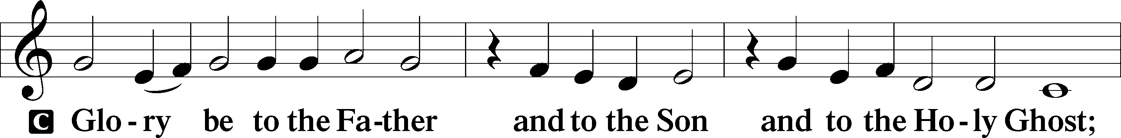
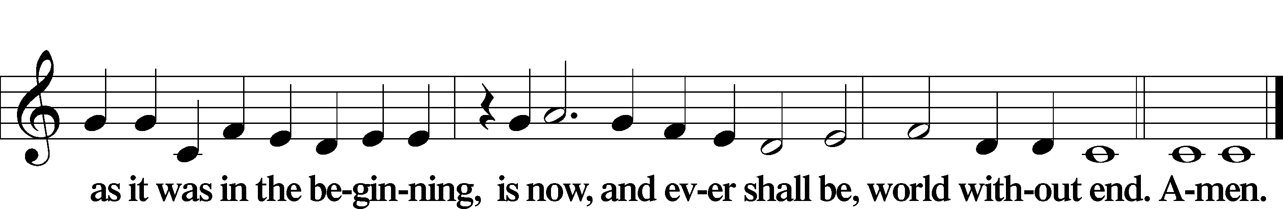

Kyrie LSB 186

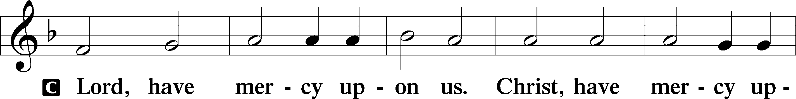
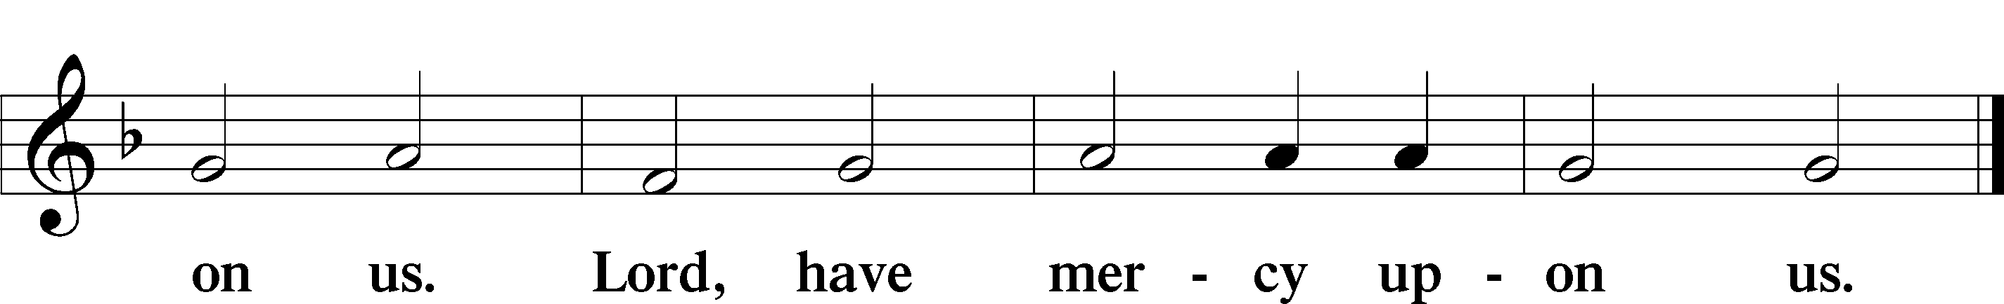

Gloria in Excelsis LSB 187
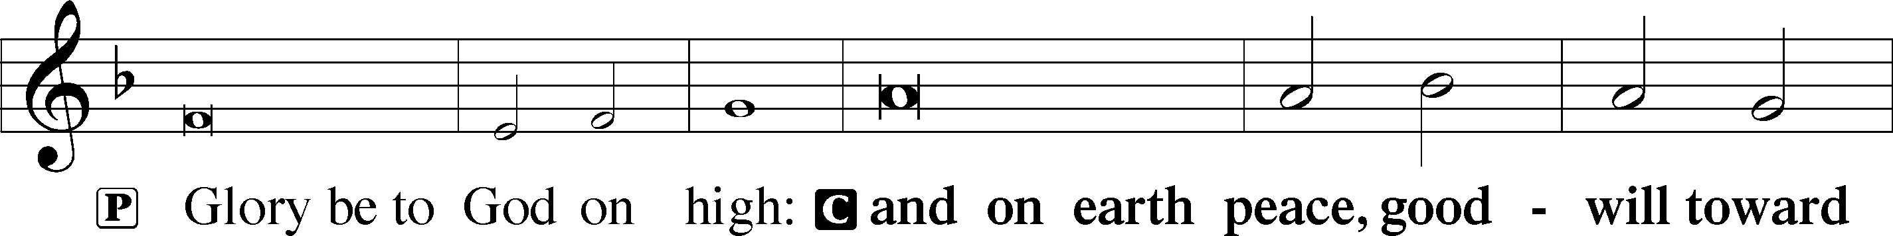
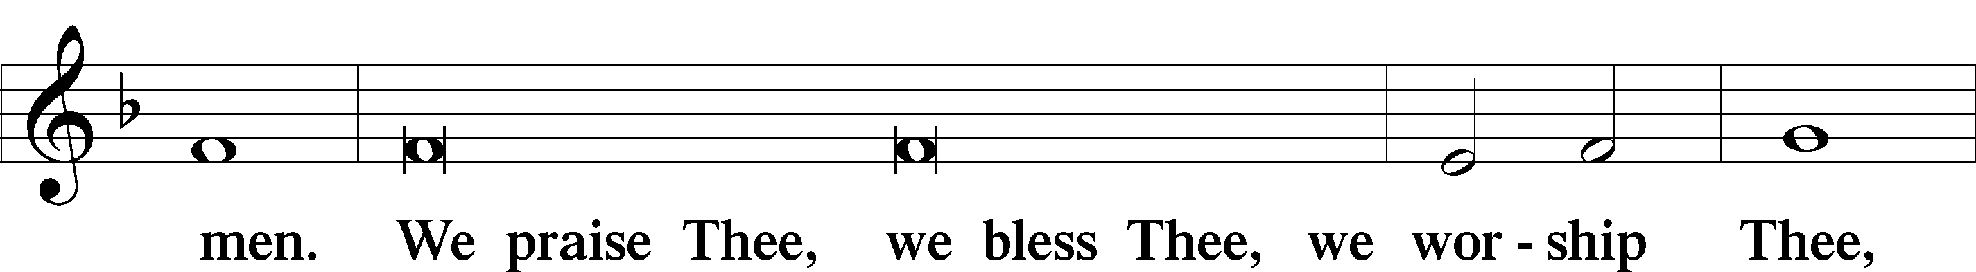
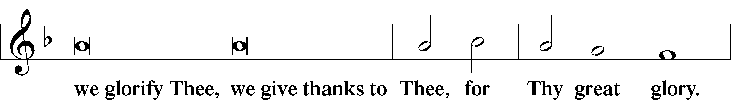
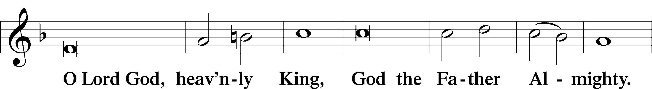
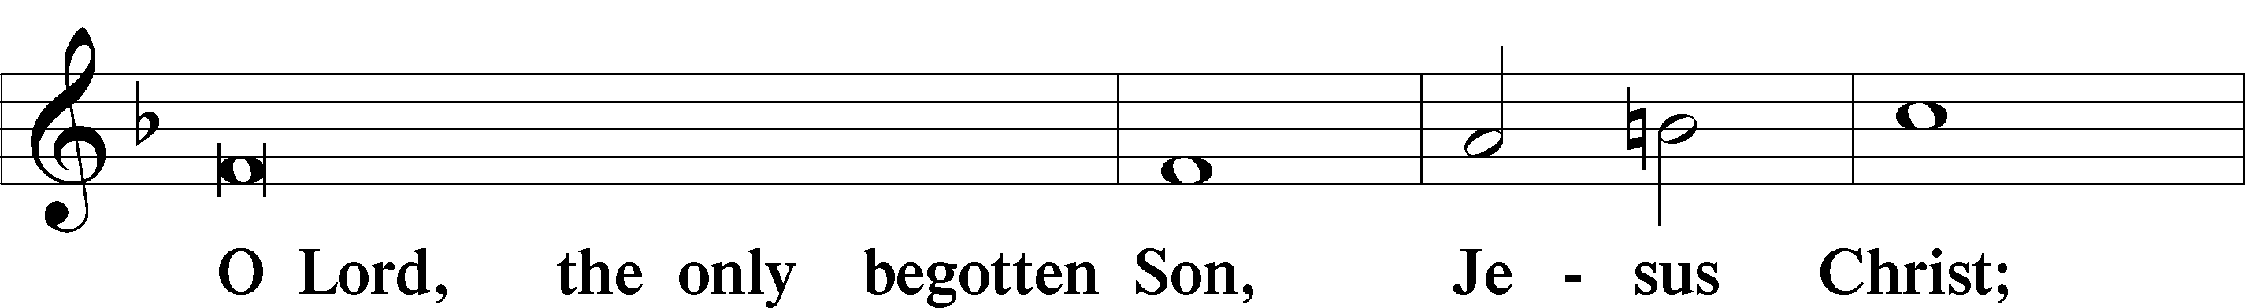
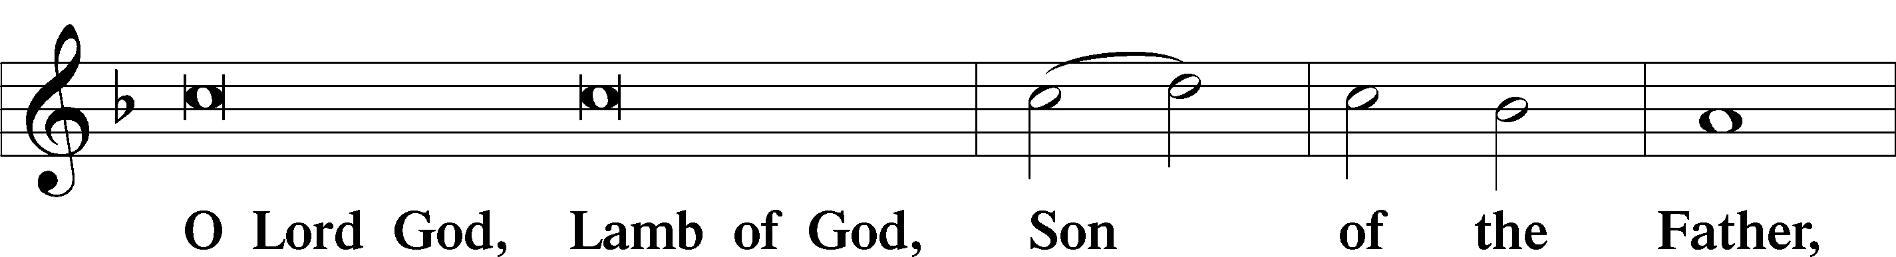
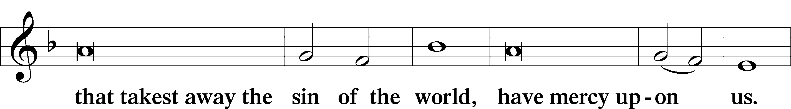
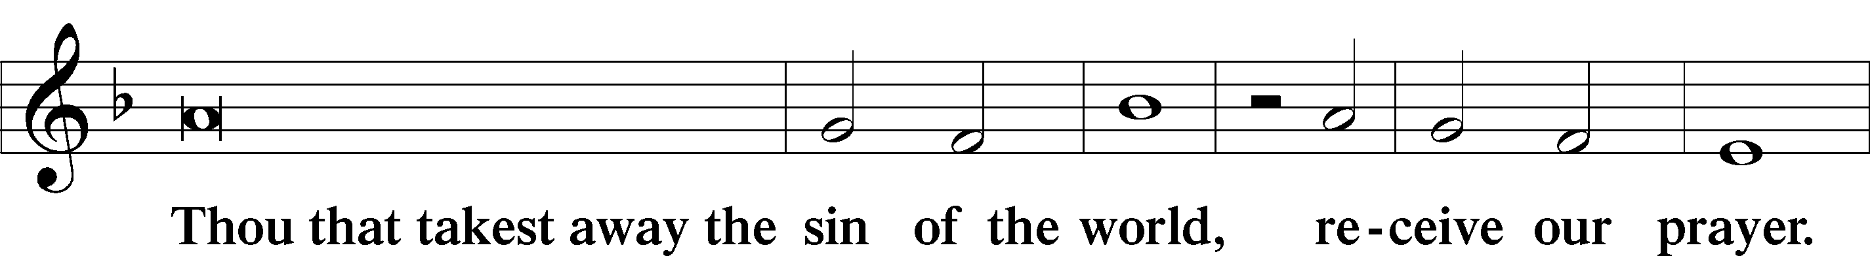
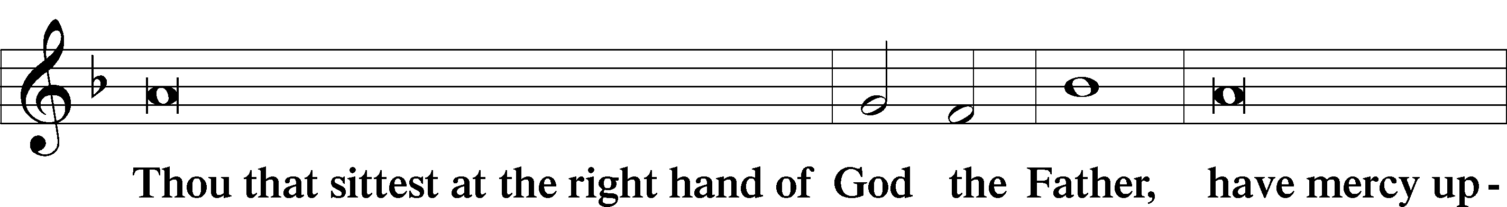
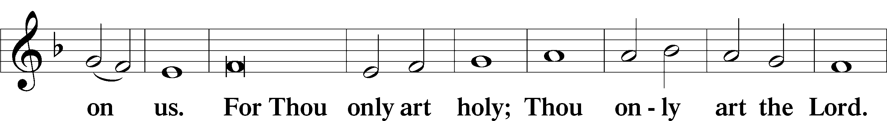
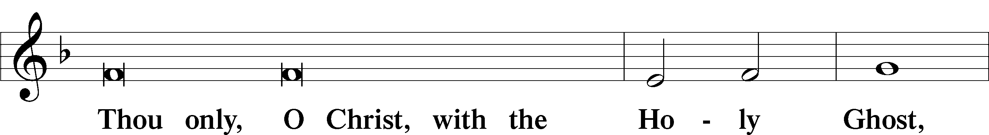
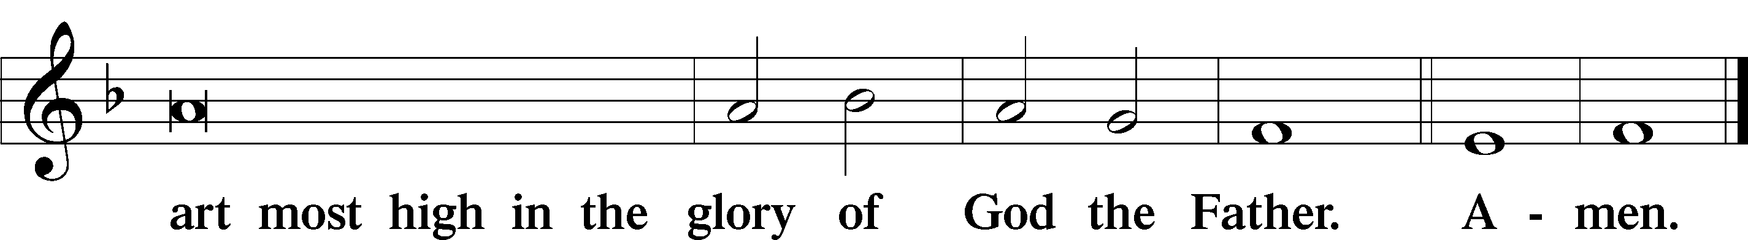

Salutation and Collect of the Day

P The Lord be with you.

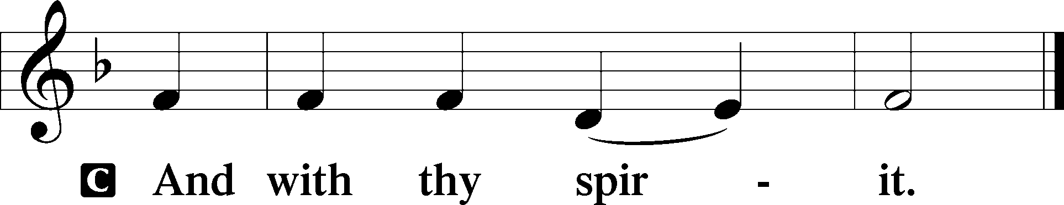

P Let us pray.
Lord Jesus Christ, so govern our hearts and minds by Your Holy Spirit that, ever mindful of Your glorious return, we may persevere in both faith and holiness of living; for You live and reign with the Father and the Holy Spirit, one God, now and forever,

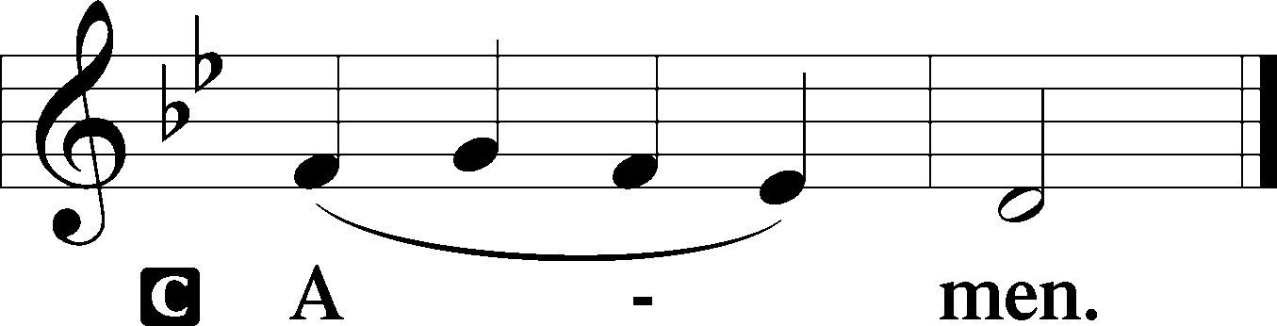

Sit

Old Testament Reading Isaiah 51:4–6
4“Give attention to me, my people,
and give ear to me, my nation;
for a law will go out from me,
and I will set my justice for a light to the peoples.
5My righteousness draws near,
my salvation has gone out,
and my arms will judge the peoples;
the coastlands hope for me,
and for my arm they wait.
6Lift up your eyes to the heavens,
and look at the earth beneath;
for the heavens vanish like smoke,
the earth will wear out like a garment,
and they who dwell in it will die in like manner;
but my salvation will be forever,
and my righteousness will never be dismayed.”

A This is the Word of the Lord.
C Thanks be to God.

Epistle Jude 20–25
20But you, beloved, build yourselves up in your most holy faith; pray in the Holy Spirit; 21keep yourselves in the love of God, waiting for the mercy of our Lord Jesus Christ that leads to eternal life. 22And have mercy on those who doubt; 23save others by snatching them out of the fire; to others show mercy with fear, hating even the garment stained by the flesh.
24Now to him who is able to keep you from stumbling and to present you blameless before the presence of his glory with great joy, 25to the only God, our Savior, through Jesus Christ our Lord, be glory, majesty, dominion, and authority, before all time and now and forever. Amen.

A This is the Word of the Lord.
C Thanks be to God.

Stand

Alleluia LSB 190
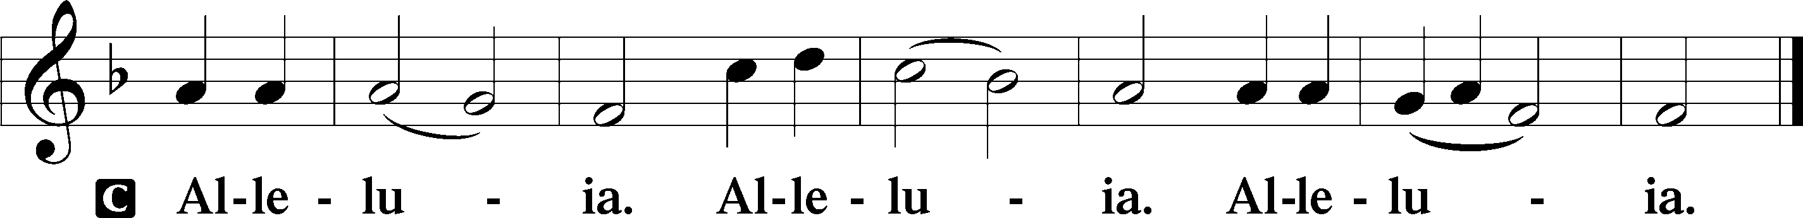

Holy Gospel Mark 13:24–37
P The Holy Gospel according to St. Mark, the thirteenth chapter.

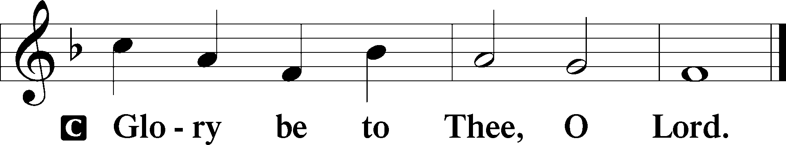

24[Jesus said:] “In those days, after that tribulation, the sun will be darkened, and the moon will not give its light, 25and the stars will be falling from heaven, and the powers in the heavens will be shaken. 26And then they will see the Son of Man coming in clouds with great power and glory. 27And then he will send out the angels and gather his elect from the four winds, from the ends of the earth to the ends of heaven.
28“From the fig tree learn its lesson: as soon as its branch becomes tender and puts out its leaves, you know that summer is near. 29So also, when you see these things taking place, you know that he is near, at the very gates. 30Truly, I say to you, this generation will not pass away until all these things take place. 31Heaven and earth will pass away, but my words will not pass away.
32“But concerning that day or that hour, no one knows, not even the angels in heaven, nor the Son, but only the Father. 33Be on guard, keep awake. For you do not know when the time will come. 34It is like a man going on a journey, when he leaves home and puts his servants in charge, each with his work, and commands the doorkeeper to stay awake. 35Therefore stay awake—for you do not know when the master of the house will come, in the evening, or at midnight, or when the cock crows, or in the morning— 36lest he come suddenly and find you asleep. 37And what I say to you I say to all: Stay awake.”

P This is the Gospel of the Lord.

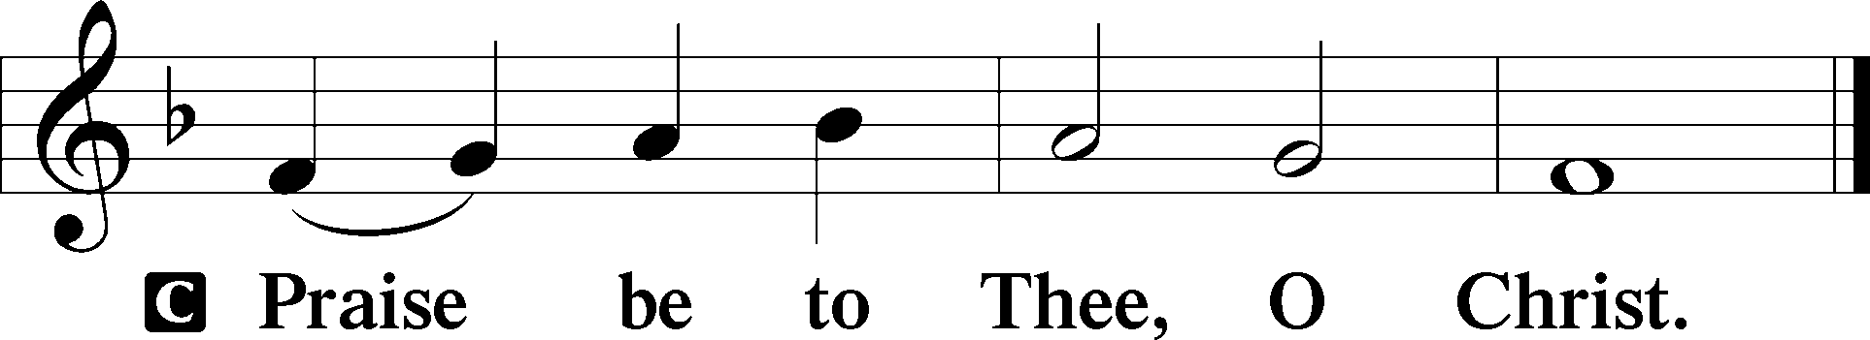

Nicene Creed

C I believe in one God,
the Father Almighty,
maker of heaven and earth
and of all things visible and invisible.

And in one Lord Jesus Christ,
the only-begotten Son of God,
begotten of His Father before all worlds,
God of God, Light of Light,
very God of very God,
begotten, not made,
being of one substance with the Father,
by whom all things were made;
who for us men and for our salvation came down from heaven
and was incarnate by the Holy Spirit of the virgin Mary
and was made man;
and was crucified also for us under Pontius Pilate.
He suffered and was buried.
And the third day He rose again according to the Scriptures
and ascended into heaven
and sits at the right hand of the Father.
And He will come again with glory to judge both the living and the dead,
whose kingdom will have no end.

And I believe in the Holy Spirit,
the Lord and giver of life,
who proceeds from the Father and the Son,
who with the Father and the Son together is worshiped and glorified,
who spoke by the prophets.
And I believe in one holy Christian and apostolic Church,
I acknowledge one Baptism for the remission of sins,
and I look for the resurrection of the dead
and the life T of the world to come. Amen.

Sit

513 The Clouds of Judgment Gather
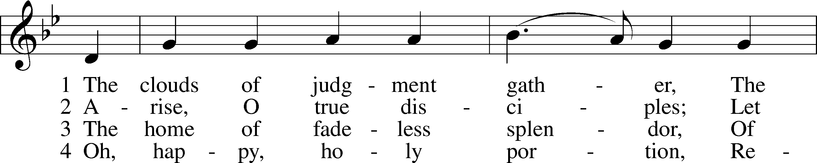
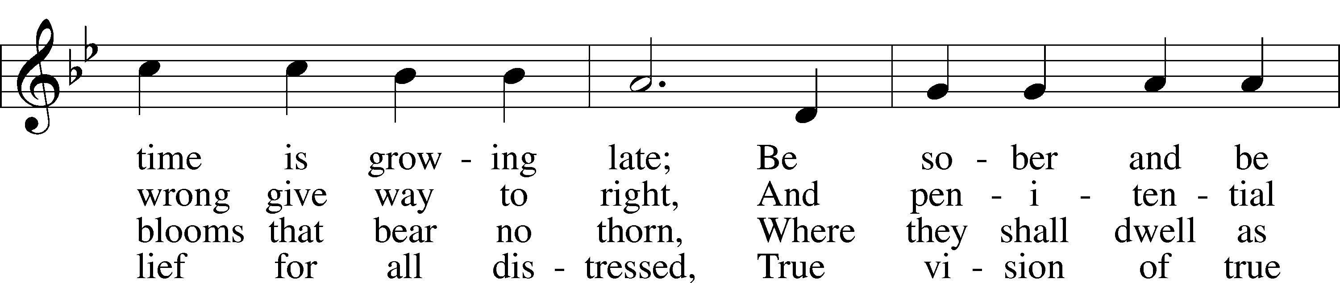
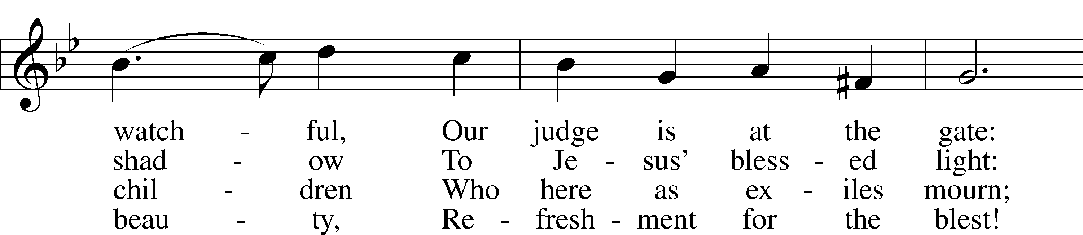
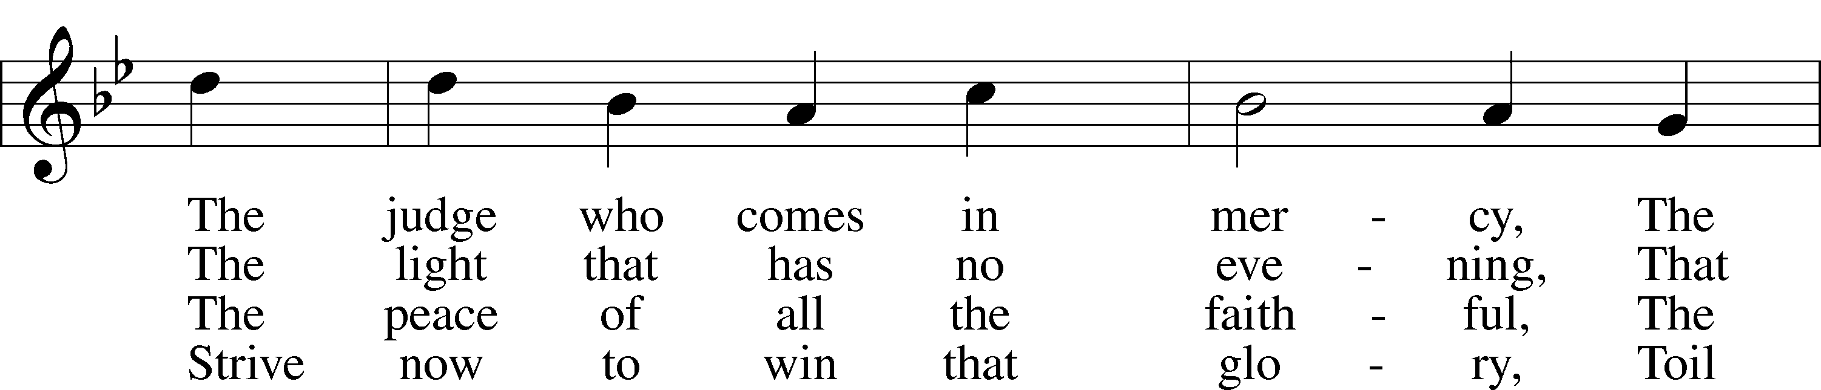
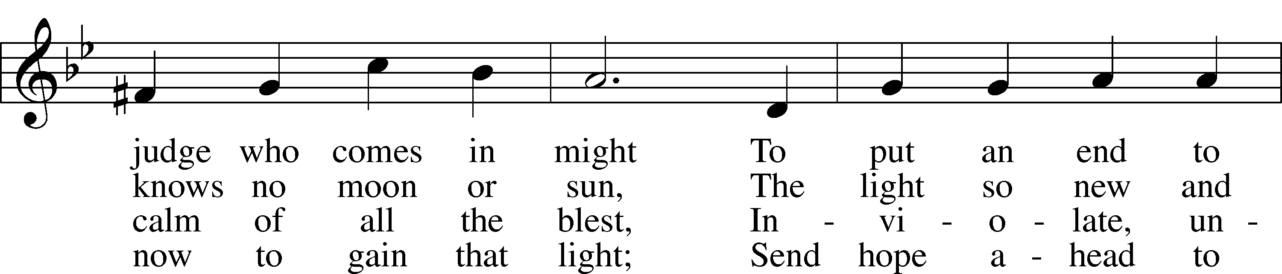
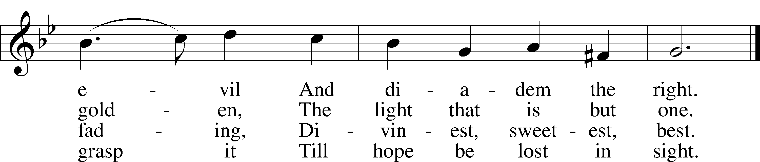
Tune: Public domain
Text: © 1978 Lutheran Book of Worship. Used by permission: LSB Hymn License no. 110003744

Sermon - "Hope For This Generation" Mark 13:30

Stand

Offertory LSB 192
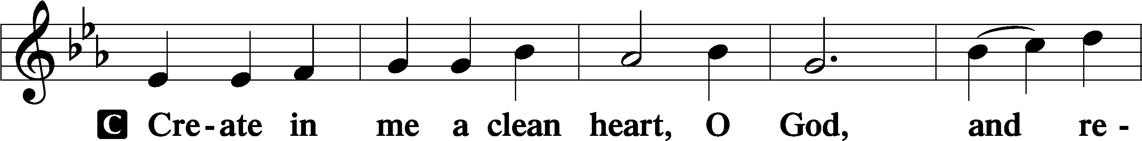
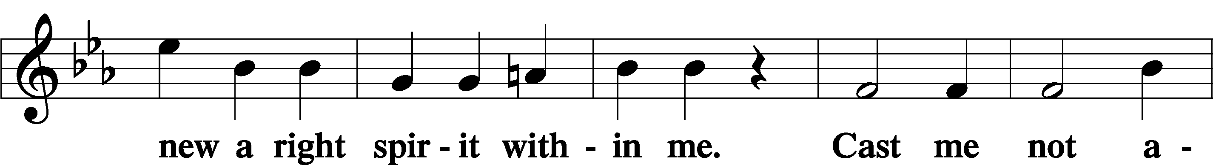
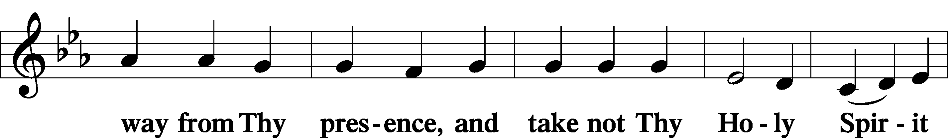
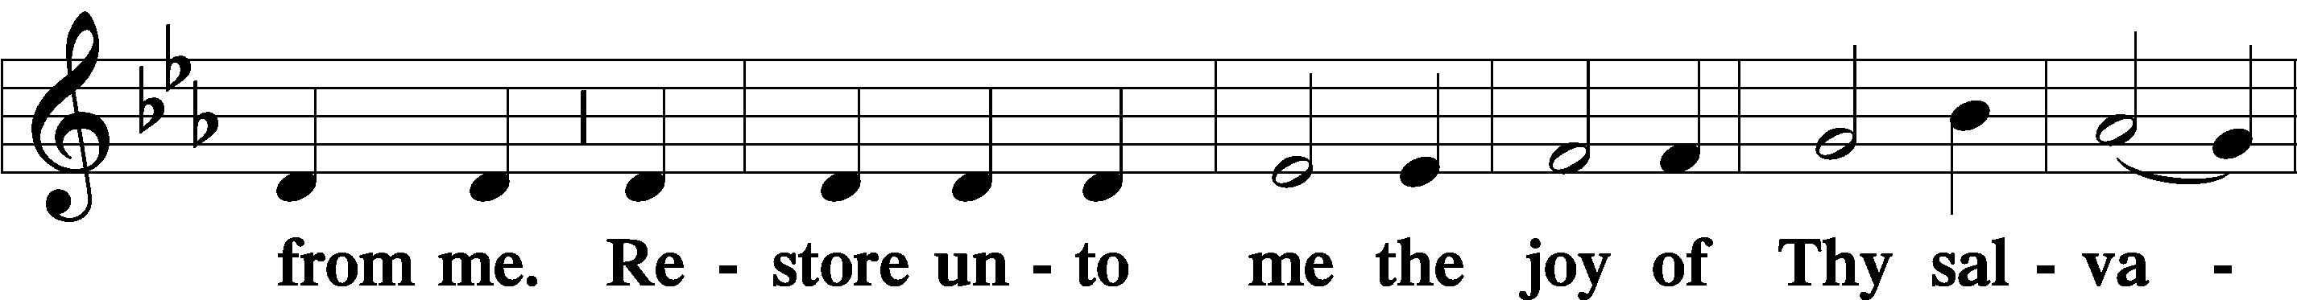
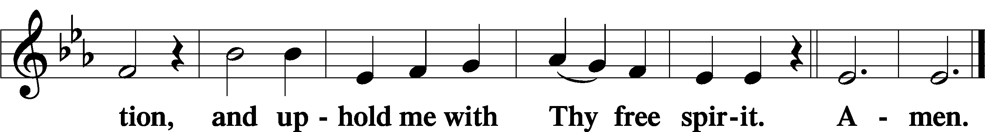

Prayer of the Church

Sit

Offertory Music

Adult Bell Choir
“Praise to the Lord”

Offering & Preparation

Stand

Service of the Sacrament
Preface LSB 194

P The Lord be with you.
P Lift up your hearts.
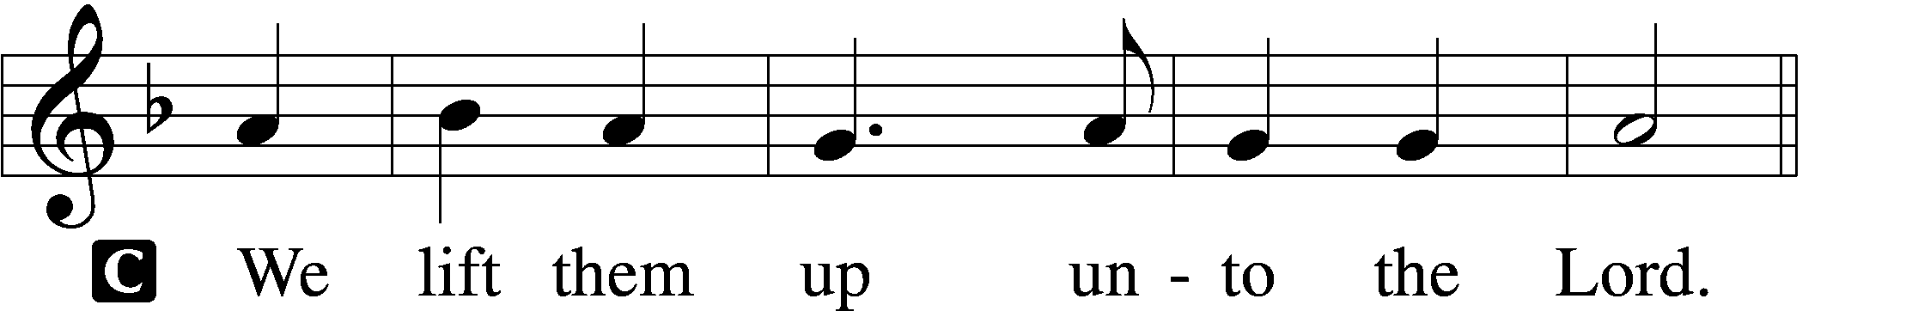

P Let us give thanks unto the Lord, our God.
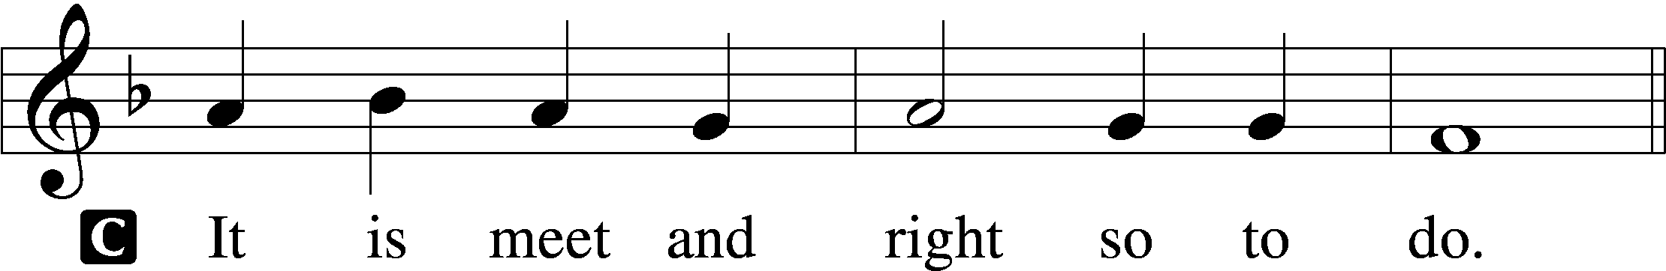

Proper Preface
P It is truly meet, right, and salutary that we should at all times and in all places give thanks to You, holy Lord, almighty Father, everlasting God, through Jesus Christ, our Lord, who, out of love for His fallen creation, humbled Himself by taking on the form of a servant, becoming obedient unto death, even death upon a cross. Risen from the dead, He has freed us from eternal death and given us life everlasting. Therefore with angels and archangels and with all the company of heaven we laud and magnify Your glorious name, evermore praising You and saying:

Sanctus LSB 195
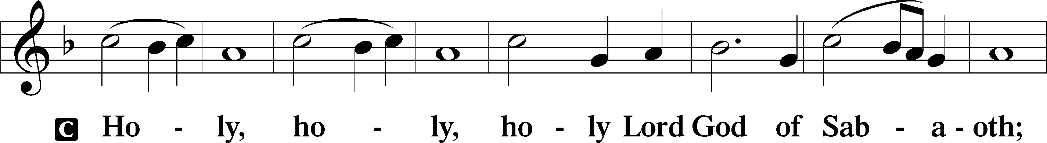
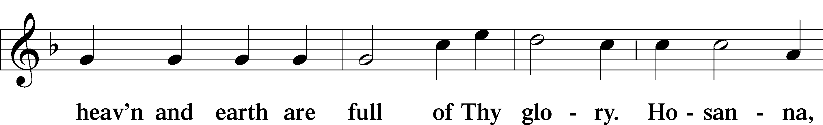
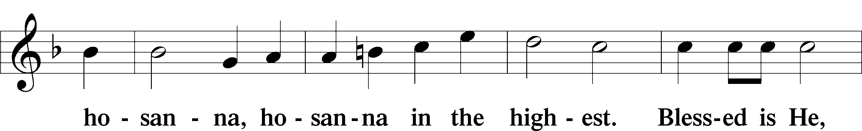
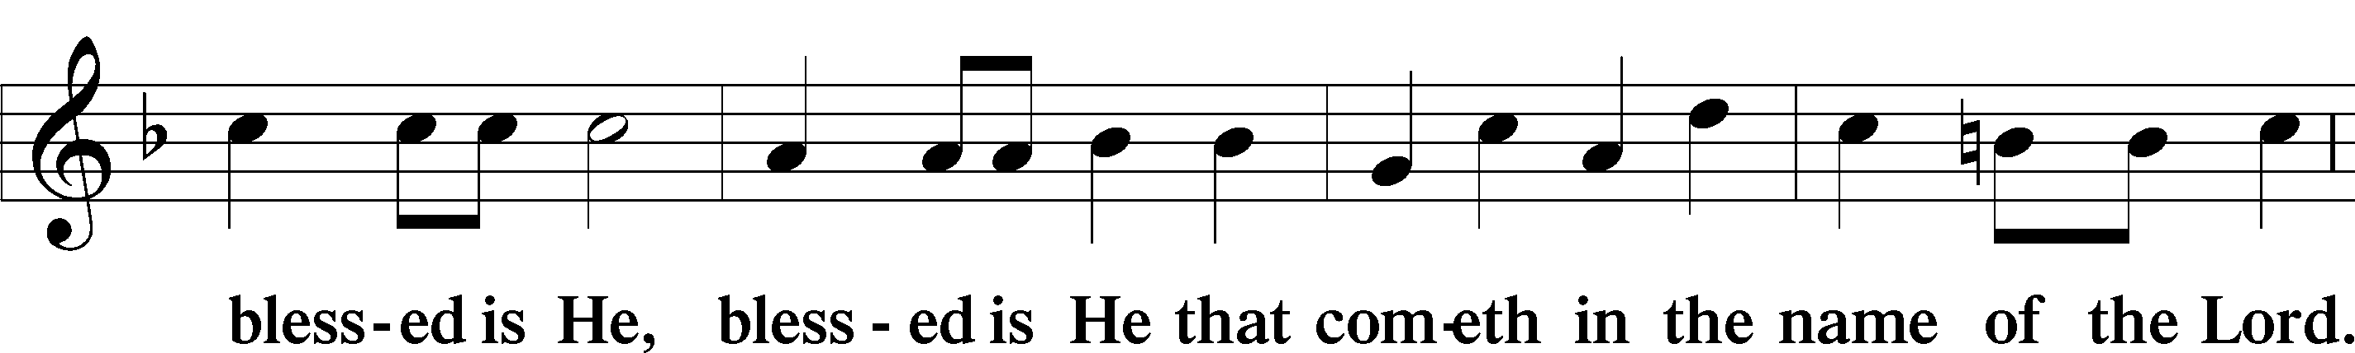
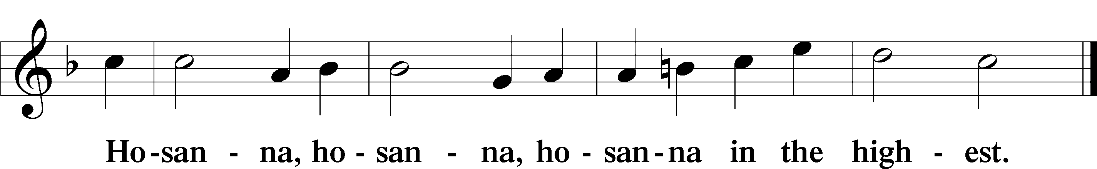

The Lord’s Prayer 196
P Our Father who art in heaven,
hallowed be Thy name,
Thy kingdom come,
Thy will be done on earth as it is in heaven;
give us this day our daily bread;
and forgive us our trespasses as we forgive those who trespass against us;
and lead us not into temptation,
but deliver us from evil.
For Thine is the kingdom and the power and the glory forever and ever. Amen.

The Words of Our Lord LSB 197
P Our Lord Jesus Christ, on the night when He was betrayed, took bread, and when He had given thanks, He broke it and gave it to the disciples and said: “Take, eat; this is My T body, which is given for you. This do in remembrance of Me.”

In the same way also He took the cup after supper, and when He had given thanks, He gave it to them, saying: “Drink of it, all of you; this cup is the new testament in My T blood, which is shed for you for the forgiveness of sins. This do, as often as you drink it, in remembrance of Me.”

Pax Domini LSB 197
P The peace of the Lord be with you always.
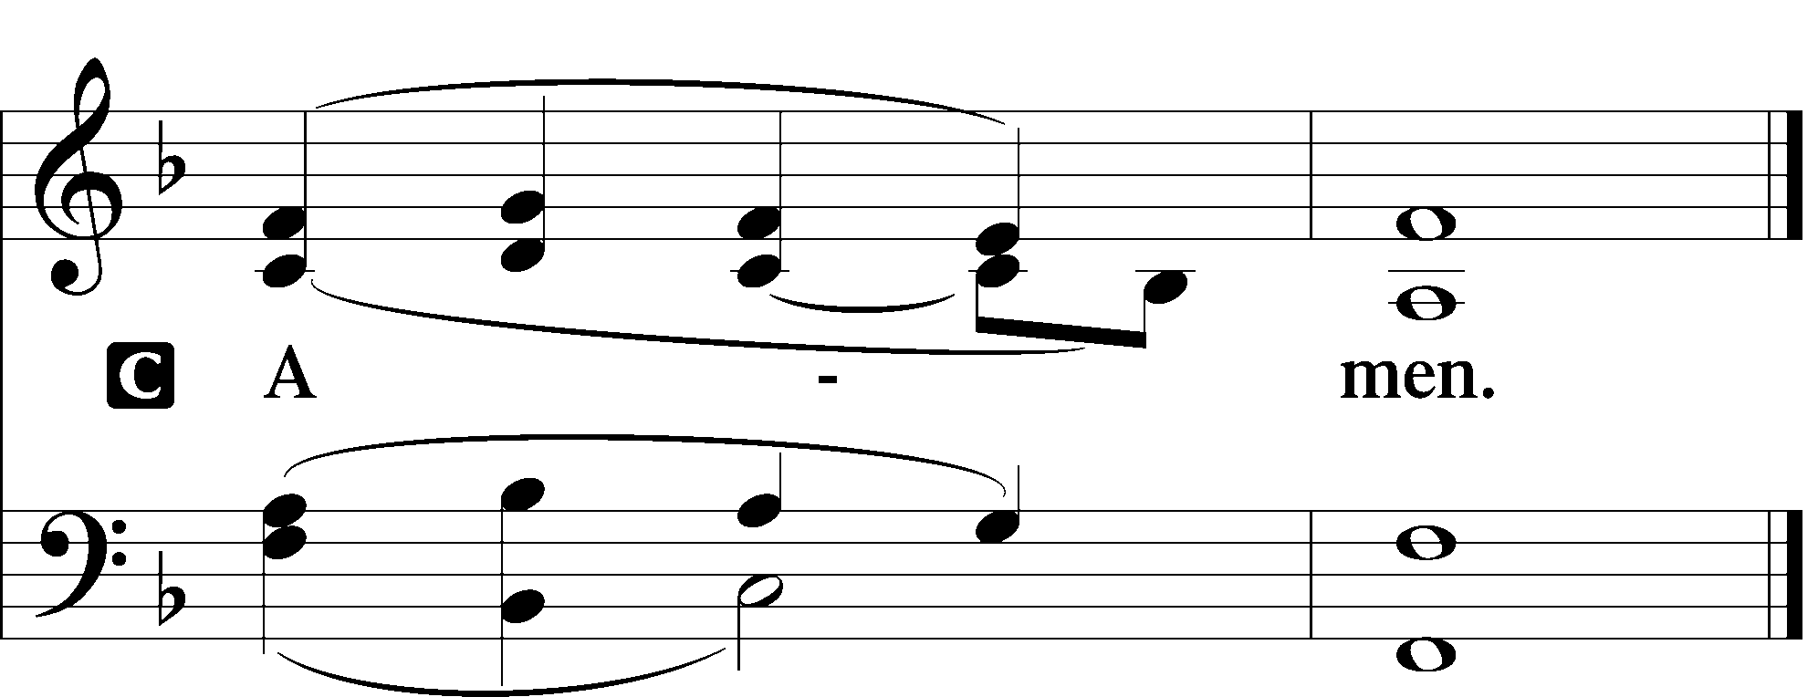

Agnus Dei LSB 198
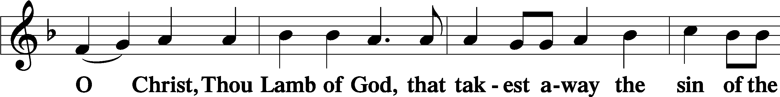
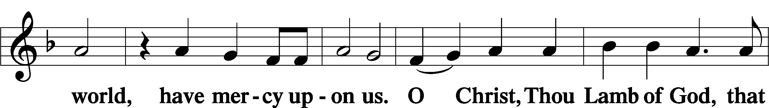
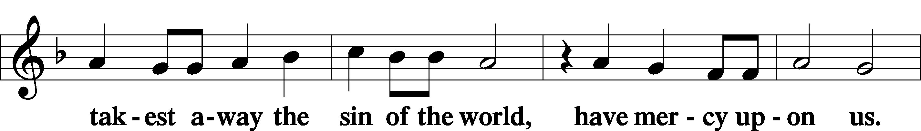
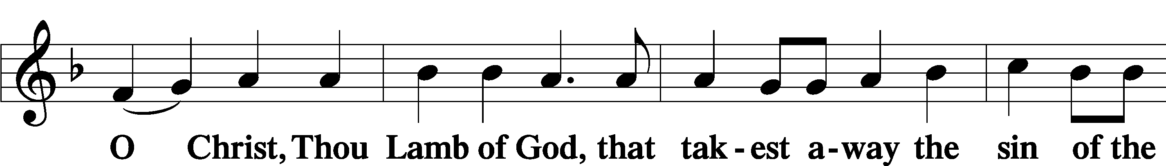

Sit

Distribution

828 We Are Called to Stand Together
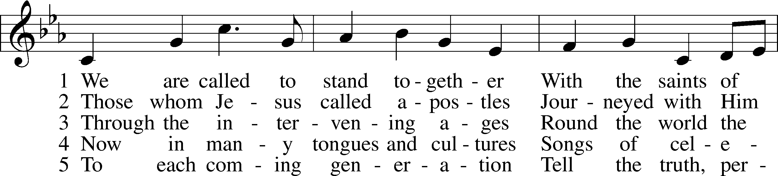
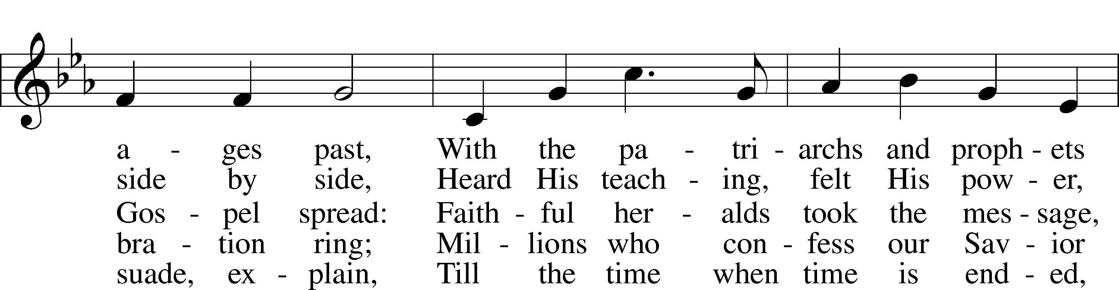
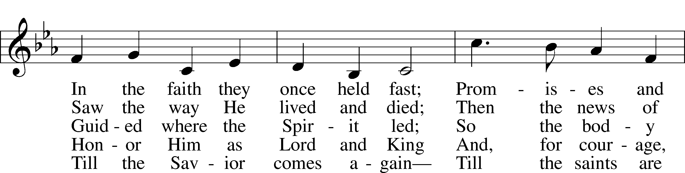
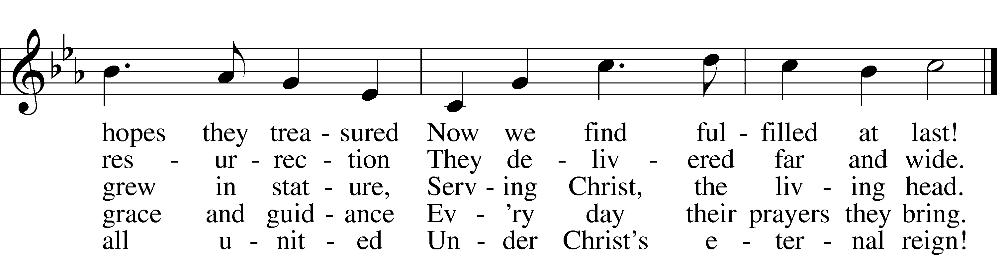
Tune: © 1973 Henry V. Gerike. Used by permission: LSB Hymn License no. 110003744
Text: © 2000 Kevin Mayhew Ltd. Used by permission: LSB Hymn License no. 110003744

620 Jesus Comes Today with Healing
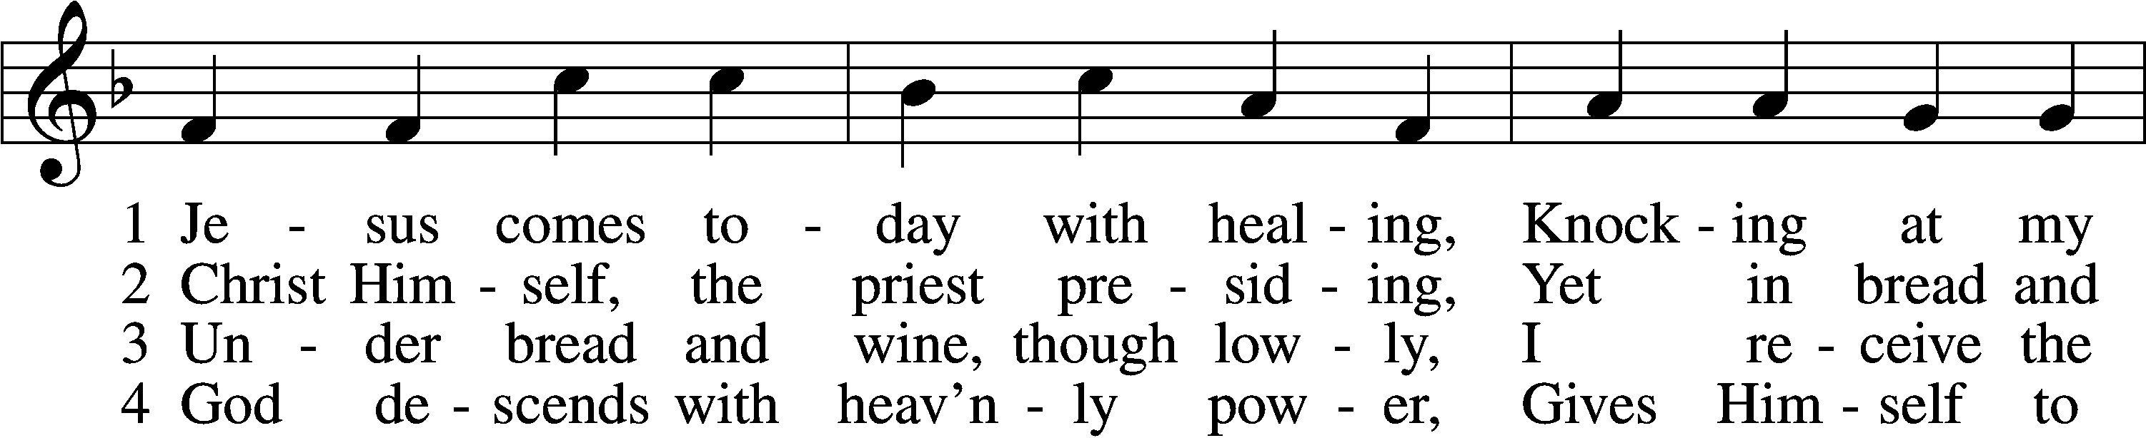
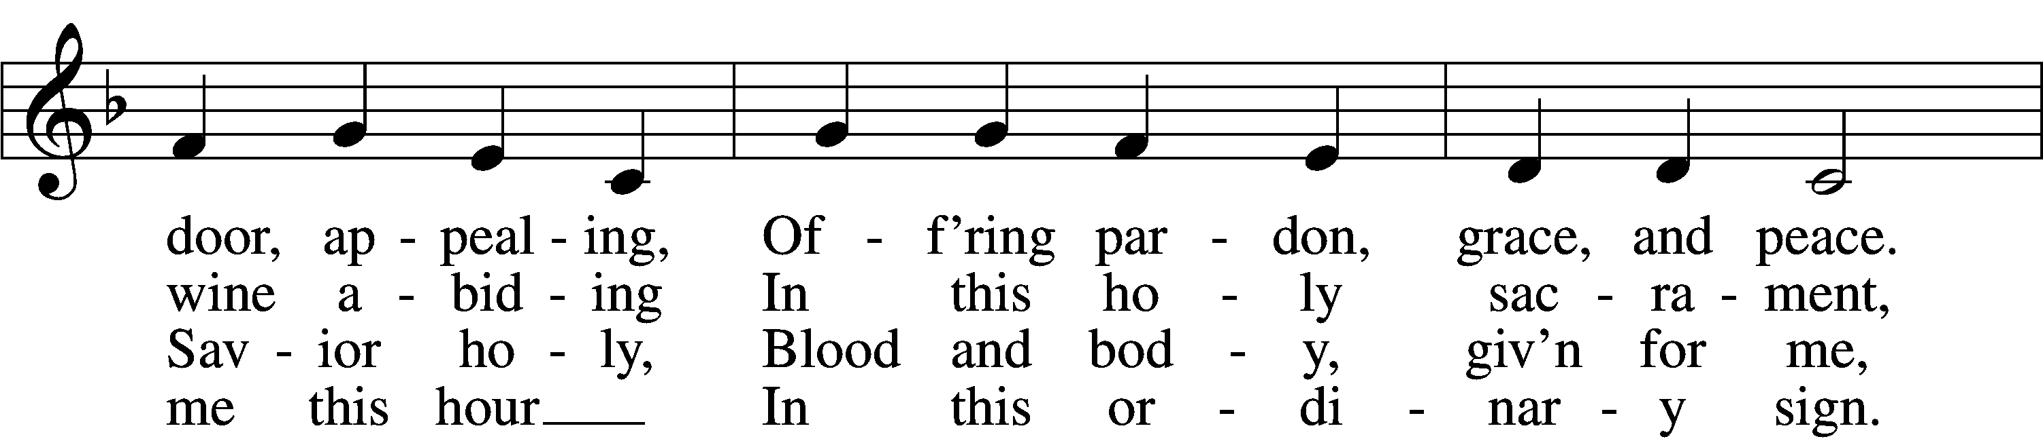
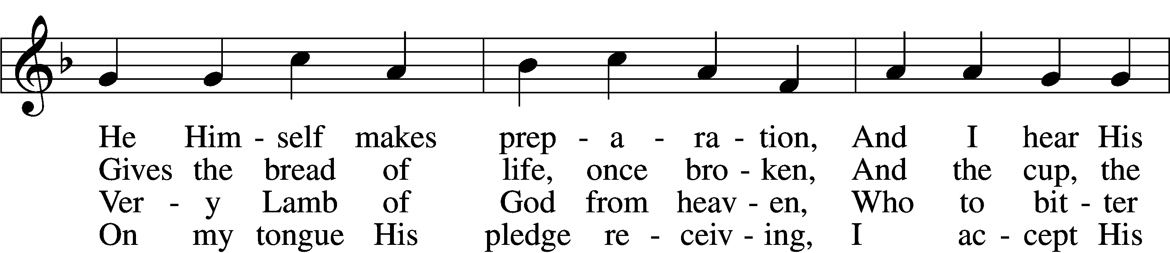
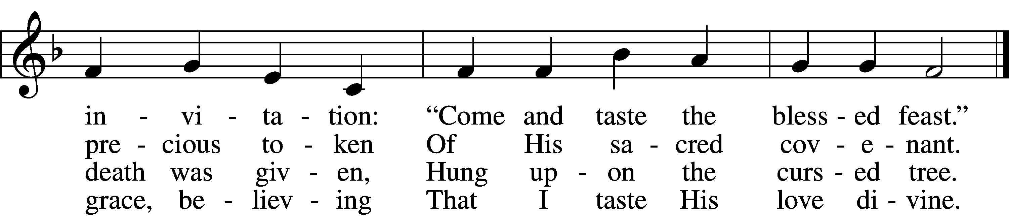

5 Let me praise God’s boundless favor,
Whose own feast of love I savor,
Bidden by His gracious call.
Wedding garments He provides me,
With a robe of white He hides me,
Fits me for the royal hall.

6 Now have I found consolation,
Comfort in my tribulation,
Balm to heal the troubled soul.
God, my shield from ev’ry terror,
Cleanses me from sin and error,
Makes my wounded spirit whole.
Text: © David W. Rogner. Used by permission: LSB Hymn License no. 110003744
Tune: Public domain

623 Lord Jesus Christ, We Humbly Pray
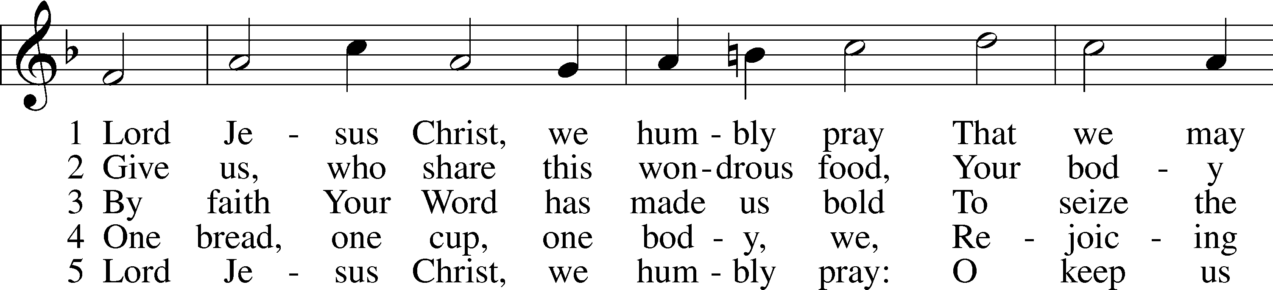
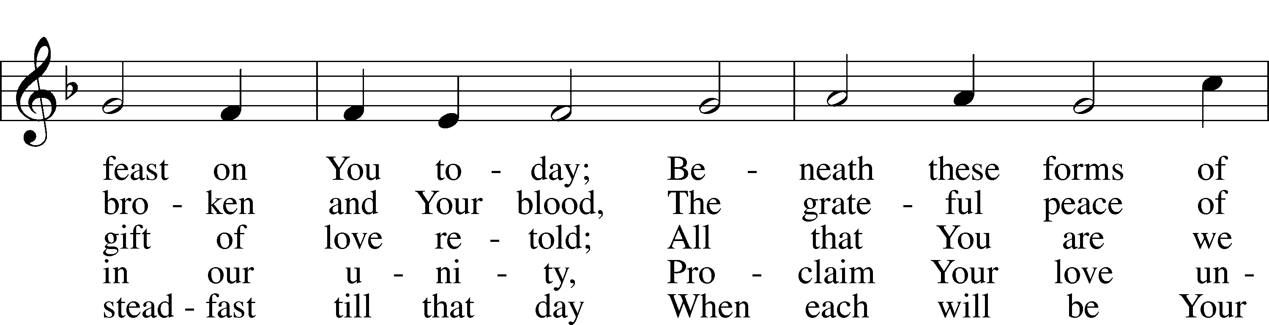
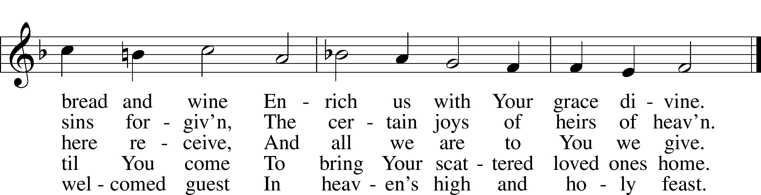
Text and tune: Public domain
The Dismissal
P The body and blood of our Lord Jesus Christ strengthen and preserve you in body and soul to life everlasting. Depart T in peace.
C Amen.

Nunc Dimittis LSB 199
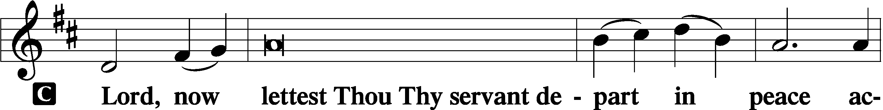
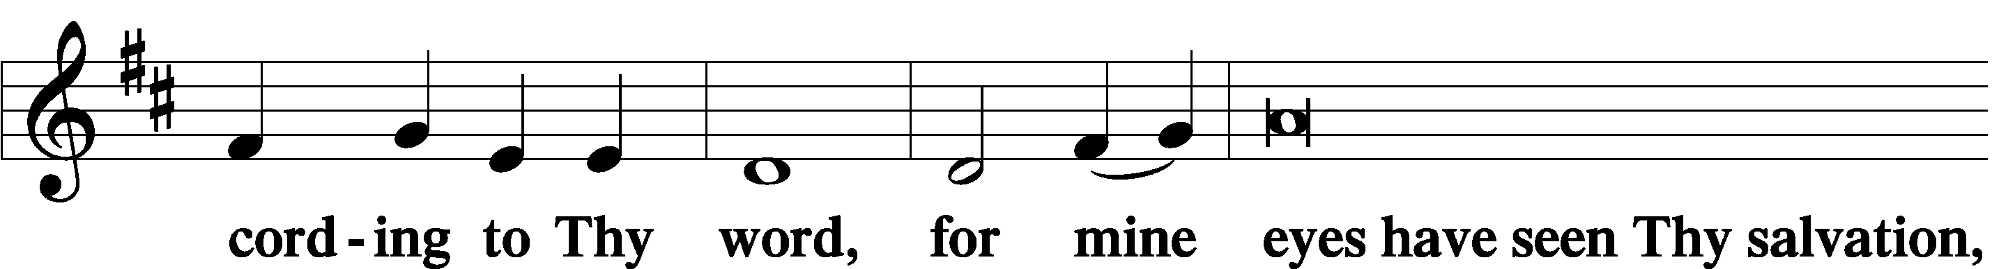
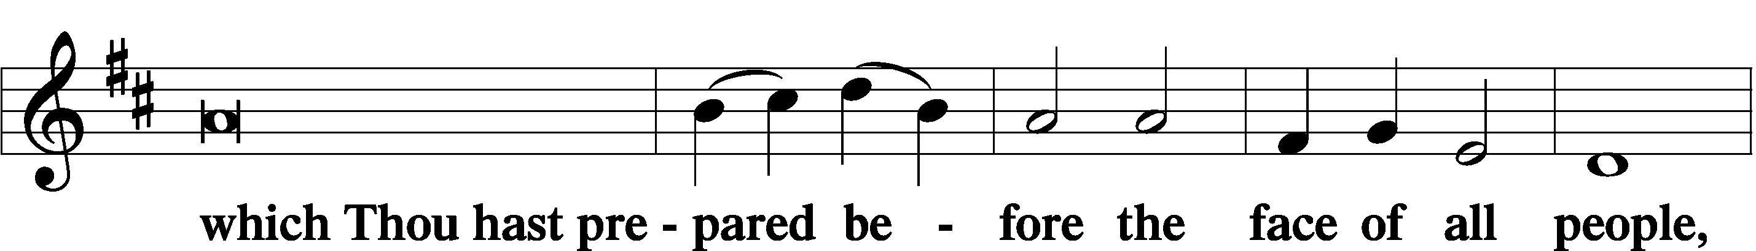
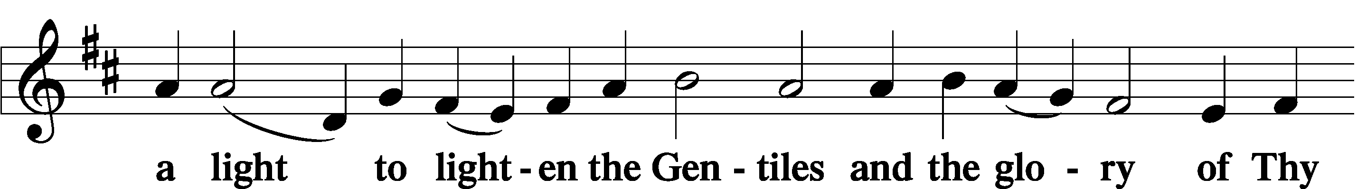
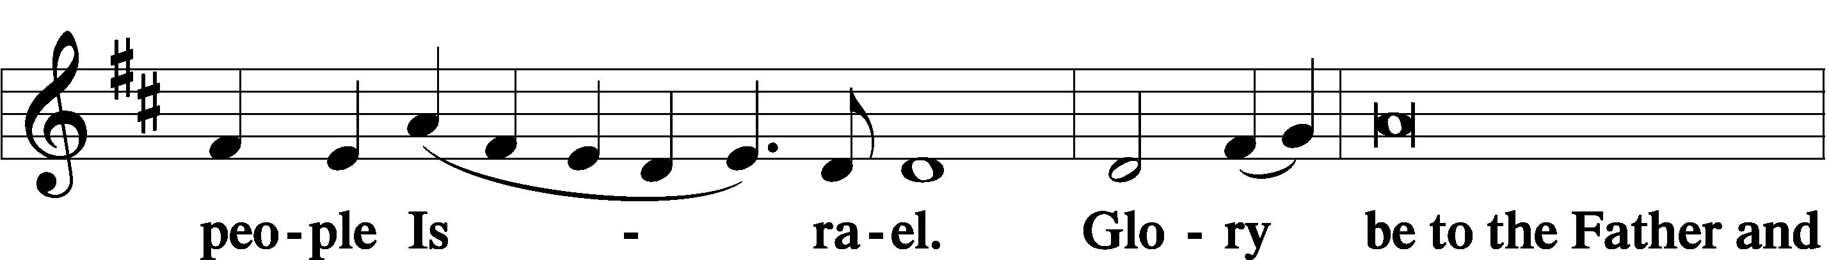
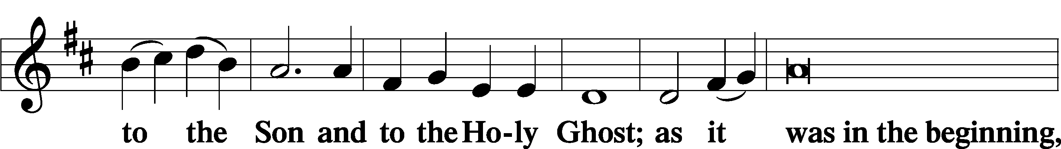
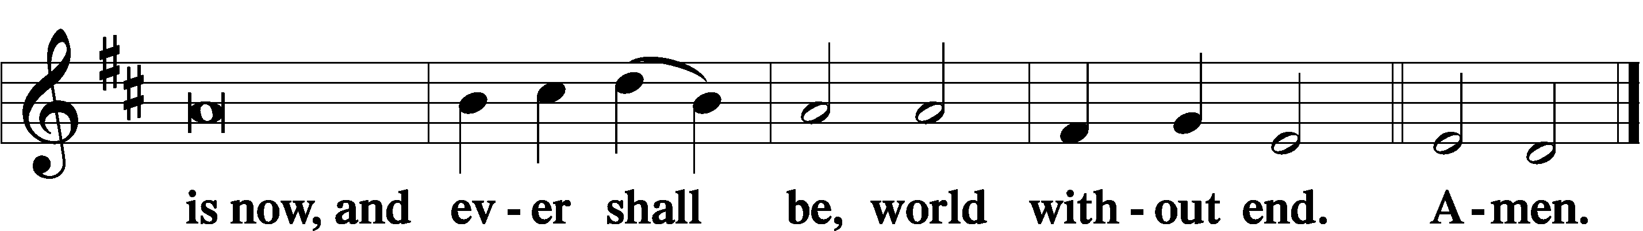

Thanksgiving LSB 200
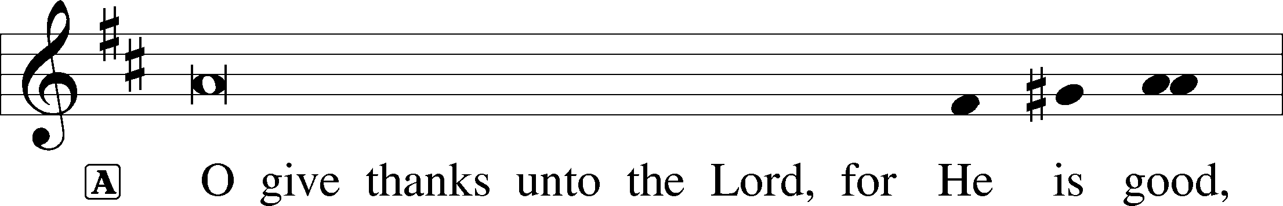
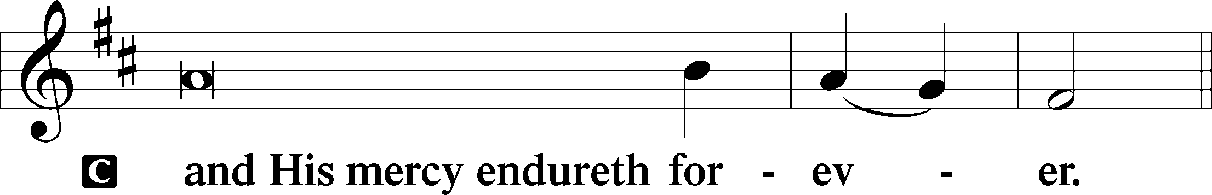

Post-Communion Collect
A Let us pray.
Gracious God, our heavenly Father, You have given us a foretaste of the feast to come in the Holy Supper of Your Son’s body and blood. Keep us firm in the true faith throughout our days of pilgrimage that, on the day of His coming, we may, together with all Your saints, celebrate the marriage feast of the Lamb in His kingdom which has no end; through Jesus Christ, Your Son, our Lord, who lives and reigns with You and the Holy Spirit, one God, now and forever.
C Amen.

Salutation LSB 201
P The Lord be with you.

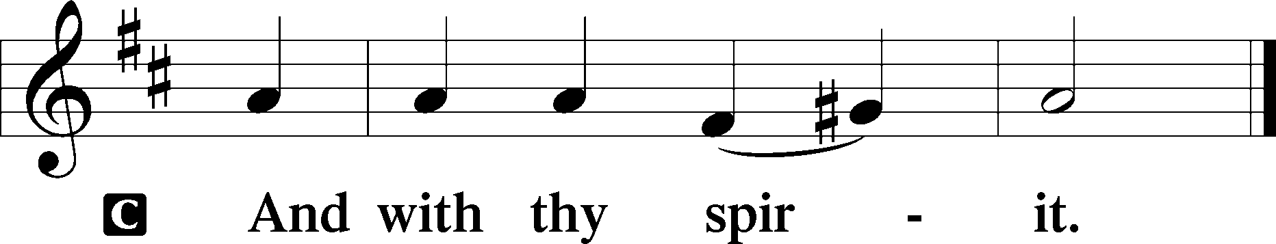

Benedicamus LSB 202
A Bless we the Lord.

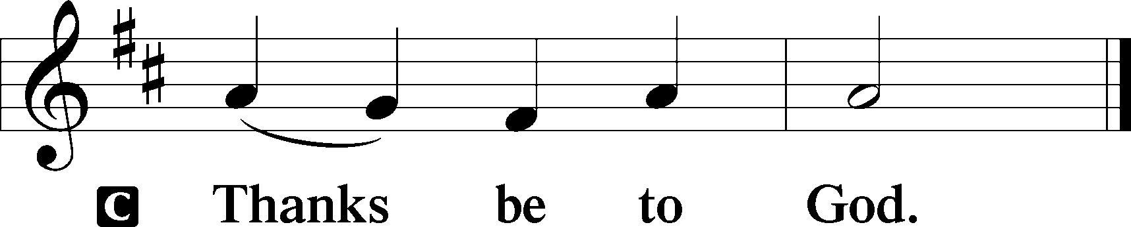

Benediction LSB 202
P The Lord bless you and keep you.
The Lord make His face shine upon you and be gracious unto you.
The Lord lift up His countenance upon you and T give you peace.
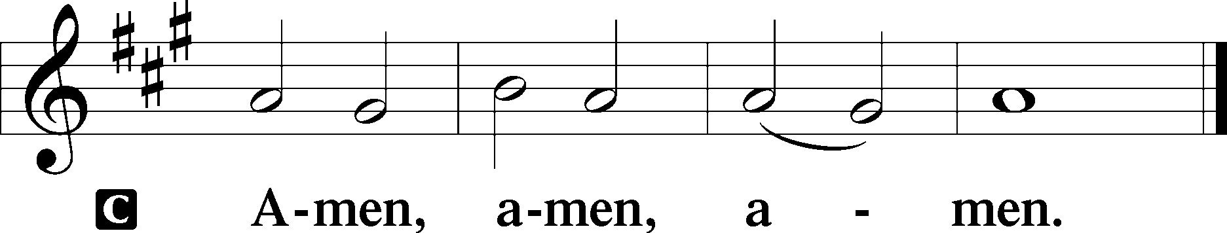

511 Herald, Sound the Note of Judgment
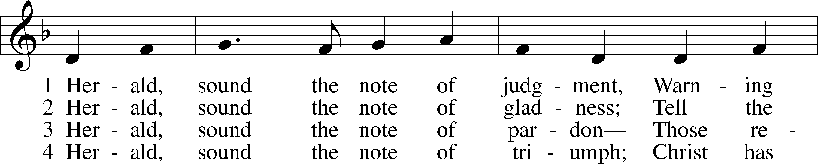
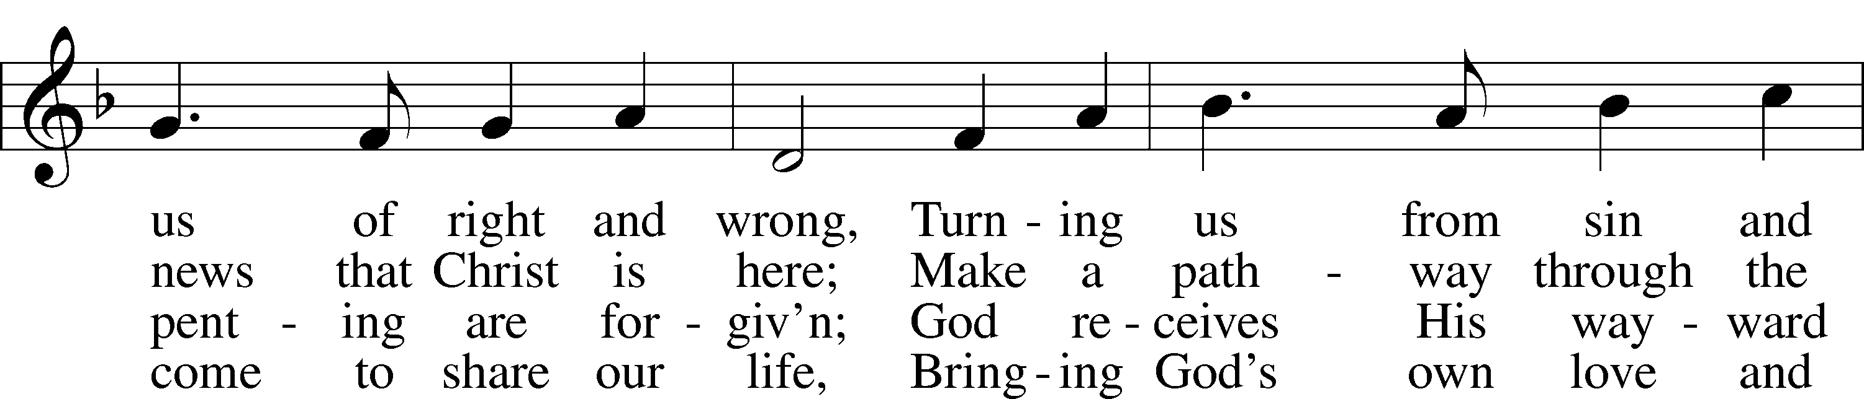
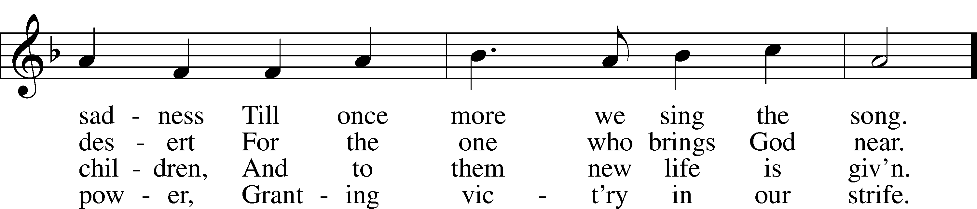
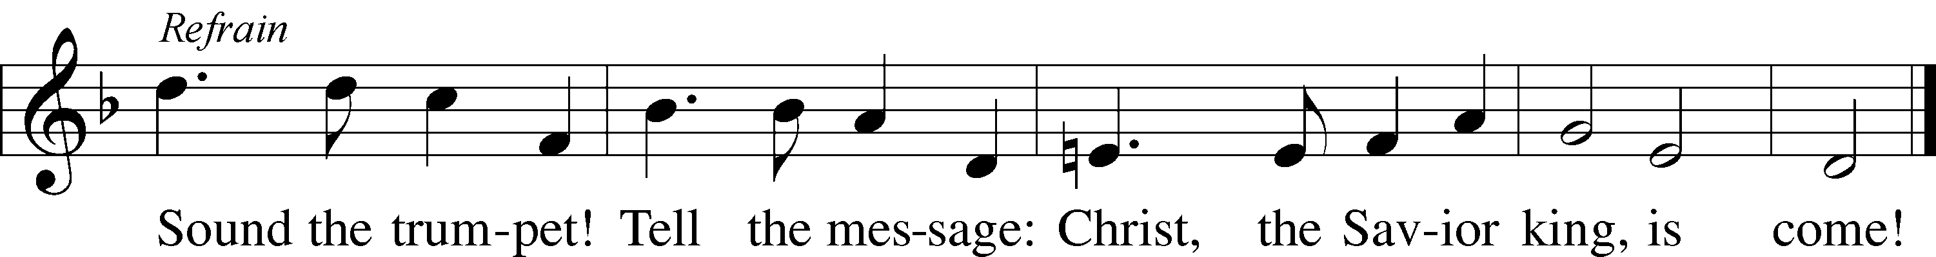
Tune: © 1975 Stainer & Bell Ltd, admin. Hope Publishing Co. Used by permission: LSB Hymn License no. 110003744
Text: © 1977 Moir A. J. Waters. Used by permission: LSB Hymn License no. 110003744

Acknowledgments
Unless otherwise indicated, Scripture quotations are from the ESV® Bible (The Holy Bible, English Standard Version®), copyright © 2001 by Crossway, a publishing ministry of Good News Publishers. Used by permission. All rights reserved.
Created by Lutheran Service Builder © 2021 Concordia Publishing House.

Prayers for Our Members
Sharon Hockemeier, Tenaya Nuttelman | Expectant Mothers
Birth of Luke Hansen (Son of Leif & Keri Hanson) | Thanksgiving
Norman Abels (Brookestone Meadows – Elkhorn) | Healing
Judy Ahrens | Healing
Vaughn Albrecht (Mount Carmel) | Healing
Tom & DyAnn Altwine | Healing
Lyle Colsden (Mother Hull) | Healing
Mary Fiddelke | Healing
Pat Flodine (Cambridge Court) | Healing
Vi Fox (Prairie View) | Healing
Verleen Gentry | Healing
Wanda Glanzer | Healing
Ruby Hatfield | Healing
Evelyn Heiden (Mother Hull) | Healing
Lennis Hodgson | Healing
Don Richmond | Healing
Ivan Bombeck | Cancer
Bertha Marienau | Cancer
Kim Vos | Cancer

ZION LUTHERAN CHURCH AND SCHOOL

Pr. James DeLoach, Pastor + (308) 627-5260
james.deloach@zionkearney.org
Pr. Doug Gaunt, Pastor + (308) 455-0552
doug.gaunt@zionkearney.org
Tony Splittgerber, Principal + (308) 293-0168
anthony.splittgerber@zionkearney.org

Church Office
Secretary: Holly Reid
Email: school@zionkearney.org
Phone: (308)-234-3410 Fax: (308) 236-8100
Office Hours: Monday-Friday 8:00am-4:00pm
Radio Broadcast: Sunday @ 10:30 a.m. on 1460 AM and 92.1 FM
Website: www.zionkearney.com
Prayers for Our Members’ Family & Friends
Naomi Wollberg (Matthias’ wife) | Expecting
Elaine Arehart (Zion’s Music Teacher) | Expecting
Mike McDaniel (Dennis & Sue Bartel’s brother-in-law | Grief
Family of James Sexton (Helmbrecht’s friend) | Dying
Jean Brooks (Bruce Brooks & Becky Thornton’s sister-in-law) | Healing
Larry Bombeck (Ivan’s brother) | Healing
Katie Cunningham (Quentin & Janel Lange’s friend) | Healing
Reg Duke (Westman’s brother-in-law) | Healing
James Gentry (Verleen’s son) | Healing
Roger Hoffman (Marc’s father) | Healing
David Kreutzer (Richard’s brother) | Healing
Dillon Malchow (Joy Barefoot’s nephew) | Healing
Urijah Mitchell (Sue & Dennis Bartels’ Grandson) | Healing
Tim Powers (Kim Wilken’s brother) | Healing
Roy Reynolds (Verleen Gentry’s son-in-law) | Healing
Lynne Saathoff (Verleen Gentry’s sister-in-law) | Healing
Randy Solomon (Beth Rosenthal’s father) | Healing
Tim Trampe (Don & Gretchen’s son) | Healing
Jonah (Jase & Jarren Blattner’s friend) | Cancer
D.D. Dugger (Sue Kaiser’s brother) | Cancer
Stuart Gronewoller (Lonna’s brother-in-law) | Cancer
Linda Heapy (Janel Lange’s mother) | Cancer
Ron Halvorsen (Jeff’s dad) | Cancer
Bill Jedlicka (Pam Uhlir’s cousin) | Cancer
Randy Jochum (Ken Hockemeier’s brother-in-law) | Cancer
Sharon Mulhair (Pam Uhlir’s cousin) | Cancer
Kolby Shiers (Jessica’s cousin) | Cancer
Pr. Richard Snow (NE District President) | Cancer
Tyrone Uhlir (Pam’s nephew) | Cancer
Scott Catterson (Jim & Pat’s Son) | Deployment
Tim Smallcomb (Wilkens’ friend) | Deployment
Today’s Altar Flowers are provided by Keith Nuttelman, in loving memory of Bev on the occasion of their 36th Anniversary.

Today’s Radio Broadcast is sponsored by Vi Fox,
all glory be to God.

Worship Assistants
Sunday, November 21st~ 9:00am

Elder: Dan Oertwig
Usher: Andy Wollberg
Acolyte: Colton Zehendner
Engineer: Jared Nuttelman
Announcer: Lonna Gronewoller
Altar Guild: Brooke Fisher & Tracy Schake

Thank You to Joy and Luke Barefoot for offering your gifts in worship!

Thank you to the Adult Bell Choir:
Joy Barefoot
Luke Barefoot
Carol DeLoach
Kim Wilkens
Jamie Wilkens

Sunday, November 28th~ 9:00am

Elder: Ken Hockemeier
Usher: Steve Junge
Acolyte: Eli Randolph
Engineer: Shawn Starkey
Announcer: Carol Kreutzer
Altar Guild: Brooke Fisher & Tracy Schake

Our Response to the Gospel

Date: 11/14/2021
Offering: $5,676
Weekly Need: $7,457.69

This Week at Zion

Sun  11/21 | 9:00a  10:20a  10:20a  10:30a  5:00p | Divine Service  Voter’s Meeting  Sunday School  Radio Broadcast 1460am & 92.1fm  Divine Service
Mon  11/22 | Birthdays | Richard Crow
Tues  11/23 | 1:30p | Sleeping Mats
Wed  11/24 | All Day  7:00p  Birthdays  Anniversaries | No School  Thanksgiving Eve Service  Christopher Crow  Todd Willers  Jesse & Ashli Florang
Thurs  11/25 | All Day  Birthdays  Anniversaries | Office Closed/No School  Happy Thanksgiving!  Jade Florang  Don & Gretchen Trampe
Fri  11/26 | All Day  Birthdays  Anniversaries | Office Closed/No School  Dwight Farmer  Chris & Sarah Hoehner
Sat
11/27
Sun  11/28 | 9:00a  10:15a  10:30a  5:00p  Anniversaries | Divine Service  Bible Study/Sunday School  Radio Broadcast 1460am & 92.1fm  Divine Service  Paul & Rachael Burger
Where our Triune God strengthens us through His mercy in faith toward Him and in fervent love toward one another.

ANNOUNCEMENTS

ANNUAL VOTERS' MEETING FOR OFFICER AND BOARD ELECTIONS IS TODAY...in the Fellowship Hall immediately following our worship service. Do you want an update on our plans to update Zion's sanctuary? Come to the Voters' Meeting, where Mr. Splittgerber will provide an update on the steps we have taken and where we are going.

Zion Pie Sales: Thank you for supporting the Zion Lutheran School pie fundraiser! We sold over 1700 pies. We do have some remaining pies left to purchase. If you are interested, stop by the office. Thanks!

December Sower: The December Sower is getting prepared! If you have anything you would like announced in the sower, please email Holly by November 29th with the details. Thank you!

Christmas Decorating: We will be decorating the church Saturday, Dec. 4th at 10:30am (note the change of time from 9am to 10:30) after the school’s Christmas Program practice. All members are welcome and encouraged to join in on the decorating!

Pastor Gaunt’s 35th Anniversary of Ordination: All wanting to show their appreciation for Pr. Gaunt’s years of service can donate toward his gift or give him a card to thank him. Please put your donation in an envelope and give it to Pr. DeLoach, who will be purchasing his gift.

The Zion Youth Group would like to give back this season by helping in our community. If you have any small jobs that you would like help with in the month of November, please contact Miss Nikodym (402) 746-0561 or Miss Dauel (308) 627-2113. Examples of jobs include raking leaves, cleaning up a garden, putting out or taking down decorations, etc.

Adult Bible Study is studying the rich variety of words God uses to communicate the Gospel—that we are justified by grace through faith. Come grab a donut and cup of coffee as we fellowship and learn together.

Zion’s 4th Quarter (Oct – Dec) Mission Offerings will support Zion’s current students, who are studying for full-time church work. All our students are at Concordia (CUNE):
Peter Kreutzer - Lutheran Teacher’s Diploma (LTD)
Jessica Zehendner – LTD
Taylor Zehendner – LTD
Please use the mission envelopes located in the narthex for this offering. Or give via Church Trac by selecting “Missions.” Thank you for your support.
Poinsettias – Zion will be taking poinsettia orders to adorn the Church Sanctuary during Christmas time. They will be $15.00 per plant. To order, there is an envelope in the Fellowship Hall on Sunday’s and in the Church Office during the week. Place your money in the envelope with your name, place the envelope in the offering plate or the mail slot on the south side of the building or drop it off during office hours. Please make checks out to Mary Martha.

Radio Broadcast – The sign-up sheets for the 2022 radio broadcast and altar flowers are up by the mailboxes! The remaining 2021 sheets are still up on the right side. The 28th of November is still available for radio sponsors! Please help Zion spread the Gospel!

Offering Options:
1) Place your offering in the basket as you leave
2) Go to zionkearney.churchtrac.com/give
3) Go to zionkearney.com and click on the ChurchTrac icon
4) Mail your gift to Zion Lutheran Church, 2421 C Ave, Kearney, NE 68847. Or place it in the mail slot on the south side of the building.

SCHOOL NEWS

The theme for our school year is “Together by Christ’s Love” based on 1 John 4:7-8.

- ZION JOB OPPORTUNITY: Music substitute teacher needed. Our K-8 music teacher, Mrs. Arehart, is expecting! She will be due sometime in March and we will need a substitute to teach music 2-3 days a week for the fourth quarter of the year. Current teacher certification needed. If you or someone you know may be eligible to help us, please contact Mr. Splittgerber (Anthony.splittgerber@zionkearney.org).

- Thanksgiving Break: NO SCHOOL November 24th-26th. Have a great Thanksgiving!

- Zion Basketball - Basketball practices for the girls and boys began this week. Since this is a club team, all Zion members in grades 5th-8th who attend public school are welcome to be on the team.

  - Boys Practices will be Mondays and Wednesdays at 3:30-5:15 starting November 29th.
  - Girls Practices will be Tuesdays and Thursdays and every other Friday at 3:45-5:00, starting November 30th.

Please contact Mr. Splittgerber for more information.

- Give Where You Live - Zion will be participating in the Give Where You Live Campaign again! It will be December 2nd (giving day), but donations will be accepted beginning November 4th. To contribute online go to: https://www.givewhereyoulive.net//zionlutheranschool. If you would rather give in person feel free to stop by the office. Please share this with family and friends.

