Divine Service

Twentieth Sunday after Pentecost
October 23rd, 2022
Zion Lutheran Church
Kearney, Nebraska
Welcome to Zion!
Guests please record your attendance on a card in the pew rack and let us know how we can be of service to you.

Holy Communion at Zion

The Lord’s Supper is celebrated at this congregation as Jesus has given it. As he says, our Lord gives into our mouths not only bread and wine but his very body and blood to eat and to drink for the forgiveness of sins and to strengthen our union with him and with one another. Our Lord invites to his table those who trust his words, repent of all sin, and set aside any refusal to forgive and love as he forgives and loves us, that they may show forth his death until he comes. All communicants need to register in the narthex prior to the service.

Because those who eat and drink our Lord’s body and blood unworthily do so to their great harm and because Holy Communion is a confession of the faith which is confessed at this altar, any who are not yet instructed, in doubt, or who hold a confession differing from that of this congregation and The Lutheran Church—Missouri Synod, are asked not to commune until they are able to speak with our pastor first. He is happy to visit with you about the Christian faith and how to receive the Lord’s Supper for your good and for the good of others. Those not communing are invited to come to the altar, cross your arms in front of you, and bow your head to receive a pastoral blessing.

In Humble Repentance, Faith Lives by Grace and Mercy
and Is Exalted by God in Christ

Jesus tells a parable “to some who trusted in themselves that they were righteous” (Luke 18:9). In this parable, the Pharisee unjustly boasted before God on the basis of his own merits, whereas the tax collector intently prayed, “God, be merciful to me, a sinner!” (Luke 18:13). That poor, miserable sinner trusted Christ, and he went “down to his house justified, rather than the other” (Luke 18:14). So do little children, “even infants,” come to Jesus with their need, and they “receive the kingdom of God” through faith (Luke 18:15–17). For “the one who humbles himself will be exalted,” but “everyone who exalts himself will be humbled” (Luke 18:14). That is why “the Lord had regard for Abel and his offering, but for Cain and his offering he had no regard” (Gen. 4:4–5). St. Paul’s life, “poured out as a drink offering,” was another sacrifice like Abel’s (2 Tim. 4:6). The Lord stood by Paul and strengthened him, that “the message might be fully proclaimed” (2 Tim. 4:17). It is by that Gospel message of Christ that we “have loved his appearing” and as repentant sinners pray to “the Lord, the righteous judge” by faith (2 Tim. 6:8).
611 Chief of Sinners Though I Be
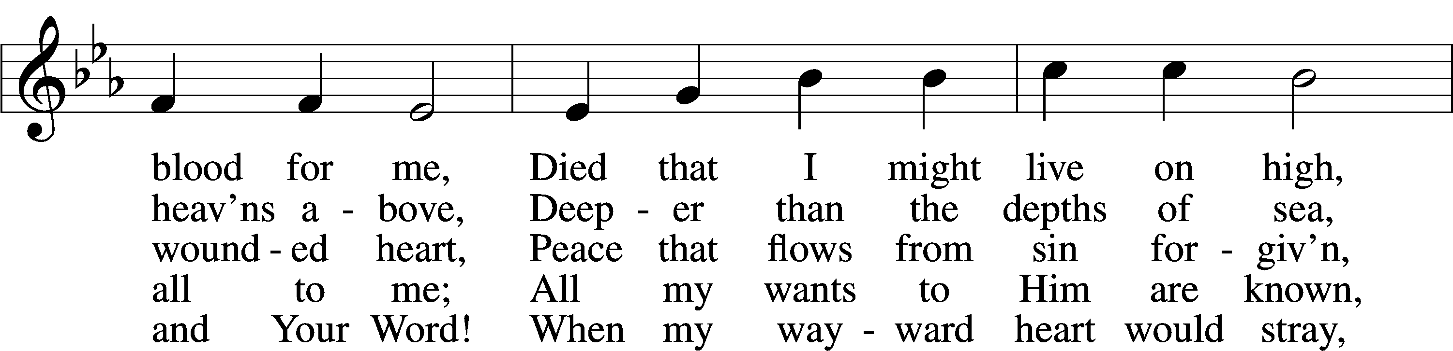
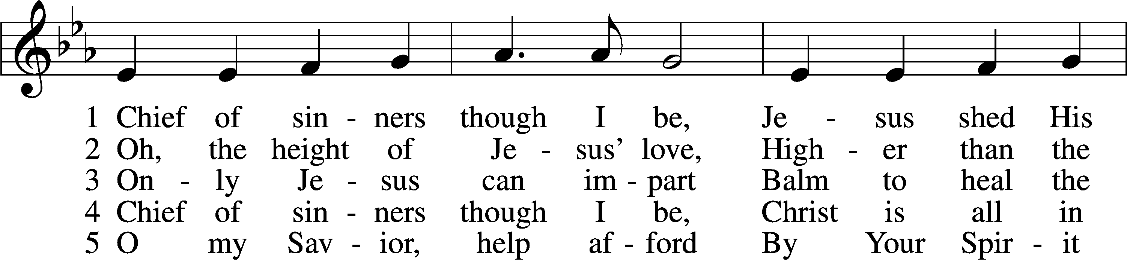

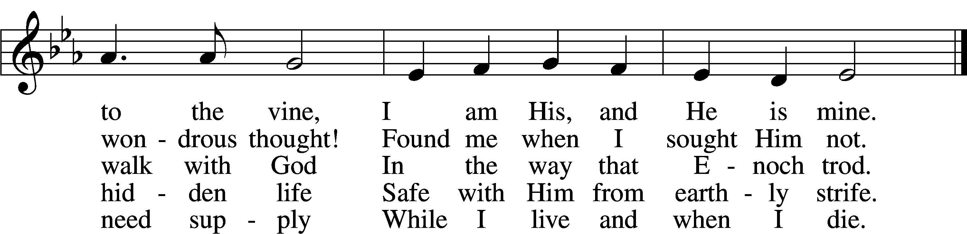
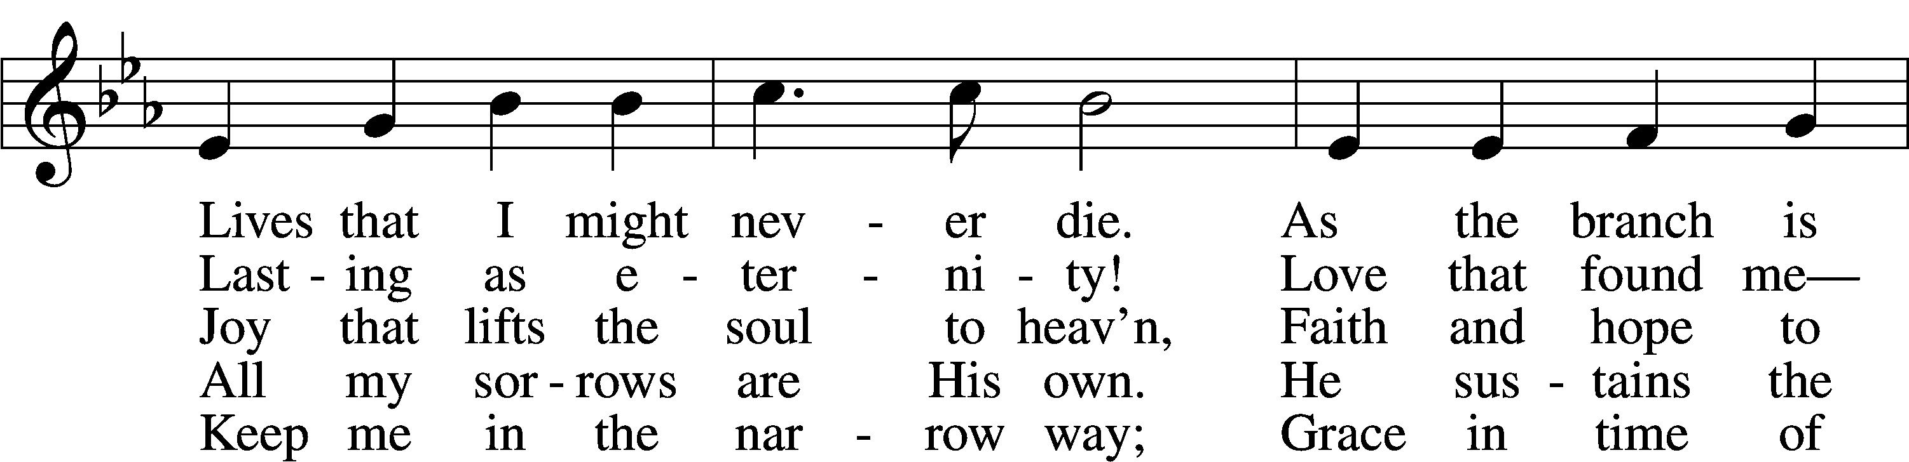

Text: William McComb, 1793–1873, alt. Tune: Richard Redhead, 1820–1901 Text and tune: Public domain

Stand

Invocation
P In the name of the Father and of the T Son and of the Holy Spirit.
C Amen.

P If we say we have no sin, we deceive ourselves, and the truth is not in us.
C But if we confess our sins, God, who is faithful and just, will forgive our sins and cleanse us from all unrighteousness.

Silence for reflection on God’s Word and for self-examination.

Confession of Sins LSB 151
P Let us then confess our sins to God our Father.
C Most merciful God, we confess that we are by nature sinful and unclean. We have sinned against You in thought, word, and deed, by what we have done and by what we have left undone. We have not loved You with our whole heart; we have not loved our neighbors as ourselves. We justly deserve Your present and eternal punishment. For the sake of Your Son, Jesus Christ, have mercy on us. Forgive us, renew us, and lead us, so that we may delight in Your will and walk in Your ways to the glory of Your holy name. Amen.
Absolution LSB 151
P Almighty God in His mercy has given His Son to die for you and for His sake forgives you all your sins. As a called and ordained servant of Christ, and by His authority, I therefore forgive you all your sins in the name of the Father and of the T Son and of the Holy Spirit.
C Amen.

Introit Psalm 56:10–13; antiphon: v. 3
When I | am afraid,*
I put my | trust in you.
In God, whose | word I praise,*
in the Lord, whose | word I praise,
in God I trust; I shall not | be afraid.*
What can man | do to me?
I must perform my vows to you, | O God;*
I will render thank offerings | to you.
For you have delivered my soul from death, yes, my feet from | falling,*
that I may walk before God in the | light of life.
Glory be to the Father and | to the Son*
and to the Holy | Spirit;
as it was in the be- | ginning,*
is now, and will be forever. | Amen.
When I | am afraid,*
I put my | trust in you.

Kyrie LSB 152
P In peace let us pray to the Lord.

P For the peace from above and for our salvation let us pray to the Lord.

P For the peace of the whole world, for the well-being of the Church of God, and for the unity of all let us pray to the Lord.

P For this holy house and for all who offer here their worship and praise let us pray to the Lord.

P Help, save, comfort, and defend us, gracious Lord.

Gloria in Excelsis LSB 154
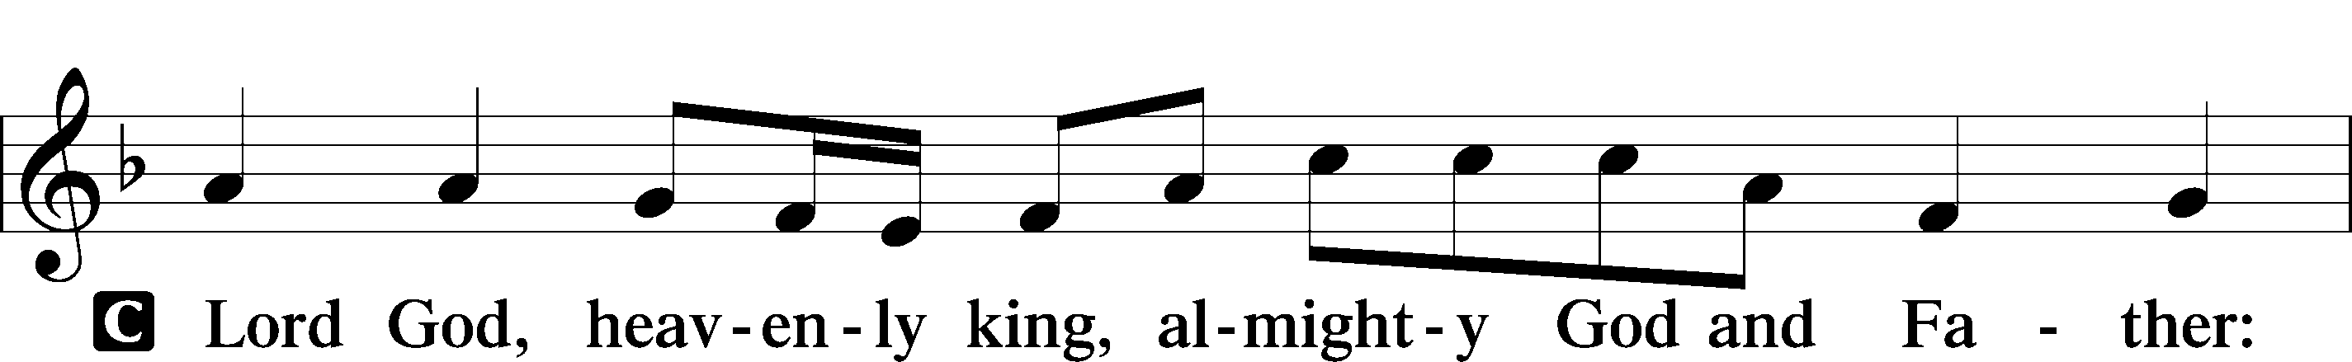
P Glory to God in the highest, and peace to His people on earth.

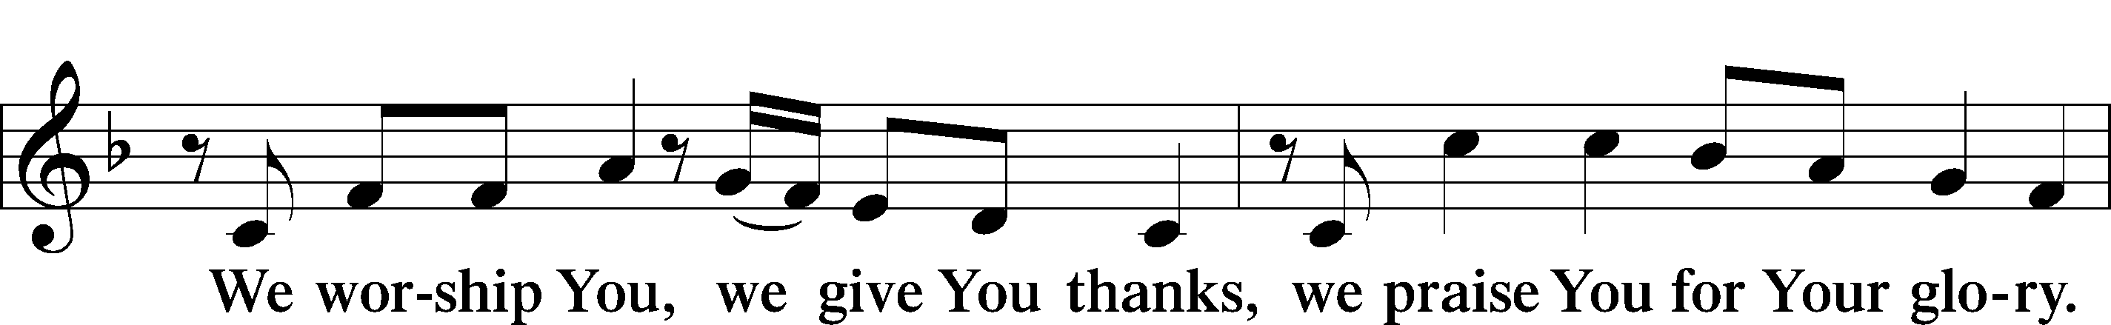

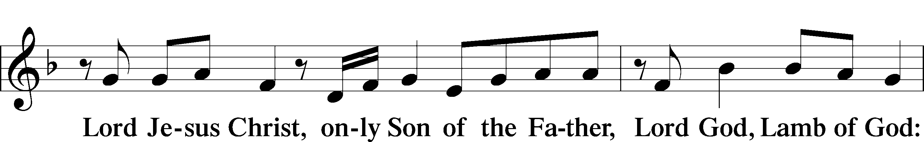

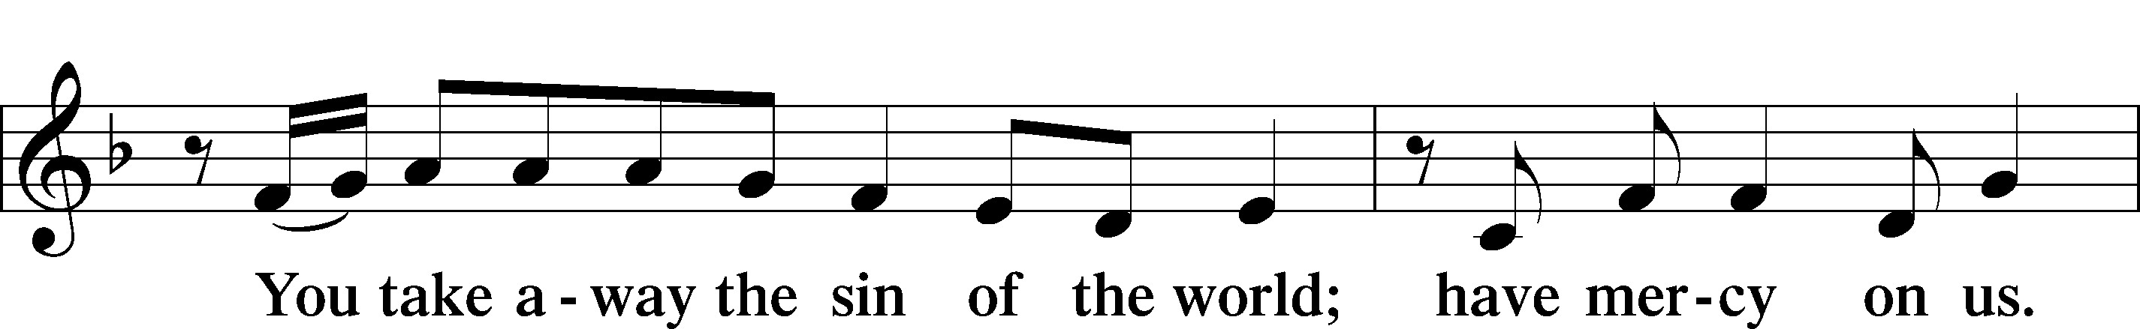

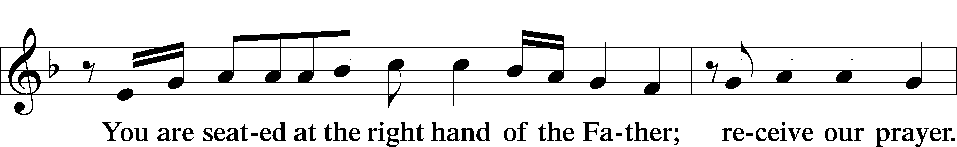

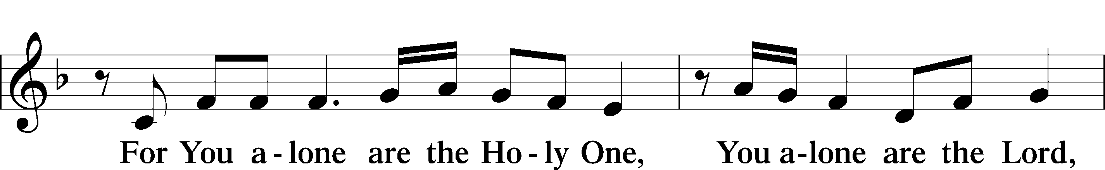

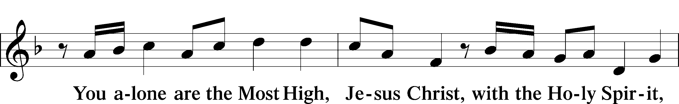

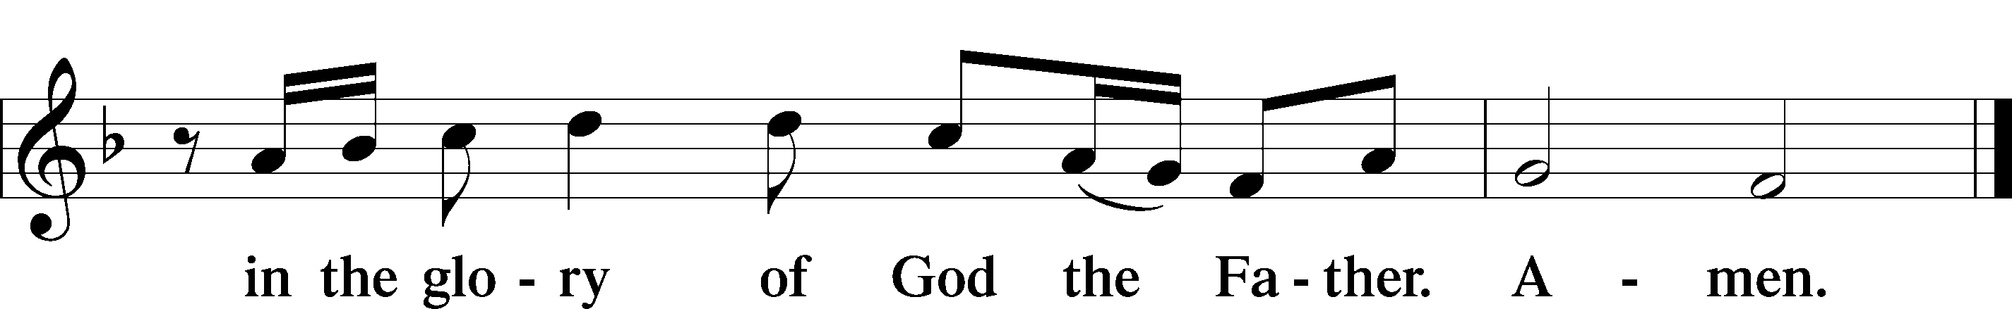

Salutation and Collect of the Day
P The Lord be with you.
C And also with you.
P Let us pray.
Almighty and everlasting God, You are always more ready to hear than we to pray and always ready to give more than we either desire or deserve. Pour down on us the abundance of Your mercy; forgive us those things of which our conscience is afraid; and give us those good things for which we are not worthy to ask except by the merits and mediation of Jesus Christ, Your Son, our Lord, who lives and reigns with You and the Holy Spirit, one God, now and forever.
C Amen.
Sit

Old Testament Reading Genesis 4:1–15
¹Now Adam knew Eve his wife, and she conceived and bore Cain, saying, “I have gotten a man with the help of the Lord.” ²And again, she bore his brother Abel. Now Abel was a keeper of sheep, and Cain a worker of the ground. ³In the course of time Cain brought to the Lord an offering of the fruit of the ground, ⁴and Abel also brought of the firstborn of his flock and of their fat portions. And the Lord had regard for Abel and his offering, ⁵but for Cain and his offering he had no regard. So Cain was very angry, and his face fell. ⁶The Lord said to Cain, “Why are you angry, and why has your face fallen? ⁷If you do well, will you not be accepted? And if you do not do well, sin is crouching at the door. Its desire is for you, but you must rule over it.”
⁸Cain spoke to Abel his brother. And when they were in the field, Cain rose up against his brother Abel and killed him. ⁹Then the Lord said to Cain, “Where is Abel your brother?” He said, “I do not know; am I my brother’s keeper?” ¹⁰And the Lord said, “What have you done? The voice of your brother’s blood is crying to me from the ground. ¹¹And now you are cursed from the ground, which has opened its mouth to receive your brother’s blood from your hand. ¹²When you work the ground, it shall no longer yield to you its strength. You shall be a fugitive and a wanderer on the earth.” ¹³Cain said to the Lord, “My punishment is greater than I can bear. ¹⁴Behold, you have driven me today away from the ground, and from your face I shall be hidden. I shall be a fugitive and a wanderer on the earth, and whoever finds me will kill me.” ¹⁵Then the Lord said to him, “Not so! If anyone kills Cain, vengeance shall be taken on him sevenfold.” And the Lord put a mark on Cain, lest any who found him should attack him.
P This is the Word of the Lord.
C Thanks be to God.

Gradual Psalm 91:11; 103:1
He will command his angels con- | cerning you*
to guard you in | all your ways.
Bless the Lord, | O my soul,*
and all that is within me, bless his | holy name!

Epistle 2 Timothy 4:6–8, 16–18
⁶For I am already being poured out as a drink offering, and the time of my departure has come. ⁷I have fought the good fight, I have finished the race, I have kept the faith. ⁸Henceforth there is laid up for me the crown of righteousness, which the Lord, the righteous judge, will award to me on that Day, and not only to me but also to all who have loved his appearing. . . .
¹⁶At my first defense no one came to stand by me, but all deserted me. May it not be charged against them! ¹⁷But the Lord stood by me and strengthened me, so that through me the message might be fully proclaimed and all the Gentiles might hear it. So I was rescued from the lion’s mouth. ¹⁸The Lord will rescue me from every evil deed and bring me safely into his heavenly kingdom. To him be the glory forever and ever. Amen.
P This is the Word of the Lord.
C Thanks be to God.

Stand

Alleluia and Verse LSB 156
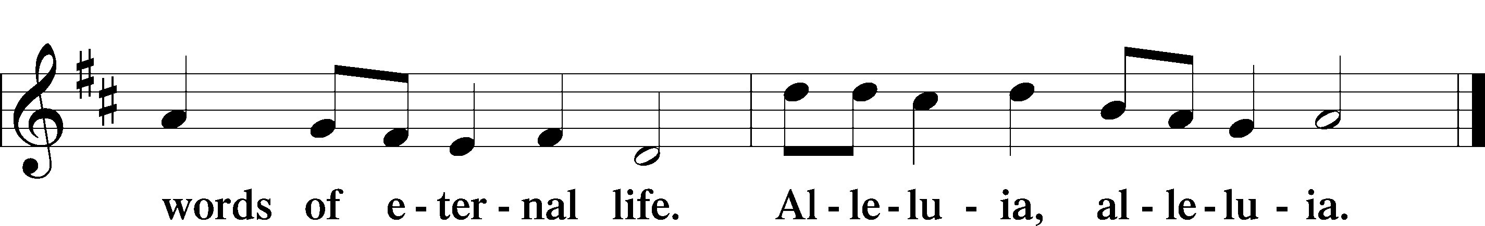
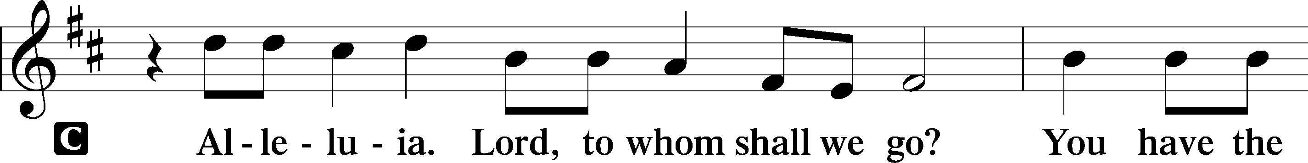

Holy Gospel Luke 18:9–17
P The Holy Gospel according to St. Luke, the eighteenth chapter.
C Glory to You, O Lord.
⁹[Jesus] also told this parable to some who trusted in themselves that they were righteous, and treated others with contempt: ¹⁰“Two men went up into the temple to pray, one a Pharisee and the other a tax collector. ¹¹The Pharisee, standing by himself, prayed thus: ‘God, I thank you that I am not like other men, extortioners, unjust, adulterers, or even like this tax collector. ¹²I fast twice a week; I give tithes of all that I get.’ ¹³But the tax collector, standing far off, would not even lift up his eyes to heaven, but beat his breast, saying, ‘God, be merciful to me, a sinner!’ ¹⁴I tell you, this man went down to his house justified, rather than the other. For everyone who exalts himself will be humbled, but the one who humbles himself will be exalted.”
¹⁵Now they were bringing even infants to him that he might touch them. And when the disciples saw it, they rebuked them. ¹⁶But Jesus called them to him, saying, “Let the children come to me, and do not hinder them, for to such belongs the kingdom of God. ¹⁷Truly, I say to you, whoever does not receive the kingdom of God like a child shall not enter it.”
P This is the Gospel of the Lord.
C Praise to You, O Christ.

Sit

745 In God, My Faithful God
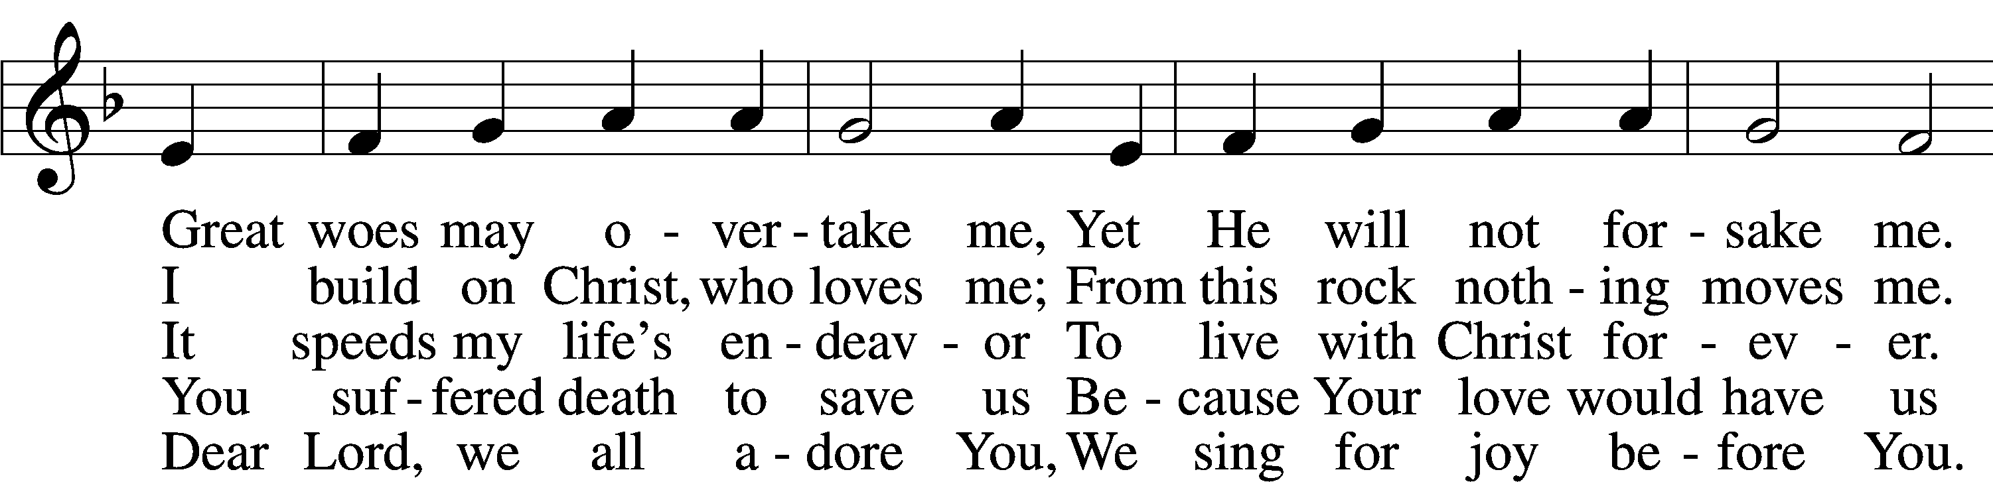
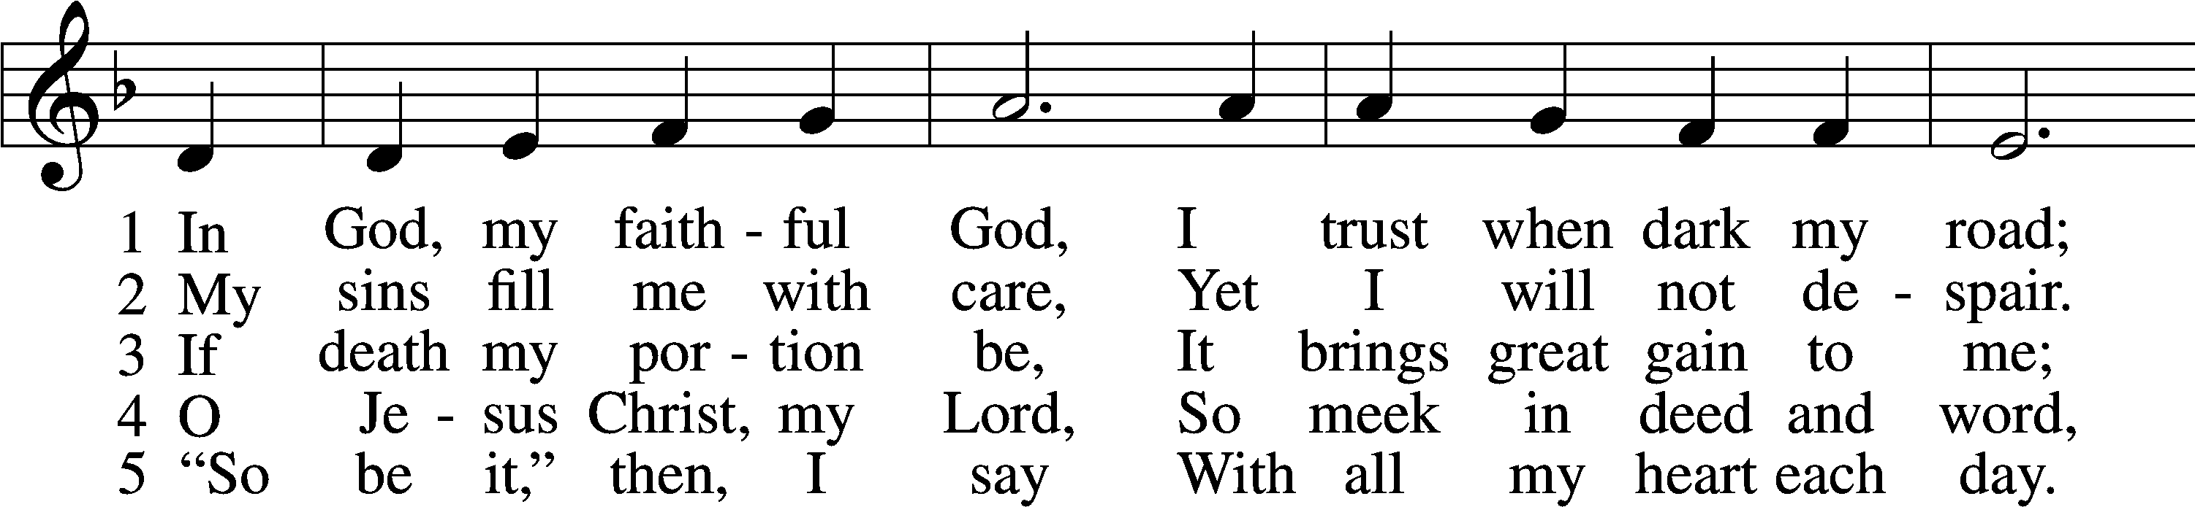

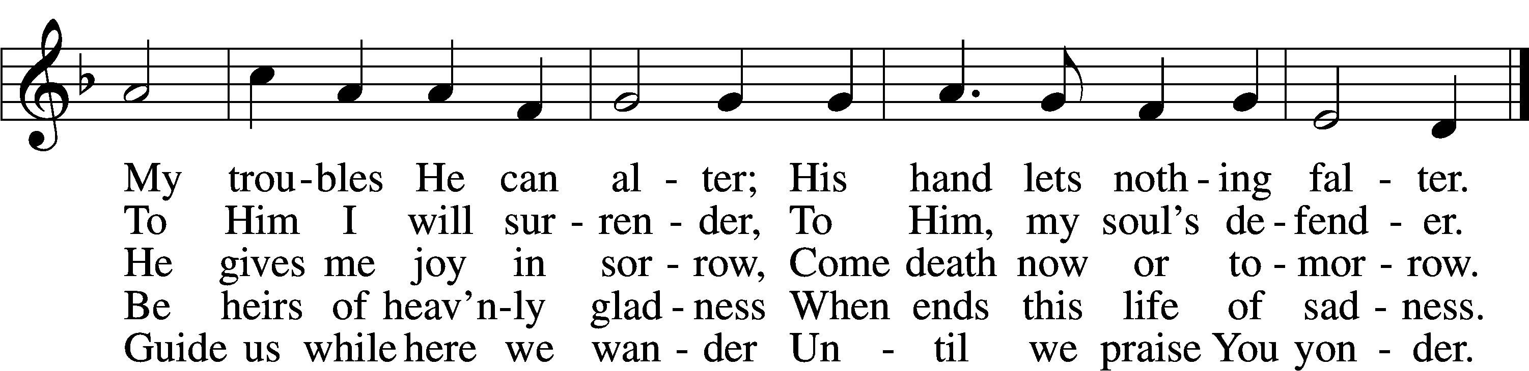
Text: Veer schöne nye Geistlike Leder, before 1603, Lübeck; tr. Catherine Winkworth, 1827–78, alt. Tune: Kurtzweilige teutsche Lieder, 1576, Nürnberg, alt. Text and tune: Public domai

Sermon

Stand

Nicene Creed
C I believe in one God,
the Father Almighty,
maker of heaven and earth
and of all things visible and invisible.
And in one Lord Jesus Christ,
the only-begotten Son of God,
begotten of His Father before all worlds,
God of God, Light of Light,
very God of very God,
begotten, not made,
being of one substance with the Father,
by whom all things were made;
who for us men and for our salvation came down from heaven
and was incarnate by the Holy Spirit of the virgin Mary
and was made man;
and was crucified also for us under Pontius Pilate.
He suffered and was buried.
And the third day He rose again according to the Scriptures
and ascended into heaven
and sits at the right hand of the Father.
And He will come again with glory to judge both the living and the dead,
whose kingdom will have no end.
And I believe in the Holy Spirit,
the Lord and giver of life,
who proceeds from the Father and the Son,
who with the Father and the Son together is worshiped and glorified,
who spoke by the prophets.
And I believe in one holy Christian and apostolic Church,
I acknowledge one Baptism for the remission of sins,
and I look for the resurrection of the dead
and the life T of the world to come. Amen.

Prayer of the Church

Sit

Consecration of the Offering
After the prayers please be seated. The altar is set for the Lord’s Supper and the offering is consecrated. As you prepare to receive the sacrament you may use the prayers in the front of the hymnal or meditate on a communion hymn.

Offertory LSB 159
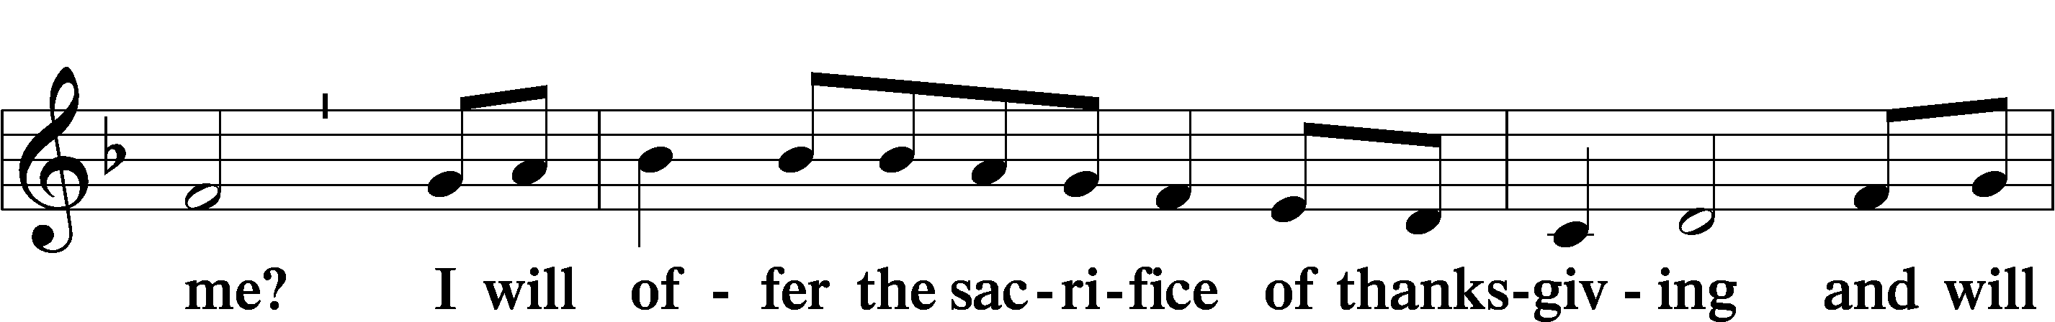
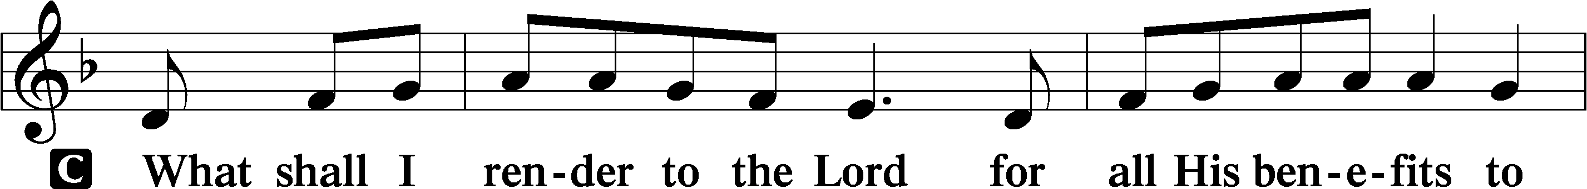

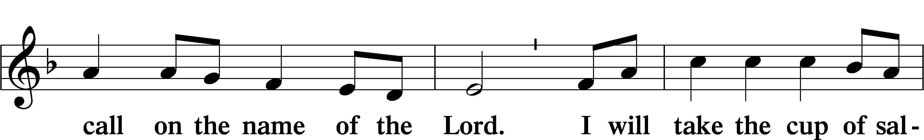

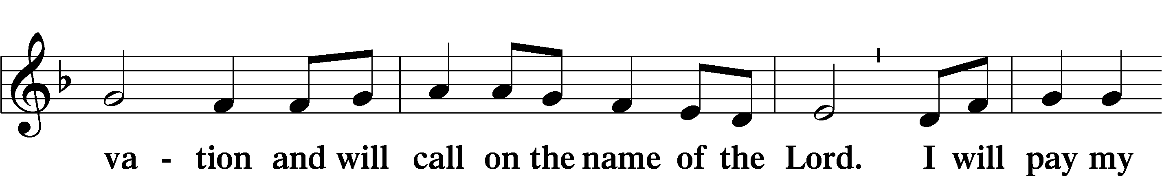

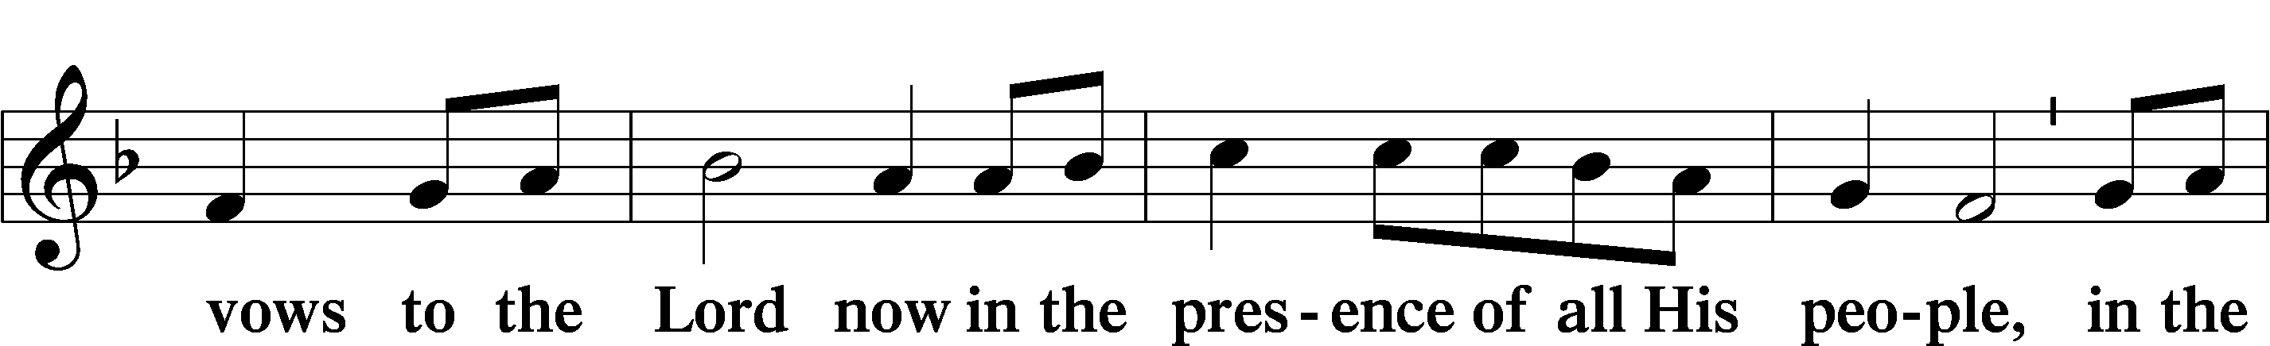

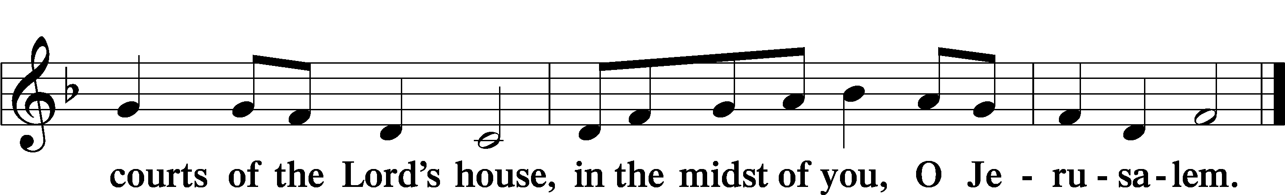

Stand
Service of the Sacrament
Preface LSB 160
P The Lord be with you.
C And also with you.

P Lift up your hearts.
C We lift them to the Lord.

P Let us give thanks to the Lord our God.
C It is right to give Him thanks and praise.

P It is truly good, right, and salutary that we should at all times and in all places give thanks to You, holy Lord, almighty Father, everlasting God, through Jesus Christ, our Lord, who, having created all things, took on human flesh and was born of the virgin Mary. For our sake He died on the cross and rose from the dead to put an end to death, thus fulfilling Your will and gaining for You a holy people. Therefore with angels and archangels and with all the company of heaven we laud and magnify Your glorious name, evermore praising You and saying:

Sanctus LSB 161
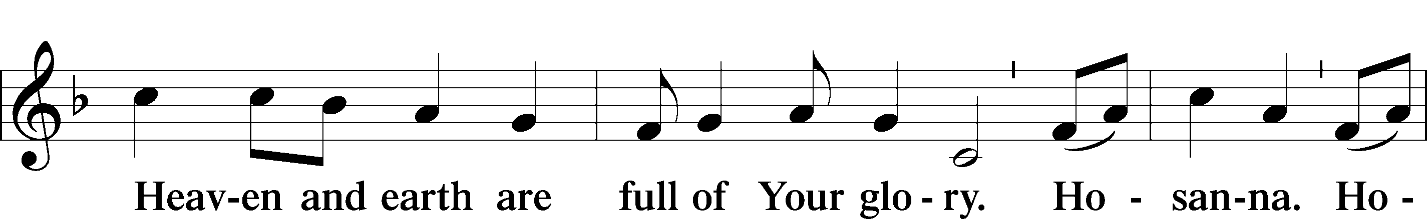
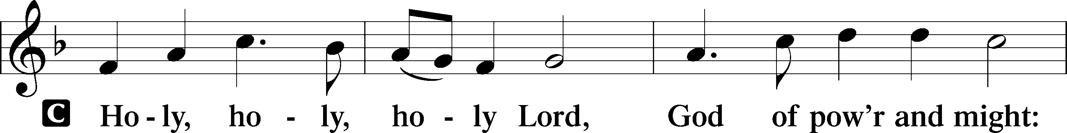

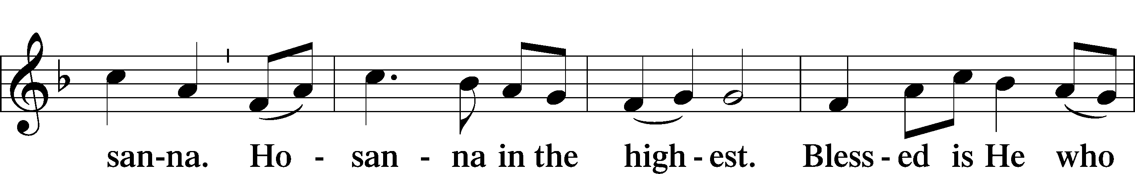

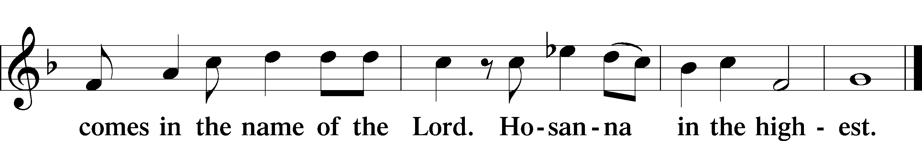

Lord’s Prayer
C Our Father who art in heaven,
hallowed be Thy name,
Thy kingdom come,
Thy will be done on earth
as it is in heaven;
give us this day our daily bread;
and forgive us our trespasses
as we forgive those
who trespass against us;
and lead us not into temptation,
but deliver us from evil.
For Thine is the kingdom
and the power and the glory
forever and ever. Amen.

The Words of Our Lord
P Our Lord Jesus Christ, on the night when He was betrayed, took bread, and when He had given thanks, He broke it and gave it to the disciples and said: “Take, eat; this is My T body, which is given for you. This do in remembrance of Me.”
In the same way also He took the cup after supper, and when He had given thanks, He gave it to them, saying: “Drink of it, all of you; this cup is the new testament in My T blood, which is shed for you for the forgiveness of sins. This do, as often as you drink it, in remembrance of Me.”

Pax Domini LSB 163
P The peace of the Lord be with you always.

Agnus Dei LSB 163
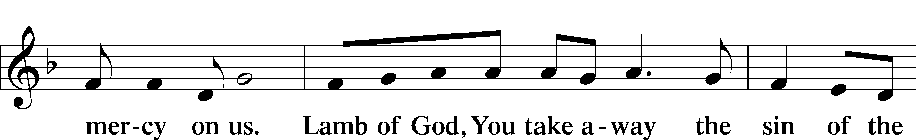
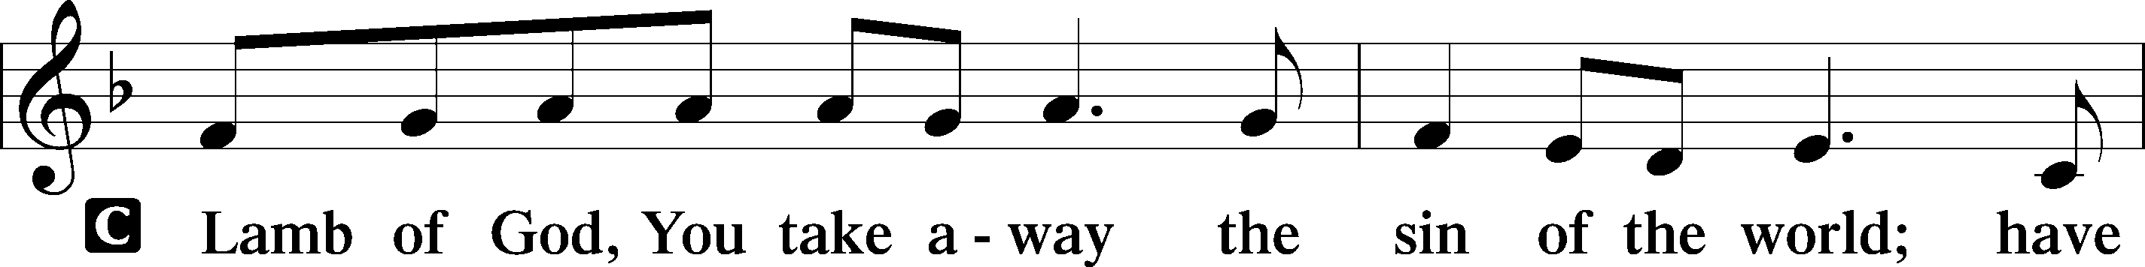

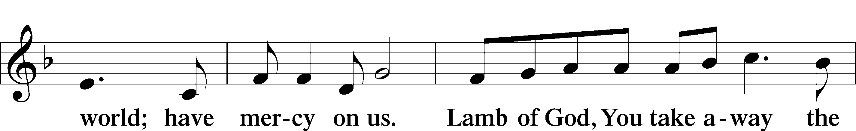

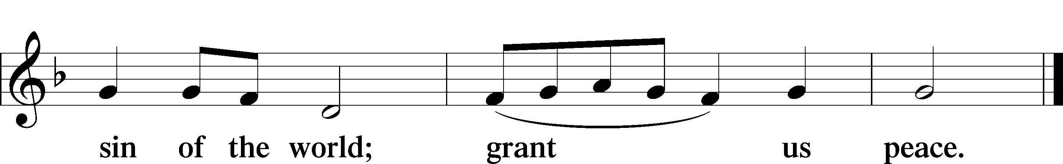

Sit

Distribution

616 Baptismal Waters Cover Me
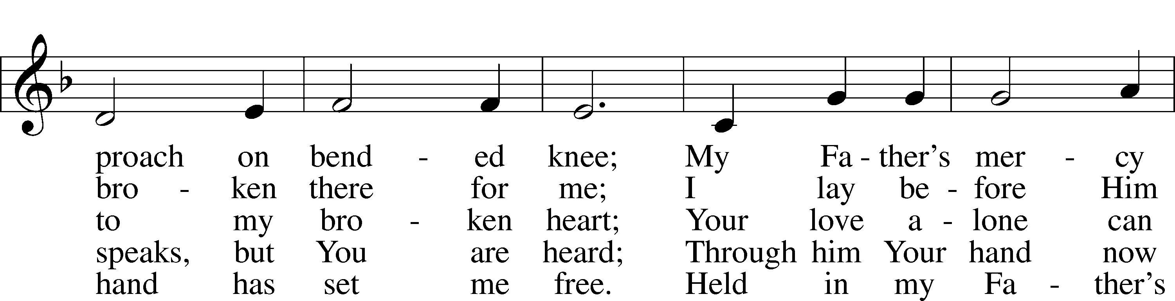
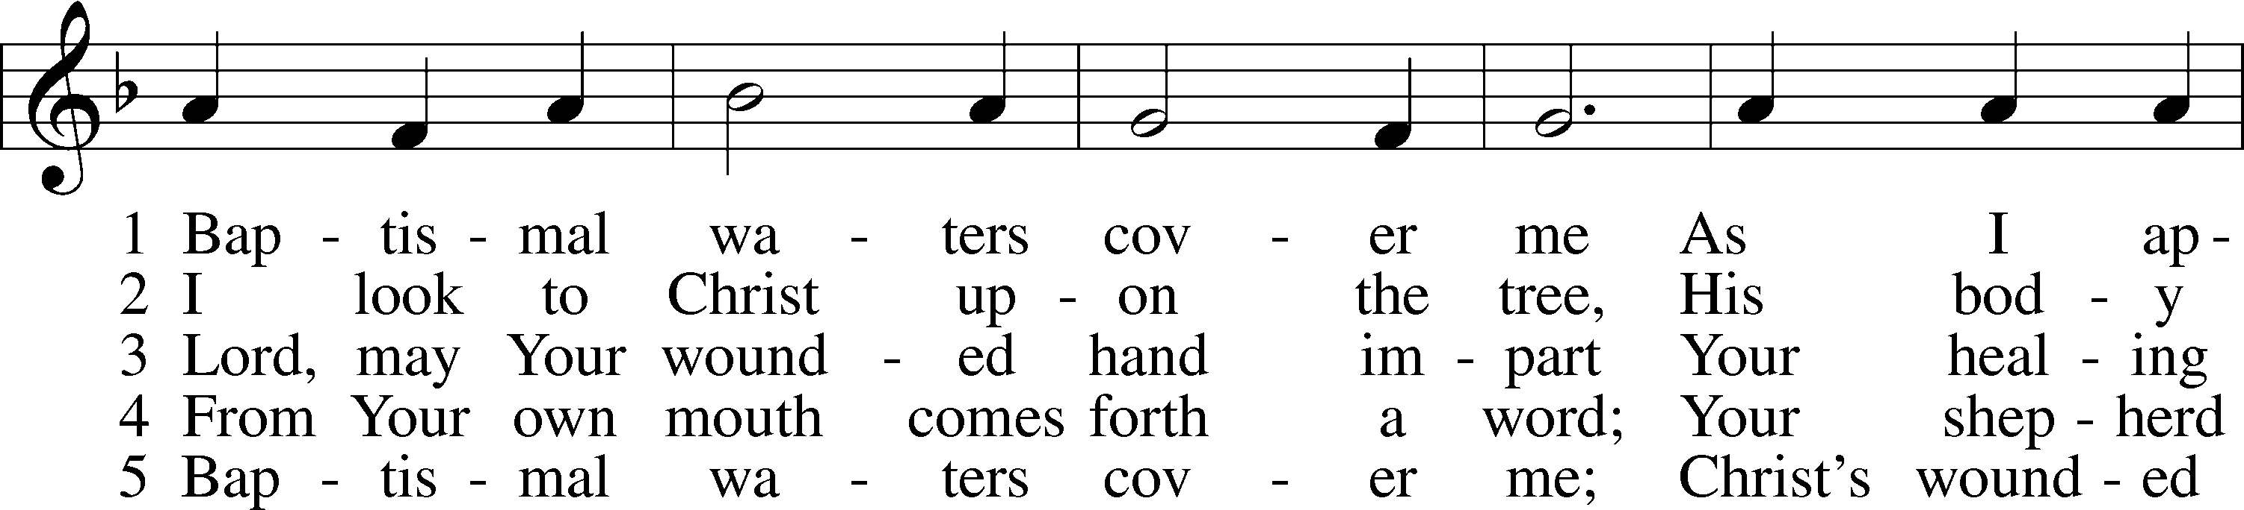

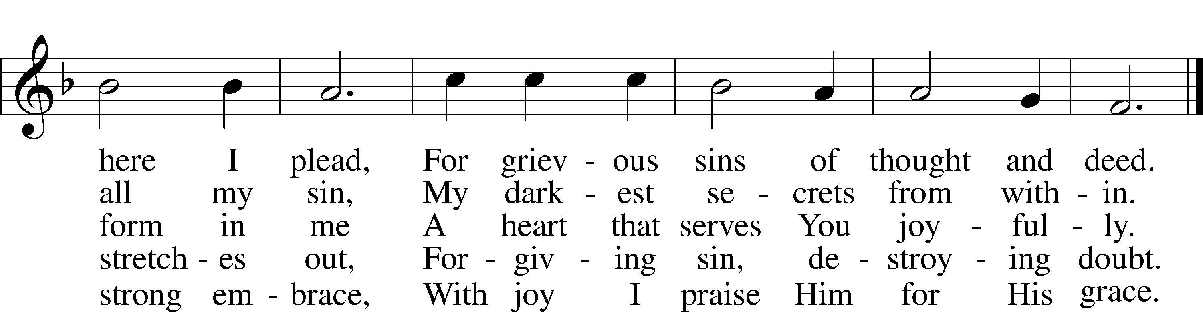

Text: Kurt E. Reinhardt, 1969 Tune: Sammlung alter und neuer . . . Melodien, 1742 Text: © 2003 Kurt E. Reinhardt. Used by permission: LSB Hymn License no. 110003744 Tune: Public domain

433 Glory Be to Jesus
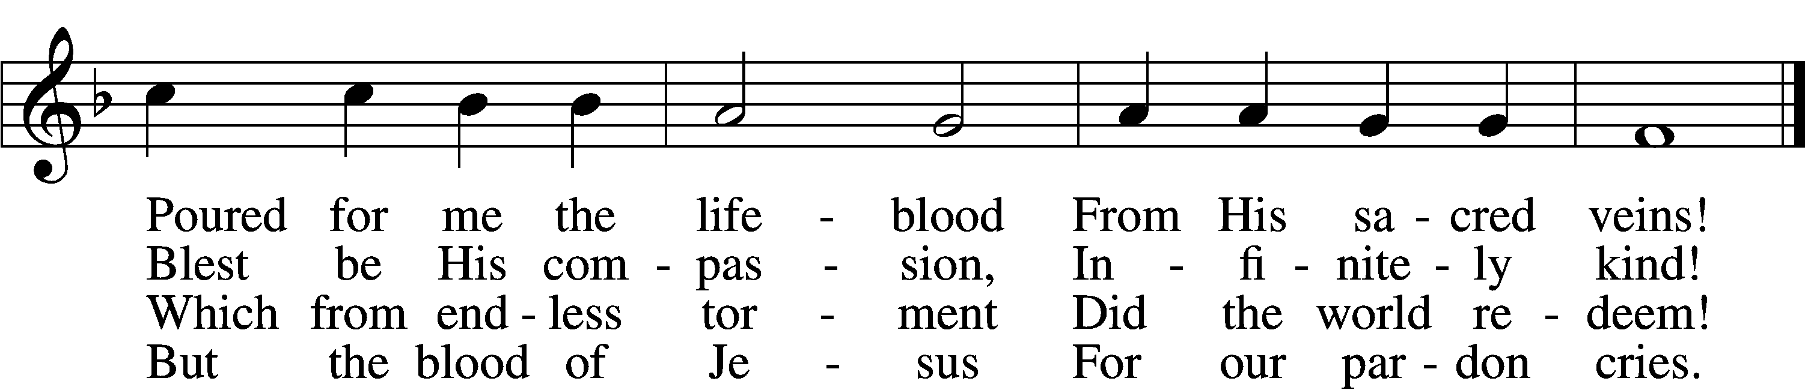
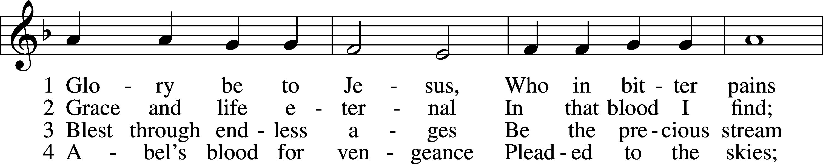

5 Oft as earth exulting
Wafts its praise on high,
Angel hosts rejoicing
Make their glad reply.
6 Lift we, then, our voices,
Swell the mighty flood;
Louder still and louder
Praise the precious blood!

Text: Italian, c. 18th cent.; tr. Edward Caswall, 1814–78, alt. Tune: Friedrich Filitz, 1804–76 Text and tune: Public domain

636 Soul, Adorn Yourself with Gladness
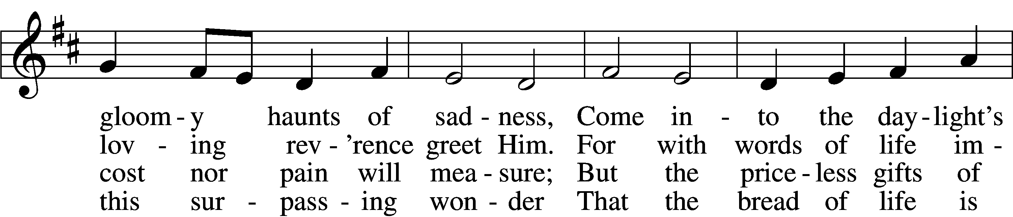
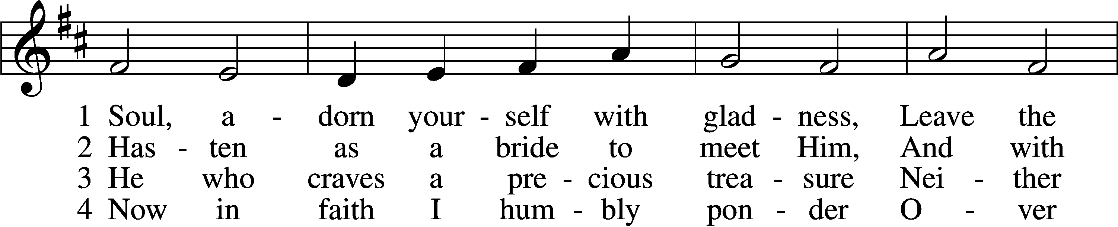

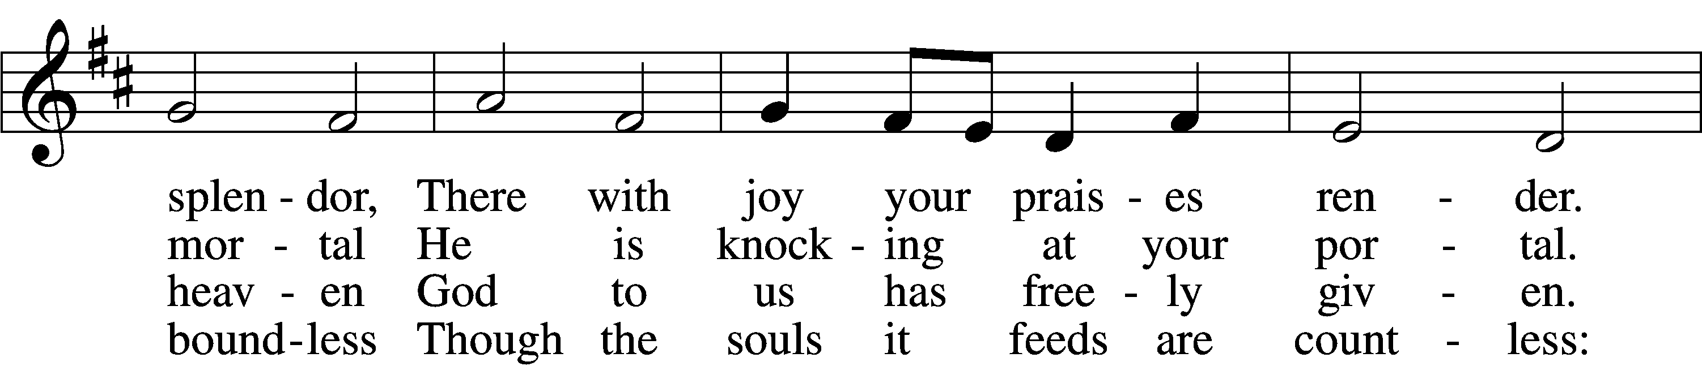

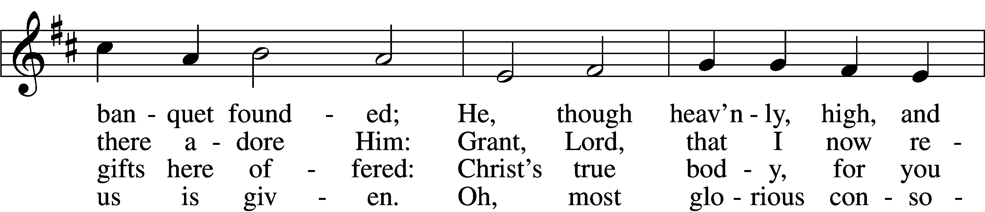
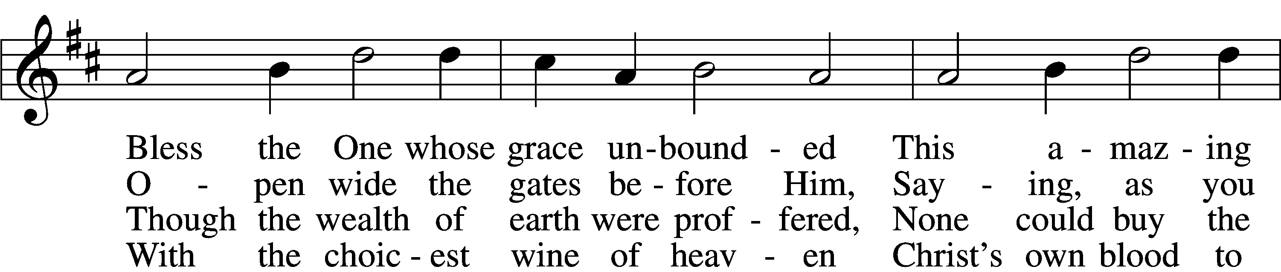

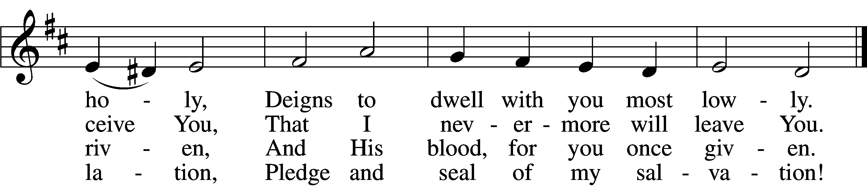

5 Jesus, source of lasting pleasure,
Truest friend, and dearest treasure,
Peace beyond all understanding,
Joy into all life expanding:
Humbly now, I bow before You;
Love incarnate, I adore You;
Worthily let me receive You
And, so favored, never leave You.

6 Jesus, sun of life, my splendor,
Jesus, friend of friends, most tender,
Jesus, joy of my desiring,
Fount of life, my soul inspiring:
At Your feet I cry, my maker,
Let me be a fit partaker
Of this blessèd food from heaven,
For our good, Your glory, given.

7 Lord, by love and mercy driven,
You once left Your throne in heaven
On the cross for me to languish
And to die in bitter anguish,
To forego all joy and gladness
And to shed Your blood in sadness.
By this blood redeemed and living,
Lord, I praise You with thanksgiving.

88 Jesus, bread of life, I pray You,
Let me gladly here obey You.
By Your love I am invited,
Be Your love with love requited;
By this Supper let me measure,
Lord, how vast and deep love’s treasure.
Through the gift of grace You give me
As Your guest in heav’n receive me.

Text: Johann Franck, 1618–77; (sts. 1, 4–5): tr. Lutheran Book of Worship, 1978; (sts. 2–3, 6–8): tr. Catherine Winkworth, 1827–78, alt.
Tune: Johann Crüger, 1598–1662 Text (sts. 1, 4–5): © 1978 Lutheran Book of Worship. Used by permission: LSB Hymn License no. 110003744 Text (sts. 2–3, 6–8) and tune: Public domain

684 Come unto Me, Ye Weary
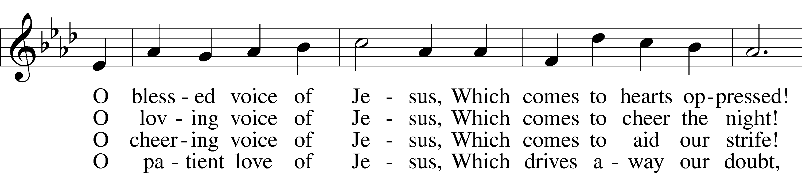
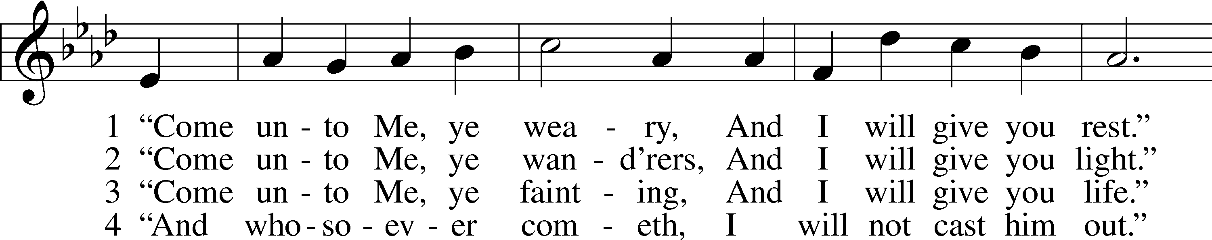

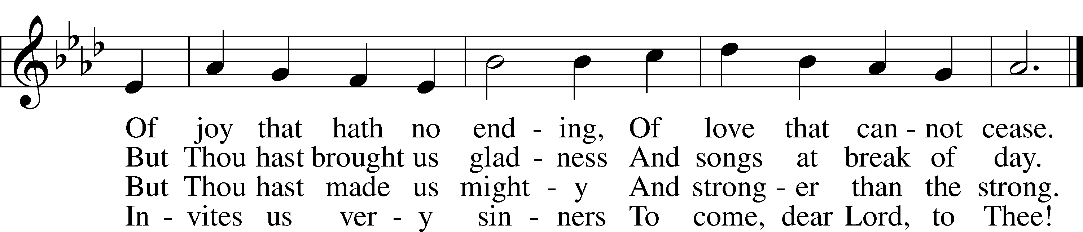
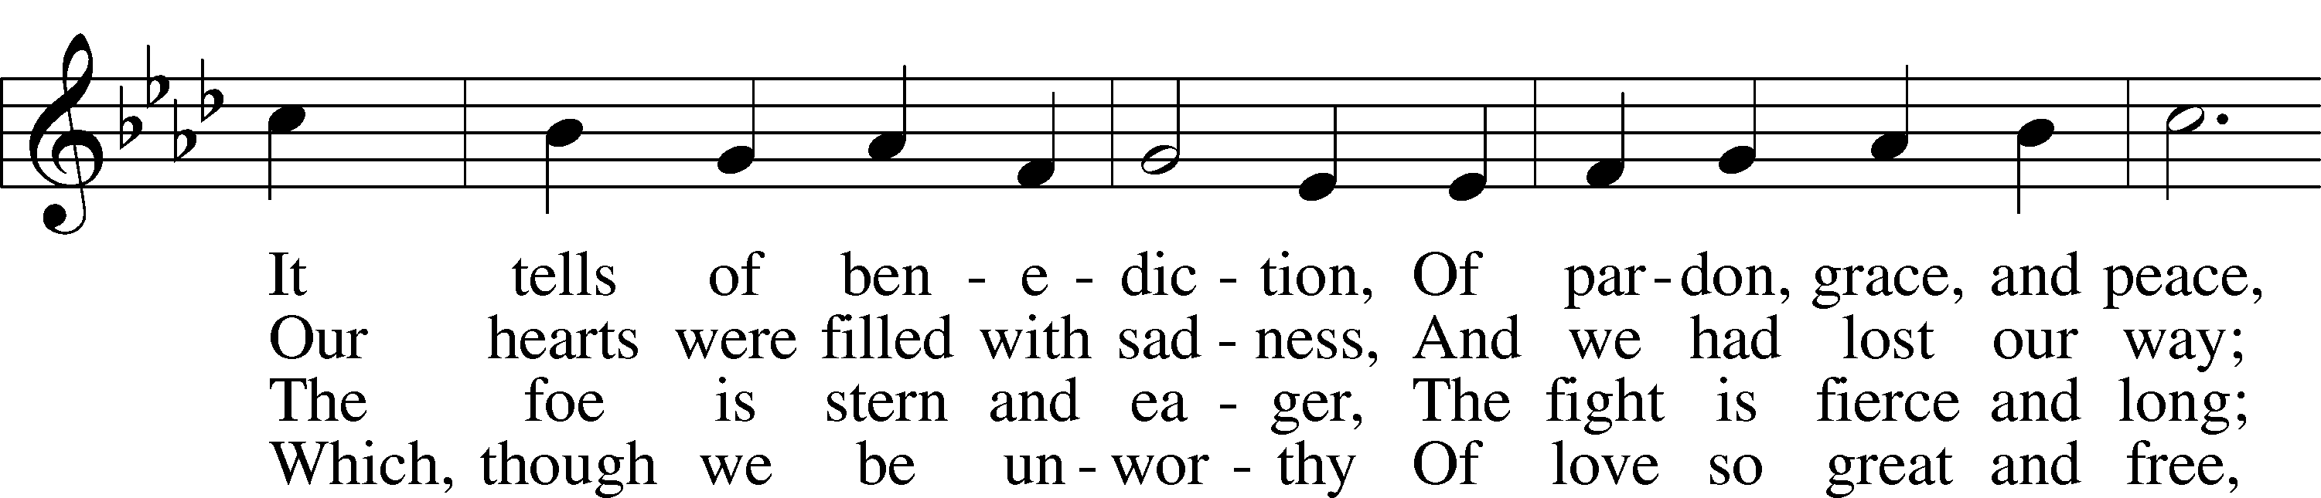

Text: William C. Dix, 1837–98, alt.
Tune: Friedrich K. Anthes, 1812–after 1857
Text and tune: Public domain

Stand

The Dismissal
P The body and blood of our Lord Jesus Christ strengthen and preserve you in body and soul to life everlasting. Depart T in peace.
C Amen.

Thank the Lord LSB 164
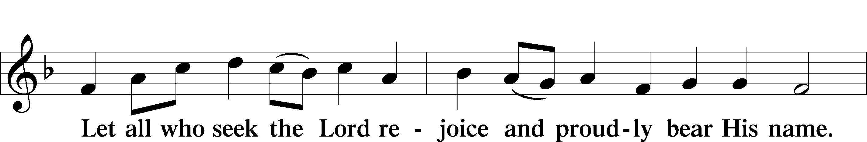
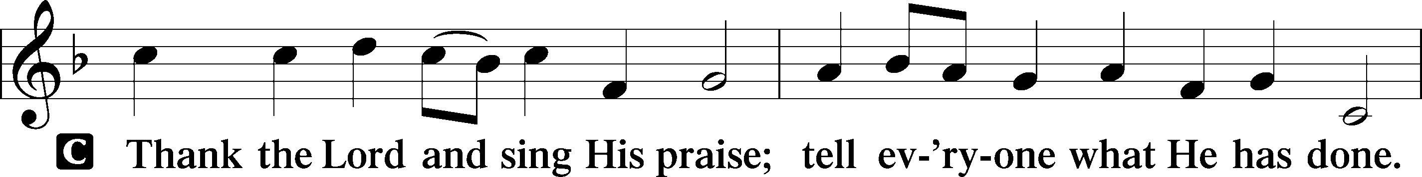

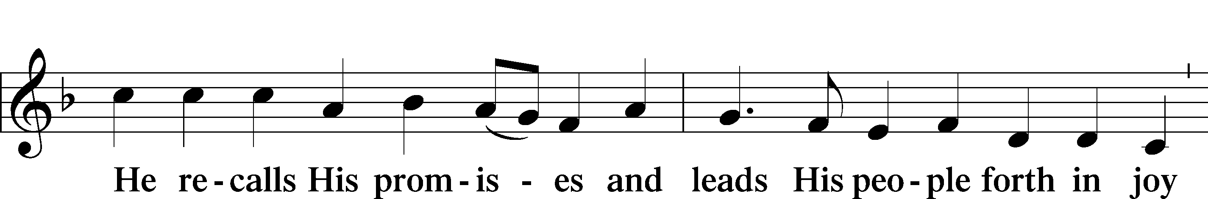

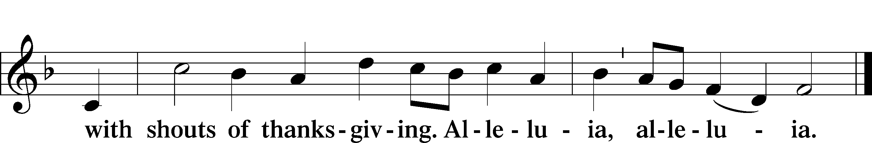

Post-Communion Collect
P Let us pray.
We give thanks to You, almighty God, that You have refreshed us through this salutary gift, and we implore You that of Your mercy You would strengthen us through the same in faith toward You and in fervent love toward one another; through Jesus Christ, Your Son, our Lord, who lives and reigns with You and the Holy Spirit, one God, now and forever.
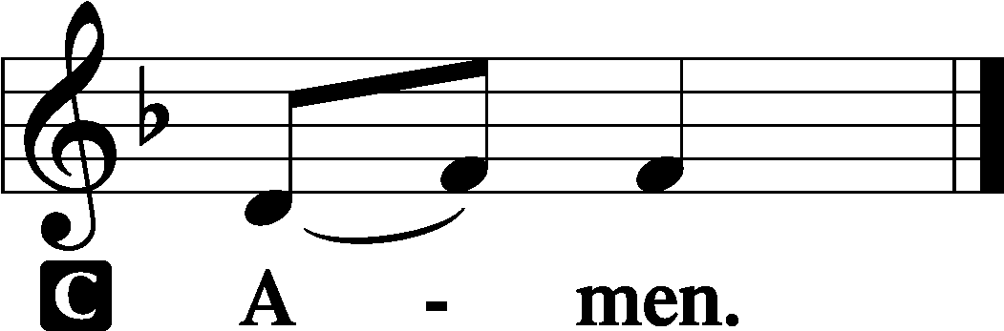

Benediction LSB 166
P The Lord bless you and keep you.
The Lord make His face shine on you and be gracious to you.
The Lord look upon you with favor and T give you peace.

702 My Faith Looks Up to Thee
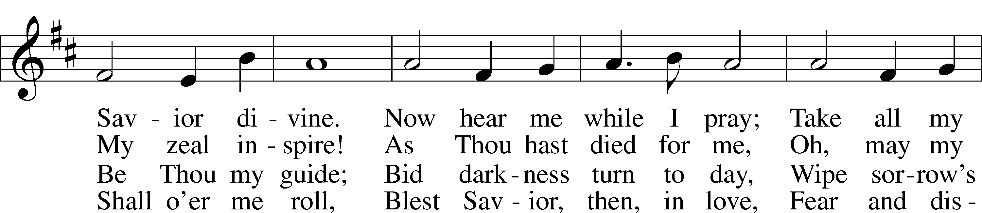
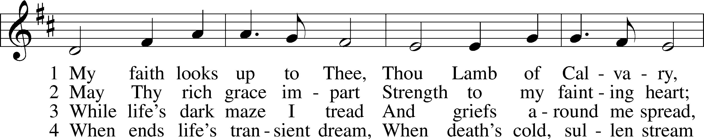

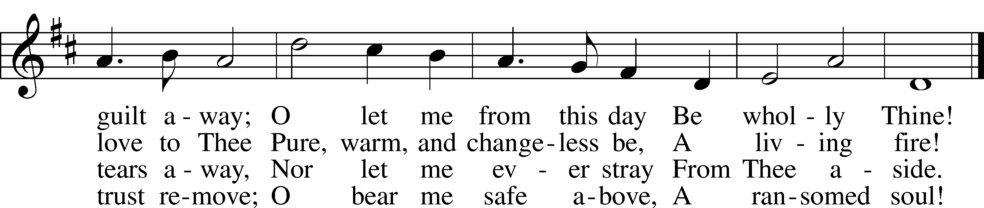
Text: Ray Palmer, 1808–87 Tune: Lowell Mason, 1792–1872 Text and tune: Public domain

Acknowledgments
Unless otherwise indicated, Scripture quotations are from the ESV® Bible (The Holy Bible, English Standard Version®), copyright © 2001 by Crossway, a publishing ministry of Good News Publishers. Used by permission. All rights reserved.
Created by Lutheran Service Builder © 2021 Concordia Publishing House.

Prayers for Our Members
Norman Abels (Brookestone Meadows–Elkhorn) | Healing
Judy Ahrens | Healing
Vaughn Albrecht (Mount Carmel) | Healing
Tom & DyAnn Altwine | Healing
Lyle Colsden (Mother Hull) | Healing
Pat Flodine (Cambridge Court) | Healing
Vi Fox (Prairie View) | Healing
Wanda Glanzer | Healing
Jan Hatfield | Healing
Ruby Hatfield | Healing
Evelyn Heiden (Mother Hull) | Healing
Sue Kaiser | Healing
Linda Luhn | Healing
Jackie Ohlmann | Healing
Diane Plummer | Healing
Debra Schinkel | Healing
Robin Baker | Cancer
Ivan Bombeck | Cancer
Bertha Marienau | Cancer

Prayers for Our Members’ Family & Friends
Roger Young (Tiffany Davis’ father) | Parkinson’s
Deb Engles (Lorelie’s sister) | Healing
Paul Hanneman (Lorelie’s brother) | Healing
Roger Hoffman (Marc’s father) | Healing
Luetta Lammers (Ruby Hatfield’s sister) | Healing
LeRoyce Margaritz (brother of Wanda Glanzer) | Healing
Tim Powers (Kim Wilken’s brother) | Healing
Howard Quandt (Don & Shirley Helmbrecht’s family) | Healing
David & Carol Shiers (Jessica’s parents) | Healing
Randy Solomon (Beth Rosenthal’s father) | Healing
Jonah (Jase & Jarren Blattner’s friend) | Cancer
Glenda Fichtner (Ruby Hatfield’s niece) | Cancer
Ron Halvorsen (Jeff’s dad) | Cancer
Sharon Mulhair (Pam Uhlir’s cousin) | Cancer
Milton Naprstek (Marilyn Fuqua’s brother) | Cancer
Cindy Pietsch (Ellen’s sister-in-law) | Cancer
Rick Schnacker (Marilyn Fuqua’s nephew) | Cancer
Tyrone Uhlir (Pam’s nephew) | Cancer
Ray Vang (Don & Shirley Helmbrecht’s brother-in-law) | Cancer
Our Response to the Gospel
Date: 10/16/2022
Offering: $4,155
Weekly Need: $7,500
Offering Options:
To worship the Lord with your offering:
1) Place your offering in the offering plate as you enter or leave.
2) Go to zionkearney.churchtrac.com/give
3) Go to zionkearney.com and click on the ChurchTrac icon
4) Mail your gift to Zion Lutheran Church, 2421 C Ave, Kearney, NE 68847 or place it in the mail slot on the south side of the building.
Today’s Radio Broadcast is sponsored by the Oertwig Family, in memory of Fred and Merna.

Worship Assistants

Sunday, October 23rd – 9:00am
Elder: Bruce Brooks  Acolyte: Miriam Gaunt  Announcer: Brooke Fisher | Usher: Mike Wilkens  Engineer: Jamie Nikodym  Altar Guild: Shirley & Jami Helmbrecht
Sunday, October 30th – 9:00am
Elder: Eric Rosenthal  Acolyte: Lauren Starkey  Announcer: Lonna Gronewoller | Usher: Andy Wollberg  Engineer: Zach DeLoach  Altar Guild: Shirley & Jami Helmbrecht

ZION LUTHERAN CHURCH AND SCHOOL

Pr. James DeLoach, Pastor + (308) 627-5260
james.deloach@zionkearney.org
Pr. Doug Gaunt, Pastor + (308) 455-0552
doug.gaunt@zionkearney.org
Tony Splittgerber, Principal + (308) 293-0168
anthony.splittgerber@zionkearney.org

Church Office
Administrative Assistant: Holly Reid
Email: school@zionkearney.org
Phone: (308)-234-3410 Fax: (308) 236-8100
Office Hours: Monday-Friday 8:00am-4:00pm
Radio Broadcast: Sunday @ 10:30 a.m. on 1460 AM
Website: www.zionkearney.com
This Week at Zion
Sun 10/23 | 9:00a  10:30a  10:30a  5:00p  Birthdays | Divine Service  Adult Bible Study & Sunday School  Radio Broadcast  1460AM & 92.1FM  Divine Service  Nancy Dissmeyer
Mon 10/24
Tues 10/25 | 1:30p | Sleeping Mats
Wed 10/26 | 8:30a  5:30p  7:00p | Chapel  Midweek  Adult Choir
Thurs 10/27 | Birthdays | Eleanor Baker
Fri 10/28 | Anniversaries | No School – Teacher Inservice  Ken & Ellen Hockemeier
Sat 10/29 | 1p-4p | UNK Homecoming –  Check in Location  School Carnival
Sun 10/30 | 9:00a  10:30a  10:30a  3:00p  5:00p  6:00p  Birthdays | Divine Service  Adult Bible Study & Sunday School  Radio Broadcast  1460AM & 92.1FM  Smith Baby Shower - FH  Divine Service  Circuit Reformation Service @ HC  Marla Hartmann

Announcements for October 23rd, 2022

Circuit Reformation Service: Holy Cross will be hosting the Circuit Reformation service this year. It will take place on October 30th at 6pm with a pie social afterward. Rev. Dr. Brian Gauthier from Concordia University Seward will be the guest speaker.

Youth Group Parents: The Board of Youth is interested in your feedback, please use the QR code to reach a Google Form. This form also gives preliminary information on the Higher Things Conference for summer 2023.

Pastor Appreciation Month: October has traditionally been designated as Pastor Appreciation Month — an opportunity for congregations to express, in various ways, our thankfulness to the shepherds who care for us. Pastor DeLoach and Pastor Gaunt serve Zion and the community in countless ways. Please consider expressing your appreciation with a card, note, or words of encouragement, and remember them in your prayers in October or any other time of the year. May God grant them continued grace and mercy in His service.

Sunday School: The Board of education is looking for volunteers to teach or help with teaching Sunday school. We are looking for 3 -pre-K, K – 2nd and 3rd–5th class teachers, subs or helpers. If you would be willing to teach or be a helper, please contact the office or Matt Hodgson (308)627-7732 -matthodgson1@hotmail.com

Radio Broadcast & Altar Flowers: The sign-up sheets for the radio broadcast and altar flowers are up by the mailboxes. Please help Zion spread the Gospel and decorate the sanctuary.

SCHOOL NEWS
School Carnival: The annual school carnival will be this Saturday, October 29th from 1p-4p. Costumes are allowed but please help your children make good choices about appropriate costumes to wear. Tickets are $0.25 each and participants earn stamps in order to purchase prizes. Volunteers are needed in many areas of the carnival. Contact the offices to help with organizing the food stand, run games, donate cakes and/or king-size candy bars, etc.

Receipts: Remember to save your grocery receipts, UPC codes and Coke rewards codes. Family Fresh register receipts (all year) and Apple Market receipts (dated September 1 through March 31 of each year) Best Choice UPC (Apple Market & Boogaarts private label) and Our Family UPC (Family Fresh private label) Coke Rewards codes from 20 oz, .5 L, 1.25 L, 2 L, Fridge packs and 24 packs. Just drop them in the small container by the south parking lot door.

