Divine Service

Eleventh Sunday after Pentecost
August 21st, 2022
Zion Lutheran Church
Kearney, Nebraska

Welcome to Zion!
Guests please record your attendance on a card in the pew rack and let us know how we can be of service to you.

Holy Communion at Zion

The Lord’s Supper is celebrated at this congregation as Jesus has given it. As he says, our Lord gives into our mouths not only bread and wine but his very body and blood to eat and to drink for the forgiveness of sins and to strengthen our union with him and with one another. Our Lord invites to his table those who trust his words, repent of all sin, and set aside any refusal to forgive and love as he forgives and loves us, that they may show forth his death until he comes. All communicants need to register in the narthex prior to the service.

Because those who eat and drink our Lord’s body and blood unworthily do so to their great harm and because Holy Communion is a confession of the faith which is confessed at this altar, any who are not yet instructed, in doubt, or who hold a confession differing from that of this congregation and The Lutheran Church—Missouri Synod, are asked not to commune until they are able to speak with our pastor first. He is happy to visit with you about the Christian faith and how to receive the Lord’s Supper for your good and for the good of others. Those not communing are invited to come to the altar, cross your arms in front of you, and bow your head to receive a pastoral blessing.

The Cross of Christ Is the Way into the Kingdom of God
With the cross of Christ, the time has come “to gather all nations and tongues” (Is. 66:18). The sign of the cross is set forth in the preaching of the Gospel, the declaration of the Lord’s glory “among the nations” (Is. 66:19). Many “will come from east and west, and from north and south, and recline at table in the kingdom of God” (Luke 13:29), but only by the narrow way of the cross. Those who refuse to follow Christ crucified will ultimately find only “weeping and gnashing of teeth” (Luke 13:28), whereas Christ’s disciples, called from all the nations, will eat and drink with Abraham, Isaac and Jacob in the kingdom of God. They will come into “the city of the living God, the heavenly Jerusalem” (Heb. 12:22).

915 Today Your Mercy Calls Us
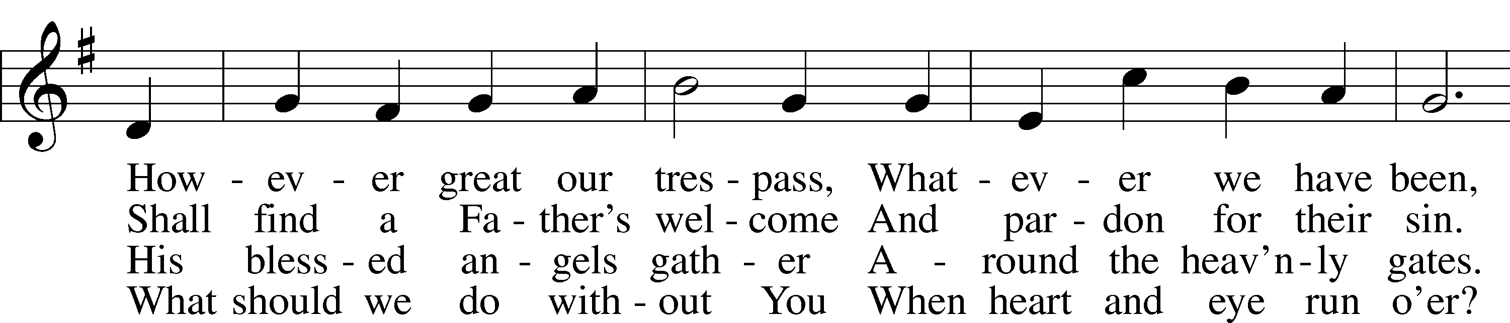
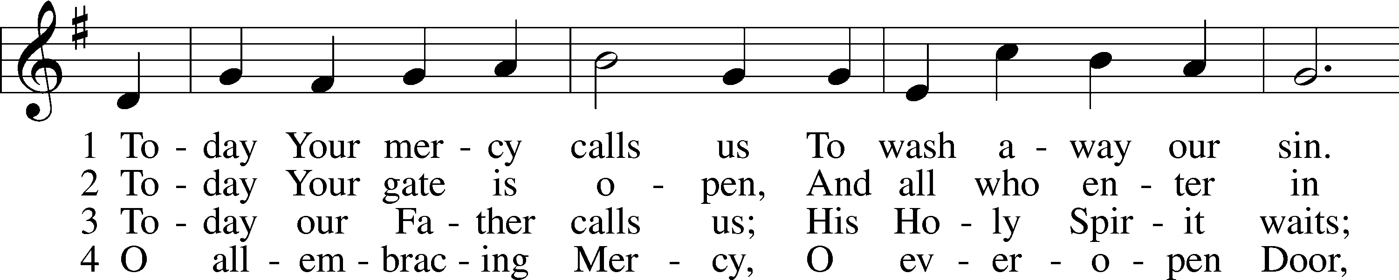

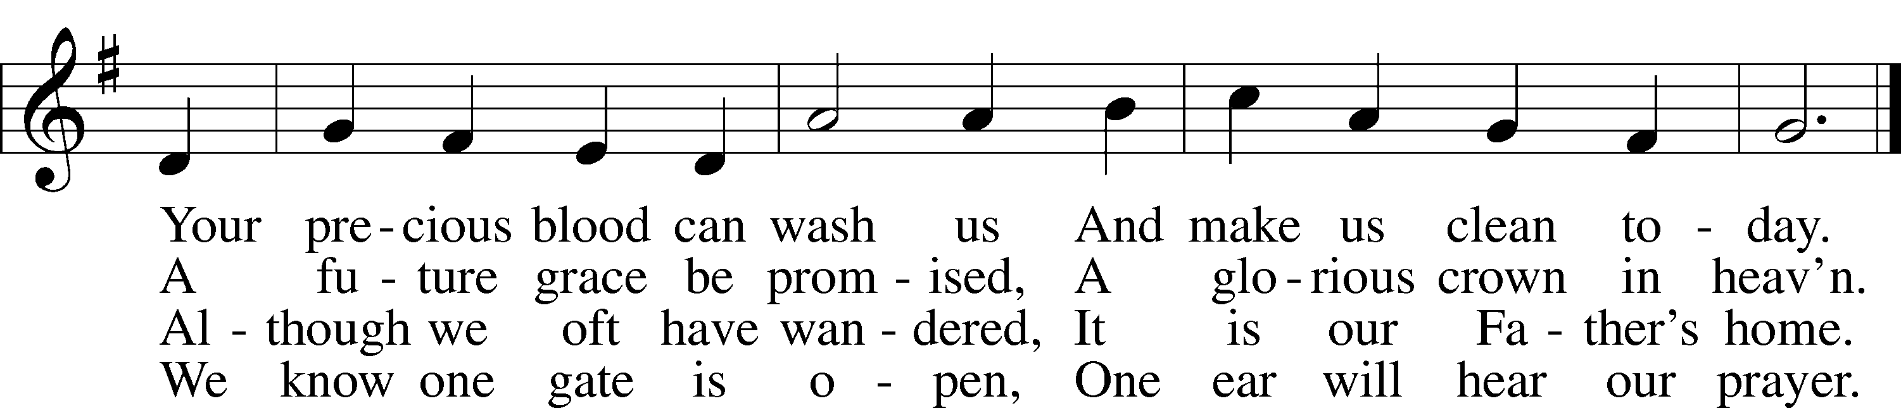
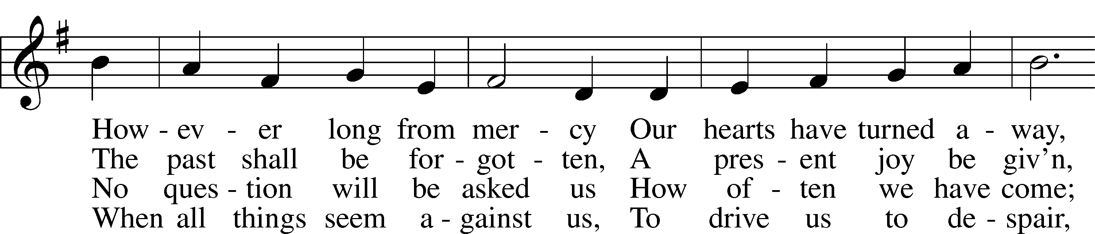

Text: Oswald Allen, 1816–78, alt. Tune: Friedrich K. Anthes, 1812–after 1857 Text and tune: Public domain

Stand

Invocation
P In the name of the Father and of the T Son and of the Holy Spirit.
C Amen.

P If we say we have no sin, we deceive ourselves, and the truth is not in us.
C But if we confess our sins, God, who is faithful and just, will forgive our sins and cleanse us from all unrighteousness.

Silence for reflection on God’s Word and for self-examination.

Confession of Sins LSB 151
P Let us then confess our sins to God our Father.
C Most merciful God, we confess that we are by nature sinful and unclean. We have sinned against You in thought, word, and deed, by what we have done and by what we have left undone. We have not loved You with our whole heart; we have not loved our neighbors as ourselves. We justly deserve Your present and eternal punishment. For the sake of Your Son, Jesus Christ, have mercy on us. Forgive us, renew us, and lead us, so that we may delight in Your will and walk in Your ways to the glory of Your holy name. Amen.

Absolution LSB 151
P Almighty God in His mercy has given His Son to die for you and for His sake forgives you all your sins. As a called and ordained servant of Christ, and by His authority, I therefore forgive you all your sins in the name of the Father and of the T Son and of the Holy Spirit.
C Amen.
Service of the Word
Introit Psalm 117; antiphon: Psalm 96:6a; 115:18
Splendor and majesty are be- | fore him;*
we will bless the Lord from this time forth and forevermore. | Praise the Lord!
Praise the Lord, all | nations!*
Extol him, all | peoples!
For great is his steadfast | love toward us,*
and the faithfulness of the Lord endures forever. | Praise the Lord!
Splendor and majesty are be- | fore him;*
we will bless the Lord from this time forth and forevermore. | Praise the Lord!
Glory be to the Father and | to the Son*
and to the Holy | Spirit;
as it was in the be- | ginning,*
is now, and will be forever. | Amen.

Kyrie LSB 152
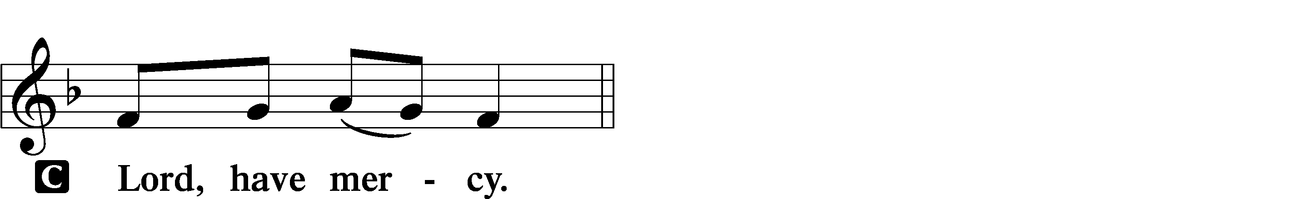
P In peace let us pray to the Lord.

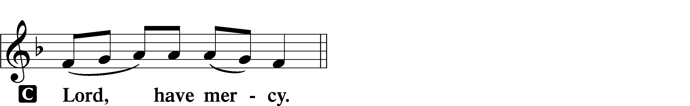
P For the peace from above and for our salvation let us pray to the Lord.

P For the peace of the whole world, for the well-being of the Church of God, and for the unity of all let us pray to the Lord.

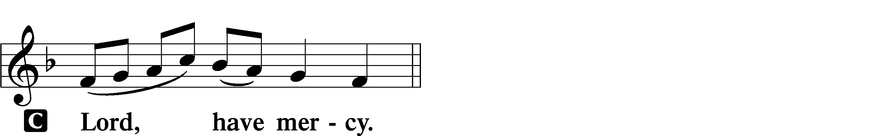

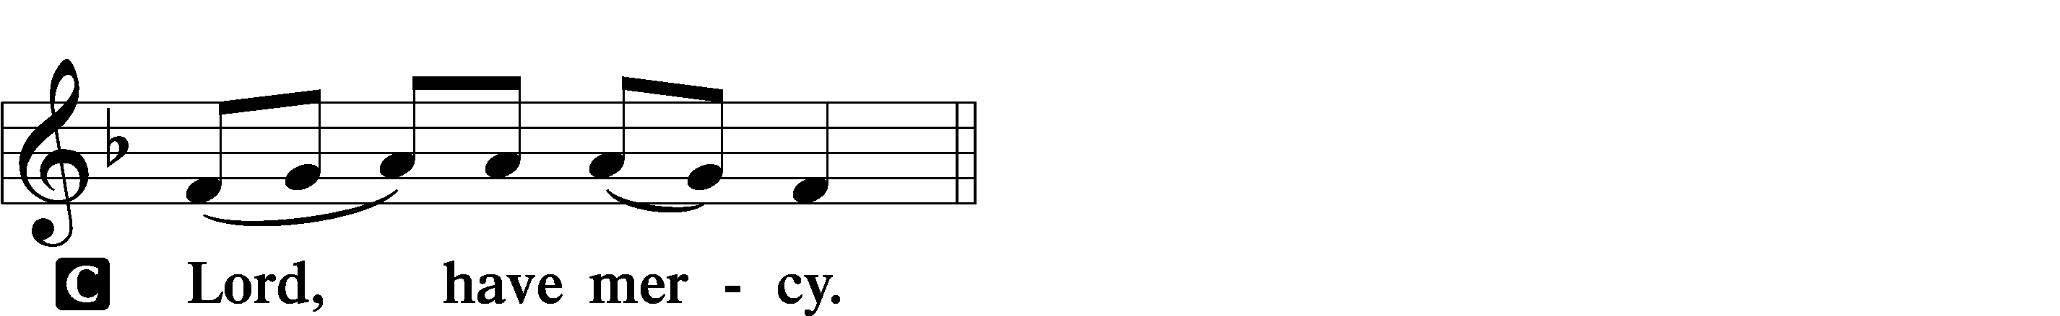
P For this holy house and for all who offer here their worship and praise let us pray to the Lord.

P Help, save, comfort, and defend us, gracious Lord.

Gloria in Excelsis LSB 154
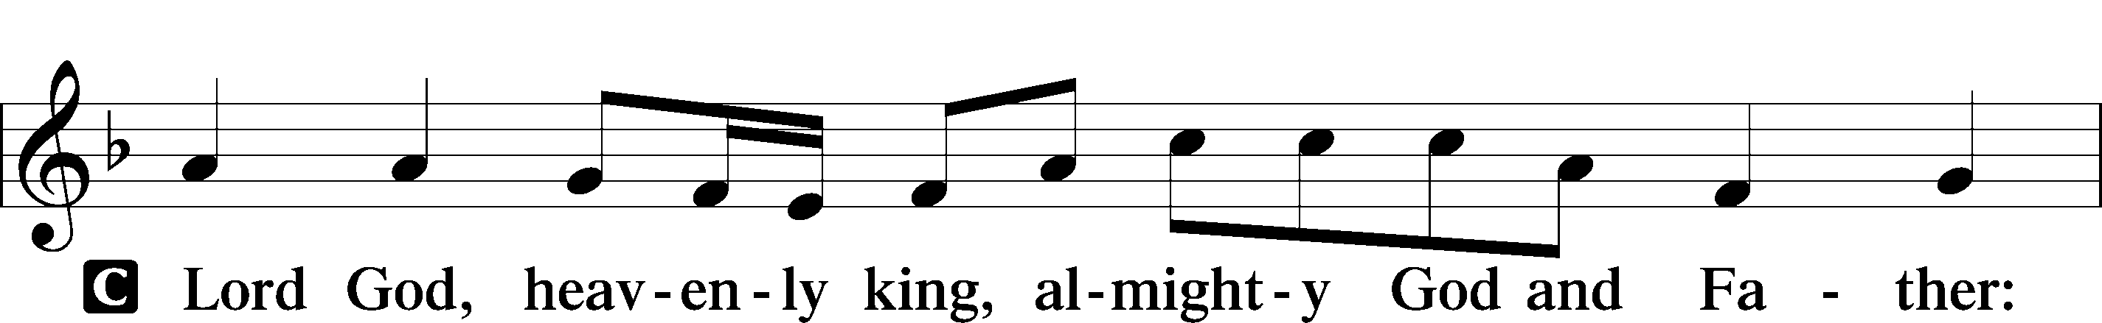
P Glory to God in the highest, and peace to His people on earth.

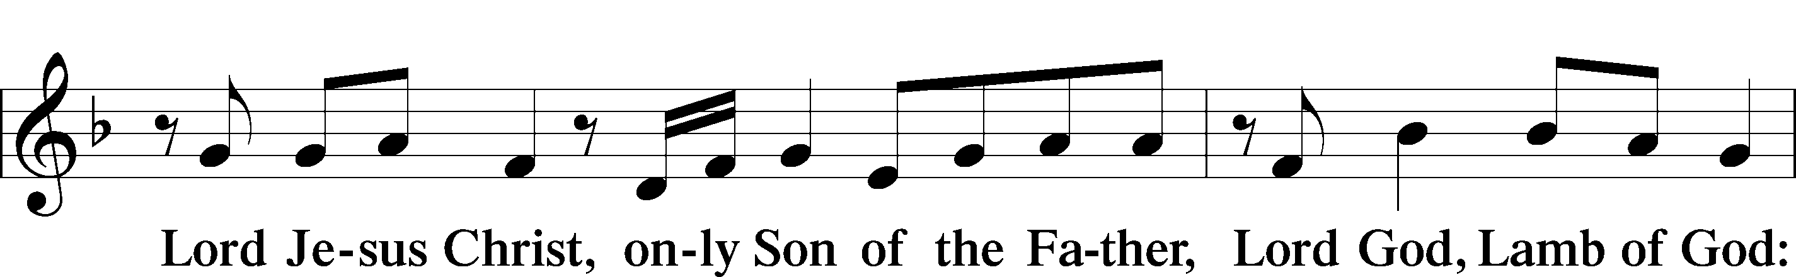
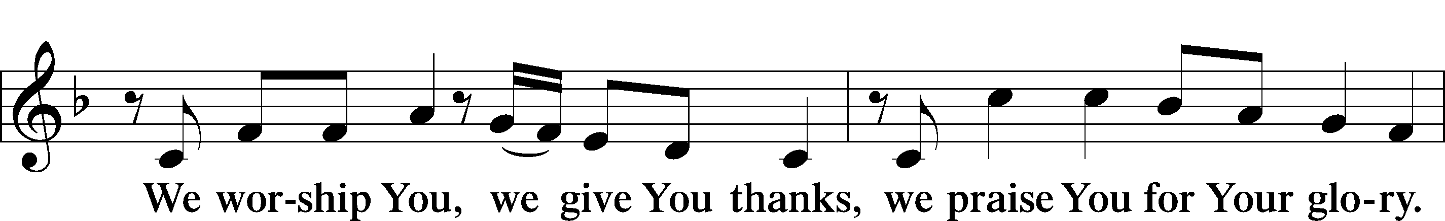

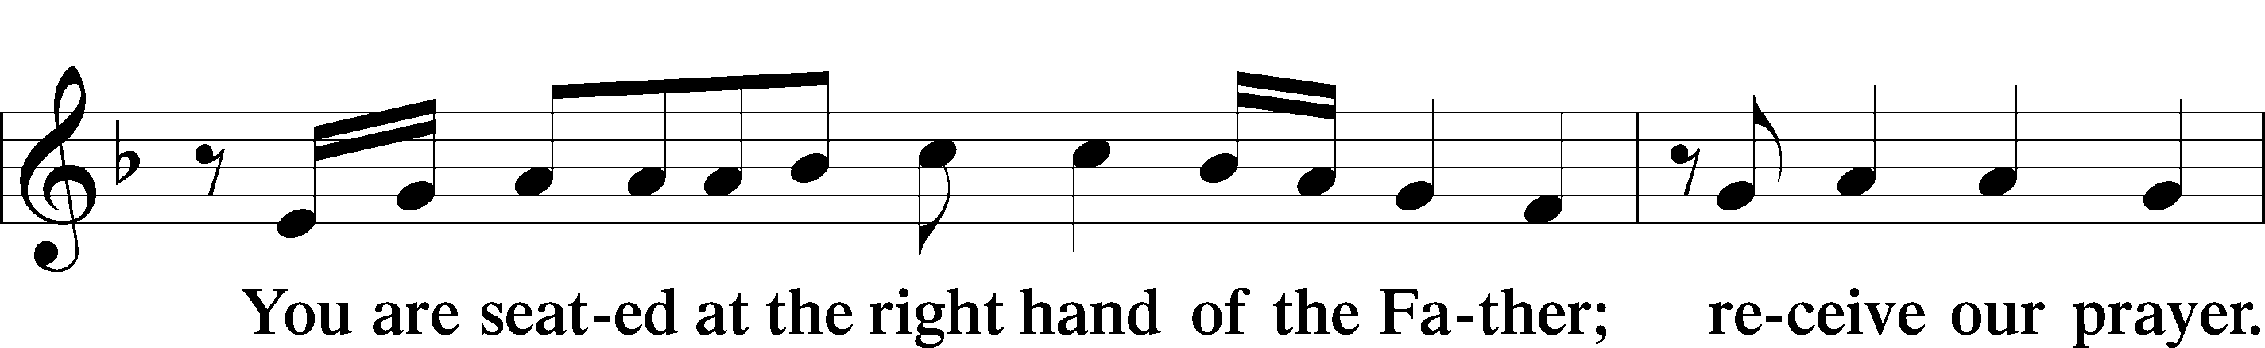
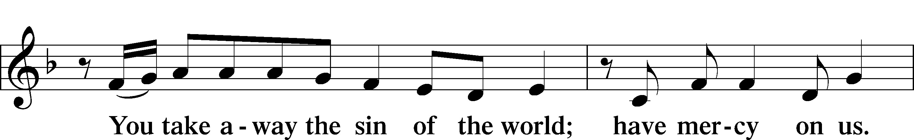

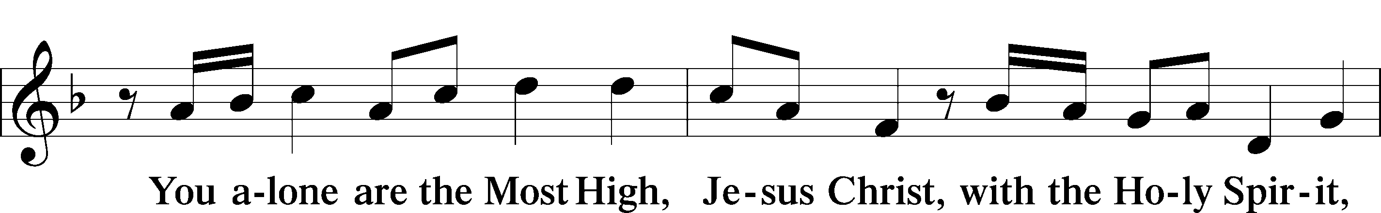
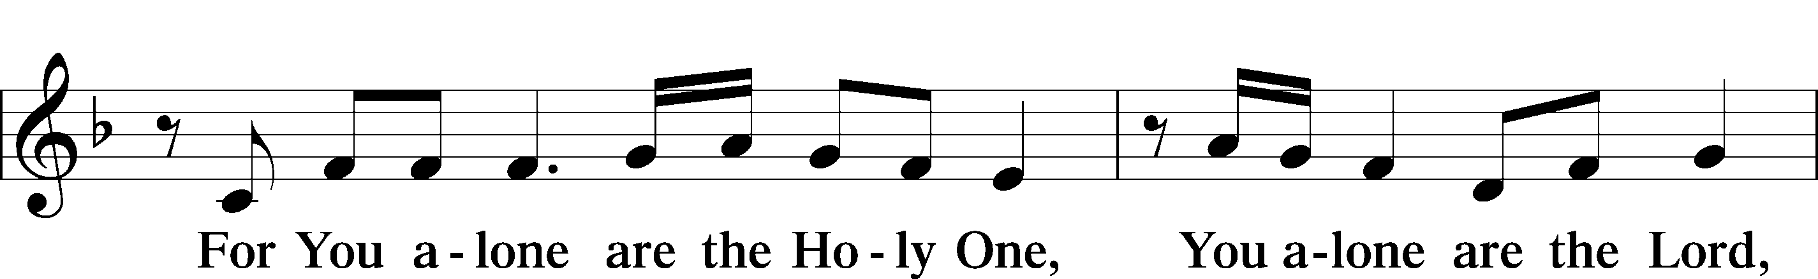

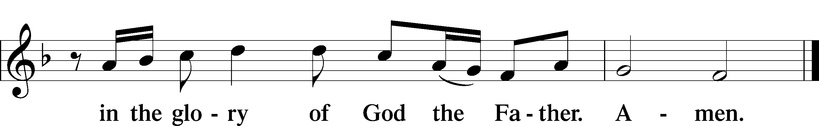

Salutation and Collect of the Day
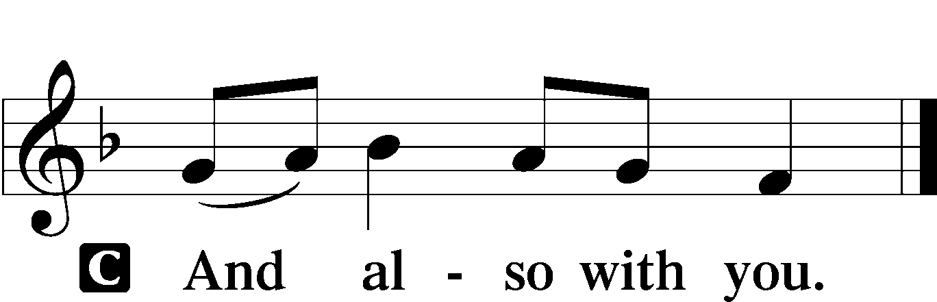
P The Lord be with you.

P Let us pray.
O Lord, You have called us to enter Your kingdom through the narrow door. Guide us by Your Word and Spirit, and lead us now and always into the feast of Your Son, Jesus Christ, who lives and reigns with You and the Holy Spirit, one God, now and forever.
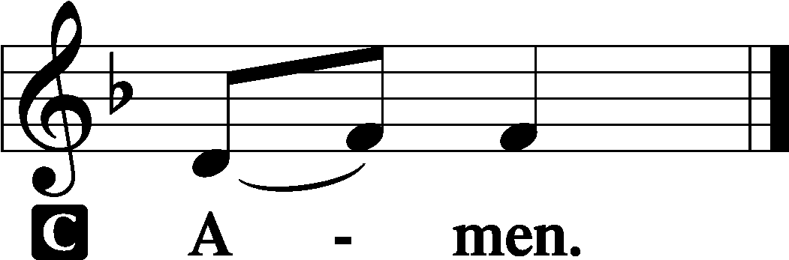

Sit

Old Testament Reading Isaiah 66:18–23
¹⁸“For I know their works and their thoughts, and the time is coming to gather all nations and tongues. And they shall come and shall see my glory, ¹⁹and I will set a sign among them. And from them I will send survivors to the nations, to Tarshish, Pul, and Lud, who draw the bow, to Tubal and Javan, to the coastlands afar off, that have not heard my fame or seen my glory. And they shall declare my glory among the nations. ²⁰And they shall bring all your brothers from all the nations as an offering to the Lord, on horses and in chariots and in litters and on mules and on dromedaries, to my holy mountain Jerusalem, says the Lord, just as the Israelites bring their grain offering in a clean vessel to the house of the Lord. ²¹And some of them also I will take for priests and for Levites, says the Lord.
²²“For as the new heavens and the new earth
that I make
shall remain before me, says the Lord,
so shall your offspring and your name remain.
²³From new moon to new moon,
and from Sabbath to Sabbath,
all flesh shall come to worship before me,
declares the Lord.”
P This is the Word of the Lord.
C Thanks be to God.

Gradual Psalm 34:9, 19, alt.
Fear the Lord, | you his saints,*
for those who fear him lack | nothing!
Many are the afflictions of the | righteous,*
but the Lord delivers him out | of them all.

Epistle Hebrews 12:4–24
⁴In your struggle against sin you have not yet resisted to the point of shedding your blood. ⁵And have you forgotten the exhortation that addresses you as sons?
“My son, do not regard lightly the discipline of the Lord,
nor be weary when reproved by him.
⁶For the Lord disciplines the one he loves,
and chastises every son whom he receives.”
⁷It is for discipline that you have to endure. God is treating you as sons. For what son is there whom his father does not discipline? ⁸If you are left without discipline, in which all have participated, then you are illegitimate children and not sons. ⁹Besides this, we have had earthly fathers who disciplined us and we respected them. Shall we not much more be subject to the Father of spirits and live? ¹⁰For they disciplined us for a short time as it seemed best to them, but he disciplines us for our good, that we may share his holiness. ¹¹For the moment all discipline seems painful rather than pleasant, but later it yields the peaceful fruit of righteousness to those who have been trained by it.
¹²Therefore lift your drooping hands and strengthen your weak knees, ¹³and make straight paths for your feet, so that what is lame may not be put out of joint but rather be healed. ¹⁴Strive for peace with everyone, and for the holiness without which no one will see the Lord. ¹⁵See to it that no one fails to obtain the grace of God; that no “root of bitterness” springs up and causes trouble, and by it many become defiled; ¹⁶that no one is sexually immoral or unholy like Esau, who sold his birthright for a single meal. ¹⁷For you know that afterward, when he desired to inherit the blessing, he was rejected, for he found no chance to repent, though he sought it with tears.
¹⁸For you have not come to what may be touched, a blazing fire and darkness and gloom and a tempest ¹⁹and the sound of a trumpet and a voice whose words made the hearers beg that no further messages be spoken to them. ²⁰For they could not endure the order that was given, “If even a beast touches the mountain, it shall be stoned.” ²¹Indeed, so terrifying was the sight that Moses said, “I tremble with fear.” ²²But you have come to Mount Zion and to the city of the living God, the heavenly Jerusalem, and to innumerable angels in festal gathering, ²³and to the assembly of the firstborn who are enrolled in heaven, and to God, the judge of all, and to the spirits of the righteous made perfect,²⁴and to Jesus, the mediator of a new covenant, and to the sprinkled blood that speaks a better word than the blood of Abel.
P This is the Word of the Lord.
C Thanks be to God.

Stand

Alleluia and Verse LSB 156
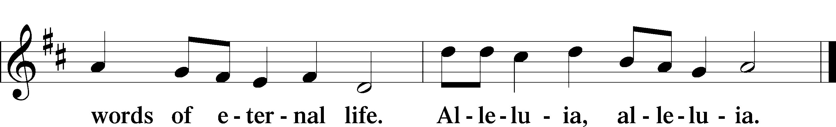
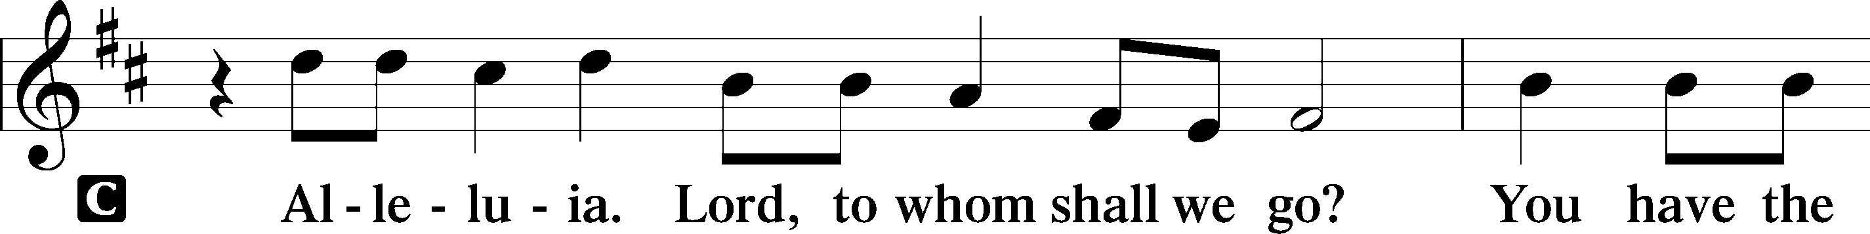

Holy Gospel Luke 13:22–30
P The Holy Gospel according to St. Luke, the thirteenth chapter.
C Glory to You, O Lord.
²²[Jesus] went on his way through towns and villages, teaching and journeying toward Jerusalem. ²³And someone said to him, “Lord, will those who are saved be few?” And he said to them, ²⁴“Strive to enter through the narrow door. For many, I tell you, will seek to enter and will not be able. ²⁵When once the master of the house has risen and shut the door, and you begin to stand outside and to knock at the door, saying, ‘Lord, open to us,’ then he will answer you, ‘I do not know where you come from.’ ²⁶Then you will begin to say, ‘We ate and drank in your presence, and you taught in our streets.’ ²⁷But he will say, ‘I tell you, I do not know where you come from. Depart from me, all you workers of evil!’ ²⁸In that place there will be weeping and gnashing of teeth, when you see Abraham and Isaac and Jacob and all the prophets in the kingdom of God but you yourselves cast out. ²⁹And people will come from east and west, and from north and south, and recline at table in the kingdom of God. ³⁰And behold, some are last who will be first, and some are first who will be last.”
P This is the Gospel of the Lord.
C Praise to You, O Christ.

Sit

513 The Clouds of Judgment Gather
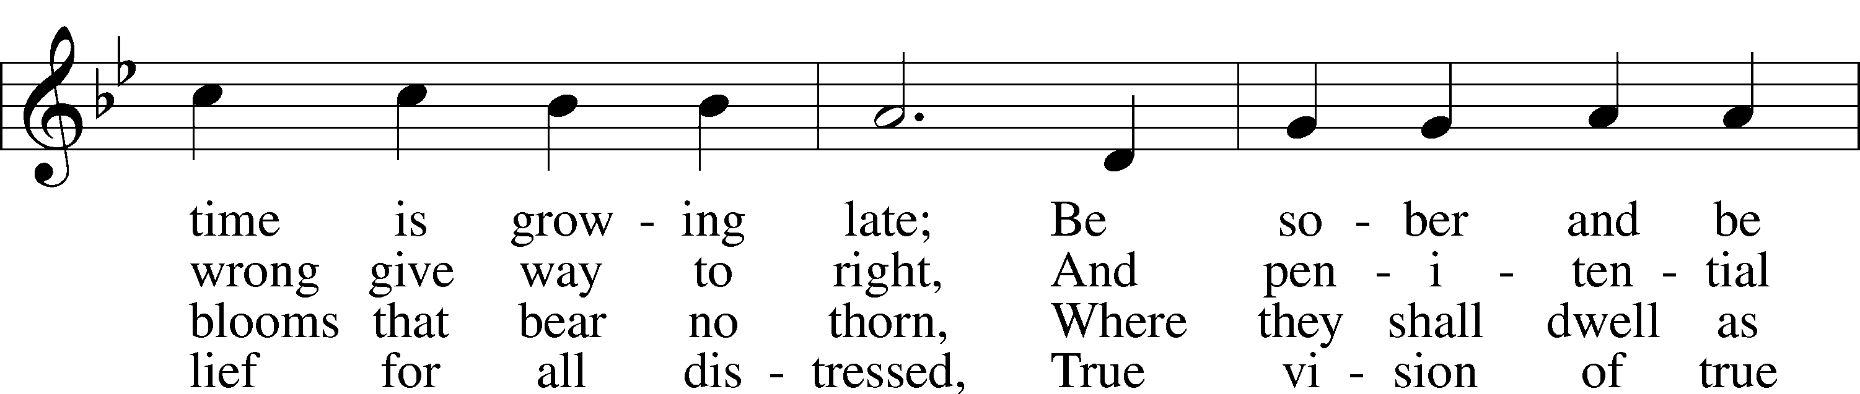
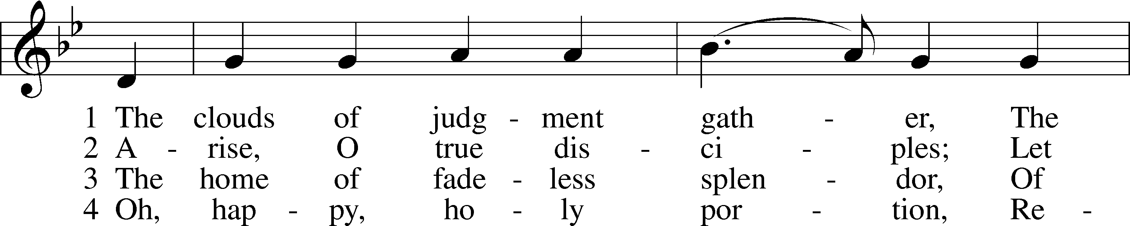

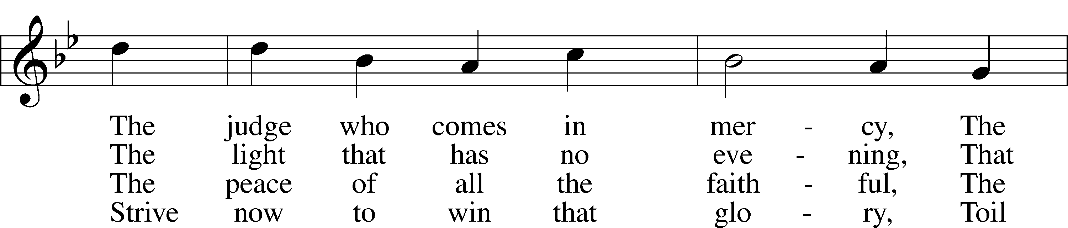
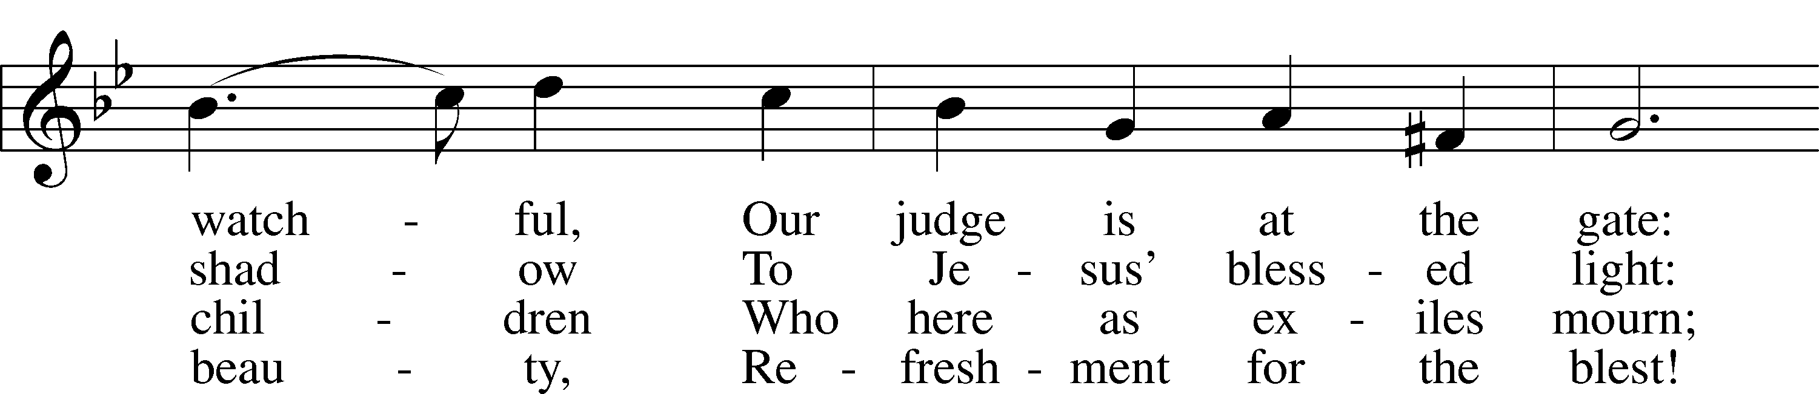

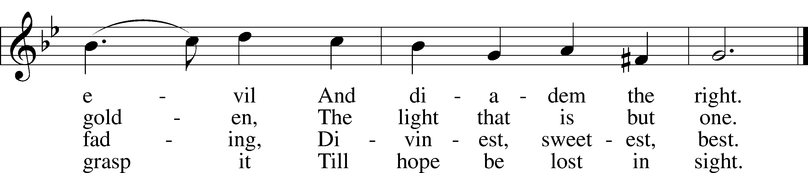
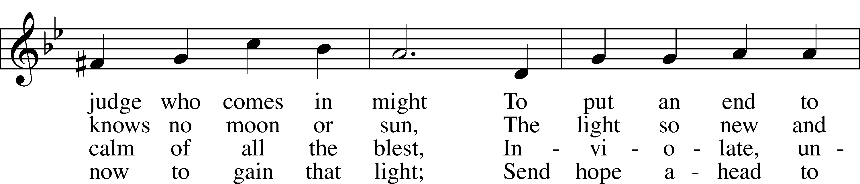

Text: Bernard of Cluny, 12th cent.; tr. Lutheran Book of Worship, 1978 Tune: Welsh Text: © 1978 Lutheran Book of Worship. Used by permission: LSB Hymn License no. 110003744 Tune: Public domain

Sermon

Stand

Apostles’ Creed
C I believe in God, the Father Almighty,
maker of heaven and earth.
And in Jesus Christ, His only Son, our Lord,
who was conceived by the Holy Spirit,
born of the virgin Mary,
suffered under Pontius Pilate,
was crucified, died and was buried.
He descended into hell.
The third day He rose again from the dead.
He ascended into heaven
and sits at the right hand of God the Father Almighty.
From thence He will come to judge the living and the dead.
I believe in the Holy Spirit,
the holy Christian Church,
the communion of saints,
the forgiveness of sins,
the resurrection of the body,
and the life T everlasting. Amen.

Prayer of the Church

Consecration of the Offering
After the prayers please be seated. The altar is set for the Lord’s Supper and the offering is consecrated. As you prepare to receive the sacrament you may use the prayers in the front of the hymnal or meditate on a communion hymn.

Stand
Offertory LSB 159
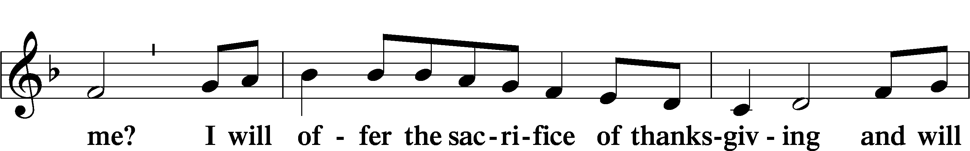
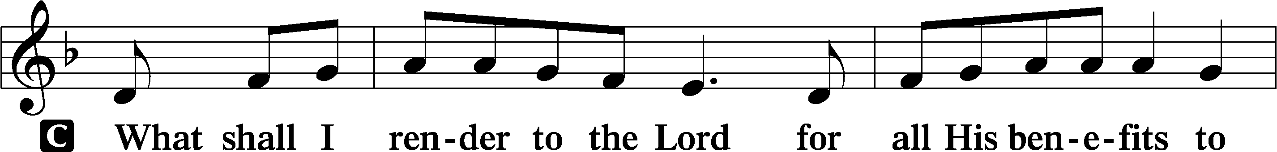

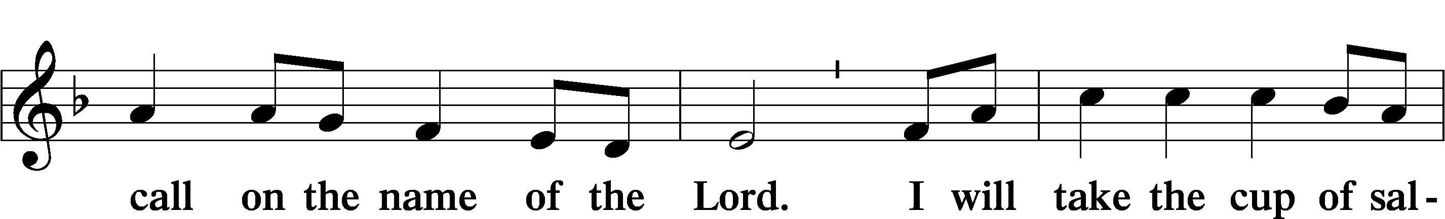

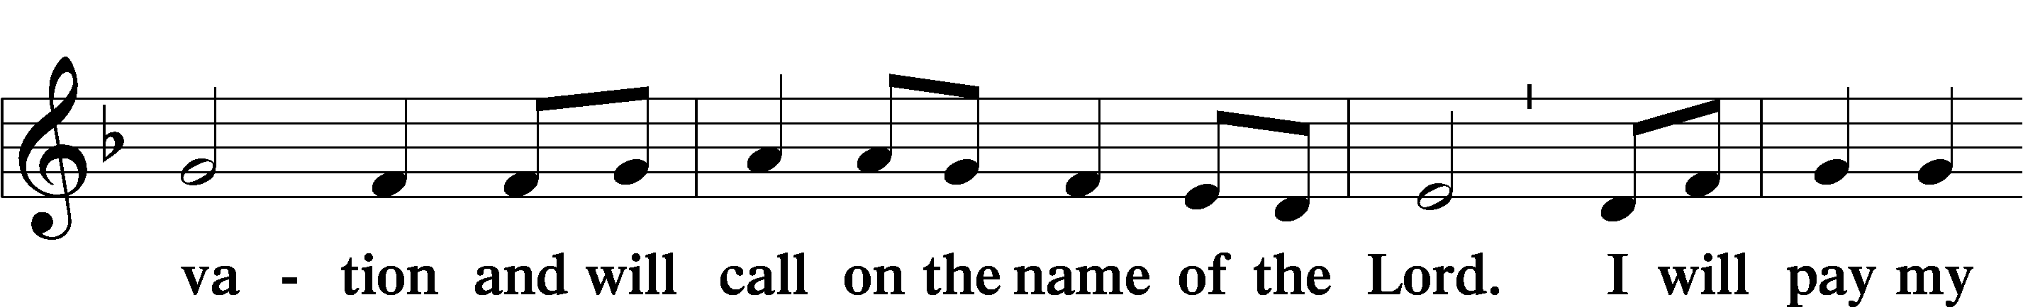

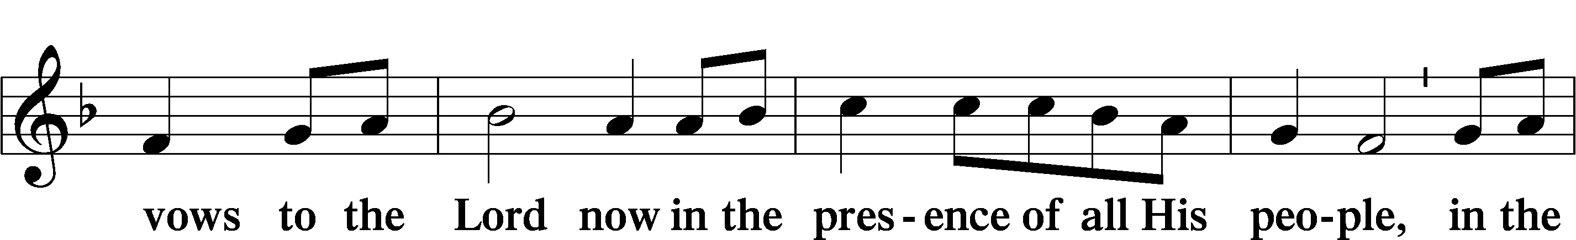

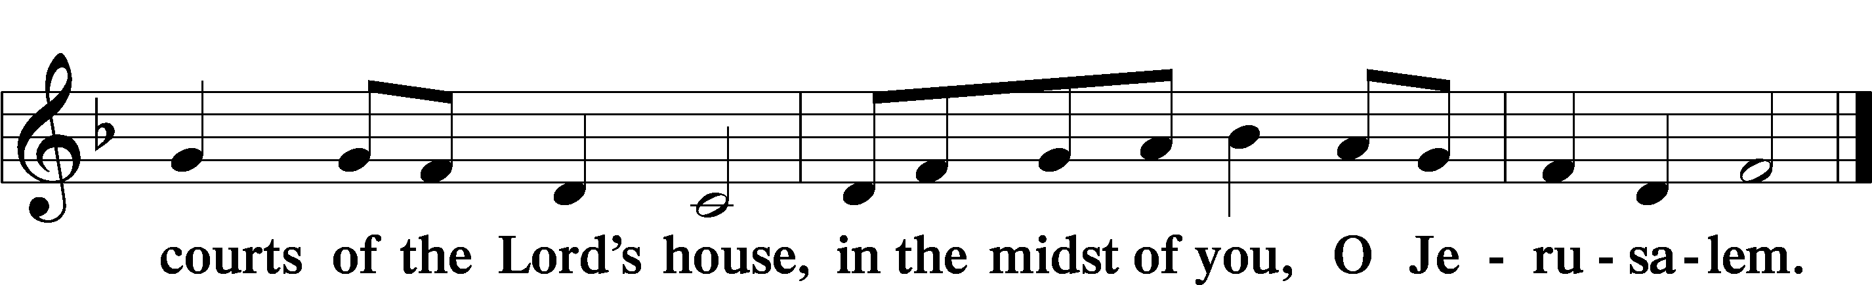

Service of the Sacrament
Preface LSB 160
P The Lord be with you.

P Lift up your hearts.

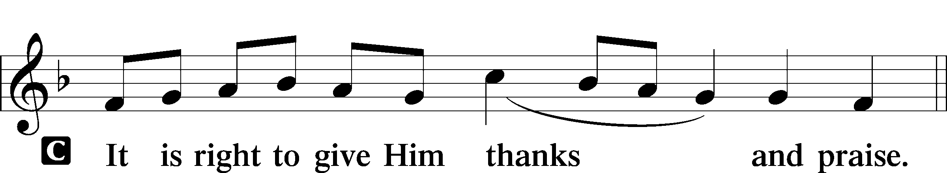
P Let us give thanks to the Lord our God.

P It is truly good, right, and salutary that we should at all times and in all places give thanks to You, holy Lord, almighty Father, everlasting God, through Jesus Christ, our Lord. Therefore with angels and archangels and with all the company of heaven we laud and magnify Your glorious name, evermore praising You and saying:
Sanctus LSB 161
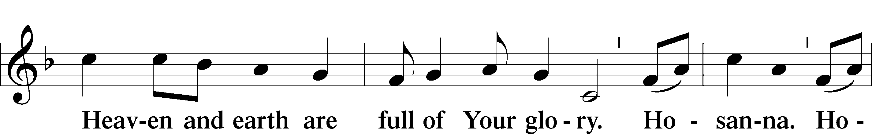
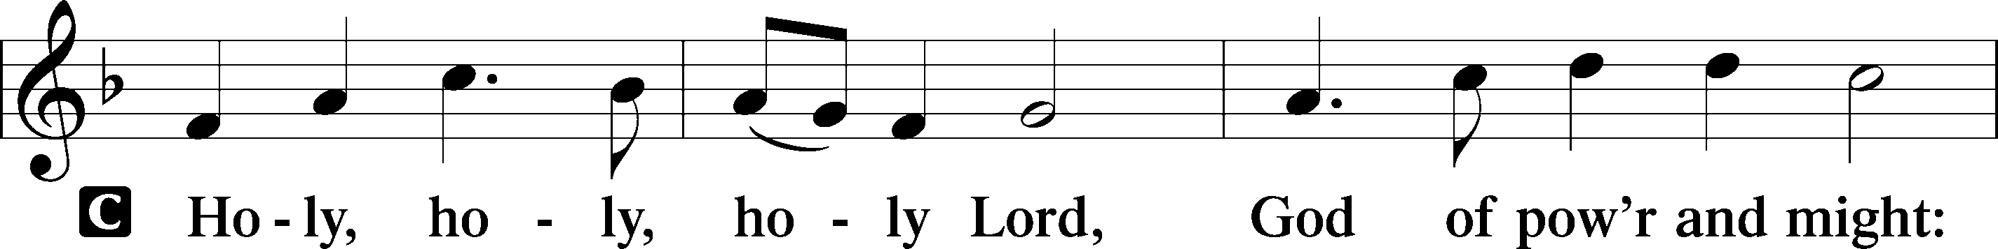

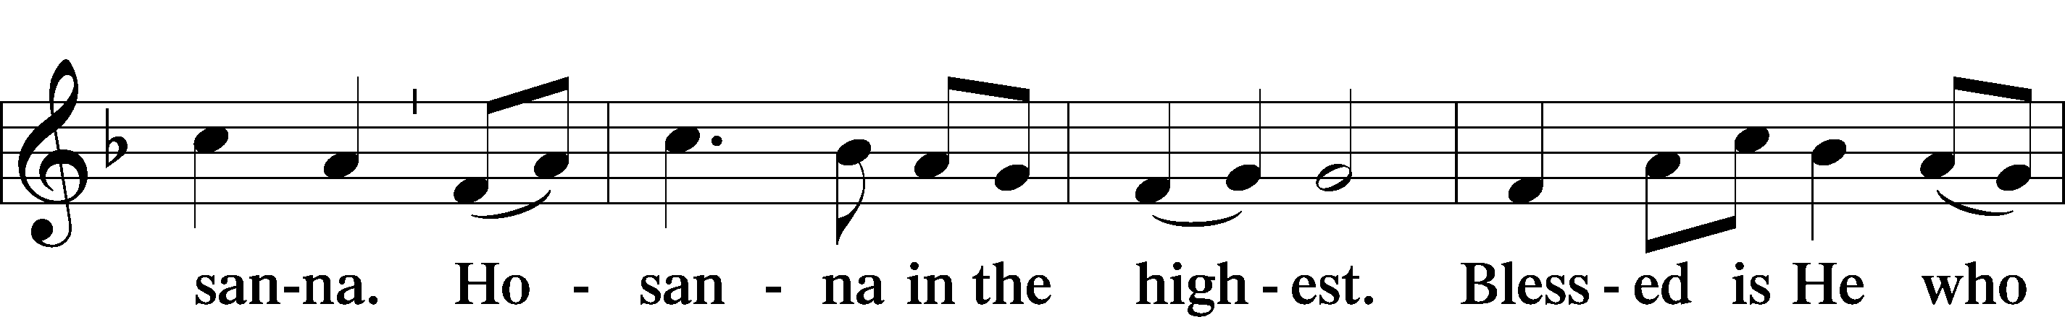

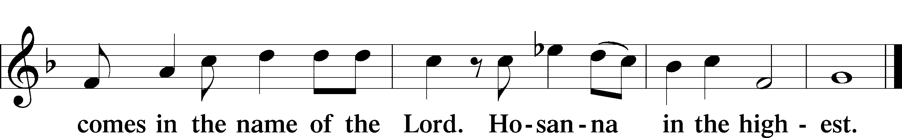

Lord’s Prayer
C Our Father who art in heaven,
hallowed be Thy name,
Thy kingdom come,
Thy will be done on earth
as it is in heaven;
give us this day our daily bread;
and forgive us our trespasses
as we forgive those
who trespass against us;
and lead us not into temptation,
but deliver us from evil.
For Thine is the kingdom
and the power and the glory
forever and ever. Amen.

The Words of Our Lord
P Our Lord Jesus Christ, on the night when He was betrayed, took bread, and when He had given thanks, He broke it and gave it to the disciples and said: “Take, eat; this is My T body, which is given for you. This do in remembrance of Me.”
In the same way also He took the cup after supper, and when He had given thanks, He gave it to them, saying: “Drink of it, all of you; this cup is the new testament in My T blood, which is shed for you for the forgiveness of sins. This do, as often as you drink it, in remembrance of Me.”
Pax Domini LSB 163
P The peace of the Lord be with you always.

Agnus Dei LSB 163
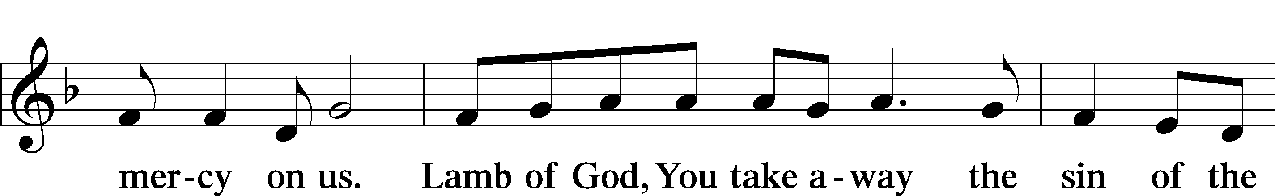
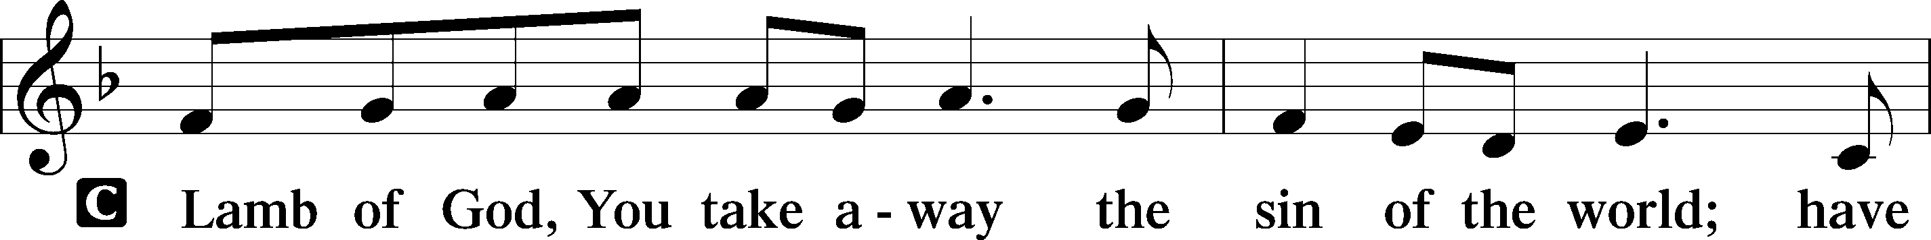

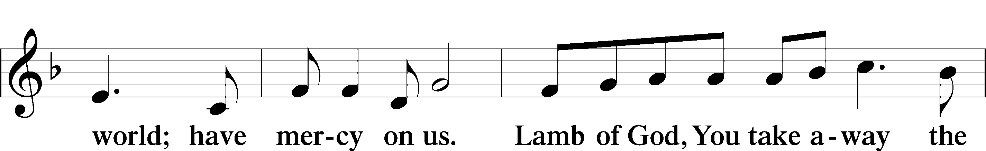

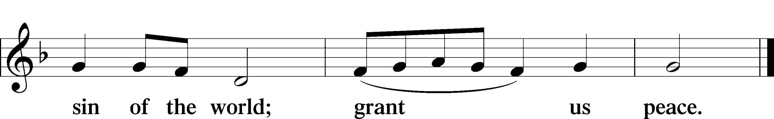

Sit

Distribution

628 Your Table I Approach
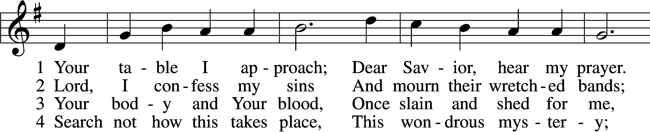
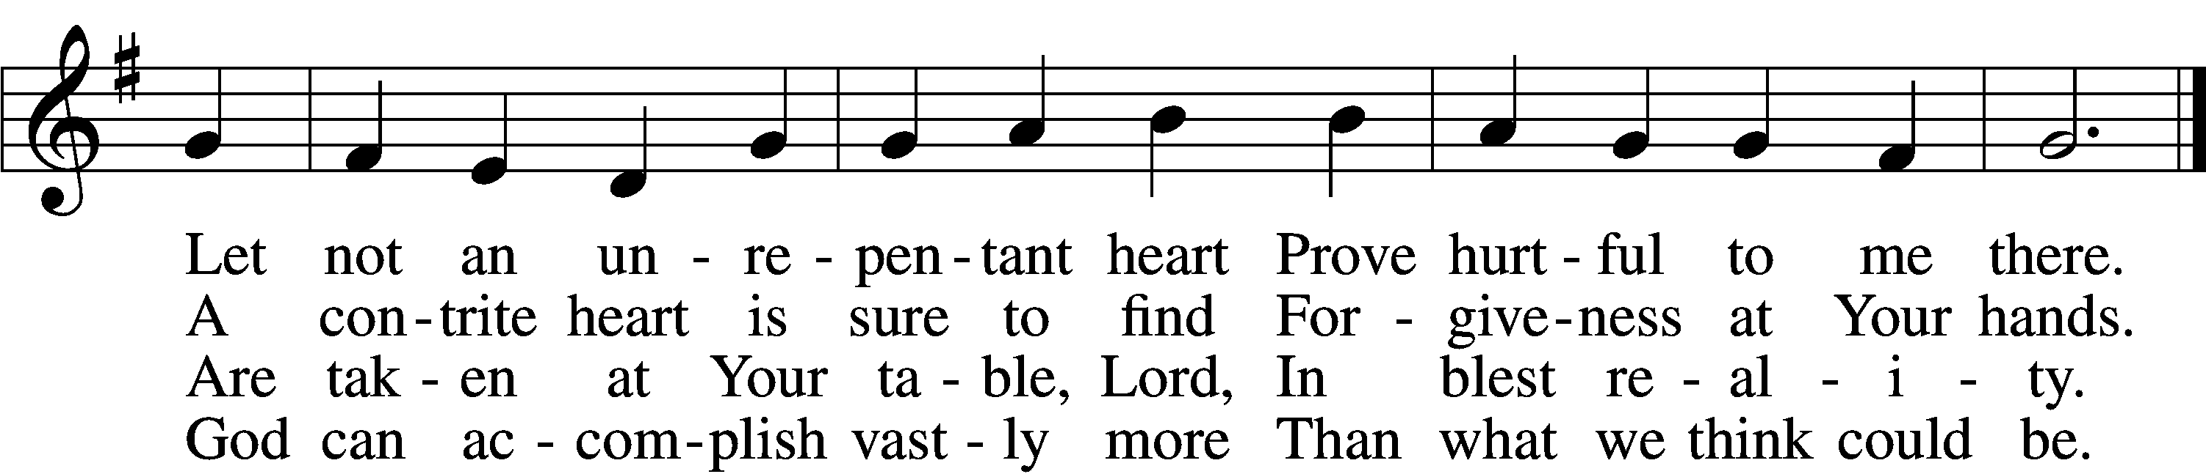

5 O grant, most blessèd Lord,
That earth and hell combined
May not about this sacrament
Raise doubt within my mind.
6 Oh, may I never fail
To thank You day and night
For Your true body and true blood,
O God, my peace and light.

Text: Gerhard Wolter Molanus, 1633–1722; tr. Matthias Loy, 1828–1915, alt.
Tune: Trente quatre Pseaumes de David, 1551, Geneva, ed. Louis Bourgeois
Text and tune: Public domain

556 Dear Christians, One and All, Rejoice
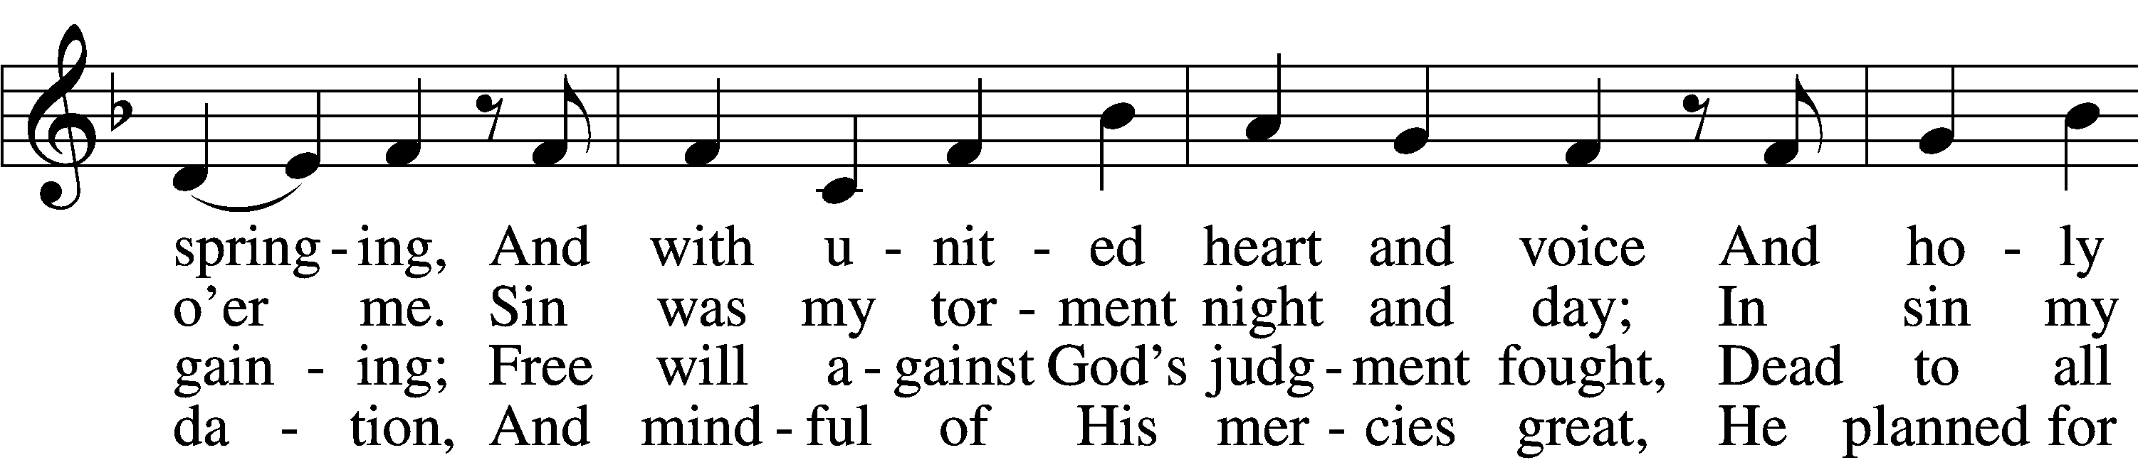
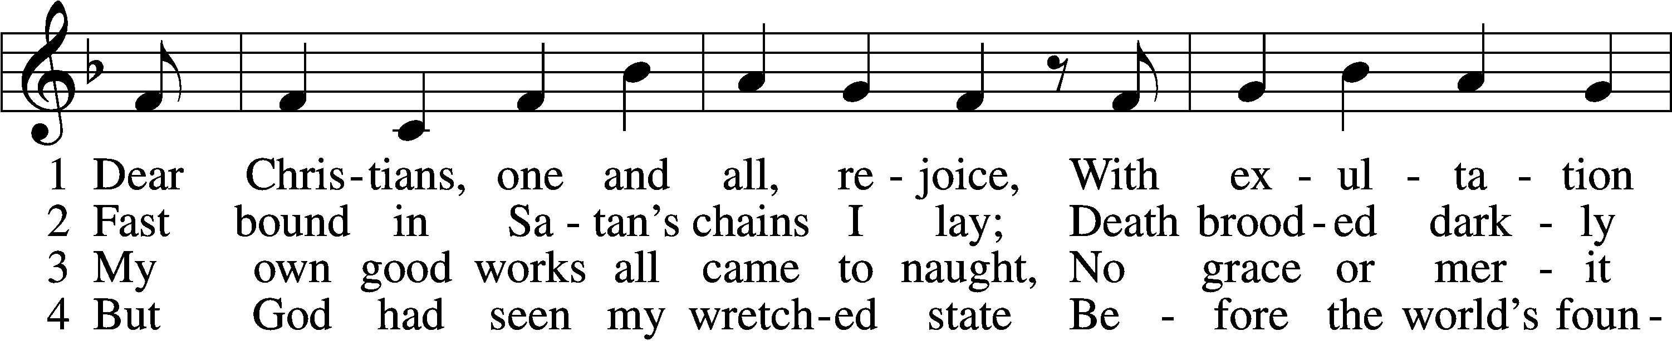

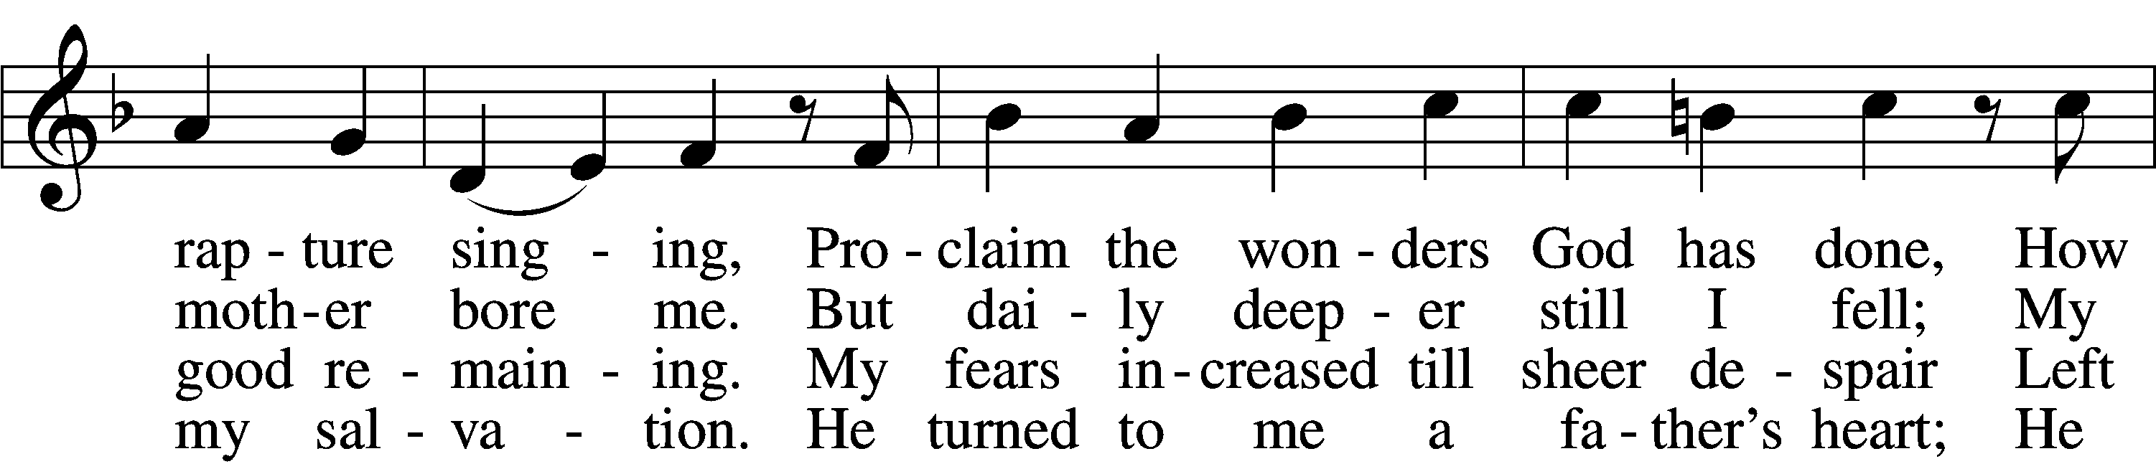

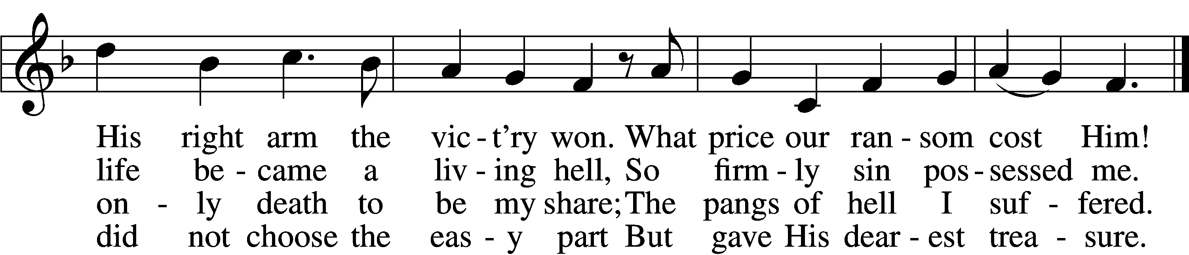

5 God said to His belovèd Son:
“It’s time to have compassion.
Then go, bright jewel of My crown,
And bring to all salvation.
From sin and sorrow set them free;
Slay bitter death for them that they
May live with You forever.”

6 The Son obeyed His Father’s will,
Was born of virgin mother;
And God’s good pleasure to fulfill,
He came to be my brother.
His royal pow’r disguised He bore;
A servant’s form, like mine, He wore
To lead the devil captive.

7 To me He said: “Stay close to Me,
I am your rock and castle.
Your ransom I Myself will be;
For you I strive and wrestle.
For I am yours, and you are Mine,
And where I am you may remain;
The foe shall not divide us.

8 “Though he will shed My precious blood,
Me of My life bereaving,
All this I suffer for your good;
Be steadfast and believing.
Life will from death the vict’ry win;
My innocence shall bear your sin,
And you are blest forever.

9 “Now to My Father I depart,
From earth to heav’n ascending,
And, heav’nly wisdom to impart,
The Holy Spirit sending;
In trouble He will comfort you
And teach you always to be true
And into truth shall guide you.

10 “What I on earth have done and taught
Guide all your life and teaching;
So shall the kingdom’s work be wrought
And honored in your preaching.
But watch lest foes with base alloy
The heav’nly treasure should destroy;
This final word I leave you.”

Text: Martin Luther, 1483–1546; tr. Richard Massie, 1800–87, alt. Tune: Etlich Cristlich lider, 1524, Wittenberg Text and tune: Public domain
732 All Depends on Our Possessing
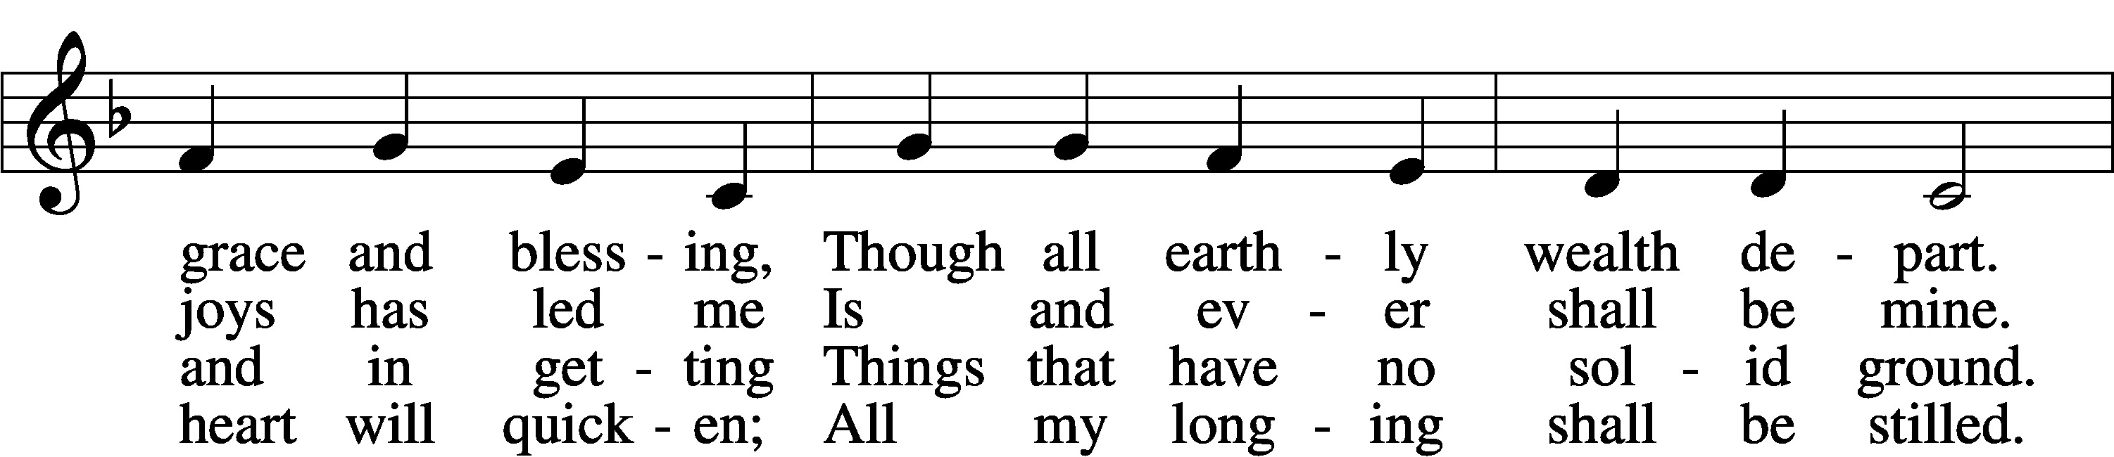
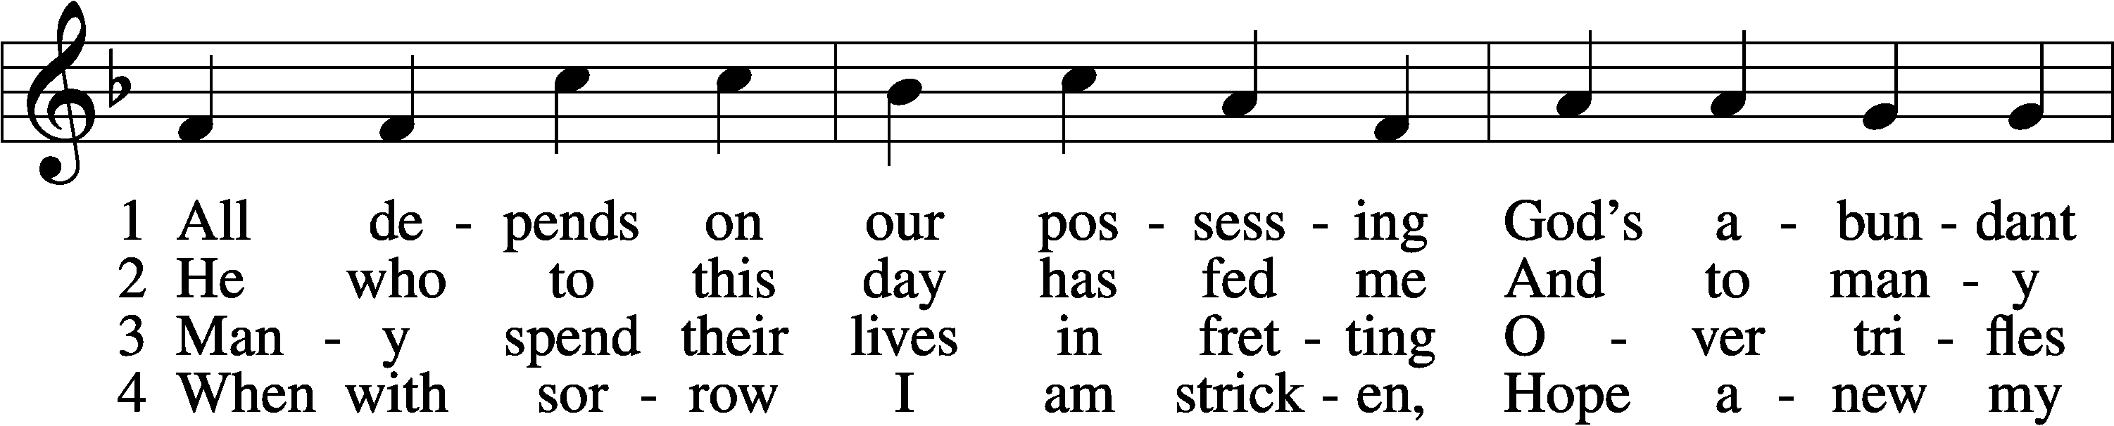

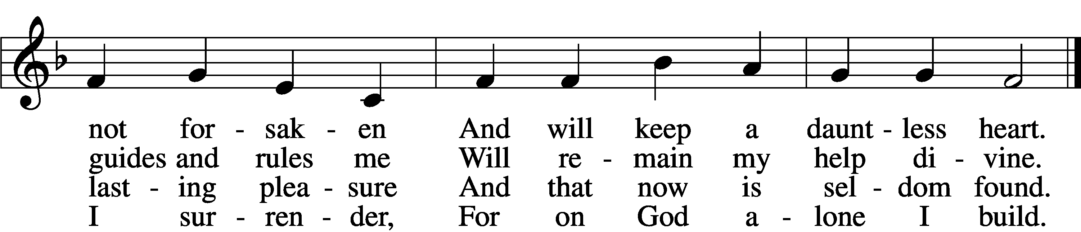
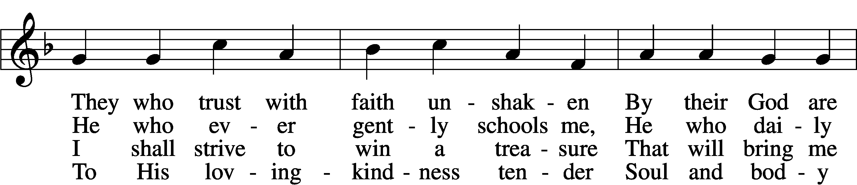

5 Well He knows what best to grant me;
All the longing hopes that haunt me,
Joy and sorrow, have their day.
I shall doubt His wisdom never;
As God wills, so be it ever;
I commit to Him my way.

6 If my days on earth He lengthen,
God my weary soul will strengthen;
All my trust in Him I place.
Earthly wealth is not abiding,
Like a stream away is gliding;
Safe I anchor in His grace.
Text: Andächtige Haus-Kirche, 1676, Nürnberg; tr. Catherine Winkworth, 1827–78, alt.
Tune: Johann Löhner, 1645–1705; adapt. Johann Balthasar König, 1691–1758
Text and tune: Public domain

622 Lord Jesus Christ, You Have Prepared
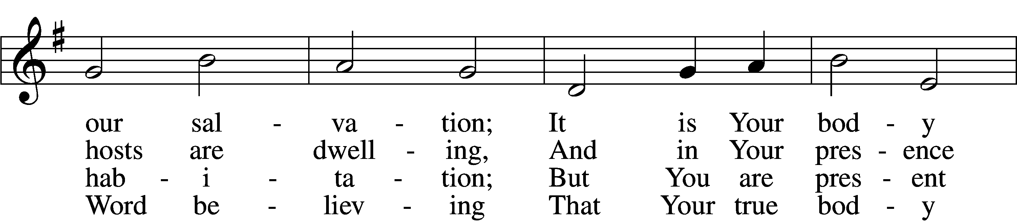
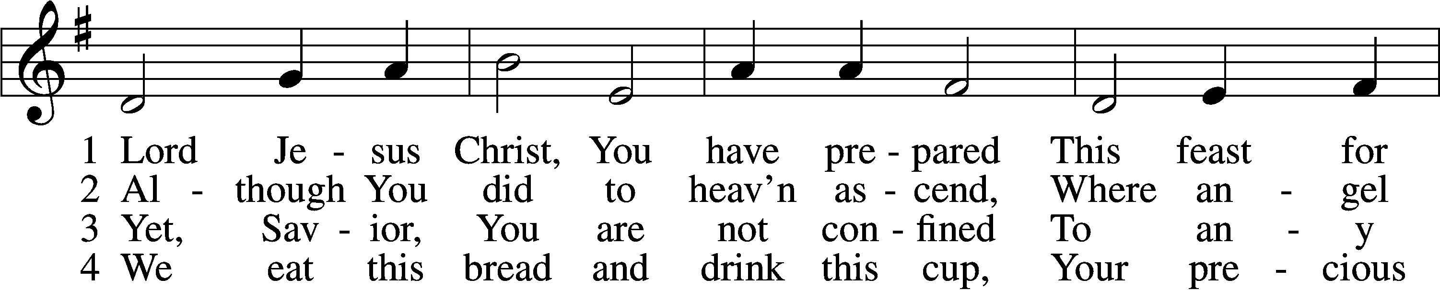

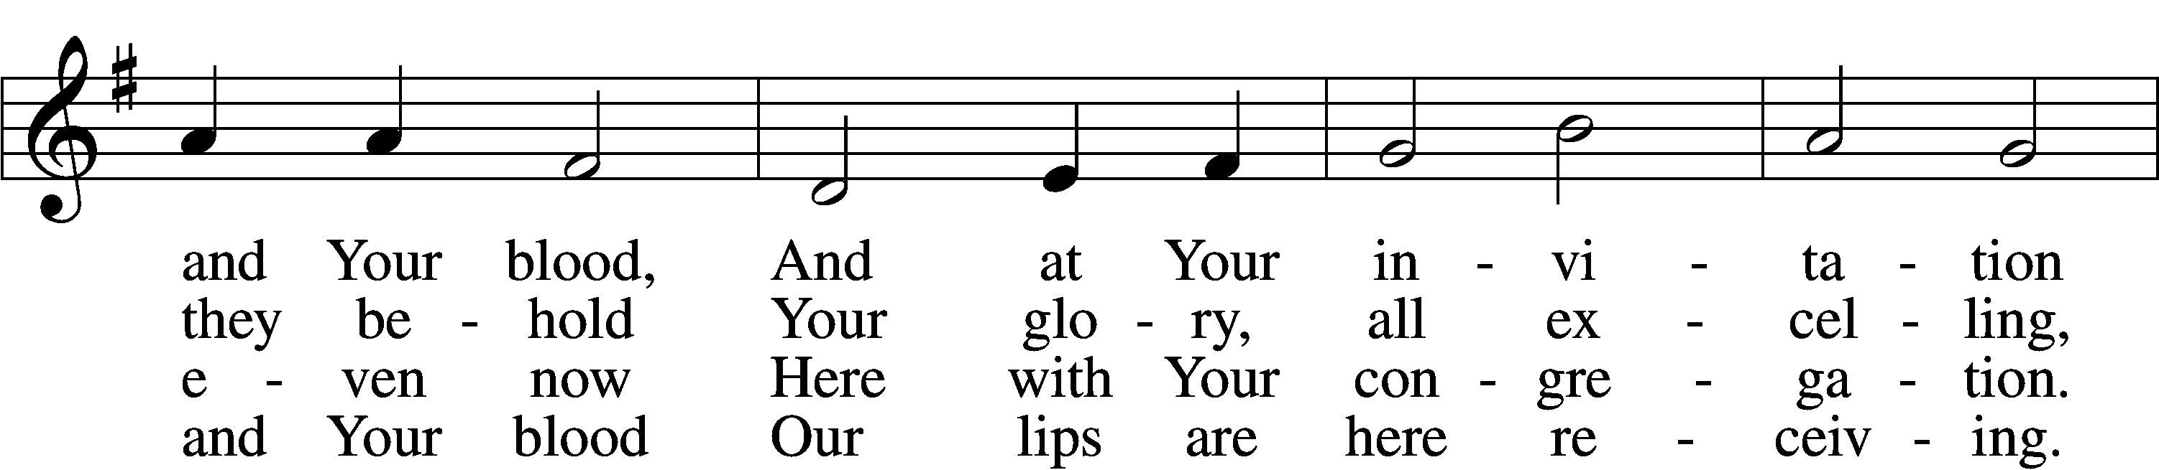

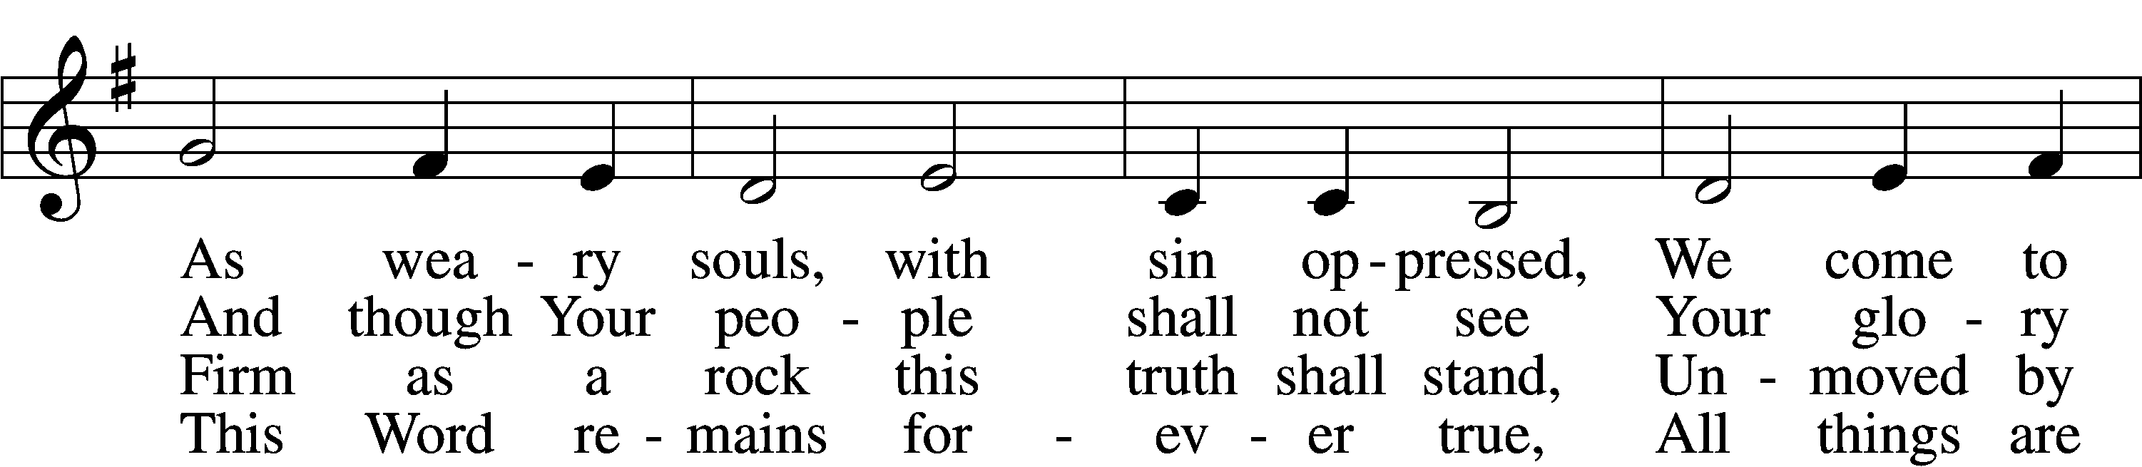

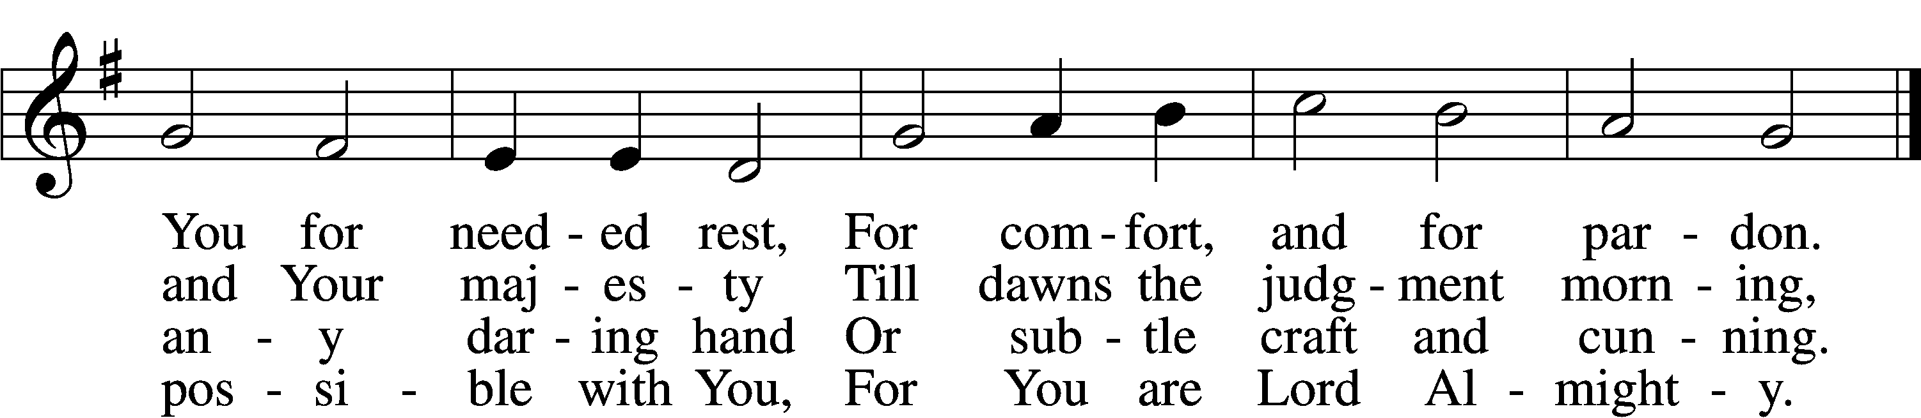

5 Though reason cannot understand,
Yet faith this truth embraces:
Your body, Lord, is even now
At once in many places.
I leave to You how this can be;
Your Word alone suffices me;
I trust its truth unfailing.

6 Lord, I believe what You have said;
Help me when doubts assail me.
Remember that I am but dust,
And let my faith not fail me.
Your supper in this vale of tears
Refreshes me and stills my fears
And is my priceless treasure.

7 Grant that we worthily receive
Your supper, Lord, our Savior,
And, truly grieving for our sins,
May prove by our behavior
That we are thankful for Your grace
And day by day may run our race,
In holiness increasing.

8 For Your consoling supper, Lord,
Be praised throughout all ages!
Preserve it, for in ev’ry place
The world against it rages.
Grant that this sacrament may be
A blessèd comfort unto me
When living and when dying.

Text: Samuel Kinner, 1603–68; tr. Emanuel Cronenwett, 1841–1931, alt.
Tune: Peter Sohren, c. 1630–c. 1692, alt.
Text and tune: Public domain

Stand

The Dismissal
P The body and blood of our Lord Jesus Christ strengthen and preserve you in body and soul to life everlasting. Depart T in peace.
C Amen.
Thank the Lord LSB 164
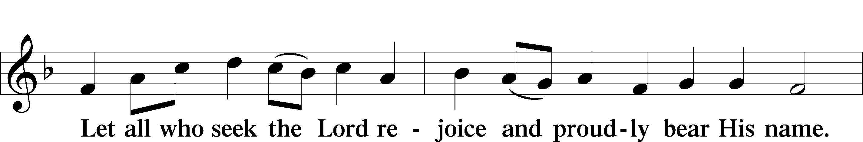
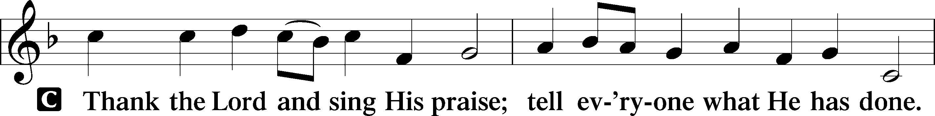

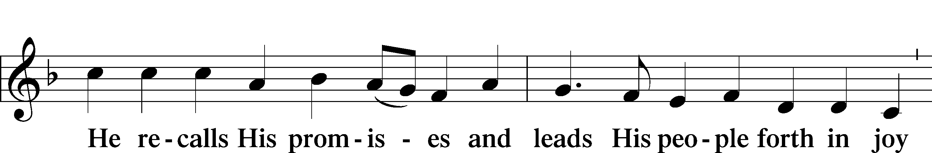

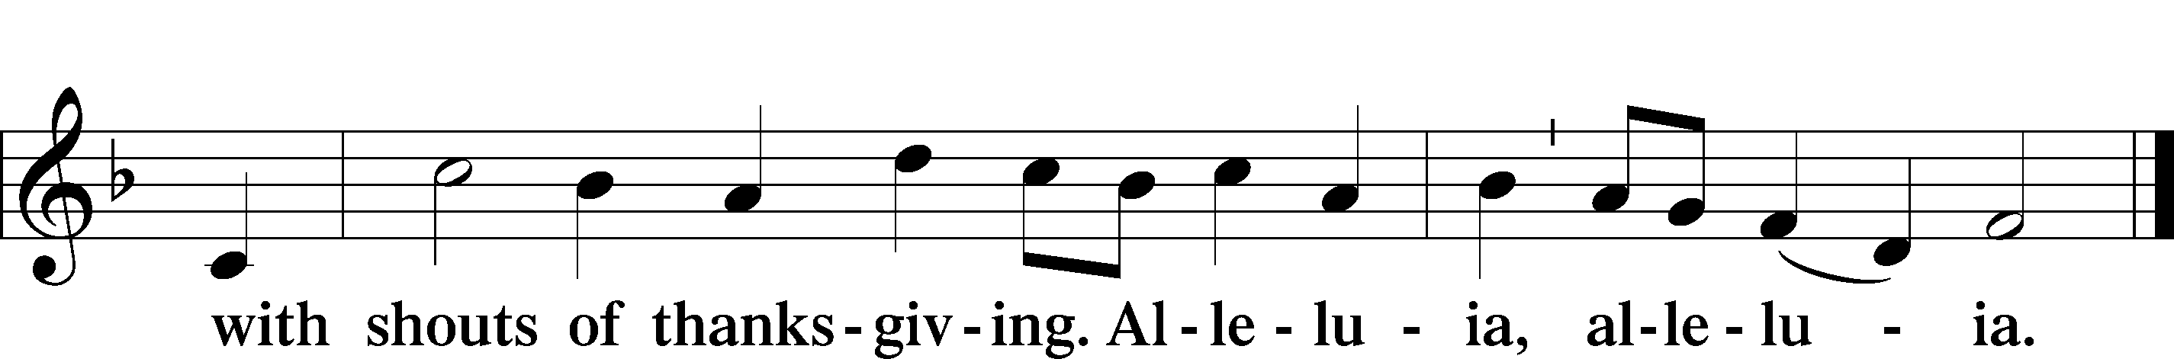

Post-Communion Collect
P Let us pray.
O God the Father, the fountain and source of all goodness, who in loving-kindness sent Your only-begotten Son into the flesh, we thank You that for His sake You have given us pardon and peace in this Sacrament, and we ask You not to forsake Your children but always to rule our hearts and minds by Your Holy Spirit that we may be enabled constantly to serve You; through Jesus Christ, Your Son, our Lord, who lives and reigns with You and the Holy Spirit, one God, now and forever.

Benediction LSB 166
P The Lord bless you and keep you.
The Lord make His face shine on you and be gracious to you.
The Lord look upon you with favor and T give you peace.

848 Lord, Whose Love through Humble Service sts. 1–3
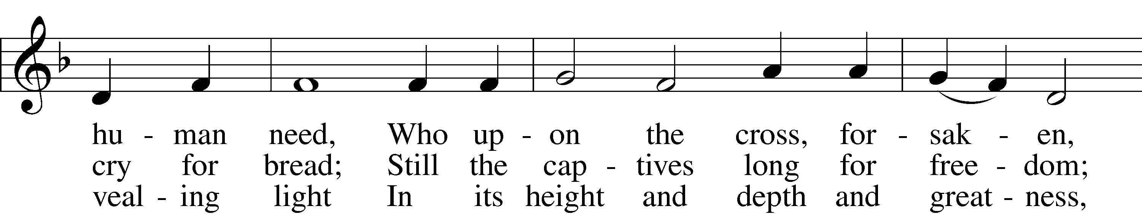
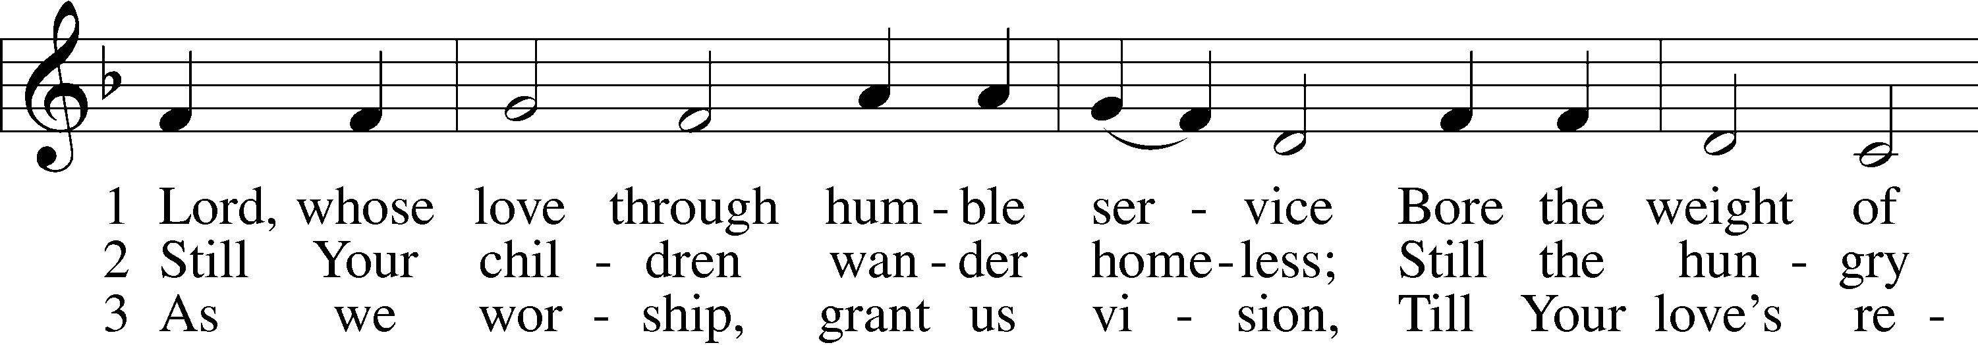

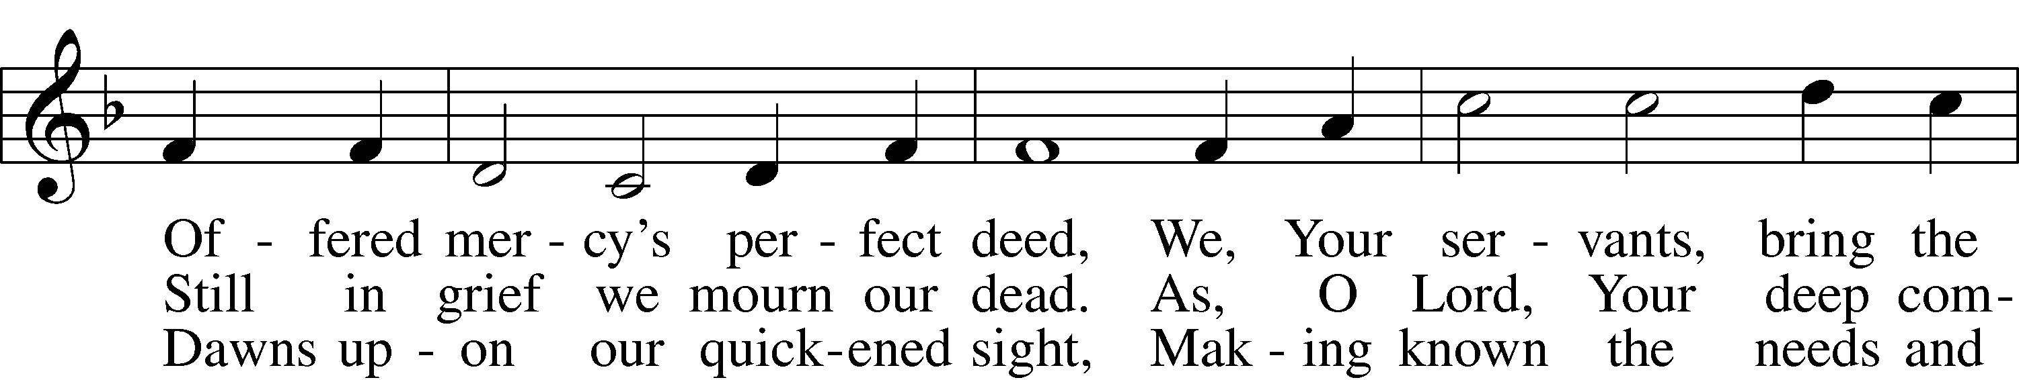

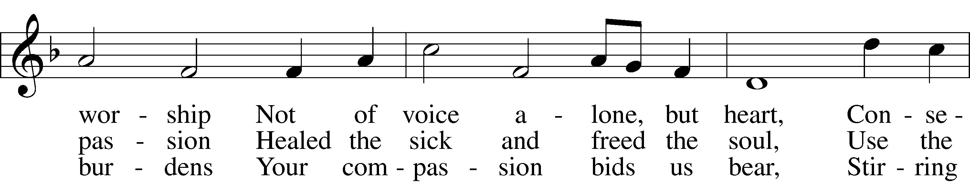

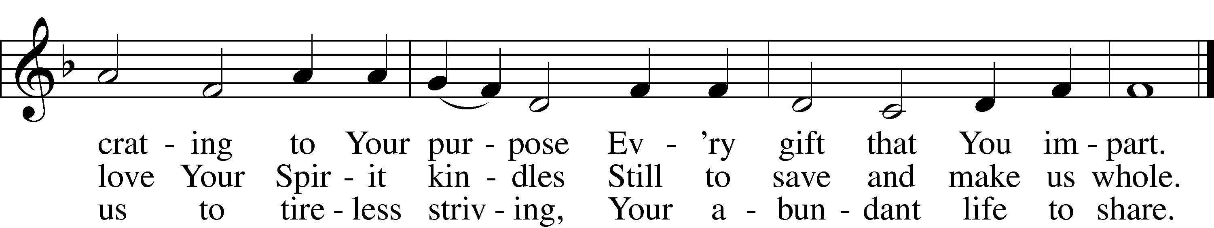

Text: Albert F. Bayly, 1901–84, alt. Tune: The Sacred Harp, 1844, Philadelphia Text: © Oxford University Press. Used by permission: LSB Hymn License no. 110003744 Tune: Public domain

Acknowledgments
Unless otherwise indicated, Scripture quotations are from the ESV® Bible (The Holy Bible, English Standard Version®), copyright © 2001 by Crossway, a publishing ministry of Good News Publishers. Used by permission. All rights reserved.
Created by Lutheran Service Builder © 2021 Concordia Publishing House.

Prayers for Our Members
Family and Friends of Verleen Gentry | Grief
Norman Abels (Brookestone Meadows–Elkhorn) | Healing
Judy Ahrens | Healing
Vaughn Albrecht (Mount Carmel) | Healing
Tom & DyAnn Altwine | Healing
Dave Banner | Healing
Lyle Colsden (Mother Hull) | Healing
Pat Flodine (Cambridge Court) | Healing
Vi Fox (Prairie View) | Healing
David Hartman | Healing
Ruby Hatfield | Healing
Evelyn Heiden (Mother Hull) | Healing
Lennis Hodgson | Healing
Pauline Jacobson | Healing
Linda Luhn | Healing
Jackie Ohlmann | Healing
Diane Plummer | Healing
Don Richmond | Healing
Debra Schinkel | Healing
Robin Baker | Cancer
Ivan Bombeck | Cancer
Dwight Farmer | Cancer
Bertha Marienau | Cancer

Prayers for Our Members’ Family & Friends
Family and Friends of Stuart Gronewoller (Lonnas brother-in-law) | Grief
Shannon Bartels (Bartels’ daughter-in-law) | Surgery
Melanie Kanode (Sue Bartels’ relative) | Heart Surgery
James Gentry (Verleen’s son) | Healing
Roger Hoffman (Marc’s father) | Healing
Luetta Lammers (Ruby Hatfield’s sister) | Healing
Tim Porter (LaRae Crow’s brother-in-law) | Healing
Tim Powers (Kim Wilken’s brother) | Healing
Howard Quandt (Don & Shirley Helmbrecht’s family) | Healing
Roy Reynolds (Verleen Gentry’s son-in-law) | Healing
David Shiers (Jessica’s father) | Healing
Randy Solomon (Beth Rosenthal’s father) | Healing
Haven Vest (Sue Bartels relative) | Healing
Jonah (Jase & Jarren Blattner’s friend) | Cancer
Glenda Fichtner (Ruby Hatfield’s niece) | Cancer
Stuart Gronewoller (Lonna’s brother-in-law) | Cancer
Ron Halvorsen (Jeff’s dad) | Cancer
Sharon Mulhair (Pam Uhlir’s cousin) | Cancer
Milton Naprstek (Marilyn Fuqua’s brother) | Cancer
Cindy Pietsch (Ellen’s sister-in-law) | Cancer
Rick Schnacker (Marilyn Fuqua’s nephew) | Cancer
Tyrone Uhlir (Pam’s nephew) | Cancer
Ray Vang (Don & Shirley Helmbrecht’s brother-in-law) | Cancer

Our Response to the Gospel
Date: 8/14/2022
Offering: $7,125
Weekly Need: $7,500
Offering Options:
To worship the Lord with your offering:
1) Place your offering in the offering plate as you enter or leave.
2) Go to zionkearney.churchtrac.com/give
3) Go to zionkearney.com and click on the ChurchTrac icon
4) Mail your gift to Zion Lutheran Church, 2421 C Ave, Kearney, NE 68847 or place it in the mail slot on the south side of the building.

Today’s Radio Broadcast is sponsored by Steve & Fran Junge, in honor of their anniversary.

Worship Assistants

Sunday, August 21st – 9:00am

Elder: Eric Rosenthal Acolyte: Gradyn Fisher  Announcer: Brooke Fisher | Usher: Andy Wollberg  Engineer: Reilly Fisher
Altar Guild: Waunita DeLaet and Connie DeLaet

Sunday, August 28th – 9:00am

Elder: Dan Oertwig  Acolyte: Isaiah Gaunt  Announcer: Lonna Gronewoller | Usher: Mike Wilkens  Engineer: Jamie Nikodym
Altar Guild: Waunita DeLaet & Connie DeLaet

ZION LUTHERAN CHURCH AND SCHOOL

Pr. James DeLoach, Pastor + (308) 627-5260
james.deloach@zionkearney.org
Pr. Doug Gaunt, Pastor + (308) 455-0552
doug.gaunt@zionkearney.org
Tony Splittgerber, Principal + (308) 293-0168
anthony.splittgerber@zionkearney.org

Church Office
Administrative Assistant: Holly Reid
Email: school@zionkearney.org
Phone: (308)-234-3410 Fax: (308) 236-8100
Office Hours: Monday-Friday 8:00am-4:00pm
Radio Broadcast: Sunday @ 10:30 a.m. on 1460 AM
Website: www.zionkearney.com

This Week at Zion
Sun 8/21 | 9:00a  10:30a  10:30a  5:00p  Anniversaries | Divine Service  Adult Bible Study  Radio Broadcast  1460AM & 92.1FM  Divine Service  Steve & Fran Junge
Mon 8/22 | 12:00p | First Day of MWF Preschool & Prekindergarten  Sr. Citizens Potluck
Tues 8/23 | 1:30p  Birthdays | First Day of TTH Preschool  Sleeping Mats  Rose Braden
Wed 8/24 | 8:20a | Chapel
Thurs 8/25 | Birthdays | Eric Rosenthal
Fri 8/26 | Birthdays | Marilyn Fuqua  Juanita Musfelt  Jamie Wilkens
Sat 8/27 | Anniversaries | Peach Sales  Rev. Doug & Carol Gaunt
Sun 8/28 | 9:00a  10:30a  10:30a  5:00p  6:00p | Divine Service  Adult Bible Study  Radio Broadcast  1460AM & 92.1FM  Divine Service  Adult Instruction

Announcements for August 21st, 2022

Peaches: Zion will be selling peaches on August 27th. The cost will be $45 a lug. The Board of Education, Mary Martha and Youth Board will be selling peaches. Follow the Facebook page called ‘Zion Peaches’ for up-to-date information! https://m.facebook.com/Zion-Peaches-101770002637076/

Sr. Citizens Update: The Sr. Citizens potluck will be August 22nd instead of August 15th.

Adult Instruction Offered: Are you interested in learning the basics of the Christian faith as confessed by the Lutheran Church-Missouri Synod? We will cover Units 9 & 10 this evening at 6-8pm. We will meet the last time on 8/28. If you are unable to attend any of the group sessions, then I will try my best to cover that session with you individually.

Sunday School: The Board of education is looking for volunteers to teach or help with teaching Sunday school for the upcoming year starting on September 4th. We are looking for 3 -pre-K, K – 2nd and 3rd–5th class
teachers, subs or helpers. We are going to have a meeting on Sunday August 21st after the Adult Bible Study. If you would be willing to teach or be a helper, please contact the office or Matt Hodgson (308)627-7732 -matthodgson1@hotmail.com

Radio Broadcast & Altar Flowers: The sign-up sheets for the radio broadcast and altar flowers are up by the mailboxes. Please help Zion spread the Gospel and decorate the sanctuary.

Offering Options:
To worship the Lord with your offering:
1) Place your offering in the basket as you leave
2) Go to zionkearney.churchtrac.com/give
3) Go to zionkearney.com and click on the ChurchTrac icon
4) Mail your gift to Zion Lutheran Church, 2421 C Ave, Kearney, NE 68847 or place it in the mail slot on the south side of the building.

SCHOOL NEWS
Volleyball Practice: will start tomorrow, August 22nd! Practices will be Mondays, Tuesdays and Thursdays from 3:40p-5:00p.

Final Registration: If you were not able to make it to Final Registration, please contact the office to set up a time you can come in to finalize paperwork.

Wanted: Part-time Middle School Teacher: Due to continued enrollment growth, the principal and Board of Education are accepting applications for a part-time middle school teacher. If you or someone you know has experience in the middle level classroom (6th-8th grades) please contact Mr. Splittgerber at (308)293-0168 by phone or email: anthony.splittgerber@zionkearney.org). Hours and subjects taught are open to discussion.

Receipts: Remember to save your grocery receipts, UPC codes and Coke rewards codes. Family Fresh register receipts (all year) and Apple Market receipts (dated September 1 through March 31 of each year) Best Choice UPC (Apple Market & Boogaarts private label) and Our Family UPC (Family Fresh private label) Coke Rewards codes from 20 oz, .5 L, 1.25 L, 2 L, Fridge packs and 24 packs. Just drop them in the small container by the south parking lot door.

