Divine Service

Twelfth Sunday after Pentecost
August 28th, 2022
Zion Lutheran Church
Kearney, Nebraska

Welcome to Zion!
Guests please record your attendance on a card in the pew rack and let us know how we can be of service to you.

Holy Communion at Zion

The Lord’s Supper is celebrated at this congregation as Jesus has given it. As he says, our Lord gives into our mouths not only bread and wine but his very body and blood to eat and to drink for the forgiveness of sins and to strengthen our union with him and with one another. Our Lord invites to his table those who trust his words, repent of all sin, and set aside any refusal to forgive and love as he forgives and loves us, that they may show forth his death until he comes. All communicants need to register in the narthex prior to the service.

Because those who eat and drink our Lord’s body and blood unworthily do so to their great harm and because Holy Communion is a confession of the faith which is confessed at this altar, any who are not yet instructed, in doubt, or who hold a confession differing from that of this congregation and The Lutheran Church—Missouri Synod, are asked not to commune until they are able to speak with our pastor first. He is happy to visit with you about the Christian faith and how to receive the Lord’s Supper for your good and for the good of others. Those not communing are invited to come to the altar, cross your arms in front of you, and bow your head to receive a pastoral blessing.

We Are Humbled and Exalted by the Cross of Christ

“Everyone who exalts himself will be humbled,” Jesus proclaims, but “he who humbles himself will be exalted” (Luke 14:11). For your hope is in the name of the Lord, who humbled Himself unto death on the cross and was exalted in His resurrection. So, are you humbled by His cross, and “at the resurrection of the just,” He will say to you, “Friend, move up higher” (Luke 14:10, 13–14)? By His grace, the King will honor you “in the presence of a noble,” where your eyes will gaze upon the Prince, His dearly beloved Son (Prov. 25:7). As He has dealt so graciously with you, “do not neglect to do good and to share what you have” (Heb. 13:16), and “do not neglect to show hospitality to strangers” (Heb. 13:2). Humble yourself and exalt your neighbor.
Violin Duet – LSB 671 “Sing With All the Saints in Glory”

837 Lift High the Cross sts. ref–6
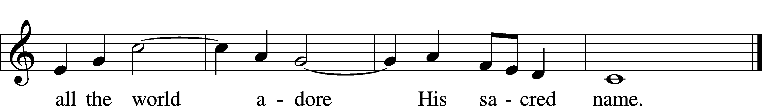
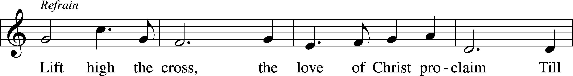

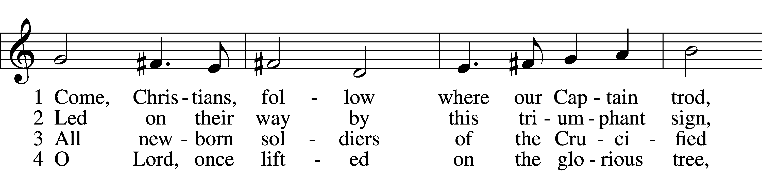

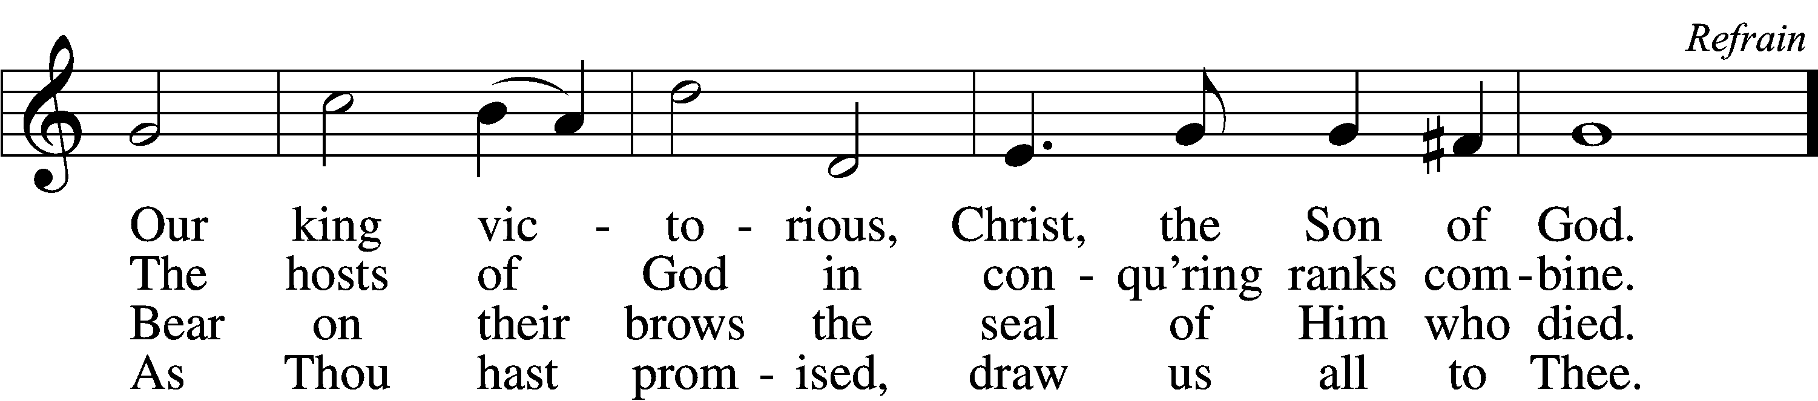

5 Let ev’ry race and ev’ry language tell
Of Him who saves our lives from death and hell. Refrain

6 So shall our song of triumph ever be:
Praise to the Crucified for victory! Refrain
Text: George W. Kitchin, 1827–1912; rev. Michael R. Newbolt, 1874–1956, alt.Tune: Sydney H. Nicholson, 1875–1947
Text and tune: © 1974 Hope Publishing Co. Used by permission: LSB Hymn License no. 110003744

Stand

Invocation
P In the name of the Father and of the T Son and of the Holy Spirit.
C Amen.

P If we say we have no sin, we deceive ourselves, and the truth is not in us.
C But if we confess our sins, God, who is faithful and just, will forgive our sins and cleanse us from all unrighteousness.

Silence for reflection on God’s Word and for self-examination.

Confession of Sins LSB 151
P Let us then confess our sins to God our Father.
C Most merciful God, we confess that we are by nature sinful and unclean. We have sinned against You in thought, word, and deed, by what we have done and by what we have left undone. We have not loved You with our whole heart; we have not loved our neighbors as ourselves. We justly deserve Your present and eternal punishment. For the sake of Your Son, Jesus Christ, have mercy on us. Forgive us, renew us, and lead us, so that we may delight in Your will and walk in Your ways to the glory of Your holy name. Amen.

Absolution LSB 151
P Almighty God in His mercy has given His Son to die for you and for His sake forgives you all your sins. As a called and ordained servant of Christ, and by His authority, I therefore forgive you all your sins in the name of the Father and of the T Son and of the Holy Spirit.
C Amen.
Service of the Word
Introit Psalm 75:1–2, 6, 9; antiphon: v. 7
It is God who executes | judgment,*
putting down one and lifting up an- | other.
We give thanks to you, O God; we give thanks, for your | name is near.*
We recount your | wondrous deeds.
At the set time that | I appoint*
I will judge with | equity.
For not from the east or | from the west*
and not from the wilderness comes | lifting up.
But I will declare it for- | ever;*
I will sing praises to the God of | Jacob.
It is God who executes | judgment,*
putting down one and lifting up an- | other.
Glory be to the Father and | to the Son*
and to the Holy | Spirit;
as it was in the be- | ginning,*
is now, and will be forever. | Amen.
Kyrie LSB 152
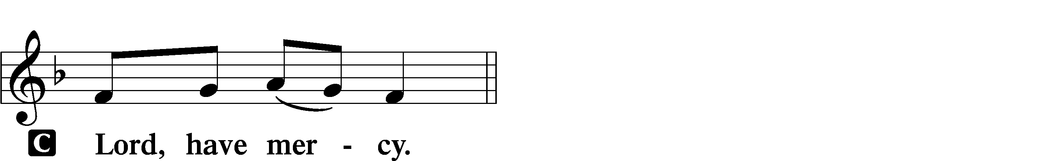
P In peace let us pray to the Lord.

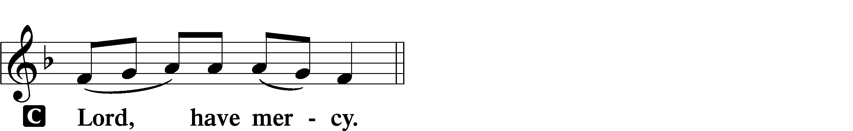
P For the peace from above and for our salvation let us pray to the Lord.

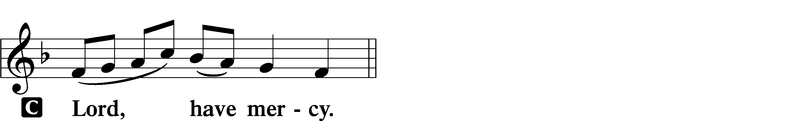
P For the peace of the whole world, for the well-being of the Church of God, and for the unity of all let us pray to the Lord.

P For this holy house and for all who offer here their worship and praise let us pray to the Lord.

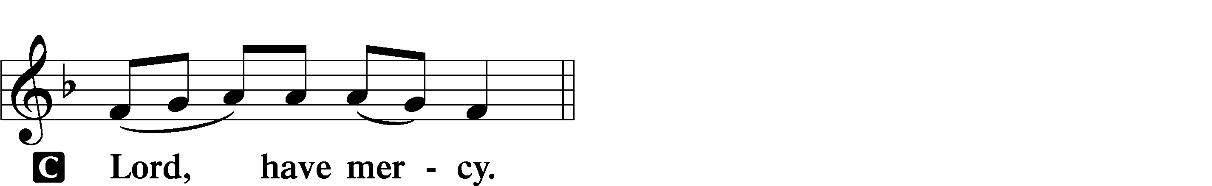

P Help, save, comfort, and defend us, gracious Lord.

Gloria in Excelsis LSB 154
P Glory to God in the highest, and peace to His people on earth.
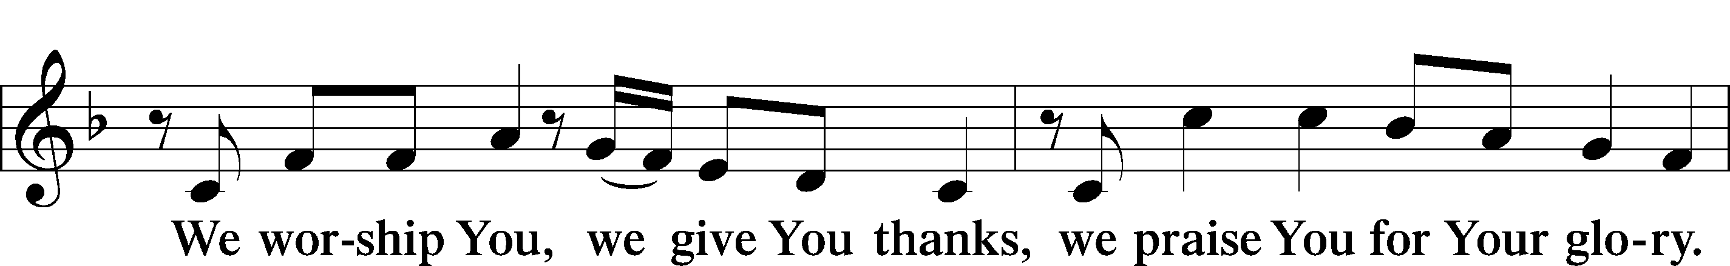
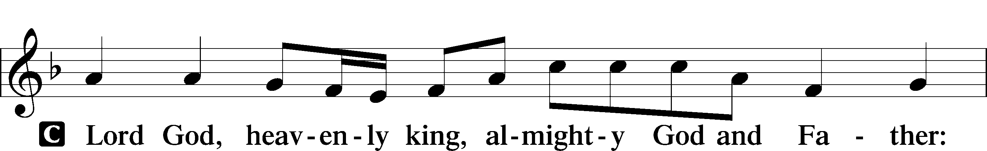

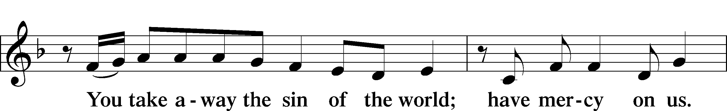
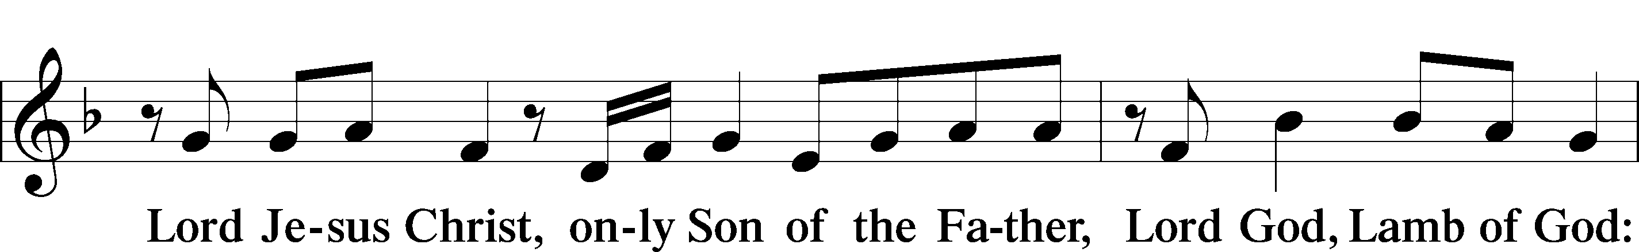

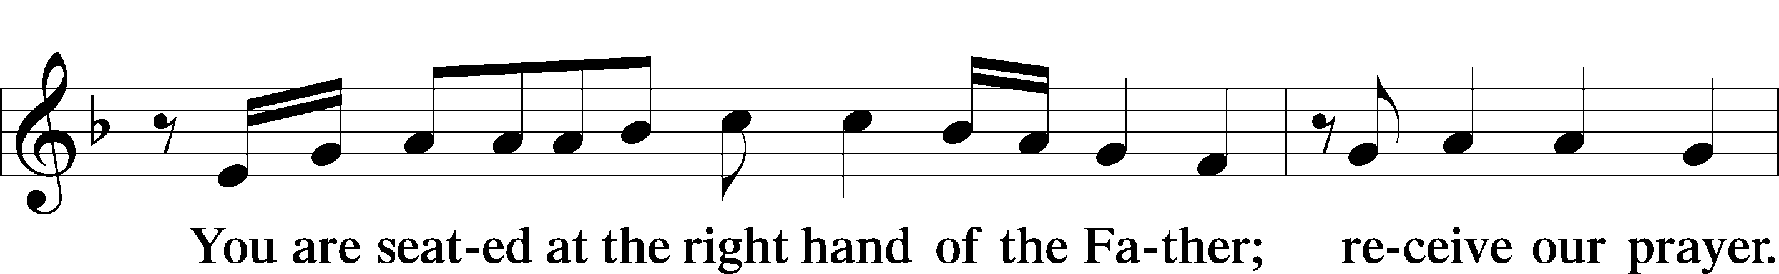

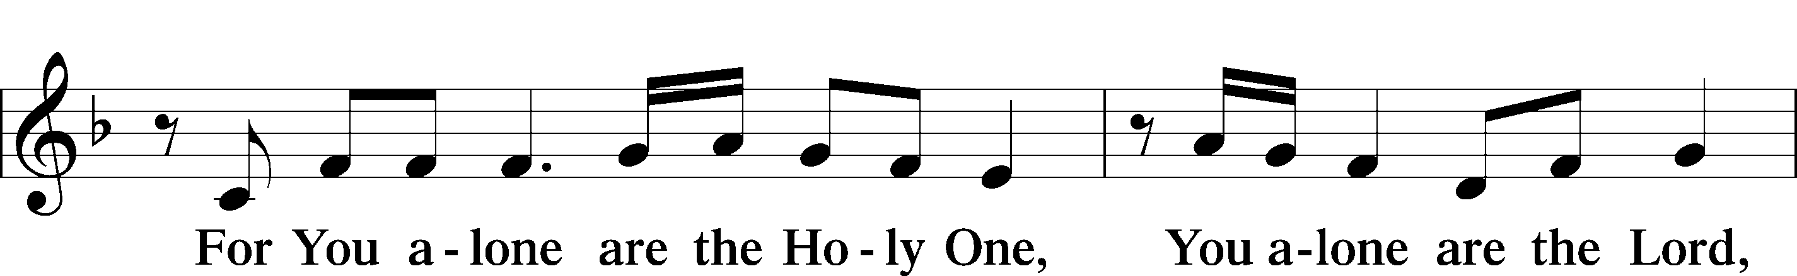

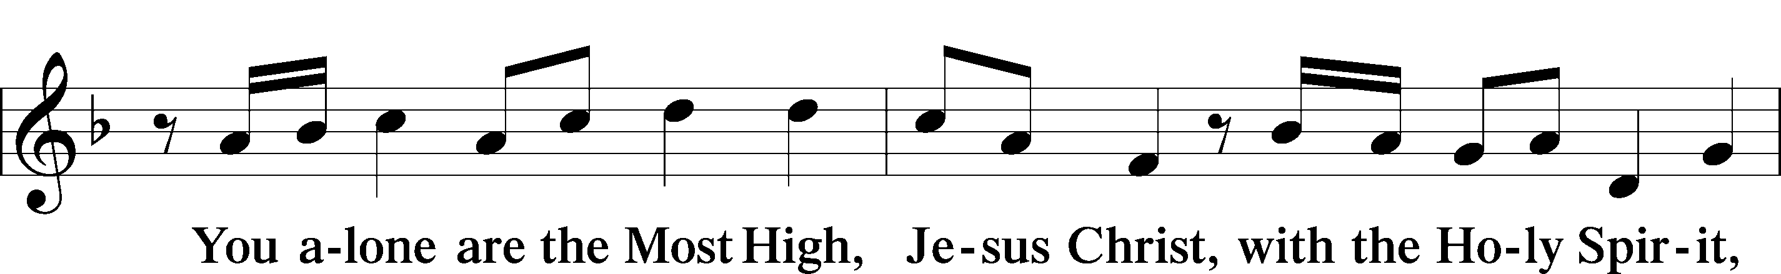

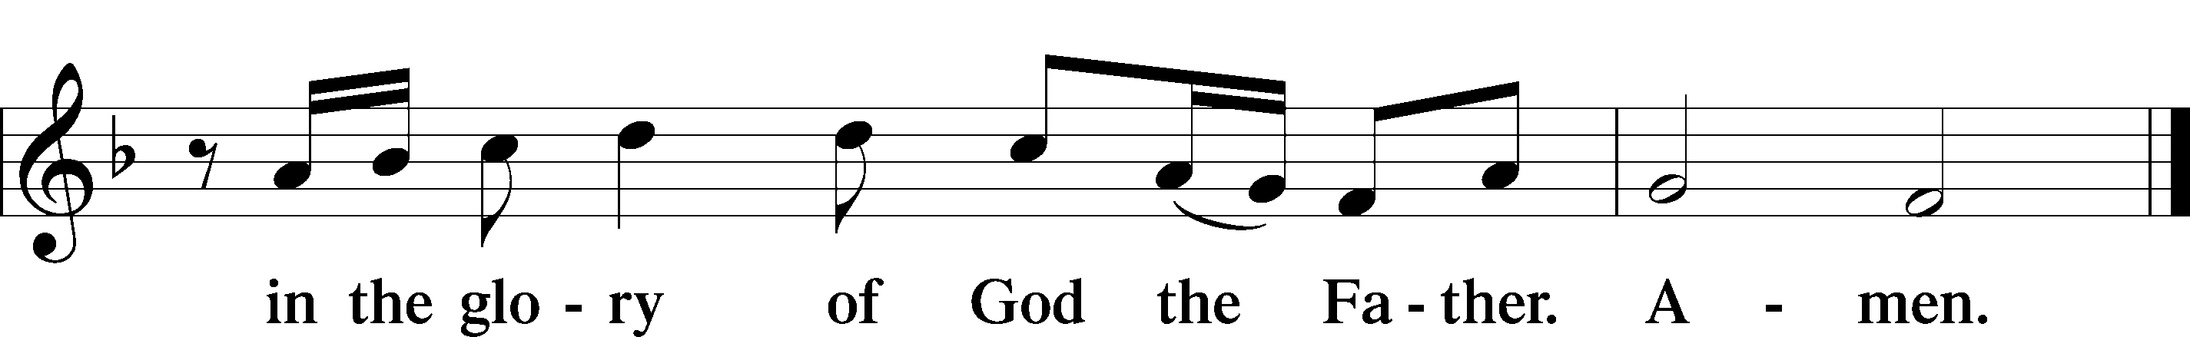
Salutation and Collect of the Day
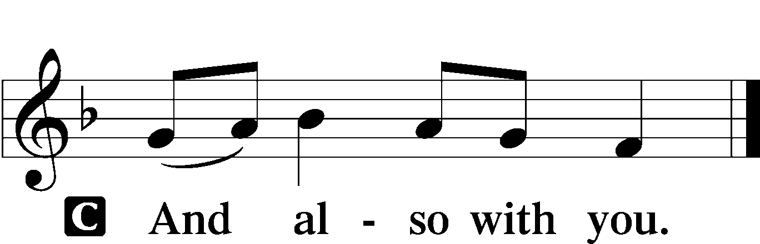
P The Lord be with you.

P Let us pray.
O Lord of grace and mercy, teach us by Your Holy Spirit to follow the example of Your Son in true humility, that we may withstand the temptations of the devil and with pure hearts and minds avoid ungodly pride; through the same Jesus Christ, our Lord, who lives and reigns with You and the Holy Spirit, one God, now and forever.
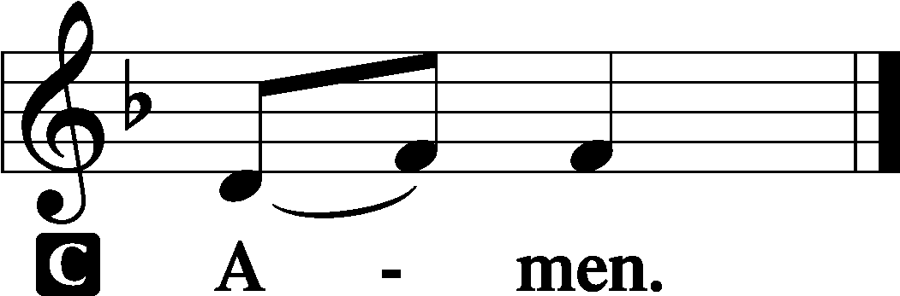

Sit

Old Testament Reading Proverbs 25:2–10
²It is the glory of God to conceal things,
but the glory of kings is to search things out.
³As the heavens for height, and the earth for depth,
so the heart of kings is unsearchable.
⁴Take away the dross from the silver,
and the smith has material for a vessel;
⁵take away the wicked from the presence of the king,
and his throne will be established in righteousness.
⁶Do not put yourself forward in the king’s presence
or stand in the place of the great,
⁷for it is better to be told, “Come up here,”
than to be put lower in the presence of a noble.
What your eyes have seen
⁸do not hastily bring into court,
for what will you do in the end,
when your neighbor puts you to shame?
⁹Argue your case with your neighbor himself,
and do not reveal another’s secret,
¹⁰lest he who hears you bring shame upon you,
and your ill repute have no end.
P This is the Word of the Lord.
C Thanks be to God.

Gradual Psalm 34:9, 19, alt.
Fear the Lord, | you his saints,*
for those who fear him lack | nothing!
Many are the afflictions of the | righteous,*
but the Lord delivers him out | of them all.

Epistle Hebrews 13:1–17
¹Let brotherly love continue. ²Do not neglect to show hospitality to strangers, for thereby some have entertained angels unawares. ³Remember those who are in prison, as though in prison with them, and those who are mistreated, since you also are in the body. ⁴Let marriage be held in honor among all, and let the marriage bed be undefiled, for God will judge the sexually immoral and adulterous. ⁵Keep your life free from love of money, and be content with what you have, for he has said, “I will never leave you nor forsake you.” ⁶So we can confidently say,
“The Lord is my helper;
I will not fear;
what can man do to me?”
⁷Remember your leaders, those who spoke to you the word of God. Consider the outcome of their way of life, and imitate their faith. ⁸Jesus Christ is the same yesterday and today and forever. ⁹Do not be led away by diverse and strange teachings, for it is good for the heart to be strengthened by grace, not by foods, which have not benefited those devoted to them. ¹⁰We have an altar from which those who serve the tent have no right to eat. ¹¹For the bodies of those animals whose blood is brought into the holy places by the high priest as a sacrifice for sin are burned outside the camp. ¹²So Jesus also suffered outside the gate in order to sanctify the people through his own blood. ¹³Therefore let us go to him outside the camp and bear the reproach he endured. ¹⁴For here we have no lasting city, but we seek the city that is to come. ¹⁵Through him then let us continually offer up a sacrifice of praise to God, that is, the fruit of lips that acknowledge his name. ¹⁶Do not neglect to do good and to share what you have, for such sacrifices are pleasing to God.
¹⁷Obey your leaders and submit to them, for they are keeping watch over your souls, as those who will have to give an account. Let them do this with joy and not with groaning, for that would be of no advantage to you.
P This is the Word of the Lord.
C Thanks be to God.

Stand

Alleluia and Verse LSB 156
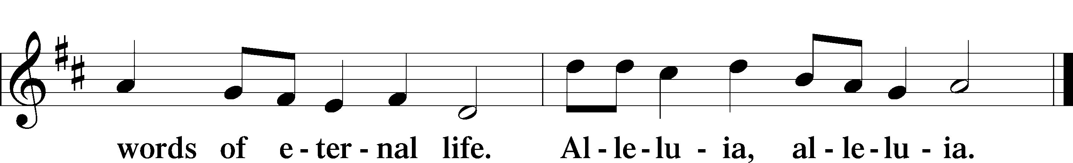
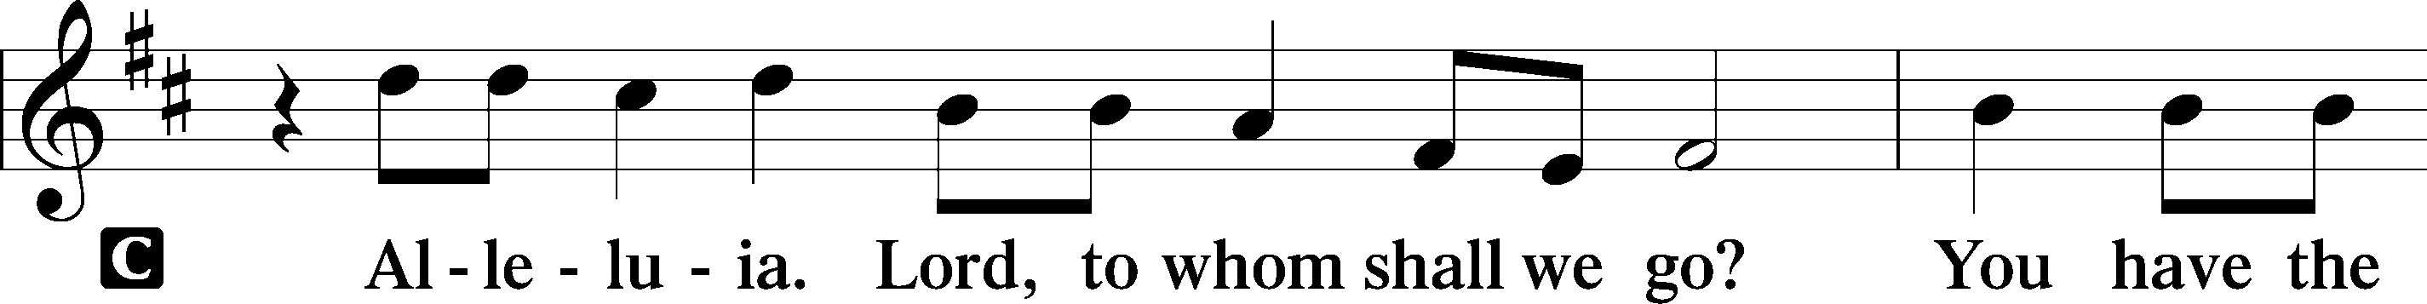

Holy Gospel Luke 14:1–14
P The Holy Gospel according to St. Luke, the fourteenth chapter.
C Glory to You, O Lord.
¹One Sabbath, when [Jesus] went to dine at the house of a ruler of the Pharisees, they were watching him carefully. ²And behold, there was a man before him who had dropsy. ³And Jesus responded to the lawyers and Pharisees, saying, “Is it lawful to heal on the Sabbath, or not?” ⁴But they remained silent. Then he took him and healed him and sent him away. ⁵And he said to them, “Which of you, having a son or an ox that has fallen into a well on a Sabbath day, will not immediately pull him out?” ⁶And they could not reply to these things.
⁷Now he told a parable to those who were invited, when he noticed how they chose the places of honor, saying to them, ⁸“When you are invited by someone to a wedding feast, do not sit down in a place of honor, lest someone more distinguished than you be invited by him, ⁹and he who invited you both will come and say to you, ‘Give your place to this person,’ and then you will begin with shame to take the lowest place. ¹⁰But when you are invited, go and sit in the lowest place, so that when your host comes he may say to you, ‘Friend, move up higher.’ Then you will be honored in the presence of all who sit at table with you. ¹¹For everyone who exalts himself will be humbled, and he who humbles himself will be exalted.”
¹²He said also to the man who had invited him, “When you give a dinner or a banquet, do not invite your friends or your brothers or your relatives or rich neighbors, lest they also invite you in return and you be repaid. ¹³But when you give a feast, invite the poor, the crippled, the lame, the blind, ¹⁴and you will be blessed, because they cannot repay you. You will be repaid at the resurrection of the just.”
P This is the Gospel of the Lord.
C Praise to You, O Christ.

Sit

842 Son of God, Eternal Savior
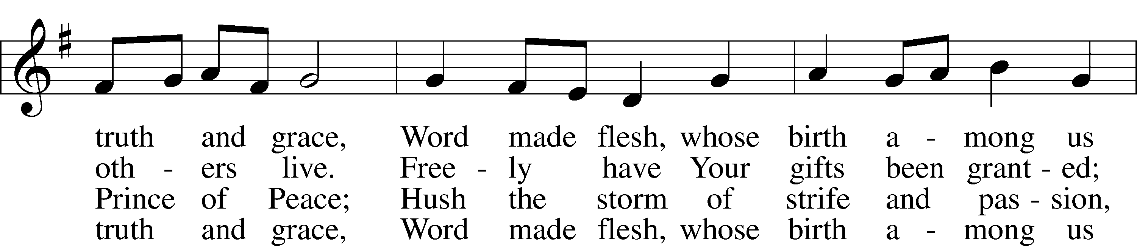
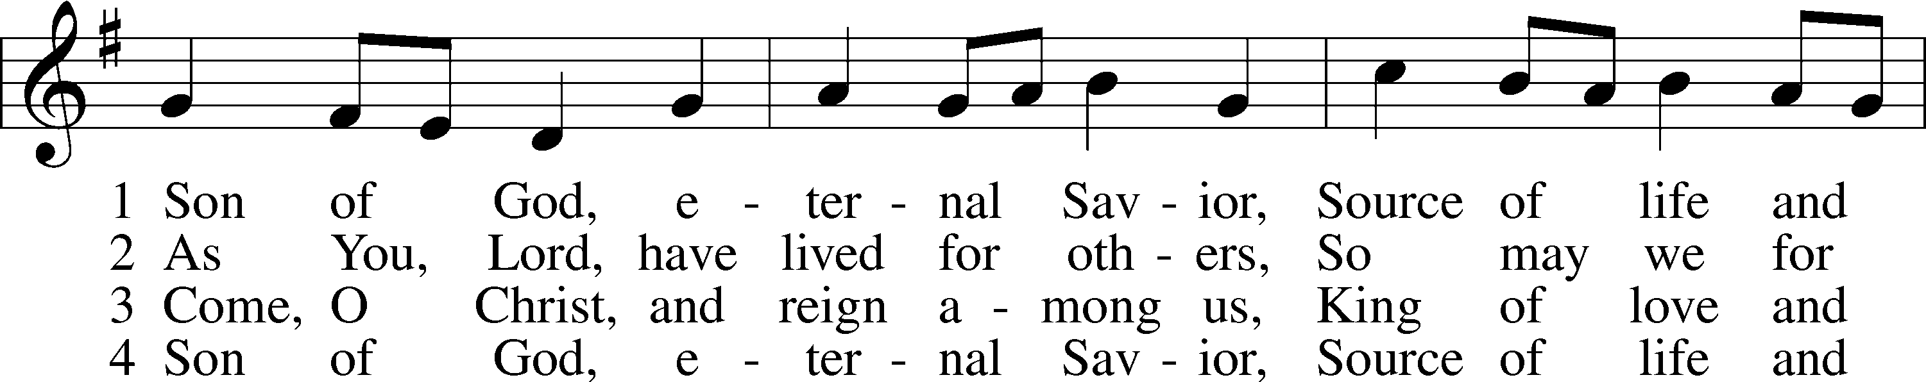

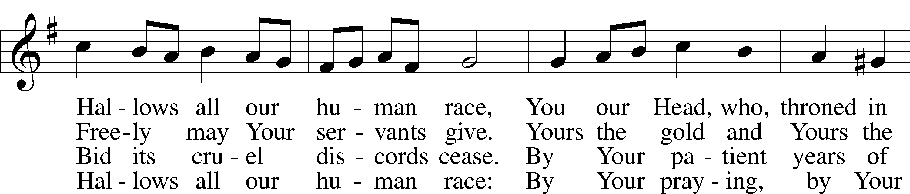

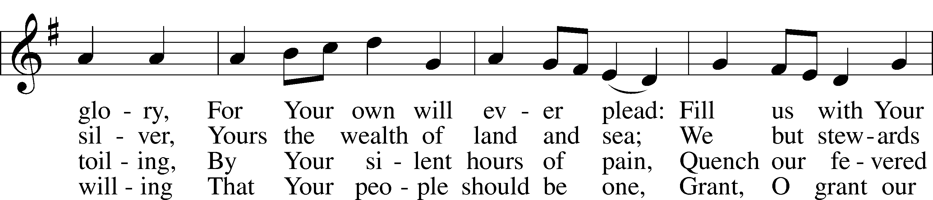

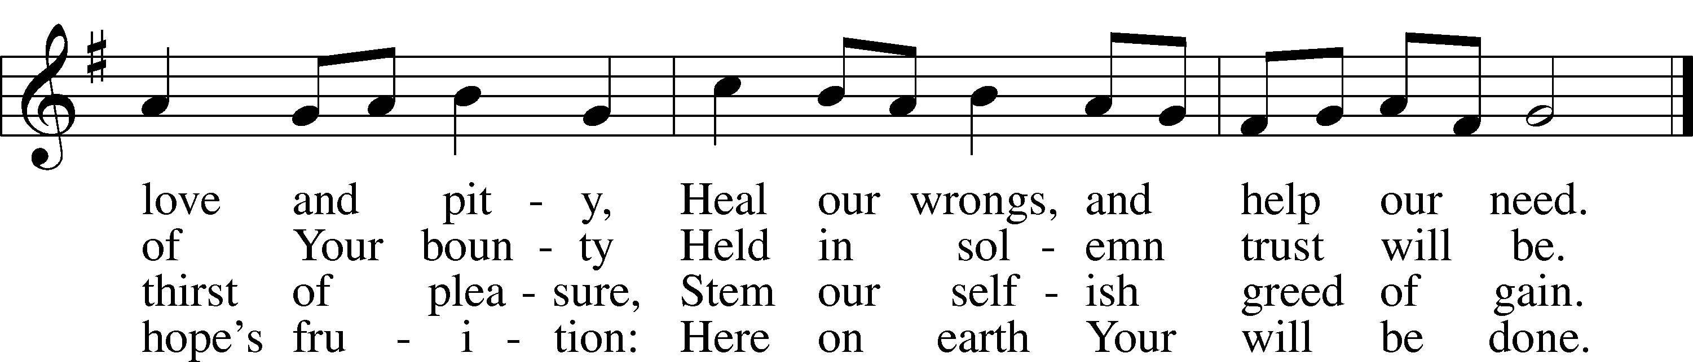

Text: Somerset T. C. Lowry, 1855–1932, alt. Tune: Oude en Nieuwe Hollantse . . . Contradanseu, c. 1710, Amsterdam Text and tune: Public domain

Sermon

Stand

Nicene Creed
C I believe in one God,
the Father Almighty,
maker of heaven and earth
and of all things visible and invisible.
And in one Lord Jesus Christ,
the only-begotten Son of God,
begotten of His Father before all worlds,
God of God, Light of Light,
very God of very God,
begotten, not made,
being of one substance with the Father,
by whom all things were made;
who for us men and for our salvation came down from heaven
and was incarnate by the Holy Spirit of the virgin Mary
and was made man;
and was crucified also for us under Pontius Pilate.
He suffered and was buried.
And the third day He rose again according to the Scriptures
and ascended into heaven
and sits at the right hand of the Father.
And He will come again with glory to judge both the living and the dead,
whose kingdom will have no end.
And I believe in the Holy Spirit,
the Lord and giver of life,
who proceeds from the Father and the Son,
who with the Father and the Son together is worshiped and glorified,
who spoke by the prophets.
And I believe in one holy Christian and apostolic Church,
I acknowledge one Baptism for the remission of sins,
and I look for the resurrection of the dead
and the life T of the world to come. Amen.

Prayer of the Church

Consecration of the Offering
After the prayers please be seated. The altar is set for the Lord’s Supper and the offering is consecrated. As you prepare to receive the sacrament you may use the prayers in the front of the hymnal or meditate on a communion hymn.

Stand

Offertory LSB 159
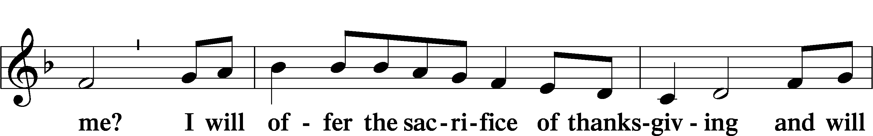
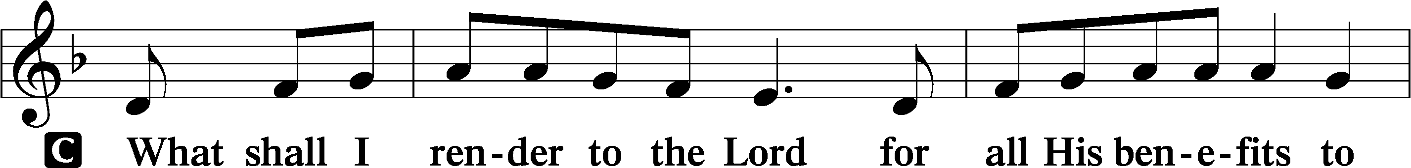

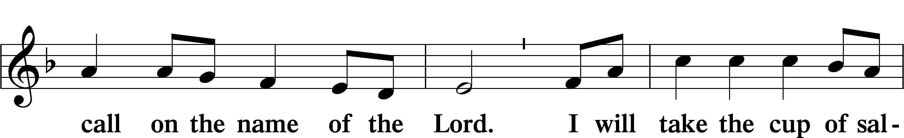

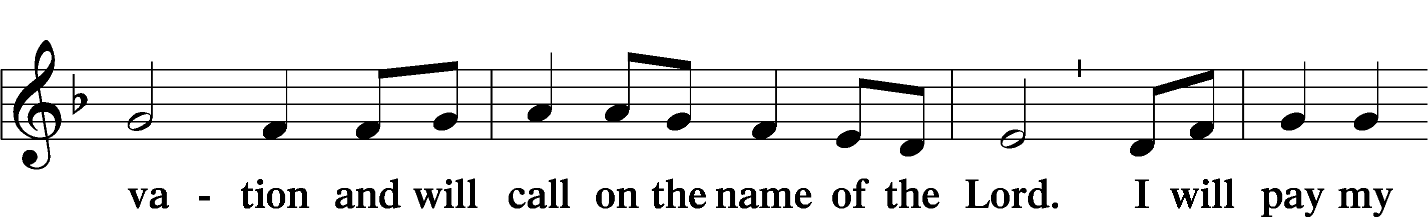

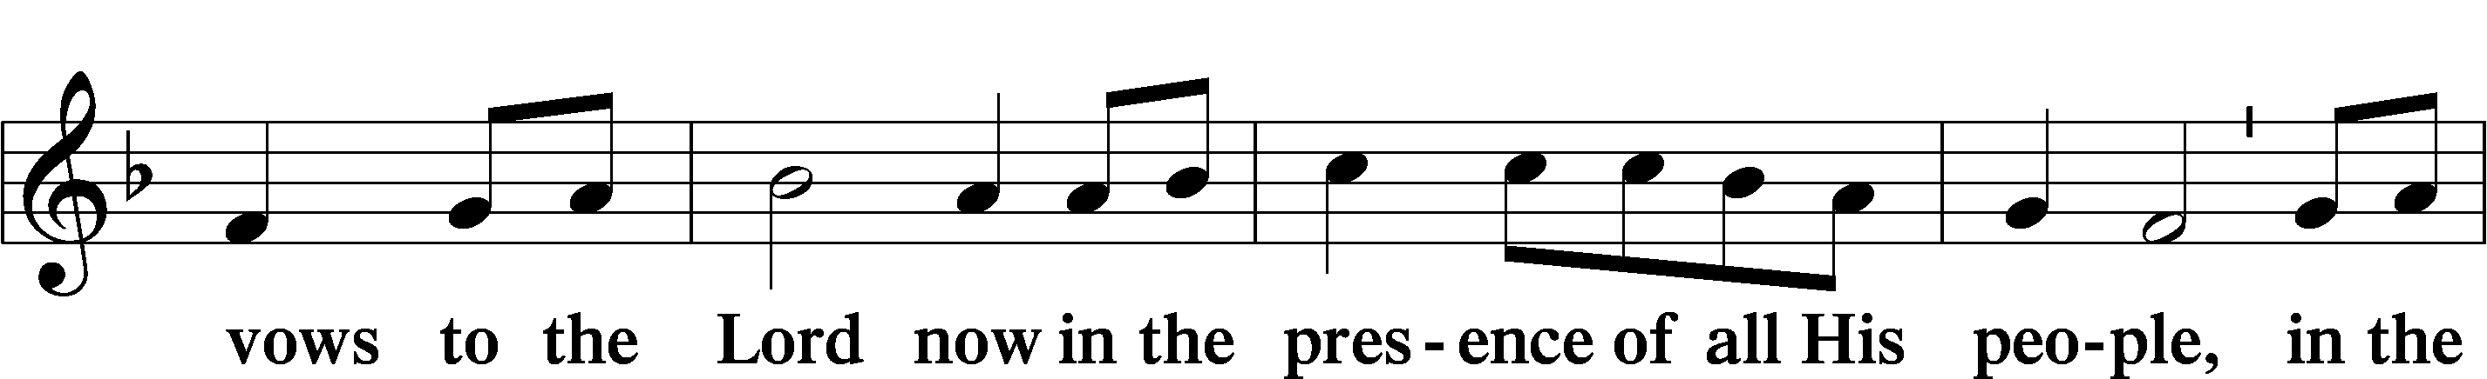

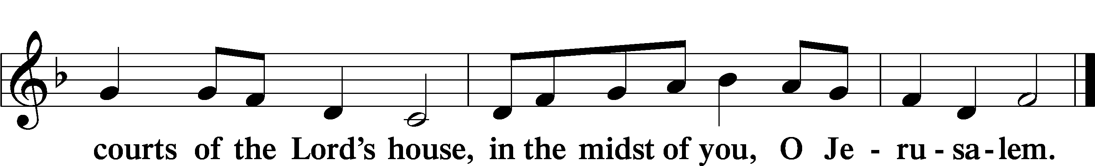

Service of the Sacrament
Preface LSB 160
P The Lord be with you.

P Lift up your hearts.

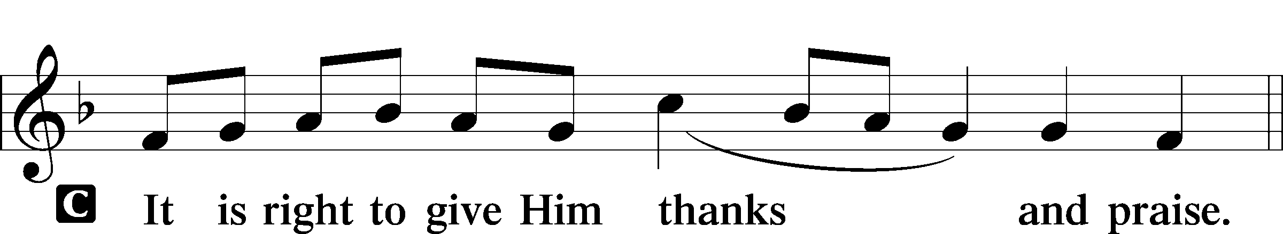
P Let us give thanks to the Lord our God.

P It is truly good, right, and salutary that we should at all times and in all places give thanks to You, holy Lord, almighty Father, everlasting God, through Jesus Christ, our Lord. Therefore with angels and archangels and with all the company of heaven we laud and magnify Your glorious name, evermore praising You and saying:
Sanctus LSB 161
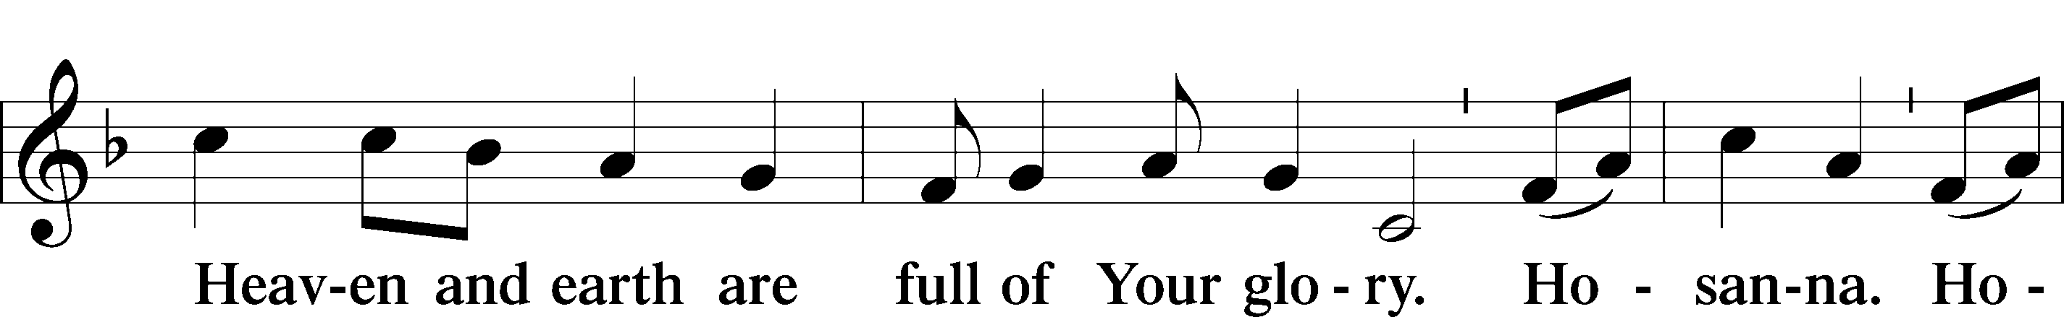
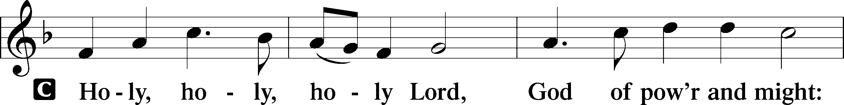

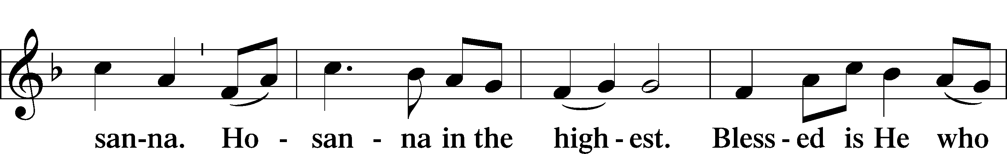

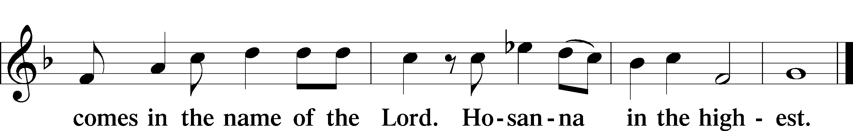

Lord’s Prayer
C Our Father who art in heaven,
hallowed be Thy name,
Thy kingdom come,
Thy will be done on earth
as it is in heaven;
give us this day our daily bread;
and forgive us our trespasses
as we forgive those
who trespass against us;
and lead us not into temptation,
but deliver us from evil.
For Thine is the kingdom
and the power and the glory
forever and ever. Amen.

The Words of Our Lord
P Our Lord Jesus Christ, on the night when He was betrayed, took bread, and when He had given thanks, He broke it and gave it to the disciples and said: “Take, eat; this is My T body, which is given for you. This do in remembrance of Me.”
In the same way also He took the cup after supper, and when He had given thanks, He gave it to them, saying: “Drink of it, all of you; this cup is the new testament in My T blood, which is shed for you for the forgiveness of sins. This do, as often as you drink it, in remembrance of Me.”
Pax Domini LSB 163
P The peace of the Lord be with you always.

Agnus Dei LSB 163
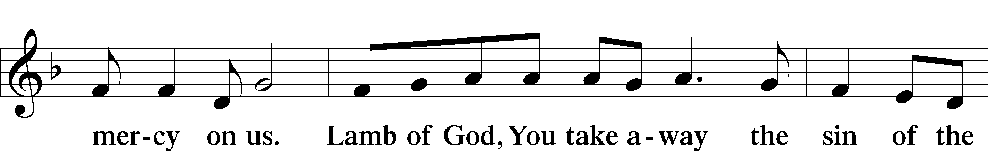
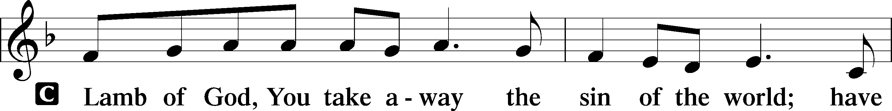

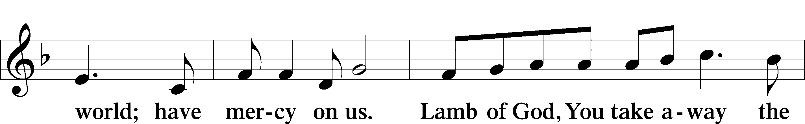

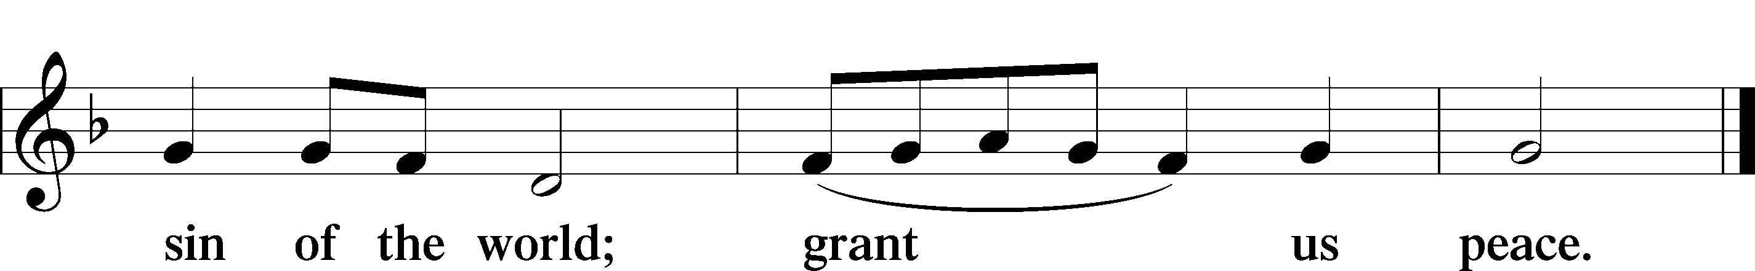

Sit

Distribution

620 Jesus Comes Today with Healing
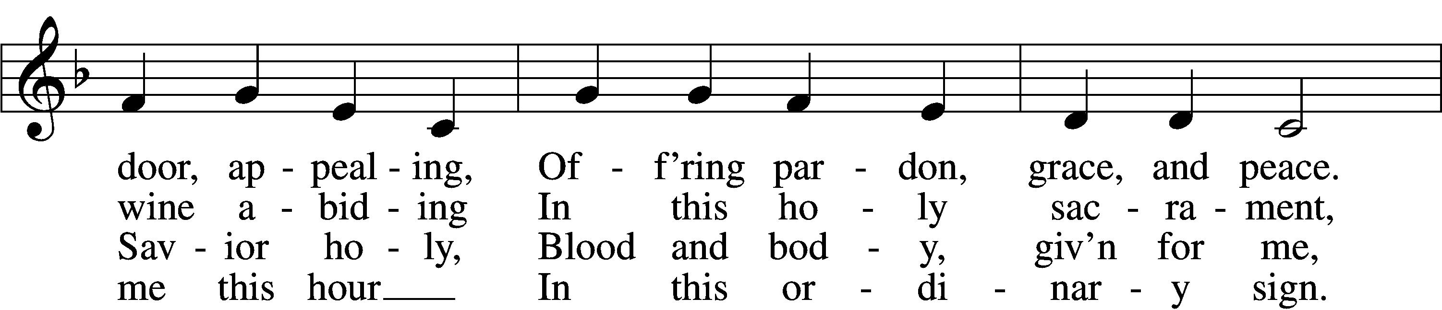
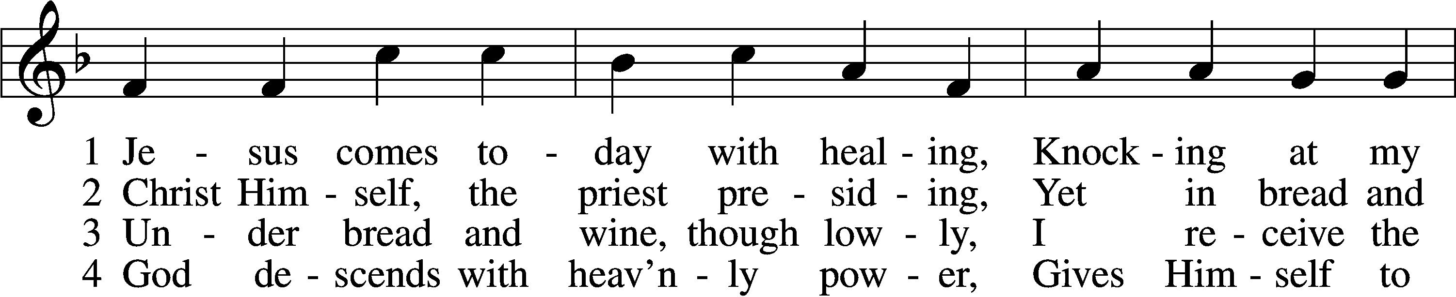

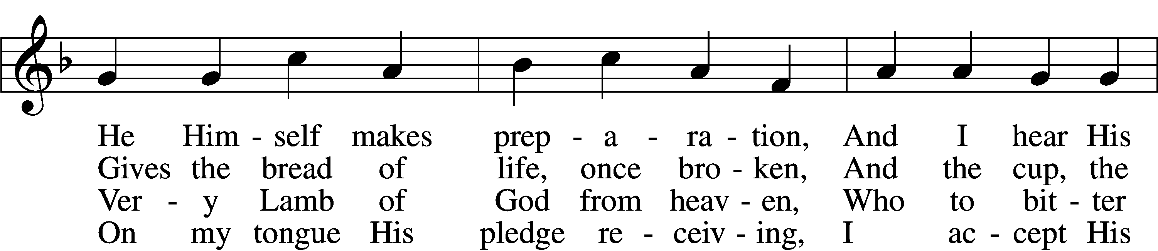

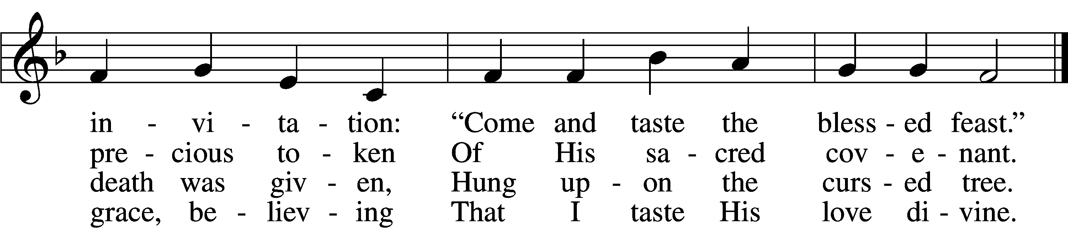

5 Let me praise God’s boundless favor,
Whose own feast of love I savor,
Bidden by His gracious call.
Wedding garments He provides me,
With a robe of white He hides me,
Fits me for the royal hall.

6 Now have I found consolation,
Comfort in my tribulation,
Balm to heal the troubled soul.
God, my shield from ev’ry terror,
Cleanses me from sin and error,
Makes my wounded spirit whole.

Text: Heinrich Puchta, 1808–58; tr. David W. Rogner, 1960 Tune: Johann Löhner, 1645–1705; adapt. Johann Balthasar König, 1691–1758
Text: © David W. Rogner. Used by permission: LSB Hymn License no. 110003744 Tune: Public domain

623 Lord Jesus Christ, We Humbly Pray
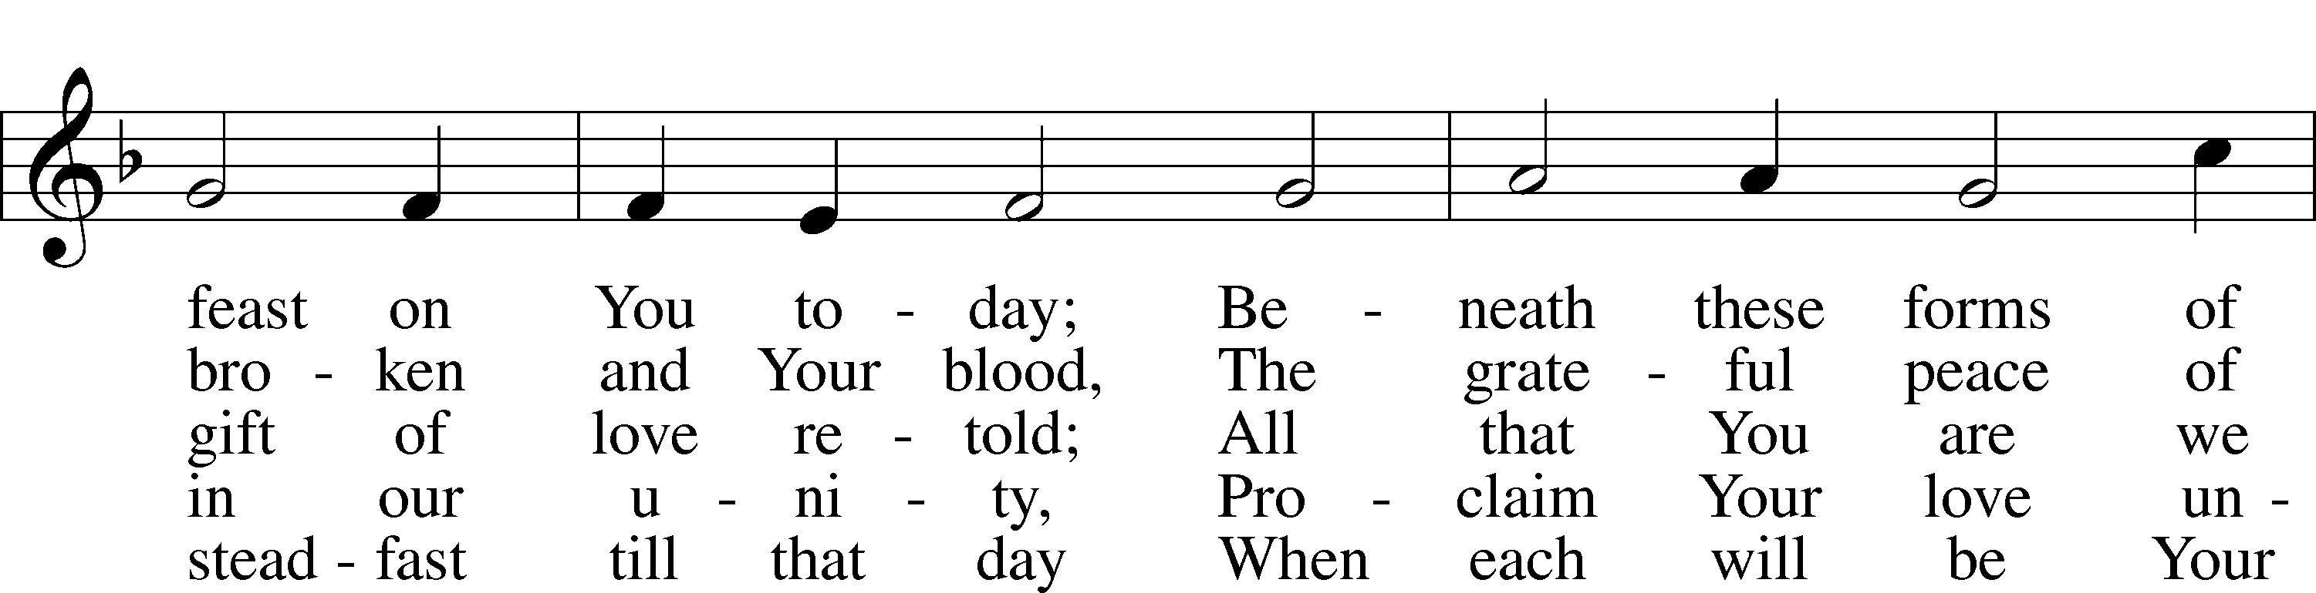
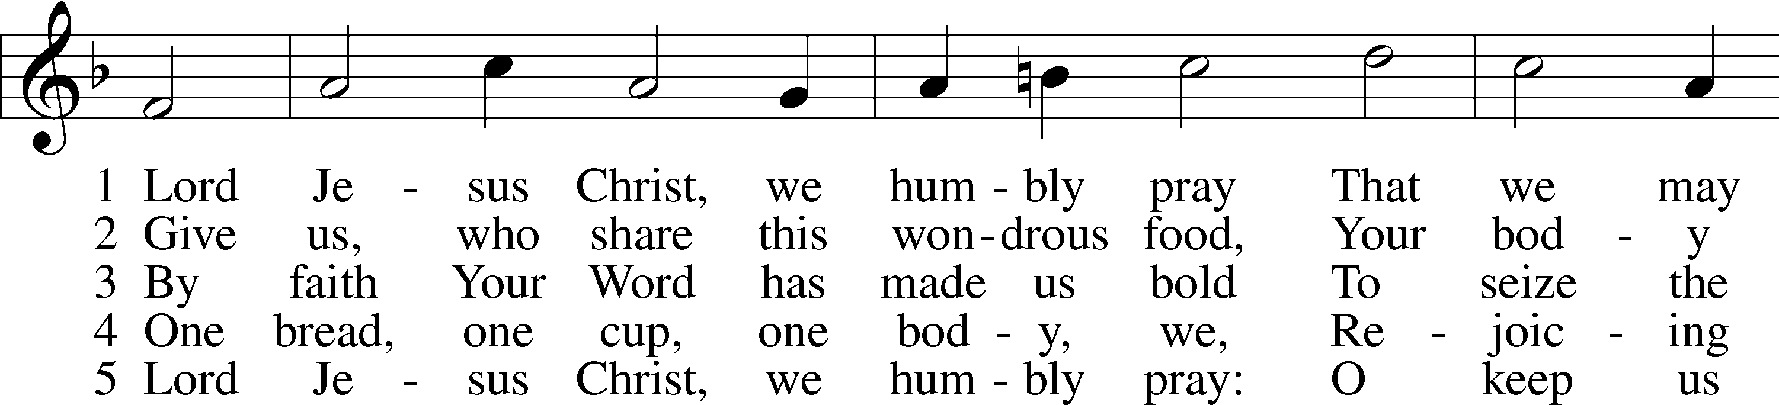

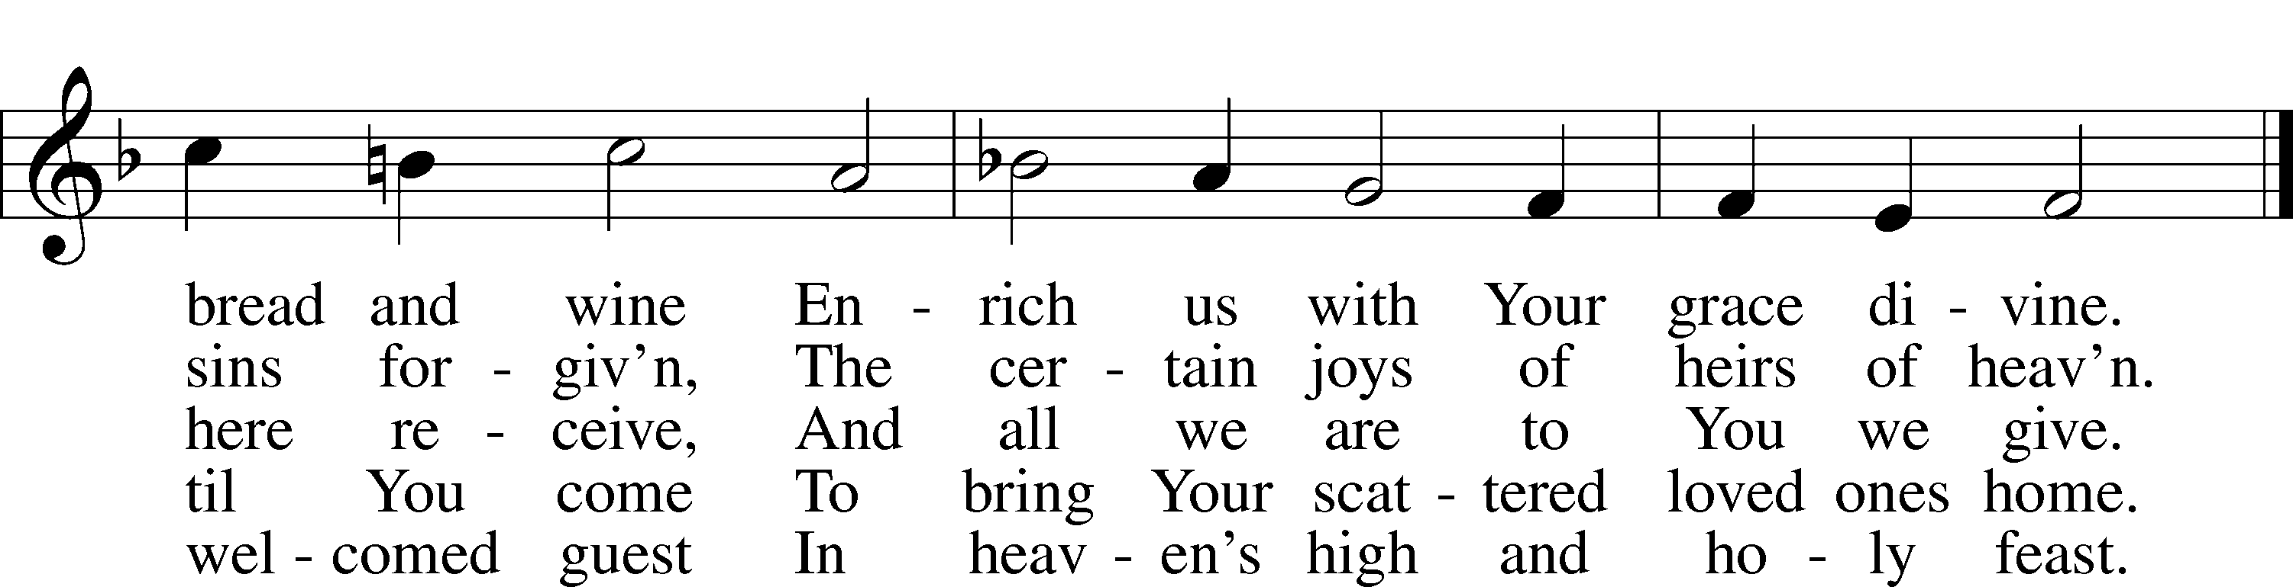

Text: Henry E. Jacobs, 1844–1932, alt. Tune: Cantionale Germanicum, 1628, Gochsheim Text and tune: Public domain

625 Lord Jesus Christ, Life-Giving Bread
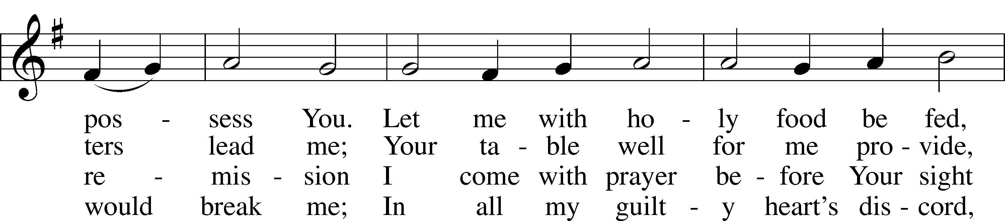
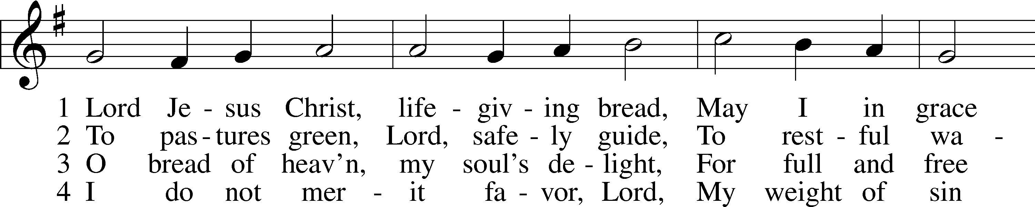

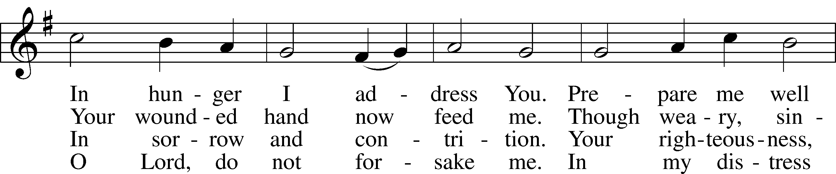

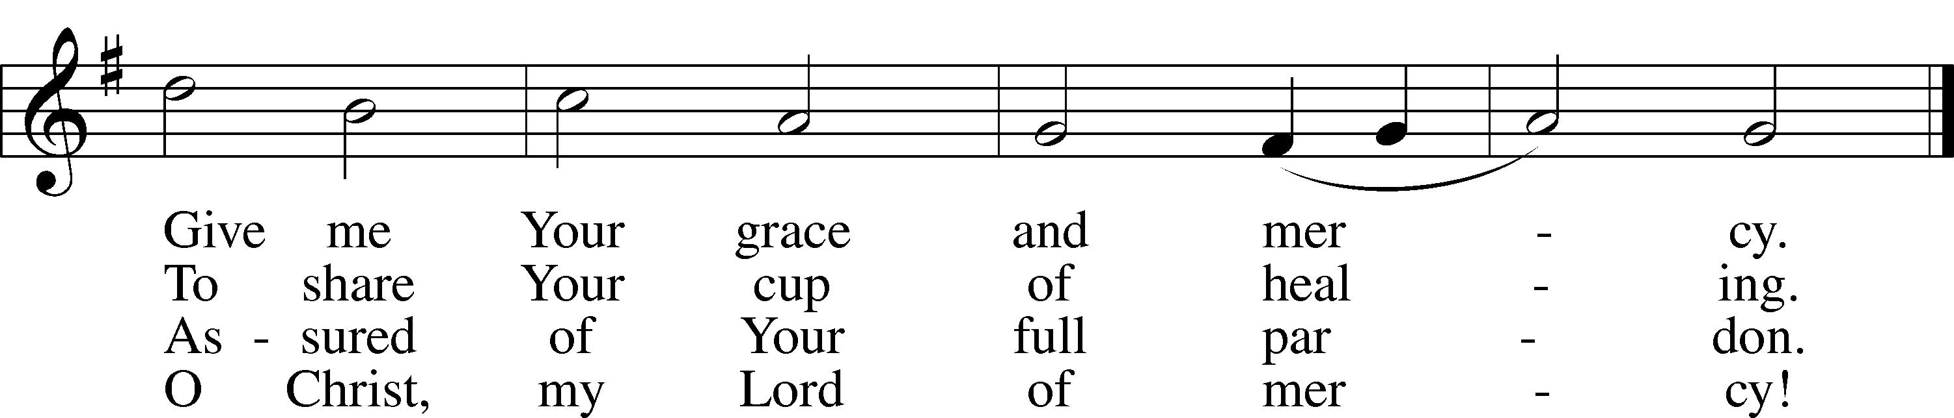
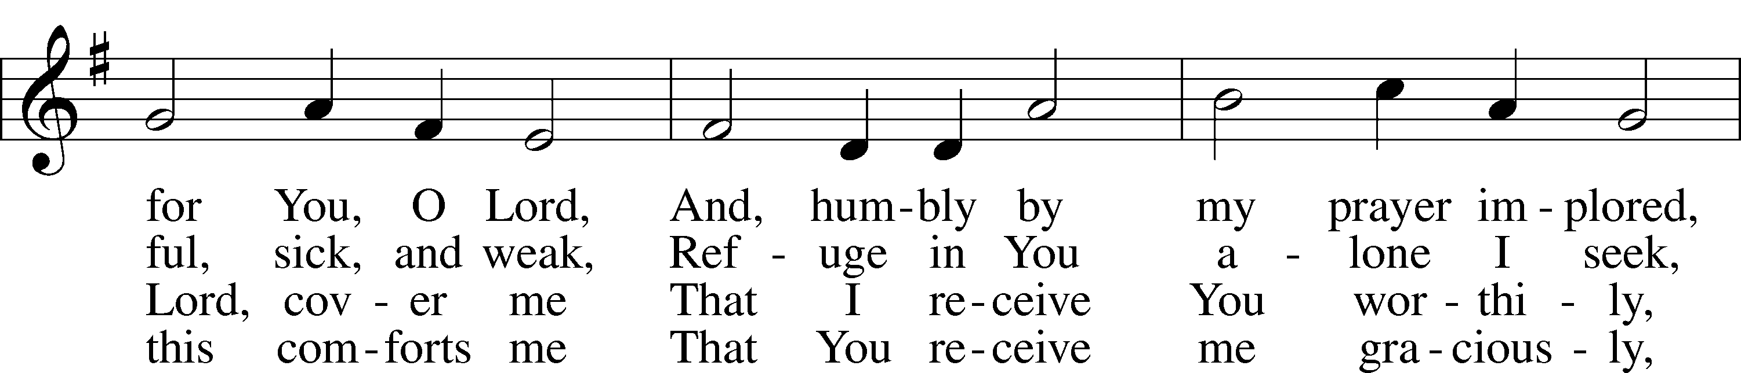

Text: Johann Rist, 1607–67; tr. Arthur T. Russell, 1806–74, alt. Tune: Theütsch kirchen ampt, 1525, Strassburg Text and tune: Public domain

706 Love in Christ Is Strong and Living
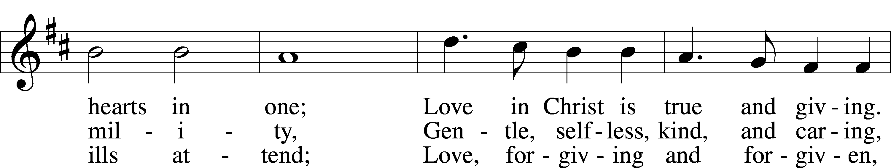
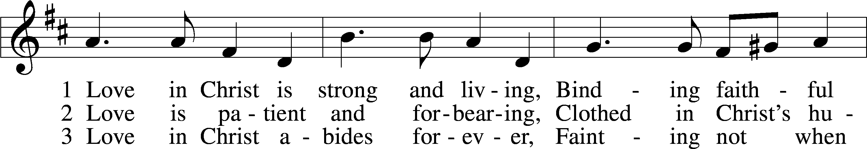

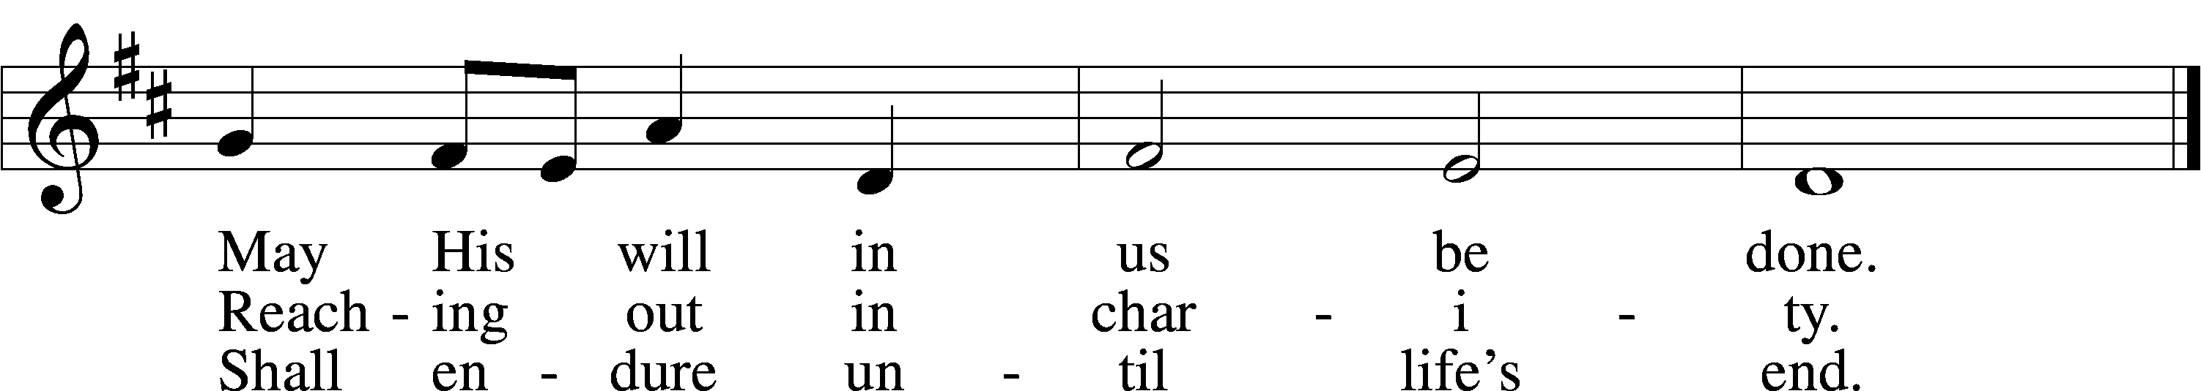

Text: Dorothy R. Schultz, 1934 Tune: Ralph C. Schultz, 1932 Text and tune: © 1979 Concordia Publishing House. Used by permission: LSB Hymn License no. 110003744
Stand

The Dismissal
P The body and blood of our Lord Jesus Christ strengthen and preserve you in body and soul to life everlasting. Depart T in peace.
C Amen.

Thank the Lord LSB 164
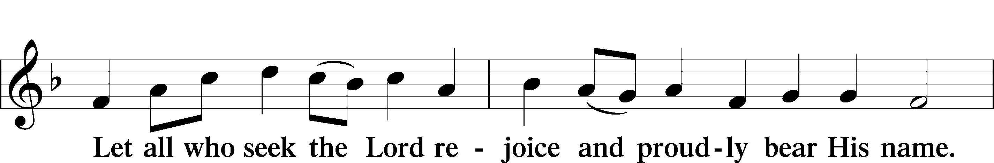
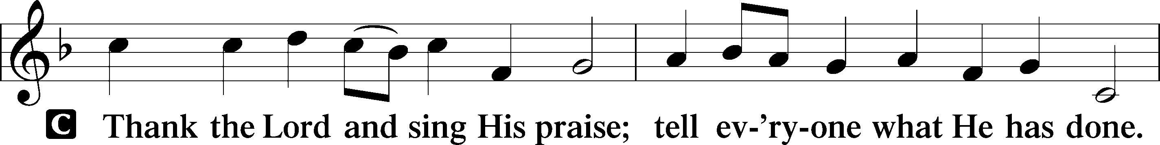

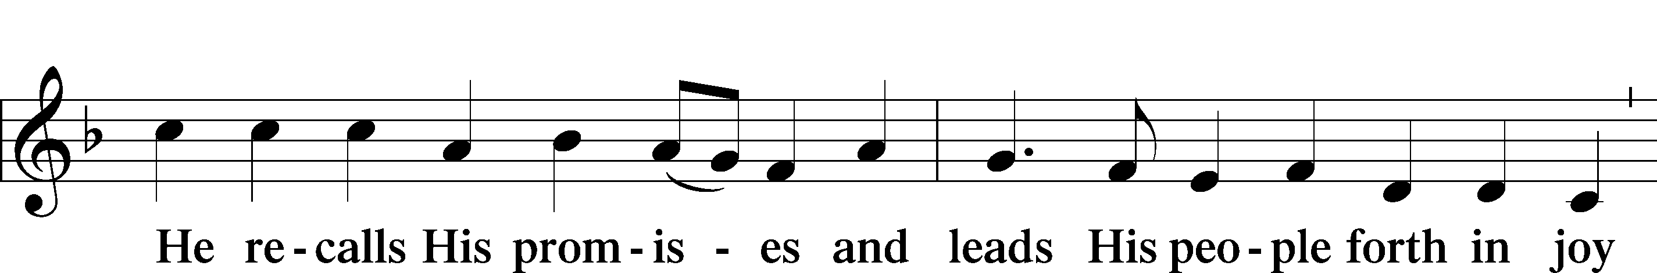

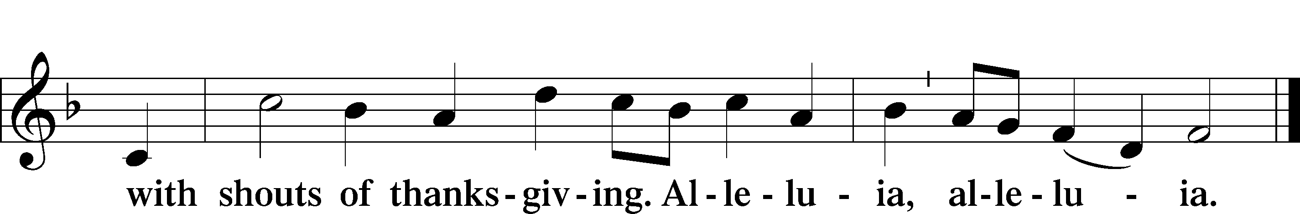

Post-Communion Collect
P Let us pray.
We give thanks to You, almighty God, that You have refreshed us through this salutary gift, and we implore You that of Your mercy You would strengthen us through the same in faith toward You and in fervent love toward one another; through Jesus Christ, Your Son, our Lord, who lives and reigns with You and the Holy Spirit, one God, now and forever.

Benediction LSB 166
P The Lord bless you and keep you.
The Lord make His face shine on you and be gracious to you.
The Lord look upon you with favor and T give you peace.

848 Lord, Whose Love through Humble Service sts. 1–3
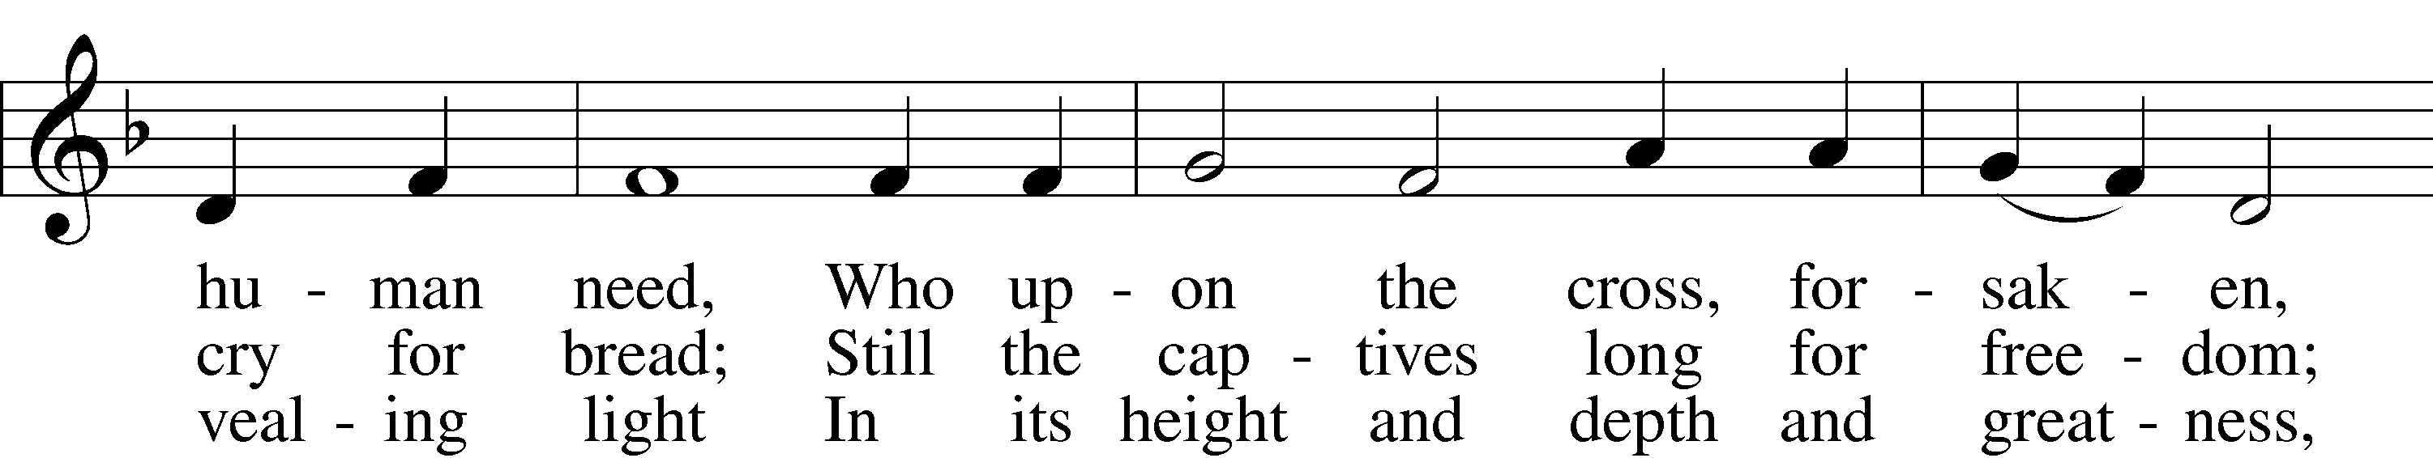
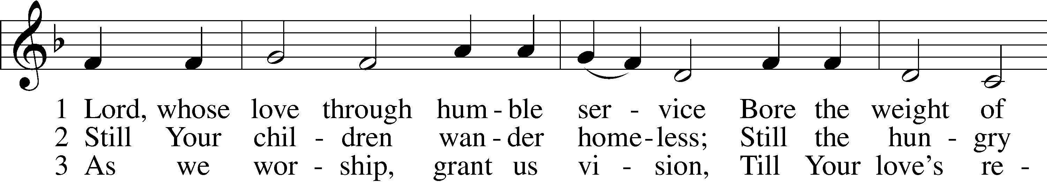

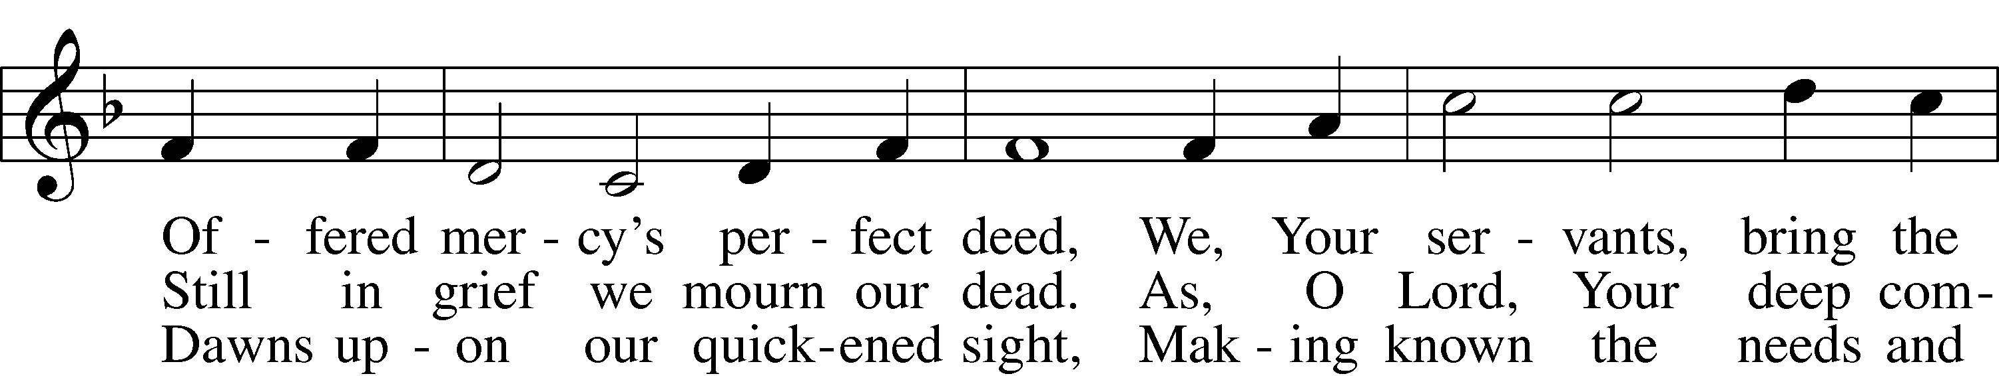

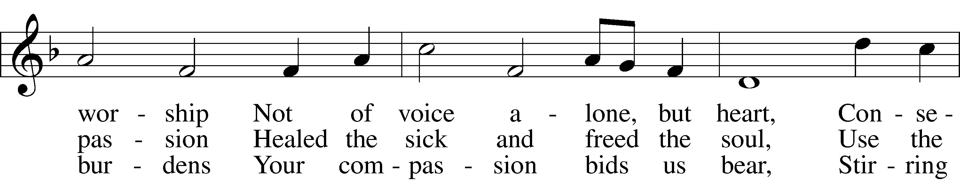

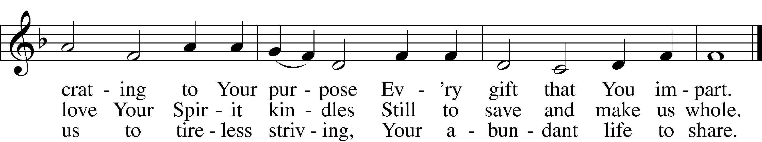

Text: Albert F. Bayly, 1901–84, alt. Tune: The Sacred Harp, 1844, Philadelphia Text: © Oxford University Press. Used by permission: LSB Hymn License no. 110003744 Tune: Public domain

Acknowledgments
Unless otherwise indicated, Scripture quotations are from the ESV® Bible (The Holy Bible, English Standard Version®), copyright © 2001 by Crossway, a publishing ministry of Good News Publishers. Used by permission. All rights reserved.
Created by Lutheran Service Builder © 2021 Concordia Publishing House.

Prayers for Our Members
Family and Friends of Verleen Gentry | Grief
Norman Abels (Brookestone Meadows–Elkhorn) | Healing
Judy Ahrens | Healing
Vaughn Albrecht (Mount Carmel) | Healing
Tom & DyAnn Altwine | Healing
Lyle Colsden (Mother Hull) | Healing
Pat Flodine (Cambridge Court) | Healing
Vi Fox (Prairie View) | Healing
Ruby Hatfield | Healing
Evelyn Heiden (Mother Hull) | Healing
Lennis Hodgson | Healing
Linda Luhn | Healing
Jackie Ohlmann | Healing
Diane Plummer | Healing
Debra Schinkel | Healing
Robin Baker | Cancer
Ivan Bombeck | Cancer
Dwight Farmer | Cancer
Bertha Marienau | Cancer

Prayers for Our Members’ Family & Friends
Roger Young (Tiffany Davis’ father) | Parkinson’s
Shannon Bartels (Bartels’ daughter-in-law) | Surgery
Melanie Kanode (Sue Bartels’ relative) | Heart Surgery
Roger Hoffman (Marc’s father) | Healing
Luetta Lammers (Ruby Hatfield’s sister) | Healing
Tim Powers (Kim Wilken’s brother) | Healing
Howard Quandt (Don & Shirley Helmbrecht’s family) | Healing
David Shiers (Jessica’s father) | Healing
Randy Solomon (Beth Rosenthal’s father) | Healing
Jonah (Jase & Jarren Blattner’s friend) | Cancer
Glenda Fichtner (Ruby Hatfield’s niece) | Cancer
Ron Halvorsen (Jeff’s dad) | Cancer
Sharon Mulhair (Pam Uhlir’s cousin) | Cancer
Milton Naprstek (Marilyn Fuqua’s brother) | Cancer
Cindy Pietsch (Ellen’s sister-in-law) | Cancer
Rick Schnacker (Marilyn Fuqua’s nephew) | Cancer
Tyrone Uhlir (Pam’s nephew) | Cancer
Ray Vang (Don & Shirley Helmbrecht’s brother-in-law) | Cancer

Our Response to the Gospel
Date: 8/21/2022
Offering: $5,811
Weekly Need: $7,500
Offering Options:
To worship the Lord with your offering:
1) Place your offering in the offering plate as you enter or leave.
2) Go to zionkearney.churchtrac.com/give
3) Go to zionkearney.com and click on the ChurchTrac icon
4) Mail your gift to Zion Lutheran Church, 2421 C Ave, Kearney, NE 68847 or place it in the mail slot on the south side of the building.

Today’s Radio Broadcast is sponsored by Lonna Gronewoller, in honor of Marilyn Fuqua’s 80th birthday.
Today’s Altar Flowers are given by the Gentry Family, in honor of Verleen.

Worship Assistants

Sunday, August 28th – 9:00am

Elder: Dan Oertwig  Acolyte: Isaiah Gaunt  Announcer: Lonna Gronewoller | Usher: Mike Wilkens  Engineer: Jamie Nikodym  Violinists: Luke and Joy Barefoot
Altar Guild: Waunita DeLaet & Connie DeLaet
Sunday, September 4th – 9:00am
Elder: Ken Hockemeier  Acolyte: Asher Splittgerber  Announcer: Carol Kreutzer | Usher: Fred Flessner  Engineer: Eric Rosenthal  Altar Guild: Carol & Liz Gaunt

ZION LUTHERAN CHURCH AND SCHOOL

Pr. James DeLoach, Pastor + (308) 627-5260
james.deloach@zionkearney.org
Pr. Doug Gaunt, Pastor + (308) 455-0552
doug.gaunt@zionkearney.org
Tony Splittgerber, Principal + (308) 293-0168
anthony.splittgerber@zionkearney.org

Church Office
Administrative Assistant: Holly Reid
Email: school@zionkearney.org
Phone: (308)-234-3410 Fax: (308) 236-8100
Office Hours: Monday-Friday 8:00am-4:00pm
Radio Broadcast: Sunday @ 10:30 a.m. on 1460 AM
Website: www.zionkearney.com

This Week at Zion
Sun 8/28 | 9:00a  10:30a  10:30a  5:00p  6:00p | Divine Service  Adult Bible Study  Radio Broadcast  1460AM & 92.1FM  Divine Service  Adult Instruction
Mon 8/29 | Birthdays | Keith Nuttelman
Tues 8/30
Wed 8/31 | 8:30a  5:30p  Anniversaries | Chapel  Midweek  Rich & LaRae Crow
Thurs 9/1 | Birthdays | Ella Hansen
Fri 9/2 | Birthdays | Carol Kreutzer
Sat 9/3 | Birthdays | Andy Wollberg
Sun 9/4 | 9:00a  10:30a  10:30a  5:00p  Birthdays | Divine Service  Adult Bible Study  Radio Broadcast  1460AM & 92.1FM  Divine Service  Abigail Lange

Announcements for August 28th, 2022

State Fair: If you happen to be at the State Fair on Sunday, September 4th, please join us at 10:30 AM to begin your day in God’s Word and song. The guest preacher will be Pastor DeLoach. The Service will be held at the AGI Stage. All are welcomed!!!

Adult Instruction Offered: Are you interested in learning the basics of the Christian faith as confessed by the Lutheran Church-Missouri Synod? We will cover Units 11 & 12 this evening at 6-8pm. We will meet the last time on 8/28. If you are unable to attend any of the group sessions, then I will try my best to cover that session with you individually.

Sunday School: The Board of education is looking for volunteers to teach or help with teaching Sunday school for the upcoming year starting on September 4th. We are looking for 3 -pre-K, K – 2nd and 3rd–5th class
teachers, subs or helpers. If you would be willing to teach or be a helper, please contact the office or Matt Hodgson (308)627-7732 -matthodgson1@hotmail.com

Radio Broadcast & Altar Flowers: The sign-up sheets for the radio broadcast and altar flowers are up by the mailboxes. Please help Zion spread the Gospel and decorate the sanctuary.
SCHOOL NEWS

FACTS: An email invite was sent to all families this week to create your FACTS account! Please get your account set up ASAP. Call the office with any questions you have.

Golf Tournament: Zion Lutheran is hosting its Annual 2 Person Golf Tournament. The golf tournament will take place at Elks Country Golf on September 25th at 1pm. Cost is $75 per team (two divisions: 2 adults or 1 adult/1 child) which includes 18 holes of golf and dinner. Sign up sheets are at the office.

Receipts: Remember to save your grocery receipts, UPC codes and Coke rewards codes. Family Fresh register receipts (all year) and Apple Market receipts (dated September 1 through March 31 of each year) Best Choice UPC (Apple Market & Boogaarts private label) and Our Family UPC (Family Fresh private label) Coke Rewards codes from 20 oz, .5 L, 1.25 L, 2 L, Fridge packs and 24 packs. Just drop them in the small container by the south parking lot door.

