Divine Service

The Sixth Sunday after Epiphany

February 12th, 2023
Zion Lutheran Church
Kearney, Nebraska
Welcome to Zion!
Guests please record your attendance on a card in the pew rack and let us know how we can be of service to you.

Holy Communion at Zion

The Lord’s Supper is celebrated at this congregation as Jesus has given it. As he says, our Lord gives into our mouths not only bread and wine but his very body and blood to eat and to drink for the forgiveness of sins and to strengthen our union with him and with one another. Our Lord invites to his table those who trust his words, repent of all sin, and set aside any refusal to forgive and love as he forgives and loves us, that they may show forth his death until he comes. All communicants need to register in the narthex prior to the service.

Because those who eat and drink our Lord’s body and blood unworthily do so to their great harm and because Holy Communion is a confession of the faith which is confessed at this altar, any who are not yet instructed, in doubt, or who hold a confession differing from that of this congregation and The Lutheran Church—Missouri Synod, are asked not to commune until they are able to speak with our pastor first. He is happy to visit with you about the Christian faith and how to receive the Lord’s Supper for your good and for the good of others. Those not communing are invited to come to the altar, cross your arms in front of you, and bow your head to receive a pastoral blessing.

Christ Sets Life Before Us so that We Can Walk in His Ways

The God who reveals Himself in His incarnate Son promises life and blessing to all who obey His commandments “by loving the Lord your God, by walking in his ways, and by keeping his commandments and his statutes and his rules” (Deut. 30:16). However, we are “people of the flesh” and “infants in Christ” (1 Cor. 3:1), among whom “there is jealousy and strife” (1 Cor. 3:3). Jesus must instruct us against the human ways of anger, adultery, divorce and false witness (Matt. 5:21–37), because all who live in these ways “shall surely perish” (Deut. 30:18). On the cross, He died to forgive our sins and free us from the ways of curse and death. Since Jesus Christ is our “life and length of days” (Deut. 30:20), we can be reconciled to our brother, live in chastity and marital faithfulness, and speak with honesty. He who serves from His cross also offers His gift of reconciliation at His altar, and we can be at peace with our brothers and sisters in Christ who are “God’s field, God’s building” (1 Cor. 3:9).

610 Lord Jesus, Think on Me
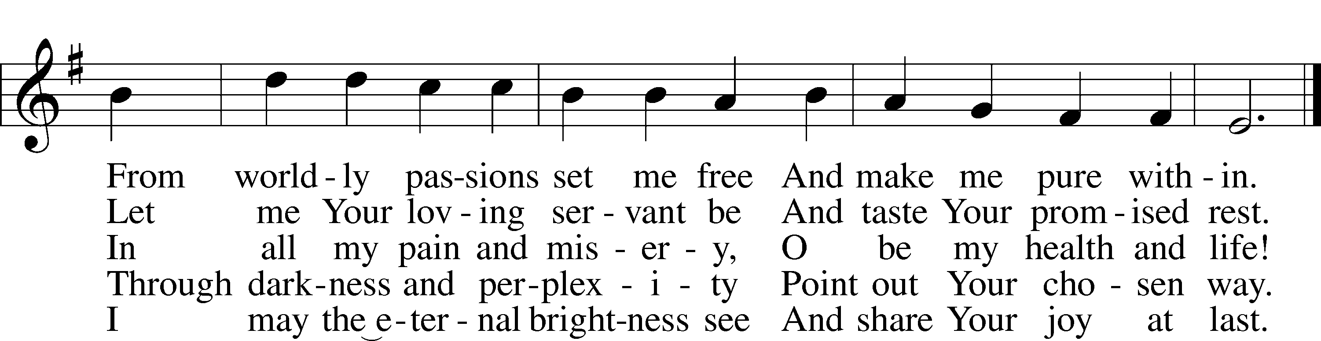
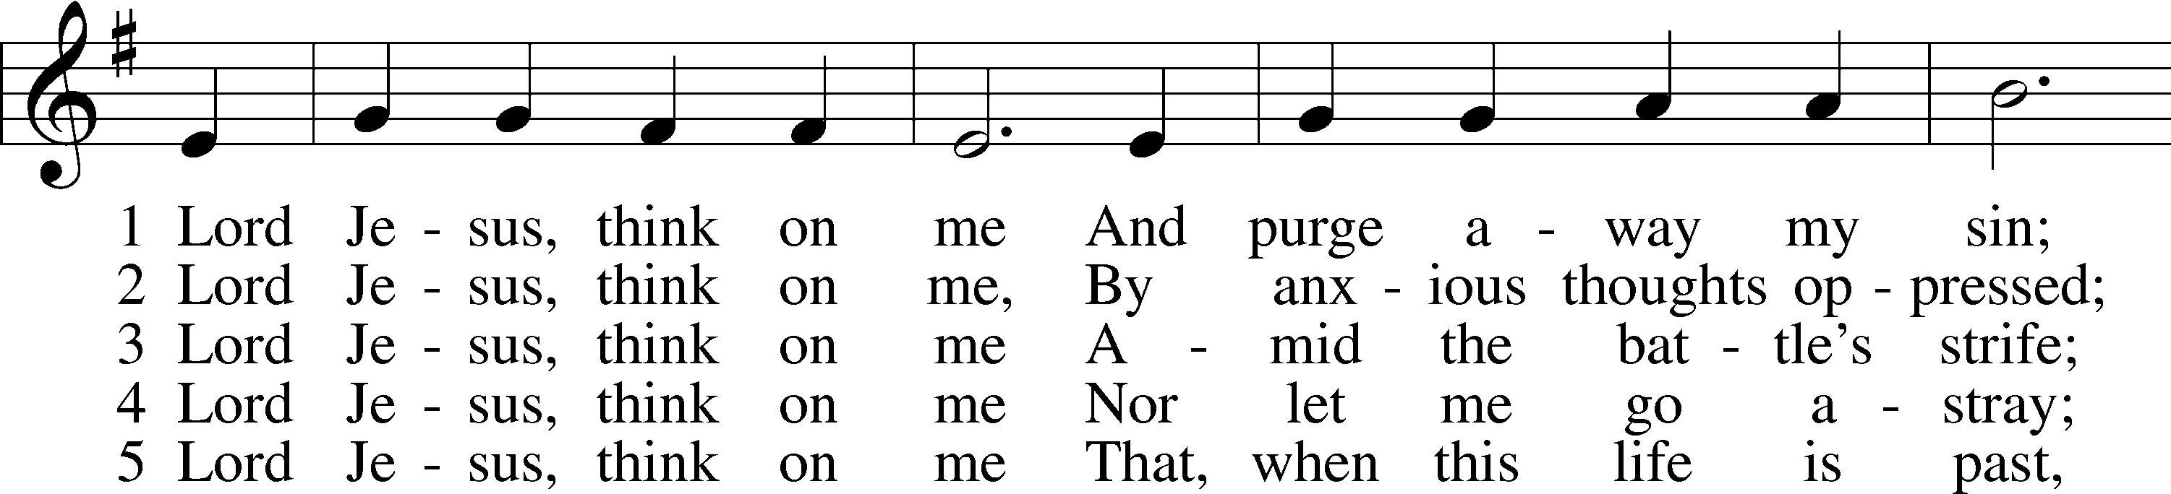

Text: Synesius of Cyrene, c. 365–c. 414; tr. Allen W. Chatfield, 1808–96, alt. Tune: William Daman, c. 1540–1591
Text and tune: Public domain

Stand

Invocation LSB 151
P In the name of the Father and of the T Son and of the Holy Spirit.
C Amen.
P If we say we have no sin, we deceive ourselves, and the truth is not in us.
C But if we confess our sins, God, who is faithful and just, will forgive our sins and cleanse us from all unrighteousness.

Silence for reflection on God’s Word and for self-examination.

P Let us then confess our sins to God our Father.
C Most merciful God, we confess that we are by nature sinful and unclean. We have sinned against You in thought, word, and deed, by what we have done and by what we have left undone. We have not loved You with our whole heart; we have not loved our neighbors as ourselves. We justly deserve Your present and eternal punishment. For the sake of Your Son, Jesus Christ, have mercy on us. Forgive us, renew us, and lead us, so that we may delight in Your will and walk in Your ways to the glory of Your holy name. Amen.

Absolution
P Almighty God in His mercy has given His Son to die for you and for His sake forgives you all your sins. As a called and ordained servant of Christ, and by His authority, I therefore forgive you all your sins in the name of the Father and of the T Son and of the Holy Spirit.
C Amen.

Introit Psalm 98:7–9; antiphon: v. 2
The Lord has made known his sal- | vation;*
he has revealed his righteousness in the sight of the | nations.
Let the sea roar, and all that | fills it;*
the world and those who | dwell in it!
Let the rivers clap their hands; let the hills sing for joy together be- | fore the Lord,*
for he comes to | judge the earth.
He will judge the world with | righteousness,*
and the peoples with | equity.
Glory be to the Father and | to the Son*
and to the Holy | Spirit;
as it was in the be- | ginning,*
is now, and will be forever. | Amen.
The Lord has made known his sal- | vation;*
he has revealed his righteousness in the sight of the | nations.

Kyrie LSB 152
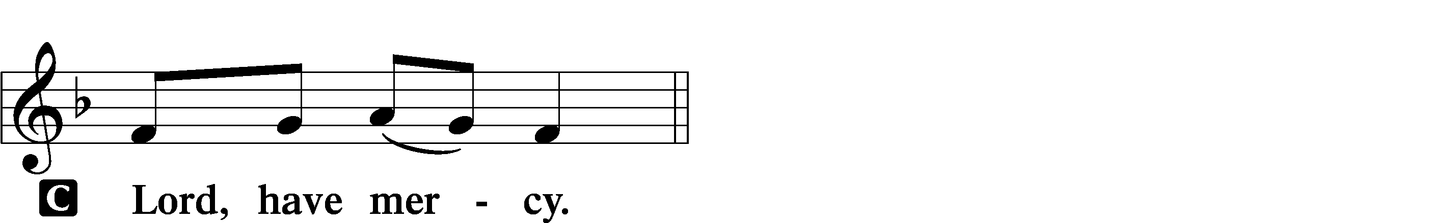
P In peace let us pray to the Lord.

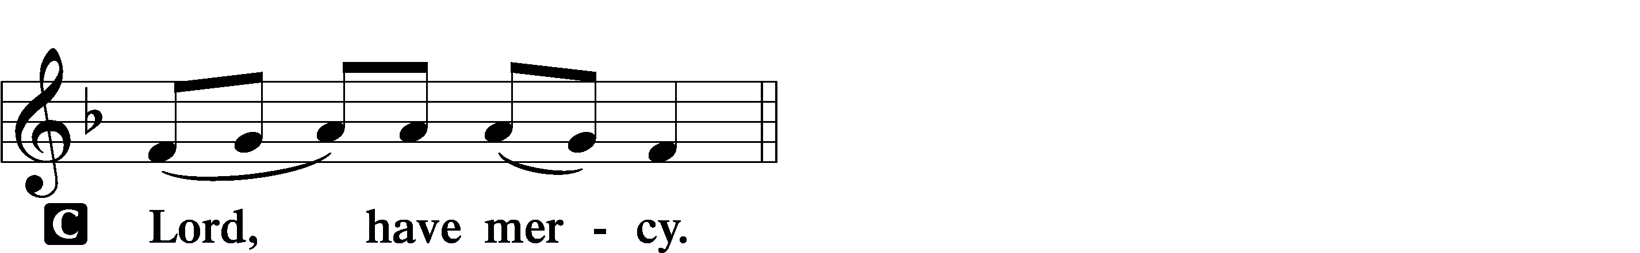
P For the peace from above and for our salvation let us pray to the Lord.

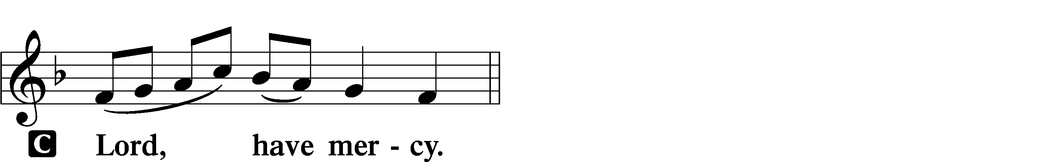
P For the peace of the whole world, for the well-being of the Church of God, and for the unity of all let us pray to the Lord.

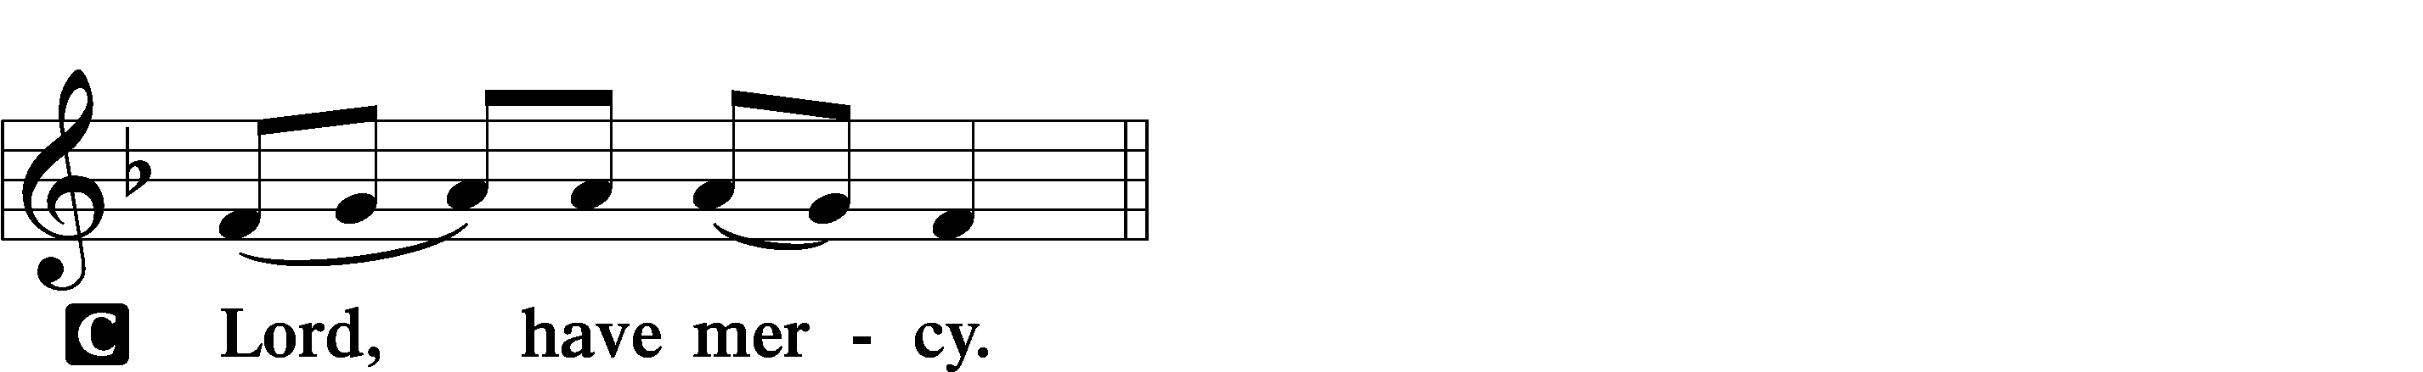
P For this holy house and for all who offer here their worship and praise let us pray to the Lord.

P Help, save, comfort, and defend us, gracious Lord.

Gloria in Excelsis LSB 154
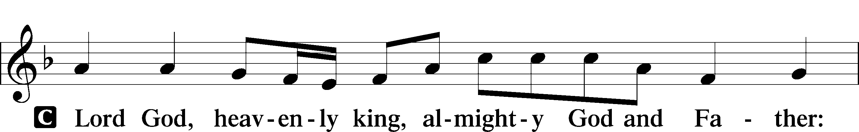
P Glory to God in the highest, and peace to His people on earth.

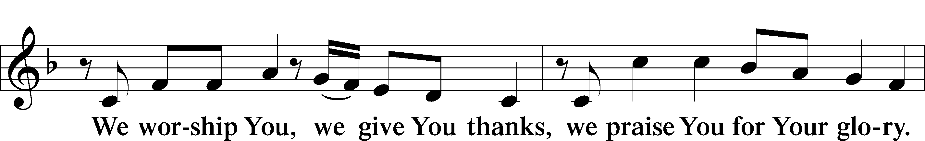

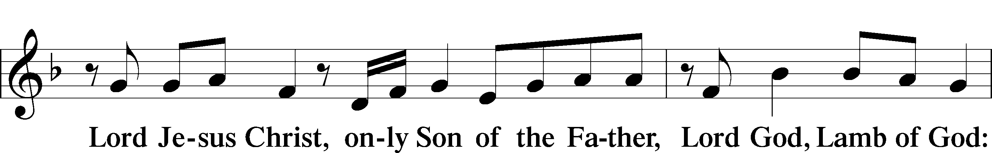

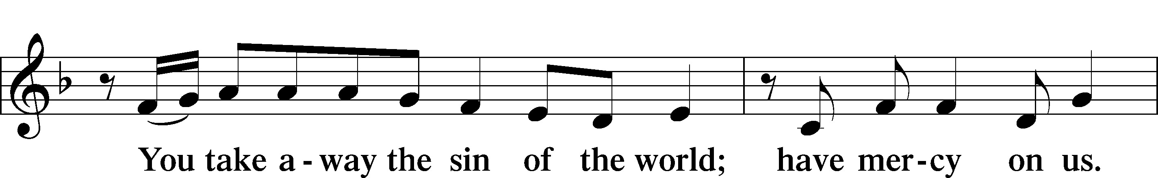

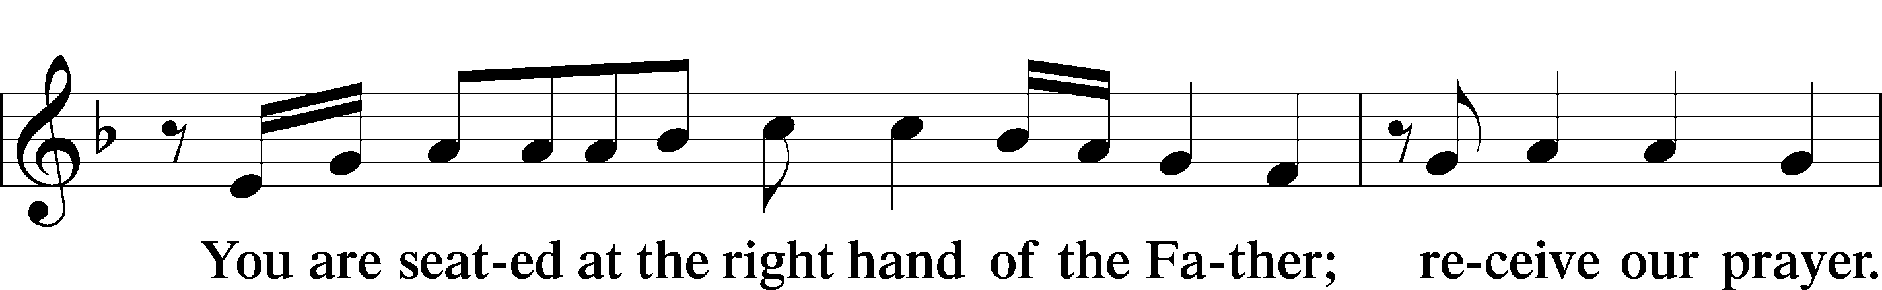

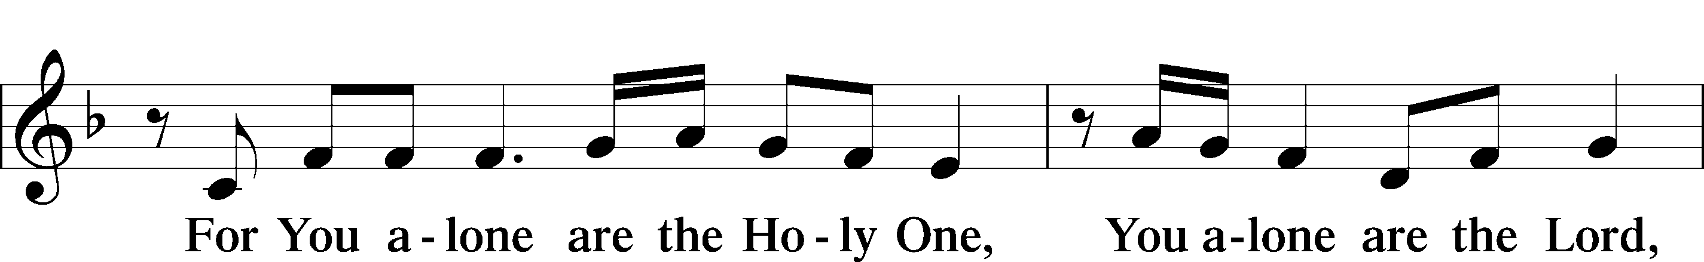

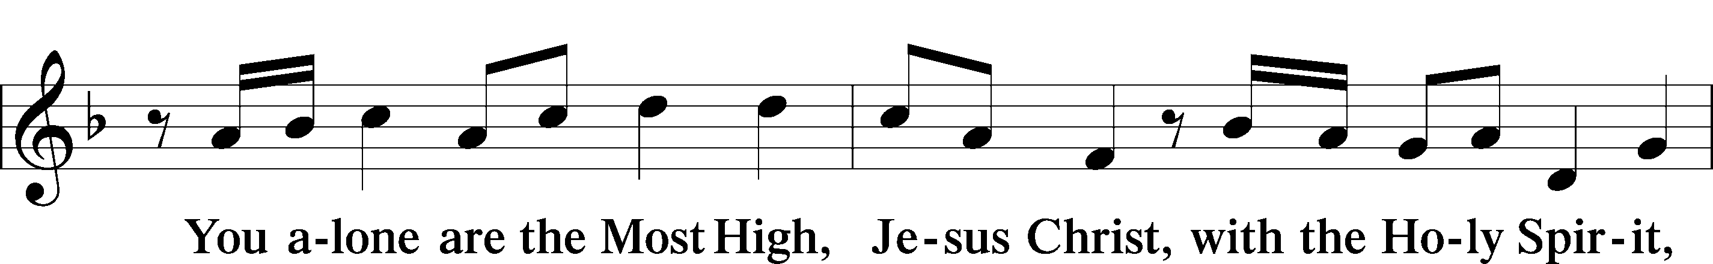

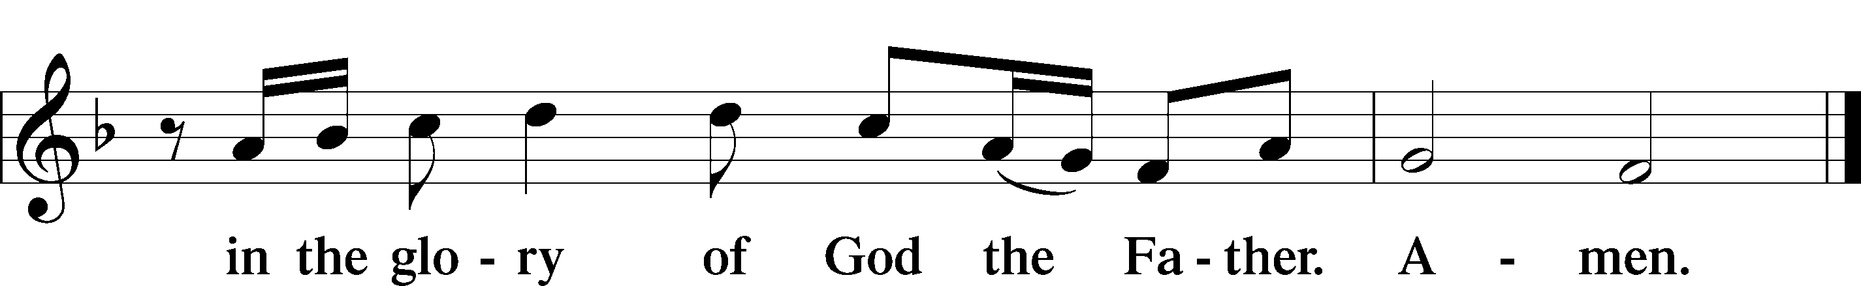

Salutation and Collect of the Day
P The Lord be with you.
C And also with you.
P Let us pray.
O Lord, graciously hear the prayers of Your people that we who justly suffer the consequence of our sin may be mercifully delivered by Your goodness to the glory of Your name; through Jesus Christ, Your Son, our Lord, who lives and reigns with You and the Holy Spirit, one God, now and forever.
C Amen.

Sit

Old Testament Reading Deuteronomy 30:15–20
¹⁵“See, I have set before you today life and good, death and evil. ¹⁶If you obey the commandments of the Lord your God that I command you today, by loving the Lord your God, by walking in his ways, and by keeping his commandments and his statutes and his rules, then you shall live and multiply, and the Lord your God will bless you in the land that you are entering to take possession of it. ¹⁷But if your heart turns away, and you will not hear, but are drawn away to worship other gods and serve them, ¹⁸I declare to you today, that you shall surely perish. You shall not live long in the land that you are going over the Jordan to enter and possess. ¹⁹I call heaven and earth to witness against you today, that I have set before you life and death, blessing and curse. Therefore choose life, that you and your offspring may live, ²⁰loving the Lord your God, obeying his voice and holding fast to him, for he is your life and length of days, that you may dwell in the land that the Lord swore to your fathers, to Abraham, to Isaac, and to Jacob, to give them.”
P This is the Word of the Lord.
C Thanks be to God.

Gradual Psalm 117:1–2a; 96:8
Praise the Lord, all | nations!*
Extol him, all | peoples!
For great is his steadfast | love toward us,*
and the faithfulness of the Lord endures for- | ever.
Ascribe to the Lord the glory | due his name;*
bring an offering, and come in- | to his courts!

Epistle 1 Corinthians 3:1–9
¹But I, brothers, could not address you as spiritual people, but as people of the flesh, as infants in Christ. ²I fed you with milk, not solid food, for you were not ready for it. And even now you are not yet ready, ³for you are still of the flesh. For while there is jealousy and strife among you, are you not of the flesh and behaving only in a human way? ⁴For when one says, “I follow Paul,” and another, “I follow Apollos,” are you not being merely human?
⁵What then is Apollos? What is Paul? Servants through whom you believed, as the Lord assigned to each. ⁶I planted, Apollos watered, but God gave the growth. ⁷So neither he who plants nor he who waters is anything, but only God who gives the growth. ⁸He who plants and he who waters are one, and each will receive his wages according to his labor. ⁹For we are God’s fellow workers. You are God’s field, God’s building.
P This is the Word of the Lord.
C Thanks be to God.

Stand

Alleluia and Verse LSB 156
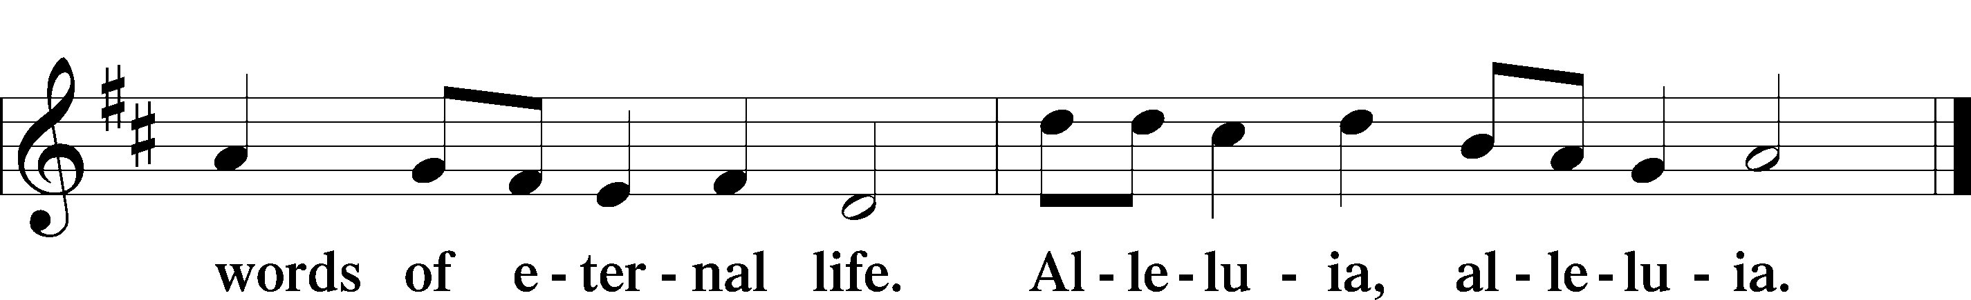
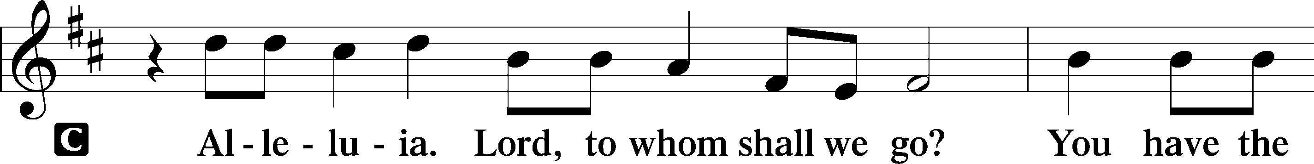

Holy Gospel Matthew 5:21–37
P The Holy Gospel according to St. Matthew, the fifth chapter.
C Glory to You, O Lord.
²¹[Jesus said:] “You have heard that it was said to those of old, ‘You shall not murder; and whoever murders will be liable to judgment.’ ²²But I say to you that everyone who is angry with his brother will be liable to judgment; whoever insults his brother will be liable to the council; and whoever says, ‘You fool!’ will be liable to the hell of fire. ²³So if you are offering your gift at the altar and there remember that your brother has something against you, ²⁴leave your gift there before the altar and go. First be reconciled to your brother, and then come and offer your gift. ²⁵Come to terms quickly with your accuser while you are going with him to court, lest your accuser hand you over to the judge, and the judge to the guard, and you be put in prison. ²⁶Truly, I say to you, you will never get out until you have paid the last penny.
²⁷“You have heard that it was said, ‘You shall not commit adultery.’ ²⁸But I say to you that everyone who looks at a woman with lustful intent has already committed adultery with her in his heart. ²⁹If your right eye causes you to sin, tear it out and throw it away. For it is better that you lose one of your members than that your whole body be thrown into hell. ³⁰And if your right hand causes you to sin, cut it off and throw it away. For it is better that you lose one of your members than that your whole body go into hell.
³¹“It was also said, ‘Whoever divorces his wife, let him give her a certificate of divorce.’ ³²But I say to you that everyone who divorces his wife, except on the ground of sexual immorality, makes her commit adultery. And whoever marries a divorced woman commits adultery.
³³“Again you have heard that it was said to those of old, ‘You shall not swear falsely, but shall perform to the Lord what you have sworn.’ ³⁴But I say to you, Do not take an oath at all, either by heaven, for it is the throne of God, ³⁵or by the earth, for it is his footstool, or by Jerusalem, for it is the city of the great King. ³⁶And do not take an oath by your head, for you cannot make one hair white or black. ³⁷Let what you say be simply ‘Yes’ or ‘No’; anything more than this comes from evil.”
P This is the Gospel of the Lord.
C Praise to You, O Christ.

Sit

394 Songs of Thankfulness and Praise
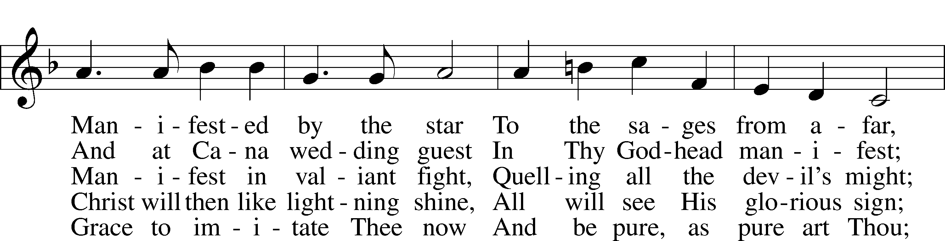
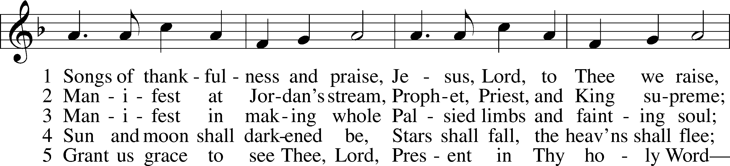

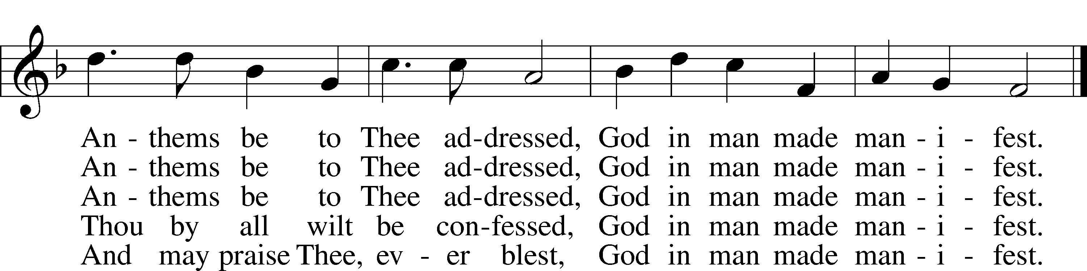
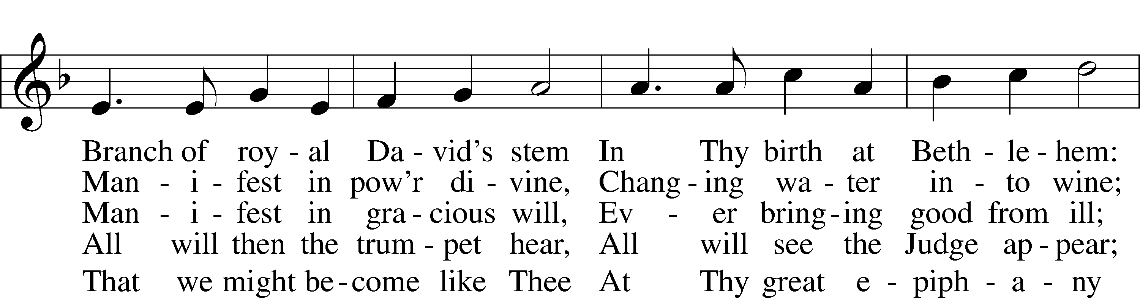

Text: Christopher Wordsworth, 1807–85, alt. Tune: George J. Elvey, 1816–93 Text and tune: Public domain

Sermon

Stand

Apostles’ Creed
C I believe in God, the Father Almighty,
maker of heaven and earth.
And in Jesus Christ, His only Son, our Lord,
who was conceived by the Holy Spirit,
born of the virgin Mary,
suffered under Pontius Pilate,
was crucified, died and was buried.
He descended into hell.
The third day He rose again from the dead.
He ascended into heaven
and sits at the right hand of God the Father Almighty.
From thence He will come to judge the living and the dead.
I believe in the Holy Spirit,
the holy Christian Church,
the communion of saints,
the forgiveness of sins,
the resurrection of the body,
and the life T everlasting. Amen.

Prayer of the Church

Sit

Consecration of the Offering
After the prayers please be seated. The altar is set for the Lord’s Supper and the offering is consecrated. As you prepare to receive the sacrament you may use the prayers in the front of the hymnal or meditate on a communion hymn.

Stand

Offertory LSB 159
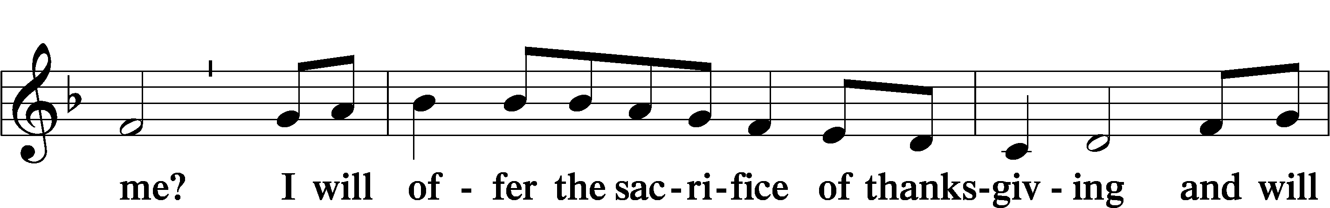
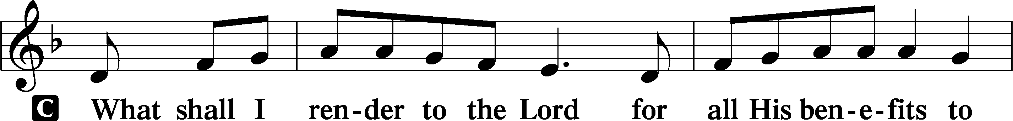

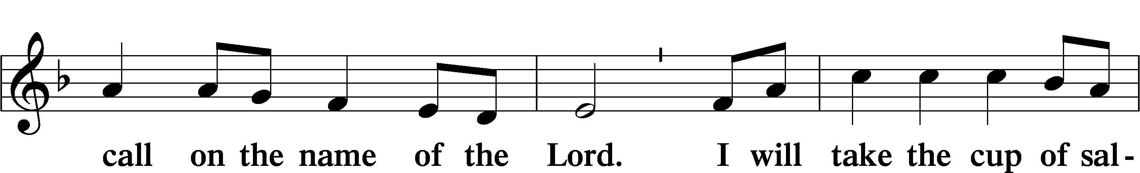

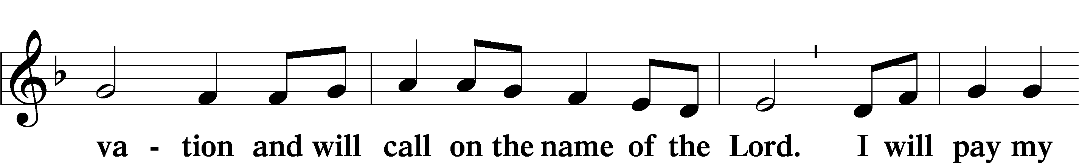

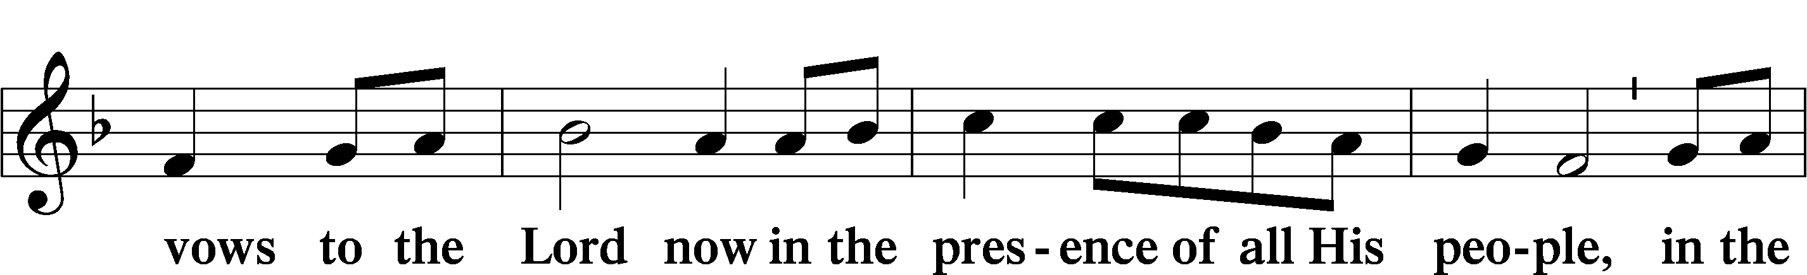

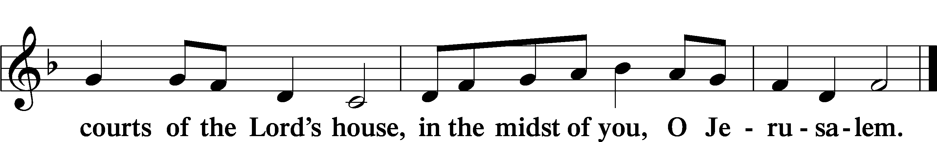

Preface LSB 160
P The Lord be with you.
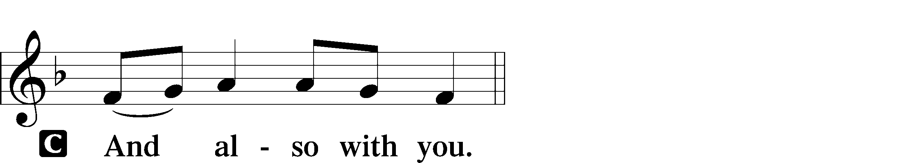

P Lift up your hearts.

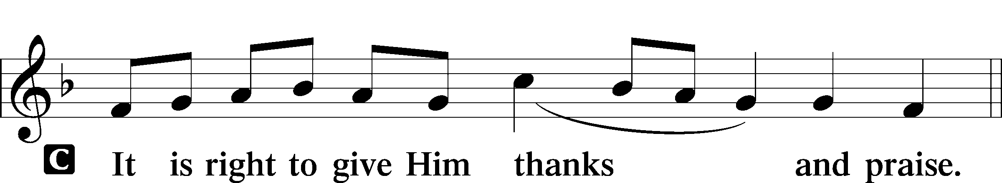
P Let us give thanks to the Lord our God.

P It is truly good, right, and salutary that we should at all times and in all places give thanks to You, holy Lord, almighty Father, everlasting God, through Jesus Christ, our Lord; for what had been hidden from before the foundation of the world You have made known to the nations in Your Son. In Him, being found in the substance of our mortal nature, You have manifested the fullness of Your glory. Therefore with angels and archangels and with all the company of heaven we laud and magnify Your glorious name, evermore praising You and saying:

Sanctus LSB 161
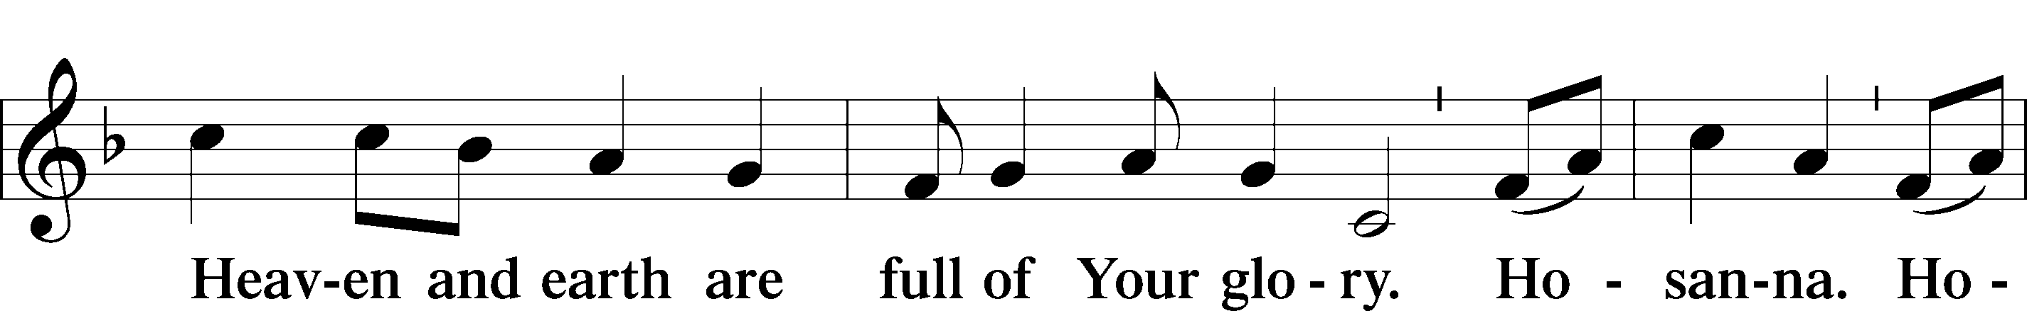
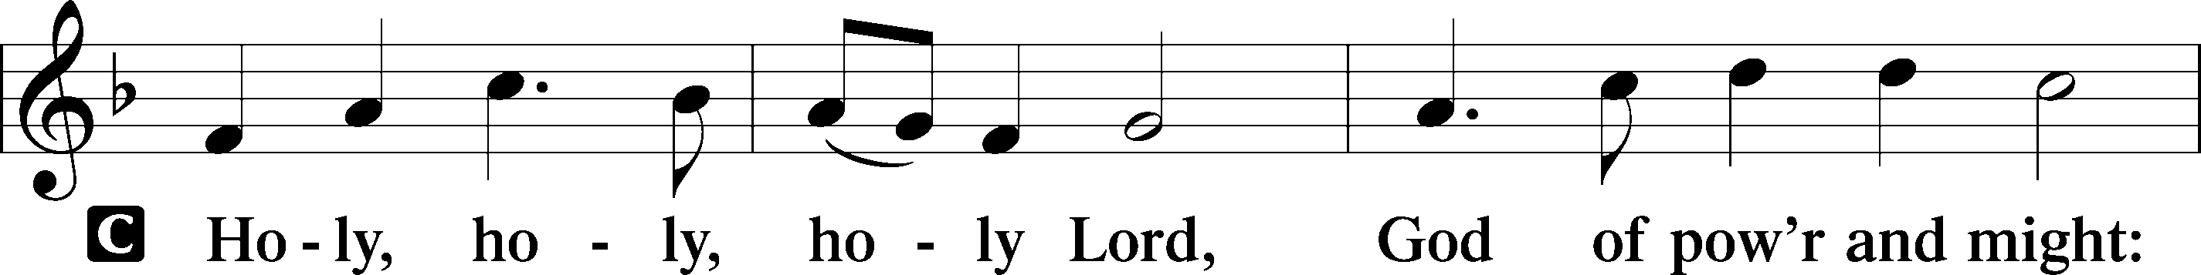

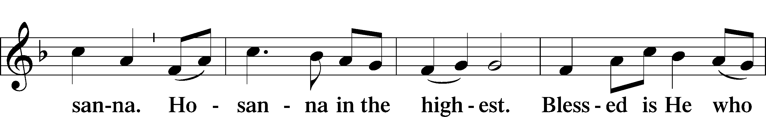

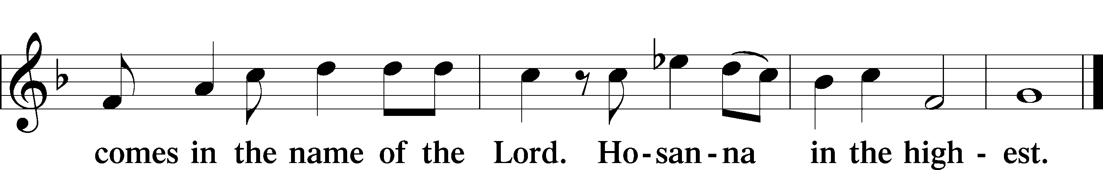

Lord’s Prayer LSB 162
P Lord, remember us in Your kingdom and teach us to pray:
C Our Father who art in heaven,
hallowed be Thy name,
Thy kingdom come,
Thy will be done on earth
as it is in heaven;
give us this day our daily bread;
and forgive us our trespasses
as we forgive those
who trespass against us;
and lead us not into temptation,
but deliver us from evil.
For Thine is the kingdom
and the power and the glory
forever and ever. Amen

The Words of Our Lord
P Our Lord Jesus Christ, on the night when He was betrayed, took bread, and when He had given thanks, He broke it and gave it to the disciples and said: “Take, eat; this is My T body, which is given for you. This do in remembrance of Me.”
In the same way also He took the cup after supper, and when He had given thanks, He gave it to them, saying: “Drink of it, all of you; this cup is the new testament in My T blood, which is shed for you for the forgiveness of sins. This do, as often as you drink it, in remembrance of Me.”

Pax Domini LSB 163
P The peace of the Lord be with you always.

Agnus Dei LSB 163
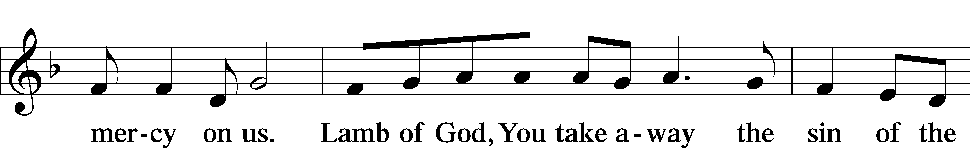
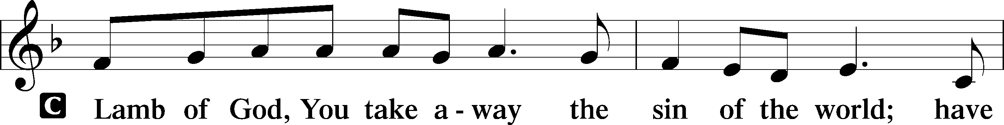

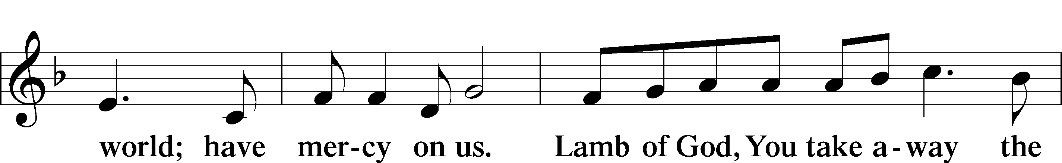

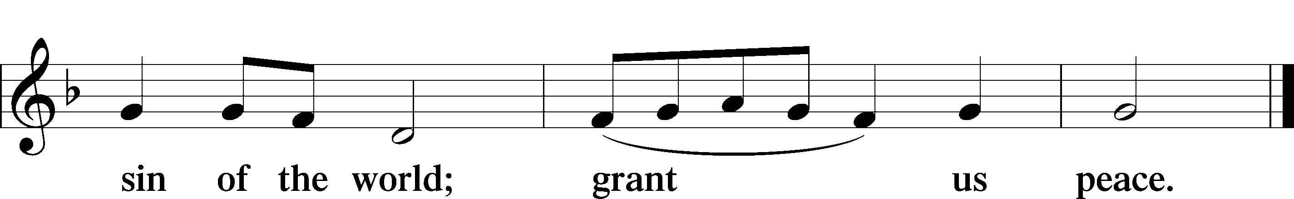

Sit

Distribution

496 Holy Spirit, Light Divine
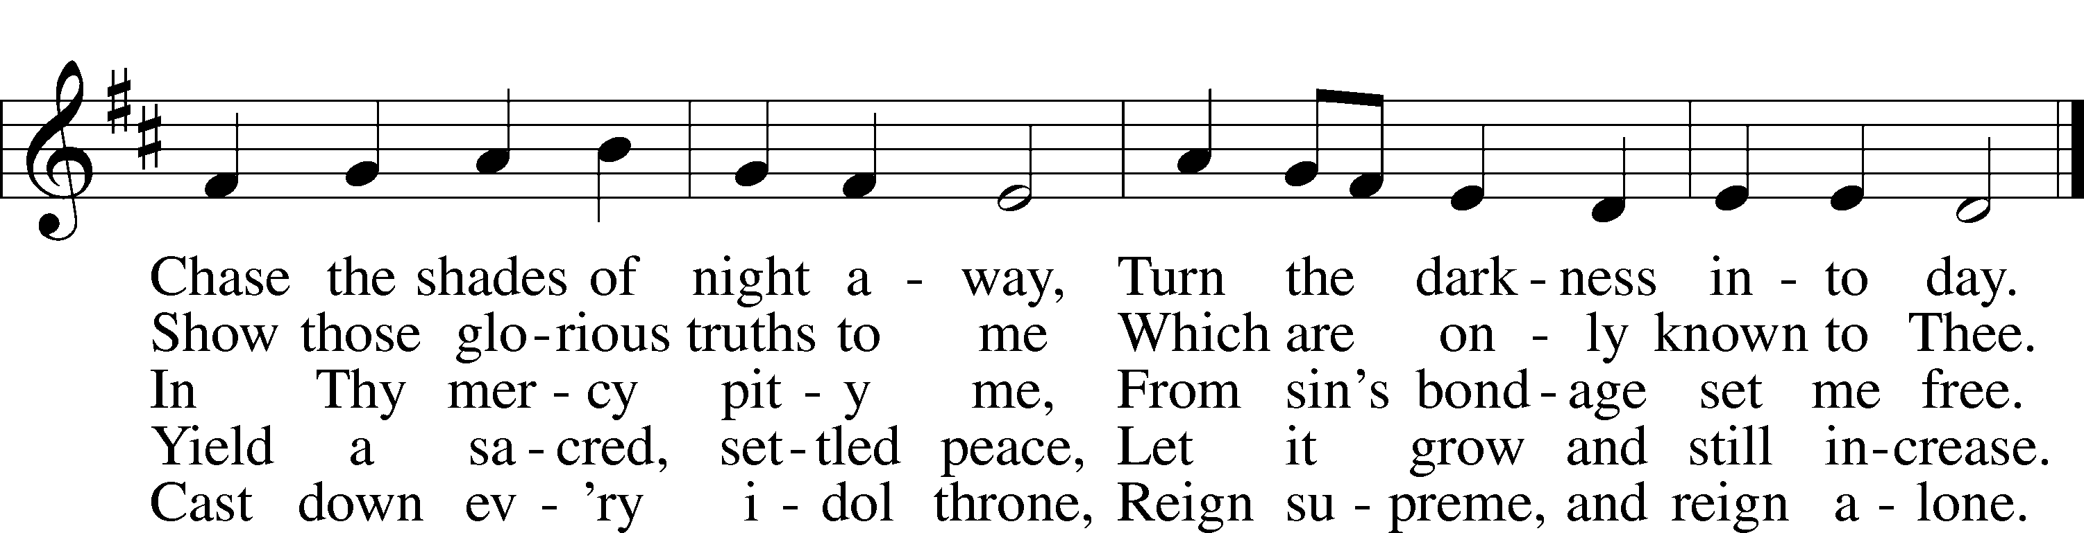
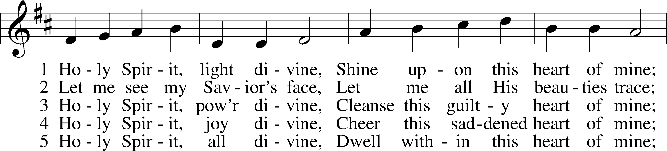

Text: Andrew Reed, 1787–1862, alt. Tune: Orlando Gibbons, 1583–1625 Text and tune: Public domain

623 Lord Jesus Christ, We Humbly Pray
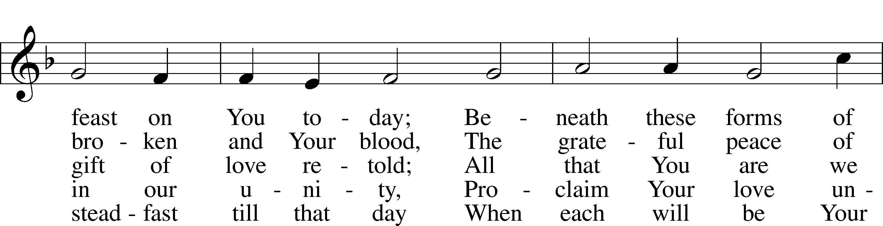
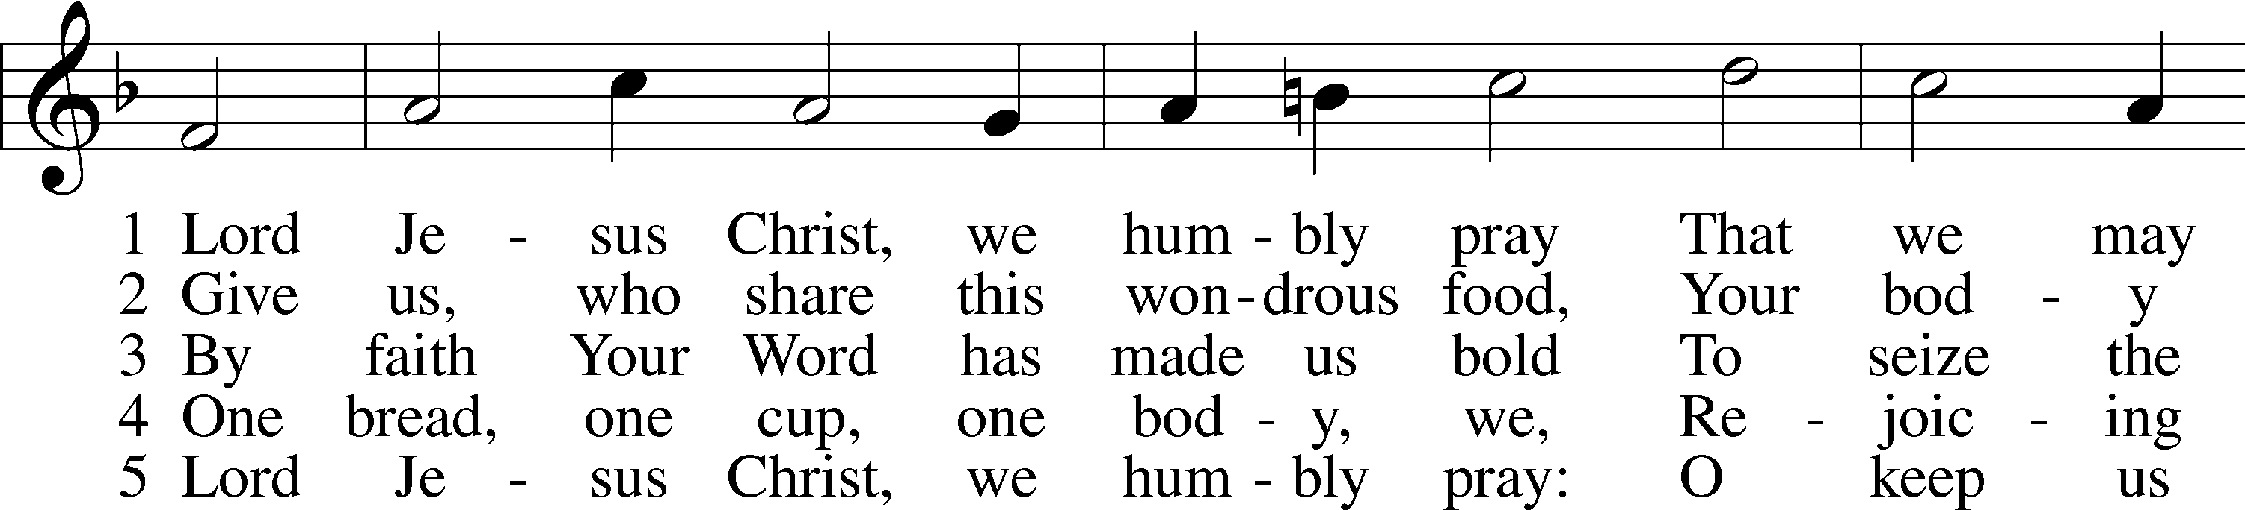

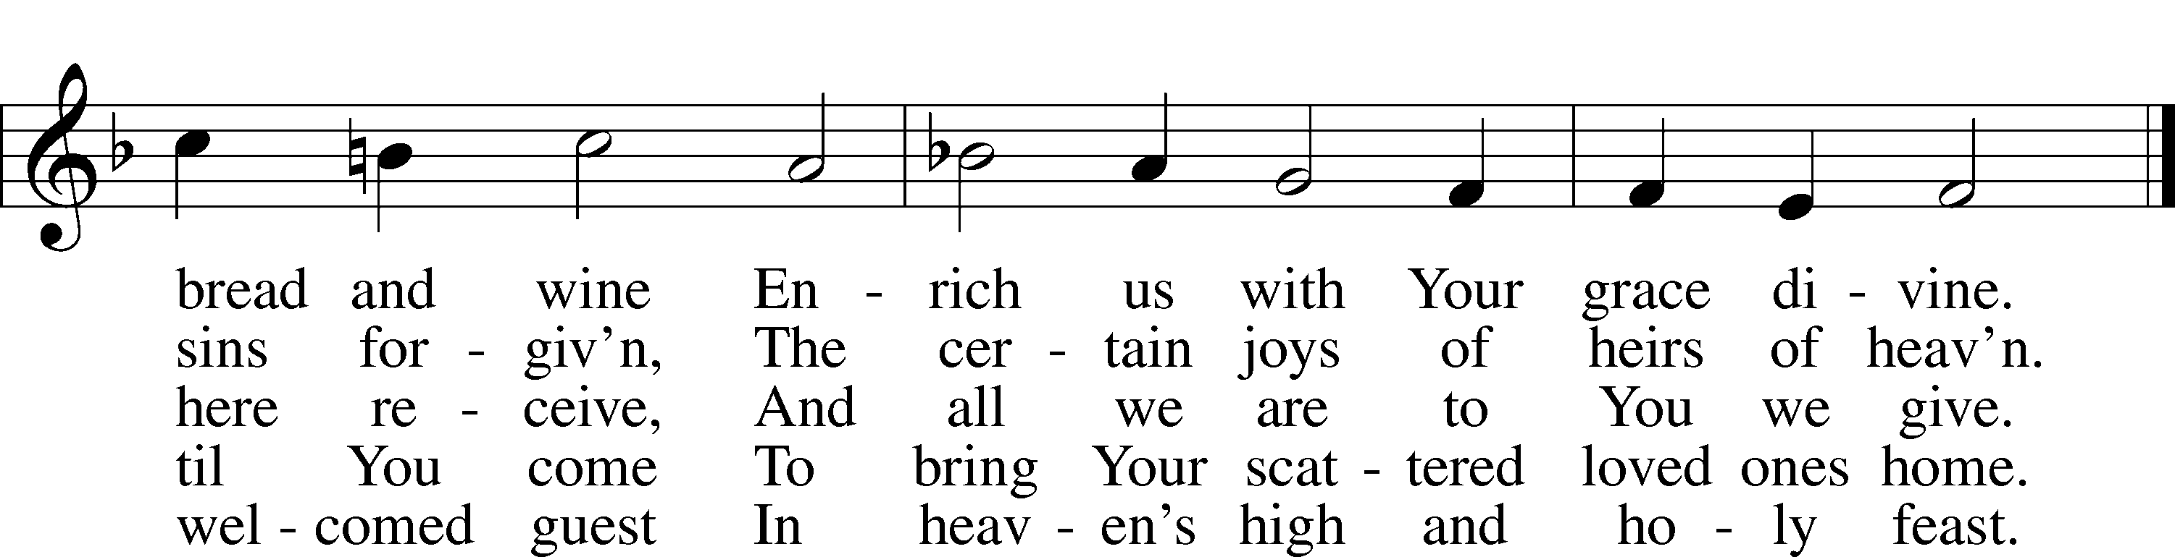

Text: Henry E. Jacobs, 1844–1932, alt. Tune: Cantionale Germanicum, 1628, Gochsheim Text and tune: Public domain

704 Renew Me, O Eternal Light
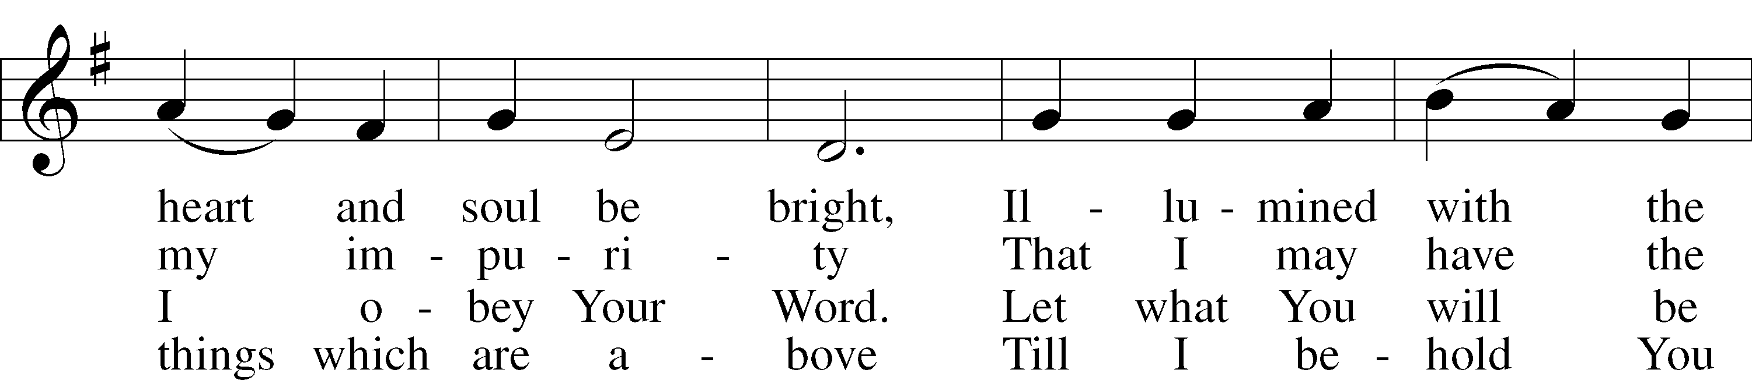
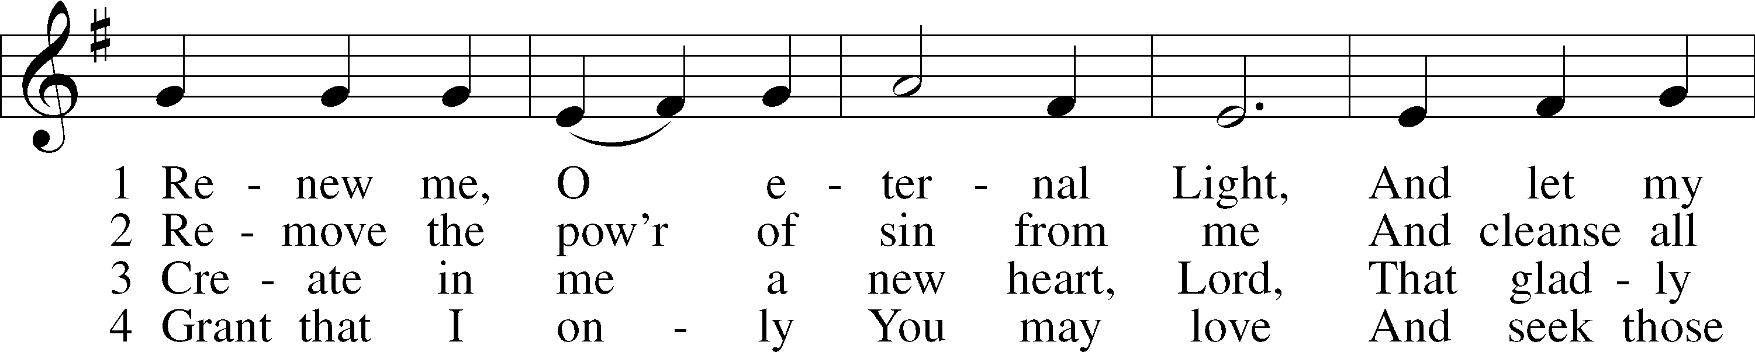

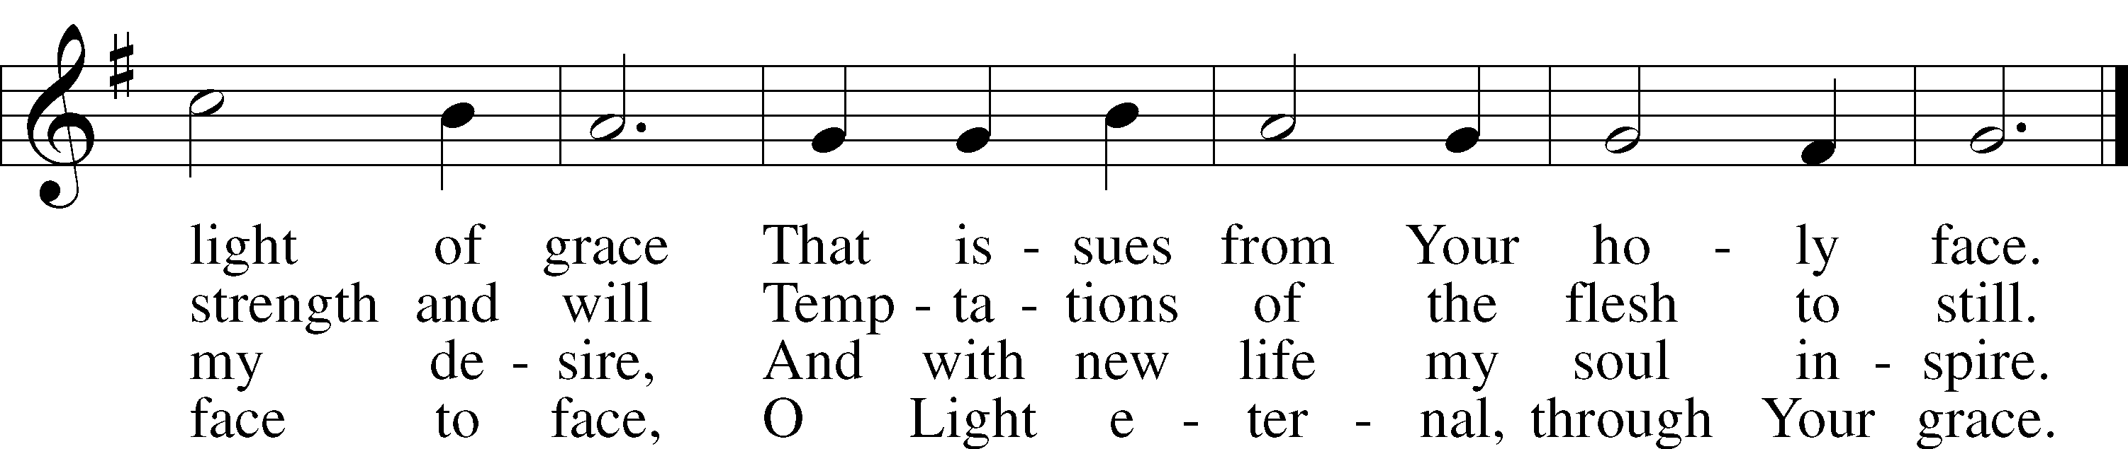

Text: Johann Friedrich Ruopp, 1672–1708; tr. August Crull, 1845–1923, alt. Tune: As hymnodus sacer, 1625, Leipzig Text and tune: Public domain

865 Lord, Help Us Ever to Retain
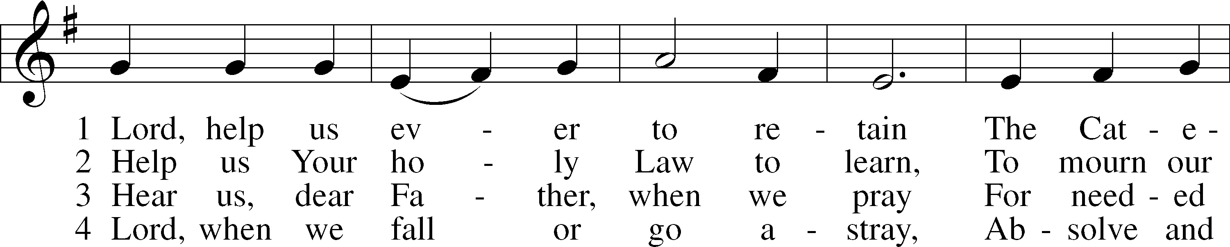
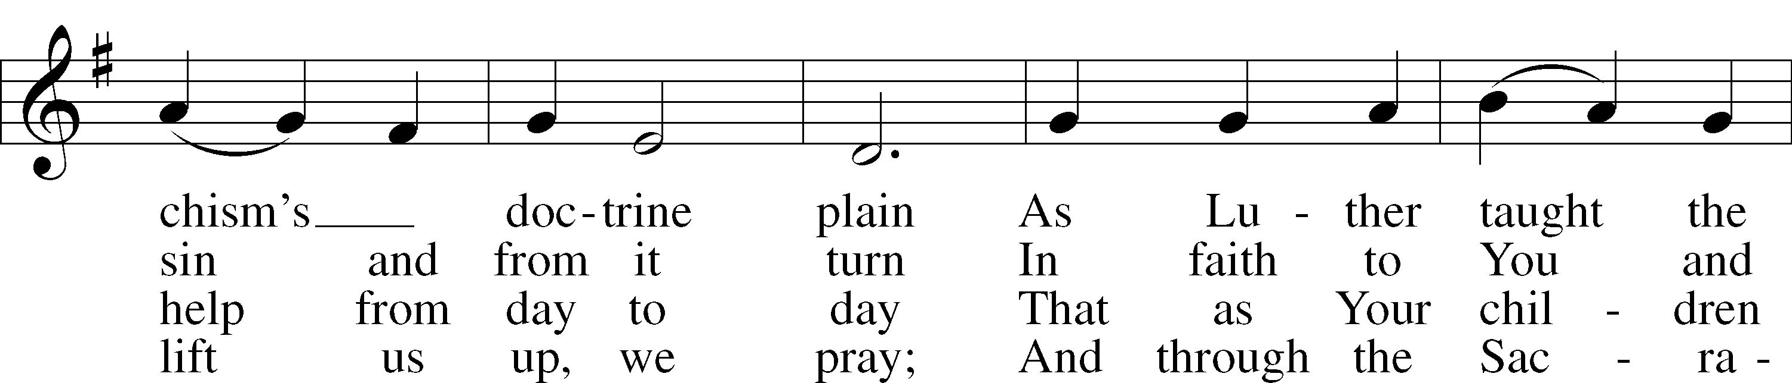
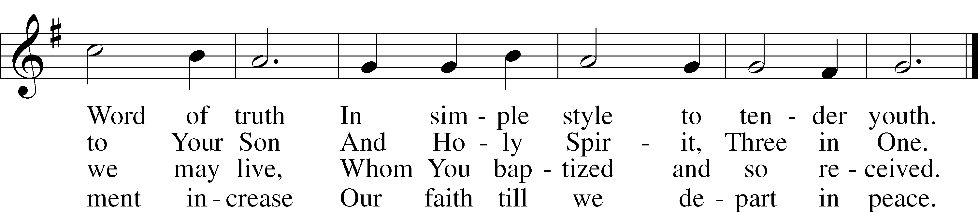
Text: Ludwig Helmbold, 1532–98; tr. Matthias Loy, 1828–1915, alt. Tune: As hymnodus sacer, 1625, Leipzig Text and tune: Public domain

The Dismissal
P The body and blood of our Lord Jesus Christ strengthen and preserve you in body and soul to life everlasting. Depart T in peace.
C Amen.

Stand

Thank the Lord LSB 164
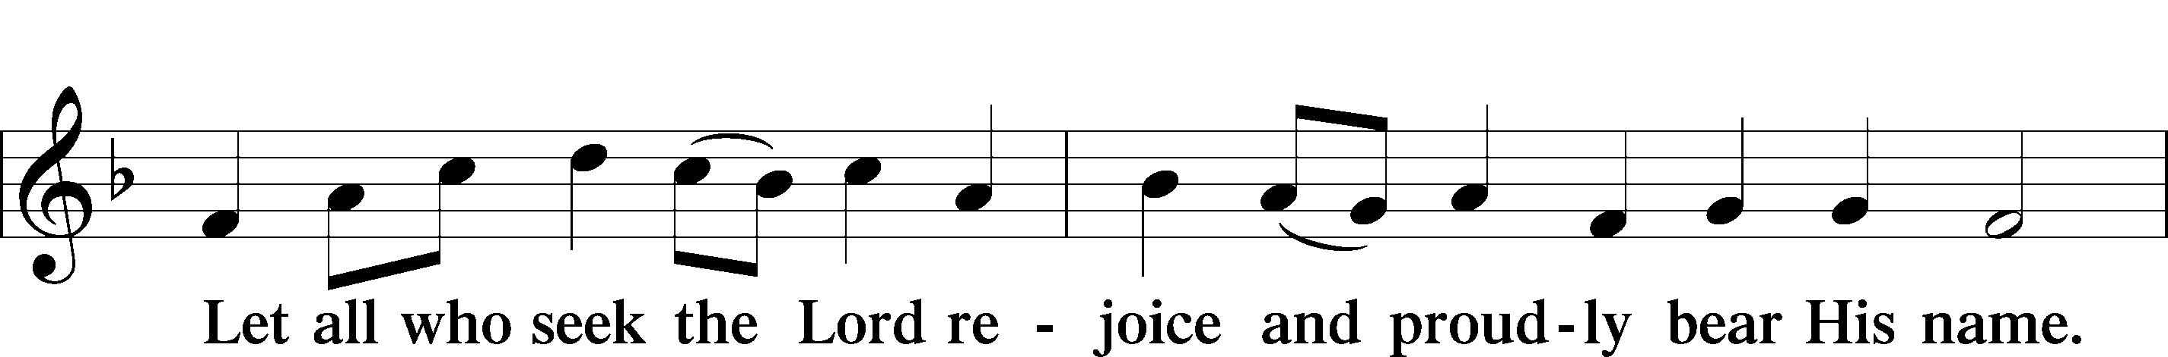
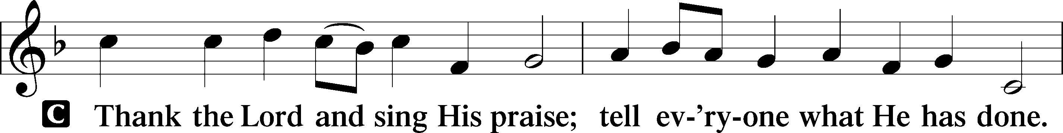

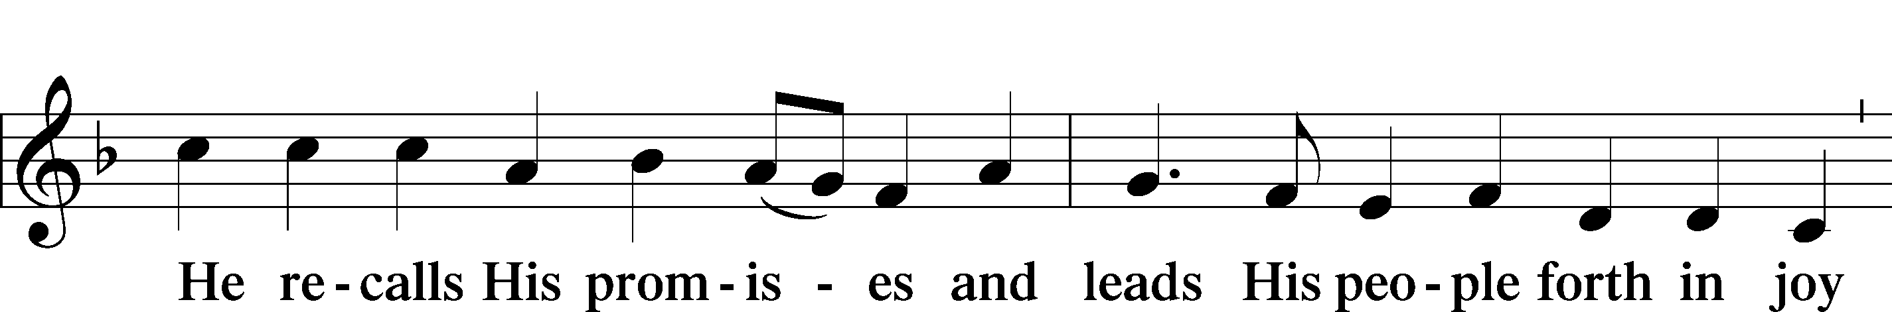

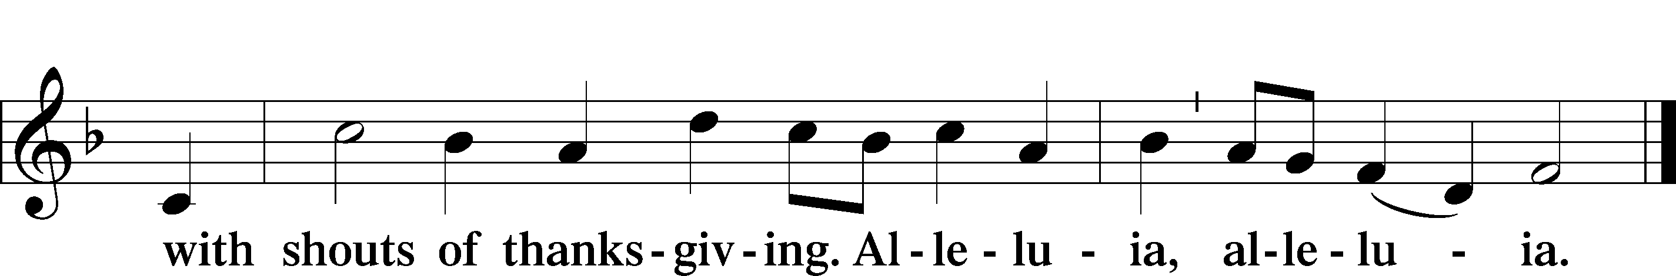

Post-Communion Collect
P Let us pray.
We give thanks to You, almighty God, that You have refreshed us through this salutary gift, and we implore You that of Your mercy You would strengthen us through the same in faith toward You and in fervent love toward one another; through Jesus Christ, Your Son, our Lord, who lives and reigns with You and the Holy Spirit, one God, now and forever.
C Amen.

Benediction LSB 202
P The Lord bless you and keep you.
The Lord make His face shine upon you and be gracious unto you.
The Lord lift up His countenance upon you and T give you peace.
C Amen, amen, amen.

921 On What Has Now Been Sown
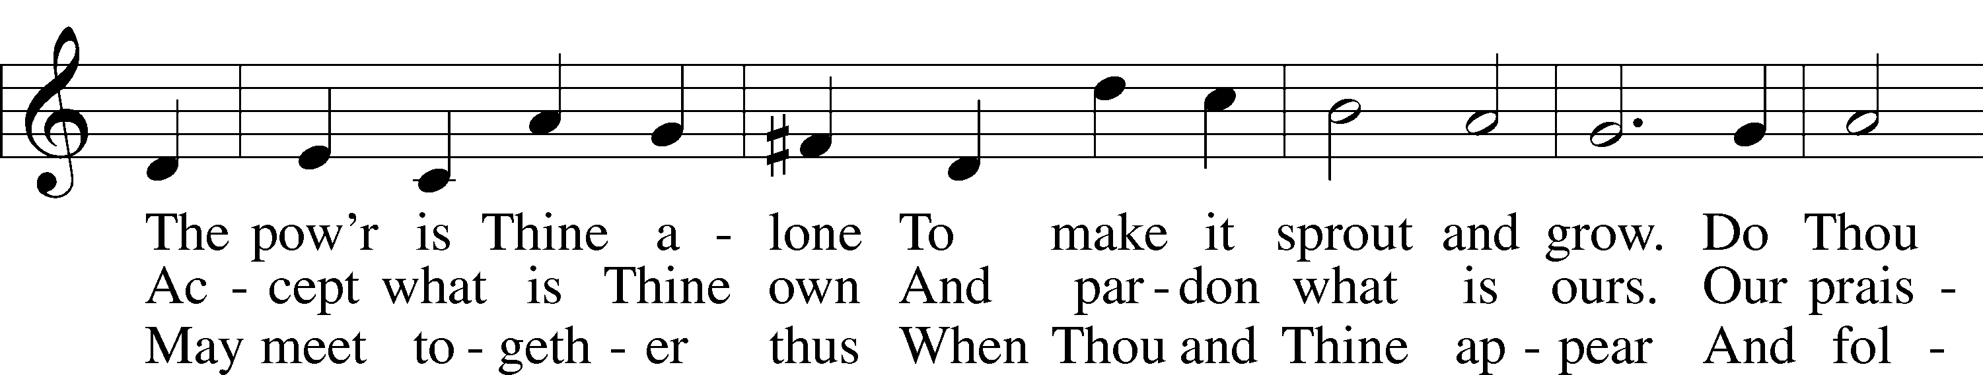
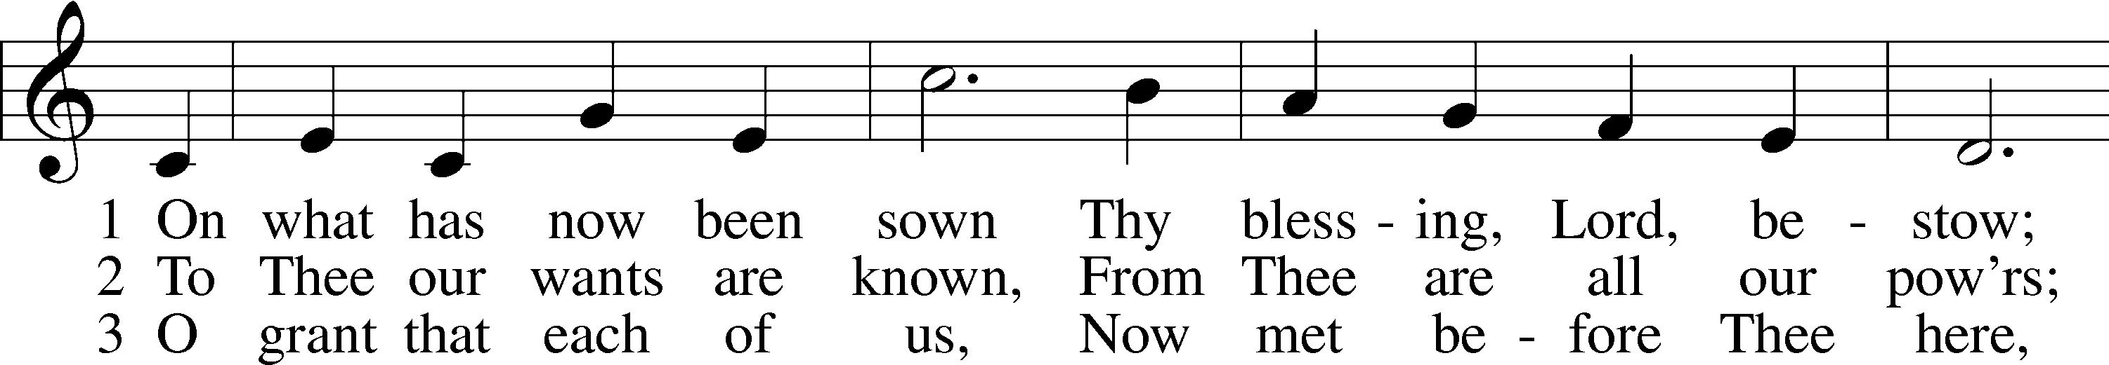

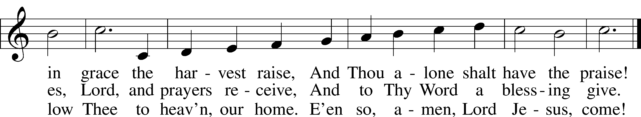
Text: John Newton, 1725–1807, alt. Tune: John Darwall, 1731–89 Text and tune: Public domain
Acknowledgments
Unless otherwise indicated, Scripture quotations are from the ESV® Bible (The Holy Bible, English Standard Version®), copyright © 2001 by Crossway, a publishing ministry of Good News Publishers. Used by permission. All rights reserved.
Created by Lutheran Service Builder © 2021 Concordia Publishing House.

Prayers for Our Members
Madisen Skaggs | Expecting
Norman Abels (Brookestone Meadows–Elkhorn) | Healing
Judy Ahrens | Healing
Vaughn Albrecht (Mount Carmel) | Healing
Tom & DyAnn Altwine | Healing
Grace Burger | Healing
Lyle Colsden (Mother Hull) | Healing
Pat Flodine (Cambridge Court) | Healing
Marilyn Fuqua | Healing
Vi Fox (Prairie View) | Healing
Jan Hatfield | Healing
Ruby Hatfield | Healing
Evelyn Heiden (Mother Hull) | Healing
Linda Luhn | Healing
Diane Plummer | Healing
Debra Schinkel | Healing
Don Trampe | Healing
Robin Baker | Cancer
Ivan Bombeck | Cancer
Bertha Marienau | Cancer

Prayers for Our Members’ Family & Friends
Lana Fattig (Eric’s wife) | Expecting
Roger Young (Tiffany Davis’ father) | Parkinson’s
Ruth Shoen (Joy Barefoot’s sister) | Surgery
Greg Blum (Junge Family Friend) | Healing
Elaine de la Motte (Carol Herron’s sister-in-law) | Healing
Roger Hoffman (Marc’s father) | Healing
Joshua Junge (Steve’s nephew) | Healing
Luetta Lammers (Ruby Hatfield’s sister) | Healing
Tim Powers (Kim Wilken’s brother) | Healing
Howard Quandt (Don & Shirley Helmbrecht’s family) | Healing
Aaron Russell (Becky Thornton’s son-in-law) | Healing
David & Carol Shiers (Jessica’s parents) | Healing
Pat Snyder (Carol Herron’s friend) | Healing
Randy Solomon (Beth Rosenthal’s father) | Healing
Don Todd, Jr. (Marilyn Fuqua’s nephew) | Healing
Jonah (Jase & Jarren Blattner’s friend) | Cancer
Glenda Fichtner (Ruby Hatfield’s niece) | Cancer
Gay Koopman (Todd Koopman’s sister) | Cancer
Ron Halvorsen (Jeff’s dad) | Cancer
Sharon Mulhair (Pam Uhlir’s cousin) | Cancer
Milton Naprstek (Marilyn Fuqua’s brother) | Cancer
Cindy Pietsch (Ellen Koopman’s sister-in-law) | Cancer
Tyrone Uhlir (Pam’s nephew) | Cancer
Ray Vang (Don & Shirley Helmbrecht’s brother-in-law) | Cancer

Worship Assistants
Sunday, February 12th – 9:00a
Elder: Ken Hockemeier  Acolyte: Landen Eckhoff  Announcer: Lonna Gronewoller | Usher: Steve Junge  Engineer: Eric Rosenthal  Altar Guild: Carolyn Westman  Rachael Burger
Sunday, February 19th – 9:00a
Elder: Nathan Gaunt  Acolyte: Isaiah Gaunt  Announcer: Carol Kreutzer | Usher: Andy Wollberg  Engineer: Jared Nuttelman  Altar Guild: Carolyn Westman  Rachael Burger
Wednesday, February 22nd – 7:00p
Elder: Nathan Gaunt  Acolyte: Eli Randolph | Usher: Mike Wilkens  Engineer: Jared Nuttelman  Altar Guild: Shirley Helmbrecht
\
Response to the Gospel
Date: 2/5/2023
Offering: $9,692
Weekly Need: $7,500
Offering Options:
To worship the Lord with your offering:
1) Place your offering in the offering plate as you enter or leave.
2) Go to zionkearney.churchtrac.com/give
3) Go to zionkearney.com and click on the ChurchTrac icon
4) Mail your gift to Zion Lutheran Church, 2421 C Ave, Kearney, NE 68847 or place it in the mail slot on the south side of the building.

Today’s Radio Broadcast is sponsored Lennis Hodgson,
in memory of Diane.

ZION LUTHERAN CHURCH AND SCHOOL

Pr. James DeLoach, Pastor + (308) 627-5260
james.deloach@zionkearney.org
Pr. Doug Gaunt, Pastor + (308) 455-0552
doug.gaunt@zionkearney.org
Tony Splittgerber, Principal + (308) 293-0168
anthony.splittgerber@zionkearney.org

Church Office
Administrative Assistant: Holly Reid
Email: school@zionkearney.org
Phone: (308)-234-3410 Fax: (308) 236-8100
Office Hours: Monday-Friday 8:00am-4:00pm
Radio Broadcast: Sunday @ 10:30 a.m. on 1460 AM
Website: www.zionkearney.com

This Week at Zion
Sun 2/12 | 9:00a  10:30a  10:30a  5:00p | Divine Service  Adult Bible Study & Sunday School  Radio Broadcast  1460AM & 92.1FM  Divine Service
Mon 2/13 | 7:00p  7:00p  Birthdays | Mary Martha  Bd of Elders  Morgan Dulitz
Tues 2/14 | 1:30p  7:00p | Sleeping Mats  Bd of Ed  Bd of Trustees
Wed 2/15 | 8:30a  5:45p  7:00p | Chapel  Midweek  Adult Choir
Thurs 2/16 | 7:00p | No School – P/T Conferences  Men’s Bible Study
Fri 2/17 | Birthdays | No School - Office Hours: 8a-12p  David Banner
Sat 2/18 | All Day | LWML Kearney Zone Conference –  Fellowship Hall
Sun 2/19 | 9:00a  10:20a  10:30a  10:30a  5:00p  Birthdays | Divine Service  Group Pictures – Retakes  Adult Bible Study & Sunday School  Radio Broadcast  1460AM & 92.1FM  Divine Service  Joyce Hartman

Where our Triune God strengthens us through His mercy in faith toward Him and in fervent love toward one another.

Announcements for February 12th, 2023

Adult Choir: Adult Choir has begun! They will meet Wednesdays at 7pm. Starting Ash Wednesday (Feb. 22nd), they will meet after Lenten Service (8pm).

Group Pictures: NEXT Sunday, Feb. 19th, if your group/organization has not taken a picture for the directory, please stay after service. Altar Guild still needs a picture taken. We will also do retakes.

Ash Wednesday and Lenten Services: On February 22nd, we will be having Ash Wednesday services at 7pm, starting the Lenten season. There will a meal served at 5:30p before each service. Mary Martha will be providing the Ash Wednesday meal.

Exchange Bank Checking: Exchange Bank has an exciting new program to help area schools like Zion and to promote their services! Look for a flier in your mailbox for details.

Ark Encounter Trip: Interested in visiting the Ark Encounter and the Creation Museum the week of May 22nd-26th? Please give Pastor DeLoach your name and number if you are interested in this trip. Save your spot before the trip fills up.

Lenten Bible Reading Cards: Reading the New Testament in Lent is a worthwhile and doable discipline. Simply read about 6-8 chapters a day, six days a week, beginning on Ash Wednesday and ending before Holy Thursday. A schedule of readings can be found on the purple sheet in the church entryway. You can also pick up a yellow Bible ready check-off card to keep track of your Bible reading progress for the whole year.

Radio Broadcast & Altar Flowers: The sign-up sheets for the 2023 radio broadcasts and flowers are on the bulletin board by the mailboxes. If you want a certain date, sign up ASAP.

SCHOOL NEWS

Track and Field: A packet went home with the 5th-8th grade students this last week. Practices start Thursday, March 2nd. Contact Coach Torres, Miss Nikodym or Coach Anderson with any questions.

P/T Conferences: There will be no school this Thursday and Friday, Feb. 16th-17th for Parent/Teacher Conferences. Office hours are Thursday 8a-4p and Friday 8a-12p.

Kindergarten Signing Day: On March 5th 5p-7p, Zion Lutheran Kindergarten will host its second annual signing day. This is great for the 2023-2024 Kindergarteners to meet their classmates and Miss Nikodym.

Best of Kearney: The Kearney Hub has started its Best of Kearney Voting. Zion Preschool has been blessed to win this award for many years. Go to this link to vote:
https://kearneyhub.com/contests/best-of-kearney-2023/

