Divine Service

Transfiguration of Our Lord

February 11th, 2024
Zion Lutheran Church
Kearney, Nebraska
A Warm Welcome toOur Guests!
Please sign our guest book in the narthex or a pew card so we can know how we can best of serve. If you are a member in good standing of a sister LC-MS congregation, we invite you to commune with us. Members of other church bodies with whom we are not in confessional fellowship are asked to please refrain from communing. Our pastor will be happy to explain how our desire for Christian care and unity is shown in our communion practice. All communicants need to register in the narthex prior to the service. Those not communing are invited to come to the altar, cross your arms in front of you, and bow your head to receive a pastoral blessing.

The Face of Jesus Christ Manifests
the Light of the Knowledge of the Glory of God

It was “a hard thing” that Elisha asked, but by his persistence he was able to see the prophet Elijah being taken “by a whirlwind into heaven.” Although “chariots of fire and horses of fire separated the two of them,” Elisha received Elijah’s cloak and a “double portion” of his spirit for preaching the Lord’s Word (2 Kings 2:9–11). It was a hard thing, too, for Israel to see Moses and come near to him, when “the skin of his face shone because he had been talking with God” (Ex. 34:29–30). Therefore, after “he commanded them all that the Lord had spoken with him in Mount Sinai,” Moses “put a veil over his face” (Ex. 34:32–33). Only the Word of the Gospel lifts the veil, and “only through Christ is it taken away” (2 Cor. 3:14). Thus are we able to behold “the light of the knowledge of the glory of God in the face of Jesus Christ,” who is “the image of God” (2 Cor. 4:4–6). For the Law and the prophets are all fulfilled in Him. Therefore, “listen to him,” and fix your sights on “Jesus only” (Mark 9:7–8).

414 ’Tis Good, Lord, to Be Here
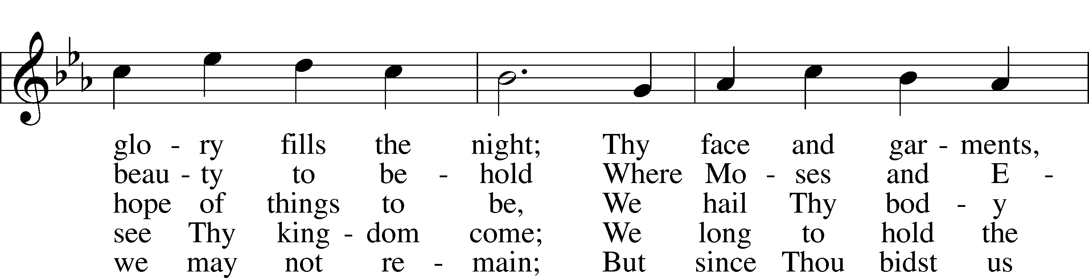
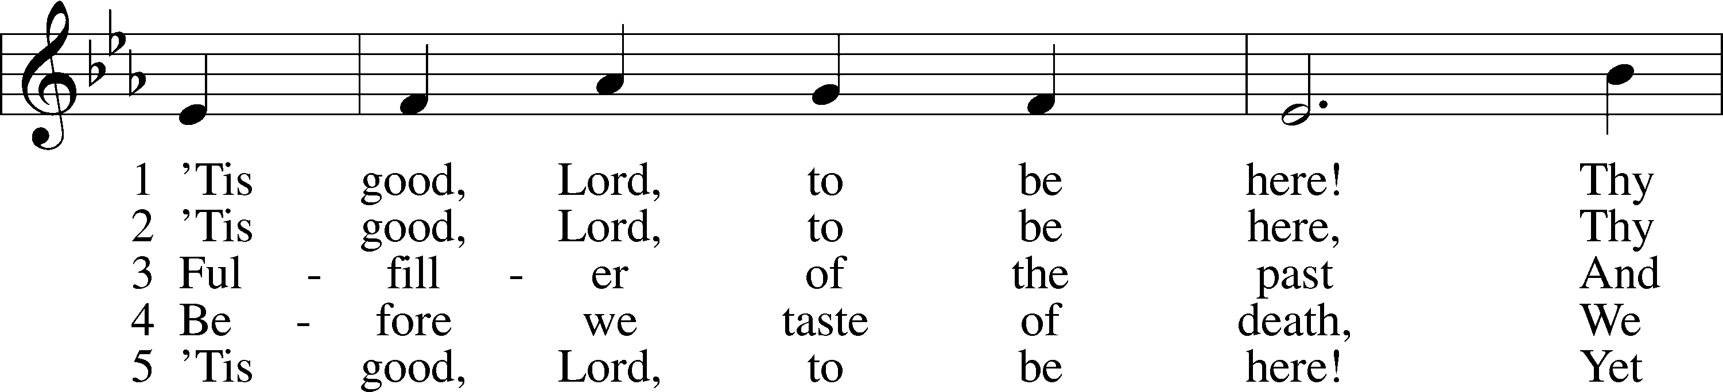

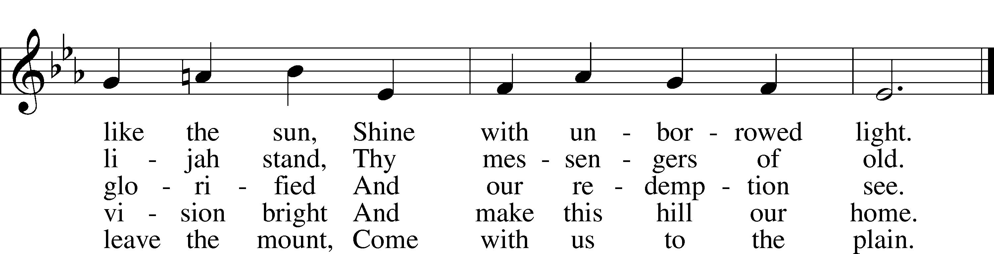

Text: Joseph A. Robinson, 1858–1933, alt. Tune: Johann Sebastian Bach, 1685–1750, adapt. Text and tune: Public domain

Stand

Invocation LSB 184
P In the name of the Father and of the T Son and of the Holy Spirit.
C Amen.
P Our help is in the name of the Lord,
C who made heaven and earth.
P I said, I will confess my transgressions unto the Lord,
C and You forgave the iniquity of my sin.

Silence for reflection on God’s Word and for self-examination.

P O almighty God, merciful Father,
C I, a poor, miserable sinner, confess unto You all my sins and iniquities with which I have ever offended You and justly deserved Your temporal and eternal punishment. But I am heartily sorry for them and sincerely repent of them, and I pray You of Your boundless mercy and for the sake of the holy, innocent, bitter sufferings and death of Your beloved Son, Jesus Christ, to be gracious and merciful to me, a poor, sinful being.

Absolution LSB 185
P Upon this your confession, I, by virtue of my office, as a called and ordained servant of the Word, announce the grace of God unto all of you, and in the stead and by the command of my Lord Jesus Christ I forgive you all your sins in the name of the Father and of the T Son and of the Holy Spirit.
C Amen.

Introit Psalm 99:1–5; antiphon: v. 9
Exalt the Lord our God, and worship at his holy | mountain;*
for the Lord our God is | holy!
The Lord reigns; let the peoples | tremble!*
He sits enthroned upon the cherubim; let the | earth quake!
The Lord is great in | Zion;*
he is exalted over all the | peoples.
Let them praise your great and | awesome name!*
Ho- | ly is he!
The King in his might loves | justice.*
You have established equity; you have executed justice and righteousness in | Jacob.
Exalt the Lord our God; worship at his | footstool!*
Ho- | ly is he!
Exalt the Lord our God, and worship at his holy | mountain;*
for the Lord our God is | holy!

Gloria Patri LSB 186
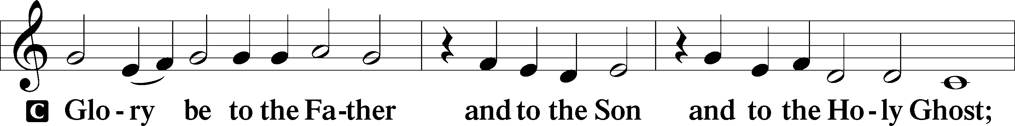

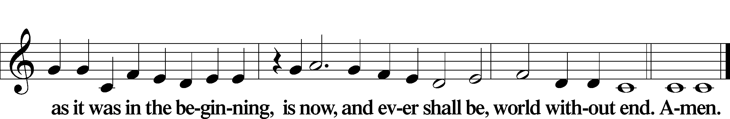

Kyrie LSB 186
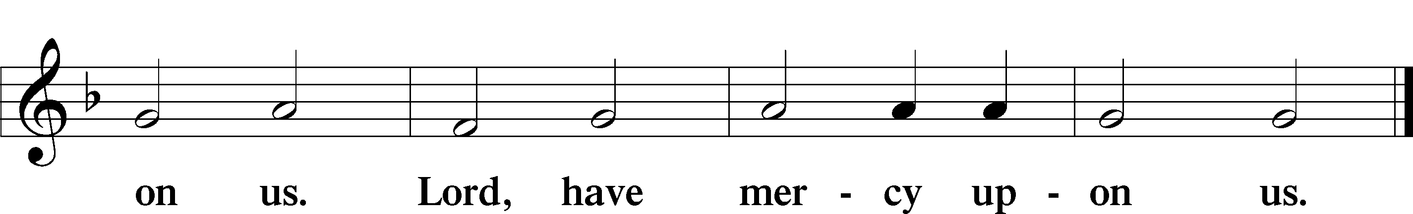
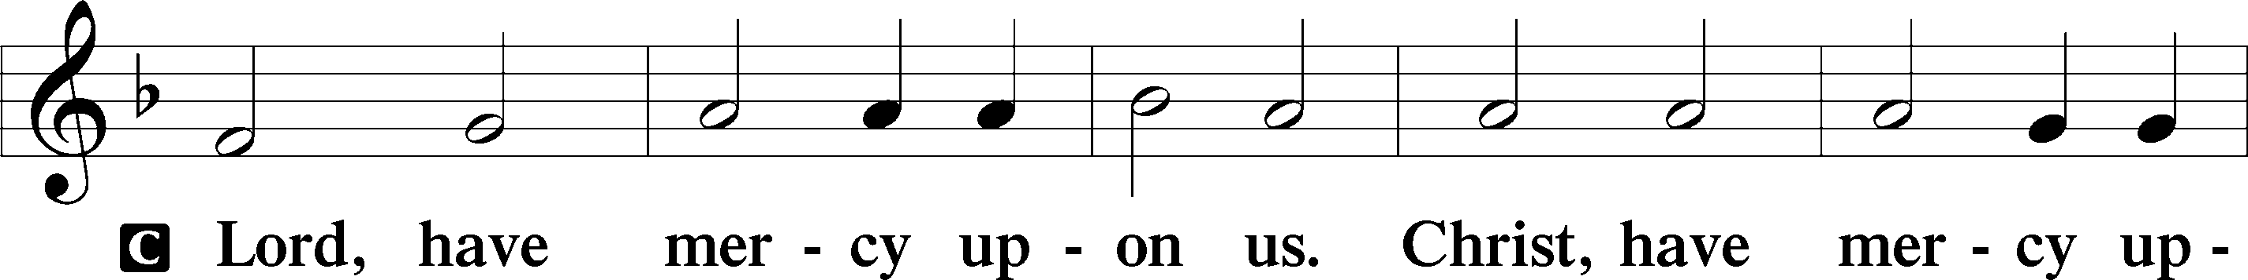

Gloria in Excelsis LSB 187
P Glory be to God on high:
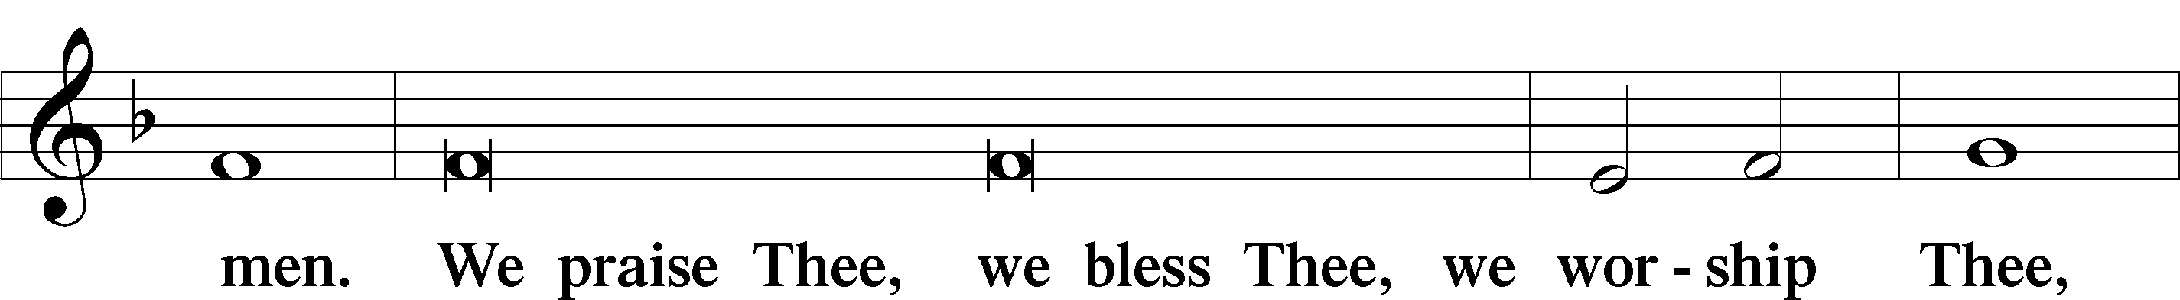
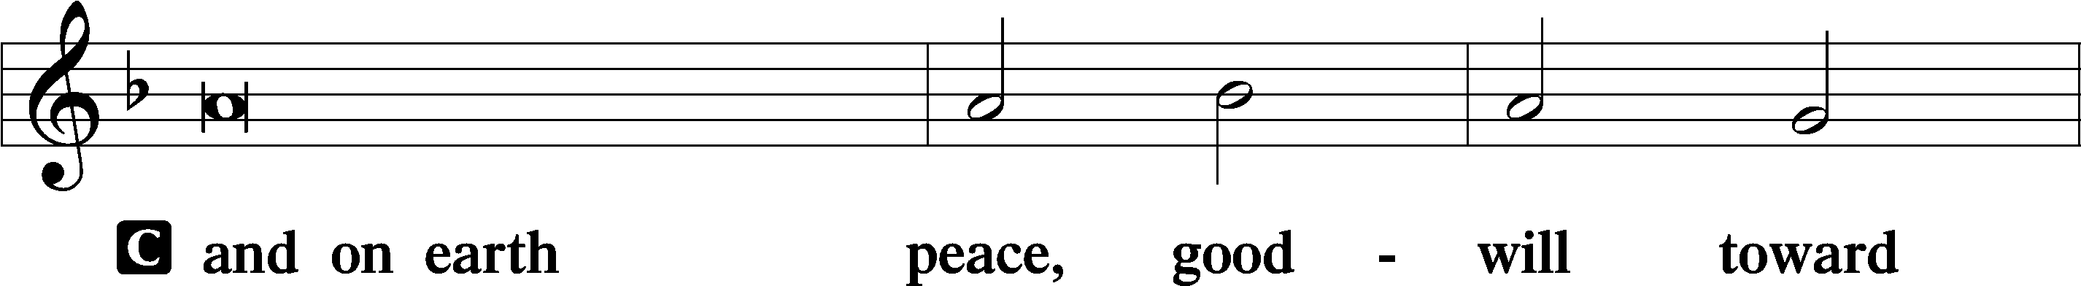

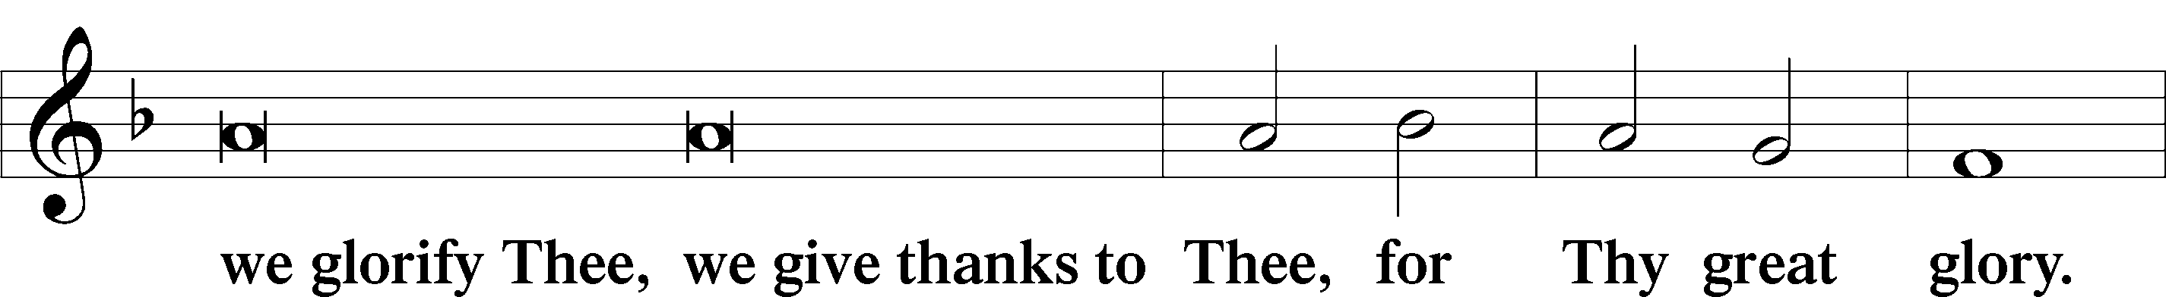

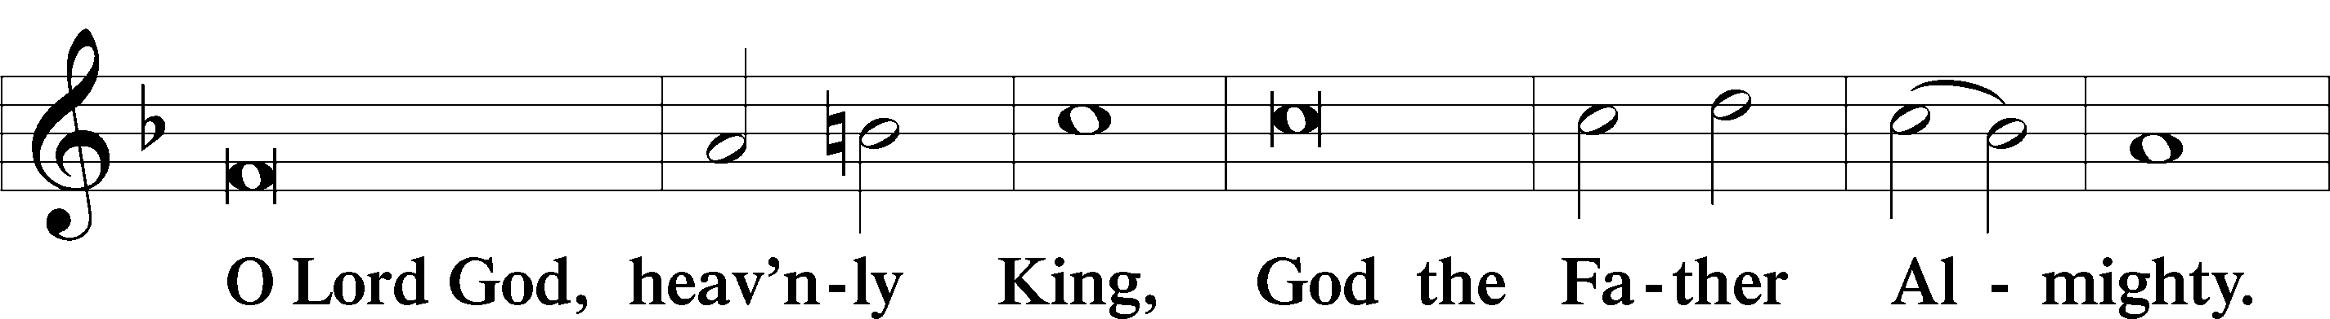

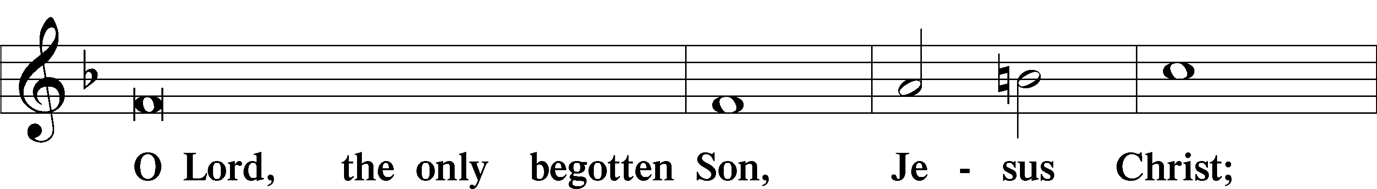

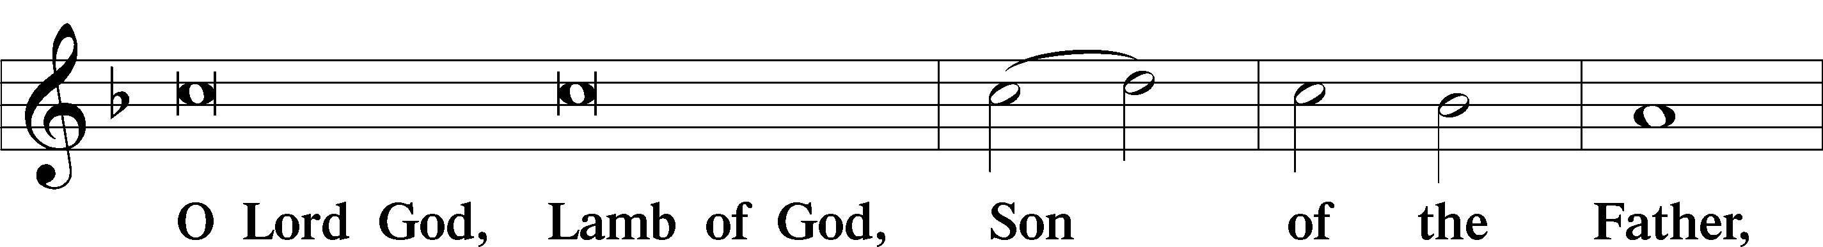

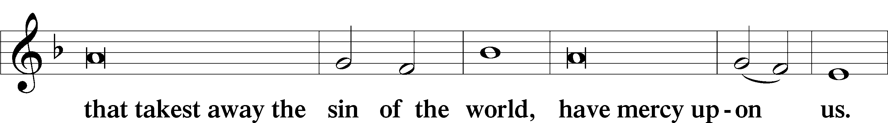

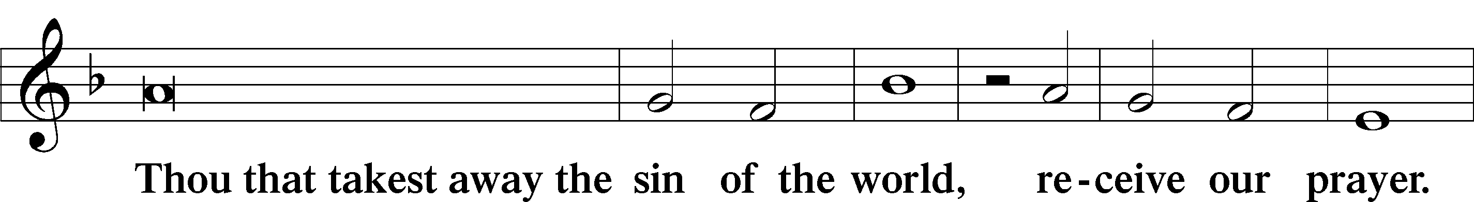

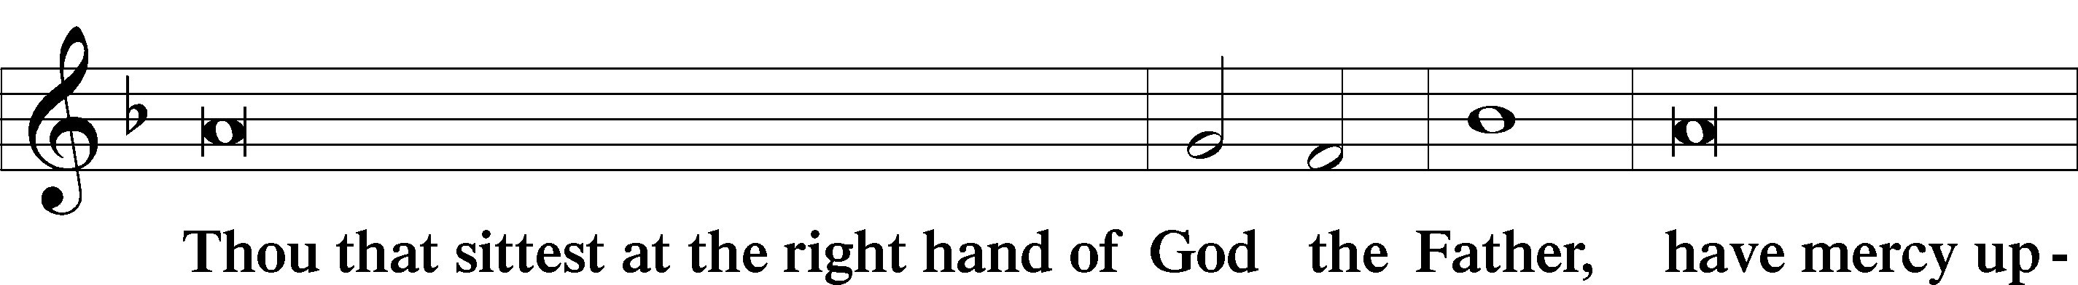

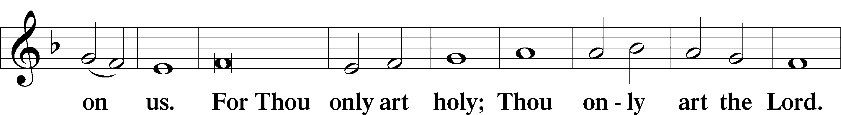

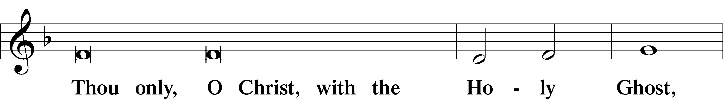

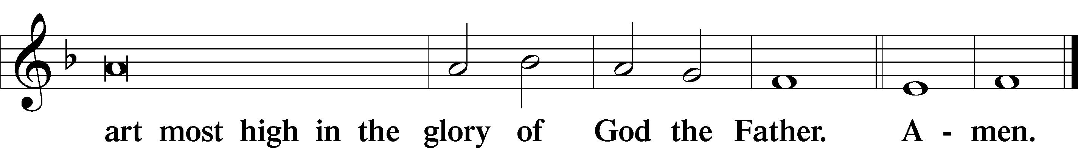

Salutation and Collect of the Day
P The Lord be with you.
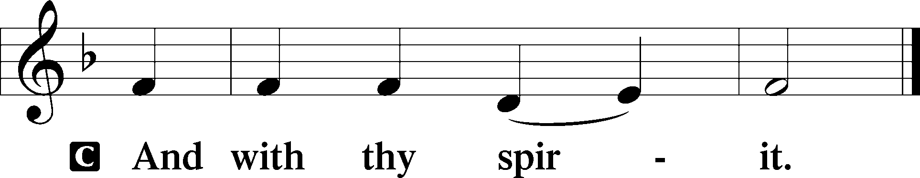
P Let us pray.
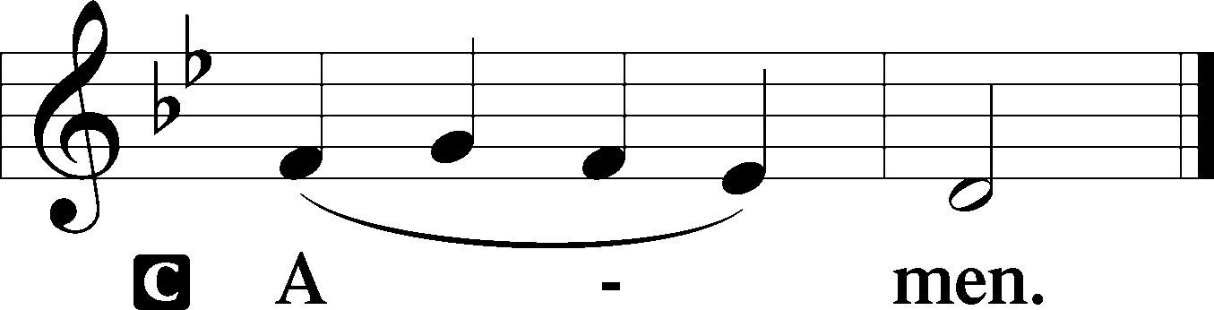
O God, in the glorious transfiguration of Your beloved Son You confirmed the mysteries of the faith by the testimony of Moses and Elijah. In the voice that came from the bright cloud You wonderfully foreshowed our adoption by grace. Mercifully make us co-heirs with the King in His glory and bring us to the fullness of our inheritance in heaven; through the same Jesus Christ, our Lord, who lives and reigns with You and the Holy Spirit, one God, now and forever.

Sit

Old Testament Reading 2 Kings 2:1–12
¹When the Lord was about to take Elijah up to heaven by a whirlwind, Elijah and Elisha were on their way from Gilgal. ²And Elijah said to Elisha, “Please stay here, for the Lord has sent me as far as Bethel.” But Elisha said, “As the Lord lives, and as you yourself live, I will not leave you.” So they went down to Bethel. ³And the sons of the prophets who were in Bethel came out to Elisha and said to him, “Do you know that today the Lord will take away your master from over you?” And he said, “Yes, I know it; keep quiet.”
⁴Elijah said to him, “Elisha, please stay here, for the Lord has sent me to Jericho.” But he said, “As the Lord lives, and as you yourself live, I will not leave you.” So they came to Jericho. ⁵The sons of the prophets who were at Jericho drew near to Elisha and said to him, “Do you know that today the Lord will take away your master from over you?” And he answered, “Yes, I know it; keep quiet.”
⁶Then Elijah said to him, “Please stay here, for the Lord has sent me to the Jordan.” But he said, “As the Lord lives, and as you yourself live, I will not leave you.” So the two of them went on. ⁷Fifty men of the sons of the prophets also went and stood at some distance from them, as they both were standing by the Jordan. ⁸Then Elijah took his cloak and rolled it up and struck the water, and the water was parted to the one side and to the other, till the two of them could go over on dry ground.
⁹When they had crossed, Elijah said to Elisha, “Ask what I shall do for you, before I am taken from you.” And Elisha said, “Please let there be a double portion of your spirit on me.” ¹⁰And he said, “You have asked a hard thing; yet, if you see me as I am being taken from you, it shall be so for you, but if you do not see me, it shall not be so.” ¹¹And as they still went on and talked, behold, chariots of fire and horses of fire separated the two of them. And Elijah went up by a whirlwind into heaven. ¹²And Elisha saw it and he cried, “My father, my father! The chariots of Israel and its horsemen!” And he saw him no more.
P This is the Word of the Lord.
C Thanks be to God.

Gradual Psalm 117:1–2a; 96:8
Praise the Lord, all | nations!*
Extol him, all | peoples!
For great is his steadfast | love toward us,*
and the faithfulness of the Lord endures for- | ever.
Ascribe to the Lord the glory | due his name;*
bring an offering, and come in- | to his courts!

Epistle 2 Corinthians 3:12–18; 4:1–6
¹²Since we have such a hope, we are very bold, ¹³not like Moses, who would put a veil over his face so that the Israelites might not gaze at the outcome of what was being brought to an end. ¹⁴But their minds were hardened. For to this day, when they read the old covenant, that same veil remains unlifted, because only through Christ is it taken away. ¹⁵Yes, to this day whenever Moses is read a veil lies over their hearts. ¹⁶But when one turns to the Lord, the veil is removed. ¹⁷Now the Lord is the Spirit, and where the Spirit of the Lord is, there is freedom. ¹⁸And we all, with unveiled face, beholding the glory of the Lord, are being transformed into the same image from one degree of glory to another. For this comes from the Lord who is the Spirit.
¹Therefore, having this ministry by the mercy of God, we do not lose heart. ²But we have renounced disgraceful, underhanded ways. We refuse to practice cunning or to tamper with God’s word, but by the open statement of the truth we would commend ourselves to everyone’s conscience in the sight of God. ³And even if our gospel is veiled, it is veiled only to those who are perishing. ⁴In their case the god of this world has blinded the minds of the unbelievers, to keep them from seeing the light of the gospel of the glory of Christ, who is the image of God. ⁵For what we proclaim is not ourselves, but Jesus Christ as Lord, with ourselves as your servants for Jesus’ sake. ⁶For God, who said, “Let light shine out of darkness,” has shone in our hearts to give the light of the knowledge of the glory of God in the face of Jesus Christ.
P This is the Word of the Lord.
C Thanks be to God.

Stand

Alleluia LSB 190
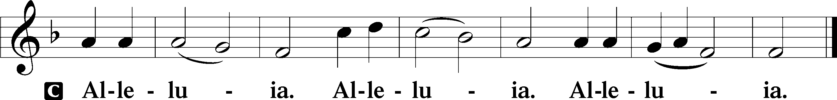

Holy Gospel Mark 9:2–9
P The Holy Gospel according to St. Mark, the ninth chapter.
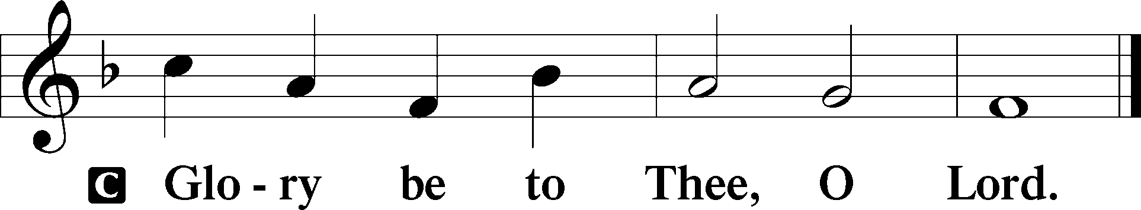
²After six days Jesus took with him Peter and James and John, and led them up a high mountain by themselves. And he was transfigured before them, ³and his clothes became radiant, intensely white, as no one on earth could bleach them. ⁴And there appeared to them Elijah with Moses, and they were talking with Jesus. ⁵And Peter said to Jesus, “Rabbi, it is good that we are here. Let us make three tents, one for you and one for Moses and one for Elijah.” ⁶For he did not know what to say, for they were terrified. ⁷And a cloud overshadowed them, and a voice came out of the cloud, “This is my beloved Son; listen to him.” ⁸And suddenly, looking around, they no longer saw anyone with them but Jesus only.
⁹And as they were coming down the mountain, he charged them to tell no one what they had seen, until the Son of Man had risen from the dead.
P This is the Gospel of the Lord.
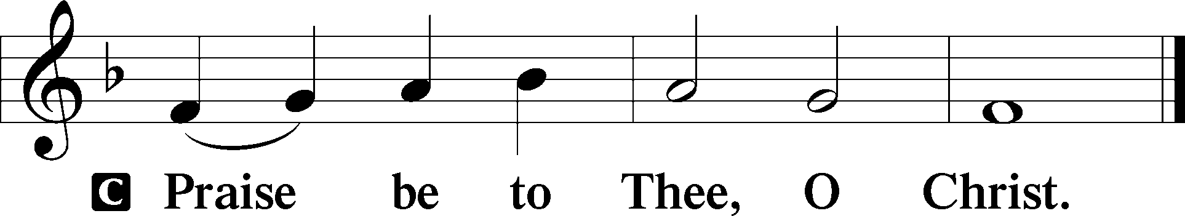
Apostles’ Creed
C I believe in God, the Father Almighty,
maker of heaven and earth.
And in Jesus Christ, His only Son, our Lord,
who was conceived by the Holy Spirit,
born of the virgin Mary,
suffered under Pontius Pilate,
was crucified, died and was buried.
He descended into hell.
The third day He rose again from the dead.
He ascended into heaven
and sits at the right hand of God the Father Almighty.
From thence He will come to judge the living and the dead.
I believe in the Holy Spirit,
the holy Christian Church,
the communion of saints,
the forgiveness of sins,
the resurrection of the body,
and the life T everlasting. Amen.

Sit

413 O Wondrous Type! O Vision Fair
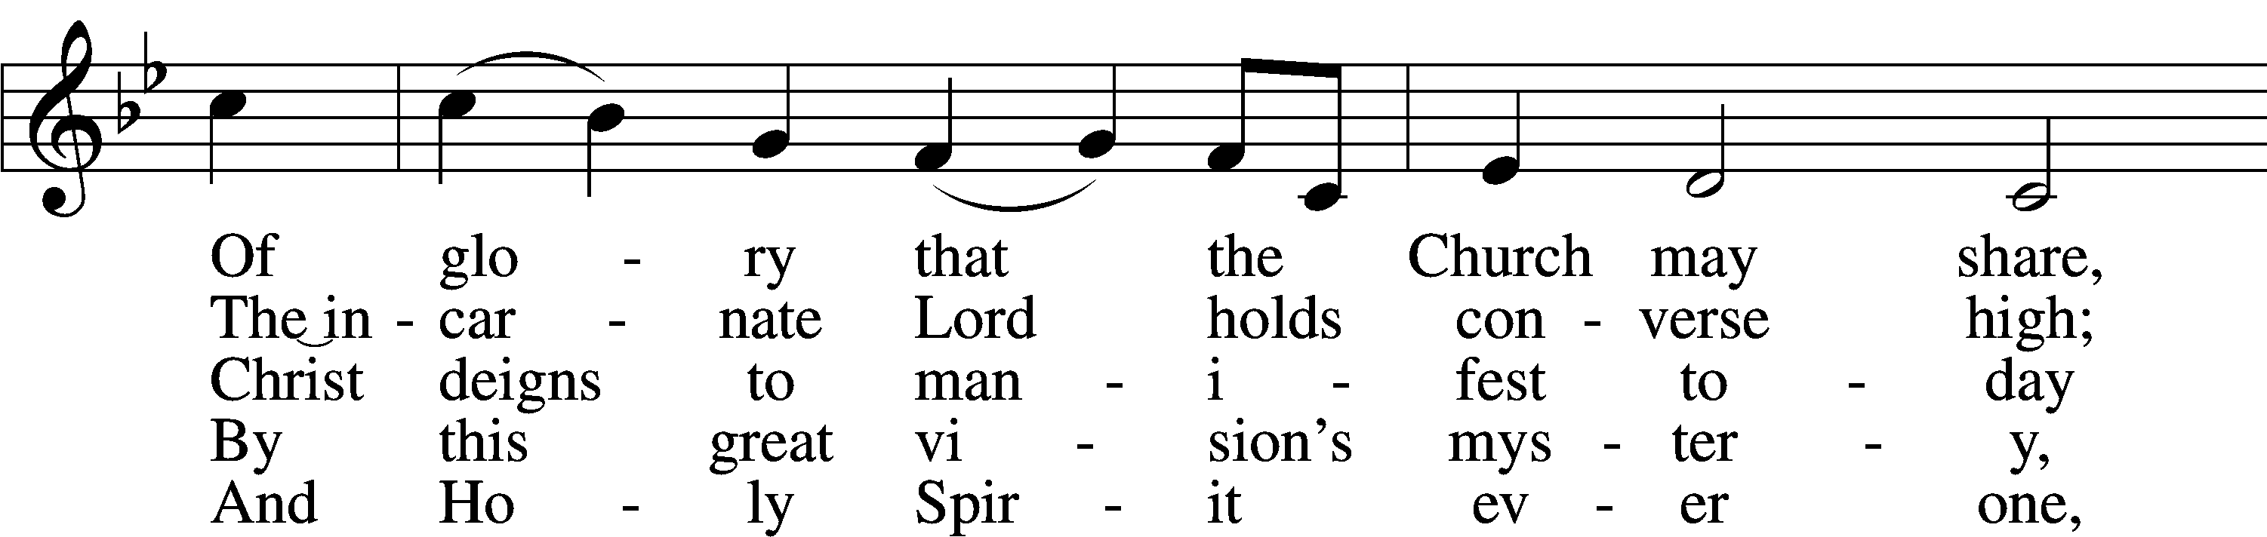
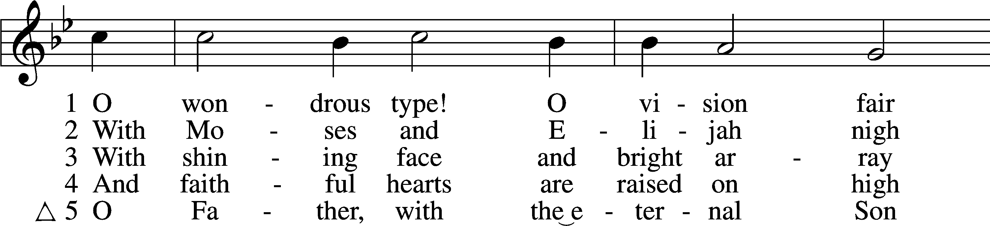

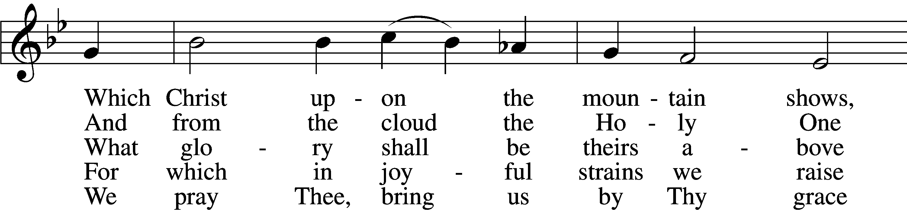

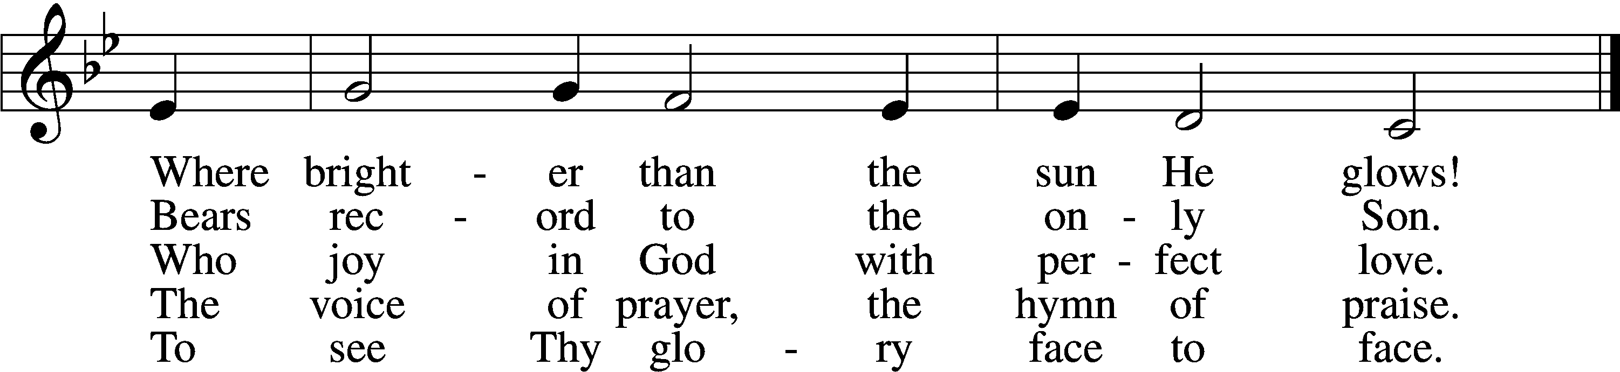
Text: Sarum Breviary, 1495, Salisbury; tr. John Mason Neale, 1818–66, alt. Tune: English, 15th cent. Text and tune: Public domain

Sermon

Stand

Offertory LSB 192
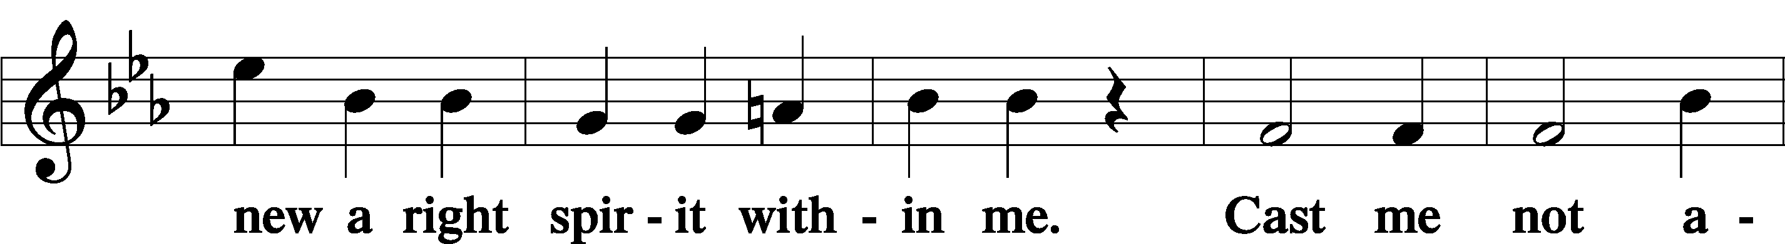
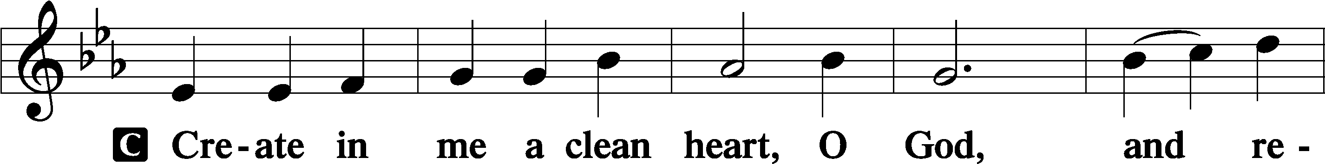

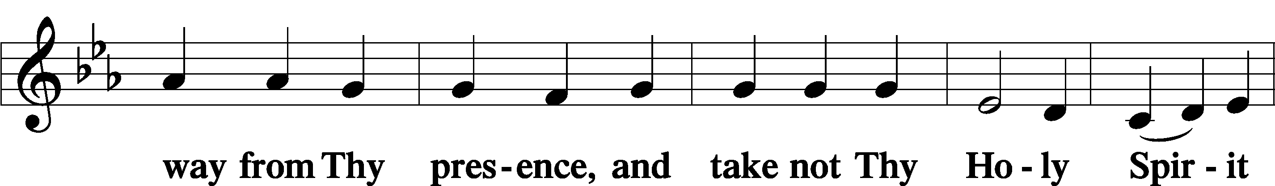

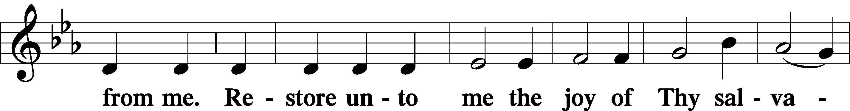

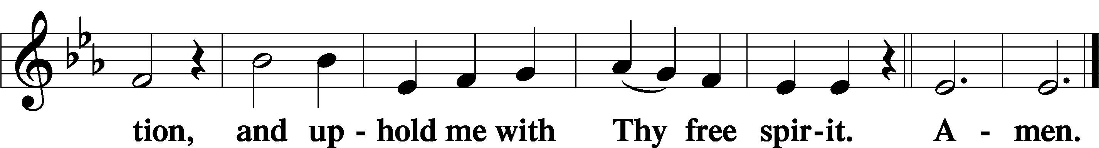

Prayer of the Church

Sharing the Peace
Following the prayers, you may greet one another in the name of the Lord, saying, “Peace be with you”. Shaking hands is not required unless one is comfortable doing so. Please respect your neighbor’s needs.

Sit

Consecration of the Offering
After the peace please be seated. The altar is set for the Lord’s Supper and the offering is consecrated. As you prepare to receive the sacrament you may use the prayers in the front of the hymnal or meditate on a communion hymn.

Stand

Service of the Sacrament
Preface LSB 194
P The Lord be with you.

P Lift up your hearts.
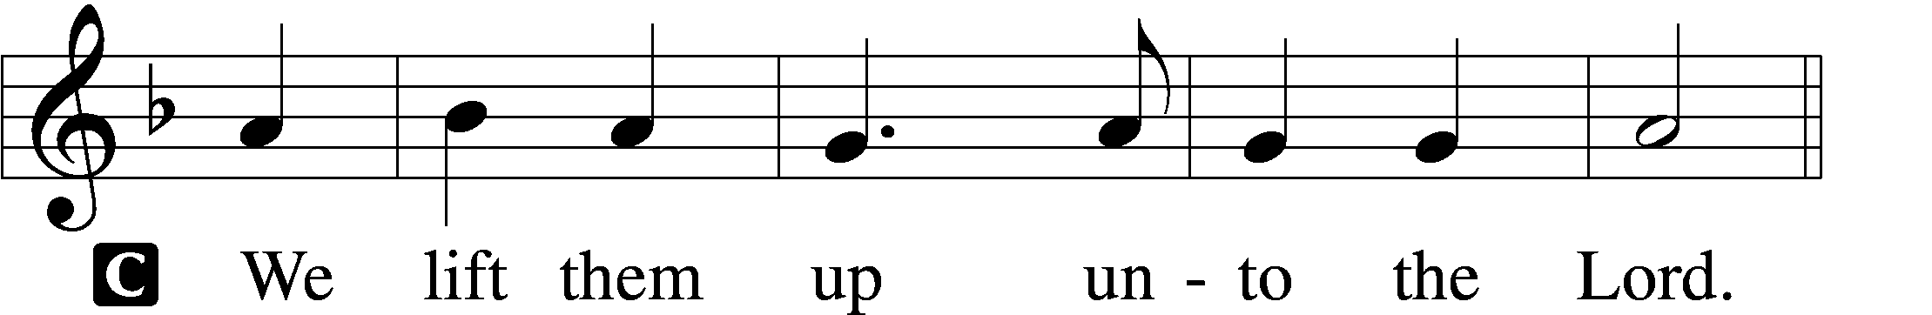

P Let us give thanks unto the Lord, our God.
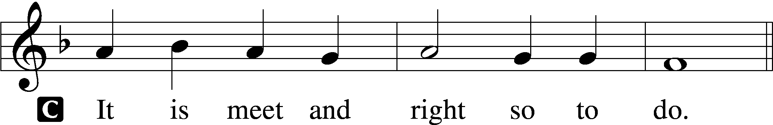

P It is truly meet, right, and salutary that we should at all times and in all places give thanks to You, holy Lord, almighty Father, everlasting God, through Jesus Christ, our Lord, who at His transfiguration revealed His glory to His disciples that they might be strengthened to proclaim His cross and resurrection and with all the faithful look forward to the glory of life everlasting. Therefore with angels and archangels and with all the company of heaven we laud and magnify Your glorious name, evermore praising You and saying:

Sanctus LSB 195
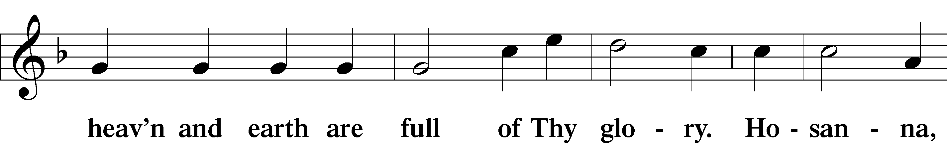
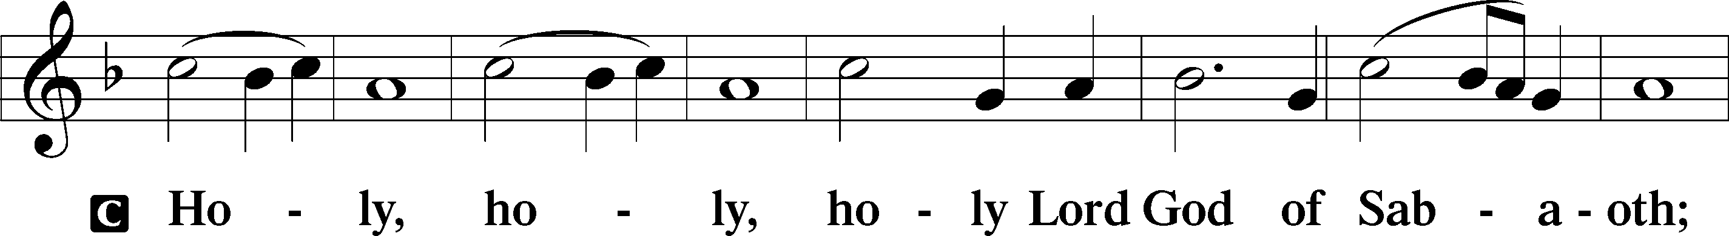

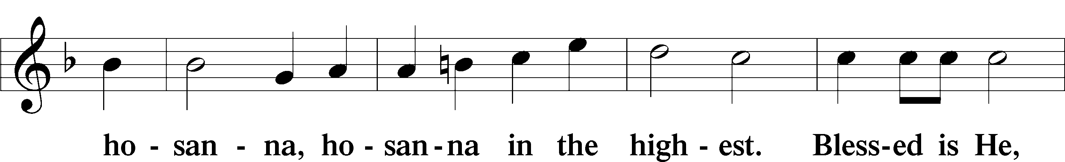

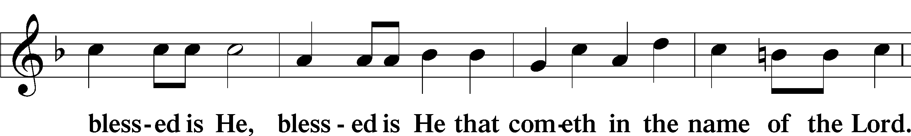

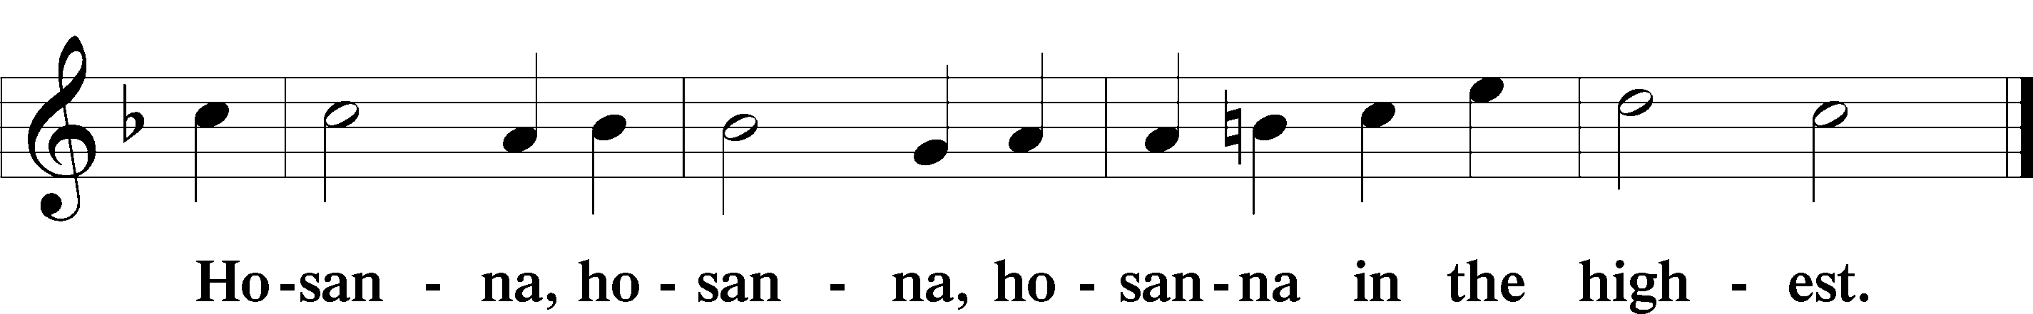

Lord’s Prayer
C Our Father who art in heaven,
hallowed be Thy name,
Thy kingdom come,
Thy will be done on earth
as it is in heaven;
give us this day our daily bread;
and forgive us our trespasses
as we forgive those
who trespass against us;
and lead us not into temptation,
but deliver us from evil.
For Thine is the kingdom
and the power and the glory
forever and ever. Amen.

The Words of Our Lord
P Our Lord Jesus Christ, on the night when He was betrayed, took bread, and when He had given thanks, He broke it and gave it to the disciples and said: “Take, eat; this is My T body, which is given for you. This do in remembrance of Me.”
In the same way also He took the cup after supper, and when He had given thanks, He gave it to them, saying: “Drink of it, all of you; this cup is the new testament in My T blood, which is shed for you for the forgiveness of sins. This do, as often as you drink it, in remembrance of Me.”

Pax Domini LSB 197
P The peace of the Lord be with you always.
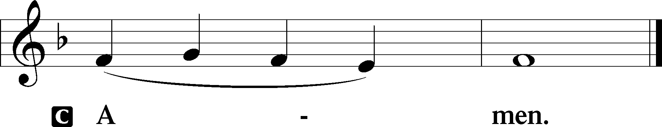

Agnus Dei LSB 198
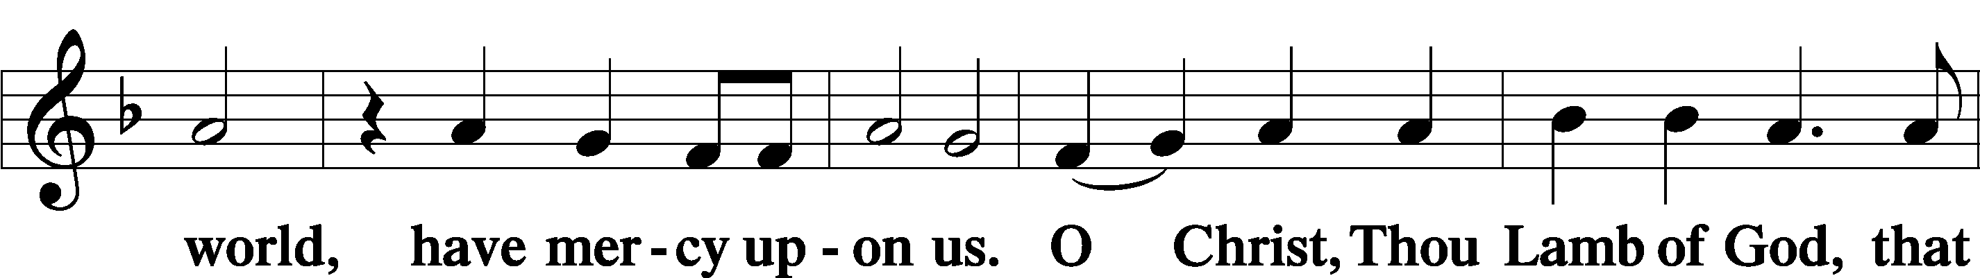
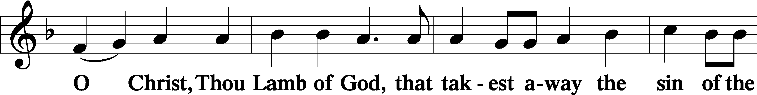

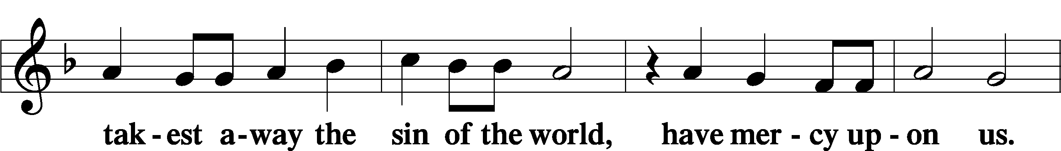

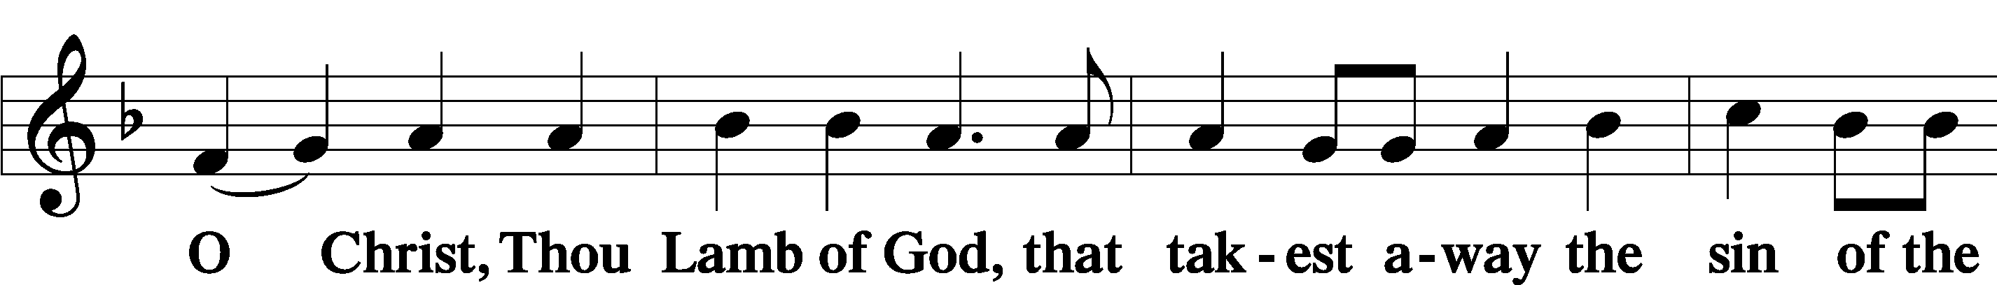

Sit

Distribution

631 Here, O My Lord, I See Thee Face to Face
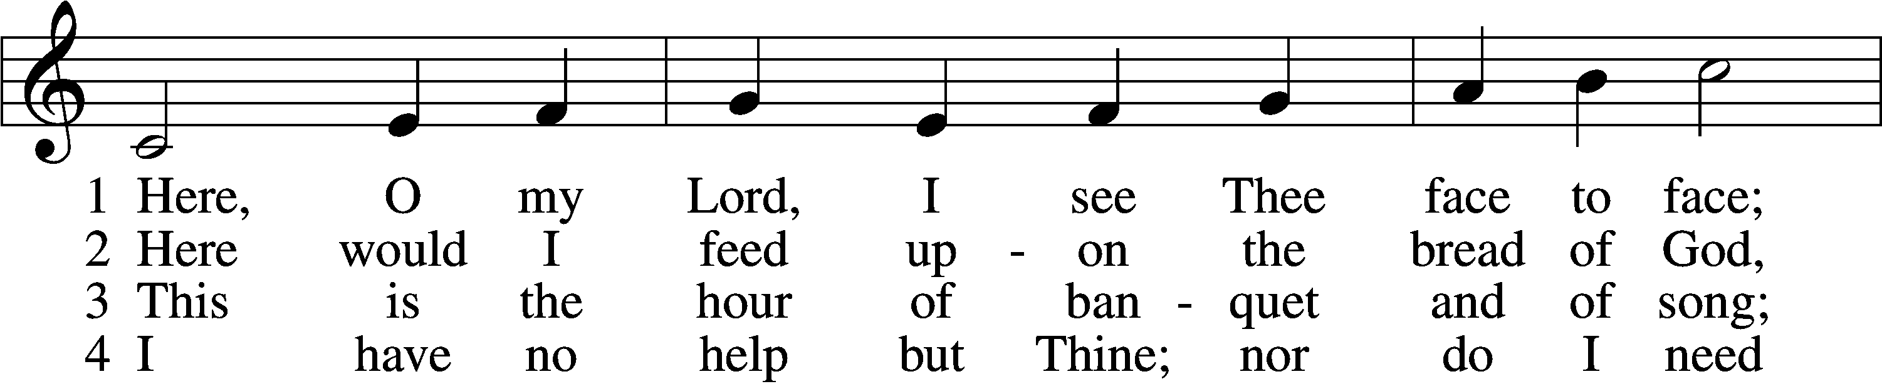
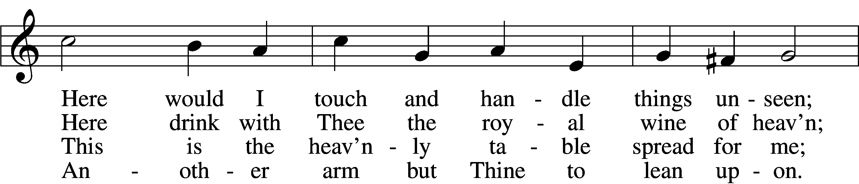
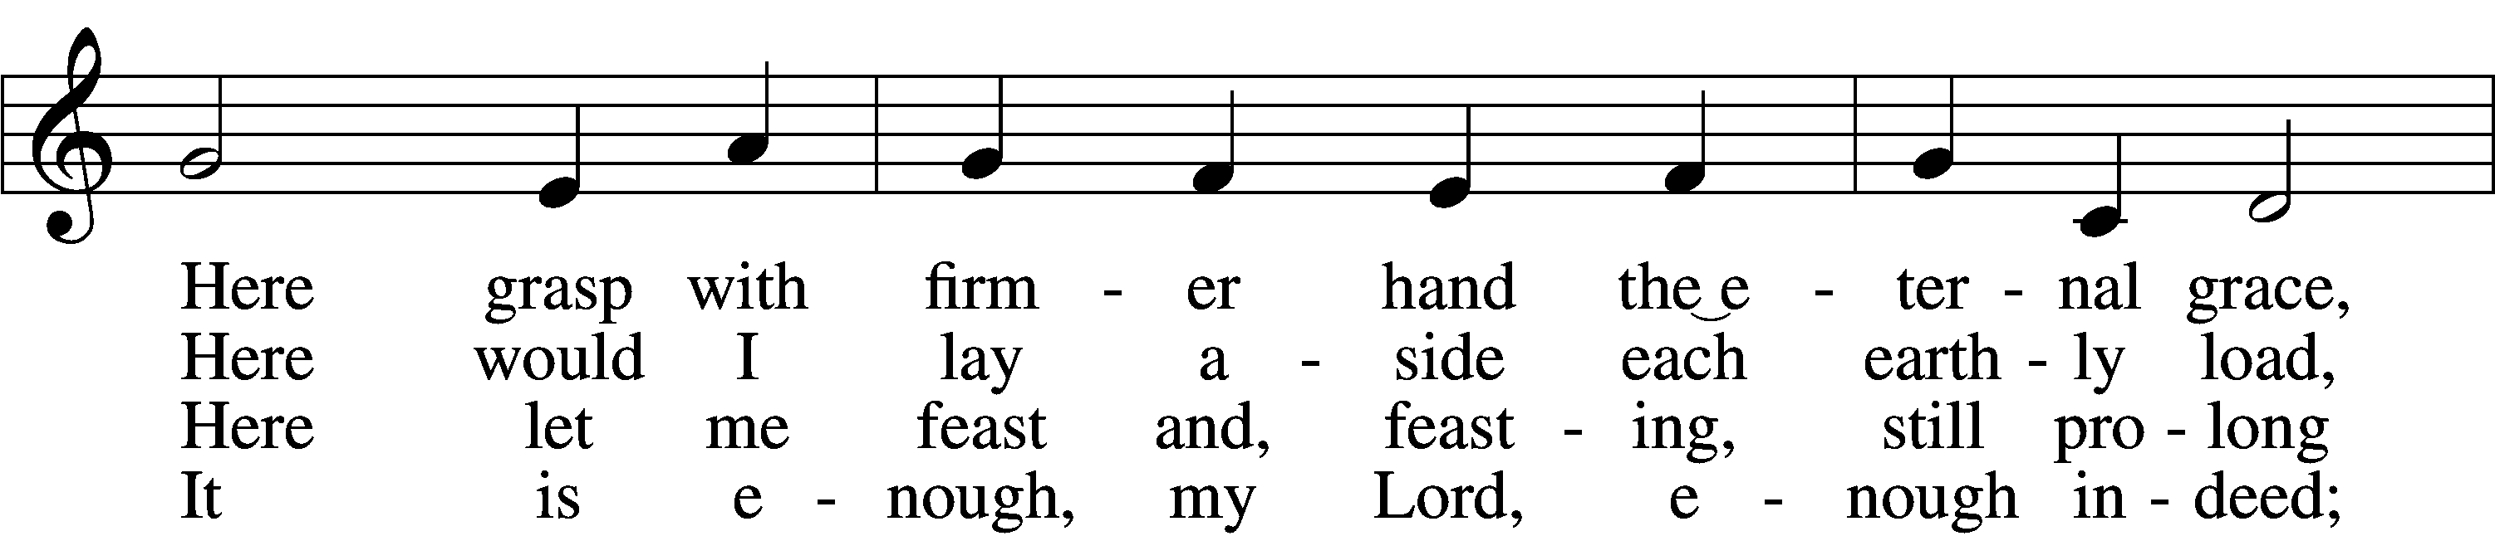
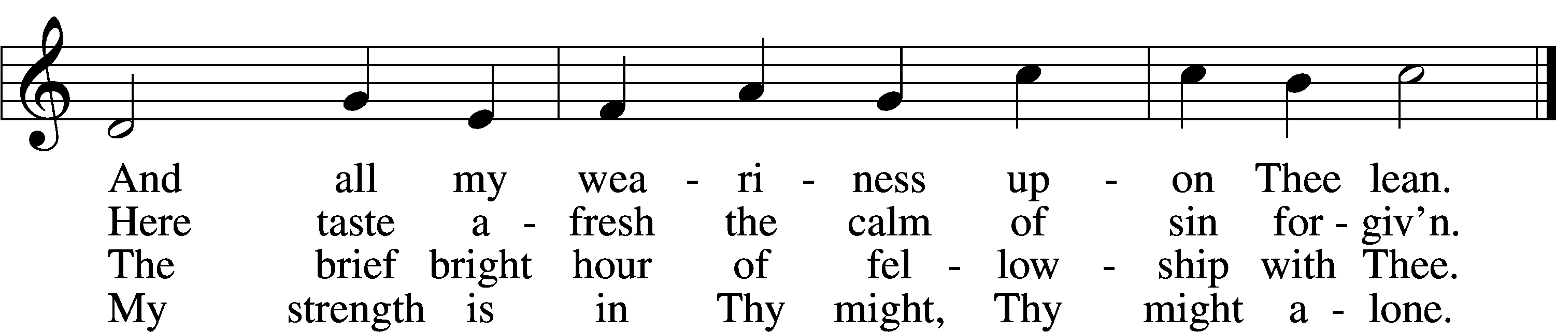
5 Mine is the sin, but Thine the righteousness;
Mine is the guilt, but Thine the cleansing blood;
Here is my robe, my refuge, and my peace:
Thy blood, Thy righteousness, O Lord my God.

6 Too soon we rise; the vessels disappear;
The feast, though not the love, is past and gone;
The bread and wine remove, but Thou art here;
Nearer than ever; still my shield and sun.

7 Feast after feast thus comes and passes by,
Yet, passing, points to that glad feast above,
Giving sweet foretaste of the festal joy,
The Lamb’s great marriage feast of bliss and love.
Text: Horatius Bonar, 1808–89, alt. Tune: Henry Lawes, 1595–1662 Text and tune: Public domain

415 Jesus on the Mountain Peak
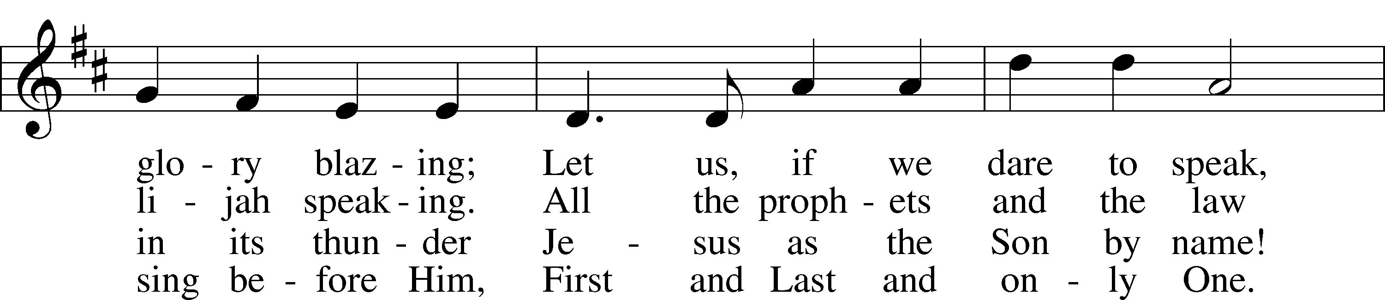
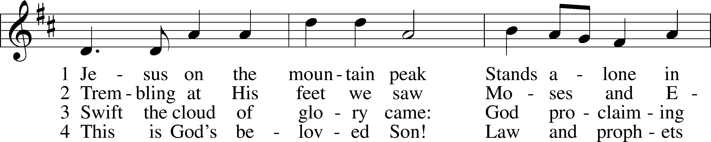

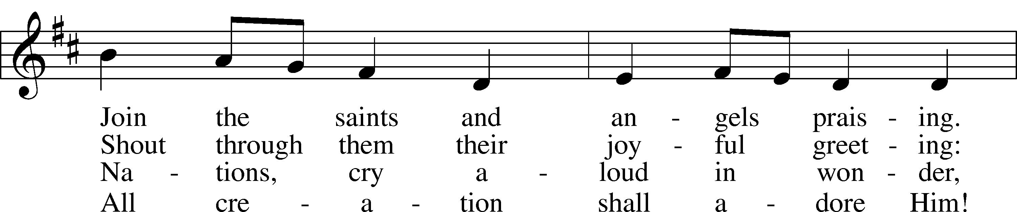

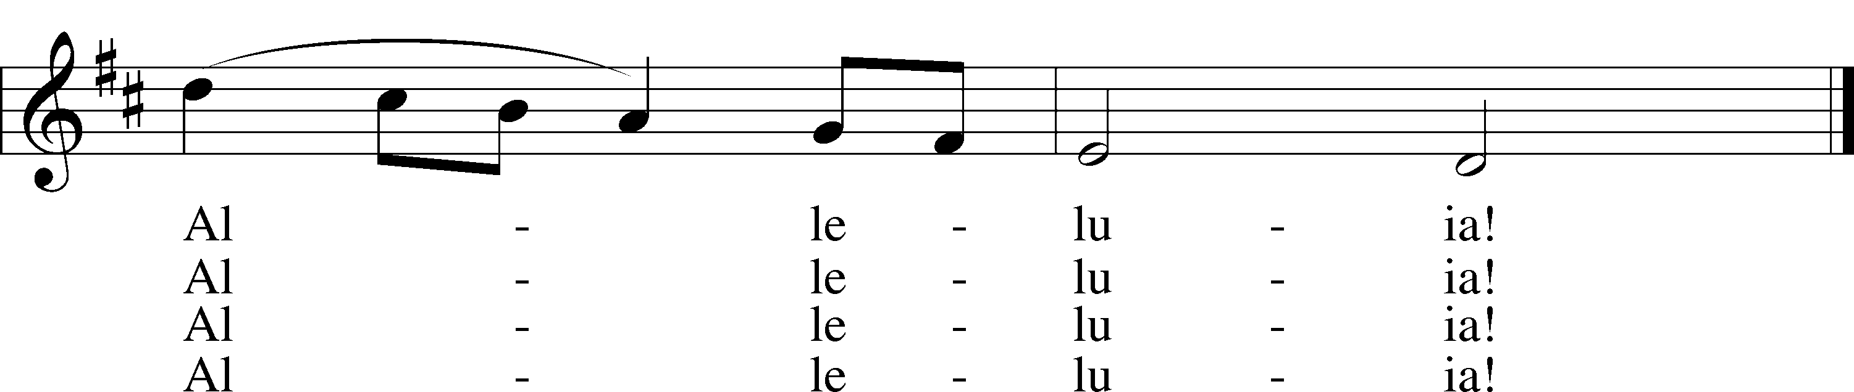

Text: Brian Wren, 1936 Tune: Theodore A. Beck, 1929–2003, alt. Text: © 1977 Hope Publishing Co. Used by permission: LSB Hymn License no. 110003744 Tune: © 1998 Theodore A. Beck. Used by permission: LSB Hymn License no. 110003744

873 Christ, Whose Glory Fills the Skies
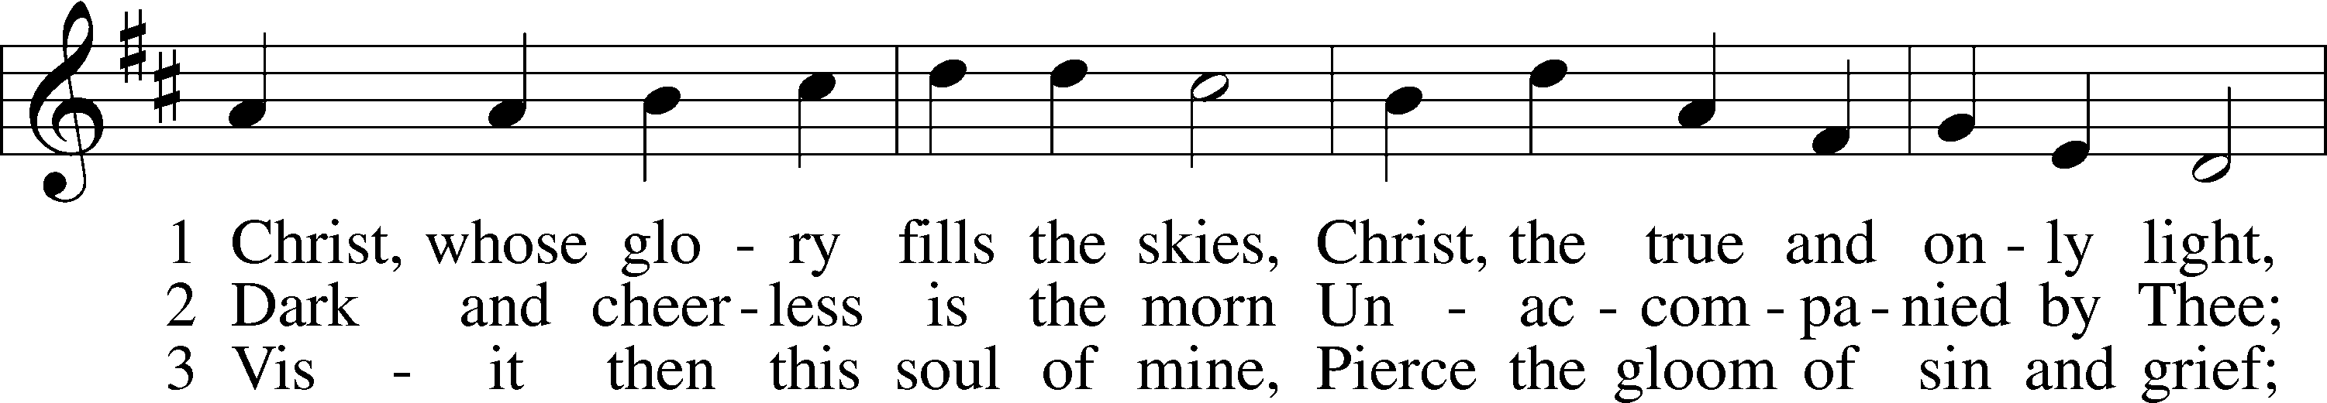
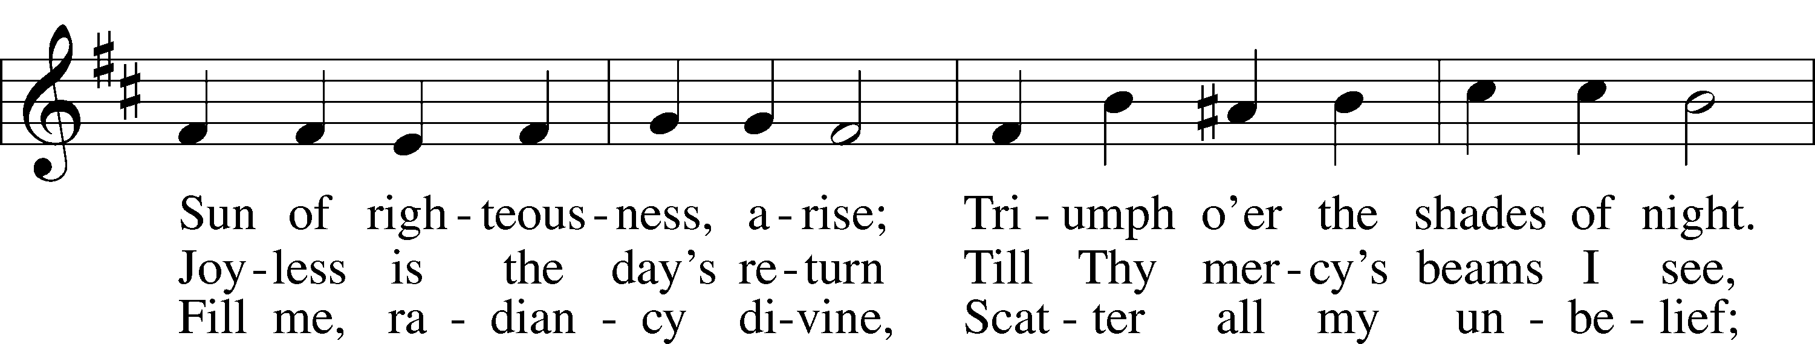
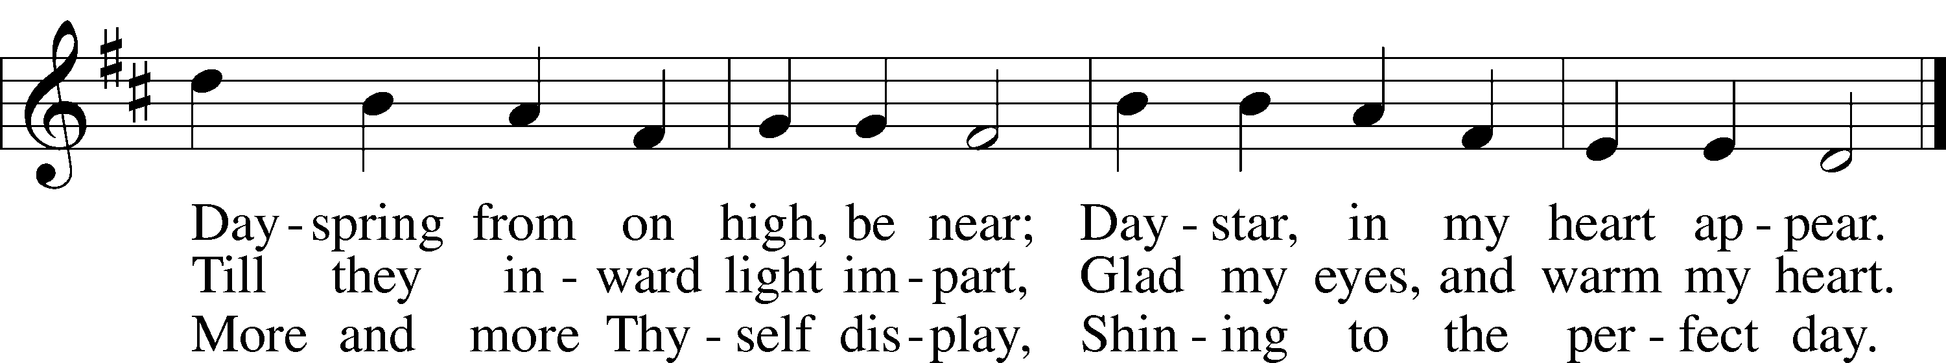
Text: Charles Wesley, 1707–88 Tune: attr. Johann G. Werner, 1777–1822 Text and tune: Public domain

537 Beautiful Savior
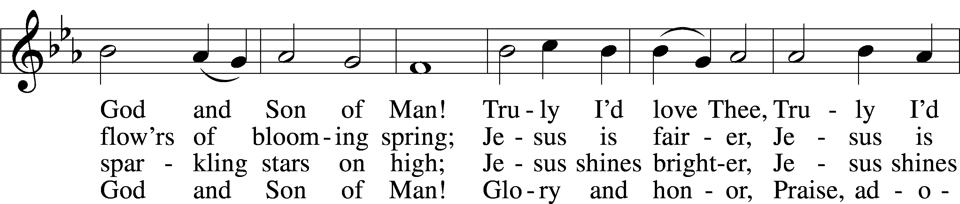
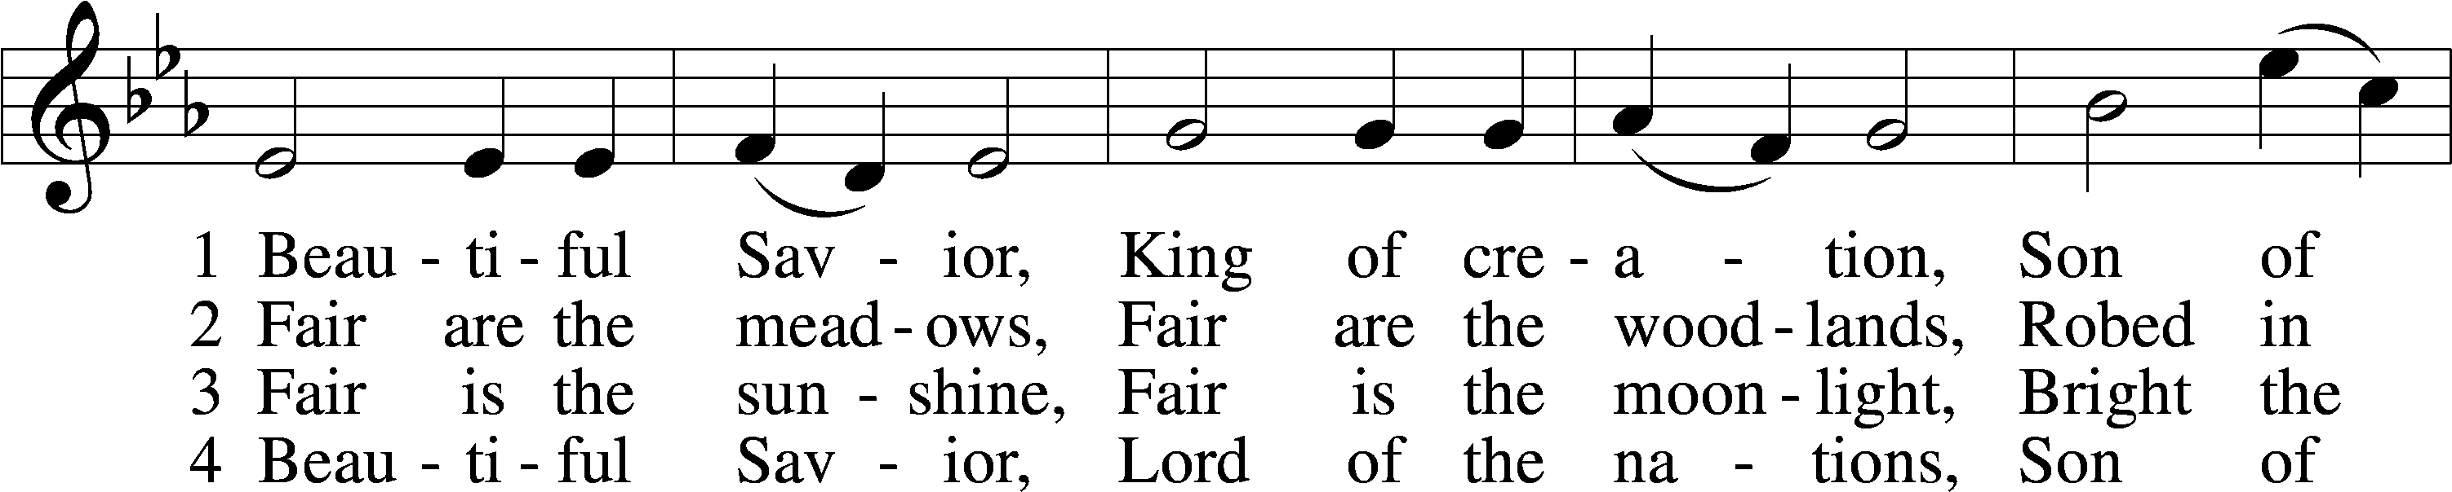

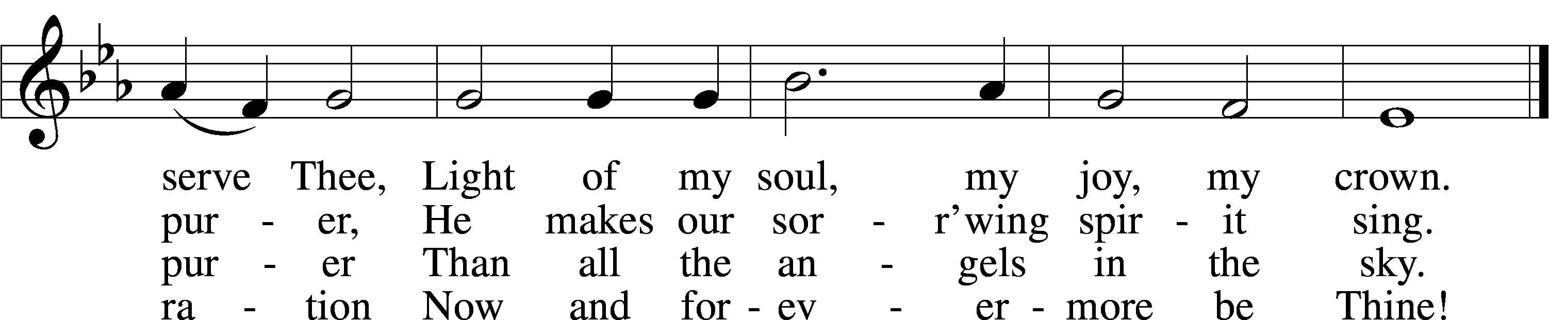

Text: Münsterisch Gesangbuch, 1677, Münster; tr. Joseph A. Seiss, 1823–1904 Tune: Silesian, 19th cent. Text and tune: Public domain

The Dismissal
P The body and blood of our Lord Jesus Christ strengthen and preserve you in body and soul to life everlasting. Depart T in peace.
C Amen.

Stand

Nunc Dimittis LSB 199

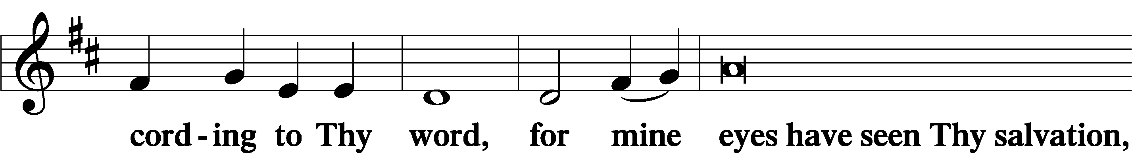
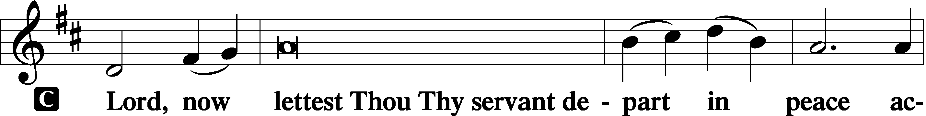

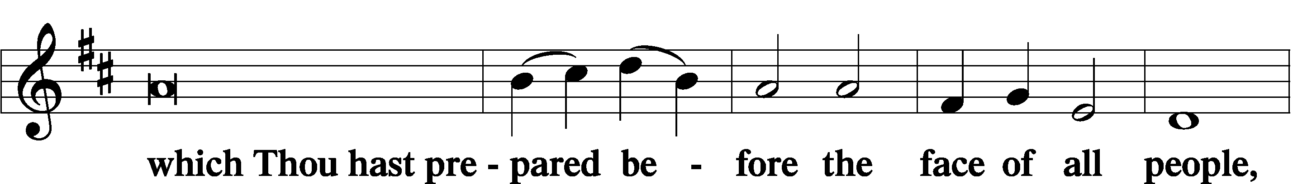

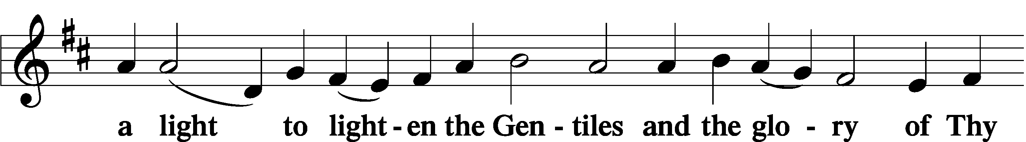

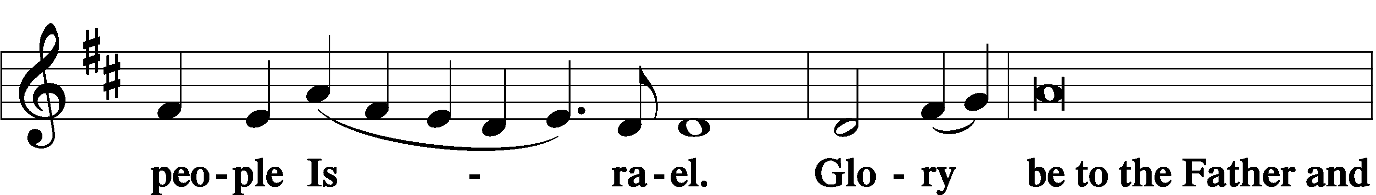

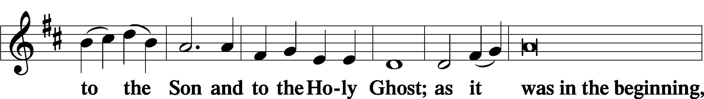

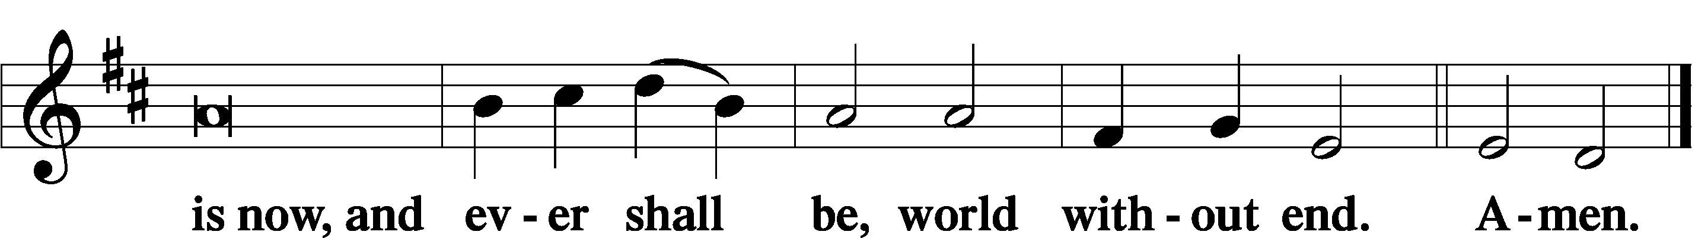

Thanksgiving LSB 200
P O give thanks unto the Lord, for He is good,
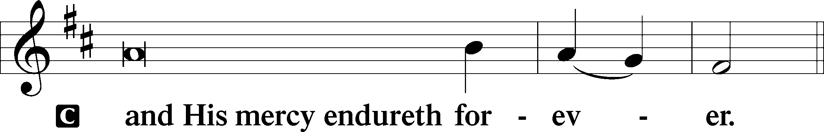
P Let us pray.
O God the Father, the fountain and source of all goodness, who in loving-kindness sent Your only-begotten Son into the flesh, we thank You that for His sake You have given us pardon and peace in this Sacrament, and we ask You not to forsake Your children but always to rule our hearts and minds by Your Holy Spirit that we may be enabled constantly to serve You; through Jesus Christ, Your Son, our Lord, who lives and reigns with You and the Holy Spirit, one God, now and forever.

P The Lord be with you.
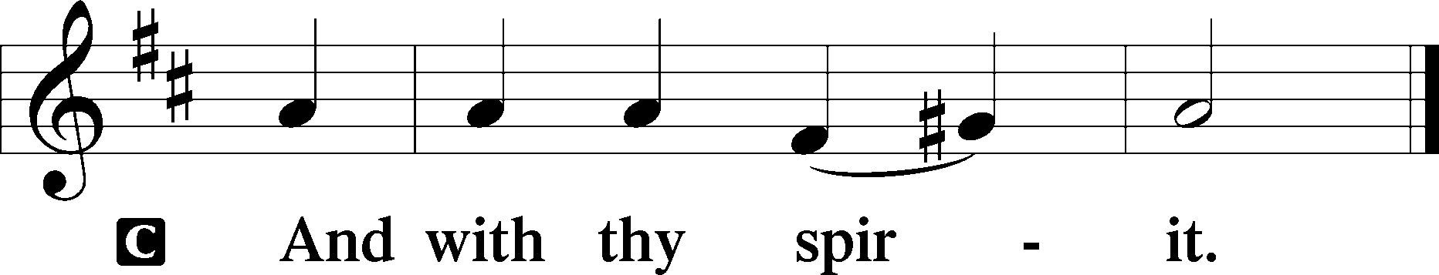

Benedicamus LSB 202
P Bless we the Lord.
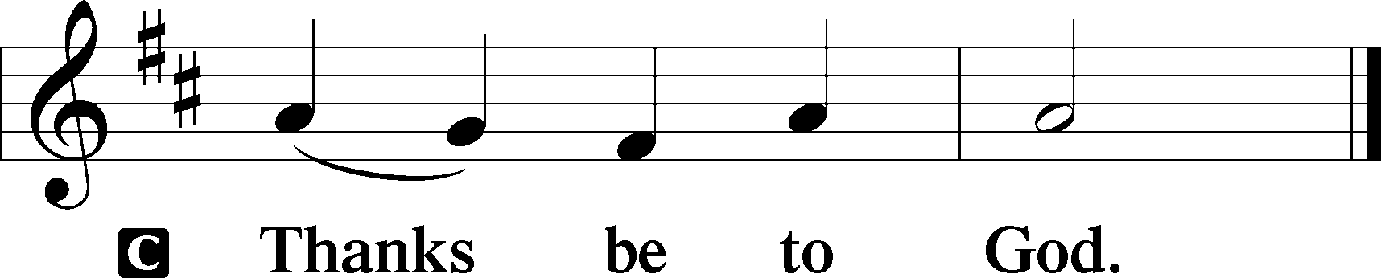

Benediction LSB 202
P The Lord bless you and keep you.
The Lord make His face shine upon you and be gracious unto you.
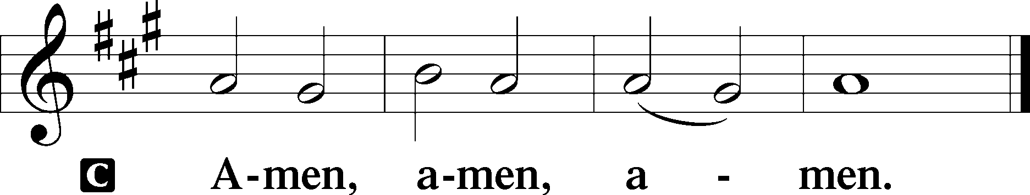
The Lord lift up His countenance upon you and T give you peace.

417 Alleluia, Song of Gladness
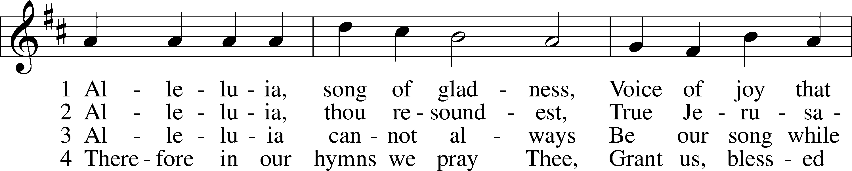
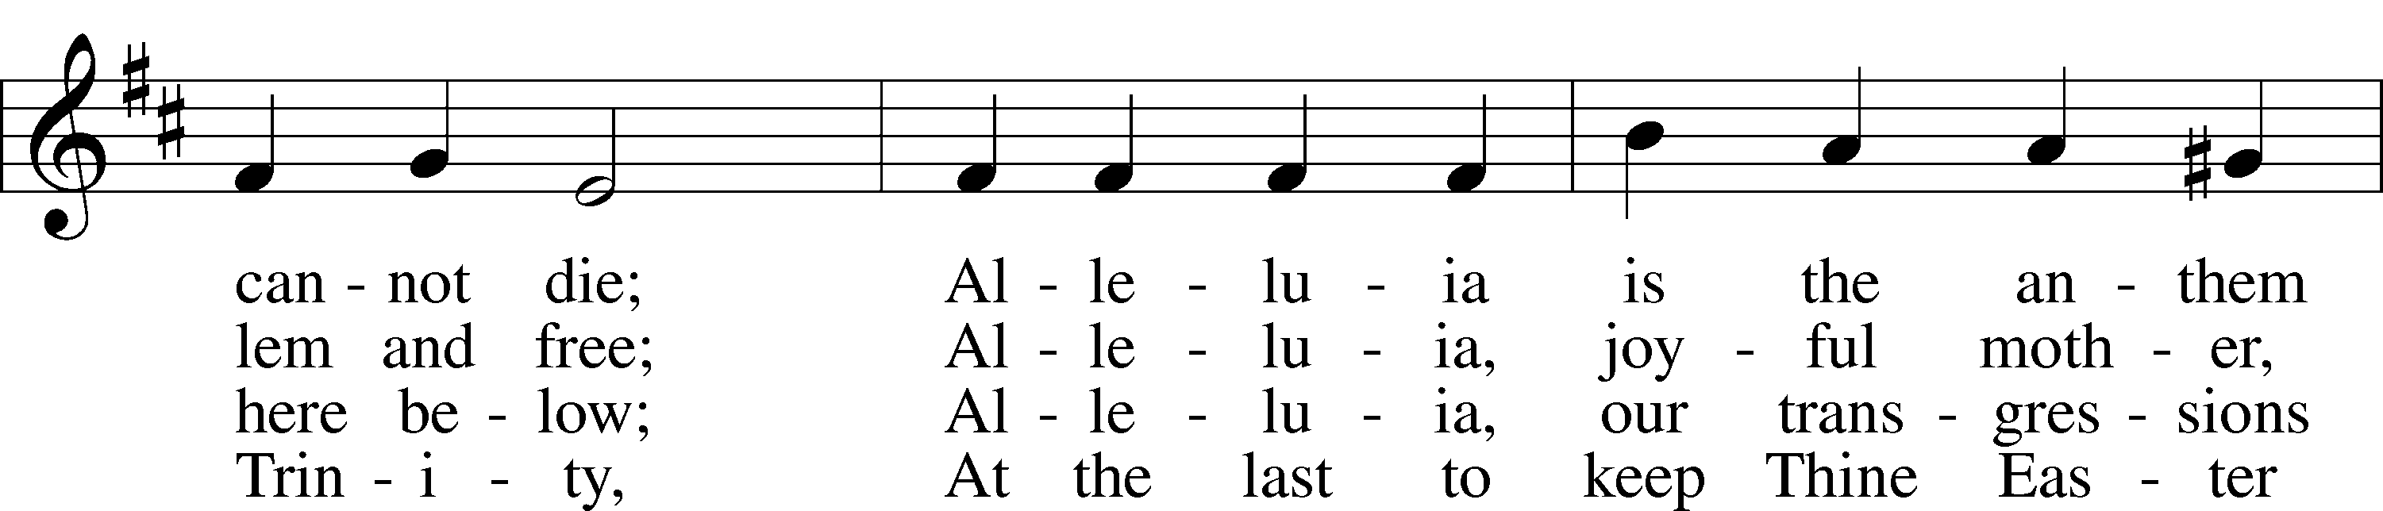
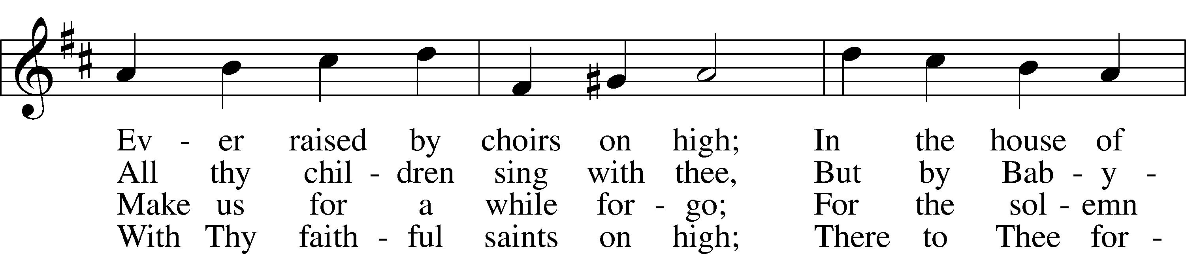
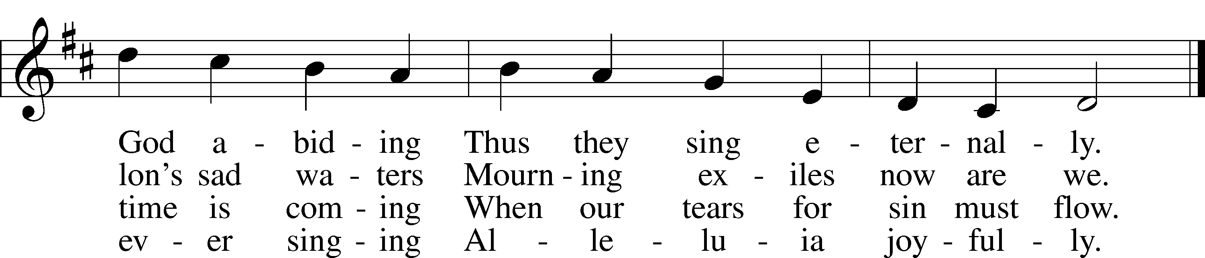Text: Latin, c. 11th cent.; tr. John Mason Neale, 1818–66, alt.Tune: John Goss, 1800–80 Text and tune: Public domain
Acknowledgments
Unless otherwise indicated, Scripture quotations are from the ESV® Bible (The Holy Bible, English Standard Version®), copyright © 2001 by Crossway, a publishing ministry of Good News Publishers. Used by permission. All rights reserved. Created by Lutheran Service Builder © 2022 Concordia Publishing House.

Prayers for Our Members
Family and Friends of Norman Abels | Grief
Judy Ahrens | Healing
Gary Albers | Healing
DyAnn Altwine | Healing
Lyle Colsden (Mother Hull) | Healing
Fred Flessner | Healing
Pat Flodine (Cambridge Court) | Healing
Jade Florang | Healing
Marilyn Fuqua | Healing
Jan Hatfield | Healing
Ruby Hatfield | Healing
Evelyn Heiden (Mother Hull) | Healing
Lennis Hodgson | Healing
Linda Luhn | Healing
Betty Mustard | Healing
Don Richmond | Healing
Norrine Rockwell (Kinship Pointe) | Healing
Debra Schinkel | Healing
Gretchen Trampe (Prairie View) | Healing
Diane Plummer | Healing
Jill Bates | Cancer
Ivan Bombeck | Cancer
Phyllis Wells | Cancer
Bertha Marienau | Hospice

Prayers for Our Members’ Family & Friends
Kayla Ernst (Bartels’ friend) | High Risk Preg.
Tenaya Nuttelman (Jared’s wife) | Expecting
Amy Nuttelman (Chris’ wife) | Expecting
Naomi Wollberg (Matthias’ wife) | Expecting
Roger Young (Tiffany Davis’ father) | Parkinson’s
Don Axeman (Bartels’ friend) | Healing
Joan Bentley (Kreutzer’s friend) | Healing
Norm Erickson (Jackie Zehendner’s father) | Healing
Jerry Foote (Carol Herron’s friend) | Healing
Marilyn Glover (Don Helmbrecht’s sister) | Healing
Emersyn Harms (Bartels’ niece) | Healing
Lorin Hartmann (Marla’s father) | Healing
David Heapy (Janel Lange’s father) | Healing
Luetta Lammers (Ruby Hatfield’s sister) | Healing
Michelle Lewis (Joni Brooks’ friend) | Healing
Tim Powers (Kim Wilkens’ brother) | Healing
Eve Sane (Quentin Lange’s friend) | Healing
Randy Solomon (Beth Rosenthal’s father) | Healing
Joanne Staton (Kristian Arevalo's grandmother) | Healing
Emily Zimmer (Leah Baker’s friend) | Healing
Diane Brandt (Junge’s and Helmbrecht’s friend) | Cancer
Glenda Fichtner (Ruby Hatfield’s niece) | Cancer
Ron Halvorsen (Jeff’s dad) | Cancer
Steven Junge (nephew of Steve & Fran) | Cancer
Lynda Kreutzer (Rich & Carol’s sister-in-law) | Cancer
Helen Lange (Bartels’ friend) | Cancer
Sharon Mulhair (Pam Uhlir’s cousin) | Cancer
Lindsey Muniz (Steve & Fran’s niece) | Cancer
Milton Naprstek (Marilyn Fuqua’s brother) | Cancer
Tyrone Uhlir (Pam’s nephew) | Cancer

Response to the Gospel
Date: 2/4/2024
Offering: $2,466.30
Weekly Need: $7,500
Offering Options:
To worship the Lord with your offering:
1) Place your offering in the offering plate.
2) Go to zionkearney.churchtrac.com/give
3) Go to zionkearney.com and click on the ChurchTrac icon
4) Mail your gift to Zion Lutheran Church, 2421 C Ave, Kearney, NE 68847

The Radio Broadcast and Altar Flowers are in memory of Norman Abels, sponsored by his 16 grandkids, 30 great-grandkids
and 3 great-great-grandkids.

Worship Assistants

Sunday, February 11th– 9:00a
Elder: Ken Hockemeier  Acolyte: Eli Randolph  Announcer: Carol Kreutzer | Usher: Steve Junge  Engineer: Eric Rosenthal  Altar Guild: Rachael Burger & Carolyn Westman
Wednesday, February 14th– 7:00p
Elder: Ken Hockemeier  Acolyte: Isaiah Gaunt | Usher: Steve Junge  Engineer: Eric Rosenthal  Altar Guild: Shirley Helmbrecht
Sunday, February 18th – 9:00a
Elder: Nathan Gaunt  Acolyte: Colton Zehendner  Announcer: Brooke Fisher | Usher: Andy Wollberg  Engineer: Jamie Nikodym  Altar Guild: Rachael Burger &  Carolyn Westman

ZION LUTHERAN CHURCH AND SCHOOL

Pr. James DeLoach, Pastor + (308) 627-5260
james.deloach@zionkearney.org
Pr. Doug Gaunt, Pastor + (308) 455-0552
doug.gaunt@zionkearney.org
Tony Splittgerber, Principal + (308) 293-0168
anthony.splittgerber@zionkearney.org

Church Office
Administrative Assistant: Holly Reid
Email: school@zionkearney.org
Phone: (308)-234-3410 Fax: (308) 236-8100
Office Hours: Monday-Friday 8:00am-4:00pm
Radio Broadcast: Sunday @ 10:30 a.m.
on 1460 AM & 92.1 FM
Website: www.zionkearney.com

This Week at Zion
Sun 2/11 | 9:00a  10:30a  10:30a  1:00p-5:00p  5:00p | Divine Service  Adult Bible Study & Sunday School  Radio Broadcast  1460AM & 92.1FM  DeLaet Family – Fellowship Hall  Divine Service
Mon 2/12 | 10:30a  7:00p | Norman Abels Funeral  Mary Martha
Tues 2/13 | 1:30p  7:00p  Birthdays | Sleeping Mats  Board of Ed  Board of Elders  Board of Trustees  Morgan Dulitz
Wed 2/14 | 8:30a  5:00p  5:30p  7:00p  8:00p | Chapel  Midweek  Lenten Meal  Ash Wednesday Service  Adult Choir
Thurs 2/15 | 7:00p | No School – Parent/Teacher Conf.  Men’s Bible Study
Fri 2/16 | 6:00p-7:00p | No School – Office Open  Hickman Birthday Party - FH
Sat 2/17 | 9:00a-1:00p  1:00p-3:00p  Birthdays | Nuttelman Baby Shower – FH  Baby Shower - Gym  David Banner
Sun 2/18 | 9:00a  10:30a  10:30a  5:00p | Divine Service  Adult Bible Study & Sunday School  Radio Broadcast  1460AM & 92.1FM  Divine Service

Announcements for February 11th, 2024

Higher Things 2024: If you’re interested in Higher Things youth conference this summer, please meet in the 1st grade classroom immediately after Sunday School TODAY. All youth going into high school or freshman year of college are welcome and encouraged to go. If you cannot attend but would like more information about the conference, contact Liz Gaunt at 308-393-5689.

Lenten Services: Starting this week (February 14th), Lenten services will be at 7pm with a meal prior at 5:30p. Mary Martha will be serving the Ash Wednesday meal.

Lenten Bible Reading Cards: Reading the New Testament in Lent is a worthwhile and doable discipline. Simply read about 6-8 chapters a day, six days a week, beginning on Ash Wednesday and ending before Holy Thursday. A schedule of readings can be found on the purple sheet in the church entryway. You can also pick up a blue Bible ready check-off card to keep track of your Bible reading progress for the whole year.

Adult Choir: On Wednesday, the Adult Choir will meet after Lenten service at 8pm.

1st Quarter Missions: The first quarter (January-March) missions will support Lutherans for Life. To donate to this worthy cause, you give online via ACH or use a specially marked envelope located in the narthex. Either way, please clearly designate your gift to this mission.

Radio Broadcast & Altar Flowers: The sign-up sheets for the 2024 radio broadcasts and flowers are on the bulletin board by the mailboxes. If you want a certain date, sign up ASAP.

SCHOOL NEWS

No School: There will be no school this Thursday and Friday for Parent Teacher conferences. A schedule was emailed to parents and the students received a hard copy.

Crusader: The most recent school newsletter is full of all the events going on in January and February. Look for it in your church mailbox.

