Zion Symbol b&w.TIFZion Symbol b&w.TIF The Sower *www.zionkearney.org*

**Zion Lutheran Church & School**

**2421 Avenue C**

**Kearney, NE 68847**

P

***308-234-3410***

***March 2017***

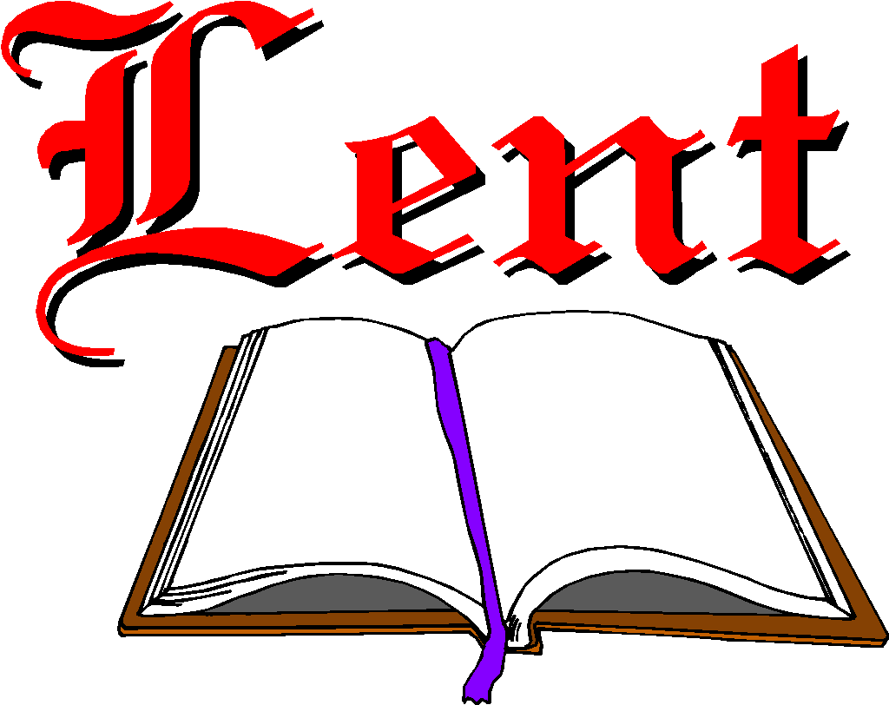Our theme for this Lenten season will be “The Spirit Anointed Christ for Mercy.” Throughout the season we will remember Jesus’ Baptism, His anointing with the Holy Spirit, and His words in Luke 4 – that He was anointed to show, and to be, mercy. As His people – hearing Him proclaim God’s Word and being God’s Word as Prophet; seeing Him sacrifice Himself on a cross and know that He intercedes for us as Priest; and knowing that we live under Him as King in righteousness and purity – we will be reminded of our work of mercy.

**Ash Wednesday**

****Please plan to join us Wednesday, March 1st at 7:00 for our Ash Wednesday Divine Service.

Ash Wednesday, begins the Christian’s Lenten journey with a reminder of our mortality and a call to repentance. We will observe the ancient practice of imposing ashes on the foreheads of all those who wish to receive them. The ashes remind us that the “wages of sin is death.” They are applied in the form of a cross to remind us of Christ’s victory for us over sin and death.

Preceding the service, Mary Martha will serve a meal in the Fellowship Hall from 5:30-6:30. The menu is pulled pork sandwiches, cheesy potatoes, salads and desserts. There will be a freewill offering with proceeds going to our emergency assistance fund.

ZYG

Thank you for the generous donations at the very successful chili cook-off hosted by ZYG. This year’s cook-off winners were Carol Kreutzer, Katie Nuttelman and Shirley Oertwig.

ZYG will host a Lenten meal on March 15. Brooke Fisher will be contacting youth families to bring food and help serve.

Our youth group will also serve Easter

Breakfast.

*Youth please note that plans are being made to attend the Higher Things Conference this summer. Please be watching for more information.*

**LWML**

Concordia

Concordia will meet Thursday, March 2 at 2:00 in the workroom.

Mary Martha Guild

Mary Martha will meet Monday March 13 in the Fellowship Hall.

Senior Citizens

Our Senior Citizens will meet Monday March 20 for their monthly potluck dinner.

**Heating & Air for Fellowship**

We have replaced the heating and air conditioning systems for the fellowship hall.  The cost will be $11,384. If you would like to help with this project, please mark your contribution “building improvements”.

**Devotion Books**

The Book Nook has copies of Pastor Allwardt’s 3 devotion books ready for purchase. They are $12 each or 1 of each of them for $30.

Any money he receives after paying for printing and shipping goes to the Ysleta Lutheran Hispanic Mission in El Paso, TX.

Stop in the Book Nook and have a look.

Thanks, Lavonne Peterson

Pancake Feed – March 11

There will be a pancake feed Saturday, March 11, at the Zion School Gym. Pancakes and sausages will be available for a freewill donation from 7:30 am to 12:00 pm. The donations will go the Zion Lutheran School Foundation.

**Peace Dinner/Auction**

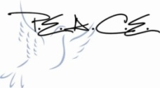Preparations for the Peace Auction and Dinner are well underway with some great auction items already donated. Some dates to keep in mind:

**March 3**- Please have all auction donations turned in so we have time to get them in the catalog.

**March 13** – Please have dinner reservations submitted (Reservation forms available in the narthex)

**March 18** – Dinner and Auction at the Holiday Inn

**March Radio Broadcast & Flowers**

**Date Radio Flowers**

5thJ.Schmidt

12th L. Hodgson

19th H. Stickney M. Wilkens

26th T. Koopman

**Radio Broadcast & Flower Charts**

The Altar Flower and Radio charts for 2017 are on the bulletin board across from the mailboxes. The cost to sponsor a radio broadcast is $161.25 per week. Families are welcome to go together to sponsor a broadcast

**March Birthdays and Anniversaries**

|  |  |
| --- | --- |
| 1 | Jacob Halvorsen, Noah Randolph,  Lindsay Wilkens |
| 2 | Ruby Hatfield, Matt Hodgson  Levi Splittgerber |
| 3 | Joan Schmidt |
| 4 | Lee Wells |
| 5 | Pat Brost |
| 7 | Emily Hartman, Kim Wilkens |
| 8 | Donna Bosard, Mary Fiddelke  *Ann. Boyd & Michelle Millsap* |
| 9 | Norman Abels |
| 11 | Wes Fiddelke, Graydn Fisher  Sylvia Schmitt |
| 12 | Connie DeLaet |
| 13 | Harry Strong, Carolyn Westman |
| 14 | Natalya Nelson |
| 17 | Chuck Zehendner |
| 19 | Gretchen Trampe |
| 20 | Ron DeLaet, Carol DeLoach  Dale Johnson, Lauren Starkey  Brenda Wommer  *Ann. Mike & Kim Wilkens* |
| 21 | *Ann. William & Brenda Wommer* |
| 22 | Harper Florang, Boyd Millsap |
| 23 | Cinda Ward |
| 24 | Reese Florang |
| 25 | Kiana Clark, Charlie Marienau |
| 26 | Kay Banner, Tiffany Hartman  Jessica Zehendner |
| 28 | Sheryl Fox, Kim Nelson |
| 29 | Carter Splittgerber |
| 31 | Carol Florang |

**Additional Opportunities to Worship during Lent**

|  |  |  |
| --- | --- | --- |
| **DATE** | **Service Time** | **LENTEN MEALS AT 5:30 -SERVED BY** |
| March 1  Ash Wednesday | 7:00pm | Mary Martha |
| March 8 | 7:00pm | Stewardship & Elders |
| March 15 | 7:00pm | Youth |
| March 22 | 7:00pm | Board of Ed |
| March 29 | 7:00pm | 7th & 8th Grade |
| April 5 | 7:00pm | Church Council |
| April 9 | 9:00am | Palm Sunday Meal @ 11:30 |
| April 13  Maundy Thursday | 7:00pm |  |
| April 14  Good Friday Service | 2:00pm | Fellowship Hour Following |
| April 14  Tenebrae Service | 7:00pm |  |
| April 16  Easter Sunrise Service | 7:00am | Easter Breakfast served  8:00-8:45 |
| April 16  Easter Festival Service | 9:00am |  |





School News

* Enrollment for the 2017-2018 school year continues. Our early childhood classes are filled except for the afternoon Pre-K.
* Our boys and girls basketball season have come to an end with the Seward tournament this last weekend of February. Thank you to coaches Brett Jagels and Phil Vogel. Thanks also to all of the parents for their wonderful support.
* We will celebrate Lutheran Schools Week March 5 through March 11. Please look at the enclosed flyer list many of the week’s activities. There will be a bookfair during the week also.

* Many of our children are preparing for the upcoming Gathering of the Talents which will be held April 1 at Concordia College, Seward.



|  |  |  |  |  |  |  |  |
| --- | --- | --- | --- | --- | --- | --- | --- |
| **Time of Service** | **Acolyte** | **Elder** | **Usher** | **Engineer** | **Announcer** | **Alter Guild** | **Book Nook** |
| **Wednesday, March 1** | Anthony Wilbur | Jeff Halvorsen | Dan Oertwig | Shawn Starkey |  | Shirley Helmbrecht |  |
| 7:00 Ash Wednesday Service |  |  |  |  |  | Denae Kuhl |  |
|  |  |  |  |  |  |  |  |
|  |  |  |  |  |  |  |  |
| **Sunday, March 5** | Gabe Bates | Dan Oertwig | Fred Flessner | Peter Kreutzer | Brooke Fisher | Mary Fiddelke | Jana Flessner |
| 9:00 a.m. Divine Service |  |  | Keith Nuttelman |  |  | Lyn Hoffman |  |
|  |  |  |  |  |  |  |  |
|  |  |  |  |  |  |  |  |
| **Wednesday, March 8** | Reilly Fisher | Dan Oertwig | Fred Flessner | Peter Kreutzer |  | Shirley Helmbrecht |  |
| 7:00 Lenten Service |  |  | Keith Nuttelman |  |  | Denae Kuhl |  |
|  |  |  |  |  |  |  |  |
|  |  |  |  |  |  |  |  |
| **Sunday, March 12** | Kassidy Halvorsen | Ken Hockemeier | Marc Hoffman | Rich Kreutzer | Lonna Gronewoller | Mary Fiddelke | Carolyn Wilkens |
| 9:00 a.m. Divine Service |  |  | Steve Junge |  |  | Lyn Hoffman |  |
|  |  |  |  |  |  |  |  |
|  |  |  |  |  |  |  |  |
| **Wednesday, March 15** | Emily Hartman | Ken Hockemeier | Marc Hoffman | Rich Kreutzer |  | Shirley Helmbrecht |  |
| 7:00 Lenten Service |  |  | Steve Junge |  |  | Denae Kuhl |  |
|  |  |  |  |  |  |  |  |
|  |  |  |  |  |  |  |  |
| **Sunday, March 19** | Lexie Eckhoff | Nathan Gaunt | Roger Riekenberg | Jared Nuttelman | Carol Kreutzer | Mary Fiddelke | Pauline Jacobson |
| 9:00 a.m. Divine Service |  |  | Robert Glanzer |  |  | Lyn Hoffman |  |
|  |  |  |  |  |  |  |  |
|  |  |  |  |  |  |  |  |
| **Wednesday, March 22** | Sophia Strong | Nathan Gaunt | Roger Riekenberg | Jared Nuttelman |  | Shirley Helmbrecht |  |
| 7:00 Lenten Service |  |  | Robert Glanzer |  |  | Denae Kuhl |  |
|  |  |  |  |  |  |  |  |
|  |  |  |  |  |  |  |  |
| **Sunday, March 26** | Hannah Zobel | Keith Nuttelman | Dan Oertwig | Shawn Starkey | Lavonne Peterson | Mary Fiddelke | Lavonne Peterson |
| 9:00 a.m. Divine Service |  |  |  |  |  | Lyn Hoffman |  |
|  |  |  |  |  |  |  |  |
|  |  |  |  |  |  |  |  |
| **Wednesday, March 29** | Tyson Wilbur | Keith Nuttelman | Dan Oertwig | Shawn Starkey |  | Shirley Helmbrecht |  |
| 7:00 pm Lenten service |  |  |  |  |  | Denae Kuhl |  |
|  |  |  |  |  |  |  |  |

